Lunar Multi-GNSS Receiver
Project Introduction
The objective of the multi-Global Navigation Satellite System (mGNSS) project is to:
- Develop a low Size, Weight, Power and Cost (SWaP-C) GNSS receiver appropriate for all orbit regimes including cislunar/lunar space
- Qualify the GNSS receiver to TRL 6
- Infuse a lunar capable GNSS receiver into lunar Positioning, Navigation, and Timing (PNT) architecture/missions and other novel applications
Operational use of GPS has been demonstrated half-way to the moon on the Magnetospheric Multiscale (MMS) mission. Lunar GNSS feasibility has been demonstrated through high fidelity simulations conducted by the Space Communications and Navigation (SCaN) program.

Anticipated Benefits
- Provide precise real-time navigation and timing for LEO, GEO, HEO, and cislunar/lunar space missions to enable guidance, navigation, and control and science
- Leverage existing always-on Earth-based infrastructure for navigation and timing
- Reduce network loading and increase onboard mission capability
- Enable crewed autonomous navigation and timing in the event of loss of communication
- Enable real-time, precise on-board PNT distribution
- Reduce risk for commercial development and operation
- Maintain hardware-in-the-loop simulation, development, testing capabilities

Primary Work Locations and Key Partners
Org Performing Work | Role | Type | Location
Goddard Space Flight Center (GSFC) | Lead Organization | NASA Center | Greenbelt, MD

Primary US Work Locations
- Maryland
Organizational Responsibility
- Responsible Mission Directorate: HEOMD
- Lead Center/Facility: GSFC
- Responsible Program: SCaN
Project Management
- Program Director: Badri A Younes
- Program Manager: Jason W Mitchell
- Project Manager: Munther Hassouneh
- Principal Investigator: N/A
Project Duration
- Start Date: Oct 1, 2020
- End Date: March 31, 2022
TRL
- Start: 2
- Current: 5
- End: 6
Technology Areas (per https://techport.nasa.gov/view/taxonomy)
- TX05 Communications, Navigation, and Orbital Debris Tracking and Characterization Systems
  - TX05.4 Network Provided Position, Navigation, and Timing
    - TX05.4.2 Revolutionary Position, Navigation, and Timing Technologies
Target Destinations
- Moon
Supported Mission Type
- Projected Mission (Pull)

Project Image
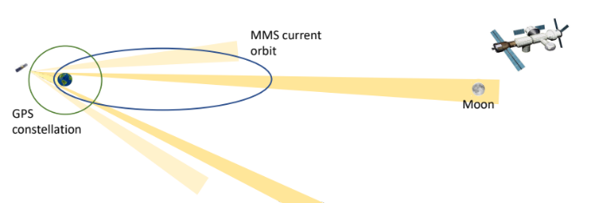 | 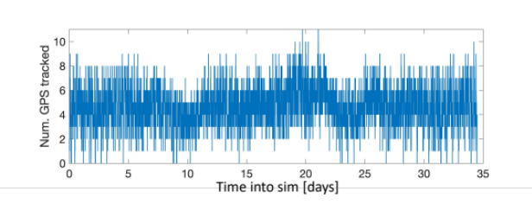
Geometry demonstrating GPS signal reception at lunar distances | Number of GPS signals tracked based on a lunar orbit simulation

