COMPOSING TEAMS WITH TEAMSTAR: TOOL FOR EVALUATING AND MITIGATING SPACE TEAM RISK
N. S. Contractor¹, A. Lungeanu¹, S. Bell², & L. A. DeChurch¹
¹Northwestern University, ²NASA

BACKGROUND
As NASA sets its sights on more Earth-independent missions, the mission to Mars as a prime example, a team’s composition becomes a critical issue for mitigating the risks of such endeavors. The purpose of this project is to develop and validate TEAMSTaR (Tool for Evaluating And Mitigating Space Team Risks), a team composition decision support system that can be used by mission stakeholders (e.g., mission schedulers, crew members) to predict how a hypothetical team’s social relationships are likely to evolve and influence crew performance over the course of a mission. TEAMSTaR will enable decision makers to evaluate composition scenarios for a set of teams, for single-member replacements, and/or for subsets of teams.
METHOD
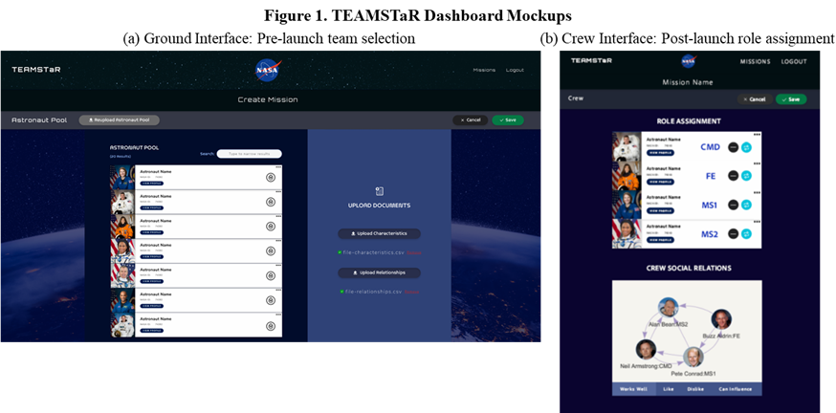
To accomplish this goal, we first leverage data and insights from recent NASA-funded team composition studies, and thoughtfully refine and extend our CREWS (Crew Recommender for Effective Work in Space, Antone et al., 2020) and SCALE (Shared Cognitive Architectures for Long Distance Exploration) agent-based models to include relevant input characteristics and their ability to predict team outcomes including team performance (Aim 1). This will enable us to identify factors known to affect crew functioning, crew member behavior, and emergent characteristics that arise during team task completion (Aim 2).
Second, we will develop and validate TEAMSTaR, a Team Composition decision support system and user interface (Aim 3). TEAMSTaR’s user interface will be optimized for both mission planners and crew members. Figure 1 presents several mockups of the interface. Next, we will validate TEAMSTaR by conducting virtual experiments and gathering stakeholder input to inform the development of TEAMSTaR.
Finally, we will validate TEAMSTaR as a decision-making tool in short and long-term isolated, confined and controlled environments (Aim 4). We intend to test the integration of the ABM and the user-interface and validate several use cases, some pre and some during a mission. This will allow us to design TEAMSTaR as a feasible and acceptable countermeasure. Some examples of pre-mission uses include crew selection from a pool of candidates, comparing several combinations of finalist crews, or determining a single-member replacement. Other use cases will be designed to mitigate team risk once the crew has launched, using as levers: crew relationships, task schedules, and mission conditions. These post-launch use cases may include re-pairing crew members on different tasks, changing the scheduling of highly interdependent tasks, or adding a decision protocol.
DISCUSSION
This project leverages and advances state of the art computational techniques to predict crew performance and to identify points of leverage in terms of team composition and task scheduling to optimize individual and team performance.

REFERENCES
[1] Antone, B., Lungeanu, A., Bell, S. T., DeChurch, L. A., & Contractor, N. (2020). Computational modeling of long-distance space exploration: A guide to predictive and prescriptive approaches to the dynamics of team composition. In L. Landon, K. Slack, & E. Salas (Eds.), Psychology and Human Performance in Space Programs: Research at the Frontier (pp. 107-130). CRC Press.

ACKNOWLEDGEMENTS
The material is based upon work supported by NASA under award 80NSSC21K0925.

