Topical:
Enabling a Precision Health System for Deep Space Exploration
Corey A. Theriot*
281-244-7331
University of Texas Medical Branch, Galveston, TX
corey.theriot@nasa.gov

Lauren Schrader
University of Wisconsin, Madison, WI
Susana B. Zanello
KBR, Human Health & Performance, Houston, TX

Jancy Mcphee
The Aerospace Corp, Houston, TX

Afshin Beheshti
KBR, Space Biosciences, Moffett Field, CA

Christopher Haas
University of Texas Medical Branch, Galveston, TX
Shean Phelps
NASA Johnson Space Center, Houston, TX

Endorsers:
Steve Platts - Chief Scientist, Human Research Program
NASA Johnson Space Center, Houston, TX
Marianne B. Sowa – Deputy Director of Science
NASA Ames Research Center, Moffet Field, CA
Ryan T. Scott
KBR, Space Biosciences, Moffett Field, CA
Lauren M. Sanders
BMSIS, Space Biosciences, Moffett Field, CA

Introduction
As exploration class missions expand in duration and distance from Earth, especially for Lunar and Mars surface missions^{1,2}, advancements in crew health surveillance and increased medical autonomy become paramount³. Newly emerging precision health methods and technology offer opportunities to achieve these goals, through their implementation into the evolving Environmental Control and Life Support System and Crew Health and Performance (ECLSS-CHP) architecture⁴. This white paper will outline a comprehensive in-flight precision health system informed by individualized genetic, molecular, clinical, and environmental information to maintain crew health and performance during spaceflight. The primary goal will be to provide recommendations for key Biological and Physical Sciences (BPS) research and development efforts and examples of emerging technologies to support the evolution of that system.
Precision health is an exciting area of cutting-edge research and medicine focused on maintaining an individual’s health and performance through in-depth understanding of their unique clinical and environmental history, genetic makeup, and molecular profiles^{5,6}. This approach can be adapted for use in-flight and throughout a mission to better predict, monitor, and address physiological responses to the environment and conditions of space⁷. Critical areas precision health could support include understanding individualized responses to the spaceflight environment, development of tailored countermeasures, and providing crew members relevant information to make informed health decisions in mission and throughout their life. However, the in-flight application of precision health approaches comes with many challenges that require research and development collaborations across BPS and beyond for such a system to be successful⁸.
Enabling precision health for exploration missions of deep space requires a fundamental change in our understanding of and ability to monitor an individual’s health status in-flight. The successful implementation of an in-flight precision health system would allow crew members and their flight surgeons to receive continual information on the current state of their health, allowing them to respond in near real-time during a mission. BPS research supporting the advancement of precision health capabilities specifically tailored for deep space missions would offer significant benefits for crew health and performance.
All about data: A precision health system such as this will rely on near-autonomous real-time generation, integration, analysis, interpretation, and utilization of individualized medical and environmental data. Thus, in support of this fundamental change, research is required to address knowledge deficiencies and promote advancements in the following four areas:
- Developing an integrated health monitoring system
- Digital biomarkers for health status assessment
- Clinical decision support tools with predictive capabilities
- Harnessing AI/ML technologies for a precision health system
Each of these objectives requires significant developments in the knowledge of spaceflight responses, data acquisition capabilities, analysis approaches, and information management and processing to fully enable an in-flight operational paradigm shift.
Developing an Integrated Health Monitoring System
The most fundamental requirement of any spaceflight medical system is the need to understand an individual astronaut’s health status throughout a mission. Current terrestrial precision medicine is capable of phenotyping an individual in incredible detail through comprehensive genetic and physiological characterization⁹. Current in-flight medical capabilities are not nearly as advanced, and integration of medical data is lacking. There is ample opportunity to develop innovative in-flight health surveillance and monitoring capabilities.
In light of this fundamental need, research efforts are recommended that support creation of an integrated monitoring system that includes environmental sensing, non-invasive physiological monitoring, and invasive biomarker/clinical measures (Figure 1). Crew time during a mission is a valuable and limited commodity, so research is warranted to develop in-flight methods of autonomous data generation for health surveillance¹⁰ through remote monitoring or other non-invasive measures. Particular emphasis should be placed on the acquisition of relevant data to enable the integrated health monitoring system¹⁰. Another important consideration is the real-time integration of a multitude of data from various and disparate sources. Improvements in computational capabilities will enable conclusions to be drawn in real-time about an individual’s response to the environment, diet, medications, exercise regimen, or other spaceflight stressor¹¹. Additional critical needs in medical technologies are addressed in another topical white paper by Shean Phelps, et al. (Topical: Development of Medical Technology for Diagnostics, Health Monitoring, and Treatment on Future Exploration Deep Space Vehicle).
Relevant environmental factors: | atmospheric conditions, gravity, CO₂, radiation, etc.
Non-invasive physiological parameters: | wearable devices¹², remote monitoring¹³, vocal biomarkers¹⁴, fatigue assessment^{15,16}, etc.
Biomarker & clinical measures: | omics analysis, digital biomarker indices, health assessments, traditional clinical evaluation, etc.
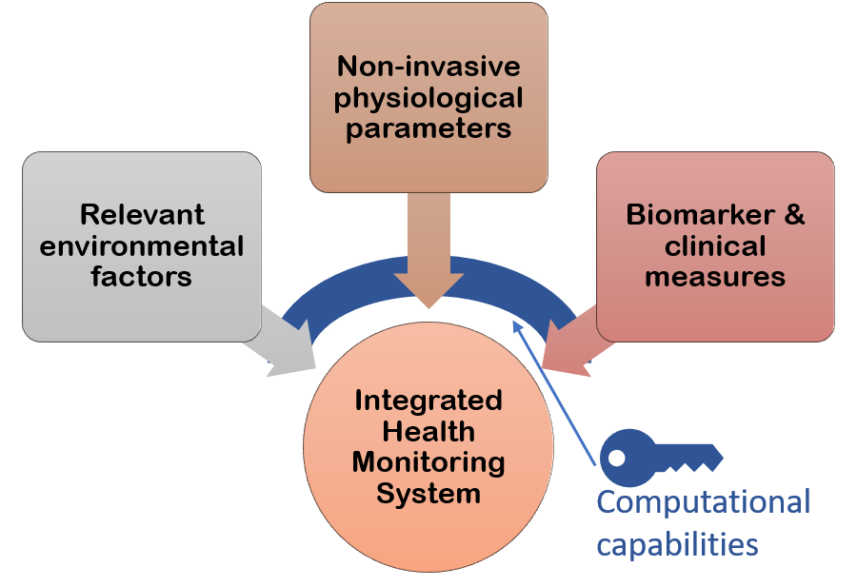
Figure 1. Schematic of an ‘integrated health monitoring system’ describing the primary inputs, with examples. The key requirement for its implementation is adequate computational capabilities.
Many relevant technologies and new avenues of research have recently been developed that could be adapted to work in the spaceflight environment¹⁷. Several are highlighted above in Figure 1, such as wearables and remote sensors capable of generating large amounts of health data. Other such emerging technologies include metagenomic next-generation sequencing (mNGS) for pan-pathogen detection and surveillance in the crews^{18,19}; microbiome monitoring to predict health status based on gathered understanding of microbiome-host interactions²⁰⁻²²; and liquid biopsies^{23,24} as validated biomarkers emerge from terrestrial medicine or developed from Space Biology studies, among many others.
Digital Biomarkers for Health Status Assessment
Another key component of an integrated health monitoring system is appropriate biomarker measures. As medical knowledge grows, so does the ability to utilize astronaut health information collected pre-flight²⁵, but more important to overall mission success is expanding in-flight data analysis capabilities. Conventional biological parameters (i.e. clinical testing, biochemical blood analysis, etc.) performed on the ground for standard clinical diagnosis only provide a snapshot assessment at a given timepoint and may not be indicative of crew health outcomes beyond low Earth orbit. This traditional paradigm is ill-suited for the continuous real-time monitoring needed during exploration-class missions, hindered by extreme time-delayed asynchronous communication and preclusion of immediate sample (or crew) return to Earth.
In contrast, digital biomarkers are defined as “objective, quantifiable physiological and behavioral data that are collected and measured by means of digital devices”²⁶ and represent the future of healthcare. These allow for remote collection and analysis of continuous health-related data, making real-time health status assessments a reality. Digital biomarkers, combined with other real-time data provided by an integrated health monitoring system, can serve as an improved surrogate for current biological sample testing without the need for samples to be returned to the ground.
The field of digital biomarker technology is still in a maturation phase and often not suitable for use under nonoptimal conditions such as the spaceflight environment. Research is recommended in areas that advance such technologies in support of near-autonomous characterization and real-time assessment of individual crew member’s in-flight. Additional investigation is needed regarding the way an individual’s digital, clinical, and molecular indices relate to specific spaceflight responses, crew health, and mission performance.
A strong emphasis should be put on systems biology research incorporating AI/ML techniques that inform next-gen digital biomarker development utilizing combined biochemical, clinical, and multi-omics parameters²⁷, integrated with real-time environmental monitoring data. Research in this area would culminate in an intuitive health assessment system that autonomously identifies dynamic biological processes and actionable profiles at the individualized level in support of personalized countermeasures. Ultimately, the system would provide critical knowledge that advances concepts of what is actionable today, what may be actionable in the near future, and what could be actionable in the long term.
Digital biomarkers have the potential to provide comprehensive real-time health monitoring and actionable insights into the biological state of individuals, while also enabling virtual modelling concepts such as a digital twin^{28,29}. Digital twin technology could revolutionize human research studies in space and on the ground to be more efficient, effective, and precise through autonomous hypothesis generation and in silico testing. Also important is research in designing biomarker indices to pioneer fully-digital predictive disease diagnosis using innovative artificial intelligence systems integrated with in-flight methods of collecting and analyzing health data. Using these biomarker indices and digital twin modeling, precision health systems would provide adaptive, real-time support tools to enable new opportunities for crew autonomy in managing health concerns far from Earth, from prevention and early detection to diagnosis and treatment.
Clinical Decision Support Tools with Predictive Capabilities
These significant advancements could only be achieved through interpretation and utilization of a wealth of digital precision health information. To accomplish this, research is needed to optimize prediction of individualized health risks through advanced phenotyping, multi-omics approaches, and understanding of individual spaceflight responses. Basic research is recommended to establish standards for characterizing sensitivities to spaceflight stressors and empowering predictive, longitudinal modelling using digital health feedback systems. For example, validated tissue-on-chip (TOC) microphysiological systems³⁰ with cells originated from induced pluripotent stem cells (iPSCs) could be used to establish an a priori understanding of individual astronauts’ phenotypic responses or risk of medical conditions that can arise in-mission or later in life.
Additionally, research is needed to develop the technology and computational capabilities for automated detection of deleterious spaceflight responses, providing clinical decision tools and personalized countermeasure options to crew members. Also needed is development of closed-loop software systems that apply next-generation treatment and medical/clinical/performance assessment tools to identify early indicators of small deviations from nominal physiological³¹, behavioral³², and emotional³³ baselines. An example with clear clinical endpoints is an approach called DELFI (DNA evaluation of fragments for early interception)³⁴ which spots unique patterns in the fragmentation of DNA shed from cancer cells circulating in the bloodstream. Next-gen software systems should be AI-enabled to autonomously identify deviations from optimum health, evolving to anticipate medical events and deploy early interventions to enhance a crew member’s capacity to respond effectively in-flight.
Harnessing AI and ML Technologies for a Precision Health System
Any in-flight precision health system requires innovative computational capabilities and analytical data systems to collect, store, and analyze health data for predictive utilization. This foundational need could be addressed through artificial intelligence (AI), machine learning (ML), deep learning (DL) and other innovative space-ready computing solutions to power a comprehensive precision health system for deep space exploration³⁵⁻³⁸ (Figure 2). Opportunities to both catalyze and inspire new space biology research in this area are detailed in another topical white paper by Lauren Sanders, et al. (Topical: Development of New Algorithms for Space Biology).
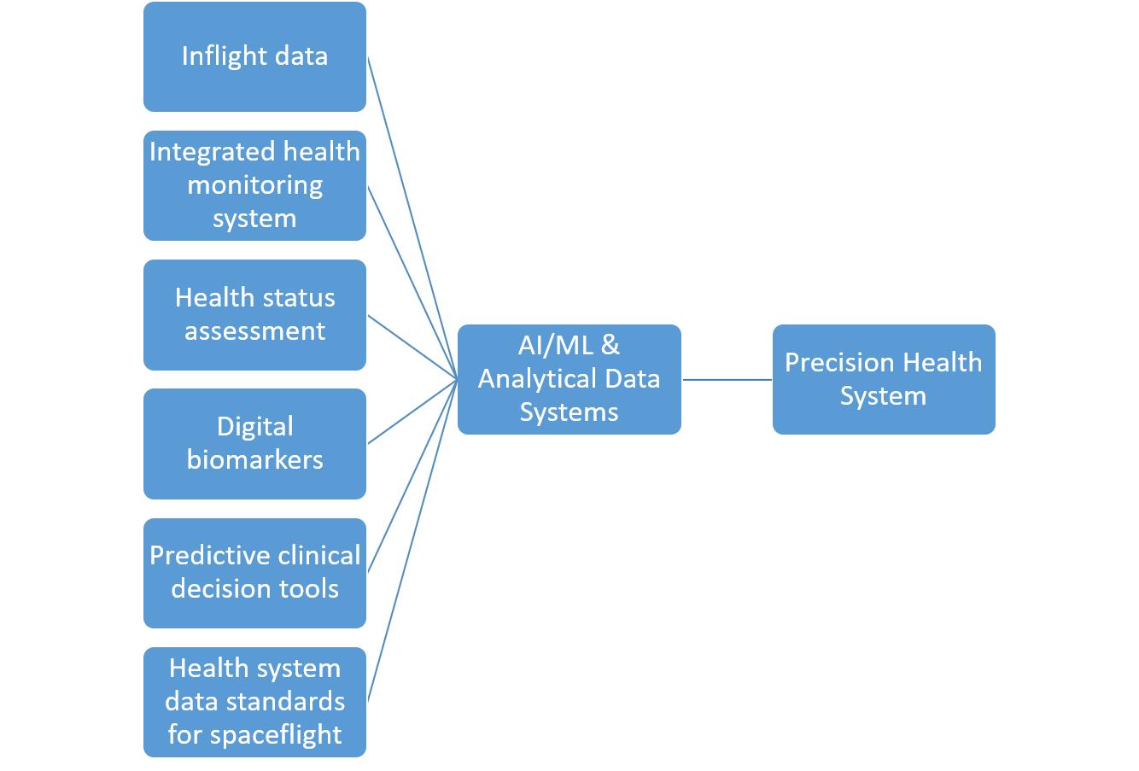
To achieve this level of technological advancement, collaborations between computer scientists, biologists, and algorithmic developers should be sponsored to: 1) establish AI-accessible/model-ready health data standards for use in all spaceflight design reference missions; 2) create a unified platform for precise monitoring of individual crew health; and 3) develop space-ready computing systems and approaches to integrate multi-omics data efficiently and effectively with traditional biochemical and clinical parameters. Successful integration could lead to a revolution in health-related data standards and interoperability solutions, ensuring spaceflight data is AI-ready and modelling accessible. Additionally, we recommend supporting AI-driven research of model organism, human, and omics data to determine novel characteristic biomarkers and profiles of spaceflight responses.
Figure 2. Schematic of a Precision Health System framework. AI/ML systems are a central component.
Examples of relevant technologies currently in development that could be exploited include: precision medicine analytics platform³⁹ to facilitate big-data research, edge cloud computing⁴⁰⁻⁴² for real-time analysis and decision making; network and causal inference techniques⁴³ to predict causal relationships among spaceflight response and health outcomes; integrating ‘Internet of Things’ (IoT)^{44,45} environment to allow system integration into the vehicle or habitat; and human-machine interactions⁴⁶ as “digital health coaches” to assist in crew health maintenance.
Summary
The areas of research proposed herein are crucial to enabling an individualized precision health system for spaceflight. Research and development efforts to enable a system such as this not only support future space exploration but could also offer solutions to similar challenges faced in terrestrial health care, particularly those in remote or isolated locations with existing limitations in health care systems. Much like the progression from information to knowledge through understanding and wisdom, a paradigm shift is required in our basic understanding of individualized spaceflight responses and ability to predict changes in health status during spaceflight. Finally, while certain aspects of precision health are currently employed by space medicine medical operations, a comprehensive and integrated precision health system would offer the best support of mission success by reducing risks, optimizing astronaut performance, and providing valuable insights into long-term astronaut health. Advancements in clinical decision making are important next steps in building dynamic individual risk profiles for astronauts and tailored countermeasure choices during deep space exploration.
References:
1 Baisden, D. L. et al. Human health and performance for long-duration spaceflight. Aviat Space Environ Med 79, 629-635, doi:10.3357/asem.2314.2008 (2008).
2 Sides, M. B. et al. Bellagio II Report: Terrestrial Applications of Space Medicine Research. Aerosp Med Hum Perform 92, 650-669, doi:10.3357/AMHP.5843.2021 (2021).
3 Hamilton, D., Smart, K., Melton, S., Polk, J. D. & Johnson-Throop, K. Autonomous medical care for exploration class space missions. J Trauma 64, S354-363, doi:10.1097/TA.0b013e31816c005d (2008).
4 Broyan, J., J. L.; Shaw, L.; McKennley, M.; Meyer, C.; Ewert, M. K.; Schneider, W. F.; Meyer, M.; Ruff, G. A.; Owens, A. C.; Gatens, R. L. in 50th International Conference on Environmental Systems.
5 Ginsburg, G. et al. The National Academies' Roundtable on Genomics and Precision Health: Where we have been and where we are heading. Am J Hum Genet 108, 1817-1822, doi:10.1016/j.ajhg.2021.08.015 (2021).
6 Traversi, D. et al. Precision Medicine and Public Health: New Challenges for Effective and Sustainable Health. J Pers Med 11, doi:10.3390/jpm11020135 (2021).
7 Schmidt, M. A. & Goodwin, T. J. Personalized medicine in human space flight: using Omics based analyses to develop individualized countermeasures that enhance astronaut safety and performance. Metabolomics 9, 1134-1156, doi:10.1007/s11306-013-0556-3 (2013).
8 Thapa, C. & Camtepe, S. Precision health data: Requirements, challenges and existing techniques for data security and privacy. Comput Biol Med 129, 104130, doi:10.1016/j.compbiomed.2020.104130 (2021).
9 Roberts, M. C. et al. Advancing precision public health using human genomics: examples from the field and future research opportunities. Genome Med 13, 97, doi:10.1186/s13073-021-00911-0 (2021).
10 Gambhir, S. S., Ge, T. J., Vermesh, O., Spitler, R. & Gold, G. E. Continuous health monitoring: An opportunity for precision health. Sci Transl Med 13, doi:10.1126/scitranslmed.abe5383 (2021).
11 Zayas-Caban, T., Chaney, K. J., Rogers, C. C., Denny, J. C. & White, P. J. Meeting the challenge: Health information technology's essential role in achieving precision medicine. J Am Med Inform Assoc 28, 1345-1352, doi:10.1093/jamia/ocab032 (2021).
12 King, C. E. & Sarrafzadeh, M. A Survey of Smartwatches in Remote Health Monitoring. J Healthc Inform Res 2, 1-24, doi:10.1007/s41666-017-0012-7 (2018).
13 Lin, C. H., Young, S. T. & Kuo, T. S. A remote data access architecture for home-monitoring health-care applications. Med Eng Phys 29, 199-204, doi:10.1016/j.medengphy.2006.03.002 (2007).
14 Fagherazzi, G., Fischer, A., Ismael, M. & Despotovic, V. Voice for Health: The Use of Vocal Biomarkers from Research to Clinical Practice. Digit Biomark 5, 78-88, doi:10.1159/000515346 (2021).
15 Bustos, D. et al. Non-Invasive Physiological Monitoring for Physical Exertion and Fatigue Assessment in Military Personnel: A Systematic Review. Int J Environ Res Public Health 18, doi:10.3390/ijerph18168815 (2021).
16 Gundogdu, S., Colak, O. H., Dogan, E. A., Gulbetekin, E. & Polat, O. Assessment of mental fatigue and stress on electronic sport players with data fusion. Med Biol Eng Comput 59, 1691-1707, doi:10.1007/s11517-021-02389-9 (2021).
17 Hussain, M. S., Silvera-Tawil, D. & Farr-Wharton, G. Technology assessment framework for precision health applications. Int J Technol Assess Health Care 37, e67, doi:10.1017/S0266462321000350 (2021).
18 Greninger, A. L. & Naccache, S. N. Metagenomics to Assist in the Diagnosis of Bloodstream Infection. J Appl Lab Med 3, 643-653, doi:10.1373/jalm.2018.026120 (2019).
19 Miller, S. et al. Laboratory validation of a clinical metagenomic sequencing assay for pathogen detection in cerebrospinal fluid. Genome Res 29, 831-842, doi:10.1101/gr.238170.118 (2019).
20 Bashan, A. et al. Universality of human microbial dynamics. Nature 534, 259-262, doi:10.1038/nature18301 (2016).
21 Haller, D. & Autenrieth, I. B. Microbe-host interaction in chronic diseases. Int J Med Microbiol 300, 1-2, doi:10.1016/j.ijmm.2009.08.002 (2010).
22 Singh, N. & Bhatnagar, S. Machine Learning for Prediction of Drug Targets in Microbe Associated Cardiovascular Diseases by Incorporating Host-pathogen Interaction Network Parameters. Mol Inform, e2100115, doi:10.1002/minf.202100115 (2021).
23 Im, Y. R., Tsui, D. W. Y., Diaz, L. A., Jr. & Wan, J. C. M. Next-Generation Liquid Biopsies: Embracing Data Science in Oncology. Trends Cancer 7, 283-292, doi:10.1016/j.trecan.2020.11.001 (2021).
24 Lo, Y. M. D., Han, D. S. C., Jiang, P. & Chiu, R. W. K. Epigenetics, fragmentomics, and topology of cell-free DNA in liquid biopsies. Science 372, doi:10.1126/science.aaw3616 (2021).
25 Charles, J. B. & Pietrzyk, R. A. A Year on the International Space Station: Implementing a Long-Duration Biomedical Research Mission. Aerosp Med Hum Perform 90, 4-11, doi:10.3357/AMHP.5178.2019 (2019).
26 Piau, A., Wild, K., Mattek, N. & Kaye, J. Current State of Digital Biomarker Technologies for Real-Life, Home-Based Monitoring of Cognitive Function for Mild Cognitive Impairment to Mild Alzheimer Disease and Implications for Clinical Care: Systematic Review. J Med Internet Res 21, e12785, doi:10.2196/12785 (2019).
27 Zilocchi, M., Wang, C., Babu, M. & Li, J. A panoramic view of proteomics and multiomics in precision health. iScience 24, 102925, doi:10.1016/j.isci.2021.102925 (2021).
28 Coorey, G., Figtree, G. A., Fletcher, D. F. & Redfern, J. The health digital twin: advancing precision cardiovascular medicine. Nat Rev Cardiol, doi:10.1038/s41569-021-00630-4 (2021).
29 Kamel Boulos, M. N. & Zhang, P. Digital Twins: From Personalised Medicine to Precision Public Health. J Pers Med 11, doi:10.3390/jpm11080745 (2021).
30 in Microphysiological Systems: Bridging Human and Animal Research: Proceedings of a Workshop-in Brief The National Academies Collection: Reports funded by National Institutes of Health (2021).
31 Purgato, M., Singh, R., Acarturk, C. & Cuijpers, P. Moving beyond a 'one-size-fits-all' rationale in global mental health: prospects of a precision psychology paradigm. Epidemiol Psychiatr Sci 30, e63, doi:10.1017/S2045796021000500 (2021).
32 Hao, Y. et al. An End-to-End Human Abnormal Behavior Detection Framework for Crowd with Mental Disorders. IEEE J Biomed Health Inform PP, doi:10.1109/JBHI.2021.3122463 (2021).
33 MacLeod, L. et al. A Mobile Sensing App to Monitor Youth Mental Health: Observational Pilot Study. JMIR Mhealth Uhealth 9, e20638, doi:10.2196/20638 (2021).
34 Mathios, D. et al. Detection and characterization of lung cancer using cell-free DNA fragmentomes. Nat Commun 12, 5060, doi:10.1038/s41467-021-24994-w (2021).
35 Johnson, K. B. et al. Precision Medicine, AI, and the Future of Personalized Health Care. Clin Transl Sci 14, 86-93, doi:10.1111/cts.12884 (2021).
36 Kriegova, E., Kudelka, M., Radvansky, M. & Gallo, J. A theoretical model of health management using data-driven decision-making: the future of precision medicine and health. J Transl Med 19, 68, doi:10.1186/s12967-021-02714-8 (2021).
37 Yu, L. et al. Artificial Intelligence Systems for Diagnosis and Clinical Classification of COVID-19. Front Microbiol 12, 729455, doi:10.3389/fmicb.2021.729455 (2021).
38 D’Haese, P.-F. et al. Prediction of viral symptoms using wearable technology and artificial intelligence: A pilot study in healthcare workers. PLOS ONE 16, e0257997, doi:10.1371/journal.pone.0257997 (2021).
39 Campbell, P. Hopkins Researchers Release Tool to Enable Better Health Care, <https://www.jhuapl.edu/PressRelease/190530b> (2019).
40 Velichko, A. A Method for Medical Data Analysis Using the LogNNet for Clinical Decision Support Systems and Edge Computing in Healthcare. Sensors (Basel) 21, doi:10.3390/s21186209 (2021).
41 Lapegna, M., Balzano, W., Meyer, N. & Romano, D. Clustering Algorithms on Low-Power and High-Performance Devices for Edge Computing Environments. Sensors (Basel) 21, doi:10.3390/s21165395 (2021).
42 Yan, X. & Ren, X. 5G Edge Computing Enabled Directional Data Collection for Medical Community Electronic Health Records. J Healthc Eng 2021, 5598077, doi:10.1155/2021/5598077 (2021).
43 Budd, S. et al. in 2021 IEEE 3rd Global Conference on Life Sciences and Technologies (LifeTech). 517-521.
44 Duran-Vega, L. A. et al. An IoT System for Remote Health Monitoring in Elderly Adults Through a Wearable Device and Mobile Application. Geriatrics (Basel) 4, doi:10.3390/geriatrics4020034 (2019).
45 Talal, M. et al. Smart Home-based IoT for Real-time and Secure Remote Health Monitoring of Triage and Priority System using Body Sensors: Multi-driven Systematic Review. J Med Syst 43, 42, doi:10.1007/s10916-019-1158-z (2019).
46 Venning, A. et al. Exploring the acceptability of a digital mental health platform incorporating a virtual coach: The good, the bad, and the opportunities. Health Informatics J 27, 1460458221994873, doi:10.1177/1460458221994873 (2021).

