TITLE: NASA Team Investigates an Enhanced Approach for Conducting Tank-to-Tank Transfers of Cryogens for Micro-Gravity Applications
AUTHOR: Jonathan R. Stephens, NASA Marshall Space Flight Center
NASA is putting emphases on reusable cryogenic systems to enable returning astronauts to the lunar surface, and eventually on to Mars. Such systems will require replenishing cryogens on-orbit via a cryogenic tanker or propellant depot, and potentially on the lunar and Martian surfaces with the utilization of in-situ resources. Replenishing cryogens on-orbit requires a tank-to-tank transfer which presents challenges due to thermal environments and the absence of gravity. If the transfer process is initiated with the receiving tank empty and at atmospheric temperature, it then must be chilled to cryogenic temperature to enable filling. Likewise, the transfer lines and associated hardware must be prechilled to assure liquid is transferred. Since prechilling results in propellant loss, it is preferred to minimize this process in interest of saving propellant mass. To simplify the operations associated with propellant transfer and explore potential mass savings, NASA has been experimenting with a new methodology which uses a Vented Chill/No-Vent Fill (VC/NVF) approach, and enhances the process using a 3-D printed spray injector augmented with a Thermodynamic Vent System (TVS).
Transfer Methodology
The operations associated with the VC/NFV approach are fairly simple. With an empty receiving tank at ambient temperature and vented to the atmosphere, the process is started by flowing cryogen through the transfer line and into the receiving tank via a spray injector. During this initial phase, cryogens boil-off absorbing energy from the transfer hardware and the receiving tank mass all while chilling the receiving tank ullage space. Boil-off gas is then released through the receiving tank vent port to avoid excessive pressure. This Vented Chill (VC) process continues until the tank temperature decreases to a predetermined “trigger point” value which is as an indication to command the receiving tank vent valve closed. If sufficient energy is removed from the receiving tank during the VC process combined with the large spray pattern acting as a heat exchanger absorbing thermal energy resulting in ullage collapse, a successful transfer can ensue filling the receiving tank to near 100% liquid level. If insufficient energy is removed from the receiving tank as a result of setting the “trigger point” temperature too high, then the flow will stall resulting in a failed transfer. However, it has been demonstrated that a stalled flow can recover when the spray injector TVS is activated and a successful transfer can ensue [1] and [2].
Experimental Setup
The VC/NVF methodology was demonstrated through a series of tests at the NASA Marshall Space Flight Center’s (MSFC) Propulsion Research and Development Lab (PRDL) [1] and [2]. NASA’s Vibro-Acoustic Test Article (VATA) served as a liquid nitrogen supply tank while the 62-gallon spherical CRYOgenic Orbital TEstbed (CRYOTE) was used as the receiving tank. Both tanks were insulated, instrumented, and placed on load cells inside a 9’X20’ vacuum chamber. Each had independent pressurization and vent lines and were connected via a single fill and drain line to enable the transfer of liquid nitrogen between the two tanks. The receiving tank was instrumented with external surface thermocouples to monitor thermal conditions during chill and transfer. A simplified schematic of the test article setup is illustrated in Figure 1.
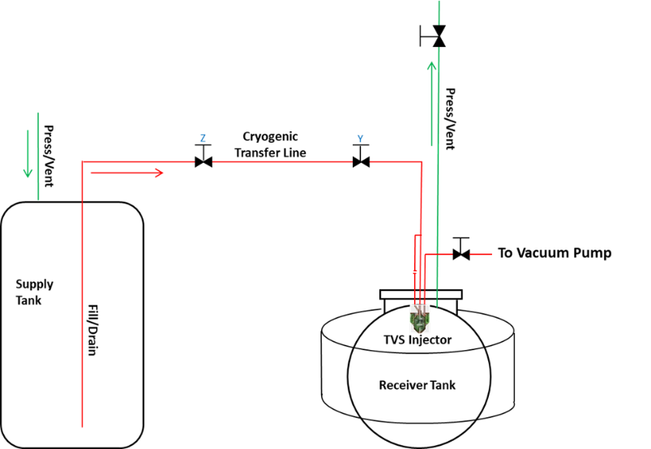
Figure 1. Test Article Setup. Image: NASA
Leveraging the capabilities of additive manufacturing, a spray injector augmented with a TVS heat exchanger was designed, manufactured, and installed into the receiving tank. The spray injector accepts subcooled cryogen which passes through an internal coiled heat exchanger before spraying it in an axial and radial pattern into the receiving tank. On a separate circuit upstream of the spray injector, an isenthalpic expansion of liquid cryogen occurs across a Joule-Thomson device resulting in a cold 2-phase mixture which is introduced via a separate path into the injector. This cold mixture then enters a cavity where it flows over the exterior of the coiled heat exchanger further subcooling the liquid nitrogen inside, and then passes through a coiled heat exchanger on the external surface of the injector which chills the ullage gas causing a reduction in receiving tank pressure. A photograph of the 3-D Printed TVS Augmented Spray Injector and an image illustrating the internal flow paths are shown in Figures 2 and 3, respectively.
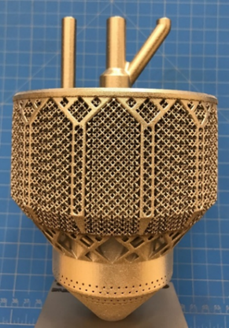
Figure 2. TVS Augmented Injector. Image: NASA
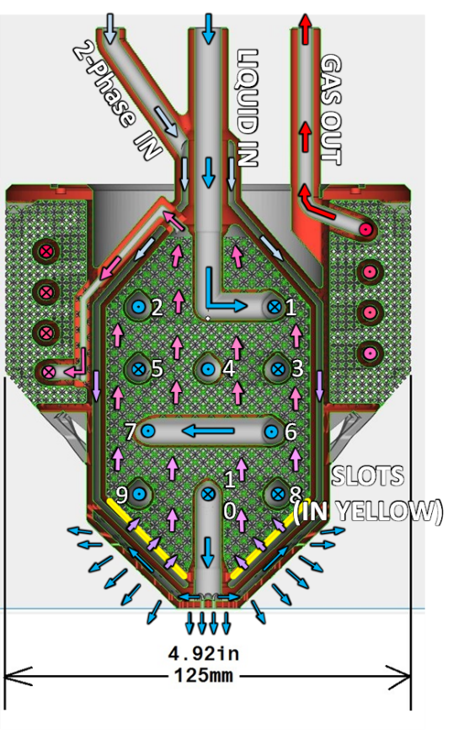
Figure 3. Injector Internal Flow Paths. Image: NASA

Results
A series of transfer test were performed at MSFC using the experimental setup described above. Successful transfers, stalled transfers, and recovered transfers were all demonstrated. Located at the 50% liquid level on the receiving tank, an external surface temperature was selected as the transfer “trigger point” which was used as an indication as to when sufficient thermal energy was removed from the system and the receiving tank vent valve could be closed. Each test started with the supply tank filled with liquid nitrogen and pressurized to 45 PSIA, and the receiving tank vent valve commanded open.
To demonstrate a successful fill to near 100% capacity, the “trigger point” value selected was 168K. Both transfer valves were opened supplying liquid nitrogen to the receiving tank via the spray injector which cooled the transfer line, receiving tank and ullage space. As the cryogen absorbed heat, the boil-off gas was vented through the receiving tank vent port until the tank was chilled to 168K and the vent valve was commanded closed. The receiving tank pressure initially began to rise, but before it could reach the supply pressure resulting in a stalled transfer, it steadily started to decrease as the ullage collapsed due to the large conical spray of subcooled liquid absorbing energy. The internal pressure continued to decrease until the transfer concluded with the receiving tank near 100% full.
A failed transfer was demonstrated on a subsequent test with an increased “trigger point”. Using the same process as the previous attempt, the receiving tank vent was closed when the “trigger point” temperature was chilled to 178K. Again, the receiving tank pressure initially began to rise and due to insufficient thermal energy removed during the chill, the pressure continued to rise to the supply pressure resulting in a stalled transfer.
The activation of the TVS heat exchanger proved to be effective in recovering a stalled transfer on another demonstration. Following the same process, the TVS was activated at start and the “trigger point” was set to 260K. After a brief chill, the “trigger point” was reached and the vent valve commanded to close. The receiving tank pressure immediately increased to the supply pressure resulting in a stalled transfer. However, with the TVS active, the liquid internal to the injector continued to cool as the injector exterior heat exchanger chilled the ullage space eventually leading to a reduction in pressure allowing the transfer to recover and fill the receiving tank to 100% full.
Future Work
With the success of the aforementioned small-scale demonstrations, the team plans to pursue this transfer methodology on a medium-scale propellant tank with a significantly higher heat load. Multiple injectors have been designed with various heat exchanger types (coiled, tube-in-shell, lattice structure, fins) and different spray patterns. The injectors will be instrumented to characterize internal heat exchanger performance. Additional transfer methodologies will be demonstrated as well in an attempt to quantify potential mass savings associated with the NV/NCF approach. Testing is planned from November 2021 through March 2022.
References
[1] Jonathan Stephens and James Martin, “Vented Fill / No Vent Fill with a TVS Augmented Injector”, presented to NASA’s Cryogenic Technical Discipline Team, December 18th, 2018
[2] Omar R. Mireles, James Martin, and Noah O. Rhys, “Development of an Additive Manufactured Cryogenic TVS Augmented Injector”, presented at the JANNAF In-Space Chemical Propulsion TIM, September 17th, 2020
Acknowledgement
This effort was funded in part by NASA Marshall Space Flight Center and NASA Space Technology Mission Directorate’s Technology Demonstration Missions program. It is currently managed as an activity within NASA’s Cryogenic Fluid Management Portfolio Project. I would like to acknowledge the Enhanced Cryogenic Transfer via a TVS Augmented Injector team which is comprised of talented engineers from NASA’s Glenn Research Center and Marshall Space Flight Center, and Yetispace Inc. This effort would not be possible without the commitment, dedication, and hard work of the great individuals involved.

