Repurposing Drilling Control Diagnostics for Subsurface Edge Detection and Boundary Advisement During Planetary Drilling

B. Glass¹, T. Stucky¹, S. Seitz¹, A. Dave¹ and R. Haynes^{1,2}

¹ NASA Ames Research Center, Moffett Field, CA 94035; brian.glass@nasa.gov.
² Morgan State University, Baltimore, MD 21251.

Abstract
Since the 1980s, technology advances have taken drilling diagnostics systems from simple expert-systems drilling advisors to real-time drilling and sampling automation and control systems capable of standalone prospecting and subsurface sampling in planetary missions. As an example of the latter, the recent ARADS project demonstrated autonomous drilling and health management from a rover at a terrestrial analog site. In this paper we discuss reversing evolution, repurposing the ARADS drilling control and onboard diagnostics to create a drilling advisory console tool, with the intent of improving situational awareness and subsurface feature recognition in support of science mission operations.

Introduction -- Robotic Drilling Assessment
Informed decision-making during lunar drilling and sampling missions will require data monitoring tools and specialized ground data systems. Accurate and updated situational awareness, with ongoing data monitoring, is critical for timely responses by to incoming science data. Traverse plans and scheduled activities may need to be flexibly changed in order to react to unexpected data or situations. Unlike (for example) Mars missions, the relative lightspeed closeness of the Moon allows for near-real-time ground processing of incoming mission and instrument data. An Apollo-class lunar regolith drill will in a sense “travel” a meter or two vertically at a given subsurface characterization site. As the drill penetrates into lunar regolith, it is likely to encounter a range of material densities, orientations, fracture toughness, and (perhaps) ice percentages. Lunar drill telemetry can provide science teams with a valuable first look into the subsurface structure, the regolith bulk properties, and constituents at each drilled site.

Real-time AI-based recognition and reaction to downhole situations has been developed for automated deeper drilling on Mars and beyond (Glass 2018, Zacny 2013, Bergman 2016, Stucky 2018). We can leverage the same knowledge bases and pattern-matching as a real-time interpreter of the subsurface, a situational awareness tool during drilling operations. The recent Atacama Rover Automated Drilling Studies (ARADS) project, in September 2019, demonstrated this AI drilling monitoring and analysis capability, in control of in-situ drilling and sampling operations, mounted on a KREX-2 rover (Figure 1) in Chile’s Atacama Desert (Glass 2021, Stoker 2021). Terrestrial automated drilling log analyses in oil exploration have used similar machine learning techniques in classifying and identifying features in drilling logs – but these typically are designed assuming a drilling fluid influencing downhole measurements and data (such as permeability and resistivity).

Drilling models and existing AI drill robotic control software, designed to detect and respond autonomously to drilling faults and hard materials, can be repurposed as an observer or advisor for near-real-time (ground-based) interpretation of drilling telemetry – a potentially valuable advisory tool for strata boundaries and changes in drilling parameters. On the Moon, this approach could be used to study the structure and to some extent the composition of lunar regolith vs. borehole depth, based on recognizable variations in fracture hardness, drilling energy and penetration rates while actively drilling.
Since the early 2000s, a series of increasingly - capable real-time drilling telemetry interpretation and characterization software tools have been developed for standalone planetary prototype drills. (Glass 2008, Glass 2014, Bergman 2016, Glass 2018, Glass 2021) These subsurface models and software tools have monitored the real-time drilling data received, and automatically identified changes in drill behavior (e.g., encountering a harder target layer, bit inclusions, drill choking due to in-fall downhole, and others) correlating these with subsurface structures and features (Stucky 2018). We will discuss several examples of mappings between drill borehole parameters, faults or events detected, and modeled changes in rock layer boundaries, in examples drawn from field testing at analog sites in an Arctic impact crater, Rio Tinto, and Chile’s Atacama Desert. These demonstrate how subsurface structural boundaries led to fault detections and responses by the software.
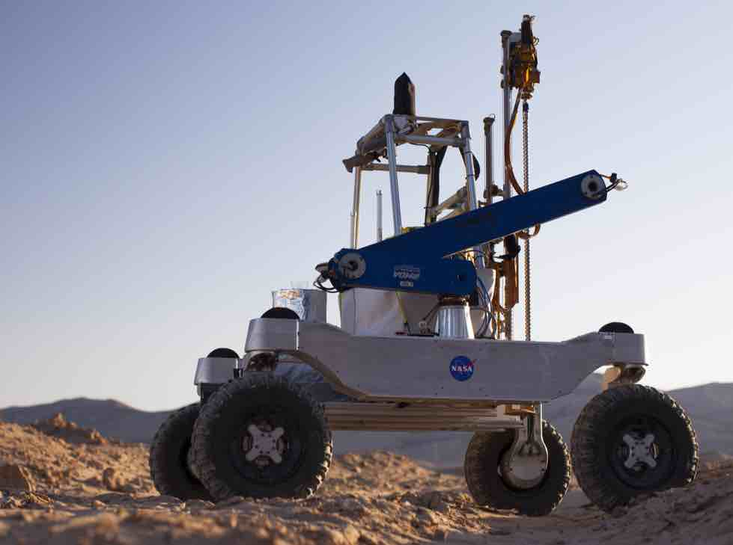Figure 1. ARADS prototype (KREX2 rover) in Chile carrying an automated Honeybee TRIDENT drill.

Planetary Drilling Advisor (PDA) Approach
Our proposed approach reverses, in a sense, a historical trend in AI and drilling -- taking a real-time-capable field robotic drill control system and effectively detuning it to become a science operations remote advisor (with no control authority). Historically, the direction of the field has been conversely to take drilling advisory systems and improve their maturity, reliability and response times to create autonomous intelligent systems capable of operational use. Several early first-generation 1980s expert systems were applied to drilling data interpretation (such as e.g., the Drilling Advisor from Teknowledge (Curteille 1986) or the Drilling Expert System (Simpson 1986)). Improvements in cognitive reasoning, large dataset and image interpretation, processing power and machine learning over the subsequent decades have led to current commercial AI monitoring and analytical tools for the oil and gas industry (viz. IBM’s Exploration Advisor Tool (IBM 2021) or modules in Schumberger’s DELFI suite (Schlumberger 2021)).

Compared to oil and gas drilling, planetary sampling drills typically have no casing or drilling fluids, aren’t concerned with substrate porosity (except in terms of fracture toughness), are drilling blind (with no prior seismic subsurface imaging) and employ orders of magnitude less mass and energy while traveling cm to meters (rather than km) deep. Commercial petroleum exploration and production software tools are not a good fit, hence our interest in retrofitting an automated drilling advisor derived from our existing validated planetary-prototype drilling model.

Table 1. Planetary Drilling Advisor -- Science Traceability Matrix
Science Goals | Objective | Sub-objectives | Observables (from remote drill telemetry) | PDA-inferred or synthesized
Determine whether observed changes in drilling response are sufficient to substantially identify the subsurface physical state, including heterogeneous layering and vertical distributions of volatiles; look for evidence of any depth-related patterns and processes (e.g., lunar impact gardening, from (Cannon and Britt 2020). | 1) Determine spatial distribution of subsurface material contrasts, both vertically per borehole and laterally across the Science Stations. | Estimate and constrain local stratigraphy from observed changes in drilling behavior | Weight-on-bit (N), penetration rate (mm/sec), shaft torque (N-m), percussive energy (J) | Hard - material boundary;  Soft/uncemented materials (bit choking); Percussion mapping
 | 2) Locate and characterize availability of volatiles | Determine vertical distribution of water | Weight-on-bit (N), penetration rate (mm/sec), shaft torque (N-m), temperatures along borehole (˚K) | Hard-material boundary; Temperature response to drilling energy inputs;  Regolith cementation and heterogeneity (bit inclusions, jamming)
 | 2) Locate and characterize availability of volatiles | Identify volatiles’ presence in solid materials | Weight-on-bit (N), penetration rate (mm/sec), shaft torque (N-m) | Regolith cementation and heterogeneity (bit inclusions, jamming)

Some of the motivations and benefits of commercial drilling advisory software systems remain relevant to planetary science drilling. Our proposed automated planetary-drilling advisor (PDA) would create a software agent that could evaluate mission drilling power and penetration rate in real-time (as telemetry is received) and hence provide ongoing regolith strength assessments to a mission science team (or an in-situ resources backroom). Regolith strength, correlated with data from water-detection instruments (such as NIRVSS (Colaprete 2010)), allows for the differentiation of lunar or martian ice states: coherent ice layers or chunks in the regolith, vs. ice-cemented regolith grains. Our top-level PDA science goal, shown in Table 1, addresses the correlation of observed drilling state changes, compared with subsequent independent ground truth from other instruments regarding the material layers and volatiles content with depth. The PDA science traceability matrix (Table 1, Objective 2) addresses locating and characterizing volatiles and their vertical distribution during drilling, as well as correlation across multiple planetary surface drilling locations.

Just as in commercial applications, creation of planetary resource maps requires drilling and the correct interpretation of the drilling results (ice and dry overburden extents), to constrain vertical profiles from other-instrument observations of the presence of volatiles. This ties to our Table 1, Objective 1.

Automated Regolith Feature Extraction in Science Drilling
Subsurface automated assessment of regolith builds on nearly two decades of NASA-supported effort in modeling, diagnosis, feature extraction, planning and execution in space drilling applications at NASA Ames. Given PDA as an advisory mission science application from an existing knowledge base, it incorporates lessons learned (with simulants and at analog test sites) and internal modeling of planetary drill behavior. These may be helpful in quickly identifying and classifying subsurface features, by leveraging and observing an existing drilling telemetry stream. The PDA can improve the situational awareness of a mission science team during drilling, and provide a first-look analysis during progress through each borehole.

The active-drilling-control version of the PDA was already used to monitor and operate the ARADS project’s (Glass 2021) TRIDENT drill in Chile (Figure 1). For use with TRIDENT drills, we can simply adapt and modify this code by disabling the drill commanding and execution capabilities, while adding parameters (for any additional sensors) and a visual user console interface. The current ARADS control software is tuned specifically for the behavior of the TRIDENT drill, with ~24m total depth drilled at field analog sites on three continents with a TRIDENT during 2016-19.

As an aside, the development of the TRIDENT drill itself was originally co-funded by the ARADS project (Glass 2019, Stoker 2021, Glass 2021) in tandem with the then-Resource Prospector project office (now the Volatiles Investigating Polar Exploration Rover (VIPER) mission). Design requirements for ARADS are reflected in the TRIDENT drill design, particularly in the brushed sample removal from the auger flutes, in the drill-string length and diameter, the slip ring, and in the drill controls and avionics. The first TRIDENT delivered to NASA by Honeybee was the ARADS drill sent to Ames in the autumn of 2016. Subsequent beta-testing experience by the ARADS team led to design improvements reflected in Honeybee’s later-built TRIDENT units, particularly in revisions to cabling, Z-axis pulleys, and avionics board mounting. The ARADS rover drill was subsequently retrofitted with these improvements for further field testing and software development.

The drilling artificial intelligence-related technologies applied in Chile were themselves initially implemented in 2004-06 for the Drilling Automation for Mars Exploration (DAME) project (Glass 2008, Cannon 2007), with real-time field tests at analog sites in the US southwest, Arctic and in Spain. Table 2 indicates the testing and development heritage of the drilling automation software. Subsequent re-designs of the drilling automation made the software smaller, more resilient, and improved its onboard real-time performance during drilling operations (10-15 to <1 sec, Glass 2021). Figure 2 shows an earlier version of the software in onboard control of an earlier Honeybee drill (the Icebreaker-1 design) in University Valley in Antarctica in 2013. Annotations indicate times and parameter changes that led to subsurface diagnoses and hence actions taken in response. A diagram of the top-level architecture (Figure 3) shows the internal multi-agent structure with command and telemetry interfaces.
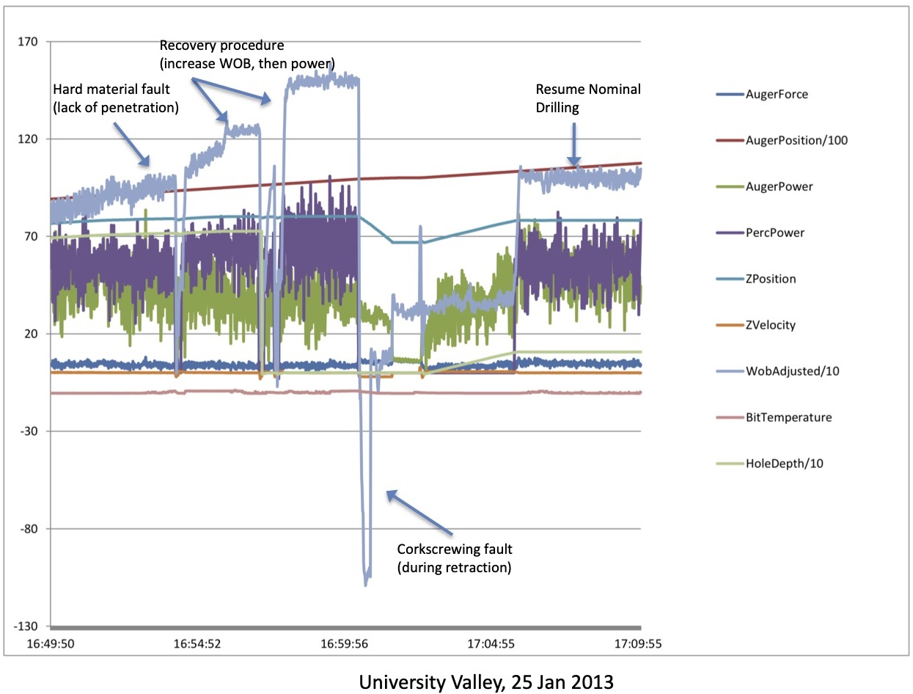
Figure 2. Detection of downhole material change and automated drill recovery/adjustment, in 2013 Antarctic test. (Glass 2014)

In terrestrial resource extraction drilling, the highly - uncertain environment, limited number of measurements, time-dependent changes downhole, and requirements to correctly identify the correct drilling state (to manage cost, risks and safety) has led to terrestrial drilling largely retaining direct human involvement and control (despite the improvements in AI and automation capabilities since Drilling Advisor).

To automate this process, one may consider “how do humans do this?” and create cognitive models. In our original DAME AI approach (Cannon 2007, Glass 2008), there were several internal agents with defined roles:
  - Quick reflex ("ow, my hand is on fire!") implemented as rules, decision trees or sensor limit-checks.
Table 2. PDA Operational Heritage, Drilling at Analog Sites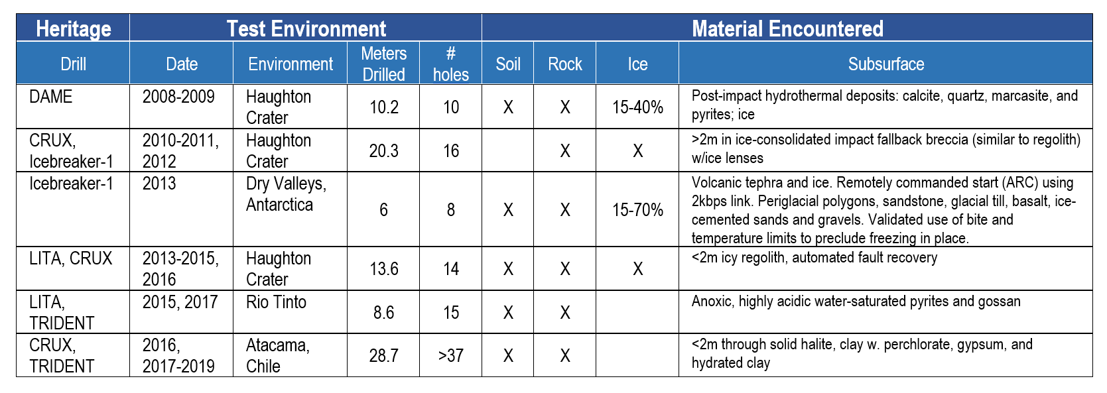
  - Fuzzy neural net (a type of machine learning) that takes past training examples of known features or states, and then perceives incoming data, choosing the closest pattern-match it knows about from its past neural weightings
  - Model-based reasoning module which runs its own simulation (Bayesian) of how the target or system is expected to behave (from physical or underlying principles) which is compared to the actual behavior(s) then seen in drilling telemetry.
  - Overall drilling executive takes the hypotheses from the three diagnostic agents, weighs between them to choose a most-likely state, and (in direct control applications) decides what course of action to invoke and how it can be made to be compatible with task recovery or safing. The current (2019) ARADS drill control software is implemented in the Plan Execution Interchange Language (PLEXIL), which has also been applied to other NASA mission uses (including ISS procedure automation) (Estlin 2006, Verma 2007).
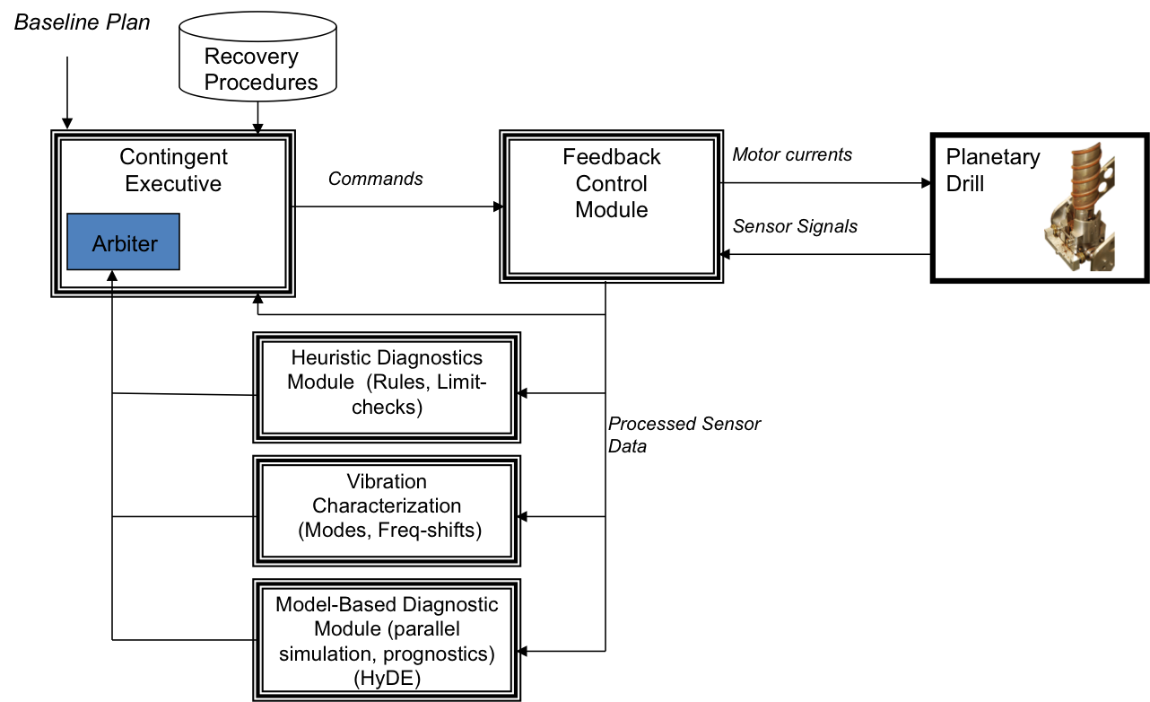
Figure 3. DAME drilling automation block diagram (Glass 2008), showing parallels in the diagnostic structure.
Earlier planetary-prototype drills had few or no local software limit checks or diagnostics, but the success of joint Ames-Honeybee drill automation in field tests led to the adoption and implementation of some fast limit-checking and rules in the current Honeybee TRIDENT drill avionics. Evolving to track the TRIDENT architecture changes, the ARADS control software was reorganized in 2016 (Figure 4), without the model-based agent, and splitting the top-level pattern-matching and diagnostic reasoning agents off from the lower-level sensor limit-checking now performed by TRIDENT’s own health software. (Stucky 2018)). This modified drilling software architecture was tested in Honeybee’s 3m thermal vacuum chamber, in shakedown tests at the Ames Roverscape (December 2016) and then successfully at analog sites (Chile and Spain) in 2017-19.
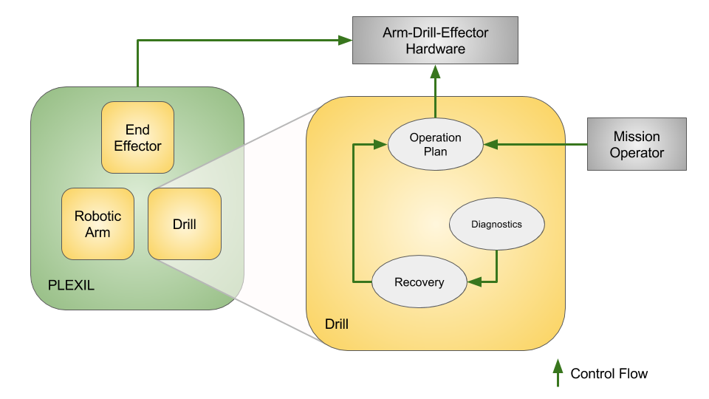
Figure 4. The existing ARADS/Icebreaker automated TRIDENT drilling architecture (Stucky 2018).

Discussion -- Improved Situational Awareness and Modeling in Drilling Operations
(Near) real-time drilling data analysis allows for smart sampling and more-productive science. A benchmark report from the National Academy of Sciences (NRC 1998) on human and organizational behavior cites the work of (Dominguez 1996) regarding the definition of situational awareness: “Continuous extraction of environmental information, integration of this knowledge to form a coherent mental picture, and the use of that picture in directing further perception and anticipating future events.” In mission field operations, these map to questions such as:
- Where are we? (XY position, Z depth, path along traverse route)
- How are we? (orientation, systems health, consumables and power levels)
- What are we doing now? (current activity, activity levels or events)
- When and what are our next priorities? (anticipating future action or event upcoming)

In near-real-time (given lightspeed and buffering), the drill performance data and observations and alerts shown on a PDA screen (see Figures 5 a(top), b(lower)) will directly improve awareness of “Where” and “How”. Its drill state hypotheses would inform science team members regarding their decision-making for “When and what?”. Rapid identification of changed drilling states will improve drilling process visibility, science context, ability to pursue unexpected opportunities, improve system resilience and lower overall drilling risks.

To build a PDA console for TRIDENT application from the existing ARADS drill automation, we would begin by defining the dataset requirements – looking at any differences in format, content, refresh rates or included parameters between the targeted TRIDENT drill, and its older prototypes (such as the ARADS drill). In flight mission application, the given telemetry format translation would be defined and coded for the input of TRIDENT telemetry to the PDA.
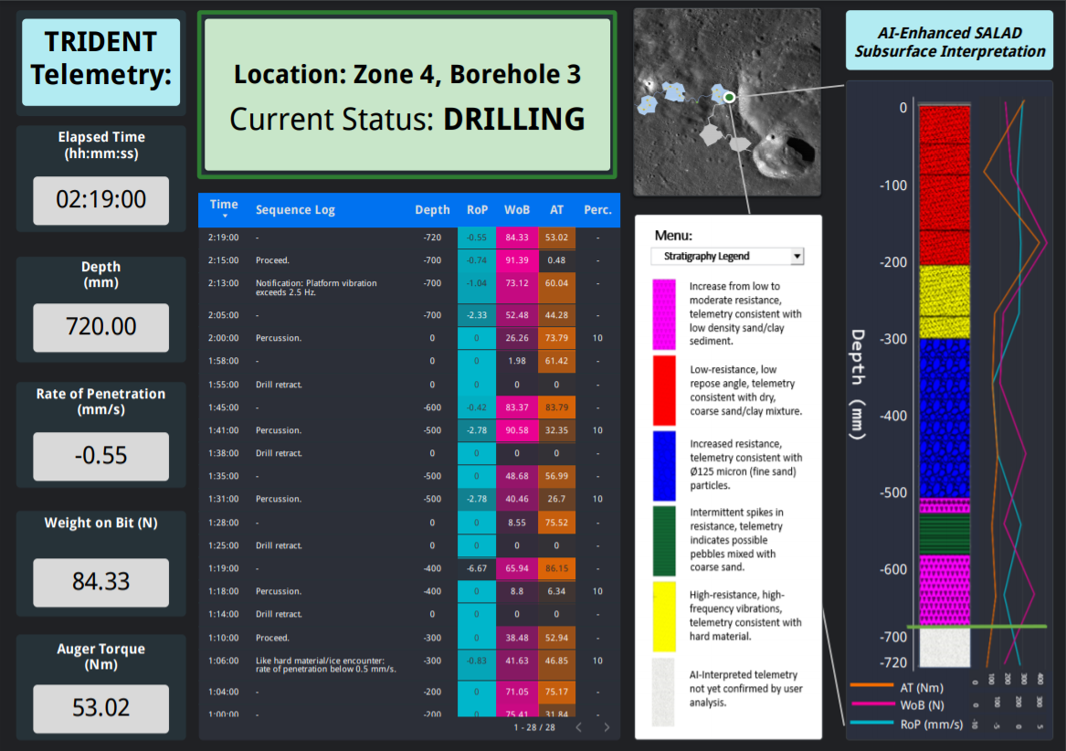
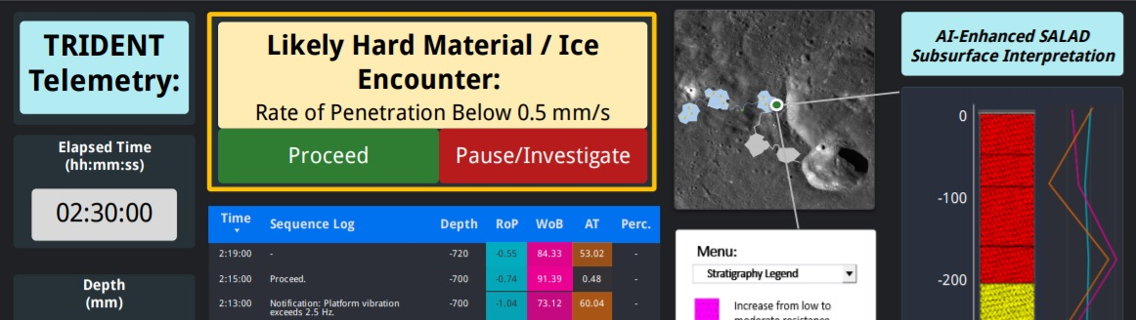
Figure 5. Mockup concepts (using ArcGIS and Google Data Studio) for the PDA console: (a) during nominal drilling, (b) flagged when the drill encounters a harder layer at depth.
The current (2019) fielded ARADS onboard drilling automation uses a command-line interface (for debug, setup or remote operator inputs). The user mockups shown in Figures 5 (a,b) are notional versions of the PDA console display to be developed for mission science team use.
A.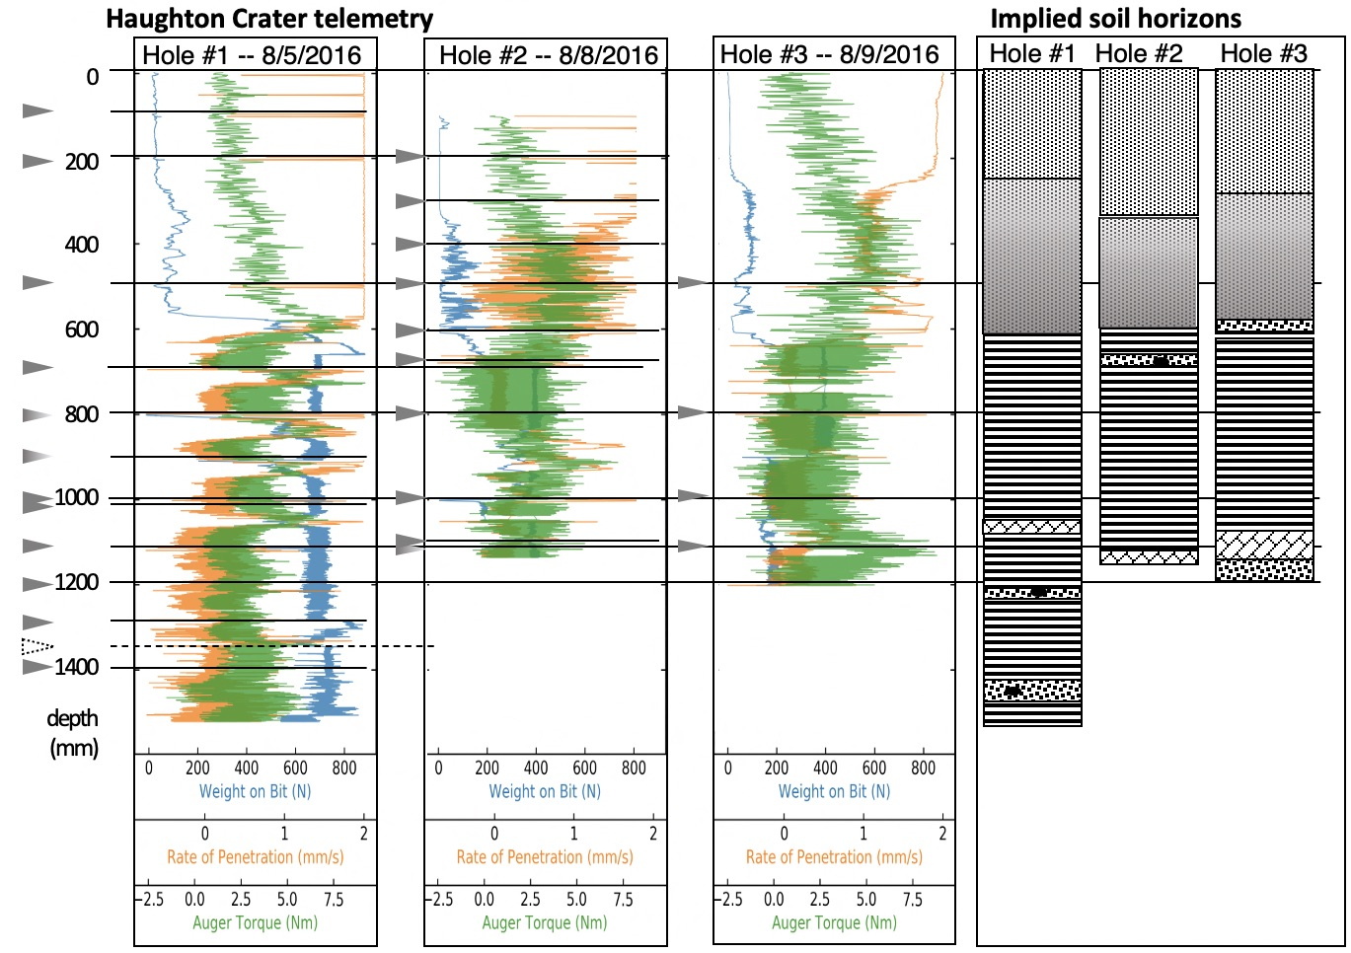 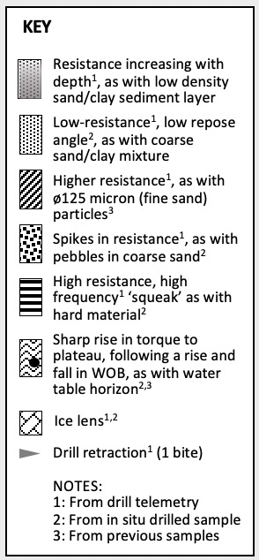
B.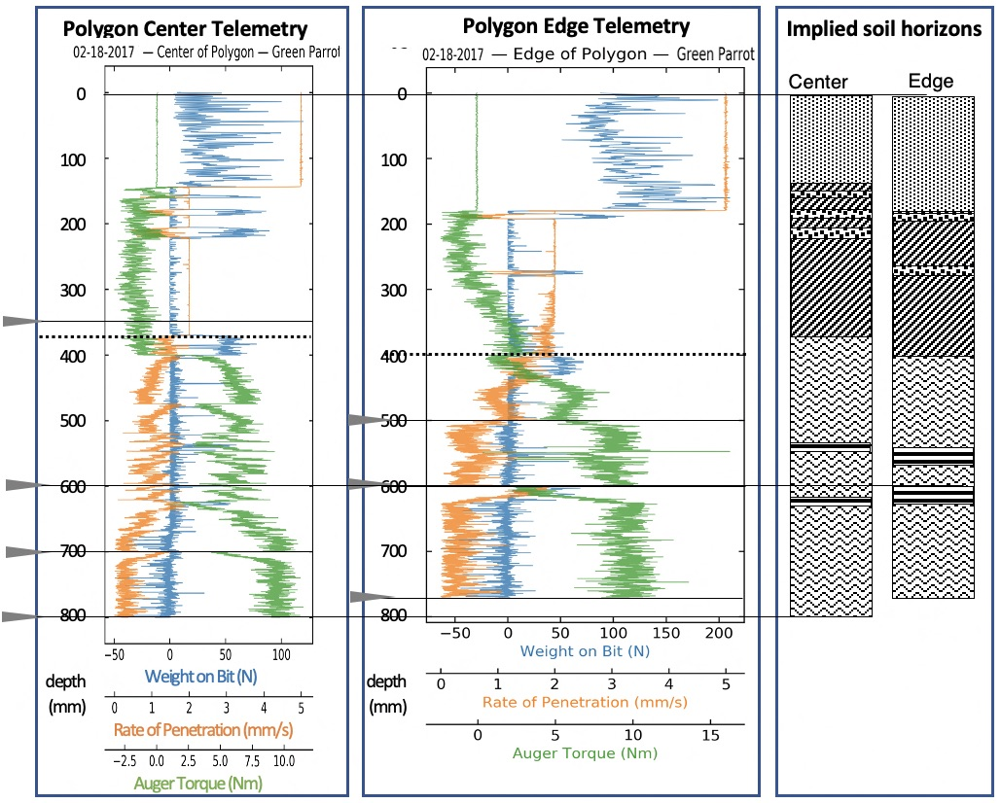 C.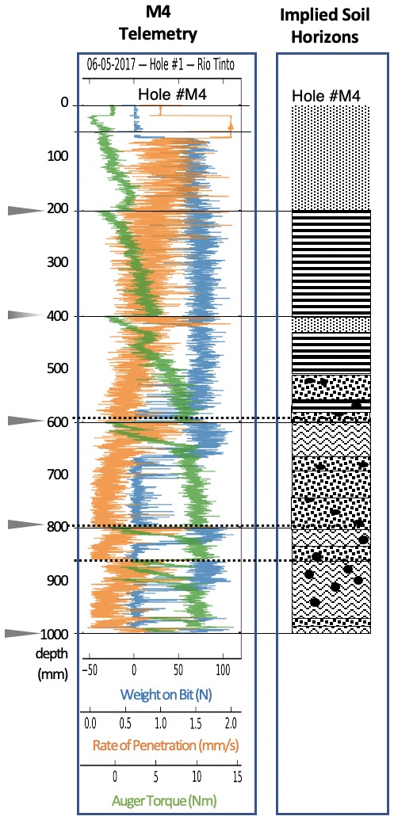
D.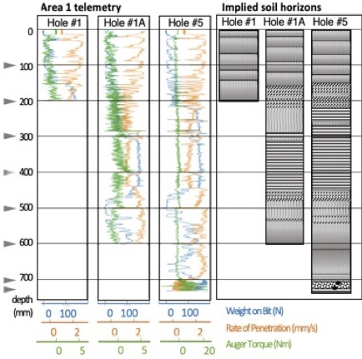
Figure 6. Field test drilling performance data with accompanying possible models: (a) Haughton Crater (permafrost, impact breccia); (b) Atacama salar, halite polygon; (c) Rio Tinto pebbly sediments with a gossan layer; (d) Adjacent boreholes at the Atacama “playa” science station Area 1.

PDA observations of drilling events and boundaries, together with raw drilling parameters (telemetry) and derived data (energy), can support the geotechnical modeling of layering and structure. In Figures 6 a-d, several examples are shown of drilling performance data from past tests at terrestrial analog sites, with accompanying post-test subsurface interpretations. Figure 6(a) was drilled in 2016 (CRUX drill prototype) into an icy high-fidelity textural regolith simulant (impact-generated fallback breccia at Haughton Crater) with permafrost and active-layer boundaries (670mm) evident (as well as clear ice layers around 900mm and 1070mm). In Figure 6(b) we see 2017 drilling of gossan and acidic sediments (TRIDENT drill) showing the presence of harder layers and choking in loose sediments (Rio Tinto, Spain). Similar contrasts are seen in Figure 6(c) (TRIDENT drill in the Atacama Desert, “Green Parrot” site in 2017) drilling into polygonal halite deposits (discovering a trapped 3cm mud layer around 520-550mm depth). Most recently, in September 2019 the final ARADS tests drilled into a previously - unexplored structure (Atacama Desert, “Playa site”) thought to be a 1 km diameter dry pond. Figure 6(d) shows drill parameters of the three parallel boreholes drilled at playa site A, with a pocket of gravel seen at about 70cm depth in the third borehole.

ARADS onboard feature extraction and pattern-matching and prognostic capabilities were necessary for hands-off autonomous drilling, in space applications where lightspeed delays and Deep Space Network accessibility preclude direct human ground flight control while drilling. Since a remote, advisory-only console is not allowed direct commanding, safing or direct diagnostic commands for the drill, these functions (Fig. 5(a)) will be disabled, noted to the operator only as advisories. However, drawing on PDA’s drill health monitoring heritage, possible TRIDENT fault conditions flagged by the PDA during drilling operations (Fig. 5(b)) would be displayed/alarmed on the PDA Console.

PDA’s internal extrapolation and feature identifications (during drilling) complement and support model-building from drilling data. Identifying likely hard layers and ice lenses supports further exploration of subsurface volatiles (in form and state) when encountering a hard spot in drilling. The PDA near-real-time analysis of drilling data can improve the odds of noticing gradients and drilling anomalies, while allowing for safer drilling.

Conclusions
Reverse-engineering the logic and pattern-matching of an onboard automated drilling controller to create a mission control advisory tool is both feasible and leverages an existing drill’s knowledge base and experience for multiple uses. The commercial drilling knowledge bases and tools relevant to high-mass, high-energy terrestrial resource drilling are of limited applicability for planetary science and resources; and, repurposing a real-time planetary drilling software system for off-line advisory use requires first that the real-time system exists for a comparable version (engineering test unit or fielded prototype) of the flight drilling system, so the general applicability of our conversion-approach is also limited. However, where feasible, mission science drilling operations can benefit from a Planetary Drilling Advisor through improving situational awareness and subsurface feature recognition, motivating the creation of a PDA tool where prior relevant software does exist.

References
Bergman, D., et al. (2016). Autonomous Structural Health Monitoring Techniques for the Icebreaker Drill, Earth and Space 2016: Engineering for Extreme Environments. American Society of Civil Engineers, Orlando, April 2016.
Cannon, H. N., et al. (2007) MARTE: Technology development and lessons learned from a Mars drilling mission simulation. J. Field Robotics, 24(10), https://doi.org/10.1002/rob.20224.
Cannon, K. M. and D. T. Britt (2020) A geologic model for lunar ice deposits at mining scales. Icarus 347, 113778, https://doi.org/10.1016/j.icarus.2020.113778.
Colaprete, A., et al., (2010) Detection of water in the LCROSS ejecta plume. Science 330, 463.
Courteille, J.M., Fabre, M., and Hollander, C.R. (1986) An advanced solution: The Drilling Advisor. Journal of Petroleum Technology, August 1986, pp. 899-904.
Dijkgraaf, H. (2021) AI advisor helps exploration geologists make better, faster predictions. IBM Customer Stories, https://www.ibm.com/blogs/client-voices/ai-helps-exploration-geologists-improve-predictions/ (April 27, 2021).
Dominguez, C. (1994) Can SA be defined? in Situation Awareness: Papers and Annotated Bibliography (U), M. Vidulich, C. Dominguez, E. Vogel, and G. McMillan, eds. Vol. AL/CF-TR-1994-0085, Armstrong Laboratory, Wright-Patterson Air Force Base, OH.
Estlin, T., A. Jonsson, C Pasareanu, et al. (2006) Plan Execution Interchange Language (PLEXIL). NASA Technical Memorandum TM-2006-213483, April 2006.
Glass, B., Cannon, H., Branson, M., Hanagud, S., and G. Paulsen. (2008) DAME: planetary-prototype drilling automation. Astrobiology, 8:653–664.
Glass, B., McKay, C., Dave, A. and K. Zacny, (2014) Robotics and Automation for “Icebreaker”. J. Field Robotics, 31(1):192-205.
Glass, B., Parro, V., D. Bergman, et al. (2018) Life-Detection Mars Analog Testing at Rio Tinto. 49th LPSC, #2927, The Woodlands, TX.
Glass, B., Davila, A., Parro, V., et al. (2019) Atacama Rover Astrobiology Drilling Studies Project: Third Year, Astrobiology Science Conference, Seattle, June 2019.
Glass, B., et al. (2021) Atacama Rover Astrobiology Drilling Studies (ARADS) Project: Remote Rover, Drilling and Instrument Operations in a Mission Simulation. 16th International Conference on Space Operations, Cape Town, South Africa, May 2021.
National Research Council (1998) Modeling Human and Organizational Behavior: Application to Military Simulations. Washington, DC: The National Academies Press, 1998. https://doi.org/10.17226/6173.
Schlumberger Ltd. (2021) Customer successes using AI in DELFI. AI modules in Schlumberger DELFI exploration and production suite, https://www.software.slb.com/delfi/ai/customer-successes-using-ai#interpretation (9 Nov 2021).
Simpson, M. A. (1986) A Microcomputer Approach to Drilling Engineering Problem Solving. SPE Deep Drilling and Production Symposium, Paper SPE-14988-MS, Amarillo, Texas, April 1986, https://doi.org/10.2118/14988-MS
Stoker, C.R., et al. (2021) A Drilling Mission to Search for Biosignatures of Life on Mars Simulated in Atacama Chile. 52nd Lunar and Planetary Science Conference, #2548, March 2021.
Stucky, T. R., et al. (2018). Autonomous Regolith Extraction Using Real-Time Diagnostics and Dynamic Plan Execution for 1 Meter Class Interplanetary Rotary-Percussive Drills. Earth and Space 2018: Engineering for Extreme Environments. American Society of Civil Engineers, Cleveland, OH 348-358.
Verma, V., Baskaran, V., Utz, H. and C. Fry (2007) Demonstration of Robust Execution on a NASA Lunar Rover Testbed. International Symposium on Artificial Intelligence, Robotics and Automation in Space (iSAIRAS), Los Angeles, 2007.
Zacny, K., et al. (2013) LunarVader: development and testing of a lunar drill in a vacuum chamber and in the lunar analog site of Antarctica. J. Aerosp. Eng. 26:74–86.

