Analysis of a Dynamic Flexed Flat Cable Harness
Bhanu Sood, Mary E. Wusk, Eric Burke, Dave Dawicke,³
Stephen Lebair, and George Slenski ²

Abstract
A dynamic flex test was performed on a spacecraft instrument harness composed of multiple individual flex cables, with each flex cable containing multiple copper traces. The purpose of the test was to demonstrate the capability of the harness to survive the number of expected flex cycles during the planned mission with appropriate margin. However, during testing, increased trace resistances and open circuits were observed beginning at approximately 10% of the total number of planned flex cycles. This paper discusses the various proximate causes that contributed to increased and open resistance in the flex cables and the subsequent redesign, manufacturing, reliability, and quality-related changes that were instituted. An analysis process, including failure analysis, non-destructive evaluation, digital imaging correlation, and parametric modeling, will also be discussed. The paper will cover the development of a robust dynamic flex harness design and include recommendations to extend flex harness life; make changes to the flex harness life test; and improve flex cable manufacturing, quality, and reliability.

Introduction
A NASA Earth-observing scientific instrument undergoing ground testing experienced life-testing failure of dynamically flexed omega-shaped flex harness used to distribute power and data throughout the instrument. The harness’ initial copper trace failures began after the first 10% of the life-test cycles were completed, and additional failures continued as cable testing progressed. The NASA Engineering and Safety Center (NESC) established a cross-agency team of experts to evaluate the contributing factors that led to the failure through non-destructive and destructive evaluation techniques and to develop parametric models supporting multiple design considerations. Ultimately, recommendations to improve flex harness design, manufacturing, reliability, quality and testing were generated and are contributing to a redesign solution now in fabrication.

Acknowledgments
This paper is based on an NESC assessment conducted at the NASA Goddard Space Flight Center (GSFC) and NASA Langley Research Center (LaRC) in support of a NASA orbital science program. In addition to the authors of this paper, the following individuals provided important technical contributions to the NESC assessment: Henning Leidecker (GSFC), John Pandolf (LaRC), Steven Smith (LaRC), Banavara Seshadri (LaRC), and Jenny DeVasher (LaRC).

Failure Discussion
The NASA Earth-observing scientific instrument uses two omega configuration flex harnesses to transfer data: one uses six ribbons with multiple copper traces for transmission of data and power (H4); the other contains four ribbons and controls certain other functions (H3). The circular part of the harness is folded over and dynamically flexed by rotating around the circular portion’s center axis. The flex harnesses were designed by the prime contractor and fabricated by a flex circuit vendor. Ribbons are not attached to each other, allowing them to move freely as the harness flexes in the omega configuration. All ribbons were manufactured as two-layer (i.e., double-sided, one-ounce copper) flexible circuit ribbons, each about 10.8 mils thick. Figure 1 shows basic ribbon construction.
Figure 1. Ribbon Cross-section, Showing Various Material Layers
Core flex in blue consisting of an inner Kapton insulation (yellow) and a top and bottom copper layer (red)
after circuit etching a top and bottom layer of acrylic adhesive (gray) and Kapton (yellow) are added. Note copper layers
are not in the center, which would be the neutral plane where the strain would be minimized during flexing.
The flex circuit vendor etches the circuit pattern onto the manufacturer’s flexible circuit layers (creating copper traces and/or a shield), then laminates a Kapton acrylic layer to the top and bottom to complete the ribbon. The six stacked ribbons that make up the H4 harness have a combined thickness of 64.8 mils. The stacked harness is placed in a 1-inch bend radius, about 15.4 x the stacked ribbon thickness (Figure 2). Digital and analog ribbons each have one controlled impedance layer
(7- and 13-mil traces) and a mesh shield layer. The power ribbons have two trace layers.
The prime contractor was contractually required to conduct a 30,000-cycle life on aH4 flex harness test article. Testing was halted after multiple circuit trace failures were detected. This test was designed to approximate two operational lifetimes. The H4 harness was also intended to be a proxy for the H3 harness, since it was considered more complex and would see more dynamic flexing than a similarly manufactured harness. Neither the prime contractor nor the flex circuit vendor had design heritage with a high-flex omega harness as complex and thick as six stacked ribbons.
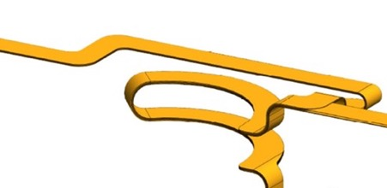
Figure 2. Basic Configuration of H4 Six-Ribbon Harness
The circular part of the harness is folded over to create the omega configuration
(forming about a 1-inch radius) and is dynamically flexed by rotating around
the circular portion’s center axis.
For the life test, all traces in the harness were daisy-chained so the combined direct current (DC) resistance could be monitored while the harness was flexed in a fixture simulating movement over the instrument’s azimuth range. Prior to start of the life test, individual traces measured well below 8Ω using a digital resistance meter. The test fixture with the installed harness had a flex harness bend radius of about one inch to approximate the flight hardware configuration. The six stacked ribbons, attached at the top and bottom of the fixture, were free to move. Fixture rotation was at 7.5 degrees per second (deg/s) for an arc rotation of -125 to +125 degrees (a total of 250 degrees). The actual time for a full cycle of motion was 53 seconds ± 1 second, as measured using video recordings of the test. For calculation of the test duration, the assessment team assumed that the time per cycle being used for the CPF article was the same. One cycle per 53 seconds is 68 cycles per hour, or 1,630 per day, or 11,411 per week. Testing to 3,000 cycles would take 44.2 hours, or 1.84 days. Testing to 30,000 requirement cycles would take 18.4 days, or 2.62 weeks. After 10% of planned cycles for the life test (an estimated 3,000 cycles), the prime contractor discovered a controlled impedance signal path exhibited a variable high resistance in ribbon H420. The prime contractor was able to locate the high-resistance trace within about an inch of the ribbon’s omega flex portion. No trace cracks or breaks could be located using X-ray inspection, so the test continued. As the life test progressed, additional traces and ribbons developed variable high resistances in the high kilohm (kΩ) range. The test was finally terminated at about 15,000 cycles; at this point most traces that initially exhibited variable resistances were now above 100 kΩ or higher. The prime contractor was unable to locate failures along trace lengths via manipulating and monitoring resistance. The life test was reportedly conducted at ambient lab conditions of pressure and temperature. A description of the H4 ribbons is given in Table 1, which also shows which ribbons and trace widths exhibited high resistance after the life test was terminated. The 7- and 13-mil copper traces showed a consistent failure pattern, where the 100 Ω controlled impedance traces (7 mil, 1-ounce copper) were the first group to fail and the 78 Ω controlled impedance traces (13 mil, 1-ounce copper) were the second. None of the larger power traces failed (110 and 200 mils). The location of failures was determined to within one inch, but X-ray inspection located no visible physical root cause failure. The prime contractor also conducted a dynamic flex life test on a single ribbon (H320) from an H3 harness to determine if a single ribbon would also develop trace failures. Multiple high-resistance trace failures were detected at 19,000 cycles, which was considerably longer than the six-ribbon harness life (3,000 cycles), but still well below the 30,000-cycle life test requirement.
The assessment team began its analysis by locating the damaged copper trace zones to study the physical root cause of the damaging stresses and strains. The cyclic strains likely nucleated a small crack, or multiple small cracks, at microstructurally sized defects. The cracks propagated roughly perpendicular to the length of the trace, likely following the maximum principal stress/strain direction.
The magnitude of crack influence on the DC resistance of a trace is relatively small. A crack that has grown almost entirely across the trace will make a barely perceptible increase in DC resistance. A crack will disrupt the electrical current distribution near the crack, over a distance roughly the width of the trace. The copper trace for ribbon H420 was 7 mils wide and more than 50 inches long. Thus, a crack that would increase the resistance in the crack zone by an order of magnitude (10) would increase the resistance of the entire trace by only 0.13% (10x0.007 in/50 in). This level of resistance change would be undetectable to most monitoring systems. The crack likely became perceptible to the life-test DC resistance measurement only when it extended almost completely across the trace.
A partial crack (e.g., one extending less than 25% across the width of the trace) may have no perceptible eﬀect on DC resistance, but it can have an easily perceptible eﬀect on local impedance. Time domain reflectometry (TDR), which measures the pulse reflected from the impedance irregularity, can detect a local impedance change caused by the reflection of a crack. This is a more sensitive crack detection technique than DC resistance, which sums the resistance along the entire trace. The NESC assessment team suggested the prime contractor characterize the life-tested ribbons using TDR. High-impedance regions were successfully located on several high-resistance traces using a TDR on ribbon H430 and marked as shown in Figure 3. All high-impedance areas were located in the dynamically flexed region of the ribbon (see Figure 3). The NESC team used the TDR results to locate suspected copper trace cracks for non-destructive analysis and destructive analysis of failed flex ribbons as part of the root cause analysis. This was followed up with digital imaging correlation and parametric modeling analysis to develop a more robust dynamic flex harness design to extend flex harness life.
Table 1. Harness Ribbon Descriptions and Life-Test Results
Ribbon | Flex Position  at Bend | Trace Width  (mils) | Type | Life Test Failures  (High Resistance  or Open Traces)
H410 | 6 (outer) | 13, 30,  110, 200 | Power and control signals, two circuit trace layers | 2/6 13 mil high R  1/12 30 mil high R  0/4 110 mil high R  0/2 200 mil high R
H420 | 5 | 7 | Digital signals with top layer circuit traces and bottom a mesh shield layer | 20/20 7 mil very high R
H430 | 4 | 13 | Analog signals, top layer circuit traces bottom a mesh shield layer | 6/26 13 mil high R
H421 | 3 | 7, 13 | Digital signals top layer circuit traces and bottom a mesh shield layer | 4/4 7 mil electrical open  4/4 13 mil high R
H461 | 2 | 13 | Analog signals, top layer circuit traces bottom a mesh shield layer | 0/10 13 mil traces failed
H460 | 1 (inner) | 200 | Power signals top layer circuit traces and bottom layer a mesh shield layer | 0/3 200 mil traces failed
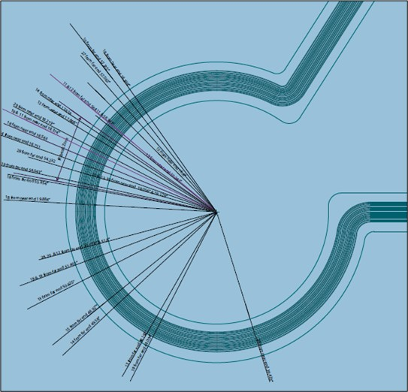
Figure 3. TDR High Impedance Detection Areas for Ribbon H430 in Circular Flex Region
Each line corresponds to a high impedance region on a trace, which was marked so the area
could be cross-sectioned to locate potential cracks.

Nondestructive Evaluation (NDE)
Several NDE methods were used to confirm the location of the breaks in the H410 harness, shown in Figure 4. Thermal analysis was used to precisely locate areas with incipient cracking. Once the defects were located, it was then possible to perform high-resolution computed tomography (CT) on cutout sections of the harness to examine the microcracking and trace thickness. Finally, the CT thickness mappings were used to validated trace thickness measurements to standard digital radiographic (DR) inspection, allowing full inspection of the complete flex harness in a timely manner.
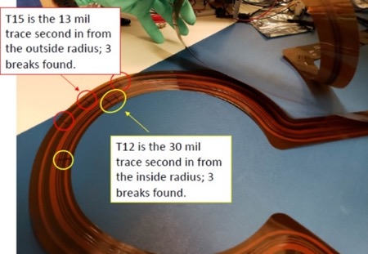
Figure 4. As-received H410 Harness with Incipient Cracking Marked
Infrared cameras are sensitive to temperature changes of hundredths of a degree Kelvin. A small amount of pulsed current was passed through the traces to create localized heating at the locations of incipient cracking.
The current was applied in 5V, 200 mA square wave pulses of 50% duty cycle; heating was observed to 10s.
This provided an accurate location of the cracking for CT analysis.
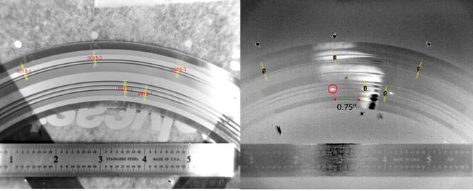
Figure 5. Heating of Incipient Cracks in H410 Harness for Trace 12
Left photo shows image in visible light; right shows infrared image (heating areas red circle (high resistance) are bright regions). The dark spots and white areas outside of the red circle are artifacts from the imaging process.
Using the locations found via thermal inspection, smaller cutout samples were removed for microfocus CT inspection. This allowed the full internal structure of the sample to be examined in post-processing, as shown in Figure 6. These 3D images illustrated that many of the cracks had grown completely through the trace and that cracking was pervasive, even in traces that were still able to conduct. Examination of the volumetric cross-slices revealed that the traces were not the same thickness, as shown in Figure 7, although the prime contractor reported the nominal thickness of all the traces should be 1.4 mils. This explained the variation in X-ray opacity observed in the direct radiographic analysis. Measurements of trace width and thickness were performed and are listed in Table 2. Similar results were found for traces 15 and 16, as shown in Figure 8 and Table 3. Cracking and thickness variation were checked for on a circular sample extracted from the same trace as the one that cracked, but results fell outside the omega region, as shown in Figure 9 and Table 4. The CT data revealed the thickness of traces 9 and 11 in the H410 harness omega region was almost twice that of the nominal trace thickness outside the region. Traces 10 and 12 were about 25% thicker outside the omega region.
Figure 6. CT Image of Apparent Cracks (arrows) in Trace 12

Figure 7. Volumetric Cross-Section of Traces 9, 10, 11, and 12
Note that traces on top layer are thicker than bottom layer, as reported in Table 2.
Table 2. H410 Measured Thickness and Width of Traces 9-11, Omega Region
Trace # | Nominal Thickness | Nominal Width
TR12 | 0.028 mm (1.102 mils) | 0.743 mm (29.252 mils)
TR10 | 0.028 mm (1.102 mils) | 0.739 mm (29.094 mils)
TR09 | 0.065 mm (2.480 mils) | 0.762 mm (30 mils)
TR11 | 0.063 mm (2.559 mils) | 0.69 mm (27.165 mils)
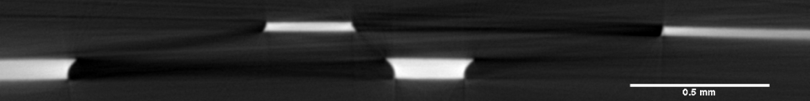
Figure 8. Volumetric Cross-Section of Traces 15 and 16, in Omega Region
Note that traces on bottom layer are thicker than top layer, as reported in Table 3
Table 3. Measured Thickness and Width of Traces 15 and 16, in Omega Region
Trace # | Nominal Thickness: | Nominal Width:
TR16 | 0.037mm (1.457 mils) | 0.312 mm (12.283 mils)
TR15 | 0.074mm (2.913 mils) | 0.739 mm (12.008 mils)

Figure 9. Volumetric Cross-section of Traces 9, 10, 11, and 12, Outside Omega Region
Note that traces on bottom and top layers are same thickness, as reported in Table 4
Table 4. Measured Thickness & Width of Traces 9 -11, Outside Omega Region
Trace # | Nominal Thickness: | Nominal Width:
TR12 | 0.037mm (1.457 mils) | 0.73mm (28.74 mils)
TR11 | 0.034mm (1.339 mils) | 0.72mm (28.35 mils)
TR 10 | 0.037mm (1.457 mils) | 0.76mm (29.92 mils)
TR09 | 0.032mm (1.260 mils) | 0.73mm (28.74 mils)
The H410 harness was placed on a large sheet of Plexiglas, which is mostly X-ray transparent but can cause some scattering. The fixture was then placed in the large-volume CT system for inspection, as shown in Figure 10. The initial inspection did not show that this X-ray setup could image cracking on the harness, as shown in Figure 11. This inspection found that traces of equal thickness had different grayscale contrast, indicating different levels of X-ray absorption. High-magnification images were taken, as shown in Figure 12, showing the different X-ray absorption levels. Note the darker image of the trace layer in the right image, compared with the left.
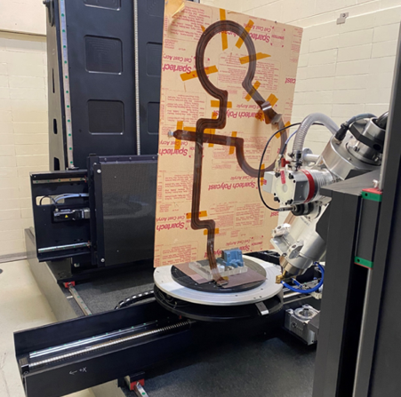
Figure 10. H410 Harness on Plexiglas in Large-Volume CT System
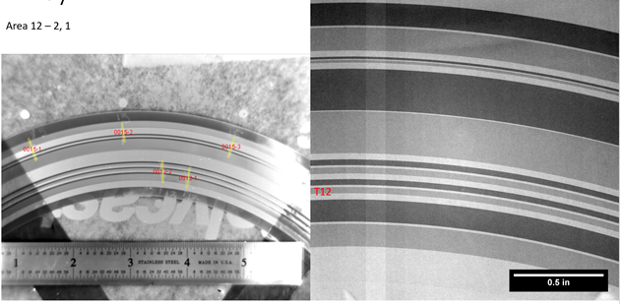
Figure 11. X-Ray Results for As-Received H410 Harness at 5x Magnification
Left image in visible light; right side is X-ray image.
The thickness measurements described in Figures 7, 8, and 9 indicated that the X-ray opacity contrast correlated directly with trace thickness. Trace thickness variation was characterized for the entire H410. Twenty radiograms were stitched together to form an X-ray map of the harness, as shown in Figure 13. This radiographic map showed that most of the thickness variation occurred in the omega region.
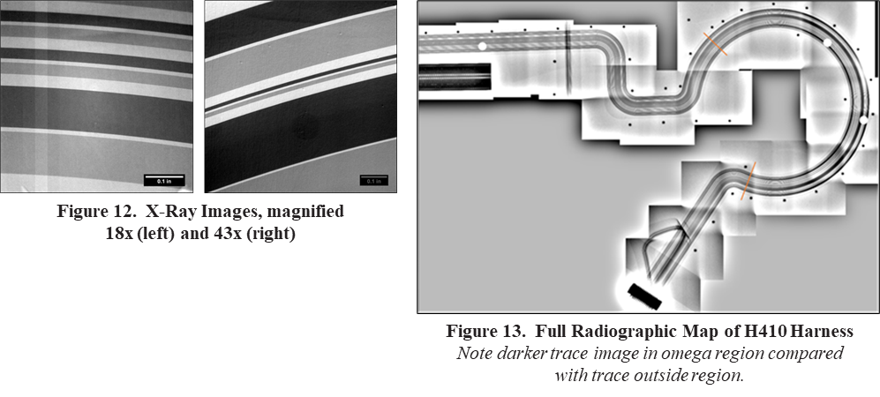
Through the NDE, it was possible to show that using several techniques to locate and characterize the harness sections in detail allows us to validate the use of regular DR for full thickness mapping of flex harness assemblies.

Destructive Physical Analysis (DPA)
A full-scale map of TDR results for the H430 ribbon identified trace discontinuities aided in selecting sampling locations for metallographic analysis (see Figure 3). This H430 ribbon is the Azimuth Feedthrough Analog interface and has one layer of 13-mil transmission lines and one mesh shield layer. Before destructive physical analysis was performed, an optical inspection of the ribbon was conducted using a Leica M125C stereomicroscope and a Keyence VHX-5000 digital microscope. The optical inspection of the traces in the omega bend region showed no obvious cracks or discoloration on the surface.
Three samples with high trace resistances were cut from the H430 ribbon with copper traces laminated between Kapton film, using sharp scissors, mounted in cold-setting epoxy, and metallographically prepared. Sample 1 was extracted from outside the omega bend region, where no TDR indications exist, to serve as a control sample. Sample 2 was taken from within the omega bend region and cross-sectioned transverse to the trace orientation. Sample 3 was also removed from within the omega bend region, but was cross-sectioned longitudinal to the trace orientation so a “side view” of the traces could be observed. The prepared samples were inspected optically with a MA200 Nikon metallograph before and after etching with ASTM No. 30. Scanning electron microscopy (SEM) and energy dispersive spectroscopy (EDS) were performed with a TESCAN MIRA3 scanning electron microscope outfitted with an Oxford Instruments AZtec energy dispersive X-ray spectrometer. The electron beam accelerating voltages for electron imaging and X-ray acquisition was 20 kV.
Metallographic inspection of Sample 1 (outside the omega bend region) in as-polished condition showed no cracks but revealed an unexpectedly thick shielding, as shown in Figure 15. Sample 2 (inside the omega bend region) showed no cracks and nominal layer widths and thicknesses, as shown in Figure 14. The design indicated that the shielding was a single layer of one-ounce copper (1.4 mil). However, measuring the shielding thickness within the omega bend region correlated to two-ounce copper (2.8 mil). Etching Sample 2 revealed the presence of trace cracks that were not visible in the as-polished condition, as shown in Figure 16. The etched sample also showed that the shielding within the omega bend region was composed of two distinct copper layers with different microstructures, as shown in Figure 17. The inner layer (closer to the neutral axis) was annealed copper with discrete copper oxide inclusions, similar in appearance to the trace layer microstructure. The outer layer (farther from the neutral axis) appeared to have been electrodeposited and showed a much finer grain structure than the trace layer and a lack of copper oxide inclusions. Etching followed by a light polish was determined to be the best way to observe cracks in cross-section. The etchant preferentially attacked the cracks, making them easier to identify, but eroded the crack faces, exaggerating the crack opening, as shown in Figure 18. A light polish after etching maintained the detectability of the cracks, but did not erode the crack faces as severely, as shown in Figure 19. Metallographic inspection of Sample 3 (from within the omega bend region) identified cracking above the shielding aperture (i.e., above the square openings created by the shielding mesh pattern), as shown in Figure 20. The cracking followed a predominantly intergranular path along high-angle grain boundaries (Figure 21) and was often highly branched. However, additional methods, such as electron backscatter diffraction (EBSD), have not been performed to prove that this is the case. Grain boundaries and copper oxide inclusions (dark spots in the images shown in the figures below) appeared to have deflected the crack tip during propagation. No evidence of stress corrosion cracking (SCC) was observed. However, a surface inspection of the copper traces would be required to conclusively determine if corrosion played a role in the crack initiation process.
Cross-sections of the H430 ribbon show the traces are composed of a high-purity copper matrix in an annealed condition with discrete copper oxide inclusions (Figures 22 and 23). The spectra shown in Figure 23 represent spot X-ray analysis of the locations indicated in Figure 22. The X-ray spectrum for the inclusion showed peaks for copper and oxygen indicative of copper oxide, while the X-ray spectrum for the spot away from the inclusions showed only copper peaks from the high-purity copper matrix. Peaks for gold were due to sputter coating the sample for charge dissipation and not associated with the sample.
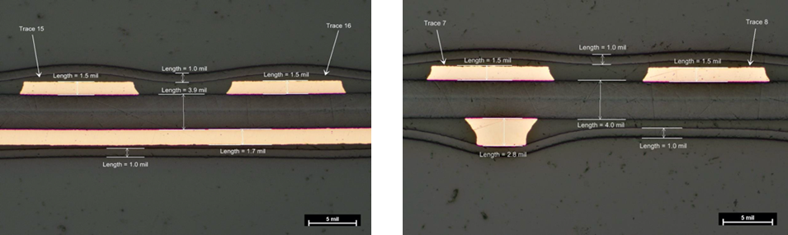
Figure 14. Nominal Layer Dimensions, Sample 1, Figure 15. Unexpectedly Thick Shielding, Sample 2,
As-Polished, Optical Microscope, 5-mil Scale Marker As-Polished, Optical Microscope, 5-mil Scale Marker
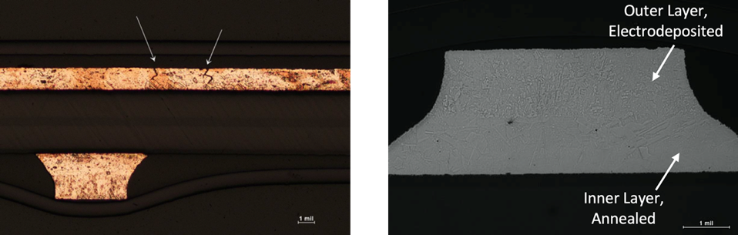
Figure 16. Trace Cracks, Sample 2, ASTM No. 30 Figure 17. Shielding Microstructure, Sample 2,
Etch, Optical Microscope, 1-mil Scale Marker ASTM No. 30 Etch, Greyscale Image,
Optical Microscope, 1-mil Scale Marker
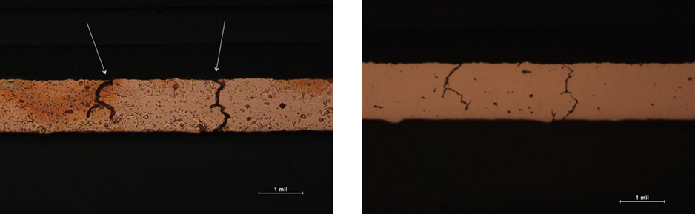
Figure 18. Etched Cracks, Sample 2, Figure 19. Polished Cracks, Sample 2,
ASTM No. 30 Etch, Optical Microscope ASTM No. 30 Etch then Polish,
1-mil Scale Marker Optical Microscope 1-mil Scale Marker
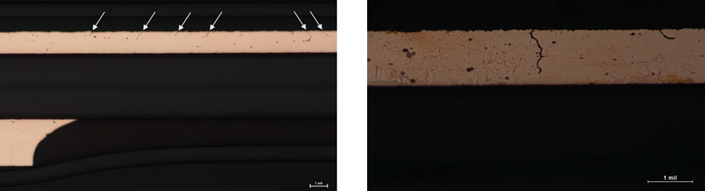
Figure 20. Cracks Above Shielding Aperture, Figure 21. Cracking Follows Intergranular Path
Sample 3, ASTM No. 30 Etch then Polish, Along High-angle Grain Boundaries
Optical Microscope, 1-mil Scale Marker Sample 3, ASTM No. 30 Etch then Polish
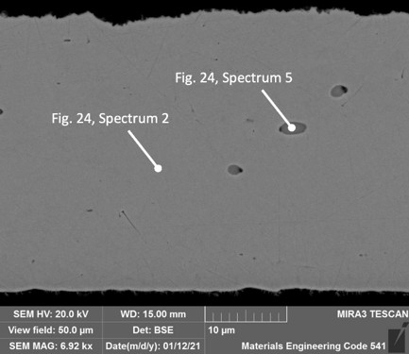
Figure 22. Trace Composition, SEM, Scale Marker = 10 µm
The pointers indicate the locations for spot X-ray analysis. See Figure 24.
Figure 23. X-ray Spectra, Spot Away from Copper Oxide Inclusion (Spectrum 2, Gray)
and Spot on Copper Oxide Inclusion (Spectrum 5, Red)

Destructive Physical Analysis (DPA) + Nondestructive Evaluation (NDE)
Metallographic measurements of the shielding thickness in the omega bend region were performed to independently confirm the radiographic thickness measurements. The thickness difference between the measurement techniques (Figure 24) was far less than the actual thickness difference between the traces inside and outside the omega region. This suggests that radiography could be a nondestructive technique for screening out-of-tolerance layer thicknesses in subsequent ribbon builds.
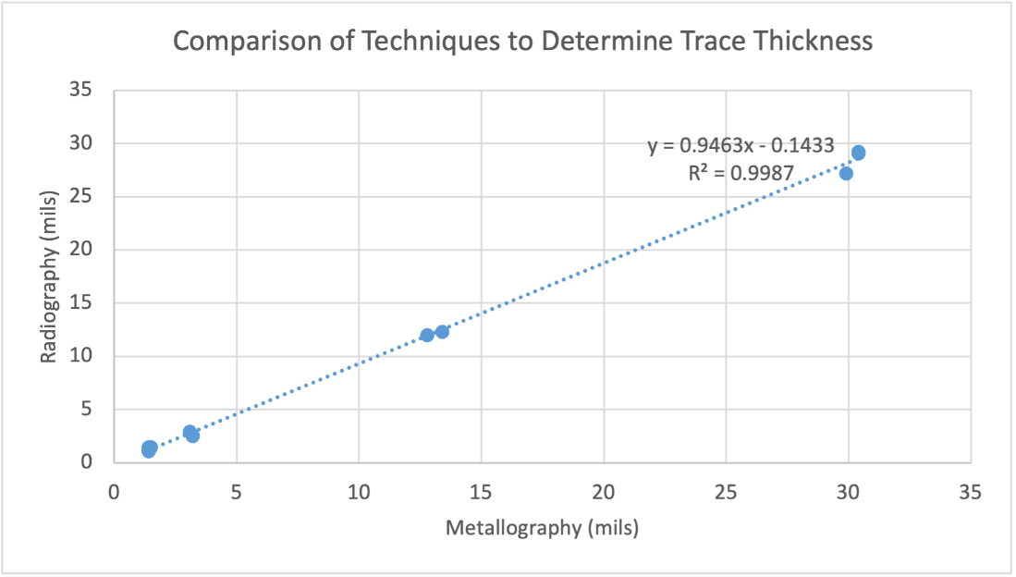
Figure 24. Scatter Plot Comparing Trace Thickness Measurement Techniques for Sample 1

Digital Image Correlation (DIC) Measurements
The Omega shaped region of flex ribbons were tested with a simulator that replicated the operational ribbon curvature. Both sides of the ribbon were characterized with digital image correlation (DIC) [1-2] systems to measure the local strain in the curvature region of two ribbons, H320 and H410. The life-tested and failed H410 was identified as the Azimuth Feedthrough Power Flex interface and has two copper trace layers with patterned traces of 13, 30, 110, and 200 mils in width. While the single ribbon life tested and failed H320 was identified as the Elevation Feedthrough Digital Flex interface with one layer of transmission lines (7 mils) and one mesh shield layer. Maximum and minimum principal strains were measured, as well as the local curvature. The following sections describe the DIC technique, the test fixture and setup, and DIC measurements.
DIC [1-2] is a non-contacting technique that uses stereo imaging (i.e., two cameras) to characterize and produce three-dimensional displacement fields. The digital cameras are oriented about 30 degrees apart and focused on the same area. The surface of the structure to be measured is painted with a high-contrast random speckle pattern (i.e., white base coat and black speckles), as shown in Figure 25. The displacements are determined from changes in the speckle pattern from an undeformed image to a deformed image. The DIC method captures both rigid body motions and distortions due to the surface strains. A Cartesian coordinate system (x, y, z) is defined, and pattern recognition over small regions, called subsets, is used to determine the corresponding displacements (u, v, w). Three-dimensional strain fields can be determined from the spatial derivatives of the displacements, and velocity and accelerations can be determined from the temporal derivatives of the displacements.
The curvature of the ribbon was simulated using a 3D printed test fixture that consisted of two rotating disks and a gear mechanism that rotated the disks in opposite directions, as shown in Figure 26. The ribbon was attached to both disks, and the region of curvature maintained a constant location relative to the cameras. The ribbon was advanced, and the disks rotated, exposing different regions to the cameras. Pairs of cameras were placed on opposite sides of the ribbon curvature region to characterize both the tensile and compressive behavior. The spatial resolution of the camera setup was about 1000 pixels/inch. This resulted in a displacement resolution of at least 0.0003 inches. The strain resolution was ±100 microstrain. Undeformed images were captured for both sides of the ribbon since both the compressive and tensile side of the ribbon were characterized in the tests. The DIC displacement measurements were used to calculate the maximum and minimum principal strains and the local curvature. The maximum local curvature allowed identification of the copper traces on the tension side, and the minimum local curvature did the same on the compressive side, as shown in Figure 27. The curvature of the ribbon was obtained from the opposite local curvature measurement (i.e., minimum local curvature for the tension side and maximum local curvature for the compression side). The principal strain directions were in the direction of the copper traces in the region of maximum curvature of the ribbon. An example of the principal strains is shown in the figure. The strains have a peak at the center of the curvature on both the tension and compression sides.
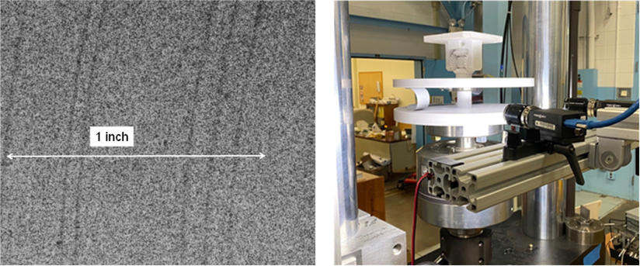
Figure 25. Speckle Pattern Used for Ribbons; Dark Lines are Copper Traces | Figure 26. Ribbon Testing Setup
Figure 27. Principal Strains on Tension and Compression Sides of Ribbon
The DIC measurements were used to obtain peak tensile and compressive strains at the region of maximum curvature at about every 0.8 inches of the Omega region of the H320 and H410 ribbons. The strain (ɛ) at the surface of a thin sheet, an approximation for the ribbon, can be expressed as a function of the thickness (t) and radius (r).
The measured thickness of the ribbons was about 0.014 inches.
e = t/2r (Eq. 1)
The DIC measurements indicated the measured curvature diameter of the ribbon varied between 1.6 and 1.8 inches for the H320 ribbon and between about 1.3 and 1.7 inches for the H410 ribbon. It was not determined if the variation in curvature was inherent in the ribbon or a result of the ribbon moving in the test fixture (note: the H320 ribbon was the second one tested, and may have experienced less curvature variation due to the operator becoming more familiar with the test setup). The maximum measured strain was inversely related to the measured curvature of the ribbon, in agreement with Equation 1, as shown in Figure 28. The dashed lines in the figure represent the theoretical strain measurements from Equation 1 for two thicknesses.
Figure 28. DIC Strain measurements as Function of Measured Ribbon Curvature

Modeling
The NESC engaged a NASA modeling group to analyze the stresses and strains imparted on flex ribbon copper traces as they were deformed through multiple cycles. Model evaluations focused on: (1) the effect of single-sided (one copper layer through the thickness) vs. double-sided (two copper layers through the thickness); (2) the effect of copper thickness; and (3) the effect of the copper properties (rolled and annealed vs. rolled and heavily annealed).

Modeling: Analysis Method
Finite element models (FEM) were developed to evaluate the strains observed for each layer of an omega flex harness ribbon. As the layered omega ribbons exhibit a certain amount of stiffness, an end bending moment or torque must be applied to produce the required fold to study the strain levels in the outer Kapton and inner copper layers. Modeling the bend of the omega ribbon into a fold as observed is numerically challenging; the severity of geometric non-linearity and large rotation present must be accounted for in the analysis. Alternatively, the fold in the ribbon and the large rotation leading up to the fold can be understood by a simplified multilayered 3D slender ribbon model. A symmetry plane can be observed, making it possible to model only half the ribbon if the influence of gravity is ignored, as shown in Figure 29. The process of folding that occurs within the ribbon’s omega region can be simulated by keeping one end fixed and bending the opposite end. The desired radius of curvature can be achieved through the amount of bending applied, and the strain levels in the ribbon layers can be characterized. Abaqus/CAE [3] software was used to generate the required finite element model. Each layer was modeled separately as an individual part and combined for the ribbon assembly. Abaqus/CAE element type C3D8R, with reduced integration option, was adopted throughout the analyses. Appropriate boundary conditions were applied to ensure that the layered ribbon was folded during geometric non-linear analyses. Material type and properties were assigned for each layer in the analyses. Corresponding to desired radius of curvature, the strain levels in Kapton and copper layers were extracted from the simulation output database for all design configurations and evaluated for improving/recommending ribbon design for future applications.
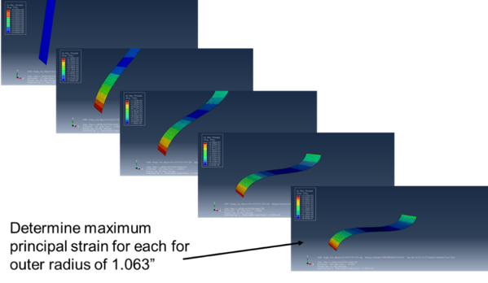
Figure 29. Various Stages of FEM Under Deformation
The ribbon fold and the large rotation leading to the fold are shown as a simplified 3D multilayered slender ribbon model. The desired ribbon curvature radius can be achieved by the amount of bending applied before strain level calculation.
Red correlates with the maximum principal strain and other colors with less strain, as shown in table at upper right.

Modeling: Limitations and Special Techniques
The FEM included no individual copper traces. Instead, each model layer was continuous, and therefore local strain variations along the outer (ribbon width dimension) edges of the copper traces were not evaluated. Additionally, the mesh used for each FEM was only one element thick for each ribbon layer. Consequently, the strain values generated from this analysis represent an average through the thickness strain for each layer. Mesh refinement would result in larger strain values along the outermost surface (thickness dimension) of the copper traces. However, to evaluate these near surface values, the complex interface (copper to adhesive) would have to be modeled accurately and validated experimentally.
The deformations in most engineering problems are small relative to the original geometry, so deviations are not perceptible. The small error introduced by ignoring the deformations in these cases does not warrant the added mathematical complexity generated by a more sophisticated theory. These analyses are performed with assumptions of geometric linearity. However, there are special conditions where the deformation cannot be ignored, and the analysis of the ribbon is one such case. The ribbon tip deflections are large relative to the ribbon thickness and shape, hence the stiffness changes during fold development. Large deflections and rotations are expected to have a significant effect on ribbon deformation. Thus, the effects of geometric nonlinearity and large rotation must be included in the analyses. Accounting for geometric nonlinearity and large rotation allowed the strains in individual ribbon layers to be evaluated for design configuration alternatives. The modeling analysis is therefore valid only for showing relative strains between design options, not for determining the actual strains in omega flex harness copper traces.
Analyses were performed for single- and double-sided design configurations, as shown in Figure 30. Three basic configurations were analyzed for varying thickness of the copper, Kapton, and adhesive layers as well as the copper material properties. The ribbon configuration (i.e., single- vs. double-sided) had the greatest influence on the strains. The predicted strain in the copper layers was significantly less (approximately 17X) for the single-sided than for the double-sided configuration, as shown in Table 4. Copper thickness (Table 5) and properties (Table 6) were also observed to affect the strain level; however, the magnitude of these effects is relatively small compared to those observed for the ribbon configuration. Fatigue analysis was not performed for the copper traces. However, by examining typical fatigue life data for annealed copper films [4], it is expected that the large strain reduction observed in the copper layer by changing from a double-sided to a single-sided configuration will result in a large increase in fatigue life (> 100X).
Figure 30. Proposed Redesigns for Single- and Double-sided Configurations
Thickness numbers provided are baseline values
Table 4. Maximum Principal Strain (Micro-strain) Observed in Outer Kapton
and Copper Layers for Single- and Double-sided Configurations
Configuration | Outer Kapton Layer | Outer Copper Layer
Single-sided | 2853 | 120
Double-sided | 4634 | 2054
Note: In each case, the copper layer was 0.7 mil thick
Table 5. Maximum Principal Strain (Microstrain) Observed in Outer Kapton and Copper Layers
for Single- and Double-sided Configurations for Two Thicknesses of Copper Layer
Configuration | 0.7 mil copper |  | 1.4 mil copper
Configuration | Outer Kapton Layer | Outer Copper Layer | Outer Kapton Layer | Outer Copper  Layer
Single-sided | 2853 | 120 | 3497 | 50
Double-sided | 4634 | 2054 | 5594 | 3082
Table 6. Maximum Principal Strain (Microstrain) Observed in Outer Kapton and Copper Layers
for Single- and Double-sided Configurations for Two 0.7-mil Copper Materials (Rolled Annealed (RA)
and Rolled and Heavily Annealed (RHA)). Elastic modulus ( E ) is provided for each annealing condition.
Configuration | RA copper (E=85 GPa) |  | RHA copper (E=70 GPa)
Configuration | Outer Kapton Layer | Outer Copper Layer | Outer Kapton  Layer | Outer Copper  Layer
Single-sided | 2853 | 120 | 2843 | 100
Double-sided | 4634 | 2054 | 4625 | 1972

Summary of Modeling Findings
A single-sided ribbon configuration results in the lowest maximum principal strain in the copper. There was a large strain reduction in the copper layer when changing from the existing double-sided configuration to a new single-sided one; a large increase in fatigue life would therefore be expected (>100X). Model changes in copper thickness and fatigue properties affected the strain level; however, the magnitude of these effects is relatively small compared to the large strain level reduction when comparing double-sided and single-sided ribbons. A double-sided configuration with no adhesive has the highest maximum principal strain in the outer copper layer. An asymmetric double-sided ribbon (1.4-mil and 2.8-mil copper layers) has higher maximum principal strain values in copper layers compared with a symmetric ribbon. The failed ribbons examined with NDE and DPA were all asymmetric. The copper trace layer was approximately 1.4 mils, and the shield layer was 2.4 mils, which led to fatigue cracking in the trace layer.

Collaborative Review on Dynamically Flexed Harnesses
As the investigation team continued collaborations with the developer, fabricators, and others, and as the value of a multidisciplinary approach to failure became evident, the team established a theory of probable cause and developed an action plan to substantiate the theories being considered. An evaluation of technical literature [4, 5] led to a technical exchange with Sandia National Laboratories (SNL) to review the lessons learned from their experience with a space-certified flex cable application. Subsequent discussions with SNL shed light on the test requirements, and end-use space environments, use conditions, and manufacturer maturity were discussed. It became evident that several areas of commonality existed between the design in the SNL paper [4, 5] and the current investigation. Not only was the importance of modeling and analysis effort highlighted, but the range of effectiveness of such efforts was reiterated by the SNL team. The team highlighted the importance of cable stacking and the resulting twisting forces as the omega configuration tries to relieve stress. The team discussed the copper requirements under high cycle fatigue—half-ounce copper or two-ounce copper—the SNL redesign used two-ounce copper because of current requirements. The design also used a wire mesh shield, which was very stiff because of the electromagnetic interference (EMI) requirement.

Physical Root Cause Analysis
The DPA, NDE, DIC, and modeling analyses all support the physical root cause of the life-test flex harness failure as the result of dynamic flexing during the test, which exceeded copper trace fatigue strength. All 7-mil traces and many 13-mil traces had high resistance failures after the life test. There were no failures in 200- and 110-mil traces and only one high-resistance failure in a 30-mil trace. Use of a double-sided flex ribbon and 7-mil and 13-mil traces in a dynamic flex environment resulted in cracking and eventual circuit failure during the life test.
Failed ribbons that were examined with NDE and DPA had copper traces outside the neutral plane that were also asymmetric. The copper trace layer was approximately 1.4 mils, and the shield layer was 2.4 mils. Modeling analysis shows the asymmetric design of the flex harness in the omega (flex) region resulted in increased strain in the copper traces. A discussion with Sandia Laboratory indicated an omega flex harness design for a dynamic flex environment should primarily use single-sided flex ribbons with the copper traces in a neutral area to maximize copper trace fatigue life.
A mesh shield layer above the trace layer further accentuated stresses on the traces. This condition created an I-beam condition, which violates IPC design rules, where copper is directly under another trace (Figures 31 and 32). Additional observed plating was not in the flex circuit drawings, and the flex circuit vendor did not expect the 2.8-mil copper to be present in the shielding. I-beam conditions would be eliminated by using a single-sided ribbon design and removing the shield from the ribbons. After reviewing the electrical requirements, the prime contractor determined most shielding and use of transmission lines could be eliminated, greatly simplifying the flex harness design.
Figure 31. Condition Where Copper is Directly Under Another Trace
When designing 2-layer flex circuits, stagger front and back traces to avoid an I-beam configuration.
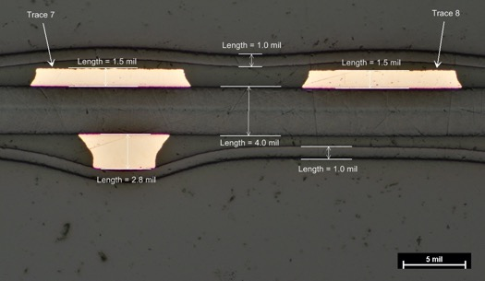
Figure 32. Cross-section Showing Trace Directly Below Shield

Cable Design Recommendations to Extend Flex Harness Life
The following design recommendations for extending the flex harness life were developed as a result of the NDE, DPA, DIC, parametric modeling:

Eliminating Controlled Impedance Traces
EMI shielding and controlled impedances for uniform transmission line purposes are typically required for digital data circuit paths, but both create mechanical reliability challenges when implemented into a thin polymeric flex tape cable assembly. The addition of the extra copper layer in the flex tape cross section stack-up results in an asymmetric cross-section that increases cyclic stresses when the flex tape is mechanically cycled. The reliability is reduced for this type of cable design when compared with single-layer copper counterparts. The prime contractor confirmed that transmission lines are not needed to meet digital communication requirements.

Single-Sided Copper Ribbons with Copper Close to the Neutral Plane
The current flex cable design is not mechanically symmetric thru the cable cross section. Moreover, the additional layers of copper in the stack up for grounding, shielding, and impedance matching move the signal traces out of the neutral plane. A single-sided flex ribbon with the copper signal traces in the neutral plane is the ideal location to minimize stresses and strains in ribbon when dynamically flexed in an omega configuration (see modeling section). This minimizes the stress magnitude and creates equal compressive and tensile stresses on the copper surface material, reducing the likelihood of cracks forming and then traveling thru the entire copper width/cross-section. There are trade-offs between using half-ounce or one-ounce copper. Trace size also needs to consider voltage drop and the current rating requirements.

More Highly Annealed Rolled Copper
The observations from the various NDE methods, construction analysis, and strain tests, lead to the conclusion that a more fatigue resistant copper is needed for the new design. While the mechanical design can be improved, the material properties also need modification to support the gravitational cable weight and relieve rotational cross-axis stress while the multiple cable(s) in the assembly rotate. Therefore, a more highly annealed and higher elongation copper than was used in the original design was recommended for the redesigned harness.

Wider Copper Traces
During the investigation, it was observed that various copper widths, ranging from 7 mils to 13 mils, were used in a dynamic flex application. All 7-mil traces failed, and many 13-mil traces failed in the flex life test. Trace selections were driven by use of controlled impedance transmission line requirements rather than mechanical robustness. One of the 12 30-mil traces also failed in the life test, but no 110- or 200-mil traces failed. This suggests cracks will take longer to bridge wider traces under dynamic flexing than thinner ones (i.e., wider traces would have lower stresses and take longer to develop cracks than thinner traces). For dynamic flex applications, mechanical robustness is a critical design requirement.

Limiting Maximum Strain Levels for Dynamic Flex Application
The maximum strain level from the Sandia paper for a dynamic flex application is 0.3% (a microstrain of 3,000). Modeling analysis calculated maximum principal microstrain levels above 3,000 (outer copper layer) for the double-sided ribbon design that failed the life test. Modeling analysis of the new single-sided ribbon design gave a maximum microstrain level of 120 for the outer copper layer (see Table 5).

Industry and Government Flex Circuit Design Handbooks Best Practices
A number of publicly available flex circuit design handbooks provide best practices for designing a flex ribbon in a dynamic flex environment. A high-level list of design considerations follows:
- For dynamic flexing applications, tensile strength is more important than ductility.
- Flex life in excess of 1,000,000 cycles is attainable. Use phenol butyral as the adhesive in such applications.
- For dynamic flex applications, the radius should be 100X the ribbon thickness.
- For traces in dynamic flex applications, use rolled and annealed copper with greater than 99% purity. Use copper of varying hardness or beryllium copper to increase fatigue life.
- For dynamic flex applications, use TEFLON FEP as the adhesive.
- Conductors should run perpendicular in the flex area.
- For dynamic flexing applications, one-ounce or half-ounce copper is the best metal thickness.
- Use uniform dielectric layers, top and bottom.
- Add inner layer shields to increase the bend radius and reduce flexibility.
- Evenly spaced conductors will provide maximum flex life.
- For dynamic flexing applications use an “adhesiveless” flexible metal-clad laminate.
- Avoid “I-beaming” copper traces, a condition where copper is directly under another trace.

PDR Process
As stated in the NASA Systems Engineering Handbook (NASA SP-2016-6105), “The Preliminary Design Review (PDR) demonstrates that the preliminary design meets all system requirements with acceptable risk and within the cost and schedule constraints and establishes the basis for proceeding with detailed design.” For this effort, a functional baseline with an agreed-upon description of the attributes of the flight-critical flex harness cable was not clearly identified. The drawings should be adequate for defining requirements for the flex harness to include, but not be limited to, material selection, thickness requirements for manufactured ribbon (e.g., copper, adhesive, and substrate) in and out of the omega region, and the IPC 2223 dynamic flex requirements for testing. Use of X-ray imaging to verify that flex ribbon trace thickness is consistent with the requirement is also recommended. Ultimately, a full review of the final flex harness drawings by engineering and parts subject matter experts (SMEs) is recommended. As part of the manufacturing review, the reviewers should ensure the printed wiring board coupon design captures the flex ribbon trace qualities. Lastly, it is recommended to require independent coupon evaluation with photo documentation and best case request a second cable for dynamic digital image correlation (DIC) to characterize the harness performance.

Manufacturing requirements identification
As a result of the preceding analytical and experimental techniques, such as NDE, DPA, DIC, and parametric modeling, completed during the assessment, along with the consultation from the internal and external SMEs, manufacturing requirements identification was performed for the purpose of statement of work (SOW) additions to improve flex harness design; enhance manufacturing, reliability and quality; and extend flex harness life for the new cable design. These SOW additions are listed in the subsequent subsections.

IPC 2223 Dynamic Flex Requirements
IPC Standard 2223E, Sectional Design Standard for Flexible/Rigid-Flexible Printed Boards, is designed for use in conjunction with IPC-2221, Generic Standard on Printed Board Design. It establishes specific requirements for the design and interconnecting structures of flex circuits. The flexible materials used in the structures include insulating films, reinforced dielectric, non-reinforced dielectric, and metallic materials. These interconnecting flex cables may contain single-layer, double-layer, multilayer, or multiple conductive layers. Interconnecting boards can be composed entirely of flex circuits or a combination of flexible and rigid circuits. IPC-2223E includes updated design rules for panel sizes, hole-spacing, bend radii, shielding, palletization, nonfunctional lands, and coverlayer access/spacing.

Full Disclosure of Ribbon Materials
Material type and construction is extremely important in designing flexible printed boards. Care should be taken in material selection to ensure compatibility with adjacent materials. IPC-2223E Section 4.1, Material Selection, requires full disclosure and documentation of ribbon materials (e.g., copper, adhesive, and substrate). For clarification, cross-sectional views are suggested to highlight material selection. Also, refer to IPC-2223E Section 4.1.1, Materials Options.

As-Received Copper Elongation above 18%
Per IPC-2223E Section 4.3.1.2, Dynamic Flex Applications, copper elongation above 18% is recommended if used in high-flex life-cycle applications. The copper elongation is to be measured in accordance with IPC-TM-650, Method 2.4.18.1. Additional electrolytic plating on the base material surface is not recommended in flexible areas. This suggestion is based on the fact that flexibility is adversely affected by conductor thickness. For dynamic applications, it is important to balance the circuit and coverlayers.

In-Process Monitoring of Elongation Specification
In addition to the time zero (or as-received) elongation specification, in-process monitoring of this property is required. Examples include resistivity or Kelvin test structures to ensure metal thickness after plating operations. Four-point probe resistivity measurements can be performed prior to pattern and etch operations to measure uniformity of metal deposits. Other in-process coupon examples include lithographic resolution structures (e.g., critical dimension measurement vehicles), impedance coupons, elongation/ductility coupons, flexural endurance coupons, and via interconnect strings. Elongation requirements for copper foil rise significantly as bend radii decrease.

Thickness Requirement for Manufactured Ribbons
In-process monitoring examples include resistivity or Kelvin test structures to ensure metal thickness. While a wide range of flexible substrates/films are available, these are provided in a narrow range of relatively thin dimension from 12 μm to 125 μm (0.5 to 5 mils). While experience shows that thinner materials are more flexible, it is worth remembering that stiffness is proportional to the cube of thickness, meaning that if the thickness is doubled, the material becomes eight times stiffer and will deflect only 1/8 as much under the same load. As with the base substrates/films, adhesives come in different thicknesses, commonly used in the creation of coverlayers to meet the fill demands of variable copper foil thickness. Many suppliers have a standard adhesive base laminate thickness, but can alter the material depending on controlled impedance requirements or other customer needs. Thinner adhesives allow for better flexibility, bringing the copper closer to the base film. It is not uncommon to use a particular adhesive thickness to create a coverlayer to meet the fill demands of one type of circuit, while another thickness may be called out for circuits with different copper-foil thicknesses.

Flexible Area Factors
The study also identified factors to consider while redesigning the flexible area and determining the total number of layers required, along with other interrelated considerations. These include quantity of signal conductors required across the flexible portion(s), line widths required for current-carrying capacity, spacing required for voltage isolation, EMI shielding, impedance, voltage drop requirements, and mechanically defined “real estate” for routing conductors (i.e., width of flexible portions).

Minimum Bend Radius and Flexible Endurance
Every flexible circuit design should be thoroughly evaluated to determine if the circuit construction will be able to withstand the bends and forms required by the application. Factors to evaluate include:
- Circuit thickness.
- Bend radius.
- Bend angle.
- Copper type (e.g., RA, ED), thickness, and elongation.
Per section 3.10.13 of IPC-6013D, flexible endurance testing was recommended to be carried out using IPC-TM-650, Method 2.4.3. Flexible endurance testing can also be accomplished with special equipment specific to the circuit application. The outline length of the coupon may be deviated from to accommodate the test method fixture and circuit design. Accordingly, the final configuration of the coupon should be determined with regard for the end product application and by user/supplier agreement. Flexibility endurance test requirements shall be specified in the appropriate document/drawing. Parameters such as the number of flex cycles, diameter of the bend mandrels or separation of the loop-defining plates, flexing rates, points of application, table travel of loop and a method for determining end of life is an electrical discontinuity during monitoring or passing the predetermined number of flex cycles without electrical discontinuity are strongly recommended. An example of the test setup used for a rolling flex test, as shown in Figure 33 [6].
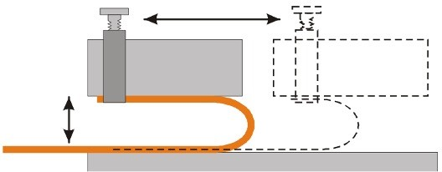
Figure 33. Rolling Flex Test Setup [6]

Independent Coupon Evaluation
The team also recommended independent coupon evaluations on representative coupons that capture the ribbon trace qualities. The objectives are:
- Quality assurance for the flex cables consists of ensuring conformance with baseline manufacturing quality standards, such as IPC-6013 and the corresponding design standards IPC-2221 and IPC-2223. Additional quality and performance criteria should be defined in the PCB drawing notes and project-specific requirement documents. Quality conformance is evaluated through inspections and tests performed on the flex cables that will be used in the space mission as well as on representative samples of those cables (i.e., coupons).
- Process monitoring coupons are critical components in the fabrication of reliable, high-quality flexible cables. These coupons are used for standard process control (SPC), certification of compliance (COC), and reliability or qualification testing. In-process monitoring helps ensure metal thickness after plating operations, four-point probe resistivity measurements prior to pattern/etch operations, and uniformity of metal deposits.
- Other in-process coupon use examples include resolution, impedance, elongation/ductility, flexural endurance, and via interconnects. For example, see IPC-6013D Section 3.10.5, Impedance Testing: “Requirements for impedance shall be specified on the procurement documentation. Impedance testing may be performed on a test coupon or a designated circuit in the production wiring. TDR is used for electrical testing, but for large impedance tolerances (± 10%), mechanical measurements from a microsection utilizing a special test coupon can be used to calculate and verify impedance values.” See IPC-2251 for the equations for calculating impedance from the test coupon and IPC-TM-650 Method 2.5.5.7 for the methodology using the TDR technique.
- It is strongly recommended that all in-process coupons be submitted along with the panels for independent third-party analysis and verification.
- The flex cable vendor should perform acceptance testing to verify quality conformance of each production panel and represented flex cable. Acceptance testing shall be per IPC-6013. The vendor shall conduct thermal shock tests and DPA as specified in the Special Requirements section of the IPC-6013 specification.
- Third-party test coupon structural integrity analysis: In addition to the flex cable vendor’s performance acceptance testing, the vendor should provide adequate coupons for third-party coupon structural integrity testing. suggested requirements for such third-party testing follow:
- General: All submitted flex cable lots shall be evaluated for structural integrity by coupon microsection analysis. This evaluation is in addition to the coupon microsection analysis required by and performed by the flex cable vendor.
- Third-party structural integrity analysis shall be performed by a qualified coupon laboratory that has been evaluated and approved by the Flight mission to perform this testing.
- Structural integrity analysis: The third-party structural lab shall examine microsections in as-received condition in the X+Y dimensional plane and thermally stressed condition in the X+Y+Z dimensional plane.
- Microsections shall be prepared per IPC-TM-650 Method 2.1.1, or a process that is documented and evaluated during the third-party structural integrity analysis testing lab assessment process.
- Microsections shall be examined and evaluated per IPC-TM-650, Method 2.1.1.
- The micro-sectioned coupons and remnants for lots that will be used for third-party evaluation shall be retained for a time period defined by the Flight mission record retention requirements.

Summary
As flexible circuits and cables are incorporated into designs at an increasing rate, the need to address design complexity, space and operational constraints, the importance of activities around design, qualification, testing, and characterization of these flexible circuits and cables cannot be understated. This paper illustrates a test case study and follow-on activities involving testing and subsequent analysis of flex cables associated with NASA’s Earth Observing Science Instrument Project. The paper describes an analysis process which includes failure analysis, non-destructive evaluation, digital imaging correlation, and parametric modeling to uncover the failure site. As a result of the activities described in this paper, the project incorporated design changes, including a transition to single-sided copper ribbons with the copper positioned as closely as possible to the neutral plane, use of wider copper traces, and use of highly annealed copper. The project also included recommendations for additions to improve flex harness design, manufacturing, reliability, and quality of final cable design.

References
- Peters, W. H., and Ranson, W. F., “Digital Imaging Techniques in Experimental Stress Analysis,” Opt. Eng. 21 (3),
427–432 (1982).
- Sutton, M. A.; Orteu, J. J.; and Schreier, H. W., “Image Correlation for Shape, Motion, and Deformation Measurements,” Springer Science and business Media, 2009.
- Abaqus/CAE User’s Manual, Dassault Systems’ Centers of Simulation Excellence, Providence, RI, USA.
- Beck, D. F., “Assessing the Operational Life of Flexible Printed Boards Intended for Continuous Flexing Applications—a Case Study,” SANDIA REPORT SAND2011-0564, February 2011.
- Beck, D. F.; Susan, D. F.; Sorensen, N. R.; and Thayer, G. E., “Fatigue Behavior of Thin Cu Foils and Cu/Kapton Flexible Circuits,” SANDIA REPORT SAND2008-4293C.
- DiStefano, T., and Fjelstad, J., “Novel uses of flexible circuit technology in high performance electronic applications.” Microelectronics International (1996).

Quality and Reliability Division, Safety and Mission Assurance Directorate, NASA Goddard Space Flight Center, Greenbelt, MD
NASA Engineering and Safety Center, NASA Langley Research Center, Hampton, VA
Research Directorate, NASA Langley Research Center, Hampton, VA
Materials Engineering Branch, Engineering Technology Directorate, NASA Goddard Space Flight Center, Greenbelt, MD
IPC-2223, 5.2.3.2, Bend Area Conductor Considerations, Condition Where Copper is Directly Under Another Trace
IPC-TR-484

