NASA/SP-20210023921

Earned Value Management (EVM)
System Description

National Aeronautics and
Space Administration

November 2021

Electronic copies are available from:
NASA STI Program: https://www.sti.nasa.gov

NASA STI Information Desk: help@sti.nasa.gov/
(757) 864-9658

Write to:
NASA STI Information Desk
Mail Stop 148
NASA Langley Research Center
Hampton, VA 23681-2199

NASA Engineering Network (NEN) at https://nen.nasa.gov/web/pm/ (inside the NASA firewall only).

OCFO-SID EVM Homepage at https://community.max.gov/display/NASA/Earned+Value+Management+HOMEPAGE (inside the NASA firewall only)

RECORD OF REVISIONS
REV | DESCRIPTION | DATE
 | Basic Issue | November 2013
1 | Incorporate IPMR, ANSI/EIA-748 reference change | March 2016
2 | Added EVM reciprocity, scalability and new EVM $250M threshold | January 2018
3 | Added SMD Class-D EVMS Deviation, revised Intra-Agency Work Agreement EVM requirements, updated links, updated NASA EVMS requirements thresholds chart, deleted special publication numbers from references, corrected Data Requirements Description acronym, minor edits, etc. | September 2019
4 | Replaced EVM PE name with Jon Fleming, added acronyms, minor edits to awkward language, set linked references for table of contents and figures, updated for 7120.5F | November 2021

TABLE OF CONTENTS
PREFACE i
P.1 Purpose i
P.2 Applicability ii
P.3 Authority ii
P.4 References ii
P.5 Point of Contact iii
INTRODUCTION iv
The NASA EVM Capability iv
Application of the EVM Capability v
Training vii
System Maintenance and Waivers vii
Document Organization and Presentation vii
Document Control ix
1 ORGANIZATION 1-1
1.1 Organization Introduction 1-1
1.2 Organization Parameters 1-1
1.3 Organization Project Work Process 1-1
1.4 Organization Procedure 1-3
1.5 Organizing Project Work 1-4
1.6 Integrating the Work and the Organization 1-12
1.7 Organization Key Management Positions or Roles 1-15
1.8 Organization Summary of Responsibilities 1-16
2 SCHEDULING 2-1
2.1 Scheduling Introduction 2-1
2.2 Scheduling Parameters 2-1
2.3 Scheduling Process 2-2
2.4 Scheduling Procedure 2-5
2.5 Schedule Status and Update Procedure 2-7
2.6 Schedule Development 2-9
2.7 Work Package Development including PMT 2-16
2.8 Integration of Contractor/Subcontractor Schedule Data 2-25
2.9 Schedule Margin 2-25
2.10 Schedule Assessment and Analysis 2-26
2.11 IMS Baseline Considerations 2-28
2.12 Schedule Baseline Maintenance 2-28
2.13 Schedule Status 2-29
2.14 Scheduling Summary of Responsibilities 2-30
3 WORK/BUDGET AUTHORIZATION 3-1
3.1 Work Authorization Introduction 3-1
3.2 Work Authorization Parameters 3-1
3.3 Budgeting Introduction 3-1
3.4 Budgeting Parameters 3-2
3.5 Work / Budget Authorization Process 3-2
3.6 Work / Budget Authorization Procedure 3-4
3.7 Work Authorization Summary of Responsibilities 3-8
3.8 Budgeting Summary of Responsibilities 3-8
3.9 Work Authorization Narrative 3-9
3.10 Program/Project Budgeting and Funding Process 3-12
3.11 EVM Reporting to the PMB 3-15
3.12 Budget Baseline versus Funds 3-16
3.13 EVM Budget Concepts 3-19
3.14 Control Account Planning 3-21
3.15 Statusing Control Account Work 3-23
4 ACCOUNTING 4-1
4.1 Accounting Introduction 4-1
4.2 Accounting Parameters 4-1
4.3 Accounting Process 4-1
4.4 Accounting Procedure 4-3
4.5 Source Systems and Other Applications 4-3
4.6 Interface Program Business Warehouse (BW) to Cost Tool 4-5
4.7 Cost Transfers and Other Retroactive Adjustments 4-5
4.8 Recording Direct Costs 4-5
4.9 Indirect Costs 4-6
4.10 Expenditure Items 4-6
4.11 Level of Costs Reporting in the Core Financial System and the EVM Tool 4-7
4.12 Summarizing Direct Costs to the WBS 4-7
4.13 Summarizing Direct Costs to the Organization 4-8
4.14 Using Estimated Actuals 4-8
4.15 Monthly Project Accounting Reconciliation 4-9
4.16 Unit Cost, Equivalent Unit Cost and Lot Cost 4-9
5 INDIRECT COST MANAGEMENT 5-1
5.1 Indirect Cost Management Process 5-1
5.2 Indirect Cost Management Procedure 5-1
5.3 Identifying Indirect Cost 5-1
5.4 Establishing Indirect Budgets 5-1
5.5 Recording Indirect Costs 5-2
5.6 Analyze and Evaluate Variances Caused by Indirect Costs 5-2
5.7 Analyze Base and Rate Variances for Contracted Services Accounts 5-2
5.8 Development of Revised Cost Estimates-at-Completion 5-2
6 MANAGERIAL ANALYSIS 6-1
6.1 Managerial Analysis Introduction 6-1
6.2 Managerial Analysis Parameters 6-1
6.3 Managerial Analysis Process 6-1
6.4 Managerial Analysis Procedure 6-3
6.5 Variance Thresholds 6-6
6.6 Monthly Cost/Schedule Performance Reporting 6-6
6.7 Managerial Analysis Summary of Responsibilities 6-13
6.8 Estimates at Completion (EAC) Introduction 6-13
6.9 EAC Parameters 6-14
6.10 EAC Process 6-14
6.11 EAC Procedure 6-16
6.12 EAC Types and Calculations 6-18
6.13 EAC Summary of Responsibilities 6-23
7 CHANGE MANAGEMENT 7-1
7.1 Change Management Introduction 7-1
7.2 Change Management Parameters 7-1
7.3 Change Management (External Changes) Process 7-3
7.4 Change Management (External Changes) Procedure 7-5
7.5 Change Management (Internal Changes) Parameters 7-8
7.6 Change Management (Internal Changes) Procedure 7-10
7.7 Formal Reprogramming 7-13
7.8 Schedule Change Control 7-14
7.9 Rebaselining versus Replanning 7-14
7.10 Project Logs 7-15
7.11 Change Management Summary of Responsibilities 7-18
8 MATERIAL MANAGEMENT 8-1
8.1 Material Management Introduction 8-1
8.2 Materials Management Parameters 8-1
8.3 Material Management Process 8-1
8.4 Material Management Procedure 8-3
8.5 About Material 8-5
8.6 Managing Material 8-6
8.7 Material Estimating 8-7
8.8 Material Planning 8-7
8.9 Material Performance Measurement 8-8
8.10 Material Actual Cost 8-9
8.11 Material Variances 8-10
8.12 Material EACs 8-10
8.13 Material Budget Changes 8-11
8.14 Physical Accountability 8-11
8.15 Material Transfers 8-11
8.16 Material Management Summary of Responsibilities 8-12
9 CONTRACT MANAGEMENT 9-1
9.1 Contract Management Introduction 9-1
9.2 Contract Management Parameters 9-1
9.3 Contract Management Process 9-1
9.4 Contract Management Procedure 9-3
9.5 Contract Management Responsibility 9-4
9.6 Performance Management Flow-Downs to Contractors/Subcontractors 9-5
9.7 Schedules for the Authorized Contracted Effort 9-7
9.8 Budgets for the Authorized Contracted Effort 9-8
9.9 Work Packages for Contracted Effort. 9-8
9.10 Collect and Report Actuals for Contracted Efforts 9-8
9.11 Estimated Actuals 9-9
9.12 Provide Effective Analysis of Contractor/Subcontractor Performance 9-9
9.13 Generate EACs for Contracted Efforts 9-9
9.14 Contractor Surveillance 9-10
9.15 Contract Management Summary of Responsibilities 9-10
10 INTRA-AGENCY WORK AGREEMENTS 10-1
10.1 Intra-Agency Work Agreements Introduction 10-1
10.2 Intra-Agency Work Agreements Parameters 10-1
10.3 Intra-Agency Work Agreements Process 10-2
10.4 Intra-Agency Work Agreements Procedure 10-4
10.5 Intra-Agency Work Agreements Summary of Responsibilities 10-5
10.6 Performance Management Flow-Downs for Intra-Agency Work 10-6
10.7 Schedules for the Intra-Agency Work Agreement 10-6
10.8 Budgets for the Intra-Agency Work Agreement 10-6
10.9 Work Packages for Intra-Agency Work Effort 10-7
10.10 Collect and Report Actual Costs for Intra-Agency Efforts 10-7
10.11 Estimated Actuals 10-7
10.12 Provide Effective Analysis of Intra-Agency Performance 10-8
10.13 Generate Revised Estimates at Completion for IAWA Efforts 10-8
10.14 Intra-Agency Surveillance 10-8
10.15 Intra-Agency Work Agreements Summary of Responsibilities 10-8
APPENDICES 1
Appendix A Work Around (s) 1
Appendix B Acronyms 5
Appendix C Glossary 8
Appendix D Performance Management Reference CARD 17
Appendix E Guideline Cross Reference Matrix 20

List of Figures
Figure Intro - 1-1 Application of EVM on NASA Projects vi
Figure Intro - 1-2 System Description Section Structure viii
Figure Intro - 1-3 "Swim Lane" Flowchart Structure ix
Figure 1-1 Agency Capability Storyboard Flowchart: Organization 1-2
Figure 1-2 NASA Structure Management System 1-6
Figure 1-3 Project WBS Partial Project WBS Element Tree Diagram 1-7
Figure 1-4 Sample Project WBS Dictionary 1-8
Figure 1-5 WBS and Project Life Cycle 1-10
Figure 1-6 Chain of Authority and Project Organization 1-11
Figure 1-7 Organizational Breakdown Structure 1-12
Figure 1-8 Responsibility Assignment Matrix (RAM) 1-13
Figure 1-9 WBS/OBS Integration and Control Accounts 1-14
Figure 2-1 Agency EVM Capability Storyboard Flowchart: Scheduling 2-4
Figure 2-2 Sample Top-Level Schedules 2-12
Figure 2-3 Sample Intermediate Schedule 2-14
Figure 2-4 Graphic Display of IMS Data (single page excerpt from an IMS) 2-15
Figure 2-5 Discrete Work Package PMTs 2-21
Figure 2-6 PMT Selection Process Flow 2-22
Figure 2-7 Schedule Assessment Checklist Example 2-26
Figure 3-1 Agency EVM Capability Flowchart: Work/Budget Authorization 3-3
Figure 3-2 Work Authorization Trail 3-9
Figure 3-3 Example of WADs: Systems Project Office 3-10
Figure 3-4 Example of P-CAM Authorization: Johnson Space Center 3-11
Figure 3-5 Comparison between EVM Baseline Budget and Funding Concepts 3-12
Figure 3-6 Commitment and Project PMB 3-13
Figure 3-7 Funds vs. Budget 3-15
Figure 3-8 Example of EVM Metrics 3-16
Figure 3-9 Example of Project Change Management Log 3-17
Figure 3-10 Example of EV Engine Log 3-18
Figure 3-11 Example of EVM Application CAP Report 3-20
Figure 4-1 Agency EVM Capability Storyboard Flowchart: Accounting 4-2
Figure 4-2 Simplified Flowchart of the NASA Accounting System 4-4
Figure 5-1 Agency EVM Capability Storyboard: Indirect Management 5-2
Figure 6-1 Agency EVM Capability Storyboard: Managerial Analysis 6-2
Figure 6-2 Variance Threshold Types 6-6
Figure 6-3 IPMR Format 1 at Control Account Level (with thresholds flagged) 6-7
Figure 6-4 Blank CPR Format 5 at Control Account Level 6-8
Figure 6-5 Completed IPMR Format 5 at Control Account Level 6-10
Figure 6-6 Internal IPMR by Budget Element for Control Accounts 6-12
Figure 6-7 Agency EVM Capability Storyboard: Estimate at Completion 6-15
Figure 6-8 Revised Work Authorization Document 6-22
Figure 7-1 Agency EVM Capability Storyboard: Change Management (External Changes) 7-4
Figure 7-2 Agency EVM Capability Storyboard: Change Management (Internal Changes) 7-9
Figure 7-3 Project Change Request Log 7-15
Figure 7-4 Change Request Example 7-16
Figure 7-5 Project Budget Base Log 7-17
Figure 7-6 SRL/Lien Lists 7-18
Figure 8-1 Agency EVM Capability Storyboard: Material Management 8-2
Figure 9-1 Agency EVM Capability Storyboard: Contract Management 9-2
Figure 9-2 Contractor/Subcontractor Cost Performance Reporting Requirements Flow-Down 9-5
Figure 10-1 Agency EVM Capability Storyboard: Intra-Agency Work Agreements 10-3

PREFACE

P.1 Purpose

The purpose of this Earned Value Management (EVM) System Description is to provide guidance in NASA’s Earned Value Management Capability for the effective application, implementation, and utilization of EVM on NASA programs, projects, major contracts and subcontracts. EVM is a project management process that effectively integrates a project’s scope of work with schedule and cost elements for optimum project planning and control. The goal is to achieve timely and accurate quantification of progress that will facilitate management by exception and enable early visibility into the nature and the magnitude of technical problems as well as the intended course and success of corrective actions. This system description contains detailed information on implementation of EVM processes, procedures, roles and responsibilities.

It should be noted that NASA EVM policy not only applies to contractors, but to NASA projects (in-house activities) as well. Throughout this document, the term “contract” may be interpreted to apply to both contracts with industry and universities as well as NASA intra-Agency agreements that meet EVM reporting thresholds. Similarly, the term “contractor” may also refer to “supplier” entities within both industry and government.

In order for the NASA EVM Capability to be responsive to NPR 7120.5 requirements and NASA EVM policy [Office of Management and Budget (OMB) Circular A-11, Part 3; NPR 7120.5, and Earned Value Management Systems, Electronic Industries Alliance (EIA)-748, Current Release (EIA-748 EVMS Standard)], the procedures in this document supersede Center-specific policies, procedures, and practices (including contractor/subcontractor flow-down requirements), which should be reviewed and updated to be consistent with the NASA EVM Capability.

It is each program’s responsibility to impose EVM requirements on its projects as required by NASA policy. In the Program Plan, the Program Manager will include approaches for integrating and managing program cost, schedule, and technical performance, including the flow down of EVM requirements to projects. When EVM is applied at the program level, the Program Manager will follow the same process as projects, including the use of this NASA EVM System Description. Projects will define tailoring of their specific processes/requirements in their Project Plans/EVM implementation Plans. Approaches to tailoring projects are presented by the National Defense Industrial Association (NDIA) Integrated Program Management Division (IPMD) in their document entitled NDIA IPMD Earned Value Management System Guideline Scalability Guide (latest version) at http://www.ndia.org/divisions/ipmd/division-guides-and-resources.

This document will be updated as needed to enhance efficient and effective EVM implementation and use across the Agency. There are two primary repositories of NASA EVM information and documents: The NASA EVM Website at https://www.nasa.gov/evm and OMB MAX, the collaboration and file-sharing tool at https://community.max.gov/display/NASA/Earned+Value+Management+HOMEPAGE is a public website that consists of all publicly available NASA EVM related policy and requirements, handbooks, links to other websites, etc. The NASA Engineering Network (NEN) EVM Sub-Community at https://nen.nasa.gov/web/pm/evm is for NASA internal use and contains documents such as this EVM System Description, as well as EVM Implementation Handbook, EVM Capability training, Empower Validity Report, etc.

P.2 Applicability
This system description provides EVM guidance for NASA Headquarters, NASA Centers, NASA Suppliers, government partners, academic institutions, international partners, and contractors to the extent specified in the contract or agreement. This system description does not contradict the EVM System Description of NASA suppliers.

P.3 Authority

- NASA Federal Acquisition Regulation Supplement (NFS) 1834.201, Earned Value Management System Policy
- NASA Policy Directive (NPD) 1000.0, NASA Governance and Strategic Management Handbook
- NPD 1000.5, Policy for NASA Acquisition
- NPD 7120.4, Program/Project Management
- NASA Procedural Requirements (NPR) 7120.5, NASA Space Flight Program and Project Management Requirements
- NPR 7120.7, NASA Information Technology and Project Management Requirements
- NPR 7120.8, NASA Research and Technology Program and Project Management Requirements
- NASA Procurement Class Deviation (PCD) 15-05, Class Deviation to NFS 1834.2, 1834.203-70, 1852.234-1 and 1852.234-2 – EARNED VALUE MANAGEMENT SYSTEM THRESHOLD
- NASA Procurement Information Circular (PIC), 10-17, Class Deviation to NFS 1816.405-274: Award Fee Evaluation Factors Are Not Directly Tied to EVM Metrics https://www.hq.nasa.gov/office/procurement/regs/pcd/pcd10-17.pdf
- NASA PIC,15-06, Guidance on the Integrated Program Management Report for Earned Value Management. https://www.hq.nasa.gov/office/procurement/regs/pic/pic15-06.pdf

P.4 References

- Earned Value Management Systems, Electronic Industries Alliance (EIA)-748, Current Release (EIA-748 EVMS Standard)
- NASA EVM Website, https:// nasa.gov/evm
- NASA Engineering Network (NEN), Program/Project Management, EVM Sub-Community, https://nen.nasa.gov/web/pm/evm
- https://community.max.gov/display/NASA/Earned+Value+Management+HOMEPAGE
- NASA Space Flight Program and Project Management Handbook
- NASA Schedule Management Handbook
- NASA Work Breakdown Structure (WBS) Handbook
- NASA Integrated Baseline Review (IBR) Handbook
- NASA EVM Reference Guide for Project Control Account Managers
- NASA Integrated Program Management Report (IPMR) Data Requirements Description (DRD) Guide
- Office of Management and Budget (OMB) Circular A-11, Part 7, Planning, Budgeting, Acquisition, and Management of Capital Assets; and the Capital Programming Guide
- OMB Procurement Memo entitled Reducing the Burden of Certifying Earned Value Management Systems, Oct 23, 2015.
- NDIA IPMD Earned Value Management System Guideline Scalability Guide (latest version).
- NASA / FAA Reciprocity MOU entitled Memorandum of Understanding Concerning Reciprocal Recognition of a Supplier’s Earned Value Management System, October 23, 2015.
- NASA Memorandum for the Record: MSC Approval of Budget BSA Decision #6 Memo: Raise EVM Thresholds to $250M, dated December 11, 2017.
- NASA Procurement Information Circular (PIC) 15-06, Guidance on the Integrated Program Management Report for Earned Value Management

P.5 Point of Contact

Primary point of contact for this system description is NASA’s EVM Program Executive, Jon Fleming, Marshall Space Flight Center, 256-544-0137 jon.f.fleming@nasa.gov.

NASA EVM Focal Points (EVMFPs) at each Center may also be consulted for assistance with the guidance contained in this system description. The listing of applicable EVMFPs is located on the NASA EVM website, https://nasa.gov/evm/evmwg.

INTRODUCTION
This document describes the NASA Earned Value Management Capability, which is the Agency-wide system to integrate the scope, schedule and budget data of a program or project for optimal planning and control of prime contracts and in-house work. It is recognized that Centers and/or projects may develop unique EVM processes if they remain in compliance with the EIA-748 EVMS Standard.
The document is organized to support the flow of EVM–related functions in the project life cycle: formulation, defining work, organizing the work, assigning responsibility, developing schedules, authorizing work, establishing budgets, measuring performance, analyzing variances, controlling costs, and summarizing the technical, schedule, and cost information required for effective control and management of a project.

The NASA EVM Capability
The NASA EVM Capability includes all aspects related to planning, managing, and controlling a project. It is based on the concept of cost and schedule performance measurement using a time-phased, resource-loaded budget baseline under disciplined control; that is, a Performance Measurement Baseline (PMB) where the dollar “budgets” are related to, yet distinguished from, the “dollars” the sponsor has allocated and authorized in funding.
- The NASA EVM Capability applies the thirty-two EIA-748 EVMS Standard guidelines to ten processes related to planning, managing, and controlling a project. To better align with NASA-specific business practices, the thirty-two guidelines have been mapped to the following ten NASA EVM capability processes in the Guideline Cross-Reference Matrix in Appendix E: Guideline Cross Reference Matrix.
- Organization: Establishes natural “control points” at the lowest practical level of the project WBS. Each of these control points (known as Control Accounts (CA)) relates directly to a single, unique element of the WBS, to a single element of the line (i.e., functional) organization, and to an individual responsible for that work.
- Scheduling: Provides a hierarchy of related levels of network schedules with each succeeding lower level providing greater detail. Each level of the schedule provides vertical traceability (same milestone and date is shown consistently—regardless of level in the schedule) to the next, depicting a continuous logical sequence of “contract” milestones from the Program Plan, Project Plan, Intra-Agency Work Authorization, or other “contractual” vehicle from the project level down to the CA level. Horizontal traceability is provided through relationships established between scheduled tasks.

- Work/Budget Authorization: Each CA is formally authorized by a document containing a “traceable” (from the Program Plan, Project Plan, Intra- Agency Work Authorization, or other “contractual” vehicle) scope, approved by the delegating manager (Project Manager or Project Office and Subproject / Element Manager). The project budget is integrated with the approved scope and schedule. A time-phased budget baseline is established to facilitate cost/schedule performance measurement and provides the budget plan to be used on the project.

- Accounting: Provides automated recording of actual costs and budgets in a manner that facilitates cost and schedule performance measurement and summarizes performance reports by line (functional) organizations as well as by WBS elements.

- Indirect Cost Management: Documents the standard and procedures employed at NASA Centers for planning and controlling indirect costs that are uniformly applied to all projects as burden (e.g., Fringe, Overhead and General and Administrative rates).

- Managerial Analysis: The EVM Capability produces automated cost variance (CV) and schedule variance (SV) reports by CA at the close of each monthly fiscal period. The internal versions of these reports provide the Project-Control Account Managers (PCAMs) with much of the required information to prepare Variance Analysis Reports (VARs). This monthly process provides a means for higher levels of management to monitor progress and follow-up on Corrective Action Plans (CAP). The results of managerial analyses may lead to the need to generate a revised Estimate-to-Complete (ETC). ETCs are the “to-go” portion of the EAC and when combined with cumulative actuals to date form the final cost estimates at the CA level. This also requires a “bottoms-up” project-wide evaluation by the project manager at least once per year to ensure the accuracy of the projected EAC.

- Change Management: Provides the disciplined methodology for maintaining a valid Project Budget Base (PBB) [also known as Contract Budget Base (CBB) in the EIA-748 EVMS Standards], and the PMB with the ability to incorporate timely and accurate revisions into the project’s budget structure.

- Material Management: Provides the means for estimating, planning, budgeting, and controlling purchased material items.

- Contract Management: Provides the means for estimating, planning, budgeting, and controlling contracted efforts.

- Intra-Agency Work Agreements: Provides a work authorization process that is essential in conducting NASA projects between Centers.

Application of the EVM Capability
The NASA EVM Capability is applicable to all NASA projects that have an estimated life cycle cost (Phases A-F) of $250 million or greater as determined at KDP-B that is formally authorized via Program Plan, Project Plan, Intra-Agency/Bypass Work Agreement, or other “contractual” vehicles. EVM is also applied when modifications, enhancements, or upgrades are made during Phase E when the estimated cost is $250 million or more.
The EVM Capability is also appropriate for tailored use on any other projects to which project/Center management intends to apply increased control and discipline. Additionally, EVM may be applied at the discretion of project/Center management due to risk and to have increased viability, control and discipline even when the life cycle costs do not meet the $250 million threshold. This language applies to contractors/subcontractors, grant recipients, and parties to agreements only to the extent specified or referenced in the appropriate contracts, grants, or agreements.
The use of the EVM Capability processes described in this system description will ensure compliance with the EIA-748 EVMS Standard. NASA’s EVM requirements as they apply to the EIA-748 EVMS Standard are summarized in Figure 1-1 below:

Figure Intro - 1-1 Application of EVM on NASA Projects
In late 2017, NASA raised the EVM project threshold from $20M to $250M Life Cycle Cost (LCC) for in-house work. Contracts will continue to follow requirements outlined in the NASA FAR Supplement (PCD 15-05) with the exception of SMD Mission Risk Class-D space flight contracts SMD Mission Risk Class-D space flight projects and contracts with a LCC of up to $150M (not including launch costs) have an approved deviation from the EVM requirements of NFS1834.201 (see NASA Assistant Administrator for Procurement memorandum, SUBJECT: Approval of Request to Deviate - Earned Value Managements Systems from SMD Class-D Tailored/Streamlined Missions, dated June 28, 2018 at https://www.nasa.gov/sites/default/files/atoms/files/approved_smd_evms_deviation.pdf). Class-D missions with a LCC of up to $150M (not including launch costs) should use the processes per the SMD Class-D Tailoring/Streamlining Policy. Additional information is located at https://soma.larc.nasa.gov/standardao/ClassD.html.
Figure Intro - 1-1 illustrates the thresholds, which will be applied differently depending upon whether the project is new or already underway, namely:

- On new projects, EVM is required when initial LCC will be $250M or greater as per the 7120.5F. (Note: EVM requirements for projects that fall under $250M threshold at KDP-B, but exhibit cost growth, will be re-assessed at KPD-C. If the LCC costs are expected to be $250M or greater, then EVM is required.)
- On existing projects, EVM is required when LCC will be $250M or greater.

Training
There are ten training courses available in the EVM Community of Practice on the NEN website (https://nen.nasa.gov/web/evm) which correspond to each of the ten EVM Capability processes.

System Maintenance and Waivers
The responsibility for the implementation, maintenance, and revisions of the NASA EVM Capability rests with the Office of Chief Financial Officer Strategic Investment Division (OCFO-SID). Requests for revisions to the NASA EVM System Description must be approved by the Program Executive for EVM and the OCFO-SID Director.

Document Organization and Presentation
The System Description includes a section for each of the ten NASA EVM capability processes as listed above; the document also includes an appendix on Workarounds (Appendix A Work Around (s)), an acronym list and glossary (Appendix B Acronyms), and a set of EVM formulas (Appendix C Glossary).
Each section of this document is structured as shown in Figure Intro - 1-2. The processes are generally presented in the sequential order of their development and use. For example, Organization (Section 1) discusses setting up a project via the WBS; Managerial Analysis (Section 6) is presented later because it deals with actions required after all the work is planned and project work has been initiated. The sections for Indirect Cost Management (Section 5), Material Management (Section 8), and Contract Management (Section 9) are an exception to sequential ordering because these processes have unique aspects that span several of the other sections.
The intent of this approach is to ease the reader into the process and provide a logical flow wherein the reader can gain a sense of perspective or overview of the process, formulate questions about the way the process works, and then answer those questions after reading the entire section.

Subsection | Purpose/Intent
Introduction | Provides a brief overview of the section
Parameters | Establishes some of the basic parameters within which the process must operate. They provide information about the basic framework of the process.
Process | Presents a “swim lane” flowchart of the required process steps. See Figure 3, which illustrates the layout of the “swim lane” flowcharts that are employed to illustrate the processes.
Procedure | Defines the steps and responsibilities for the process. The procedure steps correlate with the process steps.
Narrative | Describes the process and its functions; it is the heart of the description. This portion of the section may range from one to several paragraphs.
Summary of Responsibilities | Describes the significant duties of each indicated job role (e.g., Project Manager /Project Office and Subproject/Element Manager/ Team, and P-CAM.
Figure Intro - 1-2 System Description Section Structure

Figure Intro - 1-3 contains the legend and explanation of the swim lane flow charts found in each Section.

Flowchart Example
Figure Intro - 1-3 "Swim Lane" Flowchart Structure

Document Control
The NASA EVM System Description is a controlled document under the cognizance of the OCFO-SID. It resides on the NASA Engineering Network (NEN) Program/Project Management site at https://nen.nasa.gov/web/pm. https://community.max.gov/display/NASA/Earned+Value+Management+HOMEPAGE

ORGANIZATION

Organization Introduction
Organization outlines the definition and assignment of authorized work. Initial organization of work begins during the Formulation phase when the project team is first established. Responsibility for accomplishing the work, defined at the lowest WBS elements, is assigned to the line or functional organizations.
After a project progresses into Formulation, the definition and assignment of work is further refined and formalized as the Project Manager and Subproject/Element Managers (SP/EMs) continue to structure the project. They establish the project team, further define the lower-level WBS elements, integrate the WBS with the line or functional organization to define the CAs, and identify P-CAMs.

Organization Parameters
The following parameters apply:
  - There is only one WBS for a project.
  - A WBS Dictionary is prepared that describes the scope for each WBS element for internal and sponsor use.
  - The organization responsible for accomplishing the authorized work is identified.
  - The WBS is integrated with the line organization structure, also known as the Organization Breakdown Structure (OBS), to identify management control points (i.e., CAs) from which cost and schedule performance is measured and managed.
  - A CA’s effort can span line organizations via an Integrated Product Team (IPT), but the effort cannot span Centers. However, if charge numbers are established at the WP level, then a CA can have work from multiple Centers.
  - The intersection of the WBS and OBS is known as the Responsibility Assignment Matrix (RAM).
  - The WBS is to be consistent with the NASA Metadata Management (MdM) system numbering format.
  - When a project is authorized by a Formulation Authorization Document (FAD), the WBS becomes formalized as the project is approved; changes to it must be formally approved by the program office.
  - Not all top-level WBS elements must be subdivided to the same level of detail. As associated element risk, cost, and/or complexity increases, further breakdown may be necessary.

Organization Project Work Process
The Organization process flow is shown on the next page; the process procedure is described in Section 1.4.
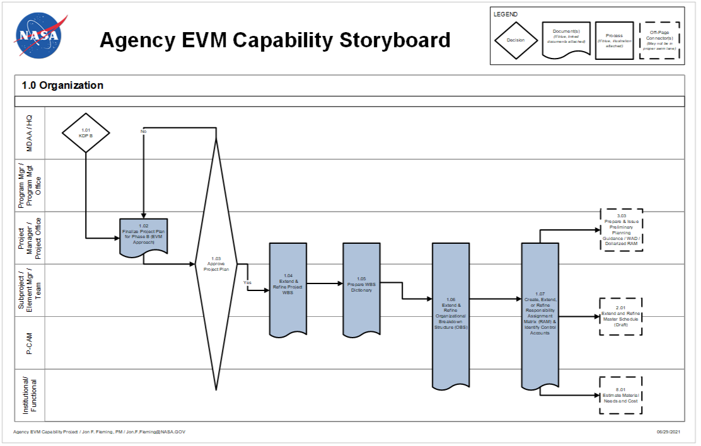
Figure 1-1 Agency Capability Storyboard Flowchart: Organization

Organization Procedure
Role | Flowchart Step | Action or Input/ Output
Mission Directorate Associate Administrator (MDAA)/NASA Headquarters | 1.01 | Approve Completion of Key Decision Point (KDP) B: After reviews culminating in the governing Program Management Council review, the program/project is determined to be ready to progress to Phase B (Preliminary Design and Technology Completion).
Project Manager or Project Management Office | 1.02 | Finalize Project Plan for Phase B (EVM Approach). Upon entering Phase B, the project further refines and formalizes the definition and assignment of work, including the planned approach for EVM implementation. The resulting Project Plan should be consistent with the Program Plan.
MDAA/NASA Headquarters, Program Manager/Program Management Office, Project Manager or Project Office and Subproject/Element Manager/Team, P-CAM, and institutional/ functional | 1.03 | Approve Project Plan: Approval of the Project Plan’s scope, schedule, and budget enables the project team to proceed with the more detailed planning required for Phase C.
Project Manager or Project Office, and Subproject/Element Manager/Team, and P-CAM | 1. 04 | Extend and Refine Project WBS. The preliminary WBS is further subdivided into its hierarchical component elements to a desired management level and uniquely numbered in accordance with the NASA Structure Management (NSM) System. The extension of the WBS continues until manageable units of work (Control Accounts) have been identified.
Project Manager or Project Office and Subproject/Element Manager/Team, and P-CAM | 1. 05 | Prepare WBS Dictionary. The WBS dictionary defines each WBS element and provides the content foundation for establishing Control Accounts. The dictionary contains a definition of the efforts associated with the WBS element (such as design, development, and manufacturing), as well as its technical content.
Project Manager or Project Office and Subproject/Element Manager/Team, P-CAM, and institutional/ functional | 1. 06 | Extend and Refine Organizational Breakdown Structure. The OBS is a hierarchical arrangement depicting how personnel are organized, as well as their reporting relationships. Responsibility for work defined in the WBS is identified in the OBS, including contractor/subcontractor effort being identified separately.
Project Manager or Project Office and Subproject/Element Manager/Team, P-CAM, and institutional/ functional | 1. 07 | Create, Extend, or Refine Responsibility Assignment Matrix (RAM) and Identify CAs. The RAM is the intersection points of the WBS and the OBS and ensures that a single line organization is identified as responsible for performing each element of work. The intersection produces a CA, where work effort is planned and budgeted, actual costs are collected, and performance is measured.
Project Manager or Project Office and Subproject/Element Manager/Team | Output to 2.01 | Extend and Refine Master Schedule (Draft). The finalized WBS, OBS, and RAM, with the identification of CAs, are used in the development of the project’s Master Schedule.
Project Manager or Project Office and Subproject / Element Manager / Team | Output to 3. 03 | Prepare and Issue Preliminary Planning Guidance/ Work Authorization Document (WAD)/Dollarized RAM.
Project-Control Account Manager (P-CAM) | Output to 8.01 | Estimate Material Needs and Cost. The finalized WBS, OBS, and RAM, with the identification of CAs, are used in the development of the project’s required purchases of hardware, software and services.

Organizing Project Work

Work Definition and Assignment
When the Program Plan and Project Plan or Intra-Agency Work Agreement (IAWA) are approved (3.1), the scope, schedule, and PBB are agreed to and the final PMB definition is completed. The entire process of work definition is based upon the Scope, WBS, WBS Dictionary, and the project schedule, as documented in the Program Plan and Project Plan or Intra-Agency Work Agreement. (See the Organization process flow in 1.3 and the Work Delegation and Authorization process flow in 3.5).

Work Content Analysis
The Organization procedure (1.4) is used to analyze the work content and develop a WBS by hierarchically decomposing the work. This analysis and decomposition results in an iterative development of the WBS, the WBS Dictionary, the project organization structure to meet the requirements, and identification of the functions and activities required by the scope. The WBS Dictionary and the project work scope are cross-referenced to ensure that all required work is captured in the WBS Dictionary, and that there is no “work” in the dictionary that is not in the approved scope definition. These analyses provide the basis for allocation of work as documented in the RAM; see Section 1.6.1.

Work Breakdown Structure
The project manager and systems engineer, in conjunction with Project Planning and Control (PP&C) team and the SP/EM, is responsible for establishing the lower levels of the WBS. The WBS is approved by the Project Manager, the Project Business Manager, and the sponsor, and is maintained by PP&C. The WBS expands a project into its hierarchical component elements, beginning at the highest level with the identification of the major project elements. The major elements are then divided into systems, subsystems, and components (i.e., hardware, software, services, or facilities) to the point where the work is performed. The extension of the WBS continues until manageable units of work have been identified. One or more CAs are then established to perform the manageable units of work.

WBS Coding: the NASA Structure Management System
Note: For additional information, see NASA Work Breakdown Structure (WBS) Handbook, available at https://www.nasa.gov/evm/handbooks, Section 3.4.2 Coding WBS Elements in a Consistent Manner.
The NSM System is the internal coding schema used by the Agency to define and organize project work content. The WBS with its NSM nomenclature provides a common management framework for project management decisions and communication, the definition and authorization of work, the development of project schedules, and the planning and allocation of resources. When developing a project WBS, the management team coordinates with all appropriate technical leads and involved enabling support organizations (e.g., Financial Management, Systems Engineering, Safety and Mission Assurance) to establish a WBS coding structure that will accommodate both the technical and business management of the effort. The approved project WBS structure should encompass the entire project’s approved scope of work. All NASA projects have the capability of subdividing the work content down to any level necessary for management and insight. However, the Agency’s Core Financial System currently limits the ability to capture costs to a maximum of seven levels (see Appendix A Work Around (s)).
Each WBS element is assigned a unique element code to be used as a reference point for its technical and financial identification throughout the life of the project. A simple decimal coding system is applied to logically indicate the level of an element and related lower-level or subordinate elements. A common coding system facilitates communications among all project participants. All project effort—i.e., all NASA in-house, contracted, international partners, university, and any other performing entity efforts— must be included. NASA project managers should work with their contracts organization, procurement organization, or other performing entities to develop the desired contractual language for each WBS element and the associated WBS coding system. The coding system must be traceable to the NSM coding structure, which is illustrated in Figure 1-2.
As illustrated in Figure 1-2, each NASA Project (Level 1) is assigned a six-digit numeric code such as 123456. Each sub level code contains a two-digit numeric code separated from the previous level code by a period. Level 2 codes would appear as 123456.02 and Level 4 codes would look like 123456.02.07.05. As previously mentioned, a maximum of seven levels is allowed in the WBS coding structure contained in the NASA Core Financial System to provide for collection of actual project costs. The typical lowest level might appear as 123456.02.07.05.02.06.03 containing a maximum of 24 characters including all the periods.

Figure 1-2 NASA Structure Management System
Note: As shown in Figure Intro - 1-3, there is no part of the unique Project WBS number that denotes a specific Center.

Preparing WBS Element Tree Diagrams
Note: For additional information, NASA Work Breakdown Structure (WBS) Handbook, available at https://www.nasa.gov/evm/handbooks, Section 3.4.3 Preparing Element Tree Diagrams.
WBS tree diagrams are routinely developed to provide a visual display of a WBS. A pictorial view of the overall WBS aids all project staff in understanding how lower-level project components support and contribute to higher level components. This type of diagram is often called a “product tree” diagram.
An example of a WBS tree diagram is shown in Figure 1-3, which reflects a portion of a Flight Project WBS structure with several key recommended development practices noted.

WBS Element Extensions
The degree to which WBS elements are decomposed or extended is governed by the following:
  - Sponsor reporting requirements.
  - The level where elements of work are managed and performed by one line organization.
  - Contractor/Subcontractor work.
  - The risk, complexity, and criticality of elements of work to meet project requirements.
  - The cost of the elements of work.
  - The visibility needed by management for controlling the element of work.
  - The limitations of the NASA Core Financial System and the NSM coding structure.

The Center is designated in an attribute field
Figure 1-3 Project WBS Partial Project WBS Element Tree Diagram
Note: recommended WBS development practices shown in red

The WBS dictionary, Figure 1-4, contains the following:
  - Title Page: Project title, Project Plan number, document issuance date, and approval by Project Manager and Business Manager. Also contained is the revision designator and approved changes from previous revisions.
  - Index: The index will cross-reference each WBS number to the appropriate Program Plan and Project Plan or IAWA paragraph number.
  - Description: Technical content containing the following information for each element of the WBS down to and including the CAs:
  - WBS Number and Title: Each description will be identified with the WBS code and the title or name of the element. The elements should be in the same order as the WBS Index.
  - Narrative: A definition of the WBS element, stating what the element is and the efforts associated with the WBS element (such as design, development, and manufacturing), as well as its technical content. The narrative is the dictionary part of the WBS Dictionary.
  - Deliverables: Define the deliverables resulting from performing the work, where applicable.
WBS Dictionary
WBS Element Title: WBS Element No:
Develop Prototype Code 123456.08.05.09.01.03
Parent WBS No: 123456.08.05.09.01 WBS Level: 6
Parent WBS Title: Develop Prototype Scope Def. Ref: 02.01.01
Project: Originator:
Project XYZ Software Development Samuel L. Kates
WBS Element Description:
The scope of this element includes the development of all necessary software code required to satisfy the functional requirements established for prototype software. This effort will include the identification of all prototype use-case functions, code development for all identified use-case functions, informal use-case testing, integration of all use-case code, and software preparation for full prototype user testing.
Technical Specification Document:
- SPEC-SW-AA000765-1 - SPEC-SW-AB000767-2
Procurement Packages: None
Related Work Excluded:
- Associated supervision
- Prototype requirements validation
- PP&C planning and control effort
Requirements Doc. No:
NASA SRD-BR549-01
WBS Index: See pages 16-18
Revision No: 01c Page _15 of 31
Revision Date: 11/30/2009 WBS Element No: 123456.08.05.09.01.03
Figure 1-4 Sample Project WBS Dictionary

WBS and the Project Life Cycle
Note: For additional information, see NASA Work Breakdown Structure (WBS) Handbook, available https://www.nasa.gov/evm/handbooks, Section 3.1 WBS and the Project Life Cycle.
A preliminary WBS is developed early in the formulation phase of the project. It is established as soon as management believes the project has reached a stage of definition where it is feasible. It is used to assist in the preparation of the FAD and the preliminary Project Plan. The preliminary project planning process through Formulation is an iterative process. During its early phases, the preliminary WBS may be revised as necessary. Once the project is established with sufficient and stable scope definition, then both the NASA in-house work elements and, if required, the WBS elements can be adequately planned and established at the necessary levels of detail.
CAUTION: To avoid collecting costs with a WBS that proves to be inadequate or inappropriate, do not enter the full preliminary WBS into the Metadata Manager (MdM) System until the scope has stabilized or until specific CAs are needed for cost collection. See Section 4.12.1 for a discussion of the MdM System. Figure 1-5 reflects how the WBS development process relates to the project life cycle.
Baseline approval of the WBS is achieved during the latter stages of project life-cycle Phase “B”. Once approved, the WBS should not be revised except through the formal approval process at major transitional points in the project. To ensure that projects meet KDP-C requirements, EVMS setup and implementation efforts should begin as soon as a project begins to develop the WBS, Organizational Breakdown Structure (OBS), and Integrated Master Schedule (IMS). EVM reporting will begin during Phase B and continue as long as the EVM applies for the remaining phases.”
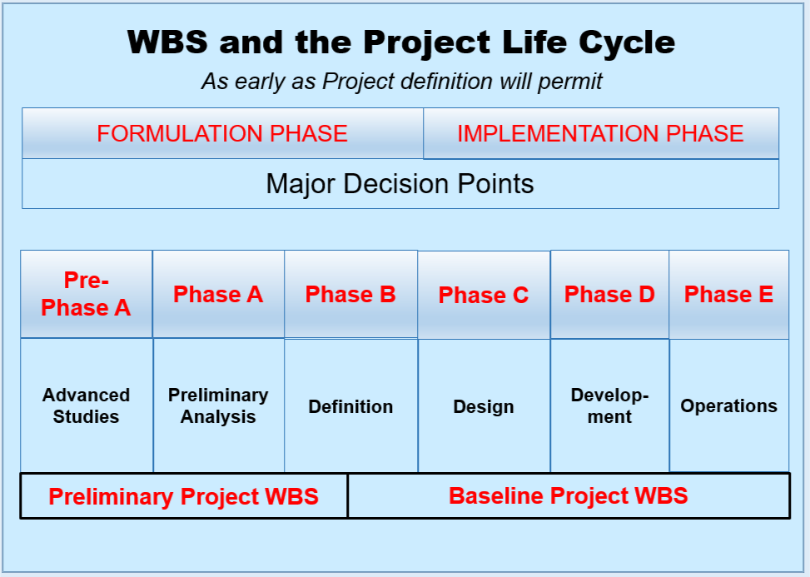
Figure 1-5 WBS and Project Life Cycle

Organization Breakdown Structure

Project Organization and Authority Trace
Figure 1-6 illustrates the chain of authority extending from the MDAA/NASA Headquarters down the management structure to the Project Manager and depicts the typical project organization. The project organization is composed of entities that correspond to and execute the major deliverable items and major subcontracts. The project organization has complete responsibility for the work to be performed. The project is managed and administered by a team that is led by the Project Manager and SP/EMs. The SP/EMs are responsible for the intermediate or “functional” management of the scope, schedule, and budget of groups of CAs. P-CAMs are responsible for the direct or “hands-on” management of the scope, schedule, and budget for individual CAs. Each project’s team members are responsible to the project manager for the project tasks assigned to them. The roles of these managers are discussed in 1.7 and a summary of their responsibilities in 1.8.

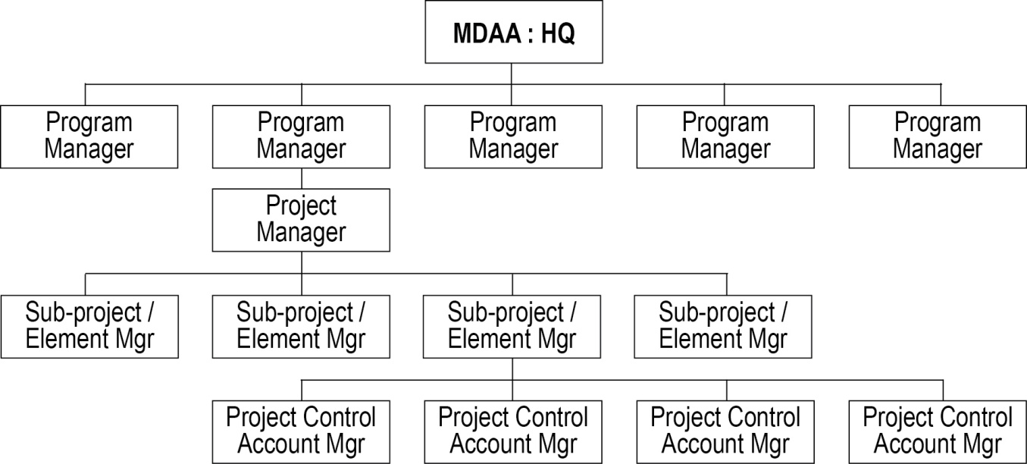
Integrated Product Teams
An Integrated Product Team (IPT) systematically employs a teaming of functional disciplines to integrate and concurrently apply all necessary processes to produce an effective and efficient product that satisfies customer needs. The product, in this sense, is not only what is delivered to the customer (e.g., hardware, software, services, and documents), but also the processes (e.g., design, manufacturing, test, and logistics) which make the product possible. Products range from complete systems to individual end items.
Applying the IPT management approach can result in significant benefits to the organization and the product it delivers. The benefits gained from IPTs are consistent with the objectives of streamlined acquisition and continuous improvement. An organization must undergo a fundamental change in the way it operates to implement IPTs.
When this is successfully accomplished the IPTs take the place of the traditional line or functional organizations in the OBS. If an IPT approach is used, the IPT lead or manager may act as the PCAM. The NASA EVM Capability and its tool sets can facilitate use of IPTs.

Figure 1-6 Chain of Authority and Project Organization

Organizational Breakdown Structure (OBS)
Figure 1-7 Organizational Breakdown Structure
Each of the primary OBS Elements, as depicted conceptually in Figure 1-7, is structured based on administrative responsibility and technical (functional) expertise. In the case of contracts, NASA projects require that contractor / subcontractor’s employ best project management practices in managing their efforts; NASA also oversees these efforts. It is from the line (functional) organizations of the OBS elements that most project resources are drawn.

Integrating the Work and the Organization

Responsibility Assignment Matrix (RAM)
In order to ensure that a single line (or functional) organization is clearly identified as responsible for performing each element of the defined work, a RAM is developed. The RAM is an integration of the WBS with the line organization structure, also known as OBS. The intersection points of these two structures produces the CAs, where there is effort to be accomplished. The CA is the point at which work is planned and budgeted, and where the actual costs and achievement are accumulated. Each P-CAM identified on the RAM reviews the allocated work scope and prepares plans, schedules, and budgets accordingly. The formal RAM, Figure 1-8, for the project is maintained by the PP&C personnel. An example is shown below.
Figure 1-8 Responsibility Assignment Matrix (RAM)

Control Accounts—Intersection of WBS and OBS
The intersection of WBS elements and the OBS typically provides the key points for cost management purposes and cost collection. These intersections are referred to as CAs and are illustrated conceptually in Figure 1-9.
The CA typically is the level at which formal organizational responsibility exists for an individual WBS element. At a minimum, it is the level at which costs and EV Performance are collected and analyzed.
Figure 1-9 WBS/OBS Integration and Control Accounts
While it is preferred that the Core Financial System WBS and the project technical WBS be one and the same, this is not always possible. In cases where there are multiple Core Financial System, WBS charge codes that belong to one CA or work package (WP) in the project structure, it is acceptable to map these to the appropriate account. This mapping must occur outside of the Core Financial System and is usually handled in the cost tool. It is not acceptable to map one Core Financial System charge code to more than one CA or WP.
The CA is the main juncture for the planning and control of authorized work because all aspects of the system including budgets, schedules, work assignments, cost collection, progress assessment, problem identification, and corrective actions come together at that point. The levels selected for establishing CAs are carefully considered to ensure that the work is properly defined into manageable units and that organizational responsibilities are clearly and reasonably established.
There are flexible rules as to the length (months) or size (dollars) of a CA. However, sound business and technical judgment must apply. If a CA is deemed to be too large, creation of multiple CAs is encouraged. The break point for these CA splits should tie to a logical completion of a deliverable end item, or development stage, such as Critical Design Review (CDR) or Assembly/Test and Launch Operations.
CA characteristics include the following:
  - Have separately identified budgets that are time-phased over the life of the CA.
  - Are planned and budgeted at the WP level and controlled using an appropriate Performance Measurement Technique (PMT) or called an Earned Value Technique (EVT).
  - As a best practice, CAs that have Level of Effort (LOE) and discrete effort WPs have the LOE portion less than 15-20% of the total CA budget
  - Summarize directly into the WBS and the OBS reporting structures via the RAM, without the allocation of a single CA to two or more reporting structure items.
  - Have segregated elements of cost (labor, material, Other Direct Costs (ODC), etc.) in separate WPs.
  - Include all planned and actual direct costs for the CA effort.
  - Have a specific manager (called the P-CAM) responsible for each CA.

Organization Key Management Positions or Roles
Project organizations remain flexible in order to accommodate any requirement. However, a three-tier management structure has been proven to satisfy the requirements of most large, complex projects. The primary positions are Project Manager, SP/EM, and P-CAM. On small projects these functions may be filled by one or two people.

Project Manager
The Project Manager is directly responsible for the success of the project and is the primary interface with the sponsor. The Project Manager is responsible for all aspects of the project including forming the project team, managing financial and acquisition activities, managing risk, managing performance, ensuring safety, and the mission assurance function. This information includes the project scope, the WBS and WBS Dictionary, the project schedule, and the NASA project’s PBB, which is equivalent to the CBB in standard EVM practice. Generally, the Project Manager identifies scope, schedule, and budget for each major project element that is assigned to the various Subproject/Element Managers, whom he/she will authorize and require those individuals to plan and control that portion of the project.

Subproject/Element Manager
The SP/EMs are the project’s “middle managers.” The SP/EM is responsible for managing and integrating the work involved in producing a given element required by the project and reflected in the WBS. Each SP/EM ensures that the scope, schedule, and budget are properly distributed and delegated to the “first-line” managers (i.e., the P-CAMs). The SP/EM has immediate control and authority over the project work that is assigned to him/her.
The SP/EM is also the individual to whom the various P-CAMs report. The SP/EM is responsible to ensure that the P-CAM plans and controls the assigned CA(s) in accordance with the scope, schedule, and budget. As one of the approvers on the Control Account Work Authorization Document (WAD), the SP/EM stipulates that they have reviewed all appropriate CA documentation and found it reasonable and consistent with the project constraints for scope, schedule, and budget.
Furthermore, the SP/EM stays involved with the progress of the CA effort in at least the following ways:
  - Participate in the review and approval of VARs.
  - Conduct follow-up activities for any Corrective Actions described and approved in a VAR.
  - Participate in the review and approval of Change Request Documents.
  - Participate in the review and approval process involving the Element Integrated Master Schedule (IMS).
  - Ensure the P-CAM has coordinated with all appropriate managers (including the SP/EM) to ensure that the needed resources are available when they are required.
  - Provide his/her technical specialty as required in contractor/subcontractor IBRs.

Project-Control Account Manager
Note: For additional information, see NASA Reference Guide for P-CAM located at https://www.nasa.gov/evm/handbooks.
The individual assigned responsibility and accountability for the planning and successful completion of all parameters of a CA is called a P-CAM. The P-CAM is responsible for preparation of CAPs, monthly schedule status data that drives EV, and the preparation of monthly VARs. The P-CAM leads a team consisting of members of their own line organization, as well as support personnel from other line organizations and/or contract organizations. The P-CAM is the “first-line” manager most deeply involved with the planning and accomplishment of work on a project. While not always in a position to exert direct supervisory control over the resources used to accomplish CA work, the P-CAM is responsible for the successful accomplishment of CA work, within both budget and schedule constraints.

Business Manager
The Business Manager is responsible for all project business activities including cost estimation, budgeting, scheduling, funds management, procurement and performance measurement as required for the planning and execution of the project objectives. The Business Manager, along with the PP&C team, supports the Project Manager and the SP/EM in the development of WBS, WBS Dictionary, and RAM, and co-approves these documents. In addition to the Business Manager, the business management team generally includes a Project Resource Analyst (PRA), and a Planner/Scheduler (P/S).

Organization Summary of Responsibilities
Responsibility and accountability for implementing the NASA EVM Capability are distributed throughout the project organization as discussed below.

Project Manager
  - Recognizes and accepts responsibility and authority for the project.
  - Provides overall management direction and oversight for the project.
  - Responsible for establishing the project team and organization structure to fulfill the requirements of the project.
  - Develops and approves the WBS, WBS Dictionary, and RAM for the project.
  - Negotiates with line management for the assignment of SP/EMs.
  - Initiates, approves, and issues all WADs. Ensures WADs are approved in a timely manner.
  - Approves or disapproves all Change Request Documents involving use or replenishment of MR.
  - Reviews and approves all VARs.
  - Supports the coordination and conduct of contractor/subcontractor IBRs as required.

Subproject/Element Manager (SP/EM)
  - Assists project manager and PP&C team in the development of the WBS and WBS Dictionary.
  - Recognizes and accepts responsibility and authority for his/her subsystem or element within the project.
  - Identifies CAs through the development of a RAM.
  - Provides overall management direction and oversight for the project subsystem.
  - Negotiates with line management for the assignment of P-CAMs.
  - Oversees the initiation and approval of all WADs. Ensures WADs are approved in a timely manner.
  - Reviews all Change Request Documents and has approval authority for Change Request Documents not requiring Project Manager approval.
  - Reviews all VARs.
  - Supports his/her technical specialty as required in contractor/subcontractor IBRs.

Project-Control Account Manager (P-CAM)
  - Assists in the development of the WBS.
  - Supports SP/EMs and PP&C in establishing the WBS Dictionary.
  - Develops, negotiates, and accepts the scope, schedule, and budget on WADs.
  - Manages all work authorization for his/her CA.
  - Negotiates with line management for the assignment of performing resources.
  - Prepares Change Request Documents for changes to the CA’s scope, schedule, and / or budget, including conversion of Planning Packages (PPs) to WPs.

Business Manager
  - Supports the establishment of the WBS with the project manager and SP/EMs.
  - Shares the responsibility for developing the WBS and WBS Dictionary with the project manager, SP/EMs, and P-CAMs.
  - Controls and maintains the project’s WBS and WBS Dictionary.
  - Reviews all WADs to ensure accuracy of the schedule and budget.
  - Advises the project manager of any cost/schedule discrepancies between the project schedule and budget and the schedules and budgets noted in the WADs.
  - Develops (with the SP/EMs) and maintains the project RAM.
  - Initiates and issues all preliminary WADs. Verifies that WADs are approved in a timely manner.
  - Assists P-CAMs with preparing and processing Change Request Documents.
  - Helps with the preparation of corrective actions for all the CV and SV analyses.

SCHEDULING

Scheduling Introduction
The project IMS provides a time-phased plan for performing the project’s approved total scope of work and achieving the project’s goals and objectives within a determined timeframe. The schedule planning and analysis process encompasses the development, update, maintenance, control, and analysis of the IMS. The project IMS is established through the integration of a set of project schedules for all WBS elements, which provides a logical sequence of activities from project start through completion, and a logical hierarchy from the detailed activity level to intermediate and project summary levels. A properly prepared schedule will provide a roadmap by which the project team can execute all authorized efforts and determine where deviations from the original plan have created a need for corrective action. A sound schedule planning process requires the integration of the technical, schedule, and cost aspects of the project. The schedule planning process must also provide for the identification of both internal and external interdependencies between work content contained in all WBS elements at a level of detail appropriate for efficient and effective project management. A credible IMS is critical to successful implementation of EVM since it provides the time-phasing utilized in the PMB.
While a project Integrated Master Plan (IMP) and Schedule Management Plan (SMP) are recommended and beneficial management documents that may be used to enhance the schedule planning process, they are not required by NASA.

Scheduling Parameters
The following parameters apply:
  - There is only one IMS for the project.
  - The IMS reflects the integration of all CA schedules (including contractor, university, and other government partners), forming a critical path method (CPM) schedule representing the project’s total scope of work.
  - All active and future CAs have either detailed WP schedules or PP schedules.
  - Time phasing of the PMB is derived from the project IMS.
  - The IMS reflects both baseline and current forecast schedule data.
  - The IMS is updated and progressed (which includes new status and changes) at least monthly in conjunction with the Institutional Fiscal calendar.
Note: the NASA accounting calendar starts at the beginning of the calendar month and ends at the end of the calendar month).
  - Once the IMS is approved it is placed under the baseline control process and is only revised in accordance with the change approval process.
  - Schedule reports contain identification of the baseline schedule and current forecast schedule, as well as other identifiers (e.g., original issue, revision number, date of print, individual responsible for the schedule, reporting status date, etc.).
Scheduling Methodology
Per NASA Schedule Management Handbook located at https://www.nasa.gov/evm/handbooks, the IMS serves as the basis for planning and performance insight for all project effort. A project IMS is developed utilizing CPM scheduling techniques that can produce a project critical path (CP). The CPM methodology entails the development of a logic network-based schedule that enables the calculation of schedule slack (or float) for all activities and milestones contained in the IMS. CPM produced data enables analysis and identification of schedule drivers, cause and impact narrative analysis, and presentation of possible Corrective Actions. The IMS will contain baseline schedule data, as well as current schedule status and forecast. A monthly comparison of current schedule progress against the established baseline schedule plan provides the necessary data to assess schedule performance in the project’s EVM system.
IMS logic network derived data provides the basis for time-phasing and coordination of all project efforts. It provides the project manager a single integrated source of schedule data that accurately reflects how the planned work is to be implemented. This dataset is established and maintained in an automated scheduling tool and consists of the following elements:
  - Activities and milestone events
  - Realistic activity durations
  - Activity/milestone interdependencies (sequencing)
  - Activity resources (recommendation only)
  - Valid activity/milestone date constraints
  - Contractor schedule data
Note: The contractor/subcontractor IMS must also reflect contractor/subcontractor work content and associated schedule in some fashion.
  - A schedule coding structure to facilitate integration of scope and cost
The Planner/Scheduler (P/S) serves as the primary project point of contact for coordinating IMS data entry, progress updates, logic maintenance, integrity assessment, performance analysis, issue identification, work-around planning, and report generation. The P/S provides the necessary recording of performance progress so that EVM support personnel may input the data to the project’s EV system management tool. All designated schedule reports, metrics, and analyses are made available as necessary to the full project management team and appropriate involved stakeholders. It is critical to project success that the Project Manager, Business Manager, Subproject/Element Managers (SP/EM), PCAM, and other key project team members are kept apprised and communicated with regarding current schedule progress and issue resolution.

Scheduling Process
The Scheduling process flow is shown in Figure 2-1, on the following page.; Part one of the process procedure is described in Section 2.4. The “Developing IMS” portion of the Scheduling process provides the significant steps to achieve a credible project baseline schedule. To better describe the scheduling process, it should be noted, that process steps 2.01 through 2.06 are iterative in nature, and where practical may be worked in parallel by the planner/scheduler, project, and subproject element teams. It should also be noted that different types of projects require different levels of task/milestone detail to adequately manage the project. This creates the need for a decision point early in the process (step 2.02) where the project office will need to determine the level at which task interdependencies (logic sequence) should be incorporated. It is at that level that management will be able to identify and monitor the project CP, as well as slack on all other activities and milestones.
The “IMS Status and Update” component of the Scheduling process provides the significant steps to successfully update and maintain a credible project baseline schedule. The process procedure for this component is described in Section 2.4.

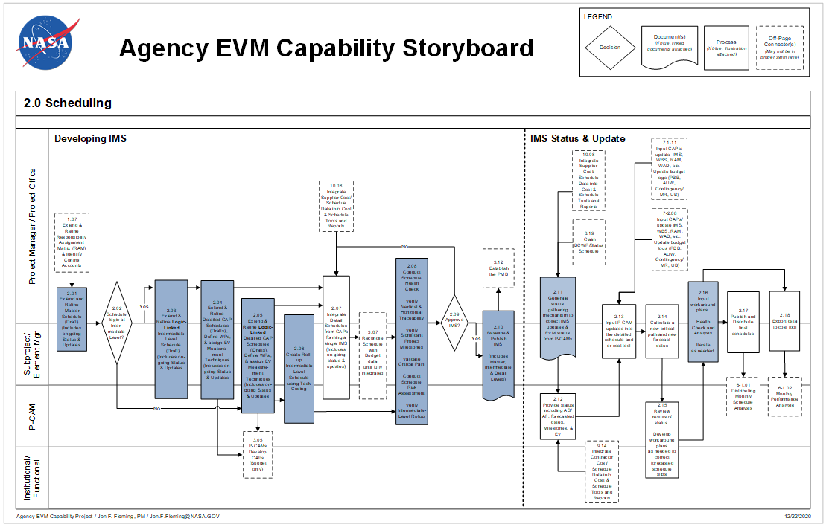
Figure 2-1 Agency EVM Capability Storyboard Flowchart: Scheduling

Scheduling Procedure
Role | Flowchart Step | Action or Input/ Output
 | Input from 1.07 | Extend and Refine Responsibility Assignment Matrix (RAM) and Identify CAs.
P/S, Project Manager, Project Office Team, SP/EM, and Subproject/ Element Team | 2.01 | Extend and Refine Master Schedule (Draft). This includes on-going status and updates. Review, evaluate, and update the preliminary top-level Master Schedule. Ensure that all WBS elements are addressed. Ensure that all summary-level tasks and event milestones reflect a valid model of the planned project implementation at a top level of detail. Ensure that current status and updates are reflected. Establish and document schedule accomplishment exit criteria for all top-level Master Schedule activities and event milestones.
P/S, Project Manager, Project Office Team, SP/EM, and Subproject/ Element Team | 2.02 | Schedule Logic at Intermediate Level? Using the current updated Master Schedule and project knowledge relative to scope and desired level of management insight and control, the project must decide if task horizontal traceability (interdependencies) is required within the Intermediate Schedule. If the decision result is “yes”, then the project proceeds to step 2.03 and further refines the top-level Master Schedule to an Intermediate level with sequence interdependencies identified for all tasks and milestones. If the decision is “no”, then the project must proceed to step 2.05 and further subdivide and refine the top-level Master Schedule to a lower detailed, CAP level schedule with sequence interdependencies identified for all tasks and milestones.
P/S, Project Manager, Project Office Team, SP/EM, Subproject/Element Team and P-CAM | 2.03 | Extend and Refine Logic-Linked Intermediate-Level Schedule (Draft) (Includes On-going Status and Updates). Review, evaluate, update, and further subdivide the top-level Master Schedule to an intermediate level with sequence interdependencies identified for all tasks and milestones. Ensure that all WBS elements and CA content are addressed. Ensure that all intermediate activities and milestones reflect a valid model of the planned project implementation. Ensure that only necessary and valid date constraints are included. Ensure that adequate resources are planned and available. Ensure that current status and updates are reflected
P/S, Project Manager, Project Office Team, SP/EM, Subproject/Element Team and P-CAM | 2.04 | Extend and Refine Detailed CAP Schedules (Drafts), Define Work Packages (WPs) and Assign Earned Value (EV) Measurement Techniques (Includes On-going Status and Updates). Review, evaluate, update, and further subdivide project Intermediate Schedule content to incorporate detailed CA and WP schedule activities and milestones. Ensure that all WBS elements and CA content are addressed. Ensure that all detailed activities and milestones reflect a valid model of the planned project and CA/WP implementation at a low level of detail. Ensure that adequate resources are planned and available to execute the project. Ensure that current status and updates are reflected. Determine and assign valid EVT appropriately to each detailed CA and/or WP schedule.
 | Output to 3.05 | P-CAMs Develop CAPs (Budget Only).
P/S, Project Manager, Project Office Team, SP/EM, Subproject/Element Team and P-CAM | 2.05 | Extend and Refine Logic-Linked Detailed CAP Schedules (Drafts), Define WPs, and Assign EVT (Includes On-going Status and Updates). Review, evaluate, update, and further subdivide project Master Schedule content to incorporate detailed CA and WP schedule activities and milestones. Ensure that all WBS elements and CA content are addressed. Ensure that all activities and milestones reflect a valid model of the planned project and CA/WP implementation at a low level of detail. Integrate activities and milestones contained internally within each detailed CA/WP by incorporating necessary and accurate task interdependencies. Ensure that only necessary and valid date constraints are included. Ensure that adequate resources are planned and available to execute the project. Ensure that current status and updates are reflected. Determine and assign valid EVT techniques appropriately to each detailed CA and/or WP schedule.
 | Output to 3.05 | P-CAMs Develop CAPs (Budget Only).
P/S, Project Manager, Project Office Team, SP/EM, Subproject/Element Team and P-CAM | 2.06 | Create Roll-up Intermediate-Level Schedule Through Detailed Task Coding. Within the detailed, logic-linked schedules established for each CA, assign the necessary activity coding structure that has been established by the project office to provide the capability for summary roll-up to the desired Intermediate-level schedule for management use and stakeholder communication. Ensure that current status and updates have been incorporated into Intermediate Schedule roll-up.
 | Input from 10.08 | Integrate Supplier Cost/Schedule Data into Cost and Schedule Tools and Reports.  Note: Other Centers are considered suppliers via Inter-Agency Work Agreements.
P/S, Project Manager, Project Office Team, and P-CAM | 2.07 | Integrate Detailed Schedules From CAPs (Forming a Single IMS (Includes On-going Status and Updates). Integrate all detailed schedules from the CAPs by incorporating all task and milestone interdependencies that exist between CAs and all identified external implementer schedule activity. If needed, resolve schedule deficiencies/issues that are identified during the final IMS review and approval decision process (see 2.09) and have prevented IMS baseline approval. Ensure that current status and updates are reflected.
 | Output to 3.07 | Reconcile Schedule with Budget Data Until Fully Integrated.
P/S, Project Manager, Project Office Team, SP/EM, Subproject/Element Team and P-CAM | 2.08 | Conduct Schedule Health Check, Verify Vertical and Horizontal Traceability, Verify Significant Project Milestones, Validate Critical Path, Conduct Schedule Risk Assessment, Verify Intermediate-Level Rollup. Assess and analyze the full IMS dataset. This activity includes, but is not limited to, assessing the IMS health relative to completeness and validity of the following: predecessor and successor interdependency assignments, activity/milestone content, activity durations, activity calendars, invalid use of date constraints, incomplete and/or erroneous task progress, omissions of new future forecasts to activity start dates, validity of CP content, validity of Intermediate-level roll-ups, and the assessment of schedule risk. This process step also includes the update or modification of IMS data based on the results of any of the above assessment and analysis practices.
P/S, Project Manager, Project Office Team, SP/EM, Subproject/Element Team, P-CAM, and Institutional and Functional Leads | 2.09 | Approve IMS? Based upon results from the assessment and analysis conducted in the previous step, a decision for approval of the project IMS which contains all integrated CA schedules and Contractor/Subcontractor schedules is required. If, after the above analysis, the decision made is yes, then the project IMS is established as the baseline for time-phasing of the project effort and budget distribution. If the decision is no, then the process flow would revert to step 2.07 for resolution of all schedule issues.
P/S, Project Manager, Project Office Team, SP/EM, Subproject/Element Team and P-CAM | 2.10 | Baseline and Publish IMS (Includes Master, Intermediate, and Detail Levels). Publish the approved IMS as the project management baseline to be used for time-phasing of the PMB and for measuring project performance. Distribute and/or make available the baseline IMS for program/project implementation management and guidance.
 | Output to 3.12 | Establish the Performance Measurement Baseline.

Schedule Status and Update Procedure
Role | Flowchart Steps | Action or Input/ Output
 | Input from 8.19 | Claim Budgeted Cost for Work Performed (BCWP)/Status Schedule
 | Input from 10.08 | Integrate Supplier Cost/Schedule Data into Cost and Schedule Tools and Reports.  Note: Other Centers are considered suppliers via Inter-Agency Work Agreements.
P/S | 2.11 | Generate Status-Gathering Mechanism to Collect IMS Updates and EVM Status from PCAMs. At least monthly, provide updated IMS and next month’s update instructions and guidance to PCAMs and other management leads that are responsible for input of schedule progress updates. Prepare and distribute necessary progress collection reports/forms, or initiate other update mechanisms with responsible PCAMs / management leads for input and/or gathering of their schedule status updates, including necessary EV data to allow for EVM Schedule Performance Index (SPI) calculations.
 | Input from 9.14 | Integrate Contractor/Subcontractor Cost/Schedule Data into Cost and Schedule Tools and Reports.
P-CAM | 2.12 | Provide status Including Actual Start (AS)/Actual Finish (AF), forecasted dates, milestones, and EV. Determine and communicate activity and Milestone Status information to P/S. (i.e., activity actual and estimated start dates, actual finish dates, remaining activity durations, percent complete, etc.). Determine and communicate changes to IMS logic network (i.e., future activity durations, interdependency changes, new work scope additions, date constraint changes, relationship lag changes, etc.) It should be noted here, that if the IMS is resource loaded the schedule will also provide a means to determine needed EAC updates.
 | Input from 7-1.11 | Input CAPs/Update IMS, WBS, RAM, WAD, etc. Update Budget Logs [PBB, AUW, Contingency/MR, and UB].
 | Input from 7-2.08 | Update Budget Logs [Project Budget Base (PBB), AUW, Contingency/MR, and UB].
P/S, Project Manager, Project Office Team, SP/EM, and Subproject/ Element Team | 2.13 | Input P-CAM Updates into the Detailed Schedule and/or Cost Tool. Meet with P-CAMs to gather and understand IMS progress and logic change updates. Incorporate all updates into the IMS and validate update accuracy and completeness. Updates will include not only current schedule updates, but also approved baseline IMS changes.
P/S, Project Manager, Project Office Team, SP/EM, and Subproject/ Element Team | 2.14 | Calculate a New CP and New Forecast Dates. Calculate IMS with all new progress and logic change updates to identify resulting CP, near CPs, all to-go forecasts and slack values.
P-CAM and Institutional and Functional Leads | 2.15 | Review Results of Status, Develop Workaround Plans As Needed to Correct Forecasted Schedule Slips. Review and analyze update impacts to IMS. Validate resulting primary CP in schedule. Validate and monitor all logic paths within the IMS with slack less than the threshold established by the project. Analyze unacceptable impacts to contract and/or controlled milestones and determine effective work around plans for schedule recovery where possible. Analyze EVM data for correctness and to identify real and potential performance issues.
P/S, Project Manager, Project Office Team, SP/EM, and Subproject Element Team | 2.16 | Input Workaround Plans. Health Check and Analysis. Iterate as needed. Incorporate logic changes into the IMS that reflect the necessary work around plans. Verify changes are acceptable and produce the desired results. Assess and analyze the full updated IMS dataset. This activity includes, but is not limited to, assessing the IMS health relative to completeness and validity of predecessor and successor interdependency assignments, invalid use of date constraints, erroneous task progress, omissions of new future forecasts to activity start dates, and the assessment of schedule risk. IMS analysis includes validating CP content, analyzing work performance to-date, analyzing resource needs and impacts.
P/S, Project Manager, Project Office Team | 2.17 | Publish and Distribute Final Schedules. Get project manager approval of IMS update. Publish and make available updated IMS to project team and stakeholders. Produce and distribute necessary schedule reports to project management team.
 | Output to  6-1.01 | Distributing Monthly Schedule Analysis.
P/S, Project Manager, Project Office Team | 2.18 | Export Data to Cost Tool. Export updated IMS containing both current schedule updates and approved baseline changes to cost management tool.
 | Output to  6-1.02 | Monthly Performance Analysis.

Schedule Development
This section provides a description of the scheduling process used to develop schedules that support management’s decision-making process, utilizing a top-down approach, supported by bottoms-up schedule development. Project schedules depict the time frame required to accomplish the defined work. This establishes a baseline plan against which current status is measured, a completion date forecast is established, and the cost of planned work is determined. The steps detailed in this process support the project life cycle. The scheduling process supports multiple levels of related schedules, with each succeeding level more fully defining the work to be accomplished. The various schedules depict a continuous logical sequence of in-house and contract milestones from the Top-Level schedule down to the detailed schedules, and from the beginning of the project to the final delivery.

Organization and Requirements
The schedule development process is initiated upon receipt of the following project specific documentation: scope definition, approved project WBS and WBS Dictionary, Program Plan and Project Plan, Test and Verification Plan, internal Task Agreements, project cost estimate, funding guidelines, and IAWAs, contract DRD, or Project Proposal. These documents are used to define the structure and time frame for authorized implementation activities. Utilizing a product oriented WBS provides a logical outline of the scope of work that can be further decomposed within the schedule.
It is noted again, that while the development of a project IMP and a SMP are not required by NASA, they are considered very beneficial management documents that may be used to enhance the schedule planning process. An IMP is a non-time phased, event-based plan consisting of a hierarchy of project events, with each event being supported by specific accomplishments, and each accomplishment associated with specific criteria to be satisfied for its completion. If used, the IMP would serve as a basis for development of the more detailed IMS dataset. The SMP provides a detailed description and framework for project schedule management. This document includes scheduling methodology, schedule hierarchy, organization roles, tool considerations, assessment and analysis needs, performance metrics, reporting formats, and the necessary processes and procedures for carrying out sound project schedule management.

Schedule Development Considerations
Things to consider when developing the IMS Baseline:
  - As the project scope and planning structure are being defined, ensure that Business and Project team members collaborate to assess the WBS, considering the way budget/cost accumulation is planned and collected for each element of work, and how performance will be assessed.
  - Within detailed CA schedules, ensure that activities and schedule logic are established by product, leading to separate and specifically defined deliverables.
  - Ensure that schedule detail represents only the approved scope of work.
  - Ensure the level of schedule detail provided is adequate to ensure objective status reporting by the managing and performing organizations.
  - Identify and segregate external effort (e.g., contractor, university partners, etc.) in alignment with the WBS. Analyze the way performance of these tasks are captured and validated.
  - Identify and document schedule risk items (i.e., technical/schedule risk, complexity, and criticality of effort) to meet project and contractual requirements.
  - Ensure that an appropriate amount of schedule margin is included in the IMS. Also, ensure that adequate MR or Unallocated Future Expense (UFE) is available to cover schedule margin contained within the IMS.
  - Consider the depth of schedule visibility required by the project for successful management of each element of work.
  - Ensure that all formats of presented schedule data are traceable to and representative of the content of the IMS.

Top-Level Schedule
The Top-Level Schedule encompasses the total project life cycle, structured by upper-level WBS elements or IMP, if implemented, across all project life cycle phases (e.g., Concept Studies, Technology Development, Preliminary Design, Final Design and Fabrication, System Assembly, Integration and Test, and Operations). This schedule, at a minimum, should reflect significant summary-level activities, project and contract milestones, control milestone events, major decision points, significant identifiable schedule margin, and gate transitions that are required to meet program milestones for all deliverables required by the Program Plan and Project Plan or IAWA. The Top-Level Schedule also depicts a variety of information on project activities, product subsystem and system summaries and major project milestones. Caution should be exercised when attempting to reflect the project CP within the Top-level Schedule due to the summary nature of activity detail and the inability to reflect all associated detailed CP interface points. From a hierarchical planning perspective, the Top-Level Schedule is a summary-level schedule product, generated from the detailed activities within the IMS and providing traceability to activities and/or milestones contained within. Figure 2-2 depicts a Software Development schedule for a Flight Mission and is a sample of a top-level schedule.
Figure 2-2 Sample Top-Level Schedules

Intermediate-Level Schedules
Different types of projects require different levels of task/milestone detail to adequately manage the IMS. This creates the need for a decision point early in the scheduling process where the Project Manager, project office, and responsible SP/EMs will determine the level at which task interdependencies (logic sequence) should be incorporated. It is at that level that management will be able to identify and monitor the project CP, as well as slack on all other activities and milestones. Using the updated Master Schedule along with project knowledge relative to scope and desired level of management insight and control, determine whether task horizontal traceability (interdependencies) is required at the Intermediate or Detailed level of the IMS.
If the project office and responsible technical managers determine that horizontal traceability (task interdependencies) is required only at an intermediate-level of schedule detail, then this process step will entail the review, evaluation, extension, progress update, and refinement of the Master Schedule to an intermediate-level of task detail containing necessary logic-links. This process step will be accomplished by the P-CAM working with the Planner/Scheduler, project office team members, and subproject and element manager(s). The Intermediate Schedule may also be referred to as a Project Summary Schedule, Level 2 Schedule, or Tier 2 Schedule. The Intermediate Schedule contains both milestones and summary tasks, such as a single task representing system or component details, or a single task representing a grouping of similar tasks such as testing or design tasks. This schedule will reflect tasks that are sequentially ordered using appropriate CPM interdependency relationships; for example, Finish-to-Start (FS), Start-to-Start (SS), and Finish-to-Finish (FF). The Intermediate Schedule is linked to the Master Schedule with interdependent logic relationships so that the Master Schedule reflects the effects of underlying task progression. The Intermediate Schedule will also be linked to appropriate detailed tasks within detailed CA schedules that are developed, in order to accurately reflect status and time-phasing at all schedule levels.
Care should be taken to ensure that all WBS elements and element content are addressed within the Intermediate Schedule. All schedule tasks and event milestones must continue to reflect a valid model of the planned project implementation at an intermediate level of detail. It is important to ensure that only necessary and valid date constraints are included in the Intermediate-Level Schedule. It should be noted that while not a requirement, it is a best practice that necessary project resources should be planned and incorporated within the IMS.
When the management decision results in the need for IMS horizontal traceability at a detailed level, the Intermediate Schedule will then be arrived at in a different manner. In these cases, the Intermediate schedules are representative summaries of the key detailed-level activities and milestones necessary to accomplish the scope of work within a selected WBS element, CA, or WP. From a hierarchical planning perspective, intermediate level schedules are summary rollup products generated using specific assigned task coding assigned within the detailed IMS. The P-CAM—working with the Planner/Scheduler, project office team members, and subproject and element manager(s)—establishes the specific coding required to provide the correct and desired Intermediate schedule. Intermediate schedules derived in this manner will typically not be used for in-depth management analysis since the horizontal interdependencies required for CP identification and analysis will only exist at the detailed CAP task/milestone level. Generally, intermediate level schedules are used effectively to communicate schedule progress, downstream forecasting, and available schedule margin to upper-level management and key project stakeholders. Representing a schedule plan at the subsystem or system level, as reflected in the Intermediate schedule roll-up, provides an effective schedule format for highlighting moderate-high risk work elements. Again, caution should be exercised when attempting to reflect the project CP within the intermediate-level schedule. This is due to the summary nature of activity detail and the probable inability to reflect all associated detailed CP interface points. Figure 2-2 depicts an Intermediate Level Schedule for a Flight Subsystem. WBS structures, and potentially the life cycle development phases, are maintained in the intermediate-level schedule format. All significant project activities and milestones contained in the project top-level schedules will also be contained in the intermediate-level schedules. Find example in Figure 2-3.
Figure 2-3 Sample Intermediate Schedule
Note that vertical and horizontal integration is expected within the Intermediate or Detailed IMS levels. The project must ensure that throughout the IMS refinement and development process, the existing schedules are updated with an agreement between the P‑CAM, Planner/Scheduler, project office team members, and subproject and element manager(s). Should a conflict arise, the Project Manager provides the resolution.

The Integrated Master Schedule
The project IMS is a network of schedule data covering all project WBS elements that have been constructed using CPM scheduling techniques. IMS data are illustrated in Figure 2-4. Integration of all detailed CAP schedules and applicable Contractor/Subcontractor schedules form the project IMS. This is achieved by identifying appropriate interface points at management-designated (see process step 2.02) levels of the CA schedules and establishing the necessary logic interdependencies at these product/organizational interfaces (aka Receivable/Deliverable).
Figure 2-4 Graphic Display of IMS Data (single page excerpt from an IMS)
The methodology of establishing these IMS logic relationships is described in further detail in NASA Schedule Management Handbook. The IMS is structured and organized by WBS element coding and potentially by life cycle development phasing. The IMS is a multidimensional database that allows the preservation of a performance measurement baseline and a coexisting dataset of current actual schedule progress, and a dataset that captures future schedule estimates. The IMS contains the necessary structure and coding to enable the creation of higher-level summary roll-up schedules that contain vertical traceability from high-level project data to the lowest level of the IMS. The IMS baseline is the foundation for time-phased resource planning (see Section 3). Schedule progress and future estimates are the foundation for Estimate-to-Complete/Estimate-at-Complete exercises (see Section 6). The project IMS provides the necessary level of activity detail to be used for CP identification and analysis and probabilistic schedule risk assessment (SRA).

Integrated Master Schedule Development
Upon completion of the necessary prerequisites [e.g., WBS, OBS, RAM, Top-Level Schedule], the scheduling process proceeds with development of the project IMS. The project IMS is developed using major contractual or management-controlled milestones as its foundation. IMS development continues by establishing the detailed activities and milestones required to accomplish the project scope of work within each CA, and will include the logical relationships/dependencies between those activities and external dependencies to activities within other CAs. IMS activities are developed in alignment with the CAs established by the intersection of the project WBS and OBS. The IMS should also include project schedule data developed by authorized contractors and other partnering supplier entities.
Characteristics of the Integrated Master Schedule:
  - Centralized Database: The IMS serves as the governing project schedule plan. The dataset of activities and milestones represent the total scope of the project.
  - Milestones and Project Phases: The project IMS is developed using the approved WBS structure and key programmatic and technical milestones as its framework. Project milestones are used to identify deliverables, interfaces, constraints, and decision events critical to the successful execution of the project. Key programmatic life cycle gate events mark phase transitions. All scheduled activities are associated with a scope of work identified to a specific WBS element.
  - Activity Planning: The scheduling process can be viewed as activity planning. An activity is defined and planned in terms of duration (in workdays), logically related to other activities via specified relationships, and identified as part of a specific CA, WP, or PP.
  - CAs, WPs, and PPs: The IMS is organized and prepared for scope, schedule, and cost integration utilizing CAs, WPs, and PPs. As noted earlier, CAs are determined by the intersection of the project WBS and OBS. CAs are further subdivided into WPs and PPs that are identified by the logical grouping of work content activities related to a specific effort, product, or a particular resource type. WPs contain short span, well-defined work content which can be planned and scheduled in detail. PPs are far term, not well-defined effort that cannot be planned and scheduled at a detail level. WP and PP schedules are the foundation for developing the time-phased resource plan to be incorporated into the project IMS. Cost and schedule integrated planning at the WP/PP level enables accurate alignment of planned resources with the work defined in the schedule. The overall level of detail within the IMS should be established at a level of detail that is both meaningful and maintainable for effective use by the project management team.

Work Package Development including PMT
The WP should be a natural subdivision of effort planned according to the way the work is to be accomplished. WPs should follow the development cycle of Hardware, Software, Fabrication/Assembly, Operations, Services, and any other process-oriented methodology as well as any support and/or management functions. WP schedule guidance is as follows:
  - Define specific work, usually including multiple schedule activities, deliverables, and/or milestones to establish detail depiction of the effort within the schedule. Incorporate, where level of detail allows, all activity and milestone interdependencies.
  - Do not co-mingle significant elements of cost (e.g., labor, material, contracts, and ODC) within the same WP unless each can be individually planned and measured.
  - Have clearly established start and end dates, durations, and completion criteria.
  - Content is clearly delineated and can be easily distinguished from all other WPs.
  - Completion is based on accomplishing all work specifically defined within the WP.
  - Size and duration are consistent with the nature and complexity of the work to be accomplished.
  - Duration is the length of “working time” expected for an activity to complete, whether for a planning package or a work package. Activity duration may be dependent upon the amount of resources applied/available, as well as the calendar applied to the activity. It is a best practice for schedule activity durations, including associated duration uncertainties, to be derived based on sources and/or processes that are appropriate and provide the best justification for their estimation. See the Schedule Management Handbook for details.
  - Contain clear indication of the way performance will be measured.
  - Assign budgets in terms of direct hours and dollars for labor or direct dollars for purchase orders, subcontracts, and ODC.
  - Integrate with detailed engineering, manufacturing, operations, subcontract, or other schedules by establishing logic interdependencies at the detailed activity and milestone level between WPs.
  - Budgets and schedules are integrated through alignment of resource estimates/budgets to WP schedules within an appropriate management tool in a manner that ensures integration.
  - Each has an individually assigned PMT appropriately selected for the type of work, duration, and other characteristics of the WP.
  - Once the WP is baselined, the PMT cannot be changed without executing the project’s authorized revised WAD process (see Section 7).

WP Performance Measurement Techniques
Discrete effort WPs are assigned appropriate PMTs. The PMT is the selected mathematical calculation method that is utilized to calculate the EV of work performed. The PMT is selected by considering duration, value, and nature of the effort. As the responsible owner, the PCAM, with assistance as needed from the P/S, will individually select the proper PMTs for each WP to enable the most accurate assessment of performance possible. WPs and PPs are assigned numeric identifiers with WPs also receiving appropriate PMT assignments either within the detail level of the IMS or within the cost management tool. The WP numeric identifiers and PMTs are then utilized throughout the resource planning and performance measurement processes to provide integration and traceability of scope, schedule, budget, and performance data. Performance data generated from WP level schedule performance may be reported at any level of the project WBS during the regular monthly/quarterly reporting process.

WP Progress Assessment
WP progress assessment must satisfy the following conditions:
  - Objectivity: Some type of quantifiable data must be established prior to starting WP effort that will enable an accurate and objective means for determining actual progress made during project implementation.
  - Progress: Regardless of selected performance technique, schedule progress is assessed at the lowest level of the schedule; i.e., the activities and milestones comprising the WPs. PCAMs provide physical percent complete, as well as actual and forecast dates, along with remaining activity durations for all activities and milestones completed or in process. It should also be noted here that if the project has implemented and is maintaining a resource loaded IMS, then accurate progress updates will enable updated cost estimate data.
  - Auditability: The procedure and criteria for earning BCWP is traceable to a predetermined progress assessment process.
  - Stability: The value or weight of the WP completion cannot be changed without a revised WAD after the WP is baselined. If milestone/activity weighting is employed within a WP, the milestone/activity weights cannot be changed after the WP is baselined without a revised WAD.
  - Independence: Completion of the WP is not dependent on the costs incurred to complete the WP.

Selecting and Implementing EV Methods and PMTs
WPs are categorized into one of three different classes of effort as follows:
- Discrete Effort: Has a specific end product or end result (e.g., a measurable milestone or product).
- Apportioned Effort: Work that does not lead to a specific product, but is directly related to Discrete Effort (i.e., its time-phased budget and earned value are in direct proportion to the time-phased budget and earned value of the Discrete Effort it supports).
- LOE: Work that does not result in a final measurable result (e.g., management, sustaining engineering, liaison, coordination, or other support activities).
Discrete Effort must be further defined into PMTs. The following descriptions are provided to assist the P-CAM and Planner/Scheduler in selecting the appropriate method and PMT:

Discrete Effort Method
This is the most desirable method because it objectively measures work accomplished to accurately determine BCWP and, therefore, provides accurate schedule and cost variances for analysis purposes. Typically, 85% of a project’s budget is discretely measured. There are multiple PMTs that are defined and may be used within NASA projects to objectively measure progress and EV. (See NASA Schedule Management Handbook for illustrations of PMTs.) The following describes typical PMTs available to P-CAMs:
  - 0–100% Technique: The 0–100% method is used for WPs scheduled to start and complete within one reporting period, or when representing scheduled lead time for purchased items. One hundred percent of the Budgeted Cost for Work Scheduled (BCWS) is assigned to the completion of the WP. No BCWP is credited when the WP is begun. One hundred percent of the BCWS is earned when the WP is completed. In the case of a purchase, the BCWS is earned when the item is received and accepted. BCWS is also called “Planned Value.”
  - 50–50% Technique: The 50–50% method is used for WPs with durations of no more than two reporting periods. When using this method, fifty percent of the BCWS is earned at the start of the WP, and the remaining 50 percent at the completion of the WP. When using other X-Y% variations the percentage weight should be determined by the weight of the budget being applied at the start of the WP as compared to the end. This helps to ensure that budget is earned in a manner consistent with how it was planned.
  - Weighted Milestone Technique: The weighted milestone method is sometimes used when WPs are longer than two reporting periods. When using this method, only those milestones that are identifiable and discrete within the WP should be selected. At least one weighted milestone per reporting period is recommended. In cases when no weighted milestone exists during the reporting period then no value is earned. Milestone weighting should correlate to the amount of resources required to accomplish the work. The sum of the budgets assigned to all weighted milestones contained in the WP should equal the approved budget for the WP.
  - Two distinct % Complete PMT options are employed: Standard % Complete and Weighted % Complete.

Standard % Complete Technique - This % Complete PMT is used for WPs with duration longer than two (2) fiscal reporting periods. PCAMs must establish the most objective indicators possible to accurately assess work accomplished on a % Complete WP.
Standard % Complete WPs follow these best practices:
  - Labor % Complete WPs must have a defined basis for assessing completion percentage. While not a requirement, it is recommended that schedule durations for labor % WPs not exceed 4 months.
  - Material or ODC % Complete WPs typically do not exceed 6 months duration and must have a defined basis for assessing completion percentage.
  - Actual and forecast dates are recorded individually for all scheduled activities and milestones comprising the WP.
  - Physical % Complete for each activity comprising the WP can be objectively measured. (Also see Basis for % Complete.)
  - Basis for % Complete: Establish and document a basis for assessing physical percent complete, (e.g., Quantifiable Back-up Data (QBD) can be illustrated as follows: total Software Development WP value weighting = 100%, which includes software requirements complete = 5%, software design complete = 20%, software code and debugging complete = 25%, software object level unit testing complete = 20%, software integrated verification and validation complete = 15%, software documentation complete = 15%.)
  - Standard % Complete Limits: Limitation to the physical % Complete recorded may be established to prevent EV from exceeding a pre-determined percentage until the WP has been completed. The remaining percentage is earned at completion of the WP. For example, a labor WP may set a % Complete limit of 80%. The final 20% would be earned at WP completion.
Note: These limits are enforced via stringent schedule status practices.
NASA projects have the latitude to develop and document methods for objective indicators of work progress. These alternative methods must demonstrate that actual progress can be related to the plan and contain forecasts of expected future progress. The methods also establish and maintain the relationship between technical achievement and progress statusing.

Recommendation: Individual activities making up the % Complete WPs do not exceed 40 to 60 days duration.

Weighted % Complete Technique – the “weighted” % Complete PMT is used for WPs with duration longer than four (4) reporting periods. P-CAMs should establish the most meaningful and objective indicators to assess work accomplished on a weighted % Complete WP.
Weighted % Complete WPs follow these standard practices:
  - Activity and/or Milestone Weighting is applied to activities and/or milestones within a % Complete WP. Weighting is based on a percentage of total WP value. The sum of weights within a WP must equal 100%.
  - When using the weighted % Complete PMT, the P-CAM determines the relative value of activities or milestones within the WP based on the relative values of the work. Monthly status information of the percentage of physical work completed is collected for each activity comprising the WP. This physical % Complete is multiplied by the “weighted” value of the activity or milestone. The weighted % completes claimed for each activity/milestone within the WP are summed to provide a total WP level % Complete.
  - Physical % Complete is assessed individually for all scheduled activities and milestone comprising the WP. Note that the basis for objective Physical % Complete achieved should be predetermined QBD.
  - Actual and forecast dates are recorded individually for all scheduled activities and milestones comprising the WP.
  - Basis for WP weighted % Complete: Establish an objective QBD basis for assessing WP physical percent complete, especially where any activities within the WP exceed 40 to 60 working days duration (see QBD discussion above for illustration).
  - Weighted % Complete Limits: May be established to prevent EV from exceeding a pre-determined percentage until the WP has been completed. The remaining percentage is earned at completion of the WP. For example, a labor WP may set a % Complete limit of 80%. The final 20% would be earned at WP completion.
Note: These limits are enforced via stringent schedule status practices.
Illustrations of each of the above PMT Techniques are provided below in Figure 2-5. Additional assistance for determining which PMT is appropriate for use in a discrete WP is also provided below in Figure 2-6. This figure reflects a PMT selection process flow which provides additional insight and guidance to P-CAMs when making their determination on PMTs to use.

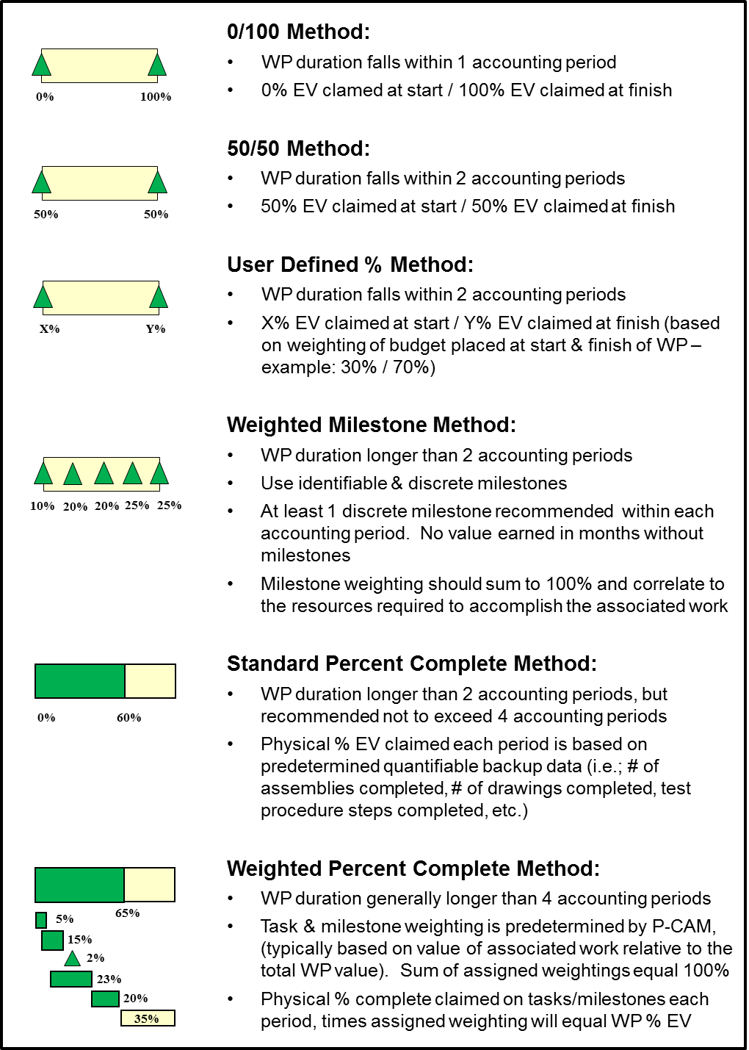
Figure 2-5 Discrete Work Package PMTs

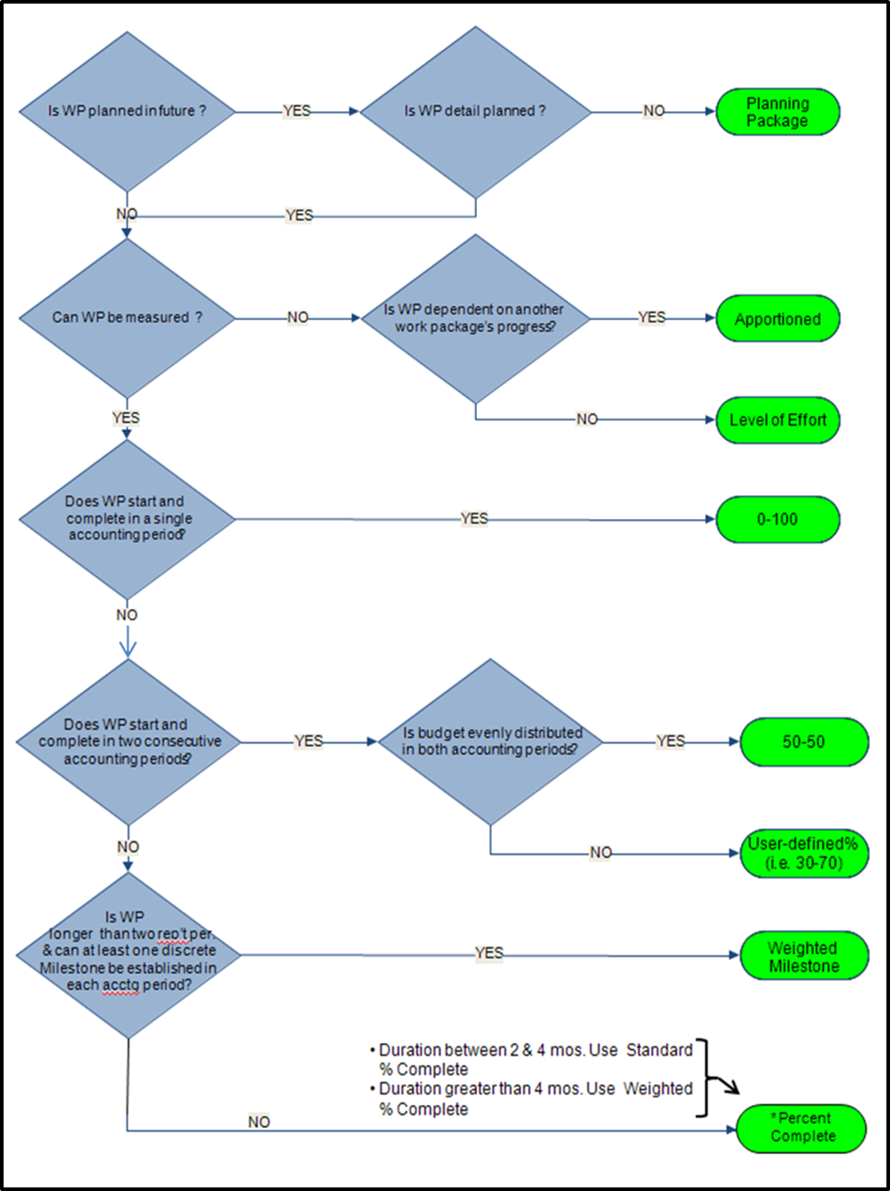
Figure 2-6 PMT Selection Process Flow

Apportioned Effort Method
Apportioned Effort’s budget value is planned in direct proportion to the budget of the effort it is directly related to. EV will also be in direct proportion to the EV of the related effort. Inspection and Quality Assurance are common examples of apportioned tasks. If Inspection was budgeted as 10% of Production, Inspection’s time-phased budget is planned in the same months as Production at 10% of Production’s budget. Inspection’s BCWP will be 10% of Production’s BCWP. Thus, Inspection’s BCWP is entirely dependent on the BCWP claimed by Production.
Best practices for Apportioned WPs:
  - The method is used only when a Discrete PMT cannot be used.
  - The Basis of Estimate (BOE) for the Apportioned Effort’s budget is defined as a specific proportion of the parent Discrete Effort.
  - The Apportioned Effort’s duration must be the same as the Discrete Effort to which it is apportioned, and the start and finish dates must be the same.
  - The proportion used cannot change during the duration of the apportioned WP.
  - An Apportioned WP may be apportioned to more than one discrete WP if the proportion does not vary.

Level-of-Effort Method
The LOE PMT method should be selected only after all others have been evaluated, reviewed for applicability, and found not to be appropriate. Activities comprising LOE WPs are more time-oriented than task-related, typically support or management related. These tasks may continue for the full term of the Project, or an element of the Project, but have no measurable deliverables or outputs. (e.g., Project Management, Business Management support, Contract Administration, Engineering support). Under the LOE concept, BCWP is automatically earned as a function of time passing; BCWP, or EV, always equals BCWS in these cases. Once started, an LOE WP never indicates a SV; however, a CV can be experienced.
Best practices for LOE WPs:
  - The LOE PMT is selected only for those tasks where discrete work measurement techniques cannot be effectively applied and the Apportioned method cannot be used.
  - LOE should not be used when there is an “end product,” a deliverable, or a discrete effort.
  - LOE efforts are separated from discrete effort at the WP level. When LOE and discrete effort are mixed within the same CA, the P-CAM must ensure visibility into the performance of the discrete effort. Therefore, a single CA may contain a combination of LOE and discrete effort WPs.
  - Within the IMS, LOE tasks must be clearly identified and be aligned with the start and finish of the effort they support or are associated with.
  - LOE budgets are separately sustained and planned as direct labor, material/subcontract, or ODCs. LOE activity should be budgeted on a time-phased basis for control and reporting purposes.
  - The amount of LOE activity varies among performing organizations, but should be held to the lowest practical level.
  - When commingling LOE with other EV Methods within a single CA, LOE exceeding 15% to 20% of the total CA budget may warrant its own CA.
  - As a rule of thumb, LOE is typically 20% of total project budget. If a project’s plan exceeds this goal, project management should justify the extent to which LOE is used.

Planning Packages
As stated earlier in section 2.4.5.1, PPs may be established for future work, where activities are not well understood or are not fully defined. PPs, normally scheduled to start beyond the near-term period within a CA, contain effort that eventually is detail planned and documented in WPs. They represent a defined scope of work and time-phased budget, but have not been detail planned into WPs. PPs meet the following general requirements:
  - PP efforts are normally scheduled beyond the current fiscal year (FY) and not earlier than 3 months to 6 months from the end of the current month.
  - PP effort can be identified to a specific CA, but cannot be identified as WPs due to lack of definition or significant unknowns.
  - PPs have scheduled start and completion dates that represent physical accomplishment and are compatible with the CA schedule.
  - Normally PPs should be converted to discrete WPs at least 3 months to 6 months prior to the scheduled baseline start of the effort, but in any case, they are converted prior to starting work. While not a requirement, it is recommended that work be detail planned into WPs prior to new FY start for the next FY whenever possible.
  - PPs have a time-phased budget expressed in hours and direct dollars for labor or in direct dollars for material, subcontracts, and ODC.
  - They have a statement of work to substantiate both the schedule and the budget.
Note: The PP budget cannot be defined without a similar/simultaneous definition of the Scope.
  - PPs cannot have an assignment of a normal, discrete PMT. For schedule planning, the value “PP” (or the PP code designated in the EVM/cost management tool) is selected in the “PMT” field in lieu of a PMT designation. Work that is identified with a PMT of “PP” cannot earn any value and requires future breakout into WPs.
  - PPs cannot have actual costs collected against them.
  - The sum of all WPs and PPs within a CA equal the total CA budget.
As work is more clearly defined, PPs are converted into WPs using a “rolling wave” planning approach. This is accomplished in accordance with the following guidance:
  - All PPs are converted into detailed WPs as requirements are defined.
  - PP conversion to WPs is accomplished by first identifying logical groupings of WP content related to a specific effort, product, or resource type then scheduling the work to the detailed activity and milestone level. The process is completed by assigning appropriate EV Methods and PMTs to the new WPs. The original PP budget is distributed to the resulting WPs, except for any portion of the original PP budget that needs to remain as a PP because the associated work scope is not yet clearly defined.
  - The baseline periods of performance of the resulting WPs fall generally within the original PP period of performance. The original PP baseline start/finish dates must be represented by the baseline start/finish dates in the resulting WPs. Significant exceptions to this rule must be documented in a revised WAD.
  - The sum of all WP budgets resulting from a PP conversion plus any budget remaining in a PP equals the original budget of the PP. All exceptions to this rule must be documented in a revised WAD.
  - PPs converted to WPs are detail planned to their completion.
  - Conversions from PPs to WPs are reflected in the EV module CAP reports.

Integration of Contractor/Subcontractor Schedule Data
The IMS also contains the official, contractually committed delivery schedule for key contract end items. When a project has elected to accomplish portions of the total project scope through contract partner relationship, the schedule for that effort may be developed and maintained by the contract partner and provided to NASA as a deliverable, at a minimum on a monthly basis, coincident with the contractor’s fiscal month end or as specified in the contract’s Project Schedules DRD. In these cases, the external schedule is received and integrated into the IMS at the lowest practical level. At a minimum, integration of schedule deliverable-receivable interfaces between NASA and the Contractor/Subcontractor are required. See NASA Schedule Management Handbook for more detail.

Schedule Margin
Schedule margin is the term used when planning for future situations that are impossible to predict (for unknown unknowns). It may also be referred to as “schedule reserve”. Just as it is an acceptable practice for technical designers and budget planners to factor in an allowable amount of reserve, tolerance, or flexibility, it is also a recommended practice for project planners to include an allowable amount of schedule margin within the project schedule. Schedule margin based on risks, duration uncertainty, and historical norms, should be included and clearly identifiable within the IMS. For clarification, schedule slack (float) is the calculated difference between early and late dates based on logic, constrains, and lags. It should not be considered as schedule margin. True schedule margin is a separately planned quantity of time above the planned duration estimate reflected in the IMS. Schedule margin is intended to reduce the impact of missing overall schedule objectives. Schedule margin is owned and controlled by the Program/Project Manager. Schedule margin levels should be monitored on a continuous basis and reported monthly to the project management team.

Schedule Margin Planning
To adequately address schedule margin in the schedule planning process, the P/S, PCAMs, and other project office leads must work together to determine an appropriate amount of reserve time to include within the IMS as identifiable schedule margin. Factors that may contribute to determining the amount of schedule margin are: a) expert judgment, b) rules of thumb, c) % of overall project (or activity) duration, d) calculated by expected value of risk impacts, or e) through insight gained from a probabilistic SRA. After determining a proposed reasonable amount of schedule margin, the Project Manager must first approve this additional project duration before incorporating into the IMS. Since this additional project time is added specifically to cover the impact of unknown risks and issues, no specified budget should be assigned to a schedule margin task because there is no known project scope involved. However, at the same time, it is very important that an adequate amount of management reserve (MR) or UFE be available to cover a reasonable workforce level through the duration of the schedule margin activity. It should be noted that applying the right amount of schedule margin is critical when establishing the Agency Baseline Commitment (ABC) with Congress and the OMB.
The preferred technique for including schedule margin within the IMS is to insert additional tasks that are specifically identified as “Schedule Margin” or “Schedule Reserve”. These tasks should have durations assigned that provide the additional quantity of time deemed necessary to absorb the impacts of unknown schedule risks. Schedule margin must be inserted into the IMS at strategic locations so that it satisfies its intended purpose as overall schedule management margin for project completion. To ensure this, it is recommended that this type of margin be placed at the end of the IMS network logic flow just prior to hardware delivery or whatever the appropriate project completion task/milestone might be. Other example locations for this type of margin might include placement just prior to Preliminary Design Review (PDR) and CDR. Only by clearly identifying the amount and location of schedule margin within the schedule can its use be tracked and managed adequately.

Schedule Assessment and Analysis
Figure 2-7 Schedule Assessment Checklist Example
Schedule assessment is the process of determining schedule validity and performance at a given point in time. A thorough schedule assessment using proven techniques such as those noted below should always be performed prior to establishing the IMS baseline. After establishing the IMS baseline, routine assessment is also necessary to maintain assurance that the schedule continues to generate valid data and to support the project’s objectives throughout the project life cycle. A reliable schedule assessment checklist is an important aid that can benefit the project team in determining schedule validity. A Schedule Assessment Check list example is contained in Figure 2-7.
Schedule analysis is the process of evaluating the magnitude, impact, and significance of actual and forecast variances to the baseline and/or current schedules. After routine updates, schedule analysis begins with the calculation of the CP and the determination of any change in the completion date of the project. Analysis continues by evaluating schedule performance metrics derived from the IMS and by using this information to assess project health. Analysis results should be reviewed with the project team. This process may be iterated as needed.
IMS assessment and analysis is the same during and after the completion of schedule development, except for progress evaluation. The processes that follow represent only a sampling of assessment and analysis techniques that should be continued routinely throughout the project life cycle. Additional IMS assessment and analysis information and illustrated techniques are provided in the Schedule Management Handbook located at https://www.nasa.gov/evm/handbooks.
  - Schedule Logic Credibility Health Check: Schedule credibility is determined by monitoring key indicators within the IMS that reflect both good and poor characteristics of schedule structure and maintenance. Examples of key indicators within the logic network that must be monitored include the following: number of missing predecessors and successors, excessive and invalid fixed task constraints, omission of task status, improper status on future tasks, logic relationships to/from summary tasks, excessive and invalid use of relationship leads and lags, and incorrect or inappropriate task interdependency relationships. These indicators are based on standard rules of logic network development utilized in CPM scheduling techniques. The indicators noted above should be identified and evaluated routinely from the to-go IMS details. This assessment technique can be accomplished manually by using normal data-filtering capabilities provided by an automated scheduling tool or by special third-party schedule assessment software add-ons. Evaluating the number of key credibility indicators will provide quick insight into the quality and validity of the project IMS.
  - Project CP Identification and Analysis: The schedule may become very dynamic during the implementation phase, and because of this, it is imperative to always know what sequence of tasks the real driver is affecting project completion. Management insight into the CP is essential in making accurate resource and workforce decisions to successfully achieve project completion. CP identification and analysis involves constant review of the validity of schedule tasks, durations, and types of relationships that are involved in the primary CP, as well as near secondary paths. Often changes made to durations and/or logic relationships can be made to shorten the CP and prevent project completion from moving to the right.
Common characteristics of a credible project CP include the following:
  - The project CP reflects the longest path (usually having the lowest slack or float values) to project completion.
  - The CP typically starts at the beginning—or at “time now” after monthly statusing has begun—and continues to project completion.
  - Tasks and milestones reflected on the CP are tied together with network logic in a sequence that is programmatically feasible or otherwise makes sense from a workflow standpoint.
  - The CP contains no LOE or summary activities, unless it is determined by the project team that network logic relationships are to be identified at the Intermediate level of the IMS. In these cases, the project CP would most likely also contain summary-level tasks.
  - Note: When performing project CP analysis on IMS data, it is important to filter out all LOE tasks from the data being analyzed to prevent erroneous or inaccurate CP identification.
  - The CP contains no gaps in time between tasks that cannot be explained.
With sound IMS structure, the project CP should be identifiable by isolating the sequence of tasks that has the least amount of total slack (float) as calculated using the CPM technique of scheduling. The project CP can only be identified accurately if all task and milestone interdependencies are satisfactorily incorporated into the IMS to form a complete end-to-end logic network. It is recommended that after each update cycle of the IMS, the CP should be identified and compared to the previous month’s CP. Analysis of differences between the previous and current CPs should ensure a clear understanding of why changes occurred and if work-around steps should be taken. Close monitoring and analysis of the top three to five paths is also recommended and will ultimately provide management with the necessary insight to better keep the project under control and on track for successful completion.
  - SRA: Conducting an SRA is crucial during project formulation and throughout the on-going implementation life cycle of a program/project. Although there are various ways of evaluating cost and schedule risks and confidence levels, a recommended technique is using a proven probabilistic risk assessment tool with random sampling functionality. The SRA is an important analysis process that evaluates the likelihood that project implementation, as reflected in the IMS, is achievable on or before the planned completion date. The analysis results obtained from the SRA provide two very significant management benefits. First, it provides management insight into the validity of schedule data contained in the IMS which serves as the basis for time-phasing of the EV performance measurement baseline. And second, these results are very beneficial in providing a basis for determining an adequate amount of schedule margin to include in the IMS. The amount of schedule margin is a key factor in determining the adequacy of project management reserve and project UFE.

IMS Baseline Considerations
When an executable plan has been developed and coordinated with the project goals, it becomes the basis for the initial EAC and original PMB. The baseline schedule is approved by project management and constitutes the official plan against which schedule performance is measured and reported to NASA Project/Line Management and the sponsoring Agency or customer. A project IMS containing negative total slack (float) should never receive baseline approval. A project schedule in this condition represents an unachievable implementation plan and must not be baselined. Schedule baseline data are maintained and controlled within the IMS. Changes to the schedule baseline are permitted in the event of negotiated contract (Program Plan and Project Plan or IAWA) changes that authorize a change in the statement of work and budget, or changes to the scheduled delivery. Any new approved effort is incorporated into the IMS and identified as new WPs and/or CAs and new associated baseline schedule information is established. Care is taken to ensure traceability and consistency among the various levels of schedules as schedule baseline changes are incorporated via revised WADs. Scope, schedule, and budget are integrated, and the completed revision to the PMB is approved, issued, and set in accordance with the Change Management process, see Section 7.

Schedule Baseline Maintenance
Throughout the life cycle of the project, there will be changes to the schedule as it serves as a dynamic record of the work performed. Most of these changes will be recorded in the current schedule without the need to change the baseline schedule. Baseline schedule control is a disciplined process for managing baseline schedule data and making the necessary changes to baseline content. Baseline schedule data represent firm commitments, while current schedule data reflect the most current forecast of how work is progressing and being managed. Baseline schedule changes are to be clearly identified, evaluated, documented, and approved. Formally documented schedule control provides assurance that the approved baseline IMS includes all the work authorized and is maintained in a manner that is accurate, traceable, and defendable.
It is recommended that for those changes that are reflected only in the current schedule, such as a simple re-ordering of task sequence causing no impact to WP start/finish, and are determined not to require a formal baseline change, that they also may be informally logged and communicated to project team members, line management, and other stakeholders using a process established by the project office so that on-going resource planning by management can be maintained in an effective manner.
As stated above NASA organizations should use a configuration control process to manage various types of technical and programmatic baseline changes. What follows is a description of the typical process sequence for a project engaged in baseline schedule control. This process is used regardless of whether the proposed change is to the external or internal schedule baseline. Terms and details reflected below may vary to some degree between projects.
  - A Change Request for the IMS is initiated by a responsible program/project Technical Lead, responsible contractor, or other outside customer source. (See Figure 7-4)
  - The responsible change initiator who originates the Change Request documentation should coordinate with the project Schedule Office to determine the resulting impacts caused by the proposed change. Impact analysis should be conducted on both external and internal schedule baselines. This may require the preparation of “what-if” versions to assess the impact of the proposed change utilizing the original baseline plan, the currently approved baseline plan, or the current updated IMS.
  - The Change Request not only documents a clear description of the proposed change, but also the “before” and “after” effects of the proposed change on the internal and external schedule and budget baselines.
  - The Change Request is then brought to the governing project Change Control Board and reviewed in accordance with the project’s Configuration Management Plan. Note, if the proposed schedule change impacts the external schedule baseline, then review and approval will also be required by the appropriate governing change board at the program, mission directorate, or Agency level.
  - Once the schedule Change Request has been formally approved by all the applicable change control boards, the project P/S issues an updated schedule with a new revision designator assigned to the baseline IMS.
  - The project P/S should maintain a log of all revisions to the baseline IMS. This log provides the on-going baseline schedule traceability required for sound project configuration control.

Schedule Status
In support of the institutional Performance Measurement and EVM requirements, the IMS is updated to capture actual progress of work and forecast plans to-go. The schedule status process will also include, but is not limited to, the updates to logic network elements such as, modifications to activity interdependencies, changes in logic lags or leads, adding or removing date constraints, changes to activity durations, addition of new activities or milestones, removal of activities/milestones that are no longer valid.

Schedule Status Process
The P-CAM and P/S work together to document performance information on the current schedule as of the status date without disturbing the WP and activity baseline plan. Schedule status for external efforts (e.g., other NASA Centers, contractors, or university partners) is provided as contractually required, or by other mutual agreement, to the P-CAM, Contract Technical Manager (CTM), the Project Manager, and Business Manager.
To ensure progress and forecast plans are accurately captured and represented, all current period WPs in the IMS are updated at the detailed activity and milestone level. Monthly schedule assessment and reporting involves the P/S, all project PCAMs, SP/EMs, and the customer. Activities and milestones within the WPs are statused relative to accomplishments, resources available, and deliveries made. With support from the P/S, the PCAM, Project Manager, and Business Manager are jointly responsible for the schedule assessment and reporting. Where schedule slips occur, horizontal or vertical dependency conflicts, or resource problems are identified, CP and SV analyses are reported at the project level and within affected WBS elements. The P/S evaluates the information provided against the original baseline and analyzes the impact on the current plan. Impact analyses summarize changes to the logic of the workflow and any affect to future or external work efforts. The P/S considers the impact of logic changes to the CP and reports the way a change impacts subsystems within the flow of work to all affected PCAMs. They also facilitate schedule related corrective action planning and issue resolution. Ultimately, performance information at the WP level is derived from the objectively determined status of the time-phased activities and milestones composing the WPs and based on predetermined QBD. The P/S documents rationale for significant variance.
The status of contractor/subcontractor effort is determined via the contractors’ schedule reporting and performance measurement systems, and obtained through the Contractor/Subcontractor cost, schedule, and EV reporting requirements to the project. Schedule performance data are then validated utilizing contractor schedule status provided to the project and validated by the P-CAM.
The P/S analyzes and reports project level schedule information to the Project Manager, P-CAMs, and other project management leads, and key stakeholders. Intermediate WBS element schedule information is provided to SP/EMs and, if significant SV exists, CA level schedule information to specific P-CAMs.

Scheduling Summary of Responsibilities
Responsibility and accountability for implementing the scheduling processes in NASA’s EVM Capability are distributed throughout the project organization as discussed below.

Project Manager
With support from PP&C, the Project Manager is responsible for the following:
  - Ensures that an IMS meeting the parameters contained in section 2.2 is established for the project and that the parameters are applied consistently throughout the life of the project.
  - Provides overall schedule constraints and guidance to the project.
  - Oversees P-CAM development of detail level CA schedules.
  - Oversees and approves development of the Project Top Level Schedule.
  - Reviews the development of CA and intermediate level schedules. Monitoring impact to the Top-Level schedule during the baseline development and in the succeeding status collection.
  - Ensures that vertical traceability through all tiers of schedules is achieved.
  - Ensures that horizontal dependency of key program activities is achieved through the establishment of a schedule network logic.
  - Review assessment, and overall approval of monthly IMS status, including the analysis for impact on the total project. Coordinating the development and approval of corrective action plans when required.
  - Reviews CA schedule status each month to assure correlation between the CA/ WP performance indicators and the performance as reflected in the project schedules.
  - Formal approval of all schedules when the baseline IMS is completed or revised via signature authority on Work Agreements.
  - Reviews all significant variances and work-around plans for approval or disapproval after schedules have been statused each month.
  - Ensures project schedule margin is reasonable and controlled.

Subproject/Element Manager
With support from PP&C, the SP/EM is responsible for the following:
  - Oversees P-CAM development of detail level CA schedules.
  - Ensures adequate schedule status information is provided by P-CAMs.
  - Supports negotiations between P-CAMs on deliverable-receivable product exchanges.
  - Oversees and approves, plan to go and work around plans stemming from schedule issues or impacts between CAMs.
  - Assesses and approves schedule status at the Project Element level.

Project-Control Account Manager
With support from PP&C and technical leads, the P-CAM is responsible for the following:
  - Produces detail schedule activity data, representing the approved scope of work, enabling development of logic driven network schedules below the CA level which are integrated to form the IMS. The IMS depicts horizontal and vertical dependencies, slack/float, development and delivery time frames, and CP.
  - Determines appropriate PMT assignments for discrete WPs.
  - When applicable, assists in preparing intermediate level schedules with sufficient detail to provide vertical traceability from CA through Top-Level Schedule. See step 2.02. If the project determines that IMS vertical and horizontal traceability is required at the detail level, then the PCAM will also assist in developing the necessary task coding to be assigned that will provide the desired Intermediate schedule rollups (see step 2.06).
  - Provides schedule status and update information for all in-process activities on a monthly basis after the baseline IMS is established/approved. This includes not only status to-date, but also changes to the following: forecast start and completion dates, durations, calendars, constraints, and task interdependencies.
  - Assesses and approves monthly schedule status at the CA level.
  - Analyzes schedule activities for slippage and impact on CA or other independent work (e.g., contractors). Develops workaround/corrective action plans for project management review and approval.

Planner/Scheduler
Working with PP&C, the Planner/Scheduler (P/S) is responsible for the following:
  - Facilitates and assists with the development of detailed CA schedules, definition of WPs within the CA schedules, assignment of WP performance measurement techniques, and milestone/activity weighting (where applicable).
  - Facilitates incorporation and integration of detail level CA schedules into the Project’s IMS.
  - Facilitates and assists with development of tiered schedules which ensure vertical traceability to the IMS. These tiers include the Detailed, Intermediate and Top-Level Schedules.
  - Analyzes and reports impact to the Top and Intermediate Level schedules during the baseline development and in the succeeding status collection.
  - Facilitates and assists in determining a reasonable amount of schedule margin to be incorporated into the IMS.
  - Records and controls the IMS baseline, establishing the basis for cost-schedule integration.
  - Manages the IMS baseline and working dataset, ensuring schedule integration, integrity, and reporting accuracy are maintained.
  - Ensures the use of Agency and institutional standard schedule processes, practices, and tools that can provide valid and timely scheduling information.
  - Performs schedule analyses, provides schedule metrics, and assists with comprehensive assessment of schedule status and forecast for impact on the total program.
  - Leads preparation of corrective action plans for significant SVs, facilitates capture of these plans within the IMS, and provides impact analysis.
  - Ensures export of required monthly schedule earned data to the project EVM/cost tool.
  - Assesses and analyzes monthly EVM data for accuracy and impacts to the project.

WORK/BUDGET AUTHORIZATION
Work/budget authorization has two major components: Work Delegation and Authorization (3.1) and Cost Planning and Budgeting (3.3).This section describes the process for authorizing work scope, schedule, budget, and assigning responsibility from the Sponsor, Program, and Project levels to the CA through the responsible organization level. It also addresses how Project budgets and baselines are established and controlled and how budget is allocated from the project level down through the WP level. This section includes a summary discussion of Work Authorization (3.1); parameters for Work Authorization (3.2); followed by a summary discussion of Budgeting (3.4); parameters for Budgeting (3.4); the Work/Budget Authorization Process (3.5) and Work/Budget Authorization Procedure (3.6).
Detail discussions and documentation for Program/Project Budgeting and Funding, and Project Budgeting for EVM are included in 3.10, and 3.11, respectively.

Work Authorization Introduction
The management team is appointed during the formulation of the project, and includes the Project Manager, SP/EMs and PP&C personnel. They establish the management team, authorize the expenditure of budgets, further define the lower level WBS elements, and integrate the WBS with the Line Organization to define CAs, identify P-CAMs, and authorize the planning and budgeting of CAs.
Normally, there are four types of authorization on the project.
  - Authorization for NASA Projects from NASA is accomplished by the execution and receipt of an approved Program/Project Plan.
  - Authorization from the Project Manager to a P-CAM is achieved with the issuance of a WAD.
  - Contract authorizations are discussed in Section 9, Contract Management.
  - IAWAs provide authorization for work between Project Offices at NASA Centers and are discussed in Section 10.
Authorization for activities defined within CAs is traceable to the NASA program-level work authorization document or equivalent form e.g. (Project Commitment Agreement, FAD).

Work Authorization Parameters
The following parameters apply to Work Authorization:
  - All authorized work is clearly defined using the framework of the project WBS decomposed or extended to a CA level.
  - A specific individual is assigned from the responsible organization to manage a specific CA scope of work, schedule, and budget. This individual has direct responsibility for the work and directs the resources required to accomplish the work.
  - If there is a change to assignment of responsibility, WBS, scope of work, period of performance, or a revision to an existing WAD, a revised WAD is issued.
  - All authorized work is clearly traceable to the authorized project phase, e.g., Formulation vs. Implementation.
  - Work is not performed, costs are not incurred, and procurement is not initiated unless authorized by a WAD.

Budgeting Introduction
When the Project Plan has been approved for projects where EVM is required, the CA planning process begins with issuance of the Preliminary Planning Guidelines document providing detail planning guidance and ends with approval of the CA cost/schedule baseline. Through sponsor direction, the Organization process, and the Work Authorization process, the project is subdivided into the various WBS elements and the project (authorized Project Plan) budget is divided accordingly. The total value of the relevant Project Plan equals the Project Budget Base (PBB) for the project. In other words, the formal allocation of budget throughout the project continues from the Project Manager to the P-CAMs.

Budgeting Parameters
The following parameters apply to Budgeting:
  - The PBB is reconciled to the Project’s target cost, including UFE and MR.
  - Budgetary data are used to establish the initial PBB in support of the Management Agreement. Project funding or EAC are used to prepare the annual project budget submission in support of the annual Planning, Programming, Budget, and Execution (PPBE) process.
  - The project’s WBS is consistent with the NASA standard space flight project WBS and has an associated WBS dictionary. (NPR 7120.5)
  - The project’s PMB is established in Phase B and baselined at PDR.
  - The sum of all WP and PP budgets within a CA equals the total CA budget.
  - Normally PPs should be converted to one or more WPs three to six months prior to the scheduled baseline start of the effort, but in any case, they must be converted prior to starting work.
  - Budgets allocated to CAs, i.e., distributed budget, are reconciled to the PBB less MR, and Undistributed Budget (UB).
  - Where there is effort associated with a WBS, but not yet allocated to a responsible P-CAM, PPs may be used to establish a high-level holding account for budgeting purposes that are controlled by the Project Manager.
  - A budget represents the negotiated estimate for costs associated with a particular scope of work and takes the form of allocating resources (labor hours, direct dollars, or other measurable units) to schedule activities.
  - Budgets are stated in hours, dollars, or other measurable units but are typically converted to dollars so they can be compared to actual costs.
  - The project budget is integrated with the Project Plan scope of work and the approved project schedule.
  - Identified WPs are planned to their completion.
  - The BCWS typically is segregated by cost element within CAs.
  - Future work that lacks the definition needed to plan the work, usually beyond six months, are defined within one or more PPs.

Work / Budget Authorization Process
The Work/Budget Authorization process flow, Figure 3-1, is shown on the following page; the process procedure is described in 3.6.

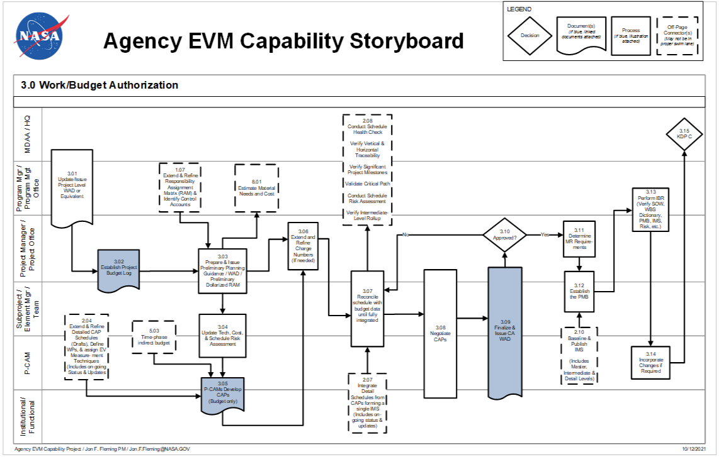
Figure 3-1 Agency EVM Capability Flowchart: Work/Budget Authorization

Work / Budget Authorization Procedure
Role | Flowchart Step | Action or Input/ Output
Mission Directorate Associate Administrator (MDAA)/ Headquarters and Program Manager or Program Management Office /Project Manager / Project Office | 3.01 | Update/Issue Project-Level WAD or Equivalent. During execution of Phase B while preparations for Phase C EVM implementation is in process, program changes, such as changes in technical content, delivery dates or funding profiles may necessitate issuing or updating a program-level WAD or equivalent form, FAD, Project Plan) that, among other things, affirms the scope, schedule and budget for the project and is approved by the program manager and the project manager. Also, in some cases, a Project Authorization Document may be issued. This serves as the basis for agreement of the authorized scope, schedule, and budget between the program and projects to establish the Project Budget Base and Project Budget Log values.
Project Manager or Project Office and SP/EM/Team | 3.02 | Establish Project Budget Log. The Project Budget Log is established with the project target cost estimate established for the authorized work to maintain traceability of the project’s total budget and all changes that occur over the life of the project, which includes the distribution of budget to the CAs as well as the establishment and changes to UFE/MR and UB. Changes to the project budget as a result of directed increases/decreases in project scope, e.g., AUW, are entered into the Log to maintain total project budget traceability for the authorized effort. These logs with the associated changes will be maintained through the life of the project.
 | Input from 1.07 | Extend and Refine Responsibility Assignment Matrix RAM and Identify CAs.
Project Manager or Project Office and SP/EM/Team | 3.03 | Prepare and Issue Preliminary Planning Guidance /WAD/ Preliminary Dollarized RAM. Once an initial target amount for UFE/MR and UB has been identified, a preliminary Dollarized RAM should be created to show the distribution of the remaining project budget to all the CAs. The project office can then provide Preliminary Planning Guidance to all P-CAMs, which includes the budget allocated to each CA as shown in the preliminary Dollarized RAM, and ground rules associated with establishing time phased budgets for their CA(s) WP/PP(s). Preliminary planning guidance to the P-CAMs may be provided through the use of various forms such as draft WADs, budget targets, or a preliminary RAM to the CA level that identifies scope, schedule and budget.
 | Output to 8.01 | Estimate Material Needs and Cost.
SP/EM/Team and P-CAM | 3.04 | Update Technical, Cost, and Schedule Risk Assessment. The P-CAMs will develop/update the risk assessment for their respective CA(s) based upon technical risks, schedule margin, and cost uncertainty. Technical reserve requirements should be based upon technical risks, identified during the Project Risk Management process. Technical risks include risk identification, mitigation, probability of occurrence, and the estimated cost of the mitigation plan. P-CAMs should be cautioned that known issues, and realized risks at outset should be included in baseline. In addition, Schedule reserve requirements are required to support schedule margins identified in the IMS. The cost associated with the schedule reserve should be calculated based upon peak burn rates for planned development, or integration activities. The probability or cost uncertainty should be developed in conjunction with the BOE, for example, labor, material or contractor/subcontractor costs which are based upon current (i.e., within the last 12 months) estimates. P-CAMs should consider bounding the most likely cost estimate with best case and worst case. P-CAMs should also identify opportunities of cost reduction. Opportunities are treated similar to risks, except that opportunities represent potentially positive impacts to reserves. Whereas risks are common, few opportunities are identified, exercised or realized. Some opportunities occur as a positive return on investment (i.e., the project spends money to save money) or potential unanticipated benefit (e.g., rate reductions, lower labor rate costs, cost efficiencies/under-runs, technology advancements, etc.). Other opportunities can be realized only by impacting reliability, engineering, or science (e.g., test reductions, de-scopes). These last examples, while common, are not desirable and should be considered only after all other efforts have been exhausted.
 | Input from 2.04 or | Extend and Refine Detailed CAP Schedules (Drafts), Define WPs, and Assign EV Measurement Techniques (Includes On-going Status and Updates).
 | Input from 2.05 | Extend and Refine Logic-Linked Detailed CAP Schedules (Drafts), Define WPs, and Assign EV Measurement Techniques (Includes On-going Status and Updates).
 | Input from 5.03 | Time Phase Indirect Budget.
P-CAM and Institutional/Functional | 3.05 | P-CAMs Develop CAPs (Budget Only). Based on the CA budgets allocated via the Preliminary Planning Guidance and the logic-linked detailed schedules developed by the P-CAM, the CAPs are created by entering the time phased WP/PP budgets into the cost tool at the resource level. Ideally, the WPs/PPs have been separated by elements of cost within the logic-linked detailed schedules. The resource categories for the planning budgets for the WPs/PPs should relate to the resource categories of the actual costs so that variance analysis can be performed.
Project Manager or Project Office | 3.06 | Extend and Refine Charge Numbers (if needed). While the charge number structure is in place for work already ongoing in phase B, the Project Office, the P-CAMs, or the institutional organizations may have developed lower level WBS elements and/or a more detailed WP/PP structure in the IMS as part of step 2.04 which may be needed for phase C implementation. The Project Office needs to define the correlation between the cost collection system (charge numbers) and the technical work (CAs and WPs). This correlation may have a one-to-one or a one-to-many type relationship between the charge numbers and WPs; but ultimately, all work must summarize to charge number elements within the Core Financial System WBS. For cost control purposes, the Project Office should authorize the creation of all charge numbers associated with the authorized work. The Project Office should only enter new WBS elements (charge numbers) within the Core Financial System when work is started in the new area, since WBS elements (charge numbers) cannot be deleted from the Core Financial System once entered (even when future re-plans make certain WBS elements obsolete).
 | Input from 2.07 | Integrate Detailed Schedules from CAPs, Forming a Single IMS (Includes On-Going Status and Updates).
Project Manager/ Project Office, SP/EM/Team, and P-CAM | 3.07 | Reconcile Schedule with Budget Data Until Fully Integrated. Once the P-CAMs detailed WP/PP schedules are loaded in the scheduling tool and detailed, time-phased budgets are loaded in the cost tool (if the schedule is not resource loaded), an iterative, reconciliation process takes place to ensure CA schedules and budgets are fully integrated and consistent with the Work Authorization Documents (WAD). This iterative process is necessary at all levels to ensure schedule and budget are fully integrated at the project level.
 | Output to 2.08 | Conduct Schedule Health Check, Verify Vertical and Horizontal Traceability, Verify Significant Project Milestones, Validate Critical Path, Conduct Schedule Risk Assessment, Verify Intermediate-Level Rollup.
Project Manager/ Project Office, SP/EM /Team, P-CAM, and Institutional/Functional | 3.08 | Negotiate CAPs. Once the schedule and budget baselines have been reconciled, the Project Manager reviews and approves the CAPs. These negotiations will include the P-CAMs and Institutional Managers.
Project Manager/ Project Office, SP/EM /Team, P-CAM, and Institutional/Functional | 3.09 | Finalize and Issue CA WADs. The WADs for all CAs are updated, as required, based on the outcome of negotiations between the Project Manager, Institutional/Functional Managers and the P-CAMs for scope of work authorized by the NASA Headquarters sponsor. The signature of these managers on the WAD constitutes the formal agreement on the scope, schedule, and budget to execute the work authorized by the NASA Headquarters sponsor during process step 3.01.
Project Manager / Project Office | 3.10 | Approve CA WADs?  If YES, proceed to 3.11. The signatures of Project Manager, Institutional/Functional Manager, and the P-CAM on the WAD constitute approval of the formal agreement on the scope, schedule, and budget to execute the work authorized in step 3.01.  If NO, return to 3.07. In instances where a CA’s WAD cannot be finalized between the Project Manager, Institutional/Functional Managers, and the P-CAM, schedule/budget reconciliation and negotiations will be iterated.
Project Manager / Project Office | 3.11 | Determine MR Requirements. The project MR requirements are determined based upon the combined costs required to cover risks, schedule reserve or margin, and cost uncertainty. The basis for this analysis is the risk assessment conducted in process step 3.04 and the final outcome of the CA negotiations from process step 3.08. However, MR requirements will need to be re-assessed and revised periodically as the project team manages the ongoing effort.
 | Input from 2.10 | Baseline and Publish IMS (Includes Master, Intermediate, and Detail Levels).
Project Manager / Project Office, and SP/EM/ Team | 3.12 | Establish the PMB. Approved/signed WADs; Approved/signed CAPs with time-phased WP/PP budget loaded in the cost tool; a baselined IMS loaded in the scheduling tool; establishment of Management Reserve and UB; all changes from the project target cost estimate to the approved budget are recorded in the Project Budget Log for traceability; and work scope, budgets, and schedules fully integrated constitutes the establishment of the PMB.
MDAA / Program Manager / Program Management Office, and Project Manager / Project Office | 3.13 | Perform IBR. Mission Directorates shall conduct a IBR to ensure that the project’s work is properly linked with its cost, schedule, and risk and that the management processes are in place to conduct project-level EVM.  Note: Additional information regarding IBRs can be found in NASA EVM Implementation Handbook and NASA IBR Handbook.
P-CAM | 3.14 | Incorporate Changes (if required). The PMB must always reflect the actual plan for work in order to assess the project’s performance. To ensure the accuracy of the PMB, as project execution or external factors necessitate change, the Change process is critical to keep the plan current. If any changes are made to the PMB after the aforementioned reviews, then the changes should be incorporated using the change control process as outlined in process flows 7-1.0 and 7-2.0.
MDAA/NASA Headquarters | 3.15 | Conduct KDP C.

Work Authorization Summary of Responsibilities

Project Manager
  - Allocates budget to SP/EM and/or P-CAMs via the WAD.

Subproject/Element Manager (SP/EM)
  - Allocates budgets to P-CAMs.

Project-Control Account Manager (P-CAM)
  - With the assistance of project planner/scheduler decomposes the elements of a WAD into WPs and PPs.
  - Negotiates and approves all work authorization documents.

Project Planning and Control (PP&C)
  - Ensures that all WADs are negotiated and approved in a timely manner.
  - Provides the custodial archive for the BOEs, Resource Plans data, WADs, and EV module CAP reports.

Budgeting Summary of Responsibilities

Project Manager
  - Project planning and direction.
  - Allocates budget to P-CAMs via the WAD.
  - Approves all WADs.
  - Leads project effort to support IBRs.

Subproject/Element Manager (SP/EM)
  - Determines feasibility of CAPs.
  - Is responsible for the BOEs of all P-CAMs under his/her direction.
  - Reviews and approves EVM application CAP reports.
  - Reviews each P-CAM’s EVM reports and provides status to executive management.
  - Supports IBRs.

Project-Control Account Manager (P-CAM)
  - Participates in the cost planning and budget allocation process.
  - With the assistance of project planner/scheduler, identifies the tasks to be accomplished within the CA in order to complete the CA effort.
  - With the assistance of project planner/scheduler decomposes the elements of a WAD into WPs and PPs.
  - Budgets each WP task by element of cost and resource required.
  - Generates a BOE for each WP and CA.
  - With the assistance of project planner/scheduler classifies all effort as Discrete, Apportioned, or LOE.
  - With the assistance of project planner/scheduler assigns a PMT to each WP.
  - Converts PPs into WPs in a timely manner.
  - Ensures that all CAs are within the constraints of project schedules.
  - Negotiates and approves all Work Authorization Documents for their CAs.
  - Supports IBRs.

Project Planning and Control (PP&C)
  - Ensures that all budget transactions are logged in the appropriate project budget logs.
  - Assists the SP/EM in establishing budgets.
  - Reconciles the project budget with the project authorized value.
  - Assists P-CAMs in planning their CAs.
  - Integrates all time-phased budgets to the appropriate schedules.
  - Ensures that all WADs are negotiated and approved in a timely manner.
  - Ensures that all WP milestones fully support the CAs for which they are prepared.
  - Provides the custodial archive for the BOEs, Resource Plans data, WADs, and EVM CAP reports.
  - Ensures that all budget data are correctly entered into the EVM software tool and the Agency’s accounting system.
  - Ensures that all CAs are properly statused on a monthly basis.
  - Supports IBRs.

Work Authorization Narrative
The work authorization process is a critical aspect of any integrated management control system. Before work begins, the work authorization system defines and identifies the work to be accomplished, the organizational unit responsible for that work, the completion criteria for the work, the schedule (i.e., at a minimum, the period of performance) within which the work is to be performed, and the budget negotiated for the work.
Figure 3-2 Work Authorization Trail
The work authorization process is a documented method that subdivides the authorized work into manageable units of work and identifies the organization and individual responsible for its accomplishment. The further down the work authorization trail (see Figure 3-2), the more specific is the scope of work and the responsibility assignment. When the unbroken “chain of authority” exists, satisfaction of the NASA Program/Project Management requirements for maintaining accountability and managerial control is enabled.
Project activities are authorized and initiated through the use of a NASA Program Plan, Project Plan, and Work Authorization Document (Figure 3-2) that authorizes a P-CAM to accomplish tasks within a project.

Program and Project Authorization
Approval of the Program Plan by the Mission Directorate Associate Administrator (MDAA) constitutes formal authorization to proceed. The Program Plan documents the authorized scope of work (Project Elements), requirements, the period of performance (schedules), and the PMB and MR.

Control Account Work Authorization
The primary objective of the work authorization process is to enable the Project Manager and SP/EM to authorize scope, schedule, and budget for each CA; and for the P-CAM (and the P-CAMs organization) to accept responsibility to perform within the parameters of that authorized scope, schedule, and budget.
Figure 3-3 Example of WADs: Systems Project Office
A WAD is the instrument to authorize work and should be fully approved before work is begun. WADs contain the scope of work traceable to the Project Plan’s scope of work, a schedule, a budget, a unique identifying WBS/CA code number and the name of the person responsible for managing the work (i.e., the P-CAM). The WAD serves as a bilateral contract between the “giver” (Project Manager or SP/EM) and the “receiver” (the P-CAM). See Figure 3-3.
Approved WADs demonstrate alignment between the project and the responsible organization for scope, schedule, and budget for a given work element, as well as an unbroken chain of authority for work authorized via a Project Plan down to the lowest WBS element or CA. The nature of work authorization requires that all elements of the WBS where costs are being incurred are documented and approved.
The P-CAM should be assigned from the group that provides the preponderance of effort for the given CA activity. Application of this principle ensures that the line approval for this effort is by the organization with the most significant share of the work effort.
The issuance and approvals of the WAD to the P-CAM completes the initial top-down authorization process. The P-CAM continues that process by fully defining the assigned scope of work into lower level near-term tasks (WPs) and far term tasks (PPs). The WPs and PPs are time-phased and budgeted based on the resources required to complete the work contained therein. When the P-CAM completes the CAP, project business personnel work with the P-CAM, SP/EM, and Project Manager to reconcile any differences between the scope, schedule, and budget originally assigned and those same elements as defined in the baseline CAP.
The scope, schedule, and budget must be determined for the entire scope of work for the CA before the final “baseline” approvals of the CAP documentation occur. The P-CAM is accountable for the management of the CA effort and is expected to take all possible legal and ethical steps needed (within the bounds of the NASA EVM Capability) to accomplish the authorized scope of work in accordance with the established budget and schedule. Any changes throughout the life cycle of the project to the scope, schedule, or budget are identified in a Change Request Document through the Change Management process. Revisions to CAPs are discussed in Section 7.

Control Account Charging Authorization
Authorization to charge labor, material, or ODC to a CA can be provided by the P-CAM or his/her Line Supervisor. While the authorization process may vary among NASA Centers, in each case this authorization is required in order for labor, purchase requisitions for procurements, and service orders/etc. for ODC costs to be charged to the account (Figure 3-4).
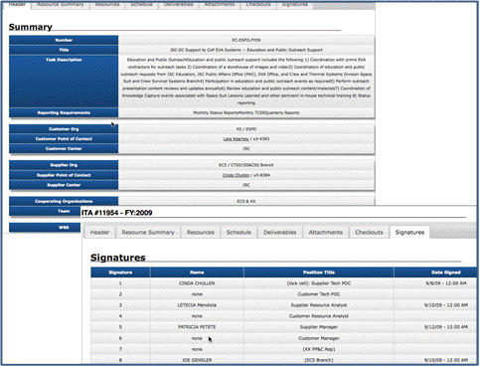
Figure 3-4 Example of P-CAM Authorization: Johnson Space Center

Program/Project Budgeting and Funding Process
NASA employs a variety of “Budget” processes to satisfy the wide variety of Stakeholders. This section clarifies the relationships between the following NASA “Budgets”: Agency Baseline Commitment (ABC), Management Agreement (MA), PBB, Funding Budgets and Operating Plans, and PMBs.

Budget Types of Baselines
ABC: An Agency Baseline Commitment is the highest-level commitment for NASA and is established at the beginning of the Implementation Phase of a program or project’s life cycle, at KDP C. It includes the program’s approved funding budgetary target. This target is used by the OMB and Congress as the total appropriation target value for the funding request and some additional UFE, and/or schedule or margin/reserve added by the mission directorates.
MA: A Management Agreement is established at each KDP specifying the cost (by year, including UFE managed by the program or project); schedule; and margins available to the project for completing the approved project scope; along with the associated Joint Confidence Level (JCL), when required.
PBB: The Project Budget Base is the project’s authorized value (with an associated scope and schedule) to which the project’s Distributed Budget, UB, Management Reserve (if applicable), and AUW must reconcile. All detailed planning below the project level is constrained by the PBB. The PBB is established on the foundation of a funding construct. For the purposes of planning and controlling the project and measuring performance accomplishments the PBB transitions to, and is managed as, a budget baseline.
PMB: The Performance Measurement Baseline is the time-phased budget expressed in dollars with separate identification of cost elements. It applies to the entire scope of authorized work and spans the project’s period of performance. The PMB is time-phased via integration with the network schedule at the WP and PP level. The PMB consists of the aggregation of individual time-phased CA budgets, including all burdens, for current project plans. The PMB is time phased based on when work is to be performed, and not when funds are committed, obligated or disbursed. Therefore, it is a budget baseline, not a funding plan. A comparison of EVM baseline budget and funding concepts is show in Figure 3-5.
Figure 3-5 Comparison between EVM Baseline Budget and Funding Concepts

ABC Relationship to PMB
The PMB is established in Phase B. NASA in-house projects are required to establish an ABC with OMB and Congress at KDP C, which is the transition gate between Project Formulation and Project Implementation.
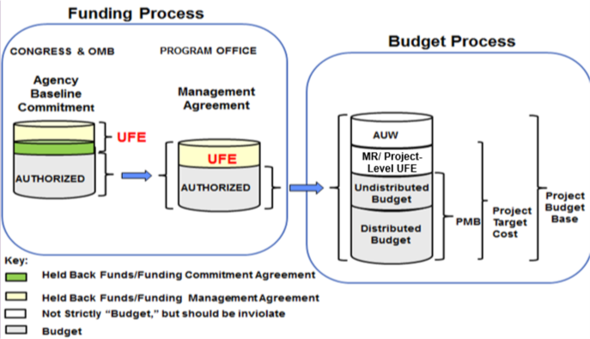
Figure 3-6 Commitment and Project PMB

Programming Phase
The Programming Phase includes the definition and analysis of programs and projects, together with their multi-year resource implications, and the evaluation of possible alternatives, including a risk assessment of each option. Programming also serves to balance and integrate resources among the various programs according to identified priorities.
The Programming Phase begins the process of identify multi-year resource (funding) guidance.

Budgeting Phase
The Budgeting Phase includes justification of the project performance budget and forecast to OMB and Congress. The project forecast requested, on an annual basis, is for two years in advance of actual year of execution. The intent of a “performance budget” is to communicate to OMB and Congress the performance commitments NASA is making for the project. The project forecast is to communicate the requested funds.
From a financial management point of view, the project forecast data are used to prepare the annual project budget submission in support of the annual program budget submissions. This forecast represents the fiscal resources required to cover the cost incurred in performing work. To support this forecast, funding is time-phased based on financial transactions for the commitment, obligation, and expenditure of costs incurred for the project effort.
From an EVM perspective, the project budget is integrated with the Project Plan statement of work and the approved project schedule and represents a performance budget plan. Budget is representative of the dollar value associated with planned work and time phased based on the plan to accomplish that work. It represents the performance target for a specific effort. Circumstances during execution of that work typically will result in either more or less funding being required for underruns or overruns to plan which represents the project forecast.

Execution Phase
The Execution Phase is the process by which financial resources are made available to Agency components and managed to achieve the purposes and objectives for which the project performance budget and forecast was approved.
Current FY Appropriations are distributed, and financial performance is monitored with attention on the rate at which Obligations are committed, and expenditures (costs) are incurred. Periodic updates to the plan created during the budget formulation process of PPBE may be accomplished through the annual/semi-annual Agency cost phasing exercise. The Resource Management communities’ prime focus during the FY (year of budget execution) is on solving current FY funding issues.
The EAC forecast (see 6.8) represents the current assessment of the cost at completion (CAC) based on status against the financial plans. The EAC provides the forecast of the actual funding requirements and is prepared for all approved CAs. Conceptually an EAC represents the actual costs incurred to date, plus the estimated cost of remaining work based on performance to date and knowledgeable projections of the cost of authorized work yet to be accomplished.
The PPBE process initiates the formulation of total New Obligation Authority (NOA) or funding, Obligation, Cost and Workforce profiles by FY. The PMB provides the project performance budget from which the overall project variance is based. The project EAC forecast can be utilized to support the annual PPBE process “budget formulation” submission as the projected cost to complete the authorized work.

EVM Reporting to the PMB
The 7120.5 (most current release) directs In-House projects to begin EVM reporting in Phase B. Contracts are governed by NFS solicitation provision 1852.234-1, Notice of Earned Value Management System, and NFS clause 1852.234-2 and typically are required to begin EVM reporting within 90 days of contract award. At the KDP-C gate, the ABC and MA are set based on the Phase C/D budget. As a result, the budget in Phase B is pre-decisional. It is expected that the rolling wave process will apply, and detailed planning will occur as the project moves through the Phases.
When the baseline is put in place at PDR, as per the 7120.5 (current release), the project should use it as the EVM PBB, and it should trigger the baseline change control process to function as changes occur throughout the life of the project. The full life cycle budgets should be in the PBB by element of cost. For work scope that has yet to be defined, planning packages can be used. As work scope is defined, the planning packages will be converted to work packages and associated lower levels.
While all work scope budgets are in the baseline, EVM indicators (e.g., SPI/CPI) can be determined for the development phases only as required by the Project Management Improvement and Accountability Act (PMIAA) PMIAA for reporting to OMB. EV analytics tools have a feature to do this calculation (see 6.6.1 Performance Reporting).
It is important for the Project Office to be able to decompose the budgetary elements of the project so that only those elements that are part of the PBB can be included for EV performance reporting. A further trace of the PPBE submittal demonstrates the reconciliation from the PPBE Walk Down to the PBB.
Other Centers’ contributions must also be included as part of the PBB and PPBE submission. However, for Suppliers, other NASA Center contributions are considered outside the PBB but must be included in the PPBE process submission.

Budget Baseline versus Funds
Budget represents the performance target—a number that represents planned work—for a specific effort. Funds represent the dollars available for expenditure in the accomplishment of the effort. Budgets are established for relevant elements of the WBS and are time phased. The total budget allocated to any particular WBS element is called the Budget at Completion (BAC). Figure 3-5 illustrated the varied usage of the term “budget” in the government/NASA hierarchy. It should be noted that at higher levels, e.g., Congress, Agency, MDAA, and program office levels, the term budget refers to funding. It is at the project level where “budget” in the project management and EVM sense comes into play.
Figure 3-7 illustrates how the project team must “manage” to the EAC. If cost growth occurs without a change in scope, the ETC must be revised. This results in a revised EAC. Although EV continues to be derived from the BAC profile, the project must manage to the new profile of the ETC/EAC; and, as Figure 3-7 illustrates, the hypothetical project required additional funding.
Figure 3-7 Funds vs. Budget

When a project team develops a baseline budget plan, the initial time-phased budget is always based on the cost estimate. However, in order for the Project to support budgetary funding requirements of NOA, the project needs to understand how and when funds will be obligated. The process becomes more complicated when projects that have Management responsibility must factor in an understanding of the funding requirements for their partner Centers. The project management application can be utilized to manage the cost baseline, the forecast, and the obligation baseline.
NASA projects are required to plan and report Obligations and Cost. Obligation plans and estimates to complete are phased differently than the cost plans and ETC. This is due to the time phasing for large purchase orders and contractor/subcontractor commitments. NASA project management systems should be configured to support Cost and Obligation planning and reporting.
As previously stated, the budget plan or Budget Cost for Work Scheduled is the foundation from which all other estimates are made (EAC forecasts, Obligations, NOA). There is a tie between the PMB used for performance measurement vs. the budgetary estimates for the EAC forecast that is contained in the PPBE. NASA’s implementation of project management systems must be flexible enough to accommodate the budgetary planning types required to support NASA’s planning needs.

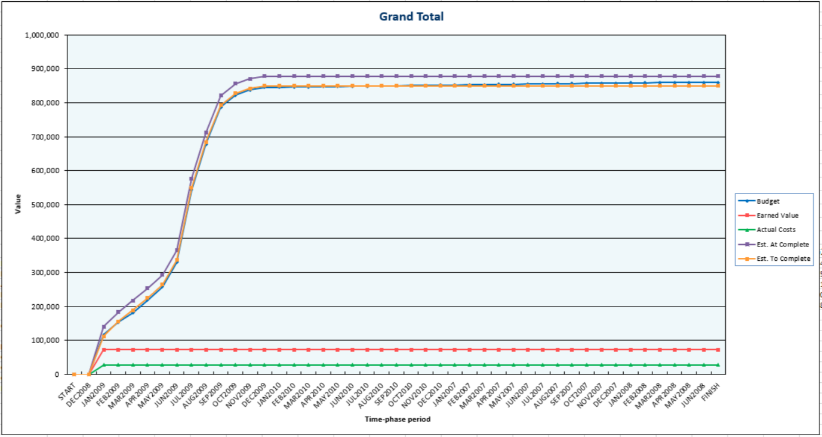
Figure 3-8 Example of EVM Metrics

EVM Budget Concepts
NASA projects that implement EVM should apply the following budget concepts.

Project Budget Base
Project activities are initiated and authorized by the NASA Project Plan. This vehicle documents the authorized scope of work, the period of performance, and the project’s total value which includes the summed budgets, management reserve, and the estimated cost of any additional AUW. The Project Plan is the “contract” or commitment between the NASA Projects and the authorizing organization such as the NASA program, mission directorate, or Center. The PBB equals the total approved project effort. The PBB is the project’s authorized value (with an associated scope and schedule) to which the project’s Distributed Budget, UB, Management Reserve, and AUW must reconcile.

Authorized Unpriced Work
AUW refers to the estimated value of work that is authorized to commence, but has not yet been definitized in terms of scope, schedule, and budget. It may be maintained in UB and monitored by project management. Until negotiated, the original proposed/estimated value for the AUW amount is used for budgets issued for near-term work associated with the change. After the work is definitized, the budget held in UB is adjusted for the AUW to reflect the negotiations, including adjustments to any CA budgets that were issued before negotiations were completed. If an individual project chooses not to use UB or AUW, they must provide total traceability from the contractually authorized work down to the detail CA/WP/PP level. AUW is maintained in the PBB Log.
All detailed planning below the contractual vehicle level is constrained by the PBB. All budget transfers are entered into a Project Change Management Log, see Figure 3-9.
Note: Most EVM software applications utilize the term CBB to support contractor/subcontractor effort instead of Project Budget Base.

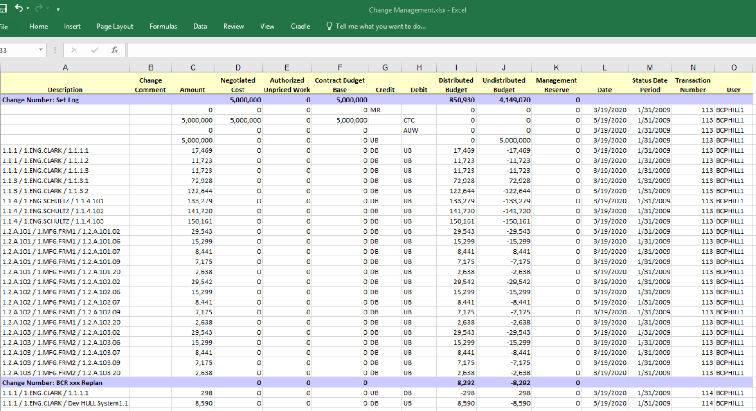
Figure 3-9 Example of Project Change Management Log
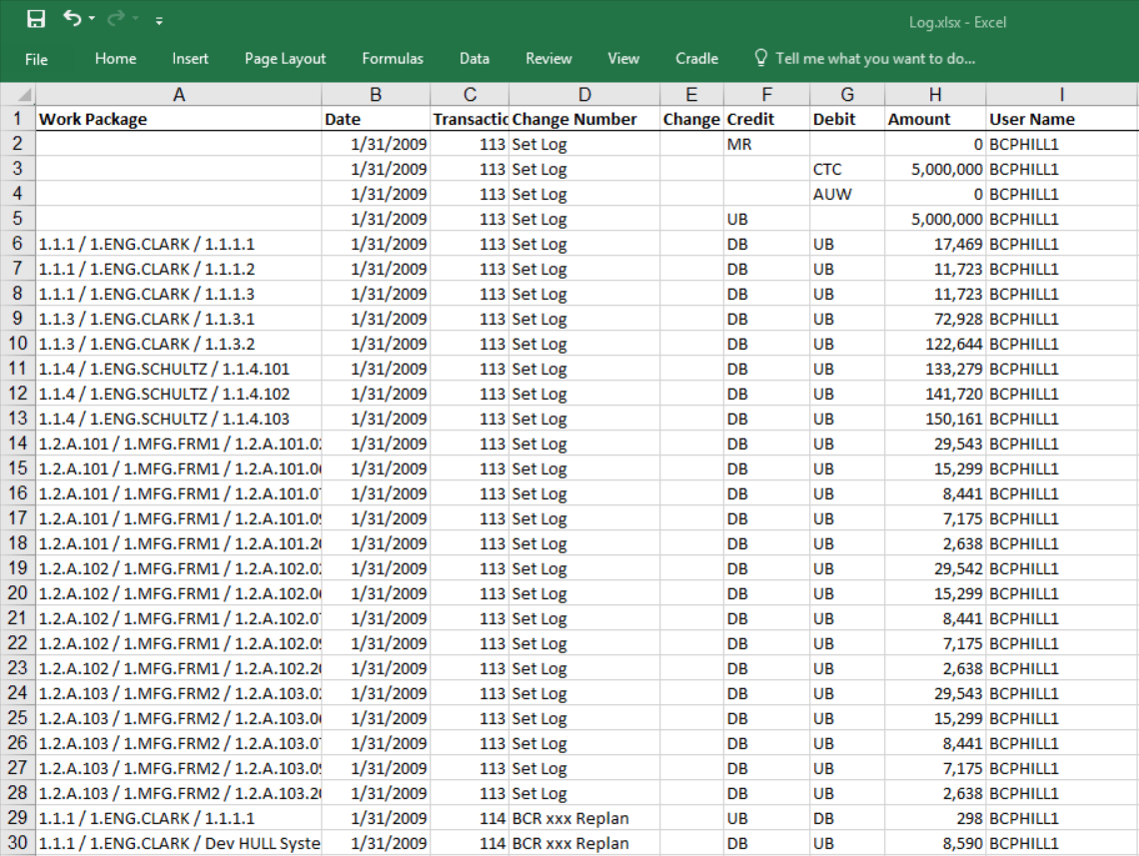
Figure 3-10 Example of EV Engine Log

Management Reserve
MR is a portion of the PBB withheld for management control purposes rather than being identified and distributed to accomplish specific tasks. Therefore, it is not part of the time-phased PMB. When establishing the overall project approach, the Project Manager will assess all risk areas and establish an MR. The MR provides the Project Manager with “budget” for resolving unforeseen problems within the project’s authorized scope.
The project MR is determined based upon an analysis of the amount required to cover risk mitigations, schedule risk, schedule margin, and cost uncertainty. Management reserves required for technical and cost risk should be based on the P-CAM’s assessment of technical and cost risk developed in process step 3.04. Schedule reserves will need to be established based upon the SRA performed in process step 2.05, and an analysis of the reserve budget required for unfunded schedule margins identified in the IMS. The Project Office must ensure that there is adequate management reserve to address technical, cost and schedule risks. MR is that portion of the PBB set aside by the Project Manager for potential work scope growth, changes in rates and factors, and other unknown project risk that may cause cost growth. MR is used for unanticipated (or unknown) work that is within the scope of the project, but is out-of-scope to any of the existing baseline CAs. Distribution of MR is documented in the MR Log, and all transactions affecting MR are recorded such that a current net dollar balance is displayed in the log (see Figure 3-10). Requests for work to be added to or deleted from a CA will use or replenish MR, and will be submitted via a revised WAD in the change request process. See Change Management, Section 7.

Undistributed Budget
UB is applicable to authorized work that has not yet been allocated for planning purposes to CAs. UB is not time-phased, but it is part of the PMB because it represents known work scope. UB may exist when a change to the project plan has been authorized, but there is inadequate time to prepare detail plans for the new work. It is intended to be a temporary holding account and typically distributed within two months. The UB associated with a project plan change is distributed to the appropriate WBS elements and CAs as soon as practical after the effort is definitized. If an individual project chooses not to use UB, they must provide total traceability from the project authorized work down to the detail CA/WP level.

Indirect Budget
Indirect expenses are those costs of doing business that are not identifiable to individual projects as a direct cost. These expenses are budgeted and controlled in pools and then applied to project accounts. While practices for indirect costs vary between NASA Centers, the Project Manager has the responsibility to include any indirect or contracted service costs in the PMB budgets as applicable. Indirect budgets are applied at the appropriate benefiting WBS and are included in the time-phased CA budgets. See Indirect Cost Management, Section 5.

Control Account Planning
The WADs are developed collaboratively by the Project Office and P-CAMs. The WADs contain requirements (scope), period of performance, control milestones (schedule), and cost (budget) targets that are collectively within the limitations of the project. The budget targets for the associated scope should be based on the original BOEs provided by the responsible organizations and adjusted for negotiations and the Project Manager’s MR withholds, as applicable. PP&C provides preliminary planning guidance, ground rules and assumptions, budget targets, and draft copies of WADs, and schedules to the P-CAM and the detailed budgeting process begins.
Control Accounts represent the integration of scope, schedule, and budget and provide for the detailed WP planning that exists at the “doing” organization levels. Cost/schedule integration is achieved in the resource-planning tool. At this point the WPs and their performance measurement techniques (PMTs) already have been identified in the scheduling process and that structure has been constituted in the resource-planning tool.
It is in the resource-planning tool that the P-CAM loads and “pre-prices” the estimated resources in WPs or PPs. WP resources are planned by significant elements of cost without commingling labor, material, ODC, or Procurements. Once resources are loaded, the resource-planning files are forwarded to the PP&C lead, who then loads the CA and WP resource data into the EVM Tool. The resulting CA BAC establishes the target for the work to be accomplished by all performing organizations assigned work within the CA. While each NASA Center may utilize different EVM software applications, the fundamentals of cost/schedule integration of CA planning and time phasing of WP and PP resources apply. A sample CAP is shown in Figure 3-11 on the next page.
…………………………………………………… 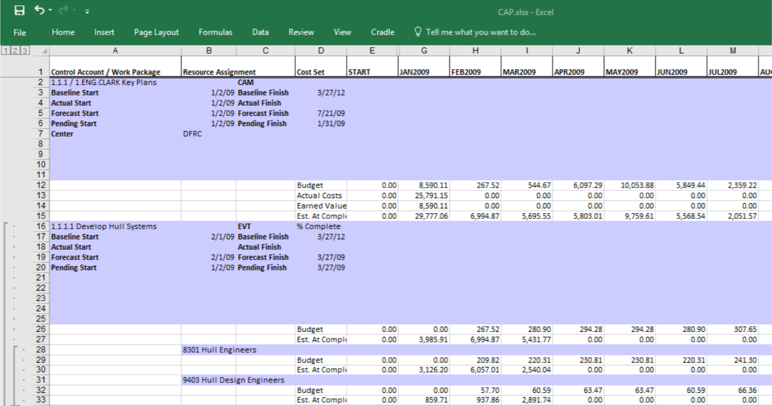
Figure 3-11 Example of EVM Application CAP Report
CA budgets are planned as WPs and time-phased prior to starting work. The time-phased CAP reports are part of the WAD documentation, and reviewed and approved by the P-CAM, his/her functional manager, and the Project Manager when the WAD is signed. The sum of the time-phased budgets within the CA equals the BAC for the CA. The CA will match the CA budgets identified in the WAD.
The P-CAMs plan each CA in detailed WPs for near-term effort and into far-term PPs that contain less detail. The CA parameters (scope, schedule, and budget) are time-phased by element of cost and resource type. The sum of all WPs and PPs equals the CA budget.
The CA budget represents the budget established to accomplish the scope which is described in the WAD. Separate identification is made for direct labor, direct procurements, and ODCs by assigning resource codes to each element of cost.
Budgets for internal and external procurements are supported by purchase orders or by time-phased estimates provided by either the contractor/subcontractor or service center. Service center cost estimation forms are used to capture the time-phased cost estimates provided by the service center.
The CA is planned to its scheduled completion. Thus, if the CA scope includes work to be accomplished over a period of 24 months, then the CA is planned for that period of 24 months. Where far-term effort cannot be planned as discrete WPs, the effort will be planned in PPs that specify the scope, schedule, and budget for that far-term effort. WPs and PPs are always planned by element of cost.
The P-CAM may accept the scope, schedule, and budget as they stand, or he/she may negotiate with the Project Manager on disputed points depending on the results of the detailed planning. Once agreement is reached the WAD is approved. The P-CAM is responsible for the CA budget at the labor, material, contract, and ODC level.

Statusing Control Account Work
EV represents the value of the work accomplished in terms of the authorized baseline budget. One PMT is assigned to each WP before the work is begun. Each month when the schedule is statused and accomplishment is determined, each WP is evaluated and compared with the work scheduled. Credit is given for work accomplished based on the BCWS that was originally planned for each portion of a WP. The performance credit, or “earned value,” is designated as BCWP and total of all BCWP equals BAC when the effort is completed. All CAs have accomplishments reported in accordance with the following principles:
  - Accomplishments are reported monthly by the P-CAM for each WP that was active during that fiscal period, as well as those for which activity was planned in that period, but for which no work was accomplished.
  - Accomplishments are expressed as BCWP using the PMT selected for the planned WP.
  - BCWP is determined when the P-CAM updates the schedule.
  - Cumulative-to-date BCWP may never exceed the BAC for a WP.
  - BCWP for level-of-effort (LOE) WPs is always equal to the BCWS.

ACCOUNTING

Accounting Introduction
NASA accounting practices are consistent with government Accounting Standards as documented in statements of the Government Accounting Standards Board. NASA accounting policies incorporate those accounting standards and are issued as NPRs.

Accounting Parameters
NASA’s accounting system incorporates an integrated suite of in-house and vendor-supplied software applications to provide an accurate and timely collection of cost data for the purposes of
  - Funds control.
  - Commitment and obligations tracking.
  - Cost collection.
  - Cost Distributions.
  - General ledger maintenance consistent with guidance for the U.S. Government Standard General Ledger.
The integrated suite of software applications includes specialized “source systems”—described in more detail below—that provide the points of initial data entry into the NASA accounting system. Data from these source systems are accumulated and consolidated in the Core Financial System General Ledger.
Cost data in the Core Financial System are summarized daily into the BW and later, into the database that will replace BW, where the data are accessed after every month-end close and loaded into the EVM tool.

Accounting Process
The Accounting process flow is shown in Figure 4-1 on the following page; the process procedure is described in 4.4.

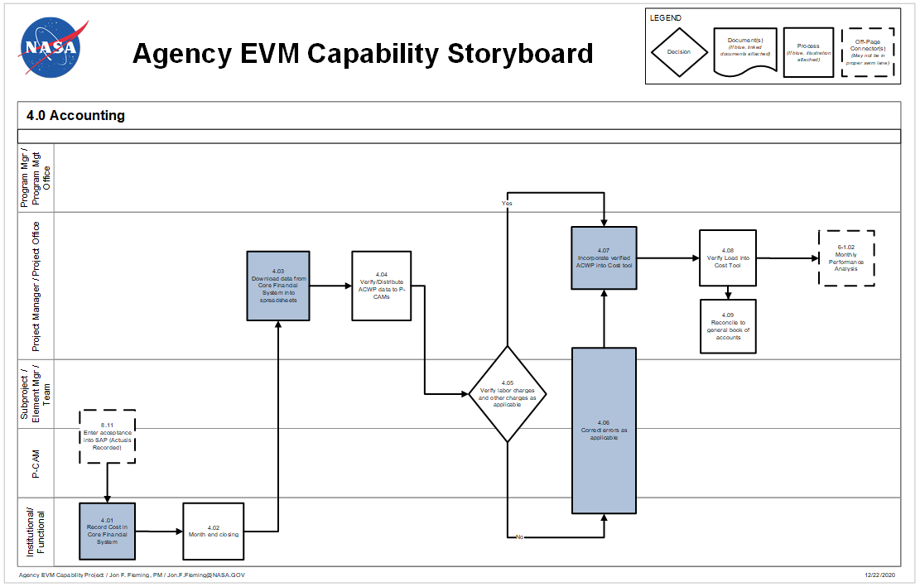
Figure 4-1 Agency EVM Capability Storyboard Flowchart: Accounting

Accounting Procedure
Actor | Flowchart Step | Action or Input/ Output
Receiving/Inspection | Input From 8.11 | Enter Acceptance into the Core Financial System (Actuals recorded).
Institutional/ Functional | 4.01 | Record Cost in the Core Financial System. Costs will be recorded on a daily basis as transactions occur.
Institutional/ Functional | 4.02 | Month-End Closing. At the end of each calendar month a month-end closing process will be executed by the center to close the books for that month.
Project Office Team | 4.03 | Download Data from the Core Financial System into Spreadsheets. The project team will download data from the BW to spreadsheets. An interface program is available, see 4.4.
Project Office Team | 4.04 | Verify/Distribute ACWP Data to P-CAMs. The project team will review the data and provide the P-CAM with reports for their review.
Project Manager/P-CAM /Project Office Team | 4.05 | Verify Labor Charges and Other Charges as Applicable. Review charges and identify any questionable charges for further analysis.
Project Manager/ P-CAM/Project Office Team | 4.06 | Correct Errors as Applicable. Use the Estimated Actual process described in 4.12.1 and/or work with institutional personal to correct the charges.
Project Office Team | 4.07 | Incorporate Verified ACWP into Cost Tool. Load Actual Cost data into the cost tool.
Project Office Team | 4.08 | Verify Load into Cost Tool. Verify the data loaded correctly into the cost tool.
Project Office Team | 4.09 | Reconcile the Cost Tool Data to the General Book of Accounts.
Project Manager/ P-CAM/Project Office Team | Output to 6-1.02 | Monthly Performance Analysis.

Source Systems and Other Applications
The NASA Accounting System (also known as the Core Financial System) includes various interacting electronic systems and subsystems. Below are some of the major components. Figure 4-2 shows a simplified diagram of the data flow between components.
  - MdM houses the WBS and supplies this information to the Core Financial System and other subsystems such as WebTADS, Concur, and Contract Management.
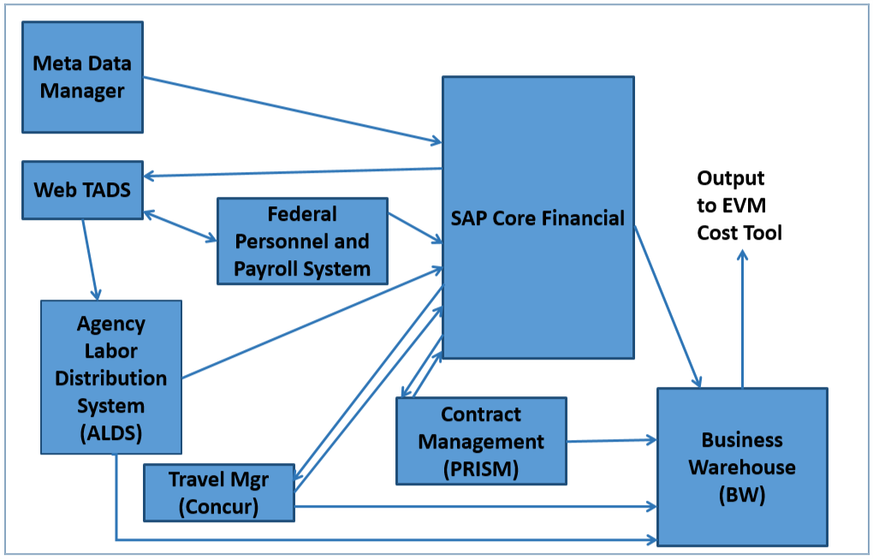
Figure 4-2 Simplified Flowchart of the NASA Accounting System
  - WebTADS provides the time and attendance system for civil servants that work for NASA. These data are provided to the Federal Personnel and Payroll System and the Agency Labor Distribution System (ALDS).
  - Federal Personnel and Payroll System provides the payroll process, including calculation of employee pay, and pay distribution.
  - ALDS maintains the details for civil servant labor hours.
  - Concur tracks travel obligations, costs, and reimbursements.
  - Contract Management supports the purchasing and receiving functions, including generation of electronic Procurement Requisitions (PRs), purchase orders and subcontracts for requested goods and services. Ancillary purchasing systems include:
  - Just-In-Time, a web-based application used to order, receive, deliver and pay for off-the-shelf catalog items.
  - Purchase Card (P-Card), which tracks credit card purchases for goods and services.
  - The Core Financial System is the central repository of all accounting cost data at the level of general ledger account.
  - BW is updated each night with the latest data from the Core Financial System and other subsystems to enable users and other stakeholders to extract information.

Interface Program Business Warehouse (BW) to Cost Tool
An interface program has been developed to extract the data needed for BW and format it in a form that can be loaded into most of the cost tools. This program produces two files, one for civil service labor and one for non-labor cost. The labor file contains WBS, Organization Code (Cost Center in BW), Accounting Period, Hours (Includes hours worked on the project and leave hours in a separate column), Cost for Hours, Commitments and Obligations. The non-labor file contains WBS, Organization Code (Cost Center in BW), Resource, Accounting Period, Cost, Commitments and Obligations. The Resource column is based on the EVM hierarchy table (which is in the BW system) for the elements of cost. For Contracts and Support Contractors/Subcontractors elements of cost the Vendor Number is inserted and the Vendor name is also shown as an aid to the person loading the data.

Cost Transfers and Other Retroactive Adjustments
Transfers of recorded costs in the Core Financial System (from one WBS number or CA to another) are made only for the correction of errors. These corrections are to be made only in the current period. Such transfers must comply with NASA requirements as shown in the Enterprise Performance Support System (EPSS) website located at https://epss.nasa.gov (SAP, BW or PPS access required) and/or the AAO Help Center website located at https://help.aao.nasa.gov.
Note: The user must be inside the NASA firewall to access the EPSS website. The site is single sign-on enabled, but depending on browser settings, the user may also need to enter his or her Agency user ID.

Recording Direct Costs

Direct Costs
Virtually all NASA work is for a project and consequently most costs are direct charges. The Center Management Operations (CMO) accounts are funded with a separate appropriation and have been given a project-equivalent project number and are treated as a project. Reimbursable projects are not presently in the scope of EVM.

Direct Labor Costs and Travel for NASA Employees
  - Labor Hour and Cost Data: Labor hour records from employees are initially accumulated in the Timekeeping system (WebTADS). The hour data are used by the Federal Personnel and Payroll System and the ALDS to calculate cost. The resulting cost data are recorded in the Core Financial System.
  - Civil Servant Leave: At present the leave for civil servants is prorated back to the projects where the labor occurred. This practice causes actual labor rates to spike during times of high leave usage and can create artificial variances. This has been identified as a gap. See Appendix A Work Arounds for possible workarounds for this gap.
  - Travel Costs: The basis for documenting and reimbursing NASA employees for travel costs is the employee’s approved Travel Expense Report.

Other Costs
“Other Costs” include expenditures for (1) materials and supplies that are incorporated in the end product, (2) miscellaneous directly associated items, such as equipment/tooling and consumables, and (3) contracted outside services or grants that benefit not more than one project.
  - Actual Costs: Costs are recorded in the Core Financial System Accounts Payable module. Direct materials and services are charged to the appropriate Project WBS numbers (i.e., CAs) as actual costs.
  - Accrued Costs: Major procurements that provide a Contractor Financial Management Report (NASA Form NF 533) usually contain the actual cost for the previous month and an expected cost for the current month. The expected cost shown on this report is entered as accrued cost and then reversed out at the beginning of the next month.

Commitments and Obligations
Commitments and Obligations are the process steps between the project cost profile and the project’s funding profile. Commitments cannot be made unless funding is available, and obligations are made from commitments which lead to costing of the funds. While Commitments and Obligations are not part of the EVM Standard EIA-748 requirements, it can be advantageous to capture all resource data in one cost tool.

Indirect Costs
The overhead burden costs that will be assessed to the projects for the foreseeable future will be planned using the Center’s processes, and charges will be assessed to the appropriate project WBS account. These accounts are Contracted Services or Operating Accounts. For additional information on indirect cost, see Section 5.

Expenditure Items
Expenditure items are individual cost records in the Core Financial System database. Each expenditure item includes (1) the WBS number, (2) the “Performing Organization” code, (3) an element of cost, (4) relevant date information, and (5) various other accounting, project and organizational identifiers and attributes. A description of the first three of these follows:

Financial WBS Number
The Financial WBS number is loaded into the Core Financial System from the MdM and generally mirrors the project WBS. In this hierarchy, the CA is the collection point for all costs associated with an authorized effort. The WBS dictionary identifies the work content that is supported or benefited by the cost in the expenditure item record. As shown in Figure 1-3, the WBS number consists of two segments. The first segment, or Project number, is a unique string of six numeric characters. The second segment, can include up to twelve numeric characters in groups of two separated by a decimal. Although the term “CA” and “WBS number” are sometimes used interchangeably, “CA” is used in the accounting section to refer to the WBS element where expenditures are collected. The term CA which is used in an EVM system is sometimes equal to the accounting “CA,” but not always. Refer to Appendix A Work Around (s).

Performing Organization
The Performing Organization identifies the NASA Center and internal organization performing the work. Within the Core Financial System, the performing organization is denoted as the “cost center.” Each WBS number that serves as a CA for collecting cost may receive charges from multiple performing organizations (cost centers), as long as they are from the same cost center to which the WBS belongs.

Element of Cost
The element of cost classifies the expenditure item cost into a pre-defined cost category. Within the Core Financial System these categories are based on the Commitment Item designator that gets assigned to the record. Below are the elements of cost categories available within the Core Financial System when the EVM hierarchy table is used.
  - Personnel Cost: The hours and dollars (including benefits) for civil servant work
  - Travel: The dollar cost for civil servant travel
  - Material
  - Equipment
  - Contracts: Includes R&D, Fixed Cost, Grants, etc.
  - Support Contractors: The cost for services to supplement the civil servant work force. Only costs are presently tracked in the Core Financial System, but hours may also be available in future modifications to the Core Financial System.
  - Other Costs
  - Overhead and General and Administrative Expense: Includes any indirect or contracted services cost that get charged back to the project.

Level of Costs Reporting in the Core Financial System and the EVM Tool
The WBS in the Core Financial System and the project WBS in the EVM Tool generally should be the same. However, there are recognized exceptions for items such as costs that are reported to summary level WBS numbers in the Core Financial System, and cases wherein the project must go below Level 7 in the WBS. While it is preferred to have the Core Financial System accounting WBS and the project technical WBS be one in the same, this is not always possible. In cases where there are multiple Core Financial System WBS charge codes that belong to one CA or WP in the project structure, it is acceptable to map these to the appropriate account. This mapping must occur outside of the Core Financial System and is usually handled in the cost tool. It is not acceptable to map one Core Financial System charge code to more than one CA or WP.

Summarizing Direct Costs to the WBS

Work Breakdown Structure in the Core Financial System
The project WBS establishes the hierarchy of all project WBS elements associated with that project. The WBS applicable to a NASA flight project is constructed in accordance with the Standard Flight Project WBS Template from NASA Space Flight Program and Project Management Handbook, Appendix C: Space Flight Project WBS. Further definition and guidance regarding WBS development and use can be found in the NASA WBS Handbook located at https://www.nasa.gov/evm/handbooks.

Work Breakdown Structure in EVM Tool
  - The WBS in the Core Financial System and the project WBS in the EVM Tool should be the same, with the exceptions noted in 4.11.
  - The WBS numbers that collect costs in the Core Financial System map to one and only one WBS at the CA level in the EVM Tool.
  - Each project WBS number at the lowest level of a WBS can have no more than one parent WBS number at the next higher level. In turn, each parent at that level is itself a child and can have no more than one parent at the next higher level. This pattern is consistent for each level of the WBS. Initial cost accumulation occurs only in the lowest level of the WBS. From there, costs are summarized through successively higher levels, strictly adhering to established parent-child relationships, until the top (project) level is reached.

WBS Creation in the Core Financial System
The WBS is created for a project and then loaded into the MdM system. From the MdM system, the structure is electronically loaded into the Core Financial System, and then MdM or the Core Financial System electronically populates other systems that need the numbers.

Summarizing Direct Costs to the Organization

Organization Breakdown Structure in EVM Tool
An organizational hierarchy is maintained in the EVM Tool. The organizational codes are maintained in the Core Financial System and costs are associated to the appropriate code. Cost accumulation occurs at the CA and Organization code. Each organizational code can map to no more than one OBS Element, in the EVM Tool. In turn, each of those OBS elements is itself a child and can map to no more than one parent OBS element at the next higher level of the OBS. This pattern is consistent for each level of the OBS. Costs are summarized through successively higher OBS levels, strictly adhering to established parent-child relationships, until the top level of the projects OBS is reached.

Using Estimated Actuals
As noted in 4.8.1.2, the NASA Accounting System systematically accrues costs for procurements and subcontracts. After each month-end close and actual cost download from the Core Financial System, the project business office determines if the actuals are adequate for variance analysis. If the actual cost data requires adjustment, the business office will gather documentation to support the reconciliation of reported costs to the institutional accounting system data. In some cases when indicated, the actuals are manually adjusted in the EVM Tool by the business office; these estimated actuals must be reversed over time as the temporary accrual is converted to cost. However, these “manual” adjustments must be reconcilable to the Agency’s books of record.

Estimated Actuals in EVM Capability Cost Tool
Achieving timely, accurate, and complete cost reporting data requires project business management working closely with project accounting and procurement personnel in monitoring procurement and subcontract costs. See Section 8 and Section 9. The resulting “actual costs” in the EVM Capability Cost tool are reconciled to the actual costs reported in the Core Financial System.

Monthly Project Accounting Reconciliation
After each month-end close and actual cost download from the Core Financial System to the EVM Tool, the project business office performs a reconciliation of the WBS actual costs. The reconciliation of these items is logged and archived monthly.
For contracts where IPMR data are used in place of the NF 533 data that have been loaded in the Core Financial System, projects must be careful not to add both the IPMR and NF 533 data into the cost tool. Also, the Fee costs that are included in the NF 533 are not in the IPMR data, so caution needs to be exercised to keep the data reconciled. This caution also applies to cases where another Center (intra-Agency work) supplies an IPMR for incorporation into the project EVM system. If actual costs are taken from the other Centers’ IPMR, the Core Financial System data for the other Center need to be eliminated to avoid double counting of the cost.

Unit Cost, Equivalent Unit Cost and Lot Cost
NASA’s work is one of a kind, and if there is production type work it is usually contracted out and the contractor’s system handles this situation. If cases occur in the future where Unit Cost, Equivalent Unit Cost and Lot Cost are required, those situations will be addressed as required.

INDIRECT COST MANAGEMENT

Indirect Cost Management Process
While each Center has slightly different indirect costs or contracted services, they each have the following things in common:
  - The NASA CFO approves the indirect or contracted services cost pools for the Center.
  - The Center CFO working with the various organizations will develop the demand forecast, budget, planning rates for each indirect cost pool.
  - The Center CFO will communicate this information to the project managers who then working with the P-CAM incorporates the associated rates into the project budget estimate.
  - Work is performed, costs are collected, and distributed based on the Center’s distribution process.
  - Variances from the planned indirect costs are reviewed periodically and rate forecasts are updated for the remainder of the year.
  - New rates are used in the planning process.
The Indirect Cost Management flow chart is shown in Figure 5-1, on the following page; the process procedure is described in 5.4.

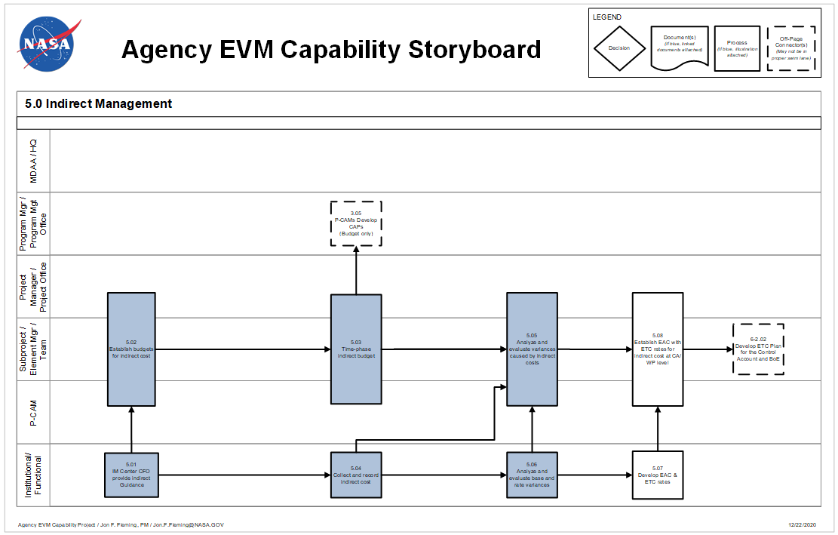
Figure 5-1 Agency EVM Capability Storyboard: Indirect Management

Indirect Cost Management Procedure
Actor | Flowchart Step | Action or Input/ Output
Institutional/ Functional | 5.01 | Indirect Management (IM) Center CFO Provide Indirect Guidance.
Project Manager/ P-CAM/ Project Office Team | 5.02 | Establish Budgets for Indirect Cost.
Project Manager /P-CAM/Project Office Team | 5.03 | Time Phase Indirect Budgets.
P-CAM/ Institutional/ Functional | Output to 3.05 | P-CAMs Develop CAPs (Budget Only).
Institutional/ Functional | 5.04 | Collect and Record Indirect Cost.
Project Manager/ P-CAM/ Project Office Team | 5.05 | Analyze and Evaluate Variances Caused by Indirect Costs.
Institutional/ Functional | 5.06 | Analyze and Evaluate Base and Rate Variances.
Institutional/ Functional | 5.07 | Develop EAC and Estimate to Complete (ETC) Rates.
Project Manager/ P-CAM/Project Office Team | 5.08 | Establish EAC with ETC Rates For Indirect Cost at CA/ WP Level.
P-CAM/Subproject/ Element Manager (SP/EM)/ Team | Output to 6-2.02 | Develop ETC Plan for the CA and BOE.

Identifying Indirect Cost
Indirect Costs consist of the cost of contracted services only and should include no civil service labor or travel costs. The Center CFO has the responsibility for evaluating all proposed contracted services budgets and budget adjustments and for informing each project of the cost they will incur due to the contracted services.

Establishing Indirect Budgets
The Project Manager has the responsibility to include any indirect or contracted services cost in the PMB budgets. Indirect budgets are applied at the appropriate benefiting WBS and are included in the time-phased CA budgets. The time-phasing will occur in conjunction with 3.05, P-CAM development of CAPs.

Recording Indirect Costs
Actual Indirect costs are collected and allocated to the projects appropriate WBS based on the Center’s predetermined policies.

Analyze and Evaluate Variances Caused by Indirect Costs
The P-CAM will analyze any variances that meet the project thresholds and identify the cause. If the variance is caused in part or whole by indirect cost, then the P-CAM will work with the Center CFO to identify the cause and corrective action. For more information on variance analysis, see Section 6 Managerial Analysis.

Analyze Base and Rate Variances for Contracted Services Accounts
The Center CFO along with the responsible organization will analyze the rates for indirect items and provide any updates to the project.

Development of Revised Cost Estimates-at-Completion
The P-CAM will apply any changes in rates provided by the Center CFO and factor into the revised EAC. The new estimates will be incorporated in conjunction with the ETC/EAC process in Section 6.

MANAGERIAL ANALYSIS

Managerial Analysis Introduction
Managerial Analysis comprises two sub processes: Managerial Analysis and EAC. This section provides guidance for preparing detailed variance analyses and corrective actions and for revising ETC for the associated effort of projects that are required to use a guideline-compliant EVMS.

Managerial Analysis Parameters
Managerial Analysis is the reporting, evaluation, and feedback process of the EVM Capability. The reporting feature of this process provides all levels of management and the sponsor with early visibility of deviations from the plan and facilitates the development of corrective actions for variances that exceed previously defined thresholds. Basic performance reporting is accomplished by providing monthly IPMRs of all in-process work to reflect current status on the project. From that information comparisons are made between BCWP and BCWS and between BCWP and ACWP. The resulting variances, SV for the difference between BCWP and BCWS and CV for the difference between BCWP and ACWP, are compared to established percentage and dollar thresholds to determine the significance of the variances.
The NASA EVM Capability employs the principle of management by exception. It is the responsibility of the project’s management team to establish thresholds for variance reporting. Therefore, only those variances considered to be significant are analyzed. Should a current and/or cumulative variance be found to exceed the threshold, the P-CAM prepares a written VAR that explains why the variance occurred, what impact it has, and any corrective action that is being undertaken.
  - The objective is to provide meaningful cost/schedule performance data to the project’s management team and to the sponsor for timely management decisions.
  - Variance analysis includes comparisons with schedule performance metrics and cost performance metrics.
  - Variances are identified and reported at the CA level in terms of labor, material, Procurement, travel and ODCs.
  - Significant differences between planned and actual accomplishments are identified.
  - The data elements (BCWS, BCWP, ACWP, BAC and EAC) and associated variances will be summarized through the functional (line) organization and the WBS to the reporting levels specified by the project management team.
  - For significant cost and schedule variance, cause and impact are analyzed, and corrective action plans are developed for both current and cumulative.
  - Significant cost and schedule variances are reviewed by the project management team at least once per month.

Managerial Analysis Process
The Managerial Analysis Process flow is shown in Figure 6-1 on the following page; the process procedure is described in 6.4.
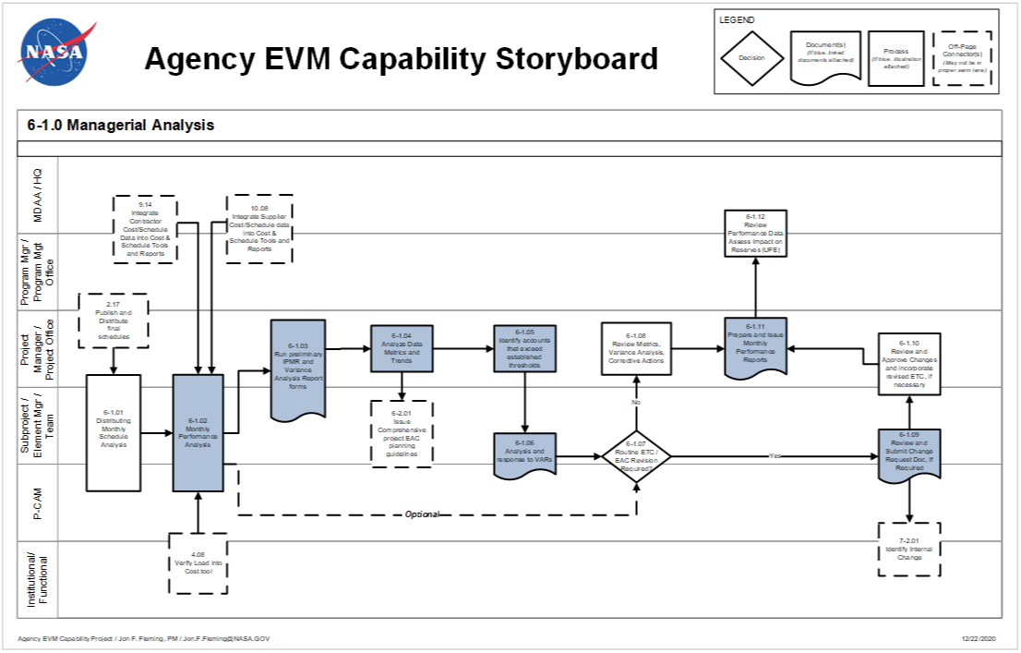
Figure 6-1 Agency EVM Capability Storyboard: Managerial Analysis

Managerial Analysis Procedure
Role | Flowchart Step | Action or Input/ Output
Program Manager or Program Management Office and Project Manager or Project Office | Input from 2.17 | Publish and Distribute Final Schedules.
Project Manager or Project Office and Subproject/Element Manager (SP/EM)/ Team and P-CAM | 6-1.01 | Distributing Monthly Schedule Analysis. Distribute the schedule analyses data including CP analyses, schedule metrics, assessment of schedule integrity, impacts to internal and external commitment and/or control milestones, and progress inputs to the EV system. The Subproject / Element Manager and Project-Control Account Managers supported by the Project Office should evaluate schedule progress, changes, related corrective action planning, and issue resolution, and assess their potential impacts relative to the overall integrated cost, risk, and technical performance data.
Program Manager or Program Management Office and Project Manager or Project Office and SP/EM /Team and P-CAM | Input from 9.14 | Integrate Contractor/Subcontractor or Supplier Cost/Schedule Data into Cost and Schedule Tools and Reports.
Program Manager or Program Management Office and Project Manager or Project Office and SP/EM/Team and P-CAM and Institutional/ Functional | Input from 10.08 | Integrate Supplier Cost/Schedule Data into Cost and Schedule Tools and Reports.  Note: Other Centers are considered suppliers via Inter-Agency Work Agreements.
Project Manager or Project Office | Input from 4.08 | Verify Load into Cost Tool.
Project Manager or Project Office and SP/EM/Team and P-CAM | 6-1.02 | Monthly Performance Analysis. Internal IPMRs and EVM Metrics are generated at the Project, Subproject and CA levels and provide the SP/EM and P-CAMs with plan, performance, and cost by element of cost for current period, cumulative-to-date, and at-completion points in time. This data reveals the nature of the variance and forms the foundation for the development of managerial actions.
Project Manager or Project Office and SP/EM/Team | 6-1.03 | Run Preliminary IPMR and VAR Forms. The availability of schedule status and monthly actual costs will enable the generation of preliminary performance measurement data. The data (IPMRs, EVM Charts, graphs, schedule CP, and actual costs) are supplied by the Project Office and is subsequently utilized by the Project Office, Project Manager, SP/EM, and P-CAM to support analysis and management decision making.
Project Manager or Project Office | 6-1.04 | Analyze Data Metrics and Trends. The Project Office performs cost and schedule trend analysis of the EV and Schedule data. The Project Office analysts evaluate project performance trends and forecasted CAC. This analysis is performed to ensure that early warnings of performance are not overlooked. This analysis includes, but is not limited to, EAC trend analysis, forecasted CAC, workforce trend analysis, schedule CP analysis, schedule reserve assessment, and risk/reserves analysis.
Project Manager or Project Office | Output to 6-2.01 | Issue Comprehensive Project ETC/EAC Planning Guidelines.
Project Manager or Project Office | 6-1.05 | Identify Control Accounts that Exceed the Established Thresholds. Program/Project level thresholds are documented in the Project directives consistent with Program and/or Project requirements, where appropriate. CV and SV thresholds are established by project management at the WBS Element or CA level, and are documented in the project plan. These thresholds are expressed as plus or minus percent variance and/or dollar amount variances. The thresholds are reflective of the risks associated with the work. When CV and/or SVs at the WBS Element or CA exceed the threshold, the required variance analysis is performed.
SP/EM/Team and P-CAM | 6-1.06 | Analysis and Response to VARs. The Internal IPMR, in conjunction with the CA/WP detailed schedule, is the primary source of data used to execute CA variance analysis. It is the data used by the P-CAM to prepare the VAR. The written variance analysis provides an explanation that clearly identifies the cause of each problem, the impact on the remaining work (inside or outside of the CA), and the corrective action plan for both SV and CVs, as required. The P-CAM is responsible for explaining CVs and SVs that have exceeded the established thresholds.
SP/EM/Team and P-CAM | 6-1.07 | Routine ETC/EAC Revision Required? The routine EAC stems from the monthly management oversight activity. Each month, the P-CAM reviews his/her cost and schedule performance data and specifically determines if the existing EAC is still accurate or valid. If it is not, he/she generates a new time-phased ETC for submission and approval by project management. The P-CAM considers past performance and the remaining work in the assessment. If the EAC is not accurate, the P-CAM requests a revision.  Optional update from 6-1.02 Monthly Performance Analysis  The ETC may not be phased in accordance with the required funding needs, this alternate process step allows the P-CAM to adjust the ETC to support funding needs.  If YES, go to 6-1.09.  If NO, go to 6-1.08.
Project Manager or Project Office | 6-1.08 | Review Metrics, Variance Analysis, and Corrective Actions. The Project, Subproject, Element, P-CAMs, and the Project Office review the EVM metrics and variance analysis, and they monitor the corrective actions identified in approved VARs to the point of resolution.
SP/EM/Team and P-CAM | 6-1.09 | Review and Submit Change Request Documentation. To obtain approval for a new EAC, the P-CAM submits a Change Request (or equivalent) form with supporting documentation for appropriate review and approval before incorporating the EAC into the integrated cost management reporting system database. This form is completed whenever the P-CAM is aware that the EAC previously agreed to by the Project Manager is not accurate. The SP/EM review any changes to the EAC before they are submitted to the Project Manager.
Project Manager or Project Office and SP/EM /Team and P-CAM | Output to 7-2.01 | Identify Internal Change.
Project Manager or Project Office and SP/EM/Team | 6-1.10 | Review and Approve Changes and Incorporate Revised ETC (if necessary). The Project, SP/EMs review and approve the revised ETC. The Project Office then incorporates the new ETC into the integrated cost management reporting system. This incorporation is accomplished by integrating the ETC on the completed Change Request (or equivalent) form, and supporting costing files. Once approved by the Project Manager, the Project Office incorporates the new ETC into the project’s cost management reporting system.
Project Manager or Project Office | 6-1.11 | Prepare and Issue Monthly Performance Reports. IPMRs are at the core of monthly variance reporting by the project. IPMR Formats 1 through 7 are prepared, as required. IPMRs are prepared for any level of the WBS and demonstrate summary level performance for project management, such as Subproject / Element, subsystem, system, and total project performance reports.
MDAA/NASA Headquarters and Program Manager or Program Management Office | 6-1.12 | Review Performance Data, Assess Impact on Reserves or Unallocated Future Expense. The Program Office reviews the performance data, trends, risk and forecast data and the project EAC to determine any impacts to Project Reserves or UFE.

Variance Thresholds
Figure 6-2 Variance Threshold Types
Cost and schedule variance thresholds are established by project management at the WBS Element or CA level and are captured in an EVM Implementation Plan or the project controls section of the project plan. While establishment of the threshold values is within the purview of the project office, a “best practice” would be to change (tighten) the thresholds at least two times: after one-third and after two-thirds of the project’s scheduled duration. The rationale is that with time passing there is less remaining time to implement corrective actions; thus, one should have a more sensitive threshold “trigger” the further along the project is. These thresholds are expressed as plus or minus percent variance and/or dollar amount variances. The thresholds are reflective of the risks associated with the work. When CV and/or SVs at the WBS Element or CA exceed the threshold, a variance analysis is required. Variance threshold types (Current Period, Cumulative to Date, and Variance at Completion) are described below (see Figure 6-2).

Monthly Cost/Schedule Performance Reporting
Project reporting of cost and schedule performance measurement plays an integral part in providing information to support the decision-making process used by management to determine the appropriate actions.
Project reporting thresholds are provided by project management to ensure that cost and schedule performance issues that can impact the project are identified early, and appropriate action can be initiated.

Performance Reporting
IPMRs support monthly variance reporting by the project. IPMR Formats 1 through 7 shall be prepared as required. The two most commonly required formats are Formats 1 and 5. Figure 6-3 displays an IPMR Format 1 at the CA level, and Figure 6-4 displays a blank IPMR Format 5 report for CA variances. IPMRs can be prepared for any level of the WBS to demonstrate summary level performance for project management, such as subsystem, system, and total project performance reports. Internal IPMR reports are generated at the CA level and provide the P-CAM with detailed current period, cumulative, and at-completion performance data for use in preparing VARs.
Figure 6-3 IPMR Format 1 at Control Account Level (with thresholds flagged)
5. Evaluation
Optical Systems 883151.05.05.01
 | Budget | Earned | Actuals | SV in $ | SV in % | CV in $ | CV in % SPI CPI
Current
Cumulative
 | BAC | EAC | VAC in $ | VAC in % | TCPI to BAC | TCPI to EAC
At Complete
Explanation of Variance/Description of Problem: (Cur SV)

Impact:

Corrective Action:
Explanation of Variance/Description of Problem: (Cum SV)

Impact:

Corrective Action:
Explanation of Variance/Description of Problem: (Cur CV)

Impact:

Corrective Action:
Explanation of Variance/Description of Problem: (Cum CV)

Impact:

Corrective Action:
Explanation of Variance/Description of Problem: (VAC)

Impact:

Corrective Action:
Figure 6-4 Blank CPR Format 5 at Control Account Level
Although the NASA Project Plans may lack specific DRD instructions for IPMR reporting at Summary Levels (WBS Level 2 or Level 3), NASA projects are prepared to present and report such data to the sponsor or to senior NASA management during Project Management Reviews (PMRs). To ensure the use of EVM data to manage the project, the focus of PMRs should be on the “internal” use of the data.
Every CA that exceeds the pre-determined thresholds requires a completed Variance Analysis (see Figure 6-4) prepared by the P-CAM using the Internal IPMR (see Figure 6-5) and the CA/ WP detailed schedule as primary sources of data for analysis.
If a CA displays a pre-determined Variance at Completion (VAC)—BAC, minus current EAC—the P-CAM includes an analysis of this VAC.
Management analysis for informed decisions requires schedule and cost variance trending data. Trending data is best viewed graphically. To gain rapid access to trending data, NASA uses industry-wide analytics tools. Data is entered using data exports from the EV cost engine and schedule. The analytical tool integrates earned value, schedule, work authorization, and other key performance data to enable proactive management of complex projects. For more information, see https://www.nasa.gov/evm/guidance

Variance Analysis
At the close of each accounting month, variances are analyzed by P-CAMs at the CA level based on the variance thresholds established by project management. VAR templates are provided to the P-CAM by the PP&C Team for CAs that exceed the established thresholds. These reports alert the project to out-of-tolerance conditions in the project and help them monitor the activities of the project team under their control. The flow chart, Figure 6-1, depicts the process through which CA variances are reported, analyzed, and reviewed.
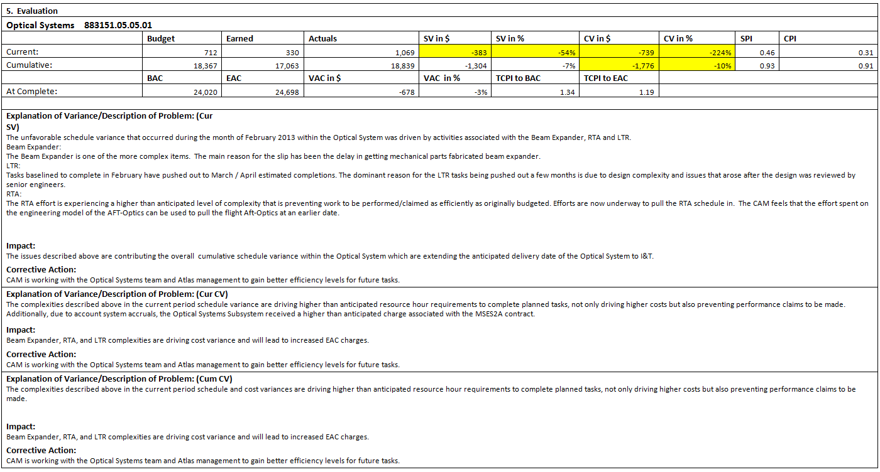
Figure 6-5 Completed IPMR Format 5 at Control Account Level

Variance Analysis Methodology
Internal IPMR reports are generated at the CA Level (see Figure 6-4) and provide the P-CAM with plan, performance, and cost by element of cost for current period, cumulative-to-date, and at-completion points in time. These data, by element of cost, reveal the nature of the variance. The Internal IPMR, in conjunction with the CA/WP detailed schedule is the primary source of data used to execute CA variance analysis. It is the data used by the P-CAM to prepare the VAR (see Figure 6-6).
The written VAR results in an explanation that clearly identifies the root cause of each problem; the impact on the remaining work (inside or outside of the CA); and the corrective action plan for both schedule and CVs, as required. The P-CAM is responsible for explaining cost and SVs that have exceeded the thresholds. Specifically, the P-CAM analyzes those CA variances that have exceeded the thresholds by cost elements; that is, by direct labor hours, ODCs, and direct material dollars. Labor variances are broken down into Rate and Efficiency variances, and Material variances are broken down into price and usage/quantity. The P-CAM also analyzes the relevant metrics for consistency and deviations from planned work, see Figure 6-5. The explanation and descriptions are entered on the VAR. Whenever the analysis indicates that a CV occurred or increased, the P-CAM evaluates the EAC to ensure that it reflects the condition
Figure 6-6 Internal IPMR by Budget Element for Control Accounts
indicated. If the cause of the variance cannot be corrected, then the P-CAM must evaluate the ETC/EAC and request that it be changed. If a significant VAC is projected, the P-CAM includes analytical narrative addressing the VAC.
A completed CA Variance Analysis Form is shown in Figure 6-5. The VAR is reviewed with the P-CAM’s functional manager (and/or SP/EM) for approval before being forwarded to the Project Manager. The scheduled time for submittal is defined by the PP&C’s monthly reporting schedule.
The approved VAR becomes the basis for the Project Manager’s monthly project assessment and any institution reporting requirements.

Project Management Reviews
At regularly scheduled monthly Project Management Reviews, the project management team reviews their EV variances (cost, schedule, and metrics) with the Project Manager. The Project Manager reviews all significant variances to include impacts, Corrective Actions, and Corrective Actions in process from previous reporting periods.

Corrective Action Monitoring
The SP/EMs, P-CAMs, and Business Manager monitor Corrective Actions identified in approved VARs to the point of resolution.

Functional Summarization and Monitoring of Variances
In addition to the variance analysis and reporting at the CA level, functional managers (SP/EMs) monitor cost and schedule performance. The monitoring is accomplished through the monthly distribution of summarized reports at the subsystem or system level, as required. Using these reports, the SP/EMs review the performance on all the CAs assigned to the P-CAMs who report directly to the SP/EM. It is the SP/EM’s responsibility to monitor cost and schedule trends within their responsibility.

Managerial Analysis Summary of Responsibilities

Project Planning & Control
  - Monitors variances and informs project management of work elements where variances indicate a potentially unfavorable condition
  - Maintains a file of all VARs
  - Reviews progress of Corrective Actions with management on a monthly basis
  - Collect, analyze, and report metrics
  - Prepares IPMR for submittal to senior management and the sponsor.
  - Retain all documentation showing management actions taken as a result of EVM data.

Project-Control Account Manager
  - Analyzes CA variances on a monthly basis (cost, schedule, and relevant metrics)
  - Prepares VARs when CA variances are over thresholds
  - Takes action to implement approved Corrective Action plans

Subproject/Element Manager (SP/EM)
  - Reviews and approves or disapproves the P-CAM VAR
  - Monitors VAR Corrective Action plans to the point of resolution

Project Manager
  - Reviews and approves or disapproves all VARs
  - Reviews ongoing Corrective Action through resolution
  - Reviews variance reports monthly to ensure the EAC remains valid
  - Approves IPMR for submittal to senior management and the sponsor.

Estimates at Completion (EAC) Introduction
When the management of the project believes the cost of the project will be different than originally planned, a new Comprehensive EAC is prepared and delivered to the sponsor. This new forecast of funding requirements is developed by adding the ACWP plus the estimate of the remaining unaccomplished and remaining planned work—i.e., the ETC, whether it is budgeted or not.
It is important to recognize the EAC is not the same thing as the BAC; the EAC can be greater than or less than the BAC. The BAC represents the planned or budget value of work to be performed, while the EAC represents the actual or expected cost to perform that work. This separation of work and the costs must be maintained if the integrated management cost system is to deliver valid management information.
For contracted effort a request for a revised ETC/EAC is directed to the Contractor/Subcontractor through the Procurement Office’s buyer/negotiator. It is expected that the contractor/subcontractor employs its own ETC/EAC process to develop a revised ETC/EAC for the Contracted effort. If the Contractor/Subcontractor does not employ a formal EAC/ETC process, the recommendation is that the Contractor/Subcontractor follows the process and procedures as described in this section.
The EAC process is illustrated on the following page. The procedures that match the EAC process follow.

EAC Parameters
  - The EAC reflects the project’s current best estimate of what the actual cost will be for all authorized work.
  - MR is not included in the EAC.
  - Revised EACs, which are based on performance to date and estimates of future conditions, are developed for each CA experiencing significant variances, or with known changes in actual or expected costs that may affect funding requirements.
  - The CA EACs are summarized to the total project level, and then compared with the BAC for the current PMB and is used to calculate the VAC.
  - The EAC—whether budget/scope change, overrun, or underrun—is revised only upon approval of a Change Request form (see Section 7) and a revised WAD.
  - The Project Manager analyzes the summarized CA EACs to determine Best Case, Worst Case, and Most Likely EACs for entry into the IPMR with the assistance of PP&C.

EAC Process
The EAC process flow is shown on the following page; the process procedure is described in 6.9.

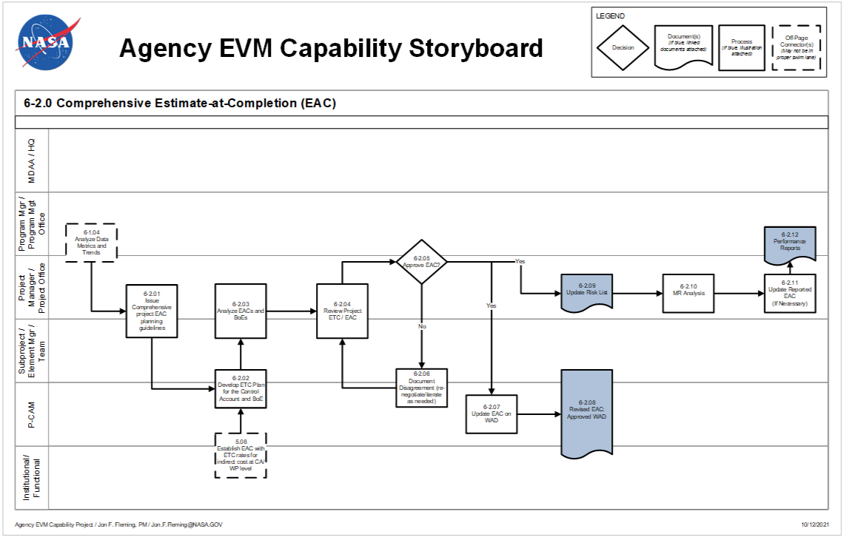
Figure 6-7 Agency EVM Capability Storyboard: Estimate at Completion

EAC Procedure
Role | Flowchart Step | Action or Input/ Output
Project Manager or Project Office | Input from 6-1.04 | Analyze Data Metrics and Trends.
Project Manager or Project Office and SP/EM/Team | 6-2.01 | Issue Comprehensive Project ETC/EAC Planning Guidelines. A comprehensive “grass roots” EAC is prepared for the total Project at least annually to support the Planning, Programming, Budget, and Execution process or more frequently if there are changes in schedule or management plans, i.e., priority changes, partial terminations, make/buy revisions, and/or current performance indicates the current EAC is invalid. The Project Office, in conjunction with the Project and SP/EMs, develops planning guidelines for an ETC exercise. Guidance includes (but is not limited to) project definition (identify opportunities, risk mitigations, cost growth liens, etc.), cost estimating instructions, documentation requirements, and a schedule for the execution of the exercise.
Project Manager or Project Office and SP/EM/Team and P-CAM | Input from 5.08 | Establish EAC with ETC Rates for Indirect Cost at CA/WP Level.
SP/EM/Team and P-CAM | 6-2.02 | Develop ETC Plan for the Control Account and BOE. P-CAMs review all available documentation and prepare a time phased estimate of the cost for the remaining work within the CAs. A comprehensive EAC is based on reported performance to date, knowledgeable projections of future performance, and commitment values for material and contracted/subcontracted items, estimated economic escalation, current overhead rates, contemplated management improvements, and inflation, as well as considering all remaining risk areas on the project versus cost avoidance possibilities.
Project Manager or Project Office and SP/EM/Team | 6-2.03 | Analyze EACs and BOEs. Review and approve EACs for the total project, including contractor/subcontractor data, to determine reasonableness in context with historical data for the total project to include contractors. Forecasted EAC formulas should be employed to corroborate the validity of the EAC.
Project Manager or Project Office and SP/EM/Team | 6-2.04 | Review Project ETC/EAC. Analyze all generated reports and EACs for anomalies. If any are found, resolve them in the most appropriate and expeditious manner to ensure the data reflects the most accurate picture of the effects of the P-CAM’s update to the EAC.
Project Manager or Project Office | 6-2.05 | Approve EAC? The Project Manager approves the EAC, or rejects for cause.  If YES, go to 6-2.07 and 6-2.09.  If NO, go to 6-2.06.
SP/EM/Team and P-CAM | 6-2.06 | Document Disagreement (Renegotiate/Iterate as Needed). Any disagreement regarding the incorporation of EACs is documented in the variance analysis report (IPMR 5) and reviewed by the SP/EM and P-CAM. If necessary, the P-CAM may iterate the EAC, as required.  Go back to step 6-2.04
P-CAM | 6-2.07 | Update EAC on WAD. Approved EACs should be reflected on the WAD.
SP/EM/Team and P-CAM | 6-2.08 | Revised EAC Approval on WAD. The WAD is approved by the SP/EM, P-CAM, and functional organization. The approval of the EAC via the WAD results in a commitment to provide the required resources to complete the work.
Project Manager or Project Office | 6-2.09 | Update Risk List. The EAC determination relies on the project’s risk posture. The Risk process systematically identifies, quantifies, and assesses cost or schedule risks for the project.  Note: Outside the EVMS may be a Project Lien List. The Project Lien List tracks cost growth liens as well as liens (commitment of reserves) that are identified by the Risk Management process. A Project Lien List is derived from Cost Growth and the Significant Risk List and should capture all cost risks stemming from 1) potential internal scope changes for risk, 2) potential overruns, and 3) potential underruns.
Project Manager or Project Office | 6-2.10 | MR Analysis. Throughout the project’s duration, the Project Manager is required to understand the projects position with respect to available Management Reserve.  Underruns and overruns affect the EAC on the project, but they do not affect the baseline BAC. After incorporation of budgetary changes, the project evaluates the remaining MR available to mitigate future project risks using the dollarized probabilistic risk list. An in-depth analysis reveals the rate at which reserves are utilized vs. risk retired. This type of analysis reveals whether the remaining MR is adequate to complete the project.  Note: Outside the EVMS, may be a Project Lien List along with the addition of Scope Changes, Opportunities/Underruns, and overruns impact the available net Project Management Reserve balance.
Project Manager or Project Office | 6-2.11 | Update Reported EAC (if necessary). If the management team of the project believes that the cost of the project will be different than originally planned, a new EAC is prepared and delivered to the Sponsor. The updated EAC is provided in the IPMRs. The new EAC may be instrumental in developing budgetary (funding) submissions required by the PPBE process.
Program Manager or Program Management Office and Project Manager or Project Office | 6-2.12 | Performance Reports. IPMRs support the monthly reporting needs of the project. IPMR Formats 1 through 7 shall be prepared and provided to Programmatic Sponsors as required. IPMRs can be prepared for any level of the WBS and demonstrate summary level performance for project management, such as subproject, element, and total project performance reports.

EAC Types and Calculations

EAC Defined
EAC is the expected total cost of a project (or a CA) when the defined scope of work has been completed. At project inception the amount of the EAC and its profile normally will be the same as the BAC. After inception the EAC is a function of the classical definition that follows:
ACWP + ETC = EAC
It should be noted that the ETC—a term frequently confused with EAC—is the “to go” cost expected to be incurred in order to complete the effort of a project or CA. See 6.6 for additional discussion of the ETC.

EAC Revision
Whether for the project or for individual CAs, the EAC should be revised whenever it is no longer valid. Given the dynamic nature of project operations the actual timing of EAC updates can be very fluid. In practice, two modes of update timing have emerged: the Comprehensive EAC and the Routine EAC, with both driven by EAC validity.

Comprehensive EAC
When one or more CAs experience a significant and permanent VAC calculated with the latest EAC, project management has an obligation to schedule, plan, and guide a new project-wide estimation of the cost-to-complete for all remaining work. Thus, all P-CAMs in effect re-estimate the cost to complete (ETC) and the resulting EAC for each CA. Comprehensive EAC activities at a minimum are required annually; the frequency will be driven by the quality of the initial cost estimates underlying the PMB, and the quality of any subsequent revisions or updates to the EAC. The basis of the cost estimates and their rationale should receive the same level of challenge and scrutiny as the original cost estimates that were negotiated into the PMB.

Routine EAC
When a CA experiences a significant VAC, the P-CAM has the obligation to develop a new cost estimate for all unaccomplished effort in the CA. The result is the updated ETC, which when added to the current (i.e., “time now”) ACWP, provides the revised EAC for the CA.

EAC Validity Tests
In determining whether a comprehensive or a routine EAC revision is required, the following tests may be used at the CA level and at all WBS levels up to and including the total project level. There are two primary methods for testing the “bottom-up” EACs that result from the initial PMB and the comprehensive and routine EACs.
The first method compares the cumulative Cost Performance Index (CPI), which is the cost efficiency to date, to the To Complete Performance Index (TCPI).
TCPI = [BAC–BCWP(cum)]/[EAC–ACWP(cum)].
The TCPI calculates the cost efficiency required to achieve the EAC. When the CPI varies by more than ten percent (10%) points (e.g., CPI = 0.93 and TCPI = 1.03), the EAC needs to be questioned and justified.
The second method involves the statistical calculation of EACs using a Performance Factor based on various combinations of calculated CPI and SPI. The results using a Performance Factor are called Independent Estimates-at-Completion (IEACs). When IEACs vary significantly (per risk-based thresholds established in advance by project management) from an EAC, the EAC needs to be questioned and justified.

Statistical or Independent EAC Calculation
Once the Performance Factor has been calculated using one of the eight statistical methods below, the EAC is derived by using the following formula:
EAC = PF×(BAC–BCWP)+ACWP
The remaining effort or Budget to Complete is calculated by subtracting the accomplished work (BCWP) from the total budgeted work (BAC) and multiplied by the Performance Factor to arrive at an ETC. The ETC is added to actual costs incurred to-date to arrive at the new EAC.
Statistical forecasts allow users to calculate revised ETC and EAC values without manual input. For each statistical forecast the user can determine how the performance factor is calculated as follows:
Method 1: Performance factor = 1. Assumes that the program will perform all remaining work according to budget.
Method 2: Performance factor = 1/CPI cum to date (where CPI = BCWP/ACWP). Assumes that all remaining work will be performed at the same rate of efficiency or CPI as has been achieved so far.
For example, assume that a WP has incurred actual cumulative costs of $5,000 while only earning $4,000 of its budget. This results in an unfavorable CPI of 0.8 (4,000/5,000) for the WP. Thus, calculation of a work-package performance factor of 1.25 is as follows:
Performance factor = 1/0.8 = 1.25
Method 3: Performance factor = 1/CPI last status period. Assumes that all remaining work will be performed at the same rate of efficiency as has been achieved in the current period.
Method 4: Performance factor = 1/CPI last three status periods. Assumes that all remaining work will be performed at the same rate of efficiency that has been achieved in the current plus two previous periods.
Method 5: Performance factor = 1/CPI last six status periods. Assumes that all remaining work will be performed at the same rate of efficiency that has been achieved in the current plus five previous periods.
Method 6: Performance factor = user-defined value. Allows one to enter a performance factor at the time new forecasts are generated.
Method 7: Performance factor = 1/((a×CPI) + (b×SPI)) (where a + b = 1.0). Allows one to define a performance factor that reflects the cumulative CPI and SPI and in which the relative weighting of CPI and SPI are user-defined. This method allows one to indicate the relative importance of cost and schedule performance when calculating performance factors.
For example, assume that the cumulative CPI for a WP is 1.5 and the cumulative SPI is 0.6. One assigns a relative weighting of 75% to the cost performance and 25% to the schedule performance. As a result, calculation of a work-package performance factor of 0.889 as follows:
Performance factor = 1/[(0.75×1.5) + (0.25×0.6)]
= 1/[(1.125) + (0.15)] = 1/1.275 = 0.889
By contrast, if one assumes the same values for CPI and SPI but assign a weighting of 25% to cost performance and 75% to schedule performance, calculation of a work-package performance factor of 1.212 as follows:
Performance factor = 1/[(0.25×1.5) + (0.75×0.6)]
= 1/[(0.375) + (0.45)] = 1/0.825 = 1.212
Method 8: Performance factor = 1/(CPI×SPI) (where SPI = BCWP/BCWS). Allows one to define a performance factor based on both the cumulative CPI and the cumulative SPI.
For example, assume that a WP originally budgeted at $10,000 is half way through its schedule and has a cumulative BCWS of $5,000. Thirty percent (30%) of the WP budget has been earned, resulting in a cumulative BCWP of $3000. Cumulative actual costs, however, are $2,000. Thus, the WP has an unfavorable SPI of 0.6 (3,000/5,000) and a favorable CPI of 1.5 (3,000/2,000).
As a result, calculation of a work-package performance factor of 1.111 as follows:
Performance factor = 1/(0.6×1.5) = 1/0.9 = 1.111

Preparation of Revised EACs
After monthly status and actual costs are loaded into the EV/cost tool, there is an inherent process that re-calculates the forecast (EAC) each month. In this case the projected amount for the current month is replaced by the newly loaded ACWP for the current month. This will result in a variable EAC each month, depending on how the ACWP for the month differed from the previously forecasted expenditures. When the P-CAM determines that the current EAC is no longer valid, they must estimate the cost of any unaccomplished effort (i.e., the ETC) taking into account performance to date, current rates and factors, and any other factors that are then known to affect the cost of the remaining work. To gain approval for a new EAC, the P-CAM submits a Change Request accompanied by a revised WAD (Figure 6-8) and other supporting documentation. Change approval must occur before incorporating the EAC into the integrated cost management reporting system database. This form is completed whenever the P-CAM knows that the EAC previously agreed to by the Project Manager is no longer accurate.

Figure 6-8 Revised Work Authorization Document

ETC/EAC Requirements
The following requirements apply to all EVM projects.
  - The ETC is developed at the WP level based on an evaluation of WP performance
  - Each ETC is a “grass-roots” forecast supported by BOEs and mutually agreed-to by the Project Manager, the responsible P-CAM, the line/functional manager, and the SP/EM—if applicable. The updated ETC is combined with the ACWP to-date to generate the revised EAC. After final approval of the revised EAC by the Project Manager and Business Manager. The Project Manager, with the support of the Business Manager prepares Best Case, Worst Case, and Most Likely EACs. The Most Likely EAC is entered into the integrated cost management reporting system (EVM projects) for inclusion in the monthly reporting to all levels of management.
  - Changes in the scope of work, erroneous estimates, changed labor and burden rates, and anticipated problems may require revisions to the EAC.
The development of the ETC includes the following activities:
- Evaluating the efficiency achieved by performing organizations for completed work and comparing it to remaining budgets.
- Assessing if any assumptions have changed.
- Establishing a schedule forecast that reflects the expected timeframe for completing the remaining work.
- Considering all remaining risk areas on the project versus cost avoidance possibilities
- Ensuring the most current direct and indirect rate structure is used to value the project resources
- Incorporating Contractor/Subcontractor EACs as prepared or adjusted by the responsible P-CAM, which are based on: a) commitment values for Contracted items, b) performance to date as reported in the Contractor's report and analyzed by the NASA project team, c) knowledgeable projections of future performance, and d) estimates of economic escalation.
- Applying this analysis to future efforts to derive the most accurate estimate.
Specifically, an ETC should be supportable in all respects and reflect the consideration of the following elements:
  - Schedule status
  - Threats/ Liens /Opportunities
  - Remaining or unaccomplished CA effort
  - Previous ETC
  - Historical performance
  - Necessary labor by type
  - Projected cost improvements
  - Future actions
  - Approved changes
  - Materials, including un-costed obligations
  - Purchase Orders, including un-costed obligations
  - Contract EACs—per item (e), above
  - Economic escalation factors.

EAC Summary of Responsibilities

Project Manager
  - Reviews and approves/disapproves each EAC change request submitted by the P-CAMs.
  - Monitors variance reports monthly to ensure the EAC remaining (i.e., the ETC) is valid.
  - Whenever it is deemed necessary, but at least once a year, requires that all P-CAMs prepare a comprehensive EAC.

Subproject/Element Manager (SP/EM), if Applicable
  - Reviews and approves/disapproves EAC change requests submitted by the P-CAM.
  - Monitors variance reports monthly to ensure the EAC remaining (i.e., the ETC) is valid.

Project-Control Account Manager (P-CAM)
  - On a monthly basis, reviews the EAC for each element of cost within the CA.
  - As required, based on monthly reviews of EAC validity, submits a new EAC to the SP/EM, if applicable, and Project Manager with a Change Request for approval of the revised WAD.
  - When required by the Project manager, develops a comprehensive EAC for the CA.

PP&C
  - Assists the Project Manager to decide when a comprehensive EAC is required.
  - Ensures that all submitted and approved EACs are incorporated into the integrated cost management reporting system.
  - Review and approve EACs to determine reasonableness in context with historical data.

CHANGE MANAGEMENT

Change Management Introduction
The purpose of the change control process is to maintain a baseline that reflects the most current management plan for meeting the approved project objectives. During the life of a project, circumstances may warrant revisions to the established PMB or PBB. Flexibility exists to allow changes to the baseline to ensure that it is as realistic as possible while ensuring stability for measuring cost, schedule, and technical progress. For example, corrections are made if erroneous data are significantly affecting the management value of the system, but the validity and value of management reports may be compromised if current plans or project history (performance to date information) are constantly changing. Therefore, revisions are subject to disciplined and documented change control processes.
Changes that affect project work authorizations, budgets (distributed and undistributed), and schedules must be incorporated in a disciplined, timely manner and provide a clear path from the original approved baseline. Traceability of a revision requires the identification of the type of change, the source initiating the change, and the project areas affected by the change as a minimum.
There are two major categories of baseline changes: (1) Replanning: normal, expected, and within authorized project scope of work (includes authorized unpriced work); and
(2) Reprogramming: unexpected or exceeding the PBB or approved project milestones.

Replanning is normal maintenance of the PMB. This maintenance is performed within approved project constraints and includes the following:

- Project Plan modifications, adding or deleting scope, etc.
- Rolling-wave planning, establishing new WPs
- Schedule realignment of future work
- Allocation of MR or UB
- Contract negotiation adjustments
- Normal accounting adjustments (e.g., rate changes, cost corrections, etc.)
- Correction of errors.
The objective of replanning is to reflect the most realistic plan and/or conditions of the contract baseline plan. Replanning actions are understood to be from two primary sources: (1) External - customer/sponsor directed changes (7.3); and (2) Internal - project directed changes (7.5).

Change Management Parameters
The following parameters apply:
- Revisions to the PBB result only from approved Project Plans.
- Budgets in excess of the PBB (also called over-target baselines (OTBs)) are established only with the coordination and formal approval of the customer/sponsor. This type of replanning is Formal Reprogramming and is discussed further in 7.7.
- The PMB (e.g., baseline) should always reflect the current project management plans for accomplishment of project objectives.
- All changes must be authorized, implemented, and communicated in a timely manner.
- Baseline changes require the appropriate authorizing documentation described herein. Unauthorized changes are not allowed.
- Authorized changes are incorporated into the baseline as soon as practical, normally within one accounting period after the approved change and in all cases before the actual work begins.
- Revisions to CA budget or schedules are reported to the customer by way of IPMR Format 3, Format 5, and Format 6 if applicable.
- Changes are documented in the appropriate Project Budget Log(s) and are reconcilable to the original scope of work and the baseline plan.
- Retroactive changes to records pertaining to work performed that would change previously reported amounts to include those in the current period for the ACWP, BCWP or BCWS, are discouraged and will be strictly controlled. See 7.4.1 for a detailed explanation.
- If the customer/sponsor issues a Stop Work Order (SWO), the work scope and budget associated with the SWO will be removed from the affected CAs and placed in UB until further direction is received from the sponsor. The SWO work scope will be deleted from baseline and current schedules. Also see changes to WPs discussed below.
- Current budgets will be reconciled to prior budgets in terms of changes to the authorized work in the detail needed by management for effective control.
- The transfer of budget between responsible organizations, CAs, or cost elements within a CA is not made unless a transfer of work scope is made. The reverse is also true. The work scope is not transferred without a corresponding transfer of budget.

Replanning Considerations
Several methodologies exist for replanning CAs or WPs for external or internal changes. The method selected should be based on careful consideration of the change objectives and resulting impact to performance measurement. In addition to the parameters described in 7.2, general guidelines include:
  - Replanning changes are not made to complete CAs/WPs, with the exception of accounting adjustments that are made in the current period.
  - When work on a CA is impacted significantly by a change, the CA may be closed and a new CA created. In this case, budget (BCWS) and BAC are set equal to earned value (BCWP) and the remaining budget and work scope are returned to UB. The work scope is then reissued from UB to a new CA or is transferred to MR if the work scope has been determined not to be necessary for contract compliance.
  - Unopened WPs scheduled to start beyond the “freeze period” and PPs may be replanned within the CA budget and schedule constraints with approval by the P-CAM and SP/EM and concurrence by the Business Manager. The “freeze period” is generally defined as the current reporting period and the next reporting period.
  - Unopened WPs within the freeze period may be replanned with the change request and supporting documentation approved by the project manager or designee.
  - Revisions to open or in-process WPs can be made for authorized changes with the goal of selecting the most effective replanning technique for the current set of circumstances. Replanning options include:
  - Closing the WP and retaining the CV in the related CA. This option requires that BCWS is set equal to BCWP eliminating the SV. The ACWP is not changed and represents the actual cost of the work completed. The remaining budget (BAC−BCWP) is transferred to a new WP and used to budget the remaining scope of work (if within the same CA) or it may be returned to MR if the remaining work scope was deleted, or to UB if the remaining scope is to be redistributed to CA(s).
  - Closing the WP eliminating the CV and SVs. This option only applies when ACWP is collected at the WP. It requires that BCWS and BCWP will be set equal to ACWP, eliminating both the CV and SVs. This is a retroactive change and must be strictly controlled (see 7.4.5). The remaining budget (BAC−ACWP) is transferred to MR or if scope remains, transferred to UB for further distribution to CAs/WPs.
  - Replanning within an open WP. This option involves making authorized changes to the future portion of the open WP. Changes to the remaining budget may involve re-time-phasing, changing the shape of the budget curve, changing the BAC or any combination of the three. The replanning method discussed above for eliminating the SV is applicable to this option except that the WP is not closed.

Change Management (External Changes) Process
The Change Management (External Changes) process flow in Figure 7-1, is shown on the following page; the process procedure is described in 7.4.

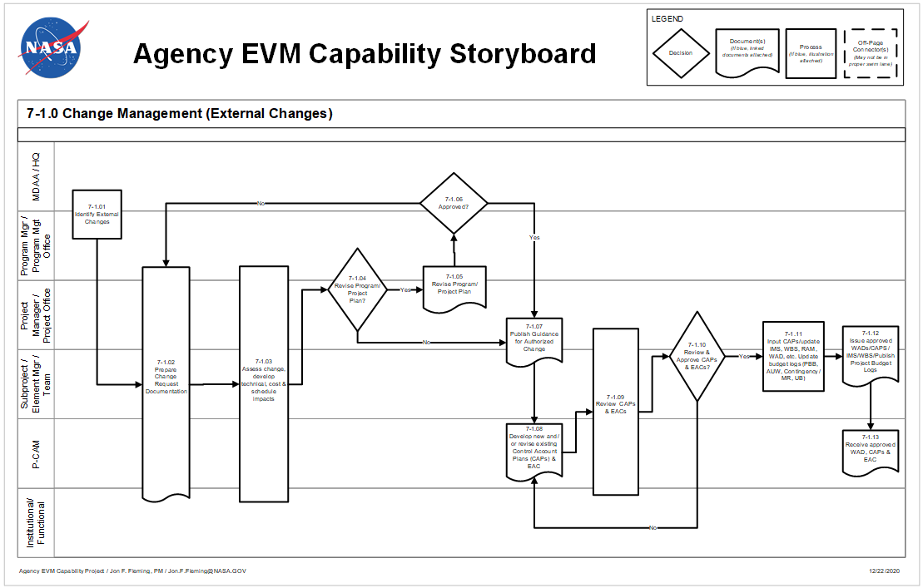
Figure 7-1 Agency EVM Capability Storyboard: Change Management (External Changes)

Change Management (External Changes) Procedure
Role | Flowchart Step | Action or Input/ Output
Mission Directorate Associate Administrator MDAA /NASA Headquarters and Program Manager or Program Management Office | 7-1.01 | Identify External (to the Project) Changes. Externally directed changes include changes directed by the MDAA, customer/sponsor, and /or the Program Manager. Examples of externally directed changes include directed Engineering Change Proposals (ECPs), program re-scope, schedule stretch out, etc., resulting from the Planning, Programming, Budget, and Execution process, etc.
Program Manager or Program Management Office and Project Manager or Project Office and SP/EM / Team and P-CAM and Institutional/ Functions | 7-1.02 | Prepare Change Request Documentation. Changes to the PBB and PMB must be formally documented. The Project Manager and PP&C provide guidance regarding change requirements and approach to responding to the directed change. The guidance is issued to the affected project team.
Program Manager or Program Management Office and Project Manager or Project Office and SP/EM/ Team and P-CAM and Institutional/ Functions | 7-1.03 | Assess Change; Develop Technical, Cost and Schedule Impacts.
Program Manager or Program Management Office and Project Manager or Project Office | 7-1.04 | Revise Program/Project Plan?  If YES, proceed to 7-1.05.  If NO, proceed to 7-1.07.
Program Manager or Program Management Office and Project Manager or Project Office | 7-1.05 | Revise Program/Project Plan. Program/Project Plan revisions are prepared by the responsible organization (i.e., the Program Manager updates the Program Plan; the Project Manager updates the Project Plan).
MDAA /NASA Headquarters and Program Manager or Program Management Office | 7-1.06 | Approved?  If YES, proceed to 7-1.07.  If NO, return to 7-1.02.
Project Manager or Project Office and SP/EM/ Team | 7-1.07 | Publish Guidance for Authorized Change. The Project Manager/SP/EM disseminates planning guidance on incorporating the authorized changes (including retroactive changes as necessary) to the affected P-CAMs. Preliminary scope, schedule and budget targets for the affected CAs will be included in the planning guidance issued by the Project Manager and SP/EM to the P-CAMs.
P-CAMs | 7-1.08 | Develop New and/or Revise Existing Control Account Plans (CAPs) and Estimates at Completion (EACs).
Project Manager or Project Office and SP/EM / Team and P-CAM and Institutional/ Functions | 7-1.09 | Review CAPs and EACs. Prior to incorporation into the existing EV software application, the revised CAPs and EACs are reviewed to ensure the planning is consistent with the authorized change(s) and within the constraints of the project schedule and budget.
Project Manager or Project Office and SP/EM/ Team | 7-1.10 | Approve CAPs and EACs?  If YES, proceed to 7-1.11.  If NO, return to 7-1.08.
Project Manager or Project Office and SP/EM/ Team | 7-1.11 | Input CAPs/Update Integrated Master Schedule, Work Breakdown Structure, Responsibility Assignment Matrix, Work Authorization Document, etc.  Update budget logs [PBB, AUW, Contingency, MR, UB].  The PP&C enters all data into the EV software application, ensures budget traceability to the latest authorized PBB (including AUW), and publishes the revised baseline documentation (WAD, IMS, CAP, WBS, and project budget logs.)
Project Manager or Project Office and SP/EM/ Team | 7-1.12 | Issue Approved WADs, CAPs/IMS/WBS. Publish Project Budget Logs.
P-CAMs | 7-1.13 | Receive Approved WADs, CAPs, and EACs. Execute the approved change in accordance with the work authorization, detailed schedule, and CAP.

Negotiated Program/Project Plan Changes
Program/Project plan changes are revisions that are recognized and approved by the customer/sponsor and that impact the PBB. Authorized work changes are in the form of amending the authorizing document (i.e., Project Plan) and authorize a change in the scope of work, schedule, or dollars and may result in a change to the PBB. All changes authorized by the sponsor are supported by formal documentation before the initiation of work. No changes are made to the PBB without the customer’s/sponsor’s formal authorization.
Customer/sponsor directed changes to the project can affect virtually all aspects of the PMB. Revisions to incorporate authorized changes to the project are made in a timely manner. There must be consistency between what is being reported to the customer and what work is in progress. Where the change has been negotiated, budget revisions are based on the negotiated cost of the change. The budget is initially put in UB, and subsequently distributed to the appropriate CA(s) by the end of the next reporting period.

Undistributed Budget
The entire value of the external change is initially entered into UB. The incorporation of approved changes from UB to CAs may not be possible within the time constraints of internal and external reporting for the month within which the change is approved. In the interim period (i.e., the time between written sponsor authorization and the detailed planning of budgets) the authorized budget is properly identified in UB. Any budget held in UB is detail planned by the end of the next full reporting period following authorization. External changes are logged into either UB or MR—as appropriate—and converted to distributed budget within a CA, as required. The project must provide total traceability of the work authorized by the Project Plan down to the detail CA/WP level.

Authorized Unpriced Work
The customer/sponsor may authorize work to be performed which represents a change to the project scope of work prior to negotiation and approval of the change. This effort is incorporated into UB based on the estimated value of the new work and when negotiated, adjusted to reflect the negotiated value. The PBB also is adjusted for the estimated value of the change. Budget to perform the authorized work is distributed to applicable CAs in small increments to allow priority work to be performed immediately. This process will continue until the change is negotiated, at which time the amount remaining in UB and the PBB will be adjusted for negotiation differences and then distributed to CAs and /or MR as appropriate.

Funding Changes
Changes in funding profiles may affect the manner in which the PMB can be performed. The baseline should be changed to accommodate changes in anticipated funding that are beyond the project’s control. If the funding profile change will affect the PBB (e.g., delays into subsequent years cause cost increases) and/or the major milestone required dates, an amended Project Plan is submitted to the sponsor for authorization of the baseline changes forced by the funding profile change.

Controlling Retroactive Changes
Retroactive changes to work performed that would change current and previously reported amounts for ACWP, BCWP, or BCWS will be carefully monitored, strictly controlled and documented. These changes should be made only for correction of errors, routine accounting adjustments, and effects of customer/sponsor or project management directed changes that improve the baseline integrity and accuracy of performance measurement data. Retroactive changes will not be used to mask legitimate variances.
Corrections to the cumulative performance measurement data are generally recognized in the current reporting period and reference back to the month requiring the correction. All changes will be documented and explained in the IPMR as appropriate.

Change Management (Internal Changes) Parameters
The Change Management (Internal Changes) process flow is shown in Figure 7-2 on the following page; the process procedure is described in 7.6.

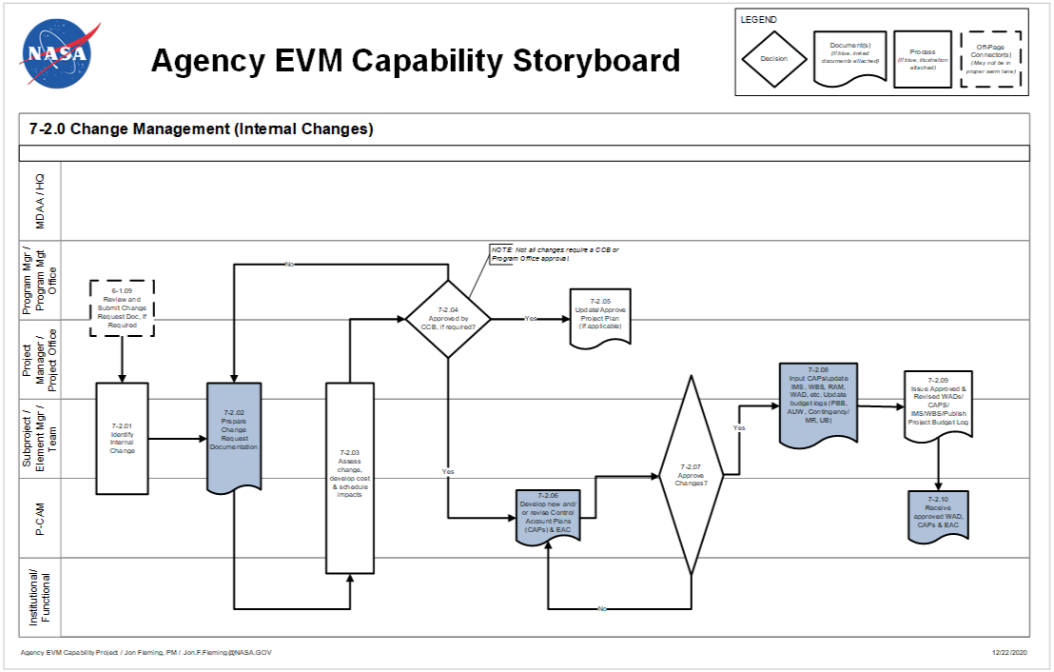
Figure 7-2 Agency EVM Capability Storyboard: Change Management (Internal Changes)

Change Management (Internal Changes) Procedure
Role | Flowchart Step | Action or Input/ Output
SP/EM/Team and P-CAM | Input from 6-1.09 | Review and Submit Change Request Documentation (if required).
Project Manager or Project Office and SP/EM/ Team and P-CAM | 7-2.01 | Identify Internal Changes. Internally driven changes involve realigning scope, schedule or budget within the authorized PBB. Examples include changes resulting from design reviews, reorganization of work or people to improve efficiency, rate changes, etc. The Project Manager approves changes to remaining work including changes that require allocation of contingency/MR. Internal changes also include correction of accounting errors and routine accounting adjustments that improve the accuracy of the data.
Project Manager or Project Office and SP/EM/ Team and P-CAM | 7-2.02 | Prepare Change Request Documentation. Typically, this type of change is initiated by the P-CAM via preparation of the formal change request documentation. This documentation includes the change description, rationale, impacts to scope/schedule/budget, and is submitted to the PP&C for review and change process coordination.
Project Manager or Project Office and SP/EM/ Team and P-CAM and Institutional/ Functional | 7-2.03 | Assess Change, Develop Cost and Schedule Impacts. The Project Office assesses the viability of the change and any resulting scope, schedule, cost, and risk impacts on the project for the Project Manager, SP/EM. The P-CAM, supported by the Project Office, champions the completed change request through the change process to include the CCB, as required. The CCB is required for changes that affect the Project Baseline (WBS, Resource, Budget total and phasing, Schedule, Scope/Requirements (Class 1 changes). CCB review/approval is not required for minor changes or changes not affecting the Project baseline (Class 2 changes).
Program Manager or Program Management Office and Project Manager or Project Office | 7-2.04 | Approved by CCB (if required)?  If YES, proceed to 7-2.05 and 7-2.06.  If NO, proceed to 7-2.02.
Program Manager or Program Management Office and Project Manager or Project Office | 7-2.05 | Update/Approve Project Plan (if Applicable). Changes affecting the project objectives, summary level scope, schedule, and /or budget (to include phasing) are incorporated into the Project Plan and submitted to the Program Manager for approval.
P-CAM | 7-2.06 | Develop New and/or Revise CAPs and EACs. Once the change request is approved, the P-CAM updates the detail planning for new and/or revised CAs, and updates the ETC/EAC to reflect any management changes, as necessary. The revised documentation is submitted for review and approval prior to incorporation into the EV software application and the IMS.
Project Manager or Project Office and SP/EM/ Team and P-CAM and Institutional/ Functions | 7-2.07 | Review CAP Changes. Approve CAP Changes?  If YES, proceed to 7-2.08.  If NO, return to 7-2.06. If disapproved, the documents are returned to the P-CAM for rework (process step 7-2.06) as instructed or for retirement.
Program Manager or Project Manager or Project Office and SP/EM/ Team | 7-2.08 | Input CAPs/Update IMS, WBS, RAM, WAD, etc. Update Budget Logs (PBB, AUW, Contingency/MR, and UB). The PP&C enters all data into the EV software application based on the approved Change Request, ensures budget traceability to the latest authorized PBB (including AUW), and publishes the revised baseline documentation (WAD, IMS, CAP, WBS, and project budget logs). The Change Request Log is updated to reflect final disposition of change.
Project Manager or Project Office and SP/EM/ Team | 7-2.09 | Issue Approved WADs/CAPs/IMS/WBS. Publish Project Budget Logs.
P-CAM | 7-2.10 | Receive Approved WADs, CAPs, and EACs. Execute the approved change in accordance with the work authorization, detailed schedule, and CAP.

Internal Changes (Replanning)
Internal replanning involves realigning scope, schedule, or budget for remaining effort within the PBB and the scope of authorized work. It does not affect the PBB. It is intended for in-scope changes to future budgets that are within the scope of the project. Future means any accounting period following the period in which the replanning activity is initiated. Internal replanning revisions normally occur as a result of updates reflecting improved information, transfer of work from one organization to another, identification of work that is within the authorized scope of the project, but out of scope to the CA and corrective action plans.
It may also be appropriate to perform internal replanning as a result of project reviews such as a PDR or CDR or to accommodate labor, overhead, or other rate changes. In addition to the parameters listed in 7.2, the following controls must be observed to ensure the integrity of performance measurement information:
  - Replanning is not used as an alternative to proper initial planning, nor is it used to mask legitimate variances.
  - Internal changes are typically implemented through a change request with supporting documentation (signed by the P-CAM, the SP/EM, or Project Manager as appropriate) with the reason for the change clearly identified on the change request as defined in the project’s EVM Implementation Plan. Significant changes to a CA incremental BCWS require a change request.
  - Changes to work scope are not made without a commensurate change in budgets. The P-CAM, the Project Manager, the SP/EM, and the Business Manager must jointly evaluate internal revisions.
  - A budget assigned to a future task is not used to perform another task regardless of the WBS level involved.
  - Replanning of unopened WPs is allowed outside the freeze period to keep the planning aligned to the way work is to be performed. However, such replanning cannot change the WP’s budget or affect the baseline schedules of other CAs unless formally approved by the Project Manager or his/her designee.
  - Replanning guidance will encourage replanning of a LOE WP if that WP has not been charged with any actual costs. Once ACWP is incurred then replanning may be limited to adjusting the time-phasing of future BCWS.
Observe the following examples for use of MR to ensure the integrity of performance measurement information:
- Examples of proper MR distribution/return:
  - Definitization of project changes reflecting revised effort.
  - Major redesign.
  - Unanticipated project requirement within the scope of the Project but not within the PMB.
  - Rate changes (future budget).
  - Realized risks and mitigation plans (rework, retest, etc.)
  - Budget returned to MR for work no longer required.
  - Examples of improper MR use:
  - Offsetting CA variances (underruns and overruns).
  - Masking overruns
  - Covering project management mistakes

Formal Reprogramming
Formal reprogramming is the comprehensive replanning process that improves the correlation of project scope, schedule, and budget for performance measurement and management control. The replanning of the remaining PMB results in an OTB, an Over-Target Schedule (OTS) or both. An OTB is the term used to describe a situation where the budget and/or schedule in the PMB exceed the PBB and the contractual schedule delivery dates. The OTB incorporates a recognized budget in excess of the PBB to provide reasonable budget objectives, work control, and performance measurement.

The primary purpose of reprogramming is to establish realistic budgets, schedules, and a meaningful basis for performance measurement for the remaining work. Reprogramming decisions must be based on achievability of the remaining plan. They are preceded by comprehensive EAC and schedule review and may result in the need for an IBR. This type of replan is for performance measurement purposes only and requires prior coordination and approval of the customer/sponsor. The Project Manager will consult with the appropriate NASA Center/organization EVM focal point on formal reprogramming plans.
Formal reprogramming includes the following:
  - Replanning of future work.
  - Replanning of in-process work.
  - Adjusting variances applicable to completed work (retroactive adjustments to cost, schedule, or both).
  - Adjustments to the PMB are reflected in the IPMR.

Formal Reprogramming Conditions
Formal reprogramming is only undertaken under the following conditions:
  - When analysis shows that the budget and/or schedule remaining is not adequate to complete the remaining work and provide for meaningful performance measurement.
  - At least 12 months of significant effort remains on the project at the conclusion of the replanning activity.
  - Formal reprogramming requires prior completion of a comprehensive EAC
  - An agreement is reached between the customer/sponsor and the NASA project on the EAC and the OTB/OTS plan and documented via the Formal Reprogramming Plan

Formal Reprogramming Plan
Formal reprogramming of project activities is initiated with a plan prepared and distributed by the Project Office, which contains the following:
  - The impact on project status reporting down to and including the applicable CAs.
  - The method to be employed in implementing the change (i.e., adjustments in variances to completed work or work in progress).
  - Estimated time to complete implementation and guidelines for performance measurement during this period.
  - Effects on Project Plan authorized requirements and project milestones.
In the event that the project’s operations should generate a condition where the predicted cost growth exceeds the PBB, there are two possible scenarios: 1) the project faces a cancellation review, and/or 2) the Project Manager, with supporting documentation as identified below, petitions the sponsor for additional funding. In accomplishing the second option, the new plan submitted to the customer/sponsor, contains the following:
  - The impact on project status reporting down to and including the CA level.
  - An estimate of the project cost growth (EAC) supported by cost and schedule performance indices
  - The method to be employed in implementing the change (i.e., adjustments in variances to completed work or work in progress).
  - Estimated time to complete implementation and guidelines for performance measurement during this period.
  - Effects on Project Plan authorized requirements and project milestones.
Upon the successful petition for additional funds, a formal reprogramming action may or may not be required. The simple condition of the EAC exceeding the PBB is not, in and of itself, a condition that requires a Formal Reprogramming. If the conditions of 7.7.1 are met, the project will notify the customer/sponsor that a Formal Reprogramming action will be prepared for approval following the Formal Reprogramming Plan cited at the beginning of this section. Adjustments to the PMB are reflected in the IPMR.

Schedule Change Control
The schedule change control process provides a mechanism to change the project’s baseline and current operating schedules in a timely, disciplined manner. There are a number of general schedule change controls that may be put in place, depending upon programmatic factors, project size, or complexity of the schedule. The controls may include, but are not limited to, a Schedule Change Board, or CCB, baseline revisions, and replanning resulting in a new baseline, and version control. This ensures the project IMS includes all of the work authorized, and only the work authorized, necessary to meet the project objectives. See 2.12, Schedule Baseline Maintenance, for additional detailed instructions.

Rebaselining versus Replanning
NASA project personnel may associate "rebaselining" with the process of eliminating all variances (cost and schedule) incurred against the Project PMB and re-establishing the PMB to reflect changes in the project funding. However, this is not consistent with the best practices defined in the EIA-748 EVMS Standard or the definition of “Rebaselining” in NPR 7120.5 which states “Rebaselining is the process that results from a change to the project’s ABC.” In the EVM context, replanning is the process for incorporating changes into the PMB and the method used will depend on the type of changes required as discussed earlier in this section.

Project Logs

Change Request Documentation
Changes to CAs must be documented in order to retain the integrity of the scope, schedule, budget baseline, and EAC throughout the life of the project. A change request document is used to track and approve internal revisions. This document includes a change control number (obtained from the PP&C and documented in the Change Request Log, originator/date, WBS element and CA number (see Figure 7-3). A description of the change (scope/schedule/budget), the associated budget amount (increase/decrease), a revised ETC/EAC (increase/decrease), supporting documentation (e.g. cost estimate, schedule, rationale and BOE) and appropriate approval signatures are provided. The P-CAM documents the cost/schedule impact of the requested change via the change request and supporting documentation as required and submits to PP&C or Business Manager for review and change process coordination. An example of the change request is provided in Figure 7-4.
Figure 7-3 Project Change Request Log
Figure 7-4 Change Request Example
The PP&C enters all data into the EV software application based on the approved change request, ensures budget traceability to the latest authorized PBB (including any AUW), and publishes the revised baseline documentation (WAD, IMS, CAP, WBS, and project budget logs). The Change Request Log (Figure 7-3) is updated to reflect final disposition of the change.
All approved changes to the PBB and the PMB and are reconciled back to the original (or prior) PBB/PMB. Documents used for reconciling original budgets to the current PMB and PBB include the change request form (Figure 7-4), the EV software application PBB/CBB Log (Figure 7-5) and the EV software application MR Log (Figure 3-14). Together, these documents contain the history of all approved budget changes throughout the life of the project; they do not include the history of EAC changes for cost growth or underruns.
Figure 7-5 Project Budget Base Log

Management Reserve Log
MR distribution/returns are entered “automatically” to the MR Log within the EV software application. Figure 3-14 is an example of a Project MR Log. When “Log Comments” are entered into the EV software application, PP&C has an audit trail for the scope changes that occur.
When establishing the initial PMB, the Project Manager ensures that there is adequate MR to address technical, cost and schedule risks. It is a best practice for PP&C to employ a project Significant Risk List/Lien to manage potential/actual project risks and liens against the MR for risk management decisions and total MR traceability. For example, when a budget change is approved, the WAD reference may be added to the Significant Risk List/Lien List form in Figure 7-6 to facilitate the disciplined and traceable use of reserves. The EV software application MR Log and the SRL/Lien List, when employed, are reconciled monthly, in order to effectively manage project MR.
Figure 7-6 SRL/Lien Lists

Revised Work Authorization Documents
Changes to CAs are formally documented in order to retain the integrity of the scope / schedule / PMB throughout the life of the project. Upon management approval of the change request, a revised WAD is issued to the P-CAM for execution documenting the current scope, budget, and schedule.

Change Management Summary of Responsibilities

Project Manager
  - Review the proposed change.
  - Disposition change (Approve / Disapprove) with the support of the Change Control Board, if required.

Subproject/Element Manager
  - Support the preparation of the change request and supporting documentation. Brief the change request documentation to the Change Control Board as appropriate.
  - Quantify the cost/schedule impact of the change, with P-CAM support.
  - Coordinate allocation of budget to the P-CAM via the WAD.
  - Review and approve EV software application CAPs/Reports.

Project-Control Account Manager
  - Prepare the change request and supporting documentation. Brief the change request documentation to the Change Control Board if required.
  - Quantify the cost / schedule impact of the change.
  - Plan the revised schedule and WPs in detail.
  - Ensures that all CAs are within the constraints of project schedules.
  - Approves all revised WADs.

PP&C (or Business Manager) and Project Resource Analyst
  - Review and support the proposed change with SP/EM and P-CAM.
  - Participate on the Change Control Board.
  - Ensure that all budget transactions are properly documented.
  - Ensure budget traceability to the latest authorized PBB
  - Integrate the project budgets with the contractual vehicle values by year.
  - Integrate all time-phased budgets to the appropriate schedules.
  - Ensure that all change requests are approved in a timely manner.
  - Ensure that all change data are correctly entered into the EV software application and the Agency’s Core Financial System as appropriate.
  - Publishes the revised baseline documentation (WAD, CAP, WBS, and Project Budget log).

Planner/Scheduler (P/S)
  - Maintains the integrity of the IMS Plan to the latest authorized PMB.
  - Captures, reviews, and documents proposed and approved changes to schedule plan detail activities, logic, duration, etc., with P-CAM, functional, and project management.
  - Ensures all schedule transactions are properly documented and have validated rationale for the Change Control Board when required.
  - Maintains cognizance over classification of schedule changes and leads in the analysis, documentation, and approval of such changes.
  - Updates/publishes the revised IMS based on approved change request.

MATERIAL MANAGEMENT

Material Management Introduction
Material plays a critical role in the success of NASA projects, and NASA maintains, manages, and accounts for all project materials. This unique research and development environment lends itself to a concurrent manufacturing and production model, facilitating the dynamic and fast paced needs of its engineers, scientists, and contractors. This section describes the requirements and methods used for planning, budgeting, analysis, and control of material.

Materials Management Parameters
The material planning and control description establishes guidelines for the control and analysis of material. The primary features of the material system include:
  - The planning of material costs (BCWS) for WPs and PPs within CAs and in a manner consistent with the authorized work scope and schedule.
  - The recognition of performance (BCWP) that measures accomplishment, not a financial or administrative function (e.g., invoice payment or purchase order preparation).
  - Accumulation of material costs incurred ACWP using acceptable costing techniques and material accountability.
  - The ability to segregate, identify, and analyze the causes of CVs for all types of material.
  - The ability to maintain records showing full accountability for all material purchased for the project/subproject/element.

Material Management Process
The Material Management process flow is shown in Figure 8-1, on the following page; the process procedure is described in 8.4.
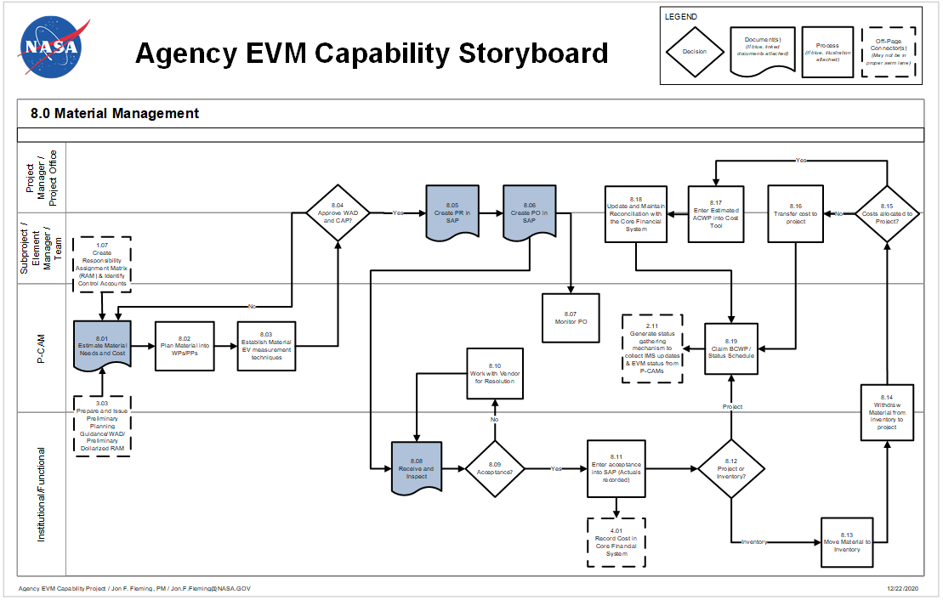
Figure 8-1 Agency EVM Capability Storyboard: Material Management

Material Management Procedure
Role | Flowchart Step | Action or Input/ Output
Project Manager or Project Office and Subproject/ Element Manager (SP/EM)/ Team and P-CAM and Institutional/ Functional Organization | Input from 1.07 | Create, Extend, or Refine Responsibility Assignment Matrix and Identify Control Accounts.
Project Manager or Project Office and SP/EM/Team | Input from 3.03 | Prepare and Issue Preliminary Planning Guidance/WAD/Preliminary Dollarized RAM.
P-CAM | 8.01 | Estimate Material Needs and Cost. The term “material” refers to any hardware, software, and/or service procured from an outside source that is planned and controlled by a unique WBS number, part number or model number. Material needs are estimated using various estimating methodologies and documented in a format designated by the project.
P-CAM | 8.02 | Plan Material into Work Packages and Planning Packages. The CAP, Bill of Material (or similar document), and schedules are the basis for establishing material budgets at the Work Package level. The P-CAM utilizes PPs until specific material requirements are defined. The WPs consist of the direct dollars for the authorized work that defines the expected quantities and are time-phased to meet the necessary requirements for the project, in support of internal schedules. Budgets should accurately represent the manner in which material is planned to be received, accepted, issued to work-in-process, or consumed. Planning of material budgets should coincide with the occurrence of events that show accomplishment.
P-CAM | 8.03 | Establish Material Earned Value Measurement Techniques. Based on the project’s strategy for tracking material, identify EV methods for material work packages. There are several performance measurement techniques available for material, (BCWP) must always be earned on the same basis as the BCWS is scheduled and as actuals or estimated actuals (ACWP) will be applied.
Project/SP/EM or Team | 8.04 | Approve Work Authorization Document and Control Account Plan? The CAPs and WADs are approved by project/subproject/institutional management.  If YES, proceed to 8.05.  If NO, return to 8.01.
Project Manager or Project Office, SP/EM/Team | 8.05 | Create Purchase Requisition (PR) in the Core Financial System. The project/subproject/Institutional/ Functional Manager is responsible for having a PR initiated in the Core Financial System. The PR must contain all information necessary for the purchase of required material.
Project Manager or Project Office, SP/EM/Team | 8.06 | Create Purchase Order (PO) in the Core Financial System. A PO is generated in the Core Financial System as a result of initiating the PR.
P-CAM | 8.07 | Monitor PO. The P-CAM regularly monitors the status of the PO in order to identify potential schedule slips. Regular monitoring facilitates the timeliness of necessary corrective actions(s).
Institutional/Functional | 8.08 | Receive and Inspect. Upon receipt of material, the receiving function performs an account and conformity inspection and records the receipt in the Core Financial System. If applicable, received material is forwarded to Quality Assurance for formal inspection.
Institutional/Functional | 8.09 | Acceptance? A determination is made whether the received material is acceptable.  If YES, proceed to 8.11.  If NO, proceed to 8.10.
P-CAM | 8.10 | Work with Vendor for Resolution. If the delivered material is unacceptable, the P-CAM works with the vendor to resolve any discrepancies that may have occurred through the receipt process or the quality inspection process.
Institutional/Functional | 8.11 | Enter Acceptance into the Core Financial System (Actuals Recorded). Upon acceptance of material, the receiving function indicates acceptance in the Core Financial System. At this point, the material is costed in the Core Financial System based on the value of the Purchase Order. There are sometimes differences between the value on the Purchase Order and the value on the invoice paid to the vendor due to factors such as interest penalties, incentives for early payment, differences in quantities, etc. When this occurs, action is taken to resolve the differences and ensure that costs are properly allocated to the project or subproject.
 | Output to  4.01 | Record Cost in Core Financial System.
Institutional/Functional | 8.12 | Decide If Project or Inventory. A determination is made whether the material goes directly to the project or if it is to be held in inventory.  If Project, proceed to 8.19.  If Inventory, proceed to 8.13.
Institutional/Functional | 8.13 | Move Item to Inventory. If not required immediately by a project, received material is sent to the inventory area. Costs are collected in an inventory cost pool or directly charged to the project.
P-CAM and Institutional/Functional | 8.14 | Withdraw Material from Inventory to Project. When material held in inventory is required by the project, items are delivered to the project.
Project Manager or Project Office, SP/EM/Team | 8.15 | Cost Allocated to Project? Verify whether costs have already been assessed to a project to determine the next step.  If YES, proceed to 8.17.  If NO, proceed to 8.16.
Project Manager or Project Office, SP/EM/Team | 8.16 | Transfer Cost to Project. If the cost for the material item withdrawn from inventory has been charged to an inventory cost pool, the applicable usage charge needs to be transferred to the project.
Project Manager or Project Office, SP/EM/Team | 8.17 | Enter Estimated ACWP into Cost Tool. When material items have been assessed to the project more than 1 month in advance of usage, it is necessary to estimate actual costs. Estimates should be based on the value of the purchase order, or invoice if available, and the amount of material used. The estimated actual is then incorporated into the cost tool.
Project Manager or Project Office, SP/EM/Team | 8.18 | Update and Maintain Reconciliation with the Core Financial System. Maintain up-do-date records of estimated actual costs, and reconcile these with the Agency’s Core Financial System to ensure traceability.
P-CAM | 8.19 | Claim BCWP and Status the Schedule.
 | Output to  2.11 | Generate Status Gathering Mechanism to Collect Integrated Master Schedule Updates and Earned Value Management Status From P-CAMs.

About Material
Material comprises a broad spectrum of items that support a project. Material is sometimes classified as Equipment, Contracts/Subcontracts, and even ODCs depending on the project. It is best practice to standardize the definitions of each of these elements of cost in a Resource Breakdown Structure (RBS) to facilitate cost collection, comparison, and estimation. Material includes consumption items, such as raw materials and piece parts that are not complete and useable end items. Material may also be an item that is standard off the shelf, or an item that is defined, negotiated, procured, and fabricated by a vendor based on a NASA developed specification or drawing. It is important to understand what the material is to determine the best way to plan and control the purchase of that item.

Managing Material
It is critical that the Project/SP/EM define a strategy for planning and control of material up front and early on in the project to aid P-CAMs in preparing time-phased estimates and schedules for material items. This strategy can be documented in several forms, such as a project directive or work authorizing document; but key information should be described such as how:
  - Material will be depicted in the schedule
  - Material will be planned into WPs and PPs
  - Purchased items fit into a defined RBS
  - Purchased items can be grouped
  - “Taxes” will be applied, planned, and tracked
The strategy employed will depend on the amount and criticality of material, and the level of insight needed. One common and effective strategy for planning and control of material is to specify a threshold for high value/critical versus low value/non-critical materials. High value or critical material requires more visibility, thus it is planned and earned using discrete EV techniques. This approach minimizes excessive tracking requirements for low value, non-critical items that tend to overburden the analyst and is designed to identify items that are truly significant relative to the CA size and dollar value.
An example of a high value material item would be an item classified as a capital asset per NASA policy. A capital asset must have its own unique WBS element where acquisition and/or fabrication costs, whether incurred internal to NASA or by contracts, are recorded. Low value material may be planned and earned as percent complete, apportioned effort, or as LOE and can be planned as items in aggregate or in homogenous groupings as desired by the P-CAM.
High value material usually represents approximately 80% of the total material costs on the project while, at the same time, representing about 20% of all material items. Low value material usually represents approximately 20% of the total material cost on the project while representing about 80% of all material items. The Project/SP/EM may also elect to place some limitations on the 80/20 rule by establishing a threshold. For example, when the material budget for a single item is >$5,000, it is tracked discreetly in its own WP within a CA.
In many instances NASA uses contractors/subcontractors and vendors for the fabrication of its material. When subcontracts are used as the vehicle for the procurement of materials such as assemblies and subassemblies, such costs and progress are tracked closely. When items are readily and commercially available, suppliers are selected in accordance with NASA’s procurement practices.

Material Estimating
CA/WP budgets for material are based on defined/expected quantities of material items necessary to meet the requirements of the project. Various methodologies can be employed for estimating material needs, such as historical data or grassroots, but all estimates should include a provision for scrap or rework as necessary. Although a Bill of Material (BoM) is sometimes used to establish the preliminary budgets for material, requirements documents may also take a variety of forms such as engineering drawings, network diagrams, schematics, parts lists, etc. The format for estimating should be specified by the project and will vary based on each project’s needs. It is best practice for the format to include details of purchased items, such as price and quantity, which will allow for price and usage variance analysis as the project progresses. It is also beneficial for the format to be structured in a manner that allows for ease of maintenance and upload to the cost tool.
When using Government Furnished Material or Equipment (GFM, GFE) the CA/WP budget does not include the value of the GFM or GFE. However, all associated costs to transport, modify, support, refurbish, assembly, and test should be scheduled and planned in WPs. Should the project borrow GFM or GFE, then the cost to restore and return to its original condition should be scheduled and planned in WPs.

Material Planning
After the material needs have been identified and estimates prepared for each CA, the P-CAM must prepare a time-phased BCWS for material. The material is time-phased based on available data, such as anticipated need dates and schedules. Material budgets are planned at the point in time most suitable for the type of material involved, but no earlier than the time of progress payments or actual receipt of the material. Appropriate time periods for planning include material receipt, usage, or release to work in process. It is also valid to phase material budgets when payments representing physical progress are made or when inventory costs are allocated to a project or subproject/element. Material BCWS is intended to permit measurement of events reflecting progress in contract performance, not measurement of administrative or financial events (e.g., booking of actual cost of invoice payment). In the case where material goes directly to inventory, BCWS is planned in the month when material will be withdrawn from inventory for project usage. The total BCWS for material on any CA reflects the approved budget from the current work authorization document for that CA.
Material is planned into WPs based on the type of material and its criticality and value to accomplishment of the mission and work scope. If a material item is on the CP or represents a significant percentage of the overall budget, the item should be separately identified and tracked in a WP. If the material items are of little significance or cost, they can be grouped into a WP. Items that are similar, or multiple quantities of the same item, can also be grouped into a single WP.
As NASA is a prototype producer, most material is typically consumed by the development or engineering organizations as they develop and test their prototypes. In support of these efforts, materials are planned within WPs which are time phased in alignment with when progress related to the material item occurs. Material WPs are also aligned with the labor WPs that consume the material. It is also valid to phase material budgets when payments representing physical progress are made or when inventory costs are allocated to a project/subproject/element.
In general, to improve accuracy of performance measurement data and visibility into variances, material items should not be co-mingled with other elements of cost in a WP. However, co-mingling material with other elements of cost is an acceptable practice for LOE WPs or when the material represents a small portion of the overall WP budget.
For material items where work has not progressed sufficiently to allow adequate definition of the parts required, PPs are encouraged. The budgets for these PPs are segregated in a manner that ensures authorized funds are not inadvertently used for other requirements.

Scheduling Material
How material is tracked in the schedule will depend on the needs of the project/subproject/ element for management insight and control. As a best practice, schedules should track significant or critical material items as milestones corresponding with acceptance and when performance is taken. Significant or critical material items that are acquired or obtained at no cost to NASA are tracked in the schedule using milestones. This approach allows projects to maintain visibility of the item, without distorting performance.

Material Performance Measurement
There are numerous performance measurement techniques available for material items, the assignment of which will depend on the criticality or significance of the material item as well as the method used to procure the item. In all cases, the only acceptable points at which to earn performance on material are when the items are received, accepted, progress payments, point of usage or disbursement, or final distribution.
For material items where the project requires additional insight, a discrete EV method should be applied. When multiple quantities of the same item are ordered, with different anticipated delivery dates, a milestone weight with percent complete EV method can be employed. If some, but not all items associated with a milestone are received and accepted, the P-CAM can take a percentage of the milestone value based on the quantity/value of items received. BCWP is equal to the budgeted unit price of the item received times the actual quantity received. If no interim reporting will be received, or all quantities are expected to be received in the same month, the milestone EV technique is an effective measure of performance. In this case, value is earned when the material item is received and accepted and is based on the budgeted value.
For items that do not require additional management insight due to value or criticality, several EV techniques are available. These are listed below in order of preference.
The first method is to calculate BCWP as a percent complete based on the formula:
BCWP = (ACWP×BAC)/EAC
Or
BCWP = (ACWP/EAC) x BAC
where:
- ACWP is the cost of the material received, which is the PO unit price times the quantity received.
- BAC is the total WP budget, which is entered as the PR unit cost and quantity.
- EAC is the BAC when adjusted for price and usage variances.
Note that BCWP=ACWP when BAC=EAC, thus it is important to ensure the EAC is valid when using this methodology. Total Cumulative BCWP may not exceed 95 percent of the WP BAC value until the final items are received and the WP is closed.
A second technique is apportioned effort where BCWP will be calculated automatically by the EVM Capability. Use this method when BCWP can be directly related to another WP.
The third, and least preferred, method is LOE where BCWP=BCWS. The selection of LOE must be justified by the P-CAM.

Special Cases
For those items classified as material, but for which there is not physical receipt, identification of the “point of receipt” may be difficult. Two examples of this type of material are software licenses and maintenance agreements. There is no shipment of any physical item that can be received. Effectively, the placement of the PO is evidence of the receipt of the renewed license and/or pre-paid maintenance agreements. Therefore, while BCWP is being claimed at the point of placement of the PO, in reality, the performance is being claimed because of the virtual receipt of the software renewals and/or the beginning of another software/maintenance period.

Material Actual Cost
NASA uses an accounting system that ensures costs for materials are budgeted and accumulated in accordance with internal and external requirements. For material management purposes, material costs include the costs of such items as raw materials, parts, subassemblies, components, hardware, software, and manufacturing supplies. Every effort is made to report material costs in the same accounting period in which EV is taken.
NASA endorses the philosophy that budget should be scheduled in accordance with the events that earn those amounts. In NASA’s accounting system, actuals are recorded when labor is expended or materials are received. The method of material cost recognition (ACWP) is based upon acceptance at NASA Receiving/Inspection. After acceptance, actual costs are recognized in the accounting system based on the value of the purchase order.
It is essential that all actual costs used for variance analysis come directly from, or be reconcilable with, the NASA accounting system.
When material is purchased for storage in inventory, or when vendor payments are not aligned with objective progress assessment, it may be necessary to use estimated actual costs to avoid artificial variances, which might be created when materials are purchased far in advance of usage. This is especially true when the lag time for acquiring actual cost data is significant. This may often be the case when other large institutions are involved in an effort and their accounting processes result in a lag of one or more accounting cycles before actual costs are available. This condition may be exacerbated when there are multiple partners in an effort. When the actual cost data becomes available it must be reconciled with the estimated actuals and corrections made to ensure that the EV information remains accurate and reliable.
The use of estimated actuals should be employed where necessary to ensure the most current information is being used in managing the effort. See discussion in 4.14 on application and reconciliation of estimated actuals.

Material Variances

Material Variance Analysis
The P-CAM is responsible for monitoring schedule and cost performance for all material on the project, discretely monitoring high value/critical material items, and analyzing groupings of low value/non-critical material items. Material price and usage variance analysis is an essential element of material cost control and begins early in the material acquisitions cycle when price and quantity data are available to support this analysis. When ACWP are accrued, the P-CAM receives a VAR form if variance falls outside of the established CA thresholds. Data from the estimating formats, material purchase requests, orders, and invoices are used as required to facilitate the analysis of material price variances.

Material Cost and Schedule Variances
On a monthly basis, reports are generated at the CA level comparing planned to actual accomplishments to derive the SV. Similarly, for the CV, the EV for the period is compared to the actual costs. Should significant differences arise, and it is determined that it is driven by material, an analysis of the source or cause of that variance is performed to determine if it is due to price, usage, or quantity. This analysis is reviewed by the project/subproject/element management office for acceptability and relevance. Relevant items are brought to the project’s senior management attention.
Sometimes, purchasing of material in excess of requirements is allowed for scrap, economic order quantity purchases, rejections, shrinkage, differing yield rates, etc. Significant differences between requirements and purchases that are driven by such factors are thoroughly documented.
When significant variances are identified, VARs are generated which describe in detail the reason for the variance, including a segregation of price and usage variance when available, and the proposed resolution, if applicable. This information is prepared by the P-CAM with input from others as needed. The vehicle for the dissemination of this information to all potentially affected parties, are the periodic (no less frequently than monthly) management meetings.

Material EACs
Material EACs are revised when purchase order or requirements documents support a change in the expected amount needed or its respective cost. Otherwise, material EACs are performed as a part of the routine or comprehensive EAC activity and in accordance with NASA’s EAC guidance. (See 6.6)

Material Budget Changes
If the material requirement has changed significantly in either unit price or quantity from the plan the P-CAM prepares a change request to reflect the additional budget requirements. The request is submitted to the program/project/subproject office for review and approval, prior to processing a PR. If the use of MR is approved, the budget change is entered into the PMB and the PR is authorized. If the PR is authorized and the use of MR is not, then the CA’s EAC must be revised. See Section 7 for additional guidance on budget changes.

Physical Accountability
NASA’s material management system requirements are defined in NASA policy and ensure full accountability of all material purchased for a project or subproject/element.
Material procured for, but not used by, a project is classified as overage or residual. Material classified as residual or overage should be transferred to inventory with its associated cost as determined by NASA requirements. Corresponding negative adjustments to budgets and EV should also be made to the performance measurement data and be documented in both the VAR and the Format 5 report for the month. If the item is not accepted as a return to NASA inventory, no adjustments are made to the performance measurement data.
Once a project is complete, all materials remaining in the physical possession of the project that were associated with the development of that phase, are considered residual and transferred to the appropriate inventory store in accordance with NASA procedures.

Material Transfers
All transfers of material items must conform to NASA requirements.
If the material is to be permanently transferred from Project A to Project B, and the material is not identified as GFE/GFM, all associated costs—including the value of the material—would be transferred to the receiving project. The project/subproject/element and institutional offices are required to assess the impacts and make a determination as to the need for changes to the existing baseline (PMB) and retroactive changes to BCWS, BCWP, and ACWP, if any. Said changes are made in accordance with the revision process discussed in Section 7, Change Management, and are reported to the sponsor in IPMR Format 5.
Project B (the receiver of the transferred material) should add a new WP to the appropriate CA that would be responsible for this item. The WP should contain the budget for the resources required to procure this item, including the actual value of the material. The EV will be taken during the month when the item is transferred and received by Project B.
If the material item was ordered but not received by Project A, then no EV would have been taken, and this project would transfer the purchase order and obligation costs to Project B. Project A will then delete or adjust the resources and budget associated from the appropriate CA/WP that placed the original purchase order. If Project A no longer requires the item, the budget should be returned to management reserve.
If Project A receives the material to be transferred and takes EV, the original budget, actual cost and EV for the material will be adjusted. The actual cost for the material will be transferred to Project B, and the original budget in the responsible CA would have to be decremented in the current period and that budget returned to MR. The EV associated with this item also will be decremented in the current period. The reason for these adjustments is that the transfer of material is a reduction in scope of the effort.

Material Management Summary of Responsibilities
Responsibility and accountability for implementing NASA’s EVM Material Management process is distributed throughout the project organization as discussed below.

Project Manager
  - Recognizes and accepts responsibility and authority for the project.
  - Provides overall management direction and oversight for the project.

Subproject Manager
  - Assists P-CAM in the planning and scheduling of material items.
  - Oversees monitoring of material costs.
  - Reviews and approves VARs addressing material costs.

Project-Control Account Manager (P-CAM)
  - Develops plan and schedule for material WPs.
  - Generates (or causes) purchase requisitions for material items.
  - Monitors the purchase order material costs.
  - Reports cost/schedule status of material items and generates VARs when significant variances occur.

Project Office, Subproject/Element Team, Institutional/Functional Organizations
  - Supports the planning and scheduling of material items.
  - Prepares Purchase Requests and Purchase Orders.
  - Assists in the monitoring of material costs.
  - Assists in the reporting of cost/schedule status for material items and the accumulation of VARs when significant variances occur.
  - Helps with the preparation of Corrective Actions for all the cost and SVs.

Receiving/Inspection
  - Receives the item from the vendor and performs an account and conformity inspection.
  - Sends item to Quality Assurance for inspection when required.
  - Returns item to vendor if not accepted.
  - Records receipt of item in the Core Financial System.
  - Delivers item to customer or inventory holding facility.

CONTRACT MANAGEMENT

Contract Management Introduction
A substantial amount of a NASA project’s budget is expended through outside contracts. The Office of Procurement (OP) and its equivalent at each Center is responsible for managing contracts for value while ensuring that all applicable public laws and prime contract flow down requirements are adhered to in a professional and highly ethical fashion. Contract management is a team effort that includes inputs from contract managers, NASA technical managers, NASA project managers, contracting officer’s representatives, business personnel schedule analysts, and business manager, etc.

Contract Management Parameters
The following parameters apply:
  - The key items for contract management are the Contract/Purchase Order (PO), WP, and CA number.
  - Major contracts are defined as contracts (currently valued ≥$20 million) that require flow down of compliance with the EIA-748 EVMS Standard guidelines and are planned in a separate CA.
  - Time-phased contract budget plans are prepared for each CA based on the following criteria:
  - Contract budget plans use the most current cost information available, reflect the P-CAM’s estimate, and are a reasonable expectation of the prices to be incurred by the contractor.
  - If a major contract, the CA time-phased budget is planned to mirror the contractor’s PMB.
  - The contract budget plans correlate to the appropriate intermediate schedules and the project’s master schedule.
  - The objectives of NASA’s EVM Capability for contract management are as follows:
  - To ensure that EVM requirements are flowed down to the applicable contracts.
  - To ensure proper cost and schedule planning and occurrence of contract resources.
  - To enable accurate and timely cost and schedule performance measurement of contract resources.
  - To ensure adequate accountability of contract resources.

Contract Management Process
The Contract Management process flow is shown in Figure 9-1, on the following page; the process procedure is described in Section 9.4.

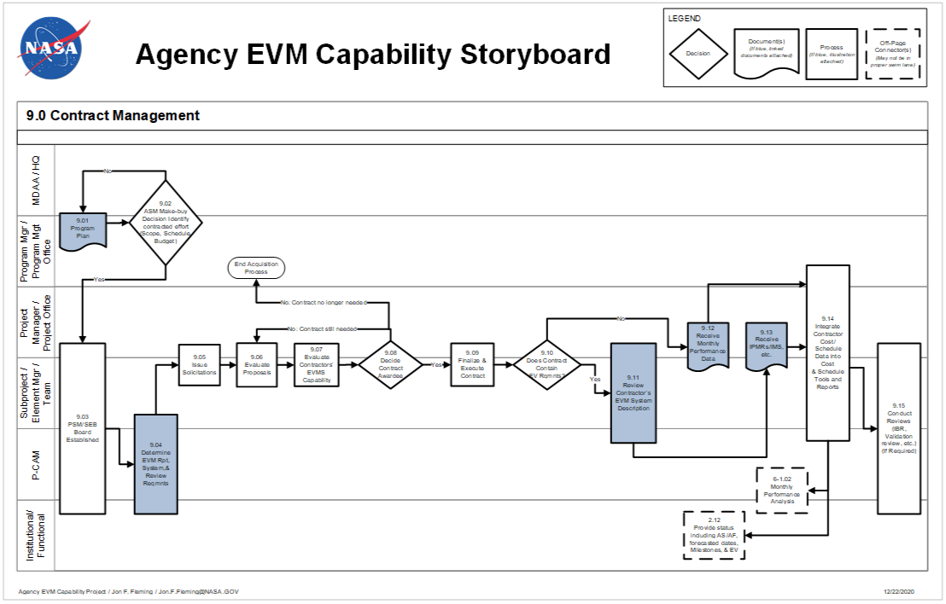
Figure 9-1 Agency EVM Capability Storyboard: Contract Management

Contract Management Procedure
Role | Flowchart Step | Action or Input/ Output
Program Manager or Program Management Office | 9.01 | Prepare Program Plan.
Mission Directorate Associate Administrator (MDAA)/NASA Headquarters and Program Manager or Program Management Office and Contracting Officer (CO) | 9.02 | Acquisition Strategy Meeting Make-Buy Decision. Identify Contracted Effort (Scope, Schedule, and Budget)  If YES, proceed to 9.03.  If NO, return to 9.01.
Project Manager or Project Office and CO | 9.03 | Procurement Strategy Meeting / Source Evaluation Board (SEB) Established.
Subproject/Element Manager (SP/EM)/Team and CO | 9.04 | Determine EVM Reporting, System, and Review Requirements and Flow Down To Applicable Contracts.
Project Manager or Project Office and SP/EM /Team and CO | 9.05 | Issue Solicitations.
Project Manager or Project Office and SP/EM/Team and CO/EVM Focal Point | 9.06 | Evaluate Proposals.
Project Manager or Project Office and SP/EM/Team and CO/EVM Focal Point | 9.07 | Evaluate Contractors’ EVM Capability (If required).
Project Manager or Project Office and SP/EM/Team and CO | 9.08 | Decide Award Contract.  If Contract is awarded, proceed to 9.09.  If No contract is awarded, return to 9.06, or end acquisition process if contract no longer needed.
Project Manager or Project Office and EP/EM/Team and CO/EVM Focal Point | 9.09 | Finalize and Execute Contract. Finalize and flow down the applicable EVM DRDs and execute contract.
Project Manager or Project Office and SP/EM/Team | 9.10 | Does Contract Contain EVM requirements?  If YES, proceed to 9.11.  If NO, proceed to 9.12.
Project Manager or Project Office and SP/EM/P-CAM/Team/EVM Focal Point | 9.11 | Review Contractor’s EVM System Description to Understand Their Project Management Process and EVM Approach.
Project Manager or Project Office and SP/EM/Team | 9.12 | Receive Monthly Performance Data. For non-EVM contracts, proceed to 9.14. (See Reporting for Contracts with No EVM Requirements located at https://www.nasa.gov/evm/guidance.)
Project Manager or Project Office and SP/EM/Team | 9.13 | Receive IPMR, etc.
Program Manager or Program Management Office and Project Manager or Project Office and Subproject / Element Manager /Team and P-CAM/Contracting Officer’s Representative (COR) | 9.14 | Integrate Contractor/Subcontractor Cost/Schedule Data into Cost and Schedule Tools and Reports.
Project Manager or Project Office and Subproject / Element Manager /Team and P-CAM/COR | Output to 6-1.02 | Monthly Performance Analysis.
P-CAM/COR | Output to 2.12 | Provide Status Including Actual Start (AS)/Actual Finish (AF) Forecasted Dates, Milestones, and EV.
Project Manager or Project Office and Subproject/Element Manager/P-CAM/Team/EVM Focal Point | 9.15 | Conduct Reviews [Integrated Baseline Review, Validation Review, etc.] (if required).

Contract Management Responsibility
The NASA Contracting Officer and the Project Manager have the overall responsibility to ensure that the EVM requirements per the NASA FAR Supplement (NFS) Part 1852.234 clause are flowed down to the contract. The Project Manager (Program Manager for major contracts) has the responsibility and authority to manage the technical, cost, and schedule performance of the contractor. The CO or COR has the requisite authority and responsibility to ensure the contractor/subcontractor fulfills the project's requirements, and is the primary contact for any contractual issues regarding the contract. Within the contract there will be lower level breakdown of work that will be managed by other lower level technical managers who will serve as P-CAMs for the management of the subsystem elements within the contract.
On a monthly basis the P-CAM reviews, assesses, and analyzes the contractor’s technical, cost, and schedule performance. The P-CAM may be assisted in this monthly activity by the following individuals:
  - Project Manager: Has overall responsibility for managing the contractor’s performance in regard to the technical scope of work, along with the cost and schedule requirements.
  - Contract Manager: Functions as NASA’s “contracting” official with the contractor.
  - Task Monitor: If applicable, provides technical expertise to assist the COR/P-CAM.
  - COR/P-CAM: Assists in analyzing contractor/subcontractor performance.
  - Planner/Scheduler: Assists in monitoring and analyzing schedule performance.
  - Project Resource or Program Analyst: Provides cost and performance reports for the CA and assists in monitoring and analyzing schedule performance.

Performance Management Flow-Downs to Contractors/Subcontractors
Flow-Down to Contractors
Less than $20M | $20M to $100M | > $100M
Non-EVM Performance Mgmt | 32 Guidelines Compliance | 32 Guidelines Validated
Performance Mgmt Terms and Conditions of DRDs | Full EVM Terms and Conditions of DRDs | Full EVM Terms and Conditions of DRDs
All Supporting Contractors

Figure 9-2 Contractor/Subcontractor Cost Performance Reporting Requirements Flow-Down
To ensure sufficient visibility into the work being performed at contractors, NFS 1834 has established various thresholds that dictate differing levels of performance measurement reporting for development type contracts. The contract EVM flow-down requirements are summarized in Figure 9-2.
Contracts with a valued between $20 and $150M that support SMD Mission Risk Class-D projects have an approved deviation from the EVM requirements of NFS 1834 (see NASA Assistant Administrator for Procurement memorandum, SUBJECT: Approval of Request to Deviate - Earned Value Managements Systems from SMD Class-D Tailored/Streamlined Missions, dated June 28, 2018 at https://www.nasa.gov/sites/default/files/atoms/files/approved_smd_evms_deviation.pdf).
For contracts and subcontracts valued at $100 million or more, the contractor/subcontractor shall have an EVM System (or a plan to develop a system) that has been formally validated and accepted by the Government.
For contracts and subcontracts valued from $20 million to $100 million, the EVMS shall be compliant with the guidelines in the EIA-748 EVMS Standard, but does not require validation.
For contracts and subcontracts that are not considered major acquisitions and valued at less than $20 million, the application of EVM is optional and is a risk-based decision that is at the discretion of the program/project manager.
For firm fixed price (FFP) contracts of any dollar value EVM is discouraged. However, a schedule management system and adequate reporting shall be required to plan and track schedule performance for development or production contracts valued at $20 million or more. In addition, FFP contracts that are part of a program/project of $100 million or more, the CO shall collaborate with the program/project manager to ensure the appropriate data can be obtained or generated to fulfill program/project management needs to comply with the overall project EVM requirements.
EVM is not required on contracts for non-developmental engineering support services, steady state operations, basic and applied research, and routine services such as janitorial services or grounds maintenance services. In these cases, application of EVM is at the discretion of the program/project manager.
CAPs for a contract that does not have a performance-reporting requirement will initially be prepared as time-phased PPs scheduled over the period of performance shown on the applicable project schedule. The BAC value will equal the contract cost submitted in the proposal to the NASA project. Following contract negotiations, the contract administrator will submit a cost/schedule change request reflecting any negotiated schedule revisions to the period of performance or significant milestone date, and any difference (plus or minus) in contract cost. The project/operations manager will review and approve all cost/schedule change requests before the revisions are formally incorporated into the related CAP. Approved budget changes will be treated as management reserve transactions.
The contract administrator will revise the CAP to reflect a task with time-phased, weighted milestones derived from the contractor’s approved master program schedule, time-phased expenditure plans, and negotiated billing plan that have been adjusted for fee/profit. Subsequent revisions to the CA time-phased budget, i.e. BCWS, will be incorporated to reflect authorized contract changes and approved revisions to the contractor’s master program schedule.
The CO, in consultation with the Center EVM Focal Point and the SEB ensures that the appropriate performance measurement reporting requirements are flowed down to the contractor/subcontractor via the Request for Proposal. This flow-down is also verified by surveillance of the contractor’s EVMS. The EVM requirements flowed down on contracts are critical for consistent cost and schedule performance reporting, periodic EACs, and IBRs. If a supplier does not have a validated EVMS for a contract exceeding $100M, an exception should be considered for one-time contracts. A one-time contract is a case where a supplier is not going to provide product or service beyond the contract period. For guidance, refer to the NASA EVMS Acceptance for One-time Contracts Guide.
To summarize, all contracts defined as “development” must be managed using an EVMS that is compliant with the EIA-748 EVMS Standard if it exceeds the thresholds defined above (unless it has an approved deviation such as SMD Mission Risk Class-D space flight projects and contracts with a life cycle cost of up to $150M (not including launch costs). If the major contract is ≥$100 million, the contractor/subcontractor’s EVMS must be accepted or validated by the Cognizant Federal Agency (CFA). Typically, NASA delegates the acceptance and surveillance of contractor/subcontractor EVM Capability to the Defense Contract Management Agency (DCMA). If, at the time of award, the contractor/subcontractor does not have an EVMS that has been approved by the CFA, NASA will take one of two actions. If the subcontract value is ≥$100 million, in accordance to the NFS Part 1852.234, the contractor/subcontractor is required to submit a plan for developing and implementing an accepted EVMS. Either NASA or the CFA (i.e., DCMA) will review and approve the plan and arrange for a formal Acceptance or Validation Review of the contractor’s EVMS. If this has been delegated to a CFA they will arrange for this review and notify and update NASA of progress. Typically, the DCMA will ask NASA to provide some of the resources to support an acceptance review. The NASA resources selected for this review will gain insight into the contractor’s EVM Capability which will benefit the project throughout the life of the contract. If the major contract value is < $100 million, NASA will require the contractor/subcontractor to verify that it is in compliance with the EIA-748 EVMS Standard guidelines, although no review will be conducted by NASA or the CFA.
If the contractor/subcontractor has an EVMS that has been validated by the Government, then that EVMS can be proposed as the system that will execute the EVM process. The Office of Management and Budget (OMB) reinforced this approach in its October 23, 2015 document entitled Reducing the Burden of Certifying Earned Value Management Systems, in which OMB encourages reducing duplicative processes by agencies adopting EVM certification reciprocity. The OMB document can be found at https://obamawhitehouse.archives.gov/sites/default/files/omb/procurement/memo/reducing-burden-certifying-earned-value-management-systems.pdf.
NASA, in fact, officially established EVM reciprocity with the Federal Aviation Administration (FAA) on March 31, 2016 when it executed a Memorandum of Understanding (MOU) entitled Memorandum of Understanding Concerning Reciprocal Recognition of a Supplier’s Earned Value Management System. This document can be found on the NASA EVM website at https://www.nasa.gov/evm/regulations.
It should be emphasized that any prime (or first tier) contractor/subcontractor is responsible for reporting the status and EV information for any subordinate (second tier) contractors/subcontractors employed.
When EVM is required on a contract it is necessary to perform an IBR. The objective of the IBR is to obtain a mutual understanding of the PMB and the inherent risks associated with it. Another benefit is to gain insight into the contractor’s management systems and to understand the detailed approach to its EVMS. Properly executed IBRs are an essential element of the project’s risk management approach. For detailed guidance and instructions on IBR see NASA IBR Handbook at https:// nasa.gov/evm/handbooks .

Schedules for the Authorized Contracted Effort
Schedule analysis provides the basis for communicating technical progress throughout the life cycle of the project. Status assessment ensures that the contractor’s schedule performance data are accurate and complete for each month-end reporting cycle.
Contractor/Subcontractor schedule requirements should be fully integrated into the overall program/project schedule. It is important to plan and track all critical schedule requirements that constrain the successful conclusion of procurement actions. If the contractor/subcontractor is a major contractor, it must develop an IMS.
Contractor/Subcontractor schedule integration should provide an accurate depiction of the impact of contractor/subcontractor performance on the project schedules.

Budgets for the Authorized Contracted Effort
The identification of budgets for contracted items is a result of establishing the requirement for the item to be procured as a contract rather than purchased as a material item. This involves identification of the contractor, the establishment of an estimated value for the contract, and ultimately, negotiating the contract scope, schedule, and budget. During this process, the Project establishes a baseline for the effort at the CA level. During negotiations, the baseline values normally are based on the Project’s estimate for the work as opposed to the contractor's proposal values. Once negotiations are complete, budgets are normally adjusted via use or replenishment of MR to reflect the negotiated value of the contract. The contract value used in the baseline must be fully vetted and negotiated.
When a contractor/subcontractor is required to provide an external performance measurement report, contractor/subcontractor data are provided to the project for performance measurement purposes. If a contractor/subcontractor is not required to provide EV information to the project, the Contract Manager/SP/EM/P-CAM should establish and negotiate procedures, which provide schedule and technical plans, and progress reports as needed for overall project cost performance management (see Figure 9-2).
Budgets assigned to CAs for contracted items are planned and supported by time-phased information from the contractor.

Work Packages for Contracted Effort.
Major contractors are identified to a scope of work and to a specific WBS element, i.e., CA. In addition, WPs may be established within the contractor/subcontractor CA to provide for separation of contract activities for performance measurement purposes.
NASA is able to support the values established within each WP using either contractor/subcontractor supplied information or internal documentation. These WPs are related to the plan established by the contractor/subcontractor to complete efforts on the contracted items.
WP and PP budgets for contractors represent the contractor’s plan for supporting contractual effort and are based on contractor/subcontractor and/or in-house documentation. The contractor/subcontractor baseline/plan is used regularly as the basis to assess their status and generate EVM data.

Collect and Report Actuals for Contracted Efforts
NASA's accounting system ensures that contract costs are allocated to the accounts for which efforts were expended in a manner consistent with the respective budgets. In most circumstances, actual costs for contract items are reported in the same accounting period that EV is taken.

Estimated Actuals
It is essential that all actual costs used for variance analysis come directly from, or be reconcilable with, the NASA accounting system.
Due to lagging reporting of costs, it may be necessary to use estimated actual costs to avoid artificial variances, which might be created by the time lag of costs being recognized by the Agency’s accounting system. This is especially true when the lag time for acquiring actual cost data is significant. This may often be the case when other large institutions are involved in an effort and their accounting processes result in a lag of one or more accounting cycles before actual costs are available. This condition may be exacerbated when there are multiple partners in an effort. When the actual cost data becomes available it must be reconciled with the estimated actuals and corrections made to ensure that the EV information remains accurate and reliable.
The use of estimated actuals should be employed where necessary to ensure the most current information is being used in managing the effort. For major contracts the use of estimated actuals can be minimized by using the contractor’s current month estimate from the Contractor Financial Management Report (NASA Form NF 533) as the accounting accrual so that the need for estimated actual is removed. See discussion in 4.14 on application and reconciliation of Estimated Actuals.

Provide Effective Analysis of Contractor/Subcontractor Performance
For major contracts (>$20 million), the Project Manager and applicable P-CAMs have been assigned the responsibility of reviewing the contractor’s IPMR for accuracy and adequacy. If the contract falls below the $20 million threshold, then the applicable EVM data must be developed by the Project Manager or P-CAMs for incorporation into the overall project EVM PMB. This review includes an analysis of the performance measurement information contained in the data formats of the report, an evaluation of the variance analysis information contained in the report, and an evaluation of the management reserve usage, baseline changes and workforce changes. The analytical results from either source are provided to the P-CAMs for their monthly CA review and assessment.
The PRA and Planner/Schedulers are responsible for incorporating the contractor’s cost and schedule and performance data, including any significant variances into the projects information to ensure a complete picture of the project’s overall status. Working with the project team, the P-CAM ensures that EV reported by the contractor/subcontractor reconciles to actual physical progress reflected in the contractor’s progress payments requests.

Generate EACs for Contracted Efforts
The procedures relative to contract EACs should focus on two aspects:
- The requirement that the contractor/subcontractor generates an EAC as necessary to support program requirements and reporting to the customer; and,
- The responsibility of the project team to evaluate the contractor's EAC for adequacy and accuracy.
Contract EACs should be based on:
- Actual costs to date
- Open commitment values for contracted or procured items
- Performance to date as reported in the contractor’s report and analyzed by the contract manager
- Knowledgeable projections of future performance
- Estimates of economic escalation
Typically, if the contractor/subcontractor has a certified EVMS, then its System Description will outline the requirements for EACs to be updated. P-CAMs should understand the frequency and process for EACs to be updated so that they can take this into consideration when updating their EACs.

Contractor Surveillance
As discussed previously, NASA imposes differing levels of EVM on its contractors. When a contractor/subcontractor has a requirement for an accepted or validated EVMS, NASA is required to periodically test or survey the EVMS. This function is normally delegated to DCMA, via a delegation letter from the NASA CO, in order to ensure that the contractor/subcontractor is still managing the contract in accordance with its validated EVMS. For specific wording, refer to the NASA MOU with DCMA at https://nasa.gov/evm/mou
However, if the surveillance is not delegated to DCMA or another outside source, then NASA is required to perform this activity at least quarterly to ensure that the contractor/subcontractor is adhering to the EIA-748 EVMS Standard guidelines and its own internal EVMS process. This will ensure that the information that is received and incorporated into the NASA project baseline is valid and reliable. If any discrepancies are found, then the contractor’s EV organization and its project team will develop a corrective action plan and provide monthly progress on the plan until full correction is achieved. If surveillance has been delegated to DCMA then they will track the contractor’s corrective action plan and report to the NASA CO as needed. If not, then the organization responsible for surveillance assumes this task. It is recommended that the project include the Center EVM Focal Point into the surveillance process or the tracking of issues and corrective action plans from the contractor.
Once surveillance report information is received from the contractor, the NASA CO or DCMA reviews the submitted information for accuracy and adequacy and provides a report to the project. This analysis includes an assessment of the performance measurement information contained in the data formats of the report, an evaluation of the VARs, and evaluation of the contractor’s EAC and overall performance.

Contract Management Summary of Responsibilities
Responsibility and accountability for managing contracts on a project is distributed among several roles as discussed below.

Project Manager
  - Recognizes and accepts responsibility and authority for the project.
  - Provides overall management direction and oversight for the project.

Subproject/Element Manager
  - Assists P-CAM in the planning and scheduling of contract items.
  - Ensures proper allocation of EVM requirements to major subcontracts
  - Oversees monitoring of contractor/subcontractor costs.
  - Reviews and approves VARs addressing material costs.

Project-Control Account Manager (P-CAM)
  - Reviews contractor’s plan and schedule for integration into the project’s data.
  - Generates (or causes) purchase requisitions for contracted items.
  - Ensures appropriate flow down of EVM requirements to major contractors.
  - Manages the contractor’s technical, schedule, and cost performance.
  - Analyzes the contractor’s EAC and, if not in agreement, develops an independent EAC.
  - Generates independent VARs when significant variances occur.

Contracting Officer (CO)
  - With inputs from the P-CAM / CTM and Business Manager, negotiates and executes the contract.
  - Ensures that the appropriate EVM clauses and data requirements are included in major contracts.

Contracting Officer’s Representative (COR)
  - Monitors contractor/subcontractor performance for timely, acceptable deliverables including cost, schedule, and EV reports.
  - Analyzes contractor/subcontractor data and provide input to PP&C.
  - Distributes reports, if necessary, to the P-CAM/CTM and the Business Manager/PRA.

Business Manager
  - Supports the planning and scheduling of contracted items.
  - Assists in the monitoring of contract costs.
  - Oversees the integration of Contractor/Subcontractor cost and schedule data into the project’s data.
  - Assists in the reporting of cost/schedule status for contracted items and the accumulation of VARs when significant variances occur.

EVM Focal Point
  - Supports the project in the surveillance activities and tracking of corrective actions.
  - Facilitates any differences between the contractor/subcontractor and the applicable NASA organizations.

INTRA-AGENCY WORK AGREEMENTS

Intra-Agency Work Agreements Introduction
NASA Project implementations are encouraged to utilize facilities, resources and capabilities available across NASA Centers, other government or non-profit entities or partners. This collaborative approach requires the responsible Project Office to negotiate Work Agreements with the performing or implementing Center. Documenting the agreed upon scope, schedule and budget via an IAWA is similar to negotiating a contract with an industry partner. The NASA Project Office, as the sponsor, is responsible for managing these Work Agreements—including scope, schedule, and budget—as well as ensuring flow down requirements are adhered to in a professional and highly ethical fashion. The Project Office will integrate all cost and schedule data from contractors and other Centers into the total project EVM data to provide information for analysis and reporting. This integration provides the project the ability to report at a total project level.

Intra-Agency Work Agreements Parameters
The following parameters apply:
  - All authorized work is clearly defined using the framework of the project WBS decomposed or extended to the project/Center level
  - A specific individual is assigned from the responsible Center to manage a specific subproject/element scope of work, schedule, and budget. This individual has direct responsibility for the work and negotiates the Center resources required to accomplish the work.
  - If there is a change to assignment of responsibility, WBS, scope of work, period of performance, or a revision to an existing IAWA, a revised IAWA is issued as documented in the change process in Section 7.
  - Work is not performed, costs are not incurred, and procurement is not initiated unless authorized by an IAWA.
  - In essence, IAWAs are “contracts” that require flow down of compliance with the EIA-748 EVMS Standard guidelines in accordance with NASA policy and procedures.
Note: The EIA-748 EVMS Standard maps the 32 guidelines to five major categories. To better align with NASA-specific business practices, NASA has mapped the guidelines to ten NASA project management processes, as described in this document.
  - The objectives of NASA’s EVM Capability for IAWAs are as follows:
  - To document the agreed upon scope of work
  - To ensure proper cost and schedule planning and application of project resources.
  - To enable accurate and timely cost and schedule performance measurement of project resources.
  - To ensure adequate accountability of project resources.
  - This applies to all NASA Centers, including bypass work and any other government agencies or non-profit partners.

Intra-Agency Work Agreements Process
The Intra-Agency Work Agreement process flow is shown in Figure 10-1, on the following page; the process procedure is described in 10.4.
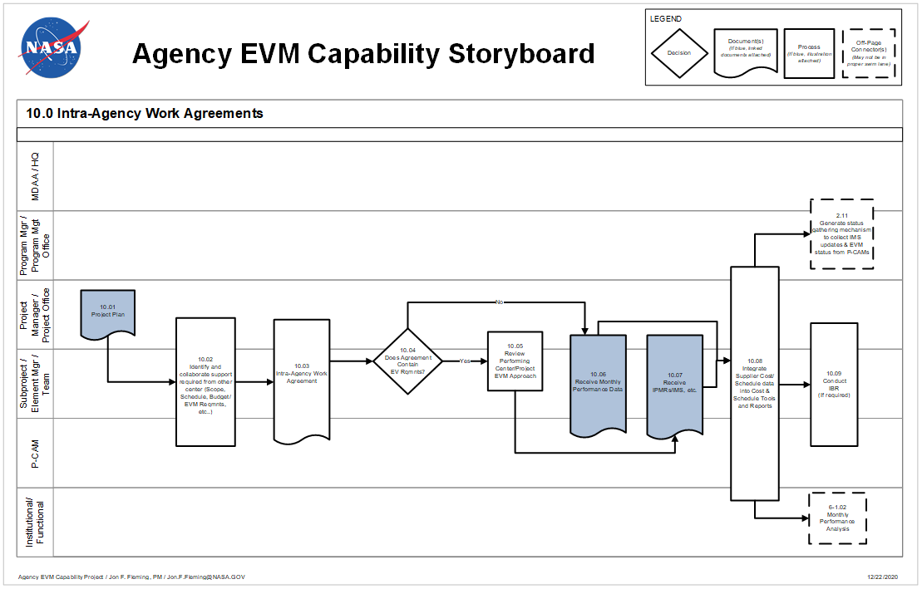
Figure 10-1 Agency EVM Capability Storyboard: Intra-Agency Work Agreements

Intra-Agency Work Agreements Procedure
Role | Flowchart Step | Action or Input/ Output
Project Manager or Project Office | 10.01 | Project Plan. The Project Plan should have any shared work agreement identified that occurs between centers.
Project Manager or Project Office and Subproject/Element Manager SP/EM/Team and P-CAM | 10.02 | Identify and Collaborate Support Required From Other Center(s). (Scope, Schedule, Budget). During the ASM a determination should be made for the work share for various Centers for the program/projects scope of work. Once the work share has been identified and assigned, an agreed upon scope, schedule and budget should be assigned for the work. The EVM, WBS and Scheduling requirements should also be agreed upon during this process.
Project Manager or Project Office and SP/EM/Team and P-CAM | 10.03 | Develop Intra-Agency Work Agreements.
Project Manager or Project Office and SP/EM/Team | 10.04 | Does the Agreement contain EV Requirements?  If YES, proceed to 10.05.  If NO, proceed to 10.06.
Project Manager or Project Office and SP/EM/Team/EVM Focal Point | 10.05 | Review Performing Center/Project EVM Approach.
Project Manager or Project Office and SP/EM/P-CAM/Team | 10.06 | Receive Monthly Performance Data. This applies to Centers that do not have EVM requirements, but do have a requirement to provide the project with performance reporting/data that can be rolled into the total project EVM data for analysis and reporting purposes.
SP/EM /Team and P-CAM | 10.07 | Receive Integrated Program Management Report etc. For Centers that have the EVM requirement included in their IAWA, certain EVM deliverables will be expected, such as the IPMR (inclusive of Format 6, IMS), etc. This data will be used by the sponsor project/program office to analyze and report as necessary. The Center will be expected to produce quality variance analysis reports in the IPMR to document any thresholds that have been established in the IAWA. The Center will be required to submit the reports/data in a timely manner as required by the IAWA.
Program Manager/ Program Management Office, Project Manager or Project Office and SP/EM/Team and P-CAM | 10.08 | Integrate Supplier Cost/Schedule Data into Cost and Schedule Tools and Reports.  The project office will integrate all cost and schedule data from contractors and other Centers into the total project EVM data to provide information for analysis and reporting. This integration also provides the project the ability to report at a total project level.  Note: Other Centers are considered suppliers via Inter-Agency Work Agreements.
Project Manager or Project Office and SP/EM /Team | Output to 2.11 | Generate Status Gathering Mechanism to Collect IMS Updates and EVM Status from P-CAMs.
Project Manager or Project Office and SP/EM/Team and P-CAM | Output to 6-1.02 | Monthly Performance Analysis.
Project Manager or Project Office and SP/EM/Team and P-CAM/EVM Focal Point | 10.09 | Conduct Integrated Baseline Review (if required).

Intra-Agency Work Agreements Summary of Responsibilities

Project-Control Account Manager
The NASA Project Manager, SP/EM, or P-CAMs may function as the P-CAM for IAWAs. The WBS level of the Intra-Agency delivery indicates the project-level accountability; e.g., Project, Element or CA. This individual will have the responsibility and authority to oversee the technical, cost, and schedule performance of the intra-Agency effort. The P-CAM has the requisite authority and responsibility to ensure the intra-Agency work fulfills the project's requirements, and is the focal point or primary contact for any management efforts or issues regarding the IAWA.
On a monthly basis the P-CAM reviews, assesses, and analyzes the intra-Agency work effort for technical, cost, and schedule performance. The P-CAM may be assisted in this monthly activity by the following individuals.

Intra-Agency Project Manager
Provides technical, schedule, and cost information to P-CAM.

Subproject Manager/Element Manager
Provides technical, schedule, and cost information to P-CAM.

Planner/Scheduler
Assists in monitoring and analyzing schedule performance.

Project Resource Analyst
Provides cost and performance reports for the CA.

Performance Management Flow-Downs for Intra-Agency Work
The NASA project office integrates all cost and schedule data from contractors and other Centers into the total project EVM data to provide information for analysis and reporting. This integration also provides the project the ability to report at a total project level.to ensure sufficient visibility into the work being performed at NASA’s supporting Centers,
the Project Manager, SP/EM and/or the responsible P-CAM ensures that the appropriate performance measurement reporting requirements are flowed down to the contributing NASA Center via the IAWA using the applicable DRDs that are used for contracts. If EVM is a requirement then the IPMR is required. However, if the EVM is not a requirement in the IAWA, then the applicable EVM data must be developed by the responsible P-CAM for incorporation into the overall project EVM PMB.
When an EVM requirement is imposed on an IAWA, then this scope of work should be included in the overall project’s IBR. See the NASA IBR handbook for specific details on conducting an IBR at https://evm.nasa.gov/handbooks.

Schedules for the Intra-Agency Work Agreement
Schedule analysis provides the basis for communicating technical progress throughout the life cycle of the project. Status assessment ensures that the intra-Agency work effort’s cost and schedule performance data are accurate and complete for each month-end reporting cycle.
Intra-Agency work effort schedules should be fully integrated into the overall program schedule. It is important to plan and track all critical schedule deliveries that constrain the successful conclusion of intra-Agency efforts. The contributing Center should follow the schedule practices outlined in this System Description and NASA Schedule Management Handbook.
Schedule integration should provide an accurate depiction of the impact of intra-Agency work effort performance on the project schedules.

Budgets for the Intra-Agency Work Agreement
The identification of budgets for Work Agreement items is a result of establishing the requirement for the delivered item to be authorized via a Work Agreement rather than simply funded. This involves identification of the Intra-Agency work efforts, the establishment of an estimated value for the effort, and ultimately, negotiating the Work Agreement scope, schedule, and budget. The project initial target estimate was established during Acquisition Strategy Planning process. During negotiations, the baseline values normally are based on the initial estimates for the work as opposed to the contributing Center’s proposal values. Once negotiations are complete and IAWAs have been approved, budgets are normally adjusted via use or replenishment of MR to reflect the negotiated value of the IAWA. The Work Agreement value used in the baseline must be fully vetted and negotiated. This agreement provides a foundation for developing funding profiles to support a Center/project’s efforts.
When another Center/project is required to provide an external performance measurement report, Center/project data are provided to the project for performance measurement purposes. If a Center/project is not required to provide EV information to the sponsor project, the Project Manager, SP/EM, and P-CAM establish and negotiate procedures, which provide schedule and technical plans, and progress reports as needed for overall project cost and schedule performance management.
Budgets assigned to CAs for IAWAs are planned and supported by time-phased information from the contributing Center.

Work Packages for Intra-Agency Work Effort
Major IAWAs are identified to a scope of work and to a specific WBS element, i.e., project CA. In addition, WPs for second-tier “subcontracted” effort should be established within the project’s CA. This provides for separation of subcontract activities from other elements of cost within the supporting Center for effective performance measurement.
The project should be able to support the values established within each WP using either other Center supplied information or internal documentation. These WPs are related to the plan established by the Center to complete efforts for the scope of work, schedule and budget negotiated in the IAWAs.
WP and PP budgets for other Centers represent the Center’s plan for supporting Work Agreement effort and are based on IAWAs and/or in-house documentation. The IAWA baseline/plan is used regularly as the basis to assess their status and to generate EVM data.

Collect and Report Actual Costs for Intra-Agency Efforts
NASA’s accounting system ensures that Center costs are allocated to the accounts for which efforts were expended in a manner consistent with the respective budgets. In most circumstances, actual costs for IAWAs efforts are reported in the same accounting period that EV is taken.

Estimated Actuals
It is essential that all actual costs used for variance analysis come directly from, or be reconcilable with, the NASA accounting system.
Due to delays in posting of costs, it may be necessary to use estimated actual costs to avoid artificial variances, which might be created by the time lag of costs being recognized by the Agency’s accounting system. This is especially true when the lag time for acquiring actual cost data is significant. This may often be the case when other large institutions are involved in an effort and their accounting processes result in a lag of one or more accounting cycles before actual costs are available. This condition may be exacerbated when there are multiple partners in an effort. When the actual cost data becomes available it must be reconciled with the estimated actuals and corrections made to ensure that the EV information remains accurate and reliable.
The use of estimated actuals should be employed where necessary in the accounting system to ensure the most current information is being used in managing the effort. For major contracts the use of estimated actuals can be minimized by closely coordinating informal contractor/subcontractor monthly “flash” reports with Agency Accounting so that the accuracy of regular accounting accruals minimizes the need for estimated actuals. See discussion in 4.14 on application and reconciliation of estimated actuals.

Provide Effective Analysis of Intra-Agency Performance
When EVM requirements are included in the IAWA, the P-CAM supported by the PP&C will be responsible for reviewing the Intra-Agency performance reports for accuracy and adequacy. If the IAWA does not include the EVM requirement, the responsible manager for the Work Agreement must obtain sufficient information from the contributing Center to perform this function. This review includes an analysis of the performance measurement information contained in the data formats of the report, an evaluation of the variance analysis information contained in the report, and an evaluation of the MR usage, baseline changes and workforce changes. The analytical results from either source are provided to the P-CAM for his/her monthly CA review and assessment.
The PRA and Planner/Scheduler are responsible for incorporating the IAWA cost and schedule and performance data, including any significant variances into the project’s information to ensure a complete picture of the project’s overall status. Working with the project team, the IAWA manager ensures that EV reported by the IAWA Center reconciles to actual physical progress reflected in the IAWA Center’s performance reports.

Generate Revised Estimates at Completion for IAWA Efforts
The procedures relative to contributing Center EACs should focus on two aspects:
- The requirement that the contributing Center generates an EAC as necessary to support program requirements and reporting to the customer P-CAM; and,
- The responsibility of the NASA project to evaluate the contributing Center’s EAC for adequacy and accuracy.
IAWA EACs should be based on:
- Actual costs to date
- Open commitment values for IAWAs or procured items
- Performance to date as reported in the contributing Center’s report and analyzed by the IAWA responsible manager
- Knowledgeable projections of future performance
- Estimates of economic escalation

Intra-Agency Surveillance
When EVMS is required on an Intra-Agency effort and its EVM Capability has been accepted per the requirements of 10.6, the cognizant NASA Earned Value Focal Point member will conduct periodic surveillance (at least annually) to ensure that the Center/project is still managing the effort in accordance with its EVM approach and this NASA EVM System Description. The surveillance may be conducted as a team with support from the Agency Earned Value Working Group personnel. The NASA EVM PE or Center Earned Value Focal Point will lead the surveillance reviews with the assistance of project personnel. Each review will result in a report identifying any corrections that need to be made. The Center’s EVM Focal Point and its project team will develop a Corrective Action plan and provide monthly progress on the plan until full correction is achieved.

Intra-Agency Work Agreements Summary of Responsibilities
Responsibility and accountability for managing IAWAs on a project is distributed among several roles as discussed below.

Project Manager
  - Recognizes and accepts responsibility and authority for the project.
  - Provides overall management direction and oversight for the project.

Subproject/Element Manager
  - Assists IAWA Responsible Manager in the planning and scheduling of intra-Agency efforts.
  - Ensures proper allocation of EVM requirements to major intra-Agency efforts.
  - Oversees monitoring of intra-Agency efforts costs.
  - Reviews and approves VARs addressing material costs.

IAWA Responsible Manager
  - Incorporates plan and schedule for intra-Agency efforts WPs and CAs.
  - Generates (or causes) funding requisitions for intra-Agency efforts.
  - Ensures appropriate flow down of EVM requirements to major intra-Agency efforts.
  - Manages the intra-Agency efforts technical, schedule, and cost performance.
  - Analyzes the intra-Agency efforts EAC and, if not in agreement, develops an independent EAC.
  - Generates independent VARs when significant variances occur.

IAWA Technical Representative
  - With inputs from the IAWA Responsible Manager and Project Manager/ Sub Project or Element Manager negotiates and executes the IAWA.
  - Ensures that the appropriate EVM clauses and data requirements are included in major IAWAs.
  - Monitors contributing Center performance for timely, acceptable deliverables including cost, schedule, and EV reports.
  - Analyzes intra-Agency efforts data and provide input to business team.
  - Distributes reports, if necessary, to the IAWA Responsible Manager and Project Manager/Subproject or Element Manager/PRA.

Project Planning & Control (PP&C) Team
  - Supports the planning and scheduling of Intra-Agency efforts items.
  - Assists in the monitoring of Intra-Agency efforts costs.
  - Integrates Intra-Agency efforts cost and schedule data into the overall project data.
  - Assists in the reporting of cost/schedule status for Intra-Agency efforts and the accumulation of VARs when significant variances occur.

EVM Focal Point
Coordinates the surveillance activities for its Center’s projects EVM approach.

APPENDICES

Appendix A Work Around (s)

A.1 Summary-Level Core Financial System Charges
The Core Financial System allows charges to be posted directly to all levels of the WBS. However, to support effective performance measurement and existing commercial off-the-shelf (COTS) EVM Tools, costs should be collected only at the lowest level. In COTS EVM Tools, budgets are established at the lowest level and then summarized to WBS elements in the hierarchy. Budgets in the PMB are planned at the lowest levels and costs from the accounting system should also come from the same level. Note: collecting costs at a summary level within NASA’s Core Financial System will cause artificial CVs since budgets are not established at the same level. When establishing a WBS for collecting actual cost data in the Core Financial System, the project manager should ensure that costs are only collected at the lowest level in the WBS hierarchy. However, if a project has already established a WBS in the Core Financial System, prior to the EVM implementation and has collected costs against the summary level WBS, it may be necessary to implement a work around. In this case, a subordinate WBS can be created under the summary level element and the Core Financial System summary-level charges mapped to this subordinate WBS (Figure A-1). For more information and assistance during the project’s EVM implementation contact your organizational EVM Focal Point.
Figure A-1 Workaround for Summary Level Core Financial System Charging

A.2 Need More than Seven Levels of WBS
In projects that need to expand the WBS below level 7 in the Core Financial System to manage the work and collect costs, a workaround has been identified. In this workaround, the WBS in the Core Financial System will stay the same down to level 7 and additional elements will be added horizontally at level 7 of the WBS to collect costs. These costs are then mapped to the appropriate lower-level WBS in the COTS cost tools. For more information for this workaround contact your organizational EVM Focal Point.
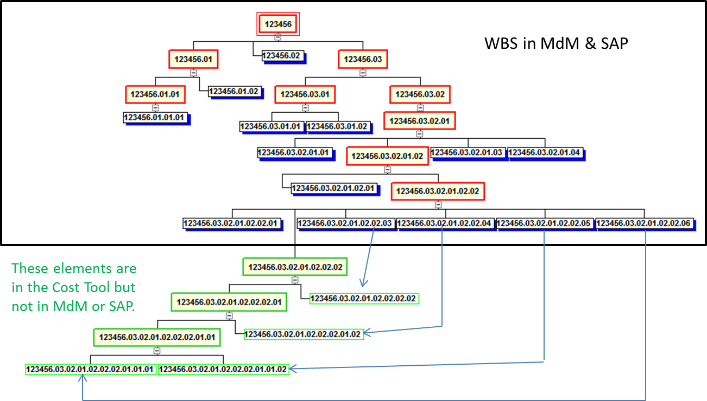
Figure A-2 Workaround for Level 7 WBS Limitations

A.3 Leave Being Charged Directly to WBS
At present the leave for civil servants is prorated back to the projects based on the WBS’ that have been charged to date. This practice may cause artificial variances during times of high leave usage. See Figure A-3 for an example of the impact of leave on labor rates. A workaround is to use a higher planned labor rate for the affected months. The second alternative is to plan only productive hours and use a loaded annual cost divided by the total available hours. This alternative will take care of the CV but will create one on the hours that will have to be tolerated. A third alternative is to do nothing and accept the known variances during the peak seasons around the holidays and summer vacations.

A.4 Cost Over Obligations
In the Core Financial System, actual costs for a WBS can only be accepted if obligations also exist. For this reason, if costs exceed obligations then the costs are placed on another WBS which causes artificial variances. This effect is known as costs over obligations. Once this takes place it is an arduous process to de-commit/de-obligate and then re-commit/re-obligate funds. For this reason, several workarounds have been identified to provide lower level visibility without the need for lower level obligations. These workarounds are discussed below.
- One workaround employed by the Extravehicular Activity (EVA) Project was to use Total Calculated Cost as the “true actuals” for the month if charges are posted correctly regardless of the funding that is available. EVA used the function in the BW module of the Core Financial System General Ledger to generate Monthly Total Calculated Cost, adjusting that number by subtracting the previous month cum to date Total Calculated Cost from the current month cum to date Total Calculated Cost to accurately depict monthly cost.
Figure A-3 Example of Leave Impact on Labor Rates
- Large Support Contractor/Subcontractor contracts use a pool process to eliminate the artificial cost over obligations. This process has been developed and employed at Goddard Space Flight Center (GSFC). The process uses CMO pool account to Commit, Obligate and Cost the contract cost. Detailed electronic data are provided by the contractor/subcontractor identifying where charges belong, and GSFC uses a program to generate the Commit, Obligation and Cost records for the Core Financial System to the correct WBS and decrement the CMO pool account in the Core Financial System. This process significantly reduces the cost over obligations issue; however, it has some consequences: 1) the funding WBS identity is lost once it is in the pool account and cannot be identified until the costs are allocated to it; and 2) the identity of the performing organization is lost temporarily in the Core Financial System.

- Another workaround for large Support Contractor/Subcontractor contracts is to fund the contract at a project or element level. Costs are then reported by the contractor/subcontractor via the Contractor Financial Management Report (NASA Form NF 533) that have costs allocated to the appropriate lower level WBS elements. The correct costs from the NF 533 are imputed into the EVM tool, either manually or through automatic upload. This process has been used on the ARES and SLS Projects at Marshall Space Flight Center. This process reduces the amount of cost over obligations and provides lower level cost information without requiring changes to the Core Financial System. However, this approach may impact other areas, such as the Cost Analysis DRD. The document relies on the Core Financial System for actual cost data, and charges are being collected at a level 2 summary account. Since costs are only at level 2 within the Core Financial System, using this approach then the project will need to use the cost information from the EVM Tool to support the development of the Cost Analysis DRD. This lack of detail in the Core Financial System will require greater coordination for projects being executed across multiple Centers. The Project Manager will need to ensure that reporting requirements are clearly communicated and close coordination with project personnel conducting EVM analysis. Another factor to consider is that costs from the lower levels must be reconcile with the level 2 WBS costs recorded in the Core Financial System.

- Finally, separate databases can be maintained with the project’s lower level cost information. The contract costs will be imputed into this external database by the project or COR based on knowledge of the work that is accomplished and other informational reports. This costing method should be reconciled with the NF 533 data and then manually input into the Core Financial System’s Contractor Cost Report extension. This is a method developed and employed by the Ames Research Center (ARC). This eliminates cost over obligations and provides the lower level cost data in the Core Financial System that project managers need for performance management. However, there is concern that this method might be too labor intensive for larger contracts. There also is a question as to whether project managers would be willing to obligate on a monthly basis as opposed to obligating larger amounts on fewer occasions.

For more information on the aforementioned workarounds, it is recommended that the project consult with its Center EVM Focal Point.

Appendix B Acronyms
ACWP | Actual Cost of Work Performed (also referred to as Actual Cost and “AC”)
ALDS | Agency Labor Distribution System
AS/AF | Actual Start/Actual Finish
ARC | Ames Research Center
AUW | Authorized Unpriced Work
BAC | Budget at Completion
BCWP | Budgeted Cost for Work Performed (also referred to as Earned Value; and as “EP”)
BCWS | Budgeted Cost for Work Scheduled Performed (also referred to as Planned Value; and as “PV”)
BOE | Basis of Estimate (plural: bases of estimate)
BW | Business Warehouse (module in Core Financial System, General Ledger)
CA | Control Account
CAC | Cost at Completion
CAP | Control Account Plan
CBB | Contract Budget Base (see PBB, Project Budget Base)
CCB | Change Control Board
CDR | Critical Design Review
CFA | Cognizant Federal Agency
CFO | Chief Financial Officer
CMO | Center Management Operations
CO | Contracting Officer
COR | Contracting Officer’s Representative
CP | Critical Path
CPI | Cost Performance Index
CPM | Critical Path Method
CTM | Contract Technical Manager
CV | Cost Variance
DCMA | Defense Contract Management Agency
DRD | Data Requirements Description
EAC | Estimate at Completion
EIA-748 EVMS Standard | Earned Value Management Systems, EIA-748 Current Release
EPSS | Enterprise Performance Support System
ETC | Estimate to Complete
EV | Earned Value
EVA | Extravehicular Activity (Project)
EVM | Earned Value Management
EVMS | Earned Value Management System
FAD | Formulation Authorization Document
FF | Finish to Finish
FS | Finish to Start
FY | Fiscal Year
GFE | Government-Furnished Equipment
GFM | Government-Furnished Material
GSFC | Goddard Space Flight Center
IAWA | Intra-Agency Work Agreement
IBR | Integrated Baseline Review
IEAC | Independent Estimate at Completion
IMP | Integrated Master Plan
IMS | Integrated Master Schedule
IPMR | Integrated Program Management Report
IPT | Integrated Product Team
ITD | Inception to Date
JCL | Joint Cost and Schedule Confidence Level
KDP | Key Decision Point
LCC | Life Cycle Costs
LOE | Level of Effort
MDAA/HQ | Mission Directorate Associate Administrator/NASA Headquarters
MdM | Metadata Manager (System)
MR | Management Reserve
NFS | NASA Federal Acquisition [FAR] Supplement
NDIA | National Defense Industrial Association
NOA | New Obligation Authority
NPR | NASA Procedural Requirements
NSM | NASA Structure Management
OBS | Organizational Breakdown Structure
OCFO | Office of Chief Financial Officer
ODC | Other Direct Cost (or charges)
OMB | Office of Management and Budget
OTB / OTS | Over Target Baseline / Over Target Schedule
PBB | Project Budget Base (see also CBB, Contract Budget Base)
P-CAM | Project-Control Account Manager
PDR | Preliminary Design Review
PMB | Performance Measurement Baseline
PMR | Project Management Review
PMT | Performance Measurement Technique
PO | Purchase Order
PP | Planning Package
PPBE | Planning, Programming, Budget, and Execution (process)
PP&C | Project Planning and Control
PR | Purchase Requisition or Procurement Requisition
PRA | Project Resource Analyst
QBD | Quantifiable Backup Data
RAM | Responsibility Assignment Matrix
RBS | Resource Breakdown Structure
SEB | Source Evaluation Board
SMP | Schedule Management Plan
SP | NASA Special Publication
SP/EM | Subproject/Element Manager
SPI | Schedule Performance Index
SRA | Schedule Risk Assessment
SRL | Significant Risk List
SS | Start to Start
SV | Schedule Variance
SWO | Stop Work Order
TCPI | To Complete Performance Index
UB | Undistributed Budget
UFE | Unallocated Future Expense
VAC | Variance at Completion
VAR | Variance Analysis Report
WAD | Work Authorization Document
WBS | Work Breakdown Structure
WP | Work Package

Appendix C Glossary

Actual Cost of Work Performed (ACWP) (Also known as Actual Cost (AC)) | The costs actually incurred and recorded in accomplishing the work performed within a given time period. Actual costs include the direct cost plus the related indirect cost such as overhead, general and administrative, etc. allocated to the activity. ACWP reflects the applied direct costs and may be for a specific period or cumulative to date. Actual cost may also include estimated actuals, which are values entered into the EVMS to represent direct costs for material and subcontracted items for which earned value has been taken but invoices or billings have not entered the accounting system.
Agency Baseline Commitment | An Agency Baseline Commitment is the highest-level commitment for NASA and is established at the beginning of the Implementation Phase of a program or project’s life cycle, Key Decision Point C (KDP C). It includes the program’s approved funding budgetary target. This target is used by OMB and Congress as the total appropriation target value for the funding request and some additional Unallocated Future Expense (UFE), and/or schedule or margin/reserve to ensure a reasonable amount of funding margin/reserve is available for unforeseen problems beyond the program’s control.
Authorized Unpriced Work (AUW) | Any effort for which contractually definitized costs have not been agreed upon, but for which written authorization has been received.
Baseline | See Agency Baseline Commitment and Performance Measurement Baseline.
Basis of Estimate | The documentation of the ground rules, assumptions, and drivers used in developing the cost and schedule estimates, including applicable model inputs, rationale or justification for analogies, and details supporting cost and schedule estimates. The basis of estimate is contained in material available to the SRB and management as part of the KDP process.
Budget at Completion (BAC) | The sum of all budgets (BCWS) allocated to the project or a given CA.
Budgeted Cost for Work Performed (BCWP) (Also known as Earned Value (EV)) | The sum of budgets for completed Work Packages and partially completed Work Packages, plus the appropriate portion of the budgets for LOE of effort Work Packages.
Budgeted Cost for Work Scheduled (BCWS) (Also known as Planned Value (PV)) | The sum of the budgets for all work packages, planning packages, etc., scheduled to be accomplished (including in-process work packages), plus the amount of level of effort and apportioned effort scheduled to be accomplished within a given time period. This is the value of planned work.
Change Request | A form used to document and justify a proposed change to either the EAC or the Performance Measurement Baseline (PMB).
Compliance | The characteristic of an EVMS that ensures the intent of the EVMS Guidelines is embodied in the integrated processes and sub processes of an organization’s methods of operation that generate accurate and auditable program performance data.
Contract | A mutually binding legal relationship obligating the seller to furnish the supplies or services (including construction) and the buyer to pay for them. It includes all types of commitments that obligate the Government to an expenditure of appropriated funds and that, except as otherwise authorized, are in writing. In addition to bilateral instruments, contracts include (but are not limited to) awards and notices of awards; job orders or task letters issued under basic ordering agreements; letter contracts; orders, such as purchase orders, under which the contract becomes effective by written acceptance or performance; and bilateral contract modifications. Contracts do not include grants and cooperative agreements.
Contact Budget Baseline | The sum of the negotiated contract cost plus the estimated cost of authorized unpriced work. It includes the PMB and MR. Customer approval is generally required to change it. (See also Project Budget Base).
Contract Work Breakdown Structure (CWBS) | A work breakdown structure of the products or services to be furnished under contract. It is comprised of selected Project WBS elements specified in the contractual document and the contractor's lower level extensions of those elements.
Control Account | An identified intersection of the Work Breakdown Structure (WBS) and Organizational Breakdown Structure (OBS) at which responsibility for work is assigned to one organizational unit and actual direct labor, material, and other direct costs (ODC) are compared with the planned budget and the earned value for management control.
Control Account Manager (CAM) | See Project Control Account Manager (P-CAM)
Control Account Plan (CAP) | A format upon which a control account plan is displayed. A CAP typically displays the control account scope and budget in time-phased work packages and planning packages, cost element visibility, PMTs for each work package, responsible performing organizations, start/finish (baseline/forecast/actual) and at least one charge number.
Core Financial System | Fully implemented in June 2003 by the NASA Integrated Enterprise Management Program (IEMP), Core Financial System is NASA's Agency-wide financial system. SAP's R/3 software is the foundation for Core Financial. Core Financial is the IEMP “backbone,” providing management and technical guidance for implementing standard processes and systems needed to support NASA's financial management activities. Core Financial allows NASA staff to provide timely, consistent, and reliable information for management decisions and provide an accounting and budgeting structure for full-cost management. It also improves information exchange with customers and stakeholders, and serves as the technical foundation for NASA's other business and eGov initiatives.
Cost Performance Index (CPI) | A measure of cost efficiency. It compares BCWP to the actual cost to perform that work (CPI = BCWP / ACWP). An index of 1.0 means that we are spending exactly what we planned to spend to accomplish the work performed. CPI > 1.0 means we are under running costs. CPI < 1.0 means that we are over running costs.
Cost Variance (CV) | A metric for the cost performance derived from earned value data. It is the algebraic difference between earned value and actual cost (CV = BCWP – ACWP). A positive value indicates a favorable condition and a negative value indicates an unfavorable condition. It may be expressed as a value for a specific period of time or cumulative to date.
Critical Path (CP) | A sequential path of tasks in a network schedule that represents the longest overall duration from “time now” through project completion. Any slippage of the tasks in the CP will increase the project duration. CP is the sequence of activities that are tied together with network logic that have the longest overall duration from time now until project completion.
Critical Path Method (CPM) | Critical path methodology entails the development of a logic network-based schedule that enables the calculation of schedule slack (or float) for all activities and milestones contained in the Integrated Master Schedule (IMS).
Data Requirements Description | The document that describes the specific data required for supplier/contract management and reporting
Direct Costs | The expenditures for labor, material, and ODC that reasonably can be related directly to performance of a unit of work, and which are charged directly and finally to the project, without distribution to an overhead or burden unit.
Discrete Effort | Tasks that are related to the completion of specific end products or services and can be directly planned and measured.
Distributed Budget | Budget that is assigned or allocated to CAs, Work Packages, and Planning Packages.
Earned Value (EV) (Also known as Budget Cost of Work Performed (BCWP)) | The value of the work that has been performed (also BCWP).
Earned Value Methods | See Performance Measurement Technique (PMT).
Earned Value Techniques (EVT) | See Performance Measurement Technique (PMT)
Element of Cost | Direct costs can be categorized to general types of resources that are represented within the direct cost value (e.g., labor, material, and ODC).
Estimate at Completion (EAC) | A value (expressed in dollars and/or hours) developed to represent a realistic projection of the final cost of a task (or group of tasks) when completed. EAC is the sum of direct and indirect costs to date, plus the estimate of costs for all authorized remaining work. EAC = ITD ACWP + ETC, where ITD is inception to date.
Estimate to Complete (ETC) | A value (expressed in dollars and/or hours) developed to represent a realistic projection of the “to go” cost of the unaccomplished work to complete a task.
Formal Reprogramming (or Reprogramming). | A comprehensive replanning of the remaining PMB that results in an Over-Target Baseline (OTB), an Over-Target Schedule (OTS) or both. This type of replan is for performance measurement purposes only and requires prior coordination and approval of the Customer.
Formulation Authorization Document (FAD) | The document issued by the MDAA to authorize the formulation of a program whose goals will fulfill part of the Agency's Strategic Plan and Mission Directorate strategies and establish the expectations and constraints for activity in the Formulation Phase. In addition, a FAD or equivalent is used to authorize the formulation of a project.
In-House Work | Project work scope conducted solely using NASA Headquarters and/or Center personnel or other NASA resources (i.e., facilities, equipment), including support contractors that augment NASA resources to achieve the objectives of the project. There is no prime contractor, university, laboratory, institution, or foreign partner involvement in in-house work.
Independent Estimate-at-Completion (IEAC) | A forecast of most likely total project costs based on historical project performance.
Indirect Costs | The cost for common or joint objectives that cannot be identified specifically with a particular program or activity. Indirect Costs consist of the cost of contracted services only and should include no civil service labor or travel costs. Also referred to as overhead cost or burden.
Integrated Program Management Report (IPMR) | Integrated Program Management Report. The standard report format to communicate program/project monthly cost/schedule performance and status between a contractor and the Government. The IPMR consists of seven report formats that provide program/project managers information to: integrate cost and schedule performance data with technical performance measures, identify the magnitude and impact of actual and potential problem areas causing significant cost and schedule variances, forecast schedule completions, and provide valid, timely program/project status information to higher management for effective decision making. The formats consist of: Format 1- provides data to measure cost and schedule performance by product-oriented WBS elements, the hardware, software, and services the Government is buying; Format 2- provides the same data by the contractor's organization (functional or Integrated Product Team (IPT) structure); Format 3- provides the budget baseline plan against which performance is measured; Format 4- provides staffing forecasts for correlation with the budget plan and cost estimates; Format 5- is a narrative report used to explain significant cost and schedule variances and other identified contract problems and topics; Format 6- Integrated Master Schedule (IMS); Format 7- time-phased historical and forecast cost submission. This is a contract data requirement when EVM is required.
Integrated Master Schedule (IMS) | An integrated schedule developed by logically networking all detailed program/project activities. The highest-level schedule is the Master Schedule supported by Intermediate Level Schedules and by lowest level detail schedules. See IPMR Format 6.
Level of Effort (LOE) | Work that does not result in a final deliverable (i.e., liaison, coordination, management, or other support activities), and which cannot be directly associated with a definable end product. It is measured “automatically by the passage of time” in terms of resources planned within a given fiscal period. With LOE effort, BCWP is always equal to BCWS.
Management Agreement | Within the Decision Memorandum, the parameters and authorities over which the program or project manager has management control constitute the program or project Management Agreement. A program or project manager has the authority to manage within the Management Agreement and is accountable for compliance with the terms of the agreement.
Management Reserve (MR) | An amount of total project budget withheld for management control and cost risk management purposes, rather than designated for accomplishment of a specific task or set of tasks. MR is not part of the PMB.
Metadata Manager (MdM) | The Metadata Manager is a web-based Enterprise application that contains the Agency's official NASA Structure Management (NSM) data elements and associated codes. MdM is the only Agency application used for identifying, creating, tracking, organizing and archiving of Mission, Theme, Program, Project and Work Breakdown Structure (WBS) 2 through 7 NSM structural elements. As the Agency's Enterprise repository for NSM data, MdM supplies NSM codes to the core financial (SAP), budget formulation (N2) and project management (POLARIS) systems that require coding structure data. Integrated with BW.
NASA Structure Management (NSM) | The NSM System is the internal coding schema used by the Agency to define and organize project work content. The WBS with its NSM nomenclature provides a common management framework for project management decisions and communication, the definition and authorization of work, the development of project schedules, and the planning and allocation of resources. This same coding system is also used to account for all financial activities associated with funds appropriated by Congress to accomplish project work.
Organizational Breakdown Structure (OBS) | The organizational and project hierarchy of line and functional organizations as applied to the specific project.
Other Direct Cost (ODC) | These costs (or charges) represent resources not classified as labor or material. They include travel, services, computer charges, etc.
Over Target Baseline (OTB) | A budgeted amount above the Project Budget Base/ CBB. The OTB term is used to describe the condition when the total allocated budget (TAB) exceeds the PBB/CBB. It is the end result of a formal reprogramming process.
Over-Target Schedule (OTS). | An established schedule that extends beyond the contract milestones or delivery dates. It is the end result of a formal reprogramming process.
Performance Measurement Baseline (PMB) | The time-phased budget plan for accomplishing all authorized work scope in a project's life cycle, which includes both NASA internal costs and supplier costs. The PMB is used to measure project performance using earned value management, if required, or other performance measurement techniques if EVM is not required. It is formed by the budgets assigned to scheduled control accounts and the applicable indirect budgets. For future effort, not planned to the control account level, the PMB also includes budgets assigned to higher level WBS elements and undistributed budgets. The PMB does not include UFE, or management reserve (MR) for contractors.
Performance Measurement Technique (PMT) | The method or "algorithm" used to calculate earned value at the work package level. Common methods include % complete, LOE, weighted milestones and 50-50, and 0-100
Performing Organization | A defined organizational unit in the OBS which applies the resources to accomplish the work.
Planning Package (PP) | A logical aggregate of far-term effort within a CA that can be identified and budgeted, but not yet defined into discrete Work Packages.
Price Variance | For material analysis, PV = (Budgeted Price – Actual Price) x (Actual Quantity). Quantity breakouts are most useful on programs procuring multiple items of the same part number, typical for production type contracts.
Project Budget Base (PBB) | The negotiated value of the project plus the estimated cost of authorized, unpriced work. It is the Government project equivalent to the Contract Budget Base. It includes the PMB and MR. Customer approval is generally required to change it.
Project-Control Account Manager (P-CAM) | A NASA manager responsible for task performance of a Control Account within the PMB and for planning and managing the resources authorized to accomplish such task.
Program Baseline | The Program Baseline is associated with a major program, and represents the program’s authorized value (with an associated scope and schedule) to include and some Unallocated Future Expenditures (UFEs), Management Reserve, Distributed Budget, Undistributed Budget (UB), and Authorized Unpriced Work (AUW). At the program level the Program Baseline is principally a funding baseline.
Rebaselining | The process that results in a change to a project's Agency Baseline Commitment.
Replanning | The process by which a program or project updates or modifies its plans. This applies to a change in the original authorized PBB or CBB planning for accomplishing formally authorized requirements, typically involving the redistribution of budget for remaining work. In accordance with the Earned Value Management Systems, EIA-748 Current Release (EIA-748 EVMS Standard), traceability is required to previous baselines, and funding requirements need to be considered in any replanning effort. There are two types of replanning effort:  Internal Replanning. Replanning actions performed by the supplier for remaining effort within the authorized PBB or CBB. It is caused by a supplier’s need to accommodate cost, schedule, or technical problems that may have made the original plan unrealistic. Internal replanning is restricted to remaining effort and if significant, the customer must be advised of the action.  Authorized Change (or External) Replanning. A change necessitated by government/customer direction which may be in the form of either a definitized or a no cost contract change order for contracts or formal change to the Project Plan for in-house Projects that calls for a change in the previously authorized plan. It most often results from a change in the authorized requirement affecting cost, schedule, technical parameters or a combination thereof.
Reprogramming (or Formal Reprogramming) | A comprehensive replanning of the remaining PMB that results in an Over-Target Baseline (OTB), an Over-Target Schedule (OTS) or both. This type of replan is for performance measurement purposes only and requires prior coordination and approval of the Customer.
Responsibility Assignment Matrix (RAM) | A matrix showing the relationship between the WBS elements and the organizations assigned responsibility for ensuring their accomplishment. The RAM normally depicts the assignment of each control account to a single manager. When resource values are applied to these relationships, it may be referred to as a dollarized RAM.
Responsible Organization | A defined organizational unit in the OBS which is assigned the responsibility to accomplish specific tasks.
Schedule Performance Index (SPI) | A measure of schedule efficiency. It compares the BCWP to the work scheduled (SPI = BCWP / BCWS). An index of 1.0 means the work is being performed right to the schedule. SPI > 1.0 means that the work is ahead of schedule. SPI < 1.0 means that the work is behind schedule.
Schedule Variance | A metric for the schedule performance derived from earned value data. It is the algebraic difference between earned value and the planned value (SV = BCWP – BCWS). A positive value is a favorable condition while a negative value is unfavorable. It may be expressed for a specific period of time or cumulative to date.
To Complete Performance Index (TCPI) | The future cost efficiency needed to accomplish the remaining work within a financial goal such as the Budget at Completion (BAC) or the Estimate at Completion (EAC). It compares the budget for remaining work with the remaining cost or the estimated remaining cost to complete the work. TCPIBAC=(BAC - BCWPcum) / (BAC - ACWPcum). Or TCPIEAC=(BAC - BCWPcum) / (EAC - ACWPcum). Compare the CPI to determine if the BAC or the EAC is realistic or not.
Total Allocated Budget (TAB) | The sum of all budgets allocated to a project/contract. Total allocated budget consists of the PMB and all MR. The TAB should reconcile directly to the PBB/CBB. If the TAB is greater than the CBB/PBB, the difference is attributable to an over target baseline and must be documented.
Unallocated Future Expense (UFE) | The portion of estimated cost required to meet the specified JCL that cannot yet be allocated to the specific project WBS elements because the estimate includes probabilistic risks and specific needs that are not known until these risks are realized. Typically, not part of PBB unless allocated to the project in conjunction with a formal change to the PBB
Undistributed Budget (UB) | Budget associated with specific work scope or authorized changes that have not been assigned to a control account or summary level planning package.
Usage Variance (UV) | For material analysis, UV = (Budget Quantity – Actual Quantity)) x (Budgeted Price). Quantity breakouts most useful on programs procuring multiple items of the same part number, typical for production type contracts.
Variance Analysis Report (VAR) | A report that explains variances that exceed specified thresholds which are reportable. Explanations of variances shall clearly identify the nature of the problem, significant reasons for cost or schedule variances (i.e., root cause), effects on immediate tasks, impacts on the total contract, and the corrective actions taken or planned.
Variance at Completion (VAC) | The difference between the budget at completion and the estimate at completion (VAC = BAC – EAC). It may be calculated at any level from the Control Account up to the total project/contract. It represents the amount of expected overrun (negative VAC) or underrun (positive VAC).
Work Authorization Document (WAD) | A form used to document, authorized, and budgeted work from the Project Manager or Subproject/Element Manager. As a minimum this document must include the relevant WBS CA code, statement of work, scheduled start and completion dates, budget, and the name of the P-CAM.
Work Breakdown Structure (WBS) | A product-oriented hierarchical division of the hardware, software, services, and data required to produce the program's or project's end product(s), structured according to the way the work will be performed and reflecting the way in which program/project costs and schedule, technical, and risk data are to be accumulated, summarized, and reported.
Work Package (WP)  Work Package Budget | A WP is a task/activity or grouping of work. A WP is the point at which work is planned, progress is measured, and earned value is computed. WPs belong to a single CA.  Resources that are formally assigned by the P-CAM to accomplish a Work Package task—expressed in dollars or hours.

Appendix D Performance Management Reference CARD
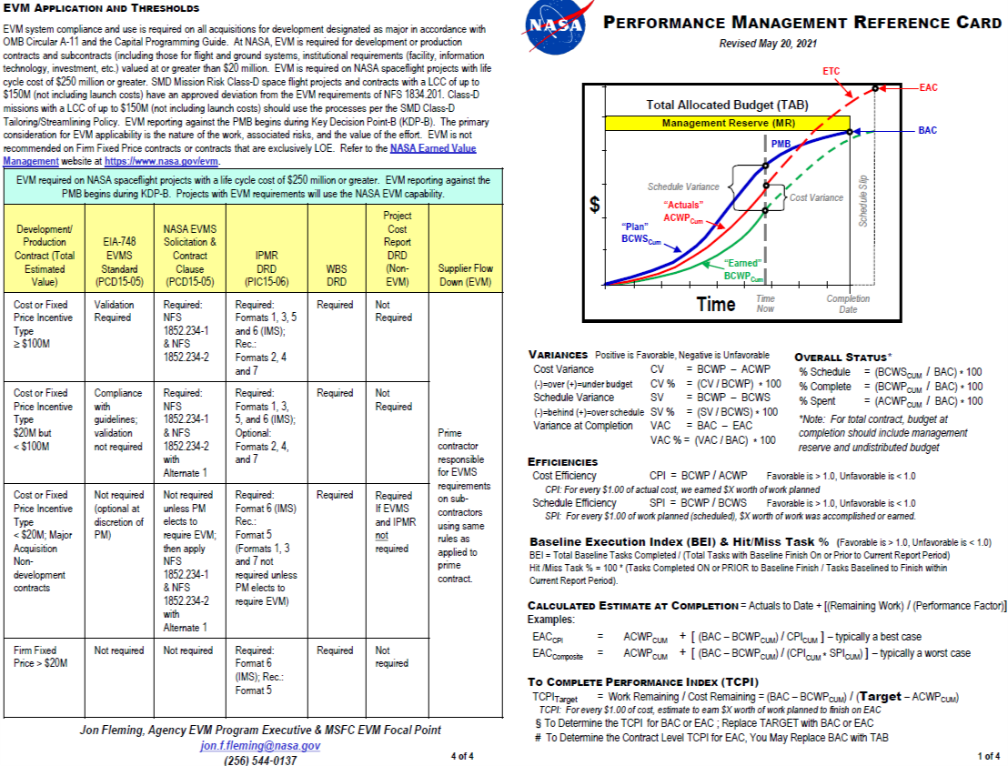
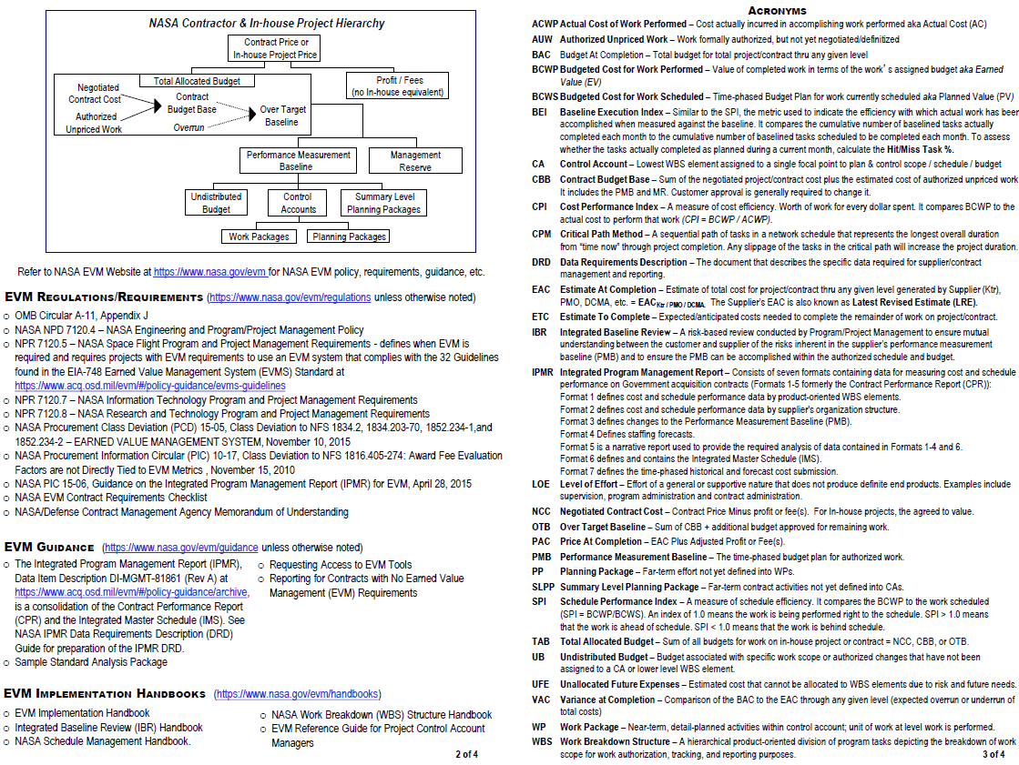

Appendix E Guideline Cross Reference Matrix

The following matrix lists the ten NASA EVM processes (blue banners), identifies the applicable EIA-748 EVMS Standard guidelines (left-hand column), and cites the section of the EVM System Description that satisfies each guideline (center and right-hand columns).
Note: The EIA-748 EVMS Standard maps the 32 guidelines to five major categories. To better align with NASA-specific business practices, NASA has mapped the guidelines to the NASA project management processes.

NASA Process and Applicable EIA-748 EVMS Standard Guidelines | Key Process  System Description  Reference | Cross Process  System Description  Reference
1. ORGANIZATION
Key Process Guidelines: 1, 2, 3, 5
Cross-Process Guidelines: 9, 10, 22, 26, and 27
Guideline 1. (2.1.a) Define the authorized work elements for the program. A work breakdown structure (WBS), tailored for effective internal management control, is commonly used in this process. | 1.4 Organization Procedure  1.5.3 Work Breakdown Structure  1.5.3.1 WBS Coding: the NASA Structure Management System
Guideline 2. (2.1.b) Identify the program organizational structure, including the major subcontractors, responsible for accomplishing the authorized work, and define the organizational elements in which work will be planned and controlled. | 1.4 Organization Procedure  1.5.4 Organization Breakdown Structure
Guideline 3. (2.1.c) Provide for the integration of the planning, scheduling, budgeting, work authorization and cost accumulation processes with each other, and as appropriate, the program work breakdown structure and the program organizational structure. | 1.4 Organization Procedure  1.6.2 Control Accounts—Intersection of WBS and OBS
Guideline 5. (2.1.e) Provide for integration of the program WBS and the program organizational structure in a manner that permits cost and schedule performance measurement by elements of either or both structures as needed. | 1.4 Organization Procedure  1.6.2 Control Accounts—Intersection of WBS and OBS
Guideline 9. (2.2.d) Establish budgets for authorized work with identification of significant cost elements (labor, material, etc.) as needed for internal management and for control of subcontractors. |  | 1.6.2 Control Accounts—Intersection of WBS and OBS  3.13 Control Account Planning  3.4 Budgeting Parameters  3.7.3 Control Account Work Authorization
Guideline 10. (2.2.e) To the extent it is practical to identify the authorized work in discrete [Work Packages] WPs, establish budgets for this work in terms of dollars, hours or other measurable units. Where the entire Control Account (CA) is not subdivided into WPs, identify the far term effort in larger Planning Packages (PPs) for budget and scheduling purposes. |  | 1.6.2 Control Accounts—Intersection of WBS and OBS  3.6 Work Budget/Authorization Procedure  3.4 Budgeting Parameters  2.7.5 Planning Packages
Guideline 22. (2.4.a) At least on a monthly basis, generate the following information at the CA and other levels as necessary for management control using actual cost data from, or reconcilable with, the accounting system:  1) Comparison of the amount of planned budget and the amount of budget earned for work accomplished. This comparison provides the schedule variance (SV).  2) Comparison of the amount of the budget earned and the actual (applied where appropriate) direct costs for the same work. This comparison provides the cost variance (CV). |  | 3.14 Statusing Control Account Work  6.1 Managerial Analysis Introduction  6.2 Managerial Analysis Parameters
Guideline 26. (2.4.e) Implement managerial actions taken as the result of earned value information. |  | 6.1 Managerial Analysis Introduction  6.2 Managerial Analysis Parameters  6.4 Managerial Analysis Procedure  6.6.2 Variance Analysis  6.6.3 Project Management Reviews  6.6.4 Corrective Action Monitoring
Guideline 27. (2.4.f) Develop revised estimates of cost at completion based on performance to date, commitment values for material, and estimates of future conditions. Compare this information with the performance measurement baseline (PMB) to identify variances at completion (VAC) important to company management and any applicable customer reporting requirements including statements of funding requirements. |  | 6.2 Managerial Analysis Parameters  6.12.1 EAC Defined  6.12.1.1 EAC Revision  6.12.6 Preparation of Revised EACs  6.12.7 ETC/EAC Requirements
2. SCHEDULING
Key Process Guidelines: 6 and 7
Cross-Process Guidelines: 23
Guideline 6. (2.2.a) Schedule the authorized work in a manner that describes the sequence of work and identifies significant task interdependencies required to meet the requirements of the program. | 2.1 Scheduling Introduction  2.2 Scheduling Parameters  2.4 Scheduling Procedure  2.6.4 Intermediate-Level Schedules  2.6.5 The Integrated Master Schedule
Guideline 7. (2.2.b) Identify physical products, milestones, technical performance goals or other indicators that will be used to measure progress. | 2.1 Scheduling Introduction  2.2 Scheduling Parameters  2.4 Scheduling Procedure  2.5 Schedule Status and Update Procedure  2.11 IMS Baseline Considerations  2.7 Work Package Development including PMT
Guideline 23. (2.4.b) Identify, at least monthly, the significant differences between both planned and actual schedule performance and planned and actual cost performance, and provide the reasons for the variances in the detail needed by program management. |  | 2.5 Schedule Status and Update Procedure
3. WORK / BUDGET AUTHORIZATION
Key Process Guidelines: 8, 9, 10, 11, 12, 14 and 15
Cross-Process Guidelines: 22
Guideline 8. (2.2.c) Establish and maintain a time-phased budget baseline, at the CA level, against which program performance can be measured. Initial budgets established for performance measurement will be based on either internal management goals or the external customer negotiated target cost including estimates for authorized but undefinitized work. Budget for far-term efforts may be held in higher level accounts until an appropriate time for allocation at the CA level. If an over-target baseline is used for performance measurement reporting purposes, prior notification must be provided to the customer. | 3.5 Work / Budget Authorization Process | 5.6 Analyze and Evaluate Variances Caused by Indirect Costs
Guideline 9. (2.2.d) Establish budgets for authorized work with identification of significant cost elements (labor, material, etc.) as needed for internal management and for control of subcontractors. | 3.4 Budgeting Parameters  3.6 Work Budget/Authorization Procedure
Guideline 10. (2.2.e) To the extent it is practical to identify the authorized work in discrete WPs, establish budgets for this work in terms of dollars, hours or other measurable units. Where the entire CA is not subdivided into WPs, identify the far term effort in larger PPs for budget and scheduling purposes. | 3.4 Budgeting Parameters
Guideline 11. (2.2.f) Provide that the sum of all WP budgets plus PP budgets within a CA equals the CA budget. | 3.4 Budgeting Parameters
Guideline 12. (2.2.g) Identify and control level of effort activity by time-phased budgets established for this purpose. Only that effort which is not measurable or for which measurement is impractical may be classified as level of effort. | 2.7.1 WP Performance Measurement Techniques
Guideline 14. (2.2.i) Identify management reserves (MR) and undistributed budget (UB). | 3.12.3 Management Reserve  3.12.4 Undistributed Budget
Guideline 15. (2.2.j) Provide that the program target cost goal is reconciled with the sum of all internal program budgets and management reserves. | 3.12.1 Project Budget Base
Guideline 22. (2.4.a) At least on a monthly basis, generate the following information at the CA and other levels as necessary for management control using actual cost data from, or reconcilable with, the accounting system:  1) Comparison of the amount of planned budget and the amount of budget earned for work accomplished. This comparison provides the schedule variance (SV).  2) Comparison of the amount of the budget earned and the actual (applied where appropriate) direct costs for the same work. This comparison provides the CV. |  | 3.14 Statusing Control Account Work
4. ACCOUNTING
Key Process Guidelines: 16, 17, 18, 20, 22, and 30
Cross-Process Guidelines: None
Guideline 16. (2.3.a) Record direct costs in a manner consistent with the budgets in a formal system controlled by the general books of account. | 4.1 Accounting Introduction
Guideline 17. (2.3.b) When a WBS is used, summarize direct costs from CAs into the WBS without allocation of a single CA to two or more WBS elements. | 4.12 Summarizing Direct Costs to the WBS
Guideline 18. (2.3.c) Summarize direct costs from the CAs into the organizational elements without allocation of a single CA to two or more organizational elements. | 4.13 Summarizing Direct Costs to the Organization
Guideline 20. (2.3.e) Identify unit costs, equivalent unit cost, or lot costs when needed. | 4.16 Unit Cost, Equivalent Unit Cost and Lot Cost
Guideline 22. (2.4.a) At least on a monthly basis, generate the following information at the CA and other levels as necessary for management control using actual cost data from, or reconcilable with, the accounting system:  1) Comparison of the amount of planned budget and the amount of budget earned for work accomplished. This comparison provides the SV.  2) Comparison of the amount of the budget earned with the actual (applied where appropriate) direct costs for the same work. This comparison provides the CV. | 4.15 Monthly Project Accounting Reconciliation
Guideline 30. (2.5.c) Control retroactive changes to records pertaining to work performed that would change previously reported amounts for actual costs, earned value, or budgets. Adjustments should be made only for correction of errors, routine accounting adjustments, effects of customer or management directed changes, or to improve the baseline integrity and accuracy of performance measurement data. | 4.7 Cost Transfers and Other Retroactive Adjustments
5. INDIRECT COST MANAGEMENT
Key Process Guidelines: 4, 8, 13, 19, 24, and 27
Cross-Process Guidelines: None
Guideline 4. (2.1.d) Identify the organization or function responsible for controlling overhead (indirect costs). | 5.3 Identifying Indirect Cost  5.5 Recording Indirect Costs
Guideline 8. (2.2.c) Establish and maintain a time-phased budget baseline, at the CA level, against which program performance can be measured. Initial budgets established for performance measurement will be based on either internal management goals or the external customer negotiated target cost including estimates for authorized but undefinitized work. Budget for far-term efforts may be held in higher level accounts until an appropriate time for allocation at the CA level. If an over-target baseline is used for performance measurement reporting purposes, prior notification must be provided to the customer. | 5.4 Establishing Indirect Budgets | 3.6 Work Budget/Authorization Procedure
Guideline 13. (2.2.h) Establish overhead budgets for each significant organizational component for expenses which will become indirect costs. Reflect in the program budgets, at the appropriate level, the amounts in overhead pools that are planned to be allocated to the program as indirect costs. | 5.3 Identifying Indirect Cost  5.4 Establishing Indirect Budgets
Guideline 19. (2.3.d) Record all indirect costs which will be allocated to the program consistent with the overhead budgets. | 5.5 Recording Indirect Costs
Guideline 24. (2.4.c) Identify budgeted and applied (or actual) indirect costs at the level and frequency needed by management for effective control, along with the reasons for any significant variances. | 5.6 Analyze and Evaluate Variances Caused by Indirect Costs  5.7 Analyze Base and Rate Variances for Contracted Services Accounts
Guideline 27. (2.4.f) Develop revised estimates of cost at completion based on performance to date, commitment values for material, and estimates of future conditions. Compare this information with the PMB to identify VACs important to company management and any applicable customer reporting requirements including statements of funding requirements. | 5.8 Development of Revised Cost Estimates-at-Completion
6. MANAGERIAL ANALYSIS
Key Process Guidelines: 22, 23, 25, 26, and 27
Cross-Process Guidelines: None
Guideline 22. (2.4.a) At least on a monthly basis, generate the following information at the CA and other levels as necessary for management control using actual cost data from, or reconcilable with, the accounting system:  1) Comparison of the amount of planned budget and the amount of budget earned for work accomplished. This comparison provides the SV.  2) Comparison of the amount of the budget earned with the actual (applied where appropriate) direct costs for the same work. This comparison provides the CV. | 6.1 Managerial Analysis Introduction  6.2 Managerial Analysis Parameters  6.4 Managerial Analysis Procedure  6.6.5 Functional Summarization and Monitoring of Variances
Guideline 23. (2.4.b) Identify, at least monthly, the significant differences between both planned and actual schedule performance and planned and actual cost performance, and provide the reasons for the variances in the detail needed by program management. | 6.1 Managerial Analysis Introduction  6.2 Managerial Analysis Parameters  6.6.3 Project Management Reviews  6.6.5 Functional Summarization and Monitoring of Variances
Guideline 25. (2.4.d) Summarize the data elements and associated variances through the program organization and/or WBS to support management needs and any customer reporting specified in the contract. | 6.1 Managerial Analysis Introduction  6.2 Managerial Analysis Parameters
Guideline 26. (2.4.e) Implement managerial actions taken as the result of earned value information. | 6.1 Managerial Analysis Introduction  6.2 Managerial Analysis Parameters  6.4 Managerial Analysis Procedure  6.6.2 Variance Analysis  6.6.3 Project Management Reviews  6.6.4 Corrective Action Monitoring
Guideline 27. (2.4.f) Develop revised estimates of cost at completion based on performance to date, commitment values for material, and estimates of future conditions. Compare this information with the PMB to identify VACs important to company management and any applicable customer reporting requirements including statements of funding requirements. | 6.1 Managerial Analysis Introduction  6.12.1 EAC Defined  6.12.1.1 EAC Revision  6.12.6 Preparation of Revised EACs  6.12.7 ETC/EAC Requirements
7. CHANGE MANAGEMENT
Key Process Guidelines: 28, 29, 30, 31, and 32
Cross-Process Guidelines: None
Guideline 28. (2.5.a) Incorporate authorized changes in a timely manner, recording the effects of such changes in budgets and schedules. In the directed effort prior to negotiation of a change, base such revisions on the amount estimated and budgeted to the program organizations. | 7.2 Change Management Parameters  7.4.1 Negotiated Program/Project Plan Changes  7.4.3 Authorized Unpriced Work  7.10 Project Logs
Guideline 29. (2.5.b) Reconcile current budgets to prior budgets in terms of changes to the authorized work and internal replanning in the detail needed by management for effective control. | 7.2 Change Management Parameters  7.10 Project Logs
Guideline 30. (2.5.c) Control retroactive changes to records pertaining to work performed that would change previously reported amounts for actual costs, earned value, or budgets. Adjustments should be made only for correction of errors, routine accounting adjustments, effects of customer or management directed changes, or to improve the baseline integrity and accuracy of performance measurement data. | 7.2 Change Management Parameters  7.4.5 Controlling Retroactive Changes  7.6.1 Internal Changes (Replanning)
Guideline 31. (2.5.d) Prevent revisions to the program budget except for authorized changes. | 7.1 Change Management Introduction  7.7 Formal Reprogramming
Guideline 32. (2.5.e) Document changes to the PMB. | 7.1 Change Management Introduction  7.10.1 Change Request Documentation  7.10 Project Logs  7.10.3 Revised Work Authorization Documents
8. MATERIAL MANAGEMENT
Key Process Guidelines: 21
Cross-Process Guidelines: 9, 10, 12, 22, 23 and 27
Guideline 9. (2.2.d) Establish budgets for authorized work with identification of significant cost elements (labor, material, etc.) as needed for internal management and for control of subcontractors. |  | 8.7 Material Estimating  8.8 Material Planning
Guideline 10. (2.2.e) To the extent it is practical to identify the authorized work in discrete WPs, establish budgets for this work in terms of dollars, hours, or other measurable units. Where the entire CA is not subdivided into WPs, identify the far term effort in larger PPs for budget and scheduling purposes. |  | 8.8 Material Planning
Guideline 12. (2.2.g) Identify and control level of effort activity by time-phased budgets established for this purpose. Only that effort which is not measurable or for which measurement is impractical may be classified as level of effort. |  | 8.9 Material Performance Measurement
Guideline 21. (2.3.f) For EVMS, the material accounting system will provide for:  1) Accurate cost accumulation and assignment of costs to CAs in a manner consistent with the budgets using recognized, acceptable, costing techniques.  2) Cost recorded for accomplishing work performed in the same period that earned value is measured and at the point in time most suitable for the category of material involved, but no earlier than the time of actual receipt of material.  3) Full accountability of all material purchased for the program including the residual inventory. | 8.7 Material Estimating  8.8 Material Planning  8.9 Material Performance Measurement
Guideline 22. (2.4.a) At least on a monthly basis, generate the following information at the CA and other levels as necessary for management control using actual cost data from, or reconcilable with, the accounting system:  1) Comparison of the amount of planned budget and the amount of budget earned for work accomplished. This comparison provides the SV.  2). Comparison of the amount of the budget earned with the actual (applied where appropriate) direct costs for the same work. This comparison provides the CV. |  | 8.11.2 Material Cost and Schedule Variances
Guideline 23. (2.4.b) Identify, at least monthly, the significant differences between both planned and actual schedule performance and planned and actual cost performance, and provide the reasons for the variances in the detail needed by program management. |  | 8.11.2 Material Cost and Schedule Variances
Guideline 27. (2.4.f) Develop revised estimates of cost at completion based on performance to date, commitment values for material, and estimates of future conditions. Compare this information with the PMB to identify VACs important to company management and any applicable customer reporting requirements including statements of funding requirements. |  | 8.12 Material EACs
9. CONTRACT MANAGEMENT
Key Process Guidelines: None
Cross-Process Guidelines: 2, 9, 10, 12, 16, 22, 23 and 27
Guideline 2. (2.1.b) Identify the program organizational structure including the major subcontractors responsible for accomplishing the authorized work and define the organizational elements in which work will be planned and controlled. |  | 1.4 Organization Procedure
Guideline 9. (2.2.d) Establish budgets for authorized work with identification of significant cost elements (labor, material, etc.) as needed for internal management and for control of contractors/subcontractors. |  | 3.10.1 Budget Types of Baselines  3.13 Control Account Planning
Guideline 10. (2.2.e) To the extent it is practical to identify the authorized work in discrete WPs, establish budgets for this work in terms of dollars, hours, or other measurable units. Where the entire CA is not subdivided into WPs, identify the far term effort in larger PPs for budget and scheduling purposes. |  | 2.6.5.1 Integrated Master Schedule Development  2.7.1 WP Performance Measurement Techniques  2.7.5 Planning Packages  3.13 Control Account Planning
Guideline 12. (2.2.g) Identify and control level of effort activity by time-phased budgets established for this purpose. Only that effort which is not measurable or for which measurement is impractical may be classified as level of effort. |  | 2.7.1.2 Selecting and Implementing EV Methods and PMTs
Guideline 16. (2.3.a) Record direct costs in a manner consistent with the budgets in a formal system controlled by the general books of account. |  | 4.1 Accounting Introduction  4.14 Using Estimated Actuals  9.11 Estimated Actuals
Guideline 22. (2.4.a) At least on a monthly basis, generate the following information at the CA and other levels as necessary for management control using actual cost data from, or reconcilable with, the accounting system:  1) Comparison of the amount of planned budget and the amount of budget earned for work accomplished. This comparison provides the SV.  2) Comparison of the amount of the budget earned with the actual (applied where appropriate) direct costs for the same work. This comparison provides the CV. |  | 6.1 Managerial Analysis Introduction  6.2 Managerial Analysis Parameters  9.6 Performance Management Flow-Downs to Contractors/Subcontractors  9.12 Provide Effective Analysis of Contractor/Subcontractor Performance
Guideline 23. (2.4.b) Identify, at least monthly, the significant differences between both planned and actual schedule performance and planned and actual cost performance, and provide the reasons for the variances in the detail needed by program management. |  | 6.4 Managerial Analysis Procedure  6.6.2 Variance Analysis  9.12 Provide Effective Analysis of Contractor/Subcontractor Performance
Guideline 27. (2.4.f) Develop revised estimates of cost at completion based on performance to date, commitment values for material, and estimates of future conditions. Compare this information with the PMB to identify VACs important to company management and any applicable customer reporting requirements including statements of funding requirements. |  | 6.11 EAC Procedure  6.8 Estimates at Completion (EAC) Introduction  6.11 EAC Procedure  9.4 Contract Management Procedure

External efforts are planned as separate Control Accounts or, at a minimum, separate Work Packages.
1 Key Process=The guideline applies primarily to the process
2 Cross Process=The guideline applies primarily to another process

