NASA/SP-20210023926


Earned Value Management
Reference Guide for
Project-Control Account Managers

National Aeronautics and Space Administration
NASA Headquarters
Washington, D.C. 20546

November, 2021

Electronic copies are available from:

NASA STI Program: http://www.sti.nasa.gov

NASA STI Information Desk
Email to: help@sti.nasa.gov
(757) 864-9658

Write to:
NASA STI Information Desk
Mail Stop 148
NASA LaRC
Hampton, VA 23681-2199

OCFO-SID EVM Homepage:
https://community.max.gov/display/NASA/Earned+Value+Management+homepage
(This is available inside the NASA firewall only)

NASA Engineering Network (NEN) Community Home Program/Project Management:
https://nen.nasa.gov/web/pm
(This is available inside the NASA firewall only)

Table of Contents

1 PROJECT-CONTROL ACCOUNT MANAGER 1-1
2 PROJECT PLAN (SCOPE) 2-1
3 WORK BREAKDOWN STRUCTURE 3-1
4 WBS DICTIONARY 4-1
5 ORGANIZATIONAL BREAKDOWN STRUCTURE 5-1
6 RESPONSIBILITY ASSIGNMENT MATRIX 6-1
7 CHARGE NUMBER(S) ESTABLISHMENT 7-1
8 WORK AUTHORIZATION DOCUMENT 8-1
9 SCHEDULING 9-1
9.1 Critical Path 9-1
9.2 Schedule Margin 9-2
10 CONTROL ACCOUNT PLAN 10-1
11 PERFORMANCE MEASUREMENT TECHNIQUE 11-1
12 PERFORMANCE MEASUREMENT BASELINE 12-1
13 INTEGRATED BASELINE REVIEW 13-1
14 MONTHLY SCHEDULE UPDATES AND ANALYSIS 14-1
14.1 Schedule Update 14-1
14.2 Schedule Analysis 14-1
15 VARIANCE ANALYSIS 15-1
15.1 Schedule Variance Analysis 15-1
15.2 Earned Value Variance Analysis 15-1
15.3 Obligation Analysis 15-3
16 UPDATE FORECAST (ESTIMATE AT COMPLETION) 16-1
16.1 To-Complete Performance Index 15-1
17 CHANGE CONTROL 17-1
18 ACRONYMS & ABBREVIATIONS 18-1

RECORD OF REVISIONS
REV  LTR | DESCRIPTION | DATE
 | Basic Issue | June 2015
A | Minor Revisions | April 2016
B | Minor Revisions | January 2018
C | Minor Revisions | September 2019
D | Minor Revisions | November 2021

Preface

P.1 Purpose
The purpose of this guide is intended to be a quick reference for a Project-Control Account Manager (P-CAM) or technical manager empowered with a project’s cost, schedule, and technical responsibilities of a control account(s) when Earned Value Management (EVM) is required. The overall objective is to support the P-CAM in performing their responsibilities as they relate to EVM. In addition, the reference guide describes at a summary level how the scope, schedule, and budget of a project integrate for optimal planning and control of prime contracts and in-house projects.
Because NASA implements a diverse and unique portfolio of projects, those projects have traditionally created project-specific systems to manage planning and performance analysis. However, establishment and implementation of a project management system that is common across all centers and mission directorates will facilitate the adoption of best business practices. In addition, the application of timely and predictive analysis, as well as, providing all stakeholders with greater insight into project performance will enhance opportunities for project success.
For more detailed information, refer to the NASA EVM System Description; Integrated Baseline Review (IBR) Handbook; EVM Implementation Handbook; Schedule Management Handbook; Work Breakdown Structure (WBS) Handbook; and other agency/industry documentation. In addition, you may contact your local center’s EVM Focal Points. All this information and more can be found at and/or the NASA Engineering Network located at https://nen.nasa.gov/web/pm.

P.2 Applicability
This reference guide provides EVM guidance for NASA Headquarters, NASA Centers, the Jet Propulsion Laboratory (JPL), government partners, academic institutions, international partners, and contractors to the extent specified in the contract or agreement.

P.3 Authority
- NASA Federal Acquisition Regulation Supplement (NFS) 1834.201, Earned Value Management System Policy
- NASA Policy Directive (NPD) 1000.0, NASA Governance and Strategic Management Handbook
- NPD 1000.5, Policy for NASA Acquisition
- NPD 7120.4, NASA Engineering and Program/Project Management Policy
- NASA Procedural Requirements (NPR) 7120.5, NASA Space Flight Program/Project Management Requirements
- NPR 7120.7, NASA Information Technology Program and Project Management Requirements
- NPR 7120.8, NASA Research and Technology Program and Project Management Requirements

P.4 References
- NASA EVM website, https://www.nasa.gov/evm
- NASA Engineering Network (NEN), Program/Project Management, EVM Sub-Community, https://nen.nasa.gov/web/pm/evm
- NASA Schedule Management Handbook
- NASA Work Breakdown Structure (WBS) Handbook
- NASA Integrated Baseline Review (IBR) Handbook
- NASA Earned Value Management Implementation Handbook
- NASA Earned Value Management System Description
- Electronic Industries Alliance (EIA-748), EVM Standard

P.5 Point of Contact
The primary point of contact for this reference guide is NASA’s EVM Program Executive, Jon F. Fleming, from the Office of Strategic Analysis and Communications, Marshall Space Flight Center, (256) 544-0137, jon.f.fleming@nasa.gov.
Center specific EVM Focal Points (EVMFPs) may also be consulted for assistance with EVM. The listing of applicable EVMFPs is located on the NASA EVM website, https://www.nasa.gov/evm/evmwg.

PROJECT-CONTROL ACCOUNT MANAGER
The P-CAM is a NASA technical manager responsible for performance of Control Account (CA) within the Performance Measurement Baseline (PMB), and for planning and managing the resources authorized to accomplish such work. This includes managing cost, schedule, and technical performance of a CA(s) in an Earned Value Management System (EVMS). This specific scope of work is represented by a Work Authorization Document (WAD). Also, the P-CAM is subordinate to the Project Manager/ Element Manager.
Note: At NASA, the acronym CAM (Control Account Manager) is used for senior management officials who manage major budgetary accounts for the Agency. Since it does not have the same meaning as in traditional EVM terminology, the acronym P-CAM is used for NASA purposes.

The CAM in industry and the NASA P-CAM should have the same roles and responsibilities in managing all the cost, schedule, and technical aspects within the control account(s) for which they are responsible. The difference between the two roles, if any, may be the government nuances associated with planning the control account; for example, the P-CAM does not have Management Reserve (MR) or typically access to labor rates. In addition, industry CAMs and NASA P-CAMs may be at different management levels, but their specific responsibilities are typically consistent and may include, but are not limited, to the following:
  - Understand and agree to the content (work scope, period of performance, and budget) of WAD(s) received; may involve negotiations with the issuing authority and resource providers.
  - Acquire resources required to perform assigned work scope in the time period required with the budget provided; may involve negotiations with the issuing authority and resource providers.
  - Verify that all approved work is properly planned and scheduled (accurate duration and resource estimates, correct sequencing of tasks, and identification of interfaces with other work products).
  - Allocate resources (planning obligations) to assigned tasks for use in establishing funding needs; the obligation profile is a requirement for the Planning, Programming, Budgeting, and Execution (PPBE) process.
  - Select the appropriate Performance Measurement Techniques (PMTs) for work packages (e.g., 0/100, 50/50, Percent Complete, Milestone Percent Complete, etc.)
  - Verify cost and schedule integration (i.e., verify that the Control Account Plan’s (CAP’s) or budget plan’s time-phasing, matches the schedule. If the schedule is resource loaded, there is automatic cost and schedule integration).
  - Provide progress updates for assigned tasks, including revised financial and schedule Estimate to Complete (ETC) and Estimate at Completion (EAC). The ETC is a value (expressed in dollars and/or hours) developed to represent a realistic projection of the “to go” cost of the unaccomplished work to complete a task. The EAC is a value (expressed in dollars and/or hours) developed to represent a realistic projection of the final cost of a task (or group of tasks) when completed. The EAC is the sum of direct and indirect costs to date, plus the estimate of costs for all authorized remaining work. EAC is also known as the Latest Revised Estimate (LRE) which contractors may use.
  - Ensure that actual costs are accurately recorded against the proper charge numbers for work performed.
  - Analyze actual costs, progress, and performance data for assigned tasks, and provide written corrective action plans when required.
  - Monitor and report on the progress of correction action plans in progress.
  - Incorporate authorized changes into the CAP.
  - Support various reviews such as: IBRs, and others involving assigned control accounts.

TIP: A good practice is for the P-CAM to assemble and routinely use a P-CAM Notebook. The P-CAM Notebook can be virtual, hard copy, or both. Typical content would include a current approved WBS, organization chart, WAD(s), CAP(s), schedule(s), EVM performance data, etc.

PROJECT PLAN (SCOPE)
The finalized Project Plan’s scope statement is a narrative description of the authorized project work scope and deliverables for in-house efforts as well as any contracted efforts. A separate contract Statement of Work (SOW) will be developed for contracted efforts that contains only the scope of work and deliverables for the specific contract. Contract SOWs should be traceable to the Project Plan’s scope of work, and other project documents.
TIP: NASA does not typically use a single document designated as a SOW for projects. The SOW equivalent for many projects is the Project Plan, which is actually a compilation of documents, such as the Technical, Schedule, and Cost Control Plan; Risk Management Plan; Acquisition Plan; Information and Configuration Management Plan (CMP); and others.
The P-CAM is typically not involved in development of the Project Plan or contract SOW. In either event, the P-CAM should be familiar with those sections or paragraphs of the Project Plan and contract SOW that apply to the P-CAM’s authorized work scope as noted in the WAD(s). Further details of this work scope should be captured in the WBS Dictionary and referenced in the WAD(s). The WBS Dictionary should be traceable to the Project Plan and contract SOW and contain details that support execution of the work scope. The P-CAM should ensure that the Contract WBS (CWBS) is traceable to the Project WBS, the schedule and other project documentation.

WORK BREAKDOWN STRUCTURE
The WBS is a product-oriented hierarchical breakdown or division of hardware, software, services, and other work tasks that organizes, displays, and defines the products to be developed and/or produced and that relates the elements of the work to be accomplished to each other and the end products as depicted in Figure 1 below.
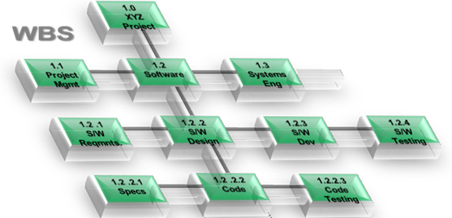
Figure 1. The WBS is structured according to the way the work will be performed, and reflective of the way in which program/project costs, schedule, technical, and risk data are accumulated, summarized, and reported.
During Program and Project Plan development, the WBS will be developed to greater detail than Level 2. The P-CAM may or may not be involved in this process. However, once the P-CAM has received a WAD, further WBS development may be required to better define or control the work effort, account for costs, or to manage risks. Detailed guidance for WBS development can be found in NASA Special Publication NASA Work Breakdown Structure (WBS) Handbook.
In situations where contracted effort is within the P-CAM’s authorized work scope, the P-CAM should be aware that major contracts are defined as contracts that require flow down of compliance with EIA-748.
Note: The EIA-748 standard maps 32 guidelines to five major categories. To better align with NASA-specific business practices, NASA has mapped the EIA-748 guidelines to ten NASA project management processes, as described in Earned Value Management System Description.

Once the P-CAM is satisfied with the level of WBS development for the approved work scope, the necessary changes should be made to the configuration-controlled Project WBS. Project WBS updates will impact several different areas that all use the WBS as a common framework for data collection, control, and reporting. The P-CAM should assist the PM in identifying WBS changes made by other involved NASA Center partners to ensure their knowledge and approval of all WBS updates and element content. As a result of a Project WBS update, changes may need to be made to other systems, including the following:
  - Meta Data Manager (MdM, the NASA WBS control data source).
  - The financial WBS code in the Core Financial System used for cost collection and time charging (also referred to as NASA Structure Management [NSM]).
  - The WBS in the Integrated Master Schedule (IMS) used to manage and coordinate the project work efforts.
  - EV analysis/reporting software (if used) for data analysis.
  - The WBS in the risk management system used to organize risks.
  - Other systems that use WBS-based data.
For this reason, serious consideration should be given to the WBS development effort.
TIP: One common issue in WBS development is the failure to consider all factors before approving and implementing the Project WBS. There should only be one WBS per project. Once a WBS is established, it becomes the foundation for cost collection, reporting, risk management, schedule management, and many other project management functions. Subsequent changes can substantially complicate the effort of managing all of these functions. Before entering the approved WBS or approved changes to the WBS into MdM, it is highly recommended that the P-CAM consult the NASA Work Breakdown Structure (WBS) Handbook for advice and cautions.

WBS DICTIONARY
The WBS Dictionary defines each WBS element and provides the content foundation for establishing control accounts. This dictionary contains a definition of the efforts associated with the WBS element (such as design, development, and manufacturing), as well as its technical content. The Project Manager, Subproject/Element Manager (SP/EM) and the Contracting Office Representative (COR)/P-CAMs develop the WBS Dictionary that is maintained by the Project Office. The dictionary should define each WBS element for all levels, including the reporting level and provides the content foundation for establishing each control account.
The P-CAMs should be involved in developing the WBS Dictionary for their assigned WBS elements unless they are brought on board later in the process. For contracted efforts, the WBS Dictionary may also form the basis for a contract SOW.
For P-CAMs who are assigned to work efforts already in progress, it is extremely important to review the associated WAD(s) and accompanying WBS Dictionary text to ensure a complete and thorough understanding of the work scope, schedule, and budget requirements.
TIP: For guidance in developing WBS Dictionary text, please refer to the NASA Work Breakdown Structure (WBS) Handbook or contact your local EVMFP.

ORGANIZATIONAL BREAKDOWN STRUCTURE
The Organizational Breakdown Structure (OBS) is a hierarchical arrangement depicting the organization of project management personnel. The OBS depicts reporting relationships and begins with the Project Manager or Project Office at the top of the structure and includes lower managerial levels such as SP/EM, P-CAM, and Institutional/Functional Organizations as depicted in Figure 2 below. Responsibility for work defined in the WBS is identified in the OBS. Subcontractor efforts are contained in the OBS and are separately identified.
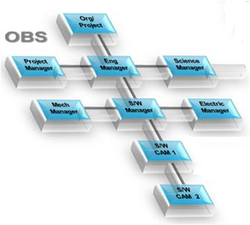
Figure 2. Many programs and projects require resources from more than one organization. The use of a project OBS helps to identify the responsibilities, hierarchy, and interfaces between these organizations. The OBS typically identifies the specific managers and/or organizations responsible for implementation of assigned work tasks within the approved project scope.
If the P-CAM is involved during the WAD negotiation process, they should determine the resources necessary to complete the authorized work scope in the time frame specified in the WAD(s); the P-CAM should also identify the reporting relationships for these resources in the OBS. Both the P-CAM and the sponsor(s) should approve the OBS. Also, the approved OBS should be subject to configuration control.
It may be necessary for the P-CAM to negotiate the WAD(s) with Functional Managers, who control resources outside the project organization. The P-CAM’s OBS element, identified as the Responsible OBS element, should include all of the resources necessary to complete the authorized work in an approved period of performance. The Performing OBS elements (resources that use the charge number to accomplish the work, but which may be drawn from engineering, safety, or other organizations) are common in a matrix organization or Integrated Product Team (IPT) structure. A matrix organization is where people with similar skills are pooled for work assignments. For example, all engineers may be in one engineering department and report to an engineering manager, but these same engineers may be assigned to different projects and report to a different engineering manager or a project manager while working on that project. Therefore, each engineer may have to work under several managers to get their job done.
An IPT is a multidisciplinary group of people who are collectively responsible for delivering a defined product or process. IPTs are typically used in complex development programs/projects for review and decision making. The emphasis of the IPT is on involvement of all stakeholders (users, customers, management, developers, and contractors) in a collaborative forum.
TIP: One of the most common issues with an OBS is that it is never formally accepted by all stakeholders. This often is a result of or leads to work agreements that are not finalized or accepted by all stakeholders. Without dedicated resources, a project risks not being able to accomplish its objectives. Every effort should be made to reach consensus with the stakeholders on the OBS.

RESPONSIBILITY ASSIGNMENT MATRIX
A Responsibility Assignment Matrix (RAM) is developed to ensure that a single line (or functional) organization is clearly identified as responsible for performing each element of the defined work. The RAM is an integration of the WBS with the line organization structure, also known as OBS. The RAM normally depicts the assignment of each Control Account—along with the assigned budget—to a single P-CAM, or IPT Lead as depicted in Figure 3 below.
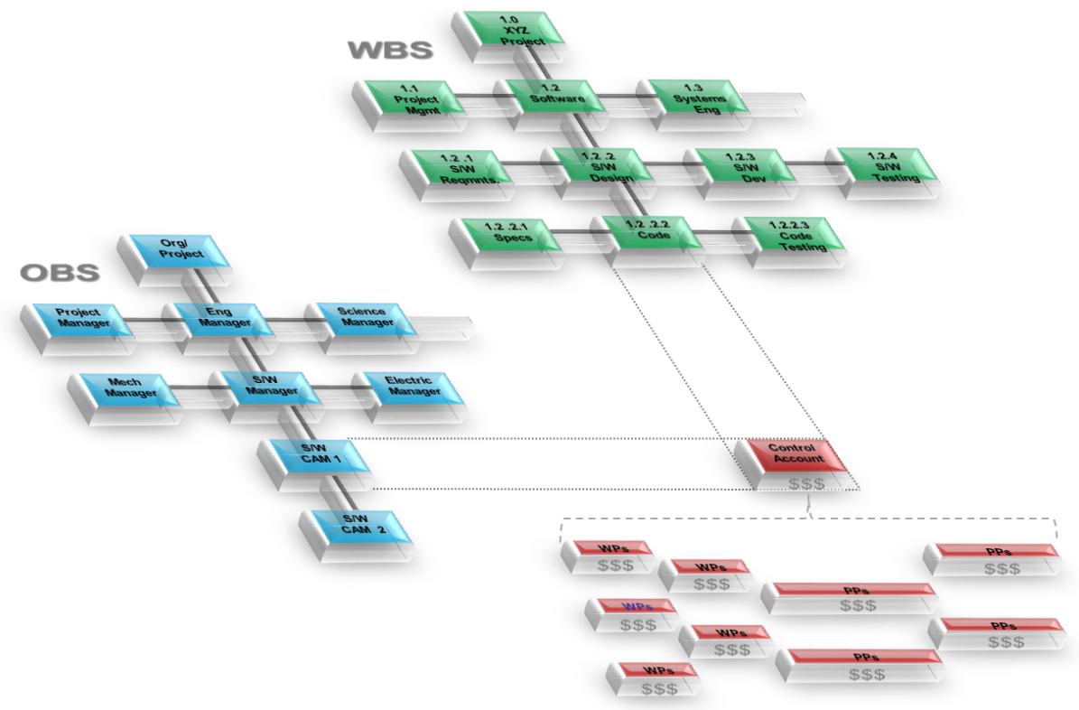
Figure 3. The RAM integrates WBS (green) and OBS (blue). The intersecting points define the Control Accounts (red), which form the hub of the technical, cost, and schedule management focus. It is the lowest level where Work Authorization, Scope, Cost, Schedule, and Risk are managed.
It is common practice for each intersection point to list the budget for that control account. This is referred to as a dollarized RAM and is used to aid in verifying that the correct budget amounts are allocated to each control account and that the control account budget totals are correct. A control account is unique in that it contains work scope, along with the associated budget and period of performance for a single WBS element. Again, it is assigned to one individual, and that individual is known as the P-CAM for that control account. It is possible to have multiple control accounts assigned to the same P-CAM.
The control account may contain in-house work scope, contracted efforts, material, Other Direct Costs (ODC), or any combination of these Elements of Cost (EOC). The P-CAM should verify that the RAM information is accurate and that it matches the information contained in the WAD. Any change to the Project WBS, OBS, or budget will necessitate a corresponding change to the RAM.
TIP: The P-CAMs should have early involvement in the planning process if possible, to thoroughly understand the work for which they are responsible. The RAM will determine who the P-CAM is and for which WBS element or control account(s) they will be responsible.

CHARGE NUMBER(S) ESTABLISHMENT
Charge numbers will be required throughout the life of the project, beginning with initial planning efforts. Charge numbers are typically established by a person in the business management part of the organization—such as a Resource Analyst, Budget Analyst, Business Manager, or Accountant—and should be created only with approval of the Project Manager, Business Manager, and/or P-CAM. Charge numbers are activated in the SAP financial system, and each charge number is typically mapped to a WBS element. Ideally, the WBS element and charge number should be one and the same but is not always the case and thus the need for proper mapping for tracking and visibility purposes. See Tip below for more clarification.
TIP: Projects that rush to establish lower-level WBS elements and related charge numbers often find themselves in the position of having to realign work and costs once requirements are more fully developed. In many cases, constraints of the accounting system prevent this movement and arrange the work in a manner not conducive for effective management control. To avoid this complexity, the P-CAM should be aware of the accounting system limitations and avoid establishing charge numbers too early in the work and planning process. Also, the P-CAM should avoid establishing charge numbers at levels of the WBS that are or may become summaries of more detailed work in the same element of the WBS. This would limit the ability within the agency’s cost/EVM toolsets to establish charge numbers in further decomposition of that WBS element and confuse reporting that summarizes costs of that element. There is also a maximum of seven levels due to the limitations of the accounting system. NASA project management processes, as described in NASA Earned Value Management System Description (Section 4 Accounting, and appendix A – Workarounds).
In the case of charge number activation for initial planning efforts, the Project Manager or Business Manager will usually direct this task. The responsibility for planning charge number activation for a control account typically belongs to the P-CAM. The P-CAM’s WAD is the authorization from the Sponsor to request charge numbers for a work effort. The P-CAM should determine which WBS elements should be activated as charge numbers to manage assigned work and what types of charges (e.g., labor, procurement, travel, etc.) are permitted for each of these charge numbers. The P-CAM coordinates this charge number activation with the Project Manager or Business Manager. While a control account may have one or multiple WP charge numbers, no charge number can be assigned to more than one WBS element within a project.
TIP: A fundamental principle of EVM is that actual costs are assigned at a minimum to the control account for the work accomplished. This principle also assumes that the budget for the work accomplished resides in the same control account where actual costs are incurred. These principles must be adhered to, in order for EV data analysis to provide accurate and useful insight. For this reason, the P-CAM should routinely verify that actual costs incurred in the control account are for the work accomplished in that account, and that the budget for work accomplished resides in the same account.

WORK AUTHORIZATION DOCUMENT
Work authorization is an important part of project management and a successful EVM implementation. Without a formal work authorization process, integration between cost, schedule, and technical objectives is difficult to demonstrate. This process also helps to ensure a common understanding between the Performer and the Sponsor regarding work scope to be accomplished. The WAD represents an agreement between the Sponsor and the Performer that is similar to a contract. At a minimum, this document must include the relevant WBS Control Account code, statement of work (SOW), scheduled start and completion dates, budget, and the name of the P-CAM. Depending on the specific project, the P-CAM may be expected to create the WAD or the P-CAM may receive a WAD from the Sponsor.
A WAD may be issued (a) during the initial planning phase, (b) after the initial planning phase to further detail plan project work scope, or (c) after approved changes to the project work scope, budget, or schedule. The P-CAM should carefully review the content of the WAD. It is normal for negotiation to occur between the P-CAM (as the Performer) and the Sponsor regarding the technical, budget, and schedule requirements represented by the WAD. If the P-CAM agrees to accept budget and schedule requirements in the WAD that do not reflect the P-CAM’s estimate (with PM’s approval) of what will be actually required to perform the work, then the P-CAM’s estimate should be reflected in the forecasted dates of the IMS and cost forecast (ETC).
TIP: At some centers, performing organizations may use their center-specific processes. Regardless, an authorization document should be created. Also, a P-CAM could have more than one WAD if they are assigned to multiple control accounts. See the Agency EVM System Description for a WAD example.

SCHEDULING
After the control account schedule has been developed the Planner/Scheduler and Resource Analyst will combine the schedule and budget plans, verify compliance with project-level requirements for schedule and budget, and verify with the P-CAM interrelationships with other control accounts. There are many other types of analyses performed during this process, such as validating the IMS’s critical path(s) and analyzing resource use. These functions are covered in detail in NASA Schedule Management Handbook.
TIP: Scheduling is not simply listing tasks to be accomplished. In order for a schedule to be effective, it must be dynamic. In this sense, dynamic means the schedule should reflect not only the plan for accomplishing work but changes to the plan as they occur. The schedule should be viewed as a project execution model. Logical relationships between tasks need to be accurately modeled in order for the reporting and analytical outputs to be effectively used.
Using the developed tasks, the P-CAM should first identify the relationships between these tasks. Relationships between tasks in the P-CAM control account and tasks in other P-CAM control accounts also need to be identified. Each task should have at least one predecessor (a task that precedes it) and at least one successor (a task that succeeds it), excluding project start, project completion, and delivery/receipt events to external entities.
Once the P-CAM’s tasks are sequenced, the resources planned for those tasks should be time-phased to match the task sequence. While this can be done manually, it is much easier to establish and maintain this data by using scheduling software. Scheduling software permits the user to assign resources directly to the task that requires them. Time-phasing then occurs automatically as the schedule data is changed or updated.
TIP: Task duration and resource allocation are linked in many cases. The process for estimating a task’s duration and allocating resources should be iterative until the technical, cost, and schedule requirements are all satisfied.
By time-phasing resources with their respective tasks, two important objectives are accomplished. First, the P-CAM can evaluate the plan and determine:
  - What resources are required in a given time frame?
  - What quantity of a particular resource is required in a given time frame?
  - If the work can be achieved as planned, given a finite set of resources.
  - The variability of resources (both type and number) over time.
  - Potential resource conflicts in availability or priority.
The second important objective enabled by time-phasing resources with tasks is the ability to develop a time-phased budget. Most scheduling software allows the user to assign rates to resources and translate this data into a time-phased dollarized plan. This function fully integrates the budget, schedule, and technical plans.
With rates assigned to resources and time-phased in accordance with the sequenced tasks, a time-phased budget for the control account has been established.

Critical Path
The Critical Path Method (CPM) calculates the longest sequence (or path) of tasks throughout the entire schedule to completion. A delay of a task on the critical path will impact the completion date of the project or consume any available total float (total slack) time. Also, there can be multiple critical paths, as many schedules are complex, and work is done in parallel. When analyzing the critical path, the P-CAM should keep in mind the following considerations:
  - The critical path typically starts with a task currently in progress or scheduled to start and proceeds through the required sequence of tasks to arrive at project completion; there are no unexplained voids or gaps (lags) in time between tasks on the critical path.
  - Use of a “waterfall” format (sort by total float or total slack value, then by start date) makes the critical path meaningful and easily understood for analysts and management.
  - Monitoring accomplished work for tasks on the critical path will indicate if the project completion date will be impacted.
  - Focus should be on the top three to five critical paths, or more depending on the project’s needs; do not stop at analyzing only one critical path.
  - The critical path should never contain summary tasks.
  - Multiple coincidental critical paths may have the same float (slack) values.
  - The critical path is dynamic and can change from one schedule update period to the next.
  - Critical path tasks are not the same as a project’s critical items. Critical path is a scheduling term and should not be used out of context.
  - Total float (total slack) values on the critical path should be consistent values (unless different task calendars are used).
  - The task sequence on the critical path should pass the commonsense test.

Schedule Margin
Schedule margin (a.k.a. reserve or contingency) is a separately planned quantity of time above the planned duration estimate reflected in the IMS; schedule margin is intended to reduce the impact of missing overall project schedule objectives. It is a recommended practice that schedule margin—based on risks, duration uncertainty, and historical norms—is clearly identifiable when included within the IMS.
Schedule margin is owned by the Program/Project Manager and should be used for future situations that are impossible to predict (for unknown unknowns). For this reason, no specified budget should be assigned to a schedule margin task because there is no known project scope involved. However, an adequate amount of project management reserve must be available to cover a reasonable workforce level through the schedule margin duration.
In addition, schedule float (slack), which is a calculated value based on the network logic, should not be considered as schedule margin. Refer to the NASA Schedule Management Handbook for more information.

CONTROL ACCOUNT PLAN
The CAP is the time-phased budget plan for a control account as depicted in Figure 4 below. The P-CAM should first plan the near-term work into Work Packages (WPs). A WP contains well-defined work scope, duration, and resources and discrete, measurable, product-oriented tasks. A WP is a natural subdivision of a control account and is the point at which work is planned, progress is measured and earned value is computed. Work that is in the future may be difficult to define in terms of discrete measurable tasks. In this case, the P-CAM may plan this work into a summary level task called Planning Packages (PPs). PPs are tasks that represent work scope, duration, and resource requirements that are not yet defined to the level of detail necessary to perform the work. PPs are subsets of control accounts. The sum of all WP’s and PP’s work scope, duration, and resources should equal the control account total scope, duration, and budget.
TIP: In planning, the P-CAM should plan as much of the work as possible into a WP but no more. When the P-CAM reaches the point in planning where requirements are not yet defined well enough to present a clear path forward, this is usually an indication to begin capturing work and budget into a PP. The WPs and PPs should represent natural breaks in the workflow and NOT be forced into arbitrary periods such as calendar or fiscal years.
There are two methods for developing a CAP. Depending on the method used, the CAP either influences or is the result of the P-CAM’s efforts. The first method is the top-down method as depicted in Figure 4. The second method is the bottoms-up method.
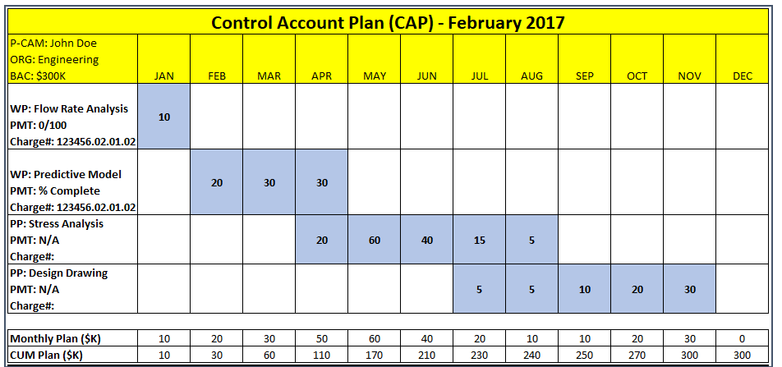
Figure 4. The CAP provides a format upon which a control account plan is displayed. A CAP typically displays the control account scope and budget in time-phased WPs and PPs, cost element visibility, performance measurement techniques for each WP, responsible performing organizations and at least one charge number.

Using the top-down method, the P-CAM develops a CAP by allocating budget to PPs at a summary level within their control account. As detailed planning occurs, budgets are decomposed to the detailed WPs that constitute the control account. The sum of the budgets for those detailed WPs and any PPs must equal the budget for the control account. The P-CAM then updates the CAP as more details are developed.
Using the bottoms-up method, the P-CAM develops detailed WPs that represent assigned work scope and assigns a cost estimate (preliminary budget) for each WP. With the detailed plan developed, the P-CAM aggregates the detailed WP costs into a preliminary control account budget. At this point, depending on the specific project process, there are two possible alternatives. First, the resulting preliminary CAP may be used as the basis for negotiating a WAD for the control account. Second, if the P-CAM already has a WAD that has been issued but not yet agreed to, the P-CAM may try to resolve any differences between the WAD and CAP by examining the CAP assumptions or basis or by negotiating with the Sponsor regarding the WAD content.
TIP: The bottoms-up method of CAP development is the recommended method as it produces the most realistic CAP. The top-down method should be used only when budget and schedule requirements are levied on the P-CAM.
Regardless of the method used by the P-CAM, the outcome is a CAP with a time-phased budget integrated with the scheduled tasks. This is accomplished by an iterative process of making changes to the related budget and schedule data as the CAP is developed or refined.
One tool that can be used by the P-CAM to aid in this planning process is called the Integrated Master Plan (IMP). The IMP is a listing of Program or Project Events (PEs), the Significant Accomplishments (SAs) required to reach those events, and Accomplishment Criteria (ACs) for each accomplishment. An IMP does not contain dates. An IMP is usually developed early in the project life cycle (for example, Phase A of Project Formulation).
TIP: An IMP is rarely used in the NASA environment, with the exception of contractors on contracted efforts. However, if used, the IMP can be a very effective tool to help the P-CAM begin the process of defining the work in a product-oriented manner.
After initial control account planning, more information may become available, enabling the P-CAM to further define PPs. Once this occurs, the P-CAM reviews affected PPs and if necessary, converts PPs into WPs. The conversion should occur three to six months before the baseline scheduled start of the work effort. The conversion is accomplished by detail-planning the PP into discrete, measurable, product-oriented tasks with scope, duration, and budget. Some projects institute a practice referred to as rolling wave, planning horizon, or block planning. This practice is used to determine the deadline for the P-CAM to decompose a PP into a WP before the scheduled start of a PP. However, the practice is instituted, PPs should represent work products and should not be assigned durations based on arbitrary influences (such as calendar or fiscal periods). This means that PPs will usually have a duration that spans time between PEs or SAs.
TIP: The PM will often establish the project planning horizon or rolling wave time period early in the project life cycle. This does not prevent the P-CAM from decomposing a PP into a WP sooner; the best time to do that is as soon as enough information is gained (when work requirements are defined). This activity will not always align with the planning horizon, so the P-CAM should be prepared to address this situation with the Project Manager in cases where PP decomposition should be delayed beyond the planning horizon but should be done three to six months prior to work beginning on the resulting WP.

PERFORMANCE MEASUREMENT TECHNIQUE
The Performance Measurement Technique (PMT) (Note: sometimes referred to as Earned Value Technique or EVT) defines the value of the work that has been performed or accomplished, or Earned Value (EV), will be recorded for a WP. Selecting the most appropriate PMT is necessary in order for EVM indicators to provide accurate and meaningful insight. EV variances and indices depend on actual costs and EV being recorded in the same reporting period as the work performed. For situations where this does not happen, accruals or estimated actuals are used to align actual costs with EV.
EV is based on the budget value for work. When all WP work is completed, the full value of the WP’s budget is earned. If work has not been performed, no value can be earned. Therefore, the only variability in determining EV is for WPs that should have started but have not or for WPs that are currently being worked. These are referred to commonly as “in progress” WPs.
The P-CAM should select a PMT that best represents how the WP will be accomplished and how actual costs should be recorded. In order to make the best possible selection, it is necessary to understand the tasks associated with the WP, and how best to reflect accurate accomplishment for the work. A recommended guide to help in PMT selection is shown in Figure 5 below.
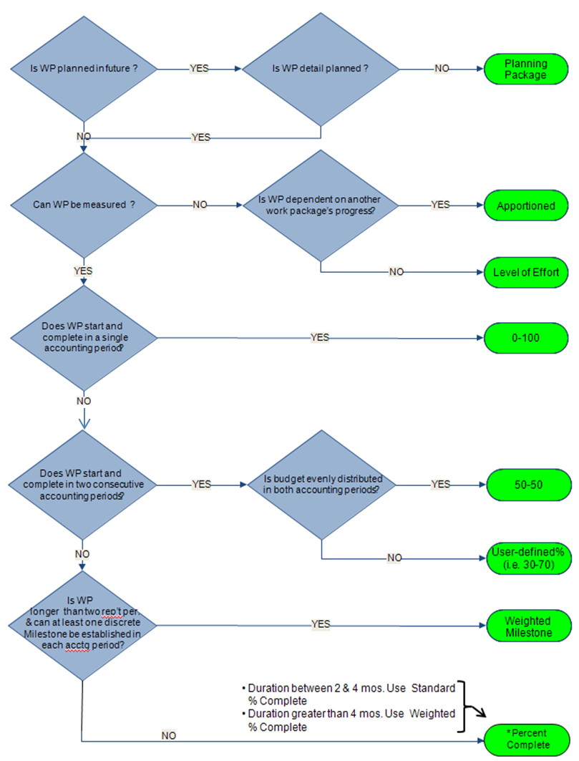
Figure 5. PMT selection guide.
TIP: It is very important for the P-CAM to carefully consider an appropriate PMT for assigned WP(s), because a meaningful PMB provides the basis for performance metrics and the usefulness of EV data.
Material purchases are subject to special consideration for recording EV. EV may be recorded for material at the point of receipt and acceptance, consumption during fabrication, delivery of the final product, or any point in between. EV for material purchases cannot be taken prior to material receipt.
Different PMTs apply to different types of WPs. The WP types are Discrete Effort, Level of Effort (LOE), and Apportioned Effort. The one common characteristic for all PMTs for all WP types is that EV is ultimately determined by multiplying the physical percent complete (percent accomplishment) by the Budgeted Cost for Work Scheduled (BCWS). The method for determining accomplishment is the variable, depending on WP type and PMT used. Figure 6 below shows some examples and uses of various Discrete Effort PMTs. Discrete Effort PMT are related to the completion of specific end products or services and can be directly planned and measured.
Figure 6. PMTs are used to objectively calculate the most accurate earned credit for the work performed. The PMT is selected when the WP has been detailed planned in the schedule. The P-CAMs choice of PMT enhances the accuracy, quality, and effectiveness of performance data produced by the EVMS.
TIP: The percent complete PMT is one of the most widely used methods. To ensure that is an objective measurement, the use of Quantifiable Back-up Data (QBD) should be used in conjunction to document and validate how the percentage was determined by the P-CAM. This ensures that an objective thought process was used to document percentages and/or steps to accomplish the work.
LOE WPs earn value based on the baseline plan. EV is recorded with the passage of time. In other words, the EV is recorded exactly as the baseline budget plan (or BCWS) shows. This PMT is appropriate for WPs that have no discrete deliverable or product, such as project management, engineering oversight, administrative, etc. An LOE WP may have a Cost Variance (CV) when actual costs exceed value earned for accomplished work for any reason. However, an LOE task will never experience a Schedule Variance (SV), because SV is the difference between EV (Budgeted Cost for Work Performed [BCWP]) and BCWS. For this reason, the P-CAM should limit the use of this PMT because it has the effect of masking potential problem areas and skewing the EV data reported.
TIP: LOE PMT should generally be used on about 20 percent of the project budget as a rule for thumb. Individual control accounts may vary in this percentage depending on the nature of the work involved. Many government functions that are traditionally treated as LOE tasks can actually be converted into Discrete or Apportioned Effort (AE) tasks when the P-CAM considers the resulting products.
The AE PMT is appropriate for use on tasks that relate directly as a percentage of work and depend entirely on the accomplishment of the WP(s) (e.g., quality, safety, or similar support services that do not have a discrete deliverable of their own and will earned credit as a percentage of the accomplished effort – typically 10% of a base WP) as depicted in Figure 7 below.
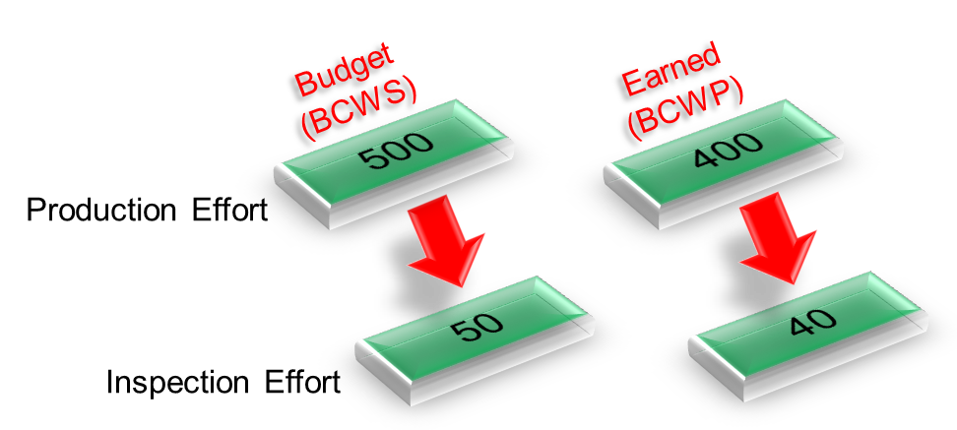
Figure 7. In the Apportioned PMT, the value for the AE (Inspection effort in this example) is based on (or apportioned to) the EV of the reference base task (Production effort in this example).

PERFORMANCE MEASUREMENT BASELINE
The time-phased budget plan against which performance is measured is formed by the budgets assigned to scheduled control accounts. For future effort, not planned to the control account level, the PMB also includes budgets assigned to higher-level WBS elements and budgets associated with specific work scope or authorized changes that have not been assigned to a control account or summary level planning package or Undistributed Budget (UB). The PMB equals the total allocated budget less MR. It is established in Phase B in preparation for Key Decision Point (KDP) C approval and is assessed during the Pre-approval IBR process, or the contract IBR process. Establishing the PMB results in the baselining of the Project IMS and the corresponding budget.
Only authorized changes may be reflected in the baseline budget and baseline IMS. The IMS and budget are retained as benchmarks for progress and performance measurement from this point forward. This is also the point at which authorized work, aside from the planning efforts that have taken place thus far, may commence. PMB development is a three-step process as depicted in Figure 8 below.
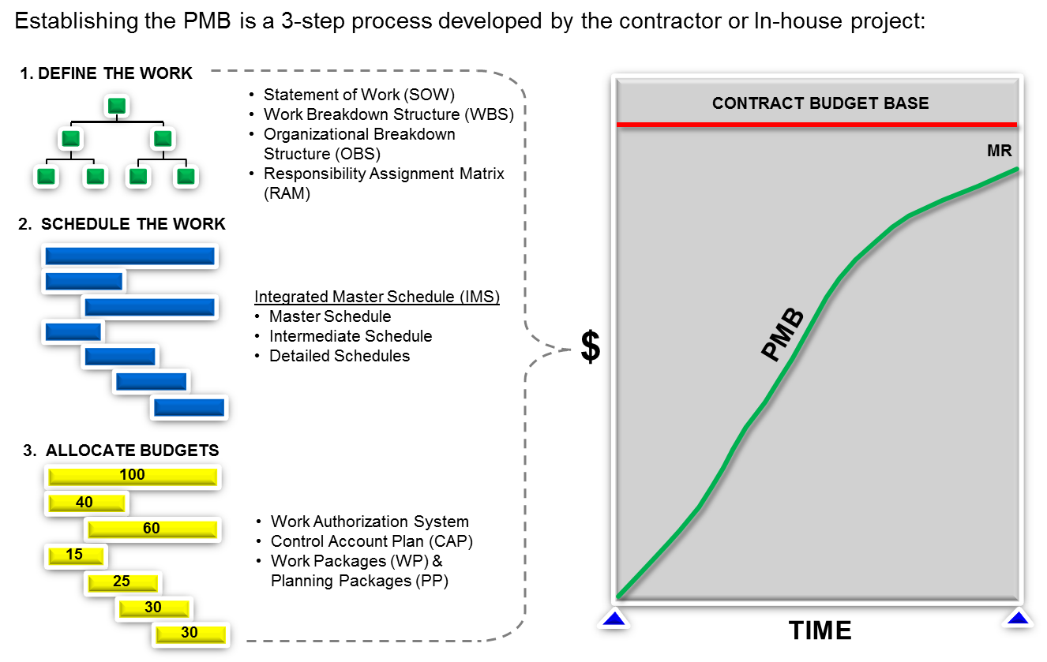
Figure 8. Establishing the PMB is a three-step process developed by the contractor or in-house project.
While establishing the PMB, the P-CAM should verify several pieces of data. First, the IMS dates for scheduled control account work should match the dates for each control account WAD. Control account budget phasing reflected in the CAP should also match the time frames indicated in the IMS and WAD for related work scope and deliverables. The sum of all control account budgets and any UB should be equal to the Project PMB.
Budget and funding are separate but interrelated. Budget is the time-phased plan of resources required to accomplish a specific center, program, project, or organizational objective. Budget in an EVM environment is defined as the PMB. Budget is developed, monitored, and controlled for the life cycle of a project. NASA work efforts it is necessary to plan for both obligations (funds) and costs (budget). For EVM projects, earned value management reporting and metrics are evaluated only against the cost (budget) profile; however, the obligation (funds) profile is also a requirement and is monitored and tracked. Once the budget (both Cost and Obligation profile) is developed and approved by management, formal authorization occurs:
  - Mission Directorate Associate Administrator (MDAA) authorizes the Program-level budget
  - The Program Manager authorizes the Project level budget
  - The Project Manager authorizes the control account-level budget
The term funding represents the appropriated funds from the federal government. Funding is the end result of the Federal Budget Process:
  - NASA submits a proposed budget (obligation-based funds plan) by Fiscal Year (FY) to the Office of Management and Budget (OMB).
  - OMB reviews the budget submittal, makes recommendations, and forwards to the president.
  - The President approves the proposed budget and forwards to Congress.
  - Congress approves and issues Authorization Acts and Appropriation Acts.
  - OMB disburses appropriated funds by agency.
  - NASA Headquarters receives appropriated funds from OMB and disburses them to each center and mission directorate.
  - The mission directorates authorized funds are then disbursed to individual programs and projects.
Changes to the budget can impact funding and vice versa. Budget is a planned amount and funding is real money. Figure 9 below illustrates the relationship between budget and funding.

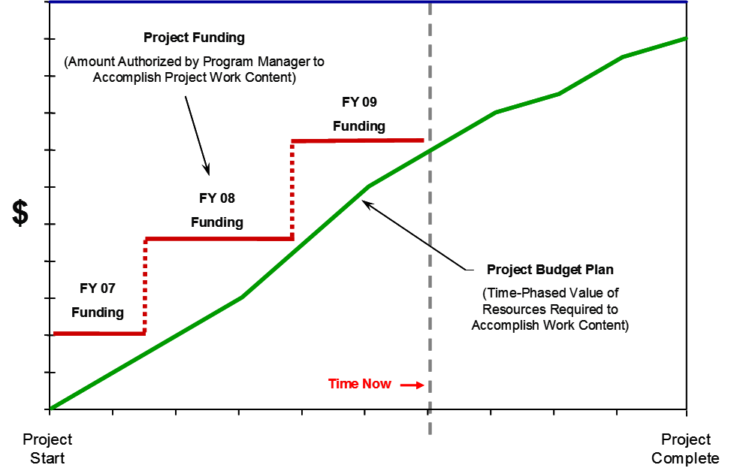
Figure 9. Budget vs. Funding.

Management Reserve (MR) is a portion of the Project Budget Base (PBB) withheld for management control purposes rather than being identified and distributed to accomplish specific tasks. Therefore, it is not part of the time phased PMB. When establishing the overall project approach, the Project Manager will assess all risk areas and establish an MR. MR provides the Project Manager with “budget” for resolving unforeseen problems within the project’s authorized scope.
The project MR is determined based upon an analysis of the amount required to cover risk mitigations, schedule risk, schedule margin, and cost uncertainty. Management reserves required for technical and cost risk should be based on the P-CAM’s assessment of technical and cost risks. Schedule Margin is established based upon the Schedule Risk Assessment (SRA) performed, and an analysis of the MR budget required for schedule margins identified in the IMS. The Project Office must ensure that there is adequate MR to address technical, cost and schedule risks. Again, MR is that portion of the PBB set aside by the Project Manager for potential work scope growth, changes in rates and factors, and other unknown project risk that may cause cost growth. MR is used for unanticipated (or unknown) work that is within the scope of the project but is out-of-scope to any of the existing baseline CAs. Distribution of MR is documented in the MR Log, and all transactions affecting MR are recorded such that a current net dollar balance is displayed in the log. Requests for work to be added to or deleted from a CA will use or replenish MR and will be submitted via a revised WAD in the change request process.
TIP: Traceability among the CAP, WAD, and IMS is key to demonstrating integration of cost, schedule, and technical objectives. This is a common audit or review point and a commonly noted issue by review teams. In addition, a success-oriented project management system should be implemented in a manner to maintain and monitor cost (budget) and obligation (funds) profiles.

INTEGRATED BASELINE REVIEW
The purpose of an IBR is to ensure that both the sponsor and the performer (i.e., customer and supplier) are in agreement regarding the interpretation of work scope, period of performance, and budget requirements. The IBR also focuses on the identification of risks inherent to the technical, budget, and schedule baselines. In addition, the IBR is not intended to be a review of an EVMS process or implementation, although certain aspects of the EVMS will be used to demonstrate congruence of technical, budget, and schedule requirements. It should also be noted that the IBR is not a “pass-fail” event, but rather a review in which all parties participate to reach a mutual understanding of the PMB and to ensure the PMB is realistic for accomplishing all the authorized work within the authorized schedule and budget.
The IBR’s duration depends on the size of the project. Basically, the IBR consists of a short in-brief, P-CAM discussions, and then a short out-brief of the findings. Findings, additional risks, and action items are documented. Prior to the actual IBR, project data is reviewed by the IBR Team, and preliminary findings and questions are documented for use at the actual IBR.
The timing of the IBR is as follows:
  - Mission Directorates shall conduct an IBR in preparation for KDP C.
  - A post-award IBR is required within 180 calendar days after contract award, or exercise of significant contract options, or within 60 calendar days after distribution of a supplemental agreement that implements a significant funding realignment or effects a significant change in contractual requirements (e.g., incorporation of major modifications). (NFS 1852.234-2(c))
  - Project EV reporting should begin no later than 60 days after the start of Phase C. (Note: Contract EVM reporting should begin no later than 90 days after contract award, with the contract IBR within 180 days of contract award).
  - An IBR occurs after the planning and budgeting have been completed at the control account level.
  - An IBR occurs when there is a significant shift in content, major modification, or time-phasing of the PMB.
  - For contracts, refer to the NASA FAR Supplement for IBR requirements.

TIP: The P-CAMs should be prepared to answer questions regarding scope, schedule, budget, and associated risks of their control accounts during the P-CAM discussions. The IBR Team will also ask the P-CAMs to walk the team through their documentation (i.e., conduct a data trace) during the discussion and explain the data, what it means to the P-CAMs, and how they use it to manage their control account(s).
Comprehensive information on the conduct of the IBR can be found in NASA IBR Handbook, available on the NASA EVM Website at https://www.nasa.gov/evm/handbooks.

MONTHLY SCHEDULE UPDATES AND ANALYSIS

Schedule Update
The schedule forecast update consists of two sets of actions:
First, the P-CAM records schedule status (typically through the Planner/Scheduler). The status includes Actual Start (AS) and Actual Finish (AF) dates for schedule tasks started or completed, as well as the Remaining Duration (RD) or Expected Completion Date (ECD) for each task actively being worked. A schedule “percent complete” input is not required and not recommended.
TIP: The “percent complete,” usually displayed in both graphic and tabular formats in a schedule, is actually the percent of duration complete. This is not necessarily the same as the physical or accomplishment percentage. Percent duration complete is a calculation that can be performed by scheduling software and is not always directly proportional to work accomplished. For this reason, it is recommended that the scheduling software be permitted to calculate duration percent complete based on the other P-CAM inputs (AS and RD or ECD). Physical percent complete is a manually entered field and should be used to show accomplishment and compared to how time is left on a task (i.e., percent complete).
As the P-CAM determines the RD or ECD for each task currently being worked, the schedule forecast is then updated by the Planner/Scheduler. Changes to the overall task duration have an impact on successor tasks, which are reflected in the updated version of the IMS.
The second action is updating the resources allocated to schedule tasks. The method for updating depends on whether or not the schedule is resource loaded.
  - If the schedule is resource loaded, the Planner/Scheduler should assist the P-CAM in adjusting the resource allocation for each task to reflect the P-CAM’s knowledge of actual and planned resource consumption.
  - If the schedule is not resource loaded, the P-CAM should assist the Resource Analyst in adjusting the resource allocation to reflect actual and planned resource consumption. This method is typically summarized at a less-detailed level than the schedule task level.
When resource allocations are updated, the ETC and, therefore, the EAC, are also updated. Also changes to schedule logic, adding tasks, removing tasks (i.e., deleting scope), etc. need to be documented as per the change control process and the impacts reviewed by the project team for any EAC adjustments.
TIP: Resource allocation and task duration are often interrelated. Both should be considered when one is adjusted.

Schedule Analysis
At a minimum, the P-CAM should verify each reporting period that the ETC and EAC data reflect the best estimate for task durations and resource allocations. In addition, the P-CAM should be involved in the following two areas on a monthly basis:
  - Schedule assessment is the process of determining schedule validity and performance at a given point in time – a decision or judgment. A thorough schedule assessment should always be performed prior to establishing the IMS baseline. Periodic assessments are also necessary to ensure that the IMS generates valid data and to support the project’s objectives throughout the project life cycle. A reliable schedule assessment checklist is an important aid that can benefit a project team or outside review team in determining schedule validity. (See NASA/SP-3403 Schedule Management Handbook for a sample checklist.)
  - Schedule analysis is the process of evaluating the magnitude, impact, and significance of actual and forecast variances against the baseline and/or current schedules – detailed analysis. After routine updates, schedule analysis begins with the calculation of the critical path and the determination of any change in the completion date of the project. Analysis continues with evaluation of schedule performance metrics (Health Check, Work-off Trend, etc.) derived from the IMS; using the results of that evaluation, the Planner/Scheduler, P-CAM and Project Manager then assesses the project’s schedule health. Analysis results should also be reviewed with the project team. This process should be repeated as needed to ensure that the project team has a clear and accurate understanding of schedule performance.

VARIANCE ANALYSIS

Schedule Variance Analysis
  - Variance analysis is a key process in assessing schedule impacts from the updated schedule. The P-CAM may need to perform “what-if” scenarios from time to time to provide alternatives to resolving schedule impacts.
  - Predicting future performance provides management with early warning of schedule impacts and allows for proactive decision making.
  - If EVM is required, the SV and Schedule Performance Index (SPI) are indicators to show how the schedule is performing against the time phased, budgeted PMB.
  - EV schedule indicators must be used in conjunction with critical path analysis to see the true performance of the schedule.

EV Variance Analysis
The P-CAM records EV for each WP in a control account using work accomplished (i.e., BCWP). The P-CAM should validate the EV data at this point before conducting variance analysis to ensure that the analysis results are based on accurate data. In order for the indices, variances, and subsequent analysis to be valid, the P-CAM should ensure that EV is recorded in the same reporting period as the actual costs or Actual Cost of Work Performed (ACWP).
The P-CAM should analyze the variances using the EV data recorded, actual costs, and IMS data compared to the time-phased budget. In particular, variances between the baseline plan (PMB), work accomplished, and actual costs should be analyzed to identify the differences and root cause(s) of those differences. By identifying the source of variances, the P-CAM should be able to determine if corrective action is warranted, what type of action, and what to expect of recovery or mitigation of impact as a result.
TIP: Traditionally, the variance analysis function is underused, perhaps in part because the benefits of a disciplined and rigorous process are not well understood by all stakeholders. First, variances are normal because estimating is not an exact science. Second, making the necessary effort to understand the root cause(s) of a variance aids in identifying the proper actions to take as opposed to reactionary efforts that may or may not address the underlying cause(s). Third, careful evaluation of planned corrective actions enables more accurate forecasts of the impacts of those actions. Combined, these processes provide management a complete overall data set that enables informed decision making.
The P-CAM should examine the CV, which is the difference between the value of work accomplished (earned value) and the actual costs to accomplish that work, as well as the Cost Performance Index (CPI):
CV = BCWP – ACWP
CPI=BCWP/ACWP (favorable is >1.0, unfavorable <1.0)
TIP: What does the CPI mean in plain English? CPI is a cost efficiency indicator; a CPI of 0.80 indicates that for every $1.00 spent, only $0.80 worth of planned work was accomplished.
This variance provides a measure of cost efficiency. A negative CV is referred to as an unfavorable variance because the cost of performing the work (or ACWP) is greater than the value of the work performed (or BCWP). Conversely, a favorable variance means the work was accomplished for less cost than its value. In other words, it shows an under-run or over-run situation.
The P-CAM should also examine the SV, which is the difference between the value of work accomplished and the value of the work planned, as well as the SPI:
SV = BCWP – BCWS
SPI=BCWP/BCWS (favorable is >1.0, unfavorable <1.0)
TIP: What does the SPI mean in plain English? SPI is a schedule efficiency indicator; an SPI of 0.80 indicates that for every $1.00 planned, only $0.80 worth of planned work was accomplished.
This variance provides a measure of schedule efficiency. A negative SV is referred to as an unfavorable variance because the value of work planned is greater than the value of the work performed. Conversely, a favorable variance means the value of work accomplished was greater than the value of work planned. In other words, it shows an ahead of schedule or behind schedule situation.
EV metrics never compare just BCWS to ACWP, planned versus actual. While it may be necessary to do so for funds management, the comparison does not provide an accurate assessment of work performance or accomplishment.
TIP: CV root causes should be categorized by the P-CAM as either usage variances or rate variances. A usage variance is for material analysis (UV = Budget Quantity – Actual Quantity)) x (Budgeted Price) and is most useful on programs procuring multiple items of the same part number, typical for production type contracts. A rate variance is a difference in the actual rate incurred for a resource (material, labor, ODC) compared to the plan. The P-CAM must identify the issue that created the usage or rate variance in order for root cause analysis to be complete.
The Variance at Completion (VAC) is the difference between the Budget at Completion (BAC) and the EAC:
VAC = BAC – EAC

Where EAC is the sum of the ACWP and the ETC:
EAC = ACWP + ETC
Because the BAC and the ACWP are both fixed, the one variable the P-CAM should focus on is the ETC.
Integrated Program Management Reports (IPMRs) and EV metrics are generated at the project, subproject, and control account levels (Note: Suppliers will also submit these reports per contract requirements); the reports provide the SP/EM and P-CAMs with plan, performance, and cost by element of cost for current period, cumulative-to-date, and at-completion points in time. This data reveals the nature of any variance(s) and form the foundation for the development of managerial actions.
The P-CAM is responsible—with assistance from the Resource Analyst, Planner/Scheduler, and possibly the Business Manager—for creating and submitting a Variance Analysis Report (VAR), if required. Typically, a VAR will be required if the P-CAM’s reporting data trips a threshold value. The VAR should be a formal document with a specified format that should include the following data items:
  - All values that are calculated—such as CV, SV, VAC, CPI, and SPI—and the values used to perform the calculations, such as ACWP, BCWP, BCWS, BAC, and EAC.
  - Separate analysis of SV and CV, both current and cumulative. They may share common causes, or they may not. The impacts of SV and CV will be different even if the causes are the same.
  - The root cause or causes of each significant variance along with the corresponding values that contributed to the total variance.
  - Classification of each CV root cause as a usage variance or a rate variance. If the CV root cause is a combination of both usage and rate variances, the P-CAM should identify the quantity (in dollars) that each type of variance contributed to the total variance.
  - The impacts of each root cause and the expected result (for example, full recovery, partial recovery quantified, or no recovery with any further degradation).
  - Corrective actions to resolve each root cause.
  - The results of the corrective actions taken for each root cause reported in prior reporting periods; these results are reported until the variance is fully recovered or until no further recovery is anticipated.

Obligation Analysis
The Obligation analysis and reporting processes are performed in support of NASA’s funds management and reporting requirements. The project business team performs obligation analysis that compares the planned commitments and obligations to the actual commitments and obligations. This data is monitored and reported monthly and annually. This information supports the projects ability to calculate carry-over funds and future years funding requirements or New Obligation Authority (NOA).

UPDATE FORECAST (ESTIMATE AT COMPLETION)
As described in Section 14, the P-CAM updates the cost and schedule forecasts monthly. In addition, the P-CAM should revisit those forecasts after variance analysis is complete in order to consider the results of the variance analysis and, if applicable, make adjustments to the cost and schedule forecasts.
Tip: Adjustments to the cost and schedule forecasts may require submission of a form such as a Change Request (CR) as described in Section 17. Even though a forecast update is not the same as a change to the baseline, some projects use the same CR form and review process for both forecast and baseline updates because approved changes and forecast updates flow through many of the same review and approval cycles.
Routine adjustments to the ETC and EAC may be needed throughout the project. The EAC revision stems from the monthly management oversight activity. Each month, the P-CAM reviews his or her cost and schedule performance data and specifically determines if the existing EAC is still accurate and valid. If it is not, the P-CAM generates a new time phased ETC for submission to and approval by project management. The P-CAM considers past performance and the remaining work in the assessment. If the EAC is not accurate, the P-CAM requests a revision.
As an alternative, the P-CAM may have established an ETC that is not time-phased; this alternative allows the P-CAM to adjust the ETC to support funding needs. One way for the P-CAM to validate the updated forecast is to calculate a statistical or Independent EAC (IEAC) for comparison to the EAC. More information on this topic can be found on the NASA EVM website (www.nasa.gov/evm) under the Tutorial, EVM training information, and links to other EVM sites. Also, the P-CAM may refer to the NASA EVM System Description for further information on EACs.

To-Complete Performance Index
The To Complete Performance Index (TCPI) is measured against the sum of all budgets allocated to the project or a given Control Account (or BAC) or with the incorporation of a new EAC, the new at-complete forecast. Once an approved EAC is in place and is a different at-complete value than that of the original BAC, the new forecast is established.
The TCPI is calculated by using the BAC and the EAC. The TCPI calculated against the BAC represents the level of efficiency required to complete remaining work and stay within the baseline budget. With the incorporation of the EAC, the TCPI represents the level of efficiency required to complete remaining work and stay within the forecasted cost (see formulas below).
TCPI to BAC
BAC – BCWP (cumulative)/BAC – ACWP (cumulative)
TCPI to EAC
BAC – BCWP (cumulative)/EAC – ACWP (cumulative)
TCPI trend analysis allows comparison between the original BAC, for which variance thresholds are derived, and the new EAC forecast. The above formulas represent the projects “best-case” scenario. By applying CPI and SPI performance factors, the TCPI can more accurately reflect the project’s “worst-case” condition (see formulas below).
TCPI to BAC
BAC – BCWP (cumulative)/BAC – ACWP (cumulative) × (CPI × SPI)
TCPI to EAC
BAC – BCWP (cumulative)/EAC – ACWP (cumulative) × (CPI × SPI)
The TCPI against the BAC equates the level of performance efficiency required to obtain the original budget or against the EAC to meet the new forecast. For example, the TCPI is 1.10, which indicates that the project must perform at 110% efficiency to complete the remaining work and still make the target (BAC or EAC). Like the CPI and SPI performance indices, the more realistic performance numbers are closer to 1. Higher efficiency requirements, such as 115% depending on schedule and cost performance, are usually a cause for re-assessing the remaining work estimates (or ETC). The VAR contains the results of these statistical calculations.
Tip: Perform monthly assessments of the projects EAC by assessing EAC realism using performance trends and metrics, identify any additional cost and schedule risks associated to the go forward plans discuss impacts to the VAC. Determine when to update the project’s EAC.

CHANGE CONTROL
Baseline control is accomplished by Program Planning and Control (PP&C). Revisions to schedules, budgets, and work scope are processed in a disciplined manner to maintain a clear path from the original approved baseline and to implement changes in a timely manner. Traceability of a revision requires the identification of the type of change, the source initiating the change, and the project areas affected by the change.
The CR a form used to document and justify a proposed change to either the EAC or the Performance Measurement Baseline (PMB) including work scope, schedule, and budget to involved stakeholders. This process also provides a means to authorize and control these changes to the PMB. Examples of the types of changes subject to this process are contract modifications; project scope, schedule, or budget objectives that are altered by the Program Office; and previously undefined project scope that has been defined and for which MR is allocated. The CR process is necessary for those changes that are instigated by, affect, or require approval from internal or external project stakeholders.
TIP: Not all changes initiated by a CR form are changes to the baseline. Many projects use the CR form and process for baseline and forecast changes, indicating by form fields the type, intent, and purpose of the change. Both approved changes and forecast updates often go through the same review and approval process, so this approach streamlines the overall process.
The following are general guidelines for replanning changes to control accounts or WPs:
  - Replanning changes are not made to complete WPs, with the exception of accounting adjustments that are made in the current period.
  - Retroactive changes to work performed are strictly controlled and only permitted to improve the accuracy of the performance measurement data.

TIP: Retroactive data changes should be permitted only as necessary to address:
*Clerical error
*Work or costs assigned to the incorrect WBS
*Work in process termination
*Prior period omission
*Adjustment for accruals or estimated actuals
*Prior period adjustments to overhead
Revisions to open or in-process WPs can be made for authorized changes with the goal of selecting the most effective replanning technique for the current set of circumstances. Replanning options include the following:
  - Close the WP and retain the CV. This option requires that BCWS is set equal to BCWP, eliminating the schedule variance. The ACWP is not changed and represents the actual cost of the work completed. The remaining budget (BAC – BCWP) is transferred to a new WP and used to budget the remaining scope of work (if within the same control account); or the remaining budget may be returned to MR if the remaining work scope has been deleted, or to UB if the remaining scope is to be redistributed in new WPs.
  - Close the WP and eliminate the cost and schedule variances. This option requires that BCWS and BCWP be set equal to ACWP, eliminating both the cost and schedule variances. This is a retroactive change and must be strictly controlled. The remaining budget (BAC – ACWP) is transferred to MR or, if scope remains, transferred to UB for further distribution to control accounts/WPs.
  - Replan within an open WP. This option involves making authorized changes to the future portion of the open WP. Changes to the remaining budget may involve revisions to the time-phasing, changing the shape of the budget curve, changing the BAC, or any combination of the three. The replanning method discussed above for eliminating the schedule variance is applicable to this option, except that the WP is not closed.

The Project Manager or designee is responsible for implementing a CR process using a form (paper or electronic) for communication, authorization, and control. The P-CAM is responsible for adhering to the process established and approved by the Project Manager. The CR should contain the following information at a minimum:
  - Description of the change.
  - Quantified impacts to cost, schedule, and technical objectives.
  - Affected contracts and control accounts.
  - Name of the person submitting the CR.
  - Names of the persons responsible for the affected areas (for example, other P-CAM, Business Manager, Resource Analyst, Planner/Scheduler).

Once the CR has been approved and accepted by Performer, Sponsor, and Project Manager, the P-CAM begins implementing the changes described by the CR.

ACRONYMS & ABBREVIATIONS

AC | Accomplishment Criteria or Actual Costs
ACWP | Actual Cost of Work Performed (a.k.a. Actuals; or “A”)
AE | Apportioned Effort
AF | Actual Finish
AS | Actual Start
AUW | Authorized Unpriced Work
BAC | Budget at Completion
BCWP | Budgeted Cost for Work Performed (a.k.a. Earned Value; or “P”)
BCWS | Budgeted Cost for Work Scheduled (a.k.a. Planned Value; or “S”)
BCWR | Budgeted Cost of Work Remaining
CA | Control Account
CAM | Control Account Manager (a.k.a. P-CAM for In-house projects)
CAP | Control Account Plan
CAR | Concern Area Report (a.k.a. Corrective Action Report)
CBB | Contract Budget Base
CMP | Configuration Management Plan
COM | Cost of Money
CPM | Critical Path Method
CPI | Cost Performance Index (Efficiency or Performance)
CR | Change Request
CTC | Contract Target Cost
CV | Cost Variance
CWBS | Contract Work Breakdown Structure
EAC | Estimate at Completion (a.k.a. Latest Revise Estimate (LRE))
ECD | Expected Completion Date
EOC | Elements of Cost
ETC | Estimate to Complete
EV | Earned Value
EVM | Earned Value Management
EVMFP | Earned Value Management Focal Point
EVMS | Earned Value Management System
FY | Fiscal Year
G&A | General and Administrative
IBR | Integrated Baseline Review
IEAC | Independent Estimate at Completion
IECD | Independent Estimated Completion Date
IMP | Integrated Master Plan
IMS | Integrated Master Schedule
IPMR | Integrated Program Management Report
IPT | Integrated Product Team
JPL | Jet Propulsion Laboratory
KDP | Key Decision Point
LOE | Level of Effort
LRE | Latest Revised Estimate (contractor estimate – see EAC)
MDAA | Mission Directorate Associate Administrator
MdM | Metadata Manager
MR | Management Reserve
NEN | NASA Engineering Network
NOA | New Obligation Authority
NPD | NASA Policy Directive
NPR | NASA Procedural Requirements
NSF | NASA FAR Supplement
NSM | NASA Structure Management
NTE | Not to Exceed
OBS | Organizational Breakdown Structure
ODC | Other Direct Costs
OMB | Office of Management and Budget
OTB | Over Target Baseline
OTS | Over Target Schedule
PBB | Project Budget Base (same as CBB, but for In-house projects)
P-CAM | Project-Control Account Manager
PDR | Preliminary Design Review
PE | Program or Project Event
PM | Program or Project Manager
PMB | Performance Measurement Baseline
PMT | Performance Measurement Technique
PP | Planning Package
PPBE | Planning, Programming, Budget, and Execution (process)
PP&C | Program Planning and Control
QBD | Quantifiable Back-up Data
RAM | Responsibility Assignment Matrix
RD | Remaining Duration
SA | Significant Accomplishment
SAP | Nickname for the NASA Core Financial System, so called because the system is based on SAP (Systems, Applications, Products) business applications]
SLPP | Summary Level Planning Package
SOO | Statement of Objectives
SOW | Statement of Work
SP | Special Publication (NASA Science and Technical Information publication category)
SP/EM | Subproject/Element Manager
SPI | Schedule Performance Index
SRA | Schedule Risk Assessment
SV | Schedule Variance
TAB | Total Allocated Budget
TCPI | To-Complete Performance Index
UB | Undistributed Budget
VAC | Variance at Completion
WAD | Work Authorization Document
VAR | Variance Analysis Report
WBS | Work Breakdown Structure
WP | Work Package

