LFR Study US-side Magnetic Nozzle Computational Modeling Update Report 10/1/2021
Nathan Schilling
We have been focused on resolving the problems we found as part of the last progress report, namely, the errors in the simulation when changing the SPH-particle resolution. We have resolved this problem by applying a limiting current based on the size of the plasma. This has resulted in favorable results with our model.
For these tests, we again tried to match the results in Re. [1]. We varied the number of SPH-particles in the simulation and got the results in Table 1.
Table 1. Sensitivity study results
Number of macro-particles | Final momentum (Ns) | Final Kinetic Energy ($KE_{z}$) in MJ
Nagamine & Nakashima |  | 2.5
1151 | 3.71 | 1.09
3595 | 3.45 | 1.10
8186 | 3.45 | 1.07
15601 | 3.43 | 1.06
26522 | 3.39 | 1.05
41636 | 3.35 | 1.03
The results in the table show performance, while about half of the Ref. [1], is within an order of magnitude, and changes by no more than 2% when the number of particles is increased in the manner in the table. This indicates stability over many particle resolutions and suggests we don’t need to run at a high resolution to get accurate performance. Somewhere in the range of 3000-15000 should suffice.
Also, varying the number of SPH particles gives the following plots of plasma density (Figure 2) in the xz-plane at $t=8 μs$. This matches well with Figure 3b from the Ref. [1].
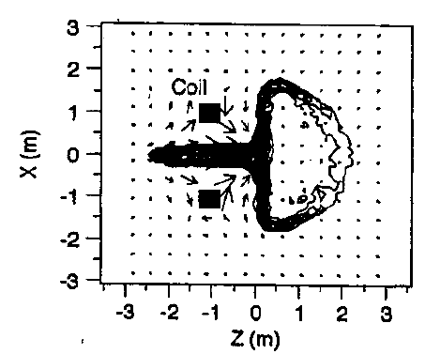
Figure 1. Reproduction of Figure 3b in Ref. [1].

a)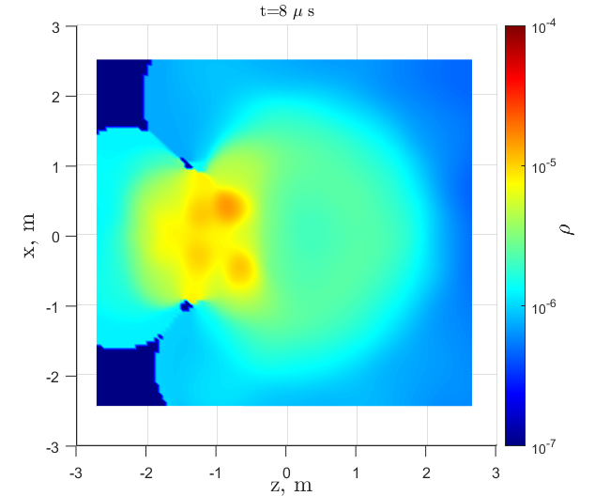 b)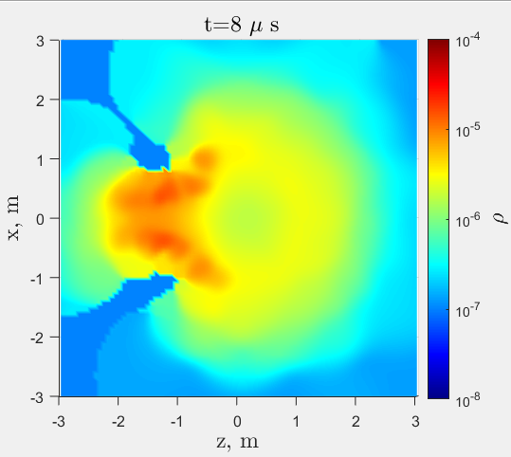
c)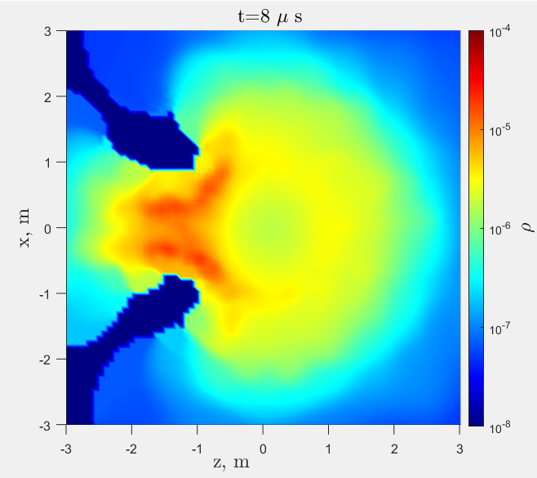 d)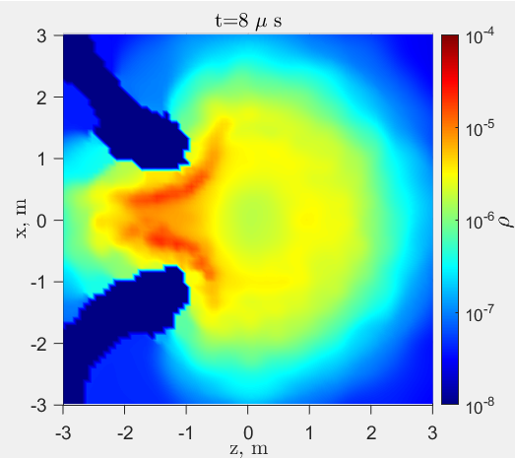
e) 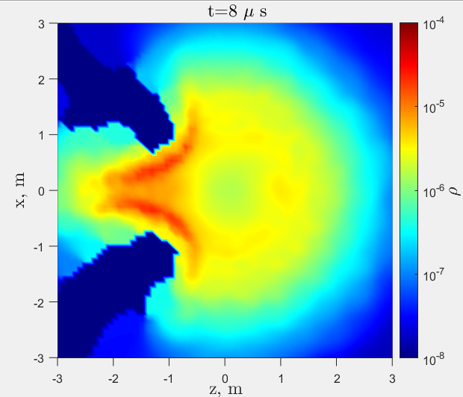 f) 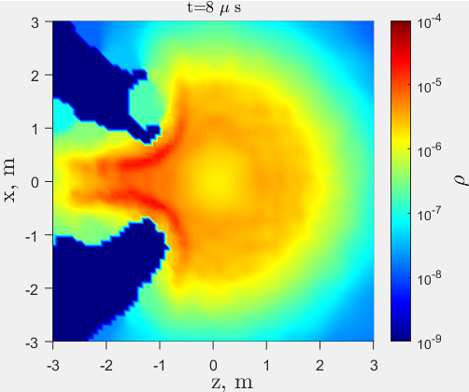
Figure 2. Plasma Density in kg/m3 in the xz-plane for a) 1151 SPH particles, b) 3595 SPH particles, c) 8186 SPH-particles, d) 15601 SPH-particles, e) 26522 SPH particles, and 41636 SPH particles
These results tell a similar story to the table results; the density doesn’t change much when the SPH-particle resolution is increased, and it looks to be stable after about 8000 SPH particles. This indicates we should use about 8000 SPH-particles in our (US-side) future analyses.
Additionally, Dr. Nakashima requested specific data in the last email correspondence, which I’ll include here. We found our effective charge state (Z) for gold to be about 6. This contrasts with Ref. [1] which peg it at about 16. Also, I generated graphs for the component energies in the plasma over time, shown below:
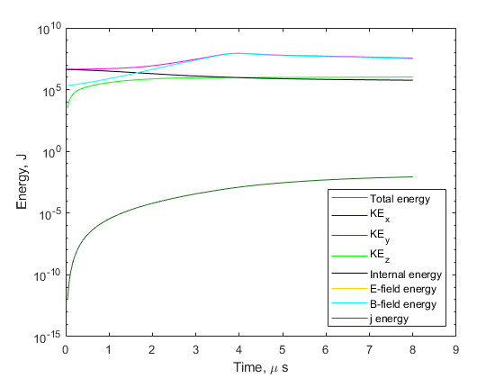
Figure 3. Constituent energies over time for 8186 SPH-particle simulation
Note that kinetic energies are calculated as follows:
$$KE_{x}=\frac{1}{2}mv_{x}^{2}$$
$$KE_{y}=\frac{1}{2}mv_{y}^{2}$$
$$KE_{z}=\frac{1}{2}mv_{z}^{2}$$
The internal energy is calculated for a particle by multiplying the specific internal energy of the particle by the mass of the particle, and then summed across all particles.
The electric field energy is calculated from
$$E_{E}=\left(\frac{1}{2}ϵ_{0}E^{2}\right)Vol_{p}$$
And the magnetic field energy is calculated from:
$$E_{B}=\left(\frac{1}{2μ_{0}}B^{2}\right)Vol_{p}$$
The current energy or j-energy is calculated from:
$$E_{j}=\sum_{p}^{n}{m_{p}\int_{0}^{t}{\frac{j_{p}^{2}}{σ_{p}ρ_{p}}dt} }$$
Where j is the current density of the particle, ρ is the mass density of the particle, σ is the conductivity of the particle. This resultant is integrated over all time for the particle and multiplied by mass before summing over all particles. As shown in Figure 3, the magnetic energy seems to dominate later in the simulation, and leads to an increase in total energy in the simulation. This doesn’t quite make sense (and would explain our performance discrepancy), but given the fact that our performance results are within an order of magnitude, and the match with Ref. [1], I’m inclined to say I’m either misinterpreting the data, or I don’t have the right formula for magnetic energy.
Lastly, for comparison with the PuFF nozzle design (from the axial nozzle design of Ref. [2]), each coil has a current of 10 MA. The ablator plate is solid copper at room temperature. The plasma, in this experiment, is a 50%-50% mix by moles of Deuterium and Tritium. Therefore, the effective molecular weight of the plasma is 2.5 g/mol. For this experiment (the axial nozzle design in Ref. [2]), we did not estimate the magnetic energy of nozzle as compared with the plasma. We did estimate the resultant magnetic pressure from the nozzle and compared that with the gas-dynamic pressure of the plasma. Initial plasma pressure is around 10^12 Pa, which is comparable to the maximum magnetic pressure (10^12 from Figure 3c in Ref. [2]). Lastly, using the nozzle design Dr. Morita uses the interior angle between coil section 1 and coil section 2 is a little high. Based off the figures you provided, it appears to be 76° but in our run we have it at 67°. Although, this is a fairly trivial difference. Applying the above changes to your nozzle simulation should allow for more accurate comparison of your results with Ref. [2].
References
- Nagamine, Yoshihiko, and Hideki Nakashima. "Analysis of plasma behavior in a magnetic thrust chamber of a laser fusion rocket." Fusion Technology (1999): pp. 62-70.
- Cassibry, J., et al. "Pulsed Magnetic Nozzle for Fusion Propulsion." Journal of the British Interplanetary Society (2018): pp. 119-125.

