**NCERA-101 STATION REPORT FROM KENNEDY SPACE CENTER, FL, USA *(November 2021)***

Gioia Massa, Matt Romeyn, LaShelle Spencer, Christina Johnson, Lucie Poulet, Ray Wheeler

***Impact Nugget:***

The Advanced Plant Habitat (APH) is a quad locker (“oven”) sized plant research chamber installed on the International Space Station (ISS) in November 2018. APH is environmentally closed from the ISS cabin air and has a suite of advanced sensor and control systems, to include automated watering and complete control and command capabilities from the ground. *Arabidopsis* and ‘Apogee’ dwarf wheat were grown as part of the hardware validation test, followed by experiment PH-01 that also grew *Arabidopsis*. In December 2020 ‘Cherry Belle’ radishes were grown as part of experiment PH-02. In addition to the valuable science gathered during PH-02, the crew were also able to consume nine of the nineteen radishes harvested. Experiment PH-04, a technical demonstration growing ‘Espanola Improved’ chile peppers began in July 2021 and will conclude in late November 2021. Using chile peppers from the first harvest, the crew made space tacos that received a considerable amount media coverage.

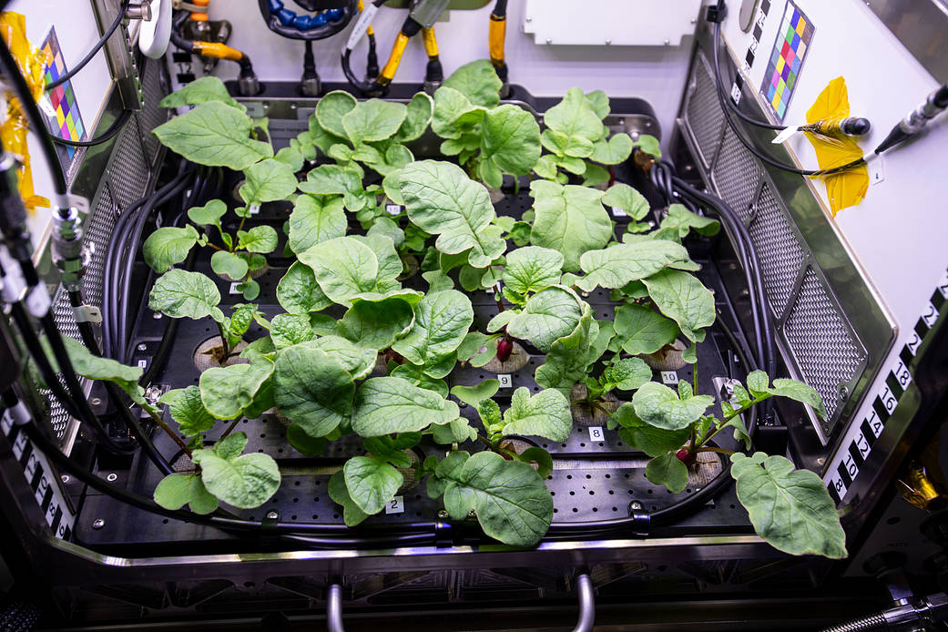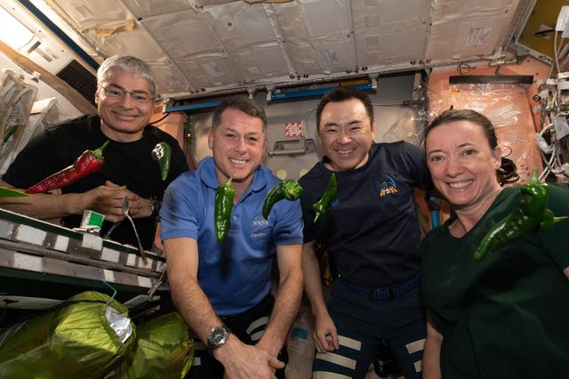

**Fig. 1.** *Left: Radishes grown during PH-02. Right: Crew on ISS with chile peppers from first harvest of PH-04 test with the Advanced Plant Habitat.*

***Facility Description:***

* Kennedy Space Center (KSC) currently has seven Percival walk-in chambers (6 ft X 8 ft) and four reach-in chambers for the Space Station Processing Facility (SSPF), and we continue to organize a nearby lab for storing plant and chamber supplies, and planting and harvesting activities. All chambers have T5 fluorescent lamp banks with supplemental incandescent sockets. Larry Koss of our team installed aspirated sensor boxes for redundant temperature, RH, and CO2 monitoring, and has connected them all to Opto-22 modules along with a custom developed software systems for real-time, graphic output with a computer in the growth chamber area for all the walk-in chambers and will continue this with the reach-in chambers. Alarming for power failures and lighting have been implemented and irrigation alarms will be implemented soon. The Opto-22 system can also accommodate additional sensor and control functions, such as irrigation timing or pH and EC for hydroponic systems. In addition, we installed two CO2 scrubbing systems that support trays of NaOH pellets. We have found that these scrubbers can hold ambient ~400 ppm CO2 while one person is inside the chamber, but require regular checking of the color-indicating NaOH pellets.

***New Equipment / Sensors / Control Systems:***

* We continue to use Heliospectra RX30 LED lighting systems for many of our studies. The fixtures provide nine, selectively dimmable LED wavelengths -- 380, 400, 420, 450, 520, 630, 660, 735 nm, and white (~5700 K). We also use four dimmable, 6500 K white LED arrays from BIOS Lighting (Melbourne, FL) and six red-green-blue BPSe arrays from SNC-ORBITEC (Madison, WI) mimicking the Veggie hardware. We also have purchased 90 OSRAM PHYOFY RL lights to outfit several of our growth chambers and plant growth rooms, with the intent of eventual replacing the Heliospectra RX30 lighting fixtures. The OSRAM Phytofy RL has selectively dimmable LED wavelengths at 385, 450, 521, 660, 730 nm and white (2700 K). We have installed a vertical wall growing system in one of our chambers that contains the 6 BPSe lights as well as 6 OSRAM PHYTOFY lights in 9 growth spaces for crop testing under environmental conditions relevant to the International Space Station.
* Larry Koss of our team completed fabrication and installation of six Environmental Test Chambers (ETC Chambers) that, when placed inside a walk-in chamber, allow for independent and precise control of a variety of environmental variables, to include CO2, temperature, and humidity. The interior dimensions of the chambers are: interior is 16” w x 18” d x 19” h (40.6 cm x 45.7 cm x 48.3) with a volume of 89.7 L. These latest ETC Chambers are an upgrade to a previous generation, and feature SOA LED lighting systems, a larger growth area, and greater control capabilities.

***Unique Plant Responses:***

* During the Veg-03I tech demo test on ISS in early 2021 the crew attempted to transplant an extra pak choi seedling into an empty plant pillow for the first time in Veggie. The extraction of the seedling did not go as intended, most of the roots were severed (Fig. 2) and the ground team had little hope the seedling would reestablish itself in its new pillow and survive until final harvest. Much to our surprise, the seedling survived and did quite well over the next few weeks and reached final harvest. A second transplant was attempted during Veg-03I with ‘Red Russian’ kale and a similar phenomenon was observed. The mechanisms are not clear right now, but microgravity appears to confer some benefit to transplanting in space.

Transplant

Original

**Fig. 2.** *Left: Pak choi seedling transplanted 10 Days after initiation. Right: Comparison at Day 28 of an original and transplanted pak choi.*

***Accomplishments:***

* A series of Veggie tech demo tests were completed in early 2021 that introduced varying amounts of crew autonomy to plant care operations. Veg-03I grew a variety of leafy greens (Red Russian kale, Dragoon lettuce, Wasabi mustard, Extra Dwarf pak choi, and Outredgeous red romaine lettuce) alongside Veg-03J (Outredgeous romaine lettuce), the first on-orbit test of a seed film technology developed at KSC that enables astronauts to plant seeds on-orbit. Veg-03K (Amara mustard first flight) and Veg-03L (Extra Wwarf pak choi) occurred immediately following Veg-03I/J, and featured the first example of fully autonomous crew growing of crops in space; the crew decided watering amounts and frequency, harvest dates, and other horticultural considerations independent of the ground team.
* A technical demonstration in the Advanced Plant Habitat (APH) on ISS will end in November 2021 that is growing cv. Espanola Improved chile (chili) peppers for a period of 137 days. This test will assess the capabilities of APH to conduct long-duration plant growth operations and the nutritional and microbiological differences that arise in chile peppers grown in microgravity. The crew will consume a portion of the fruit and perform behavioral health surveys to assess the impacts of growing crops in space. The first pepper harvest was conducted on Day 109 and received considerable media attention. This project is being conducted by Matt Romeyn, LaShelle Spencer, Oscar Monje, Jacob Torres, Jeff Richards, Lucie Poulet, Ray Wheeler, and Nicole Dufour.
* Gioia Massa continues work on 3-yr NASA grant to grow dwarf tomato in Veggie for the first time. Ray Wheeler, Mary Hummerick, Matt Romeyn, LaShelle Spencer, and Jess Bunchek at KSC, Bob Morrow at Sierra Nevada, and Cary Mitchell at Purdue are Co-Is on the grant along with several Co-Is from Johnson Space Center focusing on food and behavioral health. The focus of this research is to assess fertilizer and light quality impacts on crop growth, nutrient content, and organoleptic appeal. We have worked closely with Florikan Inc. to assess different controlled release (CR) fertilizer combinations. Two sets of mizuna were grown in Veggie plant pillows, one for 35 days and the second for 60 days with repetitive harvesting under both red-rich (ratio of 9:1:1 Red: Blue: Green) and blue-rich (ratio of 5:5:1 Red: Blue: Green) LED light.
* The team at KSC continues work in partnership with Moon Kim and his team at USDA ARS-Beltsville on advanced plant imaging technologies for use in spaceflight. The focus of this work has been on developing hyperspectral imaging technologies and a database of plant responses relevant to spaceflight, such as drought, over-watering, and pathogenic fungus. The goal is to create a monitoring system able to recognize stressors early enough to take swift corrective action, and eventually, being the eyes of an autonomous plant growth system.

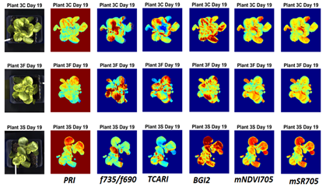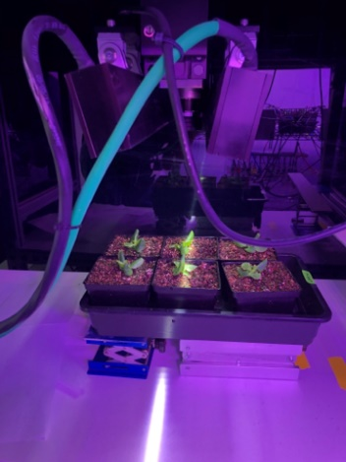

**Fig. 3.** *Left: Development of vegetation indices for integration with AI. Right: Hyperspectral camera scanning plants at Kennedy Space Center.*

* Gioia Massa was awarded a 3-yr NASA grant to study the impacts of watering on the plant microbiome in microgravity using the Advanced Plant Habitat (APH) on ISS. Plants will be grown under four different substrate moisture scenarios to assess impacts to plant growth of chronic and intermittent substrate moisture conditions. The microbiomes of the different treatments will be cataloged and assessed for impacts on food safety and other impacts of interest.
* A one-year legume screening study was completed, with 26 cultivars of multiple pea and bean (others?) being screened and 8 promising candidates down-selected for further growth studies, and nutritional and organoleptic analysis, and possible inclusion in future growth demonstrations on ISS.
* Multiple areas of new research and technology into microgreens are occurring at KSC. A one-year investigation to assess the food safety metrics of microgreens is ongoing, this is a necessary step to clear the way for microgreens testing and consumption on ISS. A study into novel microgreens is also underway to identify microgreen types that are sources of calories, fats, protein, and thiamine; some of the cultivars in this investigation include cantaloupe, sunflower, quinoa, and many types of legumes. NASA Postdoctoral Fellow Lucie Poulet received a one-year award to conduct parabolic flight testing of different microgreen techniques and technologies to enable harvesting of microgreens in microgravity.
* Studies on herbs and herb microgreens continued to determine herb varieties that will grow well in a space environment to supplement packaged diets in space flight. Sixteen herb varieties (how many species?) were tested initially in spring of 2020, and down selection of these continued based on growth, and nutrient content. In 2021, 12 varieties of full-sized herbs and 14 varieties of herb microgreens were cultivated under spaceflight-relevant conditions and analyses of these are ongoing, with microbial and nutritional analysis underway. Additionally, novel leafy crops such as Malabar spinach, dandelion and golden purslane have been tested, with more crops to be studied in the coming year.
* Lucie Poulet is a NASA Postdoctoral Fellow working on a project entitled “Modeling plant growth and gas exchanges in various ventilation and gravity levels.” Lucie has been using the LI-6800 to study plant leaf responses to different ventilation levels and has designed a custom chamber for the LI-6800, which will allow similar studies of entire crop plants and canopies of microgreens. Data collected will be used to calibrate and validate a plant gas exchange model in reduced gravity environments. Lucie is also a collaborator for the PH-04 technical demonstration of chile peppers on ISS.
* Christina Johnson is a NASA Postdoctoral Fellow at KSC assessing the differences between microgreens grown in unit gravity versus those grown in simulated microgravity using clinostats and random positioning machines (3-dimensional clinostats). She is working with a team to design a microgreens growth and imaging platform that will be used on a random positioning machine and enable testing of microgreens growth responses to different simulated gravity levels, including lunar and Martian gravity. Christina leads monthly Microgreen Chats where she brings together contacts from NASA, USDA, academia, and the private sector with interest in microgreens. Christina has also authored and co-authored multiple white papers for the “Decadal Survey” taking place right now, where NASA solicits inputs for future research areas.

***Impact Statements:***

* KSC’s space crop production research group has developed a list of gaps that has been vetted and approved with different NASA stakeholders. To enable partnership and collaboration on the challenges in controlled environment crop production we have been sharing our gaps list and having discussions with other government agencies, members of academia, and relevant industry professionals. The challenges that we face, while unique, have many intersections or areas of synergy with various sectors including agriculture automation and robotics, industrial sanitization, vertical farming, fluid and gas handling, modelling, sustainability and circular economy research, and greenhouse agriculture. Any NCERA-101 members interesting in our “gaps” list, please let us know. Ideas and edit are welcome!

***Recent Publications:***

Buncheck J.M., A.B. Curry, M.R. Romeyn. Sustained Veggie: A Continuous Food Production Comparison. International Conference on Environmental Systems. ICES-2021-229.

Burgner, S.E., K. Nemalia, G.D. Massa, R.M. Wheeler, R.C. Morrow, and C.A. Mitchell. 2020. Growth and photosynthetic responses of Chinese cabbage (Brassica rapa L. cv. Tokyo Bekana) to continuously elevated carbon dioxide in a simulated Space Station “Veggie” crop-production environment. Life Sci. Space Res. 27: 83–88, <https://doi.org/10.1016/j.lssr.2020.07.007>

Dixit, A.R., C.L.M. Khodadad, M.E. Hummerick, C.J. Spern, L.E. Spencer, J.A. Fischer, A.B. Curry, J.L. Gooden, G.J. Maldonado Vazquez, R.M. Wheeler, G.D. Massa, and M.W. Romeyn. 2021. Persistence of Escherichia coli in the microbiomes of red Romaine lettuce (Lactuca sativa cv. ‘Outredgeous’) and mizuna mustard (Brassica rapa var. japonica) - does seed sanitization matter? BMC Microbiology (2021) 21:289 https://doi.org/10.1186/s12866-021-02345-5

Hardy, J.M., P. Kusuma, B. Bugbee, R. Wheeler, and M. Ewert. 2020. Providing photons for food in regenerative life support: A comparative analysis of solar fiber optic and electric light systems. 2020 International Conference on Environmental Systems, ICES 2020-07-523.

Hummerick, M.E., C.L.M. Khodadad, A.R. Dixit, L.E. Spencer, G.J. Maldonado-Vasquez, J.L. Gooden, C.J. Spern, J.A. Fischer, N. Dufour, R.M. Wheeler, M.W. Romeyn, T.M. Smith, G.D. Massa, Y. Zhang. 2021. Spatial characterization of microbial communities on multi-species leafy greens grown simultaneously in the vegetable production systems on the International Space Station. Life 11, 1060. https://doi.org/10.3390/ life11101

Khodadad C.L., M, E. Hummerick, L.E. Spencer, A.R. Dixit, J.T. Richards, M.W. Romeyn, T.M. Smith, R.M. Wheeler, and G.D. Massa. 2020. Microbiological and nutritional analysis of lettuce crops grown on the International Space Station. Front. Plant Sci. 11:199.doi: 10.3389/fpls.2020.00199.

Khodadad, C.L.M., Oubre, C.M.; Castro, V.A., Flint, S.M.; Roman, M.C.; Ott, C.M., Spern, C.J.; Hummerick, M.E., Maldonado Vazquez, G.J., Birmele, M.N., Whitlock, Q., Scullion, M., Flowers, C.M. Wheeler, R.M., Melendez, O. 2021. A microbial monitoring system demonstration on the International Space Station provides a successful platform for detection of targeted microorganisms. Life 11, 492. https://doi.org/10.3390/life11060492.

Kusuma, P., B. Fatzinger, B. Bugbee, W. Soer, and R. Wheeler. 2021. LEDs for extraterrestrial agriculture: Tradeoffs between color perception and photon efficacy. NASA Technical Memorandum 2021-0016720.

Monje, O., M.R. Nugent, L.E. Spencer, J.R. Finn, M.S. Kim, J. Qin, M.R. Romeyn, A.E. O’Rourke, R.F. Fritsche. 2021. Design of a Plant Health Monitoring System for Enhancing Food Safety of Space Crop Production Systems. International Conference on Environmental Systems, ICES-2021-289.

Poulet, L., M. Gildersleeve, L. Koss, G.D. Massa, R.M. Wheeler. 2020. Development of a photosynthesis measurement chamber under different airspeeds for applications in future space crop-production facilities 2020 International Conference on Environmental Systems, ICES 2020-07-077.

Poulet, L., C. Zeidler, J. Bunchek, P. Zabel, V. Vrakking, D. Schubert, G. Massa, and R. Wheeler. 2021. Crew time in a space greenhouse using data from analog missions and Veggie. Life Sci. Space Res. 31:101-112. https://doi.org/10.1016/j.lssr.2021.08.002

Spencer, L. R. Wheeler, M. Romeyn, G. Massa, M. Mickens. 2020. Effects of supplemental far-red light on leafy green crops for space. 2020 International Conference on Environmental Systems, ICES 2020-07-380.

Spencer, L.C., T.A. Sirmons, M.W. Romeyn, and R.M. Wheeler. 2021. Production, nutritional and organoleptic analysis of Solanaceous crops for space. Intl. Conf. Environ. Systems ICES-2021-268.

Wheeler, R.M. 2020. NASA's Contributions to Vertical Farming. NASA Technical Memorandum 2020-5008832. 20 pages.

***Scientific Outreach:***

* The “Growing Beyond Earth” educational collaboration with Fairchild Tropical Botanic Gardens in Miami continues to generate data for NASA, while inspiring middle and high school students. Students, first in south Florida and now around the country have botany racks in their classrooms with LED lights and are helping to select crops and define growing techniques for space. They post their progress and results on twitter @growbeyondearth and provide their data to NASA. Building on the success of this citizen-science initiative, Fairchild has also been awarded additional grants to develop the first ever maker space in a botanical garden, the Growing Beyond Earth Innovation studio, which hosted the first year of the Growing Beyond Earth Maker challenge to professional, university, and high school makers in 2019-2020, and is now starting the second year of this maker challenge. ‘Extra Dwarf’ pak choi, grown during Veg-03I and Veg-03L, was a crop down-selected from the Growing Beyond Earth challenge!
* KSC has experienced a significant reduction in interns due to COVID-19. Down from an average of 3-5 per term before COVID-19, we currently have a single virtual intern per term who assists with activities such as strategic planning, bioinformatics analysis, data analysis, and manuscript preparation.
* Since on-site work was reduced our weekly seminar series for scientists and interns has gone virtual. This has allowed us to involve former interns and invite presentations from numerous external speakers.
* KSC food production team members continue to advise universities in engineering design courses focused on aspects of space plant growth. University teams are helping to design or modify crop water delivery systems, robotic plant care systems, resource recovery systems, and many other types of space plant production hardware.

|  |
| --- |
| ***Committees / Panels:*** |
| ASHS CE Working Group (Wheeler)  Com. on Space Research (COSPAR) Sub-Commission F4.2 Chair (Wheeler)  EDEN-ISS Project (EU Funded) Science Advisory Board (Wheeler)  Amer. Soc. Grav. and Space Res. (ASGSR) Governing Board and Education / Outreach Committee (Massa)  CEA Food Safety Coalition Advisory Council (Massa, Hummerick) |