Supervised Autonomous Assembly to Create and Evolve Persistent Assets

William R. Doggett, John T. Dorsey¹, Brace W. White, Kyongchan Song³, Lauren M. Simmons², Julia E. Cline, John E. Teter, David S. Kang¹, Danette Allen, Benjamin N. Kelley, John R. Cooper⁶, Iok M. Wong², Walter Waltz⁶, Carl Mills, James Plant, Jason R. Neuhaus, Scott Michael⁶, and Patrick A. Cosgrove,
NASA Langley Research Center, Hampton, VA 23681, USA

Martin Mikulas,
National Institute of Aerospace, Hampton VA 23666, USA

Ralph Williams, Sherif Shazly, David Long¹³, Ron Neale¹³
Analytical Mechanics Associates, Hampton VA 23666, USA

Supervised autonomous assembly (SAA) will create a paradigm shift in the planning and design of future persistent assets (PAs), both in near zero-g environments and on planetary surfaces. SAA refers to an autonomy approach that has the benefits of autonomous assembly as well as the benefits provided by a supervisor (operator) who is available to resolve unexpected situations. SAA provides both increased design freedom as well as reduced programmatic risk. SAA enables evolution of future PAs over decades as in-space operations transition from single purpose missions to creation of PAs, such as laboratories and experimental stations which more closely resembling terrestrial laboratories that can easily adapt and evolve to new missions leveraging repeated visits to the PA. The ability to evolve enables PAs to rapidly respond to changing objectives resulting from new questions as our understanding improves.
A recently initiated National Aeronautics and Space Administration (NASA) project in the Space Technology Mission Directorate (STMD) Game Changing Development (GCD) Program called the Precision Assembled Space Structure (PASS), leverages the advantages of SAA to develop technologies that enable efficient creation and evolution of hexagonal topologies; both planar (example: fuel depots) and curved (examples: telescopes and shelters). PASS will be used to provide context for the philosophy and concepts discussed as well as the decision and selections made.
PASS objectives are:
- Develop confidence in SAA and on-orbit servicing, assembly and manufacturing (OSAM) technologies by executing a test campaign that uses a path-to-flight autonomous precision assembly process directly applicable to future space telescopes.
- Test autonomous technologies including automated path planning and error recovery, to emphasize a robust approach that relies on generic robots and special purpose tools.
- Validate critical component models using a digital twin that includes the assembled primary mirror support structure and assembly process. A digital twin is a high-fidelity simulation of the asset capable of predicting the on-orbit performance.
The paper concludes after identifying the critical need for a modest assembly flight experiment to validate and develop confidence in the SAA paradigm, thus accelerating adoption of the benefits described. SAA is a game changing paradigm that enhances the ability of an organization to infuse new technology through rapid evolution of PAs while leveraging OSAM technologies.

Nomenclature and Acronyms
EELV Evolved Expendable Launch Vehicle
ESPA EELV Secondary Payload Adapter
EVA Extra Vehicular Activity
GCD Game Changing Development Program
iSAT in-Space Assembled Telescope
ISS International Space Station
NASA National Aeronautics and Space Administration
OSAM On-orbit Servicing, Assembly, and Manufacturing
PASS Precision Assembled Space Structure
PA Persistent Asset
RSGS Robotic Servicing of Geosynchronous Satellites
RSV Robotic Service Vehicle
SAA Supervised Autonomous Assembly
STMD Space Technology Mission Directorate
TRL Technology Readiness Level
V&V Verification and Validation

I Introduction
Future persistent assets (PAs); both in-space assets (space telescopes, earth observing platforms, science stations, etc.) and planetary surface assets (outposts, settlements, etc.), will evolve over decades, just as terrestrial laboratories and observatories do. The term “evolve” is used to describe both planned expansion of an asset as well as unplanned expansion, reconfiguration, and upgrade of an asset as mission needs change in response to lessons learned, new questions asked, or changes in mission needs. PA evolution is a necessary and critical capability because as future systems become persistent there must be cost effective ways of responding to changing requirements, changes that could not be predicted at inception. Supervised autonomous assembly (SAA), with its inherent ability to repair, expand and reconfigure a PA, is critical to achieving efficient, cost-effective creation and operation of these systems. SAA relies on supporting technologies that include; a variety of robotic agents, automated planning and in-situ metrology supervised using concise operator display techology. To take full advantage of SAA potential, new strategies and architectures must be adopted for creating future PAs that build on decades of experience of the National Aeronautics and Space Administration (NASA) in creating reliable space systems [].
The application of creating a space telescope will provide a concrete example of the opportunities and benefits SAA provides. A recent study, the in-Space Assembled Telescope (iSAT) study [], examined methods and technologies for efficiently creating large-diameter telescopes. The study sought to answer the question: “When does in-space assembly provide clear benefits, and thus should be adopted for architecting and designing of a space telescope?” [] The study concluded that SAA and on-orbit servicing, assembly and manufacturing (OSAM) technologies provided benefits to all sizes of future telescope systems, and that when a telescope had a primary mirror diameter of 10 m or larger, in-space assembly provided clear benefit [2]. A concern noted in the study was the difficulty associated with assembling a precision mirror backing structure for such a telescope. The NASA Precision Assembled Space Structure (PASS) project in the Space Technology Mission Directorate (STMD) Game Changing Development (GCD) Program seeks to retire this risk by autonomously assembling a ~20-m diameter high stiffness precision structure that includes electrical/data harness connections, at a ground-based laboratory using a path-to-flight approach. The PASS project, henceforth called PASS, will concentrate on SAA of the primary mirror backing structure, as depicted in Fig. 1. PASS will use a modular assembly approach that incorporates TriTruss modules with or without preattached mirror rafts (Fig. 2a) and that pre-integrated wiring harness (Fig 2c) []. Mirror rafts are a strategy, also used by iSAT, that enable a group of smaller mirrors (in groups of 7, 19, 37, etc.) to be efficiently integrated to form larger modules. Details of the PASS hardware design are provided in Appendix A. Note, the modules are identical, promoting mass production and test efficiencies. After initial deployment, the modules are connected at the top and bottom corners using unique “multi-nuts” which create an efficient (~1% of the module equilateral triangle length) connection between modules []. In Ref. 5 the connection between modules, which relies on low-cost metallic end-fittings and multi-nuts, is suitable for low precision applications such as fuel depots (~3 mm surface error). This metallic multi-nut approach will be used by PASS to test the autonomy architecture and predictive modeling accuracy. PASS is simultaneously maturing a reversible bonding connection approach that supports an all-composite module construction which will likely be required for high precision applications (< 0.3 mm surface error applications). The TriTruss modules allow for compact packaging without (Fig 2e) or with (Fig 2f) panels and their associated wiring harness (Fig. 2c). Panels can be packaged either as a single hexagonal panel as depicted in Fig 2f or with groups (i.e. 7, 19, 37, etc.) of hexagonal panels on a raft. Similarly, multi-nuts can be pre-integrated or added during the assembly. While not a primary objective of PASS, the SAA architecture used to assemble the primary mirror backing structure (same tools, same agents, etc.) can be used to assemble the metering truss depicted in Fig. 1. The metering truss concept depicted in Fig. 1 is composed of a central deployable beam having a pre-integrated wiring harness (as was used for the Shuttle Radar Topography Mission [] and International Space Station (ISS) solar array []) that the TriTruss modules are assembled to completing the platform.
In this paper, the benefits of SAA will be discussed where SAA will: enable the evolution of future persistent assets over decades as in-space operations transition from single purpose missions to creation of persistent space assets such as laboratories and experimental stations, more closely resembling terrestrial laboratories that can easily adapt and evolve to new missions, thus, responding to changing investigations as our understanding improves. The PASS project philosophy will be described first, then the benefits of efficient assembled structure, robotic tools, and risk reduction. At the end of the paper, the critical need for a modest flight experiment to validate the SAA paradigm will be identified, thus, accelerating adoption of the benefits described.
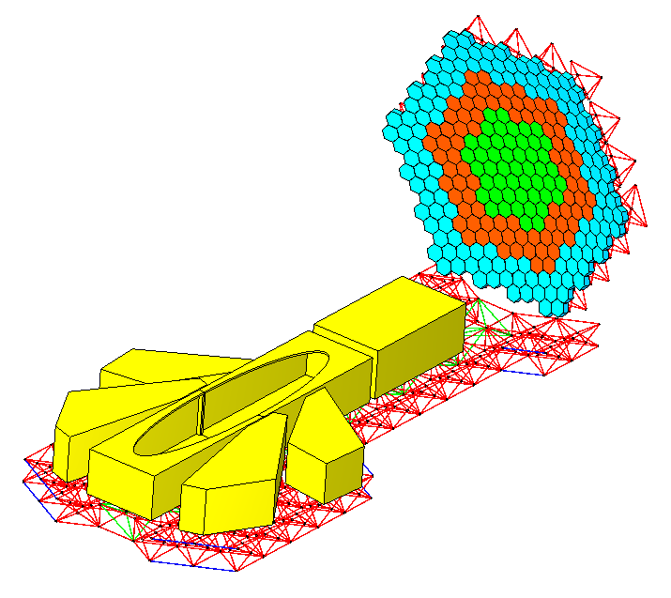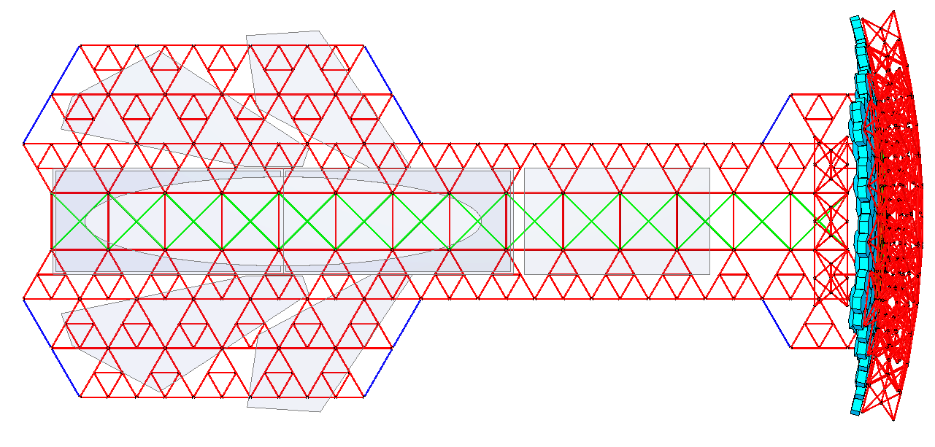
Fig. 1 In-Space Assembled Telescope 20-m operational instrument configuration with Precision Assembled Space Structure (PASS) focus identified.
PASS
Instruments
Metering Truss
Top View
Central Beam
TriTruss Module
Iso View

II Description of PASS
The PASS project builds on decades of research in space assembly using a variety of agents advancing the philosophy described next as well as planning to raise the technology readiness level (TRL) of modular assembly of hexagonal topologies to TRL 6 [, , ]. PASS will:
- Develop confidence in SAA and OSAM technologies using a test campaign that demonstrates path-to-flight precision assembly process that is directly applicable to future space telescopes.
- Test autonomy technologies, including automated path planning and error recovery, while stressing a robust approach that relies on generic robots and special purpose tools.
- Validate models of critical components using a digital twin of both the assembled primary mirror support structure as well as the assembly process. A digital twin is a high-fidelity simulation of the asset capable of predicting the on-orbit performance.

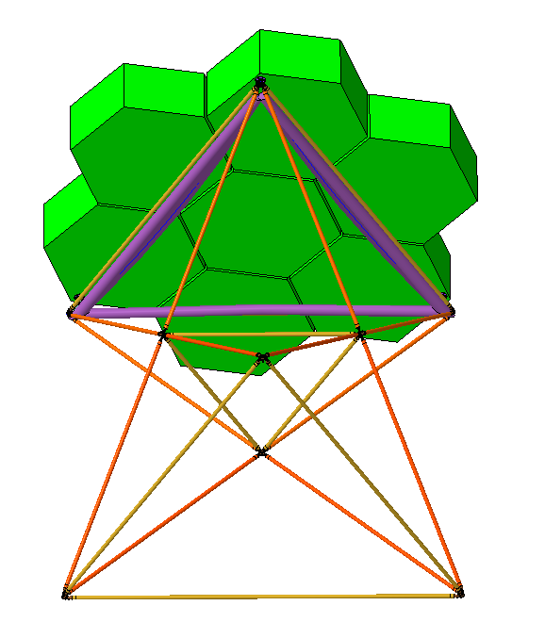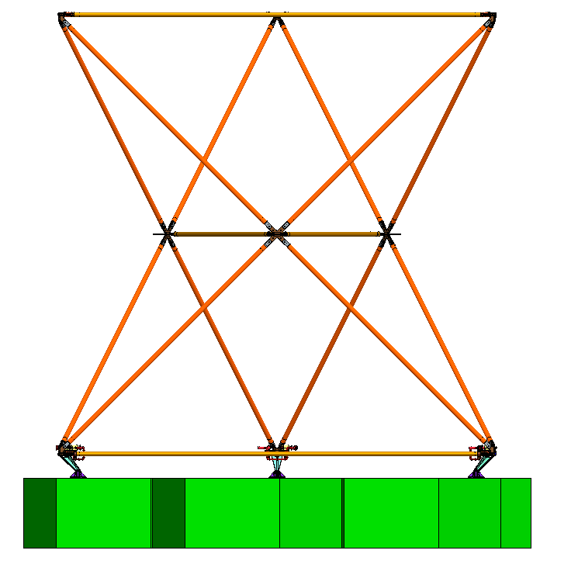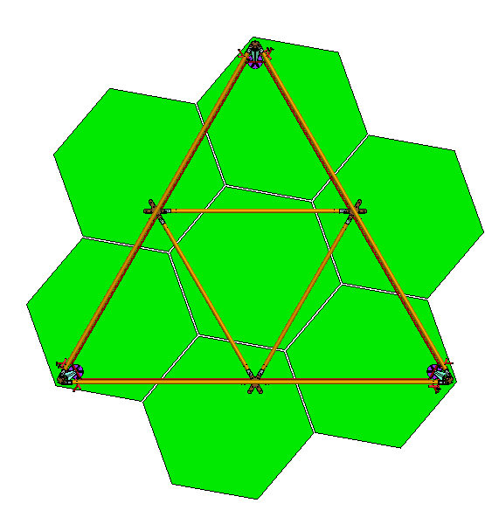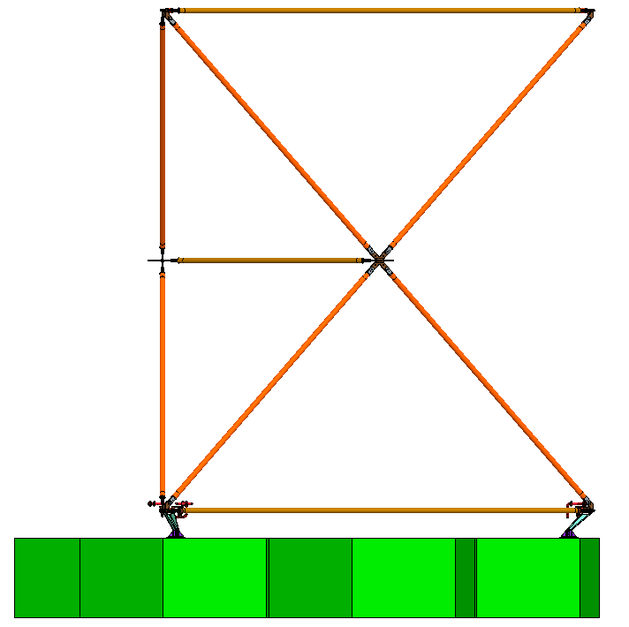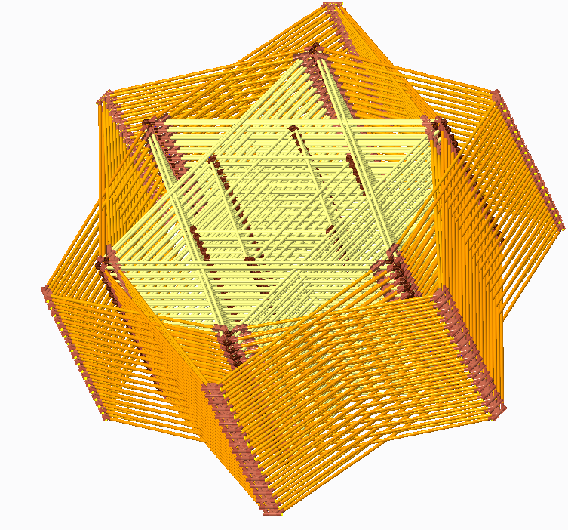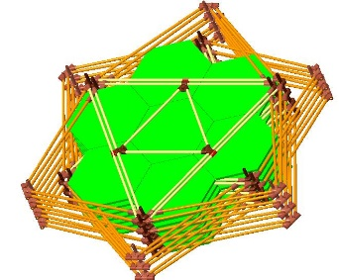The PASS philosophy in order of importance is to:
Fig. 2 TriTruss module supporting simulated mirror raft of 7 hexagonal mirrors.
a) Front View
b) Side View
d) Bottom View
1 of 7 Mirrors Cells
e) 37 Packaged TriTrusses
(3 Rings)
f) 7 Packaged TriTrusses with 7
Hexagonal Panel Mirror Rafts
(1 ring)
c) Bottom Iso-View
Mirror Raft
TriTruss
Module
Core Members
Top Equilateral Triangle
Bottom Equilateral Triangle
Equilateral
Triangle
(top and bottom)
Wiring Harness (purple)
- Focus on efficient creation of the asset, not just efficient structure. Too many previous studies have focused on creating an efficient structure while avoiding the complexities of creating an operational asset. For example, past studies focused on efficient structure assembly but neglected the need to distribute utilities through-out the structure [, , ].
- Minimize parasitic effects; including hardware, software and programmatic effects, on the assembled asset. Assets are designed to meet a customer’s requirements. Additional features needed to support SAA can be burdens, often creating parasitic features embedded in the created system for its lifetime such as the assembly aids used for the ISS []. Aspects of these features and their consequences; such as the volume, mass, power, communications, associated harnessing, planning, development, checkout, etc., represent parasitic effects on the completed system. Not only do they occupy valuable resources during development, launch and assembly, they are often present throughout the life of the asset, increasing the mass in an orbital boost of the asset for example. Parasitic effects are not restricted to addition of hardware; the need for additional data storage (for photographs for example), additional planning, etc. are also parasitic effects for the project responsible for creating, operating and maintaining the asset.
- Use tools for assembly as opposed to new robotic systems. Tools provide several advantages including:
- Tools can localize the assembly complexity into an easily reusable, replaceable and upgradeable component. As will be discussed later, a single tool can be used to assemble a large number of modules. Should a tool fail, it can be discarded and a backup used to complete the tasks. Also, on subsequent missions where it is desired to repair or evolve the asset, an updated tool that has been recently validated on the ground can be used. Tools usage is opposed to an interface design that relies on active often electrically driven components embedded in the asset. These components must be designed to survive in space and are difficult to test and repair.
- Tools enable path-to-flight approaches to be validated on the ground using terrestrial robotic systems capable of operating in 1-g. Then these same tools can be used on-orbit with more appropriate robotic systems designed to operate in reduced gravity environments. The authors acknowledge that the tools themselves can be optimized for reduced gravity, but believe that for first generation systems, the benefit of ground validation outweighs the benefits from tool optimization.
- Tools allow versatile extra vehicular activity (EVA) or robotic agents to perform a variety of tasks []. Thus, not only can replacements for the tools be easily provided as noted in paragraph c) i, a replacement robot with similar capabilities can provide redundancy during assembly. A tool is effectively a robotic device, but it relies on a symbiotic relationship with another agent to provide mobility and positioning at the worksite.
- Tools can be collected in a digital toolbox (i.e. a virtual toolbox), allowing designs to rapidly become available to the community for inclusion and adaption into other projects.
- Perform continuous verification and validation (V&V) during SAA. Assembly represents a new deployment strategy in which the relationship (and registration) between modules occurs in-space as opposed to terrestrially where the system or subsystem is traditionally verified. Ultimately in implementation this moves a portion of the V&V phase to the space or planetary surface environment. PASS addresses V&V by continuously comparing to a digital twin of the PA/SAA combination process developed that is concurrently with the hardware testing. The digital twin serves as a design tool, a V&V baseline and a reference for health monitoring during the operational life of the PA.
- Plan for evolution. Planning for evolution can be difficult, since features which do not directly support the initial implementation of the asset can be considered parasitic. Planning for evolution represents a classic design trade where the benefit from ease of future evolution must be weighed against the initial costs. However, it has been shown that simple features (changes in color, etc.) can provide dramatic improvements in the ability to interact (attach, reconfigure, access, repair) with the asset. Examples of planning for evolution include: taking detailed photographs of the as built system, verifying geometric models of the as built system, providing grip locations for robotic servicing vehicles (RSV), such as developed to support the Robotic Servicing of Geosynchronous Satellites (RSGS) mission, including wiring harnesses that support expansion, etc. [].

III Efficient Assembled Structure
While not a focus of this paper, addressing PASS philosophy a) in the previous section, the proposed backbone structure of the primary mirror depicted in Fig. 1 is constructed using highly efficient TriTruss modules. Modules which can be easily tested (with or without mirrors preintegrated) as opposed to testing of large integrated systems. Each TriTruss module (Fig. 2) is statically determinant, and the assembled structure based on the TriTruss architecture forms a high-performance structure with load paths directed primarily axially along the struts in straight lines through the nodes for planar structures and nearly straight lines for curved structures. The assembled structure forms an iso-grid across the top, as depicted in Fig. 3a, which displays top members viewed through transparent panels, and an isogrid across the bottom connected by core members (Fig. 2a) [5]. Thus, the assembled structure acts much like a honeycomb panel, with two iso-grid face sheets formed from equilateral triangles (Figs. 2b, 2d) and core members (Fig. 2a). The design also inherently provides large corridors (Fig. 3a) providing access to the back of the mirror rafts for inspection, maintenance and evolution.
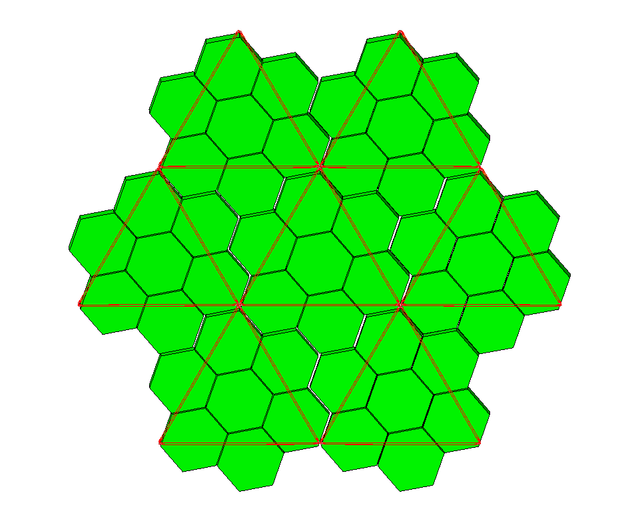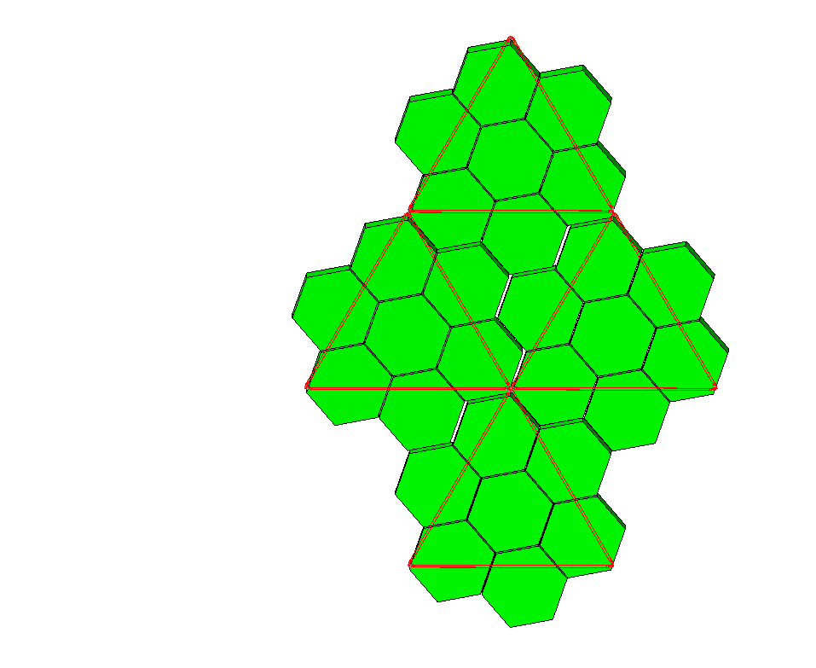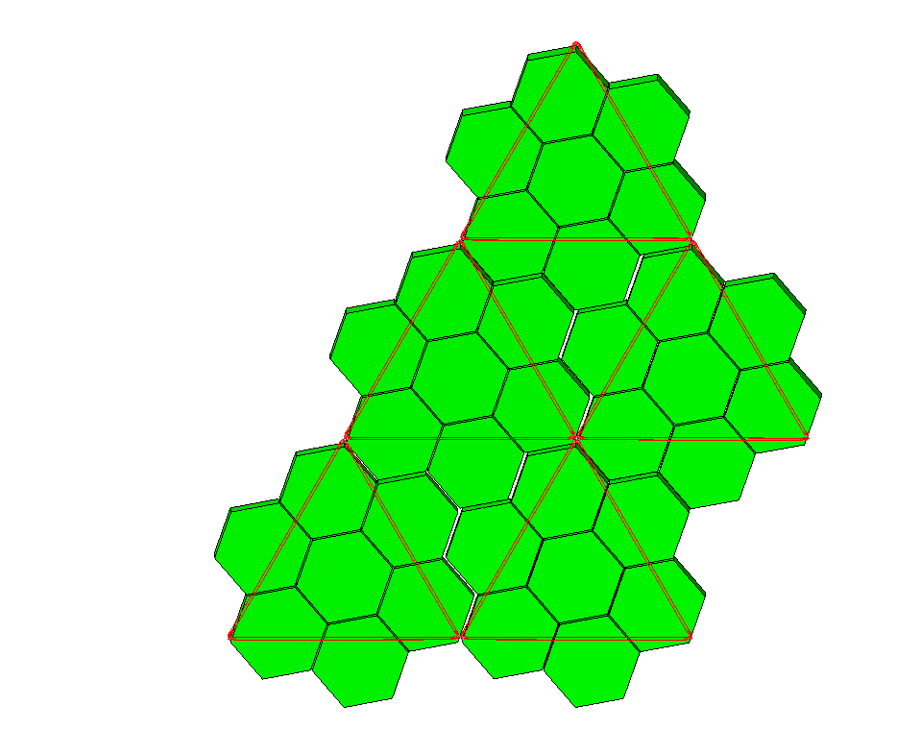
Fig. 3 TriTruss modules form high performance iso-grid.
a) 1st Ring

1

2

3

4

5

6

7

1

2

3

4

1

2

3

4

5
Typical Access Corridor
(1 of 3 in first ring)
Module Number
1 edge
2 edges
b) 1 Edge Assembly
c) 2 Edge Assembly

IV Robotic Tools for Efficient Supervised Autonomous Assembly
Robotic tools will be used to efficiently assemble the TriTruss modules. From an assembly point of view the TriTruss modules are passive units providing long-term robustness that support future evolution. Tools can be resident on the asset, but more importantly, they can be designed for a short operational use, effectively the tool is disposable. In this manner, tools can be improved and verified before the planned tasks are to occur, living digitally between uses. The tools planned to support TriTruss assembly are depicted in Fig. 4 (on the left of the figure is a TriTruss module for reference). Near the top of the TriTruss a capture tool (Fig. 4a) is used to provide final alignment between modules by closing the capture fingers (Fig. 4b) on capture posts (Fig. 4c). The grapple tool is shown attached to the bottom of the TriTruss unit in Fig. 4d, providing an efficient interface to 1 or more robotic agents to deploy, hand-off and manipulate TriTruss modules. The grapple tool has grapple fingers (Fig. 4e) which close on grapple posts (Fig. 4f) to secure the module. The grapple tool also uses capture fingers (Fig. 4e and Fig. 5) to capture a lower capture post. The fingers locally react contact forces during capture, eliminating forces imparted to the robotic agent during module assembly. The approach of a new module for installation with existing modules is depicted in Fig. 5; final guidance, as well as verification of successful capture, is provided by cameras attached to the tool. The capture post is preattached to the TriTruss module. For successful assembly, the agent needs to only provide coarse alignment (+/- ~20 mm) to place the capture posts within the capture envelope of the capture fingers. As the capture fingers 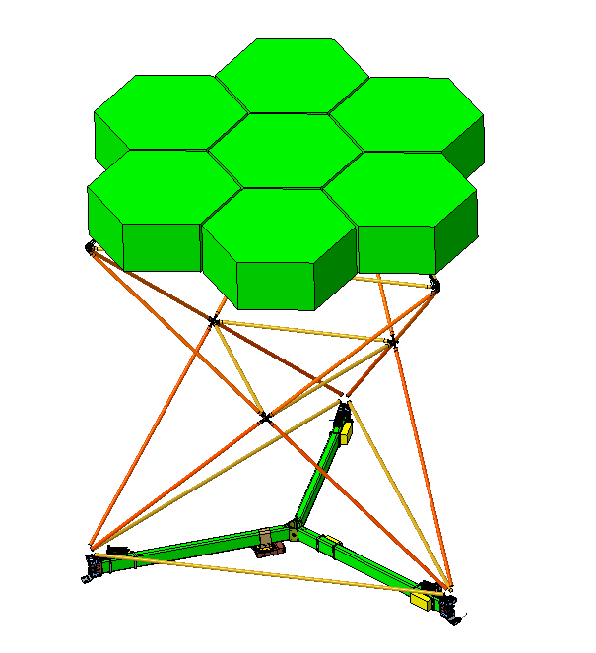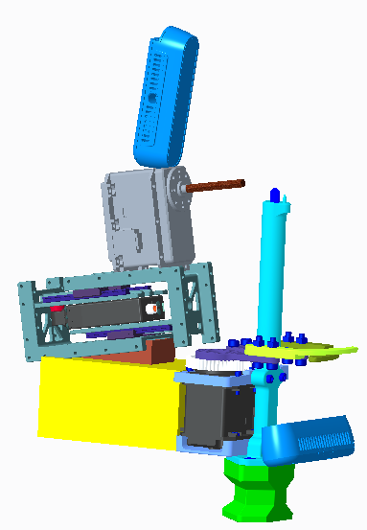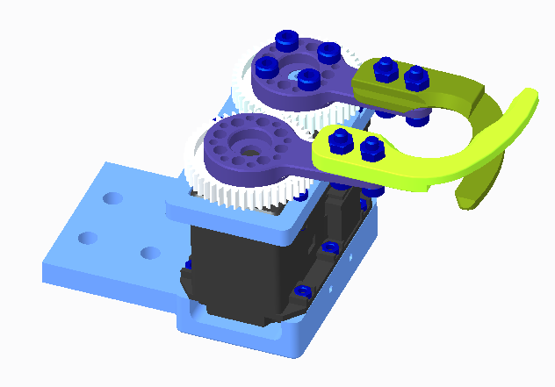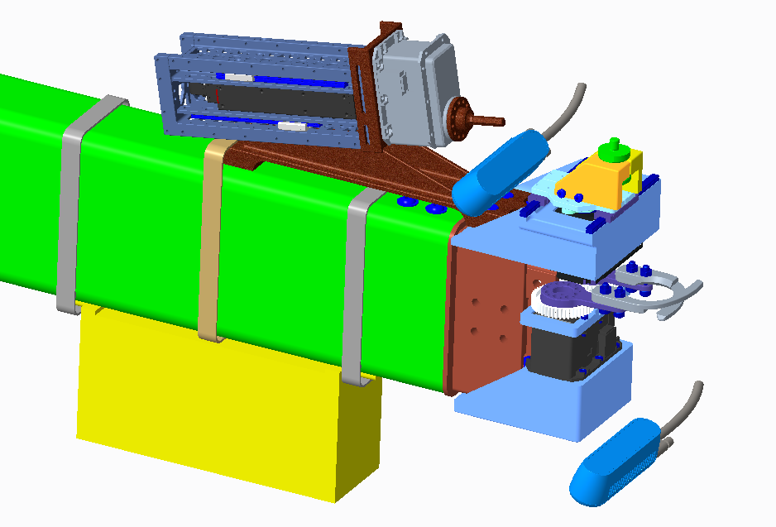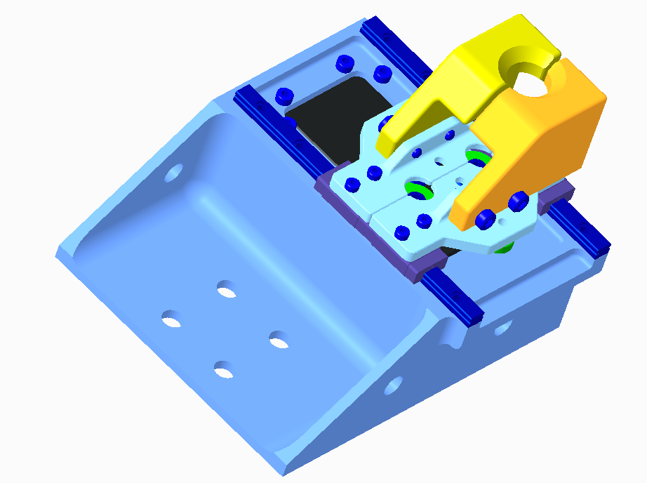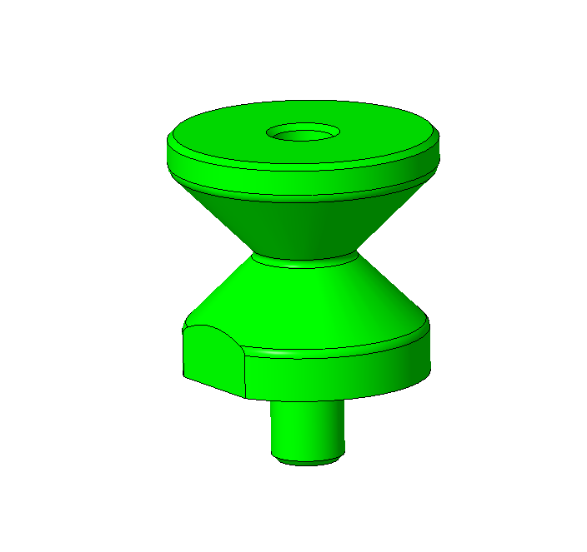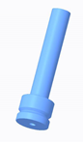 engage and close on the capture posts, they provide a distributed precision positioner which guides the robot to the final installation position using force torque feedback. The fingers engage capture posts at two (upper and lower nodes on one edge, Fig. 3b) or four (upper and lower nodes on two edges, Fig. 3c) corners of the TriTruss module. The capture posts are one of the largest parasitic features (mass, volume) associated with this assembly scheme.
Fig. 4 Tools used for TriTruss Assembly.
Grapple Tool

a) Capture Tool
b) Capture Fingers
e) Grapple Fingers
d) 1 End of Grapple Tool
f) Grapple Post
c) Capture Post
TriTruss

TriTruss Virtual Edge

Locking Driver

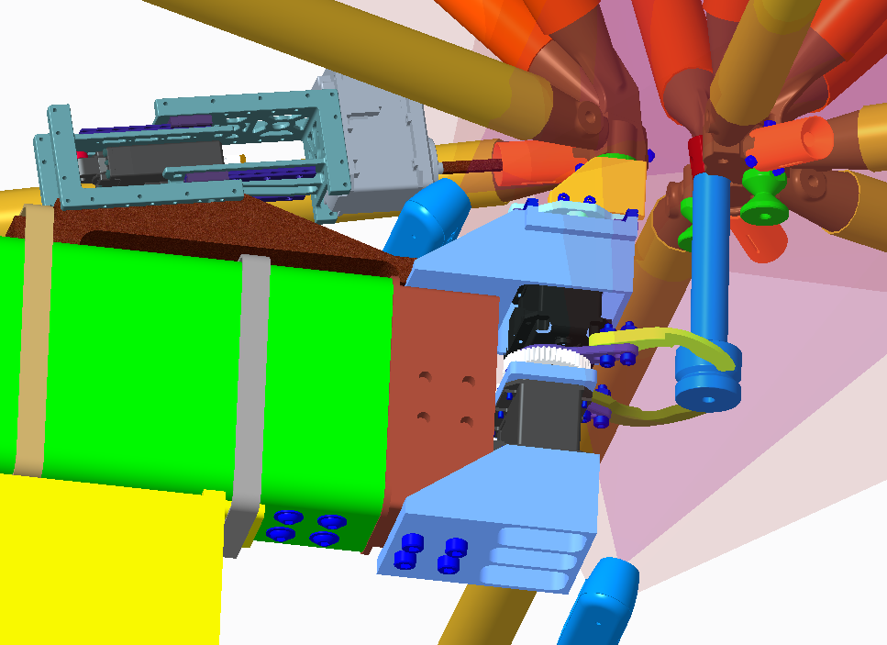
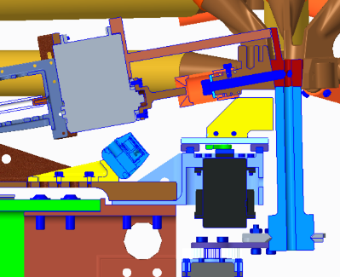
Similar to a common battery powered drill, the capture tools are planned to be battery powered with communication and coordination occurring wirelessly. The tools are charged while they are in storage awaiting installation on a module, thus eliminating the need for a wiring harness to support assembly. The tools have the responsibility to monitor the installation and provide continuous V&V during the assembly process. In the case of the depicted mechanical installation, this includes; counting the number of turns of the locking driver (Fig. 4d) while securing a captured bolt while simultaneously monitoring peak motor torque to stop at a predefined peak torque which indicates locking torque achieved. If a specified number of turns occur before reaching the peak torque, the bolt is assumed stripped and either a replacement module is retrieved, or a supervisor is notified. The supervisor would be provided with an overview of where the error occurred in the assembly sequence along with a simulation and video depicting the final few minutes of the assembly process. The supervisor will have options to review more of the video or simulation and execute a variety of corrective actions. In a similar manner, proper closure of the fingers and the joint integrity are verified. Finally, the connection is planned to be tested by partially opening the capture fingers and applying a load (Fig. 6). Providing continuous V&V is critical to achieving confidence in the overall assembly process.
Fig. 5 Grapple capture fingers closing on existing capture post.
1 end of Grapple Tool

Existing Modules

Capture Post

New Module

Fig. 6 Load test connection.
Loading Probe

Multi-Nut

The general assembly scheme is for one robot to install a TriTruss as depicted in Fig. 7. Note, if it is desired to pass a module from one robot to another, the grapple tool supports multiple robot interface locations. Steps in the assembly process are:
- Grapple the module with the grapple tool (Fig. 7a)
- Install capture tools on 1 or 2 edges as required (Fig. 7b)
- Install the module within the structure (including attaching utility harnesses for the assembled system) (Fig. 7c)
- Retrieve the capture tools (Fig. 7d)
- Retrieve the grapple tool
- Repeat until complete.
The robot (Fig. 7) used for assembly of the PASS demonstration backbone truss in the laboratory is an off-the-shelf industrial robot designed to operate in 1-g and has a 125 kg payload capacity. On orbit, a different robotic agent would be used, one that can position the tools with a precision of +/- 20 mm so that the capture tools can be activated as depicted in Fig. 8. The capture fingers are opened during approach (Fig. 8a) and close around the capture post (Fig. 8b). A compliant robotic system, such as that conceptualized in Fig. 9 is one such agent alleviating the need to use active force torque control. Notice the use of two grapple tools to enable inchworm like motion along the assembled modules.
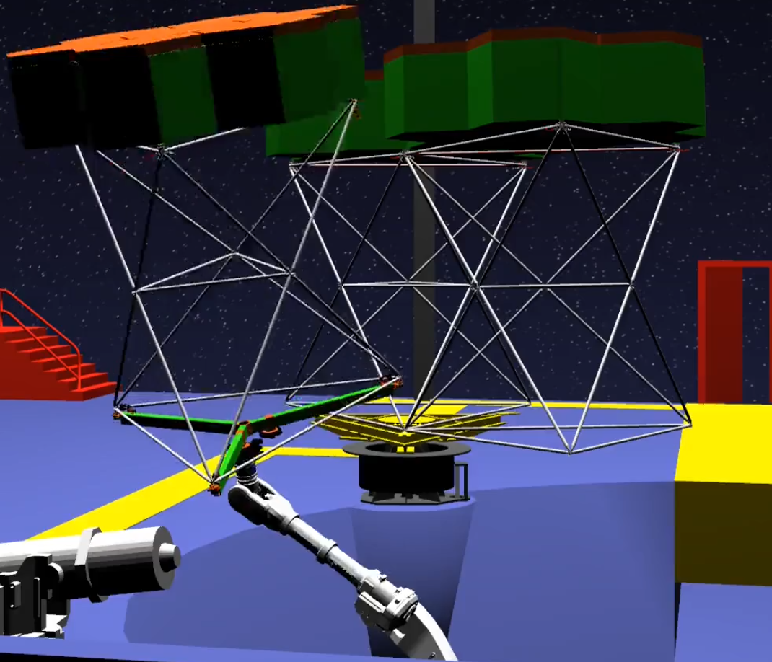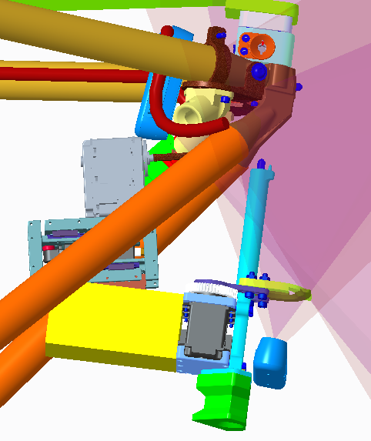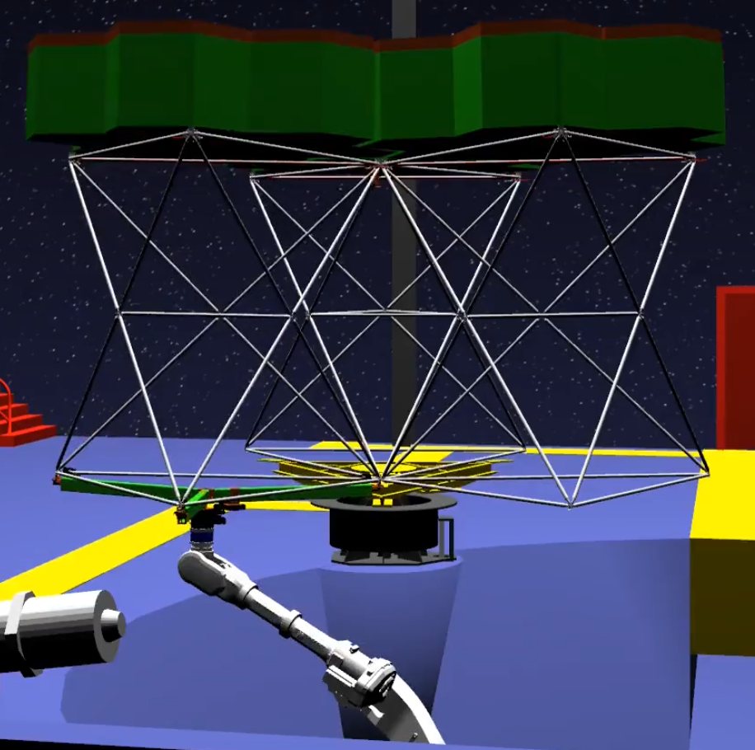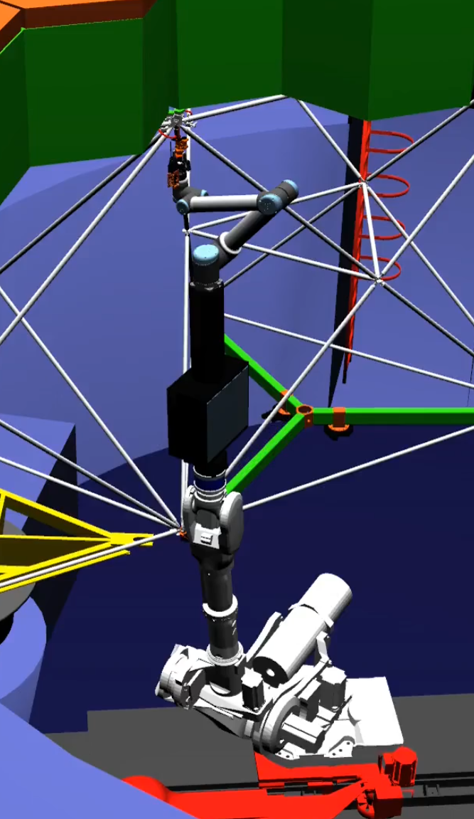
Fig. 7 General TriTruss installation.
a) Grapple Module
b) Install Capture Tool
d) Retrieve Tool
c) Install Module
1-g robot

Capture Tool

Dexterous Robot

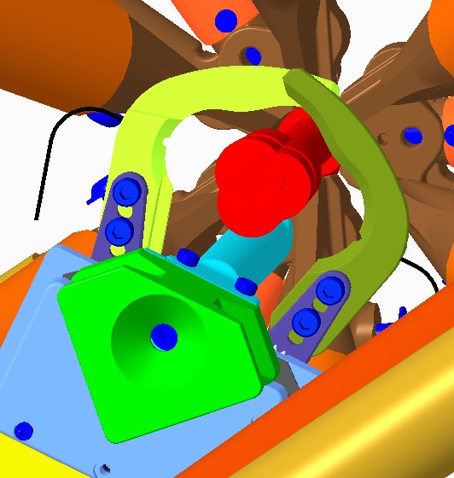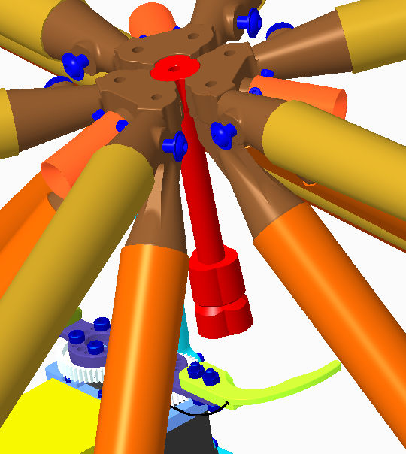
Fig. 8 Final alignment using capture fingers.
a) Side View Approaching Installation Location
b) View From Below of Capture Post fully Enclosed
Prior to Contact
Capture Finger

Capture Finger

Capture Post

New Module

V Supervised Autonomous Assembly for Reduced Program Risk
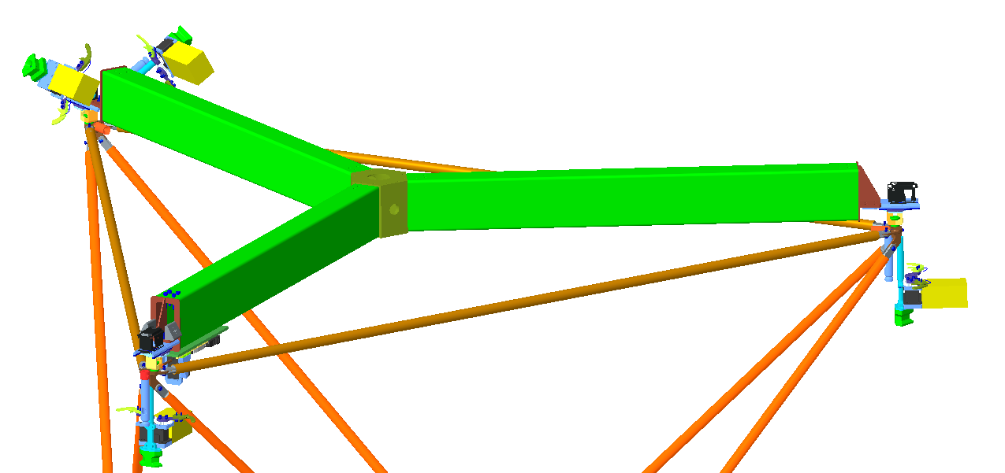
Up to this point, the focus has emphasized the simplicity and versatility provided by the assembly agents and tools used for SAA. A very important feature is that the assembly complexity is concentrated in a few well-defined tools which can be positioned using a variety of agents. The focus on tool development leverages past investment in robotic infrastructure. Since tools are easy to replicate, duplicating the tools is a simple and inexpensive means for providing redundancy to all the assembly mechanisms and reducing risk. Costs can be reduced because only a few active tools are required to execute the PA assembly process, where these tools are only used during assembly and do not reside within the assembled PA. Use of tools is in contrast to a more traditional approach that uses a large number of hinges and active deployment mechanisms throughout the PA, as in current deployable concepts. Eventually, the tools and agents will be shared between missions, further reducing costs.
Fig. 9 Inchworm compliant robot suitable for near zero-g assembly.
A major advantage of assembly is that it provides both significant design freedom as well as programmatic scheduling freedom which together reduce program risk and costs. As an example, consider the iSAT primary mirror assembly sequence, where two modular assembly approaches are shown in Fig. 10: on the left is ring assembly and on the right is raster assembly. Both options have strengths and weaknesses. For example, it may be advantageous to only assemble the inner ring due to launch constraints or as part of an in-situ verification. Raster assembly maybe more
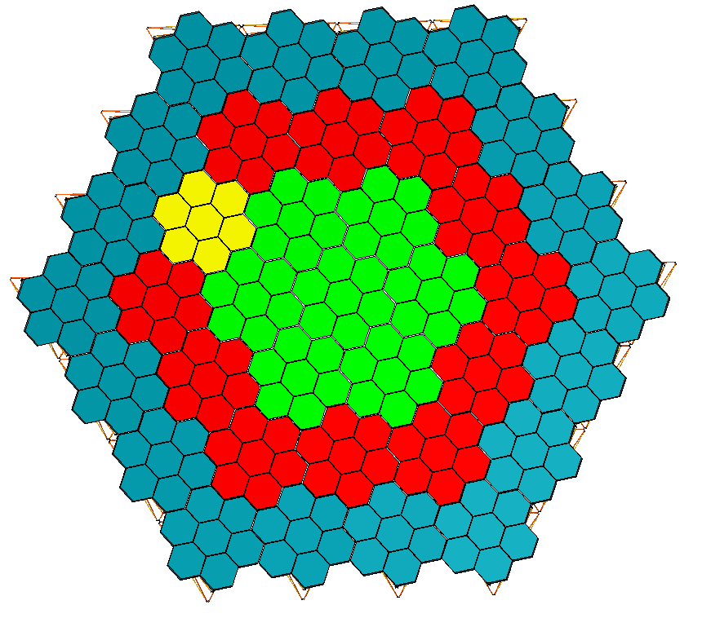
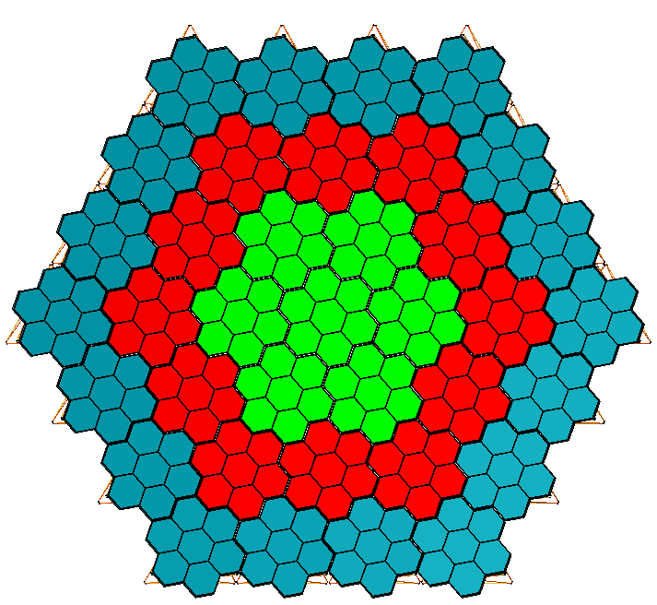appropriate when building off of an existing structure. Assembly of the reflector can occur incrementally in either approach. Properly designed packaging enables modules to be shipped on separate launch vehicles, with launch options selected near the launch date based on the lowest launch cost. Either the TriTruss modules (backing structure) can be assembled first, followed by assembly of the mirrors or mirror rafts (with an appropriate tool), or the mirror rafts and TriTruss can be assembled as an integrated module. These decisions can be modified through-out the development process providing significant design versatility that is responsive to budgetary and technical challenges, for example the unavailability of a particular launch vehicle. Likewise, the metering truss (Fig. 1) can be developed and assembled incrementally starting with just a single critical instrument and the central beam. Subsequently the metering truss can be expanded and instruments added in-situ as their schedule dictates in a “pay as you go” approach, thus enabling rapid initial science return.
Fig. 11 SAA enables repair or evolution by exchanging a module without affecting neighboring modules.
Fig. 10 Two of several assembly approaches that can be selected late in program execution.

Ring Assembly
Ring 1
Ring 2
Ring 3
Raster Assembly
Row 1
Row 2
Further, should a shortcoming of a module be encountered during assembly, with a properly designed PA, it is straight forward to exchange a TriTruss module, such as the yellow module in Fig. 11, without affecting the module’s neighbors. Replacement can be used to incrementally evolve capability or overcome failed sub-systems. In addition tools can be updated or improved for subsequent evolution of the PA. It is important to recognize the tools and agents do not have to survive extended periods on the PA. Tools and agents can be verified terrestrially then transported to the PA, along with the new modules or components, to perform a task and then removed from the PA to be applied to other tasks. As PAs become more prolific, there will be servicing vehicles that are rented for short duration tasks such as transportation and module installation.

VI Modest Flight Experiment to Validate Supervised Autonomous Assembly
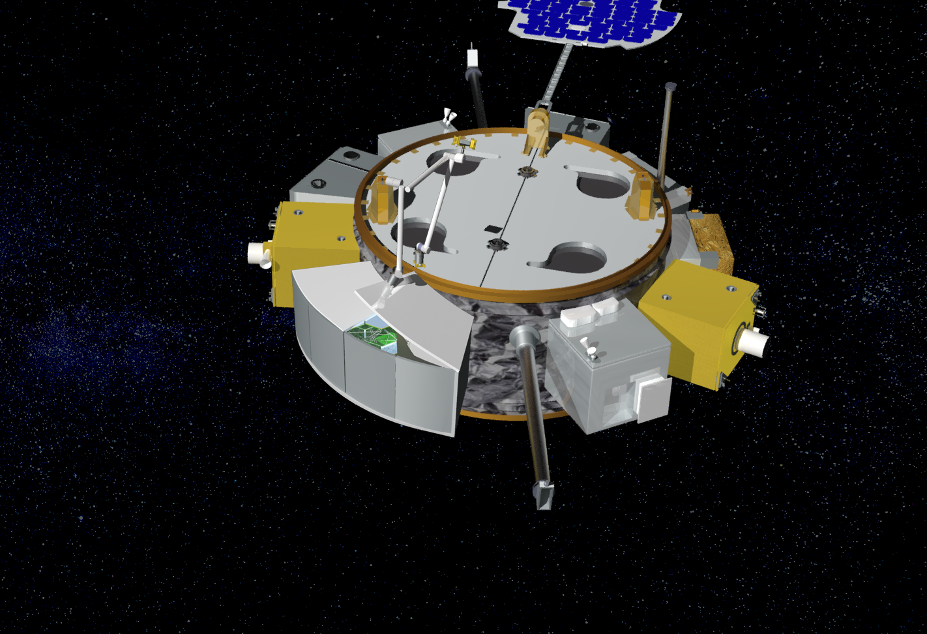
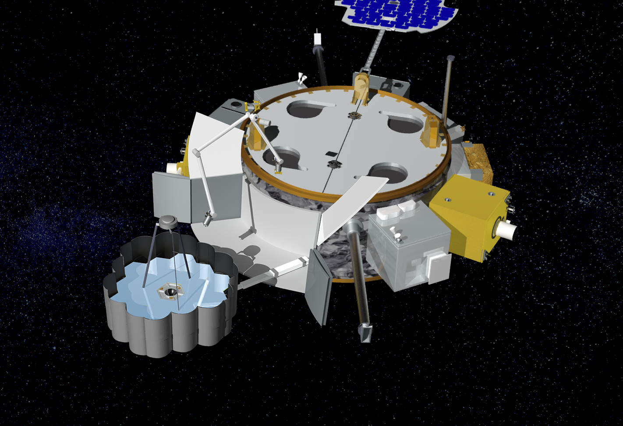
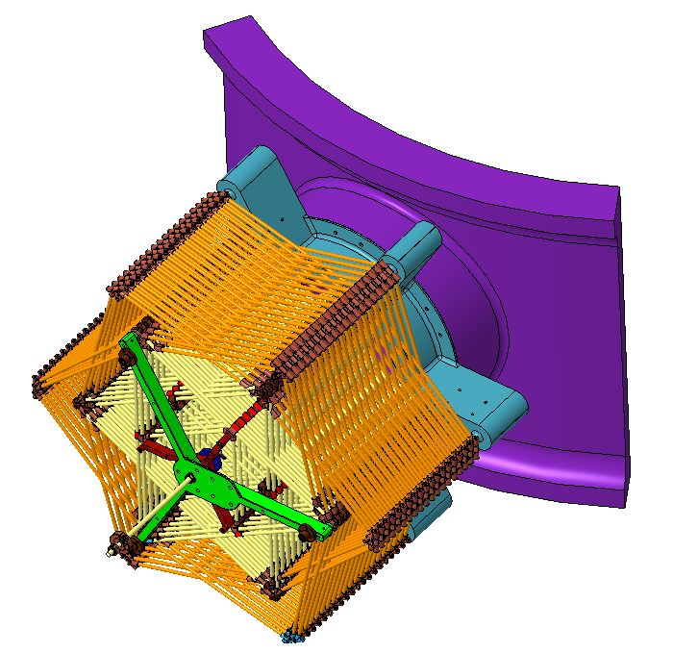
A major impediment to future projects adopting SAA is that it has not been proven in space. Thus, there is a critical need to validate the SAA paradigm; a game changing paradigm that will accelerate organizations’ ability to infuse new technology through rapid evolution of PAs, exploiting not only the advantages of SAA, but also the entire OSAM portfolio. A modest, low-cost, evolved expendable launch vehicle (EELV) secondary payload adapter (ESPA) class experiment is proposed to validate the SAA paradigm that will raise the TRL to TRL 9 []. This mission does not include an instrument, but rather focuses on validating the assembly process with associated metrology. A proposed concept based on current technology is depicted in Fig. 12 where Fig. 12a depicts opening a payload canister and Fig. 12b depicts the completed 2-ring system with panels and a deployed metrology system used to assess assembly precision. A scenario for ring assembly (as depicted in Fig. 10), is depicted in Fig. 12b where the assembly occurs using a turntable attached to an extendable boom. The first TriTruss unit and metrology package are preattached to the turntable. The hexagonal mirror panels shown are optional. An alternative packaging concept for 37 TriTruss units required to assemble a 3-ring structure that includes preattached grapple tool and a launch adapter is depicted in Fig. 12c. The package occupies approximately half of a standard ESPA volume using 6mm diameter tubes to form the TriTruss units. The parameters used in the current design and highlights the recommended 2-ring or 3-ring assembly are detailed in Table 1.
Fig. 12 ESPASTAR class flight experiment.
a) Open Container
b) Completed 2-Ring Assembly
c) 3 Rings of Packaged Modules
Table 1 ESPA packaging of modest experiment (420 mm class module).
Description | units
Bay width | mm | 455
Packaged bay thickness | mm | 7.5
Number of rings | # | 1 | 2 | 3 | 4 | 5 | 6
Aperture | mm | 1365 | 2275 | 3185 | 4095 | 5005 | 5915
Number of modules | # | 7 | 19 | 37 | 61 | 91 | 127
Packaged height | mm | 52.5 | 142.5 | 277.5 | 457.5 | 682.5 | 952.5
ESPA volumes | # | 1 | 1 | 1 | 1 | 1 | 2
ESPA grande volumes. | # | 1 | 1 | 1 | 1 | 1 | 1

Recommendation: assembly of 2 or 3 rings

No Panels Effects Included in the Table Details

Concluding Remarks and Recommendations
Supervised autonomous assembly (SAA) will create a paradigm shift in the planning and design of future persistent assets, both in near zero-g environments and on planetary surfaces. SAA refers to an autonomy approach that has the benefits of autonomous assembly as well as the benefits provided by a supervisor (operator) who is available to resolve unexpected situations. SAA provides both increased design freedom as well as reduced programmatic risk. A recently initiated National Aeronautics and Space Administration (NASA) project in the Space Technology Mission Directorate (STMD) Game Changing Development (GCD) Program leveraging the advantages of SAA, called the Precision Assembled Space Structure (PASS), is developing technologies to enable efficient creation and evolution of hexagonal topologies, for both planar (example: fuel depots) and curved (examples: telescopes and shelters) as well as surface applications. One of the goals of PASS is to raise the technology readiness level (TRL) of SAA for hexagonal assemblies with pre-integrated harnesses to TRL 6.
PASS has been used to provide context for the advantages of SAA, where concentration of assembly complexity was shown to be localized into a few disposable removable tools. Tools that can be improved for subsequent repair or expansion of the asset, i.e. it evolution. In addition, the increased design and programmatic freedom afforded by SAA provides a variety of assembly, launch and execution options reducing program risk.
A critical need to test SAA on-orbit was discussed and a modest, low-cost, flight experiment was proposed that can raise the TRL to TRL 9. The flight experiment focuses on SAA to reduce costs, and does not include a functional instrument. The technologies needed to execute such an experiment exist now.

Acknowledgments
The authors thank the Space Technology Mission Directorate (STMD) Game Changing Development (GCD) Program for their support providing the ability to investigate and develop precision assembly techniques in the Precision Assembled Space Structure (PASS) project.

Appendix A. PASS Hardware Design Details

PASS Reflector approximate governing equation
The assembled TriTruss modules are designed to form an assembly which supports a distributed 35,529 kg panel mass representing the mirror raft systems (based on James Webb Space Telescope areal mass). An advantage of assembly is the ease with which increased structural depth can be achieved. The curves of Fig. 13 indicate the how the total truss mass (i.e. the assembled TriTruss mass) can be reduced as the structural depth (H/a) is increased. Two curves (blue and black) are shown for three different global target frequencies (5 Hz, 10 Hz and 15 Hz) of the supported mirror system. The black curves (β=1) correspond to an assembly of TriTruss modules where all the structural members have the same cross sectional area. The blue curves (β=0.5) correspond to an assembly of TriTruss modules where the core structural members have half the cross sectional area of the members in the top and bottom equilateral triangles (Fig 2b). Much like a lightweight core in a honeycomb panel.
The vertical purple line, located at H/a = ~0.58, represents simple packaging where expansion of the triangle at mid height and outward folding of the core members causes the TriTruss module to package within the boundary of a supported hexagonal panel when viewed looking down on the TriTruss module from above.

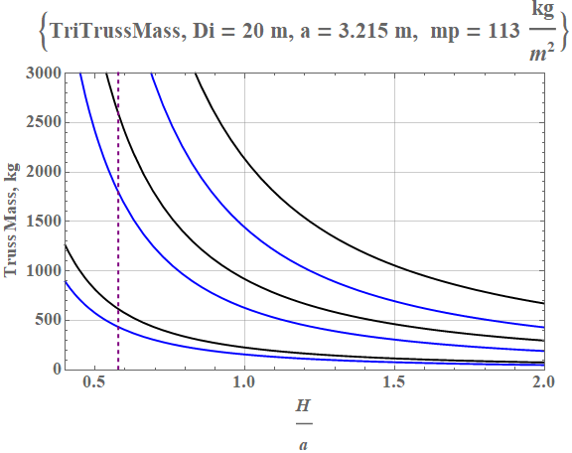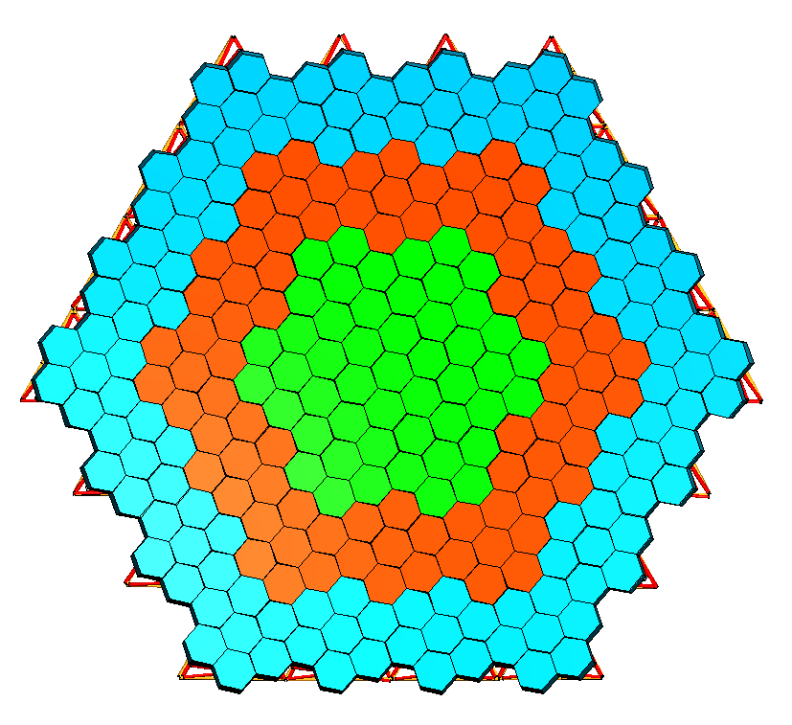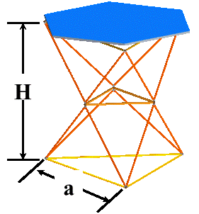
β = 1
frequency = 5 Hz
frequency = 10 Hz
Total Panel Mass = 35,529 kg
Truss Mass, kg
H
a
Simple packaging
$\frac{H}{a}=\frac{\sqrt{3}}{3}$
3 rings
Cross Sectional Area of core member
Cross Sectional Area of face member
β = 0.5
frequency =15 Hz
β = 0.5
β = 0.5
β = 1
β = 1
β:=
β:=
H
a
Fig. 13 Approximate assembled truss mass for different global frequency targets and core designs as a function of truss depth.

$$Assembled Truss Mass=\frac{2 {Di}^{6}f^{2}JF mp πρ\left(4+β+4β\sqrt{1+α^{2}}\right)}{{3a^{2}{Cf}^{2}Ecα^{2}-8Di}^{4}f^{2}JF ρ\left(4+β+4β\sqrt{1+α^{2}}\right)}$$
Approximate Governing Equation (Credit: Martin Mikulas)
Di Reflector diameter 20
mp Areal mass of panel 113 kg/m²
ρ Density of composite 1626 kg/m³
Ec Modulus of elasticity of composite 280e9 Pa
JF Joint factor (multiplier of truss mass to account for joint mass) 1.1
Cf Plate constant from Blevins [] 3.345
H Height of deployed TriTruss module m
a Characteristic length of one side of the bottom equilateral triangle m
α H/a
f Frequency Hz
β Ratio of cross section area of core member /face member

PASS Tubes

Tubes were selected based on a desired global free-free frequency of 10 Hz for the 3-ring system supporting distributed mass of 35,529 kg.
Tubes are constructed with Mitsubishi K63712 fibers in the axial direction, Mitsubishi 340700 fibers in the hoop direction and the NB301 resin. The layup schedule is [0/90/90/0] with a nominal thickness of 0.889 mm. Cured ply thickness of the K63712 is ~two times the 34-700 thickness so the percentage of fiber at 0º is 66%.
Ultra-high modulus prepreg (K63712/NCT-301) is 300 grams/m² (GSM) fiber areal weight (FAW) with 35% resin content, and the standard modulus (34-700/NCT-301) hoop layers are 150 GSM FAW with 35% resin content and a 1% black dye added.

PASS TriTruss Module Mass estimates

PASS - bare reflector truss
2.8 m by 2.8 m composite TriTruss
Part | Number per Module | Material | Unit Mass | Total mass
 |  |  | kg | kg
Nodes and Hardware Total |  |  |  | 1.605
top corner node | 3 | AL 6061-T6 | 0.152 | 0.456
mid node (no tang) | 3 | AL 6061-T6 | 0.127 | 0.381
bottom corner node | 3 | AL 6061-T6 | 0.152 | 0.456
lock screw assembly | 6 | varies | 0.052 | 0.312
tubes total |  |  |  | 5.625
top tube | 3 | composite | 0.349 | 1.047
mid tube | 3 | composite | 0.175 | 0.525
bottom tube | 3 | composite | 0.363 | 1.089
top diagonal tube | 6 | composite | 0.242 | 1.452
bottom diagonal tube | 6 | composite | 0.252 | 1.512
Grand Total |  |  |  | 7.230 kg

Nmodules Number of modules 37 for 3 rings

PASS Tool Mass

Grapple Fixture ~60 kg
Alignment Gripper ~3 kg

Senior Research Engineer, Structural Mechanics and Concepts Branch, MS 190, Associate Fellow.
Aerospace Engineer, Structural Mechanics and Concepts Branch, MS 190, Non-Member.
Aerospace Engineer, Structural Mechanics and Concepts Branch, MS 190, Member.
Senior Aerospace Engineer, Mechanical Systems Branch, MS 434, Non-Member.
Senior Research Engineer, Intelligent Flight Systems, MS 233, Associate Fellow.
Research Engineer, Intelligent Flight Systems, MS 233, Member.
Senior Research Engineer, Electronic Systems Branch, MS 488, Member.
Research Technician, Intelligent Flight Systems, MS 233, Non-Member.
Aerospace Engineer, Simulation Development and Analysis Branch, MS 125B, Senior Member.
Portfolio Manager, Space Technology Exploration Directorate, MS: 462, Non-Member.
Senior Research Scientist, Fellow.
Senior Research Scientist, Intelligent Flight Branch, MS 488, Senior Member.
Senior Research Scientist, Intelligent Flight Branch, MS 488, Non-Member.
Smaller mirrors are perceived to be less expensive.
Wiring harnesses are omitted from most figures for clarity.
The term “asset” is used here because the philosophy applies to creation of any system (satellites, platforms, surface systems, etc.) as opposed to just applying to creation of PAs, though PAs have greater benefit.
[] Stockman, B., Boyle, J., and Bacon, J., “International Space Station Systems Engineering,” Case Study, Air Force Institute of Technology Wright-Patterson Air Force Base, Center for Systems Engineering, 2010. doi: 10.21236/ada538763
[] Mukherjee, R., Siegler, N., Thronson, H., Greenhouse, M. Peterson, B. Grunsfeld, J., Bowman, L., Polidon, R., and MacEwen, H., “In Space Assembled Telescope (ISAT) Study Preliminary Findings,” International Conference for Aerospace Experts, Academics, Military Personnel, and Industry Leaders, Big Sky, MT, 2019.
[] Mukherjee, R., Siegler, N., Thronson, H., K. Aaron, Arenberg, J., Backes, P., Barto, A., et al., “When is it Worth Assembling Observatories in Space?,” Bulletin of the American Astronomical Society, No. 50, Vol. 51, Issue. 7, 2019.
[] Doggett, W., Dorsey, J., Jones, T., Mikulas, M., Teter, J., and Paddock, D., “TriTruss: A New and Novel Structural Concept Enabling Modular Space Telescopes and Space Platforms,” IAC-19,C2,2,11,x54812 (2019).
[] Brace, W. W., Doggett, W. R., and Kyongchan, S., “Tessellation and Numerical Simulation of the In-Space Assembled Telescope (iSAT) Reflector,” AIAA ASCEND 2020 Conference, AIAA 2020-4192.
[] Gross, D., and Messner, D., “The Able Deployable Articulated Mast - Enabling Technology for the Shuttle Radar Topography Mission,” Proc. of the 33rd Aerospace Mechanisms Symposium, NASA/CP-1999-209259, Pasadena, CA, pp. 15-30.
[] Winslow, C., “Space Station Freedom Solar Array Design Development,” IEEE Aerospace and Electronic Systems Magazine 8, no. 1 (1993): pp. 3-8.
[] Watson, J. J., Collins, T. J., and Bush, H. G., “A History of Astronaut Construction of Large Space Structures at NASA Langley Research Center,” In Proceedings, IEEE Aerospace Conference, Vol. 7, pp. 7-3569 – 7- 3586, March, 2002.
[] Doggett, W. R., “Robotic Assembly of Truss Structures for Space Systems and Future Research Plans,” In Proceedings, IEEE Aerospace Conference, Vol. 7, pp. 7-3589-7-3598, March, 2002.
[] Belvin, W. K., Doggett, W. R., Watson, J. J., Dorsey, J. T., Warren, J. E., Jones, T. C., Komendera, E. E., Mann, T., and Bowman, L. M., “In-Space Structural Assembly: Applications and Technology,” In 3rd AIAA Spacecraft Structures Conference, pp. 2163, 2016.
[] Lake, M. S., Heard Jr, W. L, Watson, J. J., and Collins, T. J., “Evaluation of Hardware and Procedures for Astronaut Assembly and Repair of Large Precision Reflectors,” NASA/TP-2000-210317. doi: 10.2514/3.26480, 2000. doi: 10.2514/3.26480
[] Heard Jr, W. L., and Lake, M. S., “Neutral Buoyancy Evaluation Of Extravehicular Activity Assembly of a Large Precision Reflector,” Journal of Spacecraft and Rockets, 31(4), pp. 569-577, 1994.
[] Nicolas, L. N., Burdick, J. W., Backes, P., Pellegrino, S., Hogstrom, K., Fuller, C., Kennedy, B., et al., “Architecture for In-Space Robotic Assembly of a Modular Space Telescope,” Journal of Astronomical Telescopes, Instruments, and Systems 2, no. 4 (2016): 041207.
[] Favero, J. P, “International Space Station Mechanism Contact Simulation,” Aircraft Engineering and Aerospace Technology, Vol. 77, No. 1, pp. 4-12. https://doi.org/10.1108/00022660510575993, 2005.
[] Directorate, M. O. Training Division, “EVA Tool Catalog”, NASA Doc. No. JSC-20466, Prepared by RC Trevino and RK Fullerton, 1985.
[] Roesler, G., “Robotic Servicing of Geosynchronous Satellites (RSGS),” Defense Advanced Research Projects Agency, http://www.darpa. mil/program/robotic-servicing-of-geosynchronous-satellites (14 July 2017).
[] Welsch, C. P., Rumford, T. E., and Lages, C., “ESPAStar – Enabling Space Missions with Rideshare Using an Innovative Propulsive ESPA Free Flying Platform,” IAC-19-B4.5.14x53394, Presented at 70th International Astronautical Congress (IAC), Washington D.C., United States, pp. 21-25, October 2019.
[] Blevins, R. D., Formulas for Dynamics, Acoustics and Vibration. John Wiley & Sons, Hoboken, NJ, 2015.

