Structural Analysis Findings of Open Spelter Socket Cable Terminations

Pavel Babuska and Vinay Goyal
The Aerospace Corporation, El Segundo, CA, USA
Gregory Harrigan
NASA Langley Research Center, Hampton, VA, USA
A three-dimensional nonlinear finite element model of a representative open spelter socket termination was developed to examine the underlying mechanics of load transfer from a structural cable through the termination, the sensitivity of the joint design to wire brooming, zinc material nonlinearity, contact friction between the zinc and socket, voids within the zinc, and, finally, the effects of repeated loading on the joint. Primary factors affecting open spelter socket design are cast zinc plastic flow, depth of zinc slug seating, and quality of wire brooming. Zinc plasticity and proper brooming allows for efficient load transfer by developing confining pressure on the broomed wires in the narrow part of the socket, which keep the wires from pulling out of the zinc and shift failure to occur outside the socket. Highest wire stresses in the cable occur in the outer ring adjacent to the termination. While industry use of stay cables are typically designed to carry less than half the rated breaking force in aggregate, the constituent stresses within the zinc and the wires have the potential to exceed their respective allowable in operation and should be evaluated for fatigue- and creep-critical applications.
- Introduction and Objectives

Open spelter socket terminations are used in cable stay structures and wire rope applications across multiple industries including civil (bridges), oil and gas (rigging), scientific (large telescopes), and aerospace (ground support equipment).
The successful implementation of cable stayed structures and wire rope applications requires the ability to transfer load from the cable or rope into the adjacent structural elements. This load transfer is achieved using a termination, which can exist in various forms ranging from swaging, splicing, clipping, or socketing [1]. The various methods often exchange simplicity in manufacturing with structural efficiency, with the simplest terminations not developing the full capacity of the cable and limiting the overall design capability of the combined product. Poured socket terminations, specifically, are one of the highest efficiency terminations, typically rated at 100% efficiency for proper manufacture, meaning that the termination should successfully accommodate 100% of the attached cable or wire rope rated breaking strength [2].

The focus of this work is on a type of poured socket termination specifically known as an open or closed spelter socket. This type of socket is depicted in Figures 1 and 2. The open socket differs from the closed socket in how the socket connects to an adjacent structure, with the open socket enabling a pin-clevis type connection. Each version of the poured socket uses the same load transfer mechanism with a conical volume into which the cable or wire rope is inserted with a casting material (resin or spelter) poured into it, as shown in Fig. 2.

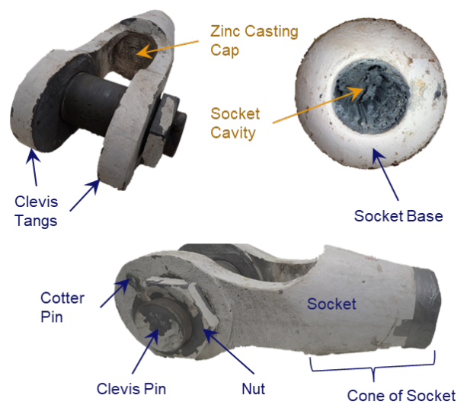
Fig. 1 Open spelter socket nomenclature [x].

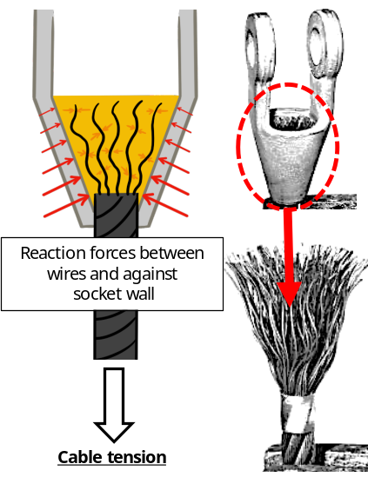
Fig. 2 Bundle of wires comprising the cable are embedded in poured zinc within a socket.

These sockets rely on three features to develop full strength and cable tension: (1) Transfer of shear loads occur due to broomed wires bonded with the zinc; (2) Broomed wires within zinc cause a “finger-trap” effect of more compression on wires, further preventing wire pullout; and (3) Conical angle provides wedging effect, prevents gross pull-through of material. The narrow side of the conical volume where compression is highest is the most critical as the compression mechanism keeps the cable end intact in the socket and allows full cable strength to be developed outside the socket.

No past analysis efforts in the literature could be identified that modeled the individual wires, wire brooming inside the socket, cast product (zinc or resin), and conical socket in a full three-dimensional finite element model. Typical modeling efforts considered individual wires by homogenizing their properties with the cast material to form an “effective” structural response of the joint from which the effects on the socket or adjacent components could be examined.
The objective of this study was to develop a more complete understanding of the load transfer mechanics local to the spelter socket termination of a representative cable design. While the application of the design safety factors occurs at the whole cable or wire rope level, it is prudent to understand what safety factors are retained local to the termination and how the relevant design variables affect overall termination capability. The following characteristics were examined analytically to determine their overall effect on the termination capability:
.
- Level of cable end brooming
- Zinc spelter plasticity
- Contact and friction between Zinc spelter and socket geometry
- Void formation in the Zinc
- Repeated loading associated with proof testing and subsequent use
- Susceptibility to creep and fatigue

The paper is organized as follows: (1) Manufacturing, acceptance testing, and qualification testing; (2) Industry civil codes; (3) Finite element model; (4) Findings and discussion; and (5) Recommendations.
- Manufacturing, Acceptance Testing, and Qualification Testing

Open spelter socket terminations have extensive usage within industry and historically are considered a highly efficient and reliable safety-critical cabling mechanism. Fabrication process is highly manual, and so the structural performance of open spelter sockets can be sensitive to process variations.

Manufacturing

Poured spelter sockets use commercially pure molten Zinc as the casting liquid that holds the cable end in the termination, while poured resin sockets typically use a thermo-set resin that is mixed prior to pouring. The key steps in the preparation and manufacture of open spelter socket terminations are:

- Install seizing at the termination of the socket. This involves "tying off" a portion of the cable to provide a root location where the individual wires will not separate and can exit the socket.
- Broom the wires by unwinding and straightening out the wire segments above the seizing. Wires form an expanded shape to occupy the volume of the conical socket.
- Ultrasonically clean the broomed wires by dipping in a citrus-based solvent and then drying.
- Apply a zinc ammonium chloride flux by dipping for a prescribed time and then allowing to dry.
- Install the socket hardware around the broomed wires, ensuring the cable is aligned concentrically with the socket at the location of seizing.
- Seal the opening of the socket to ensure no molten zinc can flow from the bottom of the socket.
- Preheat the socket to a specified value to better match thermal shock of molten zinc pour.
- Fill the heated socket with molten zinc.
- The target temperature for pouring zinc is in the 800-875 degrees Fahrenheit. This is accomplished by increasing the zinc temperature during ladling by up to 100 degrees Fahrenheit to accommodate the cooling that occurs during the manual process of transferring molten zinc.

The fabrication process is controlled through best-practice wire brooming and inspection of the socket prior to zinc pour. Brooming quality is largely regulated through training and relies on experienced fabricators. The Crosby Termination Manual [2] is a resource that provides termination installation techniques, proper cable or wire rope brooming, seizing, and sealing.

“Acceptance” Test

Because the fabrication is inherently manual and workmanship sensitive, socket terminations commonly receive a proof test load as a workmanship screen to ensure adequate bond strength developed between the zinc and broomed wires and to seat the constituents within the conical socket. The proof load level can be specified by the customer as a percentage of rated breaking strength or some proportion of design load. A proof test to 50% of the rated breaking strength is a common target load value. Note the proof test is a gross workmanship screen, acts as a screen for “early failures,” but does not act as a screen for wear out failure modes such as fatigue.

“Qualification” Test

ASCE 19-10 [3] requires a minimum design factor of safety of 2.2 for steel cables. The Crosby Termination Manual [2] indicates a factor of safety ranging between 3 and 5 depending on the specific application. A comparison of design factors of safety from various industry standards was presented in [4], which is summarized below in Table 2.

Table 2 Design Factors of Safety from Various Industry Standards
Standards | Reference | Design Factor of Safety for Stay Cables of CSBs
Japan Road Association. Specifications for highway bridges: part II, steel bridges. Tokyo: Japan Road Association, 2017. Japanese | 5 | 2.5
EN 1993-1-11: Eurocode—3. Design of steel structures – Part 1-11: Design of structures with tension components. European standard. Brussels: European Committee for Standardization; 2006. | 6 | 2.2
Post-Tensioning Institute. Recommendations for stay-cable design, testing, and installation. 5th edition. Farmington Hills: Post-Tensioning Institute; 2007. | 7 | 2.2
Service d’Etudes Techniques des Routes et Autoroutes. Cable stays – recommendations of French interministerial commission on prestressing. Bagneaux Cedex: Service d’Etudes Techniques des Routes at Autoroutes; 2001. French | 8 | 2.7
International Federation for Structural Concrete. Acceptance of stay cable systems using prestressing steels. Report. Lausanne: International Federation for Structural Concrete; 2005. | 9 | 2.2

Rated breaking strength of the cable is associated with the loads required to break the cable outside of the termination, such that 100% efficiency of the termination is achieved. The allowed load in the cable during operational conditions is found as the ratio of the rated breaking strength and the design factor of safety. In test, the location of failure can vary from just outside the termination to near mid-span and is very difficult to predict analytically.

The selection of an appropriate design factor of safety for stayed cables is discussed in the literature, and it is argued that their selection depends on the ratio of live load to dead load stress and occurrence frequency of live load stress, fatigue, and corrosion, among other factors [4].

Comparison to Aerospace Industry Standards

While zinc spelter sockets are not specifically aerospace structures, it is insightful to examine the recommended design/build process of the socket as if it were aerospace hardware, specifically in cases where the socket application is part of a design that is mass-optimized, utilizes low factors of safety, or is highly dynamic in nature, such as the design variables often found in aerospace structural design. Aerospace industry standards (e.g., NASA-STD-5001) recommend assessing the following aspects to demonstrate robustness of the design:

1. Fatigue/fracture
2. Thermal cyclic
3. Vibration
4. Creep
5. Static strength
6. Acceptance tests (e.g., proof test).

This comprehensive verification methodology is of high importance in aerospace applications because factors of safety are typically lower than in civil engineering applications. Larger structural margins in a design generally reduce the potential for fatigue and creep failure modes. Note that American Society of Civil Engineers (ASCE) standards discuss creep in the context of overall structure shape/stability but not for the cable termination itself. In some instances, specifically where fatigue and creep want to be exonerated, the qualification test and proof test factors are significantly greater than 1.0 to show how significant design margin for the production build is against the limit load condition. In aerospace applications, the proof test factor is typically required to be >1.0 to demonstrate the capability of the hardware to endure greater than limit-load-level loading.

Testing just a single unit, as is often done for aerospace hardware, may not be appropriate. Instead, the sample size should be large enough to account for lot-to-lot variability considering material, human, and process elements. In the aerospace community, manufacturers often establish expected strength based on multiple specimens pulled from multiple builds. For such process-sensitive components, workmanship testing is critical. It may be the case that the socketing community possesses an additional body of data related to this topic, but nothing specific was made available to the authors of this investigation.

- Finite Element Model of an Open Spelter Socket Joint

In this section, the finite element model, socket physics, and joint behavior to variations in the parameters are performed. No efforts were found in the literature that modeled the individual wires, cast product (zinc or resin), and conical socket in full three-dimensional fidelity. In the past, the efforts to consider the individual wires did so by homogenizing their properties with the cast material to form an “effective” structural response of the composite from which the effects on the socket or adjacent components could be examined. This approach fundamentally excludes accurate prediction of the constituent wire and zinc components of the termination.

Geometry

Several configurations of wire brooming were developed by modeling all the constituents explicitly as shown in Fig. 3. The effort required parametrization of geometric features in a computer aided design software.

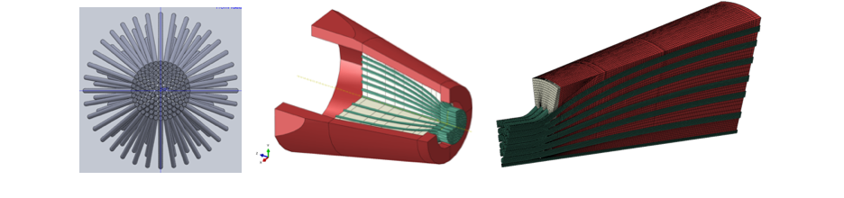
Fig. 3 (From left to right) Axial view of broomed wires; Isometric cutaway view of poured socket termination consituents; Wedge model mesh fidelity

The type of cable selected for this study was 3.25-inch structural strand of 1×127 construction consisting of 126 individual 0.25-inch diameter wires wrapped around a single, seven-wire strand in six concentric rings with a pattern of 6, 12, 18, 24, 30, 36 wires, as shown in Fig. 4. Each individual wire has a specified minimum yield strength of 160 ksi, minimum ultimate tensile strength of 220 ksi, and elastic modulus of 23,000 ksi. Three levels of wire brooming were considered for this study denoted as “Full-Broom,” “Partial-Broom,” and “Incomplete Broom” shown in Fig. 5. The levels of brooming are idealized and meant to differ qualitatively without particular attachment to any brooming quality metric. The exact configuration of brooming in practice is expected to differ from any of the model configurations; however, the range of brooming configurations in this study are likely to bound as-manufactured configurations.

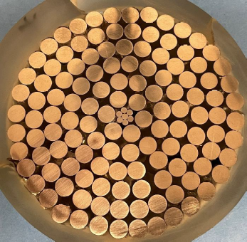
Fig. 4 Cross-section of 1x127 structural strand

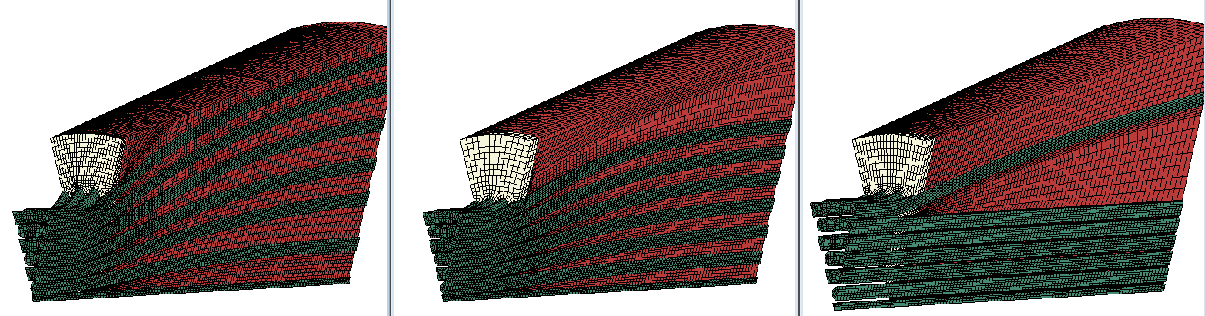
Fig. 5 (From left to right) Full broom; Partial broom; Incomplete broom

The cable itself was only modeled for one cable diameter outside of the socket wire outlet plane. Helical windings of the individual strand were not modeled for purposes of simplicity. This representation is understood to be sufficiently representative of the types of structural strand that has torsional balance by alternating lay directions of the wire rows.

Material Properties
Several configurations of wire brooming were developed by modeling all the constituents explicitly as shown in Fig. 3. The baseline set of mechanical properties were as follows, with some being altered during the trade studies:

1. Structural Strand Wires (A586-91 Steel Cable)
Elastic Modulus: 23 Msi, Poisson’s Ratio: 0.29
Yield Strength: 150 ksi, Ultimate Strength: >220 ksi (min spec)
2. Cast Steel Socket (A148 Grade 90-60 Cast Steel)
Elastic Modulus: 27 Msi, Poisson’s Ratio: 0.29
Yield Strength: ~70 ksi, Ultimate Strength: ~100 ksi
3. Commercially pure zinc casting
Elastic Modulus: 14 Msi, Poisson’s Ratio: 0.25
Ultimate Strength: < 10 ksi

Commercially pure zinc is a unique structural material in structural socket terminations because its tensile capability is extremely low; however, its compressive capability is high. Grain sizes also vary significantly based on manufacturing method and rate of cooling during casting. As such, it is difficult to construct a high-confidence material model that accurately reflects both tension and compression response or when attempting to model progressive damage.
True stress-strain curves were generated and incorporated into the models based on historical test data of the steel wire and the zinc. Several different zinc material models were developed for use in sensitivity studies to determine socket termination capability based on the variability in material properties. These sensitivity studies were performed to mitigate concerns associated with uncertainty stemming from zinc material test data. A representative example stress-strain curve for the wire steel was generated using the Ramberg-Osgood approach and is shown in Fig. 6.

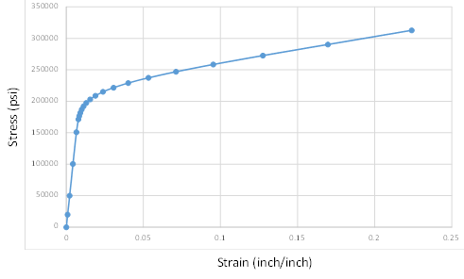
Fig. 6 Stress-strain curve of A586-91 Steel Cable Wire

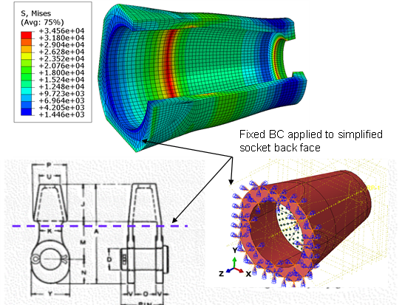
Fig. 7 Clevis joint was not modeled explicitly as its effects were found to be insignificant
to mechanics of interest

Boundary Conditions and Loads

Due to the high-level of mesh refinement required to characterize the zinc and wire constituents, additional model simplifications were needed. An initial coarse finite element model of the socket was developed to understand the effects of the clevis joint attached to the socket. This analysis demonstrated that the local stresses at the clevis hole did not influence stress levels in the zinc casting or on individual wires. Further, the socket deflections were predicted to be small (less than 0.010 inch compared to conical socket dimension of >12 inch) and the net section stresses in the Cast Steel Socket were near 15 ksi (Fig. 7), well below the ultimate material capability of ~100 ksi. Stresses adjacent to the boundary condition were even lower than those near the zinc casting interface. Because of the local nature of the stresses within the zinc casting, it was found that there was no need to model the clevis joint in subsequent modeling effort.

The primary loading configuration of the socket joint is axial tension load. Torsional forces from tension loading will arise but are balanced by alternating layers of strand wires, denoted as a “torsion-balanced” configuration. For the purpose of modeling simplicity, only axial loads were applied after determining that the minimal torsion and bending loads were negligible. While these asymmetric non-uniform effects are likely to be present, these were determined to be a small component of the total axial load acting on the joint. As a modeling assumption, the load was applied to a single node Reference Point that was kinematically coupled to the wires to allow for effective load transfer to each of the individual wires. This was done to represent the uniform far-field tension load in the cable cross-section.

The strand in question has a rated breaking strength of 1314 kips with a design factor of safety of 2.2 to be roughly consistent with those discussed Table 2. This resulted in a static applied tensile load of 600 kips to be applied in the model. Residual stresses from manufacturing, thermal loads, and sources of transient load were not explicitly considered in this section; however, these are addressed conceptually in the next section.

- Discussion of Analysis Results

Socket Mechanics

Cable tensions in real applications will stem from dead load, operational loads, and survival transients. These loads are transmitted to the socket termination through the 126 individually broomed wires that are held in place by the cast zinc spelter within the steel open socket conical volume. The zinc that fills the socket cavity is bonded to the wires, and this bond creates an efficient load transfer among the wires within the socket.

A special characteristic of the socket termination is that the combination of zinc plasticity and the conical volume forces a “squeezing” effect to occur around the broomed wire bundle in the narrow part of the socket. The high confining pressures experienced at the outlet of the socket keep the broomed wires from pulling out of the zinc and allow the failure to occur in the cable outside the socket (see Figure 6), thus developing the cited 100% efficiency termination.

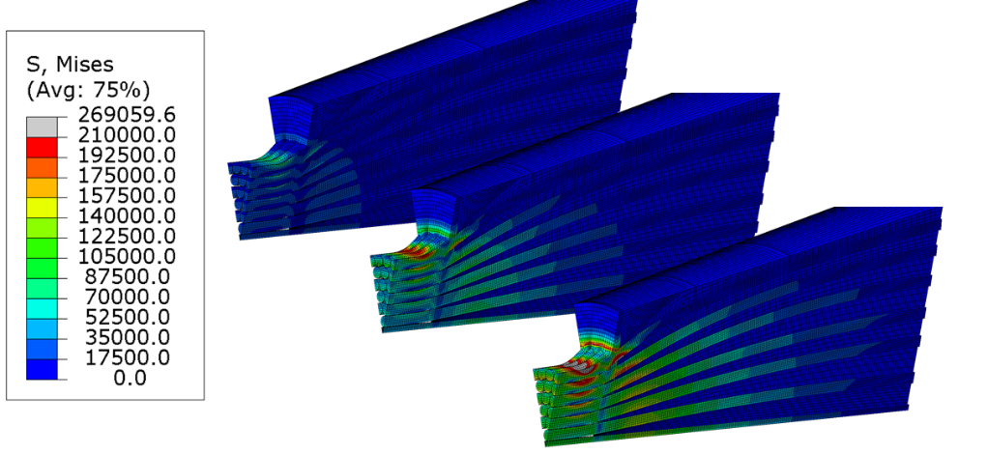
Note: The magnitude of the contour stress plots is not particularly relevant for this demonstration.
Fig 6. As loading in cables increases (left to right), the zinc distributes load amongst wires within the socket in a mechanism analogous to metal matrix reinforced composites

Some sockets, specifically those manufactured in the field, use a thermoset poured resin rather than molten zinc to confine the broomed wires within the socket. Functionally, the nearly incompressible resin achieves the same mechanical locking and squeezing of the wires as the zinc plasticity and conical socket shape. Reference 10 excerpt states:

“When a load is applied to the rope, the resin cone must move forward into the socket. This effect generates high wedging pressures in the resin, tightly gripping the embedded wires. This movement, and the resulting wedging process, is essential to the operation of the system…”

A properly manufactured socket termination should develop the full breaking strength of the structural strand or wire rope, meaning that the socket termination itself should not be the limiting strength factor in the capability of the whole cable. This is observed during testing when the failure mode is breakage in the cable rather than individual wire pullout of the zinc or resin casting. The exact progressive failure is complicated, and it is not obvious which individual wire fails first or where along the length of the cable the first failures should occur. Once individual wires fail, the failure mode may or may not shift to the cast zinc or resin or may remain somewhere within the strand.

In Reference 11, the cable fails at the far socket termination. In this failure example, it appears as though the cable core (remaining unfractured wires) would have pulled out of the socket due to zinc overload, had the test rig continued to move. In other tests, the structural strand has been shown to fail away from the socket, somewhere within the span of the strand length. However, it is not possible to predict which configurations fail in the strand near the socket and which would fail in span.

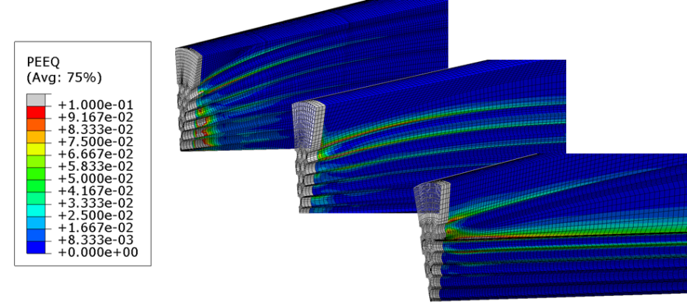

Fig 7. Comparison of representative zinc plastic strain fields for three different wire brooming configurations highlighting bands of significant shear for less-broomed cable ends

Relationship of Constituent Stress to Applied Load
Cables exhibit both geometric and material nonlinearities during operation. Cables are inelastically prestretched until individual wires settle into their final positions at a high percentage of their minimum breaking strength, which allows them to behave more predictably. Gossen [12] discusses the incongruency of how factors of safety are used in conjunction with the working stress design (WSD). Generally, stress, force, and deformation behaviors are assumed to be linear with increasing load even though the behavior of the cable is nonlinear. Gossen reports that the factor of safety is intended to account for accidental overloads, material variability, and fabrication imperfections. The argument made by Gossen is that due to the nonlinear nature of the cable, the structural margins remaining against overload can vary significantly and remain indeterminate unless the structure is analyzed beyond nominal conditions. In most standards, the loads effects are superimposed with varying amplification factors, but this is not applicable for nonlinear cables.
A linear analysis using a first-order hand-calculations can predict the breaking strength of the strand reasonably well. A bundle rated at 1314 kips is consistent with hand calculations based on cross-sectional area of each wire: $A_{wire}=π*{0.125}^{2}=0.049 in^{2}$. Based on the single-wire minimum strength specification of 220 ksi, the predicted load at failure is 1.36 million pounds ($= 126 wires × A_{wire}× 220 ksi)$ roughly equal to the rated breaking strength. However, in a nonlinear analysis, the stress is nonuniform from wire to wire, with the outermost wire reaching its ultimate capability at half the breaking strength of the bundle, Figure 8. In a strength-driven application this may not be an issue, because the stress redistributes progressively. However, it may warrant greater consideration for a fatigue- or creep-critical application as repetitive or sustained loading in the plastic region of the material can lead to failure.
To illustrate this point, an independent finite element model of the socket joint was developed to understand the relationship between stress and the load applied for two zinc material models. The rated breaking strength of the cable is 1,314 kips, so at half the breaking strength a linear stress response of the wire is expected. However, due to the complexity in the geometry and the nonlinear behavior of the zinc and the wires, the outer wire stress approaches the ultimate strength at half the cable breaking strength and exhibits a nonlinear response at one-fourth of the breaking strength of the cable, as shown in Figure 8. The model illustrates a nonlinear scaling of outer wire stress to load applied.

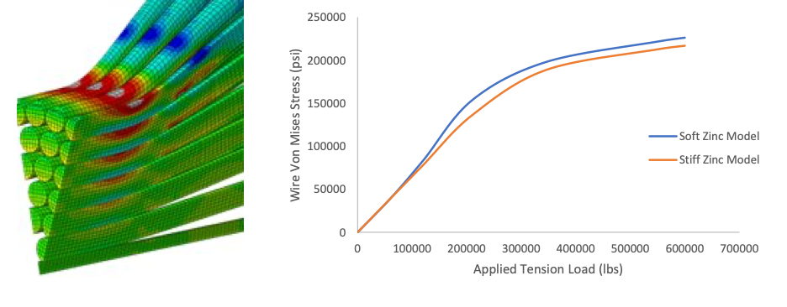
Fig. 8 Stress Response in Wire is Nonlinear with Increasing Applied Tension Load

Finite element results confirm the thesis in Reference 12 that “the ultimate load approach may result in individual cables stressed beyond their accepted level under service loads, while still satisfying the ultimate load design requirements. It is apparent that the analysis and design of these structures can be much more laborious than what is common in the design and analysis of conventional structures.”

Brooming

Level of brooming refers to the level of distribution of the wires within the zinc. An “ideal
brooming condition is one where the wires are distributed uniformly within the zinc. Several representations of brooming were considered, Figure 9. The model version containing the largest degree of brooming is referred to as the “ideal brooming condition,” although it is recognized that such a brooming would not materialize in actual socket manufacturing. Nevertheless, analyses with various brooming conditions can provide insight into the sensitivity of brooming quality to the critical stress of the socket joint and help develop a more thorough understanding of socket termination mechanics.

The brooming operation ensures that the wires are as evenly distributed as possible within the socket so that the load distribution is efficient. Since the brooming operation is a manual operation, no two sockets are exactly alike. The exact brooming geometry and the quality of the wire-to-zinc bond are affected by the manual operations.

Multiple models were developed that assumed various “qualities” of brooming in attempt to bound the problem. Specifically, three levels of broomed models were created: “ideal,” “medium,” and “poor.” The “medium” brooming resembled the “ideal” configuration in terms of relative distribution of wires, but they were broomed to a small final footprint. The “poor” brooming only broomed the outer-most row of wires and did not significantly broom the inner rows. It is recognized that the terminology assigned to each condition is in name and not an explicitly and optimized “ideal” or “poor” condition in practice.

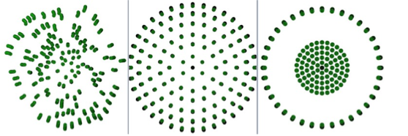
As Built Ideal Poor

Fig. 9 As-built Wire Distribution compared with Ideal Brooming Configuration
and Poorly Broomed Configuration

Analysis results suggest that a more uniform distribution of wires within the zinc matrix leads to the development of better confining pressure on the broomed wires, reduced excessive extrusion of the zinc, and a more predictable failure wire mode outside the socket termination. The more non-uniform the density distribution of wires over a cross section of the zinc matrix, the “worse” the brooming is considered. An as-built brooming configuration was developed from an existing open socket spelter build. Based on Figure 9, it is visually apparent that the as-built configuration falls somewhere between an “ideal” and a “poor” brooming, as expected. The “ideal” brooming configuration modeled may never be achieved in practice.

Brooming quality becomes more important for designs with low structural margins in the outer row of wires. A sensitivity analysis was performed comparing the outer wire stresses for the three brooming configurations with decreasing levels of quality of brooming. The plastic strains and tensile stresses in the outer wires increased with decreasing quality of brooming. The proposed explanation for this phenomenon is that more brooming leads to better development of confining pressure in the narrow end of the socket, which results in a more distributed load across the cable cross section. Better brooming prevents excessive zinc seating extrusion and time-dependent extrusion due to the distribution of wires through the zinc volume, resulting in a composite system that uses the entire embedded wire surface to resist flow. When there is a lesser degree of brooming, there is more zinc plastic flow, and the mechanical response exhibits a softening phenomenon (i.e., a reduction of tangent modulus), which leads to a distribution of load into the outer wires as the wire and zinc continue to experience excessive seating extrusion. For poorly broomed configurations, a lower volume of high triaxial compression is predicted, which is directly correlated to the effects of confining pressure on the wires that keeps the wire-zinc bond intact; more brooming redistributes load into wires across the cross section.

In summary, brooming of the cable or wire rope end section is critical in developing the overall capability of the termination. Increasing the level of brooming fundamentally achieves two things that affect final capability: (1) Develops confining pressure in the zinc to “lock” wires in place by increasing the pressure at the zinc-wire interface to prevent the wires from pulling through the socket outlet; and (2) develops a stress concentration in the wires at the socket outlet due to their curvature from brooming. Increased levels of brooming results in more wires experiencing elevated stresses at the socket outlet, but in turn locks the zinc into place better, relieving the total shear stresses in the zinc and at the zinc-wire interface. Effectively, better brooming traps the wires and redistributes stress to the wires, while poor brooming puts more shear stress into the zinc, which can have deleterious effects on termination performance.

Zinc spelter plasticity

Zinc plasticity is fundamental in achieving full design efficiency. In nearly all cases analyzed and for nearly all zinc material models considered, the majority of the zinc volume yields during initial phases of loading. The zinc plastic flow is crucial in developing the confining pressure in the conical socket cavity and the resulting squeezing that occurs at the zinc-wire interface to prevent wires from pulling out of the socket. The zinc plasticity also changes the overall stress distribution shape for the broomed wires, enabling a load redistribution across the cable cross-section to reduce the magnitude of stress concentration and ensure failure occurs just outside of the socket.

Despite the large variability in zinc material properties due to grain size, shape, orientation, and differing tensile and compressive strength, the zinc is still considerably weaker compared to the socket or the cable such that significant levels of yielding and plastic flow occur for the complete range of material properties considered. In all cases, a relatively small amount of yielding achieves the necessary flow to confine the wires and develop significant load capability in the cable.

Zinc creep

Cast zinc is under a large amount of shear and compression stress in this design due to the wires shearing the zinc at the bonded interface and the overall compression that develops once the volume of zinc flows and becomes compressed by the narrow end of the socket. Zinc is susceptible to creep behavior at a higher rate than steel wires. Shear stresses vary throughout the cast spelter volume, with the highest stressed regions being in the narrow half of the socket and sufficiently high in magnitude to expect the occurrence of creep. The significant stress and strain levels in the zinc are evident in the plastic strain field shown in Figure 7. One could model creep behavior, but a sensitivity study was performed for cases that considered zinc linear, zinc nonlinear with a “medium level” of softening, and zinc nonlinear with a “higher level” of softening. More softening contributes to more plastic flow and higher stresses in the outer wires. Analysis with “soft” zinc properties mimicking creep suggests that plastic flow is likely to occur over time and will continuously redistribute load into the outer wires as the inner wires and core continue to mobilize. The hydrostatic effects that develop in the zinc are key to developing load transfer to the wires due to the pinching mechanism that occurs in the regions of high compression near the outlet of the socket.

Contact between zinc spelter and socket

The slug of cast zinc is known to get “seated” into the socket during proof test, pre-stretching, and operation. The effect of the zinc seating itself within the conical socket volume aids in developing the same physical phenomena that occurs during zinc plastic flow. That is, the seating develops confining pressure near the wire outlet of the socket to grip the wires and prevent excessive shear from developing in the zinc or slippage in the wires. The exact friction coefficients achieved in practice are not known, however, only a small amount of slippage is required to develop significant confining compression on the wires within the socket.

Void formation in the Zinc

An analytical study was pursued to study whether zinc voids significantly affect the wire stresses at the socket outlet. Three analytical models were developed, one with a void toward the wire outlet side, one with a void midway down the length of the socket, and one with a void toward the large diameter side of the socket. The voids were simulated by deleting elements representative of the zinc material. Analyses predicted negligible effects on the outer wire stresses due to the presence of these voids. All effects of the voids were limited to the local area adjacent to the voids and did not affect the overall stress distribution of the wires. However, the analysis could not rule out local zinc damage contributing to accelerated plastic flow, which could in turn have led to higher stresses in the outer wires. It is also possible that there exists a critical defect size or void percentage that would prevent the necessary confining pressure from developing, however, that value was not determined by this study.

Separately, a model configuration was run where 20% of the zinc volume was removed from the large diameter side of the socket to mimic the existence of corrosion or damage that can occur at the exposed end of an open spelter socket. The loss of zinc away from the wire outlet of the termination indicated no change in the critical wire stress level and did not indicate a difference in termination capacity.

Cumulative Damage

A finite element model was constructed to understand the zinc and wire mechanical behavior due to proof testing followed by fluctuating cable loads. A six-step analysis process was performed: (1) socket proof test to 50% rated breaking strength (660 kips), (2) Unload (<12 kips), (3) Load to initial operational load (624 kips), (4) reduce to lower operation load (500 kips), (5) Increase to higher survival load (720 kips), (6) Return to original operational load (624 kips). In reference to Figure 10, it was confirmed that cyclic loading beyond proof test loading progressively increases strain in wires, progressively increases plastic flow in zinc, and exhibits structural hysteresis. During subsequent loading events at lower magnitudes, the response in outer wires remains linear. In Figure 11, the field outputs for state of yielding is shown for each analysis step and confirms that the majority of the structure responds linearly for loading below previously achieved loads (from proof test, initial operations, or survival conditions). Subsequent elevated loading or load reversal results in yielding of the zinc, while the wires only yield during subsequently increased tension loads but not in compression during load reversals.

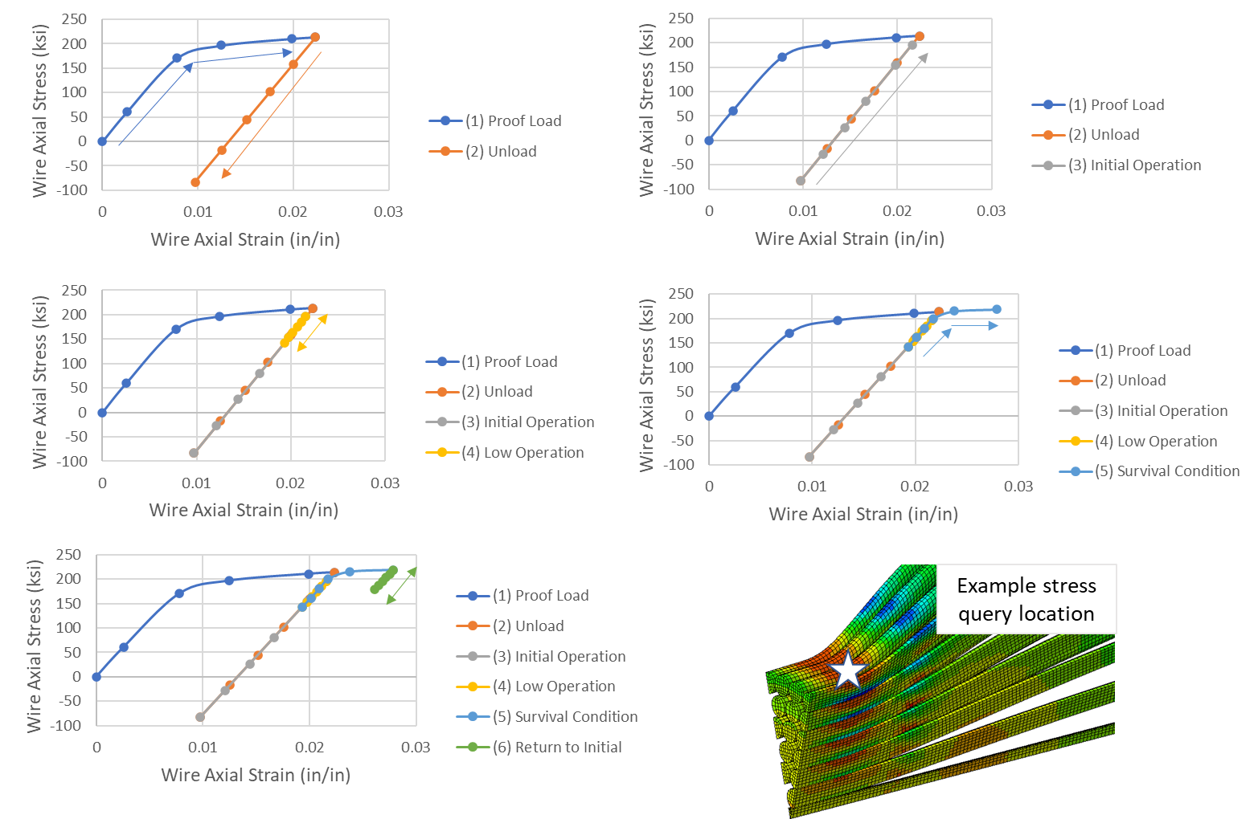
Fig. 10 Stress history and hysteresis from repeated loading during analysis Steps 1 through 6.

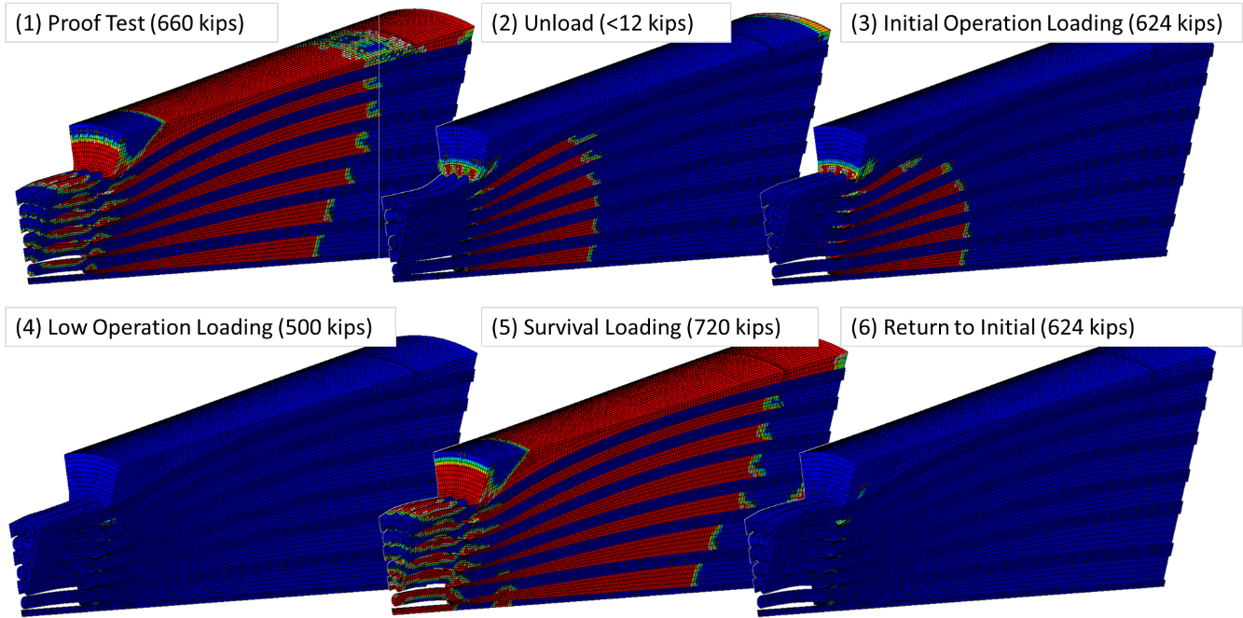
Fig. 11 Yield state shown in red for zinc and wires for each analysis step.

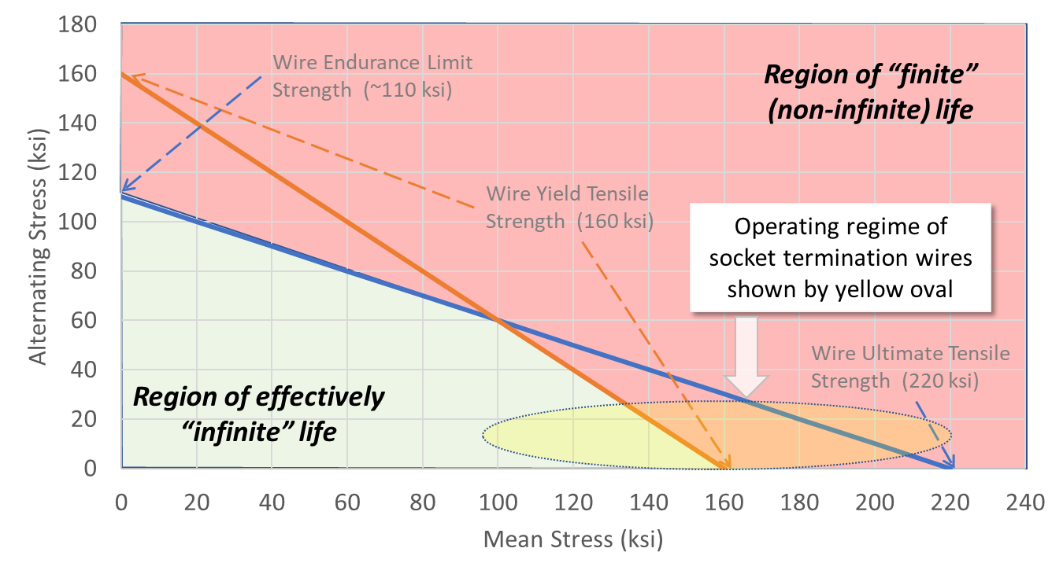
Fig. 12 Modified Goodman Diagram showing regions of finite and infinite life for combinations of mean and alternating stresses in a design. The example socket termination stress combination region is shown by the yellow oval indicating some finite expected lifetime.

The concept of a modified Goodman diagram can be employed to demonstrate the relationship between mean stress offset, cyclic stresses, and their combined effect on expected life. Qualitatively, the modified Goodman diagram gives information on whether the design space (mean and alternating stress combination) possesses effectively infinite life or whether some finite life failure is expected. The diagram is constructed by establishing axes for mean stress (horizontal) and alternating stress (vertical) and drawing one line between ultimate tensile strength and endurance limit strength and another line between yield strength on both axes. The conservative inner envelope of yield strength and endurance limit stress is the region where effectively infinite life would exist for combinations of mean and alternating stresses existing within that region. Outside this envelope, some finite lifetime is expected, dependent on the exact load history, material capability, susceptibility to environmental degradation, etc. The modified Goodman diagram for the highly loaded outer wires of the analyzed socket termination is shown by the yellow oval in Figure 12. The diagram indicates finite life due to cyclic loading conditions. The diagram was constructed for specification yield and ultimate strengths of the individual wires, but the concept can be extended to nominal strengths, A-basis, or values specified by design requirements documents.

Generally, materials incur cumulative damage due to both sustained and cyclic loading, as structures are not likely operating in conditions where one of the contributors is totally absent. Accumulation of damage occurring due to sustained and cyclic loading can be linearly combined using Miner’s rule. This is illustrated by the interaction diagram in Fig. 11. Here, $n$ and $N_{d}$ are the number of cycles and the allowable number of cycles for the loading condition $j$; $t$ and $T_{d}$ are the actual time at stress level $k$ and the allowable time at that stress level. $D$ is the allowable combined damage fraction. The point of this diagram is simply to illustrate that time-dependent degradation modes are not only due to sustained loading alone, but that cyclic loading can accelerate creep-related failure modes. The graphic shows an example exchange rate between cyclic and time-dependent contributors to total accumulated damage.

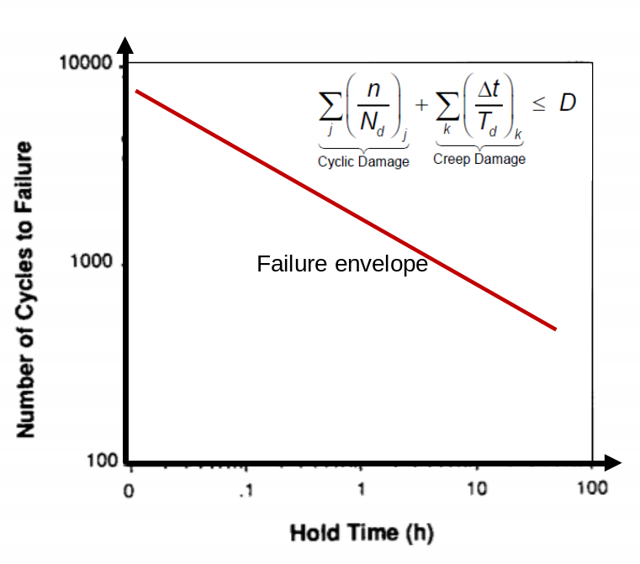
Fig. 13 Exchange of structural durability under combined cyclic and sustained loading

When designing with a spelter socket, the percentage of deadload to total load must be considered as well as the transient nature of the loads. For many deadload dominated designs, simply comparing the alternating cable load with the mean cable load (sustained) demonstrates that relevant failure modes are influenced by creep. This is of particular importance when considering the susceptibility of zinc to creep and the effects that zinc plasticity has on the wire stress levels.

- Conclusions

This work examined the fundamental mechanics associated with open spelter socket terminations, specifically a 3.25-inch structural strand of 1x127 construction terminating into a cast zinc spelter socket. The suite of analytical studies helped develop an understanding of the load transfer mechanism that develops 100% efficiency rating for these terminations. Zinc plastic flow, cast zinc slug seating, and wire brooming are all shown to be primary factors that facilitate the efficiency. Analyses helped expose the exchange that occurs between wire brooming and zinc strain level. Less complete brooming results in a more uniform stress across the wire cross section at the expense of shear stress and strain in the zinc. More complete brooming achieves more confining pressure to lock the wires into the socket termination but at the expense of locally high stresses in the highly-broomed outer wires. In all cases, the design factor of safety of 2.0 applied to the rated breaking strength of the cable does not retain a factor of 2.0 against individual structural element capability when considering the constituent stress levels in the wires and zinc local to the termination. Even during the proof testing and pre-stretching events, there is significant zinc flow and local wire yielding. This helps achieve a more linear elastic response during operation, but provides a misleading capability because damage is known to be occurring well below the breaking strength of the cable. The level of redundancy in the design, deadload to total load ratio, loading transients, and service lifetime all should be considered to protect against deleterious and previously unknown levels of stress or damage that occurs adjacent to the termination.

- Acknowledgements

The contents of this paper were derived from a failure analysis documented in References 13 and 14. The work was funded by the NASA Engineering Safety Center (NESC). The authors gratefully acknowledge the technical contributions of the following individuals: Azita Valinia (NESC Chief Scientist), Kauser Imtiaz (NASA Technical Fellow for Structures), James Smith (NESC TDT Structures Deputy), and Jonathan McGormley (Wiss, Janney, Elstner Associates, Inc., Principal Engineer).

- References
[1] "Wire Rope Slings," 1 June 2021. [Online]. Available: https://www.pacificriggingloft.com/wire-rope-slings/.
[2] The Crosby Group, Wire Rope End Terminations User's Manual, Tulsa, OK, 2014.
[3] American Society of Civil Engineers, Structural Applications of Steel Cables for Buildings, Reston, VA: ASCE, 2010.
[4] K. Ali, H. Katsuchi and H. Yamada, "Comparative Study on Structural Redundancy of Cable-Stayed and Extradosed Bridges Through Safety Assessment of Their Stay Cables," Engineering, vol. 7, no. 1, pp. 111-123, 2021.
[5] Japan Road Association. Specifications for highway bridges: part II, steel bridges. Tokyo: Japan Road Association, 2017. Japanese
[6] EN 1993-1-11: Eurocode—3. Design of steel structures – Part 1-11: Design of structures with tension components. European standard. Brussels: European Committee for Standardization; 2006.
[7] Post-Tensioning Institute. Recommendations for stay-cable design, testing, and installation. 5th edition. Farmington Hills: Post-Tensioning Institute; 2007.
[8] Service d’Etudes Techniques des Routes et Autoroutes. Cable stays – recommendations of French interministerial commission on prestressing. Bagneaux Cedex: Service d’Etudes Techniques des Routes at Autoroutes; 2001. French
[9] International Federation for Structural Concrete. Acceptance of stay cable systems using prestressing steels. Report. Lausanne: International Federation for Structural Concrete; 2005.
[10] J. Bradon, C. Chaplin, and I. Ridge, “Analysis of Resin Socket Termination for a Wire Rope,” Journal of Strain Analysis for Engineering Design, January 2001. DOI: 10.1243/0309324011512621
[11] https://youtu.be/Jj_K6bGQIfM?t=26, “hilifting.com - 76 mm Impressive Wire Rope Break Test,” August 12, 2010, last accessed June 16, 2021.
[12] P. Gossen, “Design with Cables,” Structure Magazine, November 2004. URL: https://www.structuremag.org/wp-content/uploads/2014/09/DesignWithCables.pdf, last accessed June 16, 2021
[13] G. Harrigan, V. Azita, N. Trepal, P. Babuska, V. Goyal, “Arecibo Observatory Auxiliary M4N Socket Termination Failure Investigation,” NASA/TM−20210017934, NESC-RP-20-01585. June 2021. Access online: https://ntrs.nasa.gov/api/citations/20210017934/downloads/20210017934%20FINAL.pdf
[14] G. Harrigan, V. Goyal, “Industry Recommendations from Arecibo Observatory Zinc Spelter Socket Joint Failure Analysis,” NASA Engineering and Safety Center Technical Bulletin No. 21-05. Access online: https://www.nasa.gov/sites/default/files/atoms/files/tb_21-05_arecibo_failure_analysis_080221_final.pdf

Corresponding author: Senior Member of Technical Staff, pavel.babuska@aero.org
Principal Engineer, AIAA Associate Fellow, vinay.k.goyal@aero.org
Principal Engineer, gregory.harrigan@nasa.gov

