NTAC AUGMENTED NUCLEAR AND ADVANCED PROPULSION
Sang H. Choi¹, Dennis M. Bushnell², and Robert W. Moses³
NASA Langley Research Center, Hampton, VA 23681-2199, U.S.A.
Currently, there are two types of nuclear propulsion: Nuclear Thermal Propulsion (NTP) and Nuclear Electric Propulsion (NEP). Common to both types, a nuclear reactor generates heat energy to raise the temperature of propellant, or the generated heat energy is converted into electric power. The electricity generated powers propulsion systems, such as a Hall thruster, magnetoplasma dynamic (MPD) thruster, or variable specific impulse magnetoplasma rocket (VASIMR). Customarily, only the thermal energy output from nuclear reaction is considered for NTP and NEP systems. However, the nuclear fission reaction can also generate ~7 MeV of prompt gamma rays. Therefore, most designers of NTP and NEP systems incorporate safety features to shield against this radiation. An optimized design approach would be to integrate a Nuclear Thermionic Avalanche Cell (NTAC) within the NTP or NEP structure for converting this radiation energy into additional electric power, while also shielding gamma rays. Consequently, this study addresses several combinations of NTP and NEP structures with NTAC devices in order to achieve that goal.
- Nomenclature

E_{r} = average recoverable energy per fission (MeV/fission)
c = speed of light (3x10⁸ m/s)
E_{b} = binding energy (MeV)
m = mass (kg)
N = atomic number density (atoms/cm³)
P = reactor power output (MeV/s)
V = total volume of the core (m³)
σ = microscopic cross section (cm²)
Σ = collision probability (atoms/cm)
Φ = neutron flux (neutrons/cm²⋅s)
Σ_{t}⋅Φ = total reaction rate
Σ_{a}⋅Φ = absorption reaction rate
Σ_{r}⋅Φ = radiative capture reaction rate
Σ_{f}⋅Φ = fission reaction rate

- Introduction
NTP and NEP thrusters are considered by NASA as an attractive choice for long-haul travel in space, particularly to and from Mars. Nuclear fission reactors for NTP and NEP were basically designed to use thermal energy that is yielded from the fission process of large nuclei, such as uranium-235 or plutonium-239. The energy released from nuclear fission process consists of:
- Kinetic energy of fission fragments,
- Kinetic energy of prompt neutrons,
_____________________________
¹Senior Scientist, Advanced Materials and Processing Branch, RD, Associate Fellow
²Chief Scientist, Office of Director, Honorary Fellow
³Senior Engineer, Atmospheric Flight and Entry Systems Branch/ED, Associate Fellow
- Energy carried by prompt γ-rays,
- Energy of β− decay,
- Energy of antineutrinos,
- Energy of delayed γ-rays, and
- Energy of γ-rays from radiative capture.
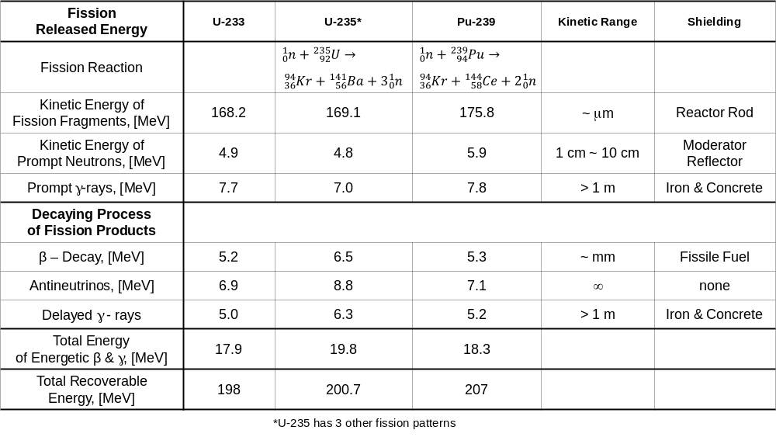
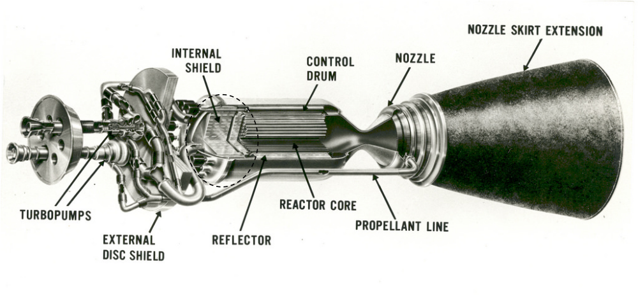
Table 1 illustrates energy release types from nuclear fission processes for U-233, U-235, and Pu-239. It is evident that a major portion of fission energy is thermal (169.1 MeV from U-235 and 175.8 MeV from Pu-239). As thermal energy from the nuclear fission reaction is directly used for heating the NTP rocket propellant, there are key limits imposed on the process is that the temperature of propellant cannot exceed the melting points of nuclear reactor materials and a shielding requirement from the prompt gamma ray (7 MeV) and the delayed gamma ray (6.3 MeV) as shown in the dotted circle area of NERVA engines [1] in Figure 1.
Figure 1. Artist rendering of NERVA engine. The dotted circle indicates the imbedded radiation shielding [1].
Table 1. Energy released from the fission reaction.
For NEP application, the thermal energy from nuclear reactor must be converted into electrical power to drive the electric thrusters. Such conversion processes are well-constituted with the conventional thermodynamic cycles or direct energy conversion processes such as for the magnetohydrodynamic (MHD) generator. However, these conversion cycles are usually only 30% efficient, resulting in up to 70 % energy loss.
A typical feature of NTP and NEP systems is to only utilize the nuclear thermal output energy (i.e. 169.1 MeV from U-235 and 175.8 MeV from Pu-239 as shown in Table 1) for propulsion. However, approximately 13.3 MeV (6.5%) out of the total fission energy which comprises photon energy by the prompt and delayed gamma ray (as shown in Table 1) is discarded and not exploited for propulsion. The conventional design of NTP and NEP adopts radiation shielding against high energy photon yields from the fission reaction. Accordingly, the shielding requirement adds more weight and complexity to NTP and/or NEP systems. This paper explores a new approach to capture that photon energy and convert it directly to electrical power.
A new energy conversion system, referred to as nuclear thermionic avalanche cell (NTAC) [2], clearly represents an advantage when combined with NTP or NEP technology to utilize high energy photons from a nuclear fission process for direct power generation. NTAC constitutes a new breed of nuclear battery that delivers high specific power by harnessing and guiding a large number of intra-band electrons directly into a power circuit. In this paper, several configurations of NTP and NEP are included to demonstrate potential benefits of integrating NTAC for increased propulsion and additional power generation.
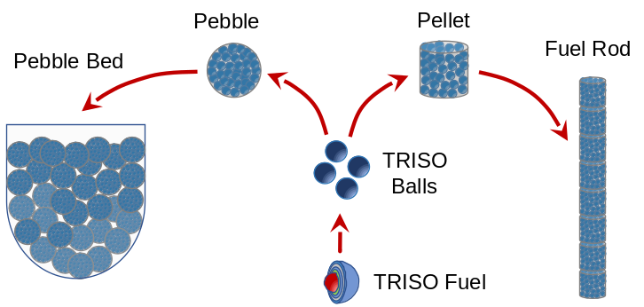
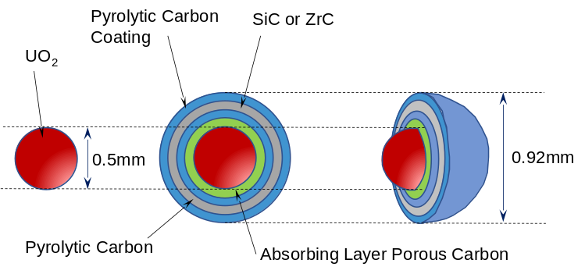
It is necessary to scrutinize NTP and NEP in terms of principles and applications to better explain the proposed, innovative configurations. A recently studied NTP model utilizes ceramic encapsulated nuclear fuel, called Fully Ceramic Micro-encapsulated (FCM™) fuel [3]. The FCM™ in its shape and composition is very similar to the TRISO (TRi-structural ISOtropic) particle fuel as shown in Fig. 2 [4]. Each TRISO particle is made up of a uranium, carbon and oxygen fuel kernel. The kernel is encapsulated by three layers of carbon- and ceramic-based materials that prevent the release of radioactive fission products. The FCM™ features high-assay low-enriched Uranium (HALEU) ZrC-encapsulated fuel particles. This variation enables high-temperature operation while maintaining the integrity of the fuel. The Ultra Safe Nuclear Technologies′ (USNC-Tech′) NTP engine [3] is regarded as an improved version and some small modular reactors (SMR) utilize TRISO fuels for nuclear fission. These are structurally more resistant to neutron irradiation, corrosion, oxidation and high temperatures (which are the factors that most impact fuel performance) than traditional reactor fuels. The TRISO particles are incredibly small and very robust. TRISO can be fabricated into cylindrical pellets or billiard ball-sized spheres called “pebbles” for use in either high temperature gas or molten salt-cooled reactors as shown in Fig. 2 [4].
Figure 3. Fabrication of pellets and pebbles using TRISO fuel.
Figure 2. TRISO fuel elements composition in a sphere pebble embodiment.
Further details of the fabrication process of TRISO pellets are presented in Fig. 3 [5]. The TRISO pellets can be used for reactor core assembly in a manner very similar to the conventional reactor configuration with fuel pellets stacked in a rod form. In contrast, the TRISO pebbles can be used as a fluidized-bed like reactor core where the active gas medium passes through the pebble bed to capture thermal energy in a much more efficient way since the overall heat transfer surface areas of pebbles are extremely large, as shown in Fig. 4, which is most-likely favorable for NTP application. In this case, another benefit of TRISO pebble fluidized-bed is the working medium that might additionally slow down those fast neutrons. When high pressurized hydrogen gas is used as an active gas medium, hydrogen atoms can easily retard the fast neutrons into slow (thermal) neutrons through an elastic collision process while passing through pebble-bed (see also Table 2) [6].

- New Configurations of NTP and NEP with NTAC
 | Neutron scattering cross  section (σ_{s}) in barns | Neutron absorption cross  section (σ_{s}) in barns
Light water (H2O) | 49 | 0.66
Heavy water (D2O) | 10.6 | 0.0013
Graphite (C) | 4.7 | 0.0035
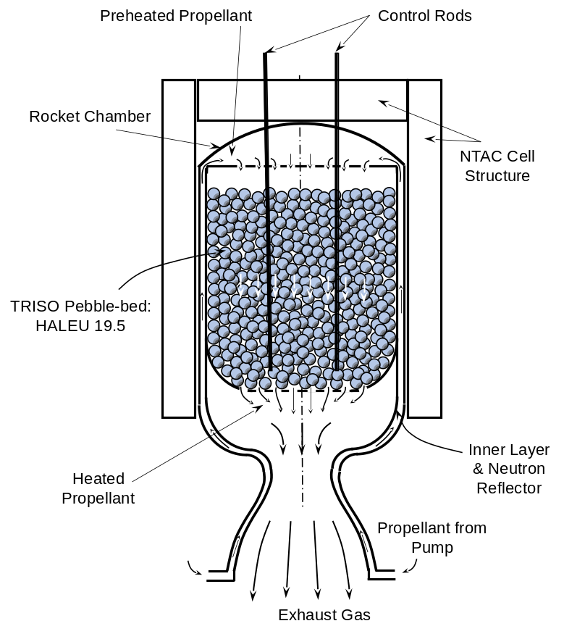
The proposed new configurations of NTP and NEP augmented with NTAC utilize not only the nuclear thermal output, but also the photon energy of the prompt and delayed gamma ray emitted from nuclear fission process for power generation using NTAC as shown in Figs. 4 - 8. As listed in Table 1, the summation of radiation energy compromises 6.5% (13.3 MeV for U-235 fission) of total energy output of fission reaction. As shown in Figs. 4 and 5, the propellant flows through the nuclear core to get heated to a desired temperature. While flowing through the core, the propellant, if it is hydrogen, also acts as a good moderator to slow down fast neutrons. Table 2 shows the neutron scattering and absorption cross sections of reactor materials currently used. Obviously, hydrogen has large scattering and absorption cross sections that play a major role to slow those fast neutrons coming out of the fission reaction.
Figure 4. A cross-section view of a nuclear reactor with TRISO pebble-bed encapsulated by cylindrical NTAC layers that capitalize all the radiation energy (6.5%, 13.3 MeV) for additional propulsion.
Table 2. Properties of common neutron moderators [6]
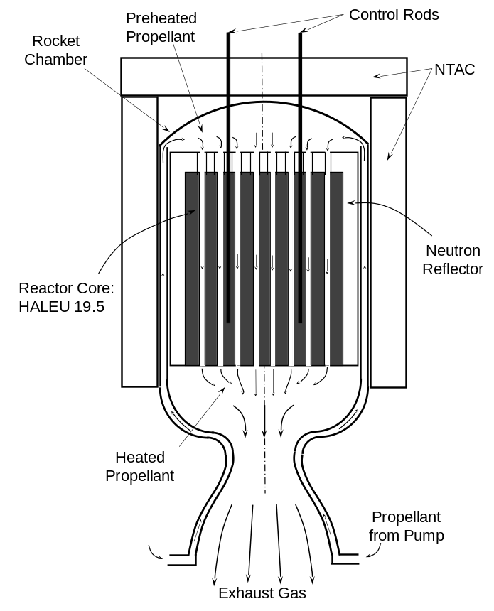
Such collisions between neutrons and propellant medium are also one of the ways to raise propellant temperature. When energetic neutrons carrying 4.8 MeV and antineutrons with 8.8 MeV from U-235 in fission collide with propellant gaseous molecules such as hydrogen molecules or argon atoms, these molecules gain sufficient energy from energetic neutrons and antineutrons. For hydrogen molecules, elastic collisions prevail and slow down fast neutrons to be thermal neutrons which require much less stringent absorption cross-section needed for chain reaction. For heavy elements that consist of propellant, inelastic collisions are dominant and exchange a small portion of energy between neutrons and heavy elements. Accordingly, energetic neutrons and antineutrons have very active roles to raise the temperature of propellant, in addition to the kinetic energy of fission fragments as listed in Table 1. During the fission reactions, there are not only the emissions of high energy photons at 7 MeV as a prompt radiation, but also the emission flux of delayed gamma ray at 6.3 MeV from decaying process of fission products (see Table 1). These gamma rays together (7 MeV and 6.3 MeV) penetrate through the fuels, neutron reflector, and rocket chamber wall to escape. Conventionally, in order to shield these gamma rays, the early and current nuclear rocket designs require a shielding blanket of gamma radiation. Instead of placing shielding, NTAC is adopted to the nuclear rockets in order to utilize these gamma rays for additional power by converting directly into electric power. A number of NTAC layers as a conversion device structure wraps around the nuclear rockets as shown in Figs. 4 and 5. The flux of high energy gamma ray photons passing through the NTAC emitter material liberating a huge number of intra-band electrons of atoms of emitter material. These avalanche electrons liberated from the emitter by gamma rays are emitted across the vacuum gap to arrive at the NTAC collector where the avalanche electrons are guided and loaded into the power circuit. Because the gamma ray from a fission reaction is so strong, several layers of NTAC may be used for converting the gamma ray energy into electricity until the penetrating gamma ray becomes completely converted and diminished. In this regard, the NTAC layers play the radiation shielding role. The nuclear reactor cores, whether with pellets or pebbles, have the same fundamental features, such as the control and trigger rods, within the reactor as the conventional reactors have. The fission reactor allows propellant to flow through between fuel rods or pebbles as shown in Figs. 4 and 5. The number of NTAC layers (of which a layer consist of the collector, insulator, and emitter as a single pair structure, except for the first layer which is the emitter attached to the fission reactor core) is determined by the kind of selected materials for emitter, insulator and collector in order to capture all spectrum of photon energies. The last layer consists of a collector, an insulator, an NTAC outermost shell structure, and a shielding layer. The outermost layer is the radiation shielding that cuts off any possible leak through NTAC layers.
Figure 5. A cross-section view of a NTP chamber with reactor rods of which chamber is encapsulated by cylindrical NTAC layers that capitalize all the radiation energy (6.5%, 13.3 MeV) for additional propulsion.
- New Design Aspects of Nuclear Rockets
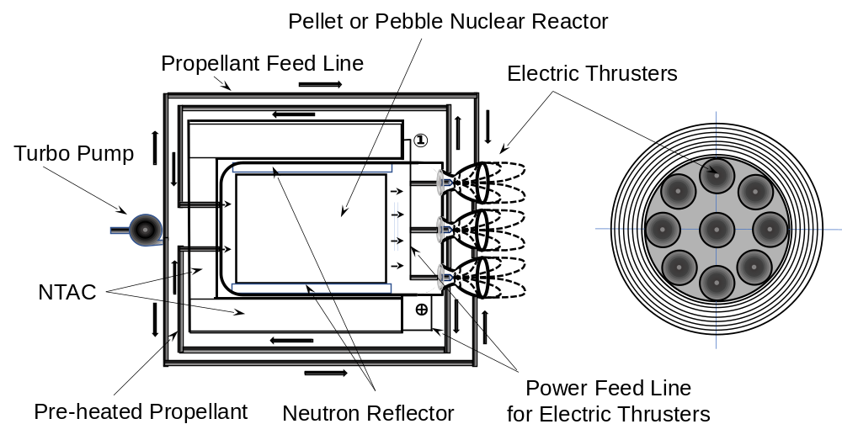
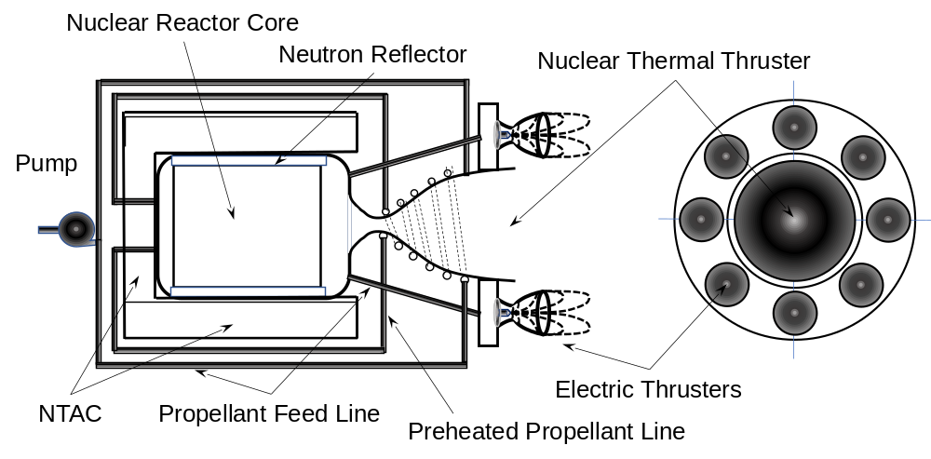
A variety of the nuclear rocket designs become possible, due to the power generation capability of a NTAC device. The electrical power generated by NTAC drives electric propulsion thrusters only or in combinations of thermal expansion thruster. In order to achieve that, the NTP shown in Figs. 4 and 5 can be modified with (1) all electric thrusters and (2) a thermal thruster augmented with additional electric thrusters. If necessary, the thermal thruster can be combined with electric thrusters. Figure 6 shows a scaled-down version of thermal thruster that allows some heated hot propellant to be by-passed to the augmented electric propulsion thrusters.
Figure 6. Nuclear thermal rocket augmented with NTAC power sustained electric thrusters.
Figure 7. Nuclear electric rocket augmented with NTAC power. NTAC power sustains all electric thrusters.
The by-passed propellant that is fully heated through the reactor core is beneficial to electric thrusters because less power is required to ionize the propellant. Although the ionization potentials of hydrogen (13.6 eV) and argon (15.76 eV) are quite high, pre-heated propellant can reduce the power for ionization. The ionization of hydrogen starts at or around 5000 K while high pressure argon of 4 g/cm³ or at 100 GPa starts at 50,000 K [7]. This group of electric thrusters is powered to ionize and accelerate propellant further for high specific impulse (Isp) by the NTAC generated power. In this case, the augmented electric thrusters improve the overall performance of the propulsion system. Usually, the Isp of electric thrusters is an order of magnitude higher than with thermal expansion thrusters. Therefore, as long as the power generated from NTAC can cover the power requirement for electric thrusters, the design must maximize the number of electric thrusters to be augmented to NTP. For this design arrangement, it does not matter whether the nuclear core is composed of a pellet or pebble fuel source. Both will work with nominal differentiation. Fig. 6 describes the nuclear core with pellets; however, the nuclear core can be designed to have pebbles as a nuclear fuel (see Fig. 4). Figure 7 shows the version of NTAC augmented NEP. In Fig. 7, NTAC powers all electric thrusters. In this case, the nuclear thermal thruster shown in the middle of thruster structure (see Fig. 6) can be replaced with an electric thruster driven by electrical power through a certain conversion cycles or by a direct energy conversion method to sustain the number of electric thrusters in a cluster.
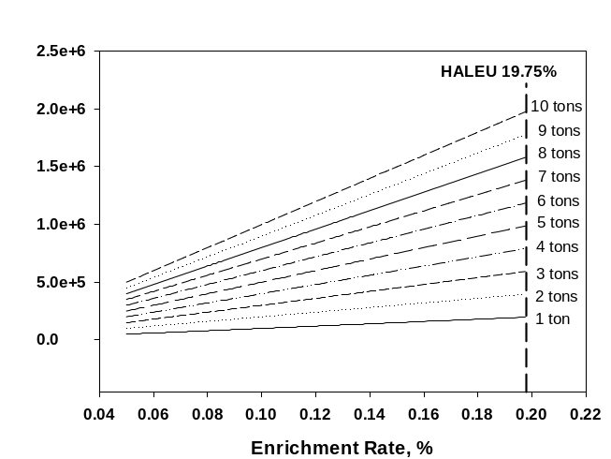It is important to determine the amount of nuclear power that is accruable from NTAC augmented NTP or NEP systems. Consequently, analysis of a nuclear reactor using High-Assay Low-Enriched Uranium (HALEU) up to 19.75% was evaluated. The fission reaction rate must be sized for the required power generation for NTP and NEP thrusters, based on the fission reactions specific to NTP and NEP. Therefore, the estimations of nuclear fission parameters and photon power are made here for NTP and NEP powers ranging from 400 MW to 3000 MW that may be practically applicable for the invented idea “NTAC augmented NTP and NEP thrusters” [8]. Another important consideration is the type of nuclear fuel selected. This paper uses High-Assay Low-Enriched Uranium (HALEU) with 19.75% for the analysis.
Figure 8. Contents of uranium-235 (U-235) within the nuclear fuel based on the enrichment rate.
Figure 8 shows the contents of uranium-235 (U-235) within the nuclear fuel based on the enrichment rate. The dotted column on the right-hand side shows the total weight of nuclear fuel for NTP or NEP. There are several types of fission reaction rate that can be determined by the interactions associated with the appropriate cross-section: Σ_{t}⋅Φ for the total reaction rate, Σ_{a}⋅Φ for the absorption reaction rate, Σ_{r}⋅Φ for the radiative capture reaction rate, and Σ_{f}⋅Φ for the fission reaction rate.
The fission reaction rate is determined by the integration of reaction rates with respect to the neutron cross section of fissile material and the thermal neutron flux for estimating the overall power generation as described in the following equation (1):
$R_{fi}=\int_{0}^{∞}{Σ\left(E\right)∙Φ\left(E\right)dE=Σ∙Φ}=Φ∙N∙σ$ (1)
The power, rate of energy, released is given by the following equation (2):
$P=R_{fi}∙E_{r}∙V=Φ∙Σ_{t}∙V=Φ∙N_{U235}∙σ_{f}^{235}∙E_{r}∙V$ (2)
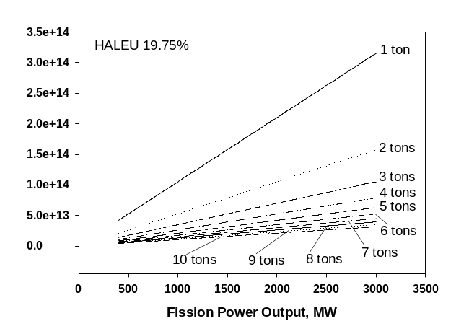
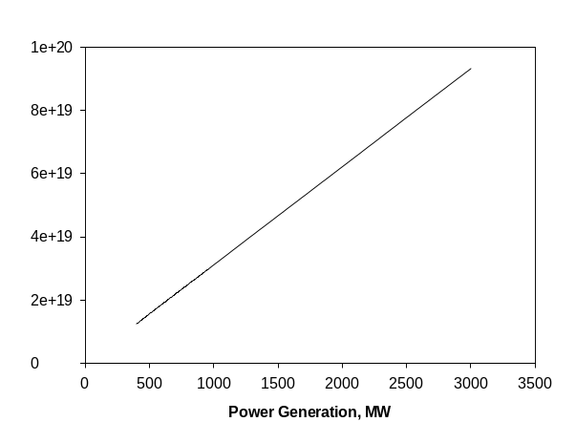In order to generate the required power output from the fission reaction, the injection of thermal (slow) neutrons into uranium fuel rods is required to have fission reactions. In general, the neutron-induced fission reaction is the reaction taking place where the incident neutron enters into the heavy target nucleus (fissionable nucleus). The incident neutron is added to the fissionable nucleus to form a compound nucleus that becomes excited to an energy level beyond the critical level (E_{excitation} > E_{critical}). In such a case, the exceedingly high excitation energy causes the nucleus to split into two large fission fragments. Through this fission process, a large amount of energy is released in the form of radiation and kinetic energy of fragments. A critical feature is that the fission process may produce 2, or 3 free and fast neutrons and 2 or 3 prompt energetic photons with 7 MeV for U-235 or 7.8 MeV for Pu-239 (see Table 1). These fast neutrons must be tampered down to slow neutrons to facilitate neutron absorption into the nucleus and at the same time those neutrons escaping from a fissionable nucleus must be reflected back into the domain to trigger further fission and a chain reaction to take place.
Figure 10. Fission reaction rate with HALEU 19.75%.
Figure 9. Neutron flux for uranium-235 (U-235) to generate desired power levels.
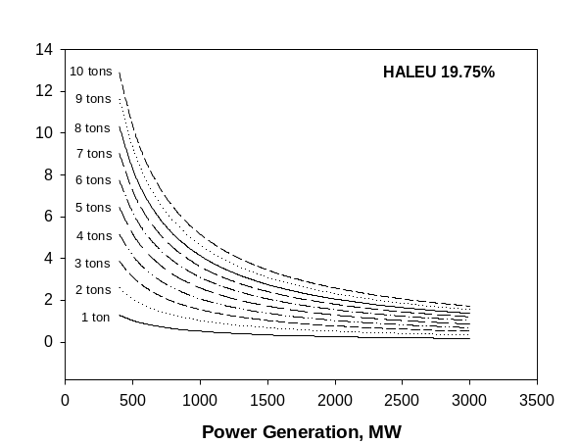
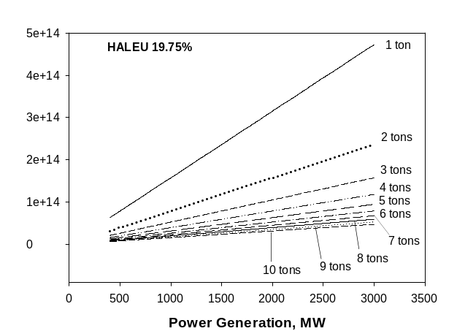At the nuclear level, the nuclear binding energy is the energy required to hold (with the strong nuclear force) or disassemble (to overcome the strong nuclear force) a nucleus of an atom into its component parts (nucleons: protons and neutrons). In general, the protons and neutrons in an atomic nucleus are held together by strong nuclear forces. However, there are many sub-atomic particles (leptons and quarks) performing exquisite roles to arrange and hold protons and neutrons in balance within the domain. The mass of a nucleus is always less than the sum of masses of the constituent protons and neutrons when taken separately. The difference is a measure of the nuclear binding energy (E_{b}) which holds the nucleus together. According to the Einstein relationship (E=m⋅c²) this binding energy is proportional to this mass difference and it is also known as the mass defect.
Figure 11. Duration of loaded fuel based on power requirement.
Figure 12. Gamma ray emission rate based on fuel consumption defined with power requirement.
Figure 9 shows the required number of thermal (slow) neutrons to not only trigger fission, but also generate the desired power level when HALEU 19.75% uranium-235 fuel is selected. Various fuel weights, 1 ton through 10 tons, were considered for generating potential power output from 400 MW to 3000 MW. When a system power requirement and size of reactor in weight for NTP or NEP are selected, neutron flux is determined to operate the fission process of nuclear reactor. The NTAC operation is defined based on the fission reaction rate.
Figure 10 shows the fission reaction rate to generate a certain power from the reactor core. For example, if the power required is 2000 MW, then at least a fission reaction rate of 6x10¹⁹ must be sustained. Technically, this type of operation associated with fission reaction rate is already well-known for a selected enrichment rate of nuclear fuel. This example illustrates that the photon power of a gamma ray can be harvested from a fission reaction with the augmented NTAC technology.
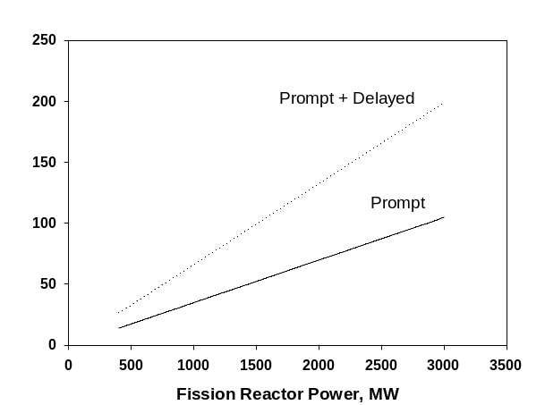
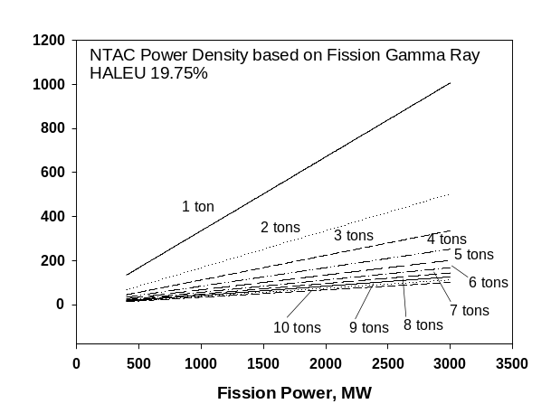
Figure 11 shows the operation duration for NTP or NEP with HALEU 19.75% nuclear fuel when an NTP operates at a given level of power generation. The plot shows that the higher the power output, the shorter the operational duration. This analysis indicates the amount of HALEU 19.75% fuel that must be loaded to achieve the required power output. For example, an NTP operating with 5 tons of fuel loading for 1000 MW power output can last about three years, which is consistent for a long-haul space travel to Mars and back. Figure 11 also serves to illustrate the fuel loading for a selected power output level based on the period of operation.
Figure 14. Photon power of gamma ray that can be converted into electrical power by NTAC.
Figure 13. Specific power of gamma ray driven NTAC based on fuel consumption defined with power requirement.
As described above, there are two kinds of gamma ray emissions from fission reaction: one is the prompt (7 MeV) and the other the delayed (6.3 MeV) for uranium-135 as listed Table 1. Figure 12 shows the gamma ray emission rate based on the fuel loading and power output requirement. The overall emission rate of gamma rays is accordingly increased for a certain power requirement, since a small amount of loaded fuel must be burned quickly. The performance requirement of the reactor is different from the HALEU reactor fuel for highly enriched uranium (HEU).
Figure 13 shows the specific power of a gamma ray-driven NTAC, based on the fission fuel loading and power output level. This specific power of NTAC is based on the weight of fuel. If the overall weights of the NTAC device and fuel are considered together, the specific power is reduced by at least one half because the weight of NTAC is at least 80% lighter than the weight of the fuel. When the power output from a fission reaction is 1000 MW, the NTAC with a 1-ton fuel loaded system shows approximately 300 kW/kg. Therefore, one half of this value represents a level of 150 kW/kg. The specific power becomes 100 kW/kg when considering a factor of 3, which is justifiable for augmenting NTAC to NTP or NEP. Even if 30% of NTAC efficiency is considered, the specific weight of NTAC is 30 kW/kg level. Historically, no power system has achieved this level of specific power, i.e. a system alpha of 0.03 kg/kW.
Figure 14 shows the photon power from nuclear fission reactions based on the power output. For a 1000 MW nuclear fission system, the photon power is 65 MW. NTAC can capitalize this photon power for useful electric power. If considering NTAC systems with over 30% efficiency, the output power from NTAC would be at least 20 MW level. The photon power from a nuclear fission reaction consists of roughly 6.5% level of fission power which offers an opportunity for powering many other applications in space and on Earth. The conversion rate of thermal energy into electrical power is 30% on average. Therefore, a 1000 MW reactor has possibly 300 MW electrical power for mainstream power. In this case, NTAC adds 20 MW the reactor’s system power output. On Earth, a reactor that uses NTAC as an augmented power source could offer 6.5% additional power. This additional power can be designed for continuous or on-demand use.
Now the flowrate of propellant is estimated to sustain the allowable maximum temperature at 2800 K within nuclear fission reactor. Figure 15 shows the flowrate of propellant for both hydrogen and argon cases. For a propellant that is heated to 2800 K while passing through the nuclear core, the requisite flowrate of hydrogen will be much lower than argon because of much higher specific heat of hydrogen (C_{p} = 18.17 kJ/kg⋅K) than argon’s (0.52 kJ/kg⋅K). The ionization potentials of hydrogen (13.6 eV) and argon (15.8 eV) are very close although argon has a larger collision cross-section. This is due to, within the Boltzmann limit, the kinetic energy distribution of argon with large mass being much smaller than hydrogen molecules.
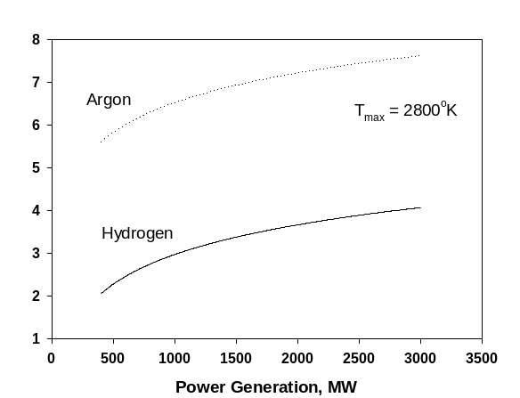
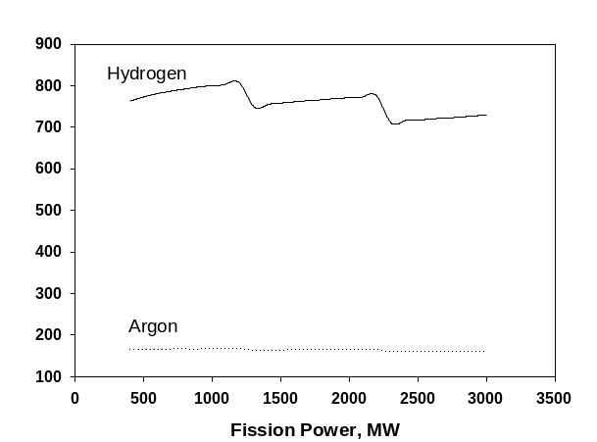
The estimation of specific impulses (Isp) for both hydrogen and argon were made based on the rocket chamber temperature and pressure of propellant. However, the results of Isp are roughly estimated to see the benefits of choice for propellant. Figure 16 shows the Isp estimated for hydrogen molecules and argon gas. It is obvious that hydrogen has much higher specific impulse as compared to argon.
Figure 16. Specific impulses of H₂ and argon propellants for NTP case only.
Figure 15. Flowrates of H₂ and argon propellants in log scale.

However, if NEP application is considered, argon propellant may perform much better for propulsion if both propellants are under the same condition in the rocket chamber. This is due largely to the facts that the high thrust can be achieved by argon’s high atomic mass and quick ionization because of the large cross section for collision and the large kinetic energy of argon.
As a reference, the figures 8 and 9 of Kubota, et al [9] illustrate the specific impulse of argon based on the flowrate of 0.8 g/s along with input power. Using the plot made by Kubota, et al [9], an extended case for the argon flow rate of 80 g/s of NEP was considered to determine how much power is required. A specific impulse of 1800 seconds can be achieved by feeding DC electric power of 8000A and 20V based on Kubota’s figures 8 and 9 [9]. The total power is 160 kW for driving 0.8 g/s argon to achieve 1800 s Isp. For driving 80 g/s of argon for 1800 s Isp, it requires 16 MW of power. The photon power harnessed from a 1000 MW nuclear power generator comprises of 65 MW which is sufficient to run 240 g/s argon through NEP.

- Conclusions
The current proposition for augmenting NTP and NEP with NTAC offers a strong case for substituting the passive radiation shielding with the NTAC technology. NTAC is a direct energy conversion system that generates electric power directly from high energy photons without requiring any thermodynamic conversion cycles. Currently, the underlying principle of NTAC device concept has been proved with numerical analyses and laboratory tests so that the current status seems to be beyond laboratory implementation. The augmentation study of NTAC system to NTP and NEP made here is to show a promising feature of converting energetic photon power (γ-ray, X-ray) into additional power rather than using passive shielding to block them. The power harnessed by NTAC is in addition to the amount possible though the traditional nuclear fission thermal process. The benefit lies in the value of the additional direct electrical power compared to the passive radiation shielding that the NTAC replaces.
The energy of high energy photons and energetic beta particles together is 19.8 MeV that comprises almost 10 % of the total nuclear fission energy. Accordingly, the power output from NTAC can be used for driving the electric thruster(s) in addition to NTP as a combination of NTP and NEP or operating the systems of spacecraft. For NEP applications of nuclear fission power, thermal energy (173.9 MeV) of nuclear fission must be converted into electrical power by using thermodynamic cycles or direct energy conversion which will turn approximately 30 % of it into electrical power. Thermal energy alone gives 52 MeV of useful energy for driving NEP. Combining it with NTAC, the NEP will have additional 5.94 MeV more than 10 % of thermal energy. However, the topping cycle is small compared to using NTAC instead of the reactor for electric propulsion, due to this 10% and associated shielding weight reduction from the NTAC energy regeneration. Ideally, when NTAC uses γ-ray emanating radioisotopes as a power source, the NTAC-driven electric propulsion will be further improved with NTAC’s high specific power greater than 1 kW_{e}/kg or system α ≤ 1.
References
[1] Finseth, J. L. “Overview of Rover Engine Tests – Final Report” (Report). Washington, DC: NASA. Retrieved 8 July 2019.
[2] Choi, S.H. and Lee, K., "Nuclear Thermionic Avalanche Cells with Thermoelectric (NTAC-TE) Generator in Tandem Mode", U.S. Patent No. 10,269,463, April 23, 2019.
[3] https://usnc.com/ultra-safe-nuclear-technologies-delivers-advanced-nuclear-thermal-propulsion-design-to-nasa/
[4] Office of Nuclear Energy, “TRISO Particles: The Most Robust Nuclear Fuel on Earth.” July 9, 2019.
[5] Bess, J.D., “Benchmar Evaluation of the Start-Up Core Reactor Physics Measurements of the High Temperature Engineering Test Reactor”, PHYSOR 2010, May 12, 2010.
[6] Bryan, J. C., in Introduction to Nuclear Science, Boca Raton, CRC Press, 2009, p. 161.
[7] Chen, Q.F. and et al. “Equation of state of partially ionized argon plasma”, AIP Physics of Plasma, 18, 112704 (2011); https://doi.org/10.1063/1.3657429
[8] Choi, S.H., Moses, R.W., and Bushnell, D.M., ““NTAC Augmented Nuclear Electric Propulsion and/or Nuclear Thermal Propulsion”, NASA Case No. LAR-19976-1, February 23, 2021. U.S. Patent Applied.
[9] Kubota, K and et al. “Numerical Investigation of Ionization and Acceleration Processed in a Self-Field MPD Thruster”, Presented at the 29th International Electric Propulsion Conference, Princeton University, October 31 – November 4, 2005: http://citeseerx.ist.psu.edu/viewdoc/download?doi=10.1.1.1061.8835&rep=rep1&type=pdf

