Benchmark Problem Development for Testing Maturity of Intelligent Contingency Management Tools
Jon Holbrook, Natasha A. Neogi, Michael J. Acheson, and Irene M. Gregory
NASA Langley Research Center, Hampton, VA, 23681, USA
This paper presents a process used to develop appropriate scenarios and metrics for evaluating the maturity of intelligent contingency management algorithms. A benchmark scenario is a reference point against which something can be measured, compared, or assessed. Creating an accurate benchmark requires considerable research and expertise. The scenario itself is an artificial representation of a real-world event, designed to achieve a set of learning objectives through experiential learning. Designing an effective benchmark simulation scenario requires careful planning, including identification of clear objectives; capability assessment of the algorithm/tool being evaluated; assessment of necessary levels of fidelity; development of a process flow map of events and event interactions; and identification of metrics that map back to objectives. Thus, a benchmark scenarios for contingency management might consist of one or several commonly used functions taken from real world applications, used for evaluation, characterization and performance measurement of a contingency management algorithm. Behavior of the contingency management algorithm under different environmental conditions should then be able to be predicted using a set of benchmark functions. The paper describes the resulting benchmark problem as an illustration of the application of this process.
- Introduction
A variety of aviation missions involve moving goods or passengers from an origin to a destination. The origin and destination are normally prepared sites. NASA defines advanced air mobility (AAM) as safe, sustainable, affordable, and accessible aviation for transformational local and intraregional missions. These missions are regarded as being enabled by vehicle electric propulsion and increasing autonomy. These increasingly autonomous vehicles will be required to handle a diverse set of conditions with less human intervention than is seen traditionally. Unforeseen, unplanned, and unanticipated events are likely to occur during a flight, and it is incumbent on the vehicle to handle these situations. An approach to intelligent contingency management (iCM) can be used to mitigate some of these scenarios.
Intelligent contingency management encompasses a broad swath of topics. Specifically, it addresses how automated agents can handle unforeseen contingency events. It also examines how automated agents can make decisions in the presence of uncertain, unreliable, and incomplete information in an intelligent fashion. Of course, the assurance of these systems, especially ones that involve non-deterministic or learning components must also be addressed before such systems can be fielded in safety-critical aviation applications.
To operate in this rich environment, multiple functions must be seamlessly integrated into an intelligent contingency management system to address concerns such as dynamic obstacle avoidance, weather events, faults and failures onboard the vehicle or in the supporting infrastructure, and dynamic airspace constraints. However, these novel models, methods, tools, and techniques must be shown to be fit for purpose and validated in a real-world environment. This necessitates the use of a benchmark, in order to test for the maturity of the developed intelligent contingency management tools and techniques.
A benchmark is traditionally defined as a standard or point of reference against which things may be compared or assessed. A benchmark scenario can be defined as a simulation scenario that is an artificial representation of real-world events in order to assess performance criteria or achieve educational/training goals through online evaluation or experiential learning. These simulation scenarios are designed to assess, educate, and help evaluators (and learning agents) to identify gaps in the execution of desired functions or application of specific knowledge. These simulation scenarios are designed to highlight potential (or perceived) performance or knowledge gaps. The developer of a benchmark needs to have a clear understanding of what must be measured, and under what circumstances these measurements are going to be conducted.
- Scenario Development Process
Designing an effective simulation scenario requires careful planning and can be broken down into several steps [1]. These steps should include (but are not limited to) the (1) identification of clear objectives; (2) capability assessment of the algorithm/tool being evaluated; (3) capability assessment of the simulation environment; (4) development of a process flow map of events and event interactions; and (5) identification of metrics that map back to objectives.
- Identification of objectives
Specifically, it is important to identify the objectives of the benchmark scenario(s). These objectives must be clearly stated and specified with as much detail as is possible. Ambiguity in the objectives may lead to an inability to assess the success or failure of the evaluation. If the objective is not clearly stated, the evaluation may not be repeatable and quantifiable, and thus the benchmark will not practically establish that the system under evaluation meets the desired objective (or standard the objective is meant to embody). Similarly, the objectives must be measurable. That is, the objectives should specify: (1) what agents are to be involved in the benchmark evaluation, (2) what are the desired outcomes for those agents (individually and as a whole), (3) the success criteria for the agents (as a whole and individually), and (4) how progress towards success can be measured (e.g., how partial achievement of objectives can be assessed). Finally, the objectives must be attainable. For instance, while an absolute freedom from accidents or loss events may be a desirable state for a system, it may be impossible for such a system to exist and perform its goals.
- Capability assessment of the algorithm/tool being evaluated
The design of a benchmark scenario should be informed by the capabilities of the learning agent that the simulation is evaluating. In the case of contingency management, consideration must be given to the level of maturity of iCM tools to be prepared for unforeseen circumstances as well as recognize and respond to unpredicted events. While the likelihood of a specific unplanned circumstance may be low, given the extremely large number of possible unplanned circumstances, the likelihood of some unplanned circumstance occurring is high. In current-day operations, both routine and exceptional contingencies are primarily managed by human operators, employing a wide range of behavioral strategies (Fig. 1).

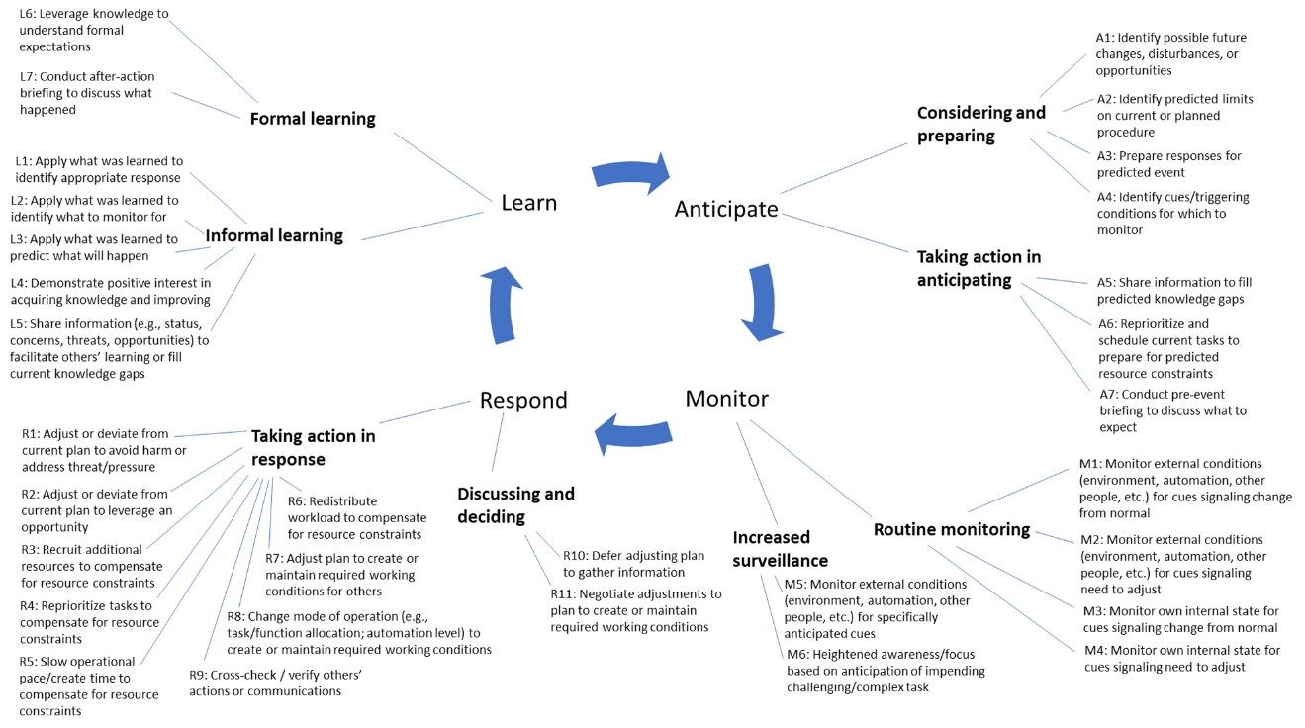
Fig 1. Taxonomy of humans’ safety-producing contingency management strategies and behaviors [2, 3, 4]

Although iCM algorithms and tools should not be expected to perform in the same way as human operators, automated agents intended to replace humans operators must eventually be capable of performing the contingency management functions that these behaviors are intended to support. Understanding the mechanisms and circumstances in which human operators successfully and unsuccessfully perform contingency management functions can inform the design of automated contingency management systems in their ability to detect, decide, and act under a diverse set of real-world conditions.
- Capability assessment of the simulation environment
It is important to note that there are many limitations attached to a simulation environment. By their nature, simulation environments are limited by the knowledge and expertise of the designers. Rare events or modelled features that have not been thought of by the designers will not be evinced in the environment. Thus, it is impossible to test for edge cases that are not contained in the requirements of the simulation, and a full-fidelity real-world simulation environment is not attainable. Similarly, there is a limit to the fidelity of the simulation. Often the (computational) complexity of the environment is traded of against the speed of the simulation, leading to a lower fidelity simulation environment than might be desired. It is important to clearly understand and document the level(s) of fidelity that are necessary in order to evaluate or learn something meaningful with respect to the benchmark objectives. Specifically, metrics (and their quantitative evaluation) must never convey more fidelity than is possible to assess in the simulation environment (e.g., the significant digits on a quantitative metric should be meaningful and justifiable in the simulated environment).
- Development of a process flow map
When planning a simulation, it is necessary to think through the sequences of events that run through the planned scenario, identifying the events that trigger decisions, creating branches in how the scenario might unfold. Features of the scenario, triggering events, participating agents, and interactions or dependencies among simulation elements must be carefully considered. Some of the critical features of the scenario that must be decided upon include the following:
- Setting. Consider not only the spatial and geographical properties of the scenario, but also the temporal setting. Is the scenario event set in the current day, or does it reflect future operations? If the scenario is set in the future, what assumptions must be made about those operations and about capabilities that may exist in that future environment that could impact the scenario?
- Duration. What time period will the scenario cover, and what events and phases of an operation should be expected to happen during that time period?
- Operational realism. Real-world events contain uncertainties, variable time-lags between stimulus-response pairs, an environment rich with stimuli that can complicate detection of critical signals and sensemaking, as well as the presence of multiple and sometimes conflicting goals. Real-world case-studies and event reports can be a useful source of inspiration for adding some of these elements to a scenario.
- Robustness. Scenarios should be robust to agent behaviors and actions, able to continue in operationally meaningful ways whatever actions the agent takes. Brittle scenarios that cannot accommodate a wide range of agent behaviors limit opportunities for learning.
- Extensibility. Development of meaningful scenarios is resource-intensive. Designing in the capability for the scenario to expand as the capabilities of the agents and the simulator mature allows for strategic re-use of the resources invested in the initial scenario.
“Triggering events” are those episodes within a scenario in which a decision can or should be made by a participating agent. In the case of an iCM agent, the triggering events represent the sources of pressure that precipitate a contingency management behavior. Based on the capabilities of the iCM agent to detect, decide, and act in response to these triggering events, various properties of these events can be considered. Triggering events can vary in their level of uncertainty or ambiguity (i.e., is the detected trigger associated with multiple possible events or only one). Likewise, triggering events can vary in their onset (i.e., abrupt or gradual), time lag between trigger and event (i.e., trigger is detectable before, simultaneous with, or after the event), and whether they are annunciated (i.e., there is a detectable alarm associated with the event or the event is only detectable when the agent takes a particular action). Because the range of possible pressures that might trigger an agent to act is quite large, identifying a subset of triggering events is necessary to scope the scenario. In the case of identifying triggering events for iCM agents, a list of precipitating events identified by operational personnel at a major air carrier was used. A subset of events that were aligned with the current maturity levels of the iCM agents and the simulator were identified (Fig. 2), with the remaining unused categories of events serving as possible directions for future expansions of both iCM and simulator capabilities.

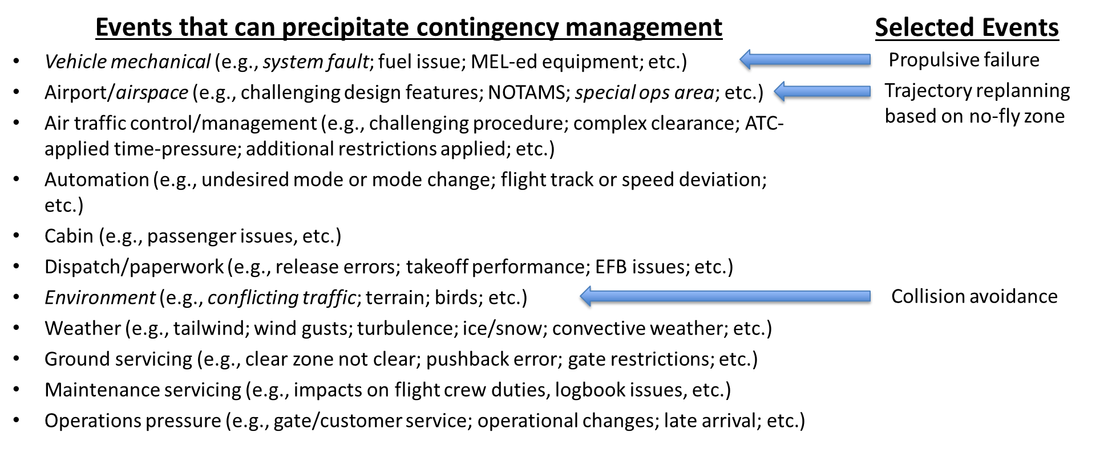
Fig 2. Selection of triggering events [5] for initial iCM benchmark scenario

Capabilities of the participating agents must be taken into consideration in scenario development. Important factors to consider include, but are not limited to, the number of agents participating in the scenario; levels of agent autonomy; and capabilities to detect triggering events, make decisions, and take action. Depending on the timing and duration features of the scenario, consideration must be given to the appropriate state of knowledge of the participating agent at scenario onset (i.e., what should the participating agent “know” when the scenario starts).
Furthermore, consideration must be given to how agents in the scenario may interact with other agents or other simulation elements. What is the range of possible outcomes of these interactions? Are the consequences of these interaction only direct and immediate, or are there also downstream impacts that must be considered? How will “confederates” (i.e., other agents in the system under the control of the scenario developers) behave in response to the actions of the evaluated agent? To the extent that a scenario may include multiple evaluated agents, each capable of independently sensing, deciding, and acting, this introduces the potential for many additional paths that must be considered in developing the process flow map.
- Identification of metrics
It is important that metrics be identified for the benchmark scenarios that map back to the objectives. If the benchmark scenario does not evaluate a property that is inherent to one of the objectives, the relevance of the scenario may be called into question. This requires the proper identification of relevant scenario parameters in each benchmark scenario that exercises a property relevant to the benchmark objectives and associated metrics. These parameters establish the relevance of the simulation to the objectives via a direct means. However, it is also important that the developed scenarios be operationally plausible and realistic in nature. If a developed scenario allows for the easy evaluation of a metric (or metrics) directly connected to an objective, but is not evinced in the real world, it becomes difficult to validate the confidence in the desired property due to the artificial nature of the scenario. Finally, benchmark scenarios should have well defined start and end points, so that the timeframe of the evaluation is clear and that metrics can be aggregated over the assessment window.
When developing a benchmark scenario, the baseline for comparison must be considered. Against what criteria will performance be measured? Performance of one agent can be evaluated against the performance of another agent. A single agent’s performance can also be evaluated against an identified system state, such as a “steady” or “nominal” state or against any predefined “desired” system state. These comparisons should consider not only the outcomes of agent behaviors, but the processes by which those outcomes were achieved. That is, consideration should be given not only to whether the evaluated agent arrived at the desired outcome, but whether it did so by a desired or undesired path. How close did the system come to an unsafe state, and were there other paths that could have achieved the same outcome with greater safety margins? To what extent was the agent’s behavior risk-seeking or risk-averse?
Process metrics might include, but are not limited to, whether event triggers were detected or missed; whether event triggers were correctly interpreted when they were detected; and how the triggered behaviors of the iCM agent compare against expected or desired behaviors. In addition, the operational plausibility of the process by which outcomes were achieved must be considered, not only in terms of compliance with the laws of physics, but also in terms of regulatory compliance, system consequences, and temporal realism (e.g., if there are temporal dependencies on other events or behaviors).
Outcome metrics might include, but are not limited to, how the scenario end-state compares against the expected or desired end-state; whether the iCM agent’s actions improved or resolved the trigger event (even if it did not do so in a manner that was planned or expected); and, for iCM agents capable of learning, ways in which the iCM agent differed after the scenario in comparison to before the scenario, as well as whether what was learned by the iCM agent improved their performance on subsequent simulations (i.e., is the iCM agent learning the “right” lessons from its experiences).
Designing metrics for benchmark scenarios that link clearly to the scenario objectives is a difficult endeavor. Interpretation of benchmarking data is extremely difficult and frequently depends on the set of assumptions associated with the benchmark scenario, the quantities that are being measured and the quality of those measurements, how data of differing levels of quality is synthesized, and the variety of conditions under which the benchmark is being sought (e.g., average, worst case, etc.). Moreover, benchmark evaluation practices often do not follow the scientific method. Issues such as a lack of rigorous variable control (e.g., altering a variable while not holding all others constant), adequate or biased sample size (e.g., not eliminating bias in scenario runs due to novelty, fatigue, processor loading or other issues), and repeatability (e.g., limited repeatability of results) plague most benchmarking endeavors. Being able to tell if the data captured from a benchmark scenario is trustworthy requires a significant initial validation effort. Once the evaluation setup and data collection practices have been validated as being fit for purpose, it may be possible to assess the trustworthiness or confidence associated with a given metric.
Furthermore, there can be a lack of standardization across benchmark evaluation practices, and metrics that have been standardized are often vulnerable to gaming. Care must be taken when designing, evaluating, and interpreting benchmarking metrics, otherwise misleading conclusions may be drawn regarding the capabilities and performance of a given system.
- Documenting Assumptions
An assumption is something that is accepted as being true or as certain to happen, without proof. Assumptions come in many forms; they can be paradigmatic, prescriptive, or causal. Paradigmatic assumptions are structuring assumptions that are used to order the world into fundamental categories and are very difficult to uncover. These assumptions often appear in interdisciplinary activities and are not uniform across domains. Prescriptive assumptions are assumptions concerning beliefs of what ought to be happening in a particular situation. These assumptions limit the actions of agents and events experienced. Causal assumptions are assumptions concerning how different agents (and elements) in the world interact with and affect one another. Causal assumptions also concern the conditions under which these relationships can be changed, and they are usually stated in predictive terms. It is critical to document all assumptions when designing a benchmark scenario. This is particularly true when the system as envisioned currently does not exist in the real world (e.g., a future Concept of Operations). Paradigmatic assumptions regarding how procedures and supporting infrastructure works for an aviation system as envisioned may be heterogeneous across multiple stakeholders and need to be surfaced and considered carefully. Prescriptive assumptions regarding the roles and responsibilities of agents must be documented and harmonized across all elements of a benchmark scenario (including in the presence of disruptive or rare events). Additionally, assumptions regarding causal relationships between physical agents (both human and automated), information agents, and the environment need to be reconsidered in the face of increasing automation.
Furthermore, there are often simplifying assumptions that attempt to bridge the gap between the complex real world and the attainable level of fidelity of the simulation. It is important to have a means to monitor the validity of these assumptions and identify when they are violated. Otherwise, any evaluation may be suspect as the conditions of the measurements may not be representative of the desired benchmark scenario.
- Conclusion
Designing an effective benchmark simulation scenario requires careful planning, including identification of clear objectives; capability assessment of the algorithm/tool being evaluated; assessment of necessary levels of fidelity; development of a process flow map of events and event interactions; and identification of metrics that map back to objectives. Scenario development helps to highlight the complexity of the problem and the challenges that need to be addressed. An effective benchmark scenario establishes a baseline capability that is extensible to new operational challenges as tools mature and allows for integration of disparate tools within a common infrastructure. The usefulness of a benchmark scenario depends largely on the considerations and assumptions made during the implementation and evaluation process.

Acknowledgments
This work was funded by the Transformational Tools and Technologies Project within the NASA Aeronautics Research Mission Directorate’s Transformative Aeronautics Concepts Program.

References
[1] Bambini, D. “Writing a simulation scenario: A step-by-step guide.” AACN Adv Crit Care, Vol. 27, No. 1, 2016, pp. 62-70. DOI: 10.4037/aacnacc2016986
[2] Hollnagel, E. (2015). “RAG – Resilience Analysis Grid.” URL:
https://erikhollnagel.com/onewebmedia/RAG%20Outline%20V2.pdf [retrieved 2 November 2021]
[3] Kiernan, K., Cross, D. C., Scharf, M. “Developing a taxonomy for success in commercial pilot behaviors.” Collegiate Aviation Review International, Vol. 38, No. 1, 2020.
DOI: 10.22488/okstate.20.100203
[4] Neogi, N. A., Holbrook, J. “Creating formal characterizations of routine contingency management in commercial aviation.” Proceedings of the AIAA Scitech 2021 Forum.
DOI: 10.2514/6.2021-1116
[5] American Airlines Department of Flight Safety. “Charting a new approach: What goes well and why at American Airlines, a white paper outlining the second phase of AA’s Learning and Improvement Team (LIT).” URL: https://skybrary.aero/bookshelf/books/AA%20LIT%20White%20Paper%20II%20-%20SEP%202021.pdf [retrieved 2 November 2021].

Research Scientist, Crew Systems and Aviation Operations Branch.
Research Scientist, Safety Critical Avionics Systems Branch, AIAA Associate Fellow.
NASA Aerospace Technologist, Dynamics Systems and Control Branch, Member AIAA.
NASA Senior Technologist for Advanced Control Theory and Application, Research Directorate, AIAA Associate Fellow.

