SeaDAS Tutorial: Applying Color Ramps to ACOLITE Turbidity Products

This tutorial provides step-by-step instructions for applying color ramps and legends to ACOLITE turbidity products derived from the Dogliotti turbidity equation. The user inputs their own image and the resulting product is a colorized visualization of turbidity. This visualization provides the user with a better understanding of turbidity in their image and can be used to support further analysis of turbidity patterns. Below, Landsat 8 OLI imagery of Fire Island, NY in 2019 is used as an example.

- Download SeaDAS 7.5.3 version from the link below.
  - NASA SeaDAS
  - Click the appropriate file for Linux, Mac, or Windows to begin the install.
  - Once the download is completed, right-click on the installer to open the file and finish the install process.
- Once SeaDAS is installed on your computer, open the application.
- Go to the folder icon in the left corner to open a data file.
- Locate the folder
- in which you stored the “.nc” file (ex. L8_OLI_2019_08_30_15_33_53_013032_L2W.nc). Left-click on the “.nc” file inside the folder to highlight it and then click the Open Product button in the bottom right corner. The data file will be added to the File Manager window with two folders beneath called “Metadata” and “Rasters”.
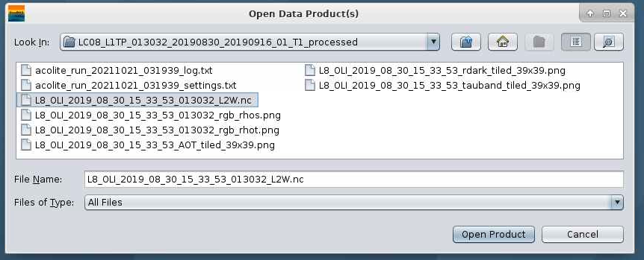
- Left-click the “Rasters” folder and locate the “t_dogliotti” layer. Double-click to add the image to the viewing window. The image will appear as a gray-scale image.
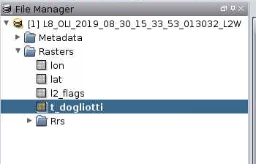
- To change the color ramp, go to the Color Manager tab located at the bottom of the File Manager window.
- In this tab, change the Cpd File section to anomalies2_universal.cpd.
- Change the Range section to have Min: 0 and Max: 20.
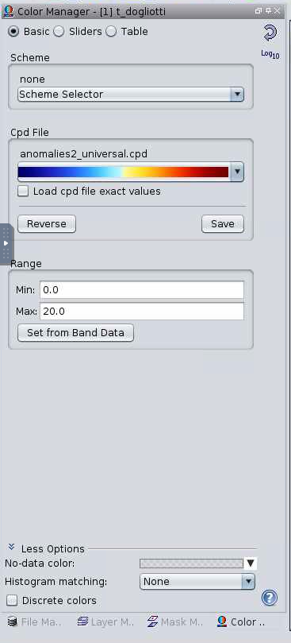

- To create a land and cloud mask, go to the Sliders option on the Color Manager tab. Click on the dark blue triangle that has “0.0” below the graph and select it to be “black”.
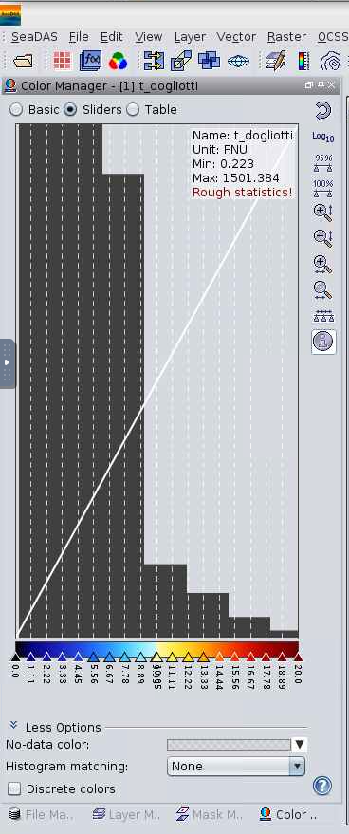
- To add a color bar, go to the top of the tool bar and click on the rainbow scale button. This will open the Create/Edit Color Bar window.
  - Go to the Title section and enter: Date, Turbidity (ex. 08/30/2019 Turbidity).
  - Click on Create Layer to add the color bar to the image.
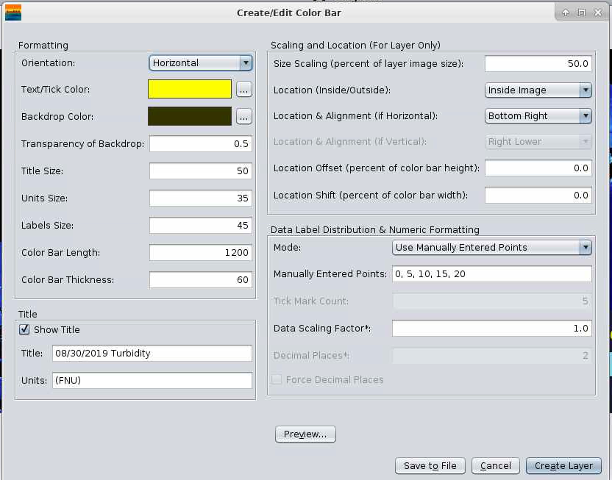
- The image should look similar to the one provided below.
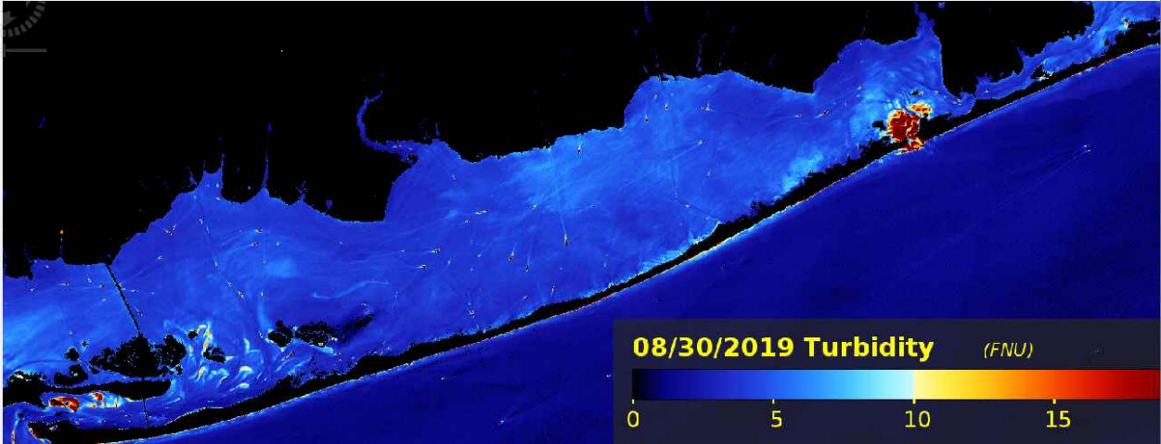
- To export the image as a .jpeg, right-click on the image and pop-up window will appear. Click on Export Image...
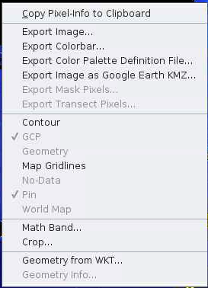
- Locate an output folder destination in which you wish to save the created .jpeg file. Under Files of Type: change to JPEG and click on save.

