Comparison of Surface Pressure Fluctuations from Flight and Wind Tunnel Tests on the Orion Multi-Purpose Crew Vehicle

J. Panda*, NASA Ames Research Center, Moffett Field, CA

Abstract
Transonic and supersonic wind-tunnel test of scaled-models are used to predict the surface pressure fluctuations on aerospace vehicles. An outstanding question is how good are such tests? The present paper attempts to answer this question for the Multi-Purpose Crew Vehicle by comparing data from the Ascent Abort-2 (AA2) flight test with those measured in two different scaled-model wind tunnel tests (WTT) 51AS and 134AS. A sensor by sensor and a Mach by Mach comparisons of spectra of surface pressure fluctuations are presented for nominal ascent part of flight. Spectra measured over a large part of the vehicle surface were found to be dominated by the wake vortices shed from the four Abort Motor nozzles situated on the upper part of the Launch Abort System. It was found that the shapes of the scaled-up spectra from WTTs were very close to those measured in the flight, but the levels, for the most part, were found to be lower than the flight data. The highest differences were from the regions of complex flows where wakes from the adjacent nozzles interacted with the free-stream flow. There the WTT predicted levels were consistently 2dB to 6dB lower than the flight data, across all spectral bands. Another region of significant under-prediction was the local separated flow region at the Fillet-Ogive junction. The accuracy of the sharp spectral peaks from regions along a nozzle axis was found to be dependent on the fidelity of the model. The model in the 51AS WTT used a simplified contour, which resulted in a large under prediction of the spectral peak by 1dB to 10dB. A limited number of data from 134AS, where the model accurately captured all features of the nozzles of the flight vehicle, however; showed that the under prediction was lower: 1-2dB. The fluctuation spectra on the large protuberance of the Umbilical Cover was found to be reasonably well-predicted by 134AS WTT, which meticulously reproduced a scaled-down shape of this protuberance. Such information will help to determine the margins to be applied to wind-tunnel data to create flight environments.

Acronyms:
AA2: Ascent Abort 2 flight test | LAV: Launch Abort Vehicle
AM: Abort Motor | MPCV: Multi-Purpose Crew Vehicle aka Orion
ATB: Abort Test Booster | OML: Outer mold line
ESM: European Service Module | SLS: Space Launch System aka Artemis
LAS: Launch Abort System | WTT: Wind tunnel test

I. INTRODUCTION
An important part of a spacecraft design is to determine the vibro-acoustic environment of all parts and components. There are multiple sources that lead to the vibro-acoustic response. One of the important sources is the pressure fluctuations on the outer surface of the vehicle during ascent through the lower part of the atmosphere. The turbulent air flow, along with the locally formed shockwaves and separated flow zones, create large amplitude pressure fluctuations, which are transmitted to every component of a space vehicle leading to modal responses. In order to determine the surface pressure fluctuations ground tests are performed in transonic and supersonic wind tunnels using scaled models. Subsequently, simple scaling laws are applied to determine the levels on a full-scale vehicle. The process has multiple limitations. The present paper attempts to determine the fidelity of the scaled-model acoustics tests for the MPCV vehicle¹ by comparing data from a flight test (AA2^{2,3}) and two wind tunnel tests performed at NASA Ames’s Unitary Plan 11ftX11ft Transonic tunnel.
Figure 1 shows a schematic of the primary parts of the MPCV vehicle which is scheduled to fly on SLS. It ought to be mentioned that the vehicle outer mold line (OML) itself is a product of multiple wind tunnel tests conducted at the inception of the program to reduce surface pressure fluctuations from unsteady shock-waves⁴. These tests were followed by a variety of large wind tunnel test campaigns for the CEV/MPCV/ORION and Constellation/SLS/Artemis programs. The AA2 flight test provided the first opportunity to verify any such WTT data. The specific goal for this paper is to provide a sensor by sensor and Mach by Mach comparison of spectra of pressure fluctuations obtained from the wind tunnel and flight tests. Note that the goal is different from typical evaluation of zonal environments conducted by the most space vehicle programs, where the concern is whether the flight data is adequately covered by a zonal acoustic environment (for example, ref 5). The zonal environments are created by combining wind tunnel data for all possible scenarios of flight: such as different flight Mach numbers, vehicle attitudes and all possible flight trajectories. To compare such a combined product to a single flight condition is to determine the adequacy of the design environment. The goal of the present paper is of a direct comparison, where individual WTT test points that come very close to flight Mach and vehicle attitudes are selected and a sensor-by-sensor comparison is performed to determines the goodness of the wind-tunnel test.

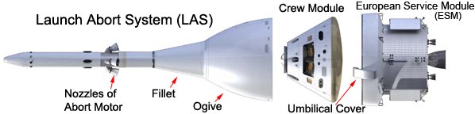
Fig 1. NASA’s Orion Multi-Purpose Crew Vehicle. Note that the ESM is covered by a fairing during atmospheric flight.
During the Constellation program, which preceded the present SLS/Artemis program, Ares I-X flight test was conducted to verify the wind-tunnel derived aeroacoustics environment. Reference 5 provides results from that comparison study. It was observed that “in general, where flight and wind-tunnel transducers matched locations, the transonic flight measurements compared well with the preflight predictions. Flight measurements near protuberances and supersonic flight measurements did not compare well with the wind-tunnel test data.” The study found discrepancies in regions where the OML had sudden changes and emphasized a “...dramatic under prediction of the supersonic environments.”
There exist multiple factors that can cause differences in the surface pressure fluctuations between a wind-tunnel and a flight test. Scaling laws are first applied to WTT data to predict the flight levels. Such laws are purely based on the equivalence of the non-dimensional Strouhal frequencies and the non-dimensional coefficient of pressure fluctuations:
${St}_{flight}={St}_{model}, ⇒f_{flight}=f_{model}\frac{D_{model}U_{flight}}{D_{flight}U_{model}}$ (1)
${Cp}_{rms-flight}={Cp}_{rms-model}, ⇒{psd}_{flight}={psd}_{model}\frac{U_{model}D_{flight}}{{D_{model}U}_{flight}}{\left(\frac{q_{flight}}{q_{model}}\right)}^{2}$ (2)
The procedure does not account for a host of other differences. The first one is the difference in Reynolds number. Flight Reynolds numbers are typically 15 to 25 times higher than that of a model-scale test. Second, typical transonic wind tunnels have far higher level of free-stream turbulence than in the atmospheric flight. The wall slot or holes used in the transonic tunnel to minimize shock reflection is known to create high level of broadband and tonal background fluctuations that are absent in the flight-conditions. Third, the model-scale tests are performed at steady Mach numbers; the transient, accelerating flight conditions are not simulated. Fourth, model-scale tests frequently require some simplification of the finer details of the outer mold line for various reasons, which can also lead to differences in pressure fluctuations. Such differences create uncertainties in the acoustic environment measured in wind tunnel tests. The uncertainties are mitigated by adding margins over the measured data. This paper sheds light on the level of uncertainty margins suitable for the aeroacoustics environment.

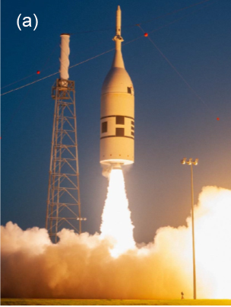 | 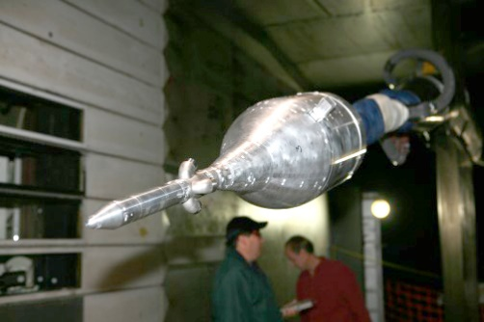  (b) | 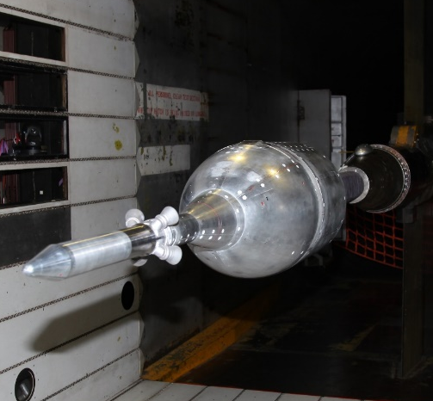  (c)
Fig 2. (a) Flight test of AA2; (b) 6% scaled-model of MPCV in NASA Ames 11-ft Unitary Plan tunnel during 51AS test; (c) 7.5% scale model in the same tunnel during 134AS test.

Ia. Description of the Flight test vehicle AA2
Ascent Abort Two (AA-2) flight test was conducted on July 2nd, 2019 from the Space Launch Complex 46 of the Cape Canaveral Air Force Station, Florida, with the primary goal of demonstrating capability of the launch abort system (LAS) and a boilerplate crew module to perform an abort from a critical high dynamic pressure, transonic test condition (fig 2a), ref [2, 3]. The flight test vehicle comprised of the launch abort vehicle (LAV) mounted on the top of an Abort Test Booster via a Separation Ring, which released the LAV from the test booster as the Abort Motor (AM) was ignited. The 78 high-sampling rate microphone sensors placed on AA2 collected good data over the entire flight regime. Only a segment of the time-series collected during the nominal ascent (from launch to M1.16) is analyzed for the present comparison. Some of the the DC-coupled microphone signals were sampled at 5081.3/s and the rest at 10162.6/s. The measurable frequency range was determined by the low-pass filters used in the flight data system. The passband was set to 0-1693.77Hz and 0-3387.53 Hz, respectively, for the two sampling frequencies mentioned above.

(a) | (b) | 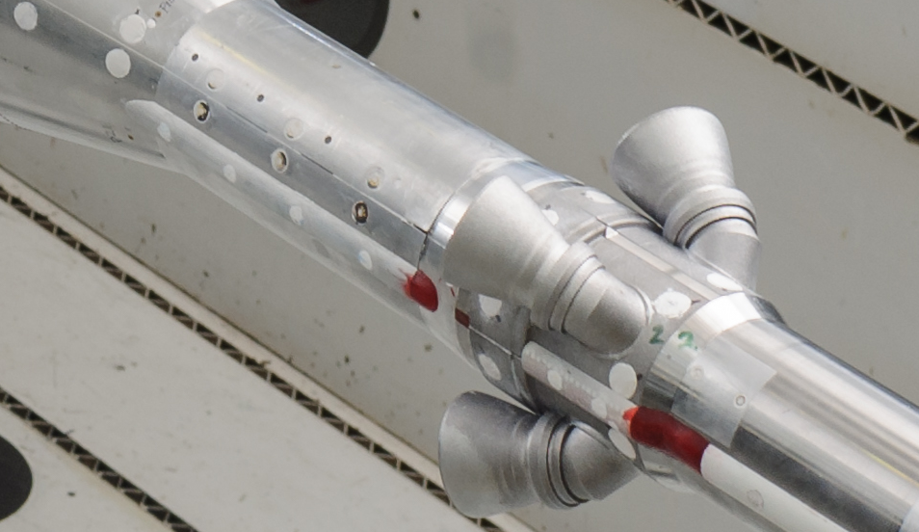  (c)
Fig 3. Shapes of the nozzles of the abort motor: (a) AA2 vehicle; (b) model of MPCV tested in 51AS; (c) model tested in 134AS.

Ib. Description of the wind tunnel tests, models and sensors
The wind-tunnel test 51AS was conducted in Oct 2008 using a 6%-scaled model of LAV plus ESM in the Ames Unitary Plan 11’ (0.5≤M≤1.4) and 9x7 (1.6≤M≤2.5) tunnels (fig 2b). The model was instrumented with 235 dynamic pressure Kulite sensors. The 134AS WTT was conducted nearly 11 years later, Sept. 2019, on a 7.5% scaled model of LAV plus Service Module (fig 2c). The primarily goal of the former was to determine the fluctuating pressure environment on the LAS and ESM, and that of the latter was to determine the same over the ESM-LAS Umbilical cover. The model used in 134AS reflected the AA2 flight vehicle more closely and incorporated various smaller changes of the vehicle OML since 51AS. It also had a far fewer, 16 Kulite sensors mostly clustered around the Umbilical cover. The WTT data were sampled at a far higher rate of 204800/s such that the scaled-up spectra cover the desired frequency range of the flight vehicle. The scaling laws of equations (1) and (2) were applied using the flight dynamic pressure and velocity values of the obtained from the AA2 trajectory. In other words, WTT data was scaled up to the AA2 scale and flight conditions for all comparisons presented in this paper.
Aside from the differences in the sizes the two models differed in one other important aspect which was found to have affected the data collected from the two tests. While the model of 134AS test correctly replicated the shape of the nozzles of the abort motor, the model used with 51AS had some differences. Figure (3) shows the differences. The model for the 51AS test was built to support a hot-Helium test 80AS that followed 51AS. To allow for the flow of the high-temperature heated Helium, the nozzles were made of sintered metal, which required simplifications and rounding off the sharp junctions. Furthermore, the nozzles of 51AS had thicker lips than a proportionately scaled unit. Also, the gap between the nozzles and the motor body surface was absent. The model for the 134AS had no such differences.
The WTTs were conducted over a wide range of Mach number and vehicle attitude conditions. Out of all such conditions a few run numbers were identified that came close to the flight conditions. Another step for the intended comparison was the identification of the corresponding sensors. Sixteen pairs of AA2 and 51AS sensors that were found to have very close spatial locations. Similarly, 8 pairs of corresponding sensors were identified between AA2 and 134AS.
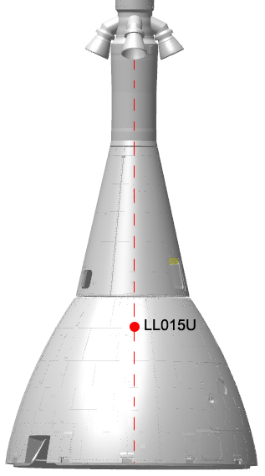  (a) | 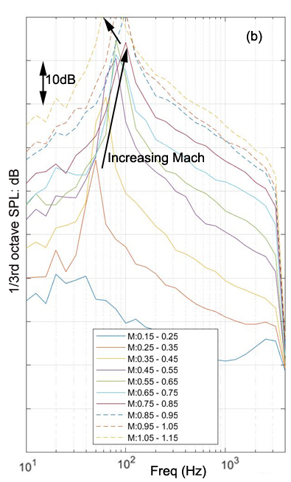(b)
Fig. 3. (a) Location of sensor LL015U on Ogive, along a nozzle axis, shown by red circle; (b) spectra of fluctuating pressure at the indicated Mach intervals measured in AA2.

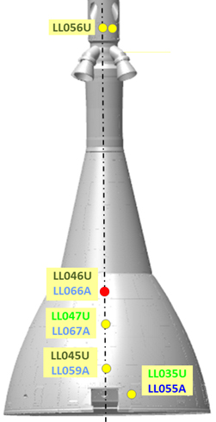  (a) | 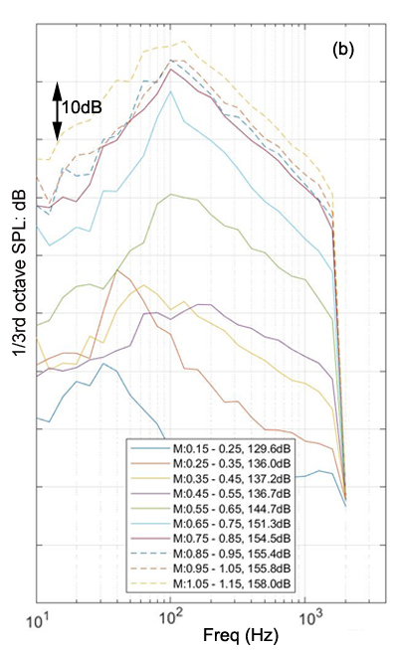
Fig. 4. (a) Location of sensor LL046U on Ogive, in-between adjacent nozzles, shown by a red dot; (b) spectra of fluctuating pressure at the indicated Mach intervals measured in AA2

II. RESULTS AND DISCUSSION

The AA2 data from the nominal ascent part of the flight, was segmented into equal Mach intervals of 0.1: 0.15≤M≤0.25, 0.25≤M≤0.35, …, 01.05≤M≤1.15. Each segment was detrended using a 7th order polynomial before the calculation of third-octave spectrum. Figures (3) and (4) show spectral plots from two different sensors on AA2. An examination of the spectra shows a progressively increasing level with flight Mach number. Most spectra particularly those in fig. (3) show sharp peaks whose frequencies changed with flight Mach in the range of 35Hz to 95Hz. The peaks correspond to the passage of the wake-vortices shed from the nozzles of the abort motors. These wake-vortices were photographed in many wind-tunnel tests in the past. Figure 5 shows one such example from frames captured from a high-speed schlieren setup. The footprints of the individual large eddies are marked by numerals I, II and III. By following each of these eddies in the time-sequence one can observe their passages on the Fillet and Ogive parts of the LAS. These eddies eventually dissipated on the rear part of the Ogive due impingement and flow acceleration. The unsteady pressure signature of these eddies presented the largest vibroacoustic load on LAS during nominal ascent.
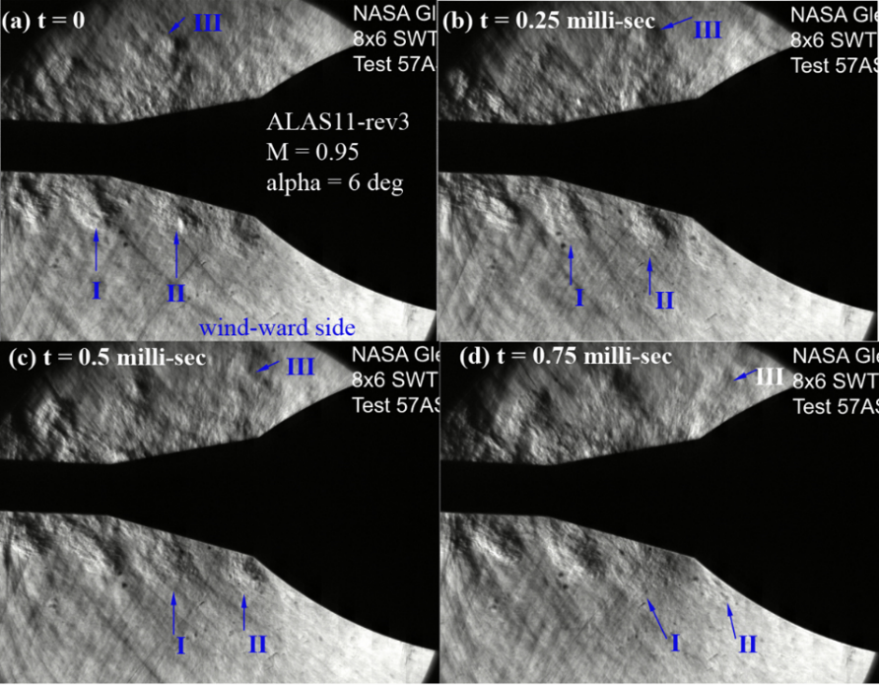 | Fig. 5. Four consecutive frames from high-speed schlieren of the MPCV model showing the shedding of AM nozzle wake vortices; M = 0.95, alpha = 6, test 57AA, NASA GRC, 2007.

The passage frequencies of the wake vortices (fig 3) varied with Mach number as shown by the two arrows of fig (3). The passage frequency at first increased with Mach number, followed by a decrease beyond M0.95. Shadowgraph images collected during the wind-tunnel test clearly shows formation of a normal shock ahead of the LAS nozzles beginning at high subsonic Mach numbers. This shock wave persisted all through the Mach range. The velocity downstream of this shock wave is expected to be lower than that of the free stream. The shear layer shed by the nozzles may have responded to this lower velocity resulting into the lowering of the wake shedding frequency. A comparison between figs (3) and (4) shows significant differences in the spectral levels. Figure 3 is from a sensor located along the axis of a nozzle. Here the spectral peaks due to wake vortices are significantly stronger; while those of fig 4 – from a sensor located in-between two nozzles- are weaker. This non-uniformity resulted in a periodic variation along the azimuthal direction about the axes of the four plumes.

The following comparison with WTT data is divided into two parts. The bulk of the comparison is between acoustic spectra collected from AA2 and 51AS, which is followed by a comparison between AA2 and 134AS. A major factor that affects unsteady pressure fluctuations measured in the wind-tunnel tests is the presence of the background turbulent fluctuations in the transonic wind-tunnels. A common feature of all transonic wind tunnels is the slots or the holes on the walls of the test-sections. These slots or holes are used to mitigate strong reflection of the shockwaves and the associated boundary layer separations on the wall. The flow over the longitudinal slots of the 11-foot tunnel is known to create a general broadband turbulent fluctuation, high amplitude tones and distinct haystacks in the spectra of spectra of the pressure fluctuations. These background fluctuations are easily detected from the empty tunnel operations, i.e., tunnel operated without a model in the test section. Since these features are artifacts of the wind tunnel -never present in the actual free flight through a quiescent atmosphere – it is a common norm to remove at least the strong tones and haystacks from model scale aero-acoustics test conducted in transonic tunnels. It is easy to determine the background fluctuations via placing dynamic pressure transducers on the test section wall or by using a small cone-cylinder model equipped with a couple of dynamic pressure transducers to measure the empty-tunnel backgrounds. The background spectra were provided by the Unitary staffs and were used to identify the strong tones in the data collected from 51AS and 134AS. Figure 6 shows examples of simple truncation of the spurious peaks in the fluctuation spectra. The corrections were applied on the as-measured model-scale spectra before the application of the scaling laws. Note that a general approach was to error on the conservative side - that is to retain as much part of the measured data as possible. Therefore, the small amplitude tones were not removed.

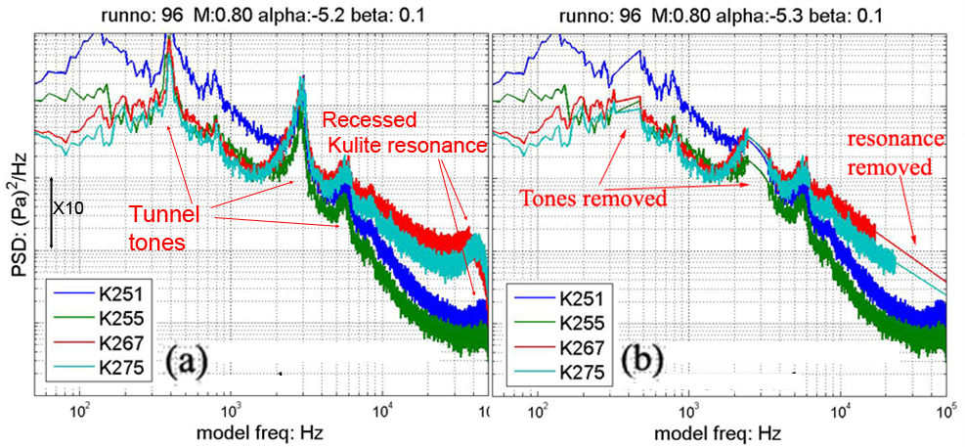
Fig 6. Example of cleaning applied to the WTT data to remove empty tunnel tones and spurious tones from the recess mounting of the sensors; (a) model-scale narrowband as measured; (b) after removal of the indicated tones.
Another correction applied to the wind tunnel data is to remove the haystacks corresponding to the Helmholtz resonance frequency of the dynamic pressure transducers – the haystacks centered at 90 kHz and 95 kHz in figure 6(a). The perforated top skin of the sensor body was flush mounted on the model wall. However, the actual piezo-resistive element was slightly recessed from the top skin. The resulting small gap effectively acted as a Helmholtz resonator when the air flow passed over the sensors. Figure 6(b) shows example of the removal of the haystack from the model-scale spectra. Effective removal of this high-frequency haystack is important since the small scale-factor of the model shifts this range to a much lower frequency upon the application of the scaling laws.

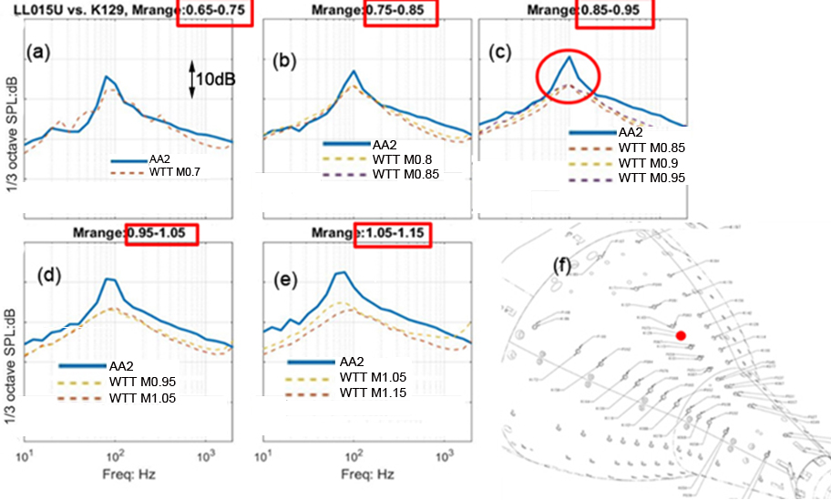
Fig 7. (a) – (e) Comparison of spectra at indicated Mach ranges between 51AS wind-tunnel sensor K129 (dashed thin lines) and flight sensor LL015U (thick solid line) on the front end of MPCV Ogive, along a nozzle axis; (f) location of the Sensor K129 is marked by the red circle.

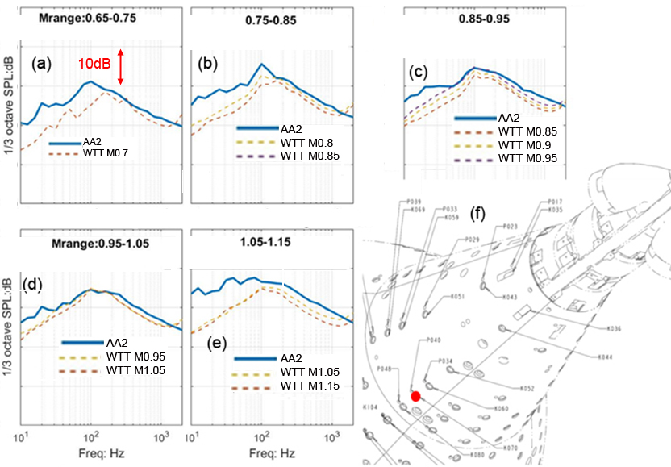
Fig 8. Same as Fig 7 except for sensors K070 and LL021U on Fillet-Ogive junction, in-between nozzles.

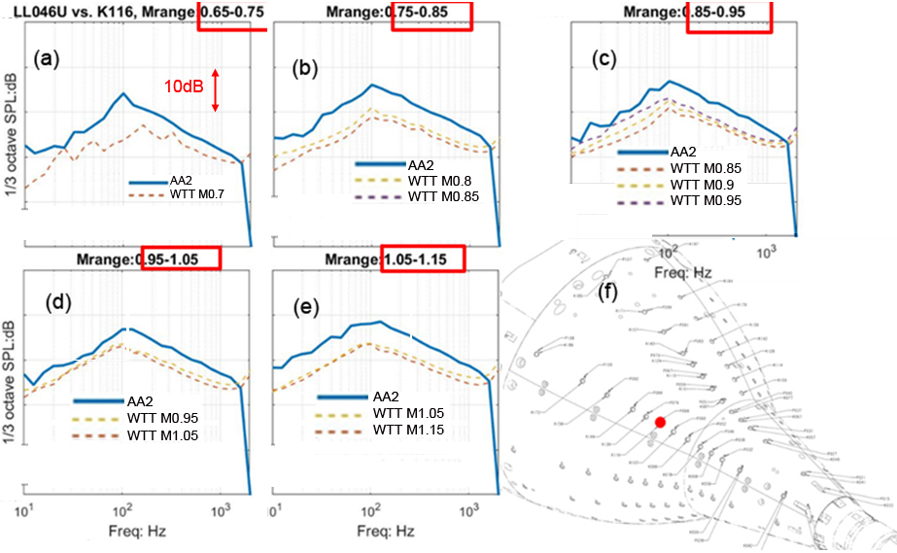
Fig 9. Same as Fig 7 except for sensors K116 and LL049U on Ogive, in-between nozzle axes.

IIa: 51AS vs AA2
While WTTs were conducted at a set of fixed Mach numbers the actual flight happened with a monotonically increasing Mach conditions. As mentioned earlier the flight data was segmented into bins of 0.1 increment of Mach numbers. Multiple WTT runs covering the same Mach range are co-plotted with AA2 data for a comparative study. In every comparison plot presented in this paper the flight data is shown in bold lines and the WTT data in thin chain lines. Figures 7, 8 and 9 show a set of comparison for three different locations on the vehicle. Each is a multi-part plot, of which the first five show spectral comparison at five different Mach ranges (shown in the title) and the last part shows the location of the sensor. In general the shapes of the spectra are very similar between the flight and the wind tunnel, but the magnitudes are different. For the most part the flight spectra have higher levels than the scaled, wind-tunnel data (Figs 7, 8 and 9). Following are some important observations:
- For sensors along a nozzle axis (fig 7): The shapes of the spectra are very similar between the flight and the wind tunnel data, but the magnitudes are different. Consistently, wind tunnel predicted levels are lower than the flight level. The worst under prediction is of the haystack in the 70Hz to 100Hz frequency range representing the passage of the vortices in the nozzle wake. The under prediction, which can be as high as 10dB, was found to progressively worsen as one moved farther downstream from the nozzle exit, and at the higher Mach ranges 0.95≤M≤1.05, 1.05≤M≤1.15.
- For sensors in-between the nozzle-axis (figs 8, 9): The haystack from the nozzle wake is not as prominent as locations along the nozzle axis, yet the level of under prediction by the wind-tunnel data worsens. At the Fillet-Ogive junction, which is expected to be a separated flow zone the wind tunnel data misses the large amplitude low frequency fluctuations (fig 8). The difference between the flight and the predicted levels are frequently by 6dB across many frequency bands.
- At the rear end of the Ogive the peak from the nozzle wakes diminishes, indicating a progressive dissipation of the large vortices, yet the differences between the flight and WTT remains significant (not shown for brevity).
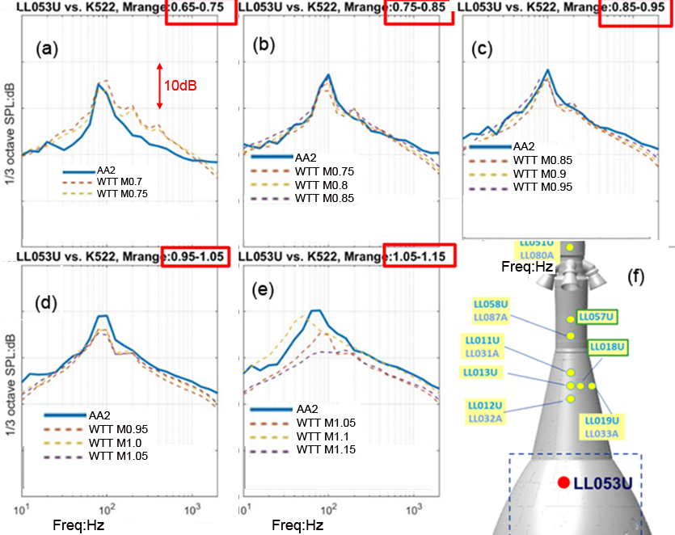
Fig 10. Comparison of spectra at indicated Mach ranges between 134ASA wind-tunnel sensor K522 (dashed thin lines) and flight sensor LL053U (thick solid line) on the Ogive and 10° off a nozzle axis; (f) location of the Sensor LL053U is marked by the red circle.

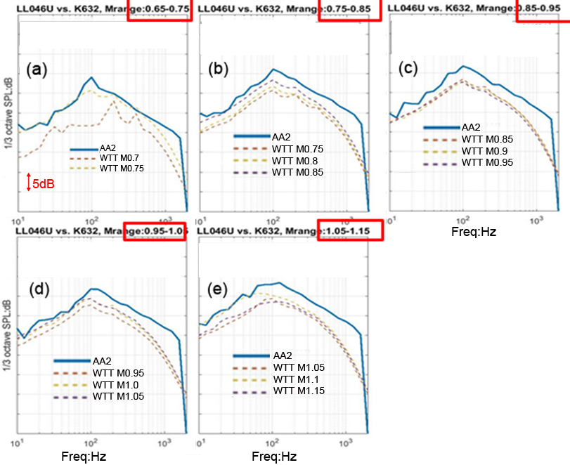
Fig 11. Same as Fig 10 above but for K632 vs. LL046U – in-between two nozzle axes.

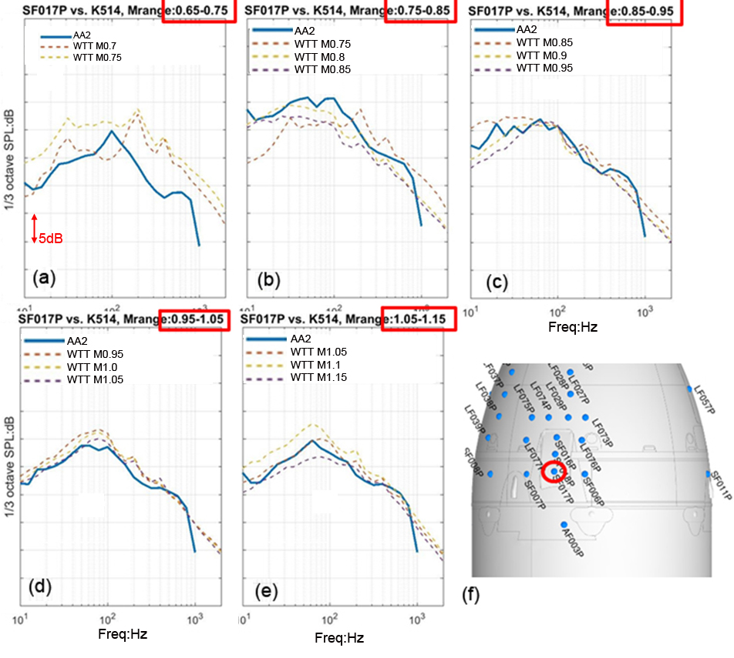
Fig 12. Same as Fig 10 above but for K514 vs. SF017PU –sensors on Umbilical cover.

IIb: 134AS vs AA2
134AS was conducted primarily to determine the fluctuating pressure environment over the Umbilical cover that lie between the LAS and the ESM. It employed many sensors around the Umbilical cover and only a few over the acreage of the Ogive to compare against flight data. Fig. 10 presents an interesting comparison from a sensor on the Ogive and along the axis of a nozzle. For all Mach ranges the wind-tunnel predicted spectra are very close to that found in the flight, and more importantly, the magnitudes of the haystacks at the wake-passage frequencies mostly matches between the flight and the wind-tunnel data. Such matching is in sharp contrast to the underprediction by the 51AS data. As described earlier the model used in 134AS correctly replicated the nozzle shapes of the flight vehicle, while the model of 51AS used a simplified shape. Obviously, the simplified nozzle shape of the 51AS model led to an under-prediction of the flight fluctuations.
There were three pairs of sensors that provided comparison from locations in-between nozzle axes. Fig. 11 shows one such comparison that is found to be typical of all three. Just like the 51AS WTT the scaled-up spectra from 134AS had similar shape to the flight data, but consistently underpredicted the levels by 2dB to 4dB at all frequency bands. The underprediction worsened with increasing flight Mach number. Similar comparisons were seen from a sensor just upstream of the Umbilical Cover (not shown).
Fig. 12 shows comparison from one of the three sensors on the top of the Umbilical cover. The wind-tunnel model scrupulously created an exact scaled-down replica of this protuberance of the flight vehicle. The wind-tunnel data showed a mixed-result of slightly under or over-predicting the levels depending on the location of the sensor. In general, the wind-tunnel predicted environment enveloped the flight data. The only exception was a small hump around 700Hz that was found in the flight data and was absent from the wind-tunnel prediction. The source for this additional peak remains uncertain.

III. CONCLUDING COMMENTS
The flow field over the MPCV vehicle is complex – far from the simple assumption of attached turbulent boundary layer. It is primarily dominated by the protuberances created by the four large nozzles at the front end of the vehicle. The formation of the periodic vortices in the wake created by the nozzles, subsequent decay of these wakes, interaction of the wakes with the free-stream flow - particularly for zones in-between the adjacent wakes, and finally the interaction with a strong shock formed at the fillet-ogive junction are the primary flow physics responsible for the generation of the relatively high level of surface pressure fluctuations on MPCV. The 6% scale model of the 51AS and the 7.5% scale model of the 134AS wind tunnel tests replicated all such physics – as is evident from the similarity of the spectral shapes from the flight and the wind tunnel tests. It also points out the value of the simple relationships, based on the identity of Strouhal number and coefficient of pressure, to scale the wind tunnel data. However, the amplitudes of the pressure fluctuations showed a general trend of under prediction by the WTT data.
The paper presents a sensor by sensor and Mach by Mach comparison of spectra from the two WTTs and the AA2 flight test. For an apple-to-apple comparison the time-histories of pressure fluctuations measured by the sensors on AA2 during nominal ascent were segmented into Mach bins: M 0.35-0.45, M 0.45-0.55, … M 1.05-1.15. For every segment the corresponding fixed Mach simulation in WTT were identified. The WTT data were cleansed of the spurious background tunnel induced tones and haystacks and scaled-up to the flight condition using the trajectory information. A comparative study of the third-octave spectra of the pressure fluctuations showed that the highest differences were from the regions of complex flow from in-between two nozzle axes. There the WTT predicted levels were 2dB to 6dB lower than the flight data. The higher differences were found at the higher Mach range of M0.95-1.15. Another region where WTT significantly under-predicted the flight data were in the local separated flow region at the fillet-ogive junction. Interestingly, relatively small differences in the protuberance shape, namely the shapes of the nozzles of the Abort Motor in 51AS, was found to create larger difference of 1dB to 10dB in predicting the spectral peaks created by the wake vortices. In contrast data from 134AS which replicated the exact shapes of these nozzles showed a reasonable 1dB - 2dB difference. 134AS also replicated the protuberance created by the Umbilical cover. The effort was found to pay off in producing good comparison of spectra from regions on and around the cover.
Besides the differences created by the model fidelity, there exist other reasons for the underprediction of the spectral levels in WTTs. The widely referred one is the 10 to 20-fold differences in the Reynolds number caused by the small size of the wind tunnel models. The flow over the MPCV was found to have transitioned to fully turbulent upstream of the nozzles; thereby reducing the impact of the lower Reynolds number. Nonetheless the lower Reynolds number may have impacted the separated flow regions. Perhaps a more important role was played by the differences in the free-stream turbulence. AA2 passed through the quiescent atmosphere with little turbulent fluctuations, while the free-stream turbulence level in transonic wind tunnels can be as high as 2% of the free-stream dynamic pressure. This high level of turbulence can lower the impact of separated flows and shock-turbulence interactions leading to a lower value of the pressure fluctuations. Another obvious problem was the sharp tones and haystacks in the WTT generated spectra, whose root cause went back to the wall slots. Unlike its subsonic and supersonic counterparts, a transonic wind tunnel (including the 11-foot tunnel used for the present tests) employ wall slots and perforations to reduce the blockage and separation on test-section walls from transonic shock waves. Air flow over such slots and perforations are the reason for the high level of free-stream turbulence seen in all transonic wind tunnels. How to improve the basic design of a transonic wind tunnel to reduce the free-stream turbulence has remained an unsolved problem of wind tunnel testing.

Acknowledgement:
Years of preparatory work by a large team from NASA and Lockheed Martin made the AA2 flight possible. The collection of the wealth of engineering data, such as those presented in this report, is a proof of the value of their effort. Similarly, a large team of engineers and supporting personnel made the wind tunnel tests possible. The author is thankful to Mr. Nate Burnside of NASA Ames for reviewing the manuscript. The author also acknowledges many valuable discussions with the members of the NASA MPCV Loads and Dynamics team, particularly Mr. Vince Fogt and Mr. Ken Fiorelli of NASA JSC.
Reference:
1. Orion Overview: https://www.nasa.gov/exploration/systems/orion/about/index.html , retrieved May 20, 2021.
2. Sloss, Philip (July 2019). "AA-2: Orion's in-flight abort test successfully completed". NASASpaceFlight.com. Retrieved July 3, 2019.
3. "Ascent Abort-2". blogs.nasa.gov. Retrieved July 2, 2019
4. Panda, J., Burnside, N. J., Bauer, S. X. S., Scotti, S. J., Ross, J. C. & Schuster, D. M., 2009 “A comparative Study of External Pressure Fluctuations on Various Configurations of Launch Abort System and Crew Exploration Vehicle” AIAA paper 2009-3322
5. Reed, D. K., Melody, M. N. & Nance, D. K., “Comparison of Ares I-X Flight and Wind-Tunnel Aeroacoustic Data,” JSR, 49(4), 2012.

