Micro-Spectrometer for Resource Mapping in Extreme Environments

Sang H. Choi¹ and Robert W. Moses²
NASA Langley Research Center, Hampton, VA 23681-2199, U.S.A.

Measurements and analyses of resources within permanently shadowed craters and along steep embankments on extraterrestrial surfaces pose extreme challenges since astronauts and rovers cannot access them. However, these areas offer the potential for the greatest scientific returns. Researchers at the NASA Langley Research Center (LaRC) invented a deployable wireless micro-spectrometer that can access those challenging areas and deliver telemetry data to a receiver safely outside those extreme environments. The micro-spectrometers are designed for deployment by an astronaut, a rover, or a lander flying overhead. This device can also be installed on rover tires, under the astronaut’s shoes, or on a cane stick. The bullet-like, expendable micro-spectrometer can penetrate into soil to spectrally identify the components of soil, such as water, He-3, or other minerals. The signals from the soil assay data are transmitted to a mother station through a telemetry system. This LaRC developed micro-spectrometer bullet consists of micro-spectrometer optics with an all-imbedded, burst-mode, light-emitting-diode ultraviolet (LED UV) light source, a super-capacitor with control electronics, and telemetry electronics. Prototypes have been fabricated to demonstrate a spectral assay of soil components. Further maturation of this technology would be necessary for demonstrations on the Moon.
- Nomenclature
a = radius of aperture
A = amplitude of light at unit distance from a source
He-3 = isotope of helium
k = wavenumber of light
μM = micro mole
P(x,y,z) = a point on image plane at where light arrives
S(η,ξ,0) = a spot on aperture where light passes through
u(P) = electric field strength at a point P
z = distance between aperture and image plane coordinates
λ = wavelength

- Introduction
Unlike the conventional spectrometers based on Fraunhofer diffraction, the micro-spectrometer (MSM) concept is based on the Fresnel diffraction principle which allows high resolution imaging of a spectral signal within a very short distance of light passage through a micro-differential ring grating or micro-differential linear grating. The concept of MSM, initially invented at NASA LaRC is based on Fresnel diffraction physics and has been studied and is detailed in issued patents [1, 2], an invention disclosure [3] and journal articles [4-6]. The first industrial optical diffraction grating was built by American astronomer David Rittenhouse in 1785 [7]. However, it was Joseph von Fraunhofer of Bavaria, Germany, who invented the first spectroscope in 1814 and developed the diffraction grating further in 1821 [8]. Most of today’s modern optical spectroscopes are founded upon Fraunhofer’s
diffraction principle.
_________________________
¹Senior Scientist, Advanced Materials and Processing Branch, RD, Associate Fellow
²Atmospheric Flight and Entry Systems Branch/ED, Associate Fellow
In Fraunhofer diffraction, the first order diffracted light has an angular dispersion with respect to the wavelength of light. Periodic linear lines with constant gap spacing reflect and diffract incoming photons into different angles with respect to the wavelengths. The diffracted photons are measured by a detector that is a long enough distance away to separate the wavelengths.
In 1818, another form of diffraction was introduced and utilized by Augustin-Jean Fresnel to build a circular flat lens, known now as a Fresnel lens. This second form of diffraction was named Fresnel diffraction and it becomes valid at very short distances, i.e. inside the Fresnel regime [9]. This is contrary to Fraunhofer diffraction, which is valid at long distances, beyond the Fresnel regime. The approximation of diffraction phenomena is related to geometrical arrangement of optical domains. Consider an optical domain of aperture and image when light passes a spot, S(η,ξ,0) at a coordinate (η,ξ,0) on an aperture and illuminates a point, P(x,y,z) at a coordinate (x,y,z) on a screen, as shown in Fig. 1. According to the Huygens-Fresnel Principle, the electric field at a far point P, is obtained by adding each point of the light’s wave-front surface, the electric field strength at point P, u(P), can be written by the integration of tiny electric fields from all spots like S in the aperture
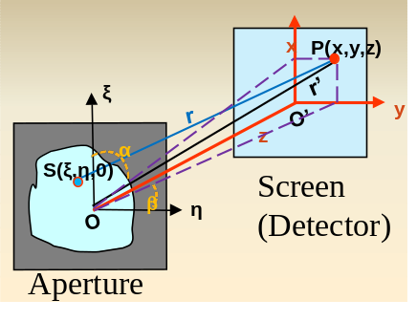
$u\left(P\right)=\frac{iA}{λ}\iint{\frac{e^{-ikr}}{r}dξdη}$ (1)
Note that in an optical domain while the distance 𝑟 is a temporary variable for integration, the distance 𝑟′ is a fixed engineering parameter of a given instrument that does not change over the integration. By the approximation with 𝑟′, the distance 𝑟 can be expanded in a polynomial form
Figure 1. Optical domain of diffraction phenomena.
$r=r^{'}-\frac{xξ+yη}{r^{'}}+\left[-\frac{{\left(xξ+yη\right)}^{2}}{2{r^{'}}^{3}}+\frac{ξ^{2}+η^{2}}{2r^{'}}\right]+ ∙∙∙∙$ (2)
In Eq. (2), the first two terms ($r^{'}-\frac{xξ+yη}{r^{'}})$ are regarded as the Fraunhofer terms and applied into the Huygens-Fresnel integral Eq. (1). And Eq. (1) for Fraunhofer diffraction is
$u\left(P\right)=\iint_{-∞}^{∞}{S\left(ξ,η,0\right)e^{[ik\left(lξ+mη\right)]}dξdη,}$ $z>\frac{a^{2}}{λ}$ (3)
where $r≅r^{'}-\left(lξ+mη\right), l=\frac{x}{r^{'}}=\cos{α; and m=\frac{y}{r'}=\cos{β.}}$ Eq. (3) is only satisfied by the following condition $z>\frac{a^{2}}{λ}$. For Fresnel diffraction, the first three terms of Eq. (2) are applicable to Eq. (1) and subsequently expressed as
$u\left(P\right)=\frac{i}{λz}e^{-ikz}\iint_{-∞}^{∞}{S\left(ξ,η,0\right)exp\left[\frac{-ik}{2z}\left\{{\left(x-ξ\right)}^{2}+{\left(y-η\right)}^{2}\right\}\right]dξdη, a<z<\frac{a^{2}}{λ}}$ (4)
Equations (3) and (4) show a fundamental difference between the Fraunhofer and Fresnel diffraction optics. In device formation, this difference is also clearly evident in Fig. 2. In Fraunhofer, the color (spectral) image forms on a vertical plane while the Fresnel image forms along the optical axis. For high optical resolution, the Fraunhofer grating requires both a long optical diffraction passage and high line density of grating. On the other hand, the Fresnel grating requires both high line density of grating and pixel density of image sensor. As shown in Fig. 3, the longer the spectral line wavelength, the shorter the converging focal length of the spectral line. The focal point of a long wavelength spectral line gets closer towards the Fresnel lens. As Eqs. (3) and (4) indicate, in order to have high resolution, the distance z between the optical aperture (or grating) and the image plane must be long for Fraunhofer ($z>\frac{a^{2}}{λ})$and short for Fresnel ($a<z<\frac{a^{2}}{λ})$spectrometers. This difference clearly suggests that a miniaturized spectrometer must be built with a Fresnel diffraction lens.
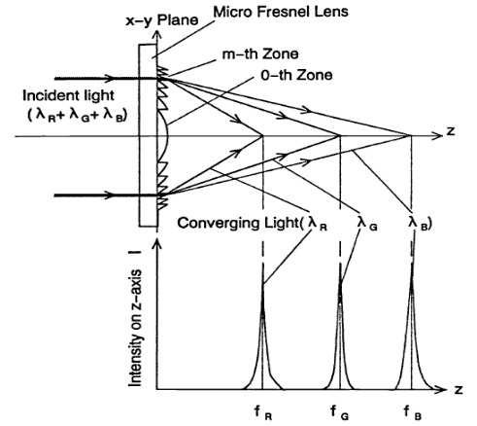
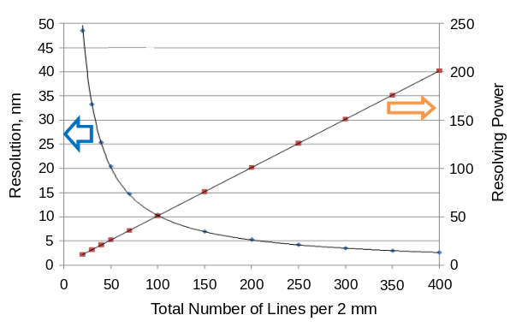
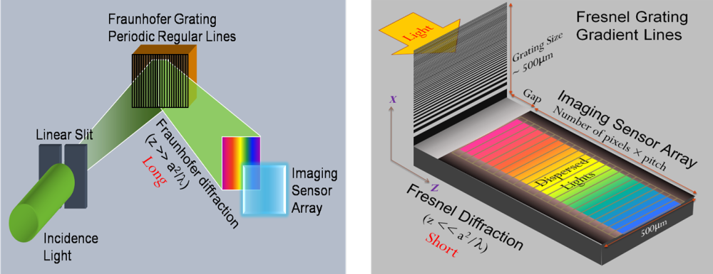
Figure 3. Spectral distribution through Fresnel lens.
Figure 4. Spectral resolution of Fresnel lens.
Figure 2. (left) Conventional Fraunhofer spectrometer, (right) Differential linear Fresnel spectrometer
Figure 4 shows the resolution and resolving power (arbitrary unit) of a Fresnel lens based on the differential line density that is fabricated within a 2-millimeter size. The resolution of 200-line density of Fresnel diffraction grating is about 5 nanometers which is reasonable for micro-spectrometer applications as long as the design of the Fresnel grating for the micro-spectrometer is tailored for monitoring targeted or specific spectral lines. However, any line density of Fresnel grating greater than 200 lines is sufficient for general applications of spectral assay.

- Use of Micro-spectrometer
A prototype of MSM was fabricated to test its functional performance against the luminescence or fluorescence of bio-components such as dopamine. Figure 5 shows the MSM prototype used for the measurement of a spectral signal from dopamine. The test data shows the functioning performance of the MSM in measuring the molar concentration of dopamine as shown in Fig. 6. When the molar density of dopamine increases from 0μM to 0.1μM, 1μM, and 10μM, the signal outputs are inversely decreased due to the absorption decay of the original signal. For the soil assay application, the MSM, along with other parts, is packaged into a bullet shape which can be delivered to a long distance by shooting.
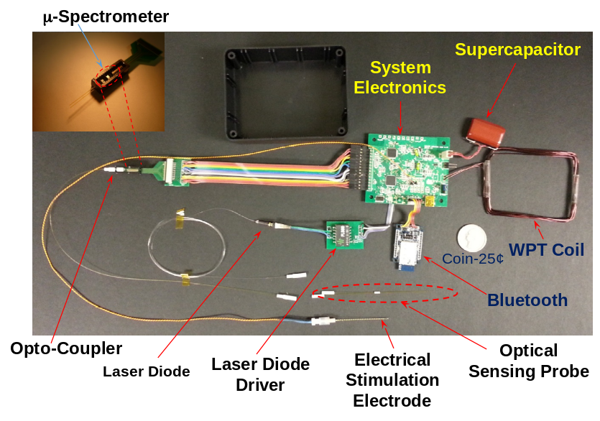
Figure 5. A prototype micro-spectrometer (MSM).
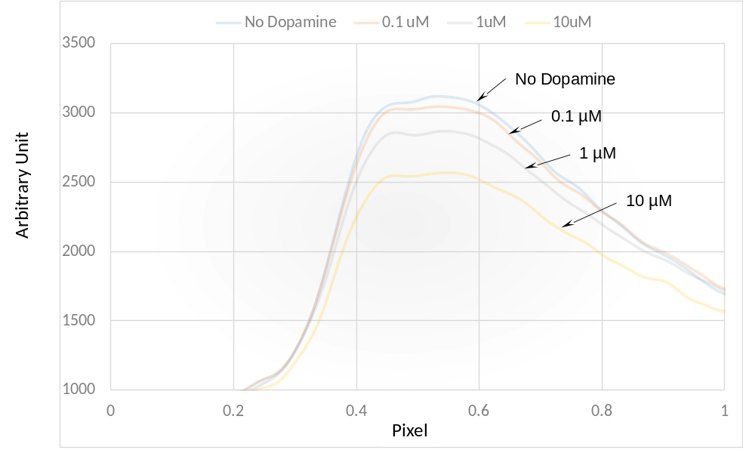
Figure 6. Test result by a prototype micro-spectrometer (MSM) against dopamine molar concentration

The assay of lunar and Martian soils by actual measurements on plain fields, within permanently shadowed craters, and along steep embankments will help create a mineral map which is essential for successful mining and excavation of resources under NASA In-Situ Resources Utilization (ISRU) program. However, spectral mapping of permanently shadowed craters, and along steep embankments pose extreme challenges since astronauts and rovers cannot readily access them.
To address this shortcoming, a new device concept offers a shootable micro-spectrometer bullet for direct access to the areas with geologically ragged formations and extreme environments. This new concept device transmits measured signals wirelessly back to the main station safely outside those extreme environments through an imbedded telemetry system. Such a scenario is shown in Fig. 7. Using multiple devices simultaneously allows large areas to be interrogated quickly and measurements to be coordinated within areas of interest.
Figure 7. Bullet-like consumable micro-spectrometers are shot out broadly to assay organic and inorganic components of Lunar/Mars/Asteroids soils.
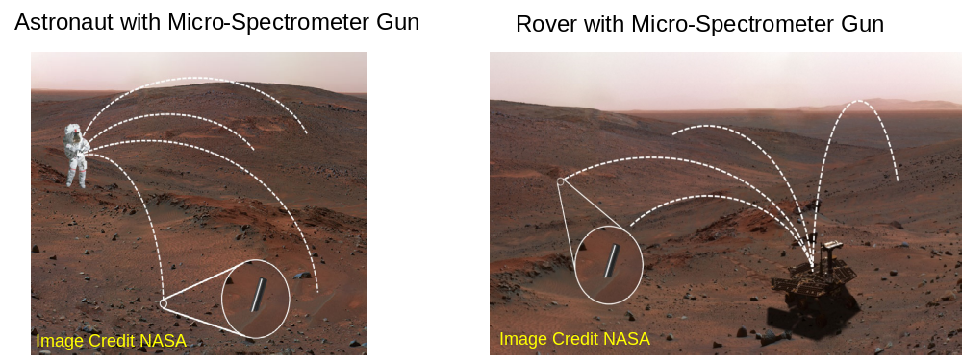
Also, it is regarded as a valuable analysis tool to assay the variety of chemical components in remotely located and/or inaccessible soil promptly such as the permanently shadowed regions (PSR). However, the MSM bullet can only work on soft soils. Figures 7, 8 and 9 show the examples how the bullet MSM can be used for resource assaying and mapping for future space exploration.
Figure 8. Bullet-like consumable micro-spectrometers are shot out broadly to assay water ice and soil components in PSR.
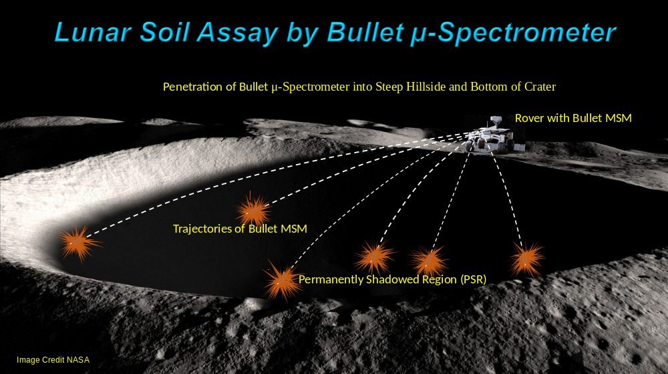
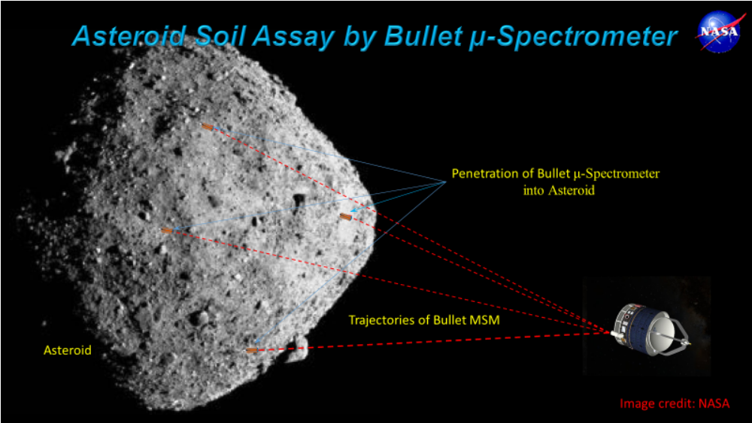
Figure 9. Bullet-like consumable micro-spectrometers can be shot out broadly to assay minerals on asteroids.
- Description of Bullet Micro-Spectrometer
The micro-spectrometers are designed for deployment by an astronaut, rover, or lander flying overhead. Many of these devices can be shot by astronauts, or by rovers, or even from satellites for wide area coverage of soil assay, as shown in Figs. 7 and 10. This device can also be installed on rover tires, under the astronaut’s shoes, or at the bottom of a cane stick or on the tumbleweed rover (see Fig. 10).
The bullet-like consumable micro-spectrometer can be shot as a projectile to a target area and penetrate to a certain depth in the soil and, at the same time, be triggered to spectrally identify the components of soil, such as water, He-3, or other minerals, as it penetrates. The spectral data collected from the soil assay are transmitted to a main station through a telemetry system. This LaRC developed micro-spectrometer bullet [3] consists of micro-spectrometer optics with an all-imbedded burst-mode LED UV light source, a super-capacitor with control electronics, and telemetry electronics, as shown in Fig. 11.
The concept of bullet MSM is regarded as an attractive approach to develop a resource map for the Moon, Mars, and asteroids as mentioned above. However, for these approaches, there are still a few key challenges to improve the performance of bullet MSM:
- Fine nanofabrication of high line density differential line Fresnel grating greater than 400 lines within 2 mm grating height is needed to assure the resolution of 1 nm order.
- Design option of Fresnel grating without increasing the line density of grating. A certain line density of Fresnel grating can be specifically designed to handle spectral lines emitted from targeted species of materials.
- High pixel density of spectral image sensor. Current pixel density of CMOS imager that is used in smart phones is sufficient, but still increased responsivity of pixel is needed. Otherwise, high pixel density of an avalanche photodiode (APD) imager needs to be developed since APD performs with high responsivity.
- Emission spectra between 100 nm ~ 200 nm of light emitting diode (LED) or diode laser in ultra-violet (UV) and vacuum UV (VUV) are preferable for triggering the quantum singlet transition or quantum triplet transition of target atoms and molecules. The singlet transition to ground state induces the emission of fluorescence of the target component while the triplet transition induces the emission of luminescence from a target component. Emission spectra between 100 nm ~ 200 nm has more energy to induce the emission of fluorescence which is more favorable for the imager responsivity and the Fresnel grating performance . Otherwise, the burst mode of LED operation might readily generate VUV for spectral lines of fluorescence.
- A long-distance telemetry capability over several tens of kilometers is probably needed for chemical assay of asteroids and other planets. Otherwise, the current telemetry technology used in smart phones is sufficient to cover the range of PSR or other mapping conditions.
- Power storage in a super capacitor of bullet MSM and programmed distribution of power for LED driver circuit, APD, and telemetry need to be refined from the current technology level.
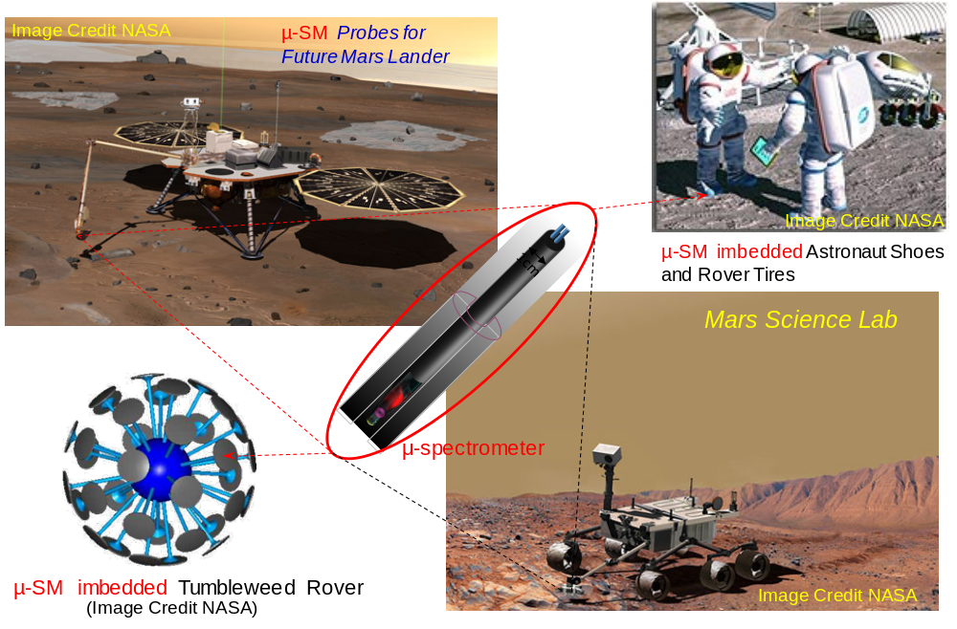
- Development of a compressed gas driven shooting gun or pencil rocket propelled bullet MSM is required. This deployment gun should have built-in magnets around the muzzle for electrically charging the super capacitor in bullet MSM while passing through the barrel.
Figure 10. Bullet micro-spectrometers can be attachable to many different places to effectively assay organic and inorganic components of Lunar/Mars/Asteroids soils.

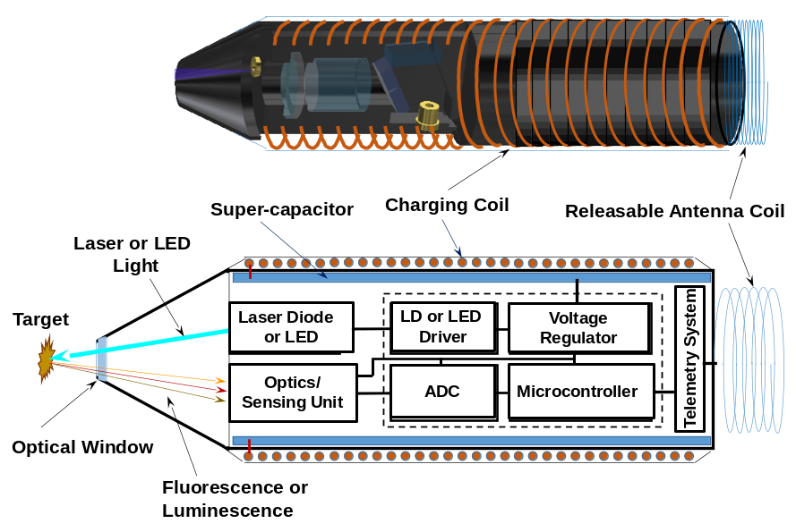
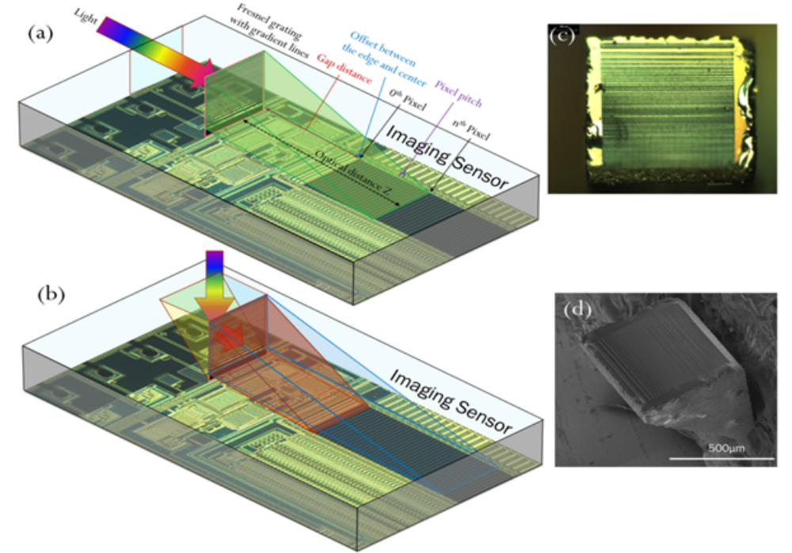
The unit cell of the micro-spectrometer is represented by the block indicating ‘Optics/Sensing unit’ in Fig. 11 and is distinguished by two different modes based on the input signal injection pattern: (a) parallel injection and (b) vertical injection, shown as (a) and (b), respectively, in Fig. 12. Regardless of its injection orientation, the spectral signal from target material, after impinging on and passing through the differential linear Fresnel grating, either (c) or (d) in Fig. 11, will shine onto the pixel array of the imaging sensor. In this process, the photons of the spectral signal of fluorescence or luminescence from the target material are diffracted through the Fresnel grating and then fall onto a specific pixel depending on the wavelength of spectral signal since the diffraction through the Fresnel grating is wavelength (or photon energy) dependent. To differentiate the spectral lines further after diffraction, two approaches can assist: one is a high pixel density of the image sensor that is required to receive the specified wavelength of the incoming signal. Another is a high line density of the Fresnel grating to increase the optical resolution as shown in Fig. 4. Thus, a high-resolution Fresnel grating and a high pixel density sensor are required to separate spectral lines to identify different soil components. The spectral data obtained by an addressable pixel element is digitized through the analog to digital converter (ADC) and micro-controller. Then the telemetry unit transmits the digitized data to a receiving station where the data are collected and processed for image construction of a mineral map or to show the distribution of other elements.
Figure 11. Block diagram of bullet micro-spectrometers.
Figure 12. Micro-spectrometer chip models: Parallel injection mode cell (a) with linear differential Fresnel grating (c) and Vertical injection mode cell (b) with right angle prism linear differential Fresnel grating (d).
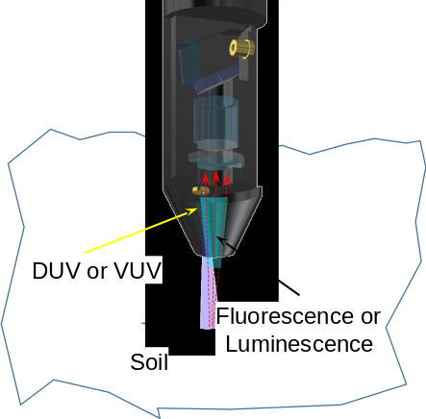
Upon shooting, a bullet micro-spectrometer flies along a trajectory path to reach the target surface and penetrates the regolith by its momentum as shown in Fig. 13. At the moment of penetration, a burst-mode LED or a laser diode is automatically turned on by an impact switch to generate an intensive deep UV (DUV) or VUV light. The burst-mode LED or a laser diode is powered by the super-capacitor that stores energy. The DUV or VUV from a burst-mode LED or a laser diode in a pulse mode illuminates and excites the soil components to create a singlet or triplet transition according to the amount of absorbed photon energy. Since the pattern of optical absorption and associated quantum transition that emanates fluorescent or luminescent emission varies from the element or molecular structure of the material, these transitions are often used to identify the spectral signature of materials. Fig. 13 shows a micro-spectrometer bullet that has penetrated into the soil. As explained above, the fluorescence or luminescence of emission spectra from the excited soil components generates the spectral signal picked up by a sensor array which is subsequently digitized and transmitted wirelessly through an onboard telemetry system and antenna at a receiving station. The data logger and analyzer at the receiving station analyze the transmitted data to illustrate spectrally the resolved signature of the chemicals detected in the soil.
Figure 13. DUV or VUV from a burst mode of LED or from a diode laser illuminates target soil to generate fluorescence or luminescence emission.
Figure 14 shows a compressed gas dispenser. When a bullet MSM from the magazine is loaded into a shooting position, the compressed gas is released by the trigger, opening the valve. When the valve is opened, the compressed gas expands and pushes a bullet MSM through the barrel. The bullet MSM passes through the array of magnets positioned circumferentially on the barrel, shown in Figure 9, where a charge coil generates an electric current to charge the super-capacitor and accelerate the bullet MSM out of the gun barrel.
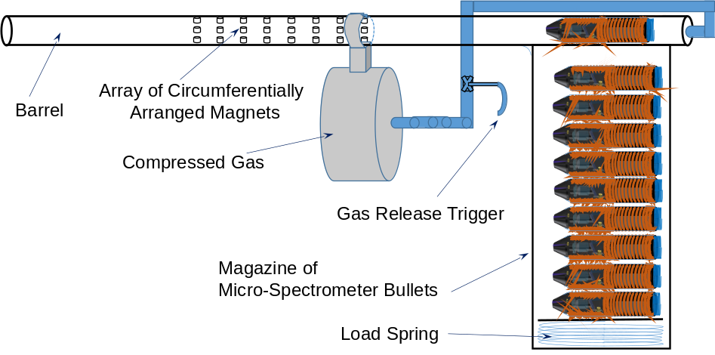
When the bullet MSM leaves the end of barrel, the antenna coil is stretched and straightened by its own stretching force from the coiled spring. In this way, as the bullet MSM penetrates powdered soft soil, the stretched antenna coil can still appear above the soil and communicate with a receiving station as shown in Fig. 15.
Figure 14. Conceptual description of a compressed gas gun to shoot bullet-like micro-spectrometers.
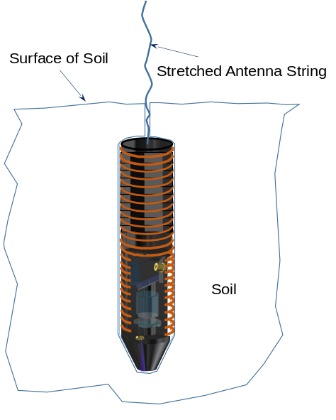
Other shooting methods include a mortar-shell which has gunpowder at the tail of bullet MSM. In this case when a bullet MSM is loaded, the gunpowder is ignited to propel the bullet MSM through magnetic field of gun barrel. Otherwise, the rest of the device concept and process is the same as that of compressed gas propelled bullet MSM described above.
Another deployment method includes a pencil rocket connected at the tail of bullet MSM. In this case when a bullet MSM is loaded, a pencil rocket is ignited to accelerate the bullet MSM through the magnetic field within barrel. Otherwise, the rest of the device concept and process is the same as that of compressed gas propelled bullet MSM.

- Results
We have developed the micro-spectrometers as a neural probe application (see Figure 1). For use in space applications described above, there are several critical elements that need to be refined for a deployable class of bullet MSM. These are the APD pixel array to enhance the photo-sensor sensitivity of micro-spectrometer bullet, the super-capacitor to supply sufficient power for the APD and telemetry system, the gun barrel or booster rocket with electric charger for super-capacitor, and the telemetry system for data transmission.
Figure 15. Deployed a string antenna when MSB pokes deep into soil.
- Conclusions
The micro-spectrometer offers a new capability for in situ resource surveys and science measurements in extreme environments and challenging access conditions. The refinement of micro-spectrometer systems illustrated above will raise the technology readiness level (TRL) to 5~7. Numerous soil assay experiments will be compared with the spectral database of known soil components compiled by U.S. Geological Survey (USGS) for validation of the device. Once the validation process is complete, the bullet micro-spectrometer with gun or launching device will be prepared for deployment packaging as a final process.
References
- Park, Y. and Choi, S.H. "Linear Fresnel Spectrometer Chip with Gradient Line Grating ", U.S. Patent No. 9,046,418 B1, June 2, 2015.
- U.S. Patent No. 8,089,677, January 3, 2012; U.S. Patent No. 7,379,231 B2, May 27, 2008; U.S. Patent No. 8,294,989, October 23, 2012; U.S. Patent No. 8,015,815 B2, September 13, 2011; U.S. Patent No. 8,174,695, May 8, 2012; U.S. Patent No. 8,059,273 B2, November 15, 2011; and U.S. Patent No. 8,094,306, January 10, 2012.
- Choi, S.H. and Moses, R.W.: NASA Invention Disclosure, “Deployable Micro-spectrometer Bullets”,
- Park, Y., Wright, J.D., Jensen, J.D.L., King, G.C., Choi, S.H., “Diffraction Analysis for Periodic Nano-scale Apertures, Scatterers and Absorbers”, IOP Journal, Measurement Science and Technology, Vol. 16, 2005, pp. 2208-2212.
- Park, Y., Koch, L., Park, S.J., King, G.C., Song, K.D., Choi, S.H., “Miniaturization of a Fresnel Spectrometer”, Journal of Optics A: Pure and Applied Optics, Vol. 10, 2008, 095301, doi: 10.1088/1464-4258/10/9/095301
- Park, Y. and Choi, S.H. “Miniaturization of Optical Spectroscopes into Fresnel Micro Spectrometer”, Commemorative paper, Journal of Nanophotonics, Vol. 7, 2013, 077599.
- Cope, T. D. "The Rittenhouse diffraction grating". David Rittenhouse Papers MSS.SMS.Coll.11: 1932. pp. 377–382.
- Parker, A.R. "A geological history of reflecting optics". Journal of the Royal Society, Interface. 2 (2), March 2005, pp. 1–17. doi:10.1098/rsif.2004.0026. PMC 1578258. PMID 16849159.
- Born, M. and Wolf, E., Principles of Optics, 7th ed., Cambridge University Press, ISBN-13 978-0-521-64222-1, Cambridge, 2006, pp. xxvii-xxviii and 411-421.

