Overview of the Predictive Simulation Capability Element of the Plume Surface Interaction Project
Jeff West, Lisa Griffin¹
NASA Marshall Space Flight Center, Huntsville, AL, 35808, USA
Peter Liever, Andrew Weaver², Thomas Shurtz², Manuel Gale² and William Krolick²
Jacobs Space Exploration Group, NASA Marshall Space Flight Center, Huntsville, AL, 35808, USA
As part of the Game Changing Development (GCD) Program funded by NASA’s Space Technology Mission Directorate (STMD), the development of simulation capability for the prediction of extra-terrestrial plume surface interaction (PSI) environments has been undertaken by the Fluid Dynamics Branch at NASA/MSFC. The GCD PSI Project, planned to be completed over a four year period, contains a Predictive Simulation Capability (PSC) Element focused on creating simulation capability for the reliable and accurate prediction of PSI in Martian (~650 Pa) and Lunar (vacuum) ambient environments. In addition to the PSC Element, the GCD Program also contains a companion Ground Testing Element for development of focused datasets for validation of predictive capability as well as a Flight-focused Instrumentation Element.
- Nomenclature/Acronyms
D = Nozzle exit plane diameter
d_{p} = Soil particle diameter
h = Height of nozzle exit plane above the soil surface
λ = Molecular mean free path
P_{i} = Impingement pressure
P₀ = Total pressure
PSC = Predictive Simulation Capability
PSI = Plume Surface Interaction
τ_{w} = Soil surface shear stress

- Introduction
NASA’s exploration goals require the development of landers for the Moon and Mars. To make safe and efficient landings, these systems are likely to require retro-propulsion, or the use of rocket engines to decelerate the landers to a soft touchdown on the surface. The environments arising from the interaction of rocket plumes with lunar and planetary regolith during descent and landing, as well as ascent from the surface, is a significant risk to propulsive landers. These environments are characterized by plume flow physics, erosion (or cratering) physics, and ejecta dynamics. Each of these pose risks to landing systems, a number of which have been experienced or observed in flight. Plume impingement effects on the lander can threaten lander stability and produce elevated convective heating during powered descent and landing. Cratering, or erosion, can lead to destabilization of the lander upon touchdown and potentially violate lander tilt requirements. Extensive and shallow cratering was observed post-flight for the Apollo lunar landers, and deep cratering was observed post-flight for the InSight Mars lander. Ejecta dynamics can lead to loss of instrumentation or function, damage to the lander and any surrounding infrastructure, and obscure visibility for radar and other optical ranging systems.

The NASA Game Changing Development Program’s Plume-Surface Interaction (PSI) Project[1] is a multi-year effort aimed at developing an integrated modeling, simulation, and testing approach to the prediction of physics associated with the exhaust plume, erosion and cratering, and ejecta from the landing site to help engineers protect the lander and to evaluate the PSI risks for favorable landing sites. Under this effort, progressively validated tools and new ground test data will be produced to reduce design uncertainty due to landing environments and to support development of mitigation strategies. Flight instrumentation specifically for in-situ PSI data will be tested in relevant environments. With many near-term exploration objectives focused on the Moon, this project prioritizes the capability to predict PSI environments for airless bodies, which requires the ability to model both rarefied and continuum flows.

These activities are designed to support the PSI Project goal[2] of developing an integrated modeling, simulation, instrumentation capability, and testing approach to PSI definition in the areas of: plume flow physics, erosion physics and ejecta dynamics, closing the identified gaps in physics modeling that are first order to accurate prediction.

The PSI Project is divided into three technical elements to accomplish the activities described above. These are the Predictive Simulation Capability (PSC) element (the focus of this paper), the Ground Testing element and the Flight Focused Instrumentation element. In order to further explain the PSC element, a description of the Plume Surface Interaction topic is helpful.

A simplified sketch of a generic Plume Surface Interaction is shown in Fig. 1. The description will begin at the rocket nozzle exit plane and generally follow plume flow path. The lander vehicle base is depicted by the heavy gray line at the top of the figure. The small blue items attached to the vehicle base represent multiple items including the Reaction Control System and various sensors and instrumentation. Each of the two landing propulsion rocket nozzles is depicted by two outwardly diverging lines creating a downward opening cone. Rocket effluent exits the two nozzles and is depicted by solid purple curves beginning at the nozzle exit and proceeding to the soil surface. The deforming and/or eroding soil surface is depicted by the solid red curve at the bottom of the figure. The plume flow impinges on the soil surface and flows outboard from the impingement point. Between the two rocket nozzles, the flow moving outboard from their respective impingement locations collide and stagnate, which directs plume flow upwards between the two plumes towards the lander vehicle base. The plume flow between the two nozzles is depicted by the purple curves located between the two nozzles.

The plumes impinging on the soil surface creates an impingement environment on the soil surface consisting of impingement pressure and shear stress. Under the forcing by the impingement environment, the soil surface begins to deform and/or erode after a threshold impingement environment intensity is reached. As the soil surface changes, the impingement environment imposed on the soil by the plume is affected, potentially increasing or decreasing the degree of soil deformation/erosion depending on specific details of the PSI in consideration. Any eroded soil is accelerated by the plume flow in each direction taken by the plume after impingement on the soil. This includes soil transported upwards between the two rocket nozzles towards the lander base as well as outboard from the lander vehicle. Any habitat structure or assets within range of the ejected soil (ejecta) may experience an adverse environment consisting of both impingement pressure as well as impacts by soil particulate.

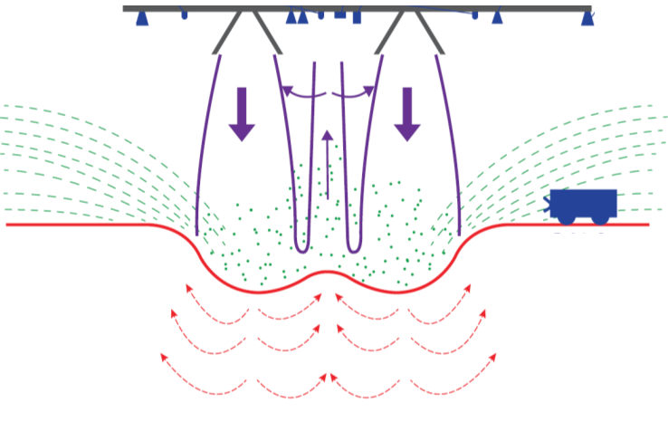
Fig. 1 Depiction of a generic Plume Surface Interaction. Lander vehicle base represented by gray line at top. Deforming and/or eroding soil surface represented by the solid red line. Soil internal flow represented by dashed red arrows. Plume boundaries and flow directions shown in purple. Ejected soil represented by dashed green lines. Surface habitat infrastructure represented by the wheeled vehicle in blue on the right.

A reasonable question to pose is why future landings on the Moon, manned or unmanned, are exposed to a risk from PSI? After all, the Apollo manned landings were successful. Why is the Apollo engineering solution not applicable to all future landers? A straightforward and compact understanding is obtained by inspecting supersonic plume impingement pressure and shear stress data conducted at very low, ~ 1 Pa, ambient pressure. The pressure profile imparted by the plume on a solid surface, the impingement pressure P_{i}, as well as the impingement surface shear stress profile, τ_{wall} has been shown[3] to be proportional to the plume total pressure P₀, multiplied by the square of the ratio of nozzle exit plane diameter, D, to the altitude of the nozzle exit plane above the soil surface, h, as shown in equation 1.

P_{i} , τ_{wall} ∝ P₀ ( D / h ) ² (1)

Some implications of this relation are as follows. The Apollo descent engine operated at a total pressure of approximately 23 psia[4]. Most current lander concepts have engine total pressures potentially significantly greater and thus will create an impingement pressure commensurately greater. Similarly, landers with a greater mass than the Apollo lander will likely have a greater nozzle exit diameter and thus greater impingement pressure. The implication of Equation 1 is that a lower maximum value of P_{i} is produced by several, adequately spaced, lower total pressure engines than one engine with high total pressure. A possibly impractical implication is that packaging the landing engine nozzle exit plane as high as possible above the soil surface reduces the impingement pressure. The same implications are true with respect to impingement surface shear stress.

Since modern landers are likely to cause significantly different soil surface environments than the Apollo lander, the availability of predictive tools with known accuracy to address the risks that PSI poses will enhance the mitigation of these risks. Therefore, the PSI Project PSC element is focused on three primary topics: (1) plume flow in low-pressure environments, (2) effects of mixed continuum/rarefied flow on soil erosion and ejecta, and (3) soil particle phase modeling. The next section, Section III, will explore the physics involved in the PSI phenomenon in order to illustrate the motivation for the specific goals and objectives of the PSC element. Section IV will describe the four sub-tasks of the PSC element that address the challenges identified in the next section.

- Challenges to the Predictive Simulation Capability Development Element

In order to identify the challenges of constructing predictive tools for PSI, the PSI phenomenon will be re-examined to a further depth following the format of the brief description provided in the previous section. The re-examination will be conducted from the perspective of supporting landings on both the Moon and Mars and will make note of differences in PSI challenges caused by the differences in landing environment between the two extra-terrestrial bodies.

The driving force that creates PSI is the impingement environment caused by the plume(s). Therefore, it is imperative for a predictive tool to accurately predict the plume from the rocket nozzle to the soil surface. For Moon landings, the lack of an atmosphere may cause rarefied effects due to increases in the Knudsen number, a ratio of the molecular mean free path, λ, to a length scale of interest, L. It has been shown in subscale tests [3] that the impingement surface shear stress, one of the key drivers of PSI, is significantly affected in a non-conservative direction by the effects due to an increasing Knudsen number. Predictive tools intended to predict PSI and its effects on Lander designs must be capable of accurately capturing these rarefied flow effects.

The prediction of the soil response to the impingement environment is required of predictive tools if they are to be used to understand and mitigate PSI-induced risks. A direct simulation of all scales of the PSI process would require resolution of a range from the smallest particle size to the size or altitude of the lander vehicle. Lunar regolith particles sizes are as small as 1 to 5 microns and the vehicle altitude during active PSI is as large as 50 meters. Spatially resolving gas-phase flow around the smallest soil particle as well as the lander vehicle altitude at the onset of PSI spans at least 9 orders of magnitude, making direct simulation an impractical approach on which to base predictive tools. Because soil erosion is a transient event in PSI, the temporal resolution requirements of a direct simulation are driven by the smallest length scales and highest surface velocity and add to the effort beyond the spatial resolution challenge. The two-phase modeling approach selected must involve a significant degree of modeling in order to be tractable.

Martian ambient pressure is also small (650 Pa) compared to that of the Earth (10⁵ Pa). Subscale experiments have shown [5] that erosion caused by jets is significantly affected by the Knudsen number of the small particles, λ/d_{p}. This means that at the soil surface, the predictive tools must simultaneously model plume impingement, two-phase flow and rarefied effects.
- Addressing the Challenges
In order to develop a set of predictive tools that can be used during this PSI Project, it is advantageous to base these tools upon existing, validated production tools. One such tool is the Loci/Chem density based, unstructured CFD tool[6] developed by Mississippi State University and in production use at NASA/MSFC, other NASA centers, the DoD, and industry. Loci/Chem has been extensively verified and validated for use with supersonic plumes from rocket powered vehicles[7][8]. The Loci framework [9][10], developed by Dr. Edward Luke of Mississippi State University, is an extension of the C++ language designed to enable the construction and evolution of computational methods, such as CFD. There have been several different CFD programs implemented in the Loci framework in the past two decades. These include Loci/STREAM[11][12][13], a pressure based unstructured CFD application developed by Streamline Numerics Inc. and Loci/Thrust[14], a Discontinuous Galerkin CFD application developed by Mississippi State University. Loci/Chem is the baseline production tool chosen for gas-phase simulation of plume for the PSC Element.

Beginning in 2012, NASA/MSFC evaluated a hybrid method that coupled the solution of the Navier-Stokes equations using traditional methods with the Boltzmann equations solved by the Discrete Velocity Method (DVM). The coupling was accomplished by choosing cell-by-cell which governing equations to solve based on a Continuum Breakdown Criteria (CBC) which is similar to a Knudsen number criteria. As the solution progressed, the balance of cells for each approach was changed based on the evolution of the CBC as the simulation progresses. The application which implemented this approach, termed here as Boltzmann, was developed by CFDRC, Inc since 2005[15]. In 2016, the DVM approach was implemented in the Loci framework and coupled with the Loci/Chem CFD application. The Loci/Chem-Boltzmann application [16] is theoretically capable of solving the coupled Navier-Stokes and Boltzmann equations for the PSI application. At the start of the PSI Project, the Loci/Chem-Boltzmann application was at a proof of concept state.

Coupled solution of the Navier-Stokes and Boltzmann equations are not new. There are many examples[17] of using Direct Simulation Monte Carlo (DSMC) to solve rarefied flow using boundary conditions from solution of the Navier-Stokes equations upstream of the rarefied region. The hybrid approach used by Loci/Chem-Boltzmann has the advantage of being fully-coupled, a single streamline can begin its path in continuum flow, expand into rarefied flow and then be compressed into a continuum flow. The hybrid approach will solve the required equations at each location along the streamline described above. In Section II, the flowpath between two plumes impinging on the ground and directing the plume back upwards towards the lander vehicle one example of such a streamline. Another advantage of the hybrid approach is that only regions which are rarefied and affect the PSI outcome are required to be solved by the relatively very expensive DVM application, minimizing the computational effort required for the coupled solution.

In order to address the range of scales challenge identified in the previous section, an Eulerian approach to modeling the soil phase was chosen. The use of an Eulerian model for the solid-phase allows decoupling of the required resolution of spatial scales from the soil particle size and thus directly address the range of scales challenge. The minimum spatial scale required for resolution is based solely on gradient resolution, which may be much larger than the soil minimum particle size. The algorithm chosen for use is the Gas Granular Flow Solver (GGFS), was developed by CFDRC, Inc since 2005[18]. This algorithm was assessed by NASA/MSFC beginning in 2018. Following a positive evaluation, an effort to implement GGFS in the Loci framework begun in 2019[19].

In the previous section, it was pointed out that rarefied effects are significant and alter the shear stress at the plume impingement location. The shear stress is a driver of soil erosion and thus must be considered within the Loci/GGFS application. In 2020[20], an effort to couple the Loci/GGFS application with the Loci/Boltzmann solver was initiated. The Loci/GGFS-Boltzmann application is being extended to two-phases to provide a fully coupled solution.

The final PSI application envisioned is the coupling of the three Loci applications, Loci/Chem, Loci/GGFS and Loci/Boltzmann into a fully coupled application termed Loci/Chem-GGFS-Boltzmann. The intended mode of operation is as follows. In regions in which there is no solid-phase present, Loci/Chem will be used for cells which are in the continuum regime and Loci/Boltzmann will be used for cells in which rarefied flow conditions exist. In regions where solid-phase is present, Loci/GGFS will be used for cells which are in the continuum regime and coupled Loci/GGFS-Boltzmann will be used for cells in which rarefied flow conditions exist.

- Predictive Simulation Capability Element Tasks
The purpose of this section is to describe the activities being conducted to achieve the vision presented in the previous section. In addition, the accomplishments and status of each activity is also described. The PSC Element activities are broken down into four tasks. The tasks are constructed to directly address the challenges described in Section III. Each task includes both predictive tool development as well as validation activities [21].
The PSI Project has funded a subscale PSI test campaign named the Physics Focused Ground Test (PFGT) with the objective of producing PSI cratering and ejecta data for validation of the predictive tools being developed by the PSC Element. The PSC Element has heavily participated in the PFGT requirements and experimental design as well as test execution. The data generated from the PFGT will form the primary basis of the validation efforts of the four PSC Tasks described in this section. The description of the PFGT test and its data product is described in companion papers [22] and presentations at this conference and will not be further described in this paper.
In the description below, it is evident that multiple sources of funding are being used to develop the computational tools to simulate PSI. In cases where non-PSI Project funding is used, then the source of funding, in most cases a NASA SBIR or STTR, is called out.
- Task 1: Plume Flow in Low Pressure Environments

The objective of Task 1 is to implement methods to simulate rarefied flow into production-class computational tools and validate computational tools for existing data in low pressure environments. The targeted low pressure environments correspond to the Lunar and Martian Environments. The figures of merit for Task 1 are plume structure and plume impingement environments. No erosion or cratering is considered in Task 1 activities. A flow chart of the primary activities comprising Task 1 is shown in Fig. 2. Task 1 consists of developing the Loci/Chem-Boltzmann application described in the previous section and validating its use for PSI applications. Task 1 also includes the validation of the Loci/Chem application for plume impingement environments under conditions similar to those found on Mars.

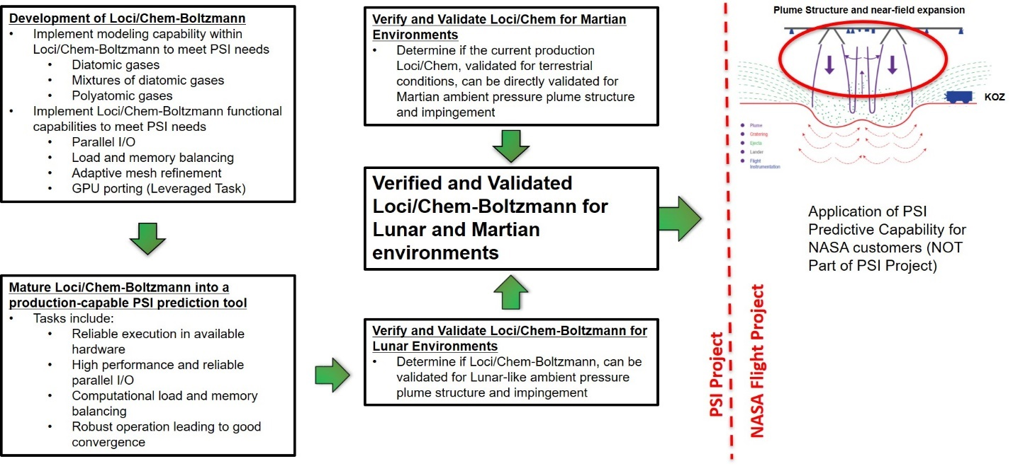

Fig. 2 Flow chart of primary activities comprising Task 1 of the PSC Element.

No tool development was anticipated for Martian environment plume structure and plume impingement environment applications. The Loci/Chem application is well validated for terrestrial ambient pressure and reduction of the ambient pressure to the 650 Pa characteristic of Mars does not result in rarefied flow in the plume and plume impingement regions for practical PSI applications. Note that when soil erosion is considered, then rarefied flow conditions are expected, but Task 1 does not consider soil erosion.

For the Lunar application, significant rarefied flow effects are anticipated in PSI applications. At the beginning of the PSI Project, the Loci/Chem-Boltzmann application had been demonstrated for PSI applications using a monoatomic gas as the plume effluent. The demonstration revealed significant parallel performance issues, including imbalance of load and memory use in parallel mode. During the first year of the PSI Project, the Loci/Chem-Boltzmann application was upgraded to achieve both load and memory use load balancing. The upgraded application was demonstrated to simulate a practical PSI application, the Apollo Lunar lander, while achieving robust parallel scalability using as many as 4,200 CPU cores on the NASA Pleiades supercomputer. The second year of the PSI Project supported the development of a diatomic plume effluent model as well as significant performance upgrades.

Evaluation of Loci/Chem-Boltzmann performance using diatomic Nitrogen as the plume effluent for the Apollo Lunar lander is currently underway. More details about the assessments can be found in a companion paper[23].

Significant efforts to validate Loci/Chem for plume structure and impingement environments has been conducted in the first two years of the PSI project[24]. In the first year of the PSI Project, initial validation assessment of the Loci/Chem application using data from a subscale experiment [25] of plumes in Martian-like ambient pressures resulted in a positive outcome. This led to more wide-ranging and detailed validation activities in the second year. More details of these validation activities can be found in the companion paper[23].

The positive assessments of Loci/Chem-Boltzmann summarized above enable the beginning of validation activities. The first validation assessment[21] will be conducted using data from a subscale experiment[3] which measured plume impingement pressure and impingement surface shear stress for supersonic jets and plume impinging on a solid surface in very low ambient pressure. The dataset demonstrates transition from continuum to rarefied conditions in terms of the solid surface shear stress. This transition is key data for demonstration of the ability of Loci/Chem-Boltzmann to model rarefied effects that are first order to PSI outcomes.

- Task 2: Effect of Mixed Continuum/Rarefied Flow on Crater Development and Ejecta Sheets

The objective of Task 2 is to: i) implement improvements to two-phase production-class computational tools, ii) implement methods to couple rarefied flow with the two-phase computational tools suitable for transient simulations of PSI, and iii) validate computational tools for existing data in low pressure environments. The target applications are PSI in Lunar and Martian environments. The figures of merit for Task 2 are crater formation and ejecta transport. A flow chart of the primary activities conducted by Task 2 is shown in Fig. 3. The task consists of developing the Loci/Chem-GGFS application, verifying its performance for production operation and validating it for crater growth and ejecta formation and transport for both Lunar and Martian environments.

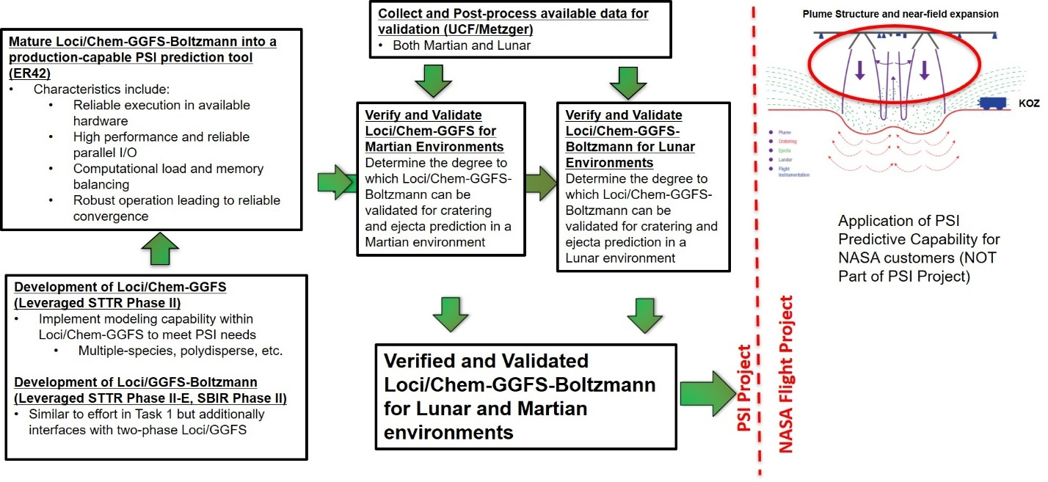

Fig. 3 Flow chart of primary activities comprising Task 1 of the PSC Element.

A NASA STTR Phase I was awarded in 2019 to implement the GGFS algorithm within the Loci framework. A subsequent STTR Phase II was awarded to continue the development. During the first year of the PSI Project, the Loci/GGFS application was applied by the PSC Element to demonstrate its use in axi-symmetric mode for the simulation of a subsonic jet-driven PSI laboratory-scale test. Late in the first year of the PSI Project, the Loci/GGFS application was demonstrated in 3D mode for simulation of the same laboratory scale PSI dataset. Significant issues were identified and addressed in the Phase II STTR effort. One drawback identified was the large amount of computational effort required to simulate a realistic PSI application. In the second year of the PSI effort, an improved Loci/GGFS application was demonstrated in a 3D supersonic plume-driven laboratory-scale PSI test. While the many improvements, including some significant performance enhancements, improved the performance of Loci/GGFS, computational performance was still less than that required to perform a reasonable PSI assessment for a NASA Program. A NASA Phase I and Phase II SBIR effort began in 2020 to couple the Loci/GGFS application with the Loci/Boltzmann application. At the current time, an initial full coupling of the two computational tools has been accomplished. Evaluation of Loci/GGFS-Boltzmann by the PSC Element will begin within the next year. Future efforts will focus on developing the final envisioned production-mode PSI tool, Loci/Chem-GGFS-Boltzmann.

Significant validation activities using Loci/GGFS were conducted during the first and second year of the PSI Project. The data used for the validation comparison is from a test series performed by Metzger[5] at the Planetary Aeolian Lab (PAL) in 2016 at a vacuum chamber pressure of 9.8 Torr (1300 Pa). This test was performed using a subsonic jet emitting from a pipe directed into a test bin filled with sand and outfitted with a splitter plate aligned with the center of the pipe such that half of the jet enters the test bin and half of the jet is directed out of the test bin. The splitting of the jet enables direct visualization of the growing crater formed by the PSI process. Simulations of this test using Loci/GGFS in axi-symmetric mode produced crater depths that at early times exceeded the experimental growth rate yet after some time became asymptotic to a constant depth while the experimental crater continued to grow. More details of this validation comparison are contained in a companion paper[26]. In the coming year, validation activities will be focused on using cratering and ejecta data generated by the PFGT campaign to compare to simulation results conducted using the Loci/GGFS tool in 3D simulations of the supersonic plume PSI experiment.
- Task 3: Regolith Particle Phase Modeling

The objective of Task 3 is to: i) development methods to determine the properties of soil mixtures for use in two-phase Eulerian soil models, ii) develop particle-phase models of realistic Lunar and Martian soil, and iii) validate two-phase production-class computational tools using the Lunar and Martian soil models with available ground and flight data.

The NASA Phase II STTR project[19] mentioned in the previous subsection implemented three soil models within the Loci/GGFS application. These models are: i) a mono-disperse spherical soil particle model after Lund[], ii) a polydisperse spherical soil particle model based on the GHD approach[28][29], and iii) a general polydisperse irregular particle shape model based on the results of an a-priori Discrete Element Method (DEM) simulation of the soil mixture[19]. The PSI simulations described in the previous subsection were conducted using the mono-disperse spherical soil particle model. In the second year of the PSI Project, several Loci/GGFS simulations using the GHD soil model for a bi-disperse soil were demonstrated. A simulation capability was also demonstrated using the DEM-based soil model for a soil consisting of mono-disperse elongated cylinders. More details of these demonstrations can be found in a companion paper and presentation[32].

In the second year of the PSI project, a DEM tool[37] was delivered to the PSC Element by UC Davis. The operation of the DEM application was assessed by PSC personnel. An instant in time of one such simulation is shown in Fig. 4. Visible in the figure are both single spherical particles as well as composite particles constructed using multiple spheres of different size in a line crating a crescent roll-like shape. The computational domain is indicated by the white outline. Future use of this DEM tool is anticipated to develop soil models to approximate both Lunar and Martian soils which will be ultimately used within the general polydisperse, irregular particle shape mode of the Loci/GGFS application. Since the UC Davis DEM tool is a research-style application, it lacks a parallel implementation, resulting in its use taking weeks or months to complete the simulations with the parametric variations required to create a database for use in Loci/GGFS. Another task within the NASA Phase II SBIR[20] described above is focused on identifying an open-source DEM implementation which can be verified to provide commensurate accuracy as the research DEM tool yet provide a highly parallel implementation to reduce DEM simulation times to days. A candidate tool, LIGGGHTS[31] has been identified and is currently undergoing assessment for suitability for PSI use.

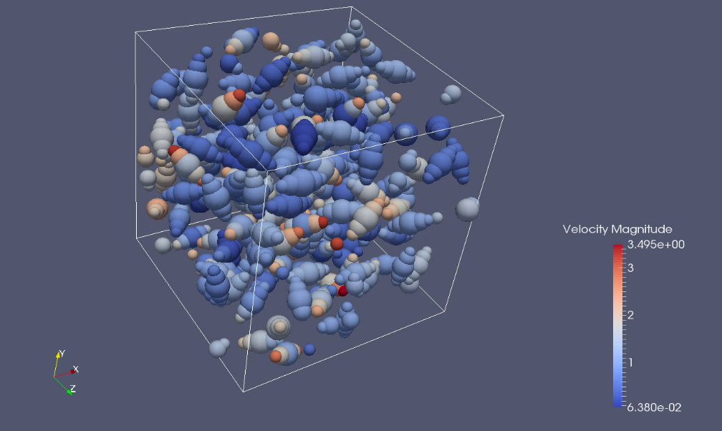

Fig. 4 Flow chart of primary activities comprising Task 1 of the PSC Element.

The ultimate objective of Task 3 is to develop validated models of Lunar regolith and Martian soil for the purposes of modeling PSI outcomes for lander vehicles. The development of these soil models will begin in earnest in the current year. The envisioned overall process of designing a solid model is described next. Based on available knowledge of target soil composition and awareness of computational effort limitations, a candidate soil composition is defined. This definition specifies the number of unique particle sizes, shapes and composition. This definition is used to construct a DEM model, which has a unit cube computational domain. Two types of DEM simulations are conducted, one a constant shear simulation and the other a ‘cooling’ simulation in which particles in the cube are given an initial condition random location, orientation and velocity vector and the simulation proceeds, simulating non-elastic collisions until the particle motion reaches a constant damping rate. These simulations are conducted over a parametric range of total particle concentration and relative concentrations of each unique particle type in the candidate soil definition. The results of the DEM simulations are assembled into a file which is read by Loci/GGFS and used to perform a validation assessment. If the validation assessment indicates acceptable accuracy, the soil model is complete, otherwise the soil composition is adjusted, and the process repeated until adequate validation can be achieved.

Task 4: Gas-Particle Interaction Modeling

The objective of Task 4 is to i) develop an understanding of existing gas-particle interaction models as applied to the PSI application, ii) Perform unit physics experiments of particle clouds in a laboratory environment to aid in the understanding of gas-particle cloud interaction in low pressure environments, iii) develop models of gas-particle cloud interactions suitable for implementation into production class two-phase computational tools, and iv) validate production-class computational tools with available data for gas-particle cloud interactions. More details of this task are available in a companion paper and presentation[33].

Particle clouds subjected to a relative gaseous flow exhibit a behavior where the flow wake behind one particle affects the gaseous flow that another particle in the cloud is subjected. An illustration of this flow is presented in Fig. 5[33]. On the left half of the figure, a stationary particle array has been subjected to a shock traveling from left to right. Multiple wakes are formed which in turn, affect the wake formation behind subsequent particles. This creates a complex, unsteady, multiple-scale flow pattern in which the complex flow interactions are termed Particle Turbulent Kinetic Energy (PTKE). In 2020, a NASA Early Stage Innovation Task was awarded in which this effect and other flow particle cloud interactions are being studied to ultimately develop a basis for practical engineering models of these effects. Also in 2019, a NASA Phase I SBIR [34] was awarded which is formulating a beginning basis for modeling PTKE as well as implement a initial model for PTKE within Loci/GGFS.

Fig. 5 Particle resolved simulation of a shock passing through particle suspension[33]. Note the chaotic flow which is termed Particle Turbulent Kinetic Energy (PTKE).

During the first year of the PSI Project, the PSI Project funded a laboratory-scale experimental campaign was conducted by Johns Hopkins University [35] to collect data on particle drag within supersonic plumes. This data will be used to inform the PTKE model that will be ultimately implemented in Loci/GGFS. A NASA Phase II SBIR[34] was awarded in 2020 to augment these experiments and further formulate a model for PTKE within Loci/GGFS. Further understanding of gas-particle interaction is the product of a NASA Early Stage Innovation (ESI)

contract [33] being executed by the University of Michigan as described above. The relationship of these efforts, including earlier efforts, to the PSI Project is depicted in Fig. 6. In the second year, the PSI project has funded the University of Michigan to investigate and document the history of models of particle-cloud interactions like those present in the PSI application[36].

Upon delivery of the PTKE model at the conclusion of the NASA SBIR Phase II effort, the PSC element will evaluate its performance suing data available at the time.

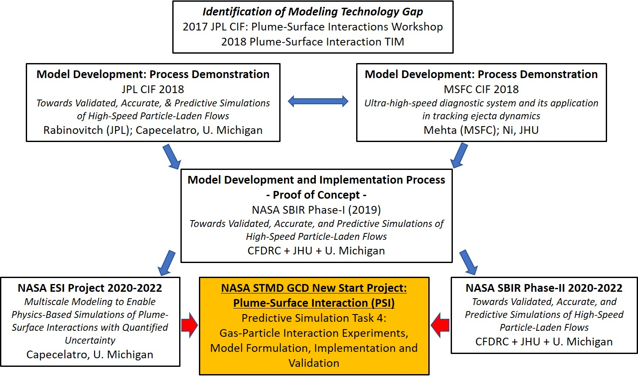
Fig. 6 Depiction of activities leading up to the formulation of Task 4 within the PSI Project PSC Element.

.

Summary and Observations
This paper has briefly described the need for the ability to predict PSI to support NASA’s near-term objective of landing humans on the Moon and the longer term objective of landing men on Mars. PSI on these extraterrestrial bodies involves physics beyond those faced on the Earth, a brief explanation of these was provided.
In 2019, NASA’s Game Changing Development awarded a project focused on developing predictive methods for PSI and its effects and validating those methods to provide support to the design of manned lander craft. The Predictive Simulation Capability element of the PSI project was described at a high level, focusing on the measures being undertaking to overcome the additional complexities of PSI on the Moon and Mars. Each of the four PSC sub-tasks were described, describing both work funded directly by the PSI project as well as other NASA funding sources being leveraged to create a predictive PSI capability. A brief status of each of the four sub-tasks was provided as well as the ongoing and future planned work in each task.

Acknowledgments
The work described here was performed under PSI Project funding. The useful discussions and validation data provided by Philip Metzger of University of Central Florida are greatly appreciated.

References
- Various, “Game Changing Development Program: Plume Surface interaction Project Plan”, May 18, 2020.
- West, J.S., “Game Changing Development Program: Plume Surface interaction Predictive Simulation Capability: Validation Plan”, November 2021.
- Legge, H., “Plume Impingement Forces on Inclined Flat Plates”, Rarefied Gas Dynamics, VCH Press, Weinheim, Germany, 1991, pp. 955-962.
- Hammock, W. R., Currie, E., C. and Fisher, A., E., “Apollo Experience Report- Descent Propulsion System”, NASA Technical Note TN D-7143, March 1973.
- Metzger, P. T., “Rocket Exhaust Blowing Soil in Near Vacuum Conditions is Faster than Predicted by Continuum Scaling Laws,” Proceedings of Earth and Space 2016: Engineering, Science, Construction, and Operations in Challenging Environments, April 2016. doi: 10.1061/9780784479971.007
- Luke, E. A., Tong, X., Wu, J., Cinnella, P., Chamberlain, R., and Walters, K., “CHEM 4.0: A Finite-Rate Viscous Chemistry Solver – The User Guide,” September 2016.
- Velura, S. P., “Code Verification and Numerical Accuracy Assessment for Finite Volume CFD Codes,” Ph.D. Dissertation, Virginia Polytechnic Institute and State University, Blacksburg, VA, 2010.
- "Shuttle Expected Debris Databook: Liftoff Debris Assessment Methodology, Volume III" National Space Transportation System, 2010.
- Luke, E., “A Rule-Based Specification System for Computational Fluid Dynamics,” Ph.D. Dissertation, Mississippi State University, Dec. 1999.
- Luke, E., and George, T., “Loci: A Rule-Based Framework for Parallel Multidisciplinary Simulation Synthesis,” Journal of Functional Programming, Special Issue on Functional Approaches to High-Performance Parallel Programming, Volume 15, Issue 03, 2005, pp. 477-502.
- Thakur, S., Wright, J., “Loci-STREAM: An All-Speed CFD Solver for Arbitrary Polygonal Meshes – Methodology,” Streamline Numerics, Inc. Report, Gainesville Florida, April 2009.
- Thakur, S., Wright, J. and Shyy, W., “An Algorithm for Chemically Reacting Flows on Generalized Grids Using a Rule-Based Framework,” 43rd AIAA Conference, Paper No. 2005-0875, Reno, NV (Jan 2005).
- Thakur, S., and Wright, J.: “Loci-STREAM: A Pressure-Based, Finite-Rate Chemistry Solver for Combustion Flows, Release 1.2.5 – Users’ Guide,” April 2009.
- Collins, E., M. and Luke, E. A., “Loci-THRUST User Guide”, Mississippi State University, August 2019.
- Tosh, A., Liever, P. A., Arslanbekov, R. R., and Habchi, S., “Numerical Analysis of Spacecraft Rocket Plume Impingement Under Lunar Environment”, Journal of Spacecraft and Rockets, Vol. 48, No. 1, 2011.
- Harris, R., E., Turansky, C. and Luke, E., A., “Unified In-Space Propulsion Framework for Prediction of Plume-Induced Spacecraft Environments.”, STTR Phase II Final Report, Contract #80NSSC17C0039, November 2021.
- Lumpkin, F., Marichalar, J. and Piplica, A., “Plume Impingement to the Lunar Surface: A Challenging Problem for DSMC”, https://ntrs.nasa.gov/citations/20070031629, October, 2007.
- Gale, M., Buettner, K., Mehta, R., Liever, P. A., and Curtis, J., “Gas-Granular Flow Solver for Plume Surface Interaction and Cratering Simulations,” AIAA 2017-4503. 23rd AIAA Computational Fluid Dynamics Conference, June 2017. doi: 10.2514/6.2017-4503
- Gale, M., Fontenot, R., L., Mehta, R., S. and Luke, E., A.,”A Scalable Gas-Particle Flow Simulation Tool for Lander Plume-Surface Interaction and Debris Prediction”, STTR Phase I and II, contract 80NSSC20C0032, 2019-2021.
- Gale, M., P., Howison, J., C., Fontenot, R., L., Mehta, R., S., Harris, R., E. and Turansky, C., “Plume-Surface Interaction in Rarefied Environments”, NASA SBIR Phase I and II, contract # 80NSSC20C0219, 2020-2021.
- West, J. S., “Game Changing Development Program: Plume Surface interaction Predictive Simulation Capability: Validation Plan”, NASA, Nov. 2021.
- Korzun, A., Eberhart, C., J., West, J., Liever, P., A., and Weaver, A., B., “Design of a Subscale, Inert Gas Test for Plume-Surface Interctions in a Reduced Pressure Environment”, Scitech 2022.
- Shurtz, T., A., and West, J., “Simulating Underexpanded Plumes in Martian and Lunar Envionments”, Scitech 2022.
- Shurtz, T.P., “Initial Loci-CHEM Simulations of Under-expanded Jets in Mars-like Ambient Pressure”, Jacobs Space Exploration Group Memo JPID-FY20-001819, 2021.
- Inman, J., “Fluorescence Imaging Study of Free and Impinging Supersonic Jets: Jet Structure and Turbulent Transition,” Ph.D. Dissertation, The College of William and Mary in Virginia, 2007.
- Weaver, A., Krolick, W., Liever, P., A., and West, J., “Overview of Predictive Simulation Capability Development for Crater Evolution and Ejecta in Continuum and Rarefied Flows”, Scitech 2022.
- Lund, monodisperse model
- Garzo, V., J. Dufty, and C. Hrenya, “Enskog theory for polydisperse granular mixtures I: Navier-Stokes order transport”, Phys. Rev. E. 76 (2007)
- Garzo, V., C. Hrenya, and J Dufty, “Enskog theory for polydisperse granular mixtures II: Sonine polynomial approximation”, Phys. Rev. E. 76 (200712)
- UC Davis DEM tool reference
- LIGGGHTS(R)-PUBLIC Documentation, https://www.cfdem.com/media/DEM/docu/Manual.html, 2016.
- Liever, P., A. and West, J., “Particle interaction Physics Model for Plume-Surface Interaction Erosion and Cratering”, SciTech 2022.
- West, J., and Liever, P., A., “Gas-Particle Interaction Model Development in Plume Surface Interaction Erosion and Cratering”, SciTech 2022.
- Capecelatro, J., “Multiscale Modeling to Enable Physics-Based Simulations of Plume-Surface Interactions with Quantified Uncertainty”, NASA Early Stage Innovation proposal, 2019.
- Mehta, R., Fontenot, R., L., Gale, M., P., Talbot, J., W., Ni, R. and Capecelatro, J., “Measurement and Modeling of High Speed Polydisperse Granular Flow Under Plume/Surface Interaction Conditions”, NASA SBIR contract number 80NSSC20C0243.
- Ni, R., “Diagnostic Demonstration of Particle-Laden Jets”, NASA contract number 80NSSC19K0488, 2020.
- Capecelatro, J., “Modeling high speed gas-particle flows relevant to spacecraft landings: A review and perspective”, NASA contract 80NSSC20K1868 deliverable, 2021.
- Curtis, J., “Improved Soil Models for Prediction of Erosion and Crater Growth in Support of NASA Game Changing Development Program for Plume Surface Interaction”, NASA contract number 80NSSC20K1113, 2021.

Insert Job Title, Department Name, and AIAA Member Grade (if any) for first author.
Insert Job Title, Department Name, and AIAA Member Grade (if any) for second author.

