Methodology and Development of SLS Ascent Loads
Lauren Griggs, Scott Swatzell
Dynamic Concepts, LLC, Huntsville, AL, 35806
Austin Decker
NASA, Marshall Space Flight Center, AL, 35812
Jayme Allgood, Natalie Oliver, Jake Moseley
Dynamic Concepts, LLC, Huntsville, AL, 35806
The methodology and development of the Space Launch System (SLS) Block 1 Boost and Core phase Ascent loads will be presented in this paper. As is common practice, a series of fixed time/mass Finite Element Models of the vehicle were developed for the purpose of evaluating the structural loads and accelerations for particular Mach or time ranges associated with the Boost and Core phases of flight. Load contributors, which vary between bins, include the flight mechanic induced portion of the loads (e.g., Static-Elastic (STEL) or Vehicle Load Indicator (VLI) tool results), gust loads, buffet loads, Solid Rocket Booster thrust oscillations, Core Stage Engine thrust oscillations, maneuvering loads, thrust vector-related dispersions, and Programmed Test Input induced loads. Each of these load contributors will be examined in this paper, as well as the Loads Combination Equations used to generate the final loads. In addition to the typical coupled loads analysis, an Ascent loads evaluation is included in the SLS Artemis 1 Day of Launch process; a summary of this evaluation will also be presented in this paper.
- Introduction
SLS has been under development since 2011 and is NASA’s first heavy lift launch vehicle since Saturn V. Artemis 1 is the first SLS mission which will be performed by the Block 1 Crew vehicle. The Block 1 Crew launch vehicle is comprised of the Orion Multi-Purpose Crew Vehicle (MPCV), MPCV Stage Adapter (MSA), Interim Cryogenic Propulsion Stage (ICPS), Launch Vehicle Stage Adapter (LVSA), Core Stage, and Solid Rocket Boosters (SRBs). Boost phase begins approximately at tower clearance and ends at SRB separation. Core phase begins just after SRB separation and ends at Core Stage engine shutoff. SLS experiences a variety of complex loading events during both Boost and Core phase. Each phase is separated into either Mach-based or event-based bins, and the applicable loading events for each bin are combined with a Loads Combination Equation (LCE). The Ascent evaluation that is to be performed as a part of the Day of Launch I-Load Update (DOLILU) process is similarly separated into Mach bins and utilizes a LCE, but it is restricted to a subset of Boost phase and also accounts for a few additional loading events due to the nature of the DOLILU process.
- Modeling
The integrated SLS Finite Element Models (FEMs) were produced by integrating the element Craig-Bampton reduced models within NASTRAN. For the Boost phase SLS, the element models used were the SRBs, the Core Stage, LVSA, ICPS, MSA, and the Orion MPCV. Core phase FEMs do not include the SRBs and include three different configurations of MPCV due to the MPCV panel jettison and Launch Abort System (LAS) jettison events occurring in Core phase. These element models have all been validated through element level static and dynamic testing. Each element model delivery also included Load Transformation Matrices (LTMs), and additional integrated vehicle LTMs were generated by the Integrated Vehicle Loads Team. Element models retained modes to a minimum of 100 Hz, and the integrated vehicle model retained modes up to 100 Hz. For Boost phase flight, the integrated vehicle models were constructed with Core Stage fill increments of 5 percent and SRB burn time increments of 10 seconds, with the fill level and burn time matched to the levels from the trajectory for each Mach bin. The Core phase models were done in a similar manner with Core stage fill increments also available every 5%.

- Boost Phase Ascent Loading Events and Loads Combination Equation
Boost phase flight begins soon after Liftoff and ends at SRB separation. During Boost phase, the vehicle experiences numerous complex loading environments. SLS Block 1 Boost phase is separated into thirteen Mach bins, and each bin contains a different combination of loading events depending on the flight regime. A summary of each Boost phase loading event as well as the Boost phase Loads Combination Equation (LCE) is included in this section.

- Axial Static-Aeroelastic Loads
The Axial static-aeroelastic (Axial STEL) analysis is a pseudo-static analysis that accounts for the vehicle response to axial thrust, axial aerodynamics, drag at the base of the vehicle, and the controller response to these externally applied loads.

- Lateral Static-Aeroelastic Loads
The Lateral static-aeroelastic (Lateral STEL) analysis is a pseudo-static analysis that accounts for the vehicle response to lateral aerodynamics and resulting control forces. Lateral aerodynamics are induced by a deviation from zero angle of attack and sideslip angle which can be caused by wind or steering. The Lateral STEL analysis accounts for the low frequency part of the wind while the Lateral Gust analysis accounts for the higher frequency part of the wind. Rather than including the actual vehicle controller to counteract the angular acceleration induced by the lateral aerodynamics, the vehicle is perfectly trimmed to achieve zero rotational acceleration. This approach is historical and is still widely used in the industry for Lateral STEL analyses.

- Lateral Gust Loads
The Lateral Gust analysis is a time domain, dynamic analysis that accounts for the vehicle response to turbulent winds (and induced lateral aerodynamics) and the corresponding controller response. The SLS Block 1 Lateral Gust analysis utilizes a measured wind database developed by NASA Marshall Space Flight Center (MSFC). For altitudes higher than the span of the MSFC measured wind database, a synthetic 1-cosine gust profile is used. The synthetic profiles are tuned to frequencies below 5 Hz, and both analyses currently cover wind wavelengths of ~3500 feet and below. The turbulent wind database is available at various time filter levels. For instance, a 1 hour profile contains wind features not expected to persist over a time period of 1 hour. A sample wind profile for various filter levels is show in Fig. 1. To cover wavelengths up to 3500 ft., turbulent wind profiles with a 1 hour filter were used for the SLS Block 1 turbulent gust analysis.

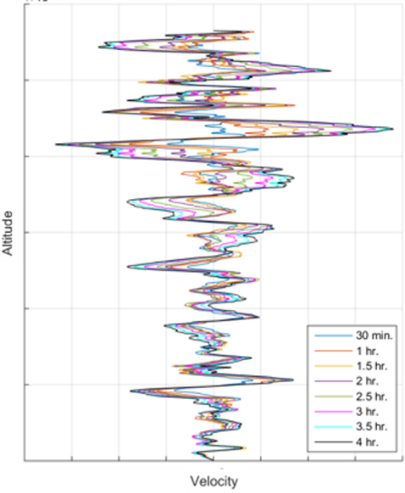
Fig. 1 Sample wind profile at various filter levels.

- Buffet Loads
The Buffet analysis is a time domain, dynamic analysis that simulates the vehicle’s response to the fluctuating vehicle surface pressures that occur in the transonic flight regime. The SLS Block 1 Buffet analysis utilizes forcing functions developed by the NASA Langley Research Center (LaRC) that are the result of a Rigid Buffet Model Test (RBMT) performed in the Transonic Dynamics Tunnel (TDT). Buffet forcing functions (BFFs) are available at total angles of attack of 0, 4, and 6 degrees for the following Mach numbers: 0.8, 0,9, 0.95, 1.1, 1.18. The BFFs are provided as force time histories. The force time history and time vector are scaled to the appropriate loads analysis (trajectory-based) dynamic pressure (Q) and velocity (V) using Eq. ( 1 ) and Eq. ( 2 ). The delivered BFFs and corresponding time vector are labeled F and T, and the scaled forcing functions and time vector used in the loads analysis are labeled with a LOADS subscript. The trajectory-based Q and V values that are used in the loads analysis are labeled with a TRAJ subscript.

$$F_{LOADS}=F\frac{Q_{TRAJ}}{Q_{BFF}}$$ | ( 1 )

$$T_{LOADS}=T\frac{V_{BFF}}{V_{TRAJ}}$$ | ( 2 )

During the development of the SLS Block 1 loads, a buffet loads mitigation task team was tasked with reducing the buffet loads. One outcome of that effort was a total angle of attack limit of 4 degrees that was placed on the vehicle from Mach 0.8 – 2.0. This constraint allowed the 6 degree total angle of attack BFFs to be removed from the buffet analysis while also reducing the STEL loads in this regime. Day of Launch (DOL) assessments have since shown that this constraint is consistently achievable.
- Maneuvering Loads
A specific analysis is performed to capture the loads due the roll maneuvers which occur early in Boost phase flight. These maneuvers are not captured well by a traditional Lateral STEL analysis because a Lateral STEL analysis assumes a trimmed vehicle condition that does not properly account for pre-planned maneuvers such as the roll maneuver. Additionally, the dynamic response from the maneuver is not captured in a STEL analysis due to the pseudo-static nature of the analysis. The pseudo-static component of the roll maneuvers is accounted for with an analysis that is almost identical to a combined Axial and Lateral STEL analysis. It is called the VLI analysis; it is named after the tool used for the analysis, the Vehicle Load Indicator (VLI) tool. The main difference in VLI and Lateral STEL is that VLI uses a trajectory directly, and, more specifically, VLI uses the trajectory gimbal angles rather than trimming the vehicle to zero rotational acceleration. The dynamic component is computed in a separate elastic maneuvering analysis. In the loads combination equation, the maneuvering loads are denoted VLI (pseudo-static portion) and Mnvr (dynamic portion).
- Booster Thrust Oscillation Loads
The vehicle response due to oscillating pressure waves within the SRBs, or Thrust Oscillation (TO), during Boost phase Ascent is included in the SLS Block 1 loads. The primary concern arising from the TO phenomenon is typically the acceleration experienced by the crew, although TO is also a contributor to the overall Boost phase Ascent loads. The TO event accounts for the first three acoustic modes, where the dome forces are applied in-phase for the 1L and 3L modes, and the forces are applied out-of-phase for the 2L mode. An illustration of the 1L, 2L, and 3L acoustic mode shapes is included in Fig. 2. The TO analyses are generally performed as Monte Carlo analyses with ~10,000 cases. The SRB tailoff timeframe is treated differently; frequency domain 1L only forcing functions are provided to be applied in timeframes when SRB internal pressure is less than 50 psi. During SLS Block 1 loads development, the TO approach was eventually modified to reduce the TO analysis time. The 2L analysis was modified to include a scale factor and less cases, and the 3L analysis was done in the frequency domain.

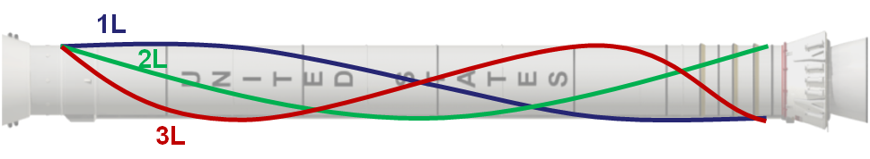

Fig. 2 Illustration of 1L, 2L, and 3L TO acoustic mode shapes.
- Core Stage Engine Thrust Oscillation Loads
The Core Stage Engine Thrust Oscillation (CSE-TO or RS-25 TO) analysis simulates the vehicle’s response to the low frequency (0 Hz – 100 Hz) oscillatory thrust for the RS-25 Core engine. The CSE-TO forcing function is provided as a Power Spectral Density (PSD); therefore, the CSE TO analysis is performed in the frequency domain. The CSE-TO forcing function is derived from high-speed data from relevant heritage Space Shuttle Main Engine (SSME) tests.
- Programmed Test Input Loads
The Programmed Test Input (PTI) analysis is a time domain analysis that simulates the vehicle’s response to pre-planned controller-commanded angular accelerations at specified times in flight. The PTI is designed to drive modes up to 5 Hz and is used for a number of post-flight analyses such as stability and loads reconstruction. There is one PTI scheduled during Boost phase for the Artemis 1 flight; the PTI command is shown in Fig. 3.

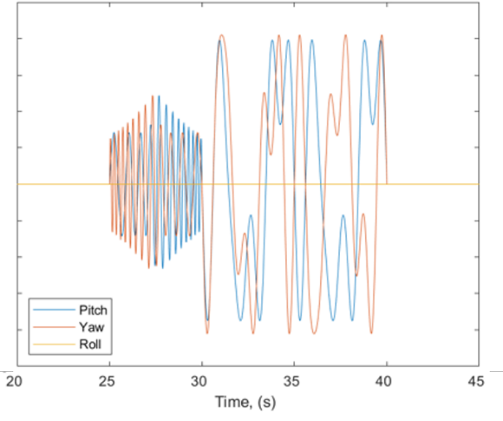
Fig. 3 SLS Block 1 Artemis 1 Boost phase Programmed Test Input command.

- Thrust Vector Misalignment Loads
The Thrust Vector Misalignment (TVM) analysis is a simple static analysis that accounts for the angular error in the actual thrust vector. Angular error is accounted for in both the Core and SRB thrust vectors. The TVM analysis is a 2000 case Monte Carlo analysis that is performed in each applicable Mach bin.
- Thrust Vector Offset Loads
The Thrust Vector Offset (TVO) analysis is a simple static analysis that accounts for the offset in the actual thrust vector. SRB and Core thrust vector offset dispersions are provided in terms of length from the center of the engine. The TVO analysis is a Monte Carlo of 2000 runs per Mach bin where the offsets and offset angles for each engine are dispersed. The offset angles were assumed to have a uniform distribution from zero to 180 degrees. A diagram of the offset (TVO) and offset angle (ϴ) is shown in Fig. 4.
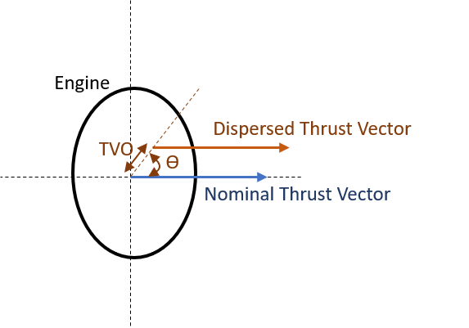
Fig. 4 Thrust vector offset and offset angle diagram.

- Boost Phase Ascent Loads Combination Equation
At the Mach bin level, the Block 1 Load Combination Equation (LCE) combines most subevent loads statistically by placing dispersed (3σ) quantities under the radical while keeping the mean quantities outside of the radical. A conservative but historical approach has been to treat the STEL-type (VLI and Lateral STEL) 3σ loads as mean terms. The LCE for this approach is included in Eq. ( 3 ). In general, this is the approach followed for SLS Block 1; however, there are times, in the development of the SLS Block 1 loads, that the STEL-type loads were treated statistically with a mean and 3σ term as is done for all other LCE components. This was done to reduce conservatism in the combined loads. The LCE for the complete statistical approach is include in Eq. ( 4 ). In both LCE equations, the 3.635 coefficient corresponds to a 99.865% statistical enclosure level.

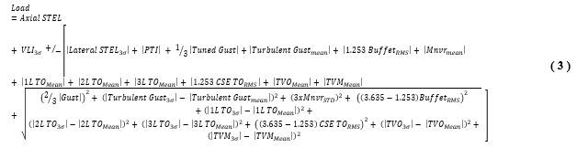

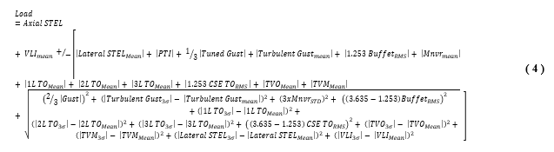
- Boost Phase Ascent Loads Results
Example results are included in this section in order to show how the Boost phase Ascent loads generally compare to overall design loads. The Boost phase Ascent loads often drive the overall load envelope for the vehicle. The following figures include Core Stage results from the most recent coupled loads analysis, the SLS Block 1 Crew Flight Readiness Analysis Cycle (FRAC) and the SLS Block 1 Crew design loads (045). The six section loads as well as axial equivalent loads (PEQ) are shown in Fig. 5 - 11. FRAC was a mission-specific cycle for the Artemis 1 mission. The curves denoted Event 045 are the envelope of the Ascent Boost phase design loads, and the curves denoted Envelope 045 are the envelope of all design SLS Block 1 Crew design loads.

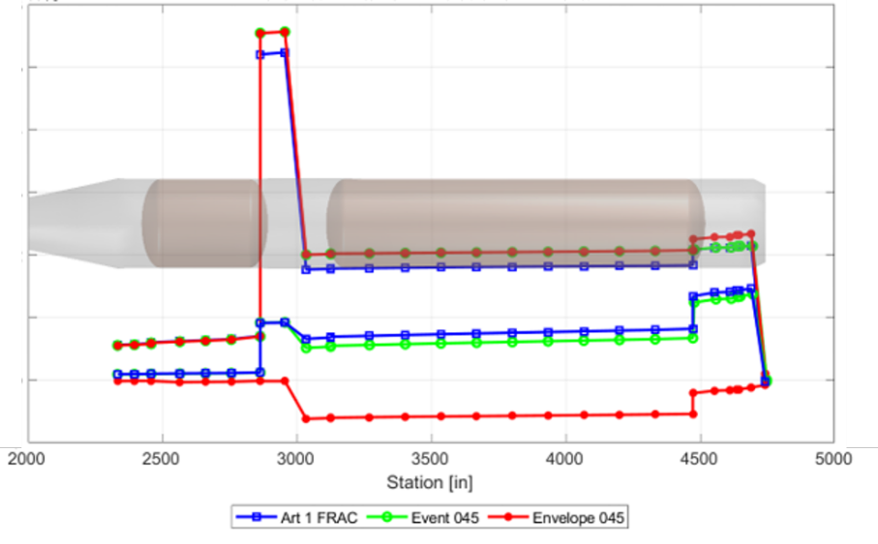
Fig. 5 SLS Block 1 Crew FRAC Boost phase Core Stage X-shear.

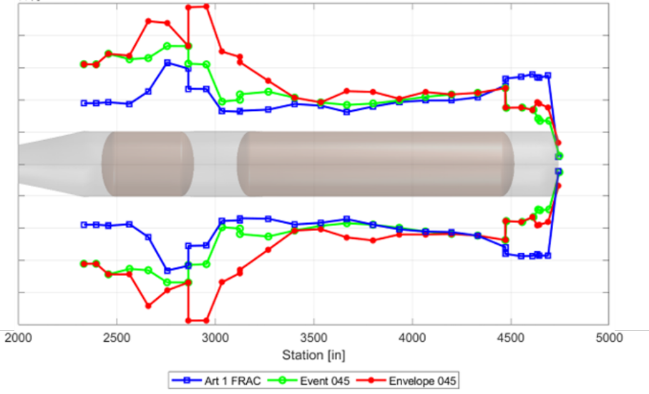
Fig. 6 SLS Block 1 Crew FRAC Boost phase Core Stage Y-shear.
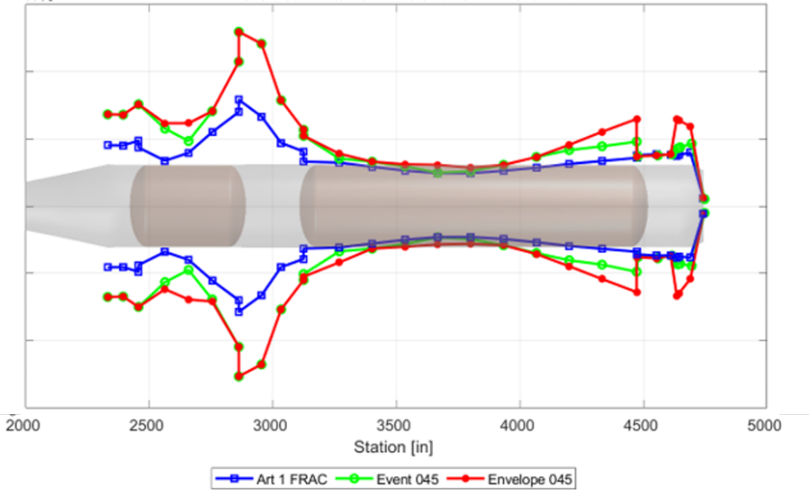
Fig. 7 SLS Block 1 Crew FRAC Boost phase Core Stage Z-shear.

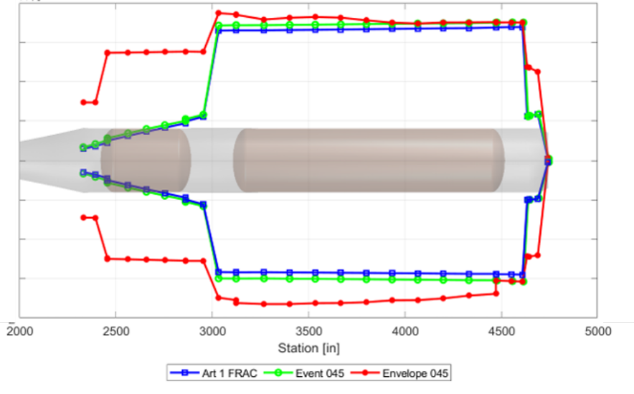
Fig. 8 SLS Block 1 Crew FRAC Boost phase Core Stage X-moment.

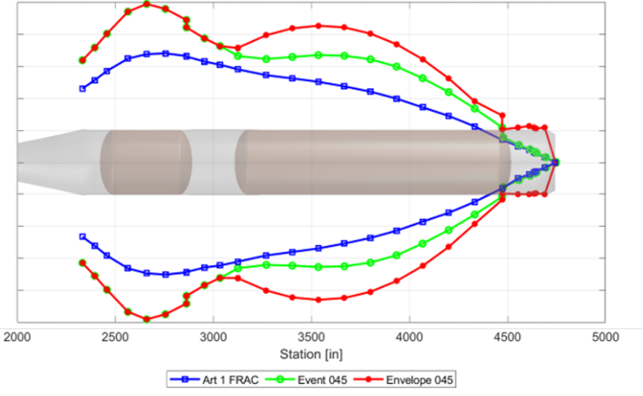
Fig. 9 SLS Block 1 Crew FRAC Boost phase Core Stage Y-moment.

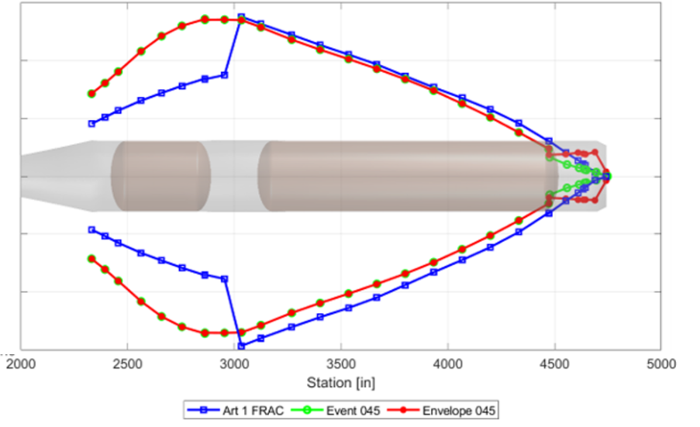
Fig. 10 SLS Block 1 Crew FRAC Boost phase Core Stage Z-moment.

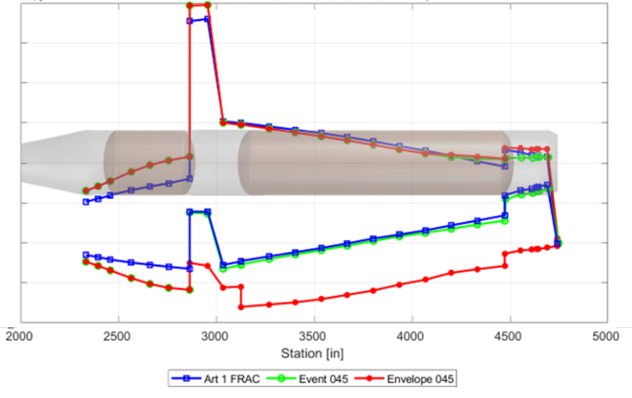
Fig. 11 SLS Block 1 Crew FRAC Boost phase Core Stage PEQ.

- Core Phase Ascent Loading Events and Loads Combination Equation
The SLS Block 1 Core phase analysis also uses a binned approach; however, the bins are event-based rather than Mach-based. The six Core phase bins are described below and shown in Fig. 12.

PostSEP: Begins just after SRB separation and extends 15 seconds past SRB separation.
CP_PTI1: Covers the first Core phase PTI; begins 20 seconds after SRB separation and ends 30 seconds later.
PanelToLASjet: Spans the timeframe from MPCV panel separation to Launch Abort System (LAS) jettison.
CP_PTI2: Covers the second Core phase PTI; begins 20 seconds after LAS jettison and ends 30 seconds later.
CP_PTI3: Covers the third Core phase PTI; begins 100 seconds after LAS jettison and ends 30 seconds later.
MaxG: Covers a Mach range sufficient to capture peak axial acceleration.

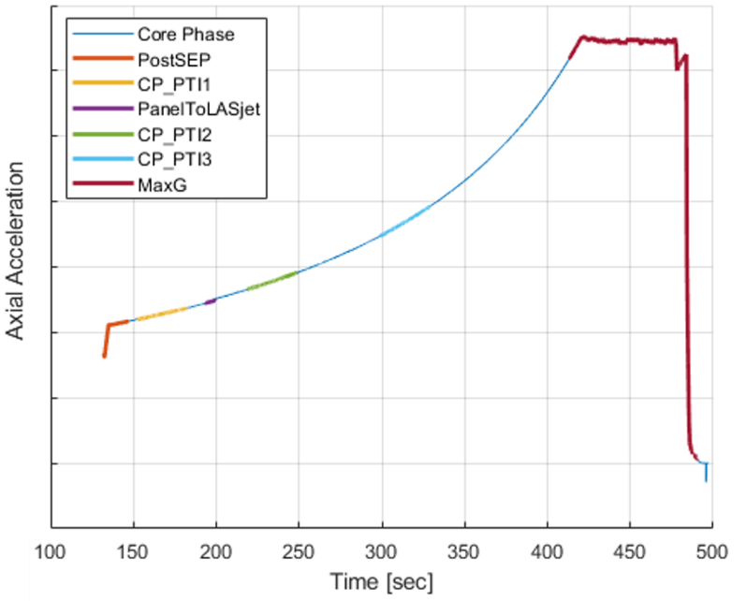
Fig. 12 SLS Block 1 Crew Core phase bins.

Core phase is less complex than Boost phase due to the atmospheric conditions during this time of flight; several loading events that are critical to the development of Boost phase loads are not necessary for a Core phase analysis. Core phase includes only three loading events: Pseudo-static STEL-type loads (run with the VLI tool), CSE-TO, and PTI. The three loading events are performed in a similar manner as was previously described for Boost phase. The only significant difference in the Core phase analysis is a methodology employed to handle variable propellant mass that is referred to as the inertial force correction methodology and the Core phase LCE. Both of these will be discussed in the following sections.

Core Phase Inertial Force Correction Methodology
One assumption that is present in most coupled loads analyses is fixed-mass Finite Element Models (FEMs). At any given analysis time, the fixed-mass FEM is an approximation of the vehicle mass and mass distribution. Because Core phase spans a much longer time than Boost phase, this assumption is more impactful in Core phase. Over the course of the SLS Block 1 loads development, several methods were employed to deal with fixed-mass FEMs. Often, it is desired to have the coupled loads match the prescribed trajectory axial acceleration; this can be achieved with thrust scaling; however, it results in potentially unrealistic thrust values being applied to the vehicle. The current methodology employed in the SLS Block 1 Core phase loads is the inertial force correction methodology. Rather than unrealistically scaling thrust, this methodology applies an inertial load at the bottom of both Core Stage tanks to simulate either more or less propellant in the tanks. This methodology requires the knowledge of the trajectory-prescribed tank propellant masses, LOX_{Traj.} and LH2_{Traj.}, (which are regarded as the truth) and the FEM propellant masses, LOX_{FEM} and LH2_{FEM}. The equation for the inertial force to be applied to the bottom of the LOX tank, F_{iLOX}, is included in Eq. ( 5 ). A similar equation is used for the LH2 tank. Depending on how the FEM propellant masses compare to the trajectory, the resulting inertial force can be either negative or positive.

$$F_{i_{LOX}}=Trajectory Axial Acceleration x \left({LOX }_{Traj.}- {LOX}_{FEM}\right)$$ | ( 5 )

Core Phase Ascent Loads Combination Equation
The SLS Block 1 Core phase Ascent loads combination equation treats the STEL-type dispersed 3σ loads (VLI for Core phase) as mean (as is typically done for Boost phase), and PTI loads, by nature, are mean loads. Therefore, the Core phase LCE is a simple straight-add equation. The SLS Block 1 Core phase LCE is included in Eq. ( 6 ). In the LCE, the 3.635 coefficient corresponds to a 99.865% statistical enclosure level.

- Core Phase Ascent Loads Results
Example results are included in this section in order to show how the Core phase Ascent loads generally compare to overall design loads. Core Stage Y-moment and PEQ results from the most recent coupled loads analysis, the SLS Block 1 Crew FRAC and the SLS Block 1 Crew design loads (045) are included. FRAC was a mission-specific cycle for the Artemis 1 mission. The curves denoted Event 045 are the envelope of the Ascent Core phase design loads, and the curves denoted Envelope 045 are the envelope of all design SLS Block 1 Crew design loads.

The Y-moment loads (Fig. 13) show that, in general, Core phase loads are much lower than design loads. However, Core phase does produce the driving load case for PEQ at the aft end of Core Stage (Fig. 14).
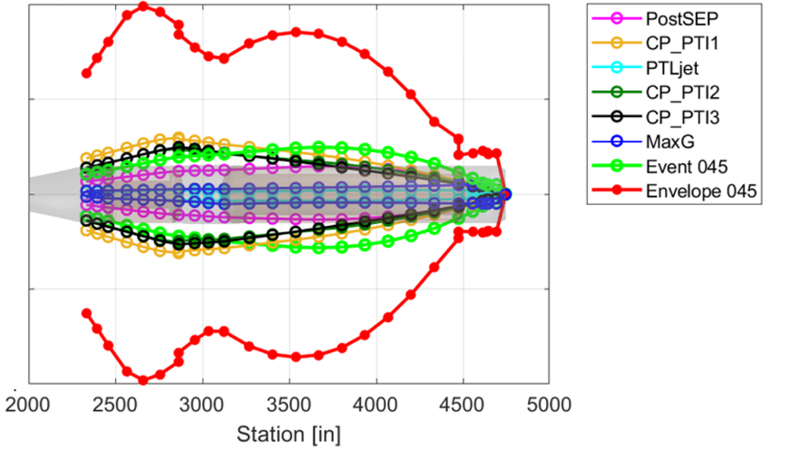
Fig. 13 SLS Block 1 Crew FRAC Core phase Core Stage Y-moment.

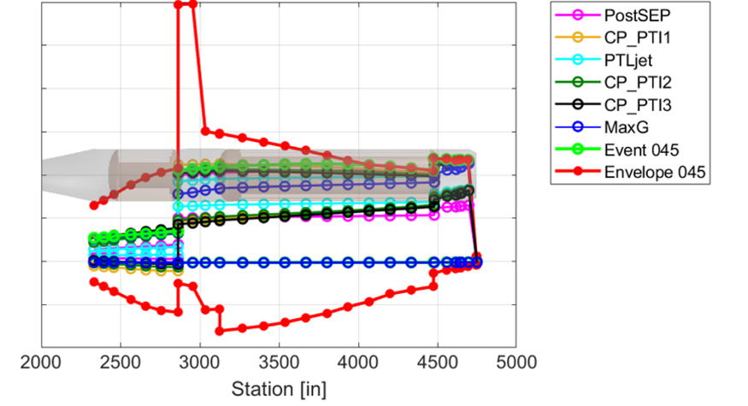
Fig. 14 SLS Block 1 Crew FRAC Core phase Core Stage PEQ.

- Day of Launch Ascent Loads Evaluation
Typically, a launch vehicle is designed to either mean monthly winds or the less conservative Day of Launch (DOL) winds. Mean monthly implies that the trajectory is designed to a wind profile representative of the mean winds for a particular month, while DOL implies that knowledge of the winds on launch day (from either balloon or radar measurements) will be used to shape the trajectory on launch day. SLS Block 1 Crew has always been designed to DOL winds and will; therefore, employ a Day of Launch I-Load Update (DOLILU) process on launch day. This process includes many disciplines; coupled loads is just one part of the process. On launch day, wind measurements will be used by the trajectory team and subsequently the loads team to verify that the trajectory and resulting vehicle loads are within acceptable limits. The loads team, among others, uses DOL analyses to give a launch “go” or “no-go” recommendation. A very simplified process for the DOL coupled loads analysis is included in Fig. 15.

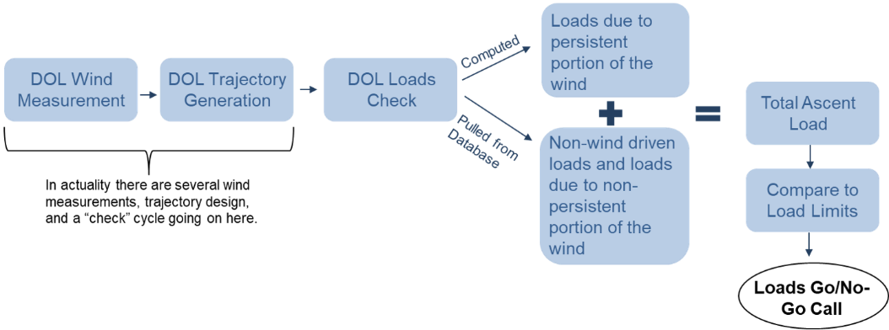

Fig. 15 Simplified Day of Launch loads check process.

The DOL loads analysis is limited to Boost phase up to ~ Mach 2.5. The only loads actually computed on launch day are the loads resulting from the persistent portion of the measured wind (persistence is a function of time until launch). These loads are computed with the VLI tool; all other loads are included statistically. Loads computed on launch day are combined with the statistical load components using the LCE included in Eq. ( 7 ) . The LCE looks very similar to the Boost phase Ascent LCE; however, three terms are included on DOL that were not included in the coupled loads analysis. Lack of Wind Persistence (LoWP) accounts for the potential change in the wind from what was measured and used for the DOL loads analysis to the actual launch winds. This term is a function of wind measurement time to launch time. Because each launch day loads analysis makes use of a single trajectory based on a single measured wind profile, most dispersions such as mass dispersions or burn rate dispersions are turned off. The System Dispersion (SysDisp) term accounts for these dispersions statistically. The 8-Hour Atmosphere (8hrATM) term accounts for stale (8 hours old) atmospheric thermal measurements. In the DOL LCE, the 3.439 coefficient corresponds to a 99.73% statistical enclosure level.

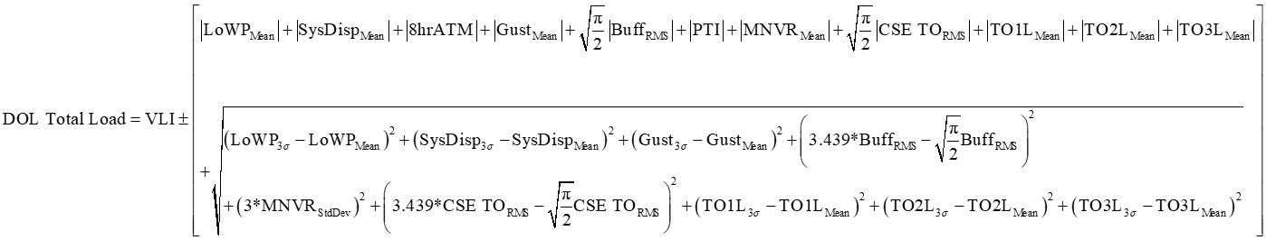 | ( 7 )

- Conclusion
The development of the SLS Block 1 Crew Boost and Core phase Ascent loads analysis has been explored. The SLS vehicle experiences numerous complex loading events during Boost and Core phase. Each loading event was explored as well as the loads combination process. A Boost phase Ascent loads evaluation will also be performed as a part of the Day of Launch process for Artemis 1. Differences in this evaluation and the typical coupled loads analysis were also described. The SLS Block 1 Crew Ascent loads have utilized test validated element models, and, for several loading events, test-derived or heritage forcing functions. This provides a high level of maturity to the analysis. Additionally, launch day analyses provide an extra layer of protection on launch day. Overall, the SLS Block 1 Crew Ascent loads analyses are high fidelity and sufficient for supporting flight readiness certification.

Engineer/Scientist; lauren.griggs@axientcorp.com.
Engineer/Scientist; scott.swatzell@axientcorp.com.
Integrated Vehicle Loads Team Lead, NASA MSFC; austin.f.decker@nasa.gov.
Engineer/Scientist; jayme.allgood@axientcorp.com.
Engineer/Scientist; natalie.oliver@axientcorp.com.
Engineer/Scientist; jake.moseley@axientcorp.com.

