Southern California Health & Air Quality
Using Remote Sensing to Detect the Frequency and Drivers of Red Tide Blooms in California to Assist in the Management of Human and Marine Exposure to Algal Toxins

Technical Report
Final – November 18th, 2021

Michael Enz (Project Lead)
Melanie Leung
Petra Nichols
Maya Zimmerman
Jonathan Van Dermark

Advisors:
Dr. Juan Torres-Pérez, NASA Ames Research Center (Science Advisor)
Ben Holt, NASA Jet Propulsion Laboratory (Science Advisor)
Dr. Christine Lee, NASA Jet Propulsion Laboratory (Science Advisor)
Dr. Clarissa Anderson, University of California San Diego/Scripps Institution of Oceanography (Science Advisor)

1. Abstract
In 2020, the dinoflagellate species Lingulodinium polyedra was measured at unprecedented levels off the southern California coast, raising concern for local communities. At high levels, L. polyedra can cause marine life mortality, food-borne illness, and respiratory-related health risks in humans. In partnership with the California Office of Environmental Health Hazard Assessment, the National Oceanic and Atmospheric Administration Southwest Fisheries Science Center, the California Department of Public Health, and the University of California San Diego’s Scripps Institution of Oceanography, this project utilized satellite imagery to visualize and analyze spatiotemporal trends of historical red tide events associated with L. polyedra. Using the Suomi National Polar-orbiting Partnership’s (NPP) Visible Infrared Imaging Radiometer Suite (VIIRS), Aqua’s Moderate Resolution Imaging Spectroradiometer (MODIS), and Global Change Observation Mission – Climate (GCOM-C) Second Generation Global Imager (SGLI), the team assessed the validity of using multiple sensors in detecting chlorophyll-a as a proxy for dinoflagellate dominated-algal blooms. The results suggest that VIIRS imagery processed using the Color Index algorithm from Hu et al. (2013), amongst all other algorithms and Earth observations assessed, shows the most promise in identifying L. polyedra blooms. The end products included an ArcGIS Dashboard and Google Earth Engine tool that when combined, provided users with spatial and temporal trends, interactive interfaces to analyze the effectiveness of various sensors and algorithms, and an overall contribution to aid in the management of human health and the economy impacted by harmful algal blooms.

Key Terms
harmful algal bloom (HAB), remote sensing, chlorophyll-a, phytoplankton, Lingulodinium polyedra, Southern California Bight

2. Introduction
2.1 Background Information
The increasing frequency, extent, and wide-reaching impacts of algal blooms have been driven by a rapidly changing climate and subsequent changes in the water quality conditions of the oceans (Ryan et al., 2014; Fischer et al., 2020). A specific subset of these blooms, known as harmful algal blooms (HABs), have recently become an important area of study because of the health impacts that they have on both marine and human life in coastal communities. Most recently, in the spring of 2020, the University of California San Diego, Scripps Institution of Oceanography (SIO) observed the highest ever concentration of Lingulodinium polyedra, a toxic dinoflagellate that causes HABs just off the Scripps Pier in La Jolla, California (Kahru et al., 2021). L. polyedra is one species of dinoflagellate responsible for a specific kind of harmful algae bloom, known as a red tide bloom. L. polyedra can produce yessotoxins, a biotoxin that can cause adverse health impacts in humans when exposed to at high concentrations, including chest and abdominal muscle paralysis (Franchini et al., 2010). Additionally, red tide events have detrimental impacts on marine ecosystem health, fisheries management, and coastal economies. Red tides are observed to increase fish and marine mammal mortality and contribute to food-borne illnesses such as amnesic shellfish poisoning (Anderson et al., 2019). The closure of coastal recreation zones, beaches, and fisheries due to red tide events can significantly impact local economies that rely heavily on both tourism and fishing industries for their survival.

Many recent and former studies have focused on quantifying the presence and overall extent of HABs off the coast of California. For this project, we replicated the previously studied ultraviolet (UV) reflectance ratios algorithm highlighted by Kahru et al. (2021) to cross-validate and assess the validity of NASA Earth observations to be used in predicting future HABs. Kahru et al. (2021) used the UV reflectance bands (380/443nm) gathered by the Second-Generation Global Imager (SGLI) aboard the Japanese Aerospace Exploration Agency’s (JAXA) Global Change Observation Mission – Climate (GCOM-C) to identify the presence or absence of dinoflagellates. This is possible because dinoflagellates synthesize mycosporine-like amino acids (MAAs), which gives them a unique signature in the UV range. Furthermore, in situ results provided by the Southern California Coastal Ocean Observing System (SCCOOS) in combination with NASA remote sensing products further validated our findings and were used in identifying our specific dinoflagellate of interest, L. polyedra.

The primary region of interest for this project was the Southern California Coastal Zone, defined by the Southern California Bight, spanning from Point Conception, CA to the southern California border with Mexico (Figure 1). The southern California coast is an important study site due to the beaches and coastal regions, which are both highly accessible and heavily trafficked. Annually, millions of beachgoers who swim, wade, and enjoy water-based activities are directly exposed to the harmful impacts of red tide events (California Department of Public Health, 2020). Over time, scientists and the general public alike have observed increases in HABs along the southern California coast. Therefore, it is crucial to monitor and understand HAB dynamics in order to protect the health of the southern California community. This project aimed to understand the spatial and temporal patterns of L. polyedra and other HABs and assess the potential threat they have on local human and marine ecosystem health. The Fall 2021 Ames Research Center DEVELOP team assessed the ability of NASA Earth observations to complement GCOM-C SGLI data used for detecting HABs between April and May of 2020. The team’s initial effort was to develop tools and a workflow capable of deriving chlorophyll-a (chl-a) maps using ocean color images from GEE. But due to limited time constraints, the team was unable to normalize the magnitudes of the chl-a concentrations from different sensors and algorithms. As a result, the team built interactive tools within a study of feasibility that are capable of producing chl-a maps comparing NASA and JAXA Earth observations. These tools illustrate the procedure of deriving chl-a concentrations over time. Because of the lack of normalized chl-a values, these maps are unable to highlight actual magnitudes, but are useful in establishing the methodology needed to build maps capable of visualizing historical patterns of red tides in southern California for the time of January 2010 through November 2021.

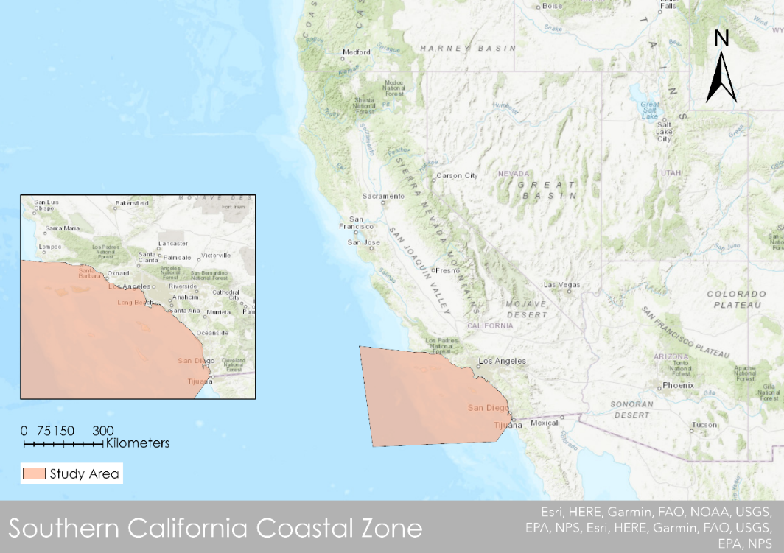
Figure 1. The study area focuses on the areas just off the Southern California Coastal Zone within the Southern California Bight (Basemap: ESRI “World Topographic Map”, ArcGIS Pro).
2.2 Project Partners & Objectives
This project was a collaboration between the Ames Research Center’s Fall 2021 DEVELOP team and the SIO to employ remote sensing techniques to support the monitoring and detection of HABs. We also partnered with the California Office of Environmental Health Hazard Assessment (OEHHA), the National Oceanic and Atmospheric Administration (NOAA) Southwest Fisheries Science Center (SWSC), and the California Department of Public Health (CDPH) to create a more thorough and concrete understanding of the patterns and trends associated with coastal HABs. The partner organizations were interested in gaining a better understanding of how remote sensing data can be used to help in HAB detection which will drive decisions regarding the management of coastal regions and waters during future dinoflagellate blooms. The tools generated from this project provided our partners and the larger southern California community access to visualizing historical HAB trends and insight on detection and dangers of future blooms in the area.

3. Methodology
3.1 Data Acquisition
Our team acquired the following NASA and JAXA Earth observations to complete our project (Table 1). The team collected satellite imagery from multiple sources, relying heavily on GEE’s extensive library of Level 3 imagery for Aqua Moderate Resolution Imaging Spectroradiometer (MODIS), and Suomi NPP’s Visible Infrared Imaging Radiometer Suite (VIIRS). Data not available directly from GEE’s library, including GCOM-C SGLI were collected from JAXA’s G-Portal. In addition to Earth observations, the team also used in situ measurements of planktonic cell counts per liter and dinoflagellate species counts per liter, which were acquired at Scripps Pier and Santa Monica Pier via the SCCOOS (Figure A1).

The Aqua MODIS observations were used in conjunction with the Suomi NPP VIIRS observations to produce chlorophyll-a indices which were, in turn, analyzed to test each sensors’ capability of accurately identifying L. polyedra blooms. These results were then compared against the GCOM-C SGLI imagery, previously proven to identify L. polyedra as outlined in Kahru et al. (2021) to evaluate the viability of the NASA Earth observations. We gathered data for April 1st to May 31st of 2020, a previously identified by GCOM-C period of algal bloom for the southern California coast, with a geographic range from Point Conception, CA to the southern California border with Mexico (Figure 1).

Table 1. Remote sensing data used.
Sensor | Processing Level | Data Provider | GEE ImageCollection ID
Aqua MODIS | Level 3 Standard Mapped Image | NASA Ocean Biology Processing Group | NASA/OCEANDATA/MODIS-Aqua/L3SMI
Suomi NPP VIIRS | Level 2 Surface Reflectance | NASA Land Product (LP) Distributed Active Archive Center (DAAC) United States Geologic Survey (USGS) Earth Resources Observations & Science Center (EROS) | NOAA/VIIRS/001/VNP09GA
GCOM-C SGLI | Level 3 Normalized Water Leaving Radiance  Level 3 Chlorophyll-a Concentration (V1) | Japanese Aerospace Exploration Agency (JAXA) G-Portal  Global Climate Observation Mission (GCOM) | JAXA/GCOM-C/L3/OCEAN/CHLA/V1

3.2 Data Processing
The outputs of this project were processed using GEE and Esri ArcGIS Pro. Initial atmospheric correction was primarily completed prior to the team’s collection by the providing agency (NASA LP DAAC at the USGS EROS Center, 2021; JAXA, 2021). However, a secondary correction was conducted within GEE for NASA Earth observation products (MODIS and VIIRS), while JAXA Earth observation products (GCOM-C SGLI) were corrected for in ArcGIS Pro and GEE.

3.2.1 GCOM-C Processing
The methodology of processing GCOM-C data for our study is built upon the techniques and practices used by the Kahru et al. (2021) paper. The Level 3 Normalized Water Leaving Radiance (nL_{w}) data for bands 380nm and 443nm were downloaded as a .tif file, and the Solar Irradiance Thuillier’s coefficient (F₀) were located within NASA’s Ocean Color Biology Forum (Thuillier et al., 2003). Using the Thuillier irradiance values, the GCOM-C data was converted from radiance to Remote sensing reflectance (R_{rs}), allowing utilization of common algorithms and band math across all sensors. The R_{rs} was calculated by dividing normalized water leaving radiance by solar irradiance (for each specified wavelength) as shown in Equation 1.

$$\begin{aligned}{\text{R}}_{\text{rs}}\text{=}{{\text{nL}}_{\text{w}}}/{{\text{F}}_{\text{0}}}\#1\end{aligned}$$

This equation was then combined with the band ratio between 380nm (UV) and 443 (blue light) equation that was developed by Kahru et al. (2021) and was employed to identify harmful dinoflagellate blooms. The F₀ values are wavelength dependent (F₀ (380nm) =117.1379 and F₀ (443nm) =195.4065) and the combined equation is outlined in Equation 2 where D is the pixel value representing the presence or absence of Mycosporine-like amino acids (MAAs) which absorb UV wavelengths, a dinoflagellate identifier:

$$\begin{aligned}\text{D =}{\left({{\text{nL}}_{\text{w}}\left(\text{380nm}\right)}/{\text{117.1379}}\right)}/{\left({{\text{nL}}_{\text{w}}\left(\text{443nm}\right)}/{\text{195.4065}}\right)}\#2\end{aligned}$$

Specifically, L. polyedra was identified from this band ratio of UV/Blue light (380/443 nm) wavelengths as previously done in Kahru et al. (2021). If D < 1, the ratio implies the presence of MAAs, while D > 1 implies the dominant presence of diatoms in the water. Once GCOM-C data were processed and L. polyedra bloom presence was identified, they were imported as assets into GEE to serve as date(s) of interest to be compared against the MODIS and VIIRS data for the same dates. Generally speaking, most values produced by this equation should fall between 0.5 and 1.5 with an average around 0.8 through 1. It is important to note once more that this ratio reflects an index similar to the Normalized Difference Vegetation Index (NDVI) or the Normalized Difference Water Index (NDWI), in this case identifying the presence or absence of an algae species, rather than a concentration as the chl-a algorithms reflect in the next section.
3.2.2 Chlorophyll-a Algorithms
Our team aspired to find the best chlorophyll-a algorithm that utilized remote sensing measurements from both MODIS and VIIRS, in order to identify products in alignment with the GCOM-C results. Having this would therefore allow us to use the MODIS and VIIRS data in conjunction with GCOM-C imagery for future detection of HABs along the southern California coast. Traditionally, blue-green remote sensing reflectance (R_{rs}) bands are used to derive chlorophyll-a in oceanic waters. However, for the purposes of our study area, using such bands have limitations in their inability to differentiate chlorophyll-a from non-phytoplanktonic water constituents, such as colored dissolved organic matter (Le et al., 2013).

Using GEE, the team was able to define the study area using both the built-in geometry drawing function of GEE, as well as the southern California shapefile asset displayed in Figure 1, which was uploaded to the GEE repository. With the study area defined, all imagery falling under the date range for the MODIS and VIIRS image collections were averaged and clipped to that study area, and cloud and land masking processes were applied.

Once the imagery had been processed for date and location, the team analyzed preprocessed indices and bands accompanying the data. To begin, we used the pre-calculated chlorophyll-a provided with MODIS data. The chlorophyll-a band is a combination of the OC3/OC4 (OCx) fourth-order polynomial algorithm, developed by O’Reilly et al. (1998) provided by NASA Goddard Spaceflight Center, merged with the color index (CI) of Hu et al. (2012). While these algorithms were supplied preprocessed together as a unique band within the MODIS data, each algorithm was applied separately and individually by the team to both MODIS and VIIRS data to identify similarities and discrepancies between each of them. The OCx algorithm is a fourth-order polynomial relationship between a ratio of R_{rs} and chlorophyll-a, shown in Equation 3:

$$\begin{aligned}{\text{log}}_{\text{10}}\left(\text{chl-a}\right)\text{ = }{\text{a}}_{\text{0}}\text{+}\sum_{\text{i=1,4}}{{\text{a}}_{\text{i}} \text{× }}{\left({\text{log}}_{\text{10}}\left(\frac{{\text{R}}_{\text{rs}}\left({\text{λ}}_{\text{blue}}\right)}{{\text{R}}_{\text{rs}}\left({\text{λ}}_{\text{green}}\right)}\right)\right)}^{\text{i}}\#3\end{aligned}$$

R_{rs}(λ_{blue}) and R_{rs}(λ_{green}) are the reflectance of wavelengths closest to 443nm and 555nm, respectively. The coefficients, a₀-a₄, are sensor-specific, provided by the Ocean Color Biology Lab at NASA’s Goddard Spaceflight Center. The Color Index (CI) developed by Hu et al. (2012) is a three-band reflectance difference algorithm that identifies the difference between the R_{rs} of the green band against a reference value gathered from the red and blue bands, as shown in Equations 4 and 5:

$$\begin{aligned}{\text{Chl}}_{\text{CI}} \text{=} {\text{10}}^{\text{-0.4909+191.6590×CI}}\left[\text{CI} \text{≤}{ \text{-0.0005 sr}}^{\text{-1}}\right]\#4\end{aligned}$$
Where,
$$\begin{aligned}\text{CI} \text{=} {\text{R}}_{\text{rs}}\left({\text{λ}}_{\text{green}}\right)\text{-}\left[{\text{R}}_{\text{rs}}\left({\text{λ}}_{\text{blue}}\right)\text{+}\frac{\left({\text{λ}}_{\text{green}}\text{-}{\text{λ}}_{\text{blue}}\right)}{\left({\text{λ}}_{\text{red}}\text{-}{\text{λ}}_{\text{blue}}\right)}\text{×}\left({\text{R}}_{\text{rs}}\left({\text{λ}}_{\text{red}}\right)\text{-}{\text{R}}_{\text{rs}}\left({\text{λ}}_{\text{blue}}\right)\right)\right]\#5\end{aligned}$$

In this equation, λ_{green}, λ_{blue}, and λ_{red} correspond to the sensor-specific wavelengths closest to 443nm, 555nm, and 670nm, respectively. For MODIS imagery, wavelengths 443nm, 555nm, and 667nm were selected. In the case of VIIRS imagery, wavelengths 443nm, 551nm, and 670nm were selected for analysis.

For MODIS data exclusively, the Red-Green Chl-a Index (RGCI) algorithm, developed by Le et al. (2013), was implemented as an improved shallow coastal water chlorophyll-a concentration index utilizing the ratio between red and green wavelengths, as illustrated in Equations 6 and 7:

$$\begin{aligned}\text{Chl-a} \text{=} {\text{10}}^{\text{1.76X+1.61}}\#6\end{aligned}$$
Where,
$$\begin{aligned}\text{X} \text{=}{\text{log}}_{\text{10}}\left({{\text{R}}_{\text{rs}}\left(\text{667}\right)}/{{\text{R}}_{\text{rs}}\left(\text{555}\right)}\right)\#7\end{aligned}$$

In this equation, the red and green wavelengths are divided to create a reflectance ratio and the log₁₀ of that value is derived to generate a single value. From there, the coefficient 10 is set to the power of 1.76 multiplied by our reflectance ratio plus 1.61 to calculate chlorophyll-a concentrations in mg/m³. This algorithm has been tested to specialize in shallow coastal waters, with high chlorophyll-a concentrations ranging from 1-50 mg/m³.

In addition to the equations above, the Green-Red Ocean Color 4 (GROC4) algorithm, developed by Abbas et al. (2019), was also applied to MODIS data. Deriving its development from the OCx algorithm, the GROC4 is a fourth-order polynomial algorithm that utilizes the red and green band wavelengths (rather than blue and green as seen in the OCx algorithm), as well as a natural logarithm, rather than log₁₀ as is seen in many other algorithms. The algorithm is shown in equations 8 and 9 as:

$$\begin{aligned}\text{Chl-a} \text{=} {\text{e}}^{{\text{a}}_{\text{0}} \text{+} {\text{a}}_{\text{1}}\text{*X} \text{+} {\text{a}}_{\text{2}}\text{*}{\text{X}}^{\text{2}} \text{+} {\text{a}}_{\text{3}}\text{*}{\text{X}}^{\text{3}} \text{+} {\text{a}}_{\text{4}}\text{*}{\text{X}}^{\text{4}}}\#8\end{aligned}$$
Where,
$$\begin{aligned}\text{X} \text{=}{\text{log}}_{\text{e}}{{\text{λg}}/{\text{λr}}}\#9\end{aligned}$$

In the latter half of the equation, λg and λr represent the R_{rs} values for the green and red wavelengths, respectively, between 531nm and 547nm for green, and 667nm and 678nm for red. This algorithm, having taken much of its development from the OCx tool, functions in a very similar way. The coefficients a₀₋₄ represent a series of values identified in the Abbas et al. (2019). This algorithm was specially developed for use in higher chlorophyll-a concentrated, shallow coastal water, much like the RGCI algorithm. Finally, each of the determined chlorophyll-a indices was analyzed against a threshold of 10 mg/m³ to determine the presence or absence of a characterized bloom at any point in the imagery.

3.3 Data Analysis
Following the completion of collecting mean satellite-derived chlorophyll-a concentrations from SGLI, MODIS, and VIIRS data, the team used periods of known bloom presence and known bloom absence, defined with GCOM-C, in situ data, and literature review to compare the viability of MODIS and VIIRS data as a suitable alternative to GCOM-C data for detecting dinoflagellate L. polyedrea blooms. To do this, our team looked at remote sensing reflectance at wavelengths 380nm and 443nm provided by the SGLI sensor on GCOM-C and analyzed the per pixel ratio between the bands as a function of identifying L. polyedra specific dinoflagellate blooms (Kahru et al., 2021). Following the identification of dinoflagellate blooms from the SGLI data and in situ, the team qualitatively compared the processed MODIS and VIIRS data to identify any correlations or differences that each algorithm achieved.

The satellite-derived chlorophyll-a concentrations from each of the sensors were cross-validated with in situ data provided by weekly HAB monitoring efforts from the SCCOOS. The field observations used were accessed from the ERDDAP server on SCCOOS, which includes HAB monitoring stations at the Scripps Pier in San Diego, CA, Newport Beach Pier, CA, and the Santa Monica Pier in Los Angeles, CA (Figure A1).

4. Results & Discussion
4.1 Analysis of Results
The team’s analysis provided results limited by the lack of normalized algorithm outputs between sensors and datasets. One component to the lack of normalization was the limited availability of VIIRS Remote Sensing Reflectance datasets within GEE which required the team to use the more readily available VIIRS Surface Reflectance data. This discrepancy is represented in the large value differences between VIIRS results and MODIS results which were calculated using Remote Sensing Reflectance. Beyond this, each algorithm utilizes its own mathematical processes, and even wavelength comparisons, to identify chl-a concentrations remotely, and thus each provides differing results. Therefore, the results lack concrete quantitative measurements, but instead allow for qualitative assessments of chl-a concentrations identified between the various sensors used.

4.1.1 NASA vs. JAXA Earth Observations
The figures below show an example of our calculated GCOM-C UV Ratio (D in Equation 2) with the chlorophyll-a values calculated by the Color Index and OCx algorithms applied to the imagery collected by VIIRS (Left Image Figures 2-3). Unlike the lefthand images in each figure, which represent chlorophyll-a concentration, the righthand images represent a ratio of light reflectance, more closely related to an index such as NDVI or NDWI. In these side-by-side images we can see that higher-values of chlorophyll-a detected by VIIRS in light green on the left seem to directly correlate with UV Ratio value of <1 as indicated by dark green on the right (Right Image Figure 2). The strong similar spatial trends of these values are well visualized along the coastline, particularly in the northern area of the bight (Figure 2). These areas show some of the highest chlorophyll-a values measured by the Color index algorithm and the lowest UV ratios, or values of <1. A UV ratio of <1 implies the presence of UV absorbing dinoflagellates, specifically L. polyedra, while the lighter green and yellow colors, or a ratio of >1, implies a dominance of diatoms in the water. These findings show that high chlorophyll-a measurements from the VIIRS Color Index algorithm in the coastal region of southern California have spatial similarity to the GCOM-C UV ratio of <1, or a dinoflagellate dominated bloom, and therefore pose as a promising first approximation to identify L. polyedra.

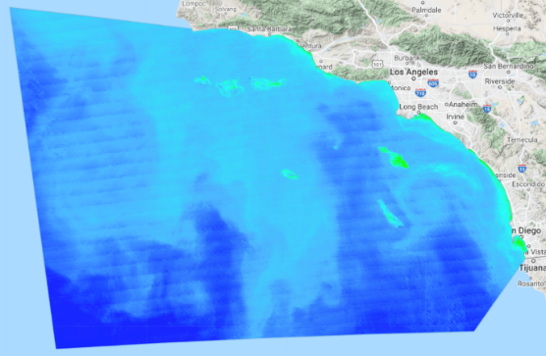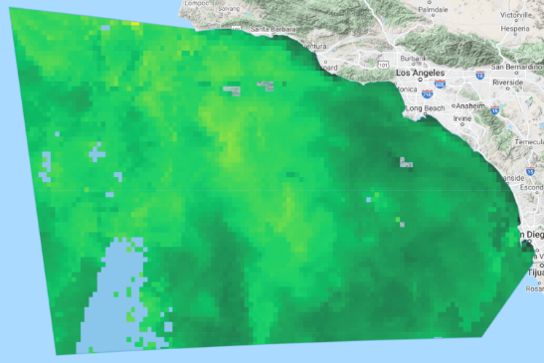
Figure 2. VIIRS Color Index Algorithm (left) vs. GCOM-C UV Ratio (right) for May 15, 2020. (Basemap: Google Earth Engine)
Additionally, we compared the VIIRS OCx algorithm directly to the GCOM-C UV Ratio (Figure 3). We completed this analysis for the same day, May 15th, 2020, as this was a predetermined date of bloom presence. While the OCx algorithm does not show extreme heightened values along the coast like the Color Index, there are still some regions, particularly along the coast of San Diego, that show increased chlorophyll-a values (Figure 3). Again, these heightened chlorophyll-a values can be compared to the UV Ratio from GCOM-C, that shows values of <1 in the same area, suggesting the dominance of dinoflagellates within the bloom (Figure 3).
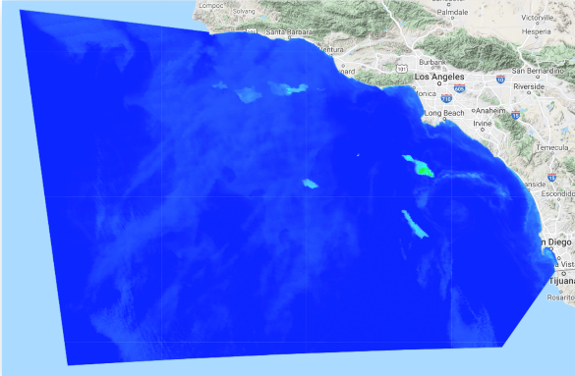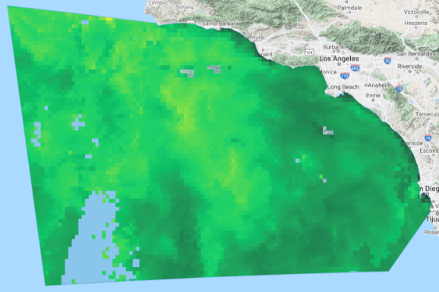
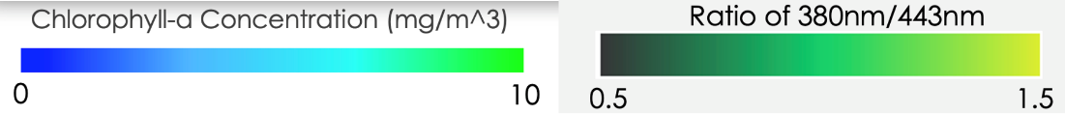
Figure 3. VIIRS OCx (left) vs GCOM-C UV Ratio (right) May 15, 2020. (Basemap: Google Earth Engine)

Much like in the VIIRS algorithms described above, the areas of higher concentrations of chlorophyll-a from the MODIS Color Index and Green-Red Ocean Color 4 (GROC 4) algorithm outputs show a similar spatial pattern as the UV Ratio of <1 from the GCOM-C imagery (Figure 4-5). The MODIS Color Index algorithm shows particularly high values around Long Beach and just north of San Diego (Figure 4). The GCOM-C UV Ratio reflects these high values in both areas, although to different extents, but both areas show a value of <1 which is indicative of dinoflagellate dominance (Figure 4).

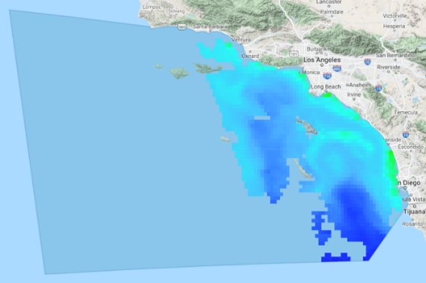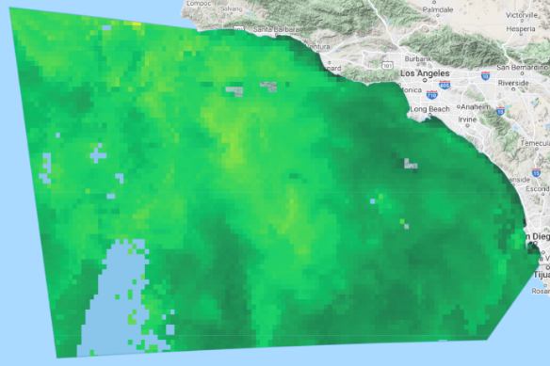
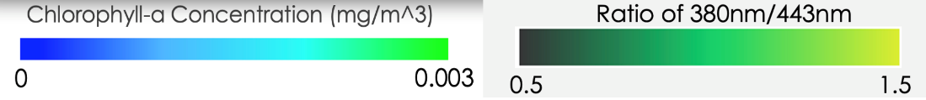

Figure 4. MODIS Color Index (left) vs. GCOM-C UV Ratio (right) for May 15, 2020. (Basemap: Google Earth Engine)
The final comparison done here was using the MODIS Green-Red Ocean Color 4 algorithm vs. GCOM-C UV Ratio (Figure 5). While the water off the coast of San Diego and in other areas right along the coast reiterates the previously stated results, there is a region between San Diego and the Channel Islands that the MODIS Color Index and GROC 4 algorithm show having high values of chlorophyll-a, while the GCOM-C UV Ratio does not show equally as strong readings (Figure 4-5). These findings could indicate that there was still a bloom that occurred, but the contributing species might have been a mixture of algae species, rather than just dinoflagellate dominance.

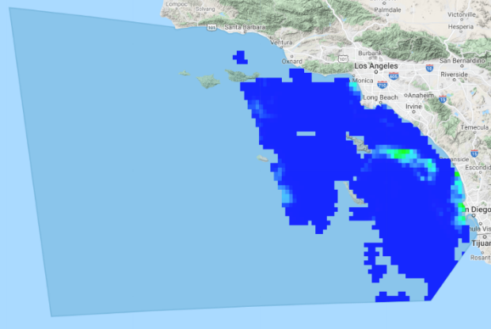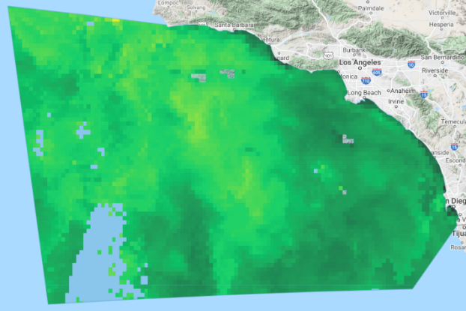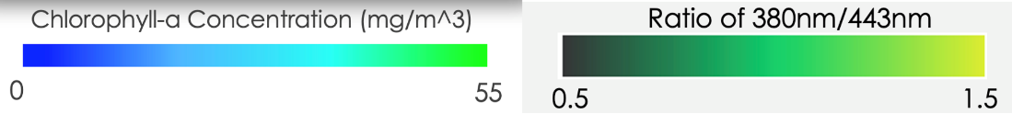
Figure 5. MODIS Green-Red Ocean Color 4 (left) vs. GCOM-C UV Ratio (right) for May 15, 2020. (Basemap: Google Earth Engine)

Additional visualizations were completed for MODIS and VIIRS for all algorithms applied. For MODIS, that included Color Index, OCx, Red-Green Color Index, and Green-Red Ocean Color 4 and for VIIRS visualizations were shown for Color Index and OCx (Figures A2-A5). These direct comparisons show similar spatial representations of chlorophyll-a along the coastal regions. Furthermore, the provided and preprocessed chlorophyll-a bands from MODIS and GCOM-C were also shown (Figure A6). These outputs also had spatial similarity and provided insight into these bands being useful for future bloom identification. Chl-a results varied across the algorithms since different bands were used. For the comparison seen in Figure 4, the blue and green bands were used, while the comparison seen in Figure 5 used the blue and red bands. Using these different bands inherently extracts data at different wavelengths, leading to some of the discrepancy in values seen across the various algorithms used in this analysis. An additional factor leading to such discrepancy seen in the results for the MODIS algorithms comes from differing mathematical processes, such as using a non-polynomial algorithm like the Color Index algorithm, versus a fourth order polynomial like that seen in the Green-Red Ocean Color 4 algorithm. Each of these processes handle the input values in very different ways, thus leading to more diverse results. To reiterate, these results showcase a distinct absence of concrete quantitative results. However, as illustrated by the images above, these results can be helpful in identifying qualitative, spatially-oriented conclusions.

4.1.2 Cross-validation analysis
To test validity of our remotely sensed data, we compared our satellite imagery data from MODIS and VIIRS to in situ data collected by the Southern California Coastal Ocean Observing System (SCCOOS), to understand how similarly the selected MODIS and VIIRS algorithms detected chlorophyll-a measurements compared to the ground-collected measurements. The data from SCCOOS gave average chlorophyll-a concentrations for the time period of March 2nd, 2020 to June 27th, 2020. This analysis provided a more complete and clear understanding of the reliability of using remotely sensed data for chlorophyll-a detection, as we discuss in the following section.

Average chlorophyll-a measurements were plotted for each MODIS and VIIRS algorithms against in situ data from the Santa Monica monitoring pier (Figures A13-A14), as well as for the Scripps pier (Figures A11-A12, Table 2) for the date range of March 2nd, 2020 through June 27th, 2020. Additionally, the coefficients of determination (R²) along with the root mean squared errors (RMSE) were calculated for each comparison (Table 2). Lower R² values, such as those less than 10⁻⁸, may be due to variable phytoplanktonic verticality across the study areas that are a result of a phenomenon known as phytoplanktonic migration (Qi et al., 2017). During the peak of day, phytoplankton are observed to be present lower in the water column as opposed to earlier and later in the day, when they are most present near surface waters. Due to the vertical variability in phytoplanktonic movement, chl-a measurements captured from satellites can be highly variable depending on the time of day they are taken from. This adds yet another layer of difficulty to validating remotely sensed satellite data with in situ data collected at varying times of day.

Higher chlorophyll-a values seen in the MODIS and VIIRS data are reflected similarly amongst higher chlorophyll-a values in the in situ data collected at both the Scripps pier and the Santa Monica pier (Figures A11-A14). From a regional perspective, the trends of high chlorophyll-a measurements collected from satellite imagery (Figures 2-5) match up with the identified trend of high chlorophyll-a measurements observed from in situ data during the known bloom presence period.

Table 2. R² and RMSE values for Santa Monica and Scripps Pier for all sensors and algorithms of interest.

Santa Monica Pier
 | MODIS OCx | MODIS Color Index | MODIS GROC 4 | MODIS RGCI | VIIRS OCx | VIIRS Color Index
R² | .0003 | .0026 | 3.72 x 10⁻⁶² | 1.77 x 10⁻⁶¹ | .004 | .0061
RMSE | 10.16 | 5.15 | 4.41 | 16.19 | 3.87 | 45.87
Scripps Pier
 | MODIS OCx | MODIS Color Index | MODIS GROC 4 | MODIS RGCI | VIIRS OCx | VIIRS Color Index
R² | .0004 | .0019 | 1.36 x 10⁻⁸ | .0002 | .013 | 9.24 x 10⁻⁵
RMSE | 152.16 | 156.61 | 153.36 | 140.09 | 155.67 | 140.00

4.1.3 GCOM-C vs. Newport Beach Imaging FloCytoBots
Imaging FloCytoBots off the Newport Beach Pier captured images that were used to identify the prominent species in the area for a certain date. The images collected on September 3rd and 9th, 2021 clearly depicted two unique bloom conditions (Figures A7 and A9). The image taken on September 3rd was highly dominated by long clear organisms most likely falling into the category of Tripos (Ceritium) spp. dominates (Figure A7). The other image depicted a stark difference, dominated instead by dark more spherically shaped organisms that were likely L. polyedra dominates (Figure A9). We compared both in-situ images to a GCOM-C UV ratio that was calculated within a day of the in-situ measurements. The GCOM-C data was collected on September 4th and 8th respectively, for the images described above (Figures A8 and A10). The team compared the visual representations of the GCOM-C UV Ratio with the in-situ data collected and we found that the observed L. polyedra dominated bloom (Figure A9) was represented by darker green colors (Figure A10) and therefore a lower UV ratio. These results are consistent with what we would have expected and confirm that the GCOM-C UV Ratio calculations are in fact able to distinguish L. polyedra blooms from other species of dinoflagellate blooms.

4.2 Errors and Uncertainties
4.2.1 Satellite Data Sources
Given the use of several data sources, there were inherent errors and uncertainties that came along with our study. Because most of our data processing was completed within GEE, the team was at the behest of the datasets contained within GEE’s dataset library. VIIRS data, in this context, was very limited, having only Surface Reflectance. MODIS, on the other hand, is collected exclusively as Remote Sensing Reflectance. These differences made comparative analysis difficult between sensors. Beyond this, the MODIS imagery the team collected was preprocessed to include cloud masking while VIIRS imagery was not. This created discrepancies between days of good quality data, and fair quality data. Additional errors may have been caused by differences in the timing of satellite overpasses of MODIS, VIIRS, and GCOM-C.

4.2.2 GCOM Data Availability
With the GCOM-data, first, we encountered image availability issues for the 380nm and 443nm wavelength bands being the normalized water-leaving upwelling radiance just above the sea surface (L3 - NWLR). Additionally, for some days of interest, there was no data available for our study period and this limited the analysis we were able to complete. Secondly, we adjusted the values of the pixel data from NWLR to R_{rs} using Thuillier solar spectrum wavelength (Thuillier et al., 2003) to equate for the UV-Reflectance. These values were provided by the NASA Ocean Biology Processing Group via the OceanColor web service and are generalized values and not sensor specific. Typically, these values would be contained within the metadata of the imagery.

4.2.3 Chlorophyll-a Algorithms
In extracting chlorophyll-a measurements from satellite imagery, different algorithms were selected based on how well they suited the spatial scope of our study. Each algorithm produced varying results and can vary depending on other factors at hand such as analyzing shallow water compared to deeper water. Working with multiple different chlorophyll-a algorithms contributed to more uncertainty in our project. The methodology behind using each of the chosen algorithms comes from the fact that to this point, there is no one algorithm identified as the best for application towards the Southern California Coastal Zone. Additionally, while the outputs from our chlorophyll-a algorithms were able to provide us with an adequate look at the spatial differences, there was little insight into a quantitative comparison of our results. This was due to the lack of normalization of chl-a values extracted from the R_{rs} between each of the algorithms and the sensors. As a result, a large and inaccurate range of output values from our algorithms was derived. Beyond this, we found that certain algorithms were not compatible with certain datasets, adding to the uncertainty about the appropriate algorithms to use.

4.2.4 Cross Validation Analysis
Limited in situ data introduced more uncertainty in our cross-validation analysis. The purpose of analyzing in situ data was to validate the use of remotely sensed data in extracting chlorophyll-a concentrations. Having more in situ data for our study period would provide us with greater validation in our methods. The in-situ data provided to our team from the Scripps pier did not contain measurements for each day in the study period of interest. Given the lack of complete time series data, the average chlorophyll concentration for the entire time period was used to fill in the null (missing) values in order to have data for each day to compare between the in situ data and satellite data. This work around introduced uncertainty in our results and conclusions because we populated the data with measurements of chlorophyll-a that were not necessarily the measured value on a given day.

With limited in situ data available on the average chlorophyll-a measurements during the study period, these conclusions were also limited. Low R² and high RMSE values are most likely due to a lack of data normalization between sensors and chlorophyll-a algorithms, as well as with in situ data. The R² measurements may also be skewed from false positives, which are expected when pulling data measurements of water quality close to the coast. As mentioned before, there is also the issue of planktonic vertical migration that drastically influences the remotely sensed data values based on the time of the satellite flyover. If the in situ data are collected at an entirely different time than when the satellite is passing over, the satellite data will not accurately reflect what was identified in the field data. Inherent differences in the dimensions being compared make it difficult to directly compare chlorophyll-a measurements taken from a single point from the in situ data against an entire pixel-based area taken from satellite imagery. Overall, there were several challenges in comparing satellite imagery data with in situ data that hindered the team’s cross validation analysis.

4.3 Future Work
Given more time, the team would expand analyses temporally to provide more findings on the similar detection capabilities between GCOM-C SGLI and those of MODIS and VIIRS. Instead of focusing on the period between April and May of 2020, further analysis could look at multiple months, or even years, to give a stronger basis of understanding on how confidently these different Earth observations can provide algal bloom detection support over years of variable bloom intensity.

The logical next steps for our project would include the addition of water quality parameters such as sea surface temperature, salinity, turbidity, and more. The quantification of these parameters would give further insight into the water conditions that are associated with HABs and could lead to a modeling system that could detect and even predict an upcoming bloom based on what is known about the driving forces. While changes in water conditions would likely alter the frequency and timing of HABs, it is also essential to understand more about the aerosolization and air quality implications of harmful algal blooms. The implications of these blooms on human health can be assessed by quantifying aerosol parameters that can be categorized as having an impact at ground level on human health, such as PM_{2.5}, NO_{x}, and more. Performing a time series analysis of these aerosol properties for the coastal regions, for both known bloom dates and known non-bloom dates, would allow for a better understanding of the potential for HABs to become aerosolized and in turn have a direct impact on human health.

Another approach to improving the scope of this project is to further develop the framework for comparison between the sensors and algorithms. More specifically, more time would provide the team the ability to look more into the issues with normalization between each of the chl-a algorithms. Being able to normalize the outputs of each algorithm would allow for a more direct comparison across results.

Finally, each of these additions could be applied to other coastal regions around the globe that are also experiencing increasing threats of HABs. The products from this DEVELOP project could be modified to help quantify the frequency and drivers of blooms elsewhere and during different time periods. Doing so would equip other management agencies and communities around the world with enhanced abilities in managing HABs locally by complementing in situ monitoring data with remotely sensed water quality data.

5. Conclusions
Our team utilized NASA Earth observations to complement the detection of HABs that is already possible with JAXA’s GCOM-C SGLI. Using Aqua MODIS and Suomi NPP VIIRS we cross validated the GCOM-C UV ratio discussed in Kahru et al. (2021) to provide insight into the validity of using the alternate or additional methods of satellite data for HAB detection. While we were unable to produce quantitative results identifying the most promising sensors and algorithms, our qualitative comparison shows that the NASA Earth observations show great promise as first spatial approximations of HAB events and can be used in addition to GCOM-C, and in situ observations to monitor trends once HAB events have been correctly identified. NASA Earth observations on their own do not have the necessary wavelength capabilities to correctly identify HAB events. Additionally, MODIS and VIIRS’ chlorophyll-a bands along with chlorophyll-a algorithm outputs were compared against chlorophyll-a measurements from in situ monitoring sites at the Santa Monica and Scripps Pier along the southern California coast. The results from these cross validations showed low R² and high RMSE values across all comparisons (Figures A11-A14) and therefore fail to indicate promising validity in the MODIS and VIIRS algorithms detecting similar chlorophyll-a patterns observed from in situ measurements.

The primary end product of this project was a GEE tool. The GEE tool’s primary use was to provide a way to visualize each of the sensors and chlorophyll algorithms of interest, while also allowing an on-screen comparison of any sensor, algorithm, or date range. This interface allowed a qualitative comparison to take place between sensors and algorithms and can help users establish the validity of using each of them either individually or in conjunction with each other. The GEE tool will allow our partners to measure HAB dynamics remotely and across time, supporting them in making data-driven decisions for future monitoring and mitigation efforts.

The second end product produced this term was an ArcGIS Dashboard. Using a date slider and time enabled layer, historical chlorophyll-a trends measured by aqua MODIS from 2010-2021 could be observed and analyzed. Furthermore, the dashboard has multiple informational panels to help educate users about HABs and the problems that the pose. The information from this tool can be used to guide decisions regarding the management of L. polyedra blooms to better protect marine ecosystems and human health.

6. Acknowledgments
The Southern California Health & Air Quality team would like to thank our collaborators from the Scripps Institution of Oceanography for their guidance and partnership with us in developing our HAB monitoring tool. We would also like to thank our project partners at the California Department of Public Health, the Office of Environmental Health and Hazard Assessment (OEHHA), and the National Oceanic and Atmospheric Administration (NOAA) Southwest Fisheries Science Center (SWFSC) for their support and cooperation. Our work could not have been possible without our Science Advisor, Dr. Juan Torres-Pérez of NASA Ames Research Center, Ben Holt of NASA Jet Propulsion Laboratory, and Christine Lee of NASA Jet Propulsion Laboratory. An additional thanks to our NASA DEVELOP Fellow, Britnay Beaudry, and our Senior Fellow Hayley Pippin for their endless support and overall assistance throughout the term.

Any opinions, findings, and conclusions or recommendations expressed in this material are those of the author(s) and do not necessarily reflect the views of the National Aeronautics and Space Administration.

This material is based upon work supported by NASA through contract NNL16AA05C.

7. Glossary
Chlorophyll-a – Photosynthetic pigment found in chloroplasts of plants, algae, and plankton
Dinoflagellate – a single-celled class of phytoplankton that occur in marine and freshwater
Earth observations – Satellites and sensors that collect information about the Earth’s physical, chemical, and biological systems over space and time
GCOM-C – Global Change Observation Mission - Climate
GEE – Google Earth Engine
HAB – Harmful Algal Bloom
JAXA – Japanese Aerospace Exploration Agency
Lingulodinium polyedra – Dinoflagellate species that are often the cause of red tides in southern California
MODIS – Moderate resolution Imaging Spectroradiometer
MSI – Multispectral Instrument
NDVI – Normalized Difference Vegetation Index
NOAA – National Oceanic and Atmospheric Administration
SIO – Scripps Institution of Oceanography
SWFSC – Southwest Fisheries Science Center
VIIRS – Visible Infrared Imaging Radiometer Suite

8. References
Abbas, M., Melesse, A. M., Scinto, L. J., & Rehage, J. S. (2019). Satellite estimation of chlorophyll-a using Moderate Resolution Imaging Spectroradiometer (MODIS) sensor in shallow coastal water bodies: Validation and improvement. Water, 11(8), Article 1621. https://doi.org/10.3390/w11081621

Anderson, C. R., Kudela, R. M., Kahru, M., Chao, Y., Rosenfeld, L. K., Bahr, F. L., Anderson, D.M, & Norris, T. A. (2016). Initial skill assessment of the California Harmful Algae Risk Mapping (C-HARM) system. Harmful Algae, 59, 1–18. https://doi.org/10.1016/j.hal.2016.08.006

Anderson C. R., Berdalet, E., Kudela, R.M., Cusack, C.K., Silke, J., O’Rourke, E., Dugan, D., McCammon, M., Newton, J.A., Moore, S.K., Paige, K., Ruberg, S., Morrison, J.R., Kirkpatrick, B., Hubbard, K. & Morell, J. (2019). Scaling up from regional case studies to a global harmful algal bloom observing system. Frontiers in Marine Science, 6, Article 250. https://doi.org/10.3389/fmars.2019.00250

California Department of Public Health. (2020, June 5). Harmful Algal Blooms. https://www.cdph.ca.gov/Programs/CCDPHP/DEODC/EHIB/EAS/Pages/HABs.aspx

Fischer, A. D., Hayashi, K., McGaraghan, A., & Kudela, R. M. (2020). Return of the “age of dinoflagellates” in Monterey Bay: Drivers of dinoflagellate dominance examined using automated imaging flow cytometry and long-term time series analysis. Limnology and Oceanography, 65(9), 2125–2141. https://doi.org/10.1002/lno.11443

Franchini A., Malagoli D., & Ottaviani E. (2010). Targets and effects of Yessotoxin, Okadaic Acid and Palytoxin: A differential review. Marine Drugs, 8(3), 658–677. https://doi.org/10.3390/md8030658

Hu, C., Lee, Z., & Franz, B. (2012). Chlorophyll a algorithm for oligotrophic oceans: A novel approach based on three-band reflectance difference. Journal of Geophysical Research, 117(C1), Article C01011. https://doi.org/10.1029/2011jc007395

Japanese Aerospace Exploration Agency (JAXA). (n.d). Standard Product & Algorithm. Retrieved October 1, 2021, from https://suzaku.eorc.jaxa.jp/GCOM_C/data/product_std.html

Kahru, M., Anderson, C., Barton, A. D., Carter, M. L., Catlett, D., Send, U., Sosik, H. M., Weiss, E. L., & Mitchell, B. G. (2021). Satellite detection of dinoflagellate blooms off California by UV reflectance ratios. Elementa: Science of the Anthropocene, 9(1), Article 00157. https://doi.org/10.1525/elementa.2020.00157

Le, C., Hu, C., Cannizzaro, J., English, D., Muller-Karger, F., & Lee, Z. (2013). Evaluation of chlorophyll-a remote sensing algorithms for an optically complex estuary. Remote Sensing of Environment, 129, 75–89. https://doi.org/10.1016/j.rse.2012.11.001

NASA Goddard Space Flight Center, Ocean Ecology Laboratory, Ocean Biology Processing Group. (n.d.). Spectral Bandpass Integration. Ocean Color Web. https://oceancolor.gsfc.nasa.gov/docs/rsr/

NASA OB DAAC, Aqua Ocean Reflectance Daily Global 1 km [01.01.2010 - 31.12.2020], accessed: 01 October 2021. https://doi.org/10.5067/AQUA/MODIS/L3M/CHL/2018

NASA LP DAAC at the USGS EROS Center, VIIRS Surface Reflectance Daily 500 m and 1 km [01.01.2010 - 31.12.2020], accessed: 01 October 2021. https://doi.org/10.5067/VIIRS/VNP09GA.001

O'Reilly, J. E., Maritorena, S., Mitchell, B. G., Siegel, D. A., Carder, K. L., Garver, S. A., Kahru, M., & McClain, C. (1998). Ocean color chlorophyll algorithms for SeaWiFS. Journal of Geophysical Research, 103(C11), 24937–24953. https://doi.org/10.1029/98JC02160

Portal earth observation satellite data providing system. (n.d.). Retrieved from https://gportal.jaxa.jp/gpr, accessed: 1 October 2021.

Qi, L., Hu, C., Barnes, B. B., & Lee, Z. (2017). VIIRS captures phytoplankton vertical migration in the NE Gulf of Mexico. Harmful Algae, 66, 40–46. https://doi.org/10.1016/j.hal.2017.04.012

Ryan, J., Davis, C., Tufillaro, N., Kudela, R., & Gao, B. (2014). Application of the Hyperspectral Imager for the Coastal Ocean to phytoplankton ecology studies in Monterey Bay, CA, USA. Remote Sensing, 6(2), 1007–1025. https://doi.org/10.3390/rs6021007

Southwest Fisheries Science Center, NOAA. (n.d.). About us. NOAA Fisheries. https://www.fisheries.noaa.gov/about/southwest-fisheries-science-center

Thuillier, G., Herse, M., Labs, D., Foujols, T., Peetermans, W., Gillotay, D., Simon, P. C., & Mandel, H. (2003). The solar spectral irradiance from 200 to 2400 nm as measured by the SOLSPEC Spectrometer from the ATLAS and EURECA missions. Solar Physics, 214, 1–22. https://doi.org/10.1023/A:1024048429145

8. Appendix

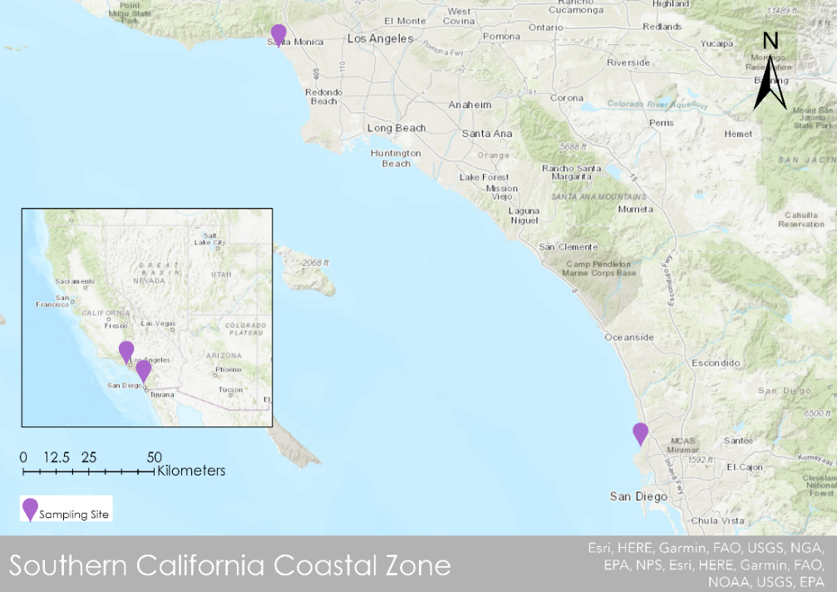

Figure A1. In situ sampling sites from the Southern California Coastal Ocean Observing System (Basemap: ESRI “World Topographic Map”, ArcGIS Pro).

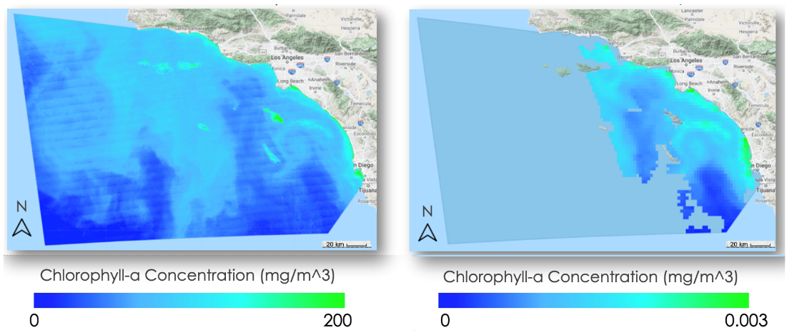

Figure A2. VIIRS (left) vs. MODIS (right) Color Index Algorithm for May 15th, 2020. (Basemap: Google Earth Engine)
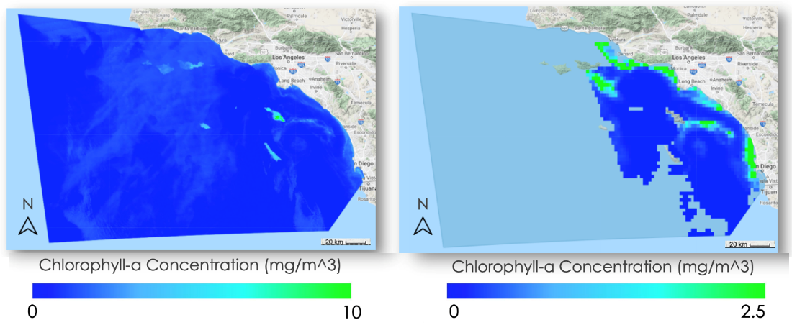

Figure A3. VIIRS (left) vs. MODIS (right) OCx Algorithm for May 15th, 2020. (Basemap: Google Earth Engine)
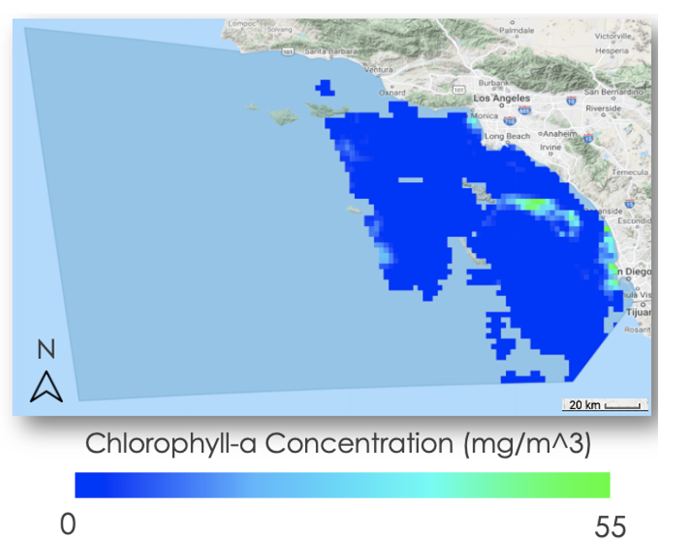

Figure A4. MODIS Green-Red Ocean Color 4 Algorithm for May 15th, 2020. (Basemap: Google Earth Engine)
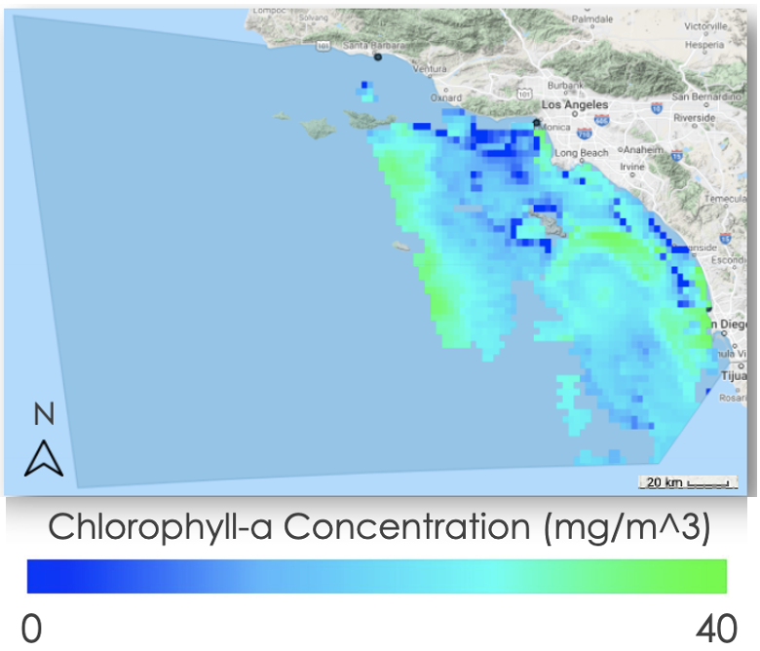

Figure A5. MODIS Red-Green Color Index Algorithm for May 15th, 2020. (Basemap: Google Earth Engine)

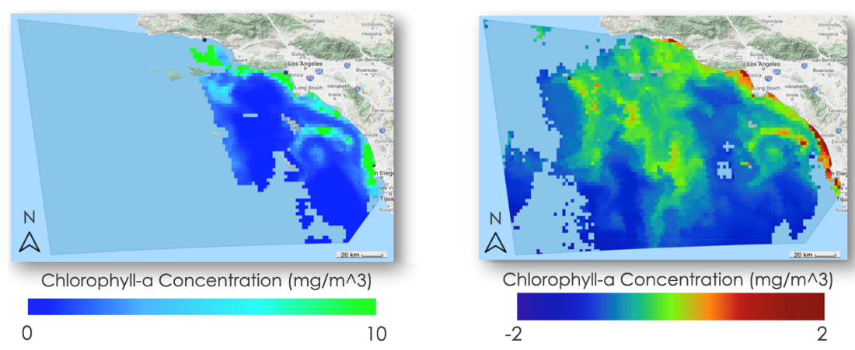

Figure A6. MODIS provided chlorophyll-a vs. GCOM-C provided chlorophyll-a for May 15th, 2020. (Basemap: Google Earth Engine)
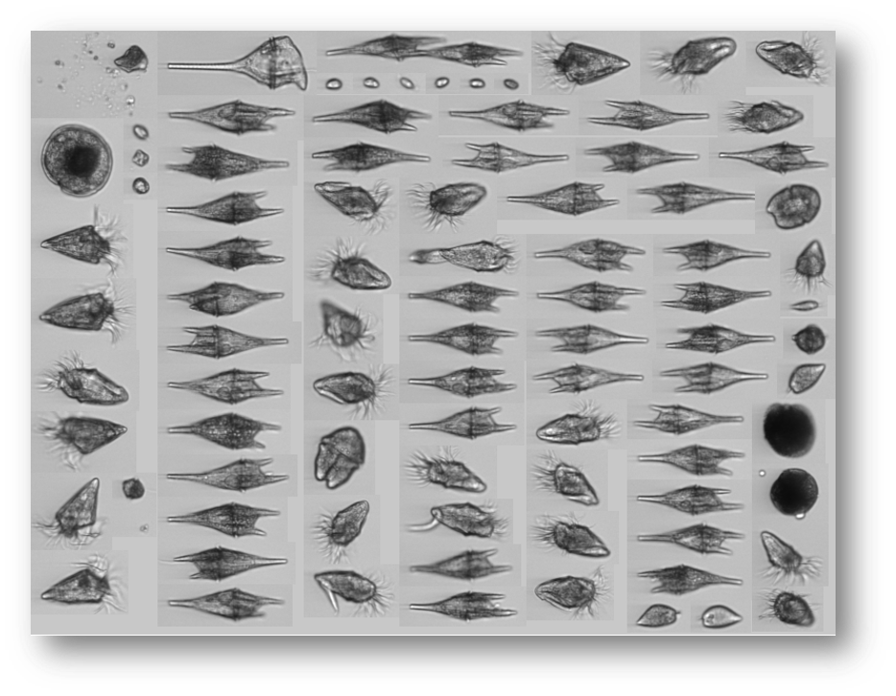
Figure A7. Image collected by Imaging FloCytoBots on September 3rd, 2021. The long clear organisms show a high dominance of diatoms on this date.
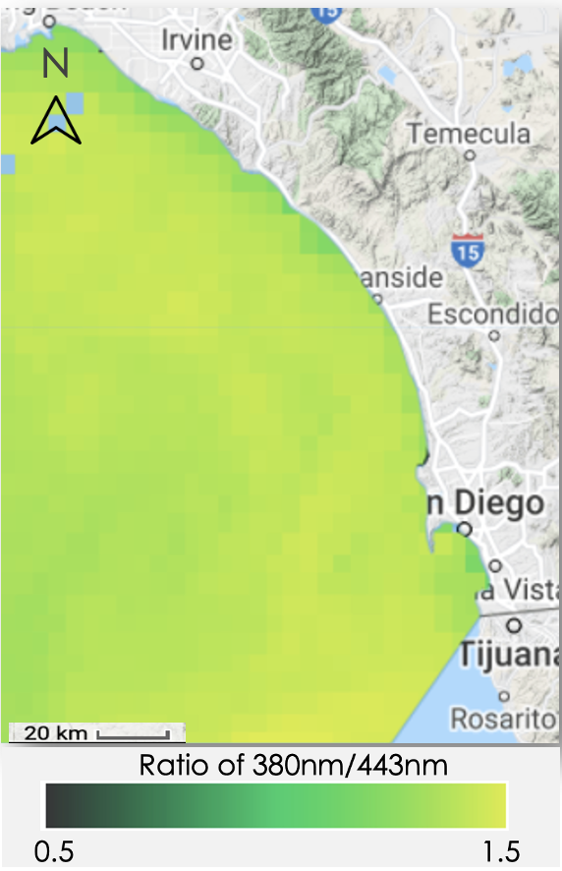

Figure A8. GCOM-C UV Ratio (380nm/443nm) for September 4th, 2021 (Basemap: Google Earth Engine)
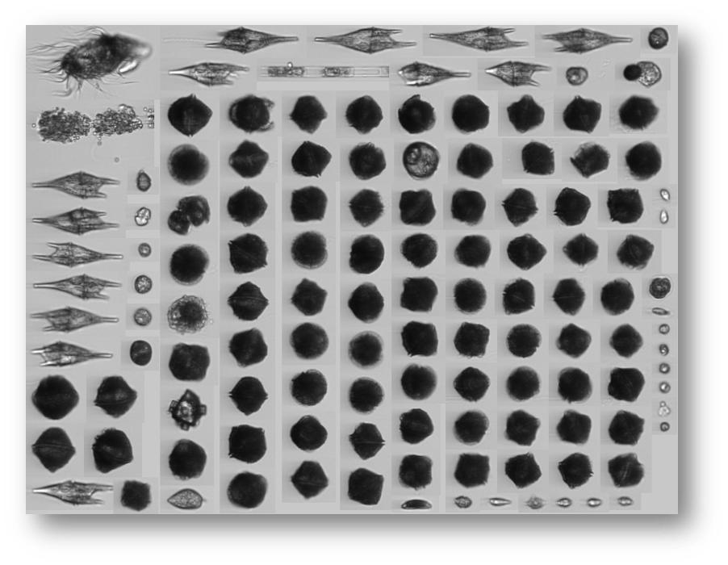
Figure A9. Image collected by Imaging FloCytoBots on September 9th, 2021. The spherical dark organisms show a dominance of dinoflagellates on this date.
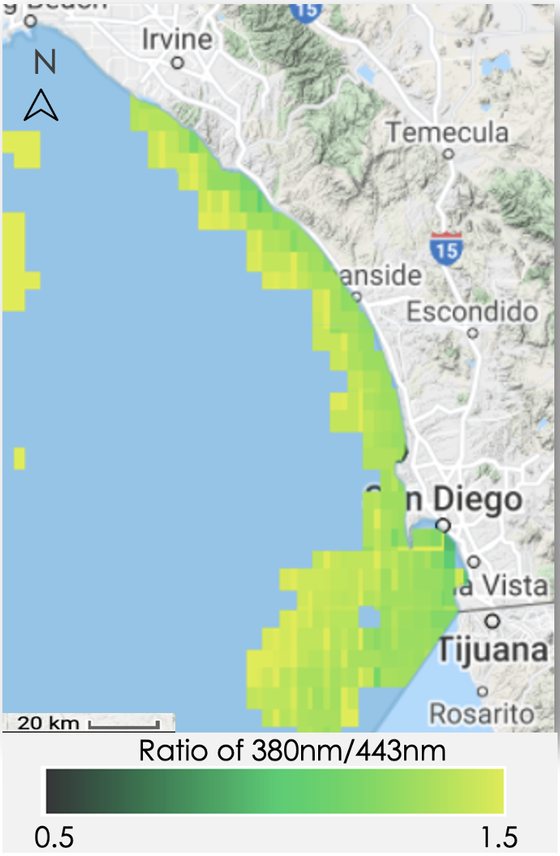

Figure A10. GCOM-C UV Ratio (380nm/443nm) for September 8th, 2021 (Basemap: Google Earth Engine)

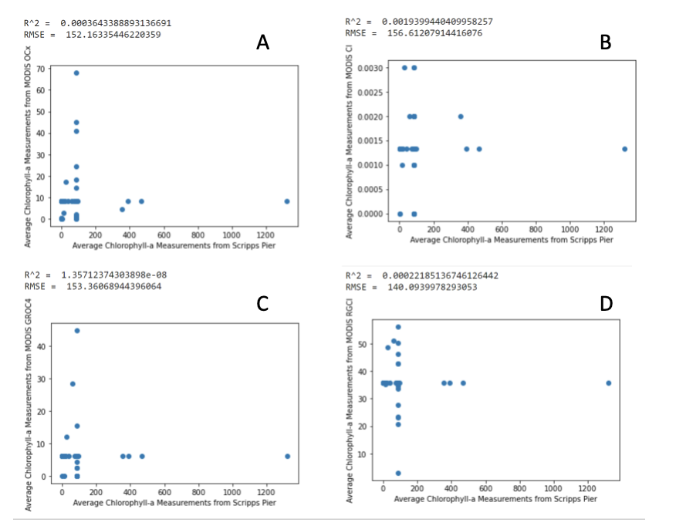

Figure A11: Cross-validation analysis results between MODIS chlorophyll algorithms (A: OCx Algorithm, B: Color Index Algorithm, C: Red-Green Color Index, D: Green-Red Ocean Color 4 Algorithm) vs. In situ Scripps pier data collected by the Southern California Coastal Ocean Observing System (SCCOOS). All measurement units are in mg/m³.

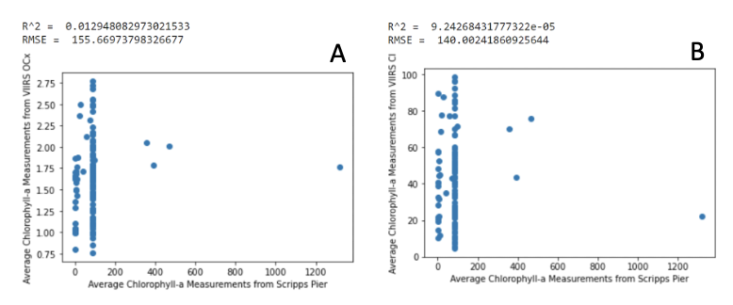

Figure A12: Cross-validation analysis results between VIIRS chlorophyll algorithms (A: OCx Algorithm, B: Color Index Algorithm) vs. In situ Scripps pier data collected SCCOOS. All measurement units are in mg/m³.

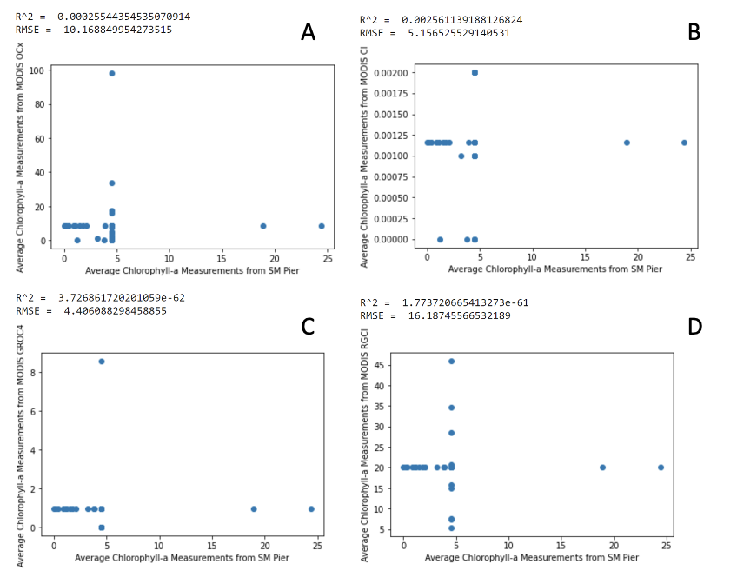

Figure A13: Cross-validation analysis results between MODIS chlorophyll algorithms (A: OCx Algorithm, B: Color Index Algorithm, C: Red-Green Color Index, D: Green-Red Ocean Color 4 Algorithm) vs. In situ Santa Monica pier data collected SCCOOS. All measurement units are in mg/m³.

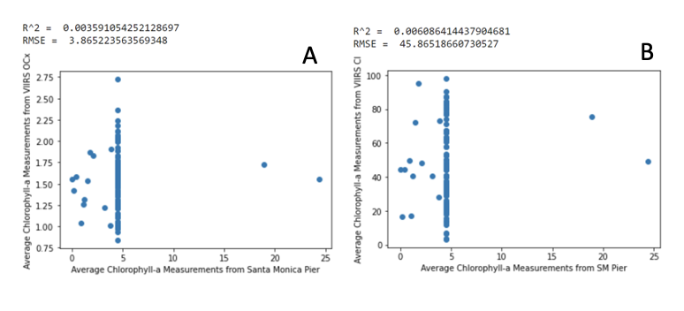

Figure A14: Cross-validation analysis results between VIIRS chlorophyll algorithms (A: OCx Algorithm, B: Color Index Algorithm) vs. In situ Santa Monica pier data collected by SCCOOS. All measurement units are in mg/m³.

