Journal of Geophysical Research: Atmospheres
Supporting Information for
Arctic cloud response to a perturbation in sea ice concentration: The North Water polynya
Emily Monroe¹, Patrick C. Taylor², Linette N. Boisvert³
¹Science Systems and Applications, Inc., Hampton, VA, USA, ²NASA Langley Research Center, Climate Science Branch, Hampton, VA, USA, ³Cryospheric Sciences Lab, NASA Goddard Space Flight Center, Greenbelt, MD, USA

Contents of this file

Figures S1 to S4

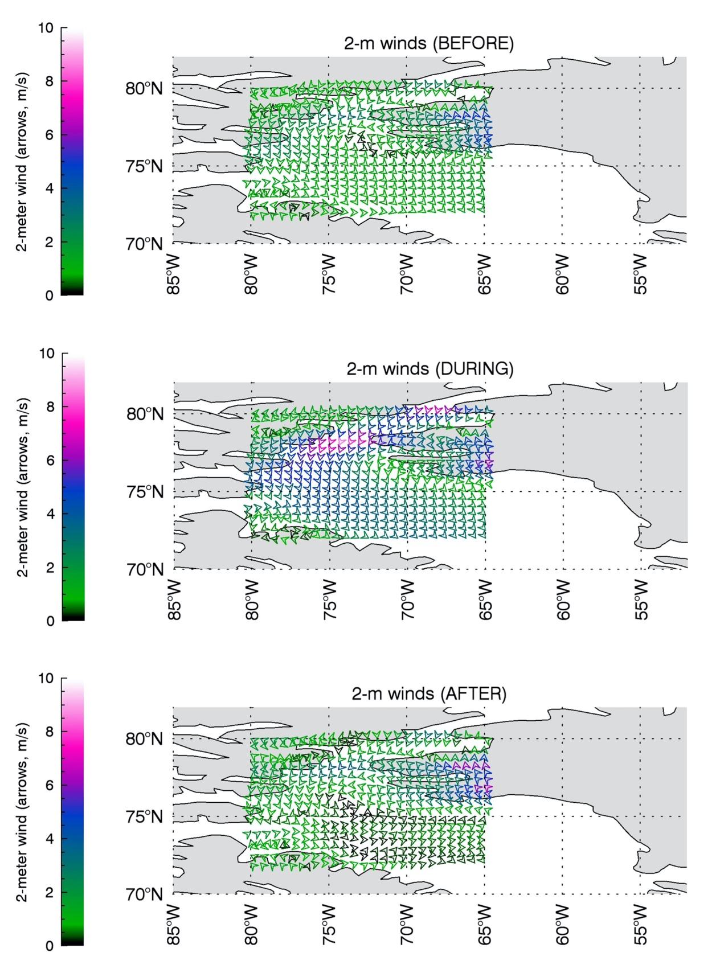
Figure S1. Mean 2-m winds in the greater North Water area before (top), during (middle), and after (bottom) a polynya event (MERRA-2).
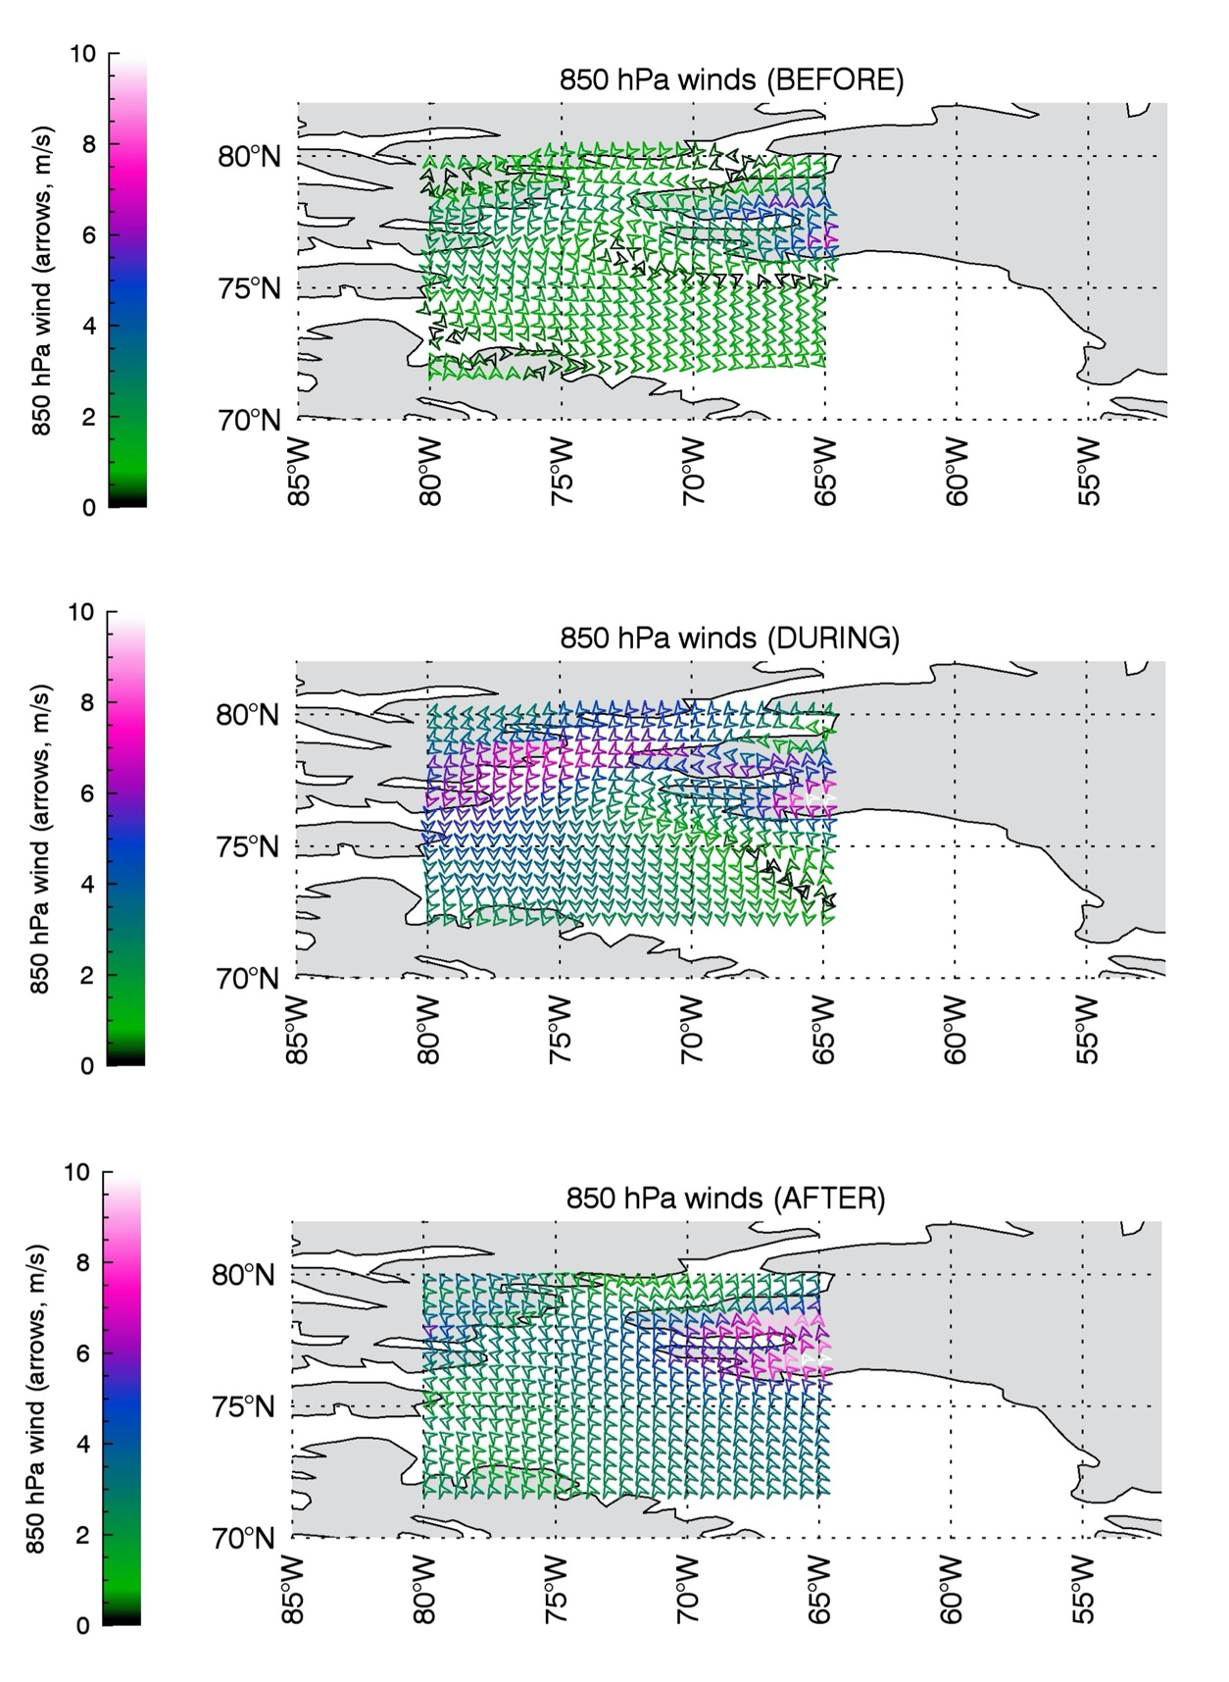
Figure S2. Mean 850 hPa winds in the greater North Water area before (top), during (middle), and after (bottom) a polynya event (MERRA-2).

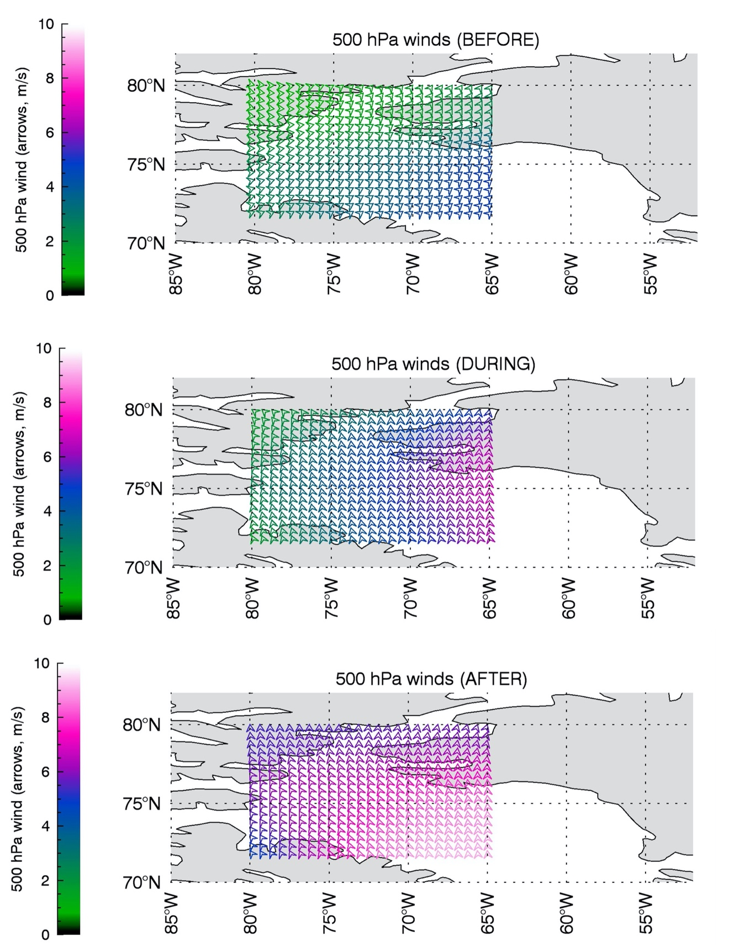

Figure S3. Mean 500 hPa winds in the greater North Water area before (top), during (middle), and after (bottom) a polynya event (MERRA-2).

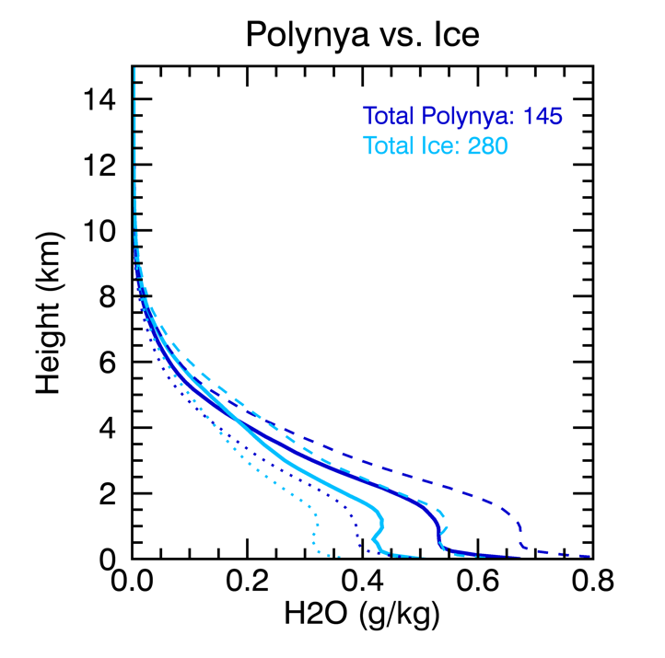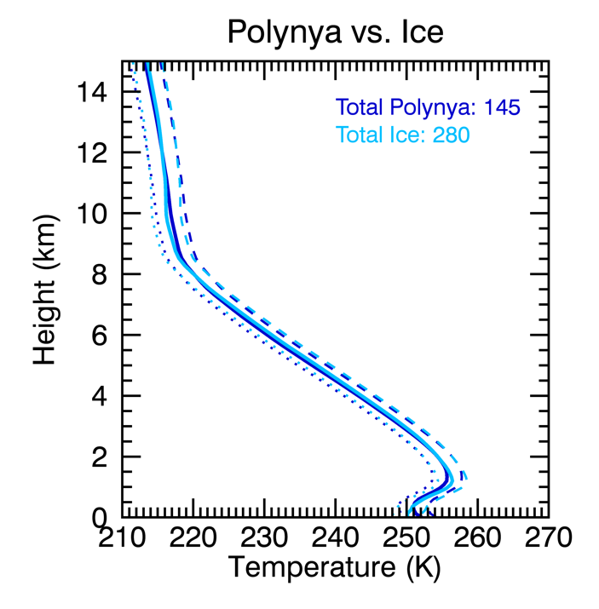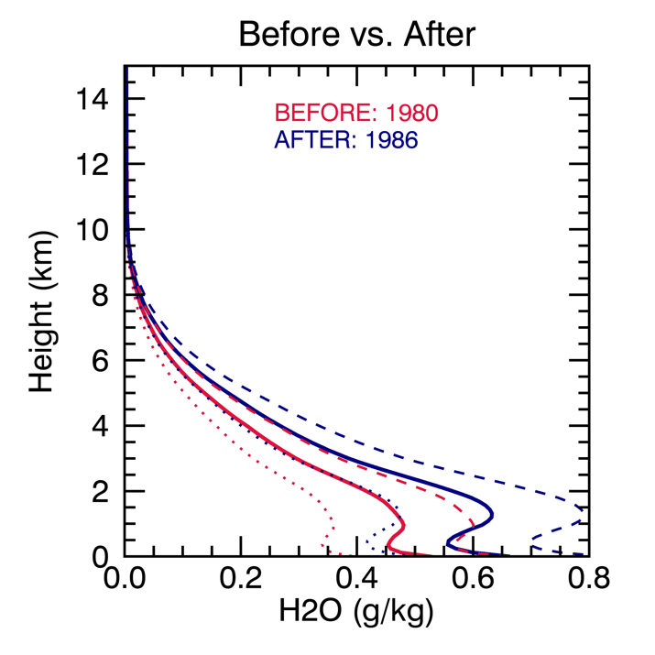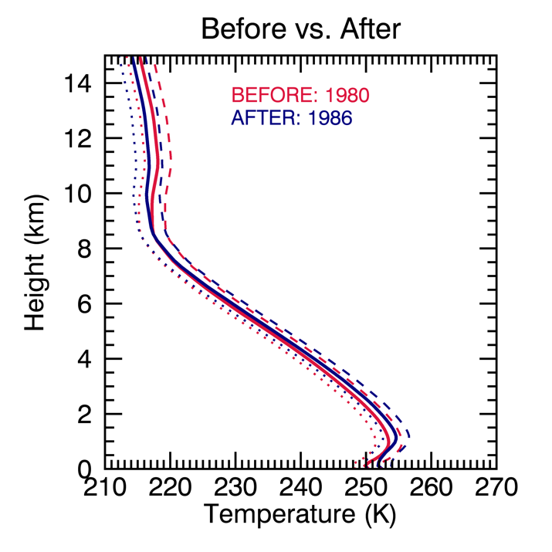

Figure S4. Mean 0-15 km vertical profiles of regionally averaged H2O (left panels) and temperature (right panels) during a polynya (footprints over the polynya (dark blue) and over ice (light blue); top panels) and domain averages for dates before (red) and after (blue) a polynya event (bottom panels). Hashed lines (mean + combined uncertainty) and dotted lines (mean – combined uncertainty) represent ranges of ±1σ uncertainty.

