Meeting a Planetary Launch Window in a Pandemic
Matthew Garrison, Dennis Reuter, Amy Simon, James Simpson, Elizabeth Matson, Teresa Null, Chanel Duncan
NASA Goddard Space Flight Center
8800 Greenbelt Rd.
Greenbelt, MD 20771
Matthew.B.Garrison@nasa.gov

Zachary Dolch
Lentech, Inc.
7500 Greenway Center Dr. Suite 505
Greenbelt, MD 20770-3558

Abstract— L’Ralph is the primary science instrument on the Lucy mission to encounter the Trojan asteroids at the Jupiter L4 and L5 Lagrange points. In December of 2019, the main instrument subassemblies were finishing their build-up and testing. The team was getting ready for integration and testing with comfortable schedule margin to our required delivery date in support of the planetary launch window. When COVID-19 started to spread, the flight hardware ground to a halt but the planets kept moving. The L’Ralph team used a risk-based process to strategically descope activities from the integration and test flow and to negotiate a late delivery to the spacecraft. They changed the entire risk posture, investing in infrastructure to allow more remote test support to protect the team’s health and reduce the schedule risk in case of an outbreak. Despite multiple technical hurdles, the team was able to make an on-time delivery to the spacecraft, and Lucy was successfully launched in October 2021.

Table of Contents
1. Introduction 1
2. Situation as of February 2020 3
3. Direct Impact of COVID-19 3
4. Scoping the Descopes 3
5. Renegotiating Delivery Dates 5
6. Changes to Instrument Risk Posture 5
7. Changing How We Operate 5
8. Conclusions 6
Acknowledgements 6
References 7
Biography 7

1. Introduction
Lucy, a NASA Discovery Class mission, is sending a spacecraft to investigate six primitive asteroids near the L4 and L5 Lagrange points with Jupiter—the so-called Jupiter Trojans (Figure 1) that lead and follow Jupiter in its orbit by 60°. Lucy will explore the L4 and L5 swarms, where planetesimals from the outer planetary system have been preserved since early in Solar System history. The Lucy mission will study the largely unexplored gap in formation history. The spacecraft will fly by and intensively observe the diversity taxonomic classes of Jupiter Trojans.
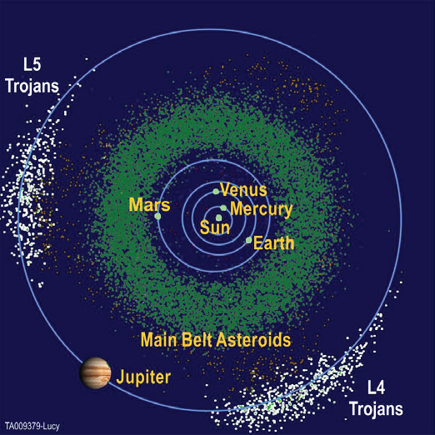
Figure 1. Jupiter’s Trojan Swarm

Lucy was launched in October 2021. It will reach its first Trojan in 2027, and have its final encounter in 2033. During its lifetime, Lucy will perform 5 Trojan encounters, closely studying six of these fascinating objects including one binary pair (Figure 2).
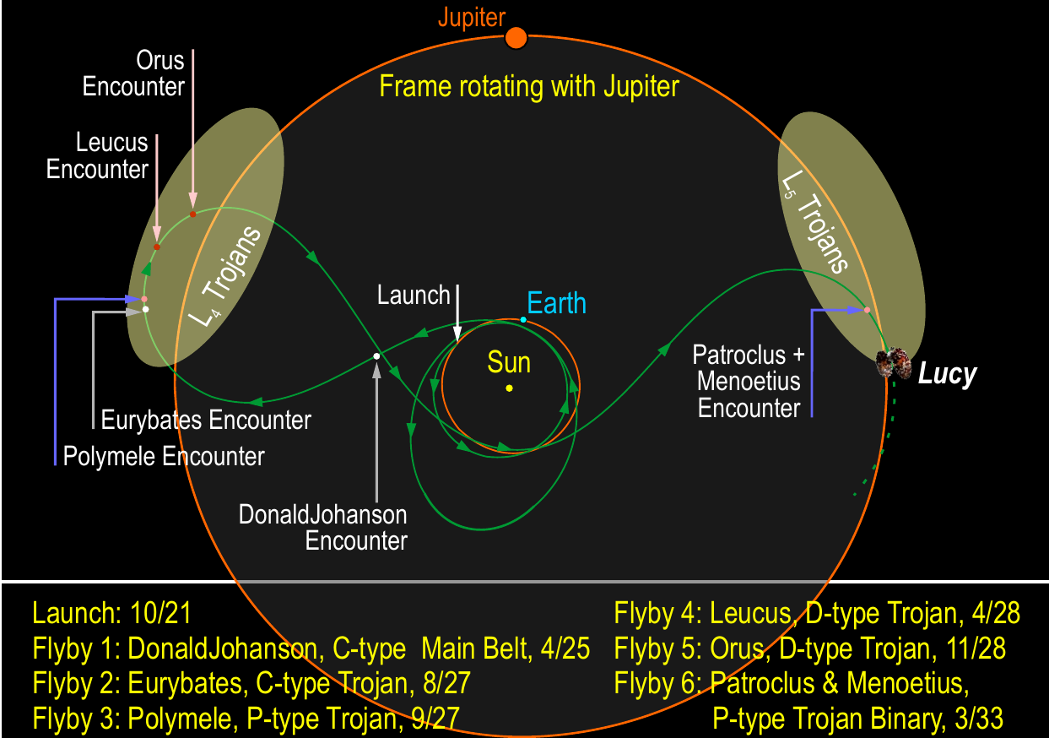
Figure 2. Lucy’s Trajectory

Lucy’s payload comprises three complementary, high-heritage imaging/mapping instruments that cover wavelengths from 0.35 to 50 um: 1) L'Ralph, the subject of this paper; 2) L’LORRI, a high-resolution visible imager, also used for optical navigation; and 3) L’TES, a thermal infrared (IR) spectrometer. Together this powerful remote-sensing suite will provide exciting, high-quality color, thermal, and panchromatic maps, as well as IR spectral maps. Additionally, Lucy will perform a Radio Science Investigation (RSI), using the spacecraft’s telecom system to constrain the masses and bulk densities of the Trojan targets.
L’Ralph is a combined multi-band visible imager and wedge-filter IR spectrometer. It follows in line from similar instruments on EO-1, New Horizons, and OSIRIS-REx. L’Ralph was developed by NASA GSFC and delivered to a Lockheed Martin (LM) spacecraft.
The flight instrument operates as two instruments in one with a shared optical path. The Multispectral Visible Imaging Camera (MVIC) acts as a multi-band push-broom camera. Five bands include color filters, and one band is panchromatic. Each of the six bands is an independent rectangular charge-coupled device (CCD) operating in a time-delay integration (TDI) mode. The Linear Etalon Imaging Spectral Array (LEISA) is an infrared mapping spectrometer utilizing a square HgCdTe array with a linear wedge filter. The filter and detector are arranged so that the cross-track spatial dimension and the direction of changing wavelength are orthogonal. The resulting system operates as a push-frame spectrometer. A common set of reflective optics allow the MVIC and LEISA to share the same field of view, with a dichroic optic splitting the incoming energy between the two separate focal places. A scan mirror mechanism (SMM) attached to the first fold-flat mirror allows the scene to be mapped without having to move the entire spacecraft or integrated payload platform. The detectors, optics, and mechanism are aligned in an assembly called the Telescope Detector Assembly (TDA). The Main Electronics Box (MEB) provides power, command interface, image processing, and memory to store science data from a single encounter.
The TDA is a passively-cooled cryogenic system (Figure 4). The majority of the TDA operates at about -100C, with the LEISA detector further cooled down to about -170C. The optics shift focus at room temperature and MVIC operates although with slightly higher noise, however the LEISA detector needs cryogenic temperatures in order to provide usable data. This drives the structure of the instrument test campaign; we cannot set focus or measure baseline performance without going into a thermal vacuum environment. This situation forces 3 serial thermal vacuum tests: TVac Focus is used to measure and set initial focal positions for both detectors, TVac 1 is used to get baseline performance measurements, and TVac 2 is used to show any changes in performance over instrument-level environmental testing (particularly vibration).

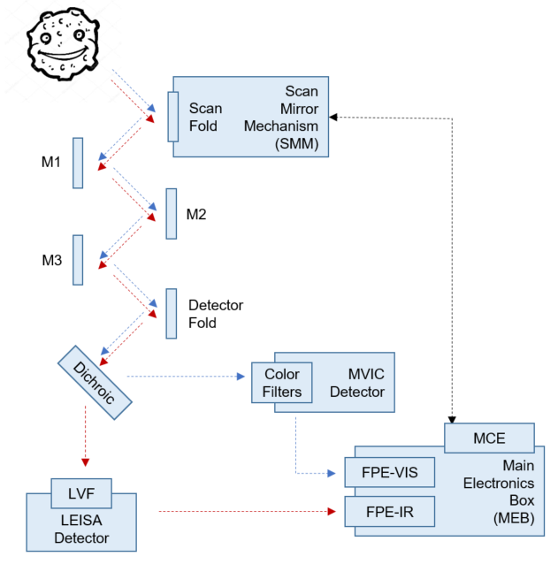
Figure 3. L’Ralph Simplified Architecture

Table 1. L’Ralph by the Numbers
Parameter | As-Built Values
Mass | 32kg
Power | 25W
Field of View | 145 x 56 mrad
Scan Angle | 140 mrad
LEISA Resolution | 68 urad Full Width Half Max (FWHM)
MVIC Resolution | 42 urad FWHM
LEISA Wavelength | 0.95-3.95 um
MVIC Wavelength Bands | Panchromatic  0.375-0.48 um  0.48-0.52 um  0.52-0.625 um  0.625-0.75 um  0.75-0.90 um
LEISA Signal to Noise Ratio (SNR) | >50
MVIC SNR | >34
Calibration | Solar, Filament, Black body

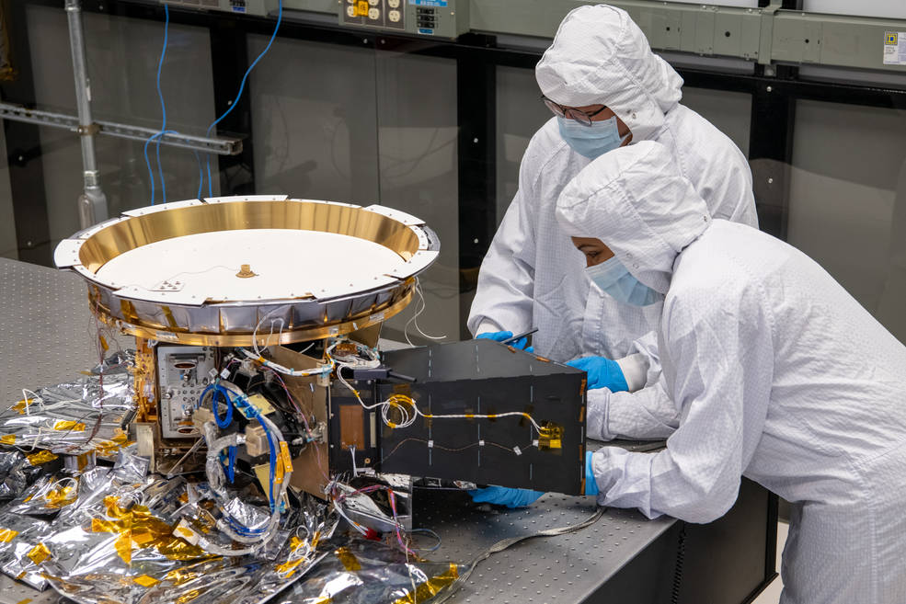
Figure 4. L’Ralph TDA with Blanketing Removed¹

2. Situation as of February 2020
In the pre-pandemic days of February 2020, L’Ralph was finalizing the integration and testing of the two major sub-components: the TDA and the MEB. The MEB had just finished box-level Electromagnetic Interference (EMI) and vibration tests at the Southwest Research Institute in San Antonio, TX. It was about to begin its thermal vacuum testing, with a plan to delivery to GSFC at the end of March. All flight optics had been installed and aligned in the TDA, and it was ready to receive the SMM and both the MVIC and LEISA detectors.
The plan through delivery was roughly:
• March – Finish assembly of the TDA by installing the SMM and both detectors. Get the MEB set up with Ground Support Equipment (GSE) to be ready for instrument-level testing.
• April – Integrate the MEB to the TDA and perform ambient instrument functional testing. Perform ambient calibration tests for the MVIC detector.
• May – Assemble in the thermal vacuum chamber to measure focus at operating temperatures, then return to ambient to adjust the focus.
• June – Return to the thermal vacuum chamber for pre-environmental baseline performance measurements and two thermal cycles.
• July – Vibrate the TDA and re-integrate it to the instrument
• August – Return to the thermal vacuum chamber for post-environmental performance measurements and two thermal cycles.
• September – Finalize instrument closeouts and deliver to the Lockheed Martin spacecraft in Littleton, CO.
Up until this point, the instrument team had some technical setbacks on the MEB and the TDA; as of February the team had 10 days of funded schedule margin against the contractual delivery date at a time when GSFC required >25 days.

3. Direct Impact of COVID-19
As COVID-19 infection rates began to climb, NASA GSFC moved quickly to close down on Center work. All L’Ralph hardware was safed on March 24 and the team was limited to remote work only. Some work could be done remotely like writing test procedures and verification reports, but the majority of the hardware work stopped. This continued for almost two months, which far exceeded the remaining schedule margin.
In order to return some of the engineering to in-person work with the flight hardware while maintaining as its chief priority the safety of individuals, the L’Ralph management team went through a detailed planning and approval process run by GSFC leadership. The work plans had to include provisions for social distancing, sanitizing work surfaces, and supply and usage of personal protective equipment. These plans had to be approved by GSFC management and the center medical staff before anybody was allowed on Center. Only after employee agreement with their supervisor was completed was the employee asked to return to work in person.
Although the team was affected by the general slow-down of supply chains, the most disruptive aspect of this and the absence of on-site personnel was the lack of the standard supplies and support on Center. During a typical I&T campaign, the engineering team has stockpiles of materials available (epoxy, tape, etc.) and multiple machine shops for any unexpected parts needs. With GSFC reduced to a skeleton crew, any unanticipated material needs could take days to resolve as the L’Ralph team tried to find someone available to prepare the materials, then submit a revised work plan to get them approval to come on Center.
There was an additional impact to team efficiency because of the travel restrictions. In business-as-usual, the MEB and MVIC teams from Texas would have sent one or more test engineers to help set up the flight electronics and train the GSFC team on how to use it. Instead, all support was done remotely which caused further delays and somewhat compromised hardware safety procedures. Multiple safe-to-mates were done with the technical experts observing operations over cell phone video calls.
On top of all of this, the integration and test of a flight system is always stressful, and 2020 added a whole new set of stresses onto the team². Staffing plans had to be rearranged with families working and schooling from home. Portions of the instrument team also had to quarantine several times due to possible exposure to COVID-19, resulting in temporary slow-downs and replans. Further team burnout leading to personnel and hardware safety risk quickly became one of the top concerns for the instrument leadership.
In order to extend our work day without overtaxing the team, 12 hour workdays split into 6 hour shifts were scheduled. This also provided flexibility for parents with lack of childcare and minimized overtime. The test conductor team was expanded in order to deflect schedule and stand-down slips in the event co-workers had to quarantine.

4. Scoping the Descopes
COVID-19 ground the world to a standstill, but the planets and Trojans kept moving. In order to reduce the stress on the instrument team and help solve the negative schedule margin, the L’Ralph leadership put together a comprehensive list of descopes for the remaining instrument integration and test flow to allow for agile decision making as challenges arose.
Any activity that was predicted to take more than a half week was considered as part of this effort. The only activities that were not considered were those that were needed to have an assembled instrument. As an example, the initial thermal vacuum test was required because it is used to set focus, but the other two thermal vacuum tests were considered as possible descopes. In general, any activity that was focused on requirement verification was considered descopable, which would defer that verification to observatory-level testing. The final list included multiple items that the entire team agreed we did not want to cut, but they were still included for completeness.
Each inspection or test on the list was then treated as a risk-mitigation activity, and the associated risk was scored. It was important to note which risks 1) were against downstream schedule performance and which risks 2) were against in-flight performance after launch (residual risks).
For example, as of early 2020 there were two future TDA vibration tests planned. The first test was a settling vibe to relieve strain in the bolted assembly before final focusing. This is part of the standard build process and greatly reduces the risk that thermal stress will cause components to move, so it was not considered as a possible descope. The second was the standard mechanical environment verification, exposing the flight hardware to random, sine vibe, and sine sweep environments. Cutting this test would impose two new requirements on the Lucy project:
- Since the assembled TDA would not have seen flight-like vibration levels before spacecraft vibration testing, there would be a risk that the TDA may be damaged in spacecraft-level vibration. This would happen later in the flow and away from the L’Ralph facilities. This was a purely programmatic risk.
- Since the assembled TDA would not have seen flight-like vibration levels before spacecraft vibration testing, there would be a risk that the TDA optical surfaces may shift in spacecraft-level vibration. Since L’Ralph performance could only be assessed in the GSFC thermal vacuum chamber with specific calibration GSE, any change in optical performance would not be detected until after launch. This would present a residual risk at launch against level 1 science.
After completing this risk assessment for each activity, the L’Ralph leadership team gave an overall qualitative assessment of each descope. The projected schedule savings were traded off against the additional risk for each activity that could be cut. The activities were either marked as easy (we can cut it now), moderate (we can cut it later), hard (we won’t cut it without project buy-in), or very hard (we would likely need program buy-in before cutting it). As a general rule, any cuts that prevented verification of instrument-level requirements or higher needed project approval. A sample of those items with their assessments are shown in Table 2.

Table 2. Example of Descope Options and Assessment
Descope | Rating | Savings | Risks | Decision
Cut MVIC Stray Light Testing | Easy | 1 week | Technical risk – Stray light far outside the Field of View (FOV) may occur in flight. TVac stray light testing with calibration GSE can cover angles near the FOV. Stray light analysis shows no issue. MVIC is descopable. | This was cut, but then we had an opportunity to add it back in later.
Cut MVIC Ambient Calibration | Moderate | 2 weeks | Schedule risk – MVIC calibration in TVac may take longer without this. MVIC is descopable. | This was reduced but not cut
Reduce some Comprehensive Performance Tests (CPTs) during TVac to Aliveness | Moderate, Hard if it impacts verification | Up to 1 week | Schedule risk – Performance issue may not be found until spacecraft TVac | Some CPTs were reduced to Aliveness tests, verification not impacted
Reduce Instrument EMI to Conducted Emissions (CE), Radiated Emissions (RE), and Radiated Susceptibility (RS) tent poles only | Hard | 3 weeks | Schedule risk – Delay if we need to investigate an RS away from tent poles at spacecraft level. No emitters expected in those frequencies. MEB already passed all conducted tests. | This was not reduced
Cut TDA Vibration | Very Hard | 2 weeks | Schedule risk – Delays if a vibe failure at SC  Technical risk – Change in optical performance can’t be detected until after launch, impacts L1 science | This was not cut

Each possible descope also had a trigger date that the final cut-or-not decision had to be made. Some cuts had to be made early to prevent wasted effort, but other decisions could be pushed off until the day of testing. For example, a decision not to vibrate the TDA had to happen weeks ahead of time, but a TVac CPT could be reduced to an Aliveness test up until the test conductor begins the test. Although a preliminary decision on the descope options was made as part of the return-to-work effort, the instrument and project leadership could revisit the decision up until that date to react to the latest schedule status on both the instrument and the spacecraft.

5. Renegotiating Delivery Dates
Armed with the list of possible descopes, the L’Ralph team was able to begin negotiating a new delivery date with the project. The Lucy team had been working through a similar process to assess the risk of flight instruments missing activities early in the spacecraft integration and test flow. It became a trade between discrete risks: a later delivery date meant fewer activities cut from instrument-level testing but more activities the instrument missed at the spacecraft level.
In the end, the Lucy project agreed to delay instrument delivery by four months and provided the associated funded schedule margin. Some of the instrument delay was absorbed by rearranging integration activities at the spacecraft vendor. Further instrument delays were accommodated by delays in the spacecraft schedule. Additionally, the Lucy project accepted the risks associated with L’Ralph missing the baseline pre-environmental CPT and early shock tests. The initial powered testing of L’Ralph on the spacecraft was expanded to meet most of the goals of the original pre-environmental CPT.
Importantly, the instrument and project management teams kept in constant contact during this time in case the re-baselined plans needed to be adjusted.

6. Changes to Instrument Risk Posture
The standard motto on planetary missions is “schedule is king.” The technical corollary of that is “an okay instrument in flight is better than a perfect instrument on the ground.” The result of this is that planetary mission risk management typically focuses on schedule risks.
In response to the COVID-19 pandemic, the L’Ralph team’s risk management process pivoted to focus on the health and safety of the team. Often schedule issues during testing would be mitigated by having more people brought in to provide live troubleshooting or real-time analysis, but that was not doable without an unnecessary increase in exposure to spreading the virus.
Previously we were tracking three yellow risks: two technical risks and one personnel risk related to burn-out of the integration and test team with our mounting schedule pressure. By the time the instrument team had resumed major integration and test activities, the risk outlook had changed significantly. The technical risks were unchanged. The risk of personnel burnout impacting team and hardware safety had increased in likelihood because of the added stresses of 2020. We also began actively mitigating a new risk to address the schedule impact of the COVID-19 pandemic.
The new focus on personnel health and safety risks resulted in a few concrete actions. L’Ralph team identified and trained back-ups for all critical personnel and implementing the changes discussed elsewhere in this paper. Leadership announced a no-questions-asked policy for team members that needed time off or were unwilling to come on Center. This forced the integration and test team to be more agile with their day-to-day activity planning. L’Ralph leadership also had to work proactively with Center management to ensure that all facilities were available and also updated to be a safer work environment. As an example, the GSFC vibration facility put up multiple barriers between workstations, then set up remote data terminals and voice communication in a conference room where the L’Ralph structural analysts could monitor results without violating social distancing limits. All of this resulted in a less time-efficient integration and test campaign, but helped maintain the health and safety of the team.

7. Changing How We Operate
The L’Ralph team had to make significant changes to normal integration and test norms to deliver the flight hardware during the pandemic.
Social distancing forced the team to operate with the bare minimum crew on center, which forced a lot of support work to stay remote. This pushed the team to set up remote access for all test consoles, allowing much of the team to support activities from their houses. A test engineer could access real-time telemetry, science data, and detailed post-processing at any time from the convenience of their home. This was not only invaluable for operations during the pandemic, but was also incredibly useful for getting the right eyes on a problem real-time without having to bring someone on-center.
The engineering and science teams spent a significant amount of time remotely stepping through the detailed plans and procedures for every activity. This was a major focus during the stand-down between the start of the pandemic and the return to work on Center. The resulting procedures were more detailed and included more contingency operations, allowing the test team to be more agile and the activities to be more streamlined.
It was important that the shifts be organized based on isolated teams with minimum cross-over, especially during multi-shift operations. This minimized the chance of an individual who tested positive for COVID-19 from forcing the entire instrument team into quarantine. Any at-work transmission of the virus would be a major personnel health issue and would likely result in a significant stand-down and schedule slip. As it turned out, at-work exposure to the virus result in only 2 team members being required to quarantine rather than the full team and there were no instances of at-work transmission.
Once the instrument was ready for delivery, COVID-19 travel restrictions also greatly limited the amount of in-person support the team could provide to the spacecraft vendor. Instrument checkouts, disassembly, and installation had to be done with the bare minimum crew, with every member serving multiple duties. Everyone who did travel was cross-trained so that they could perform multiple roles, and the remaining team was providing remote support through video calls and on-line test monitoring.

8. Conclusions
In the end, the L’Ralph instrument was delivered to Lucy in January 2021, completed spacecraft environmental testing in June, shipped to the launch site in August, and was successfully launched in October of the same year.
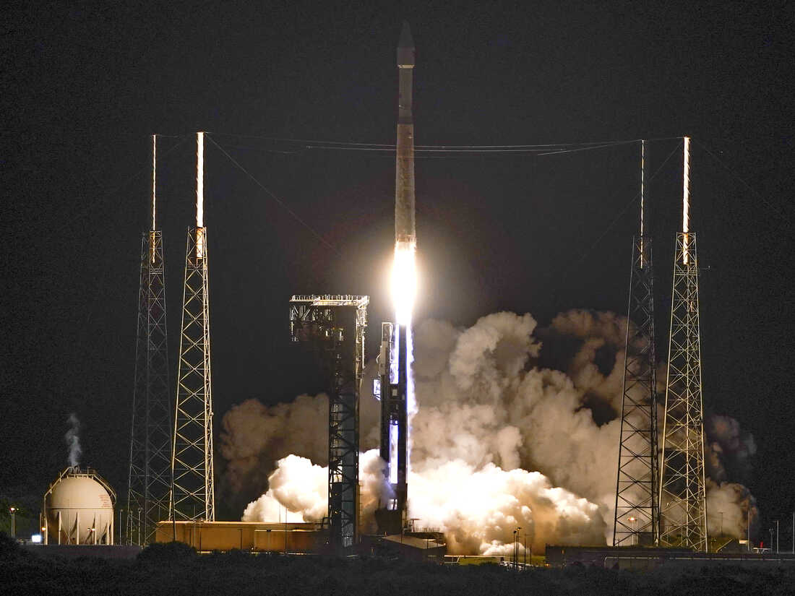Figure 4. Lucy Ready for Launch³
Based on our experience delivering flight hardware in support of a planetary launch window during a pandemic, the L’Ralph team recommends the following even in less taxing times:
- When assessing integration and test activity descopes, analyze them as a risk against future schedules or in-flight performance.
- When negotiating new delivery dates between levels, trade off the risk of cutting activities at either level.
- When there is uncertainty in the supply chain or infrastructure, take the time to plan the smallest details of what materials, parts, personnel, and facilities will be needed for an operation. If possible, include things that might be needed if activities don’t go as planned.
- When setting up a communication and technology infrastructure, make sure that systems work equally well for in-person and remote support.
- When expanding beyond a single 8-hour shift, consider whether the work can be accomplished with two 6-hour shifts in order to reduce stress on the team.
- When planning test activities, invest time in streamlining activities and providing contingency operations so that the test team can remain agile. Understand what alternatives exist and be prepared quickly adjust.

Acknowledgements
Thank you so much to the L’Ralph team, the Lucy project, and the larger NASA Goddard community for all the hard work and support during a unique and stressful I&T campaign.

References
[1] Jones, Nancy. “NASA’s First Mission to the Trojan Asteroids Installs its Final Scientific Instrument.” NASA News, www.nasa.gov. 9 February 2021.
[2] Kotsonis, Stefano. “Pandemic, Protests, and Politics: Year in Review.” NPR On Point, www.wbur.org. 24 December 2020.
[3] Raoux, John. “NASA launches an asteroid hunter named Lucy with a Beatles connection.” NPR, www.npr.org. 16 October 2021.

Biography

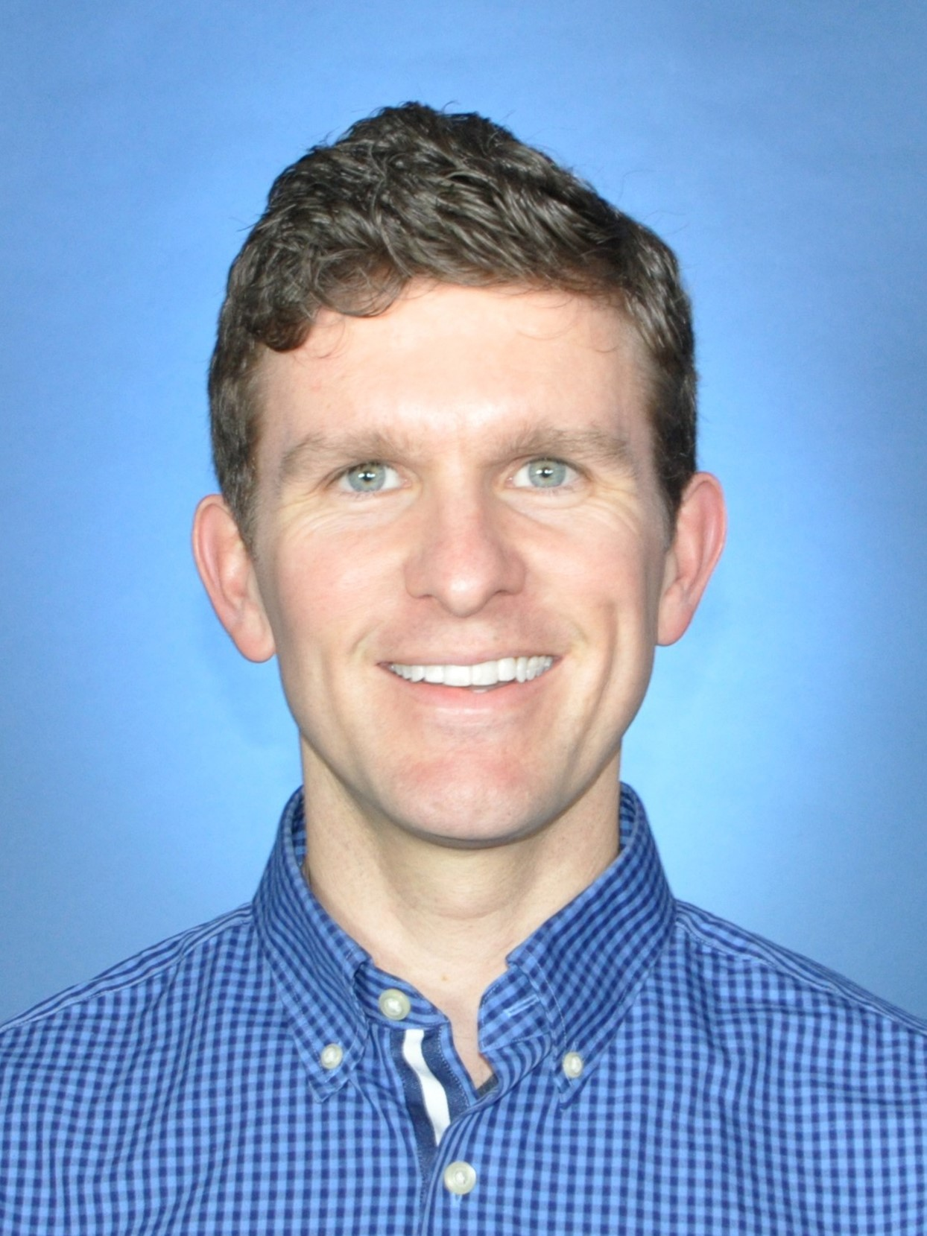 Matthew Garrison was the L’Ralph Instrument Systems Engineer. He has worked at the NASA GSFC since 2005, first as a thermal engineer and then as a systems engineer. He has supported in-house flight hardware for Earth science, planetary science, and astrophysics missions. He is currently supporting the DAVINCI mission and serving as associate branch head for the Instrument Systems Engineering branch.
Dennis Reuter is a Senior Fellow at NASA’s Goddard Space Flight Center and is the L’Ralph Principal Investigator (PI). He received his PhD in Physical Chemistry from the University of California, Berkeley in 1981. He is also the PI or Instrument Scientist for the LEISA Atmospheric Corrector (LAC) on EO-1, the Ralph instrument on New Horizons, the Thermal Infrared Sensor (TIRS) on Landsat-8 and TIRS-2 on Landsat 9, and the OSIRIS-REx Visible and Infrared Spectrometer (OVIRS) on the OSIRIS-REx asteroid sample return mission He is an author of more than 100 journal papers on topics including laboratory spectroscopy, spectral interpretation, remote sensing applications in planetary and Earth science and instrument design and applications.
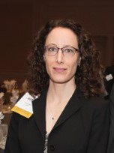 Amy Simon is a Senior Scientist at NASA’s Goddard Space Flight Center and is the L’Ralph Deputy Principal Investigator. She received her PhD in astronomy from the New Mexico State University in 1998. She is the author of more than 140 journal papers and has written two book chapters on topics ranging from giant planet atmospheres to small solar system body spectroscopy to instrument calibration.
James Simpson served as the Instrument Project Manager for the L’Ralph instrument since March of 2018. Prior to L’Ralph, he served as Instrument Project Manager for the Astro-H instrument and Deputy Payload Manger for the Laser Communications Relay Demo (LCRD) for STP-Sat3 mission. Other prior experience includes Attitude Control Systems lead for the Lunar Reconnaissance Orbiter (LRO) and Systems engineer for the Global Precipitation Measurement (GPM) mission. In the early days of his 30 years with NASA, he worked on Space Shuttle star trackers and inertial measurement units as well as GPS receivers for the International Space Station.
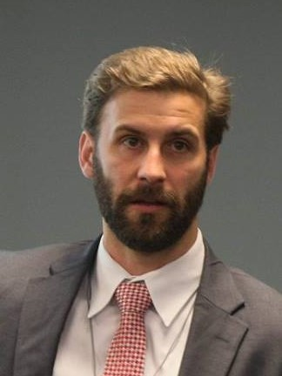 Zachary Dolch was the L’Ralph Deputy Instrument Project Manager. He has a decade of experience working directly with the NASA GSFC Planetary Science Projects Division. The Lucy Mission will be his third planetary project in a row to launch on time and within budget. He also provides schedule/project management support to other GSFC Flight Projects and assists with schedule training for engineering technical leads.

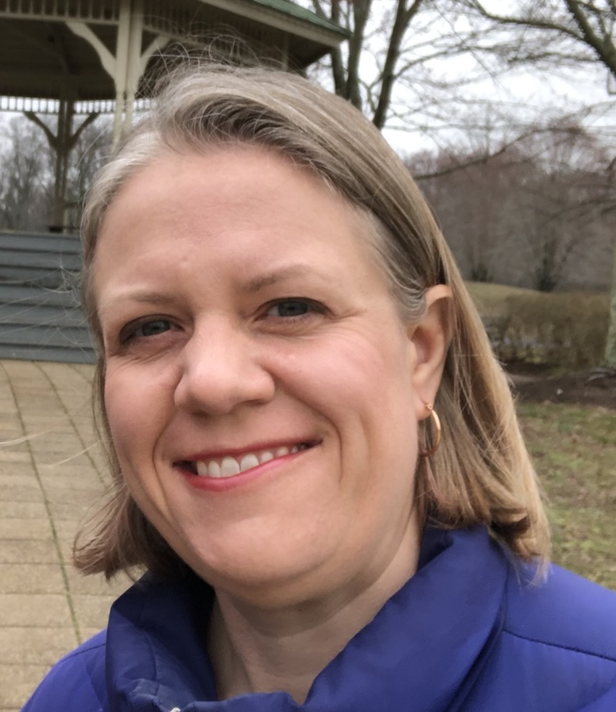 Elizabeth Matson is a Systems Engineer at NASA Goddard Space Flight Center (GSFC). She received a Bachelor’s Degree in Mechanical Engineering from Case Western Reserve University and a Master’s Degree in Aerospace Engineering from the University of Maryland College Park. Beginning her career in the Mechanical Analysis and Simulation Branch, Liz was a structural analyst for the Integrated Science Instrument Module (ISIM) on the James Webb Space Telescope (JWST) and the Lunar Orbiter Laser Altimeter (LOLA) on the Lunar Reconnaissance Orbiter (LRO) before becoming the Lead Structural Analyst for the Thermal Infrared Sensor (TIRS) on Landsat-8 and the OSIRIS-REx Visible and Infrared Spectrometer (OVIRS) on the OSIRIS-REx asteroid sample return mission. After transitioning to systems engineering, Liz became the Deputy Instrument Systems Engineer on L’Ralph and is currently the Lead Mission Systems Engineer in the Mission Design Lab (MDL) of the GSFC’s Integrated Design Center (IDC) developing early mission concept designs. In addition to her technical work, Liz is a co-chair of the GSFC Lesbian, Gay, Bisexual and Transgender Advisory Committee and is active in a variety of educational outreach activities.
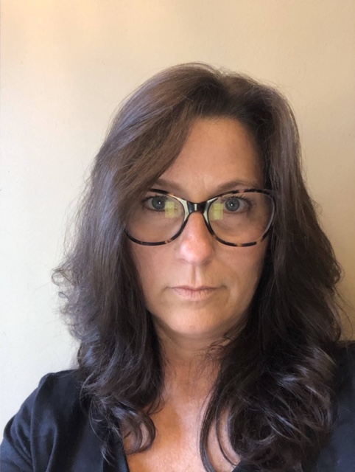 Teresa Null has 36 years of experience in aerospace. She began working at the Goddard Spaceflight Center in 1985 as a high school senior in the technician apprenticeship program, through which she earned a journeymen’s license in electronics. She has served as a battery laboratory manager, Integration and Test Manager of the Submillimeter Wave Astronomy Satellite (SWAS), Integration and Test Manager of the Thermal Infrared Sensor (TIRS) instrument, Subsystem Manager of the Micro Shutter Subsystem for the Near Infrared Spectrometer (NIRSpec) on the James Webb Telescope (JWST), Senior Integration and Test Manager of the Lucy L’Ralph instrument and is currently the Senior Integration and Test Manager for the On-orbit Servicing, Assembly, and Manufacturing-1 Robot Subsystem and Heliophysics Environmental & Radiation Measurement Experiment Suite.
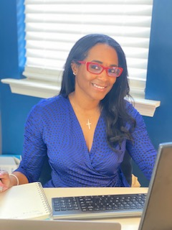 Chanel Duncan Duncan is an Aeronautical Engineer with over 10 years of supporting NASA mission. Chanel is the Safety & Mission Assurance (S&MA) Associate Branch Head and the Chief Safety and Mission Assurance Officer (CSO) for the Lucy/L’Ralph and MSR/Capture, Containment, Return, System (CCRS) Instruments being built in-house at GSFC where she leads a team of S&MA discipline. Chanel began her career at NASA Goddard Space Flight Center (GSFC) in 2007 after a successful career as an Aerospace Engineer with Booz Allen Hamilton. During her time at NASA, she has supported multiple NASA projects in the area of Safety and Mission Assurance and has led. Since 2009, Chanel has acted as the Senior Quality Assurance Engineer for multiple in-house and out-of-house programs which includes the Polar Operational Environmental Satellite Program (POES), the Magnetospheric Multiscale Mission (MMS) Fast Plasma Investigation (FPI), the Landsat Data Continuity Mission, and the Mars Organic Molecule Analyzer (MOMA), prior to being selected as the CSO on Lucy/L’Ralph and CCRS. Chanel brings years of experience in the development of Workmanship Standards and verifying the appropriate processes are implemented across the Center, in addition to acting as the Electrostatic Discharge (ESD) Lead throughout GSFC. Chanel currently holds a Master of Science Degree in Astronautical Engineering and a Bachelor’s Degree in Telecommunications Engineering from Capitol Technology University.

