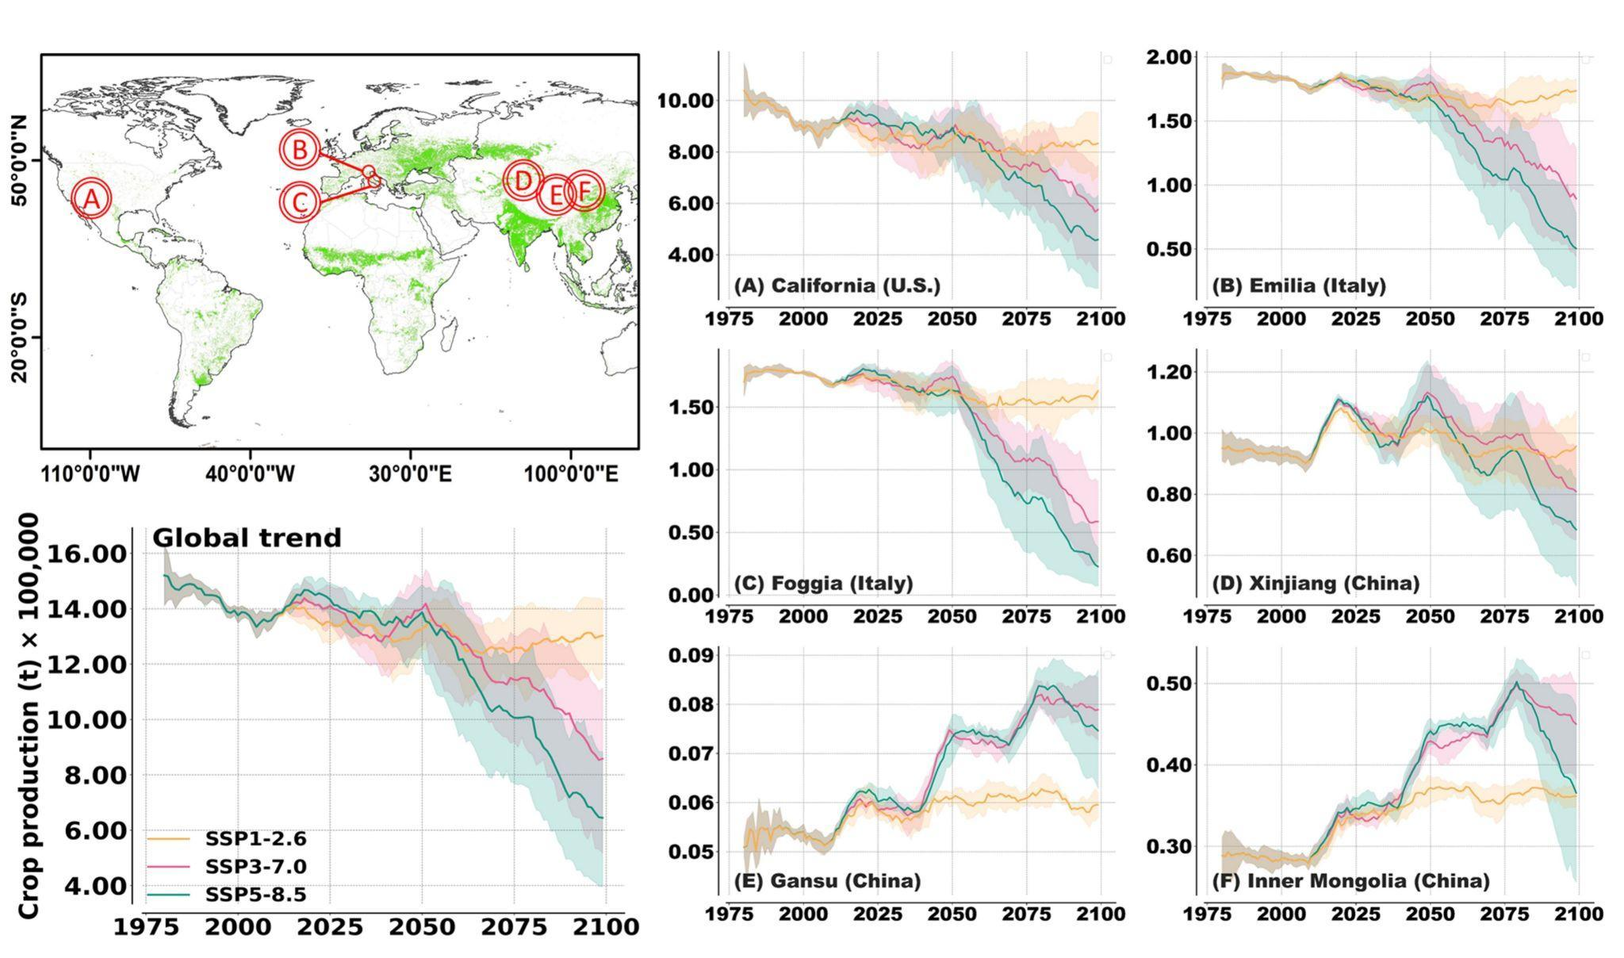

**Figure 1.** Simulated trend of processing tomato production (calculated using dry weight yield) for SSP1-2.6(orange line), SSP3-7.0 (red line), and SSP5-8.5 (green line). The red capital letters on the World’s map represent the main region of processing tomato production simulated in this study.

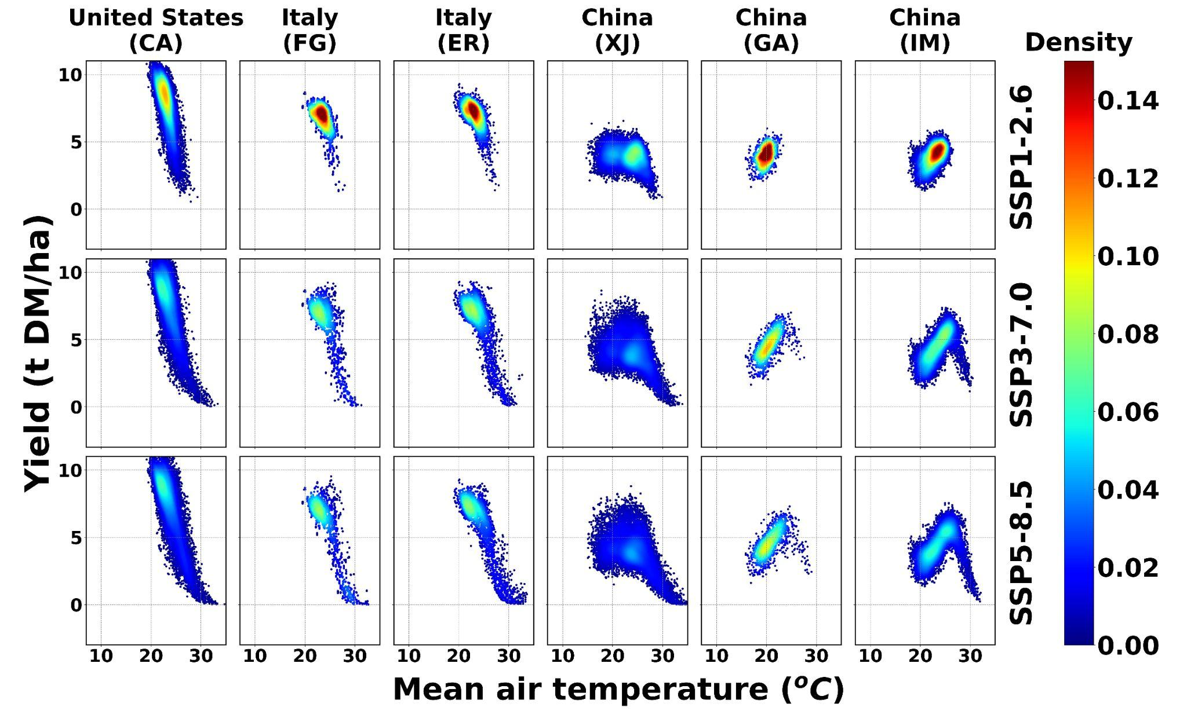

**Figure 2.** Relationship between simulated processing tomato yield and mean air temperature at different locations and for different RCPs. The color of yield-temperature relationship indicates the density of individual model simulations corresponding to a given combination of mean air temperature and yield.

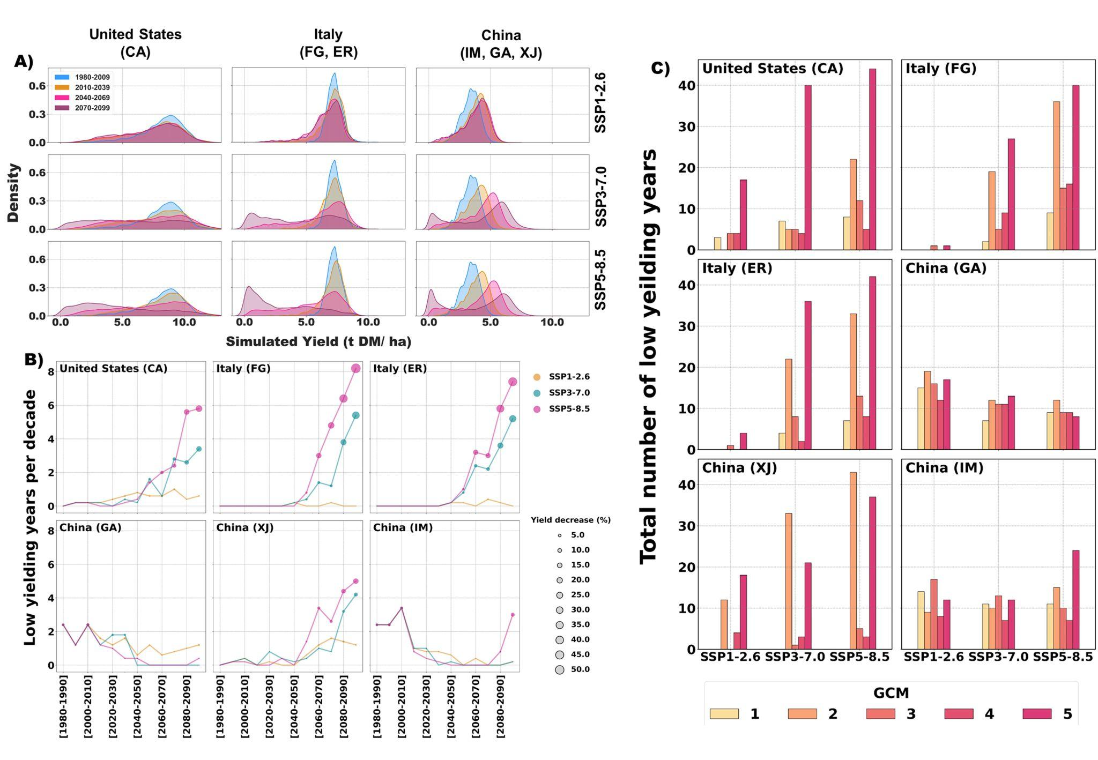

**Figure 3.** Relationship between simulated processing tomato yield and mean air temperature at different locations and for different SSPs. The color of yield-temperature relationship indicates the density of the points. The low yielding are the 0.1 quantiles of the simulated yield.

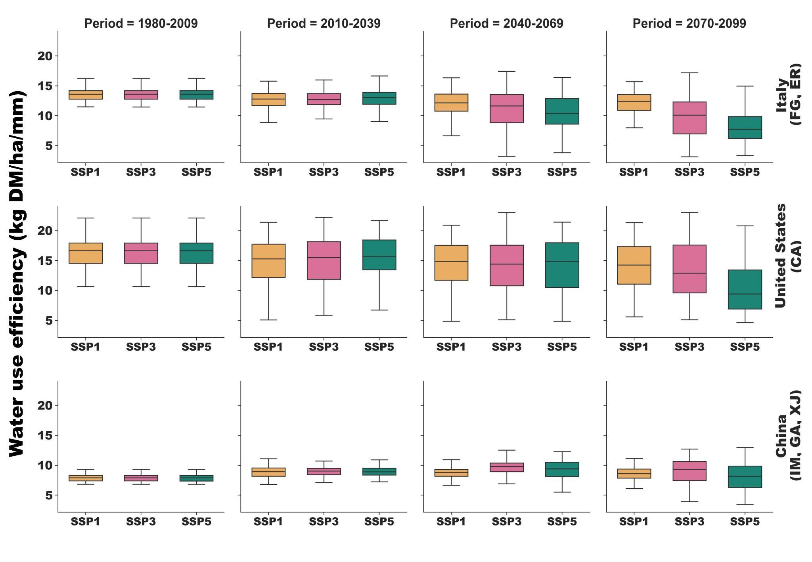

**Figure 4.** Water use efficiency calculated for SSP1-2.6 (yellow), SSP3-7.0 (purple), and SSP5-8.5 (green) for 1980-2009; 2010-2039; 2040-2069; and 2070-2099, for Italy (top row), United States (middle row), and China (bottom row). For each box-and-whiskers plot, the end of the whisker line represents the 10th and 90th percentiles. The lines of the box represent the 25th, median, and 75th percentiles.

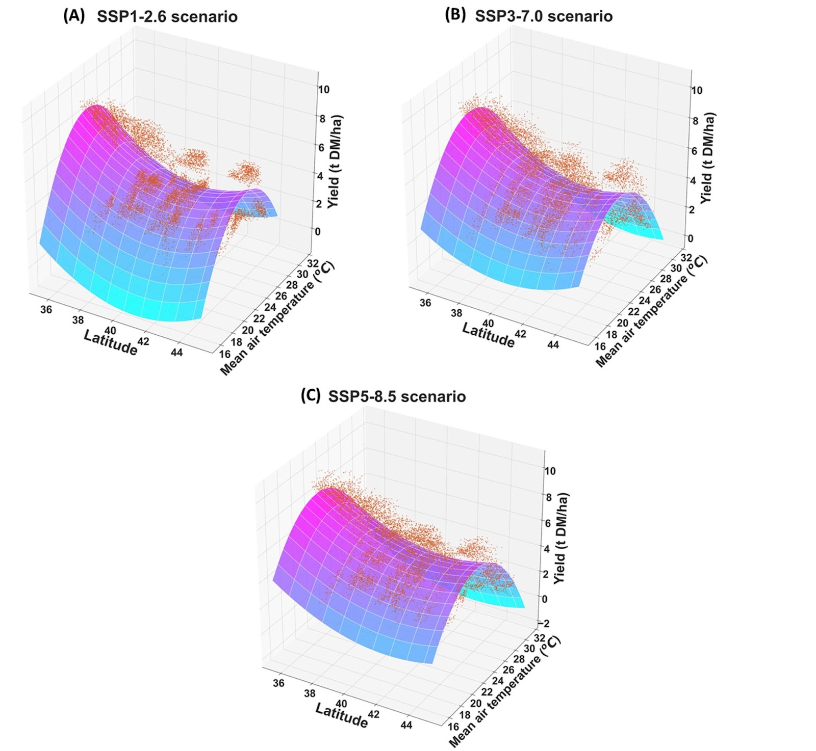

**Figure 5.** Relationship between mean air temperature, latitude and yield for the **(A)** SSP1-2.6; **(B)** SSP3-7.0; and **(C)** SSP5-8.5