Figures

Notes:
- Need to add figure credits to most figures; get permission for (or redraw) others
- I am still working on Figure 5.3, but it will be based on the placeholder that’s currently there

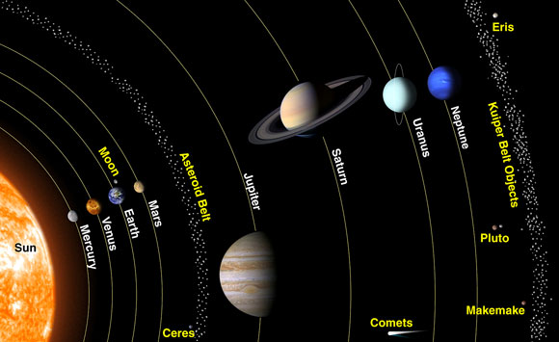

Figure 5.1. View of the Solar System showing locations of outer planets, Ceres in the asteroid belt, and Pluto and Charon in the Kuiper Belt. Planet sizes are shown to scale, but orbital distances are compressed. (Image credit: NASA/The Space Place)

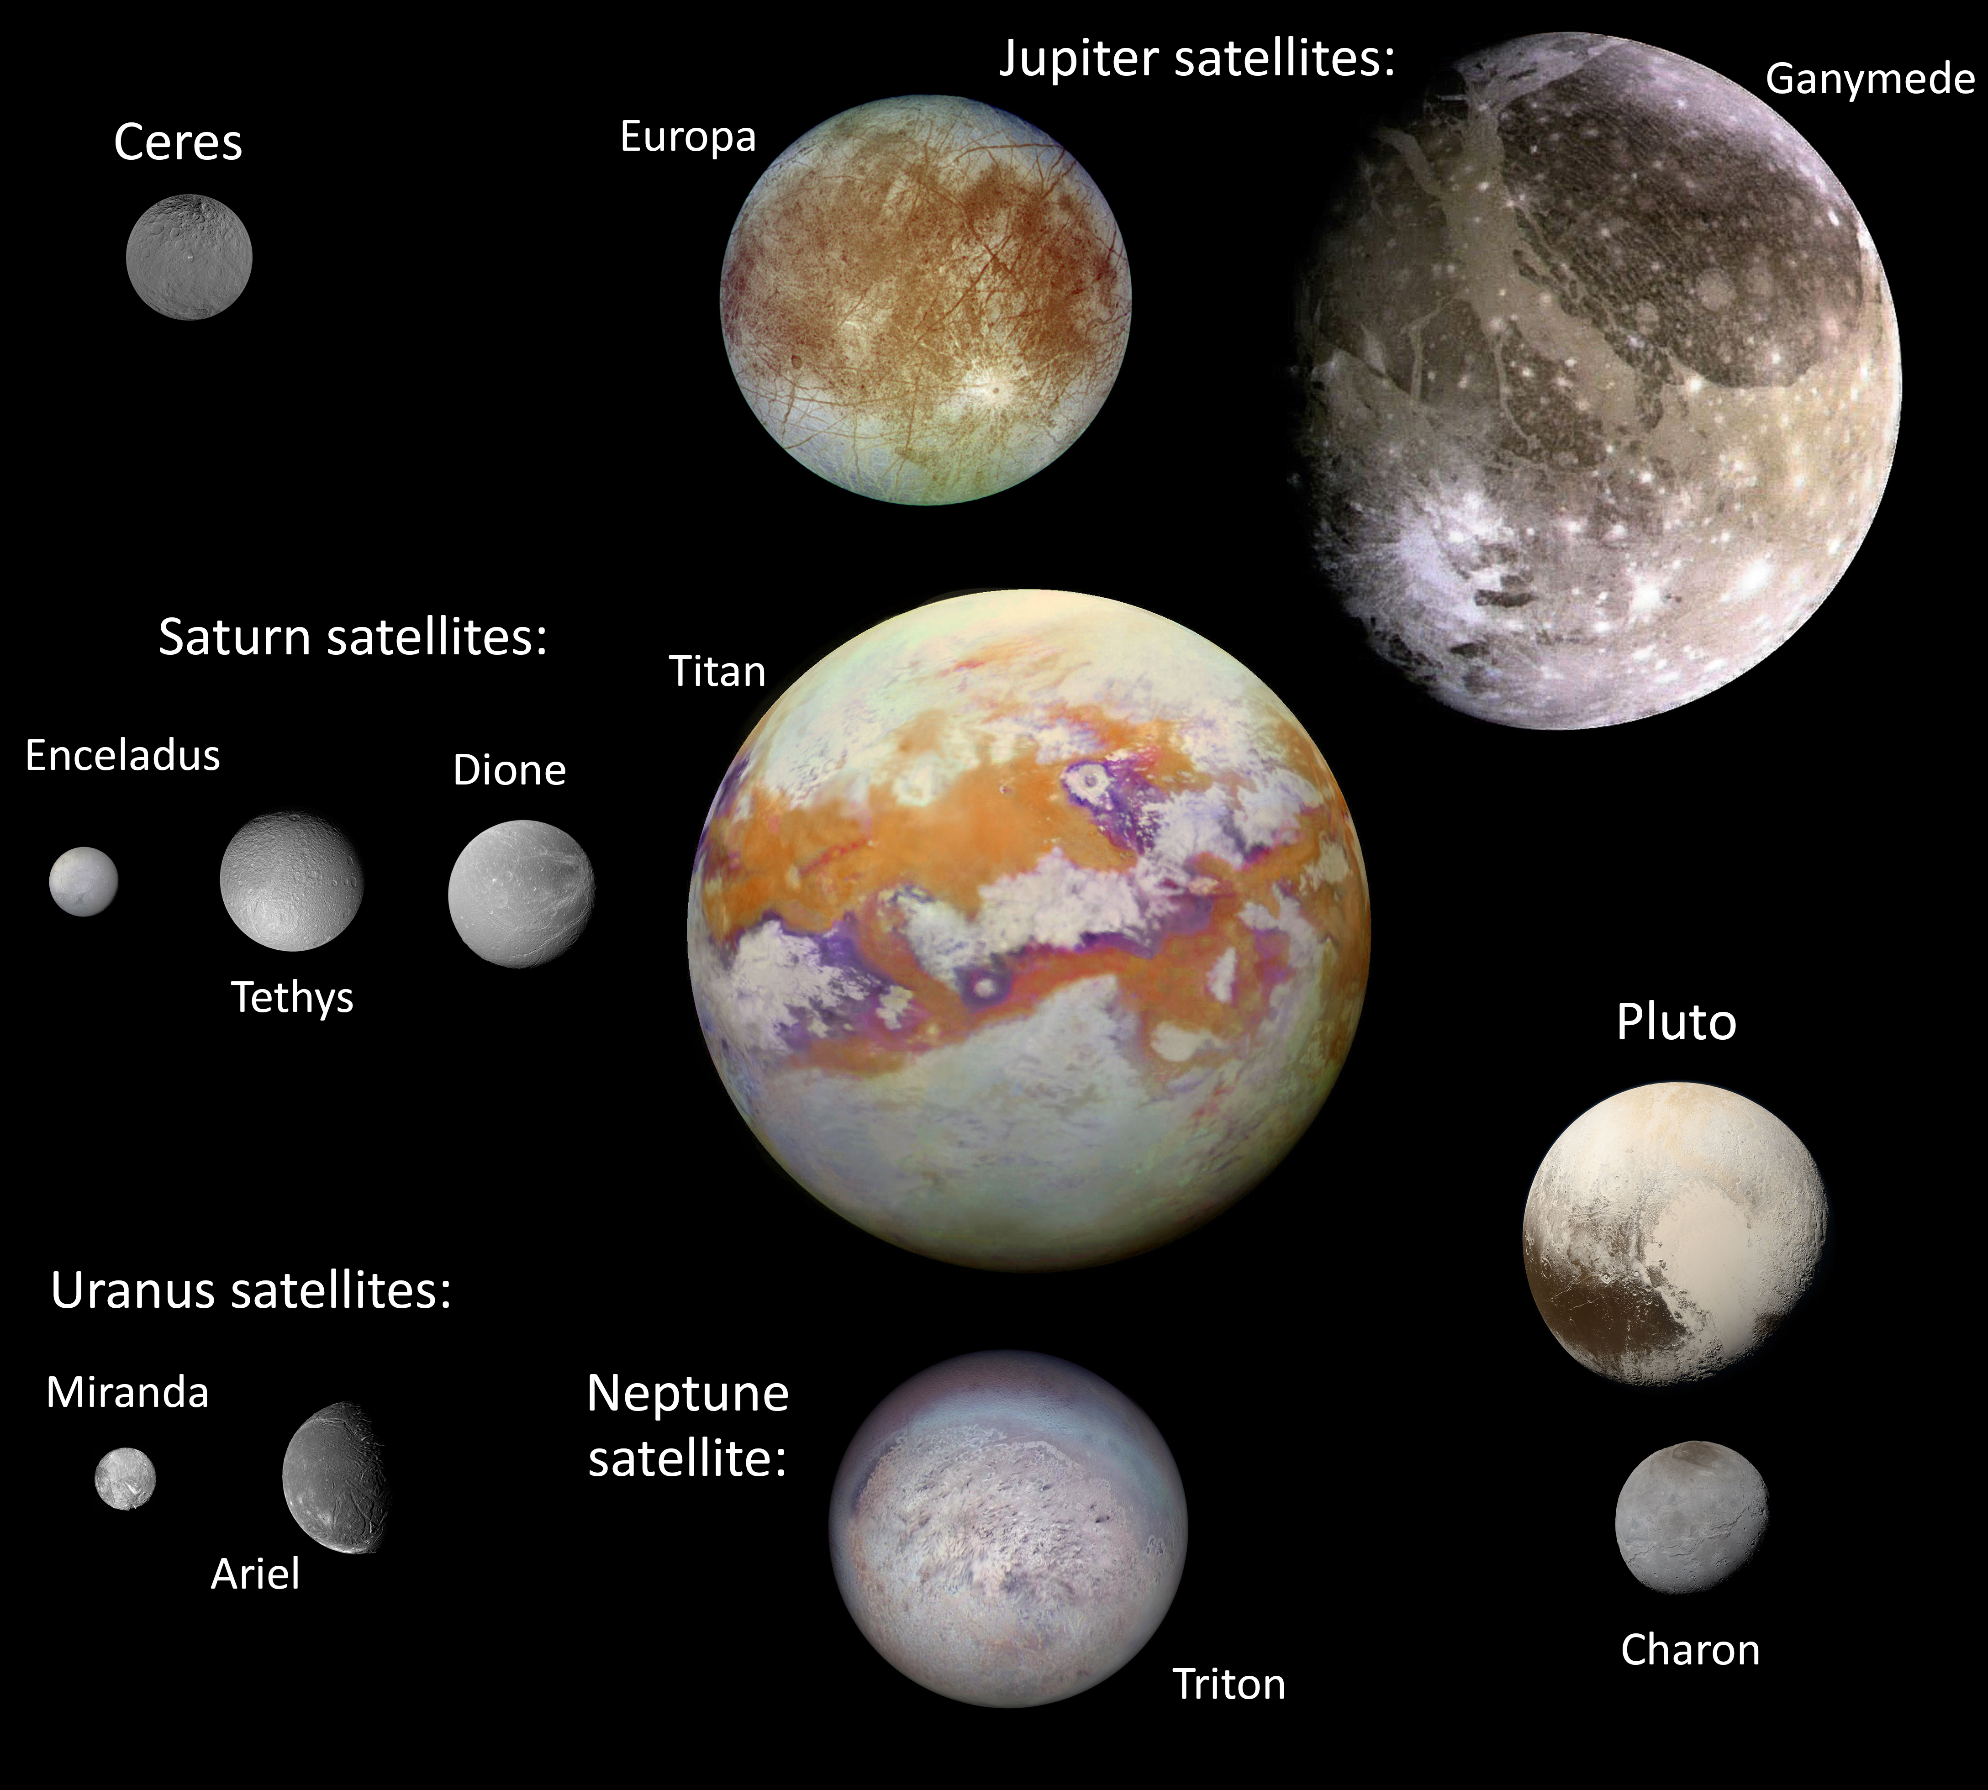

Figure 5.2. Family portrait of the main icy bodies for which cryovolcanism or cryovolcanic features have been observed or inferred.

[Image credits: Europa& Ganymede: portion of PIA01299; NASA/JPL/DLR. Titan: portion of PIA21923; Univ. Arizona/LPL. Tethys: PIA07738; NASA/JPL/SSI. Dione: PIA09861; NASA/JPL/SSI. Ceres: PIA21906, NASA/JPL-Caltech/UCLA/MPS/DLR/IDA. Triton: NASA/JPL. Pluto and Charon: NASA/Johns Hopkins University Applied Physics Laboratory/Southwest Research Institute/Alex Parker. Miranda: PIA18185, NASA/JPL-CalTech. Ariel: Calvin J. Hamilton

Links:
http://solarviews.com/eng/copyright.htm
http://pluto.jhuapl.edu/Galleries/FeaturedImages/image.php?page=1&gallery_id=2&image_id=544
http://pluto.jhuapl.edu/Galleries/FeaturedImages/image.php?page=1&gallery_id=2&image_id=543

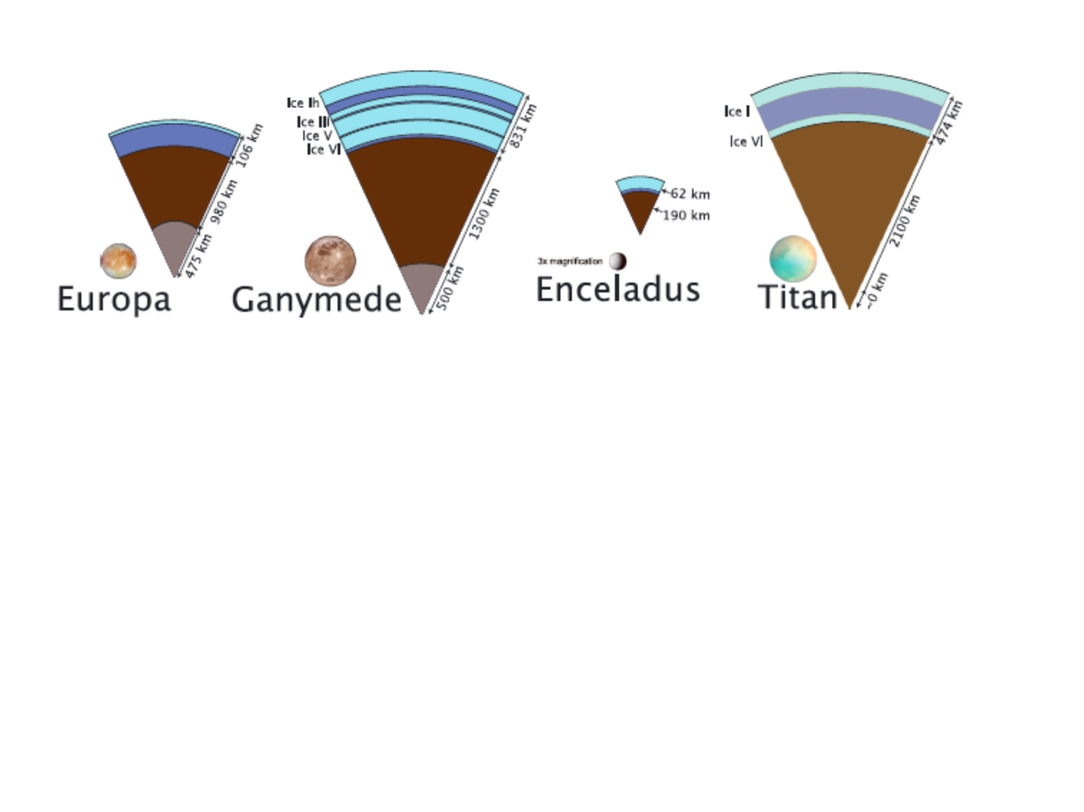
Figure 5.3. Inferred interior structures of the icy bodies thought to have experienced cryovolcanism.
[THIS IS A PLACEHOLDER, TO BE COMPLETED FOR ALL BODIES DISCUSSED IN THIS CHAPTER, BASED ON THE FIG. ABOVE FROM VANCE ET AL.]

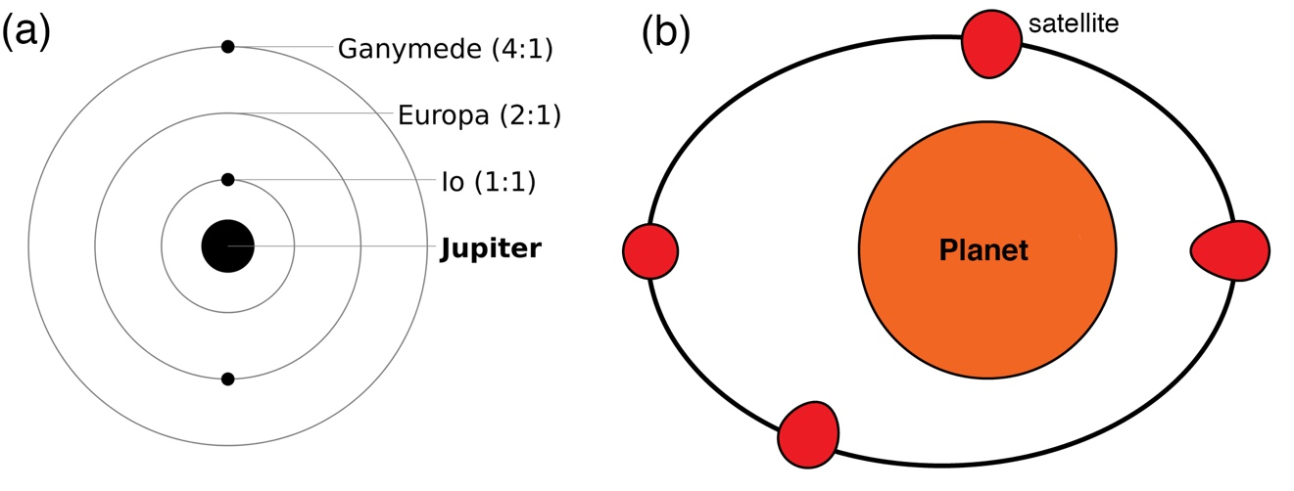
Figure 5.4 (a) Orbital resonance of the Ganymede-Europa-Io system. (b) Tidal flexing of a satellite by its host planet driven by orbital eccentricity.

Figure 5.5. Schematic of convection in an ice shell. [REDRAW: placeholder from Allu Peddinti and McNamara (2015); Add part b showing thermal profiles in presence and absence of convection]

Figure 5.6. (a) An upwelling plume of warm, buoyant ice impinging on the cooler conducting ice layer. (b) Tidal heating focused in the upwelling plume can induce melting and development of a lens of liquid within the ice shell. These scenarios lead to a range of surface morphologies. [From Sotin et al., 2002. Permission needed or redraw; add part (c) from Schmidt et al. for Thera?]

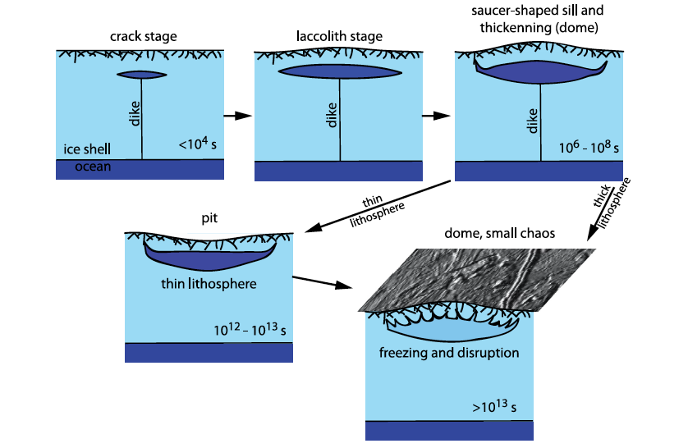

Figure 5.7. Injection of water from a pressurized ocean to form sill-like water bodies at can lead to initial upwarping, then sagging and formation of depressions, and finally disruption of the surface on refreezing [from Manga and Manga, 2017; permission needed or redraw. Find hi-res version].

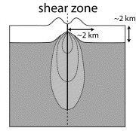
Figure 5.8. Shear heating along a tidally worked fracture, leading to locally elevated temperatures, and perhaps the formation of melt bodies aligned along the fracture [after Aydin, 2006; redraw to include a melt zone].

Figure 5.9 (a) Densities of possible cryomagmas and their corresponding solid phases. (b) Mobilities (defined as density x gravity / viscosity) of crystal-free cryomagmas plotted as a function of gravity, compared with silicate magmas. (From Kargel, 1990 via Geissler 2015; redraw?)

Figure 5.10. Summary of mechanisms of cryomagma ascent and eruption that have been proposed for icy satellites. [This is crude – need to refine.]

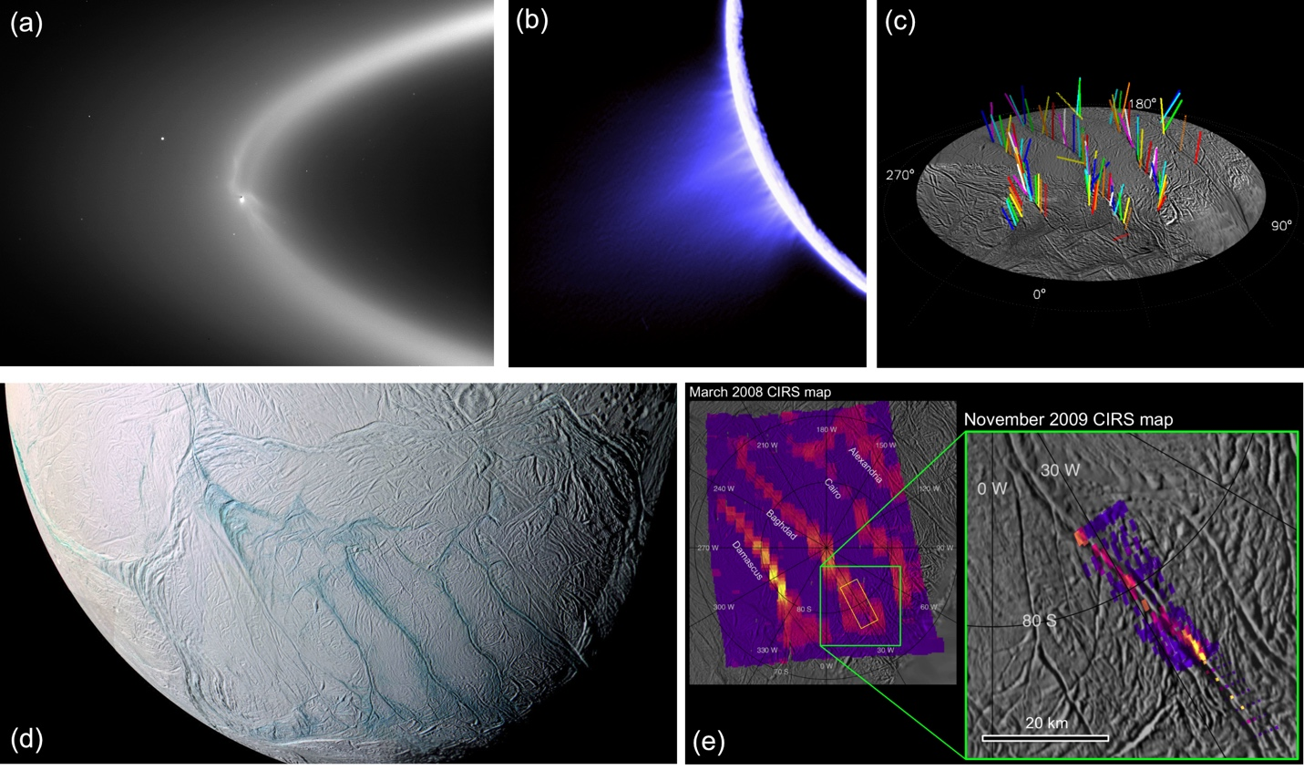
Figure 5.11. (a) Cassini ISS view of the relationship of Enceladus to Saturn’s E-ring; (b) plume of vapor and particles jetting off Enceladus; (c) identification of the sources of ~100 individual jets that comprise Enceladus’ plume; (d) Enceladus’ south polar region showing the sulci (Tiger Stripes) from which the jets emerge; bluish color is indicative of larger grain sizes of relatively pure ice. (e) Cassini CIRS map of thermal anomalies exceeding 180 K associated with the sulci. [Need Image credits]

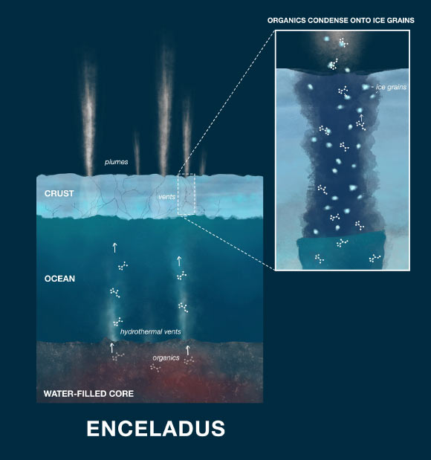

Figure 5.12. Conceptual model of Enceladus’ interior showing how the plumes eject materials from the subsurface ocean. Hydrothermal reactions at the core–ocean interface introduce a range of molecular species into the ocean water, which is subsequently released into space as water vapor and ice grains. Image PIA23173, NASA/ PL-Caltech.

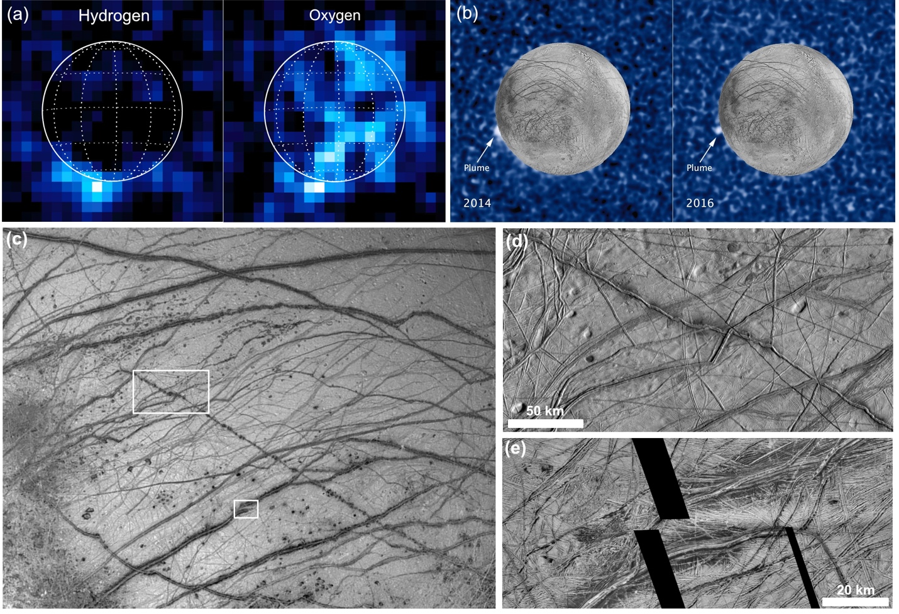

Figure 5.13. (a) Observations at ultraviolet wavelengths made with the Hubble Space Telescope (HST) captured anomalous hydrogen and oxygen above Europa’s surface, which was interpreted as evidence of eruptive plumes in the south polar region. Image credit: NASA/L. Roth. (b) Composite of Galileo images of Europa’s surface and HST images of Europa in transit across Jupiter show a bright feature off Europa’s limb in images from 2014 and 2016. Image credit: NASA/ESA/W. Sparks. (c)–(e) Lineaments with dark, diffuse margins have previously been proposed as possible sources for Europan plumes. [Need Image credits]

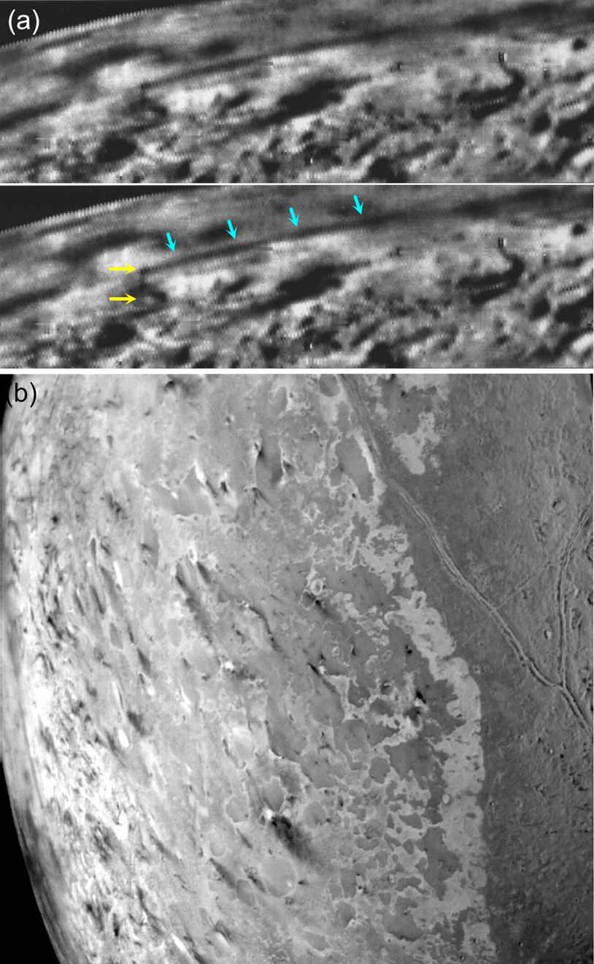

Figure 5.14. (a) Active plumes on Triton were observed by the Voyager 2 spacecraft is 1989. Yellow arrows indicate an 8 km high dark plume emerging from the surface; cyan arrows show the downwind dispersal of the plume for >100 km. (b) Voyager 2 view of Triton’s southern hemisphere showing numerous elongate dark streaks on the surface ice that are interpreted as deposits from eruptive plumes. [Need Image credits]

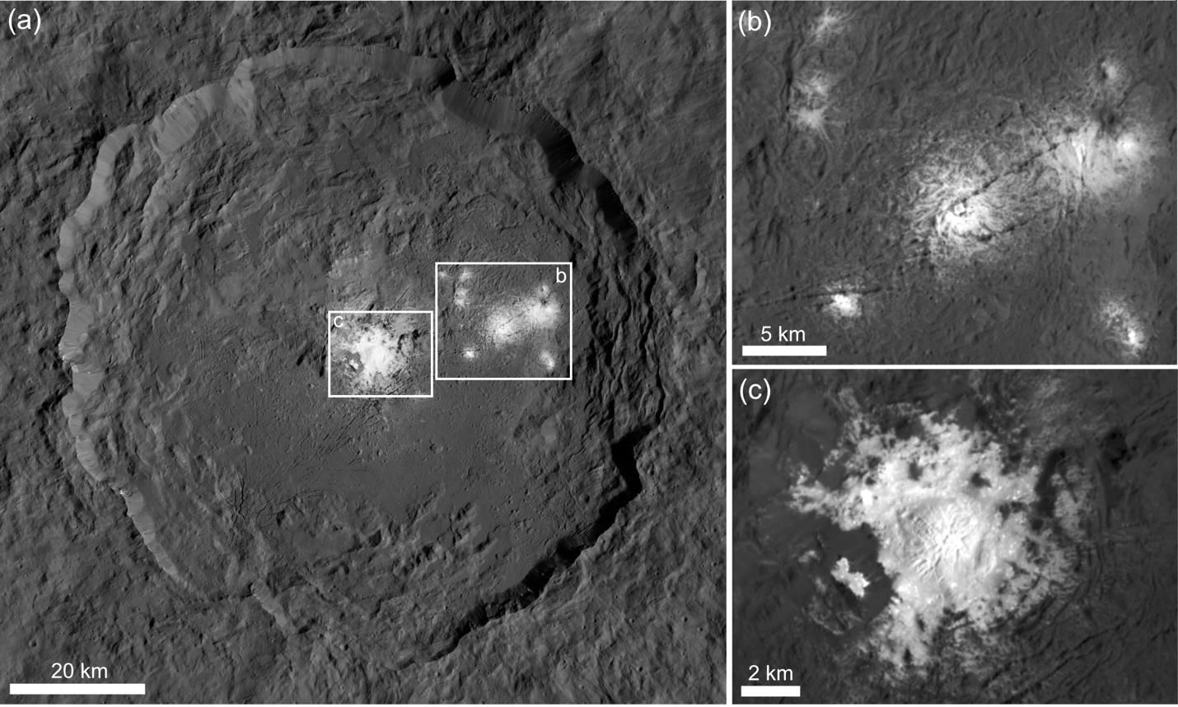

Figure 5.15. (a) Possible cryoclastic deposits within Occator crater on Ceres. Diffuse, bright deposits rich in sodium carbonates at (b) Vinalia Faculae and (c) Cerealia Facula. [Need Image credits]

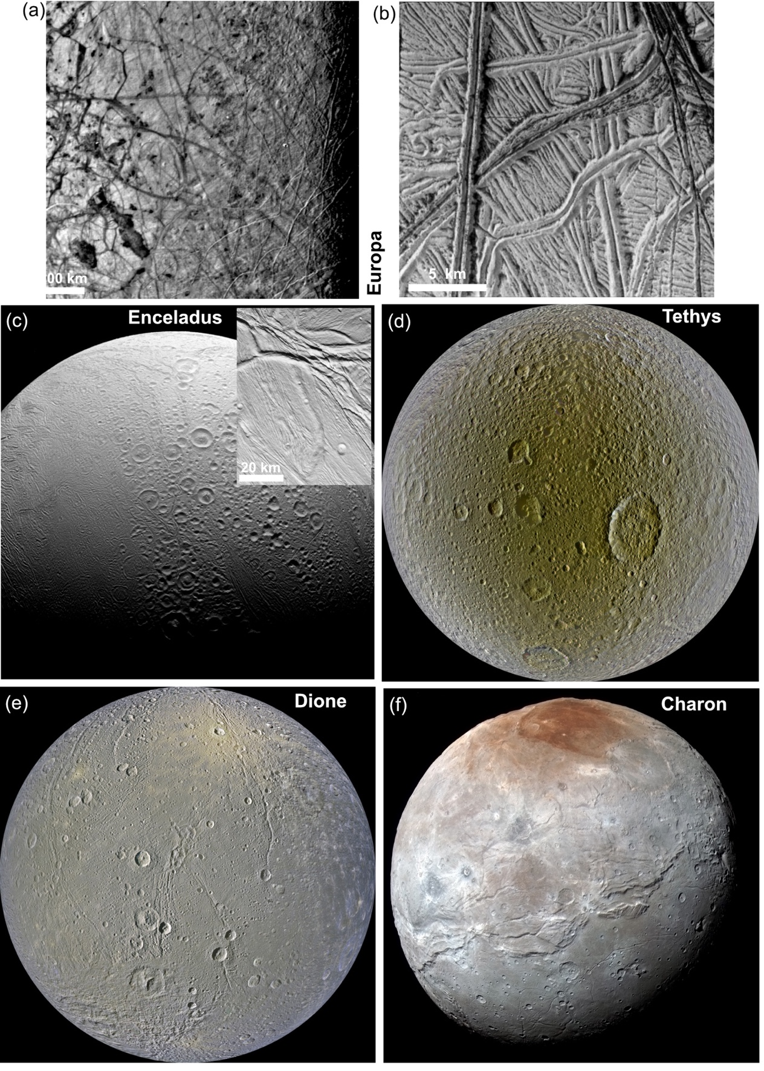
Figure 5.16. (a) Voyager views of Europa suggested the presence of smooth plains among the lineaments, but (b) Galileo revealed the plains to be ridged and fractured down to the limits of resolution; (c) Young surfaces on Enceladus in the left portion of this view are revealed at high resolution to consist of ridged and sheared terrain (inset); (d) The trailing hemisphere of Tethys and (e) the leading hemisphere of Dione both show areas with fewer impact craters, which suggest past resurfacing; (f) The southern latitudes of Charon show extensive smooth plains. [Need Image credits]
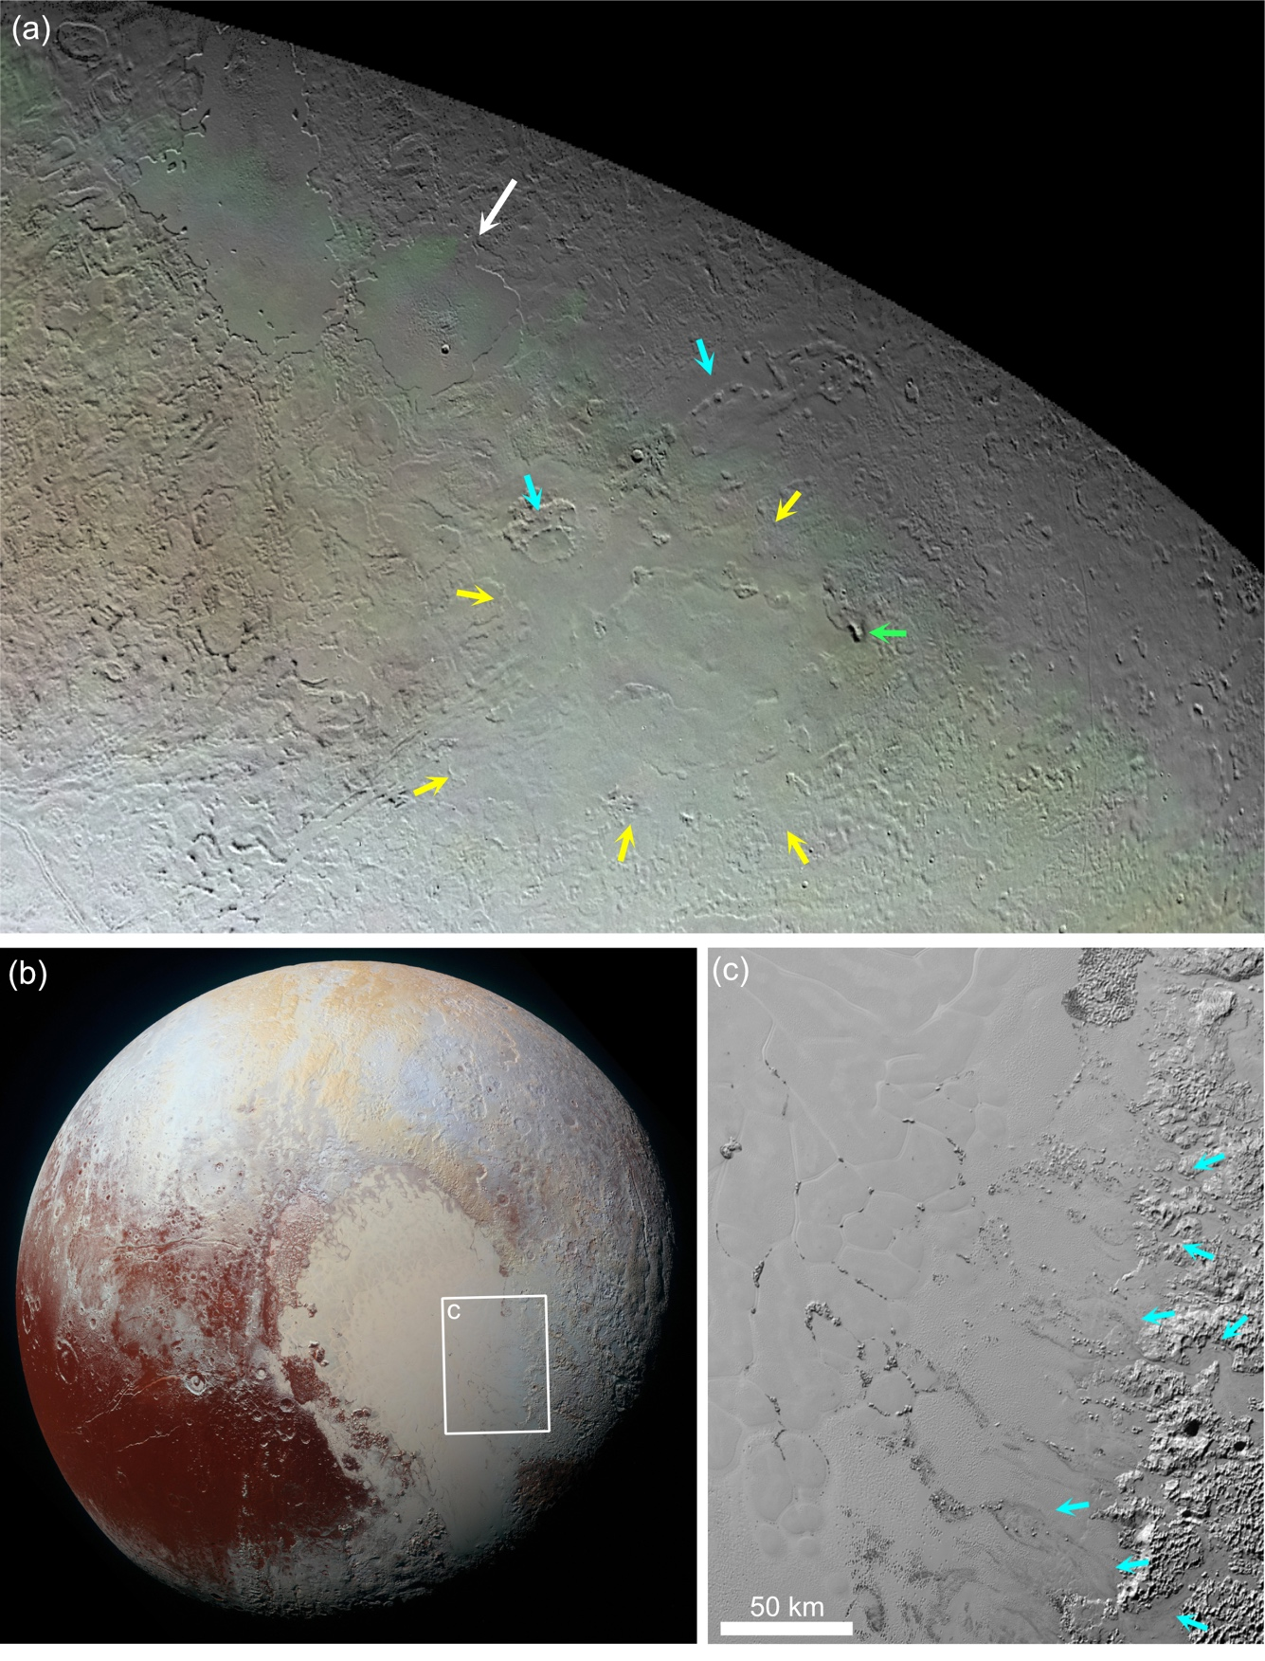
Figure 5.17a. (a) Voyager 2 view of Triton from 0 to ~40˚N, showing diverse young terrains. Sooth plains occupy the walled depression Ruach Planitia (200 km diameter; white arrow) and a broader area identified by the yellow arrows. Pits are indicated by the cyan arrows, and a pit patera by the green arrow. Image credit: NASA/JPL. (b), (c) Pluto’s Sputnik Planitia is not an example of cryovolcanic resurfacing! N₂ ice accumulates in the adjacent highlands and flows in glaciers (arrows) into the basin. Polygonal convection cells can also be seen. Image credit NASA/JHUAPL/SwRI.
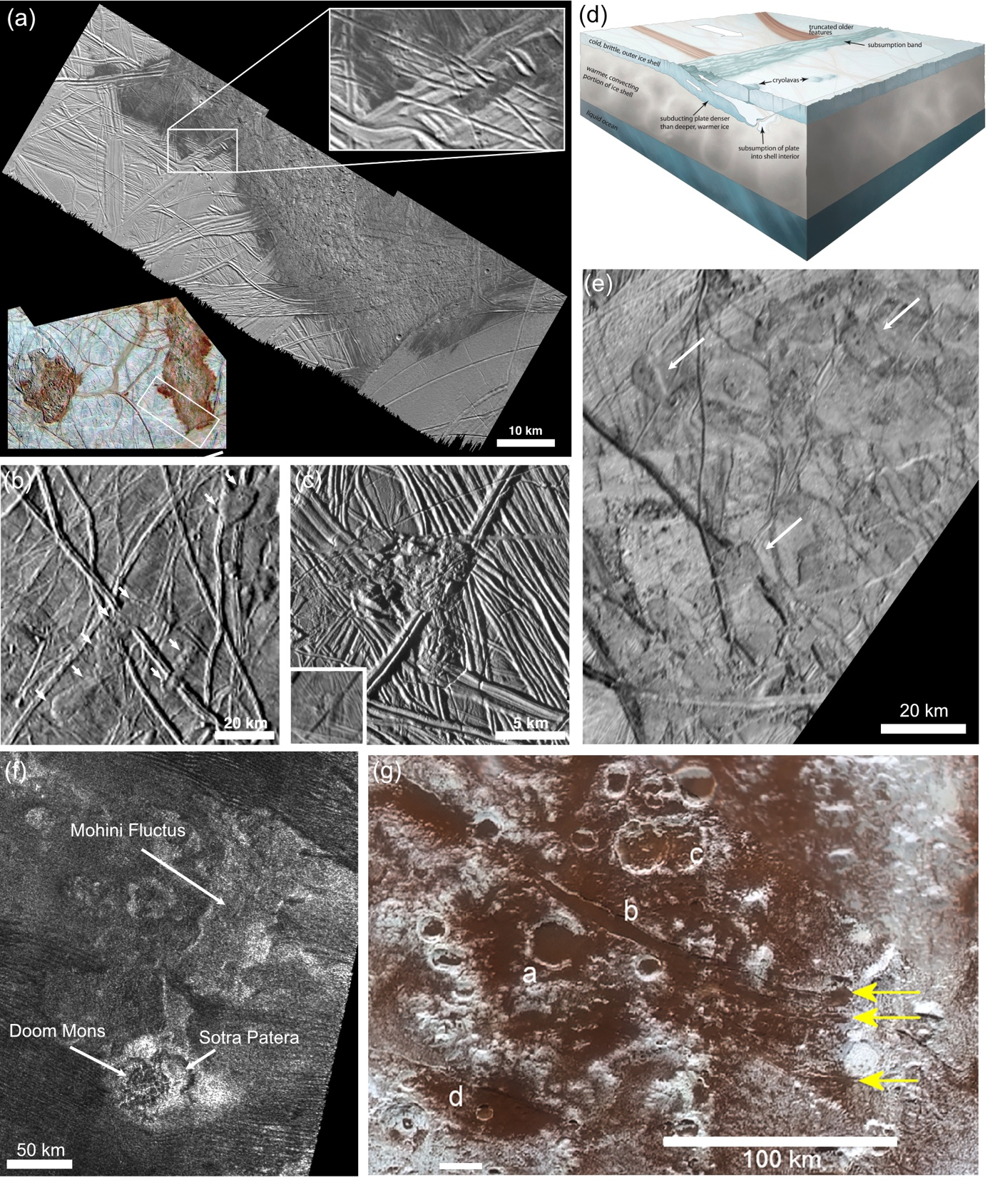
Figure 5.18 Flow-like or lobate features. (a) Europa’s Thrace and Thera Maculae are shown in the color inset and at higher resolutions in the grayscale images. Thrace was revealed by Galileo data to be an area of chaos (disrupted terrain), with evidence for liquid effusion only at its margins of the feature (inset); (b) Examples of apparently lobate features on Europa seen at 550 m/pxl, (c) 200 m/pxl (inset) and 30 m/pxl; (d) Possible mechanism of ice subduction and cryolava flow generation (Kattenhorn and Prockter, 2014); (e) Possible flows produced in response to subduction on Europa; (f) Titan’s Mohini Fluctus; (g) Virgil Fossae on Pluto shows evidence at a. for flows flooding a crater and, within the graben at b., and ponding at the end of the graben (arrows). A possible cryoclastic deposits it observed at d. [Need Image credits]
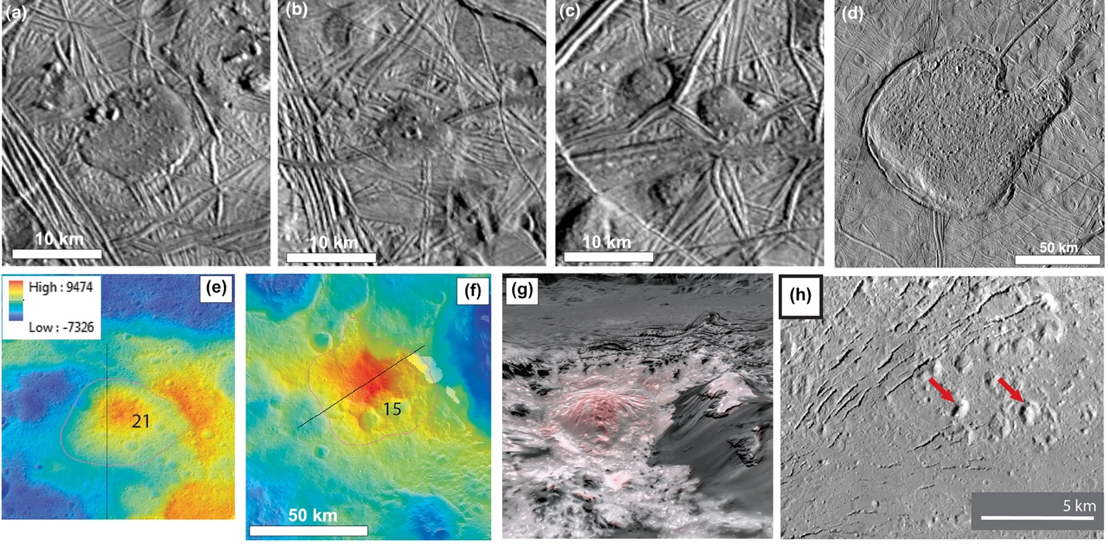

Figure 5.19. (a)–(c) Small domes on Europa; (d) Murias Chaos on Europa; (e) domes on Ceres; (f) Cerealia Tholus on Ceres, 2.5 km in diameter; (g) small mounds on Ceres. [Need Image credits]

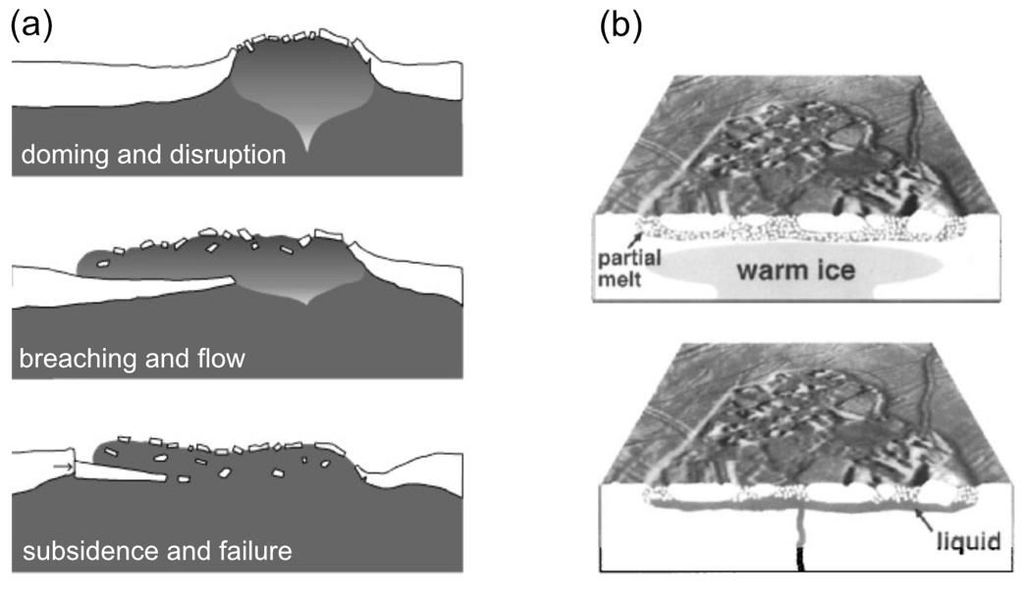

Figure 5.20. (a) Diapirs impinging on the brittle surface crust can lead to upwarping and disruption of the surface and, in the case of Murias Chaos (Figure 5.19d), breaching and extrusion of warm ice over the surface, followed by subsidence and failure of the brittle layer (Figueredo et al., 2002). (b) Models for the formation of chaos areas include partial melting of salt-rich ice by upwelling warm ice, or brine mobilization above a shallow liquid intrusion (Collins et al., 2000). [Find higher resolution version of these figures. Need permission or re-draw]

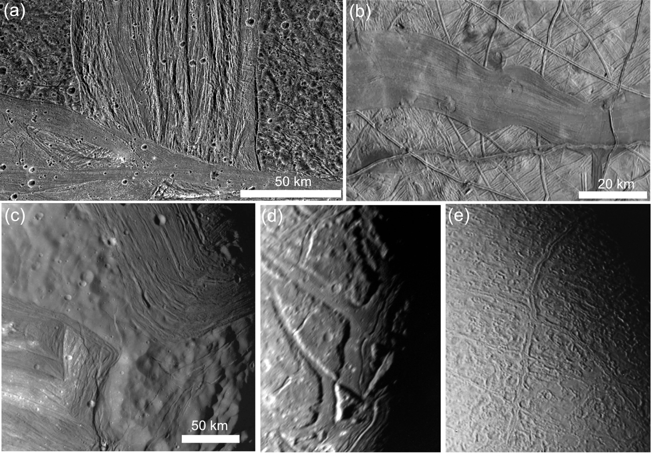

Figure 5.21. Bands and ridges on icy bodies. (a) The intersection of Erech Sulcus with Sippar Sulcus on Ganymede. Sippar Sulcus is the younger and smoother of the two features. (b) A pull-apart band on Europa. (c) Ridges within Elsinore Corona on Miranda. (d) Smooth infill in graben on Ariel. (e) Long graben on Triton containing medial ridges. [Need Image credits]

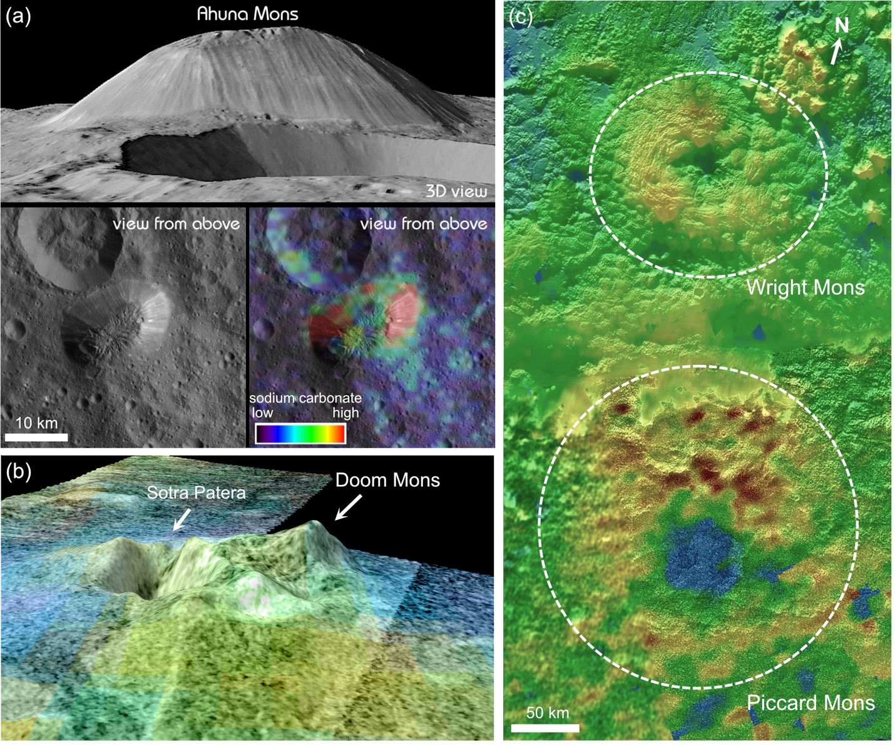
(d)
(c)
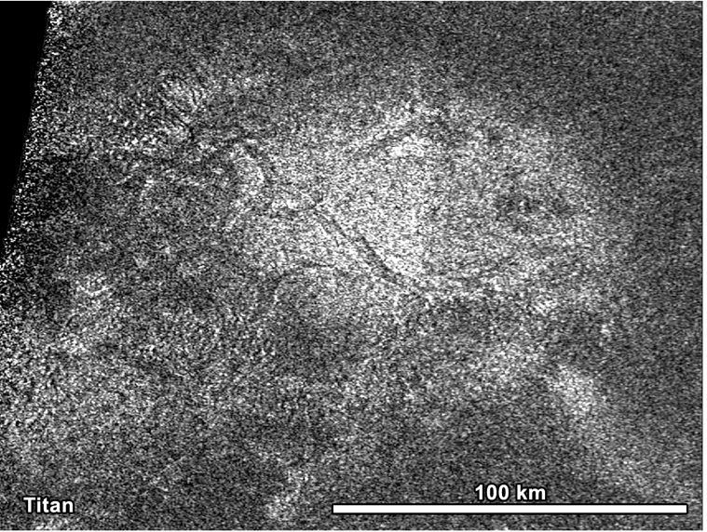

Figure 5.22. Major constructional landforms: (a) Ahuna Mons, Ceres; (b) Doom Mons, Titan. The adjacent depression Sotra Patera is 17 km wide and 1.7 km deep; (c) the Hot Cross Bun on Titan; (d) Wright and Piccard Montes, Pluto. [Need Image credits]
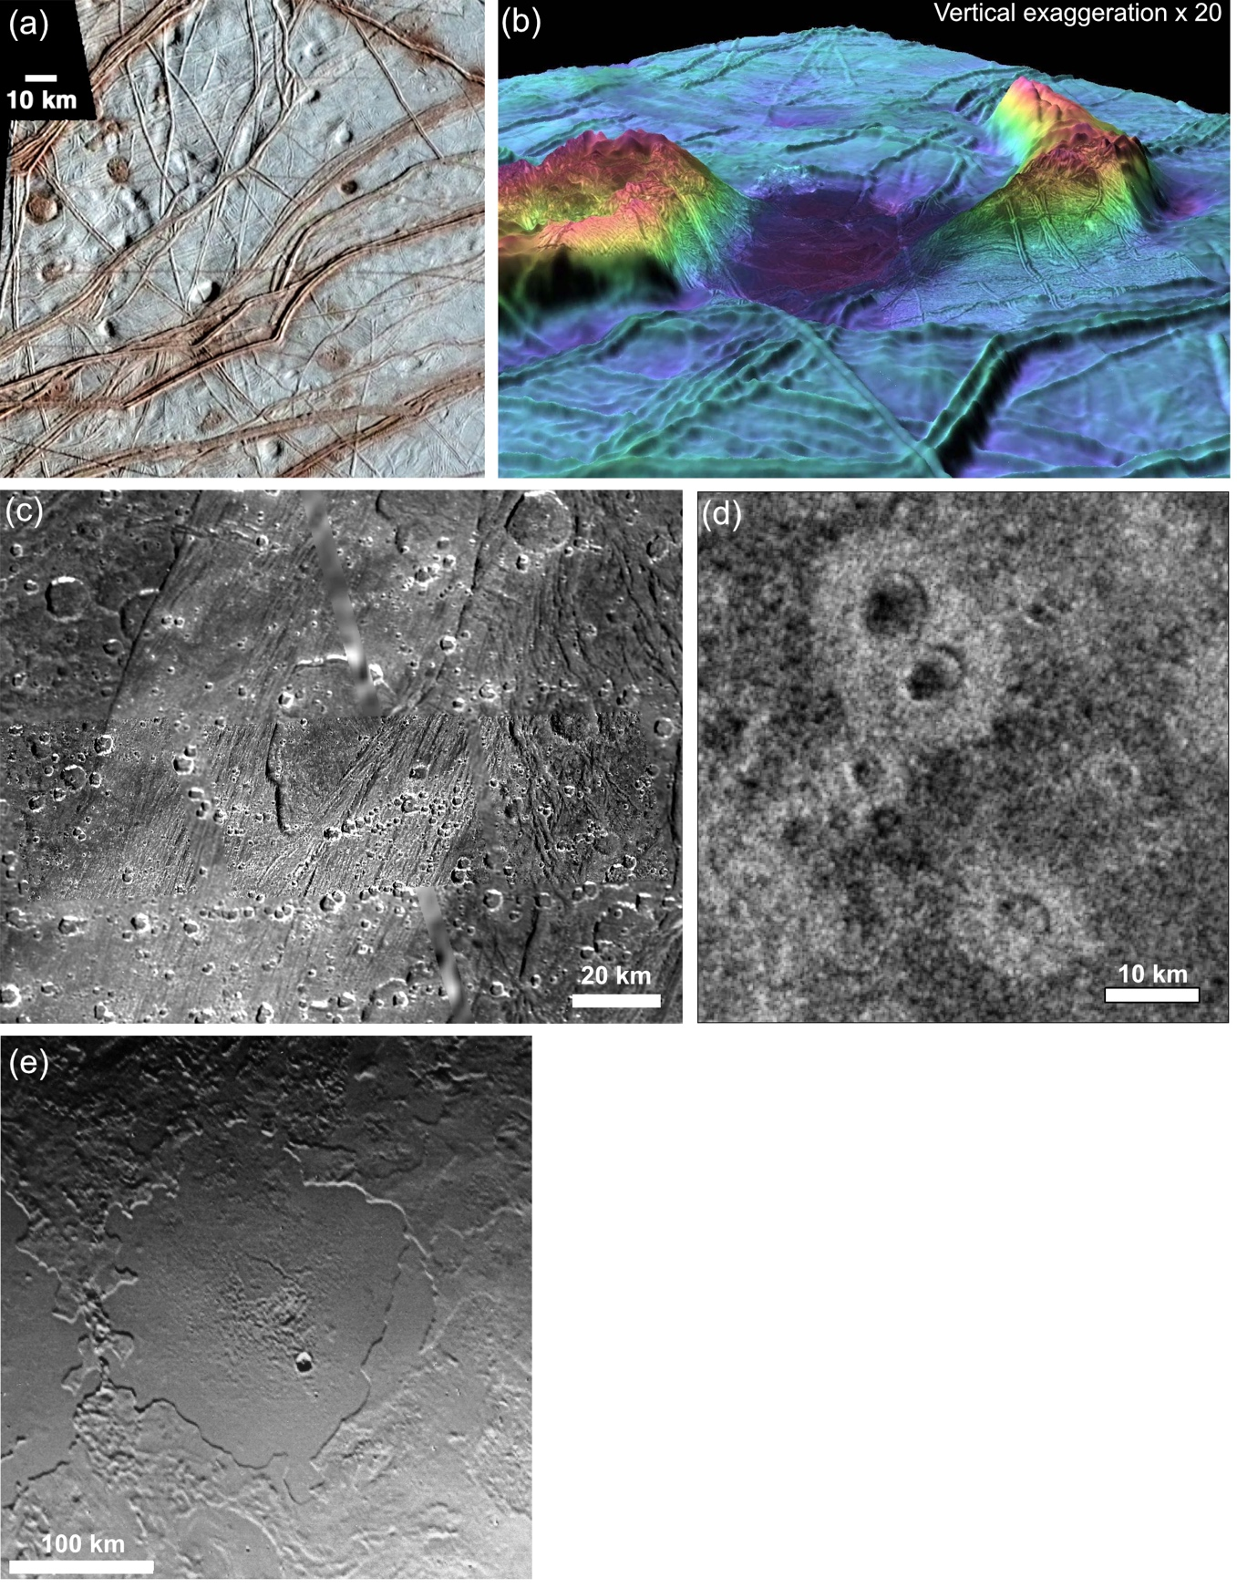
Figure 5.23 Possible cryovolcanic depressions. (a) Pits on Europa ≤ 10 km in diameter are commonly spatially associated with domes and spots; (b) Europa’s Castalia Macula is a 20 x 25 km wide depression lying between two high-relief features and containing a dark deposit; (c) shallow, scalloped “caldera-like” depression on Ganymede; (d) raised-rim depressions in the north polar region of Titan. [Need Image credits]

