Geophysical Research Letters
Supporting Information for

Coral oxygen isotopic records capture the 2015/2016 El Niño event in the central equatorial Pacific

Gemma K. O’Connor^{1,2}, Kim M. Cobb¹, Hussein R. Sayani¹, Alyssa R. Atwood³, Pamela R. Grothe⁴, Samantha Stevenson⁵, Julia K. Baum⁶, Tianran Chen⁷, Danielle C. Claar^{6,8}, Nicholas T. Hitt⁹, Jean Lynch-Stieglitz¹, Richard A. Mortlock¹⁰, Gavin A. Schmidt¹¹, Rachel Walter¹
¹School of Earth and Atmospheric Sciences, Georgia Institute of Technology, Atlanta, GA, USA
²Department of Earth and Space Sciences, University of Washington, Seattle, WA, USA
³Department of Earth, Ocean, and Atmospheric Science, Florida State University, Tallahassee, FL, USA
⁴Earth & Environmental Sciences, University of Mary Washington, Fredericksburg, VA, USA
⁵Bren School of Environmental Science and Management, University of California-Santa Barbara, Santa Barbara, CA, USA
⁶Department of Biology, University of Victoria, Victoria, BC, Canada
⁷South China Sea Institute of Oceanology, Chinese Academy of Sciences, Guangzhou, China
⁸School of Aquatic and Fishery Sciences, University of Washington, Seattle, WA, USA
⁹Victoria University of Wellington, Wellington, New Zealand
¹⁰Department of Earth and Planetary Sciences, Rutgers, State University of New Jersey, Piscataway, New Jersey, USA
¹¹NASA Goddard Institute for Space Studies, New York, NY, USA
Corresponding author: Gemma K. O’Connor (goconnor@uw.edu)

Contents of this file
Materials and Methods S1 to S5
Figures S1 to S6
Tables S1 to S8
Supplemental References

Materials and Methods

S1. Coral Sampling and Analytical Analyses
Six coral cores were recovered from living Porites coral colonies using an underwater pneumatic drill at a site on the leeward side of Kiritimati Island (see “Drill Site”, Figure S1). They were all collected from corals living 25-30 ft depth. Two of the cores were collected in April 2016 (named “X16A-Dx”), while the other four cores were retrieved in November 2016 (named “X16C-Dx”). They were slabbed along the growth axis then cleaned with distilled water, ultrasonicated, and dried at 60°C. The cores were X-radiographed for densitometry to determine the optimal location of the sampling transect (Figure S6). Along each respective growth axis, the cores were drilled at 1-mm intervals and sampled for oxygen isotopic analysis (δ¹⁸O) using either a Thermo-Finnigan Delta V or MAT253 isotope ratio mass spectrometer, both equipped with a Kiel IV Carbonate Device. The instruments have mean precisions of 0.05‰ and 0.06‰, respectively, based on long-term analysis of internal and external standards. Coral δ¹⁸O are reported in units of per mil (‰) departures from the ratio of the Pee Dee Belemnite (PDB) carbonate. Age models for each record were reconstructed by peak matching the coral δ¹⁸O data with 1° x 1° monthly NOAA OISSTv2 SST data (Reynolds et al., 2002) from the grid box containing Kiritimati Island, following procedures outlined in Cobb (2002). The error associated with this dating method is ±1 month, given the very close correspondence between SST and coral δ¹⁸O (Cobb et al., 2002, Comboul et al., 2014). Additional details of the corals presented here can be found in Table S1.

S2. Logger and Seawater Bottle Data Collection and Analysis
The in situ loggers and seawater bottle samples came from multiple sites around Kiritimati Island (see Table S3 for logger locations). The loggers were located 10-15 feet below the surface of the water. We present data from a SBE56 Seabird temperature logger from “Site 5”, an open-ocean site located on the southern shoreline, which captured hourly temperature data from July 2011 to November 2015. We recovered a Seabird SBE37 conductivity-temperature-depth (CTD) sensor from “CTD Site”, also on the Southern shoreline of the island. The CTD provides us with salinity and temperature data every 3 minutes from October 2014 to November 2015.

Seawater bottle samples were collected in 60 mL amberglass bottles from sites around the island that capture open-ocean conditions. Seawater δ¹⁸O values from the 2015/16 El Niño event were measured on a Picarro L1102-I water isotope analyzer at the Georgia Institute of Technology with instrumental precision of ±0.05‰ (1σ). Seawater bottle conductivity values were measured with a Mettler Toledo conductivity meter with a precision of ±0.2 psu. See Conroy et al., 2014 for more details on salinity and seawater δ¹⁸O analysis using these methods. Seawater δ¹⁸O values from the 1997/98 El Niño event were measured on a FISONS PRISM III mass spectrometer equipped with a MicroMass Multiprep automatic sample processing system with a precision of ±0.03‰ (1σ), using standard methods (Epstein and Mayeda, 1953; Fairbanks, 1982). All seawater d18O values in this study are reported in units of per mil (‰) departures from Vienna Standard Mean Ocean Water (VSMOW; Coplen, 1994). Salinity values from the 1997 event were measured shipboard on the RV Moana Wave, in triplicate, by conductivity with a Guildline Portasal with a precision of ±0.003 psu.

S3. Offset Calculations
Following Sayani et al. (2019), we calculated offsets in mean δ¹⁸O among colonies by calculating the mean of all records across their common period of overlap and then subtracting the mean of each record from this ensemble mean. We then subtract this offset from each record to align it to the ensemble mean. The offsets are listed in tables S1 and S2 and have a maximum absolute value of 0.19. The offset values are consistent with those of Hitt et al., 2021. The offset values in all coral records analyzed here and in Hitt et al., 2021 produce a net offset value of 0 and a standard deviation of 0.11.

S4. Error and correlation calculations
We use standard error (SE) as the metric to account for uncertainty in our calculations, as the focus of this study is on quantifying means and mean differences during El Niño events from coral oxygen isotopes and in situ data. For uncertainty calculations of means (i.e., mean during the base or mean during the peak), we use $std error= \sqrt{\frac{σ^{2}}{n_{eff}}}$, where n_{eff} is the number of independent values, accounting for autocorrelation. For changes in coral δ¹⁸O, SST, δ¹⁸O_{sw}, and salinity from the baseline to the peak of an El Niño event, we perform this calculation as: $std error= \sqrt{\frac{σ_{base}^{2}}{n_{base}}+\frac{σ_{peak}^{2}}{n_{peak}}}$ where σ_{base} (σ_{peak}) is the standard deviation of the baseline (peak) values and n_{base} (n_{peak}) is the number of the effective baseline (peak) values, after accounting for autocorrelation. Correlations are calculated using the Pearson correlation. Correlations are considered significant with 95% confidence if the 95% confidence interval, calculated using the number of independent values after accounting for autocorrelation, does not overlap with zero.

S5. Seawater δ¹⁸O Contribution Calculations
Because change in coral δ¹⁸O is the sum of change in seawater δ¹⁸O and change in SST, and these two signals strongly covary in the central equatorial Pacific (Cobb et al., 2001, Cobb et al, 2002, Nurhati et al, 2011, Sayani et al., 2019), we calculate the seawater δ¹⁸O contribution by subtracting an estimated SST-driven change in coral δ¹⁸O from the total observed change in coral δ¹⁸O (Ren et al., 2002, Cahyarini et al., 2008). We calculate the estimated SST-driven change in coral δ¹⁸O using the empirical relationship of -0.2‰ °C⁻¹ (Epstein et al., 1951). This slope has proven to be more reliable than performing linear regression analysis on individual corals in this region, as large month-to-month variability makes such analyses sensitive to the start and end dates of the short coral records (Sayani et al., 2019).

We perform the contribution calculations three times, to reflect differences in SST captured by the three gridded datasets ERSSTv5, OISSTv2, and HadISST. The change in all components is calculated as the mean during the peak minus the mean during the baseline. The peak of the event is determined as the three months centered around the month of greatest SST, and the 2-year baseline ends 9 months prior to the start of the peak. We use a baseline of 2 years, finding little difference in results between 1 and 2 years (Table S7). We use the 1SE uncertainties in SST to capture the full range of uncertainty in the calculation of these contributions, as the 1SE for coral δ¹⁸O is small in comparison. The calculations laid out in Table 1 in the main text and tables S4 - S7 are as follows: the estimated SST-driven change in coral δ¹⁸O is calculated as the product of the change in SST (calculated from each of the gridded products) and the coral δ¹⁸O-SST slope of -0.2‰ °C⁻¹ (Epstein et al., 1951). The mean SST contribution to the coral δ¹⁸O signal is calculated as the fraction of SST-driven change in coral δ¹⁸O over the total observed change in coral δ¹⁸O. The seawater δ¹⁸O contribution is calculated as the remaining percentage not accounted for by SST, or 100 x (1 – SST contribution). The results from these calculations using ERSSTv5 are presented in the main text, given its close correspondence to in situ logger data during the 2015/16 El Niño. Our main conclusions are based on analysis from all three data products, which show similar results.

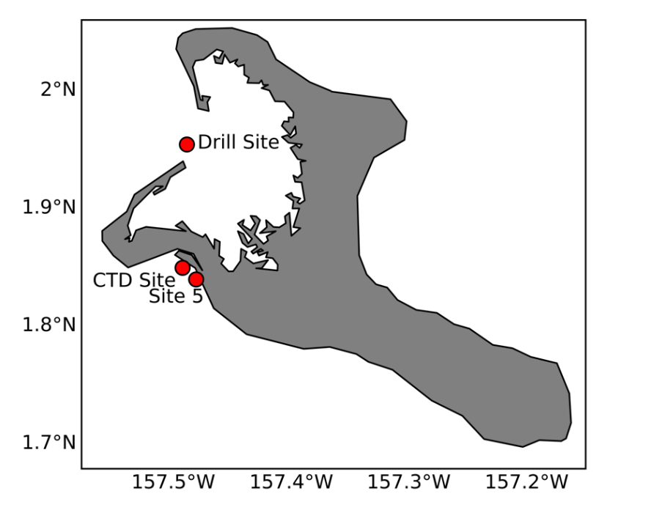
Figure S1. Map of site locations for coral drill site and logger sites around Kiritimati Island. Coordinates for each site are listed in Table S3.

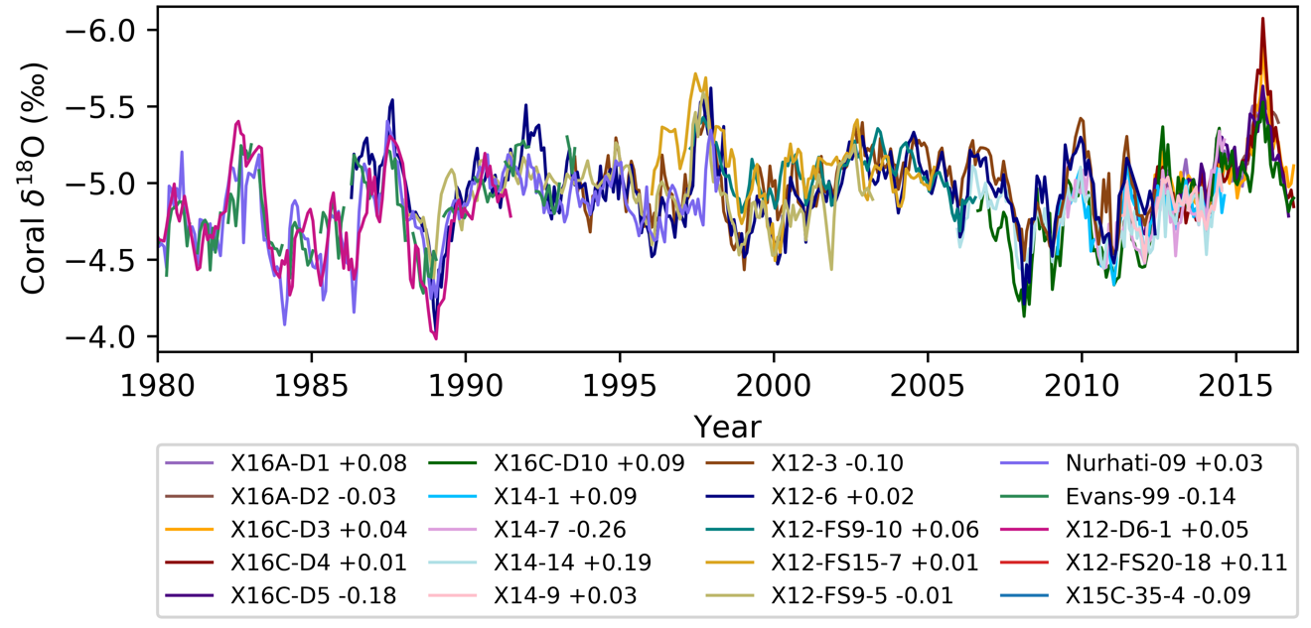Figure S2. Modern and fossil coral δ¹⁸O records from Kiritimati Island spanning 1980 to 2016 (“Kiritimati Coral Stack”). Coral δ¹⁸O records shown are the “X16” corals (this study), “X12-3” and “X12-6” (Grothe et al., 2020), “X12-FS” fossil corals and “X12-D6-1” fossil coral (Hitt et al., 2021), “X14” modern corals (Grothe et al., 2020), “Nurhati-09” (Nurhati et al., 2009), and “Evans-99” (Evans et al., 1999).
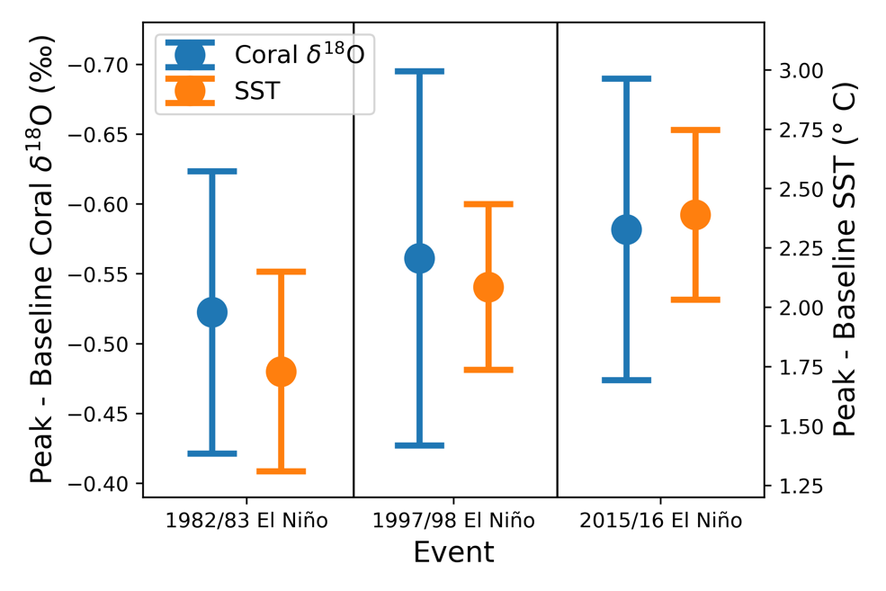
Figure S3. Ensemble mean and 95% confidence intervals from a student t-test of the changes in coral δ¹⁸O from the 1982/82, 1997/98, and 2015/16 El Niño events (blue) and the changes in SST calculated with ERSSTv5.
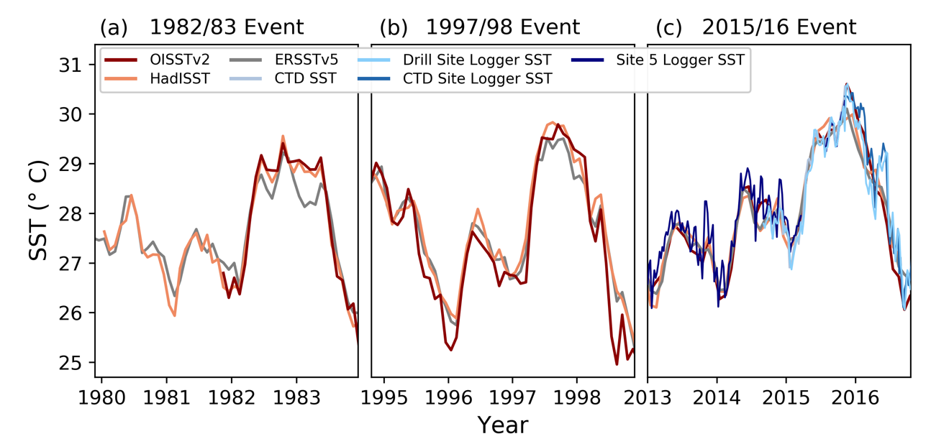
Figure S4. Comparison of gridded SST products during the 1982/83, 1997/98, and 2015/16 El Niño events. For the 2015/16 El Niño event, in situ data products are also shown.
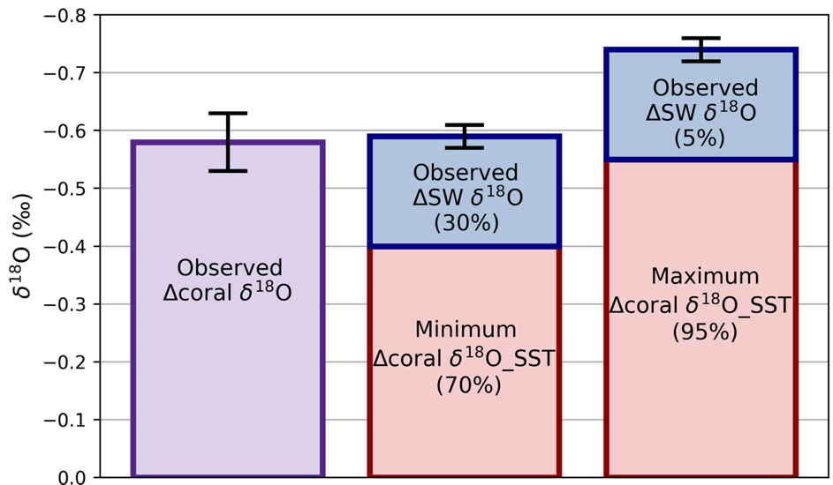
Figure S5. Stacked bar plots of budget constraints on the observed change in coral δ¹⁸O during the 2015/16 event (following values shown on Table S4). Observed mean change in coral δ¹⁸O is shown in the purple bar, with the 1SE uncertainty shown by the black vertical line. The observed mean change in seawater δ¹⁸O is shown in the blue bars, and its 1SE uncertainty is shown by the black vertical line. The SST-derived estimate of the change in coral δ¹⁸O is shown by the red bars. The left red bar reflects the lower 1SE SST bound calculated from ERSSTv5, and the right red bar reflects the upper 1SE SST bound. The corresponding percentages of the relative contributions of seawater δ¹⁸O and SST to the observed change in coral δ¹⁸O are also shown.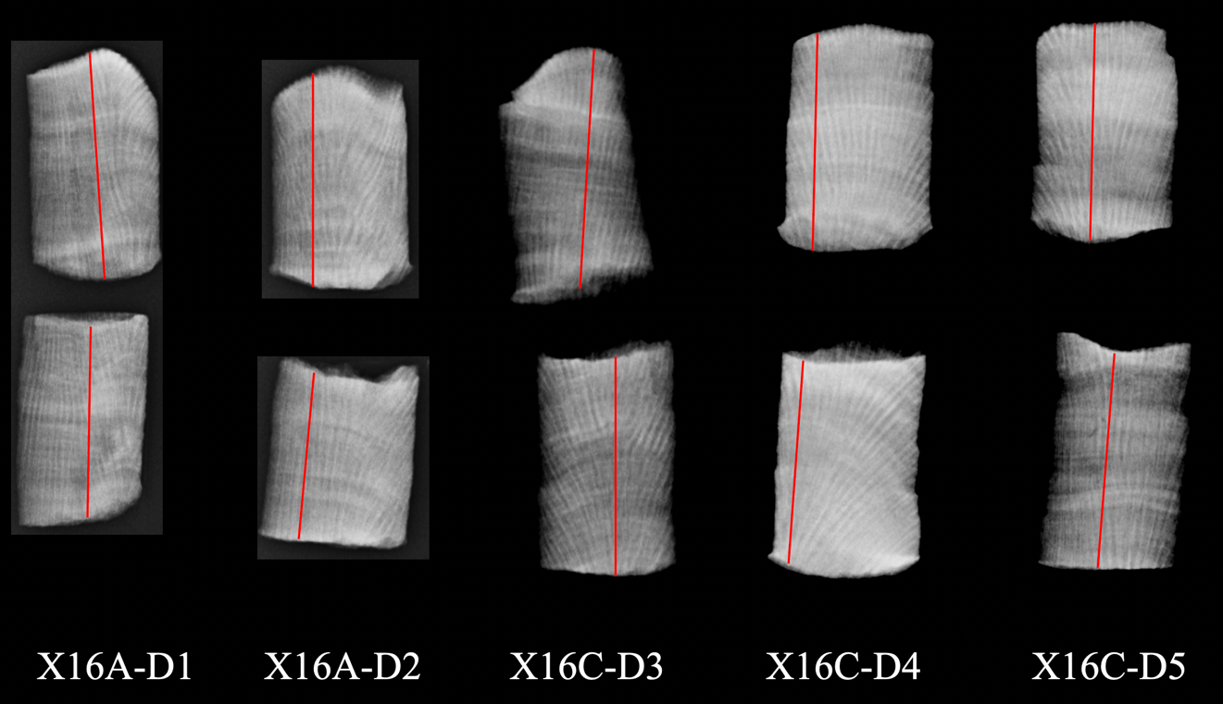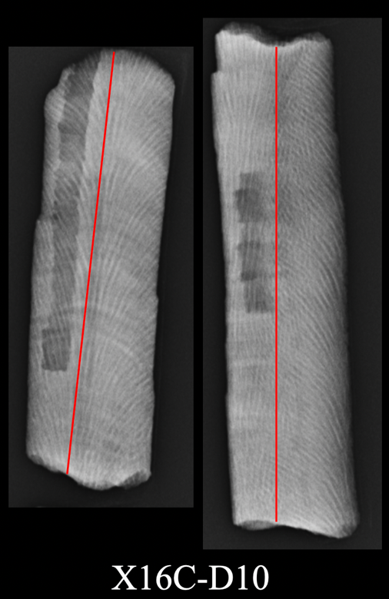
Figure S6. X-ray images of coral slabs. Red lines approximately denote the transect line used for sampling. We note that the x-ray shown for coral X16C-D10 was taken after completion of sampling for this study; the darker tracks that appear are due to sampling for another study.

Coral | Date collected | Core length (mm) | Years covered | Offset (‰)
X16A-D1 | April 2016 | 70 | 2012-2015 | +0.076
X16A-D2 | April 2016 | 61 | 2012-2016 | -0.027
X16C-D3 | November 2016 | 72 | 2012-2016 | +0.036
X16C-D4 | November 2016 | 67 | 2012-2016 | +0.015
X16C-D5 | November 2016 | 69 | 2011-2016 | -0.178
X16C-D10 | November 2016 | 168 | 2006-2016 | +0.089
Table S1. Overview of Porites corals presented in this study.

Coral | Coral Type | Year collected | Offset (‰) | Source
X14-1 | Modern | 2014 | +0.088 | Grothe et al., 2020
X14-7 | Modern | 2014 | -0.260 | Grothe et al., 2020
X14-9 | Modern | 2014 | +0.033 | Grothe et al., 2020
X14-14 | Modern | 2014 | +0.194 | Grothe et al., 2020
X12-3 | Modern | 2012 | -0.099 | Grothe et al., 2020
X12-6 | Modern | 2012 | +0.019 | Grothe et al., 2020
X12-FS 9-10 | Fossil | 2012 | +0.061 | Hitt et al., 2021
X12-FS15-7 | Fossil | 2012 | +0.006 | Hitt et al., 2021
X12-FS 9-5 | Fossil | 2012 | -0.011 | Hitt et al., 2021
Nurhati-09 | Modern | 1998 | +0.025 | Nurhati et al., 2009
Evans-99 | Modern | 1993 | -0.137 | Evans et al., 1999
X12-D6-1 | Fossil | 2012 | +0.047 | Hitt et al., 2021
Table S2. Overview of additional Porites corals from Kiritimati Island used in this analysis.

Logger name | Logger type | Site name | Site location | Source
CTD | Seabird SBE37 CTD sensor | CTD Site | N1° 50.984’ W157° 29.523’ | This study
Site 5 Logger | Seabird SBE56 Logger | Site 5 | N1° 50.400' W157° 28.860' | This study
CTD Site Logger | Seabird SBE56 Logger | CTD Site | N1° 50.984’ W157° 29.523' | Claar et al., 2019
Drill Site Logger | Seabird SBE56 Logger | Drill Site | N1° 57.263' W157° 29.301' | Claar et al., 2019
Table S3. Overview of in situ logger data used in this study.

 | A | B | C | D | E | F
 | Δ SST bound | Observed  Δ coral δ¹⁸O | Estimated SST-driven Δ coral δ ¹⁸O | Estimated  Δ δ ¹⁸O_{sw}  (B-C) | % δ¹⁸O_{sw} contri-bution (D/B)*100 | Observed Δ δ ¹⁸O_{sw}
2015/16 Event | Upper 1SE (2.8°C) | -0.58 ± 0.05‰ | -0.55‰ | -0.03‰ ± 0.05‰ | 5% | -0.19 ± 0.02‰
 | Mean  (2.4°C) |  | -0.48‰ | -0.10‰ ± 0.05‰ | 18%
 |  |  | -0.43‰ | -0.17‰ | 29%
 | Lower 1SE (2.0°C) |  | -0.40‰ | -0.18‰ ± 0.05‰ | 31%
 |  |  | -0.35‰ | -0.21‰ | 36%
1997/98 Event | Upper 1SE (2.9°C) | -0.56 ± 0.06‰ | -0.58‰ | 0.02‰ ± 0.06‰ | 0% | N/A
 | Mean  (2.1°C) |  | -0.42‰ | -0.14‰ ± 0.06‰ | 26%
 | Lower 1SE (1.3°C) |  | -0.26‰ | -0.30‰ ± 0.06‰ | 54%
1982/83 Event | Upper 1SE (2.1°C) | -0.52 ± 0.05‰ | -0.42‰ | -0.11‰ ± 0.05‰ | 20% | N/A
 | Mean  (1.7°C) |  | -0.35‰ | -0.18‰ ± 0.05‰ | 34%
 | Lower 1SE (1.4°C) |  | -0.28‰ | -0.25‰ ± 0.05‰ | 47%
Table S4. Calculations of SST and δ¹⁸O_{sw} contributions to the 2015/16, 1997/98, and 1982/83 El Niño events, accounting for 1SE uncertainty in changes in ERSSTv5 (note that we propagate the 1SE uncertainty in observed coral δ¹⁸O to column D, which is small relative to the uncertainty in SST). The 1SE bounds of the observed changes in δ¹⁸O_{sw} are shown in bold italics. The estimated value in column D is bolded to show that it fits within the observed 1SE bounds.

 | A | B | C | D | E | F
 | Δ SST bound | Observed  Δ coral δ¹⁸O | Estimated SST-driven Δ coral δ ¹⁸O | Estimated  Δ δ ¹⁸O_{sw}  (B-C) | % δ¹⁸O_{sw} contri-bution (D/B)*100 | Observed Δ δ ¹⁸O_{sw}
2015/16 Event | Upper (1SE) (3.3°C) | -0.58 ± 0.05‰ | -0.66‰ | 0.08‰ ± 0.05‰ | 0% | -0.19 ± 0.02‰
 | Mean  (2.8°C) |  | -0.56‰ | -0.03‰ ± 0.05‰ | 4%
 | Lower (1SE) (2.3°C) |  | -0.45‰ | -0.13‰ ± 0.05‰ | 23%
 |  |  | -0.43‰ | -0.17‰ | 29%
 |  |  | -0.35‰ | -0.21‰ | 36%
1997/98 Event | Upper (1SE) (3.5°C) | -0.56 ± 0.06‰ | -0.69‰ | 0.13‰ ± 0.06‰ | 0% | N/A
 | Mean  (2.5°C) |  | -0.50‰ | -0.06‰ ± 0.06‰ | 10%
 | Lower (1SE)  (1.5°C) |  | -0.31‰ | -0.25‰ ± 0.06‰ | 44%
Table S5. Same as table S4, but with SST calculations from OISSTv2 for the 2015/16 and 1997/98 events (OISSTv2 not available for baseline calculation for 1982/83 event).

 | A | B | C | D | E | F
 | Δ SST bound | Observed  Δ coral δ¹⁸O | Estimated SST-driven Δ coral δ ¹⁸O | Estimated  Δ δ ¹⁸O_{sw}  (B-C) | % δ¹⁸O_{sw} contri-bution (D/B)*100 | Observed Δ δ ¹⁸O_{sw}
2015/16 Event | Upper (1SE) (2.7°C) | -0.58 ± 0.05‰ | -0.55‰ | -0.03‰ ± 0.05‰ | 6% | -0.19 ± 0.02‰
 | Mean  (2.4°C) |  | -0.49‰ | -0.09‰ ± 0.05‰ | 16%
 | Lower (1SE)  (2.1°C) |  | -0.43‰ | -0.15‰ ± 0.05‰ | 26%
 |  |  | -0.35‰ | -0.17‰ | 29%
 |  |  | -0.35‰ | -0.21‰ | 36%
1997/98 Event | Upper (1SE) (3.1°C) | -0.56 ± 0.06‰ | -0.63‰ | 0.07‰ | 0% | N/A
 | Mean  (2.4°C) |  | -0.49‰ | -0.08‰ | 14%
 | Lower (1SE) (1.7°C) |  | -0.34‰ | -0.23‰ | 40%
1982/83 Event | Upper (1SE) (2.4°C) | -0.52 ± 0.05‰ | -0.49‰ | -0.04‰ | 7% | N/A
 | Mean  (2.0°C) |  | -0.40‰ | -0.12‰ | 24%
 | Lower (1SE) (1.6°C) |  | -0.31‰ | -0.21‰ | 40%
Table S6. Same as table S4, but with SST calculations from HadISST.

 | A | B | C | D | E | F
 | Δ SST bound | Observed  Δ coral δ¹⁸O | Estimated SST-driven Δ coral δ ¹⁸O | Estimated  Δ δ ¹⁸O_{sw} | % δ¹⁸O_{sw} contri-bution | Observed Δ δ ¹⁸O_{sw}
ERSST  v5 | Upper (1SE)  (2.5°C) | -0.51 ± 0.05‰ | -0.51‰ | 0.00 ± 0.05‰ | 0% | -0.19 ± 0.02‰
 | Mean  (2.1°C) |  | -0.42‰ | -0.08 ± 0.05‰ | 16%
 | Lower (1SE) (1.7°C) |  | -0.34‰ | -0.17 ± 0.05‰ | 33%
 |  |  | -0.28‰ | -0.21‰ | 41%
OISSTv2 | Upper (1SE)  (2.9°C) | -0.51 ± 0.05‰ | -0.59‰ | 0.09 ± 0.05‰ | 0% | -0.19 ± 0.02‰
 | Mean  (2.4°C) |  | -0.49‰ | -0.02 ± 0.05‰ | 3%
 | Lower (1SE)  (1.9°C) |  | -0.38‰ | -0.12 ± 0.05‰ | 25%
 |  |  |  | -0.17‰ | 33%
 |  |  |  | -0.21‰ | 41%
Table S7. Comparison of calculations for the relative contributions of SST and δ ¹⁸O_{sw} during the 2015/16 El Niño event with a 1-year baseline, following the same formatting as in Table S4.

 | OISSTv2 | HadISST | ERSSTv5 | Logger change in SST
Correlations
Drill Site Logger  (26 months) | 0.93 | 0.90 | 0.94 | -
CTD Site Logger  (12 months) | 0.97 | 0.93 | 0.97 | -
CTD  (11 months) | 0.99 | 0.99 | 0.98 | -
Site 5 Logger  (46 months) | 0.96 | 0.93 | 0.93 | -
2015/16 coral δ¹⁸O records (min and max correlations with 6 records) | [-0.84, -0.91] | [-0.83, -0.90] | [-0.81, -0.90] | -
2015/16 coral δ¹⁸O ensemble mean | -0.92 | -0.93 | -0.93 | -
2015/16 Event
Change in SST (1SE) | 2.8 ± 0.5 °C | 2.4 ± 0.3 °C | 2.4 ± 0.4 °C | 2.4 ± 0.4 °C  (Site 5 logger)
Estimated δ¹⁸O_{sw} contribution (1SE) | 4 ± 19 % | 16 ± 10 % | 18 ± 13 % | N/A
1997/98 Event
Change in SST (1SE) | 2.5 ± 1.0 °C | 2.4 ± 0.7 °C | 2.1 ± 0.8 °C | N/A
Estimated δ¹⁸O_{sw} contribution (1SE) | 10 ± 34 % | 14 ± 26 % | 26 ± 28% | N/A
1982/83 Event
Change in SST (1SE) | N/A | 2.0 ± 0.4 | 1.7 ± 0.3 | N/A
Estimated δ¹⁸O_{sw} contribution (1SE) | N/A | 24 ± 17 % | 34 ± 13 % | N/A
Table S8. Correlations of monthly SST products and changes in SST and seawater δ¹⁸O (δ¹⁸O_{sw}) during the three events for three gridded SST products (changes are calculated using a 2-year baseline). All correlations are significant with 95% confidence.

Supplemental References
- Comboul, M., Emile-Geay, J., Evans, M. N., Mirnateghi, N., Cobb, K. M., Thompson, D. M. (2014). A probabilistic model of chronological erros in layer-counted climate proxies: applications to annually banded coral archives. Climate of the Past, 10, 825-841. https:doi.org/10.5194/cp-10-825-2014
- Coplen, T. B. (1994). Reporting of stable hydrogen, carbon, and oxygen isotopic abundances. Pure and Applied Chemistry, 66(2), 273-276. https://doi.org/10.1351/pac199466020273
- Epstein, S., Mayeda, T. (1953). Variation of oxygen-18 content of waters from natural sources. Geochimica et Cosmochimica Acta, 4, 213-224. https://doi.org/10.1016/0016-7037(53)90051-9
- Fairbanks, R. G. (1982). The origin of continental shelf and slope water in the New York Blight and Gulf of Maine: evidence from H₂¹⁸O/H₂¹⁶O measurements. Journal of Geophysical Research, 87, 5796-5808. https://doi.org/10.1029/JC087iC08p05796

