Western Montana Ecological Forecasting II
Enhancing Habitat Suitability Modeling of Mustelid Species and Contaminant Monitoring in Northern Montana Using NASA Earth Observations

Technical Report
Final – November 18th, 2021

Chelsea Morton (Project Lead)
Amanda Bosserman
Caden O’Connell
Rylee Tomey

Advisors:
Dr. John Bolten, NASA Goddard Space Flight Center (Science Advisor)
Joseph Spruce, Science Systems and Applications, Inc., Consultant (Science Advisor)
Dr. Allison Howard, University of Georgia (Science Advisor)

Previous Contributors:
Anna Winter
Kergis Hiebert
Kjirsten Coleman
Madeleine Gregory

1. Abstract
Environmental contaminants in aquatic ecosystems threaten both human and ecosystem health. Western Montana’s rivers possess great economic and ecological value, yet the status of contaminants in these systems can be unclear. Contaminants such as brominated flame-retardants, heavy metals, and pharmaceuticals negatively affect ecosystem health by traveling through the food chain and bioaccumulating in apex predators. Exposure to these contaminants can result in neurological, endocrine, and reproductive impairments in wildlife and humans. American mink (Neovison vison) and North American river otter (Lontra canadensis) have a predominantly aquatic diet and serve as reliable indicator species of environmental health. Working Dogs for Conservation (WD4C) uses detection dogs to locate scat samples of these species which are assessed for contaminants by the Virginia Institute of Marine Science (VIMS). With Software for Assisted Habitat Modeling (SAHM), the team generated current (2013-2020) and projected (2021-2040) habitat suitability models for mink and otter utilizing NASA Earth observations from Terra Moderate Resolution Imaging Spectroradiometer (MODIS), Global Precipitation Measurement Integrated Multi-Satellite Retrievals for GPM (GPM IMERG), Shuttle Radar Topography Mission (SRTM), and Soil Moisture Active Passive (SMAP). The habitat suitability maps’ study region encompassed Flathead National Forest and Blackfeet Indian Reservation. Additionally, the team created site accessibility and precipitation anomaly maps that display the viability of survey locations. The current habitat suitability models performed well (AUC-PR=0.88). The most important predictor variables for suitable habitat were distance to rivers, elevation, and land cover. These end products will further inform WD4C survey site selection and contaminant monitoring.

Key Terms
SAHM, ArcGIS Pro, riverine ecosystems, scat sampling, heavy metals, bioaccumulation, Earth observations, remote sensing

2. Introduction
2.1 Background Information
Western Montana’s river systems are of great economic and ecological value, providing essential resources that support the livelihoods of people and the health of biological ecosystems. These rivers supply clean water to local communities and provide habitat for semi-aquatic wildlife species such as the North American river otter (Lontra canadensis) and American mink (Mustela vison; Richards et al., 2018). Contaminants in Montana rivers are a concerning issue because these chemicals can remain in the environment for extended periods of time, threatening the health of humans and animals (Richards et al., 2018). The widespread concern of environmental contaminants has led to the development of new research methods and applications which aim to address this global issue.

Potential sources of contaminants include wastewater effluent, increased use of flame retardants, hospital effluent, and runoff from urban areas (La Guardia et al., 2020; Richards et al., 2018). Contaminants such as heavy metals, brominated flame-retardants (BFRs), and pharmaceuticals can have significant endocrine, neurological, and reproductive effects (Richards et al., 2018; Shore et al., 2014). As urbanization continues to encroach on natural ecosystems, these contaminants will likely increase in abundance, threatening humans and wildlife.

Bioaccumulation is the gradual accretion of foreign substances within the body of an organism. When the rate of absorption of toxic substances exceeds the rate of excretion, this can have detrimental effects on the bodily functions of wildlife species (Richards et al., 2018). Given their largely aquatic diet and ongoing exposure to anthropogenic contaminants, river otter and mink are great bioindicators of ecosystem health (La Guardia et al., 2020; Mayack, 2012; Yates et al., 2005). However, they are difficult to locate and study due to their elusive behavior (Richards et al., 2018). Previous efforts in monitoring contaminants in these species have relied on carcass recovery from third parties such as hunters and trappers (La Guardia et al., 2020). However, in recent years, detection dogs have been utilized to locate scat samples of mink and otter for contaminant analysis. Fecal analysis provides an efficient, non-invasive method to gather insight on contaminant levels throughout designated riverine ecosystems.

During the spring of 2021, the Western Montana Ecological Forecasting team created current and future habitat suitability maps for mink and otter in western Montana using NASA Earth observations in conjunction with mink and otter scat location data. The team selected topographical, climatic, and land cover variables that correlated with mink and otter occurrence. Software for Assisted Habitat Modeling (SAHM; Morisette et al., 2013) was used to build habitat suitability models based on predictor variables and occurrence data provided by Working Dogs for Conservation (WD4C) for the years 2013 to 2020. The team found that mink and otter occurrence was most strongly correlated with distance to rivers, river depth, temperature, and land cover. Forecasted habitat suitability models developed by the team had low transferability and were less accurate than current habitat suitability models.

Leveraging the efforts of the spring 2021 term, the Western Montana Ecological Forecasting II team generated a series of refined habitat suitability models in an expanded study area for the years 2013 to 2020, and projected to 2040. The expanded study region encompassed Blackfeet Indian Reservation and Flathead National Forest in northwest Montana (Figure 1).
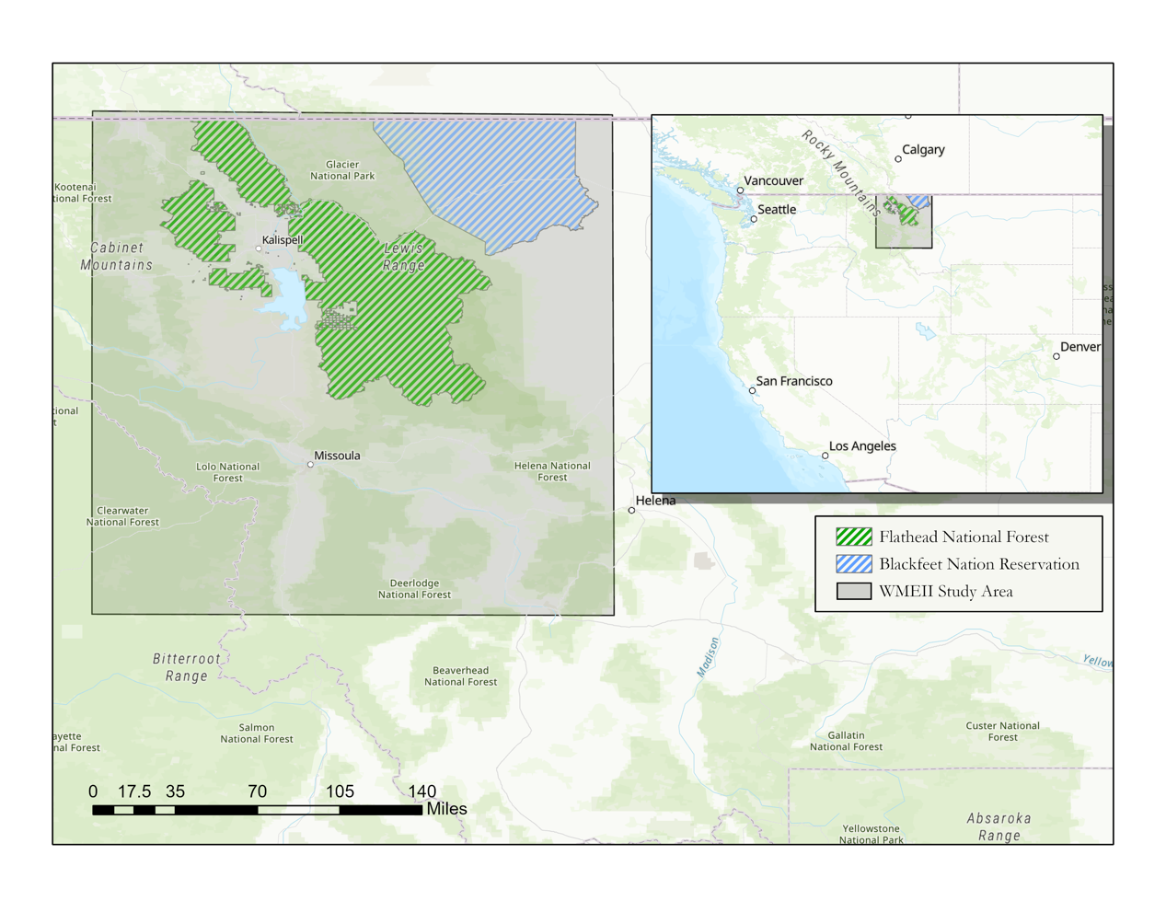
Figure 1. Western Montana Ecological Forecasting II project study area (shaded) encompassing the Blackfeet Indian Reservation, Missoula, and Flathead National Forest.

2.2 Project Partners & Objectives
Working Dogs for Conservation (WD4C) is a Montana-based nonprofit organization that uses detection dogs’ remarkable sense of smell to protect wildlife and wild places. The organization consults, collaborates, and builds the capacity for conservation in biosecurity, law enforcement, and ecological monitoring applications. WD4C has utilized detection dogs to locate scat of mink and otter for the purpose of contaminant monitoring in western Montana river systems. WD4C collaborates with the Virginia Institute of Marine Science (VIMS) in order to analyze scat samples collected from field surveys. In previous surveys, WD4C selected areas for contaminant monitoring based on their knowledge of mustelid habitat and the known locations of contaminant sources adjacent to river systems. The organization currently does not utilize Earth observations to inform its survey site selection.

The methodology developed in this project will allow WD4C to incorporate NASA Earth observations in future studies to streamline selection of scat detection survey areas. We had four primary objectives. The first objective was to generate refined current and projected habitat suitability models for mink and otter in an expanded study area using data from the years 2013 to 2020 and projected to 2040, respectively. The third objective was to create field survey site accessibility maps to assist partners in finding safe ways to access surveying locations, as well as to highlight potentially contaminated regions that are a priority for sampling. Lastly, we also produced precipitation anomaly and topographic maps to provide a better understanding of how contaminants move throughout the ecosystem.

3. Methodology
3.1 Data Acquisition
Based on literature reviews, discussions with partners and science advisors, and the analyses done by the previous team, we considered 18 predictor variables for the current habitat suitability models. Appendix A outlines these datasets in detail. Using Google Earth Engine (GEE), we obtained Land Surface Temperature (LST) data from Terra MODIS, temperature and precipitation data from Parameter elevation Regression on Independent Slopes Model (PRISM), topographic data from the Shuttle Radar Topography Mission (SRTM), and soil moisture data from Soil Moisture Active Passive (SMAP). We acquired land cover data from the USGS National Land Cover Database. River location data from the USGS National Hydrography Dataset (NHD) was used to calculate distance to rivers. For river width and depth data, we utilized hydrological information derived from the HydroSHEDS dataset. We downloaded these from the Global River Bankfull Width and Depth Database provided by the University of North Carolina (Andreadis et al., 2013). We also used species occurrence data from WD4C’s field surveys, the Montana National Heritage Program Dataset, and citizen science data from the Global Biodiversity Information Facility (GBIF; Table A1). Fur trapper data was removed from the Montana National Heritage Program occurrence data due to survey points appearing in an obvious gridded pattern. This was done to avoid possible errors introduced into the models since the gridded patterns do not accurately represent natural species occurrence locations.

For modeling future mink and otter habitat suitability, we compared historical WorldClim monthly weather data (averaged into years) with yearly WorldClim climate projections. We collected historical monthly weather data from 2010 to 2018 at 2.5-degree spatial resolution. For the WorldClim climate projections, we obtained data from 2021 to 2040 at 2.5-degree spatial resolution using the model CNRM-CM6-1. Historical and projected climatic variables included monthly precipitation, minimum monthly temperature, and maximum monthly temperature. We collected these data for the Shared Socioeconomic Pathway (SSP) 2-4.5 emission scenario. Current and projected land cover data were downloaded from USGS Conterminous United States Land Cover Projections (A1B scenario) website for the years 2021 and 2040, respectively. Historical and projected mean annual flow was downloaded from the USDA Forest Service website (HydroFlow Metrics West). Also used in the projected model workflow was elevation data from SRTM (Table A2).

We also mapped potential sources of anthropogenic contamination in waterways using data from Open Street Map (OSM) and mining sites from the Abandoned and Inactive Mines Database provided by the USDA Forest Service. Transportation features from the Montana Spatial Data Infrastructure (MSDI) website were utilized in the site accessibility map to aid in safe navigation. Digital elevation models (DEMs) from USGS and GPM IMERG precipitation data were acquired for use in the precipitation anomalies maps.

Partners collected species occurrence data in the autumn months of September and October when the streamflow is generally lower and safer for research teams and working dogs to access. We acquired Earth observation and ancillary data during the autumn time period to match the field data, and added November data to improve the range of climatic conditions and make the study more favorable for future field studies.

3.2 Data Processing
3.2.1 Current Habitat Suitability Models
For several Earth observation products used in the current suitability models, we utilized GEE to filter out unnecessary data, clip datasets to our study area extent, and visualize chosen predictor variables. We used GEE to process monthly PRISM data into 11-year (2010 – 2020) autumn (September – November) composites of pixel mean, maximum, and minimum temperature, total precipitation, mean dew point temperature, minimum vapor pressure deficit, and maximum vapor pressure deficit (Amatulli, 2018). We also created a distance to rivers raster by using the Euclidean distance tool on the National Hydrology Dataset (NHD) in ArcGIS Pro. We used the Feature to Raster tool in ArcGIS Pro to create separate rasters for river width and depth from the Global River Bankfull Width and Depth dataset. In GEE, we accessed Terra MODIS LST data for the months of September, October, and November of 2013 through 2020 and then produced a raster image of average LST for each of these months. With the averaged months, we produced an autumn average LST raster, compiling all three months over the course of eight years. We then scaled these LST raster images by a factor of 0.02 to convert the values to degrees in Kelvin, as instructed in MODIS documentation (Golon, 2017). Also with GEE, we accessed SRTM elevation data that included elevation, slope, aspect, northness, and eastness. We then clipped images to the study area shapefile within GEE and exported them. We processed the SMAP soil moisture data within GEE by collecting images from September, October, and November for 2015 to 2020, calculating the mean average of these images, and clipping them to our study area.

3.2.2 Forecasted Habitat Suitability Models
In order to train the forecasting models, we processed historical minimum temperature, maximum temperature, and precipitation from the global WorldClim database for 2010 to 2018. We then used R Studio to create a raster stack of the monthly averages and clipped these rasters to our expanded study area. Since the 2021 to 2040 WorldClim data were ready for use, we did not perform any processing before using it in our model. Individual landcover classifications were extracted from historical and projected landcover datasets using the Select by Attributes tool in ArcGIS Pro. Three classifications were chosen, two based on biological needs of mink and otter (evergreen forest, mixed forest) plus the most influential classification identified by the spring 2021 DEVELOP term project: emergent herbaceous wetland. Projected and historical mean annual flow data from USDA were downloaded as a raster file and did not require processing. Elevation was the only static variable used in the projected workflow and did not require processing.

3.2.3 Site Accessibility Maps
We produced site accessibility maps displaying roads and hiking trails derived from the Montana Spatial Data Infrastructure (MSDI) Transportation Database and contamination points derived from the QuickOSM QGIS plug-in. These maps can assist partners in planning routes and parking locations. The potential points of contamination included paint supply stores, mechanic shops, car washes, factories, gas stations, hospitals, military property, mines, recycling centers, waste dump stations, sawmills, waste transfer stations, and wastewater treatment plants. We filtered for hazardous mines to specifically focus on these sources when creating the maps. Our partners and advisors recommended including these sources of contamination based on their professional experience and knowledge of contaminants.

3.2.4 Precipitation Anomalies and Topographic Maps
We used precipitation data from GPM IMERG to calculate 2013 to 2020 averages for the autumn season of September through November. Using this information, we produced an 8-year autumn average precipitation raster and clipped it to the project study area. For the topographic maps, we used the Mosaic Raster tool in ArcGIS Pro to combine several USGS DEM tiles to cover our study area.

3.3 Data Analysis
3.3.1 Current Habitat Suitability Models
The team used VisTrails SAHM version 2.2.3x64 to generate current habitat suitability models for mink and otter. The processed Earth observations listed in Table A1 were used to create predictor variable raster layers, which were then loaded into a list file within SAHM as covariates in the model. We created our template layer by clipping the USGS NLCD layer to our study area using the Extract by Mask tool in ArcGIS Pro. The template layer had a specified projection, cell size, and extent appropriate for our study. For our field data input in SAHM, we combined species occurrence points provided by WD4C and the Montana National Heritage Program with observational data points from GBIF into one .csv file. The Project, Aggregate, Resample, Clip module within SAHM was used to resample and align all predictor rasters to the template layer projection, cell size, and extent. We then used the Covariate Correlation and Selection module to select which predictor variables would be included in the final model. This module within SAHM allows variables that exhibit high correlation with other variables to be removed by displaying a matrix of the variables using the maximum of the Pearson, Spearman, and Kendall coefficient. When two variables were correlated above the 0.70 threshold, we removed the variable with the least amount of deviance explained to avoid statistical errors. The remaining variables were then used to run Generalized Linear Model (GLM), Boosted Regression Tree (BRT), Maxent, and Random Forest within SAHM. Of the 18 predictor variables entered into SAHM, ten were correlated below the threshold of 0.70 and used in the resulting models: aspect, slope, elevation, northness, eastness, NLCD, soil moisture, river distance, minimum temperature, and minimum vapor pressure deficit. We evaluated the performance of each model using a combination of statistical metrics: the area under the precision-recall curve (AUC-PR), Pearson’s correlation coefficient, and confusion matrices.

3.3.2 Forecasted Habitat Suitability Models
We used a similar approach to generate forecasted habitat suitability models. We used the same template layer and field data within an extended workflow from the current model in SAHM. We included the previously mentioned historical climate data from 2010 to 2018 as well as landcover and streamflow metrics to train the model. Using the ApplyModel function in SAHM, we then projected this model from 2021 to 2040 using the forecasted WorldClim, landcover, and annual mean streamflow data. The static elevation raster was included in both the training and projected workflows.

3.3.3 Site Accessibility Maps
We developed a raster layer showing suitable habitat within two miles of potential contamination sources. This was done by first creating a 2-mile buffer around each source point using the Euclidean Distance tool in ArcGIS Pro and then using the Reclassify tool to create four 0.5-mile rings within the 2-mile buffer. We used the Extract by Mask tool within ArcGIS Pro to extract all pixels of suitable habitat that fell within a contamination source buffer. The team then visually assessed these areas of overlap.

3.3.4 Precipitation Anomalies and Topographic Maps
In order to create precipitation anomaly maps, we first clipped the GPM IMERG autumn raster to the study area. We used the ArcGIS Pro Raster Calculator to compute annual autumn precipitation anomaly maps for 2013 to 2020 by subtracting the 2013–2020 mean annual autumn precipitation from each year’s autumn precipitation total. The result was a map displaying deviation in average precipitation from the 2013–2020 mean for each pixel in the study area during our study period. We then clipped the merged DEM raster to the study area and used the Hillshade tool in ArcGIS Pro to create a three-dimensional topography layer.

4. Results & Discussion
4.1 Analysis of Results
4.1.1 Current Habitat Suitability Model
Analysis of the current habitat suitability models yielded plots of area under the precision-recall curve (AUC-PR), area under the receiver operating characteristic curve (AUC-ROC), and confusion matrices. We evaluated the performance of our models using the AUC-PR score and confusion matrix assessment. The AUC-ROC is often used to evaluate models and relies on true absences to summarize model performance, whereas the AUC-PR does not (Sofaer et al., 2019). For this reason, we evaluated the models using the AUC-PR score, given our models were generated using presence-only data. While both ROC and PR curves are functions of the confusion matrix, PR curves show the probability that a species is present given a predicted presence as a function of recall, or the probability the model predicts presence in locations with observed presence (Sofaer et al., 2019). AUC-PR values range on a scale from 0 to 1, where scores between 0.9 and 1 are considered excellent and scores between 0.8 and 0.9 are considered good (Talbert & Talbert, 2012). Large differences between the AUC-PR training and cross validation split values may suggest model overfitting (Mukaka, 2012).

As shown in Figure B1, our current habitat suitability models had an AUC-PR score of 0.88 for the training split and an AUC-PR score of 0.89 for the cross-validation split, indicating the models performed well. Additionally, when a model is discriminating well, the confusion matrix will show relatively high percentages along the diagonals which indicate the predicted values agree well with the observed values in the model. Large discrepancies between the training and evaluation data could indicate overfitting in the model as well. One of the main output statistics is percent correctly classified, which refers to the number of positives and negatives that were correctly classified out of all of the points classified. In our current habitat suitability confusion matrix, our percent correctly classified was 88.2 for the training data and 89.4 for our evaluation data. This low discrepancy indicates our model was discriminating between predicted and observed values relatively well.

The 10 final predictor variables that were most influential in mink and otter occurrence are shown in Figure B2. Similar to the previous term’s findings, distance to river was the strongest predictor in mink and otter occurrence, followed by elevation and land cover (Figure B2). We found that greater mink and otter presence corresponds with less distance to a river, lower elevation, and evergreen forests. These results may be due to our study region encompassing a large majority of Flathead National Forest, where nearly half of the forest type is dominated by evergreen coniferous trees at lower elevations in cool, moist forests (O’Brien, 1999).

Though both Maxent and Random Forest models perform well with presence only data, we chose to use the Random Forest model because it produced a higher percent deviance explained by the model, making it a better fit for our data. The Random Forest algorithm assesses the relative importance of each covariate based on changes in a fit statistic for individual trees, computed using a bootstrap method (Talbert & Talbert, 2012). Our current habitat suitability map shows the output of the Random Forest algorithm within VisTrails using 10 predictor variables, with distance to river, elevation, and land cover being the most strongly correlated variables of mink and otter occurrence (Figure 2).

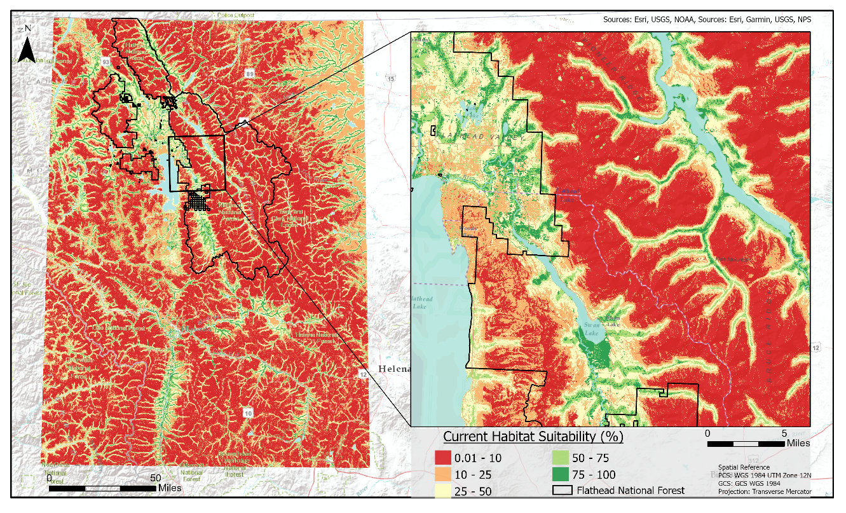
Figure 2. Current Habitat Suitability Map. Suitability values indicate the likelihood of mink and otter occurrence according to the Random Forest model.

4.1.2 Forecasted Habitat Suitability Model
The training split for our forecasting model was relatively effective in predicting suitable habitat with an AUC-PR score of 0.833 (Figure C1). The predictor variables for the training model were elevation, precipitation, mean annual streamflow, emergent herbaceous wetland, mixed forest, and evergreen forests (Figure C2). When this model was projected to the years 2021 to 2040 under the emissions scenario SSP 2-4.5, elevation and precipitation were most important (Figure C2). For the cross validation mean, or projected model, the AUC-PR score dropped to 0.595, indicating a decrease in the models’ ability to predict future suitable habitat based on the projected environmental variables. The confusion matrix produced from this model showed the percent of correctly classified data as 87.3 for the training data and 73.4 for our test data. This is an improvement from last term’s data but still requires further study to make this data useful for our partners in the field.
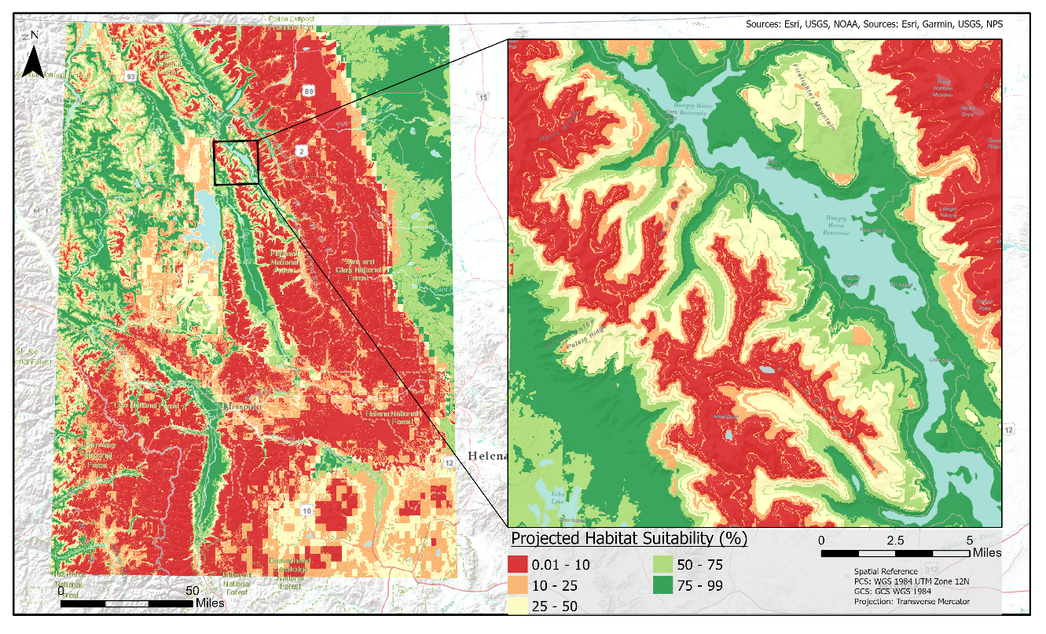
Figure 3. Future habitat suitability map using the forecasting model. Suitability values indicate the likelihood of mink and otter occurrence.

An interesting result of our forecasted maps is the increase in predicted suitable habitat (Figure 3). This may be due to SAHM’s projection workflow generalizing data resulting from less predictor variables than the current suitability model. There also may have been error introduced into the model by our use of a static input (elevation) where projected inputs were required for other variables. The elevation layer also has the most explanatory power in both the training and evaluation split data, which may explain the somewhat erroneous results in the suitability map. The results from this model highlight the difficulty forecasting habitat suitability into the future. Variables with strong explanatory power such as river distance, elevation and slope were not able to be projected into the future due to the unavailability of data. In addition to these issues, the climatic data from WorldClim was produced as a global data, making the resolution coarse in our relatively small study area. This coarse resolution resulted in difficulty detecting small variations and detail in suitable habitat.

4.1.3 Site Accessibility Maps
Visual analysis of our maps shows that potential contamination sources do in fact overlap with suitable habitat for mink and otter (Figure 4). Using the roads and hiking trails displayed in Figure 4, WD4C will be able to plan routes and locate walking paths for their detection dog teams to conduct field surveys. Road names and landmarks have also been labeled for assisting partners in locating survey sites. Symbols for each type of contamination source will help partners to easily recognize and prioritize survey locations. The contamination radius layer allows WD4C to visualize potential contamination sources and their range of impact. Depending on the type of contamination source, partners can decide to survey within 0.5, 1.0, 1.5, or 2.0 miles from the source, distances which are represented by 0.5-mile rings with varying shades of red in Figure 4. The contaminated habitat suitability layer displays mustelid habitat suitability within two miles of a contamination source. The dark blue areas within the contaminated habitat suitability layer indicate the highest habitat suitability within contaminated regions and could function as prime surveying locations for WD4C.

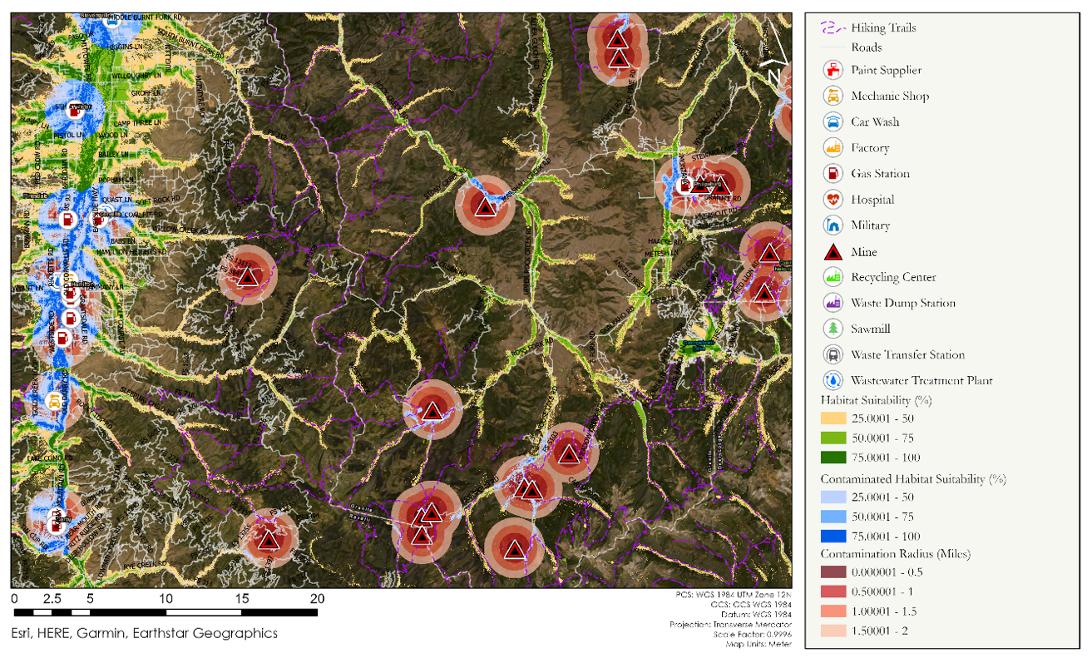
Figure 4. Site Accessibility Map displaying MSDI roads and hiking trails for navigation, as well as mustelid habitat suitability and QuickOSM-derived potential contamination sites.

4.1.4 Precipitation Anomalies and Topographic Maps
We combined the precipitation anomaly and DEM topographic maps to help the partners identify areas of water contamination due to runoff or erosion (Figure D1). We included topography to better understand how elevation, slope, and aspect may affect how precipitation moves throughout the study area. We calculated 367.92 mm/yr (14.48 in/yr) and –227.76 mm/yr (8.97 in/yr) as the maximum and minimum difference from the mean annual precipitation, respectively. The southwest region and north central region of the study area contained above average precipitation anomalies for the study period of 2013 to 2020. The Flathead National Forest may experience more runoff and erosion contamination due to above average precipitation compared to Blackfeet Indian Reservation.

4.2 Future Work
We created habitat suitability maps using species occurrence points from several different sources, with some points being obtained via citizen observations. Combining occurrence points from various sources could result in bias and a lack of consistency in accurate location recording for mink and otter in the study region. We also did not have access to absence data of mink and otter to include in the habitat suitability models. Incorporating both presence and absence species occurrence points to better predict suitable habitat may improve model accuracy. Having a sufficient amount of reliable data points collected via in-situ methods may also train models to better predict habitat suitability based on detailed environmental variables.

The forecasted habitat suitability model performed well, but was far less reliable in its credibility for predicting suitable habitat in the year 2040 compared to the current suitability model. Future work may aim to use climate data with a finer scale resolution and apply these projections to a variety of emissions scenarios. We experienced several challenges while utilizing SAHM, specifically when projecting variables into the future model. These challenges were time-consuming and did not allow the opportunity to apply our projected models to other emissions scenarios to compare models based on these different scenarios. We ran into errors regarding the extent of the template and the data entered into the future workflow. Because of this, we had to redownload all future data to increase geographic extent. We also ran into issues using the landcover raster due to an error regarding observation numbers. To remedy this, we had to extract individual land classification rasters. Having an in-depth understanding of the environmental variables that may or may not be possible to project into the future may be beneficial to aid in troubleshooting and obtaining accurate results for future models.

5. Conclusions
There were several main outcomes from this project. We determined that distance to river, elevation, and land cover were important variables for determining current habitat suitability. We found higher probability areas often corresponded with less distance to river, lower elevation, and evergreen forests. The final variables used in our model aligned with variables used in previous mink and otter habitat suitability modeling studies (Griffin & Suzzi, 2019). Although we produced projected habitat suitability models, the forecasted map results had relatively low accuracy in predicting future habitat suitability for mink and otter in the expanded study area.
We produced current habitat suitability maps, research site accessibility maps, and precipitation anomaly maps that will aid in survey site selection and safe navigation by the partners and detection dogs. The StoryMap we created will aid in public communication and outreach efforts of the partners. The methodology developed by both terms of this project can serve as a framework for further site selection for Working dogs for Conservation. Beyond our partners, our results contribute to further understanding factors influencing mink and otter habitat suitability.
Our results support that satellite data can be used to supplement field data in habitat suitability modeling. Earth observations allowed us to use variables that are challenging or impossible to measure in the field. Data provided may also be more robust in nature with consistent observations either daily, monthly or yearly. In future work, the combination of satellite and field data could assist in indicating the most optimal field survey sites for partners.

6. Acknowledgments
We would like to thank our science advisors Dr. John Bolten, Dr. Allison Howard, and Joseph Spruce for their support and guidance throughout the term. Dr. Ngaio Richards and Dr. Mark La Guardia were highly engaged partners that aided immensely in the direction of the project. NASA DEVELOP GSFC Node Fellow Dr. Nicole Ramberg-Pihl provided administrative, technical, and personal support throughout the term. We would also like to thank our SAHM point of contact, Peder Engelstad, for his extensive help troubleshooting software throughout the term. Finally, special thanks to the spring 2021 Western Montana Ecological Forecasting team for their tremendous work during the first term.
Any opinions, findings, and conclusions or recommendations expressed in this material are those of the author(s) and do not necessarily reflect the views of the National Aeronautics and Space Administration. This material is based upon work supported by NASA through contract NNL16AA05C.

7. Glossary
Detection Dogs – Detection dogs are highly-trained dogs used in conservation research applications to detect scat, plants, or other target scents.
DEM – Digital Elevation Models – topographic data including elevation, slope, and aspect
GEE – Google Earth Engine is a free, web-based geospatial data analysis tool.
GPM – Global Precipitation Measurement
IMERG – Multi-Satellite Retrievals for GPM
Landsat 8 OLI – Landsat 8 Operational Land Imager
LST – Land Surface Temperature
NDVI – Normalized Difference Vegetation Index
NLCD – National Land Cover Database
Random Forest – A machine learning algorithm that is used by SAHM
Remote Sensing – The use of sensors, such as those on satellites or aircraft, to observe areas of Earth from afar
SAHM – Software for Assisted Habitat Modeling
SMAP – Soil Moisture Active Passive
SRTM – Shuttle Radar Topography Mission
Terra MODIS – Terra is a NASA satellite that includes one of two MODIS (Moderate resolution Imaging Spectroradiometer) sensors.
Earth observations – Satellites and sensors that collect information about the Earth’s physical, chemical, and biological systems over space and time

8. References
Amatulli, G., Domisch, S., Tuanmu, M., Parmentier, B., Ranipeta, A., Malczyk, J., & Jetz, W. (2018). A suite of global, cross-scale topographic variables for environmental and biodiversity modeling. Scientific Data, 5, Article 180040. https://doi.org/10.1038/sdata.2018.40

Andreadis, K. M., Schumann, G. J.-P., & Pavelsky, T. (2013). A simple global river bankfull width and depth database. Water Resources Research, 49(10), 7164–7168. https://doi.org/10.1002/wrcr.20440

Farr, T. G., et. al. (2007). NASA SRTM Digital Elevation 30 m. NASA EOSDIS Land Processes DAAC,
accessed 13 October 2021. https://doi.org/10.5067/MEaSUREs/SRTM/SRTMGL1.003

Fick, S. E. & Hijmans, R J. (2017). WorldClim 2: New 1km spatial resolution climate surfaces for global land areas. International Journal of Climatology, 37(12), 4302–4315. https://www.worldclim.org/data/worldclim21.html

Golon, D. (2017, March). Getting Started with MODIS V6 Land Surface Temperature Data Part 2. Getting started with MODIS V6 land surface temperature data part 2. Retrieved October 6, 2021, from https://www.usgs.gov/media/videos/getting-started-modis-v6-land-surface-temperature-data-part-2#:~:text=using%20the%20data.-,A%20scale%20factor%20of%200.02%20should%20be%20
used%20for%20Land,an%20additional%20offset%20of%200.49

Griffin, B., & Suzzi, A. (2019). Habitat suitability assessment of North American River Otter in MA using GIS modeling [Preprint]. University of Massachusetts Amherst.
https://doi.org/10.13140/RG.2.2.14458.75200

Huffman, G. J., Stocker, E. F., Bolvin, D. T., Nelkin, E. J., & Tan, J. (2019). GPM: Monthly Global
Precipitation Measurement (GPM) v6. NASA GES DISC at NASA Goddard Space Flight Center, accessed 13 October 2021. https://doi.org/10.5067/GPM/IMERG/3B-MONTH/06

Klenavic, K., Champoux, L., Daoust, P. Y., Evans, R. D., & Evans, H. E. (2008). Mercury concentrations in wild Mink (Mustela vison) and River Otters (Lontra canadensis) collected from Eastern and Atlantic Canada: Relationship to age and parasitism. Environmental Pollution, 156(2), 359–366. https://doi.org/10.1016/j.envpol.2008.02.003

La Guardia, M. J., Richards, N. L. & Hale, R. C. (2020). A noninvasive environmental monitoring tool for brominated flame retardants (BFRs) assisted by conservation detection dogs. Chemosphere, 260. https://doi.org/10.1016/j.chemosphere.2020.127401

Mayack, D. T. (2012). Hepatic mercury, cadmium, and lead in mink and otter from New York State: monitoring environmental contamination. Environmental Monitoring Assessment, 184(4), 2497–2516. https://doi.org/10.1007/s10661-011-2134-3

Mladenova, I. E., Bolten, J. D., Crow, W., Sazib, N., & Reynolds, C. (2020). NASA-USDA enhanced SMAP global Soil Moisture data. NASA Goddard Space Flight Center, accessed 13 October 2021. https://doi.org/10.3389/fdata.2020.00010

Montana State Library. (2021, February 3). MSDI Transportation Dataset. Montana State Library. Retrieved November 2, 2021, from https://geoinfo.msl.mt.gov/home/msdi/transportation/

Morisette, J. T., Jarnevich, C. S., Holcombe, R., Talbert, C. B., Ignizio, D., Talbert, M. K., Silva, C., Koop. D., Swanson, A., & Young, N. E. (2013). VisTrails SAHM: Visualization and workflow management for species habitat modeling. Ecography, 36, 129–135. https://doi:10.1111/j.1600-0587.2012.07815.x

Mukaka, M.M. (2012). Statistics corner: A guide to appropriate use of correlation coefficient in medical research. Malawi Medical Journal, 24(3), 69–71. Retrieved November 17, 2021, from https://www.ncbi.nlm.nih.gov/pmc/articles/PMC3576830/pdf/MMJ2403-0069.pdf

Natural Heritage Map Viewer. Montana Natural Heritage Program.
Retrieved on October 14, 2021 from http://mtnhp.org/MapViewer/

O’Brien, R.A. (1999). United States Department of Agriculture, Forest Service. (1999). Forest Resources of the Flathead National Forest. Rocky Mountain Research Station. https://www.fs.fed.us/rm/ogden/pdfs/flathead.pdf

Richards, N. L., Tomy, G., Kinney, C. A., Nwanguma, F. C., Godwin, B., & Woollett, D. A. S. (2018). Using scat detection dogs to monitor environmental contaminants in sentinel species and freshwater ecosystems. Using detection dogs to monitor aquatic ecosystem health and protect aquatic resources, 193–262. https://doi.org/10.1007/978-3-319-77356-8_6

Shore, R. F., Taggart, M. A., Smits, J., Mateo, R., Richards, N. L., & Fryday, S. (2014). Detection and drivers of exposure and effects of pharmaceuticals in higher vertebrates. Philosophical Transactions of the Royal Society B: Biological Sciences, 369(1656), Article 20130570. https://doi.org/10.1098/rstb.2013.0570

Sofaer, H., Hoeting, J. A., & Jarnevich, C. (2019). The area under the precision-recall curve as a performance metric for rare binary events. Methods in Ecology and Evolution, 10(4), 565–578. https://doi.org/10.1111/2041-210X.13140

Sohl, T. L., Sayler, K. L., Bouchard, M. A., Reker, R. R., Freisz, A. M., Bennett, S. L., Sleeter, B. M., Sleeter, R. R., Wilson, T., Soulard, C., Knuppe, M., & Van Hofwegen, T. (2018). Conterminous United States Land Cover Projections - 1992 to 2100: U.S. Geological Survey data release, https://doi.org/10.5066/P95AK9HP

Talbert, C. B., & Talbert, M. K. (2012). Tutorial for the software for assisted habitat modeling (SAHM) package in VisTrails. U.S. Geological Survey. https://pubs.er.usgs.gov/publication/70118102

USDA Forest Service. (2005). Mines (abandoned and inactive) database for Montana. Montana Bureau of Mines and Geology, accessed 11 October 2021.

U.S. Geological Survey Landsat Team. (2020). USGS Landsat 8 Surface Reflectance Tier 1. NASA LP DAAC at the USGS EROS Center, accessed 13 October 2021.

Wan, Z, Hook, S., & Hulley, G. (2015) MOD11A1 MODIS/Terra Land Surface Temperature/Emissivity
Daily L3 Global 1 km SIN Grid V006. NASA EOSDIS Land Processes DAAC, accessed 13 October 2021. https://doi.org/10.5067/MODIS/MOD11A1.006

Yates D. E., Mayack, D. T., Munney, K., Evers, D. C., Major, A., Kaur, T., & Taylor, R. J. (2005). Mercury levels in mink (Mustela vison) and river otter (Lontra canadensis) from northeastern North America. Ecotoxicology, 14(1-2), 263–274. https://doi.org/10.1007/s10646-004-6273-y

9. Appendices
Appendix A

Table A1.
List of predictor variables used in the current habitat suitability model runs
Variable | Product | Native Resolution | Dates | Source | Acquisition Method
Species Occurrence Data | Montana National Heritage Program | N/A | 2000–2021 | Montana National Heritage Program | Montana National Heritage Program website
Species Occurrence Data | WD4C | N/A | 2013–2020 | WD4C | WD4C
Occurrence Data | Global Biodiversity Information Facility (GBIF) | N/A | 2000–2021 | GBIF | GBIF Website
Land Surface Temperature | MOD11A1 v006 MODIS/Terra Land Surface Temperature/Emissivity Daily L3 Global 1 km SIN Grid | 1 km | 2013–2020 | Terra MODIS | GEE
Northness | USGS/SRTMGL1_003/ NASA SRTM Digital Elevation 30m | 30 m | N/A | SRTM | GEE
Eastness | USGS/SRTMGL1_003/ NASA SRTM Digital Elevation 30m | 30 m | N/A | SRTM | GEE
Elevation | USGS/SRTMGL1_003/ NASA SRTM Digital Elevation 30m | 30 m | N/A | SRTM | GEE
Slope | USGS/SRTMGL1_003/ NASA SRTM Digital Elevation 30m | 30 m | N/A | SRTM | GEE
Aspect | USGS/SRTMGL1_003/ NASA SRTM Digital Elevation 30m | 30 m | N/A | SRTM | GEE
Mean Monthly Temperature | OREGONSTATE/PRISM/AN81m/ PRISM Monthly Spatial Climate Dataset AN81m | 4 km | 2010–2020 | PRISM | GEE
Maximum Monthly Temperature | OREGONSTATE/PRISM/AN81m/ PRISM Monthly Spatial Climate Dataset AN81m | 4 km | 2010–2020 | PRISM | GEE
Minimum Monthly Temperature | OREGONSTATE/PRISM/AN81m/ PRISM Monthly Spatial Climate Dataset AN81m | 4 km | 2010–2020 | PRISM | GEE
Monthly Precipitation | OREGONSTATE/PRISM/AN81m/ PRISM Monthly Spatial Climate Dataset AN81m | 4 km | 2010–2020 | PRISM | GEE
Minimum Vapor Pressure Deficit | OREGONSTATE/PRISM/AN81m/ PRISM Monthly Spatial Climate Dataset AN81m | 4 km | 2010–2020 | PRISM | GEE
Maximum Vapor Pressure Deficit | OREGONSTATE/PRISM/AN81m/ PRISM Monthly Spatial Climate Dataset AN81m | 4 km | 2010–2020 | PRISM | GEE
Mean Dew Point Temperature | OREGONSTATE/PRISM/AN81m/ PRISM Monthly Spatial Climate Dataset AN81m | 4 km | 2010–2020 | PRISM | GEE
Soil Moisture | NASA_USDA/HSL/SMAP10KM_soil_moisture/ NASA-USDA Enhanced SMAP Global Soil Moisture Data | 10 km | 2013–2020 | SMAP | GEE
Distance to River | National Hydrography Dataset | 1:24,000 | N/A | USGS National Geospatial Program | USGS Website
Land Cover | National Land Cover Database | 30 m | 2016 | USGS | GEE
River Width and Depth | Global River Bankfull Width and Depth | 15-arc sec | N/A | Global River Bankfull Width and Depth Database | University of North Carolina Website

Table A2.
Ancillary datasets used in accessibility, precipitation anomaly, and future habitat suitability maps
Variable | Source | Native Resolution | Dates | Acquisition Method
Landcover | USGS Conterminous United States Land Cover Projections | 250 m | 2040 | USGS Website
Mean Annual Flow | HydroFlow Metrics West | 30 m | 2040 | USDA Forest Service website
Mean Annual Flow | HydroFlow Metrics West | 30 m | 2021 | USDA Forest Service website
Historical Weather Data | WorldClim | 1 km | 2010–2018 | WorldClim Website
Bioclimatic Variables for 2040 | WorldClim | 1 km | N/A | WorldClim Website
Contaminant Sources | OSM | N/A | N/A | QGIS QuickOSM Plug-in
Monthly Precipitation (mm/hr) | GPM IMERG  NASA/GPM_L3/IMERG_MONTHLY_V06/ GPM: Monthly Global Precipitation Measurement (GPM) v6 | 0.1 degrees | 2013–2020 | GEE
Digital Elevation Models (DEM) Data | USGS | 30 m | N/A | USGS Website
Transportation Features | Montana Spatial Data Infrastructure (MSDI) | esriMeters | N/A | Montana.gov State Website
Abandoned and Inactive Mine Database | Montana Bureau of Mines and Geology (MBMG) | N/A | N/A | USDA website

Appendix B
- B.
Figure B1. A. AUC-PR training split and cross-validation curves for current habitat suitability models. B. Confusion matrix for training data and cross validation data showing True Positives (TP) and False Positives (FP), as well as True Negatives (TN) and False Negatives (FN).
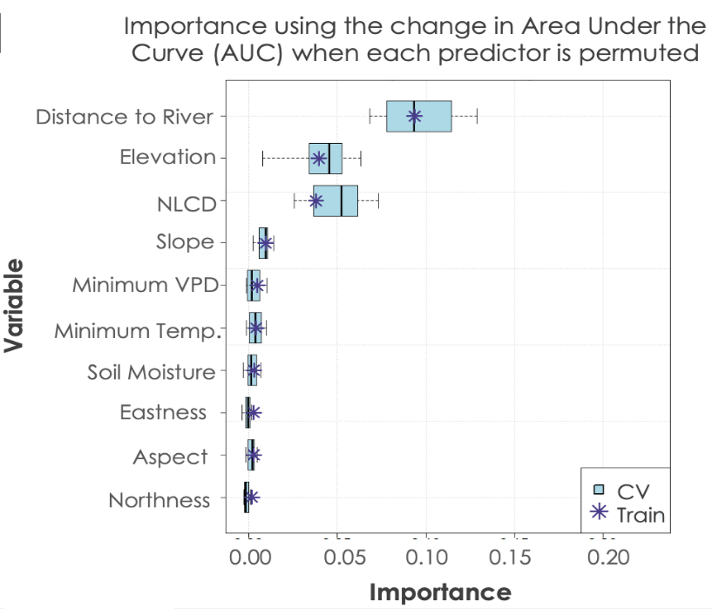
Figure B2. Variable importance plot for current habitat suitability models.

Appendix C
- B.
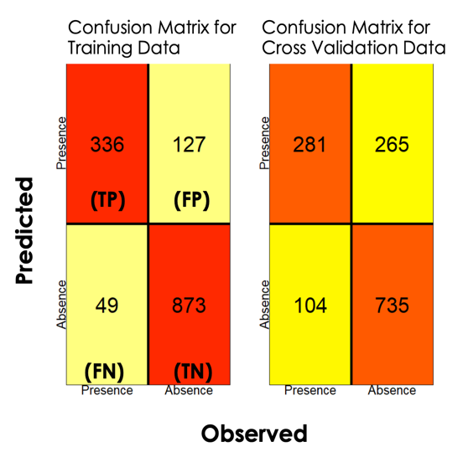
Figure C1. A. AUC-PR training split and cross-validation curves for forecasted habitat suitability models. B. Confusion matrix for training data and cross validation data for forecasted habitat suitability models.

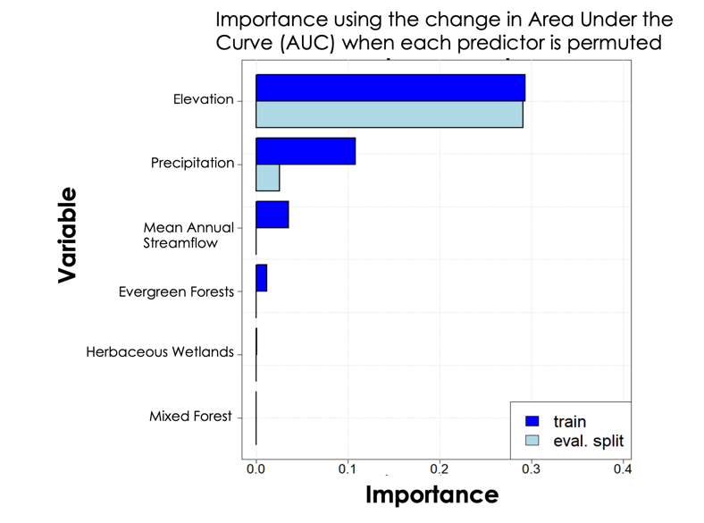

Figure C2. Variable importance plot for forecasted habitat suitability models.

Appendix D
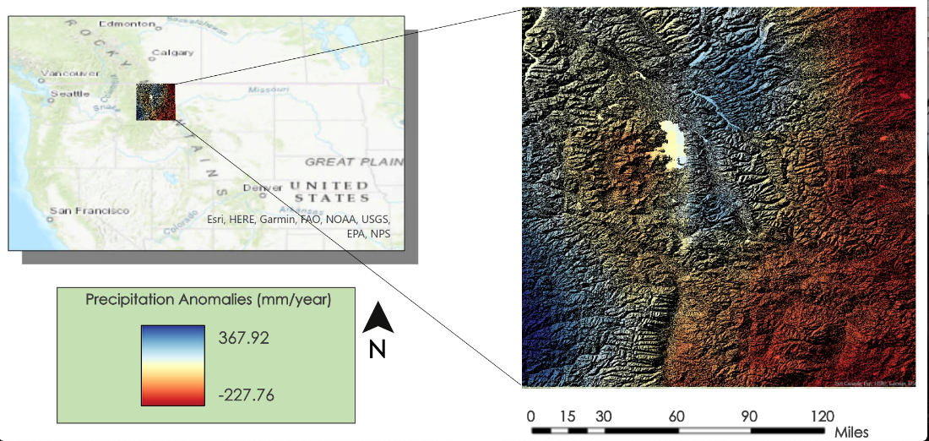
Figure D1. Precipitation anomaly map that displays precipitation differences from the mean mm/yr for the autumn months of 2013 to 2020. Blue areas represent high anomalies, or more precipitation, while the red areas indicate low anomalies, or less precipitation. Additionally, the map displays topography with relatively flat areas in dark grey and black and mountainous areas in light grey and white.

