Bhutan Agriculture
Developing a Crop Mask for Rice and Creating a Data Collection Protocol Utilizing Remotely Sensed Data in Bhutan

Technical Report
Final – November 18th, 2021

Yeshey Seldon (Project Lead)
Sherab Dolma
Kusal Khandal
Wangdrak Dorji

Advisors:
Tim Mayer, NASA SERVIR Science Coordination Office (Science Advisor)
Kenton Ross, (NASA Langley Research Center (Science Advisor)
Sean McCartney, NASA Goddard Space Flight Center, Science Systems and Applications, Inc. (Science Advisor)
Robert Griffin, The University of Alabama Huntsville (Science Advisor)
Jeffrey Luvall, NASA Marshall Space Flight Center (Science Advisor)

1. Abstract
Rice cultivation in Bhutan has been increasingly threatened by deteriorating soil health and outbreaks of diseases and pests associated with the global change in climate patterns. Field surveys, which the national government of Bhutan has relied on to monitor remote agricultural lands, are becoming increasingly overwhelmed by growing threats to agricultural health. To address these concerns, NASA DEVELOP partnered with the Department of Agriculture of Bhutan, the Bhutan Foundation, and the Ugyen Wangchuck Institute of Conservation and Environmental Research (UWICER) and worked to increase the government of Bhutan’s agricultural monitoring capacity. Utilizing Earth observations including Landsat 8 Operational Land Imager (OLI), Sentinel-1 C-band Synthetic Aperture Radar (C-SAR), Shuttle Radar Topography Mission (SRTM), and Planet imagery, the DEVELOP team worked with NASA SERVIR and created a sampling protocol to identify rice plantations and supplement field surveys for more efficient agriculture monitoring. The analysis focused on districts Paro, Punakha, Samtse, Sarpang, Trongsa, Zhemgang, Wangdue Phodrang, and Samdrup Jongkhar in the year 2020 during the period of transplantation (June) to harvesting of rice (November). The team provided the partners with a sampling protocol for integrating NASA Earth observations into their crop monitoring methods, as well as a crop mask for rice identification and to aid crop management. The crop mask for rice was developed using the Random Forest (RF) classifier for the eight districts of Bhutan. Visually, the random forest model has proved to be more accurate and precise than the classification and Regression Tree model. Statistically, the Random Forest model was 91.8% accurate in identifying rice in Bhutan.
Key Terms:
Google Earth Engine, Collect Earth Online, crop mask, rice plantation, Random Forest, Classification and Regression Trees (CART)

2. Introduction
2.1 Background Information
The Kingdom of Bhutan is a predominantly forested nation with a population heavily dependent on agricultural production. According to Ghimiray et al. (2013), more than 69% of the total population is engaged in agricultural activities with maize, rice, and wheat being the main crops. According to the Bhutan Department of Agriculture (DoA), rice plays a crucial role in the daily lives of the Bhutanese people and is a primary contributor to national food security (Bhutan DoA, 2019). Rice requires an integrated management process beginning in nurseries and ending in harvest where it is carefully monitored to avoid contamination by disease and pests. However, due to the mountainous topography of Bhutan, farmers are compelled to follow subsistence farming, which makes crops more vulnerable to natural disasters (Chhogyel et al., 2018). Moreover, Bhutan has been experiencing the effects of climate change. Increased warming and changing rainfall patterns cause various issues such as the deterioration of soil health and outbreaks of disease and pests in crops (Chhogyel et al., 2020). The DoA has relied on field surveys to monitor agricultural lands, but these are tedious given the complex topography and costly to maintain annually. Economic and environmental limitations have forced the national government to reduce their monitoring of rice crops in Bhutan, leaving crops vulnerable to unmonitored disruptions. The DoA is lacking in alternative crop monitoring options.
To overcome the costly and time-consuming nature of agricultural field surveys, professionals worldwide have begun relying on satellite data to assess agricultural health and changes. NASA maintains a fleet of Earth observing satellites that can be used to assess agricultural systems. Over the years, many organizations, including NASA, have been utilizing satellite data to assess trends in climatic variables such as precipitation and temperature, to analyze changes in soil moisture and phenology, and to monitor other parameters that impact agricultural practices. In support of Bhutanese partners, the NASA DEVELOP team utilized multiple Earth observations (EO) to create a crop mask to enable future analysis of rice crops and help with land-use planning. This project, which is the first of two DEVELOP term projects, conducted an analysis utilizing NASA Earth observations to support agricultural monitoring and land-use planning in Bhutan. As suggested by the project partners, the team set the study period to cover the duration of rice transplantation to harvesting, June 1st to November 31st of the year 2020.
Currently, rice plantations in Bhutan are distributed across three main agro-ecosystem zones including the high-altitude zone (1600–2600 meters above sea level), the medium-altitude zone (800–1600 m), and the low-altitude zone (below 800 m) (Chhogyel et al., 2020). Most rice is planted in the central and the southern regions of the country which fall under the medium- and low-altitude zones, respectively (Dorji, 1990). Based on this rice distribution, the team chose eight districts to focus the project analysis on: Punakha, Wangduephodrang, Trongsa, Samtse, Paro, Zhemgang, Trashigang, and Samdrup Jongkhar. These districts are mostly spread around the central and the southern regions of the country (Figure 1).

Figure 1. Study area map highlighting districts of interest within Bhutan in green.

2.2 Project Partners & Objectives
The team partnered with Bhutan’s DoA, the Bhutan Foundation, and the Ugyen Wangchuck Institute for Conservation and Environmental Research (UWICER) to develop a crop mask for rice. Bhutan’s DoA conducts in-field crop and land use assessments in multiple-year rotations, as they do not have the funding to monitor all agricultural plots annually. They depend heavily on this field reporting in order to develop national statistics and make land use decisions, but they are hindered by the costly and time-consuming nature of field surveys. Bhutan’s DoA does not currently use NASA EO; integration of more diverse remote sensing approaches within the DoA’s methodology will help to increase the rate of agricultural assessments. The Bhutan Foundation can identify appropriate points of contact within Civil Society Organizations (CSOs) and government ministries and circulate project end products to different branches of government. UWICER can engage local communities through the Himalayan Environmental Rhythm Observation and Evaluation System (HEROES) project to promote the use of Earth observations and DEVELOP project end products.

3. Methodology
3.1 Data Acquisition
The DoA provided the team with 82 in-situ rice points from major rice farms in Bhutan. Combining Google Earth Engine (GEE) with the Regional Land Cover Monitoring System (RLCMS) provided by NASA SERVIR, an additional 260 plot points of both rice and non-rice areas were manually collected. RLCMS is an operational system that produces high quality regional land cover maps and identifies land cover changes. The team then imported the total of 342 plot points to Collect Earth Online (CEO) for further data processing.

In conjunction with the in-situ sample points, the team utilized datasets from multiple Earth observations in GEE to derive various spectral indices (Table 1). The Earth observations used included Landsat 8 Operational Land Imager (OLI) surface reflectance and top-of-atmosphere (TOA) reflectance, Sentinel-1 C-band Synthetic Aperture Radar (C-SAR), Shuttle Radar Topography Mission (SRTM), and Planet imagery.

Table 1

Description of Earth Observations and imagery used in data processing
Platform/Sensor | Parameters | Purpose | Source
Landsat 8 OLI Surface Reflectance Collection 1 Tier 1 | Atmospherically corrected surface reflectance data  (3 Bands: Red, Near Infrared, Shortwave Infrared 1)* | Calculate Normalized Difference Vegetation Index (NDVI), Normalized Difference Water Index (NDWI), Soil-Adjusted Vegetation Index (SAVI), and Normalized Difference Moisture Index (NDMI). These indices were used in the classification of rice and creating the rice mask. | GEE
Landsat 8 OLI TOA Collection 1 Tier 1 | Calibrated top-of-atmosphere (TOA) reflectance data  (6 Bands: Blue, Green, Red, Near Infrared, Shortwave Infrared 1, and Shortwave Infrared 2)* | Calculate the tasseled cap transformation of greenness which was used in the classification of rice and creating the rice mask. | GEE
Sentinel-1 C-SAR | Ground Range Detected (GRD) scenes  (Vertical transmit and vertical receive [VV] polarization and vertical transmit and horizontal receive [VH] polarization) | Calculate Synthetic Aperture Radar (SAR) polarization indices which were used in the classification of rice and creating the rice mask. | GEE
SRTM Global 1 arc second version 3 | Digital elevation dataset (Elevation) | Calculate slope and elevation indices which were used in the classification of rice and creating the rice mask. | GEE
PlanetScope | 3- to 5-meter resolution RGB imagery of the study area | Planet imagery was used in the sampling protocol to identify testing data. | Norway’s International Climate and Forest Initiative (NICFI) Imagery from CEO
*Landsat 8 band designations can be found at the following web address: https://www.usgs.gov/media/images/landsat-8-band-designations

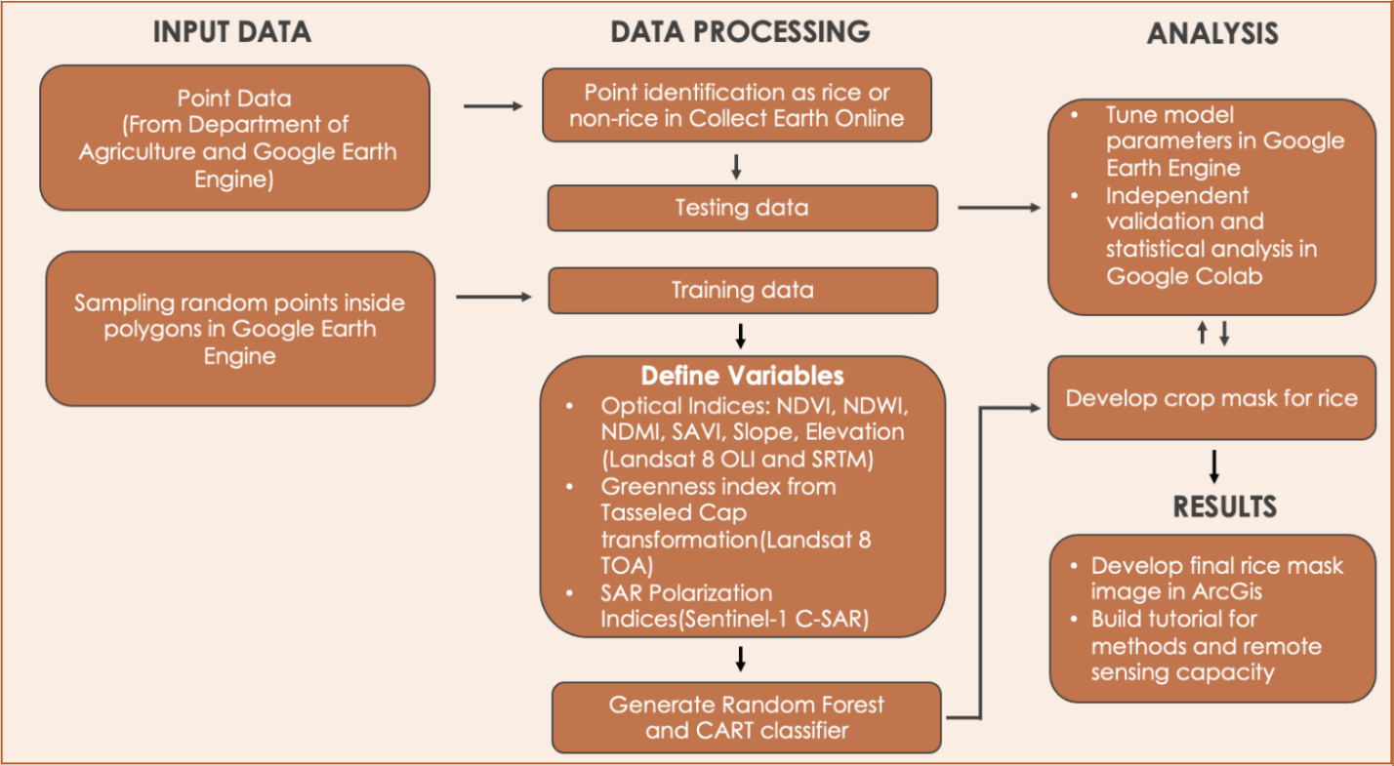
Figure 2. Project methodology flowchart.

3.2 Data Processing
Within CEO, the team expanded the 342 plot points into 30-meter squares with 25 gridded samples in each plot, for a total of 8,550 sample points generated. These sampled points from the DoA and SERVIR became the basis of testing and validation datasets used in generating the rice mask. The team manually classified the validation data into agriculture, non-agriculture, rice, and non-rice using PlanetScope’s 3-5m resolution imagery and imported the data to GEE. Additionally, the team manually drew polygons over satellite maps of the country in GEE, marking each polygon as rice or non-rice. To reduce biases, 70,000 points were randomly sampled from these polygons where half the points were rice and the other half were non-rice. These points from the polygons were used as the training data for the team’s rice classification model. The land cover data of Bhutan distinguishing different administrative districts were exported from International Centre for Integrated Mountain Development (ICIMOD). From this collection containing all districts, the team narrowed it down to only districts which were known for rice production according to Ghimiray et al. (2013).

The team utilized datasets from multiple Earth observations in GEE to calculate various spectral indices: the Normalized Difference Vegetation Index (NDVI); Normalized Difference Water Index (NDWI); Soil-Adjusted Vegetation Index (SAVI); Normalized Difference Moisture Index (NDMI); Kauth-Thomas Tasseled Cap Transformation (TCT) of Greenness, Brightness, Wetness; and changes in vertical transmit and vertical receive (VV) and vertical transmit and horizontal receive (VH) of the Sentinel-1 C-SAR bands. The optical indices of NDVI (Equation 1), SAVI (Equation 2), and Greenness provided information on the presence of vegetation (Huete, 1988; Kauth & Thomas, 1976; Rouse et al., 1974). The Sentinel-1 C-SAR polarization indices provided information on distinctive polarization signatures of different intensities to distinguish target objects. NDWI (Equation 3), NDMI (Equation 4), and Wetness outlined the presence of water (Crist & Cicone, 1984; Gao, 1996; Vermote et al., 2016). Brightness outlined man-made and natural features such as concrete, asphalt, gravel, rock outcrops, and other vegetation-bare areas (Kauth & Thomas, 1976). The elevation and slope indices outlined the steepness of the surface. These indices were the variables which aided machine learning models in the classification of areas with and without rice.

$$\begin{aligned}\text{NDVI = }\frac{\text{NIR}-\text{RED}}{\text{NIR} \text{+ }\text{RED}}\#\left(1\right)\end{aligned}$$

$$\begin{aligned}\text{SAVI} \text{= }\frac{\text{(NIR}-\text{RED)} \text{× }\text{1.5}}{\text{(NIR} \text{+ }\text{RED} \text{+ }\text{0.5)}}\#\left(2\right)\end{aligned}$$

$$\begin{aligned}\text{NDWI} \text{= }\frac{\text{GREEN}-\text{NIR}}{\text{GREEN} \text{+ }\text{NIR}}\#\left(3\right)\end{aligned}$$

$$\begin{aligned}\text{NDMI} \text{= }\frac{\text{NIR}-{\text{SWIR}}_{\text{1}}}{\text{NIR} \text{+} {\text{SWIR}}_{\text{1}}}\#\left(4\right)\end{aligned}$$

In order to create the crop mask for rice, the team utilized a random forest (RF) classifier and Classification and Regression Trees (CART) classifier in GEE. RF is a supervised learning method which combines multiple decision trees to get a more accurate and stable prediction (Donges, 2019). In contrast, the CART algorithm is a subpart of RF. CART consists of a single decision tree organized as a series of questions, the responses to which led to a decision at a terminal node of the tree where there are no more questions (Chipman et al., 1998). The team trained the RF classifier on 70,000 randomly sampled points from polygons in GEE using the combined information from all the indices of NDVI, NDWI, SAVI, NDMI, Brightness, Greenness, Wetness, and changes in polarization. After a stable prediction was acquired for each point in the region of interest (ROI), the team produced a crop mask within the ROI of areas considered to be rice by the RF model. From this crop mask, the team sampled specific classified points that matched coordinates of the validation data and exported the points from the crop mask into Google Colab.

3.3 Data Analysis
The team generated confusion matrices in Google Colab to check the validity of the model’s classification of sample points as rice or non-rice. A confusion matrix is a summary of prediction results on a classification problem which shows the number of correct and incorrect predictions (Zeng, 2020). The team compared, by geographical coordinates, the rice or non-rice label of model sample points with that of validation data sample points to see how much the model's classification is similar to the in-situ data.

From the confusion matrices, the team calculated several statistical measurements of the modeled crop mask, including accuracy and the Cohen’s kappa score. Accuracy refers to the number of correct classifications divided by the size of the total dataset (Chicco & Jurman, 2020). Cohen’s kappa is a metric that compares observed accuracy with expected accuracy while taking into account random chance; it is less misleading than simply using accuracy as a metric with a threshold of 60% for statistical significance (Chicco & Jurman, 2020).

Guided by the statistical tests mentioned above, the team optimized the RF classification performance by trying different combinations and narrowing down indices to train the model on. The indices used in the final crop mask classification include NDVI, NDWI, SAVI, NDMI, Brightness, and changes in polarization. Then, the team worked on the CART classifier as an alternative machine learning model with which to compare the performance of the RF. Following the same workflow used to create the crop mask with the RF model, the team created a crop mask using the CART model. A final crop mask image of rice for CART and RF was created using ArcGIS Pro.

4. Results & Discussion
4.1 Analysis of Results
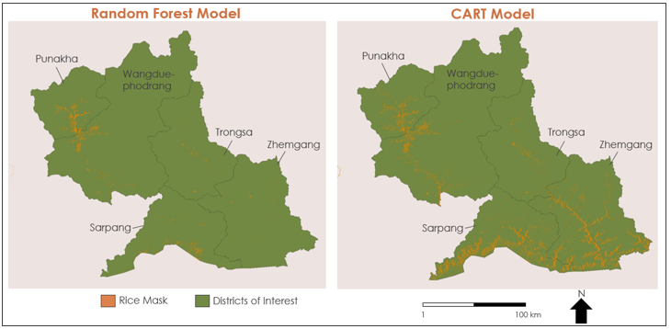
Figure 3. Rice mask model comparisons.

The maps in Figure 3 display classification results of the CART model (left) and the RF model (right) for five of the eight districts in our study area. Orange represents land classified as rice paddy fields by each model, comprehensively referred to as a rice mask. A rice mask, in this project, is a layer that identifies rice areas on the ground using satellite imagery and mathematical classification techniques coupled with field data. The CART model over-predicted rice presence in comparison to in-situ data and the RF model; in other words, CART has identified more non-rice areas as rice (Figure 4).

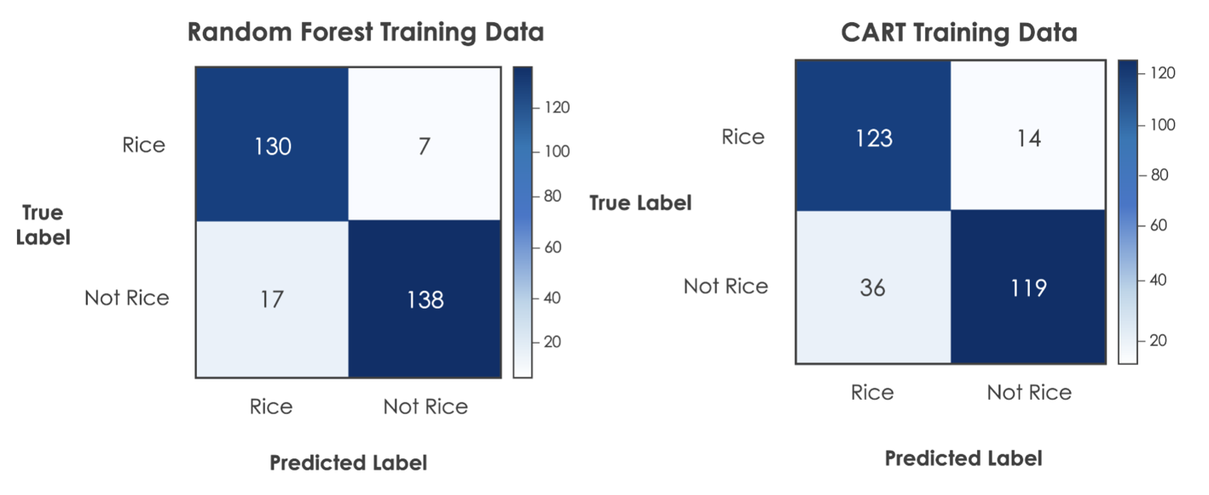
Figure 4. Confusion matrices.

The RF model identified 130 rice points and 138 non-rice points correctly based on our reference validation dataset. It misclassified 7 rice-points as non-rice and 17 non-rice points as rice. On the other hand, the CART model picked up on 14 rice-points as non-rice and 36 rice-points as non-rice. Thus, the CART model misclassified more sample points than the RF model. These mistakes exist because the machine learning model is only as powerful as the amount and quality of data that it has been trained on. The current set of training data is not as extensive as it could be in encompassing information about all forms of paddy fields, and there are times when other land cover types, such as non-rice crops or vegetation, have spectral characteristics that overlap with rice. To test the validity of our crop mask, a number of statistical measurements were calculated using the prediction results from the confusion matrices.
Table 2
Statistical measurements assessing classifier accuracy from COLAB
Statistic Method | RF | CART
Accuracy Score | 0.918 | 0.829
Cohen’s kappa Score | 0.836 | 0.659

Using the points from the DoA as our validation dataset, the team found confidence that the RF model was successful in distinguishing rice and non-rice areas with 91.8% accuracy and a Cohen’s kappa score of 83% (Table 2). In all the statistical measurements, the CART model, which is our baseline model to compare to, performs fairly well but has a lower accuracy score of 82.9 and a Cohen’s kappa score of 65.9%, showing the robustness of the RF model as a tool in classification.

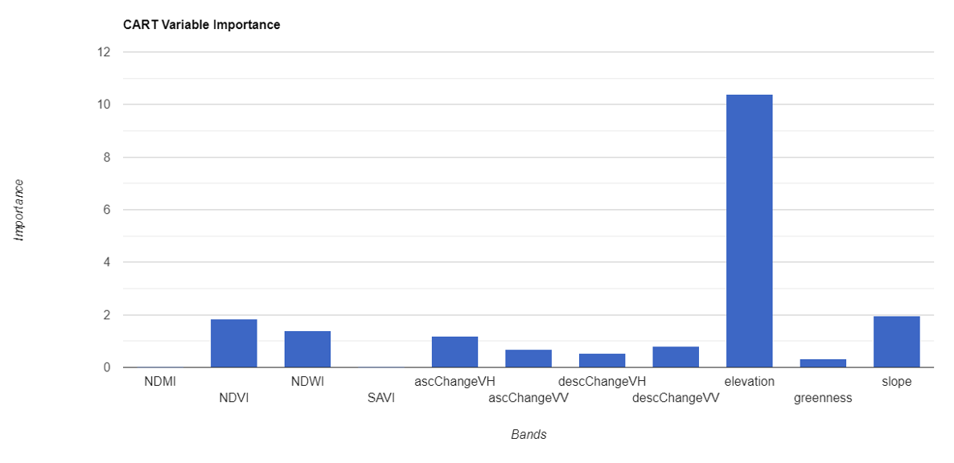
Figure 5. Comparison of indices' importance in the CART model.

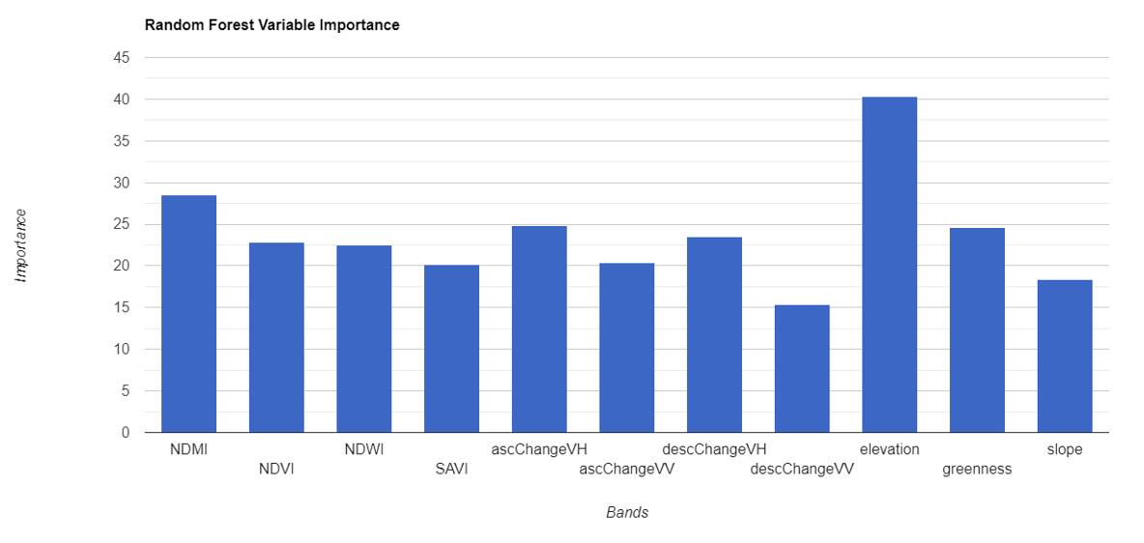
Figure 6. Comparison of indices' importance in the RF model.

The team evaluated the importance of each index or variable in generating rice masks with the CART and RF classification schemes (Figures 5 & 6). The CART model identified elevation as a key driver in the classification, which may have led to the results being skewed by the elevation values. The RF model also identified elevation as a key driver, although the distribution is not as skewed compared to CART. This could be due to altitude being a distinguishing factor of rice ecosystems in the country and this was reflected in distribution of how the training data was collected from polygons scattered across the ROI which goes from the low altitude southern foothills to higher altitude valleys. The rice ecosystems as mentioned previously are defined by three altitudes: low, mid, and high (Ghimiray et al., 2013). Rice yield is dependent on altitude, with the highest yields being produced in high-altitude areas (Ghimiray et al., 2013). However, as the altitude grows steeper, the terrain gets rougher; and most paddy fields are on narrowly terraced slopes (Ghimiray et al., 2013).

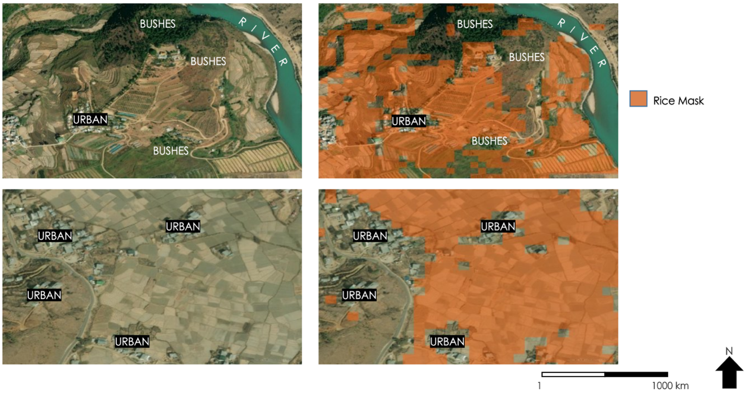
Figure 7. Applying the RF model.

To give a better view of how well the RF model worked, the team zoomed in on some sample locations in the ROI. In Figure 7, images to the left show the satellite view of an area, and images to the right show the same areas with the RF-generated rice mask. This rice mask identified all the paddy fields in these areas as rice, and successfully ignored non-rice areas such as water bodies, sand, buildings, roads, and some bushes in between the paddy fields. Based on the statistical and visual analysis, the team concluded that the RF model proved to be a better classifying algorithm than CART for creating a rice mask for Bhutan. Therefore, the team used RF classification to generate separate rice masks for each of the eight districts.

4.2 Errors and Limitations
The highly mountainous terrain of Bhutan has a great diversity of features within short distances, introducing more variability in the spectral indices used to generate the rice mask. Therefore, reliable model classification of rice and non-rice areas requires large amounts of varied data. It must also be noted that this project only used satellite imagery of rice fields captured in the year 2020, so although we can be confident in the model’s classification of rice for 2020, more data would be required to extend the timeframe of the model's classification. Although an extended timeframe could improve the robustness of the model, seasonal changes in rice growing environments would make it difficult to optimize performance with respect to each year's unique variability. Additionally, the RF model was trained primarily on cloud-free data, so its performance is hampered when dealing with imagery with clouds.

In the manual collection of rice points, it is very likely that human error and bias were at play. The RF model's accuracy, especially in a classification problem like ours, is dependent on the randomness introduced into the training set, so it is heavily dependent on the initial rice points that we fed into the model (Breiman, 2001). The RF model is an ensemble of multiple decision trees which suffers in interpretability, as it is primarily a measure of statistical significance. It is difficult to isolate a single study variable from a collection of many and determine the significance of each variable for rice classification. The RF model is only as powerful as the amount and variation of data that it has been trained on, hence, further work is needed to validate the significance of the findings.

4.3 Future Work
The second term of this project will build upon the first term’s sampling methodology and crop mask to expand the overall area assessed in Bhutan. It will also incorporate additional crop types into the classification protocol and determine the health of crop varieties within the region. The continuation project will also provide a written tutorial so partners can replicate these sampling methods and utilize Earth observations in the future. These end products could help partners meet their goal of remotely defining agricultural regions in Bhutan.

5. Conclusions
DEVELOP’s Bhutan Agriculture team developed a crop mask for rice using the RF classifier for eight districts of Bhutan covering the central and southern regions of the country. Both visually and statistically, the RF model (91.8% accuracy) has proved to be more accurate and precise than the CART model (82.9% accuracy) in identifying rice. The RF model attributed diverse levels of importance to the various input indices during the classification.

Project partners can use the crop mask to identify and monitor areas of rice cultivation in Bhutan, allowing for more robust crop management and reducing the need for field surveys. The team developed a sampling protocol on how to use CEO as a standardized approach to classify in-situ data, which is essential for creating the validation datasets used in generating a crop mask. The team also created a methodology and remote sensing capacity building tutorial to help partners in Bhutan to replicate the methods of generating a crop mask and also to better understand how to leverage Earth observations for land-use planning.

6. Acknowledgments
The team would like to acknowledge the following individuals for their influence in our work:
- Tim Mayer (NASA SERVIR Science Coordination Office)
- Dr. Kenton Ross (NASA Langley Research Center)
- Sean McCartney (NASA Goddard Space Flight Center)
- Dr. Robert Griffin (The University of Alabama Huntsville)
- Dr. Jeffrey Luvall (NASA Marshall Space Flight Center)
- Filo Gomez-Martinez (NASA SERVIR Science Coordination Office)
- Meryl Kruskopf (NASA SERVIR Science Coordination Office)
- Tshering Wangchen (Bhutan Department of Agriculture)
- Nidup Dorji (Bhutan Department of Agriculture)
- Tshewang Wangchuk (Bhutan Foundation)
- Tshering Yangzom (Bhutan Foundation)
- Changa Tshering (UWICER)
- Dr. Kevin Mwenda (Brown University)
- Paxton LaJoie (NASA DEVELOP Marshall Space Flight Center)

This material contains modified Copernicus Sentinel data (2020), processed by ESA.
Any opinions, findings, and conclusions or recommendations expressed in this material are those of the author(s) and do not necessarily reflect the views of the National Aeronautics and Space Administration.
This material is based upon work supported by NASA through contract NNL16AA05C.

7. Glossary
Brightness – Derived using function created in GEE for Tasseled Cap Transformation for Landsat 8 TOA data. Standard coefficients are applied to Landsat TOA bands 2 through 7 (blue, green, red, near infrared, shortwave infrared 1, and shortwave infrared 2) to create new band identified as Brightness.
CART – Classification and Regression Tree model used as a classification tool.
Elevation – Elevation index selected from the SRTM dataset
Greenness – Derived using function created in GEE for Tasseled Cap Transformation for Landsat 8 TOA data. Standard coefficients are applied to Landsat TOA bands 2 through 7 (blue, green, red, near infrared, shortwave infrared 1, and shortwave infrared 2) to create new band identified as Greenness.
NDMI – Normalized Difference Moisture Index
NDVI – Normalized Difference Vegetation Index
NDWI – Normalized Difference Water Index
OLI – Operational Land Imager
RF – Random Forest classifier used to classify data with decision trees.
SAR – Synthetic Aperture Radar
SAVI – Soil Adjusted Vegetation Index.
SRTM – Shuttle Radar Topography Mission
Wetness – Derived using function created in GEE for Tasseled Cap Transformation for Landsat 8 TOA data. Standard coefficients are applied to Landsat TOA bands 2 through 7 (blue, green, red, near infrared, shortwave infrared 1, and shortwave infrared 2) to create new band identified as Wetness.

8. References

Bhutan Department of Agriculture. (2019). Package of Practices for Field and Horticulture Crops of Bhutan. Agriculture Research and Extension division (ARED). Ministry of Agriculture & Forests. https://www.doa.gov.bt/wp-content/uploads/2020/03/Package-of-Prcatices-for-Field-and-Horticulture-Crops-of-Bhutan_2019.pdf

Breiman, L. (2001). Random forests. Machine Learning, 45, 5–32. https://doi.org/10.1023/A:1010933404324

Chhogyel, N. & Kumar, L. (2018). Climate change and potential impacts on agriculture in Bhutan: A discussion of pertinent issues. Agriculture & Food Security, 7, 79. https://doi.org/10.1186/s40066-018-0229-6

Chhogyel, N., Kumar, L, & Bajgai, Y. (2020). Consequences of climate change impacts and incidences of extreme weather events in relation to crop production in Bhutan. Sustainability, 12(10), 4319. https://doi.org/10.3390/su12104319

Chhogyel, N., Sadeeka Jayasinghe, L, Kumar, L., & Bajgai, Y. (2020). Prediction of Bhutan's ecological distribution of rice (Oryza sativa L.) under the impact of climate change through maximum entropy modelling. The Journal of Agricultural Science, 158(1-2), 25–37. https://doi.org/10.1017/S0021859620000350

Chicco, D., & Jurman, G. (2020). The advantages of the Matthews correlation coefficient (MCC) over F1 score and accuracy in binary classification evaluation. BMC Genomics 21, 6. https://doi.org/10.1186/s12864-019-6413-7

Chipman, H. A., George, E. I., & McCulloch, R. E. (1998). Bayesian CART model search. Journal of the American Statistical Association, 93(443), 935–948. https://doi.org/10.1080/01621459.1998.10473750

Crist, E. P., & Cicone, R. C. (1984). A physically-based transformation of Thematic Mapper data—The TM Tasseled Cap. IEEE Transactions on Geoscience and Remote Sensing, GE-22(3), 256–263. https://doi.org/10.1109/TGRS.1984.350619

Donges, N. (2019). A complete guide to the random forest algorithm. Built In. https://builtin.com/data-science/random-forest-algorithm

Dorji, N., Flinn, J. C., & Maranan, C. (1990). Rice Production in the Wangdiphodrang-Punakha Valley of Bhutan. IRRI Research Paper Series, 140. The International Rice Research Institute, Philippines. https://pdf.usaid.gov/pdf_docs/pnabg768.pdf

Gao, B. (1996). NDWI—A normalized difference water index for remote sensing of vegetation liquid water from space. Remote Sensing of Environment, 58(3), 257–266. https://doi.org/10.1016/S0034-4257(96)00067-3

Ghimiray, M., Pandey, S., & Velasco, M. L. (2013). Estimating adoption rate of modern rice varieties in Bhutan. RNR RDC Bajo. https://rcbajo.gov.bt/wp-content/uploads/2016/03/Rice-Adoption-Report.pdf

Huete, A. R. (1988). A soil-adjusted vegetation index (SAVI). Remote Sensing of Environment, 25(3), 295–309. https://doi.org/10.1016/0034-4257(88)90106-X

Kauth, R. J., & Thomas, G. S. (1976, June 29 – July 1). The Tasselled Cap – A graphic description of the spectral-temporal development of agricultural crops as seen by Landsat [Paper 159]. The Laboratory for Applications of Remote Sensing (LARS) Symposium on Machine Processing of Remotely Sensed Data, Purdue University, West Lafayette, Indiana, USA. https://docs.lib.purdue.edu/lars_symp/159/

Rouse, J. W., Haas, R. H., Scheel, J. A., and Deering, D. W. (1974). Monitoring vegetation systems in the Great Plains with ERTS. Third Earth Resources Technology Satellite-1 (ERTS-1) Symposium, 1, Paper A 20, 309–317. https://ntrs.nasa.gov/citations/19740022614

Vermote, E., Justice, C., Claverie, M., & Franch, B. (2016) Preliminary analysis of the performance of the Landsat 8/OLI land surface reflectance product. Remote Sensing of Environment, 185, 46–56. https://doi.org/10.1016/j.rse.2016.04.008

Zeng, G. (2020). On the confusion matrix in credit scoring and its analytical properties. Communications in Statistics - Theory and Methods, 49(9), 2080–2093. https://doi.org/10.1080/03610926.2019.1568485

