**Title:** A New Approach to Evaluate and Reduce Uncertainty of Model-based Biodiversity Projections for Conservation Policy Formulation

**Authors:** Myers, Bonnie J.E. 1*, Weiskopf, Sarah R. 1, Shiklomanov, Alexey N. 2 , Ferrier, Simon2, Weng, Ensheng4, Casey, Kimberly A. 5, Harfoot, Mike6, Jackson, Stephen T. 7, Leidner, Allision K. 8, Lenton, Timothy M. 9, Luikart, Gordon10, Matsuda, Hiroyuki11, Pettorelli, Nathalie12, Rosa, Isabel M.D.13, Ruane, Alex C. 4, Senay, Gabriel B.14, Serbin, Shawn P.15, Tittensor, Derek P. 6,16, Beard, T. Douglas1

1 U.S. Geological Survey, National Climate Adaptation Science Center, 12201 Sunrise Valley Drive, Reston, VA, 20192, USA; [bemyers2@ncsu.edu](mailto:bjmyers@usgs.gov) (Title: Fish Biologist), [sweiskopf@usgs.gov](mailto:sweiskopf@usgs.gov) (Title: Biologist), [dbeard@usgs.gov](mailto:dbeard@usgs.gov) (Title: Chief)

2NASA Goddard Space Flight Center, NASA GSFC, Mail Code: 618, Greenbelt , MD, 20771, USA; alexey.shiklomanov@nasa.gov (Title: Research Associate)

3Commonwealth Scientific and Industrial Research Organisation, GPO BOX 1700

Canberra ACT 2601, Australia; [simon.ferrier@csiro.au](mailto:simon.ferrier@csiro.au) (Title: Chief Research Scientist)

4Columbia University/NASA Goddard Institute for Space Studies, 2880 Broadway, New York, NY, 10025, USA; [ew2560@columbia.edu](mailto:ew2560@columbia.edu) (Title: Associate Research Scientist)

5U.S.Geological Survey, National Land Imaging Program, 12201 Sunrise Valley Drive

MS-516, Reston, VA 20192 USA; [kcasey@usgs.gov](mailto:kcasey@usgs.gov) (Title: Physical Scientist)

6UN Environment World Conservation Monitoring Centre, 219 Huntingdon Rd, Cambridge CB3 0DL, United Kingdom; [mike.harfoot@unep-wcmc.org](mailto:mike.harfoot@unep-wcmc.org) (Title: Senior Ecosystem Modelling Scientist)

7U.S. Geological Survey, Southwest Climate Adaptation Science Center, 1064 E. Lowell St., P.O. Box 210137, Tucson, AZ 85721-0137 USA; [stjackson@usgs.gov](mailto:stjackson@usgs.gov) (Title: Center Director)

8NASA Biological Diversity Program, 300 E Street, SW, Washington, DC 20546-0001, USA; [allison.k.leidner@nasa](mailto:allison.k.leidner@nasa) (Title: Program Manager)

9 Global Systems Institute, University of Exeter, Level 8 Laver Building, North Park Road

Exeter, EX4 4QE, United Kingdom; [t.m.lenton@exeter.ac.uk](mailto:t.m.lenton@exeter.ac.uk) (Title: Professor and GSI Director)

10University of Montana Flathead Lake Biological Station, 32125 Bio Station Ln, Polson, MT 59860-681, USA; [gordon.luikart@umontana.edu](mailto:gordon.luikart@umontana.edu) (Title: Professor)

11Yokohama National University, 79-1 Tokiwadai, Hodogaya Ward, Yokohama, Kanagawa 240-8501, Japan; [matsuda-hiroyuki-vj@ynu.ac.jp](mailto:matsuda-hiroyuki-vj@ynu.ac.jp) (Title: Professor)

12The Institute for Zoology, Zoological Society of London, Regent's Park, NW1 4RY, United Kingdom; [nathalie.pettorelli@ioz.ac.uk](mailto:nathalie.pettorelli@ioz.ac.uk) (Title: Senior Research Fellow)

13Bangor University School of Natural Sciences, Room G1, Thoday Building, School of Natural Sciences, Bangor LL57 2DG, United Kingdom; [i.rosa@bangor.ac.uk](mailto:i.rosa@bangor.ac.uk) (Title: Lecturer in Environmental Data and Analysis)

14U.S. Geological Survey, Earth Resources Observation and Science Center; North Central Climate Adaptation Science Center, 400 University Avenue, Fort Collins, Colorado 80523, USA; [senay@usgs.gov](mailto:senay@usgs.gov) (Title: Research Physical Scientist)

15 Environmental & Climate Sciences Department, Brookhaven National Laboratory, Bldg. 490D - P.O. Box 5000, Upton, NY 11973-5000,USA;[sserbin@bnl.gov](mailto:sserbin@bnl.gov) (Title: Associate Ecologist)

16Department of Biology, Dalhousie University, Department of Biology,

1355 Oxford Street, Halifax, NS. B3H 4R2, Canada; [Derek.Tittensor@unep-wcmc.org](mailto:Derek.Tittensor@unep-wcmc.org) (Title: Associate Professor)

*Corresponding Author: bemyers2@ncsu.edu; Cell: 307-399-1693

**Abstract**

Biodiversity projections with uncertainty estimates under different climate, land-use, and policy scenarios are essential to setting and achieving international targets to mitigate biodiversity loss. Evaluating and improving biodiversity predictions to better inform policy decisions remains a central conservation goal and challenge. A comprehensive strategy to evaluate and reduce uncertainty of model outputs against observed measurements and multiple models would help to produce more robust biodiversity predictions. We propose an approach that integrates biodiversity models and emerging remote sensing and in-situ data streams to evaluate and reduce uncertainty with the goal of improving policy-relevant biodiversity predictions. In this paper, we (1) describe a multivariate approach to directly and indirectly evaluate and constrain model uncertainty, (2) demonstrate a proof-of-concept of this approach, (3) embed the concept within the broader context of model evaluation and scenario analysis for conservation policy, and (4) highlight lessons from other modeling communities.

**Keywords:** biodiversity conservation, predictive modeling, biodiversity policy, remote sensing, Essential Biodiversity Variables

**Introduction**

Among the most urgent challenges for society and conservation today is predicting and mitigating loss of biodiversity and ecosystem services (IPBES 2019). With the potential of 1 million species to go extinct in the coming decades, developing better tools for projecting biodiversity change is vital (IPBES 2019). Currently, no single model can capture all the dimensions of biodiversity change resulting from environmental and anthropogenic impacts (Pereira et al. 2010). Consequently, modelers have developed a range of biodiversity models and scenarios to predict change across multiple dimensions of biodiversity (Ferrier et al. 2016). The diversity of models enhances researchers’ ability to predict change in a myriad of individual biodiversity variables, including species distribution and abundance, species traits and genetic composition, community composition, and ecosystem structure and function (Fulton 2010, Lacy et al. 2013, Pacifici et al. 2015, Ikeda et al. 2016, Landguth et al. 2017). This array of possible predicted variables makes it challenging to integrate model predictions to better understand large-scale biodiversity change. However, the diversity in models can be advantageous and also presents an opportunity to develop new strategies to evaluate, reduce uncertainty, and increase confidence in model predictions for decision makers (Araújo et al. 2005, Akçakaya et al. 2016, Ferrier et al. 2016, Honrado et al. 2016).

Decision makers use biodiversity projections to develop and implement policy actions for biodiversity conservation and must make decisions despite uncertainty in the projections (Wilson et al. 2002, UNEP 2010). Model-based projections can be used both to inform the formulation of targets, and to identify and prioritize actions (e.g., target implementation; Dietze et al. 2018). High-accuracy biodiversity estimates increase decision makers’ confidence in model outputs (Regan et al. 2005, Akçakaya et al. 2016). To evaluate model performance, researchers can compare model outputs to observations and from multiple models to quantify the precision and accuracy of multi-model predictions (Zurell et al. 2016). For example, Morin and Thuiller (2009) compared uncertainty in range shift predictions from niche-based and process-based models. These multi-model predictions improved understanding of species range shifts (Morin and Thuiller 2009). Other efforts to improve model predictions have focused on comparing similar biodiversity variables (e.g., range shifts and species distributions) from different model types (Araújo et al. 2005, Morin and Thuiller 2009, Zurell et al. 2016). The biodiversity modeling community continues to make strides in quantifying and reducing uncertainty for models through model intercomparison efforts (Rosa et al. 2020). Yet, additional approaches to evaluate and reduce uncertainty in model-based biodiversity projections to improve model outputs is a priority (Akçakaya et al. 2016). We identified a pressing need for improved model-data fusion approaches to evaluate and constrain uncertainty using multiple data streams (e.g., remote sensing and in-situ observations). We also expand upon Akcakaya et al.’s (2016) charge to use diverse biodiversity models to improve model outputs.

The challenges in improving biodiversity models are unique compared to other modeling communities (e.g., climate modeling). For one, biological and ecological processes, such as changes in species interactions and adaptation to a stressor, can be complex and difficult to predict (Ibáñez 2006, Jackson et al. 2009, Purves 2013, Harfoot et al. 2014, Bay et al. 2018). Second, there is currently no standard means to compare biodiversity model outputs, which creates challenges when comparing outputs to estimate uncertainty (Rosa et al. 2020). Lastly, there is no consistent process to take advantage of the multiple monitoring and varied data streams for improving model outputs (Akçakaya et al. 2016, Honrado et al. 2016). Biodiversity researchers and decision makers are actively addressing these issues. For example, the Group on Earth Observations Biodiversity Observation Network (GEO BON) is developing Essential Biodiversity Variables (EBVs), defined as the derived measurements required to study and report on biodiversity change (Pereira et al. 2013). EBVs include common biodiversity variables such as species distributions, abundance, trait diversity, genetic diversity, and taxonomic diversity. The EBV framework was developed to harmonize observations and model outputs into comparable and monitorable variables (Pereira et al. 2013, Navarro et al. 2017). Recent efforts have used the EBV framework to combine outputs from multiple models to quantify uncertainty across models (Rosa et al. 2020). Thus, this is a particularly opportune time to explore novel approaches to evaluate and reduce uncertainty in model-based biodiversity projections and contribute to this active field of research.

Given these challenges and opportunities, clearer strategies are needed for biodiversity model evaluation to inform future formulation of biodiversity policy (Tittensor et al. 2014, Ferrier et al. 2016). International science-policy efforts like the Convention on Biological Diversity’s (CBD) post-2020 biodiversity agenda (UNEP 2017), continued identification of EBVs, and the Intergovernmental Science-Policy Platform on Biodiversity and Ecosystem Services (IPBES) global assessment report have highlighted the urgency of biodiversity forecasting and conservation to society (IPBES 2019, Essential biodiversity 2019). Additionally, there has been a rapid increase in the quantity and diversity of data available to inform biodiversity assessments, including a wide array of remote sensing, field observations (e.g., the TRY trait database), metagenomics, and citizen science (Silvertown 2009, Theobald et al. 2015, Balasingham et al. 2018). Evaluating and using these data streams requires expertise as well as advanced modeling approaches to harness the abundance of available observations (Akcakaya et al., 2016).

Here, we address these stated biodiversity community and strategic needs by proposing a novel multivariate approach to directly and indirectly evaluate and reduce uncertainty of multi-scale model predictions. First, we use multiple data sources to directly constrain model-based predictions of biodiversity variables. We then combine this step with a multivariate indirect constraint between models that predict related biodiversity variables to evaluate and jointly reduce uncertainty. Our approach leverages distinct models and allows for the evaluation and reduction of uncertainty across multiple dimensions of biodiversity in an ecosystem. Collectively, we (1) describe the proposed multivariate approach to evaluate and directly and indirectly reduce model uncertainty, (2) outline a proof of concept application to illustrate this approach and how it could be applied to other models and variables, (3) embed the concept within the broader context of model testing and scenario analysis for conservation policy, and (4) highlight lessons from other modeling communities that could be applied to improve biodiversity model outputs.

**Multivariate Approach to Evaluating and Reducing Uncertainty in Model-based Biodiversity Projections**

Biodiversity variables are linked by physical, biological, and ecological processes, many of which are described quantitatively in models (Harfoot et al. 2014). We used this interdependency among biodiversity variables to develop a multivariate approach to evaluate and reduce uncertainty in model-based biodiversity projections. We illustrate the two-step process conceptually in Figure 1 using a generic EBV and a biodiversity variable. The approach is flexible in that modelers can apply any two models predicting related biodiversity variables, but we used EBVs in our example to better link to ongoing biodiversity monitoring processes. Our approach involves two main steps to reduce uncertainty in biodiversity projections. Step 1 illustrates a univariate constraint on uncertainty in initial conditions via remote sensing and in-situ observations of a biodiversity variable (Figure 1; Step 1). Step 2 applies a novel multivariate constraint on uncertainty via model overlap using the same models from Step 1 of two biologically- or ecologically-related biodiversity variables (Figure 1; Step 2). Following Step 2, we can repeat the process iteratively to directly constrain the biodiversity variables using remote sensing or in-situ observations and indirectly constrain the related biodiversity variables through reanalysis (Figure 1; Steps 1-2). The direct constraint of uncertainty using remote sensing and in-situ observations of a predicted biodiversity variable in Step 1 is common practice in modeling (Pasetto et al. 2018); the novelty of our approach lies in the indirect constraint outlined in Step 2 and described in more detail below.

The relationship between the two related biodiversity model outputs is key in Step 2. We argue that overlap of model-based predictions of different but related biodiversity variables can be used to indirectly constrain uncertainty of combined multiple model outputs (Figure 1; Step 2). Conceptually, if one biodiversity model predicts a biodiversity variable and another predicts a related biodiversity variable, and a set of observations is capable of constraining model predictions of one of those variables, then that set of observations can indirectly constrain model predictions of both variables (Figure 1). This is based on the model predictions of the related biodiversity variables being biologically or ecologically linked, and the two variables having a mechanistic connection in one of the models. This link allows for joint probability density functions of the related biodiversity predictions (see proof of concept below). Using this link, our approach can inform predictions in areas with sparse observations. That is, if an area has missing data (e.g., high cloud cover in remote sensing images) but there is strong internal model covariance between related variables with another model variable, then that undersampled area would still receive informed predictions from the multivariate constraint step and not be based purely on an uniformed base model estimate. Modelers can use this process iteratively to both directly and indirectly constrain uncertainty by integrating new remote sensing, in-situ, or emerging biodiversity relevant technologies that become available (Figure 1). Repeated improvement iterations can be done even when new observations become available for only one of the related variables in the multivariate process. Thus, new observations for one variable would reduce uncertainty for both related biodiversity variables using this approach.

For the multivariate constraint approach to function effectively, indirect constraints must have strong covariances (i.e., if two variables are only weakly related in a model then they will be ineffective constraints on each other). Covariances can be positive or negative depending on the relationship between the variables. If the covariance is 0 or weak, then the multivariate constraint approach will be less informative and so is not recommended. Furthermore, confidence in these constraints depends on confidence that models are capturing relationships between variables accurately (Zurell et al. 2016). Therefore, effective model-data integration within the approach will work best with diverse models and diverse datasets The models should have adequately described uncertainties in their measurements, and account for the predictive variance introduced by competing hypotheses about relevant processes as well as errors, biases, and scaling issues of different data sources. This approach also relies on obtaining accurate observed measurements of biodiversity variables and their uncertainty estimates. We propose that such remote sensing observation data could also fine-tune model structure or re-parameterize initial conditions where appropriate. This two-step multivariate approach could facilitate evaluation and uncertainty reduction of a single model or a diverse array of biodiversity models against wide-ranging observations, including those derivable from hyperspectral or lidar-based remote sensing, environmental metagenomics, and long-term monitoring programs. Our proposed two-step multivariate approach results would yield improved biodiversity projections for policy formulation, including for the next generation of biodiversity targets and EBVs (Bush et al., 2018). In our conceptual diagram, the EBV is linked to a related biodiversity variable physically, biologically, or ecologically (Figure 1). We highlight one of the biodiversity variables as an EBV in Figure 1; however, our approach could be applied to any two related biodiversity variables regardless if they are considered EBVs. Modelers or decision makers can choose the relevant models and variables for their needs.

**Proof of Concept: MstMIP, Madingley Model, and In-situ Observations of Moose Density**

Using various remote sensing and other observations to directly constrain initial conditions and assess accuracy of model-based predictions is fairly straightforward (Pasetto et al. 2018). Although we demonstrate the direct constraint of initial conditions with observations, in the proof of concept, we focus primarily on the novel aspect of our approach, which is the multivariate constraint of uncertainty via model overlap (Figure 1; Step 2). As a proof-of-concept of the multivariate constraint approach, we developed a simple joint analysis of live aboveground vegetation biomass and population density of moose (*Alces alces*) in North America. This analysis uses information from a combination of models and observations and demonstrates how a model that jointly predicts moose density and aboveground vegetation biomass allows us to use information from one variable to indirectly constrain other variables (Figures 2-5).

First, we obtained aboveground vegetation biomass estimates from the North American Carbon Program (NACP) Multi-scale Synthesis and Terrestrial Model Intercomparison Project (MstMIP; Huntzinger et al. 2018). The complete dataset comprises global gridded 0.5° x 0.5° simulations from 15 different terrestrial biosphere models at monthly and yearly time steps for the period 1900-2010. For each model and each pixel within North America, we calculated the mean biomass estimate from the monthly estimates for the period 1990-2010. We then generated a normal distribution of biomass for each pixel by taking the sample mean and standard deviation across the 15 models. A map of the resulting mean estimates is shown in Figure 2 (Panel a).

Second, we obtained estimates of aboveground vegetation biomass and moose population density from existing global gridded ensemble simulations of the Madingley model (Harfoot et al. 2014). The ensemble consisted of six different simulations with varying parameters and initial conditions. The Madingley model provides estimates of the total foliar biomass. To derive live aboveground vegetation biomass, we first extracted the predicted autotroph biomass density from each ensemble member for each pixel in North America. To convert the total foliar biomass to total live aboveground vegetation biomass, we multiplied these values by 10, based on allometric relationships between foliar and total biomass in Bond-Lamberty et al. (2002). A map of the resulting mean estimates of vegetation biomass is shown in Figure 2 (Panel b). The Madingley model produces population estimates of terrestrial herbivores based on diet and body mass. To get moose density from the Madingley model, we extracted the predicted adult population of each cohort of terrestrial herbivores whose body mass was greater than 400 kg for each pixel. Our criteria effectively excluded the other two largest wild herbivores in North America: White-tailed deer *Odocoileus virginianus*—whose adult mass is typically less than 100 kg—and most subspecies of elk *Cervus canadensis*—whose adult mass is typically less than 350 kg (Webb et al. 2013; Murie 2017). Adult mass of Roosevelt elk *C. canadensis roosevelti* can reach as high as 400 kg, but their geographic extent is relatively limited compared to moose and they only occasionally exceed a body mass of 400 kg (Brunt 1990). We then calculated the population density within each pixel by taking the sum of the populations of all cohorts meeting the criteria above and dividing by the area of each pixel. A map of the resulting mean estimates of moose density is illustrated in Figure 3.

Finally, we obtained a separate gridded estimate of moose density from the North Dakota Fish and Game Department (Jensen et al. 2018). We first converted the shapefile of moose density to a raster matching the grid of the above using the `rasterize` function in the R package `raster` (Hijmans 2020). This dataset did not come with uncertainty estimates, so we assumed a uniform relative standard deviation of 10% of the stated value for every pixel.

For each of the four modeled and observed datasets above—vegetation biomass (X1) from MstMIP and Madingley, and moose density (X2) from Madingley and Jensen et al. 2018—we have rasters of means (μ) and standard deviations (σ) from each pixel shown in equation 1 below. The rasters of means are shown in Figure 2 (Panel a and b) and Figure 3 (Panel a and b). For an initial evaluation of agreement between these estimates, we calculated the probability of overlap of the corresponding distributions as follows: For each pixel and each variable, we calculated the minimum of the corresponding probability density function (Equation 2) and numerically integrated the resulting values over all regions of non-trivial probability density (Equation 3):

(1)

$$X_{1}\sim N\left(μ_{1}, σ_{1}\right), X_{2}\sim N\left(μ_{2}, σ_{2}\right)$$

(2)

$$P\left(overlap|x\right)= min⁡\left(N\left(x | μ_{1}, σ_{1}\right), N\left(x | μ_{2}, σ_{2}\right)\right)$$

(3)

$$P\left(overlap\right)=\int_{-∞}^{∞}{P\left(overlap | x\right) dx}$$

The resulting gridded estimates of overlap for vegetation biomass and moose density are shown in the Figure 2 (Panel c) and Figure 3 (Panel c), respectively.

We performed two different kinds of constraint on the output variables: A univariate constraint where moose density and biomass were each constrained independently of one another highlighting Step 1 in Figure 1, and a multivariate constraint whereby they were constrained jointly illustrating Step 2 in Figure 1. In the univariate constraint, because we assume both variables are normally distributed, we can analytically calculate the best estimate of each variable (*Xbest*) from the distributions of its estimates:

(4)

$$X_{best}\sim N(μ_{best}, σ_{best})$$

$$μ_{best}=\frac{μ_{1}τ_{1}+μ_{2}τ_{2}}{τ_{1}+τ_{2}}$$

$$σ_{best}=\sqrt{\frac{1}{τ_{best}}}$$

$$τ_{best}=τ_{1}+τ_{2}$$

$$τ_{1}=\frac{1}{σ_{1}^{2}}, τ_{2}=\frac{1}{σ_{2}^{2}}$$

$τ_{n}$ represents the Kendall rank correlation coefficient for variable *n* in the equation above where $σ_{ }^{2}$ represents the variance of the variable estimates. The results of the independent univariate constraints on each variable are shown in Figure 4.

The multivariate distribution of the six Madingley ensemble members was not well approximated by a multivariate normal distribution. Therefore, we performed this constraint numerically, by weighting each Madingley ensemble member according to its agreement with MstMIP vegetation biomass and observed moose density. Our final best estimate of vegetation biomass and moose density was the weighted average of predictions across all Madingley ensemble members. The highest weights were assigned to Madingley ensemble members that agree closely with MstMIP vegetation biomass or observed moose density. Ensemble members that agree with only one of these two datasets are given lower weight, and ensemble members that agree with neither dataset are given the lowest weights. Importantly, this weighting scheme considers differences between Madingley predictions and the data *relative to the uncertainties in the data*.

Formally, $d_{i}$ and $b_{i}$ represent the estimates of moose density and biomass, respectively, by Madingley ensemble member $i$. Also, $μ_{b}$ and $σ_{b}$ represent the mean and standard deviation of the distribution of MstMIP biomass estimates, $μ_{d}$ and $σ_{d}$ represent the analogous quantities for observed moose density, and $n$ be the number of Madingley ensemble members. The *likelihood, $P(i)$* , of the Madingley ensemble member $i$ given the MstMIP vegetation biomass predictions and moose density observations is therefore given by the following equation:

(5)

$$P\left(i\right)=N\left(d_{i} | μ_{d},σ_{d}\right) N(b_{i} | μ_{b}, σ_{b})$$

We define the weight $w_{i}$ of each ensemble member as the normalized likelihood:

(6)

$$w_{i}=\frac{P\left(i\right)}{\sum_{i}^{n}{P(i)}}$$

The general solution to determining the final best estimates of variables constrained using such a multivariate approach is to use these weights to do weighted random sampling of the model ensemble predictions and then calculate summary statistics (e.g., sample mean, variance, covariance) from these samples. However, in our specific example, because we assume both terms in the earlier equation are normally distributed, the final jointly-constrained marginal distribution of biomass also follows a normal distribution with analytical solutions for the mean ${μ^{*}}_{b}$ (calculated as the weighted average of biomass estimates) and standard deviation $σ_{b}^{*}$ (calculated as the weighted standard deviation of biomass estimates):

(7)

$$μ_{b}^{*}=\sum_{i}^{n}{w_{i}b_{i}}$$

$$σ_{b}^{*}=\sqrt{\sum_{i}^{n}{w_{i}{\left(b_{i}-μ_{b}^{*}\right)}^{2}}}$$

Analogous equations were used for moose density.

For the joint constraint to produce meaningful and useful results, the distributions of the underlying variables need to have non-trivial overlap for both variables of interest. In practice, this means that the subset of model ensemble members that produce values within the range of observations (and vice versa) should be large enough to allow statistical inference. If there is no overlap between the model and observations, that strongly suggests that there is a problem with the model. In our proof of concept, while this was often true for vegetation biomass (Figure 2), overlap in moose density estimates was poor in all but a few specific locations (Figure 3), resulting in poor joint constraint results in most places. Therefore, we show the joint constraint analysis described above for one specific pixel.

We recognize that the above procedure includes many simplistic assumptions, both scientifically and statistically, and therefore the results of this analysis should only be taken as a proof-of-concept illustration and are not meant to be robust. Rather, our objective is to show a simple example of reducing uncertainty via indirect constraints from output variables of different models and with observations. In real settings, more careful consideration should be given to the choice of distributions (or, non-parametric techniques such as bootstrapping can be used) and to the processing steps used to align different variables. Where possible, we recommend running large model ensembles (100s or 1000s of members), much more than our 6, so that calculations of summary statistics (e.g., sample mean and variance) on even relatively small subsets of these ensembles are as robust as possible. Where distributions have to be assumed, practitioners should try to pick distributions appropriate to the data—for instance, a Poisson distribution is a good choice for discrete count data, while a re-scaled Beta distribution is good choice for data that have both lower and upper bounds (e.g., fractions). In comparing models to data, it is important to remember that every transformation that requires some assumptions about the data (e.g., our assumptions about the ratio of foliar biomass to total vegetation biomass; interpolation; spatial or temporal disaggregation) introduces additional uncertainties, so such transformations should be avoided wherever possible.

*Proof of Concept Results*

Uncertainty was reduced using our two-step multivariate approach. The univariate step (Step 1) directly constrained uncertainty of the Madingley model predictions of moose density and vegetation biomass (Figure 4). The univariate observed moose density estimates when combined with the Madingley model prediction reduced uncertainty in the probability distribution, which tracked with the in-situ observations (Figure 4). The joint estimates of MstMIP and Madingley also improved the vegetation biomass estimates compared to MstMIP alone. The multivariate joint analysis of both moose density and vegetation biomass further constrained both variable outputs (Figure 5). Overall, the proof-of-concept showed the utility of the multivariate approach in evaluating and reducing model output by leveraging multiple data streams and different model outputs (Figure 5).

**Discussion**

*Role in Iterative Biodiversity Model Testing and Improvement*

Biodiversity model testing, comparison, and improvement using multiple data streams is an active field of research that is continuously and rapidly advancing (Akçakaya et al. 2016, Honrado et al. 2016, Ferrier et al. 2017, Dietze et al. 2018, Rosa et al. 2020). Model-based projections of biodiversity change used in policy and decision support are generated by combining scenarios of drivers (e.g., land-use and climate change) with policy options for addressing these drivers (Ferrier et al. 2016, Ferrier et al. 2017). Our proposed multivariate approach fits into a broader model testing and improvement framework where models translate policy scenarios into expected consequences for biodiversity with clear error envelopes to convey the range of potential outcomes (Figure 6). The approach can be applied at different stages in this process, from assessing how well past models performed to reducing uncertainty in future projections.

First, we recommend re-running previously developed models using observed drivers of change and applying the two-step multivariate constraint approach to assess model performance. This would provide insight into how well the models, either individually or collectively, predicted the past. For example, researchers could re-run a model of predicted biodiversity change in response to climate and land use change variables as the dominant drivers, with reconstructions of the actual changes over a certain time period (e.g., 1950-2000) by applying Step 1 (Figure 6). The same strategy could also predict how well models predict the present status of EBVs and other biodiversity variables (Ferrier et al. 2017; Figure 6). In some cases, model predictions could be compared with observed biodiversity changes (e.g., remote sensing-enabled EBVs or the subset of EBVs that have features capable of being characterized using satellite-based remote sensing) (Figure 6; Pettorelli et al. 2016a, Pettorelli et al. 2016b). This model evaluation and uncertainty analysis can also be performed iteratively over time using updated observations to continuously improve predictions of EBVs or other biodiversity variables and refine models.

Secondly, projection and scenario analysis that informs policy and decision-making could also benefit from applying our multivariate approach. For example, the observed EBV in Figure 6 would provide the starting condition to project changes in biodiversity based on projected drivers of change. The multivariate constraint approach could then be applied to reduce uncertainty in the projected EBVs (Figure 1; Figure 6). Using different projections of drivers, depending on policy decisions, projected changes in biodiversity could be compared to inform the best policy alternatives to conserve biodiversity (Kim et al. 2018). These two components of iterative model testing could be run in parallel, at regular intervals in time to determine if actual changes in biodiversity aligned with projections based on which policy was selected. Although we focus on climate and land-use as the main drivers of biodiversity change, these are not the sole drivers that influence species populations. For example, commercial exploitation, recreational and subsistence hunting and fishing, invasive species, disease, and other use and non-use drivers of biodiversity change are important factors to take into consideration when using this approach in the broader context of scenario analysis (IPBES 2019).

Throughout this paper we have placed a particular focus on remotely-sensed EBVs. This is because satellite-based remote sensing is valuable for monitoring synoptic-scale biodiversity change due to its global and repeated coverage (Pettorelli et al. 2016b). Thus, the remote sensing-enabled EBVs may serve to link model-based projections to observed variables (e.g., aboveground vegetation biomass) and non-remote sensing observable variables (e.g., mammal densities) using multivariate model constraints. Satellite-based remote sensing technology can be especially useful for understanding ecosystem function and structure and these capabilities continue to expand (Jetz et al. 2016; Murray et al. 2018; Pettorelli et al. 2018). Additionally, remotely-sensed EBVs may be a useful way to provide more time-series data for model calibration and validation (Rosa et al. 2020). Thus far, scientists have focused mainly on identifying satellite data that can help detect past-to-present change in ecosystems and thereby support reporting requirements on target achievement. However, in addition to assessing and reporting on biodiversity change, multi-scale (i.e., tower, drone, aircraft, satellite) remote sensing observations could also serve as a rapid-response, cost-effective means to test and improve model-based projections with observed data (Shiklomanov et al. 2019).

Here, we presented one potential application of our proposed approach, but this approach could be applied to other remote sensing variables beyond biodiversity variables, as long as the models or variables are physically, biologically, or ecologically linked. Other emerging technologies, such as eDNA could also be used in our approach. Recent advances in genetic technologies provide novel opportunities to detect distribution and abundance of organisms that leave traces of DNA in the environment, including seawater, fresh water, soil, snow, and air (Pilliod et al. 2013, Lacoursiere-Roussel et al. 2015). For example, metabarcoding and next-generation sequencing of eDNA were used to detect three species at risk, an invasive species, and 78 native species from two tributary rivers to the Great Lakes in Canada (Balasingham et al. 2018). More case studies would reveal best practices in using the multivariate approach and would be a valuable exercise. Care needs to be taken, as a key component of this approach that the models accurately capture the unique biological, ecological, and physical links in ecosystems and accurately predict biodiversity variables, because our multivariate constraint depends on the strength of the relationships in the models (Harfoot et al. 2014). However, the iterative approach that we propose, including using in situ or remote sensing observations to constrain model output, will allow us to update the models as our understanding of these relationships improves.

*Strategies from Other Modeling Communities*

Biodiversity modeling has already and could continue to benefit from building on successes from other communities by learning from what worked and did not work to avoid similar pitfalls as advances are made (McMahon et al. 2011). Applying lessons from climate, agricultural, and other modeling communities for improving models could ultimately improve our multivariate approach by increasing overall model accuracy. These lessons fall into three categories: strengthening the community of practice, improving cooperation across relevant disciplines, and better adaptation of remote sensing products.

First, leveraging existing communities of practice (e.g., GEO BON; Navarro et al. 2017), and establishing a cross-community network can facilitate solutions that use appropriate expertise, address challenges and goals, and prevent the need to overcome established institutional frameworks. Much of the advances in climate modeling have been facilitated by the World Climate Research Programme, which organizes working groups to encourage engagement and systematic development across research and application groups. Through these interactions, models are often developed with goals of integration into larger climate and earth system models, allowing nested models to share boundary variables or creating interchangeable modules and parameterizations. Groundwork for common variables, formal documentation, scenario design, and the dissemination of outputs allow for coordinated climate projections (Taylor et al. 2012; Eyring et al. 2016a), stakeholder-relevant applications (Ruane et al. 2016), and user-oriented evaluation metrics (Eyring et al. 2016b). In recent years, the biodiversity modeling community has made strides through IPBES and The Inter-Sectoral Impact Model Intercomparison Project (ISIMIP) to conduct intercomparison efforts. For example, these model intercomparison efforts projected global biodiversity change in marine and terrestrial ecosystems under different climate change and economic scenarios (Kim et al.2018; Tittensor et al. 2018; Rosa et al. 2020). These efforts identified ongoing challenges in producing biodiversity projections. Biodiversity model intercomparisons and related efforts to improve models could benefit from engaging and coordinating with other disciplines to develop best practices. Such efforts could include the Agricultural Model Intercomparison and Improvement Project (AgMIP) within the agricultural modeling community; Observations for Model Intercomparison Projects initiative (Obs4MIPS; Teixeira et al. 2014); and the International Land Model Benchmarking (ILAMB) framework to formulate curated datasets with similar grids and variable specifications to the Coupled Modeled Intercomparison Project (CMIP) model outputs (Collier et al. 2018). AgMIP also developed tools to connect disciplines and scales for model inputs and outputs and to allow consistently nested driving scenarios (Valdivia et al. 2015, Rosenzweig et al. 2016). AgMIP underscored the importance of protocol-based analyses centered on clear questions and observations for validation along with inclusive leadership efforts (Rosenzweig et al. 2013, Rosenzweig et al. 2016). It was most successful when pilot intercomparisons framed a specific question, spatial domain, set of data for model configuration, driving scenarios, and output template.

Lastly, adaptation or development of remote sensing specific to biodiversity models could improve model accuracy. In the cryospheric science community, scientists who generate and use remote sensing data have interacted with cryospheric climate modelers to adapt remote sensing data products toward climate model requirements (e.g. Hall et al. 2018). Designing observational tools, networks, and easily accessible data portals to provide information for model ingestion and validation would also be helpful. A greater push to make model code and forecasts publicly available would help the biodiversity modeling community test projections (Mislan et al. 2016, Dietze et al. 2018). EBV development could benefit from some of the approaches used by ILAMB and Obs4MIPs. These projects translate observations to be directly comparable with model outputs in a way that allows improved validation exercises. A similar ‘Obs4Impacts’ was proposed by the Vulnerability, Impacts, Adaptation and Climate Services (VIACS) Advisory Board for CMIP6, which would locate and process remote sensing and related observational datasets to make them useful for model applications that could include components of biodiversity (Ruane et al. 2016). Strengthening the community of practice, cross collaboration, and adaptation and application of new remote sensing products could contribute to improved biodiversity model accuracy for target formulation and implementation.

*Policy Relevance*

Policy-makers use biodiversity goals and targets, such as the CBD Aichi Biodiversity Targets, to define agreed outcomes for biodiversity to be achieved in a given time period (UNEP 2010). Although the aim is for these targets to be science-based, previous targets have been adopted even when biodiversity information was lacking. The proposed process could be most useful for increasing confidence in target setting and decision making, as it would provide more accurate model-based information on current and future changes in biodiversity and improve the models used for these projections (Regan et al. 2005).  
 Most of the current Aichi targets were not met by the 2020 target (CBD 2020). As the CBD develops the post-2020 biodiversity framework, there has been a push to consider lessons learned from the Aichi targets. One important lesson is that the next round of targets should “be ambitious but realistic, recognizing that ambition without realism can undermine confidence in the ability to deliver on targets” (UNEP 2018). In addition to increased realism, targets should also encourage meaningful conservation outcomes (Di Marco et al. 2016). By improving the scenarios and models used to predict future states of biodiversity and assess the impact of policy interventions, the approach described here would contribute to the development of biodiversity predictions with less uncertainty. More trusted scenarios and models are necessary for effective conservation policy (Akçakaya et al. 2016) and could help identify a range of plausible targets in conjunction with other aspects and interests policy makers consider.  
 Lastly, as we have reached the end of the Strategic Plan for Biodiversity 2011-2020, we need a better mechanism to assess progress, such as addressing what policies worked and which models effectively projected the observed changes in biodiversity. This task is hampered by the fact that several Aichi targets have indicators that were not well aligned with the goal or lack indicators altogether (Tittensor et al. 2014). Using remote sensing-enabled EBVs to test, evaluate, and improve future projections from models used to formulate and implement targets is an important extension of the current EBV agenda. However, for this to happen, agreement is needed on which EBVs to monitor to better align with model-based biodiversity projections (Skidmore et al. 2015) and coordination is needed to expand monitoring data in conservation (Honrado et al. 2016). Former, current and forthcoming government and commercial high spectral, spatial and temporal resolution sensors hold promise for establishing benchmarks on the state of the world’s ecosystems against which future changes can be compared (Transon et al. 2018). Our approach could drive model development toward specific key EBVs and guide resource allocation to monitoring programs or remote sensing capabilities to continuously gather EBV observations to improve the predictive accuracy of models.

**Conclusions**

The IPBES global assessment report on biodiversity and ecosystem services stresses the urgency of continuing to improve upon biodiversity forecasting under future scenarios (IPBES 2019). Using the wealth of remote sensing, metagenomics, and citizen science data would help establish data-informed biodiversity conservation targets. Our approach illustrates the power of linking observations with multiple biodiversity model outputs to directly and indirectly evaluate and reduce uncertainty of model-based projections. The novelty of this approach is that uncertainty is jointly constrained for biodiversity variables of different taxa and functional groups, providing improvements of outputs from multiple dimensions of biodiversity – a need for future biodiversity model intercomparison efforts (Rosa et al. 2020). The approach also fits into the broader context of model testing and projection and scenario analysis for identification of alternative policies. Applying lessons from other modeling communities, such as climate and agriculture, coupled with the use of our approach could improve model-based biodiversity projections for future policy actions. We highlighted the need for reliable, data-driven and continuously improved forecasts of biodiversity to assess policy options and make science-based decisions in an ever-changing world (Ferrier et al. 2016). The proposed process meets this crucial requirement by providing a data-driven method to evaluate and improve biodiversity model outputs to better inform biodiversity conservation policy.

**Acknowledgements**

This research was funded by the NASA Biological Diversity Program under funding #NNH16AD121 with in-kind support from U.S. Geological Survey (USGS) National Climate Adaptation Science Center (NCASC). S.S. was partially supported by the United States Department of Energy contract No. DE-SC0012704 to Brookhaven National Laboratory. Timothy Lenton’s contribution was supported by the Leverhulme Trust (RPG-2018-046). We thank Woody Turner with NASA’s Biological Diversity Program for his guidance, support, and insight throughout this project; Shawn Carter with USGS NCASC; and Gary Geller with NASA Jet Propulsion Laboratory for their invaluable feedback as well as Thomas Hickler for his insight on the initial outline. Lastly, we’d like to express appreciation for Brian Miller’s extremely constructive and valuable internal review of this manuscript. Any use of trade, firm, or product names is for descriptive purposes only and does not imply endorsement by the US Government.

**References**

Akçakaya HR, Pereira HM, Canziani GA, Mbow C, Mori A, Palomo MG, Soberón J, Thuiller W, Yachi S. 2016. Improving the rigour and usefulness of scenarios and models through ongoing evaluation and refinement. In IPBES (2016): The methodological assessment report on scenarios and models of biodiversity and ecosystem services. Ferrier S et al., eds., Secretariat of the Intergovernmental Science-Policy Platform for Biodiversity and Ecosystem Services, Bonn, Germany.

Araújo MB, Pearson RG., Thuiller W, Erhard M. 2005. Validation of species–climate impact models under climate change. Global change biology 11: 1504-1513.

Balasingham KD, Walter RP, Mandrak NE, Heath DD. 2018. Environmental DNA detection of rare and invasive fish species in two great lakes tributaries. Molecular ecology 27: 112-127.

Bay RA, Harrigan RJ, Le Underwood V, Gibbs HL, Smith TB, Ruegg K, 2018. Genomic signals of selection predict climate-driven population declines in a migratory bird. Science 359: 83-86.

Bond-Lamberty B, Wang C, Gower ST. 2002. Aboveground and belowground biomass and sapwood area allometric equations for six boreal tree species of Northern Manitoba. Canadian Journal of Forest Research 32: 1441–50.

Brunt KR.1990. Ecology of Roosevelt elk. Pages 65-98 in Nyberg JB, Janz DW, eds. Deer and elk habitats in coastal forests of southern British Columbia. Ministry of Environment.

Bush A et al. 2017. Connecting Earth observation to high-throughput biodiversity data. Nature Ecology & Evolution 1: 0176.

Collier MA, Hirst AC, Dix MR, Cechet RP, Gordon HB, Kowalczyk EA, O’Farrell SP, Rotstayn LD. 2004. CMIP experimental results from the CSIRO Mk3 climate system model: Comparison with reanalysis and observations. CSIRO Atmospheric Research Tech. Paper, 69, p.73.

Di Marco M, Watson JEM, Venter O, Possingham HP. 2016. Global biodiversity targets require both sufficiency and efficiency. Conservation Letters 9: 395-397.

Díaz S, Fargione J, Chapin III FS, Tilman D. 2006. Biodiversity loss threatens human well-being. PLoS biology 4: e277.

Dietze MC et al. 2018. Iterative near-term ecological forecasting: Needs, opportunities, and challenges. Proceedings of the National Academy of Sciences 115: 1424-1432.

Essential biodiversity. 2019. Nature Ecology & Evolution 3:503.

Eyring V et al. 2016a. ESMValTool (v1. 0)–a community diagnostic and performance metrics tool for routine evaluation of Earth system models in CMIP. Geoscientific Model Development 9: 1747-1802.

Eyring V, Bony S, Meehl GA, Senior CA, Stevens B, Stouffer RJ, Taylor KE. 2016b. Overview of the coupled model intercomparison project phase 6 (CMIP6) experimental design and organization. Geoscientific Model Development 9: 1937-1958.

Ferrier S et al. 2016. The Methodological assessment report on scenarios and models of biodiversity and ecosystem services. Secretariat of the Intergovernmental Platform for Biodiversity and Ecosystem Services, Bonn, Germany.

Ferrier S, Jetz W, Scharlemann J. 2017. Biodiversity modelling as part of an observation system. In: Walters M, Scholes R, eds. The GEO Handbook on Biodiversity Observation Networks. Springer, Cham.

Fulton EA et al. 2011. Lessons in modelling and management of marine ecosystems: the Atlantis experience. Fish and Fisheries 12: 171-188.

Hall DK, Cullather RI, DiGirolamo NE, Comiso JC, Medley BC, Nowicki SM. 2018. A multilayer surface temperature, surface albedo, and water vapor product of Greenland from MODIS. Remote Sensing, 10: 555.

Harfoot MB, Newbold T, Tittensor DP, Emmott S, Hutton J, Lyutsarev V, Smith MJ, Scharlemann JP, Purves DW. 2014. Emergent global patterns of ecosystem structure and function from a mechanistic general ecosystem model. PLoS biology 12: e1001841.

Hijmans RJ. 2020. Raster: Geographic data analysis and modeling. R package version 3.0-12. https://CRAN.R-project.org/package=raster

Honrado JP, Pereira HM, Guisan A. 2016. Fostering integration between biodiversity monitoring and modelling. Journal of Applied Ecology 53:1299-1304.

Huntzinger et al. 2018. NACP MsTMIP: Global 0.5-degree model outputs in standard format, Version 1.0. ORNL DAAC, Oak Ridge, Tennessee, USA.

Ibáñez I, Clark JS, Dietze MC, Feeley K, Hersh M, LaDeau S, McBride A, Welch NE, Wolosin MS. 2006. Predicting biodiversity change: outside the climate envelope, beyond the species–area curve. Ecology 87: 1896-1906.

Ikeda DH, Max TL, Allan GJ, Lau MK, Shuster SM, Whitham TG. 2017. Genetically informed ecological niche models improve climate change predictions. Global change biology 23: 164-176.

IPBES. 2019. Summary for policymakers of the global assessment report on biodiversity and ecosystem services of the Intergovernmental Science-Policy Platform on Biodiversity and Ecosystem Services. S. Díaz, J. Settele, E. S. Brondízio E.S., H. T. Ngo, M. Guèze, J. Agard, A. Arneth, P. Balvanera, K. A. Brauman, S. H. M. Butchart, K. M. A. Chan, L. A. Garibaldi, K. Ichii, J. Liu, S. M. Subramanian, G. F. Midgley, P. Miloslavich, Z. Molnár, D. Obura, A. Pfaff, S. Polasky, A. Purvis, J. Razzaque, B. Reyers, R. Roy Chowdhury, Y. J. Shin, I. J. Visseren-Hamakers, K. J. Willis, and C. N. Zayas (eds.). IPBES secretariat, Bonn, Germany. 56 pages.

Jackson ST, Betancourt JL, Booth RK, Gray ST. 2009. Ecology and the ratchet of events: climate variability, niche dimensions, and species distributions. Proceedings of the National Academy of Sciences 106: 19685-19692.

Jensen WF, Smith JR, Carstensen M, Penner CE, Hosek BM, Maskey Jr JJ. 2018. Expanding GIS analyses to monitor and assess North American moose distribution and density. Alces: A Journal Devoted to the Biology and Management of Moose 54: 45-54.

Jetz W et al. 2016. Monitoring plant functional diversity from space. Nature Plants 2: 16024.

Kim H et al. 2018. A protocol for an intercomparison of biodiversity and ecosystem services models using harmonized land-use and climate scenarios. Geoscientific Model Development Discussions 11: 4537-4562.

Lacoursière‐Roussel A, Rosabal M, Bernatchez L. 2016. Estimating fish abundance and biomass from eDNA concentrations: variability among capture methods and environmental conditions. Molecular ecology resources 16: 1401-1414.

Lacy RC, Miller PS, Nyhus PJ, Pollak JP, Raboy BE, Zeigler SL. 2013. Metamodels for transdisciplinary analysis of wildlife population dynamics. PLoS One 8: e84211.

Landguth EL, Bearlin A, Day CC, Dunham J. 2017. CDMetaPOP: an individual‐based, eco‐evolutionary model for spatially explicit simulation of landscape demogenetics. Methods in Ecology and Evolution 8: 4-11.

McMahon SM, Harrison SP, Armbruster WS, Bartlein PJ, Beale CM, Edwards M.E, Kattge J, Midgley G, Morin X, Prentice IC. 2011. Improving assessment and modelling of climate change impacts on global terrestrial biodiversity. Trends in Ecology & Evolution 26: 249-259.

Mislan KA, Heer JM, White EP. 2016. Elevating the status of code in ecology. Trends in Ecology & Evolution 31: 4-7.

Morin X, Thuiller W. 2009. Comparing niche‐and process‐based models to reduce prediction uncertainty in species range shifts under climate change. Ecology 90:1301-13.

Murie OJ. 2017. The elk of North America. Stackpole Books.

Murray NJ, Keith DA, Bland LM, Ferrari R, Lyons MB, Lucas R, Pettorelli N, Nicholson E. 2018. The role of satellite remote sensing in structured ecosystem risk assessments. Science of the Total Environment 619: 249-257.

Navarro LM et al. 2017. Monitoring biodiversity change through effective global coordination. Current opinion in environmental sustainability 29: 158-169.

Pacifici M et al. 2015. Assessing species vulnerability to climate change. Nature Climate Change 5: 215-224.

Pasetto D et al. 2018. Integration of satellite remote sensing data in ecosystem modelling at local scales: Practices and trends. Methods in Ecology and Evolution 9: 1810-1821.

Pereira HM et al. 2010. Scenarios for global biodiversity in the 21st century. Science 330: 1496-1501.

Pereira HM et al. 2013. Essential biodiversity variables. Science 339: 277-278.

Pettorelli N et al. 2016b. Framing the concept of satellite remote sensing essential biodiversity variables: challenges and future directions. Remote Sensing in Ecology and Conservation 2: 122-131.

Pettorelli N et al. 2018. Satellite remote sensing of ecosystem functions: Opportunities, challenges and way forward. Remote Sensing in Ecology and Conservation 4: 71-93.

Pettorelli N, Owen HJF, Duncan C. 2016a. How do we want satellite remote sensing to support biodiversity conservation globally? Methods in Ecology and Evolution 7: 656-665.

Pilliod DS, Goldberg CS, Arkle RS, Waits, LP. 2013. Estimating occupancy and abundance of stream amphibians using environmental DNA from filtered water samples. Canadian Journal of Fisheries and Aquatic Sciences 70: 1123-1130.

Purves D, Scharlemann JP, Harfoot M, Newbold T, Tittensor DP, Hutton J, Emmott S. 2013. Ecosystems: time to model all life on Earth. Nature 493: 295-297.

Regan HM, Ben-Haim Y, Langford B, Wilson WG, Lundberg P, Andelman SJ, Burgman MA. 2005. Robust decision-making under severe uncertainty for conservation management. Ecological Applications 15: 1471–1477.

Rosa et al. 2020. Challenges in producing policy-relevant global scenarios of biodiversity and ecosystem services. Global Ecology and Conservation 22: e00886.

Rosenzweig C et al. 2013. The agricultural model intercomparison and improvement project (AgMIP): protocols and pilot studies. Agricultural and Forest Meteorology 170: 166-182.

Rosenzweig C, Antle JM, Elliott J. 2016. Assessing impacts of climate change on food security worldwide. EOS 97: 047387

Ruane AC et al. 2016. The vulnerability, impacts, adaptation and climate services advisory board (VIACS AB v1. 0) contribution to CMIP6. Geoscientific Model Development 9:3493-3515.

Secretariat of the Convention on Biological Diversity. 2020. Global Biodiversity Outlook 5. Montreal.

Shiklomanov AN, Bradley BA, Dahlin KM, Fox A, Gough CM, Hoffman FM, Middleton E, Serbin SP, Smallman L, Smith WK. 2019. Enhancing global change experiments through integration of remote‐sensing techniques. Frontiers in Ecology and the Environment 17: 215-224.

Silvertown J. 2009. A new dawn for citizen science. Trends in Ecology & Evolution 24: 467-471.

Skidmore AK, Pettorelli N. 2015. Agree on biodiversity metrics to track from space: ecologists and space agencies must forge a global monitoring strategy. Nature 523: 403-406.

Taylor KE, Stouffer RJ, Meehl GA. 2012. An overview of CMIP5 and the experiment design. Bulletin of the American Meteorological Society 93: 485-498.

Teixeira J, Waliser D, Ferraro R, Gleckler P, Lee T, Potter G, 2014. Satellite observations for CMIP5: The genesis of Obs4MIPs. Bulletin of the American Meteorological Society 95: 1329-1334.

Theobald EJ et al. 2015. Global change and local solutions: Tapping the unrealized potential of citizen science for biodiversity research. Biological Conservation 181: 236-244.

Tittensor DP et al. 2014. A mid-term analysis of progress toward international biodiversity targets. Science 346: 241-244.

Tittensor DP et al. 2018. A protocol for the intercomparison of marine fishery and ecosystem models: Fish-MIP v1.0. Geoscientific Model Development 11: 1421-1442.

Transon J, d’Andrimont R, Maugnard A, Defourny P. 2018. Survey of Hyperspectral Earth Observation Applications from Space in the Sentinel-2 Context. Remote Sensing 10: 157.

UNEP, CBD. 2010 “UNEP/CBD/COP/DEC/X/2 2010.”

UNEP, CBD. 2017. Scenarios for the 2050 Vision of Biodiversity. “CBD/SBSTTA/21/2.”

UNEP, CBD. 2018. Literature-based assessment and lessons learnt analysis of progress towards the Aichi Targets - Input to SBSTTA. “CBD/SBSTTA/22/INF/35.”

Valdivia RO et al. 2015. Representative agricultural pathways and scenarios for regional integrated assessment of climate change impacts, vulnerability, and adaptation. In Handbook of Climate Change and Agroecosystems: The Agricultural Model Intercomparison and Improvement Project Integrated Crop and Economic Assessments, Part 1 (pp. 101-145).

Webb SL, Gee KL, DeYoung RW, Harju SM. 2014. Variance component analysis of body mass in a wild population of deer (Odocoileus virginianus): results from two decades of research. Wildlife Research 40: 588-598.

Wilson EO. 2002. The future of life. Vintage.

Zurell D et al. 2016. Benchmarking novel approaches for modelling species range dynamics. Global change biology 22: 2651-2664.

**FIGURES AND CAPTIONS**

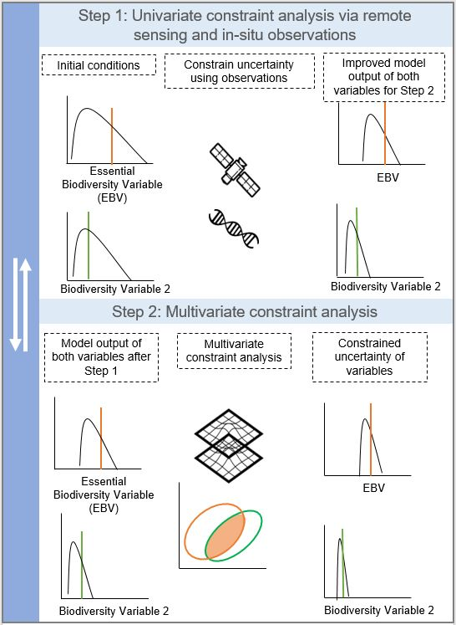

**Figure 1:** Schematic leveraging multiple biodiversity model outputs, remote sensing, and in-situ observations to evaluate and constrain uncertainty of biodiversity variables. Step 1 illustrates direct constraints using remote sensing and in-situ observations of an EBV to inform initial model conditions. Step 2 illustrates multivariate constraints of EBV uncertainty and related (but biologically different) biodiversity variable 2 output from two different models. Step 2 illustrates both a direct and indirect constraint of the EBV via a combination of using remote sensing to constrain the related biodiversity variable output (biodiversity variable 2) and subsequent model overlap to decrease uncertainty of the predicted EBV further.

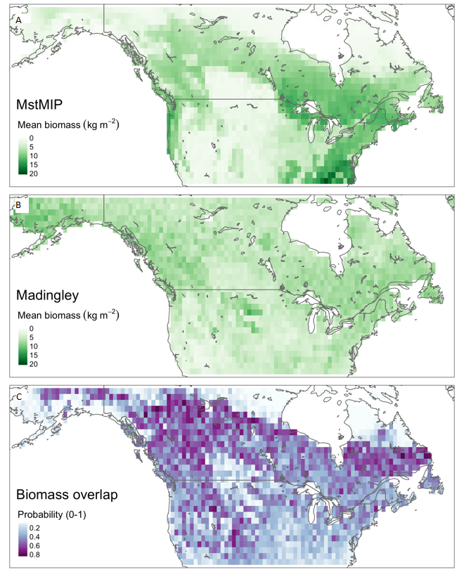

c

b

a

**Figure 2:** Mean estimates of vegetation biomass (kg m-2) from the MstMIP multi-model ensemble (a), the Madingley model ensemble (b), and the fraction of distribution overlap of the vegetation biomass estimates and their uncertainties for each pixel (c).

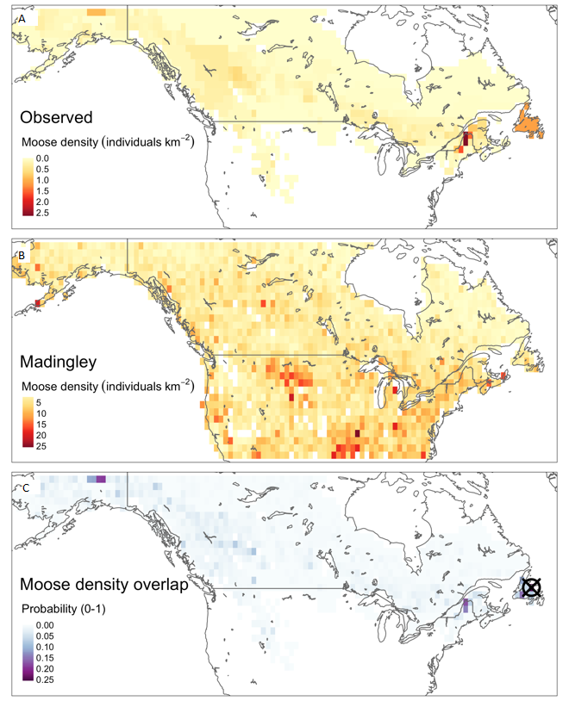

c

b

a

**Figure 3:** Moose density (individuals km-2) from in-situ observations (a). Mean estimates of moose density from a six-member ensemble simulation of the Madingley model (b). The agreement between moose density observations (a) and Madingley estimates (b) for each pixel (c), expressed as the overlap between the pixel-specific probability distributions (Equation 1). The pixel used for the multivariate constraint analysis is indicated by the symbol in panel c.

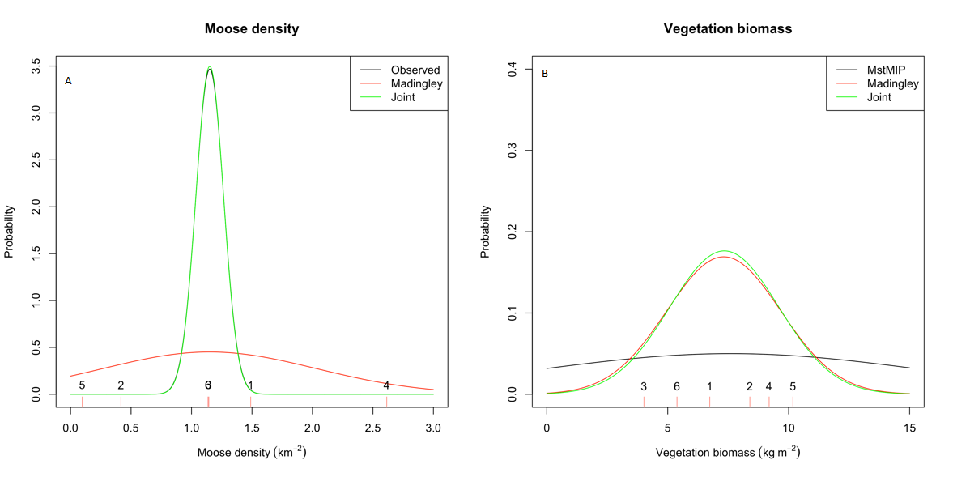

**Figure 4:** Results of the univariate constraint analysis. The black lines are the distribution of observed moose density (a)* and the MstMIP ensemble estimates of vegetation biomass (b). The labeled red dashes indicate individual predictions from the six Madingley ensemble members, and the red line in each figure is the normal distribution approximated by this six-member ensemble (i.e., parameterized according to the sample mean and standard deviation calculated from the six-member ensemble). The green lines show the best-estimate distribution from combining the model estimates and observations for moose density and the MstMIP and Madingley model estimates of vegetation biomass. *In Panel A the black moose density line tracks the green line (described below) almost perfectly making it difficult to distinguish on the graph.

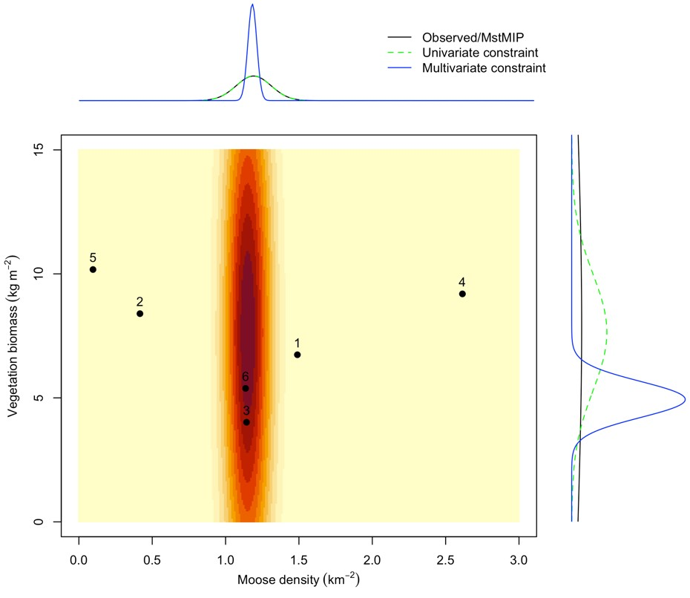

**Figure 5:** Results of the multivariate constraint analysis outlined in Figure 1 Step 2. The labeled black dots are the six Madingley ensemble joint estimates of moose density (individuals km-2) and vegetation biomass (kg m-2). Shading indicates the joint probability of moose density and vegetation biomass based on the MstMIP/observed distributions represented by the black lines in the marginal density plot. The blue lines in the marginal density plot represent the marginal distribution of the two variables after the multivariate constraint has been applied. The green dashed lines in the marginal plots show the distribution of the estimates from Figure 4 if only the univariate constraint step is applied.

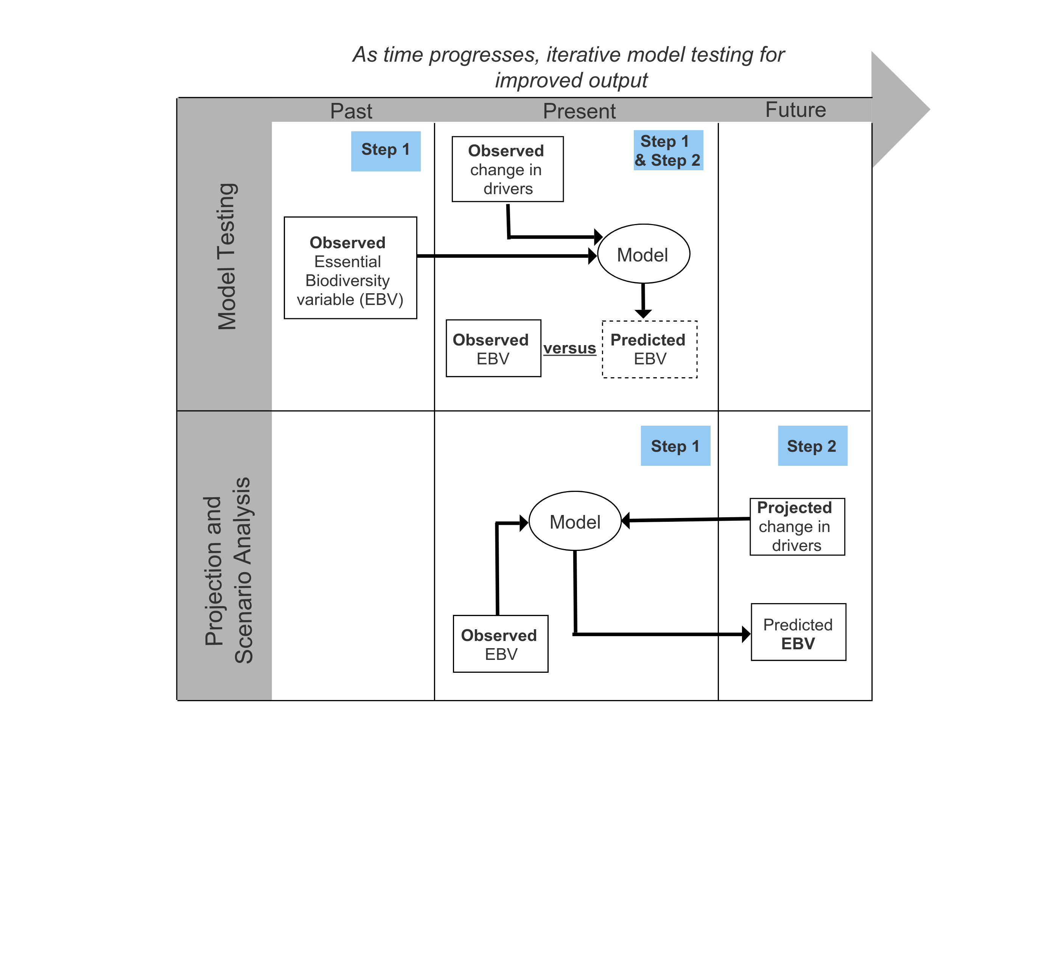

**Figure 6:** Framing of the multivariate approach to evaluating and reducing uncertainty in model-based biodiversity projections within a broader model testing and biodiversity policy and decision-making context. The approach to constrain biodiversity uncertainty via both univariate (Step 1 from Figure 1) and multivariate constraints (Step 2 from Figure 1) are mapped here to show at what time step (past, present, or future) remote sensing, in-situ observations, and multi-model overlap of related biodiversity variables can directly constrain initial conditions of an EBV (Past), directly and indirectly constrain EBV uncertainty to improve and refine model output (Present), and indirectly constrain uncertainty of EBV projections (Future).