USING SECONDARY CRATERS TO ASSESS STRENGTH DIFFERENCES BETWEEN NEIGHBORING SURFACE UNITS. J. W. Conrad¹ and C. I. Fassett¹, ¹NASA Marshall Space Flight Center, Huntsville, AL 35805. (jack.w.conrad@nasa.gov)

Introduction: An issue with Martian remote sensing studies is the difficulty directly inferring surface and crustal material properties. For direct measurements we currently rely on the instruments of landed missions, like InSight. However, these are limited to specific locations (i.e., Elysium Planitia for InSight). To understand how results from in situ missions apply to other parts of Mars’ crust, we would like to apply a methodology that uses remote sensing. We are exploring using secondary craters, which are often thought of as nuisances when finding accurate relative ages, to get at these properties. An upside of secondary craters is that they form by ejecta blocks moving at relatively slow speeds (compared to primary impacts), which lets them reside in a different crater scaling regime [1], one that is more sensitive to the crust’s effective strength (Y_{eff}) and its porosity.
Secondary Crater Scaling: There are multiple parameters that influence the size of secondary craters, but we can measure craters in ways that isolate the dependence of crater size to just Y_{eff}. We focus on secondary clusters that have impacted into distinct but bordering geological units. These secondaries can be used to determine Y_{eff} thanks to one important fact: all the secondaries in this cluster are from the same distant primary, and as a result, the ejecta velocity, median block sizes, and densities are expected to be the same (at least to first order). Thus, variations between crater size on the two units are due to material property differences (i.e. Y_{eff}). Thanks to the steep size frequency distributions (SFD) of secondaries [2], observable secondary crater sizes are tightly clustered, and we can simply use differences in median secondary sizes between two geologic units to constrain the ratio of Y_{eff}. We are also able to use the SFD of our counting areas to check if our counted craters are secondaries (i.e. have a steep distribution), and if the two crater counting areas are from the same source (and thus have the same power law slope), but are offset from each other at around the same factor as the median difference.
Counting Methodology: Our methodology needs to take care to identify secondaries within the same cluster, but lying in the contact region of two geologic units. Other secondary clusters from the same primary do not necessarily conform [2] to the same median crater diameter (and thus median impact debris size) and can create a false positive signal. Primaries will also change the crater distribution, but are easier to pick out based on degradation state or other morphological tells.
For surveying sites of interest, we aim towards younger and/or larger primary craters, as those tend to have fresher secondaries that are easy to count. Once we identify a primary of interest, we note the geologic boundaries surrounding it and if others have mapped out secondary fields in those areas. We then determine two counting areas at approximately same distance from the primary, one in each unit. We identify and count secondaries in each area and our analysis uses those results.
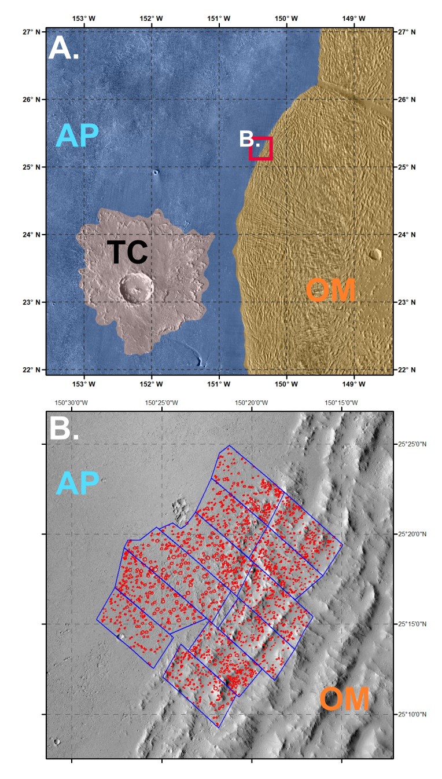
Figure 1: A. (Top Panel) Map of study area, which includes Tooting Crater (TC) and the bordering units of Amazonis Planitia (AP; blue) and the Olympus Mon Aureole (OM; orange). The approximate location of the bottom panel is shown as the red square. B. (Bottom Panel) Secondary crater count areas for the two units. This single cluster was divided up to test median size sensitivity to range from the primary crater.

Example Results: We have initially used this technique with the secondary crater fields of Tooting Crater, Mars (TC; [3]). TC is a young complex crater that is situated in the Amazonis Planitia (AP) region and the surrounding area can be observed in Fig. 1A. TC has many fresh secondary craters that are relatively easy to count. In the northeast section of TC’s secondary field (found at -150.35˚ lon, 25.25˚ lat), there is a geologic unit boundary between AP and the Olympus Mons Aureole (OM) that contains a large number of secondaries from the same cluster across the boundary.
AP is a volcanic plain, like Elysium Planitia, that lies in the border regions of the northern lowlands. OM, however, is a unit made from successive landslides off Olympus Mons that might be expected to be relatively weak and/or more porous compared to the AP volcanic plains. In addition, a recent observation of increased buried water ice in the unit [4], especially compared to AP, might drive the Y_{eff} value lower and the secondary sizes further from each other.
What we find when we count the secondaries in that cluster (Fig. 1), however, is that the median diameter of secondaries in AP is larger than those is OM (Fig. 2). This implies that either Y_{eff} is lower or the porosity is higher in AP.

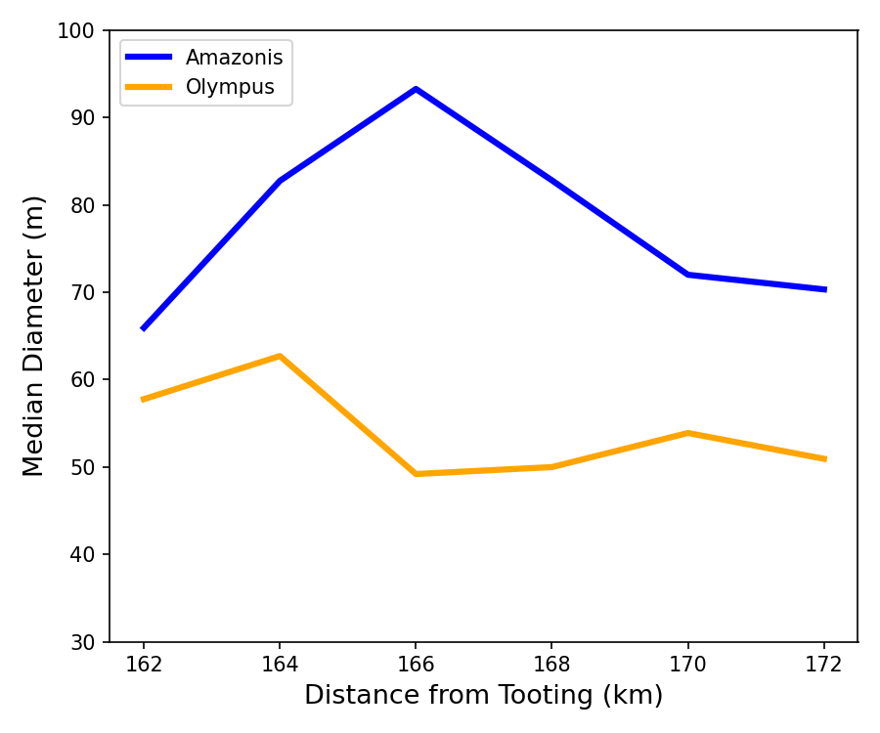
Figure 2: Median crater count diameter in each unit. AP (blue) shows a consistently higher median diameter compared to OM (orange) over the whole range. No clear range effects were observed, likely due to the relatively short distribution (12 km).

We can use [1] to translate from these median diameters to a Y_{eff} ratio of OM to AP (Fig. 3) if we assume that the porosity is constant between the two units. This ratio that we calculate varies over the range, because of the inconsistent increase in AP secondaries compared to OM ones over the range (perhaps due to secondary clustering effects). We find that over our counting range the Y_{eff} ratio of OM:AP varies from 2 to 14, and if we take the median of the whole count in each unit, we obtain Y_{eff} ratio ~ 5. In other words, this implies that the crust of OM is five times stronger than AP, or the opposite of what we hypothesized based on their geology.

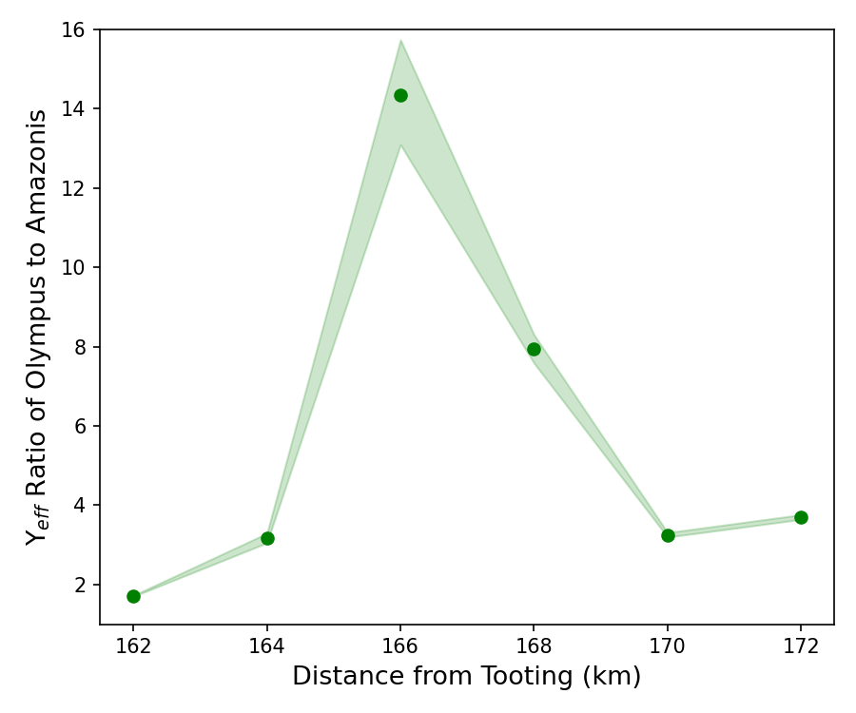
Figure 3: Y_{eff} ratio over the counting area range assuming that porosity is the same in AP and OM.

Conclusion and Future Work: While the method produced results, which show a minor difference in the Y_{eff} value between our two study areas, the results run counter to our expectations. The geology of the two units in the study region can be better constrained by our results. In the future, we plan on testing differences in porosity and how that could explain the signal we observe in, creating a network of Y_{eff} ratios for Mars’ crust with more comparison sites, and expanding to the Moon and Mercury.
Acknowledgments: J.W.C. is supported by an appointment to the NASA Postdoctoral Program at the Marshall Space Flight Center. This work was also done with support from the Solar System Workings program.
References: [1] Holsapple, K.A. and Schmidt, R.M. (1987) JGR: Solid Earth, 92(B7), 6350–6376. [2] McEwen, A.S. and Bierhaus, E.B. (2006) Annl. Rev. EPS. 34:535-567. [3] Mouginis-Mark, P.J. and Boyce, J.M. (2012) Chemrie der Erde 72: 1-23. [4] Wilson, J.T. et al. (2018) Icarus, 299, pp.148-160.

