ULTRAVIOLET/VISIBLE REFLECTANCE SPECTRA OF RETURNED SAMPLES OF (162173) RYUGU UNEXPOSED TO EARTH’S ATMOSPHERE. F. Vilas¹, A. R. Hendrix¹, C. Jaramillo², N. Pearson¹, M. E. Zolensky³, D. L. Domingue¹, E. Cloutis⁴, R. Clark¹, G. Holsclaw⁵, J. P. Allain², T. Nakamura⁶, M. Matsuoko⁷, K. Amano⁶, T. Morita⁶, M. Kikuiri⁶, E. Kagawa⁶, H. Yurimoto⁸, T. Noguchi⁹, R. Okazaki¹⁰, H. Yabuta¹¹, H. Naraoka¹⁰, K. Sakamoto¹², S. Tachibana^{12,13}, S. Watanabe¹⁴, Y. Tsuda¹²,¹Planetary Science Institute (1700 E. Fort Lowell Rd., Suite 106, Tucson, AZ, 85710, USA, fvilas@psi.edu),²Pennsylvania State University (State College, PA, USA),³NASA Johnson Space Center (Houston, TX, USA),⁴University of Winnipeg (Winnipeg, Manitoba, Canada),⁵University of Colorado (Boulder, CO, USA),⁶Tohoku University (Sendai 980-8578, Japan),⁷LESIA, Observatoire de Paris (Paris, France),⁸Hokkaido University (Sapporo 060-0810, Japan),⁹Kyoto University (Kyoto 606-8502, Japan),¹⁰Kyushu University (Fukuoka 812-8581, Japan),¹¹Hiroshima University (Higashi-Hiroshima 739-8526, Japan),¹²ISAS/JAXA (Sagamihara 252-5210, Japan),¹³The University of Tokyo (Tokyo 113-0033, Japan),¹⁴Nagoya University (Nagoya 464-8601, Japan).

Introduction: Following the successful return of JAXA’s Hayabusa2 sample capsule, the material from asteroid (162173) Ryugu retrieved from the spacecraft retrieval container has been the subject of multi-pronged analyses [e.g., 1]. We undertook an effort to acquire reflectance spectra covering 200- to- 1100 nm of particles from Ryugu. This region probes the near-ultraviolet (NUV) to acquire reflectance spectra that cover the 250-nm Fresnel peak that can result from increased graphitization (reduced H content) of carbon-bearing materials. Laboratory tests show that increased graphitization could result from the effects of increased temperature, an effect of space weathering of materials closer to the Sun. Some ground-based reflectance spectra and space-based photometry of Ryugu show that reflectance is increasing with decreasing wavelength, suggesting the beginning of a UV upturn [2]. We sought evidence for space weathering (graphitization) of the Ryugu material at NUV wavelengths, by acquiring reflectance spectra of surface samples.
Instrumentation and Procedure: Five particles of Ryugu’s surface material were sent to the University of Illinois, Champaign-Urbana from Japan. These pristine samples from Ryugu were unexposed to ambient air. They were packed in a glove box in N₂ in separate sealed plastic containers. The package was transferred to a glove box filled with N₂. We chose to not mix the particles, as they potentially had different compositions. For each particle, separate spectra were acquired.
Each particle was first removed from the sealed plastic container and placed in a compact sample capsule. The sample capsule has the capability to hold small volumes of a sample in a controlled environment (Ar or N₂) at ambient pressure; it can preserve an air-sensitive sample for 3 weeks with no visible sample reaction [3]. The sample capsule was then removed from the glove box and positioned with the rest of the spectral apparatus. Adjustments were made to avoid measuring reflections from the chamber. Several spectra of each grain were obtained to ensure repeatability.
The experimental equipment consisted of a light source and Avantes spectrometer, fiber optic probes mounted on a goniometer, and the compact sample capsule [3]. Both tungsten and deuterium lamps were used to illuminate the sample across the full spectral region, through a sapphire window in the sample capsule.
Table I lists the 5 particles we received; sizes were roughly measured using scale information. We successfully obtained spectra of three of the particles. The two smallest particles were, however, too small to provide sufficient signal to measure successfully.

Table I. Ryugu Particles:

Sample length (µm) width (µm)
A0055 1090 1037
A0064 1242 936
C0040 1475 688
C0061a 503 426
C0103 798 654

Interim Results: Because these particles had not been exposed to air, the best comparison sources for modeling their spectra are spectra of samples not exposed to air, or planetary objects themselves. We have been acquiring spectra of terrestrial and meteoritic samples under inert gas conditions through the NUV, as these spectra have not been acquired prior to this attempt. We have also been comparing the Ryugu laboratory spectra to the UV asteroid spectra we have from space-based observations. Figure 1 shows four spectra of Ryugu chip A0055, demonstrating rough repeatability in the spectra of the chip. The figure also compares these spectra to IUE spectra of B-class asteroids [2]. The similarities to the B-class asteroids in the NUV lend support to the presence of absorption features in the NUV spectral region of the B-class asteroids [2] and additional information about the attributes of these asteroids. To date, we find no sign of graphitization. These are preliminary results; current results will be presented.
Acknowledgments: This work was funded by NASA through the SSERVI Toolbox for Research and Exploration program (NNH16ZDA001N).
References: [1] Nakamura T. et al. Submitted. Science. (2022) [2] Hendrix A. R. and Vilas F. (2019) Geophys. Res. Lett., 46. [3] Jaramillo C. et al. (2021) AGUFM, P11A-06.

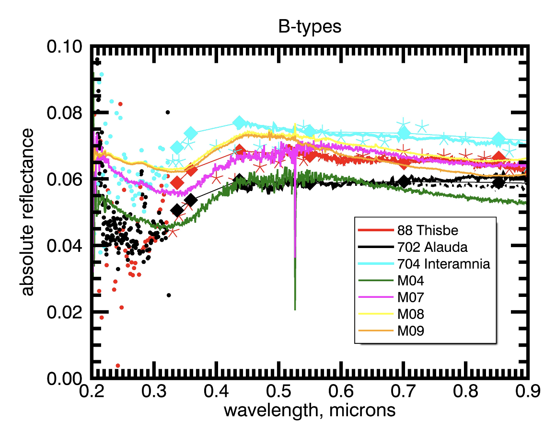

Fig. 1. Four reflectance spectra of Ryugu chip A0055 plotted with UV/VIS reflectance spectra of B-class asteroids (88) Thisbe, (702) Alauda, and (704) Interamnia.

