OLIVINE DISSOLUTION AND FORMATION OF SECONDARY PHASES IN ULTRAMAFIC SOILS. A. D. Feldman¹, E. M. Hausrath¹, E. B. Rampe², T. Peretyazhko³, P. Burnley¹, O. Tschauner¹, R. V. Morris², V. Tu³, T. Lanzirotti⁴, M. Newville⁴, ¹University of Nevada, Las Vegas 4505 South Maryland Parkway Las Vegas NV 89154 (primary author email: feldma2@unlv.nevada.edu), ²Johnson Space Center, Houston TX, ³Jacobs at Johnson Space Center, Houston TX, ⁴U. of Chicago, Chicago IL

Introduction: Olivine has been proposed as an indicator for the duration of water-rock interaction within Martian rocks and sediments [1-3]. The use of olivine as a mineralogical indicator for past aqueous alteration on Mars requires interpretation of a complex combination of factors including pH, temperature, and composition [5,6]. Here, we examine the persistence of natural olivine within terrestrial ultramafic soils (Fe/Mg-rich, Al-poor) developing under different climatic conditions and the incipient dissolution of emplaced forsterite (Fo) and fayalite (Fa) surfaces to investigate environmental effects on incipient olivine dissolution, olivine persistence in soils, and formation of secondary phases.
Methods:
Field Sites. We examined olivine weathering and secondary material formation in ultramafic soils at 6 sites in the Klamath Mountains (KM) of northern California with a mean annual temperature of ~12.8℃ and precipitation of ~55.7-95.4 cm/year [7], and soil pH of ~6.5-7.3; 4 sites in the Tablelands (TB) of Newfoundland, Canada with a mean annual temperature of <3.9℃ and precipitation of ~120.0 cm/year [8], and soil pH of ~7.7; and at 3 sites at Pickhandle Gulch (PG), Nevada with a mean annual temperature of ~14.4℃ and precipitation of ~14.1 cm/year [7], and soil pH of ~8.5. Sampling sites span an age range of ~12.1-50+ kya in the Klamath Mountains [9,10] and ~13-30 kya in the Tablelands [11]. Pickhandle Gulch sites are undated.
Parent Material and Soil Analyses. Polished thin sections of bulk soil prepared by Wagner Petrographic, Inc were carbon-coated and analyzed on a JEOL 2100 SEM in back-scattered electron mode in the EMIL lab at UNLV and at the 13-ID-E synchrotron beamline at Argonne National Laboratory using µXRF, µXRD, and XAS. Soil and parent material samples were powdered in a Fritsch pulverisette and analyzed by XRD and soil by VNIR. Soil preparation is further described in [12].
Disk Preparation, Burial, and Collection. Fo disks were cut from a column prepared via hot-pressing and Fa disks by sintering synthetic fayalite powder, see [13] for detail. Disks were polished to a 0.25-micron level with diamond grit. Disks were buried in 3 KM soils, 4 TB soils, and 3 PG soils, collected after exactly 365 days, and washed gently with 100% reagent grade ethanol to remove potential adhered soil material. Weathered disks and soil samples were stored in a -20℃ freezer until analysis. Unaltered control disks prepared identically to the buried disks were stored at -20℃ for the duration of the experiment.
Disk Analyses. One Fo and Fa disk from each climate zone was analyzed on a variable pressure Zeiss Supra 40VP SEM at Northern Arizona University. A separate Fo and Fa disk from each climate zone was analyzed by XPS using a Physical Electronics VersaProbe II at the Penn State Univ. Materials Characterization Lab after a Na-dodecyl sulfate wash and ozonation to remove carbon contamination as in [14]. VNIR measurements were conducted at Johnson Space Center using an ASD FieldSpec3 under ambient lab conditions on a separate Fo and Fa disk from each climate zone. One separate Fo and Fa control sample was analyzed for each technique for comparison with weathered samples. XPS uncertainty was determined from 5 repeat measurements on controls.
Results:
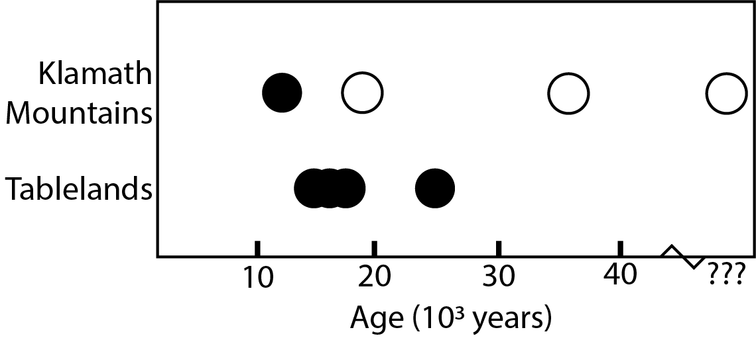
Figure 1: Olivine persistence within KM and TB soils. Closed circles indicate olivine presence, and open circles olivine absence. Olivine persists to ~12.1 ka in the KM but >20 ka in the TB.
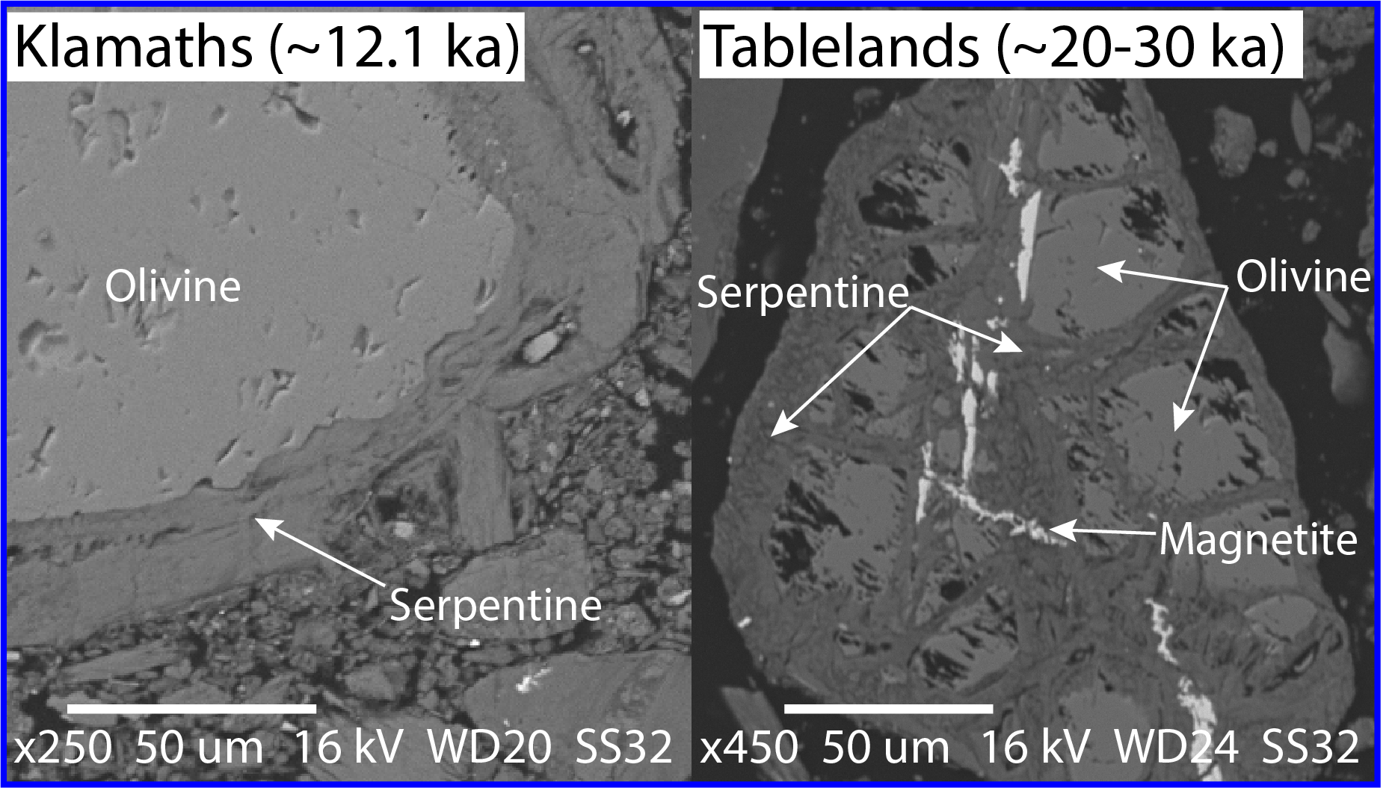
Figure 2: Olivine in SEM images from the oldest KM/TB soils where olivine was present.
Bedrock and Soil Results Olivine is present in the parent material in the KM and TB. Olivine is found in ~12.1 ka KM soils but is absent from all older soils, while persisting into the oldest (>20 ka) TB soil (Figure 1). In both locations, olivine is found as cores surrounded by a serpentine rind (Figure 2). VNIR spectra from the analyzed soils possess strong OH-associated spectral features at ~2.33 µm indicating the presence of Mg-rich phyllosilicates as well as ferric-oxide features at ~0.92 µm in the KM (Figure 3). Primary crystalline silicate grains mostly incorporate Fe²⁺, while poorly crystalline weathering rinds are best fit by ferric oxide XAS standards (Figure 4). µXRF also shows that Fe and Ni concentrate in weathering rinds and Cr remains within interior silicate grains (Figure 4).
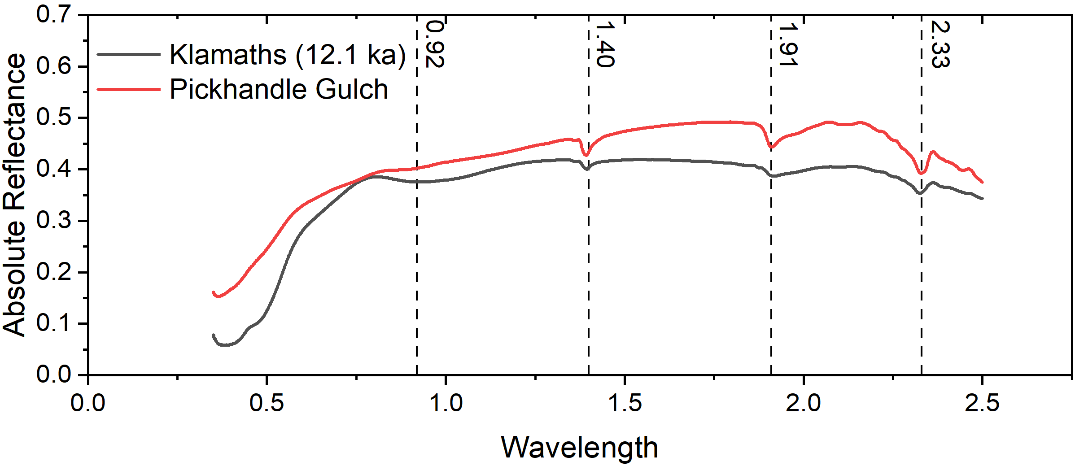
Figure 3: VNIR spectra of bulk soils from a 12.1 ka KM soil and from a PG soil. Features at ~2.33 µm indicate Mg-phyllosilicate presence. A feature at ~0.92 µm indicates ferric oxide presence in KM soil.
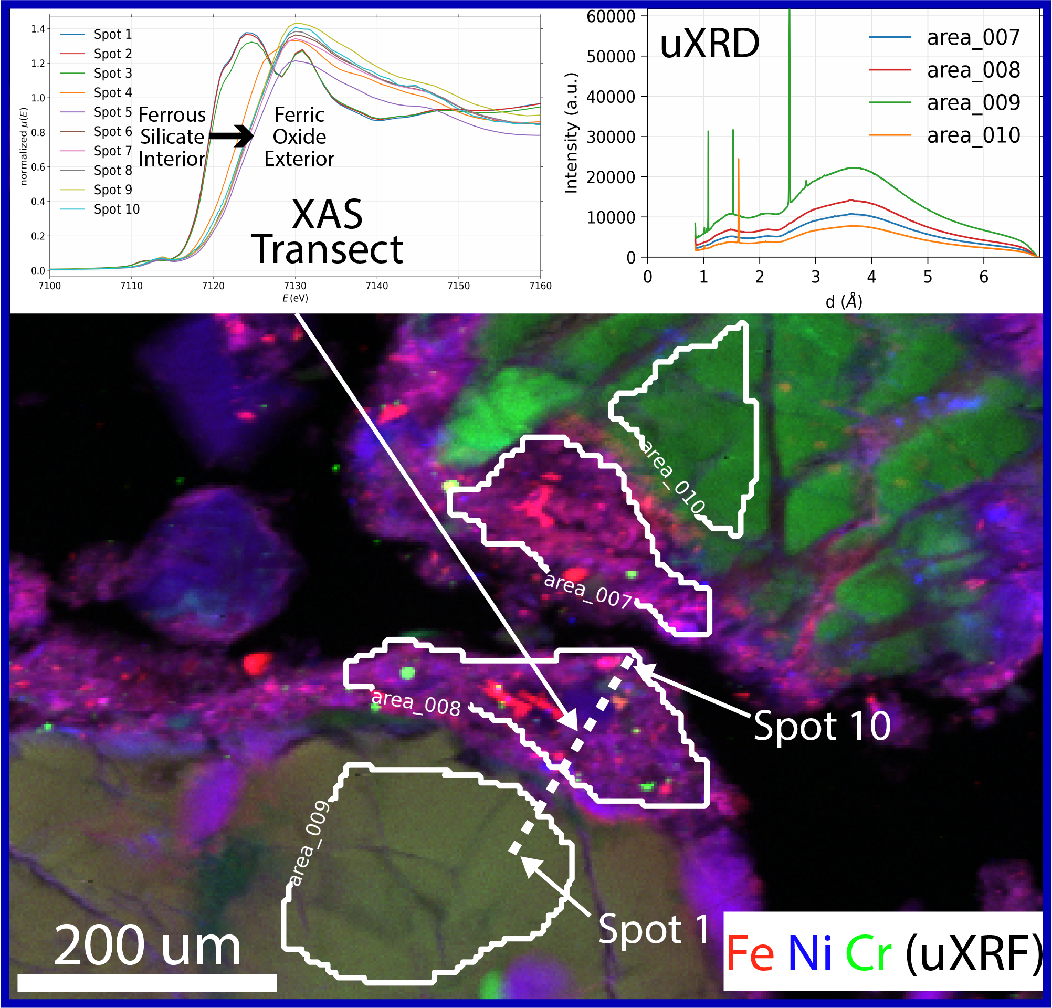
Figure 4: μXRF map of a 12.1 ka KM soil showing μXRD of selected areas and an XAFS transect.
Buried Sample Results All Fo surfaces exhibited formation of dissolution features including shallow pitting not observed on controls. Dissolution features were most visually widespread on the KM disk (Figure 5). Leaching of Mg from KM and TB Fo disks was evident from <1.6 Mg/Si ratios measured by XPS (Figure 6). Fe-rich precipitates in SEM (Figure 5) and Fe presence in XPS scans (Figure 6) indicate Fe deposition onto KM and TB Fo disk surfaces. The appearance of a spectral feature at 0.55 µm in the VNIR spectra from the TB Fo suggests this Fe is ferric (Figure 7). The PG Fo appears least altered, with minimal formation of dissolution features in SEM (Figure 5), a Mg/Si ratio inconsistent with leaching (~2) (Figure 6), and VNIR spectra almost identical to the control sample. Analysis of Fa surfaces is ongoing.
The higher temperatures and more acidic pH in the KM soils likely drive the faster dissolution of the Fo disks described above. While the TB soils experience greater precipitation than in the KM, the cooler temperatures and more basic soil pH facilitate observable but more limited alteration. The dry climate and basic soil pH at PG lead to minimal dissolution of the PG disk surfaces.
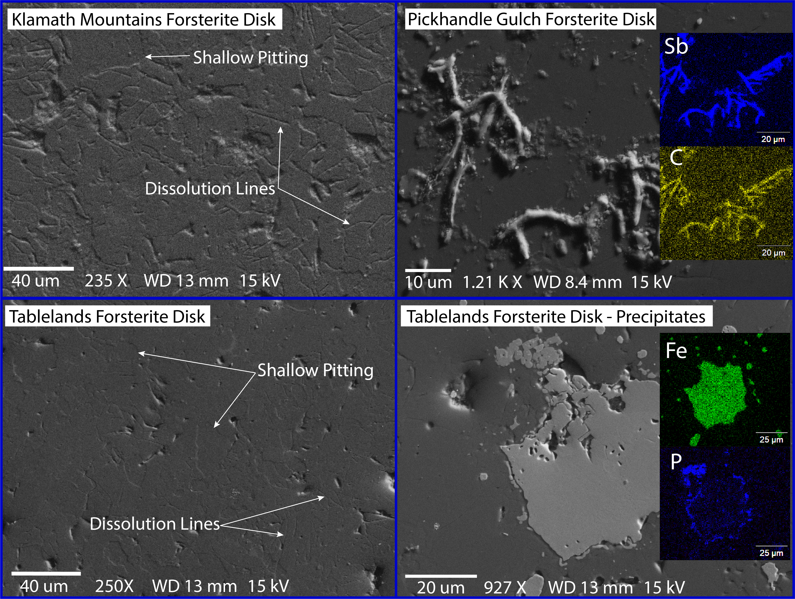
Figure 5: SEM images of Fo disks buried for 365 days.
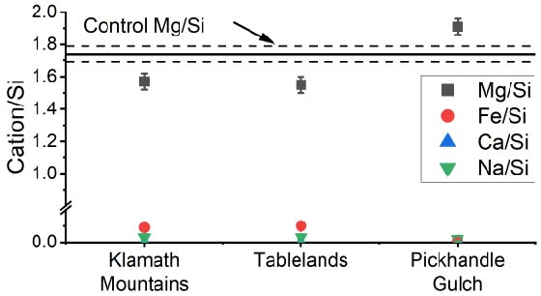
Figure 6: Cation/Si ratios on disk surfaces from XPS.
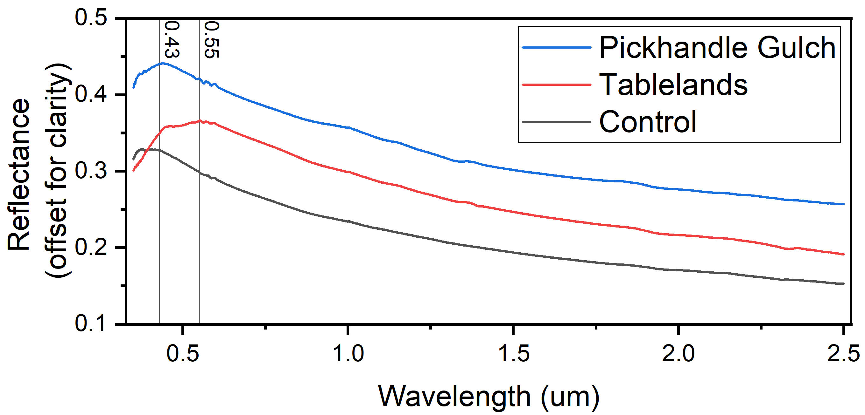
Figure 7: VNIR spectra from Fo disks. The shoulder at ~0.55 µm indicates Fe³⁺ presence on the TB disk.
References: [1] Hausrath et al. (2008) Geology 36, 1, 67-70 [2] Stopar et al. (2006) GCA 70, 24, 6136-6152 [3] Olsen and Rimstidt (2007) Am Min 92, 4, 2007 [4] Tosca et al. (2004) LPS XXXV Ab. 1043 [5] Wogellius and Walther (1992) Chem Geo 97, 101-112 [6] Stopar et al. (2003) 6th Int. Con. on Mars Ab. 3151 [7] NOAA 1991-2020 Climate Normals [8] Environmental Canada 1981-2010 Climate Normals [9] Sharp (1960) Science, 258, 305-340 [10] Daniels et al. (2005) The Holocene, 15, 7, 1062-1071 [11] Osborn et al. (2007) Can. J. Earth. Sci, 44, 819-834 [12] Feldman et al. (2020) LPS LII Ab. 1782 [13] G Xia (2013) Diss. UC-Riverside. [14] Hausrath et al. (2008) Astrobiology 9, 6, 1079-1092

