Grand Teton Ecological Forecasting
Assessing Forage Change and Winter Habitat Availability for Bighorn Sheep that Employ a High-Elevation Overwintering Strategy to Identify Areas for Intervention


Technical Report
Final – November 18th, 2021

Alex Posen (Project Lead)
Allyson Earl
Sarah Hettema
Michael Hitchner

Advisors:
Keith Weber, Idaho State University, GIS Training and Research Center (Science Advisor)
Joseph Spruce, Science Systems and Applications, Inc., Diamondhead, MS (Science Advisor)

1. Abstract
Grand Teton National Park provides habitat for a small native population of approximately 125 bighorn sheep (Ovis canadensis). The reduction in population of this species is attributed to loss of low elevation habitat, changing local environmental and climatic conditions, and increased disturbance from backcountry recreation. In response to these changes, this population of sheep employs a unique high-elevation wintering strategy in which they amass large fat stores in the summer and expend as little energy as possible in the winter while foraging on high elevation wind-swept and snow-free areas. For this project, DEVELOP partnered with Grand Teton National Park and used NASA Earth observations including Landsat 8 Operational Land Imager (OLI), Landsat 7 Enhanced Thematic Mapper Plus (ETM+), Landsat 5 Thematic Mapper (TM), and Terra Moderate Resolution Imaging Spectroradiometer (MODIS) snow cover data to assess habitat suitability. Landcover change analyzed between 1987 and 2020 indicated shifting trends in grass and forb cover and tree cover. These trends persisted in the 2031 prediction, with grass cover decreasing and tree cover increasing, which translates to a loss of overall favorable habitat for bighorn sheep. Snow cover analyzed between 2001 and 2020 indicated similar unfavorable trends for the sheep with a decrease in barren areas, important for winter foraging. Finally, habitat suitability was modeled for 2020 and predicted to 2031 to determine habitat gains and losses for this species across the landscape. Overall, the results predicted decreases in suitable habitat and indicated that while these sheep are highly adaptable, strategies to manage suitable bighorn habitat may need to be employed rapidly to effectively conserve this species.

Key Terms
Remote sensing, habitat suitability modeling, TerrSet, Landsat, MODIS, land cover change, snow cover change

2. Introduction
2.1 Background Information
Migratory ungulate populations are in decline around the globe as anthropogenic impacts threaten migration routes and historical seasonal ranges in the form of habitat destruction and shifting climate and seasonality (Courtemanch, 2014; Singer et al., 2001). The migratory patterns and adaptations of these ungulates have generally allowed them to sustain large populations and high levels of fitness, however, this is changing for a population of bighorn sheep (Ovis canadensis) in the Teton Mountain Range (Figure 1). Historically, the bighorn sheep experienced significant population decline in this region through the late 1960s due to introduced disease from domestic livestock and the elimination of lowland habitats (Courtemanch et al., 2017; Whitfield, 1983). However, due to conservation efforts by the National Park Service (NPS) within Grand Teton National Park and other organizations spanning the nearby Caribou-Targhee National Forest, a dwindling endemic population of approximately 60-80 bighorn sheep has continued to persist (Teton Bighorn Sheep, 2017). Today, climate change and increased human activities such as urban development and outdoor recreation have continued to decrease the former range of the species and populations are now restricted to a single seasonal range or split between two seasonal ranges (Courtemanch, 2014; Pettorelli et al., 2007). This disruption in migratory patterns has been implicated in driving the current population decline of these ungulates due to limitation of suitable foraging and overwintering habitat (Courtemanch et al., 2017; Singer et al., 2001).

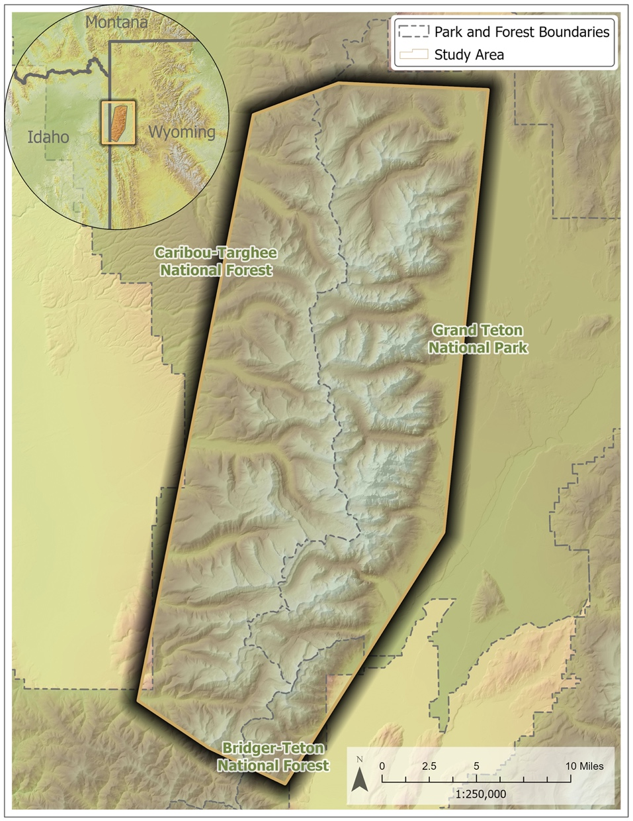
Figure 1. Study area encompasses the majority of the Teton Mountain Range near Jackson in northwestern Wyoming. The study area contains portions of Grand Teton National Park, Caribou-Targhee National Forest, and Bridger-Teton National Forest. Digital Elevation Model (DEM) and hill shade products derived from the USGS National Elevation Dataset (NED). Locator map data provided by CHS, ESRI, GEBCO, DeLorme, and NaturalVue.

The Teton Mountain Range is characterized by rugged mountain peaks that run from east to west and range in height between 2,000 to 4,197 meters. This region contains a diverse network of suitable bighorn habitat including vegetation from alpine, mesic sagebrush, meadow, and grassland plant species (Courtemanch, 2014; Whitfield, 1983). Historically, bighorn sheep in this region employ a unique high-elevation wintering strategy in which they amass large fat stores in the summer and expend as little energy as possible in the winter while foraging on high elevation wind-swept and low-snow or snow-free areas (Whitfield, 1983). While many bighorn populations in the U.S. migrate seasonally in a similar fashion, this population in the Teton Mountain Range has shifted its historical migration strategy from utilizing a high elevation (2800–3100 m) summer habitat and a lower elevation (1900–2300 m) winter habitat to residing almost exclusively in the high elevation summer habitat year-round (Courtemanch et al., 2017; Whitfield, 1983).

As the home range of this unique population of bighorn sheep continues to be affected by the impacts of climate change and human activities, such as backcountry skiing and urbanization, it is important to understand how historical and current shifts in the environment may change suitable habitat for this species now and into the future. This project compared recent and historical habitat data to understand how variables such as land cover change and snow cover fluctuations have affected bighorn sheep habitat between 1987–2020, and forecasted comparable habitat changes to 2031.

2.2 Project Partners & Objectives
The primary partner for this project was the National Park Service Grand Teton National Park, which manages an extensive portion of the habitat in which the bighorn sheep are found and has a philosophy of using nature-based solutions to environmental management problems such as the conservation of bighorn sheep habitat. NPS currently identifies bighorn sheep locations through the use of GPS collars and through a database of citizen science observations. These data have then been used to develop protective buffer zones for bighorn habitat, especially during winter months when the recreational use of this habitat is high (Teton Bighorn Sheep, 2017). Additionally, these data and NASA Earth observations have been used previously to create a snapshot of suitable habitat for bighorn sheep (Courtemanch, 2014). An additional collaborator on this project was the Teton Range Bighorn Sheep Working Group, which is comprised of biologists from US Forest Service, Bridger-Teton and Caribou-Targhee National Forests, Wyoming Fish and Game, Northern Rockies Conservation Cooperative, and Wyoming Wild Sheep Foundation.

Land managers are considering implementing restoration and conservation strategies to improve low-elevation bighorn sheep winter range in the area. Understanding how this habitat has changed historically and may change into the future due to shifting variables such as snowpack and land cover will provide nuanced information that can be used to create a more effective and targeted approach to restoring and conserving discrete regions within the study area. Our study objectives were as follows: 1) conduct a land cover change analysis between 1987–2020 using the Landscape Change Monitoring System (LCMS) land cover data derived from Landsat imagery to elucidate what land cover changes may be driving sheep home range movements, 2) analyze changes in snow cover using MODIS data to understand overwintering habitat for 2001–2020, 3) forecast future land cover and snow cover change to 2031, and finally 4) create a 2020 and 2031 habitat suitability model.

3. Methodology

3.1 Data Acquisition
We acquired data from several sensors and downloaded these data in raster format. After our initial data download, we clipped these layers to the project study region. We downloaded the LCMS data, derived from Landsat 4 and 5 Thematic Mapper (TM), 7 Enhanced Thematic Mapper Plus (ETM+), and 8 Operational Land Imager (OLI) sensors (30m spatial resolution) and the Sentinel-2 MultiSpectral Instrument (MSI) sensor (10m spatial resolution, 2020 data only), through the USDA Forest Service LCMS data portal and used this to assess land cover change across the time period. Additionally, we downloaded Terra Moderate Resolution Imaging Spectroradiometer (MODIS) snow data (MOD10, 500m resolution) to analyze shifting snow cover. For topographic variables such as aspect, elevation, and slope, we used the National Elevation Dataset (NED; Table 1). To define the study area, we used Google Earth Engine’s (GEE) polygon tool to recreate the Courtemanch et al. (2014) study area to maintain consistency and cohesion between the current project and NPS policies that were based on the Courtemanch thesis. In situ GPS collar data from 2008–2021 were provided by our partners at NPS along with shapefiles of suitable summer and winter habitat in the region.

Table 1
Data products utilized in project analysis.
Data Type | Source | Native Resolution | Image Date | Access/Processing
Topography – Elevation | National Elevation Dataset (NED) | 10m | 1999–2001 | USGS/ArcGIS Pro
Snow Cover | MODIS  (MOD10) | 500m | 2001–2003, 2018–2020 | GEE/ArcGIS Pro and TerrSet
Land Cover –Landscape Change Monitoring System (LCMS) | Landsat 4 and 5 TM, 7 ETM+, and 8 OLI  Sentinel-2 MSI | 30m | 1987, 2020 | USDA Forest Service LCMS data portal/ArcGIS Pro and TerrSet

3.2 Data Processing
3.2.1 Raster Data Acquisition and Processing
For our analysis, we acquired data from several sources to use data as inputs for land cover predictions and habitat forecasting. These data were all in raster format and were loaded into ArcGIS Pro 2.8.3. We exported sheep GPS points, provided by project partners, from a CSV spreadsheet into ArcGIS Pro and visualized them relative to the extent of the study area. We extracted trail data from a Grand Teton National Park trail shapefile and the USDA National Forest trails dataset and then converted them into a geodatabase feature class upon analysis in ArcGIS Pro. The vector features were merged and clipped to the study area. We derived topography variables slope, aspect, and solar radiation from the NED digital elevation model (DEM). These data created the backdrop for the land cover change, snow cover change, and habitat suitability analysis preformed in this study.

3.2.2 Land Cover Change Processing
We acquired annual LCMS land cover map data, reprojected the layers to Universal Transverse Mercator Zone 12N (WGS_1984_UTM_Zone_12N), and clipped each layer to the study area. For our land cover change analysis, we used LCMS images from 1987 and 2020. Then, we reclassified the original 14 land cover classifications into 7 generalized classes (Table 2, Figure 2). We used literature review and project partner input to determine the reclassification structure based on the sheep’s diet and habitat preference (Courtemanch, 2014; Whitfield, 1983). The study area did not include any pixels classified as tall shrubs and trees mix or tall shrubs.

Table 2
Reclassification of LCMS data for land cover change analysis.
Original LCMS Classification | LCMS Reclassification
1: Trees | 1: Trees
2: Tall Shrubs and Trees Mix  3: Shrubs and Trees Mix  5: Barren and Trees Mix  6: Tall Shrubs  7: Shrubs  9: Barren and Shrub Mix | 2: Shrub and Tree Mix (STM)
10: Grass/Forb/Herb  11: Barren and Grass/Forb/Herb Mix | 3: Grass/Forb/Herbaceous plants (GFH)
4: Grass/Forb/Herb and Trees Mix  8: Grass/Forb/Herb and Shrub Mix | 4: Grass/Forb/Herbaceous plants w/Shrubs and Trees (GFHST)
12: Barren or Impervious | 5: Barren or Impervious (Bare)
13: Snow or Ice | 6: Snow or Ice (Snow)
14: Water | 7: Water
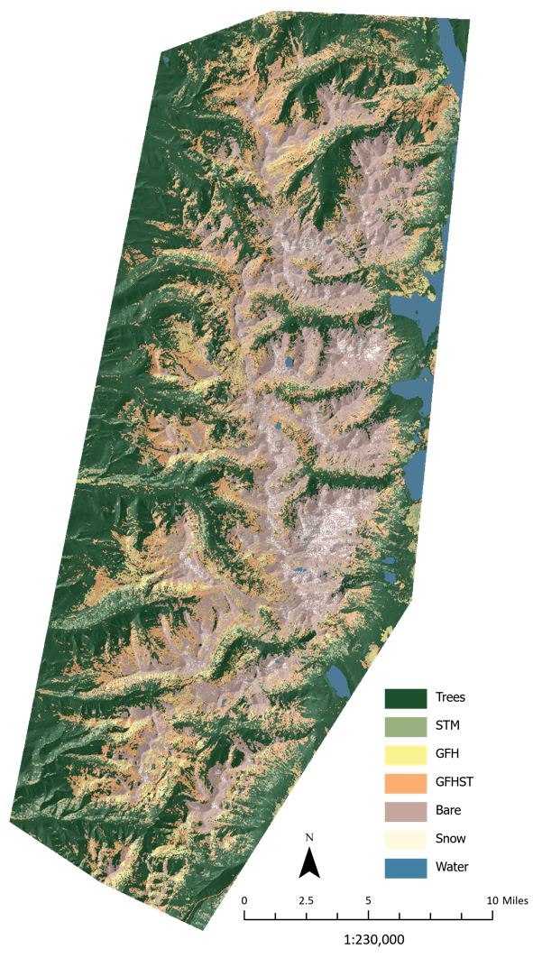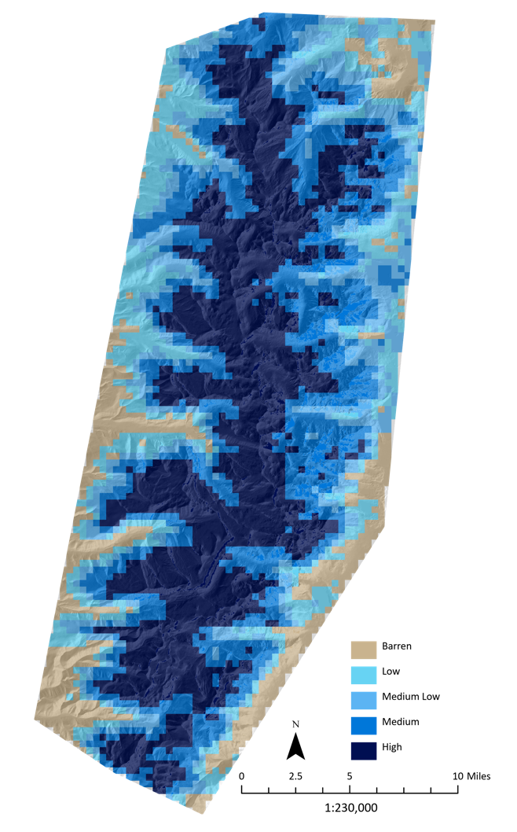
Figure 2. (left) Map of reclassified 2020 LCMS land cover data.
Figure 3. (right) Map of reclassified 2018–2020 MODIS median average snow cover.

3.2.3 Snow Cover Change Processing
We used daily snow cover data from MOD10A1(500M) and created a 3-year median average composite over the winter and spring seasons. We defined the seasons as winter (15 Jan – Feb 21) and spring (8 May – 31 May), to maintain consistency with Courtmanch et al. (2014). We created these composites for the beginning of the study period (2001–2003, “Past”) and the end (2018–2020, “Present”), leveraging the data processing capabilities of GEE. The average median values were created by calculating the median Normalized Difference Snow Index (NDSI) value, a proxy for percent snow coverage within each pixel, from the MODIS imagery over the course of the season (Kulkarni et al., 2002). These values (0–100) were then density sliced and reclassified into 5 cover classes (Table 3, Figure 3). This was repeated for each year in the two 3-year time spans and then composited using the mean value to create the final two images, Past and Present, used in the study.

Table 3
Reclassification of MOD10 data for snow cover analysis.
Original MODIS Band Value | Fractional Snow Cover Reclassification
0–20 | 1: Barren Cover
22–40 | 2: Low Snow Cover
41–60 | 3: Medium Low Snow Cover
61–80 | 4: Medium Snow Cover
>81 | 5: High Snow Cover

3.3 Data Analysis
3.3.1 Land Cover Change Analysis and Forecast
We input LCMS data from 1987 and 2020 into the TerrSet Land Change Modeler (LCM) in order to assess and forecast land cover change. To understand the land cover changes between the two dates, we emphasized and tracked changes by land cover category (Table 2). We then optimized the transition potential model by determining six sub-model transitions (1-trees to grass, 2-trees to barren, 3-grass to trees, 4-grass to barren, 5-barren to trees, and 6-barren to grass) and input driver variables, including aspect, distance to trails, elevation, slope, and solar radiation. We ran the transition potential model using a multilayer perceptron (MLP) neural network and 5000 iterations for each of the six transition sub-models. We did not analyze sub-models where net land cover change was less than 10 sq. km. Finally, we used the output from the transition potential model to forecast land cover in 2031.

3.3.2 Snow Cover Change Analysis and Forecast
We input the classified snow data into the LCM to analyze snow cover change between the Past and Present time periods for both the spring and winter seasons. The dataset was analyzed to track net losses and gains in snow cover during spring and winter seasons to better understand how habitat has changed seasonally for bighorn sheep in the last 20 years. The model was optimized in a similar fashion to the land cover change analysis; however, the transition model was optimized using only transitions of barren cover to higher classifications of snow cover and included elevation, slope, aspect, and solar radiation as driver variables. These driver variables coupled with the information derived from the first change analysis were used within the LCM to map predicted snow cover in 2031, using the transition potential sub-models and the same modeling parameters as land cover in the MLP model.

3.3.3 Habitat Suitability Analysis and Forecasting
We created a habitat suitability model for 2020 using the ArcGIS Pro habitat suitability modeler. We ran the model using elevation, slope, aspect, distance to trails, solar radiation, 2020 land cover, and Present (2018–2020) snow cover data. Insight from Grand Teton National Park (GTNP) biologists and literature review provided the basis for the habitat variable weighting within the model. Each input raster was weighted on a scale from 1 to 10 based on suitability for GTNP bighorn sheep, with 1 being least suitable and 10 most suitable (Table 4). Variables with a greater influence on bighorn sheep habitat received the highest weights, while those with lower influence received lower weights. Categorical data, such as land cover, was weighted by category on the same 1 to 10 scale. Similar to the 2020 suitability analysis, the forecasted 2031 habitat suitability model used the same input driver variables and weighting system. The forecasted habitat suitability model incorporated the predicted 2031 land and snow data to make predictions for future suitability. Both results were displayed in the same raster scale of 0–255, with values of 255 the most suitable and values of 0 the least suitable.

Table 4
Driver variables and weights for the habitat suitability model. The habitat suitability modeler was run twice, once with 2020 data and once with 2031 forecasted land and snow cover.

Feature | Weight | Land Cover Class | Weight | Snow Cover Class | Weight
Land Cover | 10 | 1: Trees | 1 | 1: Barren Cover | 10
Snow Cover | 5 | 2: STM | 1 | 2: Low Snow Cover | 9
Solar Radiation | 2 | 3: GFH | 10 | 3: Medium Low Snow Cover | 8
Elevation | 7 | 4: GFHST | 5 | 4: Medium Snow Cover | 6
Slope | 8 | 5: Bare | 6 | 5: High Snow Cover | 5
Distance to Trails | 2 | 6: Snow | 5
Aspect | 1.5 | 7: Water | 1

4. Results & Discussion

4.1 Analysis of Results
4.1.1 Land Cover Change Analysis and Forecast Results
Net land cover change between 1987 and 2020 showed the greatest gain in 4: GFHST of 78.9 sq. km (Figure 4). 3: GFH experienced the greatest loss of -39.3 sq. km, followed by 5: Bare (-24.46 sq. km) and 1: Trees (-24.18 sq. km). There was minimal change in 7: Water, 6: Snow, and 2: STM land cover classes. The loss of 3: GFH land cover, a vital habitat for sheep forage, can be attributed to tree and shrub encroachment.

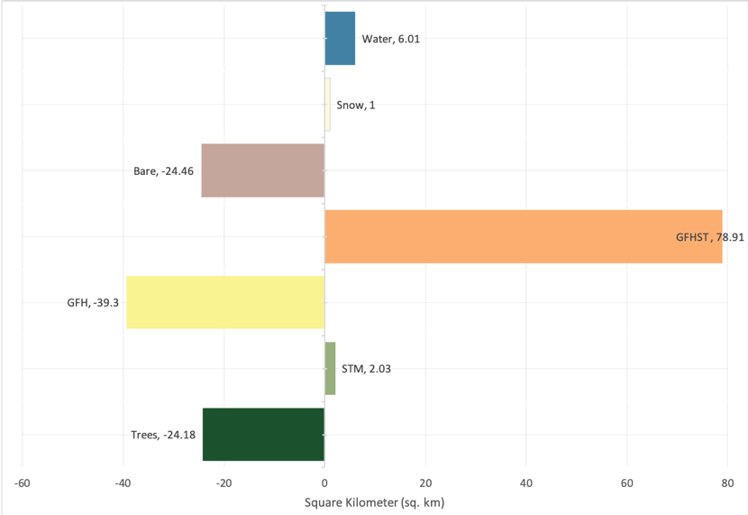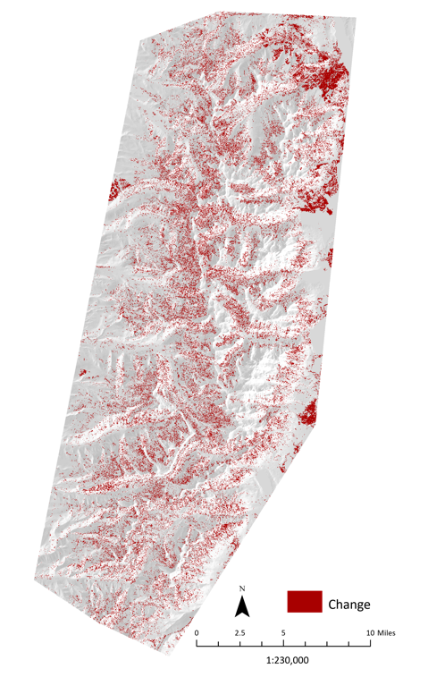
Figure 4. Net change between 1987 and 2020 experienced by all land cover classes in sq. km (left). Map highlighting land cover change pixels shown in red (right).

The transition potential models achieved the following accuracy rates: 1-trees to grass 55.27%, 2-trees to barren 73.55%, 3-grass to trees 44.09%, 4-grass to barren 43.58%, 5-barren to trees 71.68%, and 6-barren to grass 52.23%. The accuracy rate measured how accurate the model was able to predict whether the validation pixels would change. We observed the net change between 2020 and 2031 which showed the greatest gain in 4: GFHST (9.74 sq. km) followed by 3: GFH (1.19 sq. km; Figure 5). 5: Bare experienced the greatest loss of 5.81 sq. km followed by 1: Trees (-5.12 sq. km). The land cover changes between 2020 and 2031 predict the largest contributor to the gain in 4: GFHST land cover class is the loss of 1: Trees land cover. While this predicted transition away from tree land cover suggests the potential for additional sheep forage habitat, there is not enough evidence to conclude the shrub and trees included in the 4: GFHST class would allow for suitable sheep habitat.

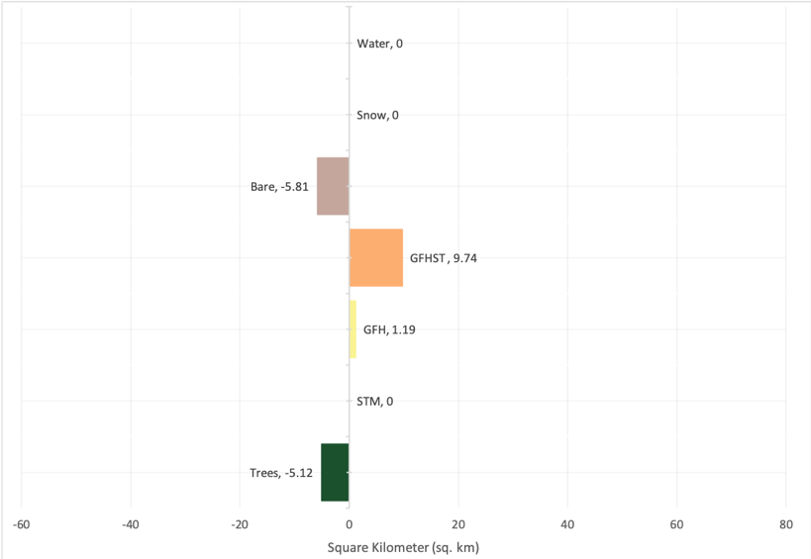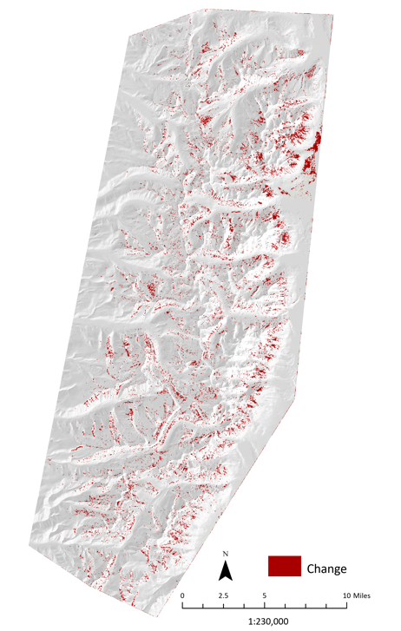
Figure 5. Predicted net change between 2020 and 2031 experienced by modeled land cover classes in sq. km (left). Map highlighting predicted land cover change pixels shown in red (right).

A substantial region of land cover change was identified in the northeast region of the study area, where the 2016 Berry Wildfire burned approximately 38.5 square kilometers (Weber, 2020). Of the burned area, 32.2% or 12.4 square kilometers experienced land cover change in our analysis. The land cover change was primarily from 1: Trees to 4: GFHST and to a lesser extent 3: GFH.

4.1.2 Snow Cover Change Analysis and Forecast
Net change in each category was reported for each season and can be seen in Figure 6. In spring, areas classified as 1: Barren experienced the most loss with 93 sq. km in the study area converted to another more snow-covered category based on the Past compared to the Present composite image. The 2: Low cover class experienced slight gains (14.75 sq. km), 3: Medium Low cover experienced the next greatest loss (77 sq. km), while 4: Medium and 5: High snow cover categories experienced the most gain (with the 4: Medium category gaining 59.50 sq. km and the 5: High cover class gaining 90 sq. km).

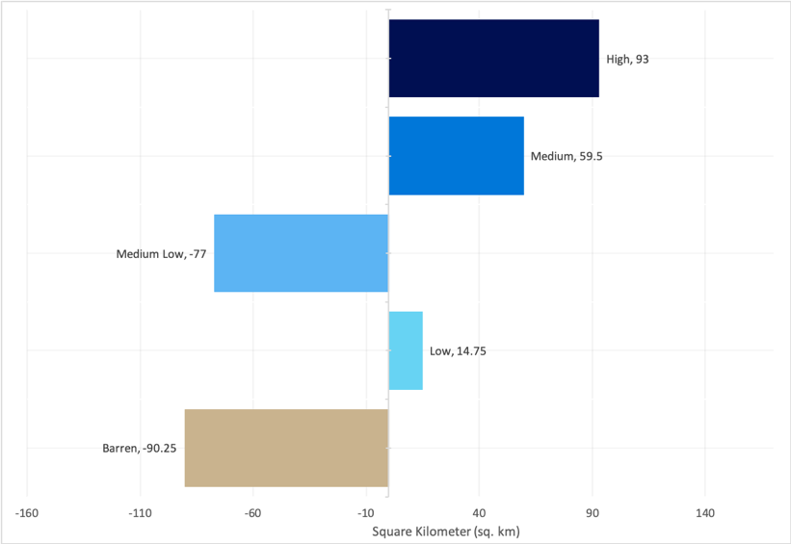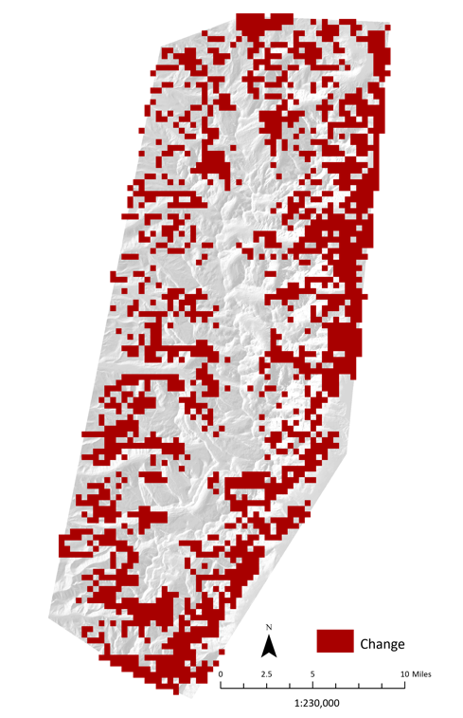
Figure 6. Net change in spring snow cover between the Past composite (2001-2003) and the Present composite (2018-2020). The right panel is a spatial representation of these transitional pixels shown in red.

In winter, snow generally covers the entirety of the study area. Change in snow cover was only experienced in the 3: Medium Low, 4: Medium, and 5: High categories between Past and Present (Figures A1 and A2). The 3: Medium Low category gained 1.5 sq. km, 4: Medium cover gained 31.5 sq. km, and the 5: High category lost 33 sq. km. The transitions between these two relative time periods are additionally represented in Figures A1 and A2 where the changes experienced are visualized in red and areas with no change are left transparent.

Predicted snow cover change between 2020 and 2031 indicates gains in 5: High snow cover areas and losses in 1: Barren snow cover areas (Figure 7). We found snow cover in the region is changing overall, most of this change is happening at the lower elevations during the spring season and changes are less prominent in the winter. Most changes recorded between the Past and Present images used in this study were exacerbated in the 2031 snow cover prediction. As climate change continues to impact seasonal snow fluctuations, such changes will continue to impact bighorn sheep habitat.

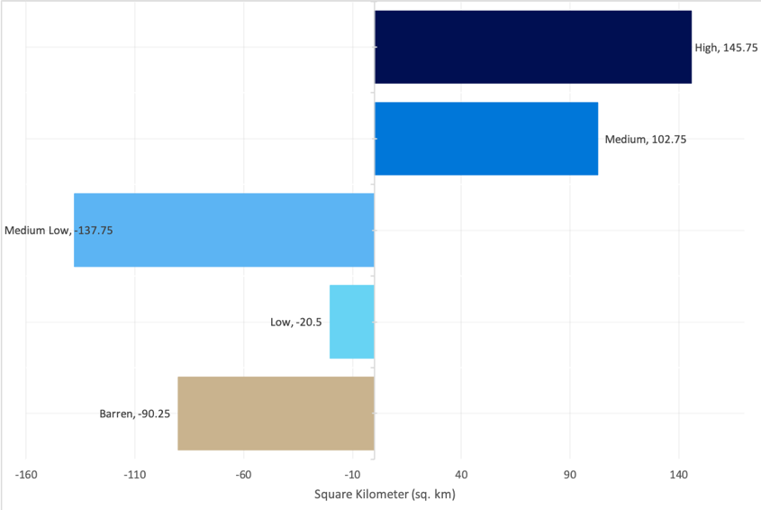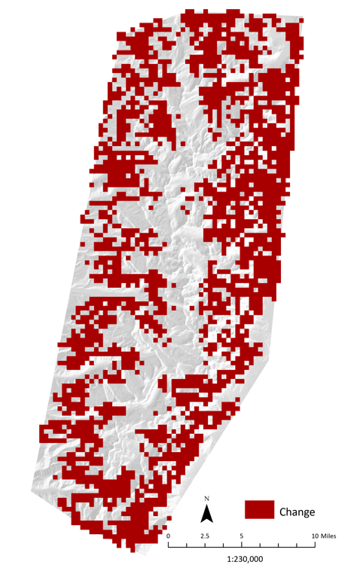
Figure 7. Net change in snow cover between the spring present composite (2018-2020) and the predicted time period of 2031. The right panel is a spatial representation of these transitional pixels shown in red.

In spring, there is a trend of increased snow cover and a decrease of barren areas. Increased snow cover during this time could negatively impact the quality of important spring forage by delaying green up of important plant species and could potentially restrict sheep to smaller zones where forage is less plentiful. This increase in snow cover may also limit the ability of bighorn sheep to migrate seasonally between elevational zones as well as between the northern and southern herds. This could have several implications to the population, the first of which is a reduced population. As snow cover may decrease the availability of high-quality forage, ewes may not be able to properly feed, decreasing their fecundity and the probability of survival for their offspring. Increased separation of the herds may also limit genetic mixing and diminish overall genetic diversity and fitness of the Grand Teton population in the future.

4.1.3 Habitat Suitability Analysis and Forecast
Winter and summer bighorn sheep range polygons (Figure B1) were created based on maps found in Courtemanch et al. (2014). These polygons allowed detailed analysis of suitability within known bighorn sheep range. Tables 5 and 6 highlight changes within these ranges in winter and summer.

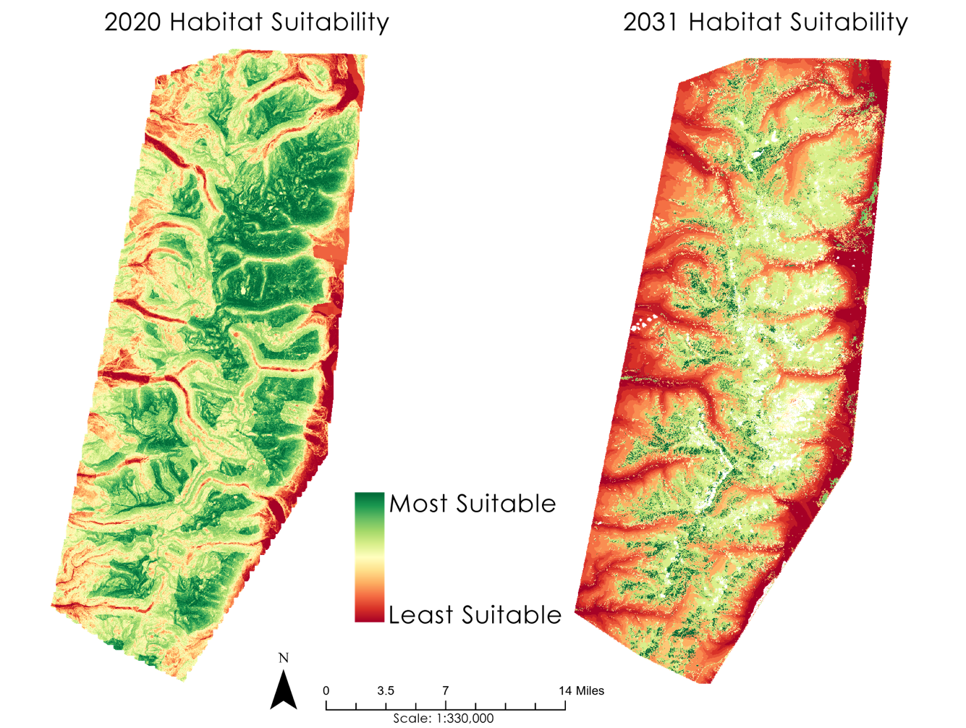
Figure 8. Habitat suitability models for 2020 (left) and 2031 (right). Dark green denotes high habitat suitability and a value of close or equal to 255, and dark red a low habitat suitability value close or equal to 0. We used percent clip as the symbology stretch type for data visualization for both habitat suitability maps.

Table 5
Mean, median and standard deviation for 2020 and 2031 winter range habitat suitability. Values are out of a scale of 0 to 255.
Winter Range Habitat Suitability | 2020 | 2031 | Predicted Change
Mean Suitability | 146.3 | 121.7 | -24.6
Median Suitability | 153.6 | 143.8 | -9.7
Standard Deviation | 44.4 | 49.6

Table 6
Mean, median and standard deviation for 2020 and 2031 summer range habitat suitability.
Summer Range Habitat Suitability | 2020 | 2031 | Predicted Change
Mean Suitability | 128.3 | 129.0 | 0.6
Median Suitability | 130.5 | 148.1 | 17.5
Standard Deviation | 40.6 | 58.9

Figure 8 visualizes 2020 habitat suitability and predicted habitat suitability in 2031. Mean winter bighorn sheep habitat suitability is expected to decrease by 9.6 percent or a suitability value of 24.65. Median suitability is expected to decrease by 3.8 percent or a suitability value of 9.74. Both of these changes are expected within the existing winter range established by Courtemanch et al. (2014). This represents a potential threat to future persistence of the population as winter is the most challenging season for bighorn sheep survivability. Additionally, mean summer habitat suitability is predicted to increase by a 0.25 percent, or a suitability value of 0.66. Median suitability is expected to increase by 6.8 percent or a value of 17.53 within the summer bighorn sheep ranges. Whether these summer suitability gains can help to offset winter suitability losses will require future research.

4.2 Future Work
To improve upon our research, additional analysis can be conducted on land cover in the study area using higher resolution remote sensing products than those applied in this study. Region-specific remote sensing data products such as LiDAR data or hyperspectral imagery could offer additional insight on the current land cover and improve land cover predictions. Additionally, developing a land cover classification rather than using a preprocessed product would improve land cover analysis by classifying land cover specifically in mind for the bighorn sheep. For example, building land cover classes such as forgeable vegetation would allow the analysis to track pertinent land cover changes and habitat suitability.

Understanding snow depth and its connection to snow coverage would help correlate snow cover to sheep energy expenditure and their likelihood of survival and movement through the environment. Snowpack Telemetry (SNOTEL) stations are located throughout the region; however, these stations cover a large area and in a region with highly variable topography high spatially resolute data is needed to make any effective connections between snow cover and depth. Ground truthing would additionally be an important step to help with the creation of a depth data set as well as to check the validity of this study. Finally, the NDSI daily MODIS data used in this study is at a 500m resolution. Using a higher resolution snow cover dataset derived from sensors such as Landsat or Sentinel may inform future work to a higher degree. Additionally, a future study could integrate avalanche risk in the snow cover analysis due to the role of avalanche-related mortality for this population of sheep. A linear analysis to understand the connection between land and snow cover would further inform the habitat suitability modeling and forecasting.

Additional forecasting scenarios including a 5- and 20-year forecast would further help project partners implement the best management decisions. To improve the habitat suitability model, additional variables can be included to develop a robust representation of bighorn sheep habitat. As GPS collar tracking continues to accumulate data, it will be important to monitor how bighorn sheep habitat selection changes in response to the changes seen in this analysis, or due to other factors. The weighting of variables in accordance with their importance to bighorn sheep is a critical component of habitat suitability modeling. With updated tracking data, it will be important to change variable weighting accordingly to best model current or future sheep behavior and habitat selection.

5. Conclusions
The objectives of this study were developed to understand how bighorn sheep habitat has been changing between 1987 and 2020 and predict these changes to 2031 to better understand how to protect, conserve, and maintain the bighorn sheep population in the Teton Mountain Range. Our study used NASA Earth observations to observe and define these changes and leverage this data using geoprocessing tools such as ArcGIS Pro to predict habitat suitability into the future. Our analysis indicated that bighorn sheep habitat is changing, that these changes are generally unfavorable, and they may lead to an overall loss in bighorn sheep habitat. In order to thrive, the bighorn sheep will need to continue to adapt to these changing conditions.

5.1.1 Land Cover Change Analysis and Forecast
Regarding land cover, between 1987 and 2020 bighorn sheep experienced a loss in suitable, forgeable land cover. The greatest contributor to this land cover transition is the encroachment of trees and shrubs. Our 2031 forecasted land cover prediction showed additional gains within the 3: grass, forb, herbaceous plants with trees and shrub land cover class which would further exacerbate the current problem. This land cover change is tied to a loss in 1: tree cover. In the last decade, forests in the western United States have experienced precipitation extremes, tree mortality, and increased wildfire risk and these trends are projected to continue (Crockett & Westerling, 2018). Our study did not explore these variables, but it is possible the losses observed in the 1: tree land cover class will follow this trend in forest structure. The predicted loss of trees might benefit bighorn sheep but will ultimately depend on if the converted land provides suitable habitat with good forage. Additionally, the Berry Fire in 2016 reduced tree cover and drove land cover changes towards 4: grass, forb, herbaceous plants with trees and shrubs, indicating that wildfire may improve habitat for the bighorn sheep. This trend was also observed by project partners in the field.

5.1.2 Snow Cover Change Analysis and Forecast
Overall, the increase in snow cover may indicate a decrease in suitable habitat for bighorn sheep in both the spring and in the winter. Increased snow cover during these seasons may limit winter food availability and impede sheep movement. This increase in snow cover could potentially constrain sheep to smaller zones within their preferred environment and continue to diminish habitat quality. Finally, an increase in snow cover along with increased winter recreation may worsen the loss of winter habitat.

5.1.3 Habitat Suitability Analysis and Forecast
With winter habitat suitability decreasing alongside potential summer suitability increases, it will be important to continue to monitor bighorn sheep habitat selection and population health. Winter is the most challenging time for bighorn sheep survival, and it remains to be seen how forecasted suitability changes might impact bighorn sheep in the Teton Mountain Range. As the land cover, snow cover, and overall suitable habitat for bighorn sheep changes in this region, it is imperative to inform stakeholders in the community and begin a conversation to address how these changes will affect both sheep and the community. This study, preformed in partnership with Grand Teton National Park, will act as a piece in the development of this conversation and will begin to fill gaps in the knowledge base that surrounds bighorn sheep and some of the factors that determine their ideal habitat. This information will help inform the creation of restoration and conservation plans that fit the needs of the sheep and the surrounding community to continue the legacy of this charismatic species into the future.

6. Acknowledgments
- Brandy Nisbet-Wilcox (NASA DEVELOP National Program)
- Keith Weber (Idaho State University, GIS Training and Research Center)
- Joseph Spruce (Science Systems and Applications, Inc., Diamondhead, MS)
- Alyson Courtemanch (Wyoming Cooperative Fish & Wildlife Research Unit)
Project Partners
- Sarah Dewey (National Park Service, Grand Teton National Park)
- Carson Butler (National Park Service, Grand Teton National Park)

This material contains modified Copernicus Sentinel data 2020, processed by ESA.

Any opinions, findings, and conclusions or recommendations expressed in this material are those of the author(s) and do not necessarily reflect the views of the National Aeronautics and Space Administration.

This material is based upon work supported by NASA through contract NNL16AA05C.

7. Glossary
Earth Observations - Satellites and sensors that collect information about the Earth’s physical, chemical, and biological systems over space and time
GFH - Grass/Forb/Herbaceous plants
GFHST - Grass/Forb/Herbaceous plants with Shrubs and Tree
GTNP - Grand Teton National Park
Habitat Suitability Model - A map showing areas of suitable habitat for a certain species
Landsat - Series of NASA Earth observation satellites
LCM - Land change modeler tool within TerrSet software package
LCMS - Landscape Change Monitoring System – Land cover classified data derived from Landsat imagery and processed by the U.S. Forest Service
LiDAR - Light Detection and Ranging – High resolution elevation data
MLP - Multilayer perceptron neural network
MODIS - Moderate resolution Imaging Spectroradiometer
NDSI - Normalized Difference Snow Index, a measure of the relative magnitude of the reflectance difference between visible (green) and shortwave infrared (SWIR)
NPS - National Park Service
SNOTEL - Snowpack Telemetry - A remote weather station that measures snow depth
STM - Shrub and tree mix
TerrSet - Geospatial software package available from Clark Labs
Ungulate - A hoofed mammal
USGS - U.S. Geological Survey

8. References
Courtemanch, A. B. (2014). Seasonal Habitat Selection and Impacts of Backcountry Recreation on a Formerly Migratory Bighorn Sheep Population in Northwest Wyoming, USA [Unpublished master’s thesis]. University of Wyoming.
Courtemanch, A. B., Kauffman, M. J., Kilpatrick, S., & Dewey, S. R. (2017). Alternative foraging strategies enable a mountain ungulate to persist after migration loss. Ecosphere, 8(6). https://doi.org/10.1002/ecs2.1855
Crockett, J. L., & Westerling, L. A. (2018). Greater temperature and precipitation extremes intensify western U.S. droughts, wildfire severity, and Sierra Nevada tree mortality. Journal of Climate, 31(1),
341–354. https://doi.org/10.1175/JCLI-D-17-0254.1

Kulkarni, A.V., Srinivasulu, J., Manjul, S. S., Mathur, P (2002). Field based spectral reflectance studies to
develop NDSI method for snow cover monitoring. Journal of the Indian Society of Remote Sensing,
30, 73-80. https://doi.org/10.1007/BF02989978.

Moneymaker, B., Au, M., Beltran, G., Kasraee, N., Ross, K., Ramthun, J., Burks, D., & Heck, M. (2018). NASA DEVELOP National Program California-JPL. Mojave Desert Ecological Forecasting: Monitoring Bighorn Sheep Habitat by Assessing Vegetation, Topography, and Soil Moisture Technical Report.
Pettorelli, N., Pelletier, F., Hardenberg, A. von, Festa-Bianchet, M., & Côté, S. D. (2007). Early onset of vegetation growth vs. rapid green-up: Impacts on juvenile mountain ungulates. Ecology, 88(2), 381–390. https://doi.org/10.1890/06-0875
Singer, F. J., Bleich, V. C., & Gudorf, M. A. (2001). Restoration of bighorn sheep metapopulations in and near western national parks. Restoration Ecology, 8(4S), 14–24.
https://doi.org/10.1046/j.1526-100x.2000.80062.x
Teton Bighorn Sheep. Teton Sheep Working Group. (2017). Retrieved January 5, 2022, from
https://www.tetonsheep.org/overview
Weber, K. T., Idaho State University GIS Training and Research Center. (2020). Historic Fires Database
(HFD) version 4.1. Downloaded from
http://giscenter.isu.edu/research/Techpg/HFD/ November 10, 2021
Whitfield, M. (1983). Bighorn sheep history, distributions, and habitat relationships in the Teton Mountain range, Wyoming [Unpublished master’s thesis]. Idaho State University.

9. Appendices

Appendix A
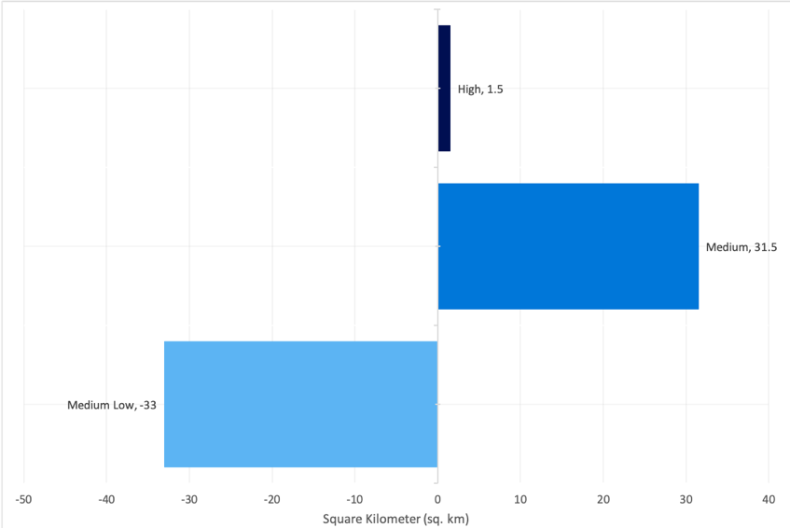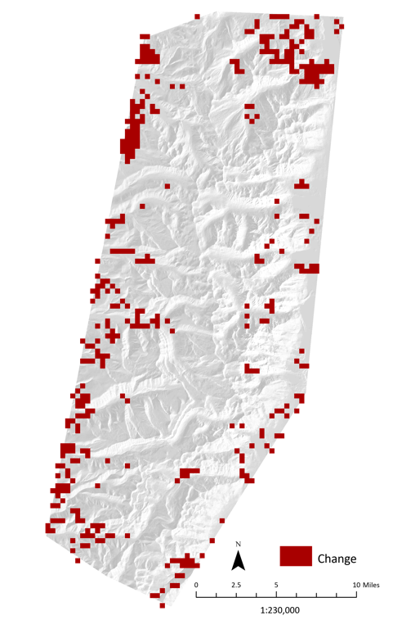
Figure A1. Net Change in snow cover between the winter Past composite (2018–2020) and the Present composite of (2018–2020). The right panel is a spatial representation of these transitional pixels shown here in red.

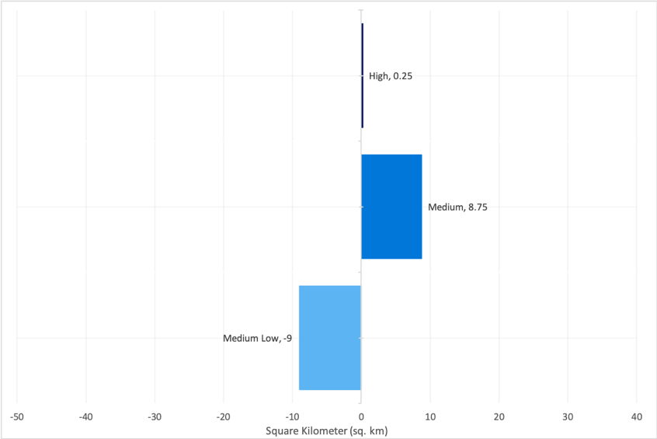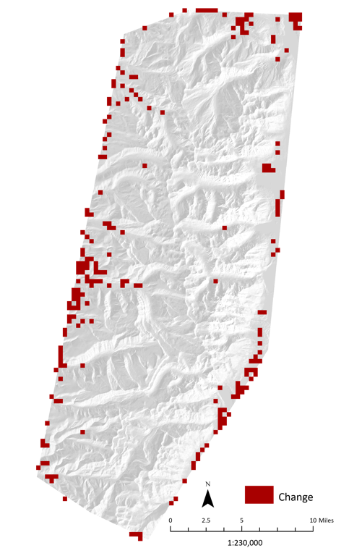
Figure A2. Net Change in snow cover during winter between the Present composite (2018–2020) and the predicted time period of 2031. The right panel is a spatial representation of these transitional pixels shown here in red.

Appendix B

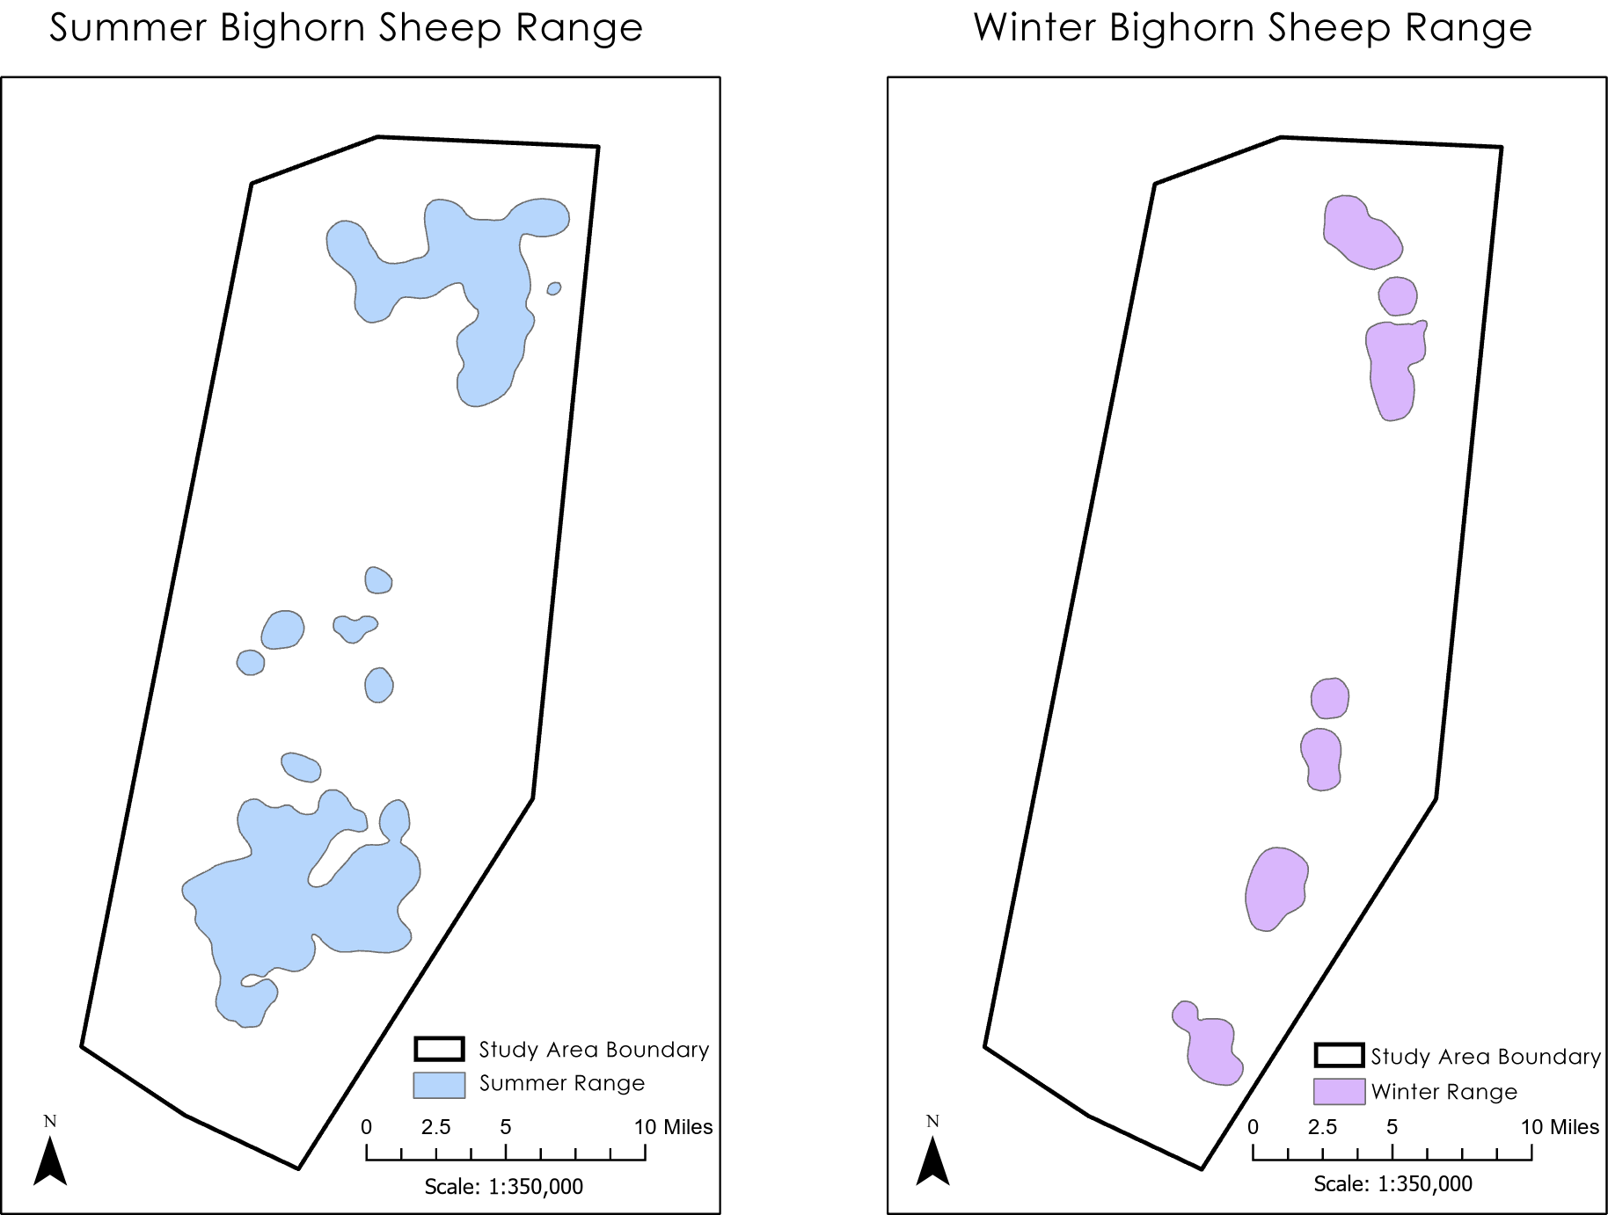
Figure B1. Winter and summer range polygons derived from Seasonal Habitat Selection and Impacts of Backcountry Recreation on a Formerly Migratory Bighorn Sheep Population in Northwest Wyoming (Courtemanch et al. 2014). Utilized for the habitat suitability change analysis. Summer habitat is forecasted to gain suitability, while winter habitat is predicted to have reduced suitability.

