Supplementary Information for

Empirical estimates of regional carbon budgets imply reduced global soil heterotrophic respiration

Philippe Ciais*, Yitong Yao, Thomas Gasser, Alessandro Baccini, Yilong Wang,
Ronny Lauerwald, Shushi Peng, Ana Bastos, Wei Li, Peter A. Raymond, Josep G. Canadell, Glen P. Peters, Rob J. Andres, Jinfeng Chang, Chao Yue, A. Johannes Dolman,
Vanessa Haverd, Jens Hartmann, Goulven Laruelle, Alexandra G. Konings,
Anthony W. King, Yi Liu, Sebastiaan Luyssaert, Fabienne Maignan, Prabir K. Patra,
Anna Peregon, Pierre Regnier, Julia Pongratz, Benjamin Poulter, Anatoly Shvidenko, Riccardo Valentini, Rong Wang, Grégoire Broquet, Yi Yin, Jakob Zscheischler,
Bertrand Guenet, Daniel S. Goll, Ashley-P. Ballantyne, Hui Yang, Chunjing Qiu, Dan Zhu

* Correspondence to: philippe.ciais@lsce.ipsl.fr

This file includes:
Supplementary Text 1 to 5
Supplementary Table 1 to 6
Supplementary Figure 1 to 9
References

Supplementary Text 1. Plausible bias of regional NEE from ignoring soil C change in Tropical regions due to a lack of observations
There is a large uncertainty on soil C changes. Pan et al. [41] analyzed forest C changes used models for SOC changes in absence of data. SOC changes are nevertheless generally smaller than biomass increments in managed tropical forests [105]. No long term tropical SOC changes inventory is available to our knowledge in intact tropical forests.

We can only get a rough estimate of the SOC change contribution to ∆C from models. We looked at the TRENDY v6 DGVM models for SOC changes in the 4 tropical regions and found a) that some TRENDY models are clearly unrealistic with a ratio of SOC change to total carbon change (∆C) of up to 7. When excluding models being 2-sigma outliers in the ensemble for this ratio, the median ensemble values of SOC change to total C change (∆C) during 2000-2009 (Supplementary Table 2) ranges from 13% in S.E. Asia up to 40% in South Asia, with an average of 27%. This gives a rough indication of the omission error in ∆C in our study due to ignoring (non-measured) SOC changes. This error stays within the range of the uncertainty we derived for regional ∆C.

Supplementary Text 2. Regions not covered by RECCAP region have a small C flux
These regions cover Greenland, Antarctica, Middle East countries, Ukraine, New Zealand and Kazakhstan. Greenland and Antarctica are ice covered and do not contribute significant C fluxes with the atmosphere. Except for New Zealand, there no systematic observations of the carbon balance of these territories. Middle East and Kazakhstan are dry areas with low forest cover. Ukraine also has a low forest cover. The table below summarizes partial estimates of the carbon balance (mainly ∆C) for these regions.

Supplementary Text 3. SHR upscaling from site-level measurements using a machine learning approach
Data preparation for upscaled SHR estimation.
The 455 site-level SRDB observation data are unevenly distributed in boreal, temperate and tropical zones, with the highest sampling density in temperate areas (Supplementary Fig. 5). This dataset covers seven land cover types in total. We tested different predictors and selected those that altogether explained the largest fraction of variance across sites. Table 4 shows the specific data sources of chosen predictor variables, their spatial resolution and temporal resolution. Soil carbon content and soil nitrogen content are static variables without any inter-annual variability. Other variables listed in Supplementary Table 4 are dynamic and we used yearly values.

Leave-one-out cross validation (LOOCV)
As mentioned in the Methods section, we applied LOOCV to evaluate whether the model performs well enough at site-level to enable the spatiotemporal SHR prediction at large scales. In the framework of LOOCV, each sample data is used as a validation and compared with the predicted value by a random forest model that is built by all other training samples. The R² and RMSE between the observed and predicted values are shown in Supplementary Fig. 6.

We forced the trained RF model at 0.5° spatial resolution and yearly time step to generate the annual SHR predictions in spatiotemporal grids from 2000 to 2009. The input climatic variables of annual temperature, precipitation and radiation are from CRUNCEP v6. This dataset is a combination of CRU TS3.2 0.5°×0.5° monthly climatological output and NCEP reanalysis data of 2.5°×2.5° and finer temporal resolution of 6-hourly time intervals in near real time. The annual soil moisture input is based on averaging over the CPC monthly soil moisture dataset, which was derived by a leaky bucket model [100]. The annual GPP data is the average of six GPP ensemble data produced by three machine learning methods and two flux partitioning methods in Jung et al [101]. Atmospheric nitrogen deposition data is from the Multi-scale Synthesis and Terrestrial Model Inter-comparison Project environmental forcing dataset [102]. Soil carbon content information is from Harmonized World Soil Database [103]. Both top-soil (0-30cm) and sub-soil (30-100cm) carbon contents are included. Soil nitrogen content data (depth of 0-100cm) is from Global Gridded Surfaces of Selected Soil Characteristics (IGBP-DIS) dataset [104]. The original resolution of soil carbon content (0.05°×0.05°) and soil nitrogen content (0.083°×0.083°) were resampled to 0.5°×0.5° before using in the SHR upscaling procedure.

Comparison of the two bottom-up SHR upscaled products used in this study
In addition to Main text Fig. 2 comparing regional average values of bottom-up SHR between the climate based upscaling with re-parameterized Hashimoto et al. [29] functions by Konings et al. [31] and the random-forest based upscaling approach (this study), spatial patterns of annual median SHR from both products are displayed in Supplementary Fig. 7a-b. Desert areas in Sahara, Arabia and Xinjiang in China have been filtered in the Konings et al. products. The spatial distributions of the first (Q1) and third quantiles (Q3) are shown in Supplementary Fig. 7c-f.

Supplementary Text 4. OSCAR earth system model
Model description
The compact carbon-climate model OSCAR v2.1 [33] was used to estimate the effect of including/excluding processes that prevent carbon from NPP to be delivered as a substrate of soil heterotrophic respiration. This specific version of OSCAR was calibrated to emulate the land carbon cycle of seven ESMs (Supplementary Table 5) with a regional subdivision that follows RECCAP regions (see main text Fig. 1). For each ESM, OSCAR was tuned to match for each RECCAP region the preindustrial land carbon stocks, the turnover times of carbon in biomass and soils, and the NPP of the CMIP5 control run, with unforced variability (named piControl). The regional NPP sensitivities to atmospheric CO₂ (assumed hyperbolic in OSCAR) and to temperature change (assumed linear) are calibrated on the ESMs’ outputs from three idealized simulations of CMIP5 (namely 1pctCO2, esmFdbk1, esmFixClim1). The regional SHR sensitivities to the input carbon flux from dead biomass (assumed linear), and to temperature change (assumed exponential, i.e. following a Q₁₀ formulation) are also calibrated on those three simulations, for each ESM and for each RECCAP region. The climate response to global radiative forcing is emulated by an impulse response function [95] that is calibrated on the CMIP5 simulation abrupt4xCO2 of the corresponding ESM. Only two correspondences could not be found: so we took CCSM4 as the climate model of the land carbon model CESM-C1 and NorESM-M as that of the land carbon model NorESM-ME.

Future scenarios SIM-1 and SIM-2 derived from CMIP5 Earth System Model results
We determine β_{soil} and γ_{soil} (shown in main text and. Figure 3) with two simulations giving the increase in atmospheric CO₂ and prescribing non-CO₂ radiative forcing of the RCP8.5 [96]. In the first simulation, the carbon cycle and the climate are fully coupled. In the second one, only the climate is impacted by the increase of atmospheric CO₂ while the carbon cycle sees a pre-industrial climate. β_{soil} and γ_{soil} are then calculated following the methodology developed for C4MIP [6]. To determine the increase in atmospheric CO₂ and temperature (shown in main text Figs 3c and 3d) we used OSCAR in an emission-driven fashion: emissions of CO₂ from fossil-fuel burning are prescribed following the RCP8.5 data [96].

Two sets of simulations were made in order to estimate the effect of including or not some component fluxes of NEE assessed in this study, that prevent carbon from NPP to be delivered as a substrate of soil heterotrophic respiration. These components are not included in ESMs. In all cases, those fluxes, excepted LUC emissions, are prescribed as a fraction of NPP that is immediately oxidized and emitted to the atmosphere. In the first set of simulations (SIM-1) only the fluxes that are already included in the CMIP5 version of the considered ESM are prescribed (see Supplementary Table 5). In the second set of simulations (SIM-2), all the fluxes are prescribed in each region according to the results synthesized for this study, whatever the ESM.

To perform the SIM-2 simulations with OSCAR being calibrated for each CMIP5 ESM, we need time series of all the NEE components that are not related to SHR, expressed as a fraction of yearly NPP. To create those time series, we first grouped the fluxes of Supplementary Fig. 3 into six groups (Supplementary Table 6). Second, we considered the RECCAP estimates of each flux in each region from Supplementary Table 1 as reference values of the ratio of each flux over NPP, for the 2000-2010 time period. Third, for each of these groups of fluxes, and for NPP, we estimated changes relative to this reference period at different snapshots, using various proxies. The snapshots used to create the time series of the groups of fluxes listed in Supplementary Table 6 are: 1850, 1900, 1950, 2050 and 2100 (following RCP8.5); except for the Rivers group that was back-casted only for 1850. Between these points, we used linear interpolation. We used the multi-model mean from the CMIP5 ESMs as proxy for regional NPP (seven models), emissions from wildfires (four models) and CO₂ fluxes from land-use change and harvested wood products (five models for the past, three for the future). We used the change in cropland and pasture area from the LUH1 dataset [92] as proxies for the Harvest and Grazing groups of fluxes.

Projections of relative changes in inland water-atmosphere CO₂ fluxes from 1850, 2000, 2050 and 2100 were specifically made for this study using the spatially-explicit empirical model of ref. [97] with updated values of its main predictor variables: air temperature, terrestrial NPP and population density. The average projected change in NPP and air temperature were derived from the gridded historical data and future projections corresponding to the seven ESMs discussed in this study. Projected changes in population density were obtained from the medium fecundity scenario of the population growth estimated by the UN [98]. The simulated relative changes in CO₂ evasion were then applied to the present-day estimates of ref. [27] used in this study. For the projections of soil carbon exports to inland waters, it was assumed that the increase in inland water-atmosphere fluxes with time reflects mainly the increased release of non-refractory carbon from soils. Fluvial C exports to the coasts and C burial in sediments are only poorly constrained for 2030 and 2050 [19] and likely reflect more the behavior of refractory soil carbon which is less relevant in the context of this study. In the absence of better constraints, these fluxes were thus assumed constant and, although highly uncertain, the estimated soil carbon change should thus be regarded as conservative. The difficulty in predicting changes in fluvial carbon exports in the coming century is supported by a recent study [99] on the Amazon basin. Finally, we assumed no change in CH₄ and VOC fluxes in the future, given uncertainties in the sign of these changes. The proxies used for setting changes in the groups of fluxes in the different snapshots, are summarized in Table 3.

Finally, we repeat the above simulation setup for each of the four central estimates of NPP (MODIS, BETHY, GIMMS, CARDAMOM), each of the two central estimates of F_{fires} (GFED, GFAS), each of the two central estimates of F_{LUC} (RECCAP, BLUE) and each of the two central estimates of F_{rivers}. This leads to a total 32 different values of SHR to NPP ratios combined to seven different ESM parameterizations. The final 224 cases are presented in main text Fig. 3.

Supplementary Text 5. Including error correlations between SHR and NPP for estimating the uncertainty of the ratio of SHR-to-NPP
The distributions of the ratio SHR to NPP (denoted as r) were estimated by error propagation rules. Assuming that both SHR and NPP follow unbiased Gaussian distributions with means μ and standard deviation σ so that SHR ~ N(μ_{SHR}, σ_{SHR}²) and NPP ~ N(μ_{NPP}, σ_{NPP}²), the mean of r for a region i is:

$\underline{r_{i}}={μ_{SHR/NPP}}_{i}=\frac{{μ_{SHR}}_{i}}{\left|{μ_{NPP}}_{i}\right|}=-\frac{{μ_{SHR}}_{i}}{{μ_{NPP}}_{i}}$

And the first-order approximation for the error of r is:

$$ε_{r_{i}}=\frac{∂r_{i}}{∂{(SHR)}_{i}}ε_{{SHR}_{i}}+\frac{∂r_{i}}{∂{(NPP)}_{i}}{ε_{NPP}}_{i}=-\frac{1}{{μ_{NPP}}_{i}}{ε_{SHR}}_{i}+\frac{{μ_{SHR}}_{i}}{{μ_{NPP}^{2}}_{i}}{ε_{NPP}}_{i}$$

The standard deviation of the ratio error is:

$σ_{r_{i}}=\sqrt{{\left(\frac{1}{{μ_{NPP}}_{i}}\right)}^{2}{{σ_{SHR}}_{i}}^{2}+{\left(\frac{{μ_{SHR}}_{i}}{{{μ_{NPP}}_{i}}^{2}}\right)}^{2}{{σ_{NPP}}_{i}}^{2}-2\left(\frac{1}{{μ_{NPP}}_{i}}∙\frac{{μ_{SHR}}_{i}}{{{μ_{NPP}}_{i}}^{2}}\right)cov\left({σ_{SHR}}_{i},{σ_{NPP}}_{i}\right) }$(1)

where cov(,) means the covariance of the two variables within the brackets. Since SHR is calculated based on mass balance from NEE, NPP and other non-SHR sources composing NEE noted $F_{ik}$ for k = 1, 8 (Supplementary Eq. 2), the covariance between SHR and NPP can be written as:

$$cov\left({σ_{SHR}}_{i},{σ_{NPP}}_{i}\right)=cov\left({SHR}_{i},{NPP}_{i}\right)$$
$=cov\left({NEE}_{i}-{NPP}_{i}-\sum_{k=1}^{8}{}F_{ik}, {NPP}_{i}\right)$ (2)
$=cov\left({NEE}_{i},{NPP}_{i}\right)-var\left({NPP}_{i}\right)-\sum_{k=1}^{8}{}cov\left(F_{ik},{NPP}_{i}\right)$
Assuming NPP is independent from NEE the other fluxes that compose NEE, equation (SOM-6) becomes:

$$cov\left({σ_{SHR}}_{i},{σ_{NPP}}_{i}\right)=-var\left({NPP}_{i}\right)={{σ_{NPP}}_{i}}^{2}$$
Substituting equation (SOM-7) into equation (SOM-5), the standard deviation of the ratio error is calculated by:

$σ_{r_{i}}=\sqrt{{\left(\frac{1}{{μ_{NPP}}_{i}}\right)}^{2}{{σ_{SHR}}_{i}}^{2}+{\left(\frac{{μ_{SHR}}_{i}}{{{μ_{NPP}}_{i}}^{2}}\right)}^{2}{{σ_{NPP}}_{i}}^{2}+2\left(\frac{1}{{μ_{NPP}}_{i}}∙\frac{{μ_{SHR}}_{i}}{{{μ_{NPP}}_{i}}^{2}}\right){{σ_{NPP}}_{i}}^{2}}$ (3)
$=\frac{\sqrt{{\left({μ_{NPP}}_{i}\right)}^{2}{{σ_{SHR}}_{i}}^{2}+{\left({μ_{SHR}}_{i}\right)}^{2}{{σ_{NPP}}_{i}}^{2}+2\left({μ_{NPP}}_{i}∙{μ_{SHR}}_{i}\right){{σ_{NPP}}_{i}}^{2}}}{{{μ_{NPP}}_{i}}^{2}}$
We further verified that Monte Carlo simulations with random realizations of each flux and SHR calculated as in the main text by mass balance gives the same error in r_{i} for each region.

Supplementary Table 1. Carbon storage change, lateral fluxes from rivers and trade, NEE, component fluxes from NEE, and SHR in each region in Tg C yr⁻¹. All data for the period 2000-2009 except for rivers, lakes and estuaries which are based on data covering an epoch of the last two decades.
North America
(TgC yr⁻¹) |  |  |  | Reference | Uncertainty estimation
∆C | -348 | ± | 285 | King et al. [7] ª | ^{b}
F_{trade} | 30 | ± | 37 | Peters et al. [18] for wood products and SOCCR report [56] for crop products | 20%
F_{rivers} | 124 | ± | 47 | Mayorga et al. [27], Hartmann et al. [20] ^{c} | 50% ^{d}
NEE | -487 | ± | 291 | Equation (1) | ^{e}
F_{crop products} | 182 | ± | 36 | SOCCR report [56] ^{f} | 20%
F_{wood products} | 76 | ± | 7 | SOCCR report [56] for wood products decay, Wang et al. for wood burned in power plant and industry [53] ^{g} | ^{h}
F_{grazing} | 119 | ± | 24 | This study (see Methods) | 20%
F_{fires GFED} | 88 | ± | 33 | Extended from [81] ^{i} | see Methods
F_{fires GFAS} | 78 | ± | 23 | Giuseppe et. al. [82] ^{i} | see Methods
F_{LUC RECCAP} | -130 | ± | 60 | SOCCR report [56] ^{j} | ^{k}
F_{LUC BLUE} | 67 | ± | 14 | Hansis et al. [66] updated in ref. [83] | see Methods
F_{reduced} | 71 | ± | 13 | This study (see Methods) | see Methods
F_{outgas rivers + lakes RAY} | 219 | ± | 110 | Raymond et al. [84] | 50%
F_{outgas rivers + lakes LAU} | 20 | ± | 10 | Lauerwald et al. [26] | 50%
F_{outgas estuaries} | 33 | ± | 16 | Laruelle et al. [74] | 50%
NPP_{MODIS} | -7513 | ± | 1503 | Zhao et al. [85] | 20% ^{l}
NPP_{BETHY} | -8638 | ± | 1728 | Tum et al. [23] | 20%
NPP_{GIMMS} | -6477 | ± | 1295 | Kolby Smith et al. [24] | 20%
NPP_{CARDAMOM} | -7579 | ± | 2725 | Bloom et al. [25] | 20%
Soil Het. Resp. | 6315 | (5063,7664) |  | Equation (2) | Inter-quartile from Monte Carlo (Methods)

a Changes in territorial C stocks including ecosystem C pool and product pool changes "Atmospheric flow method" in Table 1 of King et al. plus burial in lakes and reservoirs from SOCCR Report
b Mean uncertainty of the AIM, TBM and Inventory estimates in King et al.
c F_{rivers} is the C flux transported from estuaries to ocean, obtained by summing biogenic C transport from rivers into estuaries with estuaries C outgassing from Laruelle et al. For C transport from rivers into estuaries, we used Mayorga et al. for DOC and POC and Hartmann et al. for DIC, the sum of this flux rescaled so that all northern hemisphere regions have a river C transport equal to that of Resplandy et al. To separate biogenic river C transport of DIC from total DIC transport, the lithogenic river DIC transport was estimated from Harmann et al. to be 15 Tg C yr⁻¹ in this region
d River C transport to estuaries and estuaries C outgassing are both assumed a relative uncertainty of 50%. The total error on F_{rivers} is calculated by assuming these two terms have independent uncertainties
e The total error on NEE is calculated by assuming each term of Equation (1) have independent uncertainties
f F_{crop products} is estimated from crop production (217 TgC yr⁻¹) minus crop trade net export (35 TgC yr⁻¹) based on SOCCR Report (p. 88)
g F_{wood products} is the sum of wood products decay in landfills, biomass burned in industry and biomass burned in power plants
h Uncertainty assumed to be 50% for landfills wood products and estimated by Monte Carlo approach by Wang et al. for biomass burned in industry and power plants
i F_{fires} includes open fires and crop residues burning estimated from Wang et al.
j F_{LUC RECCAP} includes agricultural soils C balance and a woody encroachment carbon sink from SOCCR Report (Table ES.I pp. 6). Note that changes in forest land-use are imbedded in the ΔC estimate
k From SOCCR uncertainty reported as a 95% CI divided by two to have 1-sigma estimate, assuming Gaussian error
l Based on site level evaluation. The same relative NPP uncertainty was used for other NPP products

Europe
(TgC yr⁻¹) |  |  |  | Reference | Uncertainty estimation
∆C | -316 | ± | 158 | Luyssaert et al. [86] ª | Luyssaert et al.
F_{trade} | -97 | ± | 17 | Peters et al. [18] | 20%
F_{rivers} | 24 | ± | 26 | Mayorga et al. [27], Hartmann et al. [20] | 50% ^{b}
NEE | -232 | ± | 161 | Equation (1) | ^{c}
F_{crop products} | 272 | ± | 54 | Peters et al. [18] | 20%
F_{wood products} | 72 | ± | 19 | Eggers et al. [87] for wood products decay, Wang et al. for wood burned in power plant and industry [53] | ^{d}
F_{grazing} | 122 | ± | 24 | This study (see Methods) | 20%
F_{fires GFED} | 4 | ± | 2 | Extended from [81] ^{e} | see Methods
F_{fires GFAS} | 4 | ± | 1 | Giuseppe et. al. [82] ^{e} | see Methods
F_{LUC RECCAP} | -2 | ± | 1 | Schulze et al. [9] ^{f} | Schulze et al.
F_{LUC BLUE} | -67 | ± | 9 | Hansis et al. [66] updated in ref. [83] | see Methods
F _{reduced} | 14 | ± | 4 | This study (see Methods) | see Methods
F_{outgas rivers + lakes RAY} | 166 | ± | 83 | Raymond et al. [84] | 50%
F_{outgas rivers + lakes LAU} | 34 | ± | 17 | Lauerwald et al. [26] | 50%
F _{outgas estuaries} | 22 | ± | 11 | Laruelle et al. [74] | 50%
NPP_{MODIS} | -3029 | ± | 606 | Zhao et al. [85] | 20%
NPP_{BETHY} | -3649 | ± | 730 | Tum et al. [23] | 20%
NPP_{GIMMS} | -2361 | ± | 472 | Kolby Smith et al. [24] | 20%
NPP_{CARDAMOM} | -2268 | ± | 813 | Bloom et al. [25] | 20%
Soil Het. Resp. | 1989 | (1435,2614) |  | Equation (2) | Inter-quartile from Monte Carlo (Methods)

a Luyssaert et al. change in stocks in their Table: 9a to j + 10a,b + 11ab + LUC + burial ; change in forest stocks for period 2000-2007 ; other periods for other land use types
b River C transport to estuaries and estuaries C outgassing are both assumed a relative uncertainty of 50%. The total error on F_{rivers} is calculated by assuming these two terms have independent uncertainties
c The total error on NEE is calculated by assuming each term of Equation (1) have independent uncertainties
d Uncertainty from Eggers et al. for landfills and waste wood products and estimated by Monte Carlo approach by Wang et al. for biomass burned in industry and power plants
e F_{fires} includes open fires and crop residues burning estimated from Wang et al.
f See their Fig. 3 (this flux only for EU countries)

Russia
(TgC yr⁻¹) |  |  |  | Reference | Uncertainty estimation
∆C | -563 | ± | 218 | Dolman et al. [10] ª | ^{b}
F_{trade} | 38 | ± | 11 | Dolman et al. ^{c} | 20%
F_{rivers} | 139 | ± | 45 | Mayorga et al. [27], Hartmann et al. [20] | 50% ^{d}
NEE | -725 | ± | 223 | Equation (1) | ^{e}
F_{crop products} | 60 | ± | 12 | Dolman et al. ^{f} | 20%
F_{wood products} | 43 | ± | 14 | Bookkeeping model (see methods) for wood products decay, Wang et al. for wood burned in power plant and industry ^{g} | ^{d}
F_{grazing} | 22 | ± | 4 | This study (see Methods) | 20%
F_{fires GFED} | 114 | ± | 75 | Extended from [81] ^{h} | see Methods
F_{fires GFAS} | 102 | ± | 31 | Giuseppe et. al. [82] ^{h} | see Methods
F_{LUC RECCAP} | -34 | ± | 2 | Schulze et al. [9] ^{i} | Dolman et al.
F_{LUC BLUE} | -5 | ± | 15 | Hansis et al. [66] updated in ref. [83] | see Methods
F_{reduced} | 28 | ± | 7 | This study (see Methods) | see Methods
F_{outgas rivers + lakes RAY} | 134 | ± | 67 | Raymond et al. [84] | 50%
F_{outgas rivers + lakes LAU} | 17 | ± | 9 | Lauerwald et al. [26] | 50%
F_{outgas estuaries} | 18 | ± | 9 | Laruelle et al. [74] | 50%
NPP_{MODIS} | -5109 | ± | 1022 | Zhao et al. [85] | 20%
NPP_{BETHY} | -6633 | ± | 1327 | Tum et al. [23] | 20%
NPP_{GIMMS} | -4291 | ± | 858 | Kolby Smith et al. [24] | 20%
NPP_{CARDAMOM} | -5475 | ± | 1989 | Bloom et al. [25] | 20%
Soil Het. Resp. | 4163 | (3180,5314) |  | Equation (2) | Inter-quartile from Monte Carlo (Methods)

a Dolman et al. their Table 5 estimate for year 2009 corrected to period 2007-2009 using same IIASA LEA C accounting system (A. Shvidenko pers. Com.)
b Dolman et al. pp.5335 196 TgC yr⁻¹ uncertainty 90% CI plus 120 TgC yr⁻¹ additional uncertainty added to account for the fact that only 2007-09 is estimated
c Dolman et al. BG 2012 et al. pp. 5332 for wood products and table 5 for crop products
d River C transport to estuaries and estuaries C outgassing are both assumed a relative uncertainty of 50%. The total error on F_{rivers} is calculated by assuming these two terms have independent uncertainties
e The total error on NEE is calculated by assuming each term of Equation (1) have independent uncertainties
f Dolman et al. BG 2012 Table 2 minus "net export" in Table 5
g Uncertainty of 20% for wood products decay and estimated by Monte Carlo approach by Wang et al. for biomass burned in industry and power plants
h F_{fires} includes open fires and crop residues burning estimated from Wang et al.
i See their Fig. 3

East Asia
(TgC yr⁻¹) |  |  |  | Reference | Uncertainty estimation
∆C | -300 | ± | 100 | Piao et al. [13] | Piao et al.
F_{trade} | -62 | ± | 10 | Peters et al. [18] | 20%
F_{rivers} | 88 | ± | 19 | Mayorga et al. [27], Hartmann et al. [20] | 50% ª
NEE | -321 | ± | 102 | Equation (1) | ^{b}
F_{crop products} | 375 | ± | 75 | Peters et al. [18] | 20%
F_{wood products} | 135 | ± | 64 | Bookkeeping model (see Methods) for wood products decay, Wang et al. for wood burned in power plant and industry | ^{c}
F_{grazing} | 118 | ± | 24 | This study (see Methods) | 20%
F_{fires GFED} | 20 | ± | 5 | Extended from [81] ^{d} | see Methods
F_{fires GFAS} | 19 | ± | 6 | Giuseppe et. al. [82] ^{d} | see Methods
F_{LUC RECCAP} | -13 | ± | 29 | Piao et al. [13] | Piao et al.
F_{LUC BLUE} | 98 | ± | 48 | Hansis et al. [66] updated in ref. [83] | see Methods
F_{reduced} | 25 | ± | 6 | This study (see Methods) | see Methods
F_{outgas rivers + lakes RAY} | 164 | ± | 82 | Raymond et al. [84] | 50%
F_{outgas rivers + lakes LAU} | 29 | ± | 14 | Lauerwald et al. [26] | 50%
F_{outgas estuaries} | 8 | ± | 4 | Laruelle et al. [74] | 50%
NPP_{MODIS} | -3017 | ± | 603 | Zhao et al. [85] | 20%
NPP_{BETHY} | -3654 | ± | 731 | Tum et al. [23] | 20%
NPP_{GIMMS} | -2811 | ± | 562 | Kolby Smith et al. [24] | 20%
NPP_{CARDAMOM} | -3059 | ± | 1080 | Bloom et al. [25] | 20%
Soil Het. Resp. | 1821 | (1307,2384) |  | Equation (2) | Inter-quartile from Monte Carlo (Methods)

a River C transport to estuaries and estuaries C outgassing are both assumed a relative uncertainty of 50%. The total error on F_{rivers} is calculated by assuming these two terms have independent uncertainties
b The total error on NEE is calculated by assuming each term of Equation (1) have independent uncertainties
c Uncertainty of 20% for wood products decay and estimated by Monte Carlo approach by Wang et al. for biomass burned in industry and power plants
d F_{fires} includes open fires and crop residues burning estimated from Wang et al.

South Asia
(TgC yr⁻¹) |  |  |  | Reference | Uncertainty estimation
∆C | -124 | ± | 25 | Baccini et al. [17] | see Methods
F_{trade} | -7 | ± | 1 | Peters et al. [18] | 20%
F_{rivers} | 151 | ± | 44 | Mayorga et al. [27], Hartmann et al. [20] | 50% ª
NEE | -253 | ± | 108 | Equation (1) | ^{b}
F_{crop products} | 213 | ± | 43 | Peters et al. [18] | 20%
F_{wood products} | 65 | ± | 16 | Bookkeeping model (see methods) for wood products decay, Wang et al. for wood burned in power plant and industry | ^{c}
F_{grazing} | 121 | ± | 24 | This study (see Methods) | 20%
F_{fires GFED} | 9 | ± | 3 | Extended from [81] ^{d} | see Methods
F_{fires GFAS} | 10 | ± | 3 | Giuseppe et. al. [82] ^{d} | see Methods
F_{LUC RECCAP} | -14 | ± | 50 | Patra et al. [11] | Patra et al.
F_{LUC BLUE} | 77 | ± | 6 | Hansis et al. [66] updated in ref. [83] | see Methods
F_{reduced} | 25 | ± | 6 | This study (see Methods) | see Methods
F_{outgas rivers + lakes RAY} | 40 | ± | 20 | Raymond et al. [84] | 50%
F_{outgas rivers + lakes LAU} | 35 | ± | 18 | Lauerwald et al. [26] | 50%
F_{outgas estuaries} | 6 | ± | 3 | Laruelle et al. [74] | 50%
NPP_{MODIS} | -1291 | ± | 258 | Zhao et al. [85] | 20%
NPP_{BETHY} | -1418 | ± | 284 | Tum et al. [23] | 20%
NPP_{GIMMS} | -1586 | ± | 317 | Kolby Smith et al. [24] | 20%
NPP_{CARDAMOM} | -1443 | ± | 517 | Bloom et al. [25] | 20%
Soil Het. Resp. | 577 | (355,826) |  | Equation (2) | Inter-quartile from Monte Carlo (Methods)

a River C transport to estuaries and estuaries C outgassing are both assumed a relative uncertainty of 50%. The total error on F_{rivers} is calculated by assuming these two terms have independent uncertainties
b The total error on NEE is calculated by assuming each term of Equation (1) have independent uncertainties
c Uncertainty of 20% for wood products decay and estimated by Monte Carlo approach by Wang et al. for biomass burned in industry and power plants
d F_{fires} includes open fires and crop residues burning estimated from Wang et al.

South East Asia
(TgC yr⁻¹) |  |  |  | Reference | Uncertainty estimation
∆C | 8 | ± | 76 | Baccini et al. [17] ª | see Methods
F_{trade} | 81 | ± | 14 | Peters et al. [18] | 20%
F_{rivers} | 109 | ± | 62 | Mayorga et al. [27], Hartmann et al. [20] | 50% ^{b}
NEE | -169 | ± | 186 | Equation (1) | ^{c}
F_{crop products} | 153 | ± | 31 | Peters et al. [18] | 20%
F_{wood products} | 61 | ± | 16 | Bookkeeping model (see Methods) for wood products decay, Wang et al. for wood burned in power plant and industry | ^{d}
F_{grazing} | 23 | ± | 5 | This study (see Methods) | 20%
F_{fires GFED} | 102 | ± | 49 | Van der Werf et al. ^{e} | see Methods
F_{fires GFAS} | 106 | ± | 32 | Di Giuseppe et al. ^{e} | see Methods
F_{LUC RECCAP} | 350 | ± | 130 | Cervarich et al [14] | Cervarich et al
F_{LUC BLUE} | 234 | ± | 17 | Hansis et al. [66] updated in ref. [83] | see Methods
F_{reduced} | 76 | ± | 20 | This study (see Methods) | see Methods
F_{outgas rivers + lakes RAY} | 507 | ± | 254 | Raymond et al. [84] | 50%
F_{outgas rivers + lakes LAU} | 84 | ± | 42 | Lauerwald et al. [26] | 50%
F_{outgas estuaries} | 19 | ± | 10 | Laruelle et al. [74] | 50%
NPP_{MODIS} | -3380 | ± | 676 | Zhao et al. [85] | 20%
NPP_{BETHY} | -3385 | ± | 677 | Tum et al. [23] | 20%
NPP_{GIMMS} | -3726 | ± | 745 | Kolby Smith et al. [24] | 20%
NPP_{CARDAMOM} | -4254 | ± | 1385 | Bloom et al. [25] | 20%
Soil Het. Resp. | 2338 | (1755,2976) |  | Equation (2) | Inter-quartile from Monte Carlo (Methods)

a Includes also ∆C from burial in lakes and reservoirs from Mendoca et al. [43]
b River C transport to estuaries and estuaries C outgassing are both assumed a relative uncertainty of 50%. The total error on F_{rivers} is calculated by assuming these two terms have independent uncertainties
c The total error on NEE is calculated by assuming each term of Equation (1) have independent uncertainties
d Uncertainty of 20% for wood products decay and estimated by Monte Carlo approach by Wang et al. for biomass burned in industry and power plants
e F_{fires} includes open fires and crop residues burning estimated from Wang et al.

South America
(TgC yr⁻¹) |  |  |  | Reference | Uncertainty estimation
∆C | 193 | ± | 282 | Gloor et al. [12] ª | Gloor et al. ^{b}
F_{trade} | 53 | ± | 9 | Gloor et al. ^{c} | Gloor et al.
F_{rivers} | 219 | ± | 79 | Mayorga et al. [27], Hartmann et al. [20] | 50% ^{d}
NEE | -72 | ± | 293 | Equation (1) | ^{e}
F_{crop products} | 96 | ± | 19 | Mayorga et al. [27], Hartmann et al. [20] | 20%
F_{wood products} | 74 | ± | 15 | Bookkeeping model (see Methods) for wood products decay, Wang et al. for wood burned in power plant and industry | ^{f}
F_{grazing} | 252 | ± | 50 | This study (see Methods) | 20%
F_{fires GFED} | 159 | ± | 51 | Van der Werf et al. ^{g} | see Methods
F_{fires GFAS} | 166 | ± | 50 | Di Giuseppe et al. ^{g} | see Methods
F_{LUC RECCAP} | 525 | ± | 130 | Gloor et al. | Patra et al.
F_{LUC BLUE} | 291 | ± | 84 | Hansis et al. [66] updated in ref. [83] | see Methods
F_{reduced} | 302 | ± | 61 | This study (see Methods) | see Methods
F_{outgas rivers + lakes RAY} | 719 | ± | 360 | Raymond et al. [84] | 50%
F_{outgas rivers + lakes LAU} | 283 | ± | 142 | Lauerwald et al. [26] | 50%
F_{outgas estuaries} | 17 | ± | 9 | Laruelle et al. [74] | 50%
NPP_{MODIS} | -13462 | ± | 2692 | Zhao et al. [85] | 20%
NPP_{BETHY} | -15097 | ± | 3019 | Tum et al. [23] | 20%
NPP_{GIMMS} | -14667 | ± | 2933 | Kolby Smith et al. [24] | 20%
NPP_{CARDAMOM} | -13228 | ± | 4462 | Bloom et al. [25] | 20%
Soil Het. Resp. | 12321 | (10166,14485) |  | Equation (2) | Inter-quartile from Monte Carlo (Methods)

a Gloor et al. their Table 12 + LUC induced ∆C + burial in lakes and reservoirs ∆C from Mendoca et al.
b Uncertainty in ∆C forest biomass (Gloor et al. Table 12), LUC ∆C, burial ∆C added in quadrature; average of 2000-2004 + 2005-2009 errors
c Gloor et al. their Table 11 for wood and Table 10 for crop products
d River C transport to estuaries and estuaries C outgassing are both assumed a relative uncertainty of 50%. The total error on F_{rivers} is calculated by assuming these two terms have independent uncertainties
e The total error on NEE is calculated by assuming each term of Equation (1) have independent uncertainties
f Uncertainty of 20% for wood products decay and estimated by Monte Carlo approach by Wang et al. for biomass burned in industry and power plants
g F_{fires} includes open fires and crop residues burning estimated from Wang et al.

Africa
(TgC yr⁻¹) |  |  |  | Reference | Uncertainty estimation
∆C | 3 | ± | 292 | Valentini et al. [8] ª | Valentini et al. ^{b}
F_{trade} | -22 | ± | 5 | Peters et al. [18] | Peters et al.
F_{rivers} | 96 | ± | 34 | Mayorga et al. [27], Hartmann et al. [20] | 50% ^{c}
NEE | -65 | ± | 294 | Equation (1) | ^{d}
F_{crop products} | 182 | ± | 36 | Peters et al. [18] | 20%
F_{wood products} | 127 | ± | 13 | Bookkeeping model (see methods) for wood products decay, Wang et al. for wood burned in power plant and industry | ^{e}
F_{grazing} | 213 | ± | 43 | This study (see Methods) | 20%
F_{fires GFED} | 1040 | ± | 52 | Van der Werf et al. ^{f} | see Methods
F_{fires GFAS} | 1022 | ± | 52 | Di Giuseppe et al. ^{f} | see Methods
F_{LUC RECCAP} | 510 | ± | 100 | Valentini et al. ^{g} | Valentini et al.
F_{LUC BLUE} | 299 | ± | 102 | Hansis et al. [66] updated in ref. [83] | see Methods
F_{reduced} | 198 | ± | 62 | This study (see Methods) | see Methods
F_{outgas rivers + lakes RAY} | 147 | ± | 74 | Raymond et al. [84] | 50%
F_{outgas rivers + lakes LAU} | 138 | ± | 69 | Lauerwald et al. [26] | 50%
F_{outgas estuaries} | 15 | ± | 7 | Laruelle et al. [74] | 50%
NPP_{MODIS} | -10104 | ± | 2021 | Zhao et al. [85] | 20%
NPP_{BETHY} | -11531 | ± | 2306 | Tum et al. [23] | 20%
NPP_{GIMMS} | -10546 | ± | 2109 | Kolby Smith et al. [24] | 20%
NPP_{CARDAMOM} | -10931 | ± | 3558 | Bloom et al. [25] | 20%
Soil Het. Resp. | 8274 | (6656,9959) |  | Equation (2) | Inter-quartile from Monte Carlo (Methods)

a ∆C biomass for intact forest from Pan et al. Science 2011 and land use ∆C from Valentini et al. + burial in lakes and reservoirs ∆C from Mendoca et al.
b Pan et al. ∆C-biomass and litter + LUC ∆C + burial ∆C uncertainties added in quadrature
c River C transport to estuaries and estuaries C outgassing are both assumed a relative uncertainty of 50%. The total error on F_{rivers} is calculated by assuming these two terms have independent uncertainties
d The total error on NEE is calculated by assuming each term of Equation (1) have independent uncertainties
e Uncertainty of 20% for wood products decay and estimated by Monte Carlo approach by Wang et al. for biomass burned in industry and power plants
f F_{fires} includes open fires and crop residues burning estimated from Wang et al.
g From Valentini et al. their Table 11 based on Houghton bookkeeping model + an estimate of degradation carbon loss

Australia
(TgC yr⁻¹) |  |  |  | Reference | Uncertainty estimation
∆C | -65 | ± | 36 | Haverd et al. [15] ª | Haverd et al.
F_{trade} | 11 | ± | 2 | Haverd et al. | 20%
F_{rivers} | 3 | ± | 5 | Mayorga et al. [27], Hartmann et al. [20] | 50% ^{b}
NEE | -80 | ± | 36 | Equation (1) | ^{c}
F_{crop products} | 9 | ± | 2 | Peters et al. [18] | 20%
F_{wood products} | 8 | ± | 3 | Haverd et al. for wood products decay, Wang et al. for wood burned in power plant and industry | ^{d}
F_{grazing} | 37 | ± | 7 | This study (see Methods) | 20%
F_{fires GFED} | 113 | ± | 35 | Van der Werf et al. ^{e} | see Methods
F_{fires GFAS} | 106 | ± | 35 | Di Giuseppe et al. ^{e} | see Methods
F_{LUC RECCAP} | 18 | ± | 7 | Haverd et al. | Haverd et al.
F_{LUC BLUE} | 18 | ± | 7 | Hansis et al. [66] updated in ref. [83] | see Methods
F_{reduced} | 53 | ± | 21 | This study (see Methods) | see Methods
F_{outgas rivers + lakes RAY} | 13 | ± | 7 | Raymond et al. [84] | 50%
F_{outgas rivers + lakes LAU} | 5 | ± | 3 | Lauerwald et al. [26] | 50%
F_{outgas estuaries} | 7 | ± | 4 | Laruelle et al. [74] | 50%
NPP_{MODIS} | -1792 | ± | 358 | Zhao et al. [85] | 20%
NPP_{BETHY} | -1243 | ± | 249 | Tum et al. [23] | 20%
NPP_{GIMMS} | -1868 | ± | 374 | Kolby Smith et al. [24] | 20%
NPP_{CARDAMOM} | -1563 | ± | 515 | Bloom et al. [25] | 20%
Soil Het. Resp. | 1269 | (954,1602) |  | Equation (2) | Inter-quartile from Monte Carlo (methods)

a Haverd et al. from their change of territorial C stocks (biosphere + wood products)
b River C transport to estuaries and estuaries C outgassing are both assumed a relative uncertainty of 50%. The total error on F_{rivers} is calculated by assuming these two terms have independent uncertainties
c The total error on NEE is calculated by assuming each term of Eq. (1) have independent uncertainties
d Uncertainty from Haverd et al. for wood products decay emissions and estimated by Monte Carlo approach by Wang et al. for biomass burned in industry and power plants
e F_{fires} includes open fires and crop residues burning estimated from Wang et al.

Globe
(TgC yr⁻¹) |  |  |  | Reference | Uncertainty estimation
∆C | -1547 | ± | 582 | Sum of regions ª | propagated ^{b}
F_{trade} | 24 | ± | 29 | Sum of regions | propagated
F_{rivers} | 952 | ± | 135 | Sum of regions | propagated
NEE | -2438 | ± | 624 | Sum of regions | propagated
F_{crop products} | 1542 | ± | 170 | Sum of regions | propagated
F_{wood products} | 663 | ± | 78 | Sum of regions | propagated
F_{grazing} | 1026 | ± | 82 | Sum of regions | propagated
F_{fires GFED} | 1649 | ± | 125 | Sum of regions | propagated
F_{fires GFAS} | 1611 | ± | 94 | Sum of regions | propagated
F_{LUC RECCAP} | 1211 | ± | 225 | Sum of regions | propagated
F_{LUC BLUE} | 1012 | ± | 500 | Sum of regions | (see Methods)
F_{reduced} | 792 | ± | 155 | Sum of regions | propagated
F_{outgas rivers + lakes RAY} | 2109 | ± | 479 | Sum of regions | propagated
F_{outgas rivers + lakes LAU} | 645 | ± | 166 | Sum of regions | propagated
F_{outgas estuaries} | 144 | ± | 72 | Sum of regions | propagated
NPP_{MODIS} | -48697 | ± | 9739 | Sum of regions | propagated
NPP_{BETHY} | -55248 | ± | 11050 | Sum of regions | propagated
NPP_{GIMMS} | -48333 | ± | 9667 | Sum of regions | propagated
NPP_{CARDAMOM} | -49845 | ± | 6945 | Sum of regions | propagated
Median of four NPP | -50300 | (-57600, -44000) |  | Sum of regions | Inter-quartile from Monte Carlo (Methods)
Soil Het. Resp. | 39100 | (32700,45500) |  | Equation (2) | Inter-quartile from Monte Carlo (Methods)

a The sum of all regions covers the globe excepted Ukraine, Belarus, Kazakhstan, Middle East, Greenland and New Zealand
b Assuming each region has independent uncertainties in bottom-up flux estimates

Supplementary Table 2. Median SOC to biomass change ratio during 2000-2009 from TRENDY models.

TRENDY models | S. America | Africa | South Asia | SE Asia
Median SOC to biomass change ratio during 2000-2009 * | 0.16 | 0.37 | 0.40 | 0.13
- Excluding models in the ensemble that have ratios larger than ensemble 2-sigma

Supplementary Table 3. Carbon flux estimates of regions not covered by RECCAP publications.

Region / country | Flux | Reference
Ukraine - Cropland abandoned (LUC) | -0.008 | Vuichard et al. [88]
Ukraine (forest) | -0.012 | Shvidenko et al. [89]
Kazakhstan - Cropland abandoned (LUC) | -0.01 | Flux of Vuichard et al. extrapolated to area abandoned Henebry et al. [90]
Kazakhstan (forest) | -0.04 | Goodale et al. [91] (their Fig. 3)
New Zealand | -0.021 to 0 | Tate et al. [92]
All five countries above + Middle East | -0.36 ± 0.4 | Zscheischler et al. [93,94]
Units: Pg C yr⁻¹ (negative means land carbon accumulation)

Supplementary Table 4. Explanatory variables for random Forest based SHR upscaling used in this study.

Explanatory variables | Temporal resolution | Spatial resolution | Data sources
annual temperature | yearly | 0.5°×0.5° | CRUNCEPv6 (http://dods.extra.cea.fr/store/p529viov/cruncep/ )
annual precipitation | yearly | 0.5°×0.5°
annual radiation | yearly | 0.5°×0.5°
annual soil moisture content | yearly | 0.5°×0.5° | CPC soil moisture (https://www.esrl.noaa.gov/psd/data/gridded/data.cpcsoil.html)
annual nitrogen deposition | yearly | 0.5°×0.5° | NACP MsTMIP (https://daac.ornl.gov/cgi-bin/dsviewer.pl?ds_id=1220)
gross primary productivity | yearly | 0.5°×0.5° | FLUXCOM (Jung et al., 2017)  (https://www.bgc-jena.mpg.de/geodb/projects/Data.php)
soil carbon content | static | 0.05°×0.05° | Harmonized world soil database (HWSD) (https://daac.ornl.gov/SOILS/guides/HWSD.html)  top-soil (0-30cm)  sub-soil (30-100cm)
soil nitrogen content | static | 0.083°×0.083° | (https://daac.ornl.gov/cgi-bin/dsviewer.pl?ds_id=569)  0-100cm
land cover type | static | 0.5°×0.5° | MODIS land cover data (http://glcf.umd.edu/data/lc/)

Supplementary Table 5. This table shows whether the six groups of flux components of NEE not related to SHR assessed in this paper were included (i.e. reported) in CMIP5 simulations by the seven ESMs. "Fires" include only wildfires (F_{fires}), i.e. not anthropogenic biomass burning; "LUC & wood products" stands for land-use change and harvested wood products (F_{wood products} + F_{LUC}); "Harvest" corresponds to harvest from croplands only (F_{crop products}); "Grazing" corresponds to animal-driven harvest from pastures (F_{grazing}). "non-CO₂" covers fluxes of CH₄, CO and VOCs (F_{reduced}). "Rivers" includes all lateral fluxes linked to continental water streams and lakes (F_{outgas rivers} + F_{outgas lakes} + F_{outgas estuaries}).

 | Lateral fluxes included in CMIP5 simulations
Models | Fires | LUC & wood products | Harvest  of crop | Grazing | Non-CO₂  Biogenic C-fluxes | Rivers
BCC-CSM-1.1 | False | False | False | False | False | False
CanESM2 | False | False | False | False | False | False
CESM1-C | True | True | False | False | False | False
HadGEM2-ES | False | True | False | False | False | False
IPSL-CM5A-LR | True | True | True | False | False | False
MPI-ESM-LR | True | True | False | False | False | False
NorESM1-ME | True | True | True | False | False | False

Supplementary Table 6. Summary of the proxies used to back-cast and forecast the change in the flux components of NEE not related to SHR, relative to the reference period of 2000-2100. Global values of these relative changes are also shown for some points in time.

 | Proxy used to assess relative change
 | NPP | Fires | LUC & HWP | Harvest | Grazing | CH₄ fluxes | Rivers
Backcast  (1850, 1900, 1950) | CMIP5  (7 models) | CMIP5  (4 models) | CMIP5  (5 models) | LUH1 data | LUH1 data | constant | This study  (see text)
Reference  (2000-2010) | RECCAP | RECCAP | RECCAP | RECCAP | RECCAP | RECCAP | RECCAP
Forecast  (2050, 2100) | CMIP5  (7 models) | CMIP5  (4 models) | CMIP5  (3 models) | LUH1 data | LUH1 data | constant | This study  (see text)
 | Global values relative to reference period
1850 | 1.00 | 1.14 | 0.53 | 0.14 | 0.11 | 1.00 | 0.85
2000-2010 | 1 | 1 | 1 | 1 | 1 | 1 | 1
2050 | 1.87 | 2.05 | 1.14 | 1.06 | 1.05 | 1.00 | 1.31
2100 | 1.72 | 1.87 | 0.75 | 1.12 | 1.03 | 1.00 | 1.75

Supplementary Figure 1. Illustration of the calculation of NEE from C storage change and lateral rivers and trade fluxes in equation (1)

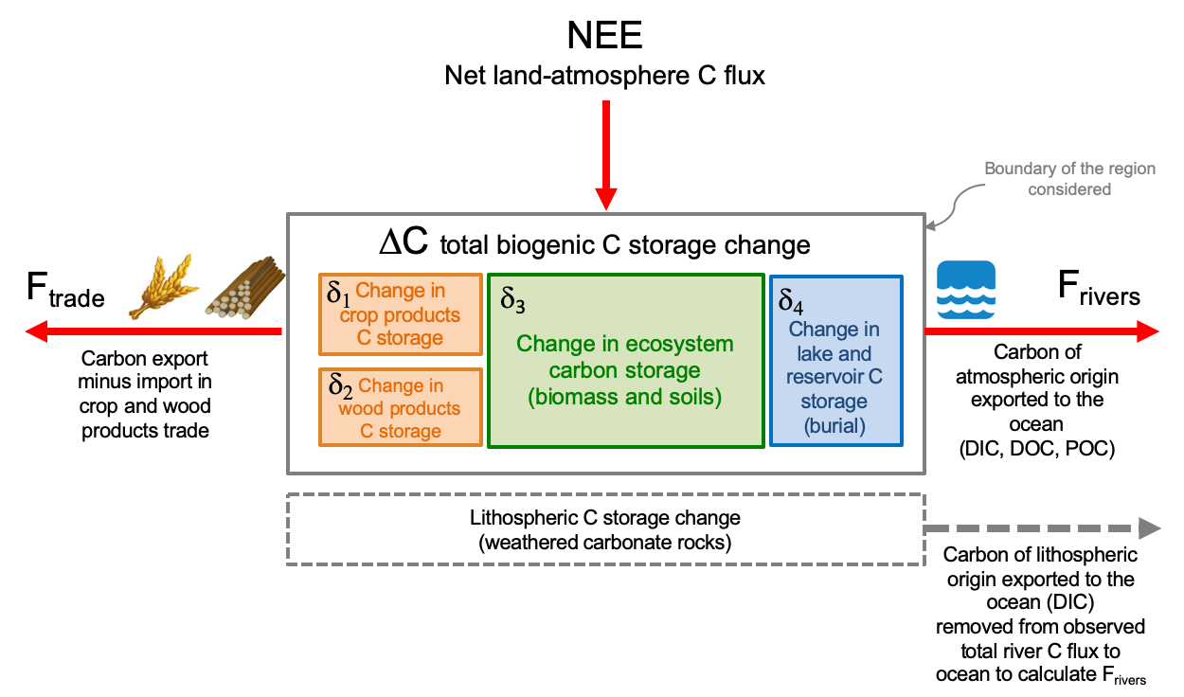

Supplementary Figure 2. Comparison of ∆C from inventories based on RECCAP publications (2000-2009) with the satellite-based estimates from ref. [17] covering only biomass C stock changes (2003-2009)
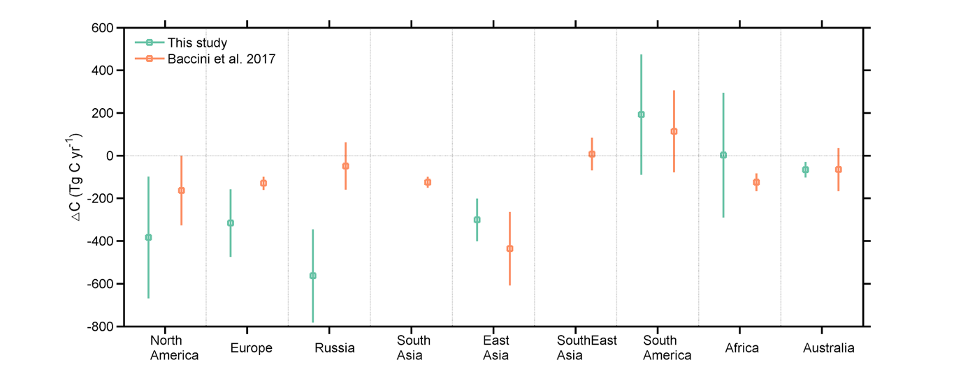

Supplementary Figure 3. Decomposition of NEE into component fluxes used to calculate SHR as a residual for each region. Global values of each flux are provided in Pg C yr⁻¹ rounded from Supplementary Table 1 to 0.1 Pg C yr⁻¹

Supplementary Figure 4. Comparison of NPP from four empirical based estimates (2000-2009) for each region (Methods)
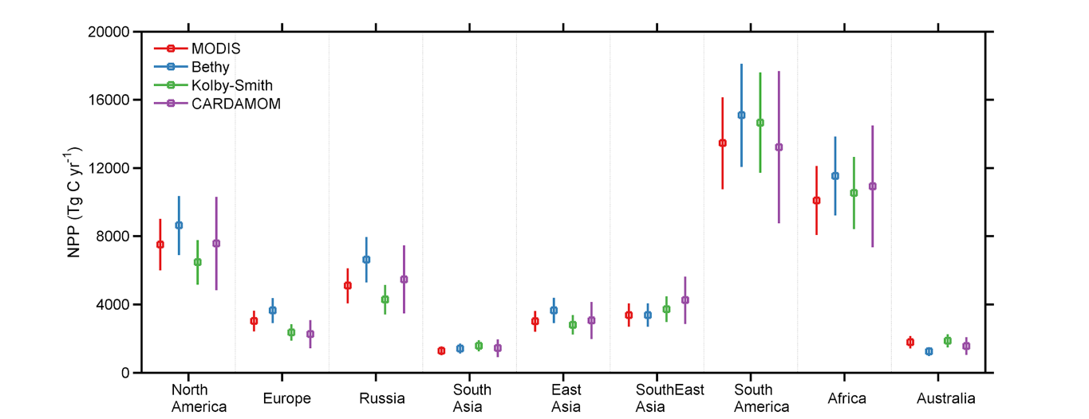

Supplementary Figure 5 The spatial distribution of SHR observation data used in the Random Forest upscaling (N=455).
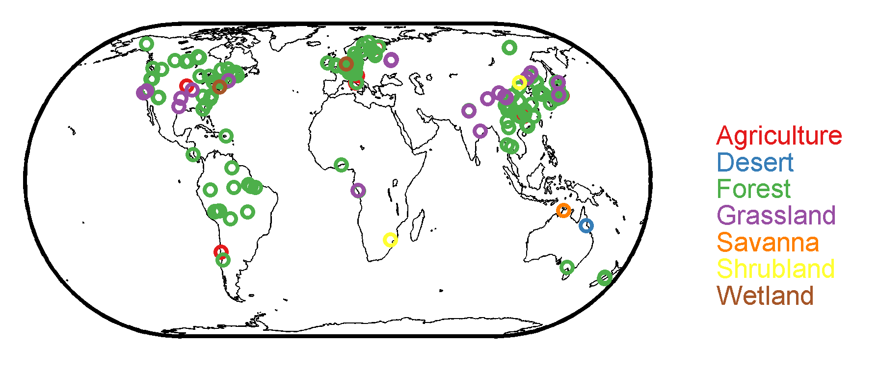

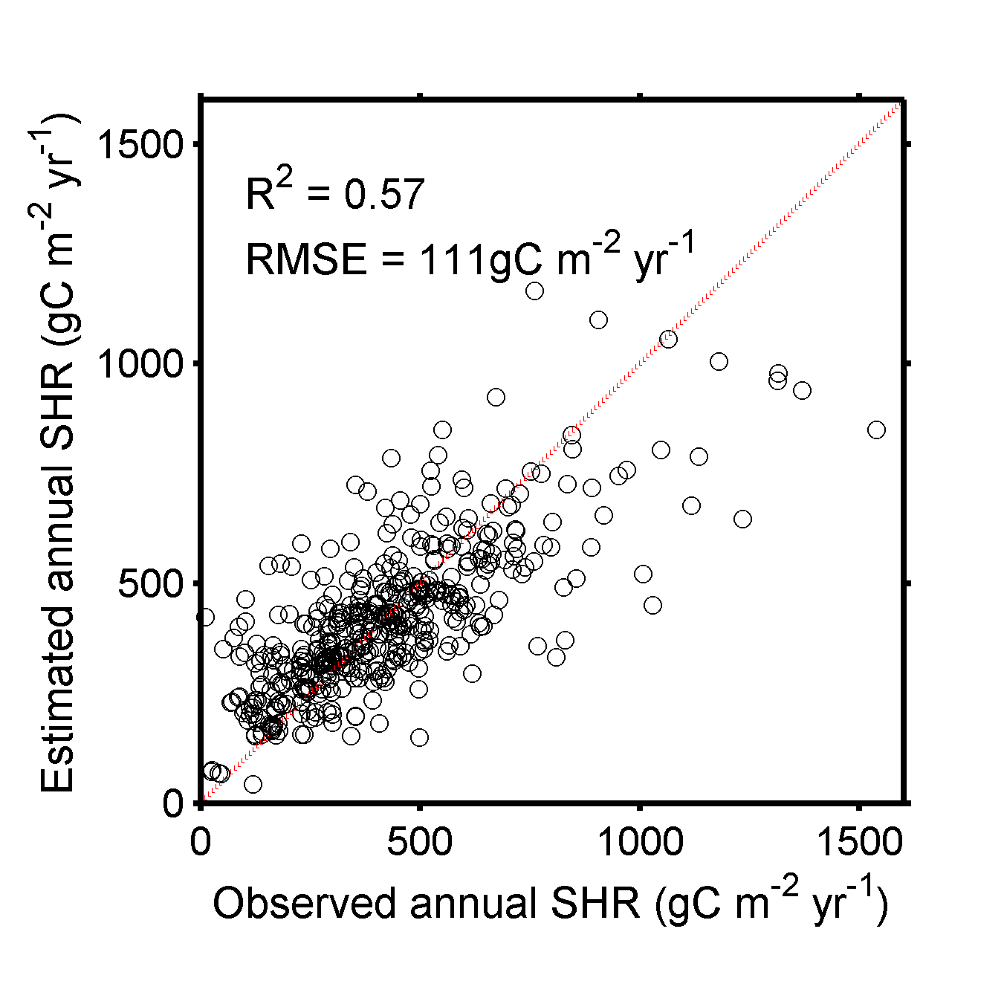
Supplementary Figure 6 Performance of random forest in estimating site-level annual SHR. The predicted value of each observation is estimated by a random forest model trained by other training samples excluding the validated one.

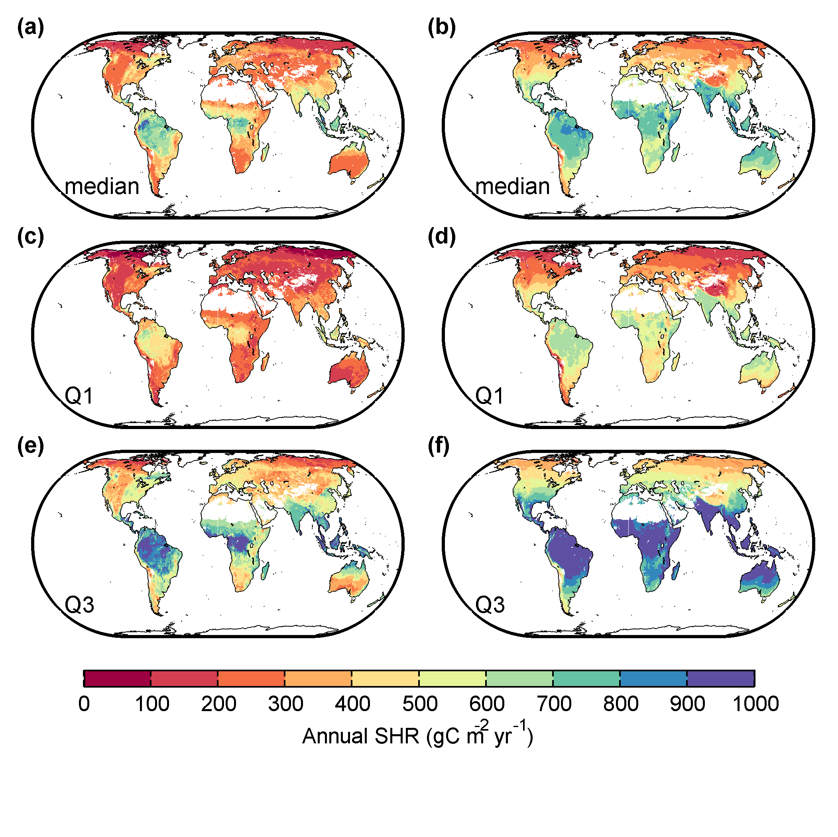
Supplementary Figure 7. Spatial distribution of site upscaled SHR from Random Forest in this study (a,c,e) and from climate functions as in Konings et al. [31] also used in this study (b,d,f). Median, first quantile, and third quantile are shown.

Supplementary Figure 8. Fire C emissions from GFED4 compared with GFAS (Methods)
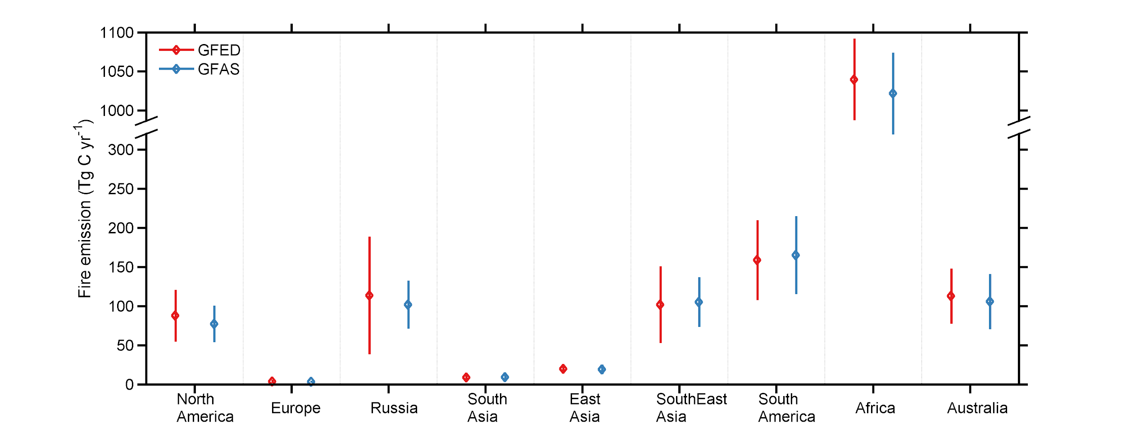

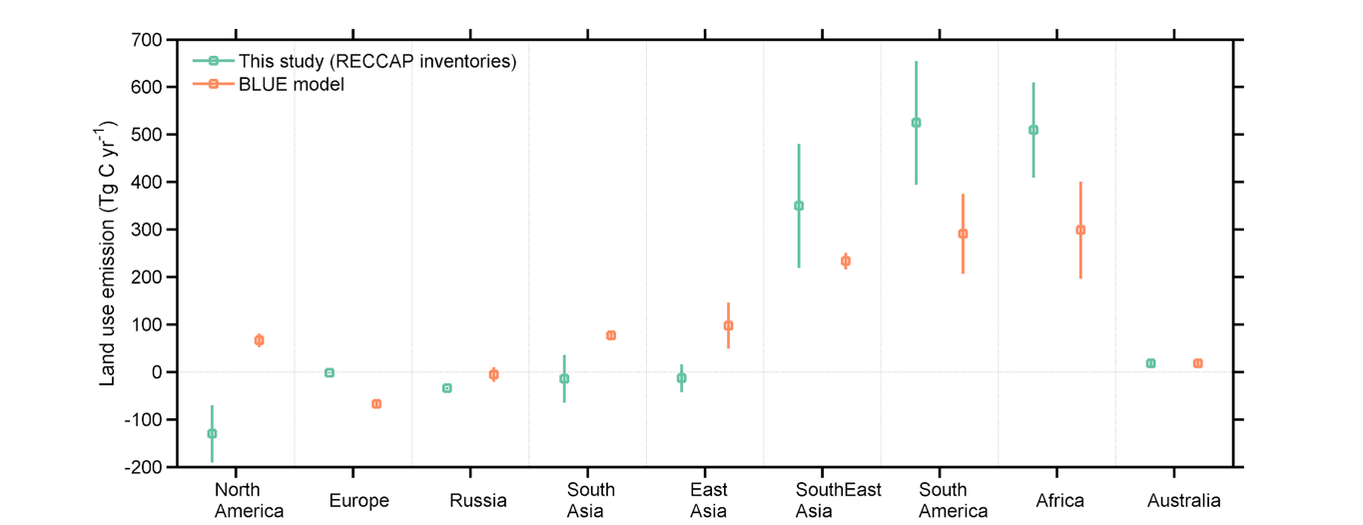
Supplementary Figure 9. Net land use change (LUC) emissions from BLUE model compared with RECCAP estimates (2000-2009). Positive values are emissions of carbon to the atmosphere (Methods)

References
81. van der Werf GR, Randerson JT and Giglio L et al. Global fire emissions and the contribution of deforestation, savanna, forest, agricultural, and peat fires (1997–2009). Atmos Chem Phys 2010;10:11707–35.
82. Di Giuseppe F, Rémy S and Pappenberger F et al. Using the Fire Weather Index (FWI) to improve the estimation of fire emissions from fire radiative power (FRP) observations. Atmos Chem Phys 2018; 18: 5359–70.
83. Le Quéré C, Andrew RM and Friedlingstein P et al. Global Carbon Budget 2018. Earth Syst Sci Data 2018;10:2141–94.
84. Raymond PA, Hartmann J and Lauerwald R et al. Erratum: Global carbon dioxide emissions from inland waters. Nature 2014;507, DOI: 10.1038/nature13142.
85. Zhao M, Running SW and Nemani RR. Sensitivity of Moderate Resolution Imaging Spectroradiometer (MODIS) terrestrial primary production to the accuracy of meteorological reanalyses. J Geophys Res 2006;111:G01002.
86. Luyssaert S, Abril G and Andres R et al. The European land and inland water CO2, CO, CH4 and N2O balance between 2001 and 2005. Biogeosciences 2012;9: 3357–80.
87. Eggers T. The impacts of manufacturing and utilisation of wood products on the European carbon budget., 2002.
88. Vuichard N, Ciais P and Belelli L et al. Carbon sequestration due to the abandonment of agriculture in the former USSR since 1990. Global Biogeochem Cycles 2008;22: GB4018.
89. Shvidenko A, Lakyda P and Schepaschenko D et al. Carbon, climate and land-use in Ukraine: forest sector, Korsun-Shevechkivsky, Ukraine [in Ukrainian]., 2014.
90. Henebry GM. Global change: Carbon in idle croplands. Nature 2009;457:1089–90.
91. Goodale CL, Apps MJ and Birdsey RA et al. Forest carbon sinks in the northern hemisphere. Ecol Appl 2002;12:891–9.
92. Tate K, Scott N and Parshotam A et al. A multi-scale analysis of a terrestrial carbon budget. Agric Ecosyst Environ 2000;82:229–46.
93. Zscheischler J, Mahecha MD and Avitabile V et al. Reviews and syntheses: An empirical spatiotemporal description of the global surface-atmosphere carbon fluxes: Opportunities and data limitations. Biogeosciences 2017;14:3685–703.
94. Zscheischler J, Mahecha M and Reichstein M et al. Towards an purely data driven view on the global carbon cycle and its spatiotemporal variability. EGU Gen Assem 2015 2015.
95. Geoffroy O, Saint-Martin D and Olivié DJL et al. Transient Climate Response in a Two-Layer Energy-Balance Model. Part I: Analytical Solution and Parameter Calibration Using CMIP5 AOGCM Experiments. J Clim 2013;26:1841–57.
96. Meinshausen M, Smith SJ and Calvin K et al. The RCP greenhouse gas concentrations and their extensions from 1765 to 2300. Clim Change 2011;109:213–41.
97. Lauerwald R, Laruelle GG and Hartmann J et al. Spatial patterns in CO₂ evasion from the global river network. Global Biogeochem Cycles 2015;29:534–54.
98. United Nations, Department of Economic and Social Affairs, Population Division (2013).World Population Prospects: The 2012 Revision, DVD Edition.
99. Langerwisch F, Walz A and Rammig A et al. Climate change increases riverine carbon outgassing while export to the ocean remains uncertain. Earth Syst Dyn Discuss 2015;6:1445–97.
100. Huang J, van den Dool HM and Georgarakos KP. Analysis of model-calculated soil moisture over the United States (1931–1993) and applications to long-range temperature forecasts. J Clim 1996;9:1350–62.
101. Jung M, Reichstein M and Schwalm CR et al. Compensatory water effects link yearly global land CO₂ sink changes to temperature. Nature 2017;541:516–20.
102. Wei Y, Liu S and Huntzinger DN, et al. NACP MsTMIP: Global and North American Driver Data for Multi-Model Intercomparison. ORNL DAAC, Oak Ridge, Tennessee, USA. 2014.
103. FAO, IIASA; ISRIC, ISSCAS. JRC: Harmonized World Soil Database (version 1.2). FAO, Rome, Italy and IIASA, Laxenburg, Austria. 2012.
104. Global Soil Data Task Group. Global Gridded Surfaces of Selected Soil Characteristics (IGBP-DIS). 2000.
105. Marín-Spiotta E and Sharma S. Carbon storage in successional and plantation forest soils: a tropical analysis. Glob Ecol Biogeogr 2013;22:105–17.

