MYCOTECTURE OFF PLANET: FUNGI AS A BUILDING MATERIAL ON THE MOON AND MARS. L. J. Rothschild¹, C. Maurer², M.B. Lipińska³, D. Senesky⁴, I. Paulino-Lima⁵, J. Snyder⁵, M. Dade-Robertson⁴, A. Wipat⁴, M. C. Rheinstädter⁶, E. Axpe⁴, C. Workman⁷, D. Cadogan⁸ and J. W. Head⁹. ¹NASA Ames Research Center, Moffett Field, CA, 94035, USA, Lynn.J.Rothschild@nasa.gov, ²redhouse studio, Cleveland, OH 44113, USA, Newcastle University, Newcastle upon Tyne NE1 7RU, UK, ⁴Stanford University, Stanford, CA 94305, USA, ⁵Blue Marble Space Institute of Science at NASA Ames Research Center, Moffett Field, CA, 94035, USA, ⁶McMaster University, Hamilton, ON L8S 4M1 CANADA, ⁷DTU, Kongens Lyngy, DENMARK, ⁸Moonprint Solutions, Dover DE, 19901, USA, ⁹Brown University, Providence, RI, 02912, USA.

Introduction: A turtle carries its own habitat. While reliable, it costs energy and is not easily adapted for the environment. NASA makes the same trade-off when it transports habitats and other structures needed to lunar and planetary surfaces. Astronauts stayed on the lunar surface for up to 75 h (Apollo 17), so the lunar module (LM) could double as a habitat. An example of the “build it on Earth, launch it into space” approach is the Habitat Demonstration Unit (HDU) Deep Space Habitat, developed by the Habitat Systems Project (NASA AES). The hardware consists of a composite fiberglass resin-infused shell attached to eight steel ribs, providing living and working space for a crew of four. Even with the use of advanced materials, it weighs >14,000 kg (~ 466 kg/m² living space), leading to high launch costs. Upmass and resupply will result in reduced surface operations, greater mission risk, loss of productivity and psychological stress.
In contrast, a bird builds its home at destination using sustainable manufacturing and in situ materials. In this vein, NASA’s Centennial Challenges program ran a 3D printed Habitat design challenge for the Moon, Mars and beyond [1]. Top designs used ISRU, focusing on agglutinated regolith or frozen water. Requirements included a vapor barrier, and a robotic infrastructure for preparing the site, gathering regolith and building. While regolith and ice have advantages as building materials and are compatible add-ons to our concept, regolith has disadvantages including rigidity, poor thermal insulation, massive energy demand, potential mineral/chemical toxicity and incompatibilities, and a dedicated infrastructure required for production of both.
In a NASA Innovative Advanced Concepts (NIAC) Phase 1 study, we introduced the use of structures grown by fungal mycelial biocomposites at destination [Fig 1, Concept of mycotecture habitat on the moon]. 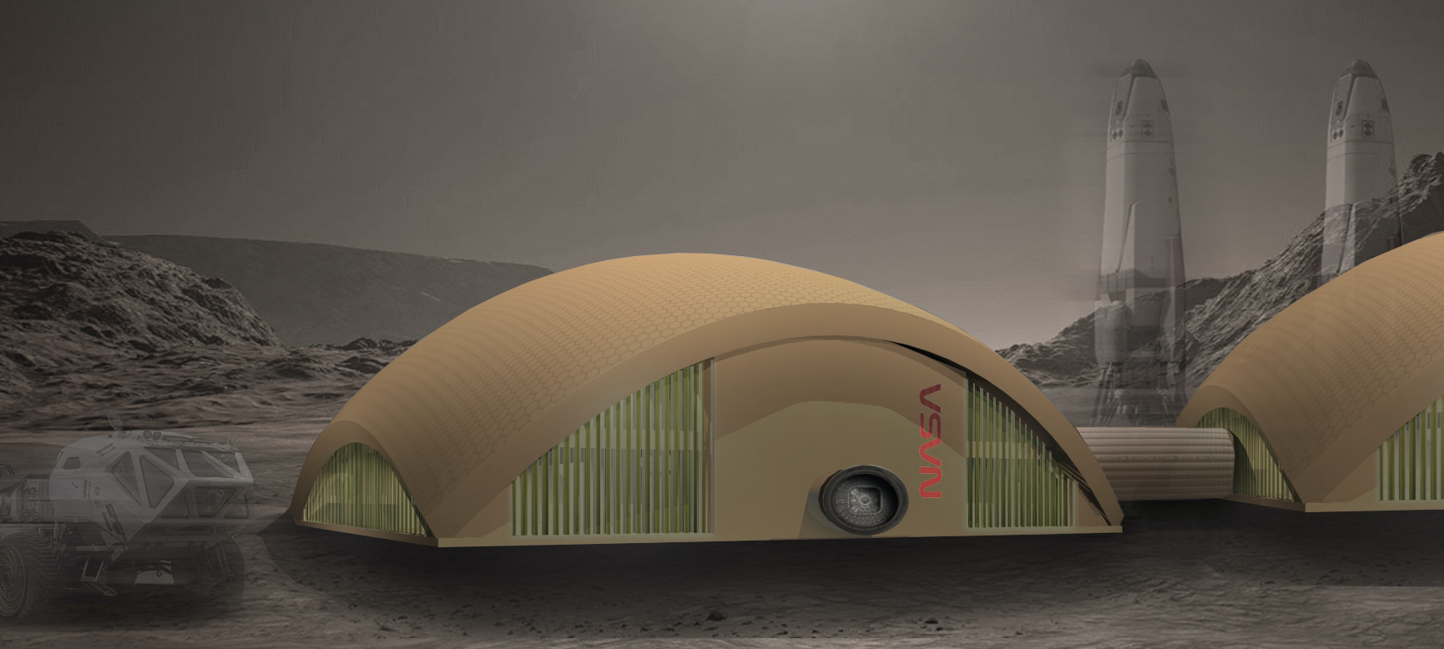Mycelial materials are known thermal insulators, fire resistant, and unlike plastics and glues, do not outgas. They are more flexible and ductile than regolith alone. The density and material properties are tuned during production. The material could be used dry, wet, frozen with water or as part of a self-produced biocomposite which would allow such enhancements as radiation protection and a vapor seal. Even better, it is self-replicating so the habitat could be extended at a future date, and thus also be self-repairing. Some form of this material could be used for a habitat at destination, furniture, storage, additional buildings, and the shell of multiple rovers. As a standalone material or in conjunction with agglutinated or sintered regolith, a mycotectural building envelope could significantly reduce the energy required for building because in the presence of food stock and water it would grow itself. After the arrival of humans, additional structures could be grown with feedstock of mission-produced organic waste streams including inedible plant or soil components, or human waste. When protected, the mycomaterials can have a long life, but at the end of its life cycle the material could be become fertilizer for mission farming or production of new mycomaterials.
Radiation has been considered a “show stopper” for human missions, but some black fungi not only survive, but may thrive in space radiation [2]. We could supplement our mycomaterials with either genetic engineering of the mycelia to bind materials such as metals as we did in Phase 1, or with bacteria with which they would form a mutualistic relationship. These bacteria could supplement the structural integrity of the mycotectural envelope through bio-mineralization, polymer production or filament formation. Alternatively, they could act as an intelligent input (biosensor) in the mycomaterial synthesis process detecting pressure and flaws in the mycotectual structural integrity by measuring mechanical strength, and reporting anomalies through color change or fluorescence. Autotrophs could provide to, and receive from, the fungal mycelia, essential metabolites to speed up the growth of the structure. These bacteria would be a flight-proven spore former Bacillus subtilis, whose remarkable space-compatible abilities were proven during the nearly six year LDEF mission [3] and during the PowerCell mission on EuCROPIS (Rothschild, PI).
If we succeed in developing a biocomposite material that can grow itself, we will provide NASA with a radically new, cheaper, faster, more flexible, and lighter material for habitats for extended duration lunar and Mars missions, as well as furniture and other structures. While our habitat shell is designed to be inert, we can envision its extension into a living state participating actively in waste recycling, oxygen production, and detoxification similar to a living roof. The long-term goals of this concept would be to create a living shell that functions beyond structure and warmth, where the organisms can be manipulated to perform tasks like: self-healing, humidity regulation, energy production, nutrient production, and bio-luminescence. Such living architecture was demonstrated by a five-story Bio Intelligent Quotient building in Hamburg, Germany [4] showing that this approach can scale.
The use of mycotecture on Earth, its variable density, lack of outgassing, ability to tune the material, construct it through multiple routes including ones with little to no on-site infrastructure, suggest that the concept is credible for building structures off planet. However, unknowns remain that are not readily determined, thus is intended to begin to address these with experiments and paper studies. Mycelia products use two main approaches: either the mycelium series to agglutinate materials such as wood chips, or it is grown to feature the mycelium itself as the product, resulting in an imitation leather. Both could be useful to NASA. In Phase 1 we imagined a co-culture of cyanobacteria and fungi in a bag. Here we introduce a novel third approach where the mycelia grow to fill a plastic shell containing a lightweight, compressible, porous scaffold, coated with a nutrient-rich hydrogel, possibly embedded with B. subtilis spores, and seeded with mycelia. The structure will be deployed by the expansion of the scaffold, and the heating to 30 °C during the beginning of the lunar night. Ideally the structure will be complete during this time allowing the heat of the lunar day to bake the structure in place. If the growth cannot be completed during lunar night, cooling will be needed for thermal stability during the lunar day until the structure is ready for baking.
Benefits to NASA and the broader aerospace community. There are numerous possibilities for off-planet building with mycotecture. Features include the modest upmass requirements of a few organisms, scaffold, hydrogel feedstock and plastic enclosure, their future potential to reproduce with in situ resources, the ability to grow to accommodate on-site terrain, and the tunability and multi-functionality of the materials. Other ISRU building proposals suggest agglutination of regolith, which could be done by fungal mycelia. In Phase 1 we demonstrated growth of mycelium on regolith simulant with added nutrients. Other benefits of mycotecture for NASA include production of furniture and fabrics on site, to water purification. Several of the fungi used have other uses. Aspergillus oryzae is used to make soy sauce, miso, sake and rice vinegar, and is used in biotechnology for protein production. We are assessing the potential of mycotecture to aid in building solid substrate at destination for landing or launch.
Terrestrial spin-offs: The building processes to be developed in Phase 2 may have profound effect on the building industry. This is responsive to the UN Sustainable Development Goals 9, 11, 12 [5]. Currently the building industry is responsible for 40% of Earth’s carbon emissions. The concept of a rapidly deployable, self-building self-healing structure potentially with embedded biosensors and eco-friendly in that it would be biodegradable and emit no toxic volatiles, is appealing. The commercial sector is exploring insulation and packing materials, but with the addition of our new feedstocks, scaffold and embedded sensing capabilities, they could be more useful. The techniques can be used to build quickly deployable, warm safe shelters with little carbon footprint to house the hundreds of millions of refugees anticipated by midcentury. With the right material properties, new applications include lightweight protective gear, buoys and custom grown shoes in areas where access to clothing that fits may be limited. We are currently exploring the use of mycotecture to increase sustainability in the restaurant, Azurmundi.
Acknowledgments: We are indebted to two iGEM teams in the development of this work, Stanford-Brown 2018 (Rothschild’s lab) and DTU 2018 team (Workman’s lab), and Rothschild and Head’s groups for mentoring (https://2018.igem.org/Team:Stanford-Brown-RISD and http://2018.igem.org/Team:DTU-Denmark). We gratefully acknowledge support from the NIAC program for Phase I and II, and STMD, Rhode Island and California Space Grant Consortium, and NASA Ames for support for the iGEM teams. This research is partially funded by Northern Bridge Consortium as part of the Hub for Biotechnology in the Built Environment (HBBE), and by the research group Bio-Futures for Transplanetary Habitats.
References: [1] https://www.nasa.gov/directorates/spacetech/centennial_challenges/3DPHab/about.html [2] Dadachova, E., & Casadevall, A. (2008) Curr Opinion Microbiol, 11(6), 525–531. [3] Horneck, G. (1993) Orig Life Evol Biosph 23(1), 37-52. [4] Wallis, D. (2013) The New York Times, http://www.nyti.ms/11Ceu9J [5]. https://sustainabledevelopment.un.org/?menu=1300

