Predicting the Penetration of a Shielded TPS Tile

W. Schonberg
Missouri University of Science & Technology

J. Williamsen
Institute for Defense Analyses

E. Christiansen
NASA/Johnson Space Center

Abstract
All spacecraft are subject to the possibility of high-speed particle impacts during their mission life. In low earth orbit, those impacts could be the result of collisions with pieces of orbital debris or with meteorites. Beyond LEO, and especially beyond GEO, those impacts will likely be caused by meteorites. Such high-speed impacts on spacecraft surfaces create debris clouds that travel towards and eventually impact other downstream spacecraft components. In addition to the impulsive load that such debris clouds would impart to the spacecraft elements with which they subsequently collide, the largest fragment in these debris clouds poses a significant threat on its own to those spacecraft elements. In order to be able to assess the severity of the threat posed by such a fragment, it is important to be able to predict the extent of damage sustained by the impacted spacecraft element.
In this paper, we present a new process for determining the penetration depth in a shielded TPS tile system. The requirements for the process were that it be applicable across a full spectrum of impact low velocities (i.e. from ~ 7 km/s to above 50 km/s), that it be applicable over a wide range of projectile materials densities (i.e. ranging from water to steel, for example), and that it be applicable over a wide range of trajectory obliquities (i.e. not just normal impacts). Furthermore, the process developed should be sufficiently flexible so that it can be used for shield design parameter and / or system configuration trade studies (i.e. be written in terms of as many shield and TPS tile system parameters as possible).
Figure 1 shows a sketch of the shielded TPS system. Following the initial impact of the projectile on the outer wall of the dual-wall shield, a debris cloud (i.e. the primary debris cloud) is created that travels towards and impacts the inner wall of the shield. Within this debris cloud is a combination of solid, liquid, and vaporized material, depending on the impact velocity and the impedance mismatch of the projectile and outer wall materials. The impact of this debris cloud on the inner wall creates another debris cloud (i.e. the secondary debris cloud) that then travels towards and impacts the TPS tile. Within the particulate distribution of the material in each of these debris clouds is a so-called largest fragment.

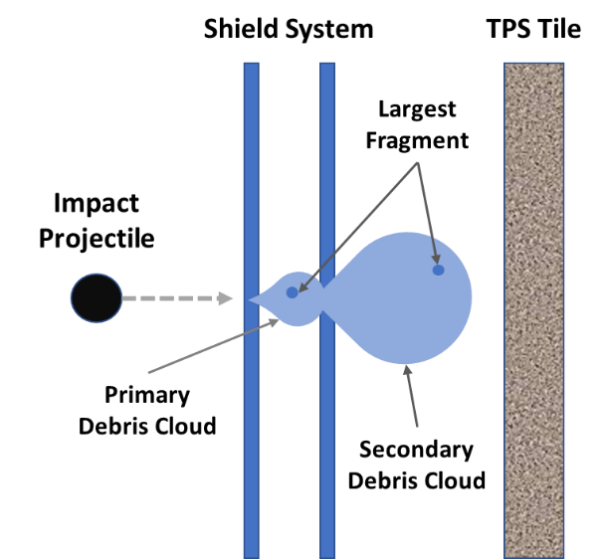
Figure 1. Sketch of a high-speed impact on a shielded TPS tile system
The process used to calculate the penetration depth in a shielded TPS tile system developed herein consists of the following three steps:
- Does the initial projectile perforate the outer wall of the shield? If NO, the TPS tile remains undamaged. If YES, calculate the size and speed of the largest fragment exiting the outer wall of the shield and traveling towards the shield’s inner wall.

- Does the largest fragment in the debris cloud exiting the outer wall of the shield perforate the inner wall of the shield? If NO, the TPS tile again remains undamaged. If YES, calculate the size and speed of the largest fragment exiting the rear of the shield inner wall.

- Calculate the penetration depth of the largest fragment in the debris cloud exiting the inner wall into the TPS.
Perforation of the inner and outer shield walls is predicted using the Cour-Palais penetration depth equation and an associated failure criterion [1]. The largest debris cloud fragment diameters and associated velocities are calculated using regression equations developed from a mix of hydrocode and experimental diameter and velocity information [2]. Finally, TPS penetration depths are calculated using an empirical penetration depth predictor equation based on high-speed impact test data and are calibrated using a limited number of hydrocode penetration depth predictions for water, nylon, aluminum, Dunite, and steel projectiles
The predictions of the penetration depth calculation process are compared against the predictions of more than 60 SPHC hydrocode runs. These comparisons show that the process used to calculate TPS tile penetration depths usually yields values that are within 1 mm of the predictions of hydrocode simulations. If a maximum allowable TPS penetration depth is known, the process developed herein can now be used to develop a failure limit equation that would predict whether or not an impacting particle would penetrate deeply enough into the TPS to result in a “failed” or “not failed” end state.
References
[1] E.L. Christiansen, “Design and performance equations for advanced meteoroid and debris shields”, International Journal of Impact Engineering, Vol. 14, 1993, pp. 145-156.
[2] W.P. Schonberg, “Predicting the size of the largest particle fragment in a debris cloud created by an orbital debris impact and its associated velocity”, 2021 Applied Space Environments Con-ference, NASA Jet Propulsion Laboratory, Pasadena, California, November, 2021.

