Supporting Information for
Could road constructions be more disastrous than an earthquake in terms of mass movement?
Hakan Tanyaş¹, Tolga Görüm⁴, Dalia Kirschbaum², Luigi Lombardo¹
¹University of Twente, Faculty of Geo-Information Science and Earth Observation (ITC), Enschede, Netherlands
²NASA Goddard Space Flight Center, Hydrological Sciences Laboratory, Greenbelt, MD, USA
³USRA, Universities Space Research Association, Columbia, MD, USA
⁴Istanbul Technical University, Eurasia Institute of Earth Sciences, Istanbul, Turkey
Corresponding author: Hakan Tanyaş (h.tanyas@utwente.nl)

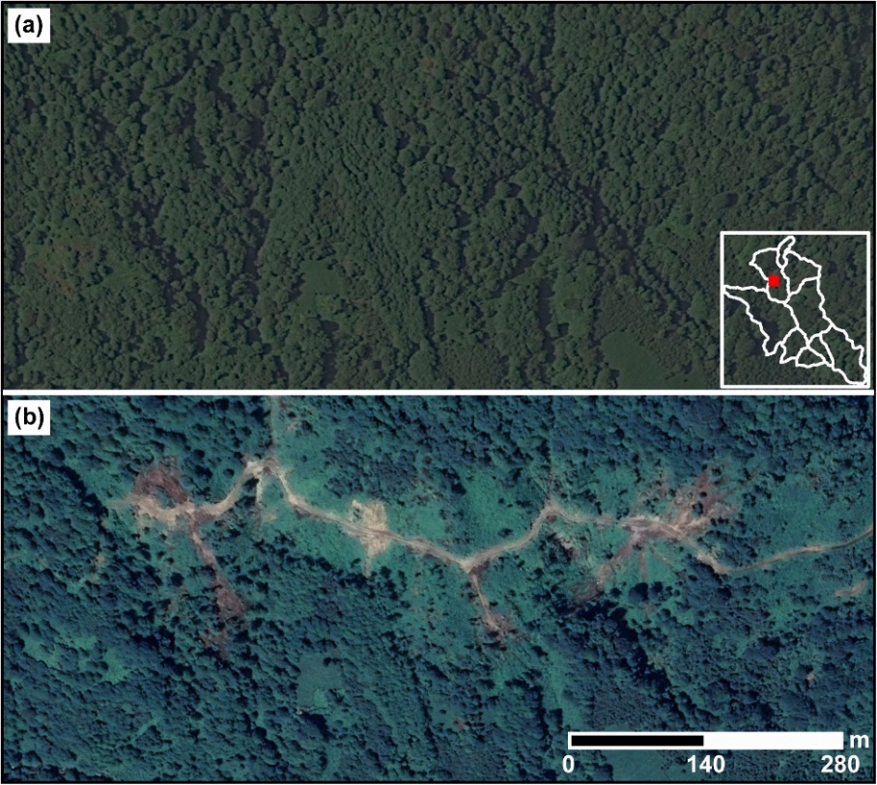
Fig. S1 Google Earth scenes showing the pre- and post- road expansion conditions at a selected site (41º 16ʹ 24ʺ N and 41º 17ʹ 51ʺ E) representing the mass movements categorized as Others. The examined the segment of the road constructed between 10th September 2013 – 3rd September 2014. Landslides occurred between 18th November 2017 – 27th May 2018 and 20th March 2019 – 21st May 2019. The location of these mass movements is given at the lower right of the panel (a).
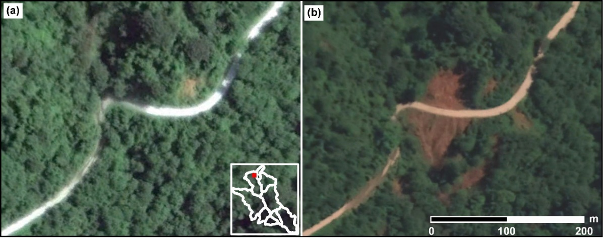
Fig. S2 Google Earth scenes showing the pre- and post- landslide views at a selected site (41º 18ʹ 20ʺ N and 41º 20ʹ 14ʺ E), representing the mass movements that occurred along an existing road (i.e., Pre-2010). Mass movements occurred between 3rd November 2016 – 16th April 2017. The location of these mass movements is given in the lower right of the panel (a).
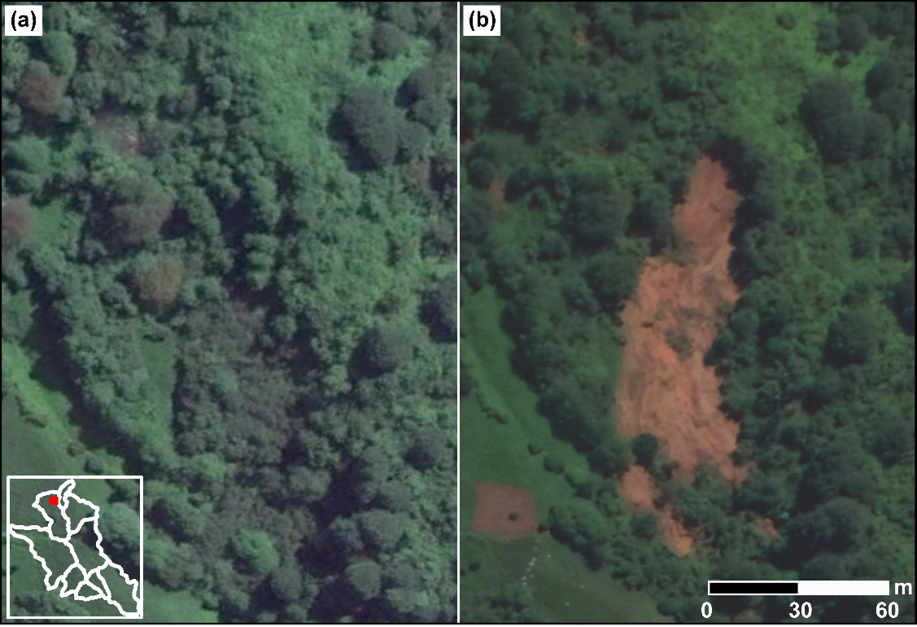
Fig. S3 Google Earth scenes showing the pre- and post- landslide landscape at a selected site (41º 18ʹ 20ʺ N and 41º 17ʹ 58ʺ E) representing the mass movements triggered by natural agents (i.e., No Road). The landslide occurred between 17th July 2016 – 9th September 2016. The location of the landslide is given in the lower left of the panel (a).

Table S1. The satellite scenes used to create multi-temporal road and landslide inventories.
Source | Acquisition date | ID
RapidEye-5 | 09.25.2009 | 3758023_2009-09-25_RE5_3A
 |  | 3758223_2009-09-25_RE5_3A
 |  | 3758123_2009-09-25_RE5_3A
 |  | 3758122_2009-09-25_RE5_3A
RapidEye-5 | 11.09.2010 | 3758122_2010-11-09_RE5_3A
 |  | 3758122_2010-11-09_RE5_3A
 |  | 3758223_2010-11-09_RE5_3A
 |  | 3758123_2010-11-09_RE5_3A
RapidEye-3 | 10.21.2011 | 3758023_2011-10-21_RE3_3A
 |  | 3758122_2011-10-21_RE3_3A
 |  | 3758123_2011-10-21_RE3_3A
 |  | 3758223_2011-10-21_RE3_3A
RapidEye-5 | 05.29.2012 | 3758023_2012-05-29_RE5_3A
 |  | 3758122_2012-05-29_RE5_3A
 |  | 3758123_2012-05-29_RE5_3A
 |  | 3758223_2012-05-29_RE5_3A
RapidEye-2 | 06.26.2013 | 3758223_2013-06-26_RE2_3A
 |  | 3758122_2013-06-26_RE2_3A
 |  | 3758123_2013-06-26_RE2_3A
RapidEye-2 | 09.10.2013 | 3758223_2013-09-10_RE2_3A
 |  | 3758023_2013-09-10_RE2_3A
 |  | 3758122_2013-09-10_RE2_3A
 |  | 3758123_2013-09-10_RE2_3A
RapidEye-4 | 09.12.2013 | 3758223_2013-09-12_RE4_3A
 |  | 3758023_2013-09-12_RE4_3A
 |  | 3758123_2013-09-12_RE4_3A
RapidEye-1 | 07.11.2014 | 3758023_2014-07-11_RE1_3A
 |  | 3758123_2014-07-11_RE1_3A
 |  | 3758122_2014-07-11_RE1_3A
RapidEye-3 | 09.03.2014 | 3758023_2014-09-03_RE3_3A
 |  | 3758123_2014-09-03_RE3_3A
 |  | 3758122_2014-09-03_RE3_3A
 |  | 3758223_2014-09-03_RE3_3A
RapidEye-3 | 05.20.2015 | 3758023_2015-05-20_RE5_3A
 |  | 3758122_2015-05-20_RE5_3A
 |  | 3758123_2015-05-20_RE5_3A
 |  | 3758223_2015-05-20_RE5_3A
RapidEye-3 | 09.03.2015 | 3758023_2015-09-03_RE1_3A
 |  | 3758122_2015-09-03_RE1_3A
 |  | 3758123_2015-09-03_RE1_3A
 |  | 3758223_2015-09-03_RE1_3A

Table S1. (Continued)
Source | Acquisition date | ID
PlanetScope | 07.17.2016 | 20160717_042959_0d05_3B
 |  | 20160717_042759_0c41_3B
 |  | 20160717_042800_0c41_3B
 |  | 20160717_042801_0c41_3B
 |  | 20160717_042955_0d05_3B
 |  | 20160717_042956_0d05_3B
 |  | 20160717_042957_0d05_3B
 |  | 20160717_042958_0d05_3B
RapidEye-3 | 07.17.2016 | 3758023_2016-07-17_RE1_3A
 |  | 3758123_2016-07-17_RE1_3A
 |  | 3758122_2016-07-17_RE1_3A
 |  | 3758223_2016-07-17_RE1_3A
PlanetScope | 09.06.2016 | 20160906_080327_1_0c65_3B
 |  | 20160906_080324_0c65_3B
 |  | 20160906_080325_0c65_3B
 |  | 20160906_080326_0c65_3B
 |  | 20160906_080327_0c65_3B
PlanetScope | 09.08.2016 | 20160908_071431_0d06_3B
 |  | 20160908_071430_1_0d06_3B
 |  | 20160908_071430_0d06_3B
PlanetScope | 09.09.2016 | 20160909_071400_0e20_3B
 |  | 20160909_071358_0e20_3B
 |  | 20160909_071359_0e20_3B
PlanetScope | 10.11.2016 | 20161011_114552_0d06_3B
 |  | 20161011_114552_1_0d06_3B
 |  | 20161011_114553_0d06_3B
PlanetScope | 10.22.2016 | 20161022_072604_0c19_3B
 |  | 20161022_072605_0c19_3B
 |  | 20161022_072606_0c19_3B
PlanetScope | 11.03.2016 | 20161103_090136_0c0b_3B
 |  | 20161103_090135_0c0b_3B
 |  | 20161103_090134_1_0c0b_3B
 |  | 20161103_090134_0c0b_3B
PlanetScope | 04.16.2017 | 20170416_083914_0c46_3B
 |  | 20170416_083914_1_0c46_3B
 |  | 20170416_083915_0c46_3B
PlanetScope | 06.09.2017 | 20170609_072127_0e30_3B
 |  | 20170609_072128_0e30_3B
 |  | 20170609_072129_0e30_3B
PlanetScope | 07.26.2017 | 20170726_072148_0e30_3B
 |  | 20170726_072146_0e30_3B
 |  | 20170726_072147_0e30_3B
PlanetScope | 09.04.2017 | 20170904_072029_103d_3B
 |  | 20170904_072030_103d_3B
 |  | 20170904_072031_103d_3B

Table S1. (Continued)
Source | Acquisition date | ID
PlanetScope | 09.18.2017 | 20170918_071932_0f42_3B
 |  | 20170918_071933_0f42_3B
 |  | 20170918_071934_0f42_3B
PlanetScope | 10.19.2017 | 20171019_072318_0e26_3B
 |  | 20171019_072319_0e26_3B
 |  | 20171019_072320_0e26_3B
PlanetScope | 11.18.2017 | 20171118_072437_0f4e_3B
 |  | 20171118_072438_0f4e_3B
 |  | 20171118_072439_0f4e_3B
PlanetScope | 05.27.2018 | 20180527_073042_1025_3B
 |  | 20180527_073041_1025_3B
 |  | 20180527_073040_1025_3B
PlanetScope | 06.28.2018 | 20180628_073245_0f17_3B
 |  | 20180628_073244_0f17_3B
 |  | 20180628_073243_0f17_3B
RapidEye-3 | 07.24.2018 | 3758122_2018-07-24_RE2_3A
 |  | 3758123_2018-07-24_RE2_3A
PlanetScope | 08.27.2018 | 20180827_073416_0f15_3B
 |  | 20180827_073415_0f15_3B
 |  | 20180827_073414_0f15_3B
PlanetScope | 09.25.2018 | 20180925_071315_103f_3B
 |  | 20180925_071314_103f_3B
 |  | 20180925_071313_103f_3B
PlanetScope | 10.07.2018 | 20181007_071157_0f33_3B
 |  | 20181007_071156_1_0f33_3B
 |  | 20181007_071156_0f33_3B
 |  | 20181007_071155_0f33_3B
PlanetScope | 11.09.2018 | 20181109_073629_1038_3B
 |  | 20181109_073628_1038_3B
 |  | 20181109_073627_1038_3B
PlanetScope | 03.20.2019 | 20190320_073854_1035_3B
 |  | 20190320_073853_1035_3B
 |  | 20190320_073852_1035_3B
PlanetScope | 05.21.2019 | 20190521_063655_100d_3B
 |  | 20190521_074307_0f3f_3B
 |  | 20190521_074306_0f3f_3B
 |  | 20190521_074305_0f3f_3B
 |  | 20190521_063656_100d_3B
PlanetScope | 06.11.2019 | 20190611_074120_0f35_3B
 |  | 20190611_074119_0f35_3B
 |  | 20190611_074118_0f35_3B
 |  | 20190611_073955_1021_3B
 |  | 20190611_073954_1021_3B
 |  | 20190611_073953_1021_3B

Table S1. (Continued)
Source | Acquisition date | ID
PlanetScope | 07.02.2019 | 20190702_074207_1024_3B
 |  | 20190702_074206_1024_3B
 |  | 20190702_073441_0e20_3B
PlanetScope | 08.04.2019 | 20190804_103007_0f02_3B
 |  | 20190804_103006_0f02_3B
 |  | 20190804_074420_0f4e_3B
PlanetScope | 09.25.2019 | 20190925_075817_42_106e_3B
 |  | 20190925_074355_0f35_3B
 |  | 20190925_074354_0f35_3B
PlanetScope | 10.02.2019 | 20191002_061504_100d_3B
 |  | 20191002_074426_0f15_3B
 |  | 20191002_074425_0f15_3B
 |  | 20191002_061505_100d_3B
PlanetScope | 11.09.2019 | 20191109_074234_1025_3B
 |  | 20191109_074233_1025_3B
 |  | 20191109_074232_1025_3B
PlanetScope | 11.14.2019 | 20191109_074234_1025_3B
 |  | 20191109_074233_1025_3B
 |  | 20191109_074232_1025_3B
PlanetScope | 04.13.2020 | 20200413_074533_1001_3B
 |  | 20200413_074532_1001_3B
 |  | 20200413_074531_1001_3B
 |  | 20200413_074530_1001_3B
PlanetScope | 04.17.2020 | 20200417_054549_0f4d_3B
 |  | 20200417_054548_0f4d_3B
 |  | 20200417_054547_0f4d_3B
PlanetScope | 05.12.2020 | 20200512_074305_64_106b_3B
 |  | 20200512_075632_32_105c_3B
PlanetScope | 06.06.2020 | 20200606_075039_1026_3B
 |  | 20200606_075038_1026_3B
 |  | 20200606_075037_1026_3B
PlanetScope | 07.07.2020 | 20200607_074232_100c_3B
 |  | 20200607_074230_100c_3B

