Yonkers Urban Development II
Leveraging NASA Earth Observations to Support Modeling Urban Cooling Interventions and Urban Heat Vulnerability in Yonkers, New York

Technical Report
Final – November 18th, 2021

Tamara Barbakova (Project Lead)
Lauren Mahoney
Akshay Agrawal
Amanda Trakas
Kyle Pecsok

Advisors:
Dr. David Hondula, Arizona State University (Science Advisor)
Dr. Kenton Ross, NASA Langley Research Center (Science Advisor)
Lauren Childs-Gleason, NASA Langley Research Center (Science Advisor)

Previous Contributors:
Joseph Scarmuzza
Kathryn Greenler
Jillian Walechka
Samain Sabrin
Tanya Bils

1. Abstract
The City of Yonkers, New York, located in Westchester County, is experiencing rising temperatures which are a growing threat to the health and safety of its residents. Furthermore, the risk of heat-related illnesses and mortality disproportionately affects neighborhoods in Yonkers historically subjected to race-based housing segregation. To better understand these inequities, Groundwork Hudson Valley and NASA DEVELOP collaborated for a second term to evaluate community-level heat vulnerability, landcover distribution, street-level thermal comfort, and modeled urban cooling interventions. This team applied 2019 5-year American Community Survey (ACS) data and social and biophysical heat vulnerability variables established by the New York State Department of Health (NYSDOH), along with land surface temperature (LST) data collected from Landsat 8 Thermal Infrared Sensor (TIRS), and ISS ECOsystem Spaceborne Thermal Radiometer Experiment on Space Station (ECOSTRESS) to identify communities in Yonkers in need of prioritized cooling intervention at the census tract level. Data from the Real-Time Mesoscale Analysis (RTMA) provided relevant meteorological data for the ENVI-met model to conduct street-level thermal observations and model tree canopy cooling interventions in the Yonkers neighborhoods of Kimball and Old 7th Ward. The project results will support the prioritization and equitable distribution of cooling infrastructure in identified neighborhoods. Additionally, Groundwork Hudson Valley will use the analyses as a heat literacy tool to improve advocacy efforts and inform both residents and officials about how investment in deliberate modification to tree canopy cover improves the city’s thermal environment and helps mitigate extreme heat.

Key Terms
Urban heat island, heat vulnerability, thermal comfort, equity, Landsat 8 TIRS, ECOSTRESS, ENVI-met

2. Introduction

2.1 Background Information
Climate change is a ubiquitous problem with impacts felt across the globe. However, the distribution of these impacts is not felt equally. Marginalized populations are often the most vulnerable to impacts of climate change while also possessing the fewest resources to prepare for and adapt to extreme climate events (Markkanen & Anger-Kraavi, 2019). In urban environments, at-risk populations are gaining attention as rising temperatures are becoming a growing threat to human health and safety. Rising temperatures, along with rapid urbanization, are creating urban heat islands (UHIs), a phenomenon in which the temperature of urban areas is elevated relative to the surrounding rural countryside, largely due to greater proportions of absorbed and stored solar energy by artificial materials (Phelan et al., 2015).

UHIs contribute to heat waves, reduced nighttime cooling, and higher air-pollution levels. These, in turn, contribute to above average heat-related deaths and illnesses such as respiratory difficulties, and non-fatal heat stroke. The sensitivity of populations to extreme heat-related illness and death is largely influenced by interconnected socioeconomic factors, pre-existing medical conditions, the presence or lack of heat-mitigating infrastructure, and geography (Declet-Barreto et al., 2016; Hondula et al., 2015; Olsson et al., 2014). The main cause of UHIs is the modification of energy balance in urban areas which is in part caused by the substantial conversion of natural green areas to impervious surfaces (Balany et al., 2020). Thus, it is likely that intentional modification of urban landscapes will reduce temperature locally.

Green infrastructure (GI) is a common cooling strategy that harnesses the innate properties of vegetation to reduce the amount of solar radiation that is absorbed by impervious surfaces (Bowler et al., 2010). Trees in particular are an effective GI strategy, providing two principal ecosystem services to reduce heat loads— shading and evapotranspiration. Tree canopies absorb and reflect solar radiation, shading surfaces from direct solar exposure. Meanwhile, through evapotranspiration, trees release water vapor to the atmosphere and thus increase relative humidity, decreasing temperature and improving thermal comfort conditions (Balany et al., 2020). The heat mitigating properties of trees are consistent across multiple literature reviews, reporting that the addition of trees and hedges in urban areas may reduce peak ambient temperature between 0.2 and 5.0°C with the median reduction being close to 1°C (Balany et al., 2020).

Understanding the components and distribution of heat vulnerability within cities can guide adaptation strategies for communities. Therefore, in the summer of 2021, the NASA DEVELOP Yonkers Urban Development I team partnered with Groundwork Hudson Valley (GHV) to better understand heat vulnerability and model possible intervention scenarios in the City of Yonkers, New York. Yonkers is a medium-sized city (Figure A1) located in Westchester County directly north of the Bronx in New York City and has a population of 200,000 residents: 44.2% non-white and 34.7% Hispanic as of 2010. Like many other urban areas, Yonkers will continue to see a rise in heat-related morbidity and mortality in response to increasingly frequent and intense hot-weather episodes (Aminipouri et al., 2019). These effects, however, are not uniform across the city largely due to historical race-based housing segregation that took place in the 1930s and 1940s (Groundwork Hudson Valley, 2021). To aid in analysis, Yonkers Urban Development I combined environmental data from NASA Earth observations (EO) with socioeconomic, demographic and heat outcomes data to address community-level urban heat inequity in Yonkers. The team mapped land surface temperature (LST) and vulnerability to heat and found that blocks located within the neighborhoods of Radford, Kimball, Old 7th Ward, and Glenwood experienced the most intense clustering of LST (hot-spot) (Walechka et al., 2021).

2.2 Project Partners & Objectives
Groundwork Hudson Valley (GHV), a trust of Groundwork USA, is a local organization empowering people and guiding the transformation of low-resource communities to promote equity, leadership, and economic opportunity. Under the Climate Safe Neighborhoods initiative, GHV explores the relationship between historical race-based housing segregation and the impacts of climate change. In continued partnership with GHV, Yonkers Urban Development II leveraged NASA EOs to provide spatially explicit urban cooling capacity data. Street-level thermal observations and landcover variables were analyzed using ENVI-met to model outdoor thermal comfort in identified high heat-vulnerability sites along with the microclimate benefits of increasing tree canopy in the respective areas. In addition, the team revised the previous terms heat vulnerability index based on factors examined by the NYSDOH (New York State Department of Health, 2017) and an additional temperature exposure component. Beyond these efforts, we utilized Open Space data to examine per capita landcover distribution and developed heat literacy graphics for public education and advocacy. GHV will utilize these results for their Climate Safe Neighborhoods initiative to help city planners strategize urban cooling interventions. The products will also aid GHV’s prioritization of mitigation efforts to help Yonkers meet the goals of New York State’s Climate Smart Communities program — improving community public health, safety, and building climate resiliency.

3. Methodology

3.1 Data Acquisition
Open-source data were collected for each analysis performed for this project, listed in Table A1 – A3. Table A1 lists the NASA EOs and rasterized datasets used for each analysis, Table A2 lists the ancillary datasets, and Table A3 lists the non-temperature data used to calculate the heat vulnerability index. Additional ENVI-met datasets that were not open source are listed in Table A4.

The team created a new Heat Vulnerability Index and Heat Priority Score for Yonkers Census Tracts. This updated index takes into account social and biophysical variables that the NYSDOH (NY State Department of Health, 2017) selected based on variables observed to influence the heat-health relationship within New York State and similar climates (Nayak et al., 2017). These variables fall under four different components that NYSDOH uses to help define vulnerability which are: elderly vulnerability, language vulnerability, socioeconomic vulnerability, and environmental vulnerability (Nayak, et al., 2017). Most of these variables were acquired from the ACS 2019 5-year estimate data (Table A3) through the TidyCensus package in RStudio, and the environmental data came from the National Land Cover Database (NLCD) 2019 data from the Multi-Resolution Land Characteristics (MRLC) Consortium website at a 30-meter spatial resolution. From this dataset we were specifically interested in landcovers that were defined as ‘Percentage land with high building intensity areas’ and ‘Percentage land that consists undeveloped areas.’ Beyond the variables the NYSDOH uses to calculate heat vulnerability, we also added an exposure component by obtaining Landsat 8 Thermal Infrared Sensor (TIRS) imagery for daytime LST and ECOsystem Spaceborne Thermal Radiometer Experiment on Space Station (ECOSTRESS) imagery for nighttime LST. The Landsat 8 TIRS imagery was obtained through Google Earth Engine (GEE) at a 30-meter spatial resolution while the ECOSTRESS data were downloaded through The Application for Extracting and Exploring Analysis Ready Samples (AppEEARS) at a 70-meter spatial resolution.

To compare and analyze tree canopy cover distribution along with impervious surface distribution, we downloaded NLCD's percent Developed Imperviousness and percent Tree Canopy datasets released in 2016 from the MRLC Consortium website at a 30-meter spatial resolution to compare their distribution throughout Yonkers census tracts. In addition, population data used to calculate tree canopy cover and impervious surface per person in each census tract in Yonkers were obtained from the ACS 2019, 5-year estimate data, through use of the TidyCensus package in RStudio.

In addition, we downloaded New York State 2019 census tract shapefiles from the US Census Bureau, and from this shapefile, we created two new shapefiles. We created a Westchester County shapefile by selecting by attribute for ‘COUNTYFP’ = 119 and then creating a Yonkers census tract shapefile from that by selecting by attribute for ‘NAME’ less than or equal to 24.05. While we downloaded ACS data from TidyCensus, they were not spatial datasets; we later joined the ACS data with our census tract shapefile. We also acquired Yonkers neighborhood data from the previous Yonkers Urban Development I, which simply provided location information of each Yonkers neighborhood.

In order to understand thermal comfort (level of satisfaction with the surrounding environment) within Yonkers neighborhoods, and how adding additional street trees might improve heat conditions for residents, a climate model called ENVI-met was used. The ENVI-met climate model produces a three-dimensional simulation of microclimate that can be used to estimate the effects of climate conditions on human thermal comfort within cities (Hunter 2008). The ENVI-met simulations performed for this project were located in the Kimball and Old 7th Ward neighborhoods in Yonkers. The two neighborhoods selected were of particular interest to our partners, Groundwork Hudson Valley, and were identified by the previous term as areas of moderate – high heat vulnerability. We then used Google Maps and further input from our partner to narrow down to two specific areas of interest.

The first modeled intervention was located in the Kimball neighborhood. The study area is bordered to the east and west by Kimball Ave and Maple Place and includes both the north and south sides of Edgewood and Winifred Avenues. Kimball is an upper-middle class neighborhood that features wide landscaped easements on residential and collector streets, essential existing infrastructure for planting street trees. The second intervention was modeled in the Old 7th Ward neighborhood, which demonstrates a high heat vulnerability due to factors related to both socioeconomic and surface temperature characteristics. This neighborhood lacks the infrastructure necessary to plant additional street trees because of its higher density urban form. Despite this, a similar simulated increase was modeled here as in Kimball to demonstrate how, if equitable investment was made, a cooling benefit might be experienced in this area for pedestrians, public transit users, and local residents. The study in Old 7th Ward was located between Oak Street and Linden Ave, to the east and west, with Chestnut Street as the northern boundary and Elm Street to the south.

Six meteorological data parameters were required to run the ENVI-met model. The first variable, wind speed (m/s) 10 m above ground, was acquired from the RTMA dataset extracted through GEE. This input was used as a point of reference for average wind speed, general wind direction and air temperature range for the hottest day in Yonkers, 30th of June 2021. The remaining inputs were acquired through a beginner level simulation completed using ENVI Guide.

3.2 Data Processing
3.2.1 Heat Vulnerability Calculation
To calculate heat vulnerability and a final heat priority score, we based our calculations and code off of a Principal Component Analysis (PCA) created by Nisbet-Wilcox et al. (2020, NASA DEVELOP). The ACS variables needed for the calculation were easily accessible through the TidyCensus package in R Studio. We acquired all of them for census tracts within Westchester County, New York and created a CSV with each census tract’s value for each variable from the ACS 2019 5-year estimate. We acquired data from all the census tracts within Westchester County rather than just Yonkers because we wanted to have enough data points for the PCA, given there would be fifteen input variables. It is generally recommended that for each variable within a PCA, there are approximately 520 observations (census tracts) present to run the analysis. Since Yonkers is composed of only 52 census tracts, we used all 223 Westchester County census tracts to run a more robust analysis. (Mundfrom et al., 2005)

To obtain percentage values for all variables from the ACS, we divided each variable by the total population or the total population for residents between 18 and 64 years old. To calculate housing unit density, we wanted to take the total number of housing units in a census tract and divide it by the census tract’s land area. We created a new column in the Westchester County land-only census tract shapefile in ArcGIS Pro, then performed Calculate Geometry to obtain the size of each census tract in square miles. We then exported the table to Microsoft Excel, where we joined the census tract area and number of housing units by GEOID and divided the number of housing units by the total land area. The landcover (biophysical) data were clipped within the Westchester County Census Tract shapefile. Next, the data were reclassed as follows: The NLCD class 24 was assigned ‘high built intensity’, the classes that were not 21-24 or 11 were assigned to ‘open space’, 11 was assigned to ‘water’, and the other landcover classes assigned to an ‘other landcover types’ class. Using the Tabulate Area tool, the area was calculated in sq feet for each landcover type within all of the Westchester County census tracts. To determine the percentage of each landcover type within each census tract, the Tabulate Area result was exported as a CSV. Within Excel, we calculated the percentage of ‘high built intensity’ and ‘open space’ by dividing those landcover types by the combined area of all landcover categories except for water.

The daytime LST data (LANDSAT/LC08/C02/T1_L2) downloaded through GEE was processed by removing clouds and cloud shadows as specified in the quality assurance band of the Landsat 8 Surface Reflectance dataset. We then clipped the daytime LST data within a Westchester County land only census tract shapefile, referencing code from Nisbet-Wilcox et al. (2020, DEVELOP). We created this shapefile by producing a water raster layer from the 2019 NLCD data and converting it to vector format, then performing the Erase operation on the Westchester County Census Tract shapefile to only include areas that are over land. Once clipped, we acquired median temperature values in the summer months between June 1st and August 31st from 2016 to 2021 for each individual pixel. Afterward, this dataset was exported from GEE as a shapefile and further processed in ArcGIS Pro by using the Zonal Statistics tool .to calculate the median temperature pixel value for each census tract in Kelvin. The nighttime LST (ECO2LSTE.001) and cloud masked data (ECO2CLD.001) were downloaded from AppEEARS between June 1st and August 31st of 2018-2021, since this ECOSTRESS was not operational until 2018. However, because some of the data was incorrectly georeferenced this data was clipped within the Westchester County census tract shapefile and a 2-kilometer buffer surrounding the county. Once downloaded, the images were filtered to only fall between 22:00-05:00 EDT through filtering a CSV downloaded in RStudio that had a list of all the ECOSTRESS images downloaded along with their collection dates. With certain imagery selected, we then went through each individual ECOSTRESS image in ArcGIS Pro to see which ones covered a sizeable area of the county, if the image only covered small sections of the county, we did not include it in the analysis. Once we filtered the images, we reclassified the cloud imagery values 0, 1, 32, and 33 to 1 (for not masking out) and 0 (for masking out) in order to mask out clouds obscuring the landscape. After performing the reclass we created a conditional statement where if the pixel value was 1, return the nighttime LST image value, and if the pixel was 0, return no data. Once this process was done for all available dates, we removed one image from July 17th, 2021, due to excessive cloud cover and then shifted each image and georeferenced it using the basemap (in the same projection) and the Landsat 8 TIRS data to accurately shift the data to the correct location. When shifting each image, we applied Snap Raster to the July 30th, 2018 image. We then used the Cell Statistics tool to calculate the median temp for each pixel, and then used Zonal Statistics to calculate the median value for each census tract. Lastly, the data had to be converted to Kelvin by multiplying the median values to a scale factor of 0.02. With all of these variables gathered, we had the information needed to run a Principal Component Analysis (PCA) to determine our final heat vulnerability for each census tract.

3.2.2 Temperature Difference
Beyond using LST data for the heat vulnerability analysis, we wanted to directly look at and compare how the LSTs compare across Yonkers during the daytime to look more specifically at heat exposure. We acquired all the median daytime LST data for each Yonkers census tract and exported it from ArcGIS Pro to Excel. Afterward, we performed Zonal Statistics again to calculate the median temperature value within a non-water Yonkers census tract shapefile that we performed the Dissolve operation on.

3.2.3 Landcover Distribution Data
To compare the distribution of tree canopy cover throughout Yonkers’ census tracts, the team utilized two methods. The first looked at tree cover canopy per person, and the second looked at the percentage of land (excluding water) that each census tract has comprised of tree canopy cover. We clipped the USFS Tree Canopy Cover NLCD 2016 data within the Yonkers’ census tract boundary file including and not including water, and then used Zonal Statistics to determine what the average percent tree canopy pixel value is for each census tract - with and without water. Afterwards, we performed a Spatial Join with the Yonkers census tract data.

Similarly to the tree cover data, we wanted to compare the distribution of impervious surfaces throughout Yonkers' census tracts by looking at the amount of impervious surface per person, and the percentage of land (excluding water) of each census tract comprised of impervious surfaces. We utilized the Erase operation in ArcGIS Pro over the vector NLCD water layer to exclude water surfaces when calculating average percentage of impervious and tree canopy cover for each census tract. We clipped the USFS Developed Imperviousness NLCD 2016 within the Yonkers census tract boundary file including and not including water. We then again used Zonal Statistics to determine what the average percent developed imperviousness pixel value was for each census tract and joined this data with the Yonkers census tract data.

3.2.4 ENVI-met Processing
To extract temperature, wind, wind direction, and cloud cover data from GEE (to examine how much cloud cover was in the way), we filtered the RTMA hourly data from June 1st, 2021, to August 31st, 2021. We clipped it within our neighborhoods of interest Kimball and Old 7th Ward. We then extracted these neighborhood shapefiles from the broader Yonkers neighborhood shapefile. For Old 7th Ward, the shapefile that we clipped the RTMA data within was surrounded by a 500-meter buffer because there was no data output when initially clipping it to the neighborhood. The neighborhood’s size was too small relative to the size of the RTMA pixel. Once we exported these data into a CSV, we filtered the data to show the warmest hour within our dates of interest — June 30th, 2021 at 2pm. This was then used as the time of interest to model in ENVI-met.

To perform the Kimball and Old 7th Ward simulations, we converted Google Maps snapshots of the study locations (aligned with true north), to a bitmap using Microsoft Paint. The bitmap was then used in the ENVI-met Spaces application to create a map of buildings, vegetation and surfaces as the microclimate analysis models the interaction of these parameters (Hunter et al., 2012). Additional predictive variables necessary for the simulations include wind speed and direction, air and soil temperature and humidity, turbulence, radiative fluxes, gas and particle dispersion (Hunter et al., 2012). For these preliminary simulations, beginner level simulations were completed using ENVI Guide which provided temperature range, wind speed and direction along with time duration for the simulation as inputs. The interaction of atmosphere, soil, vegetation and building variables of the study locations was analyzed by the model of both the existing conditions as well as a simulated increase in canopy cover on a microscale of less than 10 m of vertical height. The Leonardo application was used to produce 2D and 3D graphic interpretation and visualization of these variables.

3.3 Data Analysis
3.3.1 Heat Vulnerability Analysis
With social, landcover, and temperature data available for Yonkers Census Tracts, we were able to run a PCA within R of all these variables collected following Nisbet-Wilcox et al.’s (2020, DEVELOP) methodology. We conducted this PCA using the ‘prcomp’ function, which is part of base R. We picked four components based on the percentage variance explained by eigenvalues. After running the PCA, there was a heat vulnerability index associated with each census tract. We exported a CSV of the heat indices for each Westchester County Census tract, we then joined it with a Westchester County census tract shapefile (excluding four census tracts with null values) based on GEOID, and then clipped the file to within the Yonkers census tract shapefile. These indices for the Yonkers census tracts were then split into five quantiles for all of Yonkers’ census tracts to help determine which level of priority each census tract should have in cooling infrastructure initiatives, with 1 being the lowest priority and 5 being the highest priority.

3.3.2 Temperature Difference
To calculate the median LST difference between each Yonkers census tract and all of Yonkers, we used Excel to convert our temperature data from Kelvin to Fahrenheit. We then calculated the LST difference by taking the Yonkers median temperature and subtracting it by each census tract's median temperature. Finally, to map this data, we joined this table to the Yonkers census tract shapefile in ArcGIS Pro.

3.3.3 Landcover Distribution
As previously mentioned, two 2016 NLCD data products, USFS Tree Canopy Cover and Percent Developed Imperviousness, were utilized to calculate percentages of census tracts covered by impervious surface versus tree canopy, which was used as a proxy for shaded green spaces where residents can cool down. We exported these percentage values as a CSV file, then loaded that file into ArcGIS Pro, where it was table-joined to a shapefile of Westchester County census tracts including population, which was in turn created by table-joining a shapefile of Westchester County to a table of population data collected from the 2019 ACS. We then clipped it to the Yonkers municipal boundaries and exported the subsequent shapefile for continued usage by our project partner, Groundwork Hudson Valley. Lastly, we added new columns to the attribute table of this shapefile in ArcGIS Pro using the Add Field function, and then filled in these new columns with our calculated tree canopy and impervious surface per capita using Field Calculator. To calculate area of tree canopy coverage (in square feet) per person, we multiplied the fraction of each census tract represented by tree canopy by the total area of each census tract (in square feet), and then divided this value by the total population of each census tract.
Since looking at landcover surfaces at a per capita scale can de-prioritize census tracts with large populations and small surface area, the team created a metric called landcover assets that would better consider the landcover equity at stake in Yonkers’ neighborhoods. Areas of tree canopy cover were reframed as ‘assets’ i.e., a resource of positive value in terms of heat vulnerability, and areas of impervious surface were framed as ‘liabilities’ i.e., a source of negative value in terms of worsening heat vulnerability. Liabilities were subtracted from assets to determine which census tracts have more assets (positive resources to combat urban heat island) than liabilities, and which census tracts have more liabilities than assets, making it more difficult for them to combat urban heat.
3.3.4 ENVI-met
The simulation outputs of air temperature, mean radiant temperature, relative humidity, and global radiation were used within BIOmet, an ENVI-met post data-processing application, to calculate thermal comfort for both the existing conditions as well as the simulated increase in tree canopy coverage. Thermal comfort was calculated based on the Universal Thermal Climate Index (UTCI) for a standard male, 35 years of age, 1.75 m in height, and 75 kgs in weight using 1.4 m view of plane. The interventions (Figure B1 & B2) were based on modeled characteristics of Ceris siliquastrum (European Redbud) with similar growth characteristics of the native Ceris canadensis (Eastern Redbud)– labeled for moderate use in NYC approved street tree list. This species matures at a maximum height of less than 35’, making it an exceptional selection for use as an understory street tree, below existing powerlines. Placement of the trees were simulated with a concentrated point-heat source planting of trees along busier collector streets, and a less-frequent and staggered placement on the residential streets, based on existing vegetation and potential policy challenges realizing tree plantings in these areas.

4. Results & Discussion

4.1 Analysis of Results
4.1.1 Heat Vulnerability Analysis
The PCA produced four components of heat vulnerability in Yonkers (Table C1). The first component shows various socioeconomic, environmental/urban, and social/language vulnerabilities that are highly correlated with one another: (percent Hispanic, percent foreign born, percent building intensity, percent below poverty, housing unity density, and a language variable —percent of population that speak English very well. The second components consist of our two temperature variables median daytime LST and median nighttime LST, and two environmental variables percent open space and percent of building built before 1980, with percent open space correlating highly against the other variables. The third component consists of socioeconomic (percent of 18 – 64 year old residents that are with disability, percent Black, and percent of population that is age 18 – 64 and unemployed, while the fourth component consists of the two variables that make up elderly vulnerability (percent age over 65, and over 65 and live alone).

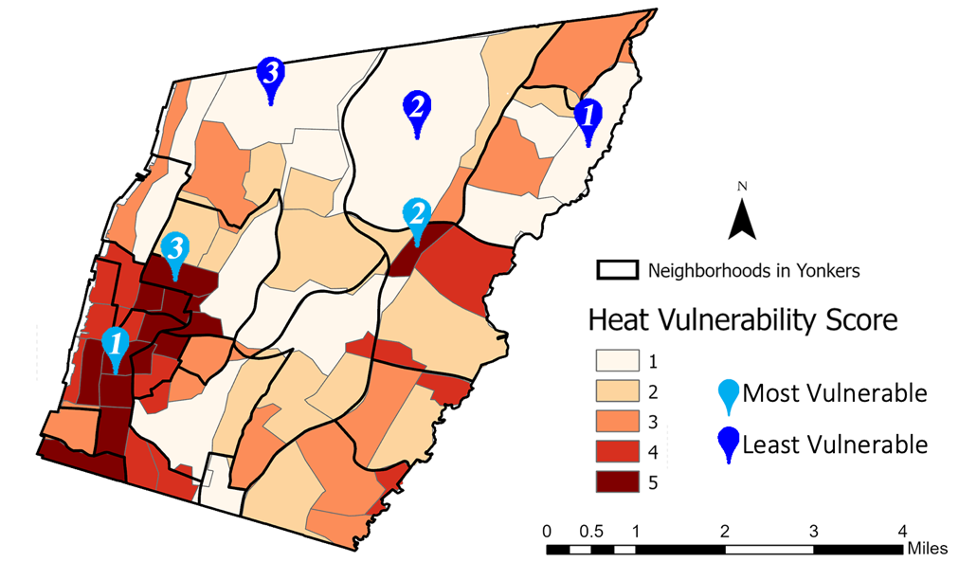
Based on the four principal components we produced the following Heat Vulnerability Map of Yonkers census tracts (Figure 1). Heat vulnerability is depicted on a scale of 1-5, by splitting the heat vulnerability indices in Yonkers census tracts into fifths that indicate how vulnerable certain areas of the city are to heat events compared to others, with a higher score indicating greater heat vulnerability. As depicted in Figure 1, the most heat vulnerable census tracts are located in the southwestern portion of the city, particularly around Old 7th Ward and areas surrounding it to the north and west. The three most vulnerable census tracts were located in the neighborhoods Radford, Sunnyside Park, and Glenwood (Table C2). Areas with lower heat vulnerability tend to be scattered throughout the city, with the northeastern section of the city seeing the highest concentration of low heat vulnerable census tracts. The three least vulnerable census tracts were located in Crestwood Lake, Sprain Lake Knolls, and Nepera Park (Table C3).
Figure 1: Heat vulnerability index calculated for Yonkers, NY. Location markers depict the most (purple) and least (blue) vulnerable neighborhoods.

4.1.2 Temperature Difference
The distribution of the median LST difference map shows a relatively similar pattern to the heat vulnerability map as seen in Figure C1. The higher temperatures tend to be concentrated to the southwestern portions of the city and the neighborhoods of Old 7th Ward and Kimball, both of which have some of the highest LSTs in the city. The northern and eastern portions of the city tend to be the locations of the lower temperatures.

4.1.3 Landcover Distribution
Our landcover distribution analysis produced five major mapping products, which were then compared against one and other to determine how different landcover types may be associated with heat vulnerability. These mapping products include assessing tree canopy cover and impervious surface at both the per capita and per census tract scale, as well as calculated net landcover assets.
4.1.3.1 Tree Canopy
The first map of tree canopy coverage per capita (Figure D1) captures the area in square feet of tree canopy attributed to each person living in the census tract. In this visualization, the north of Yonkers contains more tree canopy cover than the southwest and southeast and downtown areas of Yonkers, including the neighborhoods Kimball and Old 7th Ward. Census tracts with the highest area of tree canopy per person include Sprain Lake Knolls (North central), Beech Hill–Victory Heights (Northeast), and Nepera Park (North central) (Table D1). Census tracts with the least area per person include Radford (Southwest), Nodine Hill (center next to Old 7th), and Old 7th Ward (Table D2). The second visualization, tree canopy coverage per census tract (Figure D2), displays mainly areas predominantly in the north of Yonkers as having a greater percentage of tree canopy cover making up their surface area, including: Sunnyside Park (East central), Park Hill (South central), and Woodstock Manor (Northwest) (Table D3). Areas with an overall lower percentage of tree canopy cover are predominantly located to the southeast and southwest, such as the neighborhoods Radford (Southwest), LaMartine Heights (West central), and Old 7th Ward (Southwest) (Table D4).

4.1.3.2 Impervious Surface
Figure D3, depicting impervious surface per person, shows more impervious surfaces to the north, with census tracts in Sprain Lake Knolls and Beech Hill-Victory Heights ranking among the highest area of impervious surface per person. In contrast, census tracts with a smaller area of impervious surface per person are located towards the southeast and southwest, including our modeled neighborhoods Old 7th Ward and Kimball. These results, however, are misleading and not representative of which areas are actually in most need of green spaces. Neighborhoods such as Old 7th Ward and Kimball are ranked as having the least area of impervious surface per person (Table D6), when in reality, the population is densely packed into a small surface area so that people have less area in general per person, illustrated in the Figure D4. Based on impervious surface at the per census tract scale (Figure D4), areas to the north, such as Sunnyside Park and Crestwood Lake, actually rank among the lowest percentage of impervious surface throughout their respective census tracts (Table D8).

4.1.3.3 Pearson Correlation
Later on in our analysis, we found a negative association between percent tree canopy cover and heat vulnerability with a Pearson Correlation value of –0.68, indicating that places we identified as more heat vulnerable do tend to have a lack of tree cover that might act as a cooling mechanism. In addition, there was a positive association with a similar strength of association between percent impervious surface and heat vulnerability with a Pearson Correlation value of 0.71, indicating that areas with a greater amount of impervious surface tend to be more prevalent in more heat vulnerable neighborhoods. Both of these relationships were pretty linear, as seen in Figure D5. We also looked at the relationship between tree canopy cover and impervious surface per capita; there was a negative relationship between these variables and heat vulnerability, as seen in Figure D6. This result is likely attributed to greater heat vulnerable neighborhoods being located in census tracts with smaller areas and a greater amount of impervious surface and tree canopy cover per capita being in census tracts with larger areas.
4.1.3.4 Landcover Assets
Areas such as Sprain Lake Knolls and Park Hill, which earlier displayed as having more impervious surface per capita (Table D5), actually have more tree canopy coverage than impervious surface coverage and are thus more prepared to combat heat vulnerability. When we compare Figure D3, which looks at impervious surface per person, to Figure D7, it becomes apparent that certain areas to the north, such as Sprain Lake Knolls and Park Hill, actually have more net assets (green space) than liabilities (impervious surface). This map helps elucidate some of the equity issues with looking at impervious surface at a per person level when neighborhoods in need have small surface area and are densely populated.
4.1.4 ENVI-met
4.1.4.1 Kimball
The results of the Kimball thermal comfort analysis (Figure 2) visualize the thermal comfort felt in the existing conditions vs the modeled intervention, and reveal that substantial cooling was provided by the increased street tree canopy coverage. The majority of the improvements were seen in the immediate vicinity of the planted trees, though additional cooling was felt at both the east and west ends of Edgewood and Winifred Ave's as well as off the street, between individual homes and even in private backyards. The maximum thermal comfort temperature had an overall reduction of 0.5°F in the study area and the minimum decreased by 2°F.

Ten locations within the modeled intervention were subtracted from the temperatures in same locations obtained from the study of the existing conditions for a closer look at improvement to thermal comfort. Improvements of 1.5°- 7.6°F were observed within the study area, with the highest numbers in the range within direct proximity to planted trees nearer to the street – location 2 & 3 in Figure 2. Only one location was observed to lack a cooling improvement – location 7 – which experienced a 1.5°F increase in thermal comfort. This may be due to a blockage of ventilation caused by new intervention trees with winds noted to be out of the southwest on this day at this location. Overall, an average of 4.1°F of cooling was experienced per location of all the points in this analysis.

Thermal Comfort Analysis: Kimball Neighborhood
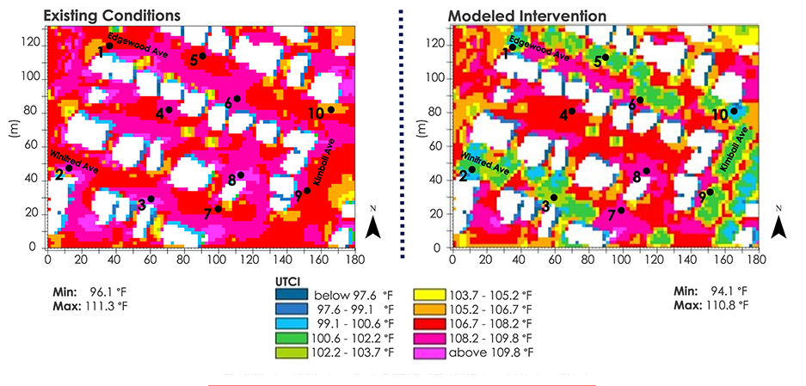
Figure 2: Comparison of thermal comfort analysis from ENVI-met model output at ten specific locations in the Kimball neighborhood showing the modeled conditions of June 30th, 2021, at 2pm (left) and the same conditions with a simulated increase in tree canopy coverage (right). Buildings are in white.

4.1.4.2 Old 7th Ward
The results of the thermal comfort analysis in the Old 7th Ward neighborhood (Figure 3) demonstrated a significant cooling effect along the streets that received the planting intervention and, similarly to Kimball, in adjacent spaces including residential backyards and even the vacant parcel within the study area. The overall maximum temperature was reduced by 3°F relative to human thermal comfort, with more dramatic cooling felt in specific locations within the study area. Minimum temperature was decreased by 0.5°F.
The temperatures were again compared both before and after the simulated intervention at ten specific locations shown in Figure 3 below. Improvements of up to 9.3°F in thermal comfort were felt along the street – locations 2 & 6 – with lesser degrees of cooling noted at other street locations 3, 6, 7, & 10. The smallest improvement in thermal comfort in this analysis was felt in residential backyards – locations 4 & 5. The vacant parcel located just east of location 8 experienced an improvement of 3.1°F of thermal comfort. Overall, an average of 6.1°F in cooling was experienced per location of all the points in this analysis. Old 7th Ward experienced a greater net benefit from the street tree intervention than Kimball, with higher temperatures noted without any intervention within its existing conditions along with a more significant cooling benefits noted after the intervention.
Thermal Comfort Analysis: Old 7th Ward Neighborhood
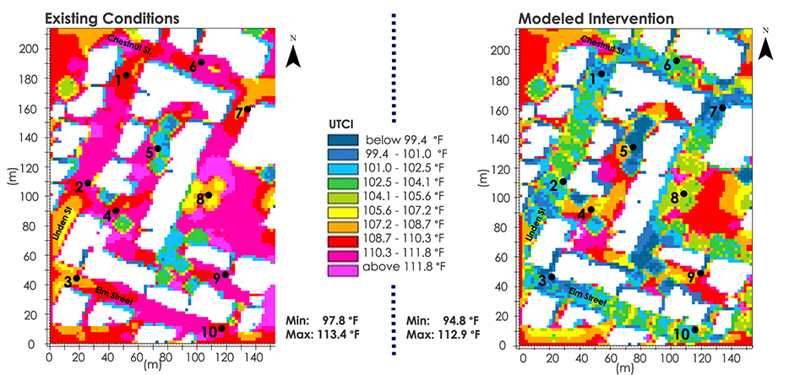
Figure 3: Comparison of thermal comfort analysis from ENVI-met model at ten specific locations in the Old 7th Ward neighborhood showing the modeled conditions of June 30th, 2021, at 2pm (left) and the same conditions with a simulated increase in tree canopy coverage (right).

4.2 Limitations and Uncertainties
The results of our data were limited to the quality and availability of data we had within the ten-week term. For all analyses, we were limited by the size of our raster data, particularly the RTMA data that had a spatial resolution of 2,500 meters. The low spatial resolution made it difficult for the temperature and wind data to fully represent the ENVI-met modeled areas as their extent was at a much finer scale. The ECOSTRESS data were incorrectly georeferenced, and while we worked to correctly georeferenced the images, they may not have had perfect placement. Additionally, we were only able to acquire nine usable ECOSTRESS images. Some of those images did not cover the entire Westchester County extent due to cloud masking, so limited amounts of data represented nighttime LST measurements. The LST input data used for the heat vulnerability calculations did not consider thermal comfort, only the surface temperature. While the RTMA data provided air temperature data, the spatial resolution was too low to differentiate temperatures between Yonkers census tracts effectively. Beyond the limitations of our raster data, the ACS data used for the heat vulnerability calculations were estimates with some margin of errors that were as large or larger than the population, particularly if the population estimates for a variable were under 100, which did not guarantee certainty for all the data.

An additional limitation to consider concerns the calculation of thermal comfort temperatures. Although surface temperature and meteorological information and radiation fluxes can give a strong indication of thermal comfort, this information has been shown to represent of half the total human experience and interpretation of this measure (Middel et al., 2016). The other half is determined by personal, physical, and even behavioral dynamics of each person and their interaction with the environment. Some of these individual characteristics include age, fitness level, previous exposure, expectations, adaptation to local conditions, clothing, time of day, location, and many other factors (Middel et al., 2015). This makes true thermal comfort for diverse populations difficult to determine no matter how comprehensive the index that is used. A limitation to the chosen simulation of increase tree canopy coverage using the ENVI-met model has also been identified. In the executed simulation only a single species of tree – Ceris siliquastrum (European Redbud) – was chosen across the study area. A more sustainable tree intervention would include using a greater variety of tree species to ensure greater genetic diversity and resistance to pests or blight.

4.3 Future Work
Some possibilities of future work include implementing The Air-temperature Response to Green/blue-infrastructure Evaluation Tool (TARGET) to model the cooling effects of tree planting interventions on a neighborhood scale, along with additional heat mitigating infrastructure implementation. One consideration could be a cost benefits analysis of green roofs to support GHV’s partnership with a local municipal housing group. Our partner has also expressed considerable interest in looking at the increase of landslides in Yonkers, NY and how they relate to high-vulnerability neighborhoods. Future teams can also perform more in-depth statistical analyses to look at the relationship between walkability, heat, and socio-economic or health variables.

5. Conclusions
While exploring urban cooling in Yonkers at the street and census tract scales, our team observed that location specific interventions to Southwest Yonkers could provide great benefits to decrease the city’s UHIs. Meanwhile, our heat vulnerability index map revealed differing factors contributing to the exposure to urban heat effects across the city. The vulnerability of communities to these effects was understood through local relationships between land surface temperature, sociodemographic and biophysical factors. Our landcover analysis illustrated lower tree canopy landcover in identified heat-vulnerable neighborhoods, supporting our PCA results which depict percent open space as a key contributing factor to heat vulnerability. This suggests that increasing the quantity of open spaces available in vulnerable neighborhoods is one strategy cities can implement to make communities more equitable and heat resilient. In addition, our application of the ENVI-met model allowed for the calculation and visualization of thermal comfort in identified heat vulnerable areas of great interest to GHV. The modeled benefits of simulated tree canopy interventions show how much even a minor intervention can improve thermal comfort for residents in heat-vulnerable areas. These results will help GHV inform the city on neighborhoods that should be prioritized for urban cooling mitigation. These products will also help GHW inform stakeholders of potential urban cooling strategies and their relative cooling benefits in efforts to provide efficient UHI relief, particularly in vulnerable neighborhoods. In combination with the heat literacy graphics that we produced, these results will help GHV support the city of Yonkers in improving community public health, safety, and building climate resiliency, thus meeting the goals of New York State’s Climate Smart Communities program and making Yonkers more environmentally just.

6. Acknowledgments
We would like to extend a special thank you to our Science Advisors, Mentors, and Fellow for their direction and support:
- Dr. David Hondula (Arizona State University, Associate Professor)
- Dr. Kenton Ross (NASA Langley Research Center, DEVELOP Lead Science Advisor)
- Lauren Childs-Gleason (NASA Langley Research Center, DEVELOP Science Manager)
- Ryan Hammock (NASA DEVELOP, Fellow/Lead)

We would also like to thank our wonderful project partner and collaborator at Groundwork USA, Groundwork Hudson Valley: Oded Holzinger, Climate Resilience Manager of Groundwork Hudson Valley
Finally, we would like to thank Dr. Ariane Middel for providing us access to her support and providing the team with access to ENVI-met.

This material contains modified Copernicus Sentinel data (2021), processed by ESA.

Any opinions, findings, and conclusions or recommendations expressed in this material are those of the author(s) and do not necessarily reflect the views of the National Aeronautics and Space Administration.

This material is based upon work supported by NASA through contract NNL16AA05C.

7. Glossary
ACS – American Community Survey; conducted annually to provide frequent estimates about socioeconomic attributes of communities.
Cooling Capacity – a measure of a system’s ability to remove heat
Earth Observations – Satellites and sensors that collect information about the Earth’s physical, chemical, and biological systems over space and time
ECOsystem Spaceborne Thermal Radiometer Experiment on Space Station (ECOSTRESS) - satellite mission located on the International Space Station that measures the temperature of plants to understand how much water they need and their response to stress.
ENVI-met – software that simulates the microclimate of urban areas at fine scales and provides multiple tools to analyze multiple facets of the microclimate complex.
Evapotranspiration – the sum of evaporation of water from land and other surfaces and through transpiration by plants
Landsat 8 – an Earth-imaging satellite from NASA, launched in 2013
Land Surface Temperature (LST) – the temperature of the surface of the Earth
National Land Cover Database (NLCD) - data released by the U.S. Geological Survey the contains land cover data of the entire continental United States at a 30-meter spatial resolution, and provides data on percent developed imperviousness and percent tree canopy cover per pixel.
Real-Time Mesoscale Analysis (RTMA) - high spatial and temporal resolution dataset that records near-surface weather conditions
Thermal Comfort – satisfaction with the surrounding thermal environment that is subjective between individuals.
Thermal Infrared Sensor (TIRS) – sensor aboard the Landsat 8 satellite that measures both Earth’s surface and atmospheric temperature
tidycensus – package in R that is used to get US Census data that is pre-prepared
Universal Thermal Climate Index (UTCI) - is a human biometeorology parameter that is used to assess the linkages between outdoor environment and human well-being. Thermal comfort indices describe how the human body experiences atmospheric conditions, specifically air temperature, humidity, wind and radiation.
These indices can be modeled for a variety of demographics.

8. References
Aminipouri, M. (2019). Evaluating heat vulnerability and the impact of urban street tree planting on radiant heat exposure: examples from Vancouver’s neighborhoods (Doctoral dissertation, Environment: Department of Geography).
Balany, F., Ng, A. W. M., Muttil, N., Muthukumaran, S., & Wong, M. S. (2020). Green Infrastructure as an urban heat island mitigation strategy—A review. Water, 12(12), 3577. https://doi.org/10.3390/w12123577
Bowler, D. E., Buyung-Ali, L., Knight, M. T., & Pullin, A.S. (2010). Urban greening to cool towns and cities: A systematic review of the empirical evidence. Landscape and Urban Planning, 97, 147–155. https://doi.org/10.1016/j.landurbplan.2010.05.006
Broadbent, A. M., Coutts, A. M., Nice, K. A., Demuzere, M., Krayenhoff, E. S., Tapper, N. J., & Wouters, H. (2019). The air-temperature response to green/blue-infrastructure evaluation tool (TARGET V1.0): An efficient and user-friendly model of City Cooling. Geoscientific Model Development, 12(2), 785–803. https://doi.org/10.5194/gmd-12-785-2019
Declet-Barreto, J., Knowlton, K., Jenerette, G. D., & Buyantuev, A. (2016). Effects of urban vegetation on mitigating exposure of vulnerable populations to excessive heat in Cleveland, Ohio. Weather, Climate, and Society, 8(4), 507–524. https://doi.org/10.1175/wcas-d-15-0026.1
Climate safe neighborhoods. Groundwork Hudson Valley. (2021, July 20). Retrieved October 14, 2021, from https://www.groundworkhv.org/programs/transforming-places/climate-safe-neighborhoods/.
Hondula, D. M., Balling, R. C., Vanos, J. K., & Georgescu, M. (2015). Rising temperatures, human health, and the role of adaptation. Current Climate Change Reports, 1(3), 144–154. https://doi.org/10.1007/s40641-015-0016-4
Huttner, S. (2012). Further development and application of the 3D microclimate simulation ENVI-met (Doctoral
dissertation, Universitätsbibliothek Mainz).
Huttner, S., Bruse, M., & Dostal, P. (2008, October). Using ENVI-met to simulate the impact of global warming on the microclimate in central European cities. In 5th Japanese-German Meeting on Urban Climatology (Vol. 18, No. 18, pp. 307-312).
Markkanen, S., & Anger-Kraavi, A. (2019). Social impacts of climate change mitigation policies and their implications for inequality. Climate Policy, 19(7), 827–844. https://doi.org/10.1080/14693062.2019.1596873
Middel, A., Chhetri, N., & Quay, R. (2015). Urban forestry and cool roofs: Assessment of heat mitigation strategies in Phoenix residential neighborhoods. Urban Forestry & Urban Greening, 14(1), 178–186. https://doi.org/10.1016/j.ufug.2014.09.010
MRLC (2019). NLCD 2019 Percent Developed Imperviousness (CONUS). https://www.mrlc.gov/data/nlcd-2019-percent-developed-imperviousness-conus
MRLC (2016). NLCD 2016 USFS Tree Canopy Cover (CONUS). https://www.mrlc.gov/data/nlcd-2016-usfs-tree-canopy-cover-conus
Mundfrom, D.J., Shaw, D.G., & Ke, T.L. (2005). Minimum sample size recommendations for conducting factor analyses. International Journal of Testing, 5(2), 159-168. https://doi.org/10.1207/s15327574ijt0502_4
Hook, S., Hulley, G. (2019). ECOSTRESS Land Surface Temperature and Emissivity Daily L2 Global 70 m (v001) [Data set]. NASA EOSDIS Land Processes DAAC https://doi.org/10.5067/ECOSTRESS/ECO2LSTE.001
Hook, S., Hulley, G. (2019). ECOSTRESS Cloud Mask Daily L2 Global 70 m (v001) [Data set]. NASA EOSDIS Land Processes DAAC. https://doi.org/10.5067/ECOSTRESS/ECO2CLD.001
Middel., A., Selover, N., Hagen, B., & Chhetri, N. (2016). Impact of shade on outdoor thermal comfort – a seasonal field study in Tempe, Arizona. International Journal of Biometeorology, 60, 1849–1861. http://dx.doi.org/10.1007/s00484-016-1172-5
Nayak, S. G., Shrestha, S., Kinney, P. L., Ross, Z., Sheridan, S. C., Pantea, C. I., Hsu, W. H., Muscatiello, N., & Hwang, S. A. (2017). Development of a heat vulnerability index for New York State. Public Health, 161, 127–137. https://doi.org/10.1016/j.puhe.2017.09.006
New York State Department of Health (2017). Heat Vulnerability Index Westchester County, NY. https://www.health.ny.gov/environmental/weather/vulnerability_index/docs/westchester.pdf
Nisbet-Wilcox, B., Meltzer, S., Nelson, S., Wagner, C., & Hondula, D. (2020). Assessing Land Surface Temperature, Vegetation Cover, and Compounding Vulnerability Factors to Identify High Priority Areas for Cooling Initiatives in Philadelphia, Pennsylvania. [Unpublished manuscript]. NASA DEVELOP National Program, Arizona – Tempe.
NOAA National Centers for Environmental Prediction Products Inventory (2021). Real-Time Mesoscale Analysis (RTMA) Data Products. Courtesy of NOAA NCEP. NCEP. https://www.nco.ncep.noaa.gov/pmb/products/rtma/
Olsson, L., Opondo, M., Tschakert, P., Agrawal, A., Eriksen, S., Ma, S., ... & Zakeldeen, S. (2014). Livelihoods and poverty: climate change 2014: impacts, adaptation, and vulnerability. Part A: global and sectoral aspects. Contribution of working group II to the fifth assessment report of the intergovernmental panel on climate change.
Phelan, P. E., Kaloush, K., Miner, M., Golden, J., Phelan, B., Silva, H., & Taylor, R. A. (2015). Urban heat lsland: Mechanisms, implications, and possible remedies. Annual Review of Environment and Resources, 40, 285–307. https://doi.org/10.1146/annurev-environ-102014-021155.
U.S. Census Bureau. (2010). 2010 Census – Census Tract Reference Map Retrieved November 18, 2021, from https://www2.census.gov/geo/maps/dc10map/tract/st36_ny/c36119_westchester/DC10CT_C36119_004.pdf.
U.S. Census Bureau (2019). American Community Survey 5-Year Data, 2015-2019. Retrieved from https://www.census.gov/data/developers/data-sets/acs-5year.html.

U.S. Census Bureau. (2019). Cartographic boundary Files 2019. Retrieved November 18, 2021, from https://www.census.gov/geographies/mapping-files/time-series/geo/cartographic-boundary.2019.html.
U.S. Geological Survey Earth Resources Observation and Science Center. (2016-2021). Provisional Landsat Landsat 8 and TIRS Level-2 Data Products. Courtesy of the U.S. Geological Survey. https://doi.org/10.5066/F71835S6.
Walechka, J., Bills, T., Greenler, K., Sabrin, S., & Scarmuzza, J. (2021). Yonkers Urban Development: Utilizing NASA Earth Observations to Identify Environmental and Social Drivers of Urban Heat Vulnerability and Model Urban Cooling Interventions in Yonkers, New York [Unpublished manuscript]. NASA DEVELOP National Program, Arizona – Tempe.

9. Appendices
Appendix A

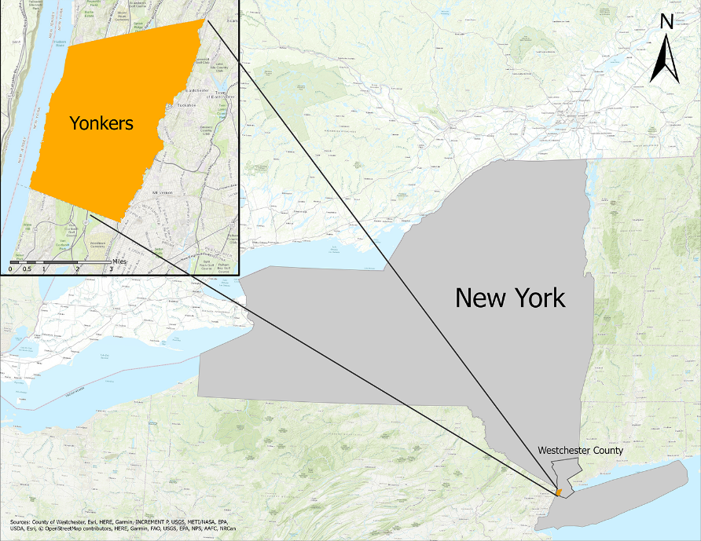
Figure A1. Study area map showing Yonkers in relation to the state of New York.

Table A1
List of Earth observations, remotely sensed imagery, and other raster data acquired for analysis.
Platform/ Program | Sensor | Product ID | Purpose | Dates Used | Acquisition Method | Resolution
Landsat 8 | Thermal Infra-red Sensor (TIRS) | LANDSAT/TIRS/L T08/C01/Level-2 | Calculate daytime LST for input into calculating a heat vulnerability sore. | June 1st - August 31st of 2016-2021 | GEE | 30-meter
ISS- | ECOSTRESS | ECO2LSTE.001  ECO2CLD.001 | Calculate nighttime LST for input into calculating a heat vulnerability sore. | June 1st - August 31st of 2018-2021 | AppEEARS | 70-meter
MultiResolution Land Characteristics (MRLC) Consortium | - | Tree Canopy Cover, Developed Imperviousness | Used as environmental inputs for Heat Priority Score and to examine statistical relationship between land cover and social variables. | 2016 | MRLC | 30-meter
 | - | National Land Cover Database (2019) | Calculate percent open space and high building intensity for Yonkers Census tracts. | 2019 | MRLC | 30-meter
Real-Time Mesoscale Analysis (RTMA) | - | NOAA/NWS/RTMA | Collect meteorological data needed for ENVI-MET inputs. These inputs included temperature, wind speed, and wind direction. | June 1st - August 31st 2021 | GEE | 2,500-meter

Table A2:
List of additional ancillary datasets used for analysis.
Parameter | Provider | Purpose | Dates Used | Source | Resolution
Census Tract American Community Survey Data | US Census Bureau | Socioeconomic data to contribute to heat vulnerability analysis | 2015-2019 | ACS | Census Tract
Census Tracts | US Census Bureau | Census Tract boundaries | 2010 | ACS | Census Tract
Table A3:
List of non-temperature variables obtained from the American Community Survey (ACS) used for analysis in determining our updated Heat Vulnerability values.
Dataset | Granularity | Date/Time | Source
Percentage of the Population that is Hispanic | Census Tract | 2019, 5-year estimate (2015-2019) | American Community Survey (ACS)
Percentage of the Population that is foreign born
Percentage of the Population who speak English less than ‘very well’
Percentage of the Population with income below poverty level
Percentage of the Population that is Black
Percentage of the Population that is over 65 years of age
Percentage of the Population that is over 65 years of age and living alone
Percent of the Population (18-64) that has a disability
Percent of the Population (18-64) that are unemployed
Percentage of Houses that are built before 1980
Density of Housing Units per Square Mile
Percent of Land Classified as Open Space | - | 2016 | Multiresolution Land Characteristics (MRLC) Consortium
Percent of Land Classified as High Building Intensity

Appendix B

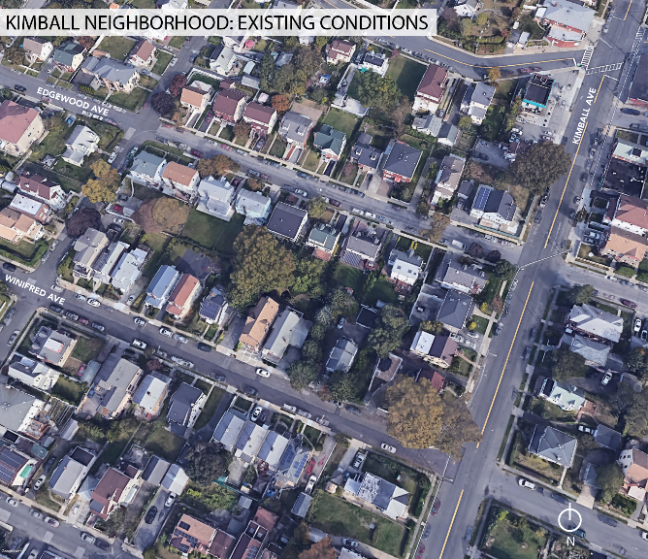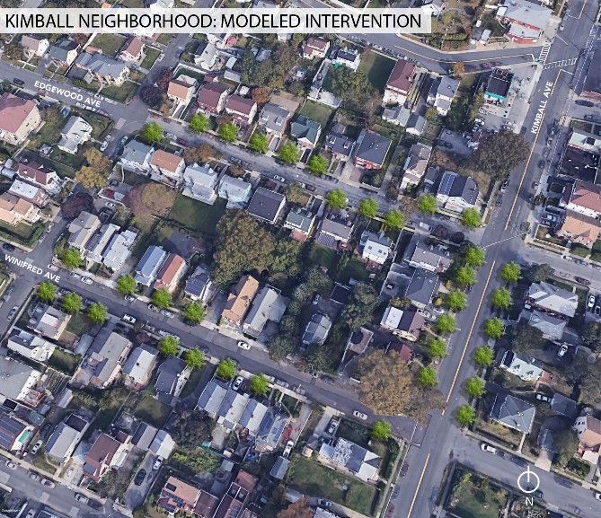
Figure B1: Depicted are Google Earth imagery that capture the location of the Kimball neighborhood simulation. On the left are the existing conditions which demonstrate the lack of streetscape on Kimball Ave along with only moderate canopy coverage along the residential streets of Edgewood Ave (north) and Winifred Ave (south). On the right is a graphic representation of the modeled increase in street canopy coverage through ENVI-met.

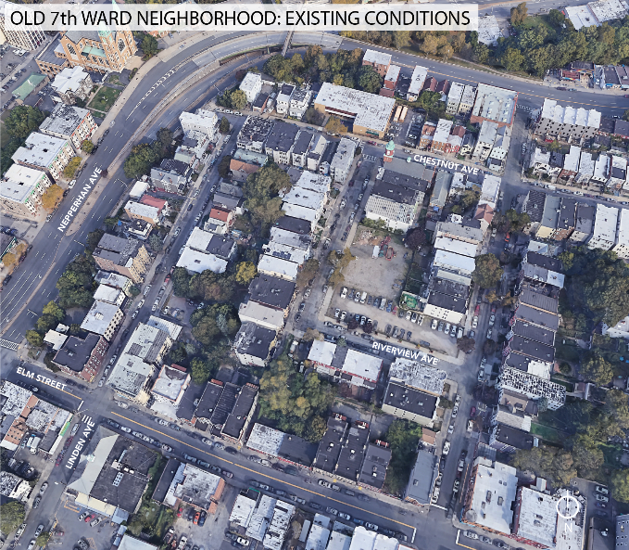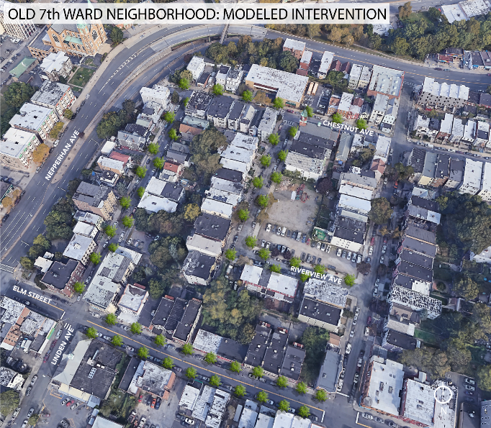
Figure B2: Google Earth imagery that capture the location of the simulation run in the Old 7th Ward neighborhood. On the left are the existing conditions with minimal trees along the public facing side of each street. On the right is a graphic representation of the modeled increase in street canopy coverage through ENVI-met. It features a more concentrated planting of tress along the Elm Street and a more staggered placement on the residential streets, including Linden Street, Chestnut Street, and Riverview Place.

Appendix C
Table C1:
4 principal components resulting from PCA analysis on sociodemographic and temperature variables. Bolded numbers in each column represent the variables that define each individual principal component (PC).
Variables | PC 1 | PC 2 | PC 3 | PC 4
Percent Who Speak English Less Than Very Well | 0.97 | 0.11 | 0.05 | -0.03
Percent Hispanic | 0.91 | 0.10 | 0.11 | -0.11
Percent Foreign Born | 0.81 | 0.33 | 0.16 | -0.01
Percent High Building Intensity | 0.65 | 0.27 | 0.49 | 0.00
Percent Below Poverty | 0.63 | 0.15 | 0.55 | -0.06
Housing Unit Density | 0.50 | 0.46 | 0.41 | 0.16
Percent Open Space | -0.30 | -0.83 | -0.15 | -0.12
Percent of Houses Built Before 1980 | -0.05 | 0.76 | -0.17 | -0.18
Median Nighttime LST | 0.35 | 0.76 | 0.31 | 0.08
Median Daytime LST | 0.52 | 0.70 | 0.32 | 0.06
Percent Black | -0.02 | 0.35 | 0.79 | -0.15
Percent (18-64) Disability | 0.13 | -0.16 | 0.70 | 0.22
Percent (18-64) Unemployment | 0.25 | 0.10 | 0.50 | -0.14
Percent Over 65 and Living Alone | 0.09 | 0.11 | 0.02 | 0.92
Percent Over 65 | -0.22 | -0.09 | -0.08 | 0.91
Cumulative proportion | 0.37 | 0.63 | 0.84 | 1.00

Table C2:
Heat Vulnerability Index table of top five heat vulnerable census tracts.
Variable | Census Tract Name
 | 3.00 | 22.03 | 6.00 | 5.00 | 2.03
Heat Vulnerability | 4.60 | 4.35 | 4.32 | 4.31 | 3.99
Neighborhood(s) Census Tract Falls In | Radford & Old 7th Ward | Sunnyside Park | Glenwood & LaMartine Heights | Radford, LaMartine, & Glenwood | Riverdale
Table C3:
Heat Vulnerability Index table of bottom five heat vulnerable census tracts.
Variable | Census Tract Name
 | 21.03 | 20.00 | 19.00 | 13.01 | 23.00
Heat Vulnerability | -1.33 | -0.52 | -0.46 | -0.28 | -0.21
Neighborhood(s) Census Tract Falls In | Crestwood Lake | Sprain Lake Knolls & Nepera Park | Nepera Park | Park Hill | Dunwoodie & Sunnyside Park

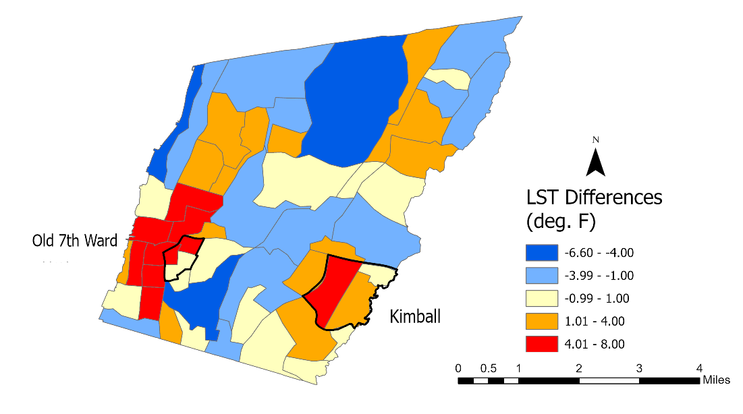
Figure C1: Median Land Surface Temperature differences throughout Yonkers’ Census Tracts

Appendix D
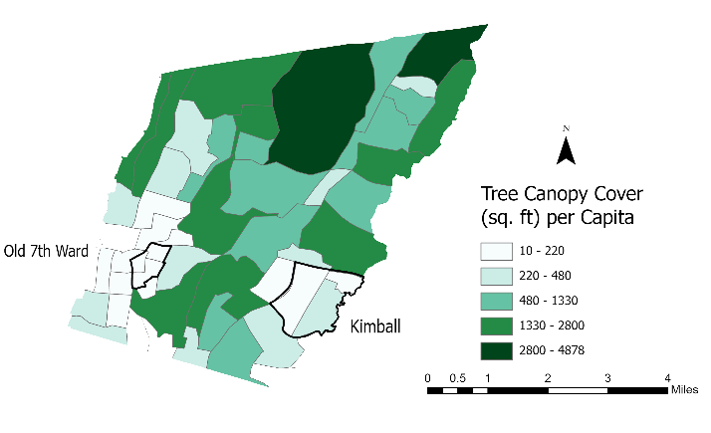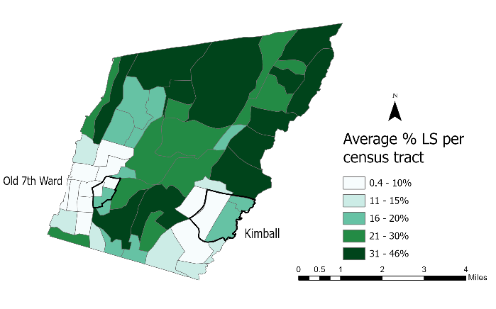
Figure D1: Tree Canopy Landcover Per Capita Figure D2: Tree Canopy Landcover Per Census Tract

Table D1:
Top 5 census tracks with highest Tree Canopy Landcover Per Capita
Variable | Census Tract Name
 | 20 | 21.05 | 9 | 7.02 | 21.03
Tree Canopy Landcover Per Capita | 44,877.33 | 3,636.57 | 2,787.37 | 2,181.36 | 2,015.96
Neighborhood(s) Census Tract Falls In | Sprain Lake Knolls | Beech Hill & Victory Heights | Nepera Park | Woodstock Manor | Crestwood Lake

Table D2:
Bottom 5 census tracks with lowest Tree Canopy Landcover Per Capita
Variables | Census Tract Name
 | 2.01 | 1.03 | 11.01 | 1.01 | 3
Tree Canopy Landcover Per Capita | 10.54 | 25.95 | 29.86 | 30.08 | 33.22
Neighborhood(s) Census Tract Falls In | Radford | Radford | Nodine Hill | Radford | Old 7th Ward & Radford

Table D3:
Top 5 census tracks with highest Tree Canopy Landcover Per Census Tract
Variables | Census Tract Name
 | 22.04 | 13.01 | 7.01 | 21.03 | 22.02
Tree Canopy Landcover Per Census Tract | 45.79 | 45.63 | 42.57 | 38.97 | 36.94
Neighborhood(s) Census Tract Falls In | Sunnyside Park | Park Hill | Woodstock Manor | Crestwood Lake | Sunnyside Park
Table D4:
Bottom 5 census tracks with lowest Tree Canopy Landcover Per Census Tract
Variables | Census Tract Name
 | 1.04 | 2.01 | 4.01 | 3 | 1.03
Tree Canopy Landcover Per Census Tract | 0.40 | 2.09 | 2.73 | 3.32 | 3.68
Neighborhood(s) Census Tract Falls In | Radford | Radford | Radford & LaMartine Heights | Radford & Old 7th Ward | Radford

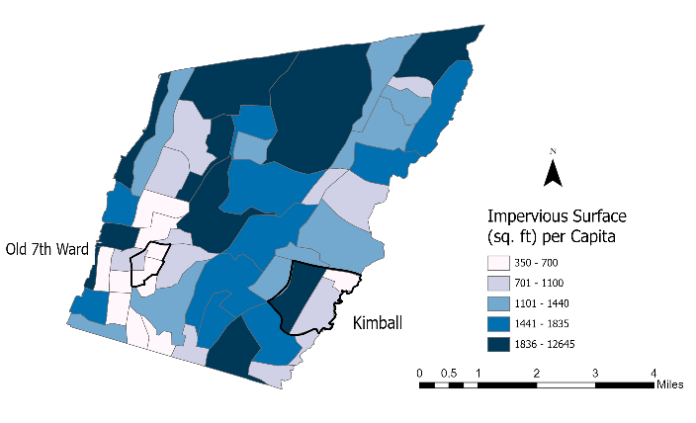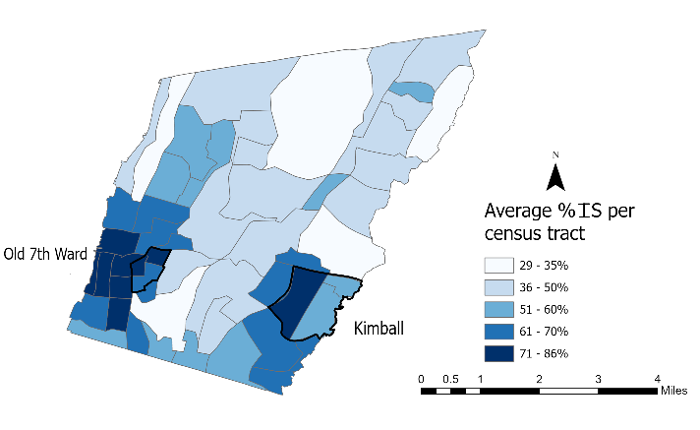Figure D3: Impervious Surface Per Capita Figure D4: Impervious Surface Per Census Tract

Table D5:
Top 5 census tracks with highest Impervious Surface Per Capita
 | Census Tract Name
Variables | 1.04 | 20 | 21.05 | 9 | 7.02
Impervious Surface Per Capita | 12,645.19 | 4,504.39 | 3,879.63 | 3,402.27 | 2,692.17
Neighborhood(s) Census Tract Falls In | Radford | Sprain Lake Knolls | Beach Hill-Victory Heights | Nepera Park | Woodstock Manor & Nepera

Table D6:
Bottom 5 census tracks with lowest Impervious Surface Per Capita
Variables | Census Tract Name
 | 13.03 | 2.01 | 11.01 | 24.03 | 1.03
Impervious Surface Per Capita | 350.37 | 399.23 | 431.16 | 516.03 | 551.02
Neighborhood(s) Census Tract Falls In | Radford | Radford | Radford & Old 7th Ward | Kimball | Radford

Table D7:
Top 5 census tracks with highest Impervious Surface Per Census Tract
Variables | Census Tract Name
 | 1.04 | 3 | 4.01 | 2.01 | 11.01
Impervious Surface Per Census Tract | 85.80 | 83.24 | 80.78 | 79.15 | 79.13
Neighborhood(s) Census Tract Falls In | Radford | Radford & Old 7th Ward | Radford & LaMartine Heights | Radford | Nodine Hill

Table D8:
Bottom 5 census tracks with lowest Impervious Surface Per Census Tract
Variables | Census Tract Name
 | 22.04 | 21.03 | 13.01 | 7.01 | 20
Impervious Surface Per Census Tract | 29.39 | 29.48 | 30.13 | 31.24 | 32.78
Neighborhood(s) Census Tract Falls In | Sunnyside Park | Crestwood Lake | Park Hill | Woodstock Manor & Nepera Park | Sprain Lake Knolls
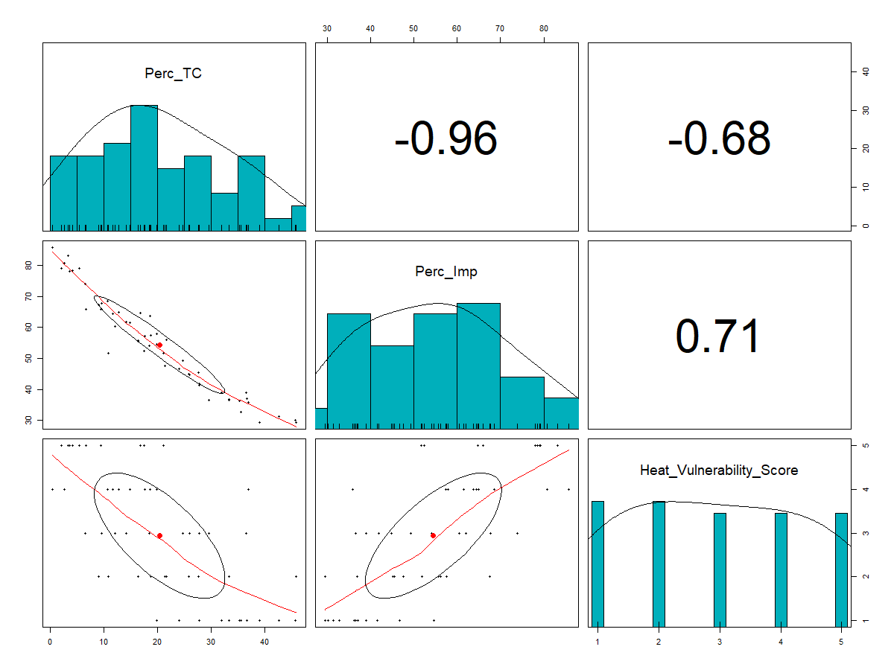
Figure D5: Pearson Correlation values and graphs of the relationship between Percent Tree Canopy Cover, Percent Impervious Surface, and the Heat Vulnerability Score.

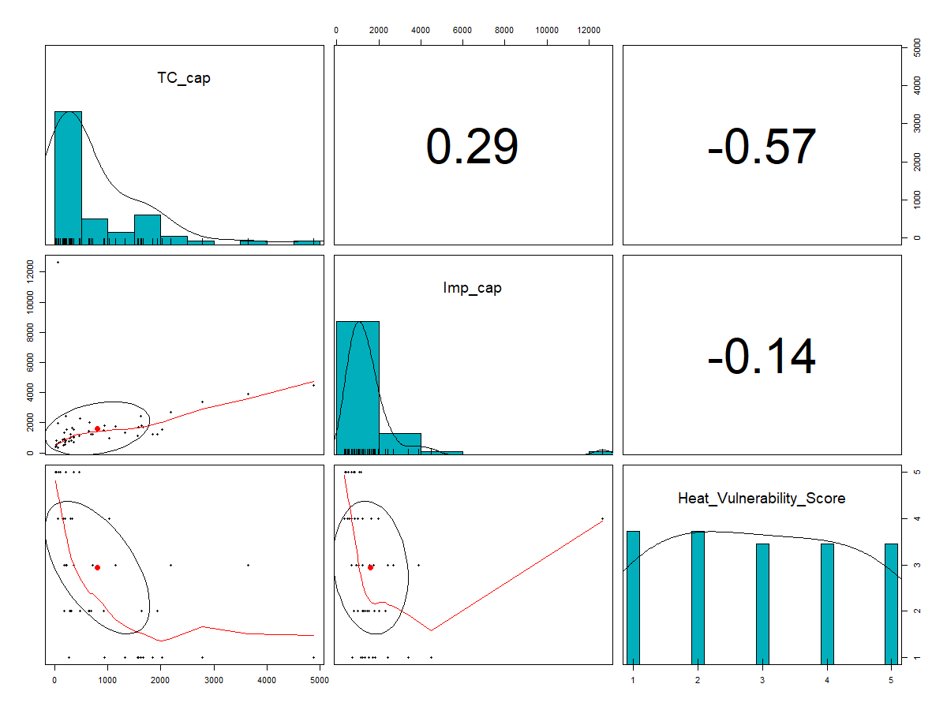
Figure D6: Pearson Correlation values and graphs of the relationship between Tree Canopy per capita, Impervious Surface per capita, and the Heat Vulnerability Score.

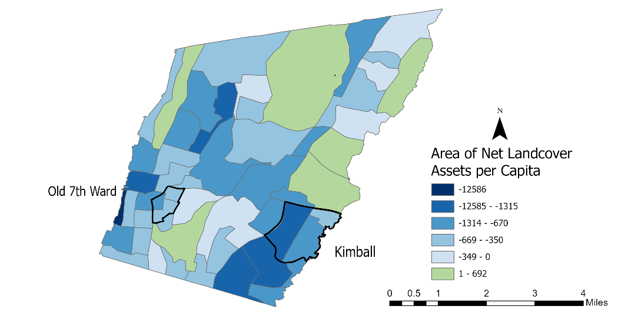
Figure D7: Landcover Assets Map. Blue areas represent census tract with more liabilities than assets i.e., greater area of impervious surface than tree canopy coverage. The green area represents census tracts with more assets than liabilities i.e., more tree canopy coverage than impervious surfaces.

