Northeast US Ecological Forecasting
Modeling Invasive Plant Habitat Suitability to Support Management Efforts in the American Northeast

Technical Report

Rebecca Ohman (Project Lead)
Chloe Birney
Anthony Bowman
Scarlet Jackson
Margaret Jaenicke

Advisors:
Peder Engelstad, Colorado State University, Natural Resource Ecology Laboratory (Science Advisor)
Nicholas Young, Colorado State University, Natural Resource Ecology Laboratory (Science Advisor)

1. Abstract
Invasive plant species threaten environmental and economic interests when they spread into new areas, outcompete native species, and disrupt ecosystem services. If the spread is not controlled early, species can become well-established and increasingly difficult to manage. The National Park Service (NPS) Invasive Plant Management Teams (IPMTs) strive for an “early detection, rapid response” approach to reducing invasive species spread. Management teams can better prioritize their work with the help of species distribution models (SDMs), which map habitat suitability by combining species occurrences with environmental predictor variables. Scarce invaded range data for newly arrived invasive species presents a particular challenge for producing accurate models. To improve future modeling efforts, this project compared SDM methods using different spatial scales to model two plant species invasive to the Northeast US: the well-established Japanese stiltgrass (Microstegium vimineum) and newer invasive species wavyleaf basketgrass (Oplismenus undulatifolius). The team used NASA Earth observations and climate datasets to model occurrence data and predictor layers at a US-specific extent (90m² spatial resolution) and global extent (1 km² spatial resolution). Landsat 5 Thematic Mapper (TM), Landsat 7 Enhanced Thematic Mapper Plus (ETM+), and Landsat 8 Operational Land Imager (OLI) provided data for US Normalized Difference Moisture Indices (NDMI), while global NDMI and topographic predictor layers were derived from Shuttle Radar Topography Mission (SRTM) and Terra Moderate Resolution Imaging Spectroradiometer (MODIS). The resulting models indicated important predictor variables for each species and explored the benefits and tradeoffs of using global data to model habitat suitability for new-arrival invasive species.

Key Terms
Japanese stiltgrass, wavyleaf basketgrass, Species Distribution Model (SDM), Maximum Entropy Modeling (MaxEnt), invasive plant species, VisTrails

2. Introduction
2.1 Background Information
The last few centuries of globalization have enabled the spread of plant species from one continent to another. These organisms become invasive species when they expand into territory in which they did not originally evolve, find an ecological niche, and potentially outcompete native species. Left to spread without intervention, invasive plant species can homogenize landscapes, threatening species richness (Adams & Engelhardt 2009), original ecosystem services such as nutrient cycling (Ehrenfeld, Kourtev, & Huang 2001), and community structure (Rodrigues et al. 2015). When management teams carry out appropriate control tactics before a species becomes well-established in an invaded range, they can better restrict spread into new territories and habitats.
Japanese stiltgrass (Microstegium vimineum) has been spreading in the Eastern US since its arrival in the early 1900s from Southeast Asia (Kurtz & Hansen 2017). After a century as the most aggressively spreading invasive plant in the US (Drake, Weltzin, & Parr 2003), Japanese stiltgrass has been reported present in 28 US states and Puerto Rico (Centre of Agriculture and Biosciences International & US Department of Agriculture 2021). An annual plant that is highly tolerant of shady conditions and acidic to neutral soils, Japanese stiltgrass thrives along vectors of spread like streams and roads (Kurtz & Hansen 2017). It quickly invades disrupted habitats, displacing native species, reducing viable wildlife habitat, and disrupting vital ecosystem functions (Adams & Engelhardt 2009; Kurtz & Hansen 2017). While Japanese stiltgrass is difficult to control and often requires multiple treatment efforts to be removed from an ecosystem (Fryer 2011), a more recent invader, wavyleaf basketgrass (Oplismenus undulatifolius), potentially poses even greater concern as an invasive species (Beauchamp et al. 2013; Bowen & Stevens 2020).

Wavyleaf basketgrass is a perennial grass native to Europe, Asia, and India. Since it was first documented within the United States in Maryland in 1996 (National Park Service, Biological Resources Division 2020), it has become an established invasive in mid-Atlantic US Forest understories (Centre of Agriculture and Biosciences International & US Department of Agriculture 2021). Wavyleaf basketgrass spreads prolifically because of its shallow root system, clonal replication, and sticky seed spikelets that adhere to human clothing and animal fur (Beauchamp et al. 2013). Unlike the annual Japanese stiltgrass, perennial wavyleaf basketgrass individuals can regrow each year maintaining an area from which clones and seeds can continue to spread for consecutive growing seasons. Because wavyleaf basketgrass persists in a similar ecological niche as Japanese stiltgrass, understanding the specific abiotic conditions that support or deter invasive species’ establishment may improve efforts for controlling spread going forward.

In response to the unpredictability of invasive species, compounded by the effects of urbanization and climate change (Kepner & Beauchamp 2020), the National Park Service (NPS) Invasive Plant Management Teams (IPMTs) strive for an “early detection, rapid response” (U.S. Department of the Interior 2019) approach to managing invasive species, and seek tools and products to assist with this effort. Recently, the Northeast IPMT, managing approximately 1,146 acres occupied by invasive species (NPS 2020) designated wavyleaf basketgrass and Japanese stiltgrass as high priority target species for control within the region, which warrants further investigation into the ecological and mechanistic basis of these species’ establishment.

This project employed species distribution models (SDMs) to inform invasive species management by improving the spatial understanding of potential habitat, using occurrence data and known environmental conditions of the target species’ invaded and native ranges. Recent SDM advancements have expanded modeling capacity for species that have not fully exploited all possible niche space within the invaded environment (Elith, Kearney & Phillips 2010) and those with ranges shifting or expanding with changes in climate variables (Colville, Griffin & Bradley 2021). Because the impacts of invasion on ecosystem function and biodiversity have been shown to vary in severity across time (Cunard & Lankau 2017), within regions (Warren, Wright & Bradford 2010; Landsman, Burghardt, & Bowman 2020), and with species richness (Kepner & Beauchamp 2020), modeling habitat suitability with SDMs is crucial to identifying areas at high risk of invasion and informing management decisions before species spread. While recent research has sought to create fine-scale SDMs for wavyleaf basketgrass (Bowen & Stevens 2020), few studies have been conducted to assess the most influential climatic or topographic variables for predicting these species’ presence across the Northeast US and how these predictive factors differ in influence across spatial scales. The multi-scale methodology applied in this project to assess the most influential predictors of invasive presence while addressing tradeoffs between model predictions can inform future research and aid in identifying areas vulnerable to invasion.

2.2 Project Partners & Objectives
Since 2000, regional IPMTs have worked to control invasive plant species across the United States, collaborating with approximately 290 national park units to protect natural and cultural resources (NPS 2020). The Biological Resources Division of the NPS currently supports 15 IPMTs in managing the arrival and ongoing presence of invasive plant species on the ground, with another two funded at specific park bases. This DEVELOP project aimed specifically to support the efforts of IPMTs in the Northeast, Mid-Atlantic, and National Capitol Area affected by the two target species. Teams employ a variety of invasive species management tactics, including monitoring and inventory, prevention, Early Detection Rapid Response (EDRR), treatment and control, and restoration of native plant communities (U.S. Department of the Interior 2019).

The management efforts practiced by IPMTs, particularly EDRR, are most effective when teams can apply them to species detected well before they are established in the area. However, it can be difficult to find adequate information about recent arrival species’ suitable habitats in non-native environments. This project aims to expand on existing habitat suitability modeling methods for both new and established invasive species to better equip land managers like the IPMT to prioritize management areas, educate staff and community members, and protect areas of potential spread.

This project addressed several objectives: to (1) model species distributions for Japanese stiltgrass and wavyleaf basketgrass in the Northeast US and compare model performance for established versus new invasive species and high versus low spatial resolution predictors; (2) evaluate the accuracy of these models in determining suitable habitat; (3) identify the predictive variables that contributed most to model accuracy; (4) produce habitat suitability maps of target species that indicate patterns in range spread; and (5) share results that could strengthen future predictive modeling of invasive species.
2.3 Study Area
The team selected the modeling study area with guidance from partners at the NPS Biological Resources Division. The study area encompasses states in the Northeast US with concerns about the increasing spread of wavyleaf basketgrass, including areas at early stages of invasion. This area also encompasses occupied suitable habitat for Japanese stiltgrass, which is a well-established invader. The chosen area includes the Northeast, Mid-Atlantic, and National Capital region IPMTs, as well as state territory outside IPMT networks where other parks are located (Figure 1).

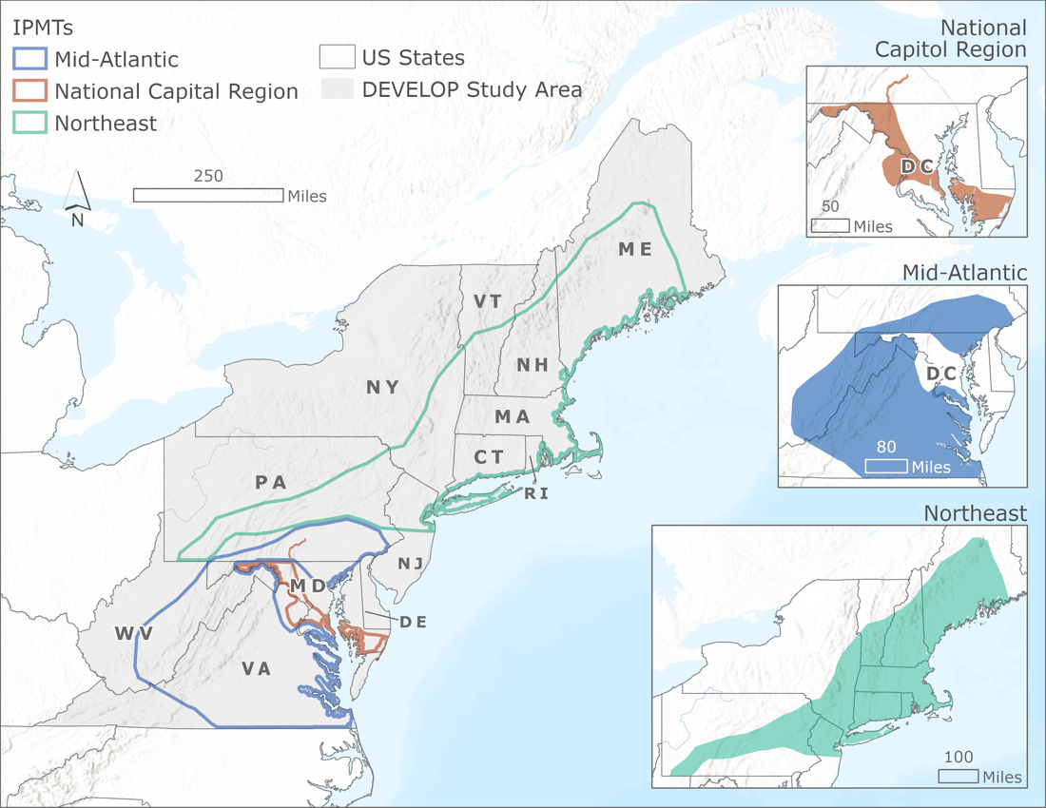
Figure 1. Project study area in the Northeast US with IPMT regions of interest for managing presence of Japanese stiltgrass and wavyleaf basketgrass (National Park Service 2015; United States Census Bureau 2018).

3. Methodology
3.1 Data Acquisition
Occurrence observations for the two species were acquired from the Global Biodiversity Information Facility (GBIF), Early Detection & Distribution Mapping System (EDDMaps), and National Invasive Species Information Management System (NISIMS) from the Bureau of Land Management (BLM) and NPS. The team chose predictor data to use in modeling Japanese stiltgrass and wavyleaf basketgrass habitat that were likely to contribute to the suitability of growing conditions for these species. For the global model, we included climate data layers from Climatologies at High resolution for the Earth's Land Surface Areas Bioclimatic (CHELSA Bioclim) variables (Karger et al. 2017). For the US model, we replaced CHELSA Bioclim with higher-resolution Parameter-elevation Regressions on Independent Slopes Model (PRISM) bioclimatic variables (O’Donnell 2012) and added a high spatial resolution distance to water layer. For both sets of models, we incorporated layers to account for vegetative moisture and variables to explore how evapotranspiration and topography would impact suitability. The team and advisors acquired environmental layers from existing United States Geological Survey (USGS) datasets, or from satellite imagery from Shuttle Radar Topography Mission ​(SRTM), Landsat 5 Thematic Mapper (TM), Landsat 7 Enhanced Thematic Mapper Plus (ETM+), Landsat 8 Operational Land Imager (OLI), and Terra Moderate Resolution Imaging Spectroradiometer (MODIS). We acquired global layers at 1km² spatial resolution, and US layers at three fine-scale pixel resolutions to create 90m² spatial resolution US models (Table 1).

Table 1
Sources, resolution, and dates of environmental layers for SDM
Source or Satellite | Data Product(s) | US-specific (90m² resolution) | Global (1km² resolution)
USGS | National Elevation Dataset (NED) Digital Elevation Model (DEM) | Continuous Heat-Insolation Load Index (CHILI) (2006-2011)  Multi-Scale Topographic Position Index (mTPI) (2006-2011)  Topographic Diversity (2006-2011)
 | National Hydrography Dataset Plus (NHDPlus) | Distance to Water (Fine scale)
PRISM | Climate data | US Bioclimatic Variables, 800m spatial resolution (1981-2010)
CHELSA | Climate data |  | Global Bioclimatic Variables, 1km Spatial Resolution (1981-2010)
Landsat 5 TM  Landsat 7 ETM+  Landsat 8 OLI | Surface reflectance time series analysis; used to indicate vegetation moisture | Normalized Difference Moisture Index (NDMI) Median and Standard Deviation (1984-2020)
SRTM | DEM |  | CHILI (2006-2011)  Topographic Diversity (2006-2011)  mTPI (2006-2011)
Terra | MODIS surface reflectance; used to indicate vegetation moisture |  | NDMI Median and Standard Deviation (2000-2017)

3.2 Data Processing
The majority of our environmental layers required pre-processing before running the Software for Assisted Habitat Modeling (SAHM) to create indices of habitat suitability across our study area (Morisette et al. 2013). Through Google Earth Engine (GEE), the team pre-processed and downloaded global environmental layers to supplement existing US and global data. We downloaded raster images of NDMI median and standard deviation, mTPI, CHILI, and Topographic Diversity from GEE in tiles, then mosaicked them into a single global raster image in Esri ArcGIS Pro (Table A1). From these layers, we created a template layer for the model, a rasterized image of our study area with the appropriate (90m² or 1km²) spatial resolution.

3.3 Data Analysis
The team conducted data management and creation of model workflow for SDMs in SAHM. We provided inputs of environmental variables and species occurrence data in SAHM for the modeling software MaxEnt (Phillips et al. 2006) to create indices of habitat suitability across our study area. MaxEnt is a correlative approach for species niche modeling based on the principle of maximum entropy which generates the most uniform distribution of the data given the constraints of environmental variables on the species potential spread. Using this principle, the model compares the conditions of the available environment to the environment occupied by species via known occurrences to produce an estimate of habitat suitability across the entire study area.

3.3.1 Modeling with US and Global Environmental Layers
For modeling with data confined to the US study area, we supplied our model with US environmental variables and occurrence data collected within the study area for the two species. We used the resulting US-specific model output to: 1) Determine the most important environmental predictors of species presence in the invaded ranges; 2) Compare the importance of environmental variables between the two spatial scales to inform our report on variable usefulness; and 3) Create habitat suitability distributions for each species at this scale in order to compare spatial trends and variable contributions to the global model.

For global models, we input environmental variable layers at 1km² spatial resolution and species occurrence data from the entire range of occurrence data for the two species, both from the US study area and from the species’ native ranges and other invaded regions. MaxEnt created a model applicable to the global extent, then applied this habitat suitability to the US study area. With the global models, we aimed to: 1) Verify that our model can effectively predict known species occurrences in the data and estimate suitability for surrounding habitat; 2) Determine the most important environmental predictors of habitat suitability at this spatial scale to inform our report on variable usefulness; and 3) Compare the importance of environmental variables between our two spatial scales.

3.3.2 Model Evaluation
High correlation between environmental predictors can lead to models that are inaccurate or overstate the importance of a particular set of correlated layers. Therefore, we selected a correlation threshold of r = .7 to identify and remove highly correlated predictor variables that were neither biologically significant to species presence nor statistically influential to the model’s prediction. For climate variables, where possible, we prioritized quarterly data over yearly or monthly, to account for greater seasonal variability without contributing too much minor variation to the models, respectively. We also monitored regularization and threshold parameters to avoid overfitting our predictive models to the established occurrence data.

To examine differences in predicted habitat suitability, each model output included continuous and binary suitability maps. MaxEnt determined binary suitability by evaluating where the model would expect species occupation with our chosen threshold optimization strategy (Sensitivity = Specificity). We also created a Multivariate Environmental Similarity Surface (MESS) map for each model, which evaluated areas where the model was extrapolating beyond known environmental conditions and was therefore unable to evaluate suitability with confidence. MESS analysis was important for identifying environmental novelty for these invasive species (Elith, Kearney & Phillips 2010).

MaxEnt provided summary statistics analyzing our models’ predictive ability and the contribution of predictor variables. These statistics included model Sensitivity, or the model’s rate of accurately identifying a true positive point; AUC, the area under the rate-of-change curve, which aggregates sensitivity with other accuracy metrics on a scale from 0 (entirely inaccurate model) to 1 (a perfect predictive model), with a value of 0.5 indicating the result of random chance; and AUC-PR, area under the precision-recall curve, which assesses the performance of a model using both true and false positives. For the two spatial scales, MaxEnt evaluated variable importance and model accuracy using 10-fold cross-validation with partitioned occurrence data.

4. Results & Discussion
4.1 Japanese Stiltgrass Models
4.1.1 US Japanese Stiltgrass Model
Suitable habitat for Japanese stiltgrass, shown in Figure 2, was predicted (AUC = 0.78, AUC-PR = 0.86) in areas surrounding the US occurrence point concentration. A MESS analysis of this model revealed dissimilarities in environmental conditions, restricting suitability analysis in parts of New York state, Vermont, New Hampshire, and Maine. After removing highly correlated variables from our model that were neither biological significant to the presence of Japanese stiltgrass nor contributed heavily to the model’s prediction, we retained eleven predictor variables (Table A2). The most important contributing predictor variables for the US model are shown in Figure 3. A full-sized probability map and model statistics can be found in Figure B1.

 | Continuous Habitat Suitability | Binary Habitat Suitability
US Model | 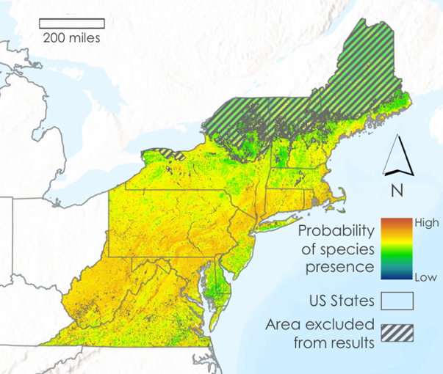 | 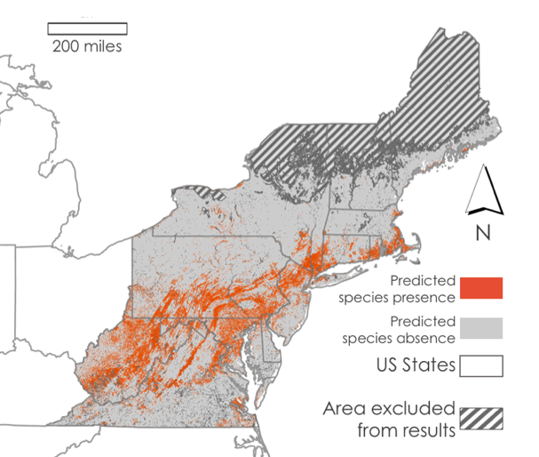
Global Model | 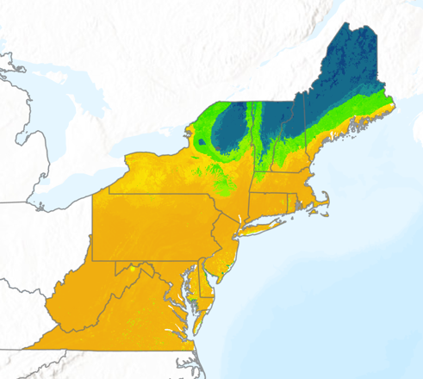 | 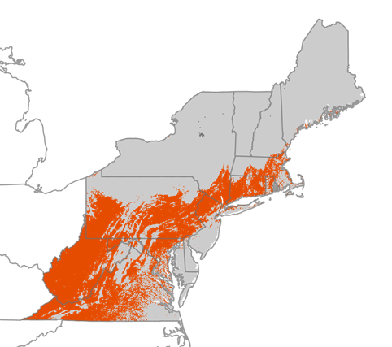
Figure 2. US and global model habitat suitability maps for Japanese stiltgrass. Areas covered by gray stripes represent MESS map analysis of low extrapolation confidence due to environmental differences. Continuous predictions (left) are compared with binary predictions of habitat suitability (right).

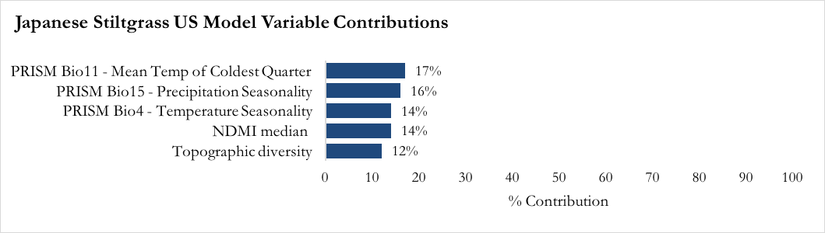Figure 3. Percent contributions of top five variables used in training US model of Japanese stiltgrass.
4.1.2 Global Japanese Stiltgrass Model
Suitable habitat for Japanese stiltgrass modeled using global occurrence data and environmental predictor variables was predicted (AUC = 0.96, AUC-PR = 0.97) throughout the study area, with moderately high suitability predicted continuously throughout the majority of our study area. MESS analysis of this model reflected a very small area of low extrapolation confidence. A binary prediction of this model (Figure 2) reflected a significant reduction in suitable habitat most notably in the southward recession of habitat deemed as moderately suitable in our continuous prediction. After removing highly correlated variables from our model that were neither biologically significant to the presence of Japanese stiltgrass nor contributed heavily to the model’s prediction, we retained eight environmental predictor variables (Table A2). The most important contributing variables for the global model are shown in Figure 4. A full-sized probability map and more model statistics can be found in Figure B2.

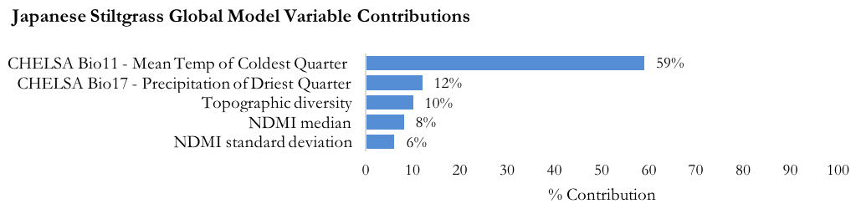Figure 4. Percent contributions of top five predictor variables used in training global Japanese stiltgrass model

4.2 Wavyleaf Basketgrass Models
4.2.1 US Wavyleaf Basketgrass Model
Suitable habitat for wavyleaf basketgrass was predicted in areas surrounding the occurrence points (AUC = 0.89, AUC-PR = 0.68). Because the environmental conditions within the current US occurrence range for wavyleaf basketgrass are in a concentrated distribution, the model faces greater environmentally dissimilar regions in the study area. Binary output from this model differed from continuous probability (Figure 5). After removing highly correlated variables that did not have substantial biological significance nor contributed heavily to the model’s prediction, we retained eight predictor variables (Table A2). The top contributing variables for this model (Figure 6) identify which environmental variables are driving the model's prediction at the 90m² scale. A full-sized suitability map and more model statistics can be found in Figure B3.

 | Continuous Habitat Suitability | Binary Habitat Suitability
US Model | 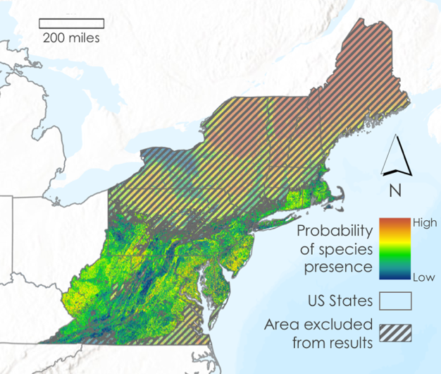 | 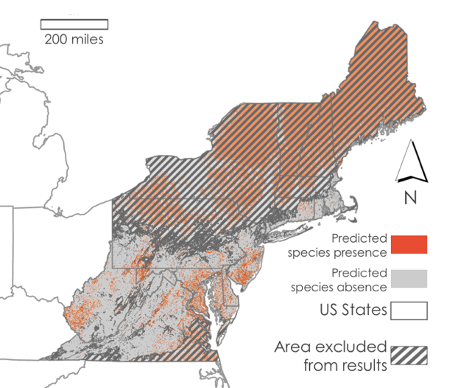
Global Model | 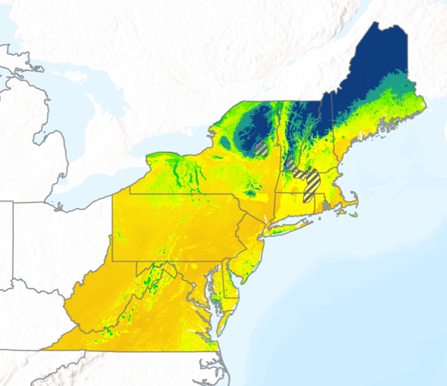 | 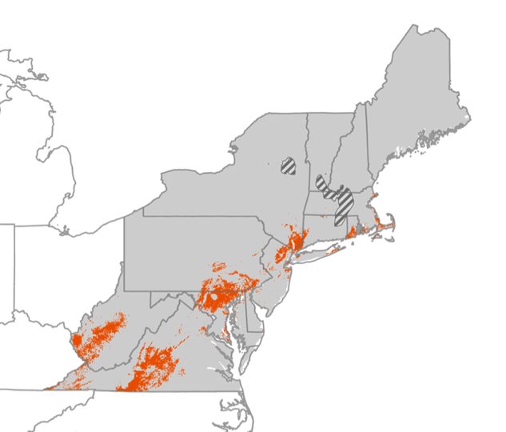
Figure 5. US and global model habitat suitability maps of wavyleaf basketgrass. Continuous predictions (left) are compared with binary predictions of habitat suitability (right).
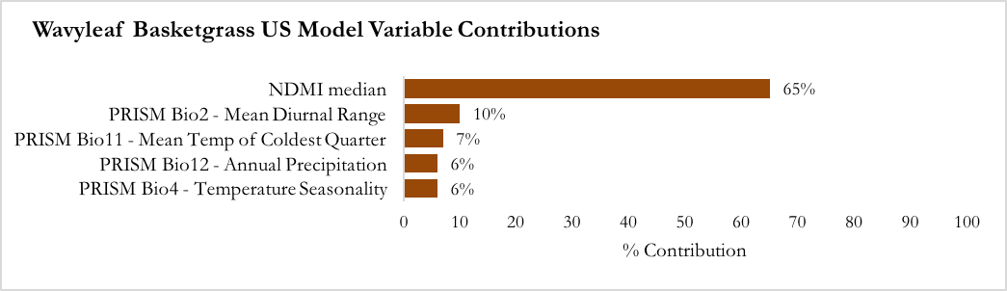
Figure 6. Percent contributions of top five variables used in training US wavyleaf basketgrass model

4.2.2 Global Wavyleaf Basketgrass Model
Suitable habitat for wavyleaf basketgrass using global occurrence data and environmental predictor variables was confidently predicted (AUC = 0.98, AUC-PR = 0.99) throughout our study area. MESS analysis in this model identified a vastly reduced area of low extrapolation confidence in comparison to the US-data only model (Figure 5). In this model, the region excluded from the results is likely due to a single environmental variable with values significantly different from the training dataset driving low extrapolation confidence in these specific locations. After removing highly correlated variables that neither had substantial biological significance to species presence nor significant contribution to the model’s prediction, we retained nine predictor variables (Table A2), with the top five indicated in Figure 7. A full-sized suitability map and more model statistics can be found in Figure B4.

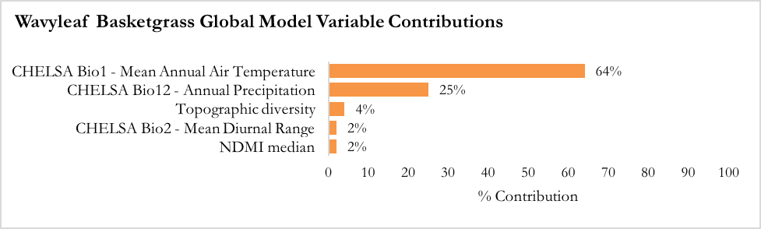
Figure 7. Percent contributions of top five variables used in training global wavyleaf basketgrass model
4.3 Challenges and Future Work
This project took place in the context of a developing use of remote sensing software applications to predict suitable habitat of invasive plant species. The goal of suitable habitat prediction is to provide on-the-ground responders, such as IPMTs, a tool for early detection or prevention of further spread. Mapping suitable habitat for invasive species like Japanese stiltgrass and wavyleaf basketgrass provides a clear picture of where they could establish if they were to spread to these areas. There are many known limitations to the accuracy of SDM with remotely sensed data; even high-resolution satellite imagery can be too coarse to adequately identify differences in conditions between species observation points, and discrepancies in the timing and conditions of field observations and remotely sensed data collection must be considered. Another common limitation to invasive species distribution modeling has been the difficulty of tying modeling techniques and predictive variables to the biological characteristics of the species being studied, as research on biological needs of invasive plants, particularly new arrivals, is often scarce. The addition of datasets known to have biological or mechanistic contribution to a particular species’ habitat suitability can alleviate some of these concerns. To improve the accuracy of our suitable habitat predictions, future work on this project could explore environmental layers that were excluded due to time constraints. For example, though this project accounted indirectly for soil moisture (based on NDMI and Topographic Diversity), it did not account for soil type or vegetation variables such as Normalized Difference Vegetation Indices (NDVI), which could be useful for identifying suitability for plant species like the two studied here.

To progress the research we have conducted here, it would be helpful to further explore the mechanistic environmental constraints on Japanese stiltgrass and wavyleaf basketgrass invasion within the US such as novel environmental change, competition, and other abiotic factors to inform future SDMs. Additionally, climate warming scenarios produced by the International Panel on Climate Change (IPCC) would be useful to project varying extents of species invasions under the unique constraints of each scenario, providing a better understanding of the variability of species invasions in changing climatic conditions (Elith, Kearney & Phillips 2010). The application of Light Detection and Ranging (LiDAR) derived variables could likely also be utilized in certain locations to delineate ground cover and provide an avenue for measuring invasive species abundance in varying richness plots. These measurements may provide researchers with the tools to give further detail to the habitat suitability maps we produced here by identifying areas likely to be invaded based on species-specific niche preferences. The identification of these areas may further aid decision-makers in planning invasion management strategies.

5. Conclusions
This project provides a framework for assessing results from presence-only SDMs at differing spatial scales to contrast trends in environmental variable importance and habitat suitability. Our primary goal was to evaluate and improve the methods and capacity of habitat suitability modeling by comparing models created with invaded range data (higher 90m² spatial resolution) and those created with globally available native range data acquired from NASA Earth observations (lower 1km² spatial resolution) for our two (established and newly arrived) target invasive species. Rather than centering the creation of new suitability maps, this project’s focus was on identifying key predictors for Japanese stiltgrass (temperature of coldest quarter; NDMI; topographic diversity) and wavyleaf basketgrass (moisture, including NDMI and annual precipitation; annual and coldest quarter temperature ranges) and methods to improve existing suitability studies of these species and future invasive species modeling.

Ultimately, using global predictor variables in SDMs can expand the data available for modeling recently arrived species, but there are limitations to consider. Past efforts to create habitat suitability maps for non-established, newly invasive species (e.g., wavyleaf basketgrass) have been hindered by a lack of field observations in the invaded range. When invaded range data is limited for invasive species that are not yet widespread, species observations in the native range can inform habitat suitability models, and relevant global predictor variables help provide an understanding of environmental conditions in species’ native ranges. However, we should use caution when interpreting models created with global data, as low spatial resolution and unforeseen differences between the native and invaded ranges can lead to extrapolation errors and less accurate results. These methods and conclusions can be used to strengthen the future creation of habitat suitability maps and models to guide the early prevention of invasive plant species spread.

6. Acknowledgments
This work was made possible by our mentors: Dr. Catherine Jarnevich from the United States Geological Survey (USGS); Dr. Paul Evangelista, Peder Engelstad, and Nicholas Young from Colorado State University Natural Resource Ecology Laboratory; and Scott Cunningham from NASA DEVELOP. The team would also like to thank our project partners from the National Park Service Biological Resources Division, Terri Hogan and Dr. Jennifer Sieracki, for sharing their extensive knowledge of invasive plants and species distribution modeling.

Any opinions, findings, and conclusions or recommendations expressed in this material are those of the author(s) and do not necessarily reflect the views of the National Aeronautics and Space Administration.

This material is based upon work supported by NASA through contract NNL16AA05C.

7. Glossary
Annual plant – Individuals complete their life cycle (from germination to production of new seeds) in a single growing season
AUC (Area Under the Curve) – A value that indicates the model’s predictive power. A value of 0.5 would be the result of random chance, while a value of 1 would be a perfect predictive model. A threshold independent variable, created over several model iterations
AUC-PR (Area Under the Precision-Recall Curve) – A value that is a better measure of accuracy for a model with fewer points. A threshold independent variable, created over several model iterations
Digital Elevation Model (DEM) – A model representative of elevation data in order to represent landscape
Earth observations – Satellites and sensors that collect information about the Earth’s physical, chemical, and biological systems over space and time
Habitat suitability – The capacity of a particular habitat to support a given species
Invasive Plant Management Team (IPMT) – Part of the Biological Resources Division at the National Park Service, combats invasive plants by preventing introductions of new species, reducing existing infestations, and restoring native plant communities and ecosystem functions
Invasive species – A non-native species that out-competes native species, homogenizes landscapes, reduces local biodiversity, and potentially impacts human economic or social interests
MODIS – Moderate resolution Imaging Spectroradiometer
Native species – A species that is indigenous to a particular ecosystem, having originated in the region independently from human activity
Perennial plant – Individuals live longer than two years
Sensitivity – A value that indicates the model’s probability of identifying a true presence point from our dataset accurately
Species Distribution Model (SDM) – Using environmental and occurrence data, model algorithms are able to predict distribution of a species across space. SDMs can also be referred to as environmental niche modeling or habitat modeling

8. References
Adams, S. N. & Engelhardt, K.A. (2009). Diversity declines in Microstegium vimineum (Japanese stiltgrass) patches. Biological Conservation, 142(5), 1003-1010. doi:10.1016/j.biocon.2009.01.009Get

Beauchamp, V. B., Koontz, S. M., Suss, C., Hawkins, C., Kyde, K. L., & Schnase, J. L. (2013). An introduction to Oplismenus undulatifolius (Ard.) Roem. & Schult. (wavyleaf basketgrass), a recent invader in Mid-Atlantic forest understories. The Journal of the Torrey Botanical Society, 140(4), 391–413. doi:10.3159/TORREY-D-13-00033.1

Bowen, A., & Stevens, M. (2020). Temperature, topography, soil characteristics, and NDVI drive habitat preferences of a shade-tolerant invasive grass. Ecology and Evolution, 10(19), 10785–10797.
doi:10.1002/ece3.6735

Centre of Agriculture and Biosciences International & US Department of Agriculture. (2021). Microstegium vimineum (Nepalese browntop). Invasive Species Compendium.
https://www.cabi.org/isc/datasheet/115603

Centre of Agriculture and Biosciences International, & US Department of Agriculture. (2021). Oplismenus hirtellus subsp. Undulatifolius (wavyleaf basketgrass). Invasive Species Compendium.
https://www.cabi.org/isc/datasheet/115961

Colville, W., Griffin, B., & Bradley, B. (2021). Identifying high-impact invasive plants likely to shift into northern New England with climate change. Invasive Plant Science and Management, 14(2), 57-63.
doi:10.1017/inp.2021.10

Cunard, C.E. & Lankau, R.A. (2017). Declining survival across invasion history for Microstegium vimineum. PLoS ONE, 12(8), e0183107. doi:10.1371/journal.pone.0183107

Drake, S.J., Weltzin, J.F. & Parr, P.D. (2003). Assessment of non-native invasive plant species on the United States Department of Energy Oak Ridge National Environmental Research Park. Appalachian Botanical Society, 68(1), 15-30. https://doi.org/10.2172/814178

Ehrenfeld, J.G., Kourtev, P.S., & Huang, W. (2001). Changes in soil functions following invasions of exotic understory plants in deciduous forests. Ecological Applications, 11(5), 1287-1300.
doi:10.1890/1051-0761(2001)011[1287:CISFFI]2.0.CO;2

Elith, J., Kearney, M. & Phillips, S. (2010). The art of modeling range-shifting species. Methods in Ecology and Evolution, 1(4), 330-342.
doi:10.1111/j.2041-210X.2010.00036.x

Fryer, J. L. (2011). Fire Effects Information System. Microstegium Vimineum.
https://www.fs.fed.us/database/feis/plants/graminoid/micvim/all.html

Hogan, Terri. (2021). Professional communication [Microsoft Teams Video Call].

Japanese stiltgrass. (2018). Invasive Plant Atlas of the United States.
https://www.invasiveplantatlas.org/subject.html?sub=3051

Kepner, C., & Beauchamp, V. (2020). Interspecific competitive potential of wavyleaf basketgrass (Oplismenus undulatifolius), a recent introduction to the mid-Atlantic United States. Invasive Plant Science and Management, 13(1), 23-29. doi:10.1017/inp.2020.3

Kurtz, C. M., & Hansen, M. H. (2017). An assessment of Japanese stiltgrass in northern US forests. Res. Note NRS-247. Newtown Square, PA: US Department of Agriculture, Forest Service, Northern Research Station. 5 p., 247, 1-5. doi:10.2737/NRS-RN-247

Landsman, A.P., Burghardt, K.T., & Bowman, J.L. (2020). Invasive grass (Microstegium vimineum) indirectly benefits spider community by subsidizing available prey. Ecology & Evolution, 10(20), 11133-11143.
doi:10.1002/ece3.6752

McCune, B. & Keon, D. (2002). Equations for potential annual direct incident radiation and heat load. Journal of Vegetative Science, 13(4), 603–606. doi:10.1111/j.1654-1103.2002.tb02087.x

Morisette, J.T., Jarnevich, C., Holocombe, T.R. & Talbert, C. (2013). VisTrails SAHM: Visualization and workflow management for species habitat modeling. Ecography, 32(2), 129-135.
doi:10.1111/j.1600-0587.2012.07815.x

National Park Service, Biological Resources Division. (2020). IPMT Annual Report: FY 2020. https://irma.nps.gov/DataStore/DownloadFile/662804

Phillips, S.J., Anderson, R.P. & Schapire, R.E. (2006). Maximum entropy modeling of species geographic distributions. Ecological Modelling, 3, 231-259. doi:10.1016/j.ecolmodel.2005.03.026
Rodrigues, R.R., Pineda, R.P., Barney, J.N., Nilsen, E.T., & Barrett, J.E. & Williams, M.A. (2015). Plant invasions associated with change in root-zone microbial community structure and diversity. PLOS ONE, 10(10), e0141424.
doi:10.1371/journal.pone.0141424

Theobald D.M., Harrison-Atlas D., Monahan, W.B., & Albano, C.M. (2015). Ecologically-relevant maps of
landforms and physiographic diversity for climate adaptation planning. PLoS ONE 10(12): e0143619. doi:10.1371/journal.pone.0143619

U.S. Department of the Interior. (2019). Northeast. National Park Service.
https://www.nps.gov/subjects/invasive/ne.htm.

Warren II, R. J., Wright, J. & Bradford, M.A. (2010) The putative niche requirements and landscape dynamics of Microstegium vimineum: an invasive Asian grass. Biological Invasions, 13, 471-483.
doi:10.1007/s10530-010-9842-4

9. Data Citations

GBIF Occurrence Download Accessed from R via rgbif (https://github.com/ropensci/rgbif) on 2021-09-30
https://doi.org/10.15468/dl.mp7zm4

Jarvis, A., H.I. Reuter, A. Nelson, E. Guevara (2008). Hole-filled SRTM for the globe Version 4, available from the CGIAR-CSI SRTM 90m Database [Data set]. CGIAR Consortium for Spatial Information. http://srtm.csi.cgiar.org.

Karger, D.N., Conrad, O., Böhner, J., Kawohl, T., Kreft, H., Soria-Auza, R.W., Zimmermann, N.E., Linder, P., Kessler, M. (2017). Climatologies at high resolution for the Earth land surface areas. Scientific Data. 4 170122. doi:10.1038/sdata.2017.122

Karger, D.N., Conrad, O., Böhner, J., Kawohl, T., Kreft, H., Soria-Auza, R.W., Zimmermann, N.E., Linder, H.P., Kessler, M. (2017) Data from: Climatologies at high resolution for the earth’s land surface areas. Dryad Digital Repository. doi: 10.5061/dryad.kd1d4

Lyapustin, A., Wang, Y. (2018). MCD19A1 MODIS/Terra+Aqua Land Surface BRF Daily L2G Global 500m and 1km SIN Grid V006 [Data set]. NASA EOSDIS Land Processes DAAC. https://doi.org/10.5067/MODIS/MCD19A1.006

National Park Service. (2015). EPMT Boundaries. Provided by partners at NPS.

O’Donnell, Ignizio. (2012). PRISM Climate Group, Oregon State University (n.d.). Retrieved from https://prism.oregonstate.edu/

United States Census Bureau. (2018). States. Retrieved from https://www.census.gov/geographies/mapping-files/time-series/geo/carto-boundary-file.html.

United States Geologic Survey (2018). Landsat 4-5 TM Level-2 Data Products - Surface Reflectance [Data set]. USGS EROS Archive. https://doi.org/10.5066/F7KD1VZ9

United States Geologic Survey (2020). Landsat 7 ETM Plus Collection Level-2 Data Products - Surface Reflectance [Data set]. USGS EROS Archive. https://doi.org/10.5066/P9C7I13B

United States Geologic Survey (2018). Landsat 8 OLI/TIRS Level-2 Data Products - Surface Reflectance [Data set]. USGS EROS Archive. https://doi.org/10.5066/f78s4mzj

Appendix A – Environmental Predictor Layers

Table A1
Preprocessing and functionality of environmental layers
Environmental Layer | Equation (if provided) | Functionality
Continuous Heat Isolation Load Index (CHILI) |  | A value of 0 indicates a northeast slope and a value of 1 indicates a southwest slope. A northeast slope will have some of the coolest temperatures, while the southwest slopes will have some of the warmest (McCune 2002).
Multi-Scale Topographic Position Index (mTPI) | TPI = E₀ - E_{n} | A TPI measures topography in a way that allows hillslope position to be quantified. A positive value indicated a ridge high peak, a negative value indicates a valley or sink, and a value of 0 indicates a flat area or no slope.  E₀ is the elevation in meters at a given location, and E_{n} is the mean elevation within a desired area specified by radius r (Theobald 2015).
Topographic Diversity (D) | D = 1 - (1 - T') * (1 - C’) | Topographic diversity was retrieved to look at the combinations of temperatures and moisture conditions that are occurring.  Where C’ is the standard deviation of the CHILI, and T’ is mTPI (Theobald 2015).
Normalized Difference Moisture Index (NDMI)/Normalized Difference Water Index (NDWI) | NDMI = (NIR - SWIR) / (NIR + SWIR) | A Normalized Difference Moisture Index is used to indicate the water content in vegetation. We retrieved imagery from a Terra MODIS Daily NDWI dataset from GEE, which has bands analogous to NDMI.

Table A2
Predictor layers included in final models and their percentage contribution to model results

 | Predictor Layer & Occurrence Data Extent (% contribution to model)
 | US Invaded Range | Global Range
Japanese stiltgrass (Microstegium vimineum) | 1. PRISM Bio11 - Mean Temp of Coldest Quarter (17%) | 1. CHELSA Bio11 - Mean Temp of Coldest Quarter (59%)
 | 2. PRISM Bio 15 - Precipitation Seasonality (Coefficient of Variation) (16%) | 2. CHELSA Bio17 - Precipitation of Driest Quarter (12%)
 | 3. NDMI median (14%) | 3. Topographic diversity (10%)
 | 4. PRISM Bio4 - Temperature Seasonality (14%) | 4. NDMI median (8%)
 | 5. Topographic diversity (12%) | 5. NDMI standard deviation (6%)
 | 6. mTPI 270m (10%) | 6. CHELSA Bio2 - Mean Diurnal Range (4%)
 | 7. PRISM Bio 16 - Precipitation of Wettest Quarter (9%) | 7. CHELSA Bio16 - Precipitation of Wettest Quarter (1%)
 | 8. PRISM Bio 2 - Mean Diurnal Range (Mean of monthly (max temp-min temp)) (4%) | 8. mTPI 1 km (0%)
 | 9. Distance to water (2%)
 | 10. CHILI 90m (2%)
 | 11. NDMI standard deviation (1%)
Wavyleaf basketgrass (Oplismenus undulatifolius) | 1. NDMI median (65%) | 1. CHELSA Bio1 - Mean Annual Air Temperature (64%)
 | 2. PRISM Bio2 (10%) | 2. CHELSA Bio12 - Annual Precipitation (25%)
 | 3. PRISM Bio11 (7%) | 3. Topographic diversity (4%)
 | 4. PRISM Bio12 - Annual Precipitation (6%) | 4. CHELSA Bio2 (2%)
 | 5. PRISM Bio4 (6%) | 5. NDMI median (2%)
 | 6. NDMI standard deviation (3%) | 6. CHELSA Bio 15 (2%)
 | 7. mTPI 270m (2%) | 7. NDMI standard deviation (1%)
 | 8. Distance to water (1%) | 8. mTPI 1km (<1%)
 |  | 9. CHILI 1km (<1%)

Appendix B – Model Outputs

a) | 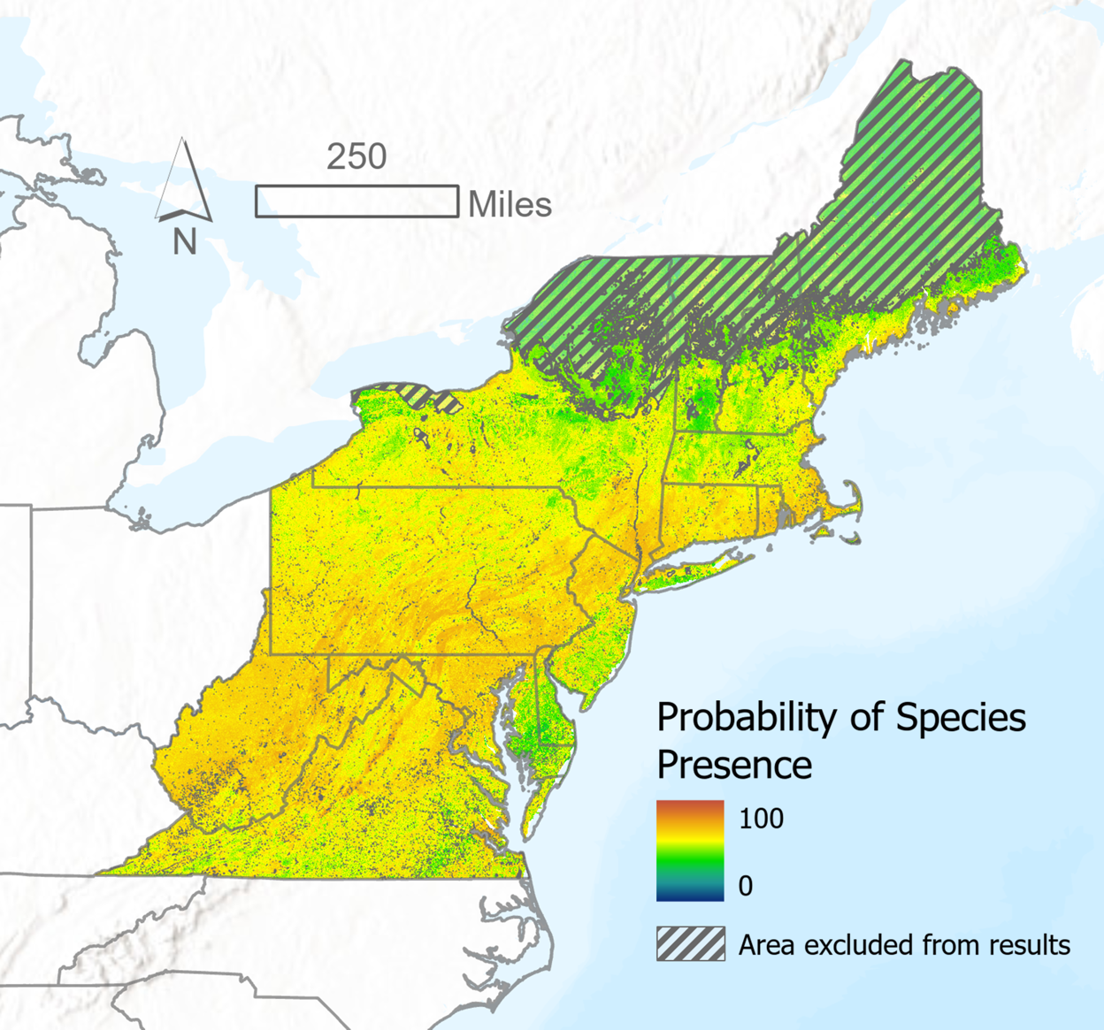
​b) |  | Train​ | Cross-Validation​
 | Sensitivity ​ | 0.72​ | 0.71​
 | AUC ​ | 0.79​ | 0.78​
 | AUC-PR ​ | 0.87​ | 0.86​

Figure B1. Habitat suitability model for Japanese stiltgrass (M. vimineum) at 90m² resolution (US invaded range data). a) Continuous probability map overlaid with area of low extrapolation confidence (diagonal stripes) and outlines of US states (gray). Values range from low (blue-green) to high (orange-red) suitability. Note the significant area of low extrapolation confidence in the northeastern portion of the study area. Data was acquired from GEE and image generated in ArcGIS Pro. b) Model performance statistics generated by MaxEnt in VisTrails SAHM.

a) | 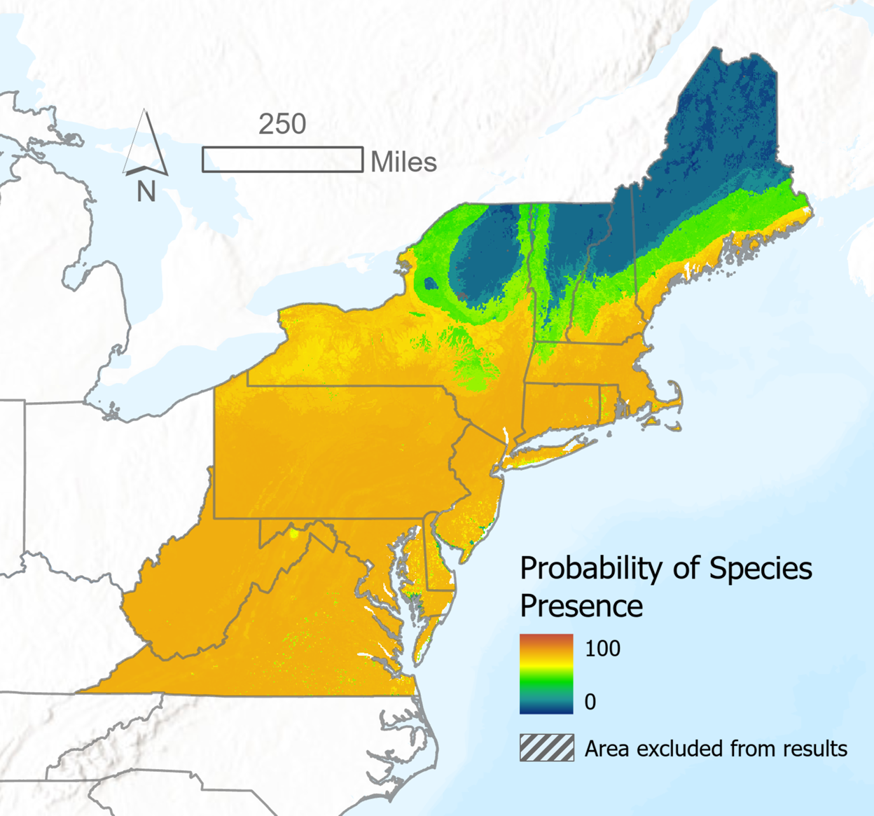
​b) |  | Train​ | Cross-Validation​
 | Sensitivity ​ | 0.90​ | 0.90​
 | AUC ​ | 0.96​ | 0.96​
 | AUC-PR ​ | 0.97​ | 0.97​

Figure B2. Habitat suitability model for Japanese stiltgrass (M. vimineum) at 1km² resolution (global native range data). a) Continuous probability map overlaid with area of low extrapolation confidence (diagonal stripes) and outlines of US states (gray). Values range from low (blue-green) to high (orange-red) suitability. Note the near-absence of areas with low extrapolation confidence compared to the previous models. Data acquired from GEE and image generated in ArcGIS Pro. b) Model performance statistics generated by MaxEnt in VisTrails SAHM.
a) | 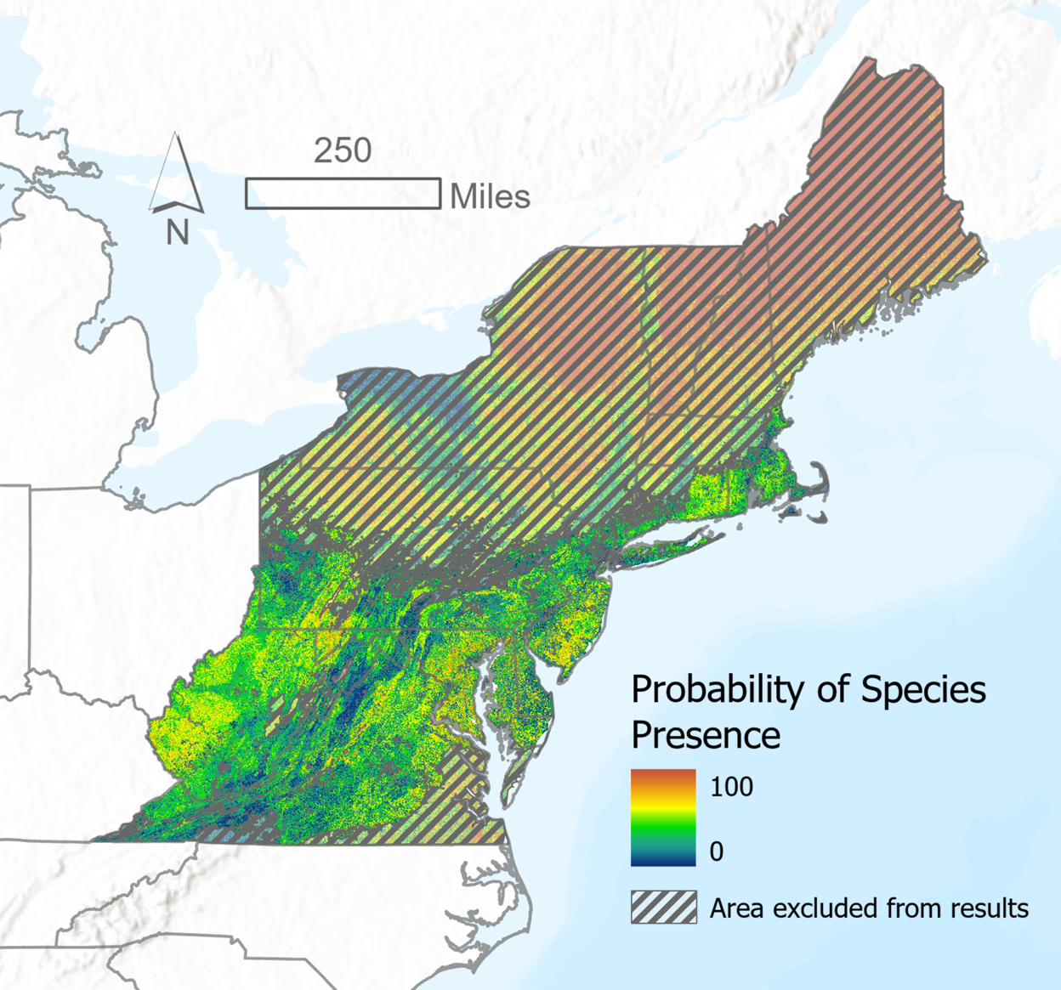
​b) |  | Train​ | Cross-Validation​
 | Sensitivity ​ | 0.83​ | 0.81​
 | AUC ​ | 0.91​ | 0.89​
 | AUC-PR ​ | 0.72​ | 0.68​

Figure B3. Habitat suitability model for wavyleaf basketgrass (O. undulatifolius) at 90m² resolution (US invaded range data). a) Continuous probability map overlaid with area of low extrapolation confidence (diagonal stripes) and outlines of US states (gray). Values range from low (blue-green) to high (orange-red) suitability. Note the low extrapolation confidence in the northern half and southeast corner of the study area. Data was acquired from GEE and image generated in ArcGIS Pro. b) Model performance statistics generated by MaxEnt in VisTrails SAHM.
a) | 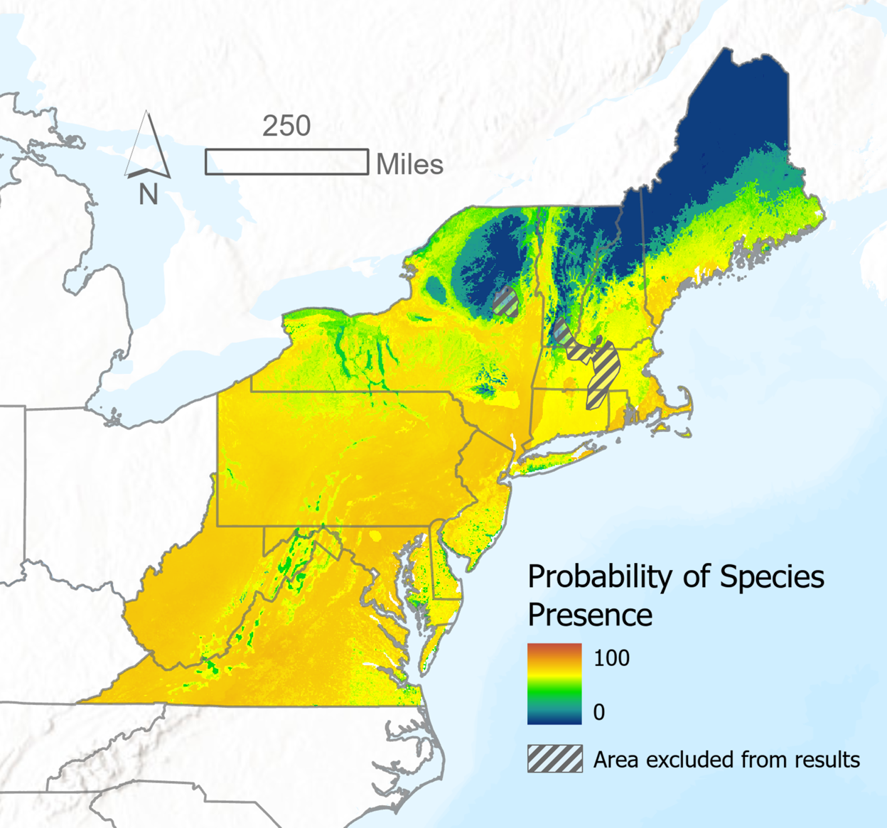
​b) |  | Train​ | Cross-Validation​
 | Sensitivity ​ | 0.93​ | 0.93​
 | AUC ​ | 0.98​ | 0.98​
 | AUC-PR ​ | 0.97​ | 0.99​

Figure B4. Habitat suitability model for wavyleaf basketgrass (O. undulatifolius) at 1km² resolution (global native range data). a) Continuous probability map overlaid with area of low extrapolation confidence (diagonal stripes) and outlines of US states (gray). Values range from low (blue-green) to high (orange-red) suitability. Note the limited area of low extrapolation confidence compared to the US model. Data was acquired from GEE and image generated in ArcGIS Pro. b) Model performance statistics generated by MaxEnt in VisTrails SAHM.

