Maya Forest Water Resources II
Mapping Inundation Below the Forest Canopy in the Maya Tri-National Forest

Technical Report
Final Draft – November 18th, 2021

Stephanie Jiménez (Project Lead)
Karen Alvarez
Rene Castillo
Daniel Nohren
Stephanie Lawlor

Advisors:
Benjamin Holt, NASA Jet Propulsion Laboratory, California Institute of Technology (Science Advisor)
Dr. Bruce Chapman, NASA Jet Propulsion Laboratory, California Institute of Technology (Science Advisor)
Dr. Emil Cherrington, SERVIR, NASA Marshall Space Flight Center (Science Advisor)

Previous Contributors:
Madelyn Savan
Kathryn Tafoya
Lara O’Brien
Tamara Rudic

1. Abstract
To monitor seasonal flooding within the tri-National Maya Forest the team completed the methodology started by the Summer 2021 term to analyze changes in inundation dynamic throughout 2017. The team analyzed inundation dynamics in Google Earth Engine (GEE) using Earth observation products from the Landsat 8 Operational Land Imager (OLI), Advanced Land Observing Satellite (ALOS) Phased Array type L-band Synthetic Aperture Radar (PALSAR) 2, and International Space Station (ISS) Global Ecosystem Dynamics Investigation LiDAR (GEDI). The team improved the landcover classification using the Random Forest algorithm in GEE by adding canopy height data derived from GEDI, elevation and slope data from Copernicus, and additional multi-spectral band ratios from Landsat 8. The pixel-based land cover classification produced an overall accuracy of 88%. Experiments measuring inundation extent using L-band SAR included comparing results with a priori knowledge, topography datasets, and auxiliary datasets. We iteratively tested and found threshold values for identifying forested inundation using the ratio for HH divided by HV. The resulting methodology and products helped end users from Belize’s Land Information Center (LIC) and Forest Department, Guatemala’s Center for Monitoring and Evaluation (CEMEC), and Mexico’s El Colegio de la Frontera Sur (ECOSUR) manage land and water resources and protect communities.

Key Terms
ALOS-2 PALSAR-2, L-band SAR, Random Forest, Google Earth Engine, flooding, LiDAR, canopy height

2. Introduction

2.1 Background Information
The Maya Forest is the largest tropical rainforest in North America. It hosts many endangered species and provides a safe haven for up to 400 species of birds, having as many as several million avian visitors during peak migratory months (Belize.com, 2021). This exceptionally biodiverse region is becoming vulnerable to increasingly severe weather events resulting from climate change (Emmanuel, 2005; Bray et al., 2008). Additional risks come from land use changes, namely fragmentation from road construction and deforestation from logging and agricultural development. These landscape changes leave the forest vulnerable to extreme flooding and further degradation by diminishing its ability to absorb extreme weather events (Bradshaw et al., 2007). Vulnerable human and animal populations that depend on a healthy forest structure and biodiversity sit at the crossroads between forest degradation and extreme weather events. Local community stakeholders want to better understand inundation dynamics within the Maya Forest to manage and conserve this unique ecosystem, monitor land-use changes, map archaeological features and reduce flood local communities’ risk from climate induced flooding. Identifying inundation below the forest canopy is the first step in knowing the extent and nature of Maya’s wetlands and understanding the hydrological dynamics of the area. Additionally, centuries of Indigenous Maya agroforestry knowledge are useful to inform conservation and development efforts within the forest and its surrounding communities (Ford & Nigh, 2009).
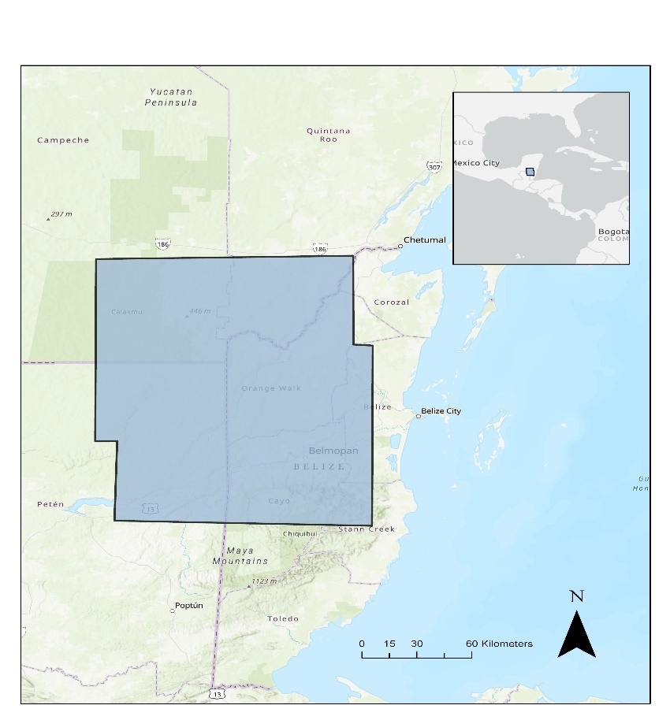
Figure 1. The Maya Forest encompasses 13.3 million acres across Belize, Guatemala, and Mexico. In blue is the study area outlined by the coverage of ALOS PALSAR 2 fine beam images.
The previous term used field data and Earth observations to delineate seasonal inundation extent throughout 2008 (a year with extreme flooding events). Products used came from Landsat 7 Enhanced Thematic Mapper (ETM+), NASA Shuttle Radar Topography Mission (SRTM), Ice, Cloud, and Land Elevation Satellite (ICESat-1), and Advanced Land Observing Satellite (ALOS) Phased Array type L-band Synthetic Aperture Radar (PALSAR) 1. The team applied a Random Forest algorithm in Google Earth Engine (GEE) to Landsat 7 imagery, generating an object-level land cover classification with an overall accuracy of 72.1% and forest class with 100% recall and 78% precision. Within the forest delineated by the classification, observed inundation at the –5.4 dB L-band HH polarization threshold indicated the highest extent in both study sites in wet and dry seasons. The team also observed that inundation appeared overestimated in hillier and mountainous terrains, specifically in the Mountain Pine Ridge region of Central Belize as shown in the resulting inundation maps in Figure A1. Therefore, it was suspected that the complex terrain in this region increased the double-bounce effect, leading to increased backscatter values that were erroneously detected as inundation.
2.2 Project Partners & Objectives
The project partners included Belize’s Land Information Center (LIC) and Forest Department, Guatemala’s Center for Monitoring and Evaluation (CEMEC), Mexico’s El Colegio de la Frontera Sur (ECOSUR), the MesoAmerican Research Center (MARC) at the University of California Santa Barbara, and Boles Environmental Consulting. Belize’s Forest Department and LIC are responsible for land use and forest management and flood risk assessment. LIC is involved in contributing to the country’s climate change adaptation and mitigation plans and managing Reducing Emissions from Deforestation and Forest Degradation (REDD+) objectives of reducing emissions, conservation and enhancement of forest-carbon stocks, and sustainability. The Forest Department and LIC use NASA products, including the Fire Information for Resource Management System (FIRMS) and Landsat imagery, in their decision-making. Guatemala’s Center for Monitoring and Evaluation (CEMEC) is responsible for monitoring all protected areas within Guatemala. CEMEC uses remote sensing in its forest cover and fire monitoring but has not applied remote sensing methods to current wetland monitoring and surface water mapping. Studies have shown that mapping inundation is key to understanding flood risks; however, such studies can be limited by the complexity of predictive models and the high cost of data collection and digitization (Opolot, 2013). This study provides an easily reproducible, modifiable, and low-cost approach to inundation mapping that can be used for flood risk assessment and environmental management and may fulfill local scientific and societal needs such as water management and conservation, archaeological feature mapping, disaster response preparation, and land use change monitoring.
As a continuation of the previous term, the objective of this term was to improve results of the previous term by using higher resolution and a wider variety of datasets and by refining inputs to the Random Forest classifier. A major addition of this term was the incorporation of topography into our classification, which helped exclude areas of high slope where inundation is not possible. Another improvement was the use of trail cameras provided by CEMEC to validate results by visually confirming our results with field collected data (Garcia-Anleu et al, 2021). The use of trail cameras in this way demonstrates the great potential they may have in ground truthing the results of future studies.

3. Methodology

3.1 Data Acquisition
The team acquired Landsat 8 Operational Land Imager (OLI) Collection 2 Tier 1 imagery from the GEE data catalog to create dry (March-May) and wet (June-November) season composites collected between 2016–2018. The International Space Station (ISS) Global Ecosystem Dynamics Investigation (GEDI) Level 3 (L3) mean canopy height products for 2020 were downloaded from NASA's Earth Data Search. The Advanced Land Observing Satellite (ALOS) Phased Array type L-band Synthetic Aperture Radar (PALSAR) 2 L-band polarized imagery were acquired by special request from the Japan Aerospace Exploration Agency (JAXA). Each fine beam image was radiometric terrain corrected at the Alaska Satellite Facility and covered January (ID: 14492), February (ID: 14625), September (ID: 14492), and December (ID: 19253) of 2017 for frames 330-350. In total, the team acquired eight fine beam images with ascending HH and HV polarizations. Additional data included a digital elevation model (DEM) from the 2000 NASA Shuttle Radar Topography Mission (SRTM) and European Space Agency’s (ESA) Copernicus DEM for 2020. Detailed information about the satellite imagery and products are found in Table 1 below. Data provided by project partners are shown in Table A1, including shapefiles of the regional environmental features and infrastructure.

Table 1.
Satellite remote sensing data products, dates of coverage, and sources used.
Data Products | Data Parameters | Temporal Coverage Used for Study | Source | Use
Landsat 8 OLI | Collection 2, Tier 1 OLI sensor imagery containing four visible and near-infrared (VNIR), two short-wave infrared (SWIR), and one thermal infrared (TIR) band at 30-meter resolution. | March-November (2016-2018) | United States Geological Survey (USGS); in GEE catalog. | Land cover classification & Inundation mapping
ALOS-2 PALSAR-2 | Radiometric Terrain Corrected (RTC), L-Band, Fine Beam (FBD), ascending, HH+HV polarizations at 10-meter resolution. | January-December (2017) | Japan Aerospace Exploration Agency (JAXA) | Inundation mapping
ISS GEDI | Gridded mean canopy height per 1 km x 1 km grid cells globally within -52- and 52-degrees latitude. | April - April (2019-2020) | The Oak Ridge National Laboratory Distributed Active Archive Center (ORNL DAAC) | Land cover classification & Inundation mapping
Copernicus DEM | Digital elevation models at 30-meter resolution | 2020 | European Union Copernicus Programme | Land cover classification & Inundation mapping
NASA Shuttle Photography Radar Mission (SRTM) | Digital elevation models at 90-meter resolution | 2000 | NASA / Consultative Group for International Agricultural Research (CGIAR) | Land cover classification

3.2 Data Processing
3.2.1 Overview
Outlined in Figure 2 is an overview of our methodology to map inundation using a combination of data from multi-spectral, LiDAR, and SAR imagery. The team generated a land cover classification map with multi-spectral dry and wet season composites of imagery and indices calculated from Landsat 8 OLI imagery, topography products (bare Earth elevation, slope, and Topographic Position Index) derived from the Copernicus DEM, and a canopy height model from ISS GEDI. To create the classification, the team first segmented the parameters using a Simple Non-Iterative Clustering (SNIC) algorithm in GEE and then applied a Random Forest machine-learning algorithm trained with points manually collected using Google Earth Pro. The resulting classification map identified each pixel as either forest, settlement, open water, or other. The settlement and open water classes were removed and the forest class was outlined in the SAR imagery to identify potential forested regions. Topography products were used to isolate areas of low slope within the SAR imagery with specific parameters selected through an iterative process which applied and compared tentative threshold results to regional layers.
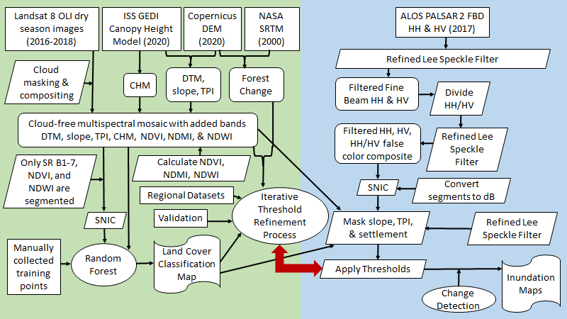
Figure 2. Methodology overview described by two pathways, the green pathway resulting in the land cover classification, and the blue pathway resulting in the inundation maps. Rectangular boxes represent the data inputs, slanted boxes represent intermediary data, triangles represent pre-processing, and circles represent analysis. The red arrow indicates the iterative refinement process. The final resulting maps are indicated by the curved shapes.

3.2.2 Pre-Processing
The USGS’s Landsat 8 OLI Tier 1 Collection 2 Surface Reflectance products and radiometric terrain corrected products by the Rochester Institute of Technology (RIT) and NASA Jet Propulsion Laboratory (JPL) required no additional corrections. The team masked out clouds and shadows by applying the C Function of Mask (CFMASK) algorithm developed by Foga et al. (2017) to identify how much each pixel was affected by surface, atmospheric, and sensor conditions. The team then used these bands to mask all pixels affected by clouds or shadows before mosaicking the best final image composite to represent March-May of 2016-2018 and another composite image which represents June-November of 2016-2018.
Once the dry and wet season composites were created, Normalized Difference Indices were calculated using Equations 1-3 below. Normalized Difference Vegetation Index (NDVI), a measurement for pixel greenness that uses a ratio of red and near infrared bands, was added to the classification to assist the distinction between vegetated and non-vegetated areas as well as different vegetation types (Jensen, 2000). Normalized Difference Moisture Index (NDMI) uses a near infrared and shortwave infrared band ratio to measure vegetation moisture content to help identify inundated regions (Wilson & Sader, 2002), while Normalized Difference Water Index (NDWI) uses green and near infrared bands to distinguish open water bodies (Gao, 1996). The Normalized Difference Indices were calculated using the following equations:
NDVI = (NIR − Red) / (NIR + Red) (1)
NDMI = (NIR − SWIR) / (NIR + SWIR) (2)
NDWI = (Green − NIR) / (Green + NIR) (3)
For all imagery relevant to the land cover classification, we clipped and resampled each to Landsat 8 OLI’s 30-meter spatial resolution. We calculated the bare Earth elevation model, which was used to derive slope and Topographic Position Index (TPI), by subtracting GEDI's canopy height model from the Copernicus DEM. TPI is calculated as the difference between any one pixel’s elevation and the average elevation of its neighborhood divided by the standard deviation of the neighborhood (Canuto & Auld-Thomas, 2021). The creation of a TPI allowed for the identification of locally low areas conducive for inundation within areas with high overall elevation and identification of ridges within areas of low overall elevation.
The ALOS-2 PALSAR-2 images were acquired with radiometric terrain correction (RTC) by Brian Buechler and Ciji Clark at Alaska Space Facility (ASF). The corrected 2017 L-band ALOS-2 PALSAR-2 fine beam images were placed through the Refined Lee speckle filter algorithm adapted for GEE by NASA SERVIR-Mekong to reduce backscatter noise. The team used the filtered fine beam HH and HV bands to create the HH/HV ratio for each season of each frame. The HH backscatter appears very bright compared to the surrounding non-inundated forest. This is due to a strong double-bounce reflection from the vertical forest structure and horizontal water surface. The HV backscatter is dominated by volume scattering from vegetation. Thus, the difference between inundated and non-inundated forest is not as apparent within each polarization alone (CEOS, 2018). However, the backscatter differences can be made obvious and more easily interpreted when combined as the ratio HH/HV. We applied the Refined Lee Speckle Filter again to the HH/HV ratio and then created a false color composite (HH, HV, HH/HV respectively).

3.2.3 Pixel-Based Land Cover Classification
The initial term of this project conducted an object-based image analysis, a method of classifying satellite imagery over a vast geographic area with complex land cover categories compared to traditional pixel-level approaches (Evans et al., 2010; Rodriguez-Galiano et al., 2011). Object-based image analyses involve two steps: image segmentation and classification. The results from the object-based land cover classification from last term are likely to have missed smaller features such as smaller settlements and open water bodies. Similar to the previous term, this study segmented the Landsat 8 surface reflectance bands 1-8, along with the calculated NDVI and NDWI. Instead of performing an object-based analysis, which calculates the mean of each cluster, the team chose pixel-based classification which calculates the mode of each segment. In addition to the inputting the segments into the Random Forest classifier, the team input NDMI, bare Earth elevation, slope, TPI, and GEDI canopy height model in addition to revised training points. The classification produced four land cover classes: forest, settlement, open water, and other lands.

Image segmentation is a process that groups neighboring pixels with similar spectral characteristics into distinct clusters. This study used the simple non-iterative clustering algorithm (SNIC) available in GEE to segment the Landsat composite image. SNIC is a computationally efficient segmentation algorithm based on the process of super-pixel clustering, wherein centroids are initialized on a regularly spaced seed grid and connected pixels are clustered based on distance and spectral similarity (Achanta and Süsstrunk, 2017). The algorithm takes in four user-defined parameters: the spacing of the initial seed grid, which influences final cluster size; the compactness factor, influencing the shape of final clusters; the neighborhood tile size, set to avoid tile boundary effects; and the connectivity, defining how to merge adjacent clusters (either 4 or 8-pixel connected). The team used seed grid size 10, connectivity 8, neighborhood tile size null, and compactness factor 0 and null seed grid size.
After segmenting the images using SNIC, training points were collected manually using Google Earth Pro (GEP) and GEE with review from our partner Dr. Anabel Ford of MARC, an expert on the Maya Forest with knowledge of specific natural features within our study area. The segmented composites and training points were placed through a Random Forest (RF) machine-learning classifier to create the land cover classification. RF classifies large areas with complex landscapes into land cover classes while utilizing a relatively small number of training data. (Rodriguez-Galiano et al., 2011). In the absence of sufficient ground-truthed training data from the time period of interest (2017), an accepted alternative to gathering training points was to use imagery of higher quality than the imagery being used for the classification (Olofsson et al., 2008). Therefore, the team compared the Landsat imagery to high-resolution imagery available in GEP to visually scrutinize and then select training points for each land cover type. Where high resolution imagery was not available in 2017 in GEP, but available in nearby years, the team ensured that the land cover types consistently matched acquisitions closest in time to 2017 – either before or after – and scrutinized the potential training point in the Landsat composite image to confirm each determined land cover type. These land cover classes are consistent with those described by the Belize Collect Earth Protocol (Correa et al., 2019) except that the team omitted the wetlands class and added an open water class. Forest was identified as having a canopy cover >30% and trees >5 meter high. This included mature broad-leaf forest, secondary broad-leaf forest, pine forest, and mangrove forest as well as managed forest plantations. The team collected a total of 222 forest points. Settlement includes urban and rural settlements and open archaeological sites. The team collected a total of 144 settlement points. Open water includes any open water such as lakes, rivers, and ponds, and excludes forested wetlands or seasonally flooded wetlands. The team collected a total of 140 open water points. The other class is a required input to run RF. We input the grassland, cropland, and other land points from last term to encompass the other land class. Other includes areas of bare earth, sand, and areas disturbed by mining, includes unmanaged grasslands, pasturelands, shrublands, fallow croplands, and recently abandoned croplands, includes only active cropland excluding agricultural tree plantations. The team used a total of 200 other points. The test set was made up of 50 points, while the training set was made up of 144 points. The RF classifier was trained with 1000 trees and a bag fraction of 0.5 on the training point set using the six Landsat 8 bands (red, green, blue, near infrared, and two shortwave infrared bands), the NDVI, NDMI, NDWI, bare earth elevation, slope, TPI, and canopy height as input features.
3.2.4 Object-Based Inundation Mapping
Prior to detecting inundation within the fine beam ALOS-2 PALSAR-2 images, the team segmented the fine beam ALOS-2 PALSAR-2 false color composites using SNIC in order to detect continuous objects of inundation. The team segmented the HH, HV, and HH/HV ratio bands using the SNIC parameters of size 30, compactness 0, connectivity 4, and neighborhood size 256, and seeds nulled. The parameters for size were experimented with to determine the superseed location spacing in pixels that best captured the distinctions between bright and dark pixels. Since the main focus of this project was to observe forest inundation in low lying and flat regions, urban areas and areas with slope higher than 7 degrees and ridges were masked out from the imagery.
The ALOS-2 PALSAR-2 products were provided in gamma naught (γ⁰), a linear power unit. The gamma naught values were converted to decibels (dB) in order to apply initial threshold values on the fine beam images using Equation 4 below (Personal Communication, Bruce Chapman, 2021). ALOS has a calibration factor of -83.00, which needs to be subtracted from the dB value to get the calibrated value. None of the image altering or averaging techniques were applied to images in dB to keep calculations accurate and consistent.
dB = 20 × log(γ⁰) - 83 (4)
Once the values were converted to dB and high slopes, settlement, and ridges were removed, the team applied L-band HH/HV polarized backscatter thresholds based on previous literature and a histogram analysis to classify forested inundation. These initial thresholds for comparison with the HH/HV ratio were drawn from previous studies conducted in similar ecological regions, including one study that found that -5.3 dB captured forested inundation in the HH band while last term’s results indicated –5.4 dB for forested inundation also within the HH band (Evans et al., 2010). While backscatter thresholds were only applied to inundated vegetation in this study, these methods are designed to be reproducible and can be applied to other land cover types. The team compared inundation maps to various regional data layers and known coordinates of inundation from trail cam photos provided by partners to select an optimal threshold for the Maya Forest region (see Table A1).
3.3 Data Analysis
With limited ground surveys to statistically validate the results, the team needed a detailed alternative method for checking the logic behind the resulting inundation. Slopes higher than 7 degrees, TPI values greater than 0.3, open water, and settlement were masked out of the imagery and what was left were low slope valleys and flat land within forests and any other land cover types that were not urban settlements or open water. The team then applied a threshold that defined anything below that threshold value as not inundated and defined anything above that threshold as inundated.

A starting threshold value was referenced from literature that conducted similar studies thresholding the HH and HV bands individually with ALOS PALSAR imagery in similar tropical forests (CEOS, 2018). Our team chose a band ratio to threshold because dividing the HV band from the HH band essentially removes many of the conflating effects that topography and concentrated vegetation have on the L-band backscatter values, thereby removing uncertainties behind the meaning of high or low values from the imagery. In addition to reviewing related literature, the team also took a look at the histograms of the HH/HV band to determine possible thresholds to test.

After analyzing the patterns in the L-band backscatter values, a standardized and semi-automatic process was used for deciding which threshold captures inundation below the forest best. A set of land cover points reviewed by partners at MARC with expert ground-based knowledge helped the team validate the results. Trail camera photos provided by CEMEC showed inundation within one frame of the study area to help the team review whether the results were reflected by the expected inundation during each respective month. This review of validated points resulted in our top three thresholds that were then compared to all related derived layers and regional layers to review whether the resulting forested inundation truly fell within the forest. For example, inundation should not fall within an area in the forest that has since been deforested which can be confirmed by scrutinizing vegetation health, moisture content, and the forest change map as shown by the top photo arch in the slide.

Finally, each regional hydrology, infrastructure, and archaeological layer from MARC were clipped to the extent of the inundation results for each tentative threshold to calculate the percent overlap. Each regional layer has its own specific parameters for defining the best fit for each threshold. Archaeological sites for example, should not overlap at all with the resulting inundation. General regional wetland and swamp polygons however, are expected to have higher percent overlap. Other layers such as soil and geology were reviewed for observation. After reviewing the results of this iterative process, a final threshold was chosen and the total area of inundated forest was calculated throughout each frame of the ALOS PALSAR-2. An important note is that although the team only reviewed inundation below the forest, this methodology can review inundation over different land cover types. Should a review of inundation in agriculture fields or urban centers be desired, this process can be modified by inputting several threshold values that reflect flooded other land classes such as agricultural plots or cities.

4. Results & Discussion
4.1 Analysis of Results
4.1.1 Image Segmentation and Classification Accuracy
The landcover classification produced an overall accuracy of 88% for classifying forest, settlement, open water, and other. Table 2 below shows the confusion matrix for the pixel-based classification. The confusion matrix is produced from 50 test points. This matrix looks at each land cover class to assess the recall – the number of true points that are correctly classified – and the precision – the number of points classified as a class that are actually that class. In the pixel-based classification, there is high recall in the other, open water, and forest classes, but low precision for settlement. We suspect this is due to the "other land" training points encompassing a large variety of other land cover types that could use further editing and validation in future research. We proceeded with the pixel-based classification because the settlement, and open water classes were small features to classify. Averaging them as objects may run the risk of underestimating each class. Classifying each pixel may increase the chances of capturing those smaller land features and resulted in 100% recall of the forest and open water classes. However, pixel-based inundation classification may overestimate inundation. Ground-truthing will greatly increase the certainty of differences between the object and pixel-based classification. Figure 3. displays the resulting land cover classification map.
Table 2.
The resulting pixel-based land cover classification confusion matrix with 88% accuracy.
 | Forest | Settlement | Open Water | Other
Forest | 7 | 0 | 0 | 0
Settlement | 0 | 1 | 0 | 3
Open Water | 0 | 0 | 4 | 0
Other | 0 | 3 | 0 | 32

There are several suspected reasons for the improved accuracy. The Landsat 8 dry and wet season composites themselves were created by only choosing images within dry season between 2016-2018 with less than 10% cloud cover. We chose to composite the Landsat 8 images this way because previous literature has shown that land cover classification algorithms such as Random Forest are equally sensitive to the quality of the composite itself and that including data over the same region of several years increases the chances of collecting cloud-free images and even capture slight differences in land use (Phan, Kuch, & Lehnert, 2020). The team also chose to incorporate more datasets that may present additional information about the differences in land cover types to the Random Forest classifier. The canopy height model, NDVI, NDMI, and NDWI may increase the classifier’s sensitivity to varying vegetation densities throughout the forest or other land cover types. Additionally, topography products such as the DTM, slope map, and TPI can distinguish variability in the bare Earth elevation that may relate to human engineering, such as clearing and flattening land for building or agriculture or identifying natural waterbodies.
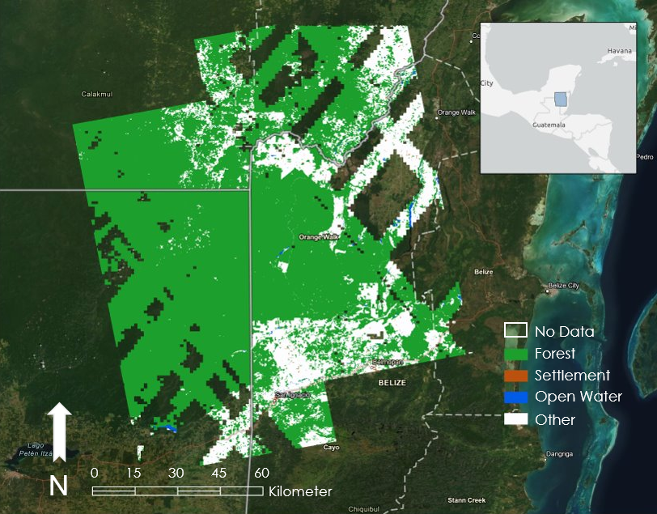
Figure 3. Land cover classification results. Green represents forest, orange represents settlement, blue represent open water, and white represents other. The coverage of the four fine-beam ALOS PALSAR 2 frames dictated the study area and was used to clip imagery from Landsat 8 OLI, NASA SRTM, Copernicus DEM. The gaps in the map above are due to ISS GEDI canopy height model coverage which limited the study.
4.1.2 Step 2 Inundation Mapping Results
We chose to revise the threshold without using the forest class to remove any possible inaccuracies the forest class may present when running through the iterative threshold refinement process. The team initially applied the threshold to the HH band similar to the previous term, but found that the HH band was incorrectly capturing inundation because it is hard to distinguish between bright HH values representing forest inundation and bright HH values that were bright due to other land cover characteristics, such as topography. The final threshold of –77.5 dB was determined for forested inundation as detected by the HH/HV ratio band and was clipped to the extent of the forest class from the land cover classification for the final product. The team decided to delineate the forest because although this threshold is most likely reflecting forested inundation, there are objects of other land cover types such as cropland or grassland that also have values of –77.5 dB or above as shown in Figure 4. The fact that inundation is being called within other land cover types using the final forest threshold does not necessarily mean that the threshold is incorrect but attests to the difficulty in deciphering SAR imagery. The team tested thresholds of –77.5, -78.4, -76.2, -79.0, and –75.6. As for validation, there was one trail camera with 69 photos chosen showing inundation throughout the year that fell within the top left frame (January and December). None of the inundation called for either month fell over the location of this camera. While this result may indicate inaccurate inundation results, this conclusion needs more support from incorporating other trail cameras and additional validation. Table 3 below shows the total inundation falling within the forest class (from the land cover classification) in hectares and displays the results of the total percent forested inundation falling within the forest.

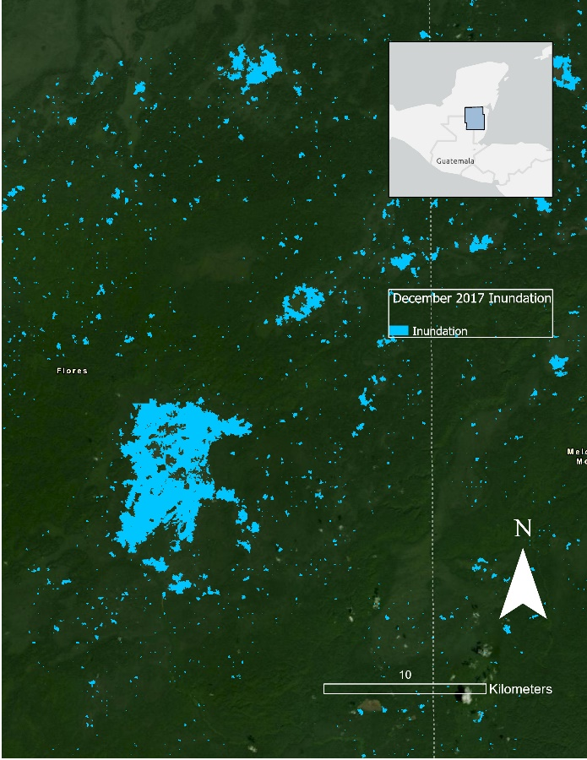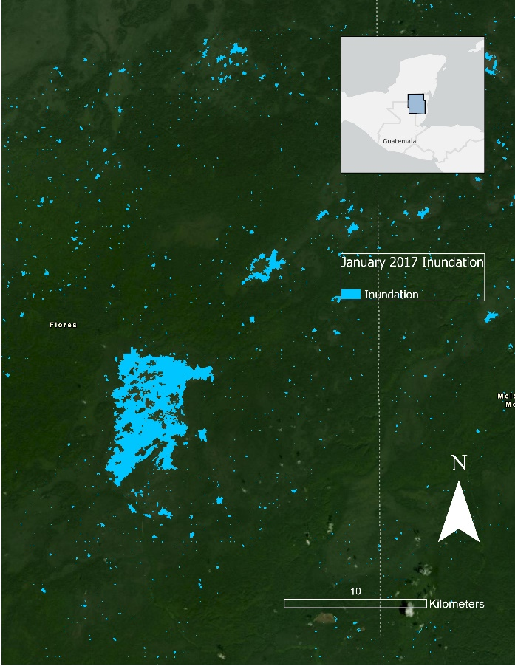
Figure 4. (left) Inundation is displayed in blue. This frame displays the Maya Forest mostly within Guatemala and parts of Belize during December of 2017. The team segmented the speckle filtered HH/HV ratio into spectrally similar objects that were then classified using a threshold for forested inundation –77.5 dB. (right) Inundation is displayed in blue for the same location in January 2017. Base map source: CONANP, Esri, Garmin, FAO, NOAA, Earthstar Geographics, CONANP, Esri, HERE, Garmin, METI/NASA, USGS.

The team observed several patterns within the inundation observed and HH/HV backscatter values, HV band, and forest change map. In the bottom left frame, for inundation in January and December 2017, inundation fell within the larger regions of bright values in the HH/HV ratio with minimal concern over some inundation being called in darker values. The bright values fell within –76 to –74 dB. In the bottom right frame, for inundation in February and September bright values in the ratio fell within –75 to –73 dB and within darker values at –77 dB. In the top left frame, for inundation in January and December, inundation falls in dark areas near –77.45 and –78.84 dB but also in bright areas near –75 dB. In the top right frame, inundation in February and September fell mostly within the darker ratio values, and the inundation value was consistently close to –77 dB.

Inundation values that overlay with the HV band for the bottom left frame in January and December showed that inundation fell mostly over dark values around –16 to –13 dB in the HV band. For the bottom right frame in February and September inundation fell within both darker and brighter values in the HV band. In the top left frame in January and December, the inundation in the HV band generally falls around –14 dB. In the top right frame inundation fell in the bright values in the HV polarization correlating to areas not categorized as forested wetlands.

Other observations for the bottom left frame in January and December include that very few archaeological sites fell directly within the classified inundation. More inundation from January overlapped with MARC’s wetland and swamp layers and the most common types of soils were leptosoles, vertisoles, gleysoles and caliza (limestone). For the bottom right frame in February and September there were relatively few archaeological and Maya sites (64) that fell within inundated areas. There was little overlap with MARC’s wetland layers and around 15% overlap with MARC’s swamp layers in both months. Soil layers included gleysoles, fluvisoles, leptosoles, and vertisoles. For the top left frame in January and December, about 34 Maya archaeological sites and 7 archaelogical sites overlapped with the inundation extent. The soil layer shown is gleysoles. In the top right frame in February and September inundation resulted consistently in the low range of NDMI values of 0.1 - 0.3 dB. The soils were mostly gleysol Within the Peten soils layer, the most common soils observed were Roca Caliza Suave, or River Limestone. While few roads fell in this portion of the study area, inundated roads included Rio Honda, Ucum – La Union, and Ramal a tres Garantias.

Table 3.
Total area of inundation within the forest in hectares and percent total inundation within the forest. BL is bottom left frame, TL is the top left frame, TR is the top right frame and BR is the bottom right frame. There were four frames aligned in two vertical and two horizontal adjacent paths.
Total | BL dry Jan 28 2017 | BL wet Dec 16 2017 | TL dry Jan 28 2017 | TL wet Dec 16 2017 | TR dry Feb 6 2017 | TR wet Sep 18 2017 | BR dry Feb 6 2017 | BR wet Sep 18 2017
Area inundated in the forest (ha) | 47343.5 | 49634.8 | 19697.8 | 27111.1 | 22057.3 | 27108.6 | 125204.7 | 110985.4
Percent inundated forest of total forest (%) | 12.9 | 13.6 | 4.5 | 6.1 | 5.7 | 7.0 | 31.1 | 27.6

4.1.3 Limitations/Error Analysis
Ground-based field studies in the Maya Forest are costly and intensive due to the large area of the forest and complex terrain. The absence of comprehensive inundation field data made it difficult to validate the results of this study. To address this, each inundation map and average threshold value were quantitatively and visually scrutinized against high resolution georeferenced map layers including the bare Earth elevation, Landsat composites, NDVI, NDMI, NDWI, slope map, TPI, canopy height model, forest change map, and land cover classification map. Layers used to scrutinize the thresholding results include data from MARC included hydrology and potential wetland layers, land use layers, soil, soil fertility, soil drainage, geology, and archaeological sites. With these layers, the team was able to calculate differences in the areas of each classified polygon. Only one CEMEC trail camera location was within our study area which provided little validation for our results. However, the inclusion of such ground data demonstrates the potential for its integration in future studies as a way to validate results.
Another limitation within this study was understanding the difference between inundation identification at the object and pixel levels. The object-based averaging of clusters led to the entire cluster being classified as either inundated or non-inundated by the threshold, which could fail to capture the intricate details of flooding under the forest. The pixel-level identification, however, was determined by the previous term of the project to be affected by the inherent noisiness of SAR imagery even after filtering. This could result in an overestimation of inundation within the scene as concluded by last term. The issue with object-level classification accuracy also applies to the results of the landcover classification, as the classifications are based on segmented objects. In addition to uncertainties within the pixel-based land cover classification, this study did not include robust validation for the training points used for each class. The resulting 88% accuracy may include confusion between classes therefore overestimating classes such as the forest and open water. Confusion between the settlement and other class should be investigated and improved with validated training points.

As with many remote sensing studies, the temporal and spatial resolution of the Earth observations presented a constraint. The ISS GEDI data did not fully cover our study area, thus derivative layers of slope, TPI, canopy height model, and bare Earth elevation were not entirely representative of the inundation dynamics of the full region of interest. In regard to spatial resolution, Landsat 8 had a 30-meter resolution and ALOS-2 PALSAR-2 imagery had 10-meter resolution. Temporally, the team had limited access to ALOS-2 PALSAR 2 imagery from the specific study year and corresponding wet and dry seasons. As a result, each scene is a snapshot of inundation extent during a specific day and may overestimate or underestimate flood extents from agricultural irrigation and storm events. Some areas identified as inundated may have contrasting identities due to differences in resolution, errors in the object classification algorithm, differences in data acquisition date ranges, and any threshold errors.

4.2 Future Work
The team acquired eleven wide-beam ScanSAR ascending L-band HH and HV polarizations at 100-meter resolution. These original ALOS-2 PALSAR-2 Data Products were provided by © JAXA (2021). The image dates ranged from February-April and September-November of 2017 and 2020 and were radiometric terrain corrected externally courtesy of Josef Kallndorfer from Big Earth data. These images were not entirely processed but may follow a similar methodology as the fine beam. The HH, HV, and HH/HV bands were Lee speckle filtered and not intended to be segmented. Each filtered ratio can be placed through the same iterative threshold refinement process as the fine beam. Future work using these images can include running the threshold across all the image HH/HV ratios, conducting a time series analysis to identify wetlands and varying extents of inundation over time.
Continued remote sensing collection and analysis in this region will allow for more meaningful comparisons between seasonal changes in inundation. Results from this project and others like it could help highlight key hydrological features and areas important for future land management and environmental monitoring. Future work could also benefit from the increased resolution and temporal coverage of NASA-ISRO SAR satellite (NISAR) L-band SAR which would be useful when refining inundation detection and analysis as well as landcover classification in areas under tree canopy. Future studies could also examine changes in urban and agricultural development around seasonally inundated areas that significantly impact local hydrologic systems and ecosystem dynamics. Other future work includes using inundation observations and hydrologic patterns to assess settlement patterns of ancient Maya. Ultimately, the results of this study can be adapted to different land cover types to inform governments and researchers how the landscape works and changes over time.

5. Conclusions
By using a combination of L-band SAR, LIDAR, optical and in-situ data, the team was able to identify and map possible inundation extents under the dense Maya Forest canopy. We observed that these methods captured varying levels of inundation in the forest. We gained confidence through our semi-validation, iterative process, and related research that our inundation maps captured flooding within the time periods and regions as hypothesized. The inundation maps and landcover classification system developed in this project provided our partners with improved estimations of inundation extent useful for developing land use management plans, flood risk assessments, wetland monitoring, and conservation efforts. Additionally, archaeological research focused on reconstructing the ancient landscape of the Maya Forest has been largely limited and concentrated on community-level analysis (Canuto and Auld-Thomas 2021). Results from this project could help narrow down locations of potential flood-prone areas where partner groups can conduct targeted field campaigns to gather validation data needed to further refine the inundation backscatter thresholds. GEE scripts released for our partner groups along with validated thresholds and detailed methods workflow, may be implemented in a variety of studies and further refined to suit different datasets and objectives.

6. Acknowledgments
We gratefully acknowledge our node fellow, Erica Carcelén, for her constant support and mentorship and our science advisors Ben Holt, Dr. Bruce Chapman, and Dr. Emil Cherrington for their technical guidance and project feedback. We would also like to thank all our partners who collaborated on this project with us for providing valuable insight into the context of monitoring and management of the Maya Forest in Belize, Guatemala, and Mexico as well as for providing field data and geospatial layers that were useful in our analysis: Edgar Correa, Alfred Cal, Victor Hugo Ramos, Jorge Mendoza Vega, Victor Manuel Ku Quej, Josue Ramos, Dr. Ed Boles. We would also like to thank our partners Dr. Anabel Ford, Sherman Horn, and Thomas Crimmel at the Mesoamerican Research Center for sharing with us their geospatial datasets that were useful in our analysis and for meeting with us regularly throughout the term to revise intermediary results. We give special thanks to JAXA, the Alaskan Satellite Facility, and Josef Kellndorfer from Big Earth Data for pre-processing the ALOS-2 PALSAR-2 images so quickly. Thank you, Jorge Arturo Cabrera Hidalgo, for your inspirational words. Also, thanks to Sarah Payne and Alexander Gunnerson from the Coastal California Water Resources team for the scripting help. Finally, we would like to additionally thank Kathy Elizabeth Salinas Mojica, Olinda Salguero Orellana, Vinicio Cerezo Arevalo, Jose Orlando Reyes Canales from the Central American Integration System (SICA), and also Betzy Hernandez Sandoval and Sean McCartney for help in communicating with SICA.
Any opinions, findings, and conclusions or recommendations expressed in this material are those of the author(s) and do not necessarily reflect the views of the National Aeronautics and Space Administration.
This material is based upon work supported by NASA through contract NNL16AA05C.

7. Glossary
ALOS PALSAR – Advanced Land Observation Satellite Phased Array Type L-band Synthetic Aperture Radar.
Backscattering – The process by which the microwave signals emitted by a radar sensor are scattered by the surface, resulting in a portion of the original signal being reflected back to the sensor. Generally, a smooth surface will have low backscatter values because less of the signal will be reflected back to the sensor, while rough surfaces will have high backscatter values because a larger portion of the signal will be reflected back to the sensor.
CHM – Canopy height model. Calculated by subtracting a DTM from a DSM. Models the height of the forest canopy above the ground.
DEM – Digital elevation model. DEM is an umbrella term that may refer to a DSM or a DTM.
DSM – Digital surface model. DSMs model the height of the first return from a LiDAR signal, or the first surface that the signal hits and is reflected off of.
DTM – Digital terrain model. DTMs model the height and topography of the bare earth surface.
Earth observations – Satellites and sensors that collect information about the Earth’s physical, chemical, and biological systems over space and time

Inundation – Process describing a land surface becoming covered with water, as in a flood.
LiDAR – Light Detection and Ranging. A form of active remote sensing where a pulsed laser is transmitted towards the surface and measures the distance between the sensor and any surfaces or features the laser interacts with on its path. DEM products can be derived from LiDAR data.
SAR – Synthetic Aperture Radar. An active remote sensing process involving the transmission of microwave signals from a sensor to the Earth’s surface, where the signals interact with the surface, experience some level of backscattering, and return to the sensor.
SNIC - Simple Non-Iterative Clustering; a Google Earth Engine algorithm

8. References
Achanta, R., Süsstrunk, S. (2017). Superpixels and polygons using simple non-iterative clustering. IEEE Conference on Computer Vision and Pattern Recognition (CVPR). https://doi.org/10.1109/CVPR.2017.520
Adeli, S., Salehi, B., Mahdianpari, M., Quackenbush, L. J., Brisco, B., Tamiminia, H., & Shaw, S. (2020). Wetland monitoring using SAR data: A meta-analysis and comprehensive review. Remote Sensing, 12(14), 2190. https://doi.org/10.3390/rs12142190
Belize.com. (2021). 236,000 Acres Of Maya Forest Secured For Posterity On Earth Day. Belize.com. https://belize.com/news/236000-acres-of-maya-forest-secured-for-posterity-on-earth-day/
Bradshaw, C.J.A., Sodhi, N. S., Peh, K.S.-H., & Brook, B.W. (2007). Global evidence that deforestation amplifies flood risk and severity in the developing world. Global Change Biology, 13(11), 2379-2395. https://doi.org/10.1111/j.1365-2486.2007.01446.x
Bray, D. B., Duran, E., Ramos, V. H., Mas, J. F., Velazquez, A., McNab, R. B., & Radachowsky, J. (2008). Tropical deforestation, community forests, and protected areas in the Maya Forest. Ecology and Society, 13(2). https://doi.org/10.5751/ES-02593-130256.
Canuto, M. A., & Auld-Thomas, L. (2021). Taking the high ground: A model for Lowland Maya settlement patterns. Journal of Anthropological Archaeology, 64, 101349. https://doi.org/10.1016/j.jaa.2021.101349.
CCKP. (2021). Historical Data. World Bank Climate Change Knowledge Portal (CCKP). https://climateknowledgeportal.worldbank.org/

CEOS. (2018). A Layman’s Interpretation Guide to L-band and C-band Synthetic Aperture Radar V2. CEOS Global Forest Observations Initiative. https://ceos.org/document_management/SEO/DataCube /Laymans_SAR_Interpretation_Guide_2.0.pdf
Chapman, B., McDonald, K., Shimada, M., Rosenqvist, A., Shroeder, R., & Hess, L. (2015). Mapping regional inundation with spaceborne L-band SAR. Remote Sensing, 7(5), 5440-5470. https://doi.org/10.3390/rs70505440
Committee of Earth Observation Satellites (CEOS). (15 November, 2018). A Layman’s Interpretation Guide to L-band and C-band Synthetic Aperture Radar Data Version 2.0. Global Forest Observations Initiative. https://ceos.org/document_management/SEO/DataCube/Laymans_SAR_Interpretation_Guide_2.0.pdf
Dubayah, R.O., Luthcke, S.B., Sabaka, T.J., Nicholas, J.B., Preaux, S., & Hofton, M.A. (2021). GEDI L3 Gridded Land Surface Metrics (v1) [Data set]. Oak Ridge National Laboratory Distributed Active Archive Center (ORNL DAAC). https://doi.org/10.3334/ORNLDAAC/1865
Ellison, A.M. (2004). Wetlands of Central America. Wetlands Ecology and Management, 12, 3–55. https://doi.org/10.1023/B:WETL.0000016809.95746.b1
Evans, T.L., Costa, M., Telmer, K., & Silva, T. S. F. (2010). Using ALOS/PALSAR and RADARSAT-2 to map land cover and seasonal inundation in the Brazilian Pantanal. IEEE Journal of Selected Topics in Applied Earth Observations and Remote Sensing. 3(4),1939-1404. https://doi.org/10.1109/JSTARS.2010.2089042
European Space Agency, Sinergise (2020). Copernicus Global Digital Elevation Model. Distributed by OpenTopography. Accessed August 27, 2021. https://doi.org/10.5069/G9028PQB
Farr, T.G., Rosen, P.A., Caro, E., Crippen, R., Duren, R., Hensley, S., Kobrick, M., Paller, M., Rodrigues, E., Roth, L. Seal, D. Shaffer, S. Shimada, J., Umland, J., Werner, M. Oskin, M. Burbank, D., and Alsdorf, D.E. (2007). The shuttle radar topography mission. Reviews of Geophysics, 45(2). https://doi.org/10.1029/2005RG000183
Foga, S., Scaramuzza, P.L., Guo, S., Zhu, Z., Dilley, R.D., Beckmann, T., Schmidt, G.L., Dwyer, J.L., Hughes, M.J., & Laue, B. (2017). Cloud detection algorithm comparison and validation for operational
Landsat data products. Remote Sensing of Environment, 194, 379-390. http://doi.org/10.1016
/j.rse.2017.03.026
Ford, A., & Nigh, R. (2009). Origins of the Maya Forest garden: Maya resource management. Journal of Ethnobiology, 29(2), 213-236. https://doi.org/10.2993/0278-0771-29.2.213
Forest Department. (2020). Belize Forest Reference Level, 2001 - 2015. Belmopan City: Government
of Belize. https://redd.unfccc.int/files/belize_frel_final__report__2001-2015__2020.01.13.pdf.
Gao, B. (1996). NDWI - a normalized difference water index for remote sensing of vegetation liquid water from space. Remote Sensing of Environment, 58, 257–266. https://doi.org/10.1016/S0034-4257(96)00067-3
Garcia-Anleu R. (2021). Registro de Vertebrados Medianos y Mayores con Cámaras Automáticas en La Colorada, Reserva de la Biosfera Maya; temporadas 2019-2021. Reporte interno FCG-WCS
Garcia-Anleu R., et al. (2021). Informe de Monitoreo con Cámaras Automáticas en los Parques Nacionales Mirador-Rio Azul y Laguna del Tigre, temporadas 2019-2020. Proyecto de Biodiversidad d USAID. Guatemala – WCS.
Garlati, A. (2013). Climate change and extreme weather events in Latin America: An exposure index. (No.4821). Inter-American Development Bank, Research Department. https://dx.doi.org/10.2139/ssrn.225
Google Earth Pro V 7.3.4.8248. (2021). Maxar Technologies, CNES/Airbus, Landsat, Copernicus.
Jarvis, A., H.I. Reuter, A. Nelson, E. Guevara. (2008). Hole-filled SRTM for the globe (v4) [Data set]. CGIAR-CSI SRTM 90m Database. https://srtm.csi.cgiar.org.
Jensen, J.R. (2000). An Earth Resource Perspective. Remote Sensing of the Environment. Prentice Hall, New Jersey. https://www.pearson.com/us/higher-education/program/Jensen-Remote-Sensing-of-the-Environment-An-Earth-Resource-Perspective-2nd-Edition/PGM200207.html
JAXA (2021). ALOS PALSAR 2 ScanSAR RTC L-Band SAR [Data set]. Japanese Aerospace Exploration Agency (JAXA).
Kriegler, F.J., Malila, W.A., Nalepka, R.F., and Richardson, W. (1969). Preprocessing transformations and their effects on multispectral recognition. Proceedings of the Sixth International Symposium on Remote Sensing of Environment, p. 97-131.
Mahdianpari, M., Salehi, B., Mohammadimanesh, F., & Motagh, M. (2017). Random forest wetland classification using ALOS-2 L-band, RADARSAT-2 C-band, and TerraSAR-X imagery. ISPRS Journal of Photogrammetry and Remote Sensing, 130, 13-3. https://doi.org/10.1016/j.isprsjprs.2017.05.010
Olofsson, P., Foody, G.M., Herold, M., Stehman, S. V., Woodcock, C.E., & Wulder, M. A. (2014). Good practices for estimating area and assessing accuracy of land change. Remote Sensing of Environment, 148, 42-57. https://doi.org/10.1016/j.rse.2014.02.015

Opolot, E. (2013). Application of remote sensing and geographical information systems in flood management: a review. Research Journal of Applied Sciences Engineering and Technology, 6(10), 1884–1894. https://doi.org/10.19026/rjaset.6.3920

Rebelo, L. M. (2010). Eco-hydrological characterization of inland wetlands in Africa using L-band SAR. IEEE Journal of Selected Topics in Applied Earth Observations and Remote Sensing. 3(4): pp. 554-559. https://doi.org/10.1109/JSTARS.2010.2070060.
ReliefWeb. (2008). Floods in Central America: Tropical Depression No. 16 causes problems at the end of the 2008 hurricane season. ReliefWeb. https://reliefweb.int/report/belize/floods-central-america-tropical-depression-no-16-causes-problems-end-2008-hurricane.
Rodriguez-Galiano, V. F., Rogan, J., Ghimire, B., Chica-Omo, M. (2012). An assessment of the effectiveness of a random forest classifier for land-cover classification. ISPRS Journal of Photogrammetry and Remote Sensing. 67(1), 93-104. DOI:10.1016/j.isprsjprs.2011.11.002.
Schmidt, G.L. & Jenkerson, C.B. & Masek, J. & Vermote, E. & Gao, Feng. (2013). Landsat ecosystem disturbance adaptive processing system (LEDAPS) algorithm description. U.S. Geol. Surv. Open File Rep. 1057. https://doi.org/10.3133/ofr20131057.
Simard, M., Pinto, N., Fisher, J., Baccini, A. (2011). Mapping forest canopy height globally with spaceborne lidar. Journal of Geophysical Research, 116(G4). https://doi.org/10.1029/2011JG001708.
U.S. Geological Survey (2020). USGS EROS Archive – Landsat Archives – Landsat 8-9 OLI/TIRS Collection 2 Level-2 Science Products. [Data set]. USGS Earth Resources Observation and Science (EROS) Center. https://doi.org/10.5066/P9OGBGM6
Wilson, E.H. and Sader, S.A. (2002). Detection of forest harvest type using multiple dates of Landsat TM imagery. Remote Sensing of Environment, 80(3), 385-396. https://doi.org/10.1016/S0034-4257(01)00318-2
Zha, Y., Gao, J., Ni, S. (2010). Use of normalized difference built-up index in automatically mapping urban areas from TM imagery. International Journal of Remote Sensing, 24(3), 583-594. https://doi.org/10.1080/01431160304987

9. Appendices

Table A1.
In-situ and other data provided by project partners and other regional entities.
Data Products | Creation Date | Source(s)
Land use and land cover for Campeche, Mexico | 2009 | CEMEC
Wetlands Cartographic Model Scale 1:50 000 (Modelo Cartográfico de Humedales Escala 1:50 000) | 2014 | Instituto Nacional de Estadística y Geografía (INEGI)
Protected Areas of Belize, Guatemala, and Southern Mexico | 2004 | MARC; Eco-Regional Plan of the Maya, Zoque and Olmeca Forests
Three Country Boundary Lines | 2004 | MARC; Eco-Regional Plan of the Maya, Zoque and Olmeca Forests
Mesoamerican Soils: Belize, Guatemala, and Southern Mexico | 2004 | MARC; Eco-Regional Plan of the Maya, Zoque and Olmeca Forests
Mesoamerican Soil Fertility: Belize, Guatemala, and Southern Mexico | 2004 | MARC; Eco-Regional Plan of the Maya, Zoque and Olmeca Forests
Mesoamerican Soil Drainage: Belize, Guatemala, and Southern Mexico | 2004 | MARC; Eco-Regional Plan of the Maya, Zoque and Olmeca Forests
Localities with Populations of 2000 or more | 2004 | MARC; Eco-Regional Plan of the Maya, Zoque and Olmeca Forests
Geology and Volcanoes of Mesoamerica: Belize, Guatemala, and Mexico | 2004 | MARC; Eco-Regional Plan of the Maya, Zoque and Olmeca Forests
Waterways of Mesoamerica: Belize, Guatemala, and Southeastern Mexico | 2017 | MARC; OpenStreetMap®
Mesoamerica Swamps and Wetlands | 2017 | MARC; OpenStreetMap®
Major Roads and Urban Centers in Mesoamerica: Belize, Guatemala, Southern Mexico | 2017 | MARC; OpenStreetMap®
Archaeological Sites: Belize, Guatemala, and Mexico | 2017 | MARC

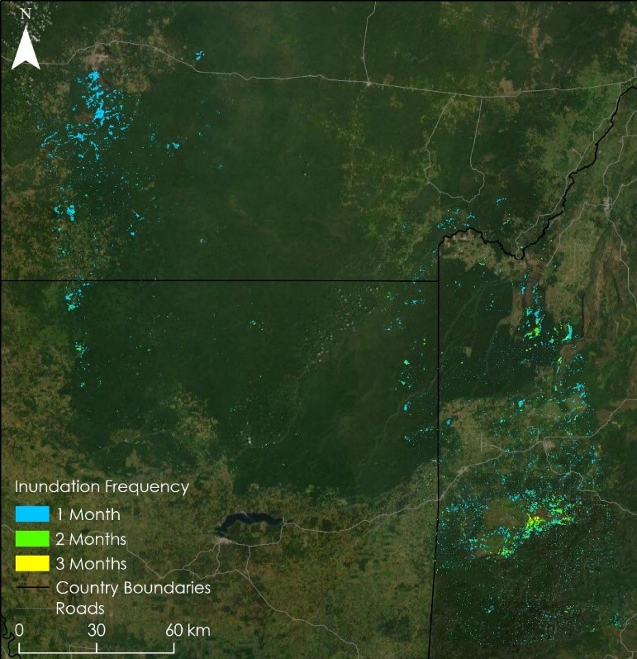
Figure A1. The above map from the initial study of this project delineates inundation duration throughout the entire study area including each ALOS PALSAR-1 frame from both Path 168 and 170. Areas inundated during one month are blue, two months are green, and areas inundated for all three months are yellow. The southeastern area of this map is where inundation is overestimated due to mountains and other errors.

