Washington, D.C. & Maryland Energy
Estimating Solar Potential Using NASA POWER Data to Inform Renewable Energy Policy for Washington, D.C.

Technical Report
Final Draft – November 14th, 2021

Edward Cronin (Team Lead)
Ashley Fernando
Jarrett James
Rupa Kurinchi-Vendhan

Advisors:
Dr. Kenton Ross, NASA Langley Research Center (Science Advisor)
Dr. Paul Stackhouse, NASA Langley Research Center (Science Advisor)

1. Abstract
In line with the Sustainable D.C. 2.0 plan to combat climate change, Washington D.C. aims to decrease its greenhouse gas emissions by 100% by 2050. As solar energy is a clean, renewable energy form, its integration into the region’s power grids lowers energy costs and incentivizes sustainable development. We partnered with the Washington D.C. Department of Energy & Environment (DOEE) to determine how urban areas surrounding D.C. can better be incorporated into decisions regarding renewable energy policy. The team used NASA’s Prediction of Worldwide Energy Resources (POWER) solar data and a Light Detection and Ranging (LiDAR) derived digital surface model, to estimate and visualize rooftop solar potential for Maryland’s Prince George’s and Montgomery counties. POWER provided solar irradiance data adjusted for tilt angle while the digital surface model contributed aspect and slope data. This methodology factored out areas that were unsuitable for solar panel installation while displaying areas that possess a high potential for energy return. The team found the total rooftop solar potential for the study area to be almost 32 million kW, which is equivalent to roughly 660 kW per building. The methodology used to generate the solar potential maps can be applied to other regions of the country seeking to efficiently utilize solar energy. The end users at the DOEE can use our resulting solar potential map and data table to effectively target buildings that have the highest potential to generate solar energy.

Key Terms
digital surface model (DSM), irradiance, LiDAR, NASA POWER, photovoltaic, remote sensing, solar potential

2. Introduction
2.1 Background Information
Currently, the United States continues to rely on nonrenewable sources of power like coal, natural gas, and oil. These finite sources of energy contribute to the emission of greenhouse gases (GHGs) and other pollutants promoting global climate change and increased exposure to air pollutants that impact human health. As of 2020, the United States produced 79% of its total energy from nonrenewable sources and only 12% from renewable sources. Of the 12% of renewable energy consumed, 26% came from wind turbines, 22% came from hydroelectric power, and 11% came from solar while other sources like biomass and geothermal energy constituted the remaining 41% (U.S. Energy Information Administration [EIA], 2021). Switching to renewable energy sources can combat the negative effects caused by the use of nonrenewable energy. Solar power, in particular, helps by reducing the emission of air pollutants and serves as an infinite source of energy to aid in reducing global climate change. (Kalogirou, 2004).

Washington, D.C. has already begun the process of expanding its use of renewable energy sources. In an effort to transition the District into a city that is fully dependent on renewable energy, it has set goals within the Sustainable DC 2.0 Plan to reach 100% renewable power generation by 2032 and zero GHG emissions by 2050. The District currently attributes 96% of its GHG emissions to energy consumption, of which 75% powers buildings (Department of Energy and Environment [DOEE], 2019). The cost of solar energy falls continuously and, as of 2021, the price of residential solar power has decreased by 64% compared to the 2010 price point while other uses, such as commercial or utility fell by 69% and 82% (National Renewable Energy Laboratory, 2021). Reductions in solar panel prices occurred after major decreases in the cost of materials and increases in production, investment, and efficiency advanced significantly in the last two decades (Pillai, 2015). The benefits of widening the installation of photovoltaic solar panels in the District include localized energy decreasing home utility costs by 50%, the creation of jobs locally, the reduction in air pollutants emitted, and no longer contributing to climate change through energy production (DOEE, 2019).

The two surrounding Maryland counties, Prince George's and Montgomery, connect to the same power feeder lines as the District. The energy generated in these Maryland communities can aid in the District's goal of total renewable energy reliance by 2032 to ensure that greenhouse gas emissions from the District’s power feeders reach 0% by 2050. To understand more about the potential market for solar energy within these neighboring areas, a detailed map of solar rooftop potential provided information to estimate the value and feasibility of expanding photovoltaic solar panels within the Maryland counties. Previously, a solar potential map explored the viability of rooftops throughout the District to provide solar energy and supply the District's consumption needs. This previous map, created by Mapdwell, a software company that specializes in solar potential mapping and assessment, encompassed the entire city of D.C. to estimate the total solar potential for rooftops. This Mapdwell study did not extend into Prince George’s and Montgomery Counties, where the District’s power feeders stretch, to analyze the feasibility of solar installation. Prior studies used Light Detection and Ranging (LiDAR) data in various GIS software programs to account for variables in parameters like land cover and roof orientation (Prieto et al., 2019). To develop a solar potential map, the team crafted a digital surface model (DSM) and calculated slope and aspect for different building footprints using LiDAR data. (Prieto et al., 2019). NASA’s Prediction of Worldwide Energy Resources (POWER) provided meteorological quantities of solar energy fluxes from 2015 to 2021 which revealed solar irradiance for the optimal tilt angle and sun position (Stackhouse et al., 2020). Building footprints displayed the locations of rooftops relative to the county and the surrounding environment. The team applied this methodology to our approximately 111-square kilometer (or 43-square mile) study area, which surrounds the power feeders that connect to both the District and Prince George’s and Montgomery Counties (Figure 1).
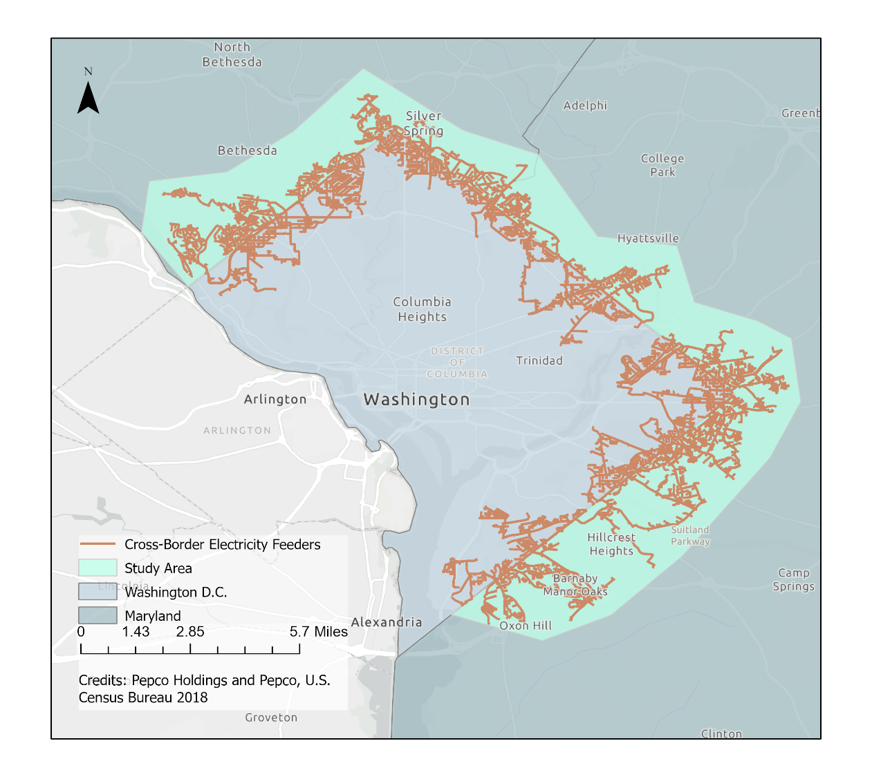
Figure 1. The study area comprises the Maryland communities immediately surrounding Washington, D.C. that supply solar energy to the District through cross-border electricity feeder lines (shown in orange).

2.2 Project Partners & Objectives
We partnered with the DOEE to generate solar potential maps for surrounding Maryland counties and to further the goals set by the Sustainable D.C. 2.0 Plan. In the District, the DOEE is responsible for policy decisions that concern renewable energy and environmental issues. To incentivize the use of renewable energy—more specifically, solar power—for residents in the District, they implemented solar energy credits. In 2020, 20% of solar energy credits were generated outside of the District, understanding the energy potential for surrounding areas will be crucial for partners in identifying where increased solar panel initiatives will produce future solar credits (Public Service Commission of the District of Columbia, 2021). The DOEE aims to encourage rooftop solar panel installations where the gridlines overlap between the District and these counties to increase the amount of solar energy in their power system.

Using LiDAR and NASA POWER data, the total rooftop solar energy potential was calculated for the regions surrounding the District. The results were demonstrated through an ArcGIS StoryMap, which provides an interactive medium for exploring the methodology and end products of our work that display how this study discovered the solar potential for Prince George’s and Montgomery counties with regard to energy generation for all powers feeders linked to the District. In providing the Washington, D.C. DOEE with solar potential maps by building, partners will be able to make informed decisions on solar panel installations based on the specific locations where solar panels will yield the most energy. The DOEE will also use our end products to gain better insight into the market potential for solar energy credits in the area, and how this demand may evolve.

3. Methodology
3.1 Data Acquisition
The team collected LiDAR and building footprint data from Maryland’s Mapping and GIS Data Portal (Maryland’s Mapping & GIS Portal, 2018a & 2018b), a web service run by the state’s government. We downloaded the 2018 LiDAR data as point cloud tiles in LASer (LAS) file format. Meanwhile, we downloaded the building footprint data as shapefiles and projected them directly into ArcGIS Pro. The polygons of the building outlines used were created in August 2018 but updated in December 2020.
Solar irradiance data were obtained from the NASA Langley Research Center POWER Project. This dataset was composed of meteorological, climate, and solar information by month and year ranging from January 1990 to December 2019. The NASA POWER data, partially derived from Global Modeling and Assimilation Office Modern Era Retro-analysis for Research and Applications, Version 2 (GMAO MERRA-2) model and the NASA Global Energy and Water Exchanges Surfaces Radiation Budget (GEWEX/SRB), provided meteorological and solar information for the preprocessed dataset which accounted for cloud cover, sun duration, and position. An electrical feeder map (Figure A1) displays all of the Potomac Electric Power Company (PEPCO) power feeder lines that are connected between the District and Prince George’s and Montgomery counties. The DOEE provided this map of the power feeders to our team as a form of reference to determine the study area and the amount of data required for this project. All of the Earth Observation data and Ancillary data used in this study are displayed in Tables 1 and 2.

Table 1.
NASA Earth Observation Data used for our study
Dataset | Dates | Purpose | Source
30-year Meteorological and Solar Monthly & Annual Climatologies | January 1990 – December 2019 | Global Horizontal Irradiance (GHI), Diffused Horizontal Irradiance (DHI), and surface albedo data to be used as inputs to a Python code that calculates solar irradiance. Solar irradiance will then be used to determine the solar potential for tilted surfaces. | NASA POWER

Table 2.
Ancillary Data used for our study
Specifications | Type | Use | Source
LiDAR 2018 | Vector | Calculate aspect, slope, and shading of rooftop segments. | Maryland GIS Data Catalog
Building footprint dataset | Vector | Create roof segmentation shapefiles. | Maryland GIS Data Catalog
Electrical Feeder Map | Vector | Visualize the extent of solar energy market of the District, used to refine the study area. | PEPCO

3.2 Data Processing
The main goal of our data processing methodology was to use LiDAR data and NASA POWER data to create a map of solar potential by building rooftop. We first processed the LiDAR data by creating DSM tiles from point cloud files that we downloaded in LAS format. For each DSM tile, we used ArcGIS tools to create slope and aspect polygons for each tile, and we clipped these to our building footprint polygons to analyze the distribution of different slope and aspect angles of different facets of each rooftop. Next, for each tile, we combined our slope and aspect polygons into a single feature class and dissolved them so that the feature class attribute table would contain one shape area value for each slope angle value.
Simultaneously, we ran a NASA POWER Python script with Global Horizontal Irradiance (GHI), Diffused Horizontal Irradiance (DHI), and surface albedo parameters from NASA POWER’s 30-year Meteorological and Solar Monthly & Annual Climatologies data tables as inputs. This resulted in a table of the solar irradiance kWh/m²) for each rooftop slope angle between 10 and 90 degrees on the 15th day of each month in 1999. Next, we joined our slope-aspect feature classes with our solar irradiance table and wrote a Python script to calculate, tile by tile, a preliminary total solar potential value over all rooftops in the study area.
We used the building footprint shapefile along with slope and aspect data from our DSM to create three polygon layers of roof segments that would be unsuitable for solar panel installation. These layers included flat roofs (areas with slope angles between 0 and 10 degrees), north-facing roof areas (segments with aspects between 0 and 67.5 degrees and 337.5 and 360 degrees), and a building footprint buffer layer. North-facing rooftops in the northern hemisphere do not receive adequate solar irradiance (Chace & Comis, 2018), flat rooftops require additional construction of racks (in Maryland, optimally angled 35-40 degrees) upon which panels may be mounted (Chace & Comis, 2018), and international fire code prohibits solar panel installation on roof edges (International Code Council, 2018). By applying these layers to filter certain roof segments out of our initial solar potential map, we eliminated large data spikes and were then able to calculate the solar potential for strictly viable rooftops in the study area.

For our final steps, we merged all solar potential tiles into one polygon. The attribute table associated with this polygon contained a daily solar potential value of each month of the year and a daily potential value averaged over a year for each slope angle between 10 and 90 degrees. We then converted this polygon layer into a raster in order to calculate statistics such as minimum, maximum, and mean solar potential using ArcGIS Pro raster tools.

3.3 Data Analysis
The team used a validation process to analyze the accuracy of the generated solar potential maps. To perform a validation analysis, the team obtained and confirmed that our potential calculations yielded values of the correct order of magnitude. The outputs were then compared with those of Google’s Project Sunroof (Google’s Project Sunroof, 2017). This energy estimator product is designed to give users an insight into the amount solar energy potential a location possesses. The team used this resource to check the median electricity of a sample location in our study area. More specifically, the team chose to focus our analysis on Silver Spring, Maryland (zip code 20910), where there exists an overlap between the data availability for Project Sunroof and the Maryland LiDAR data. This validation process allowed the team to gain an insight on the accuracy of the resulting solar potential values.

4. Results & Discussion
The team estimated the study areas rooftop solar potential by building, reporting daily values in kilowatt-hours (kWh) for each month of the year and an annual average. The team calculated a daily total of close to 18 million kWh averaged over a year within our study area. Figure 2 shows the daily average of solar potential in kWh. The average amount of daily solar potential averaged over a year per building footprint was derived to be 366 kWh. These values were calculated for an area of roughly 45.5 sqMi (118 sqKm).

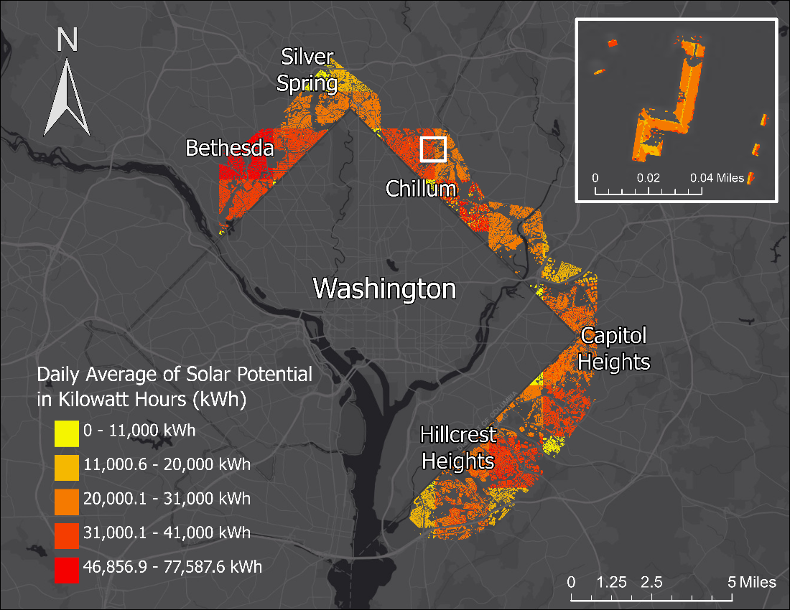
Figure 2. The solar potential map of the study area displays areas that have the highest solar potential in dark red, while yellow is used to represent areas with the lowest potential. The values represent total solar potential in an area defined by each LiDAR shapefile from Maryland’s Mapping and GIS Data Portal. Each area contains different number of buildings, typically between 20 to 200 buildings. The inset map shows a large rooftop in our study area, which displays how solar potential varies by individual roof segment due to the different slope and aspect values as well as the varying levels of solar irradiance. The inset map also shows how North-facing and flat roofs were masked out to be excluded from solar potential calculations.

4.1 Analysis of Results
To find the total potential of solar energy for each building footprint, the team first calculated the total potential for solar energy within the entire study area. Figure 2 revealed that our study area throughout Prince George’s and Montgomery counties contained a daily total of 17.7 million kWh of potential solar energy averaged over a year. The average daily solar potential per building was calculated to be 366 kWh and was created by dividing the total potential solar energy by the 48,365 buildings recorded in the study area. Values shown in Figure 2 above are higher than the average solar potential per building due to unresolved discrepancies between the LiDAR tiles and not dividing the total daily average by the number of buildings counted.

Because our study area lies within the Northern Hemisphere, there are seasonal differences that impact the amount of daily solar irradiance onto rooftops that fluctuate throughout the year. Summer months, May through August, provide the most solar irradiance with a peak in June, while the Winter months unsurprisingly provide the least solar irradiance with the minimum solar potential in December. Our study found that June contributed an average daily potential of 20.2 million kWh. December contributed only 13.1 million kWh of average daily potential.

Alongside factors like seasonal changes in solar irradiance, the total solar irradiance that building rooftops in our study area receive is influenced by a multitude of factors such as tree cover, area of roof size, building shadows, and atmospheric conditions. Because of the variations that these factors cause, regions that are close together geographically can differ greatly in solar energy potential. Figure A2 and Figure A3 are two examples that highlight this difference. Figure A2 represents a region on the eastern end within our study area that encapsulates a portion of the Hillcrest Heights neighborhood, which had a daily solar potential average of 1.4 million kWh and a daily average of 552 kWh per building. North Barnaby, a bordering neighborhood also in Hillcrest Heights visualized by Figure A3 revealed lower solar potential compared to Figure A2. The North Barnaby neighborhood contributed a total of 0.3 million kWh and a daily average of 465 kWh per building.

Throughout the course of this project, our team faced several limitations that placed constraints on the results of our analysis. The LiDAR and building footprint data served as the base for assigning values and locations for polygons. Both resources had uncertainties in their spatial resolution precision, meaning that the team could not determine with full certainty if the location of the buildings matched exactly between both the LiDAR and building footprint data. One indication of this discrepancy was that the LiDAR data may have had inaccuracies in elevation measurements in the order of centimeters. Other potential limitations were uncertainties in the NASA POWER data. These physical uncertainties may occur from the use of physical calculations like cloud statistics when crafting the dataset and could result in inaccuracies in our analysis of solar irradiance (Stackhouse et al., 2020). Lastly, due to computational runtimes and the functionality of the geospatial analysis processes, the team chose to reduce the size of our study area to no longer encompass every location that the power feeder lines reached. While this decision excluded some portions of the study area, it allowed the team to produce results that met the needs of the DOEE and provided a potential solar energy total for a majority of our study area.

The time variance of our solar potential matches our expectations (Figure 3). The potential varies with seasonality with higher average potential values for summer months when irradiance is the highest and lower average potential values for winter months when irradiance is the lowest.

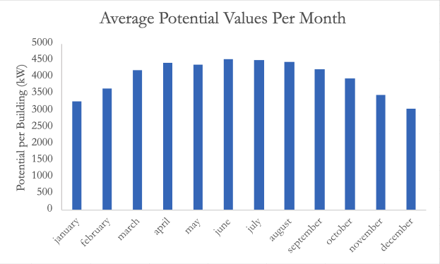
Figure 3. The average daily values for potential per building, for each month of the year.

The team also took steps to ensure the accuracy and precision of our results through the use of a validation analysis to support our findings. After applying our methodology to this specific area, we calculated that the median potential per building was 14.7 MW, with an interquartile range of 10.3 MW. Note that 1 MW is equal to 41.7 kWh/day. Values were changed from kWh to MW because the validation process from Project Sunroof used MW as the unit, making it easier to validate. According to Project Sunroof, Silver Spring’s median potential per building was 17.7 MW (Google’s Project Sunroof, 2017). Notably, Project Sunroof does not account for the 3-foot setback around the edges of each roof that is unsuitable for solar panel installation and it does not filter out North-facing or flat roofs (Google’s Project Sunroof, 2017). As such, although the value obtained from Project Sunroof is greater than that obtained from our calculations, it falls within the interquartile range of the value we calculated. This enables us to confirm that our methodology produces results of the correct order of magnitude.
4.2 Future Work
In future works, we hope to extend our methodology to other regions to inform decisions about solar panel installation around the nation. Additionally, including a comprehensive analysis of grayspace—areas of unused land—alongside the rooftops of buildings in our study may offer the possibility of maximizing solar potential over a given region. Accounting for tree shading, possibly using vegetation polygons created from a Normalized Difference Vegetation Index (NDVI), will also be an important improvement to our solar potential maps, as excluding the regions with heavy tree shading will provide a more accurate account of possible solar panel locations. The team also hopes to model socioeconomic distribution in the study area to highlight income variability to our partners and ensure equitable solar panel distribution. To make the solar potential maps more accessible to our partners, we also hope to develop a platform through which others can access our data post-processing.

5. Conclusions
DOEE's primary goal when partnering with NASA DEVELOP was to identify buildings with high solar potential so those building rooftops could be fitted with solar panels. The energy generated by these rooftops would push the District closer to its renewable energy goals and contribute to a growing solar renewable energy credit (SREC) market. Our final map, (Figure 2), and feature classes of solar potential by Maryland neighborhood (Table A1) will provide partners at DOEE with key information about where solar panels should be installed in Maryland to provide the highest amount of clean energy to Washington, D.C. This, in turn, will inform decisions regarding the expansion of the SREC market beyond District boundaries.
Our team also created an ArcGIS StoryMap that DOEE may use as a tool to educate the District and Maryland residents on the merits of photovoltaic panels and make solar energy more widely accessible.

Overall, we found the study area to have a total estimated daily solar potential of 17,706,177.50 kWh in an average year if solar panels were installed on all rooftops deemed viable by this study. This is enough energy to power roughly 1,652.5 homes for a year (U.S. EIA, 2020). Flat rooftops and gray spaces fitted with mounting racks may be viable for solar panel installation, which would increase predicted solar energy generation beyond our estimate. These results have also demonstrated that it is feasible to map and calculate the solar potential for a large area spanning several towns and cities using LiDAR point cloud data and atmospherically corrected solar irradiance data from NASA POWER. Our results will validate new solar panel installation initiatives in Maryland and empower the District to achieve 100% renewable energy by 2032, with 10% coming from solar energy by 2041, in accordance with the Clean Energy D.C. (CEDC) Omnibus Act of 2018. Our methods have the capacity to be applied to other regions of the country seeking to efficiently utilize solar energy, and our documented methodology can be reused by future NASA DEVELOP project teams as they calculate the solar potential for other study areas around the globe.

6. Acknowledgments
We gratefully acknowledge Dr. Kenton Ross (NASA Langley Research Center), Bradley Macpherson (NASA Langley Research Center), and Dr. Paul Stackhouse (NASA Langley Research Center) for their contributions to this work as science advisors. We also thank Thomas Bartholomew (Branch Chief of the Washington, D.C. DOEE) for his support as a partner, and Adriana LeCompte (DEVELOP LaRC Fellow) for her coordination between the team and the DEVELOP program.

Any opinions, findings, and conclusions or recommendations expressed in this material are those of the author(s) and do not necessarily reflect the views of the National Aeronautics and Space Administration.

This material is based upon work supported by NASA through contract NNL16AA05C.

7. Glossary
Earth observations – Satellites and sensors that collect information about the Earth’s physical, chemical, and biological systems over space and time
Remote sensing – Process of detecting and monitoring the physical characteristics of an area by measuring its reflected and emitted radiation at a distance (typically from satellite or aircraft)
Digital surface model (DSM) – Representation of first LiDAR laser returns, including the highest features in a landscape and may include the ground
Solar irradiance – Power per unit area of light energy from the sun
LiDAR – Light Detection and Ranging, a remote sensing method that measures the distance traveled by a laser pulse emitted towards the earth before it is reflected by a surface
NASA POWER – Prediction of Worldwide Energy Resources, database of solar and meteorological datasets from NASA research for support of renewable energy
Photovoltaic technology – Technology, such as solar panels, that convert light into electricity
Solar potential – Potential energy that can be generated by solar panels in a given area
Roof segment – A facet of a building’s rooftop that faces a particular cardinal direction and has a particular slope angle.

8. References
Chace, D. & Comis, D. L. (2018). A Maryland Consumer’s Guide to Solar. Maryland Energy Administration. https://energy.maryland.gov/Reports/A%20Maryland%20Consumers%20Guide%20to%20Solar.pdf

Department of Energy and Environment. (2019, April 23). Sustainable DC 2.0 Plan Outline. Sustainable DC 2.0 Plan. https://sustainable.dc.gov/sdc2

Google’s Project Sunroof. (2017, May). Project Sunroof data explorer: a description of methodology and inputs. https://www.google.com/get/sunroof/assets/data-explorer-methodology.pdf

International Code Council. (2018). 2018 International Fire Code. Retrieved November 17, 2021, from https://codes.iccsafe.org/content/IFC2018

Kalogirou, S. A. (2004). Environmental benefits of Domestic Solar Energy Systems. Energy Conversion and Management, 45(18-19), 3075–3092. https://doi.org/10.1016/j.enconman.2003.12.019

Maryland’s Mapping & GIS Portal. (2018a). Maryland Building Footprints. MD IMAP Data Catalog, https://data.imap.maryland.gov/datasets/maryland-building-footprints/explore? location=38.825561%2C-77.268450%2C8.50

Maryland’s Mapping & GIS Portal. (2018b). Maryland LiDAR Statewide. MD IMAP Data Catalog, https://data.imap.maryland.gov/datasets/maryland-building-footprints/explore? location=38.825561%2C-77.268450%2C8.50

NASA Langley Research Center. (2019). NASA Langley Research Center (LaRC) POWER Project funded through the NASA Earth Science/Applied Science Program [Data set]. Retrieved September 21, 2021 from https://power.larc.nasa.gov/data-access-viewer/

National Renewable Energy Laboratory. (2021, February 10). Documenting a decade of cost declines for PV Systems.
NREL.gov. https://www.nrel.gov/news/program/2021/documenting-a-decade-of-cost-declines-for-pv-systems.html.

Pillai, U. (2015). Drivers of cost reduction in solar photovoltaics. Energy Economics, 50, 286–293. https://doi.org/10.1016/j.eneco.2015.05.015

Prieto, I., Izkara, J. L., & Usobiaga, E. (2019). The application of LIDAR data for the solar potential analysis based on Urban 3D model. Remote Sensing, 11(20), 2348.https://doi.org/10.3390/rs11202348

Public Service Commission of the District of Columbia (2021, May 3). Renewable Energy portfolio Standards a Report for Compliance Year 2020. Retrieved October 13, 2021, https://dcpsc.org/getattachment/Orders-and-Regulations/PSC-Reports-to-the-DC-Council/Renewable-Energy-Portfolio-Standard/2021-RPS-report-FINAL.pdf.aspx?lang=en-US

Stackhouse, P., Zhang, T., Barnett, A. J., Macpherson, B., Mikovitz, C., Broddle, M., & McNeil, C. (2020, October 14). POWER Data Methodology. https://power.larc.nasa.gov/docs/methodology/.

U.S. Energy Information Administration. (2021, April). U.S. energy facts explained. US energy facts explained – consumption and production - EIA. Retrieved October 7, 2021, from https://www.eia.gov/energyexplained/us-energy-facts/

US Energy Information Administration (2020). How much electricity does an American home use? - FAQ - U.S. Energy Information Administration (EIA). Retrieved November 16, 2020, from https://www.eia.gov/tools/faqs/faq.php?id=97&t=3

Appendix A
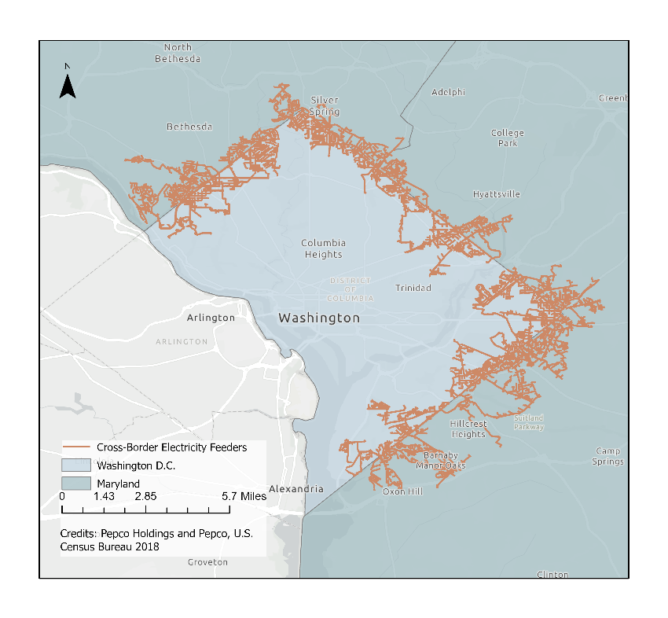
Figure A1. The PEPCO electrical feeder lines that are distributed throughout Washington, D.C., and extend into Prince George’s and Montgomery counties in Maryland.
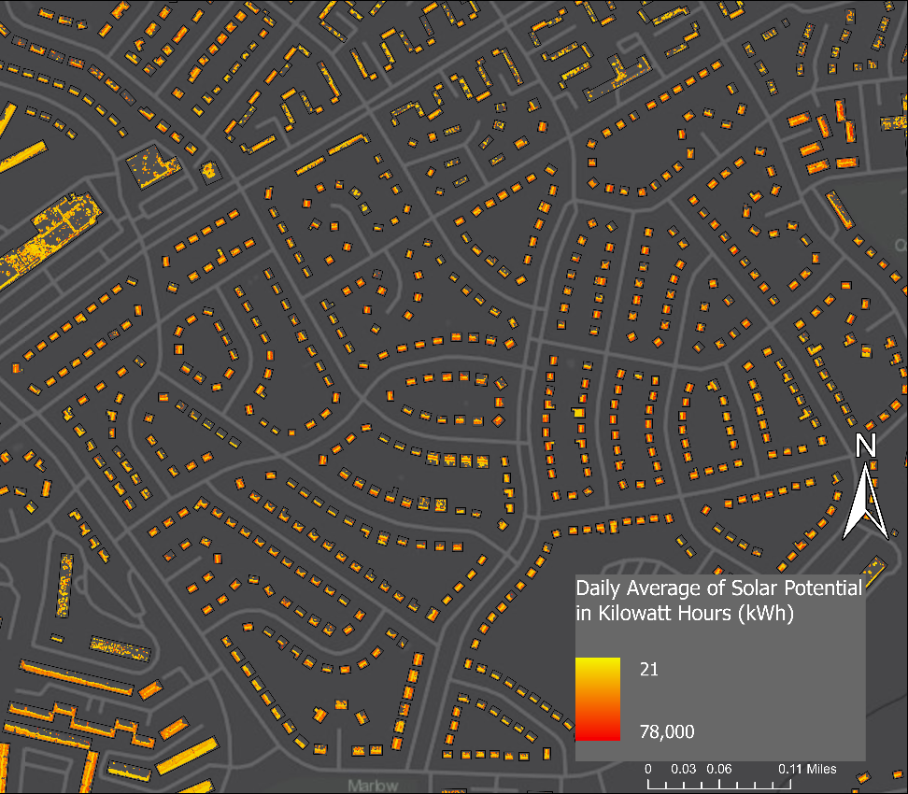
Figure A2. The map shows a portion of one of our tiles with the maximum total solar potential. The maximum total solar potential was identified to be the eastern residential area of Hillcrest Heights. The building footprint for this contained a daily total of 1,440,217.30 kWh and an average of 551.81 kWh per building) for an area of 2.87 square miles (7.44 sqKm).

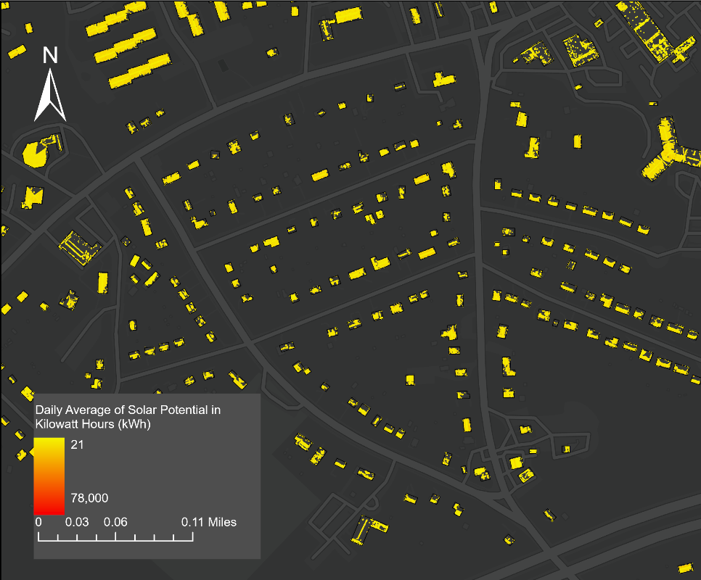
Figure A3. The map shows a portion of one of our tiles with the least total solar potential. We identified one region of minimal total solar potential in Maryland’s North Barnaby neighborhood. The daily solar potential averaged over a year for this 0.87-square mile (2.25 sqKm) region was 291,413.90 kWh. On average, each building in this region has the potential to generate roughly 464.8 kWh of solar power. Therefore, on an average day of the year, each building in the region of the study area with the lowest solar potential can generate enough energy to power an average American home for roughly half of a month.

Table A1.
The Attributes Table for the one particular grid cell (or neighborhood) of the study area.
