Supplementary Materials for:

Comprehensive comparison of airborne and spaceborne SAR and LiDAR estimates of forest structure in the tallest mangrove forest on Earth

Atticus E.L. Stovall^{1,2,*}, Temilola Fatoyinbo¹, Nathan M. Thomas³, John Armston², Médard Obiang Ebanega⁴, Marc Simard⁵, Carl Trettin⁶ Robert Vancelas Obiang Zogo ⁴, Igor Akendengue Aken ⁴, Michael Debina⁵, Alphna Mekui Me Kemoe⁴, Emmanuel Ondo Assoumou⁴, Jun Su Kim⁷, David Lagomasino⁸, Seung-Kuk Lee⁹,Jean Calvin Ndong Obame⁷, Geldin Derrick Voubou⁷, Chamberlain Zame Essono ⁷

¹NASA Goddard Space Flight Center, Greenbelt, MD, USA
²Department of Geographical Sciences, University of Maryland, MD, USA
³Earth System Science Interdisciplinary Science Center, University of Maryland, MD, USA
⁴Omar Bongo University, Libreville, Gabon
⁵Jet Propulsion Laboratory, California Institute of Technology, CA, USA
⁶USDA Forest Service Southern Research Station
⁷German Aerospace Center (DLR), Microwaves and Radar Institute, 82234 Wessling, Germany
⁸Department of Coastal Studies, East Carolina University, Wanchese, NC, USA
⁹Department of Earth and Environmental Sciences, Pukyoung National University, Busan, South Korea

*Corresponding Author; email: atticus.stovall@nasa.gov

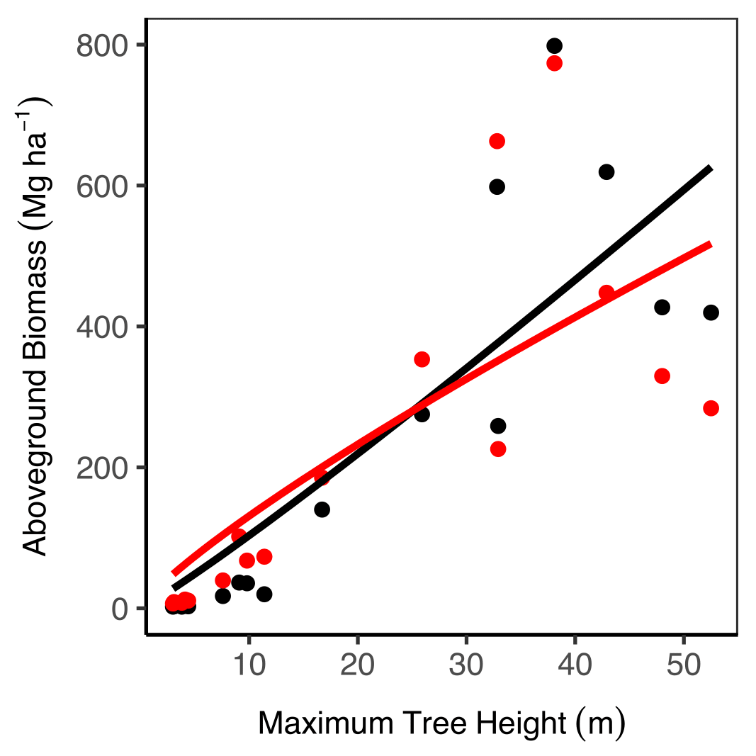
Figure S1: Plot-level allometric models using the (black) Chave et al. 2014 and (red) Komiyama et al. (2005) equations.

Table S1: Model summary for maximum plot-level tree height to Chave et al. (2014) and Komiyama et al. (2005) biomass (see Figure S5).
 | Coefficients | Estimate | Std. Err | t-value | p-value | RMSE  (Mg ha-1)
Chave et al. 2014 | $$β_{0}$$ | 8.4525 | 9.6629 | 0.875 | 0.39551 | 131.7
 | $$β_{1}$$ | 1.0870 | 0.3093 | 3.514 | 0.00313
Komiyama et al. 2005 | $$β_{0}$$ | 19.4314 | 20.2064 | 0.962 | 0.3515 | 146.1
 | $$β_{1}$$ | 0.8287 | 0.2871 | 2.886 | 0.0113

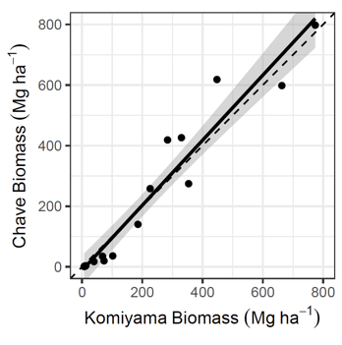
Figure S2: Comparison of plot-level biomass estimates from Komiyama et al. (2005) and Chave et al. (2014) allometry. Grey region is the standard error of the slope estimate. The primary source of variation between the two equations stems from the inclusion of height in the Chave allometry.

Table S2: ICESat-2 and GEDI TanDEM-X height calibration model and statistics.
ICESat-2 |  | Coefficients | Estimate | Std. Err | t-value | p-value
 |  | $$β_{0}$$ | 1.12005 | 0.12998 | 8.617 | <0.001
 |  | $$β_{1}$$ | 0.68158 | 0.01485 | 45.907 | <0.001
Residual standard error: 1.988 on 391 degrees of freedom
R-squared: 0.8435
F-statistic: 2107 on 1 and 391 DF, p-value: <0.001

GEDI | Coefficients Estimate Std. Err t-value p-value  $$β_{0}$$ 4.815837 0.115274 41.78 <0.001  $$β_{1}$$ 1.157313 0.005584 207.27 <0.001  Residual standard error: 4.83 on 3482 degrees of freedom  R-squared: 0.925  F-statistic: 4.296e+04 on 1 and 3482 DF, p-value: <0.001

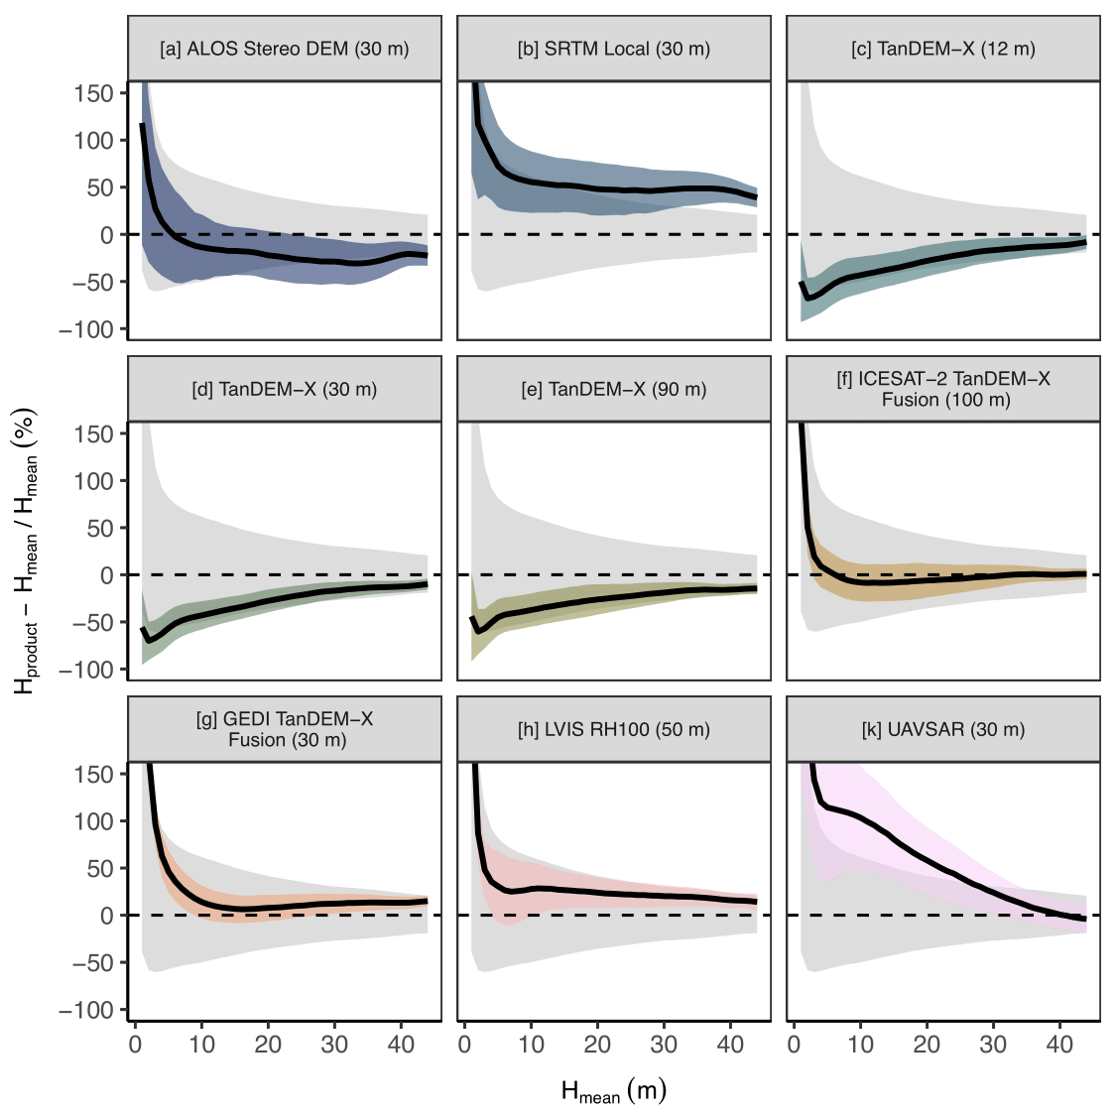
Figure S3: Relationship between sitewide mean mangrove canopy height (H_{mean}) and (C) product heights minus H_{mean} and standard deviation (within a product (color) and across products (grey) from 9 remote sensing products represented as a percent of H_{mean}. Relative variability decreases with H_{mean}.

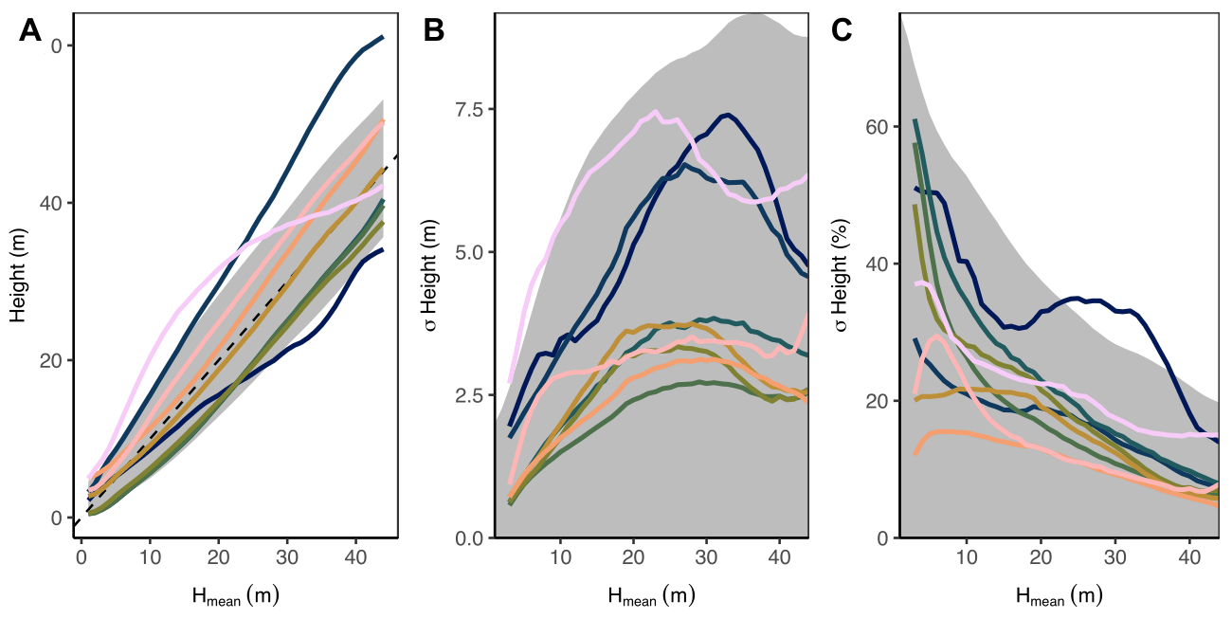
A
B
C
Figure S4: Relationship between sitewide mean mangrove canopy height (H_{mean}) and (A) product heights and (B) absolute and (C) relative standard deviation intra-sensor (color) and inter-sensor (shaded grey) heights from 9 remote sensing products. Intra- and inter-sensor height variability increases with H_{mean}, while the equivalent relative variation decreases with H_{mean}.
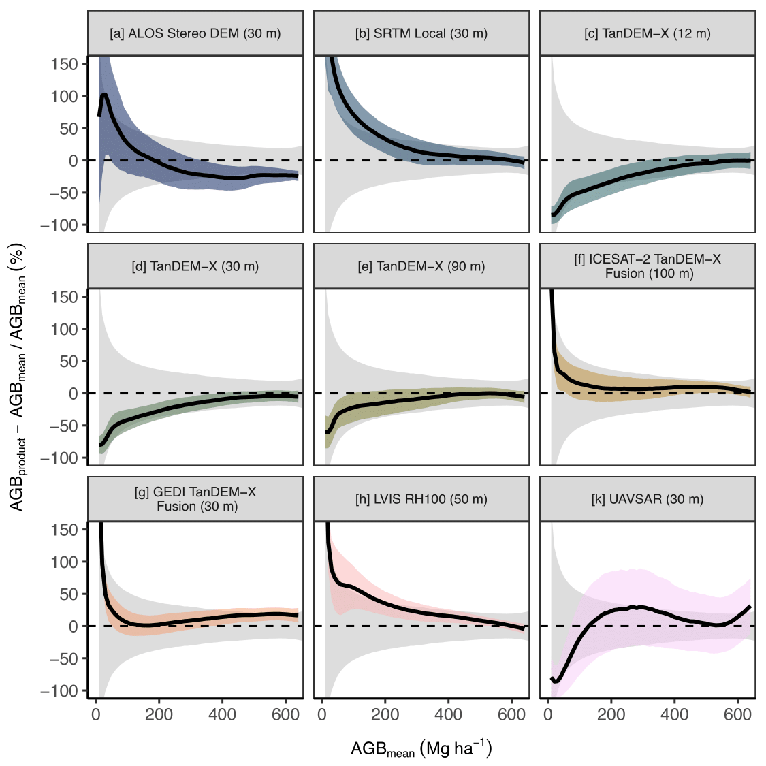
Figure S5: Relationship between AGB_{mean} and product biomass (AGB_{product}) minus AGB_{mean} (residuals) as a percentage of AGB_{mean}, with standard deviation (within product (color) and across all products (grey)) from 9 remote sensing products. AGB variability decreases with AGB_{mean}.
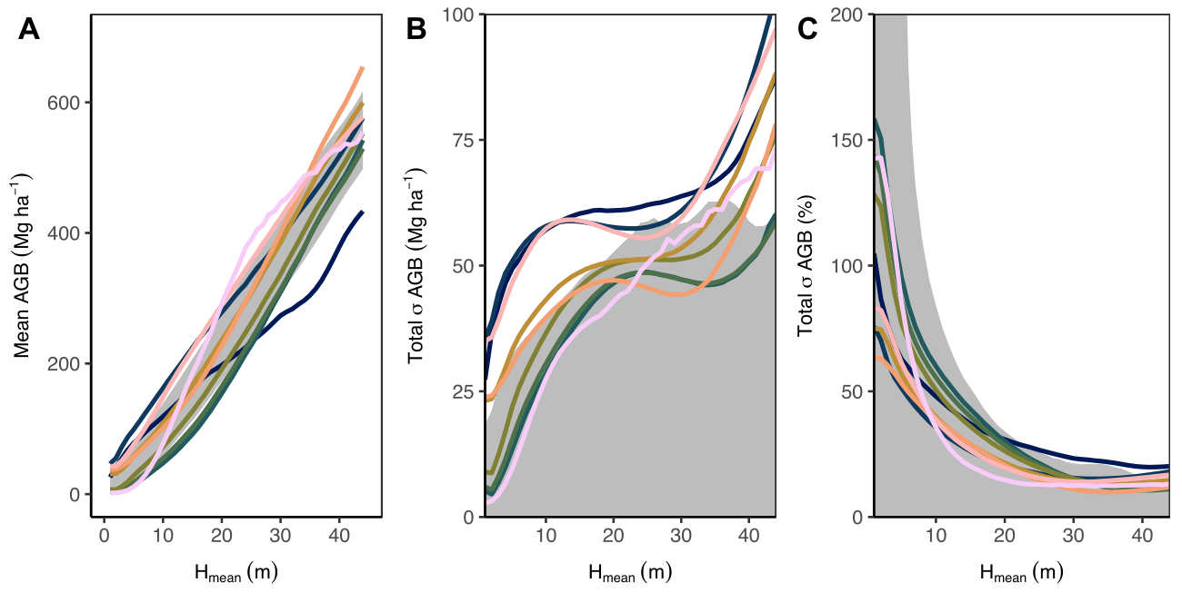
A
B
C
Figure S6: Relationship between sitewide mean mangrove canopy height (H_{mean}) and (A) product heights and (B) absolute and (C) relative standard deviation intra-sensor (color) and inter-sensor (shaded grey) heights from 9 remote sensing products. Intra- and inter-sensor height variability increases with H_{mean}, while the equivalent relative variation decreases with H_{mean}.

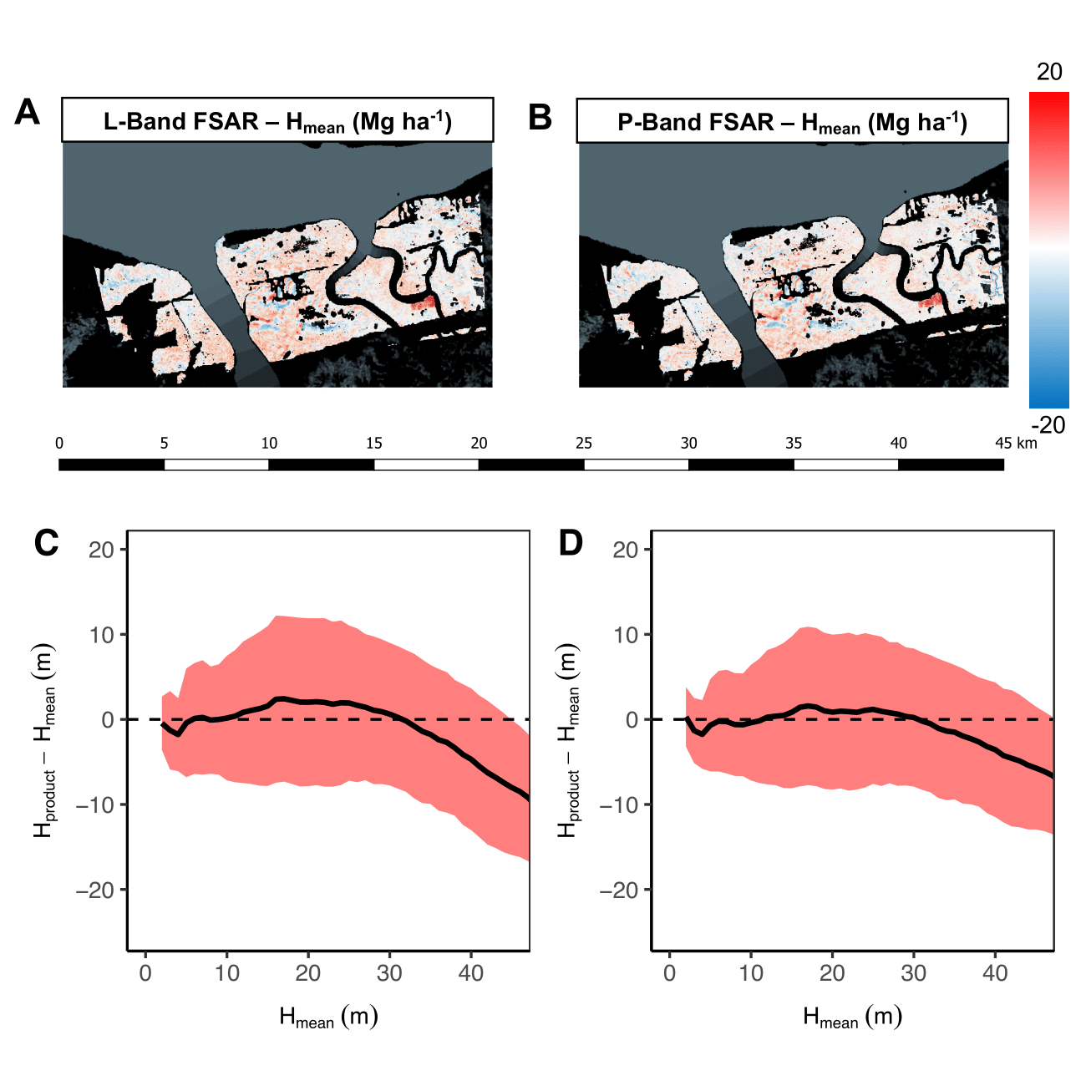
Figure S7: Pixel-level comparison of local mean (across 9 products) height estimates (H_{mean}) and the [A] L-band and [B] P-band FSAR height products. The residual plots indicate an agreement in the [C] L-band and [D] P-band heights, becoming more negative above 35 m in H_{mean}.

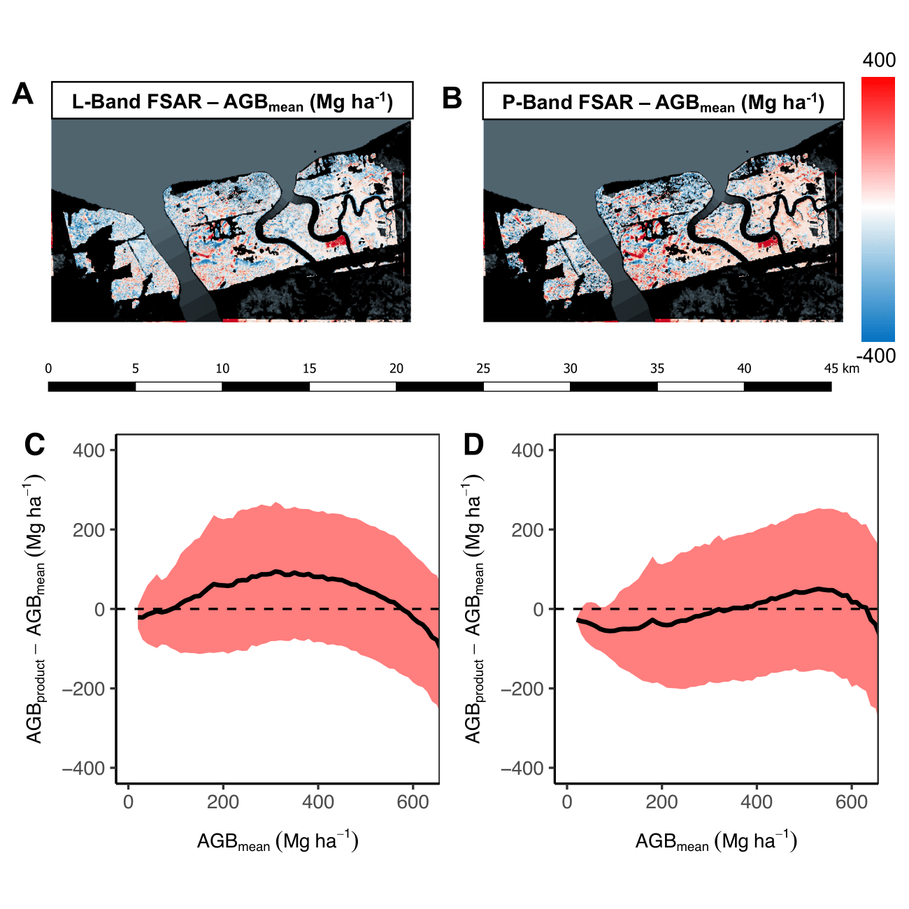
Figure S8: Pixel-level comparison of local mean (across 9 products) aboveground biomass estimates (AGB_{mean}) and the [A] L-band and [B] P-band FSAR height products. The residual plots indicate a slight positive deviation in the [C] L-band between 175-550 Mg ha⁻¹, while [D] P-band heights closely match AGB_{mean} throughout the range.

