The Remarkable Cyclone Wati – Bellona Plateau Carbonate Sediment Resuspension Event of March 2006
James Acker, R. Jude Wilber, Emily Eley, and Subramanyam Bulusu

Bellona Plateau is a submarine plateau located east of northeast Australia and approximately 600 km west of New Caledonia. The plateau’s long axis is oriented from the northwest to the southeast, and is approximately 180 km long. The plateau is bi-lobed, with the northwest end having a maximum width of ~75 km wide and the southeast end about 38 km. Depths on the plateau can reach 100m, but most of the plateau ranges between depths between 25 and 50m.
In late March 2006, Cyclone Wati moved westward as a Category 2 storm to a location near the northwest lobe of Bellona Plateau, where its forward motion stalled. It remained in that location on March 21-22, intensifying to Category 4. It then moved to the southeast approximately along the long axis of Bellona Plateau, varying between Category 3 and Category 4.
Following the transit of Cyclone Wati, resuspension of benthic carbonate sediments by accelerated bottom currents caused the entire plateau to be observable in visible satellite remote sensing data. A MODIS-Aqua image on March 25 clearly shows the plateau, as well as several plumes of sediment being transported off the plateau. The areal extent of this event may be the largest area of carbonate sediment resuspension ever observed from space.
Oceanographic modeling of Cyclone Wati, using the GLobal Oceans ReanalYsis and Simulation (GLORYS) v12 model which uses the NEMO Ocean General Circulation Model, indicated that induced current velocities on the plateau reached a maximum between 0.2 and 0.3 m/s at 50m depth, and a maximum of ~0.2 m/s at 100m depth. These data are important first steps in estimating the sediment resuspension and transport potential of tropical storms, hurricanes, and cyclones, which is a research goal of the Continuous Orbital Remote Sensing of Archipelagic Geochemical Events (CORSAGE) program.
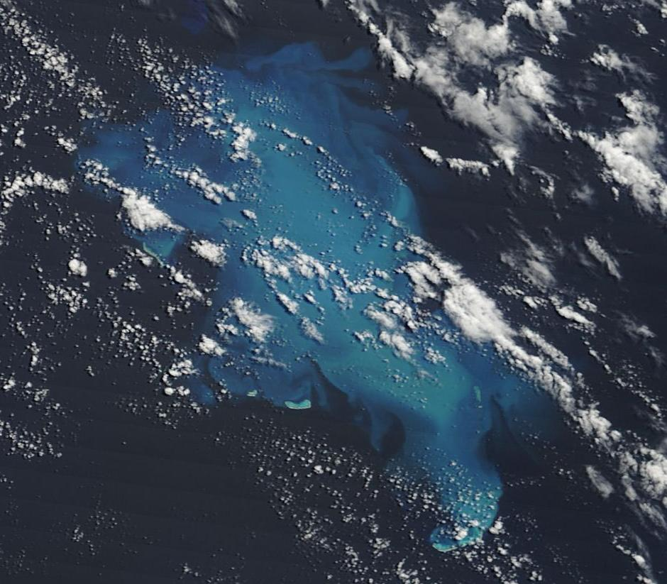
MODIS-Aqua image of Bellona Plateau, acquired on March 25, 2006.

The Remarkable Cyclone Wati – Bellona Plateau Carbonate Sediment Resuspension Event of March 2006
James Acker, R. Jude Wilber, and Emily Eley
Bellona Plateau is a major Coral Sea carbonate platform about 600 km west of New Caledonia. The bi-lobed plateau’s 180 km long axis is oriented from NW to SE, wider at the NW end than the SE end. Water depths range between 25 to 50m; maximum depths reach 100m at sinkholes. Bellona is about 60% as large as Little Bahama Bank, a well-studied platform for suspension and shedding events driven by atmospheric forcing.
In late March 2006, Cyclone Wati moved W as a Category 2 storm to near the NW lobe of Bellona Plateau. It stalled there March 21-22 as it intensified to Category 4. Wati then moved SE along the long axis of Bellona Plateau, varying between Category 3 and Category 4.
Following the transit of Wati, resuspension of benthic carbonate sediments by accelerated bottom currents made the entire plateau observable in visible satellite remote sensing images. A March 25 MODIS-Aqua image clearly shows the plateau, in a 100% suspension phase, and several sediment plumes moving off-bank to the NE and SW. Suspended CaCO₃ was visible over Bellona until March 27-28. This event’s areal extent is the largest CaCO₃ suspension/shedding occurrence ever observed, in terms of both total area and total carbonate volume. It holds major implications for CO₂ cycling in the Coral Sea and Western Tropical Pacific.
Oceanographic modeling of Wati, using the GLobal Oceans ReanalYsis and Simulation (GLORYS12 v1) model employing the NEMO Ocean General Circulation Model, indicated that induced current velocities on the plateau reached a maximum between 0.2 and 0.3 m/s at 50m depth, and a maximum of ~0.2 m/s at 100m depth. These new data are important for estimating CaCO₃ sediment resuspension and shedding (net shallow-to-deep flux) and transport potential from large sources during major tropical storm system events, in both the tropical Atlantic and Pacific. This is a primary research goal of the Continuous Orbital Remote Sensing of Archipelagic Geochemical Events (CORSAGE) research group.

