VERNE: REVEALING THE MYSTERIES AND HISTORIES OF VENUS. H. Alpert¹, C. Ahrens², T. Bell³, C. Bierson⁴, K. Bonnet⁵, R. Dhingra⁶, R. Dinsmore⁷, K. Dzurilla⁸, J. Garland⁹, E. L. Gustafson¹⁰, J. Knicely¹¹, C. Kremer¹², V. Lowry¹³, N. Naz¹⁴, S. Niemoeller¹, P. O’Brien¹⁵, A. White⁵, A. Zucherman¹⁶, L. Lowes⁶, T. Hudson⁶, K. Mitchell⁶; ¹AMA at NASA Ames, CA (hannah.s.alpert@nasa.gov); ²NASA GSFC, MD; ³University of Guam, Guam; ⁴Arizona State University, AZ; ⁵University of Colorado, CO; ⁶JPL, CA; ⁷Pennsylvania State University, PA; ⁸University of Arkansas, AR; ⁹Hampton University, VA; ¹⁰Brigham Young University, UT; ¹¹University of Alaska Fairbanks, AK; ¹²Brown University, RI; ¹³University of Central Florida, FL; ¹⁴Tufts University, MA; ¹⁵University of Arizona, AZ; ¹⁶Cornell University, NY

Introduction: The three Venus missions that were recently selected for upcoming flight (VERITAS, DAVINCI+, and EnVision) will be incredibly valuable to our understanding of Venus’ history, geology, and atmosphere. However, even once completed, key gaps in our knowledge of Venus, and more generally the formation and active processes on rocky, Earth-like planets, will still persist. Remaining questions include 1) how global intrinsic magnetic fields might be maintained on rocky worlds, and how they could then go extinct, and 2) what role atmospheric sulfur chemistry plays in climates of Earth-like planets, which is an increasingly timely subject as Earth’s own atmospheric sulfur content is climbing due to human activity. These questions require in-situ observations from Venus’ cloud deck, at the altitudes at which the UV absorber exists.
The Venus Environment Research and Novel Exploration (VERNE) mission will address these questions with an aerial platform that will drift around the equatorial region of the planet for 9 days. VERNE will collect data to determine the identity of the mysterious UV absorber, while also taking magnetic field measurements over the tesserae, the regions on Venus that are most likely to retain remanent crustal magnetization, in order to understand the potential role of a past intrinsically-generated global magnetic field on Venus.

Mission Objectives: The two major science objectives that drive the VERNE mission are:
1) Determine the identity of the Venusian unknown ultraviolet absorber(s). First observed approximately a century ago [1], the composition of Venus’ ultraviolet (UV) absorber is one of the oldest mysteries in Venus atmospheric chemistry [2,3]. While several candidate UV absorbers (mostly sulfur species) have been proposed, no consensus has been reached on its composition and its specific interactions with the atmosphere. Determining the identity of the UV absorber will aid climate models by showing how and where incident solar energy is absorbed by the atmosphere and make progress towards understanding the chemical and energetic processes taking place above Venus’ upper cloud deck [4].
2) Determine if Venus retains evidence of a past, internally-generated magnetic field. While Venus does not currently have an intrinsically-generated magnetic field, evidence for the existence of a past field on Venus and a timeline of its decay will fill in a more holistic picture of the evolution of Venus’ geological record and atmosphere. As the oldest geologic units on the surface, Venus’ tesserae may still have remanent crustal magnetization signatures within the rocky composition [5]. In any case, the signatures detected will provide insight into Venus’ past geological and core dynamo activity.

Mission Summary: VERNE includes a 3-part flight system made up of 1) an entry system with a HEEET (Heatshield for Extreme Entry Environment Technology) aeroshell, 2) an orbiter for data relay, and 3) an in-situ balloon and gondola. After entry into Venus’ atmosphere, the balloon will be deployed within the upper cloud deck, at an altitude of 62 km, over a tesserae region. The in-situ data collection will last for the duration of 2 full circumnavigations of the planet, which will take ~9 days.

Instrumentation Suite: The four instruments that comprise VERNE’s instrument payload will enable the identification of the unknown UV absorber and the detection of remanent crustal magnetization if it exists in the tesserae. The proposed instrument suite cycle during mission operations is shown in Fig. 1.

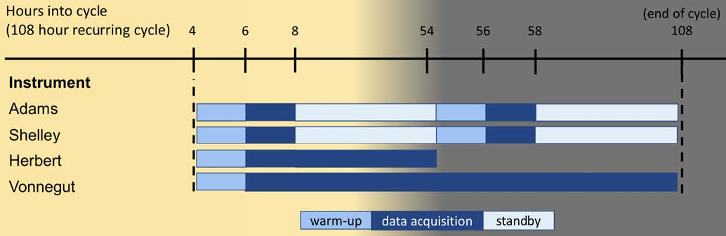
Figure 1: Timeline of operation of instruments onboard VERNE.

The four instruments are described below:
1) Adams (ion neutral mass spectrometer) has a range of 18-257 AMU and will detect and distinguish the mixing ratios of O₂, H₂O, H₂SO₄, S, S₂, S₃, S₄, S₅, S₆, S₇, S₈, SO, SO₂, OSSO, SO₃, Cl₂, FeCl₃ and other trace sulfur and organic species. The spatial (longitudinal) and temporal (day/night) variations will be observed throughout 2 circumnavigations with a sample cadence of 12 minutes.
2) Shelley (nephelometer) will determine the size distribution of the aerosols (0.4 to 36 um) in the atmosphere. With a size resolution of <0.7 um, it can determine which mode of H₂SO₄ is present and characterize the large (>30 um) organic particles previously detected by the Venera and Galileo missions [6,7].
3) Herbert (UV imager) will measure UV radiance at 283 nm (the wavelength of SO₂ absorption) and 365 nm (the unknown part of the absorber). UV images will be taken concurrently with the INMS and nephelometer to correlate UV absorption with abundances of the UV absorber species.
4) Vonnegut (magnetometer) has a range of >600 nT and a precision and accuracy of 1 nT. If magnetized by a past field, the crust may have retained a magnetization of up to 3 A/m² [5]. With a noise floor of 10 nT, the magnetometer will be able to detect RCM from an altitude of 62 km, even if the thickness of the magnetized crust is just 1 km (Fig. 2).

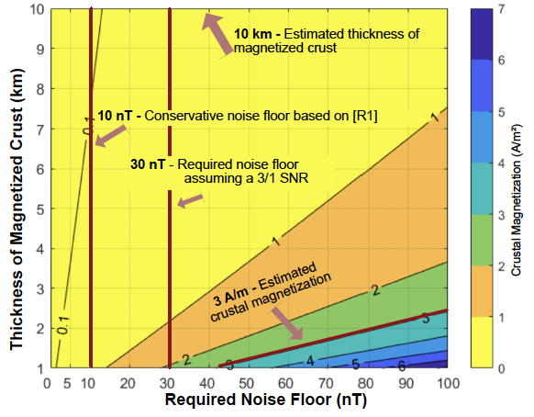
Figure 2: Plot of magnetic anomaly strength vs. the thickness of the magnetized crust and crustal magnetization, based on Eq. 13 from [8]. A sensor altitude of 62 km is assumed. Even extremely thin magnetized crust or very weak magnetization produces magnetic anomalies that are detectable with a conservative SNR of 3:1.

Mission Concept Design: VERNE will be launched with a mass of 3300 kg in an intermediate-high performance class vehicle with a 4-m fairing. The 475-day mission includes 466 days for the cruise, coasting, and orbit initialization phases before entry, descent, and balloon deployment. During the 9-day science phase, the aerial platform will make 2 circumnavigations of the planet at an altitude of 62 km. The INMS and the nephelometer will acquire data for 2 hours during the daytime and nighttime during each circumnavigation, while the UV imager will be on for the duration of the daytime, and the magnetometer will be operational throughout the entirety of the science phase. Data will be stored and processed with the JPL-designed Sphinx command and data handling system. Data will be sent from the balloon to the orbiter using an S-band relay link, stored on the orbiter, and then forwarded to Earth where it will be received by the DSN.

Conclusion: VERNE will fill key gaps in our understanding of the history and ongoing processes related to the geology and atmosphere of Venus and rocky worlds in general. Even with adequate flight system contingencies and expected costs below the $900M New Frontiers cost cap, VERNE is not without its risks and challenges. Further trade spaces to explore include 1) using solely battery power vs. including solar panels to increase the mission duration and 2) investigating the use of lightweight materials and 3D-printed structures to reduce the gondola mass, among others.

Acknowledgments: We would like to thank the JPL Planetary Science Summer School, especially our mentors Troy Hudson, Karl Mitchell, and Leslie Lowes, as well as our Team-X study lead Al Nash and the members of Team-X. We’d additionally like to thank our review panel for asking insightful questions and providing valuable feedback.

References: [1] Ross, F. E. (1928) Astrophysical J., 68, 57-92. [2] Rossow, W. B. et al. (1980) J. Geophysical Research, 85, 8107-8128. [3] Pinto, J. P. et al. (2021) Nature Communications, 12, 175. [4] Titov, D. V. et al. (2007) Cosmic Research, 21, 401. [5] O’Rourke, J. et al. (2019) Geophysical Research Lett., 46, 5768–5777. [6] Limaye, S. S. et al. (2018) Astrobiology, 18(9), 1181-1198. [7] Grinspoon, D. H. et al. (2013) Planetary and Space Sci., 41(7), 515-542. [8] Parker, R. L. (2003) J. Geophysical Research, 108, 5006.

*The cost information contained in this document is of a budgetary and planning nature and is intended for informational purposes only. It does not constitute a commitment on the part of JPL and/or Caltech.

