Using X-Ray Computed Tomography to Catalog Rock Fragments in Apollo Drive Tube 73002. R. A. Zeigler¹, J. Gross^{1,2,3}, S. A. Eckley^{4,5}, F. M. McCubbin¹, and the ⁶ANGSA Science Team, ¹NASA, Johnson Space Center, Houston, TX,. ²Dept. of Earth & Planetary Sciences, Rutgers University, Piscataway, NJ. ³Dept. of Earth & Planetary Sciences, American Museum of Natural History, New York, NY. ⁴Jackson School of Geosciences, University of Texas at Austin, Austin TX. ⁵Jacobs Technology, Johnson Space Center, Houston, TX. ⁶includes all members of the ANGSA Science Team, which includes members of the JSC curation team.
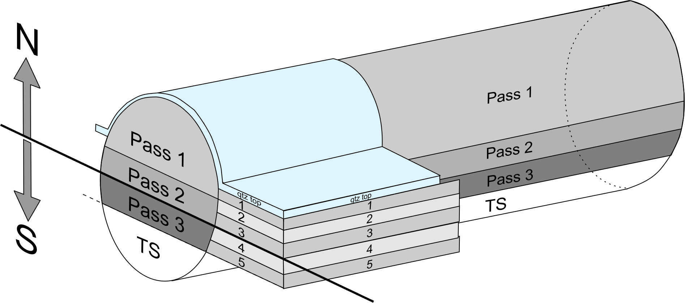

Overview: The Apollo missions collected 382 kg of rock, regolith, and core samples from six locations on the nearside of the Moon. Approximately 84% by mass of the Apollo collection remains in pristine condition within the curation facility at Johnson Space Center (i.e., never allocated, continuously stored in dry-N₂ purged cabinets, exposure history restricted to Teflon, stainless steel, and Al-metal). Although most Apollo samples have been well characterized, there are several types of samples that have remained wholly or largely unstudied since their return, and/or that have been curated under special conditions, e.g., frozen samples, samples stored in He-purged environment, and previously unopened drive tubes. NASA solicited proposals for the Apollo Next Generation Sample Analysis Program (ANGSA), and 9 teams were selected to study a subset of the unopened and frozen samples [1].
Figure 1: Sketch of 73002 core with locations of each pass [5]. Material remaining after pass 3 are made into thin sections (TS).
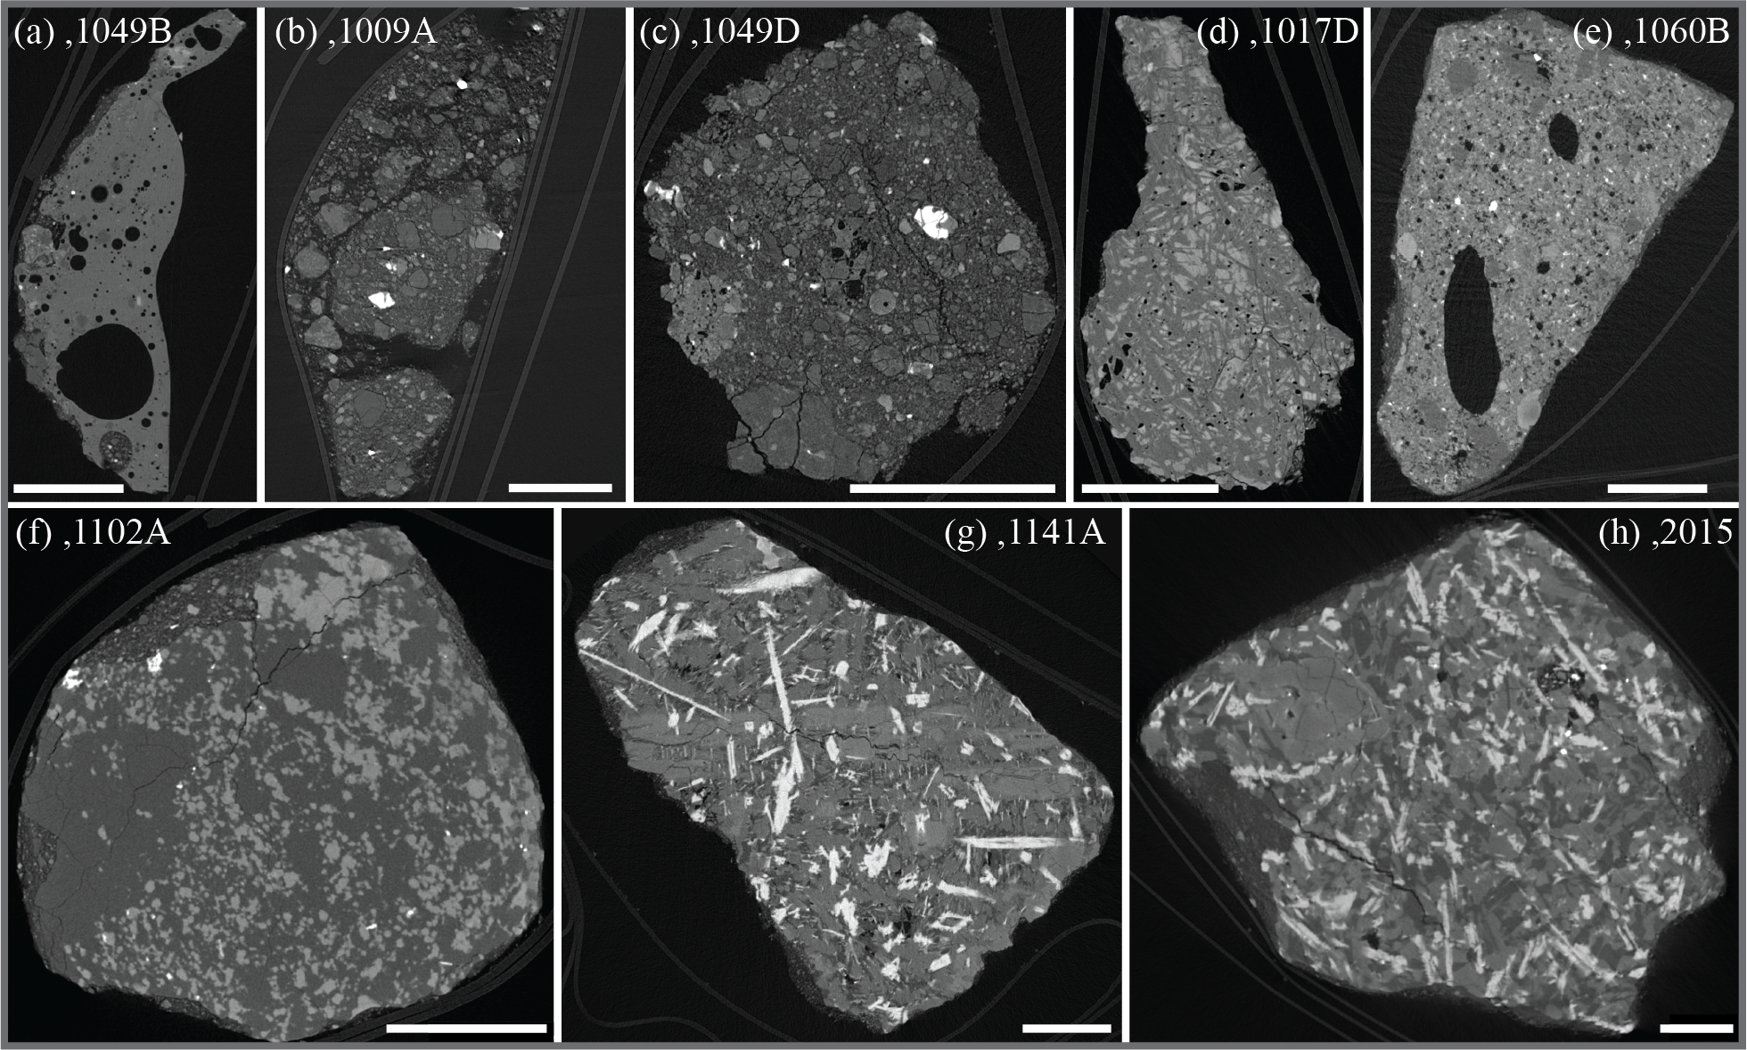
The first sample opened as part of the ANGSA program was drive tube 73002. This was originally a ~30 cm long, 4 cm diameter drive tube collected on a landslide deposit near Lara Crater at the Apollo 17 landing site. It was part of a ~60 cm long double drive tube collected, and the bottom half of the tube (73001) was sealed under vacuum on the Moon [2]. Prior to opening sample 73002, the sample was imaged with a high resolution X-ray Computed Tomography (XCT) scan of the entire tube [3], which provided invaluable information during the dissection process [4]. In addition to the pre-dissection XCT scans, individual >4 mm particles were separated from the 73002 regolith during processing and scanned at high resolution by XCT. Here we present the initial lithologic classification of 134 individual >4 mm rock fragments separated from the 73002 core during the dissection process.
Figure 2: Representative XCT slices of the different lithologies observed in 73002. Brighter phases are more x-ray attenuating (i.e., higher average atomic number and/or more dense). All scale bars are 1 mm. (a) agglutinate; (b) soil breccia; (c) regolith breccia; (d) impact melt; (e) ilmenite-lath IMB (vesicular); (f) poikilitic ilmenite IMB (granulitic texture); (g) high-Ti basalt.; (h) high-Ti basalt.
Methodology: Drive tube 73002 was manually dissected in 0.5 cm depth intervals in three passes (Fig. 1) [4,5]. Each interval from pass 1 and 2 was sieved to <1 mm and >1 mm size fractions, and >1 mm particles were further manually subdivided into 1-2, 2-4, 4-10, and >10 mm size fractions. Pass 3 was not sieved, but >10 mm clasts were separated manually. Each 4-10 mm and >10 mm fragment was individually weighed, triply bagged in Teflon, and scanned by XCT. There are 60 rock fragments in Pass 1, 64 rock fragments in Pass 2 (from the 4-10 mm and >10 mm size fractions), and 8 rock fragments from Pass 3 (>10 mm size fraction).
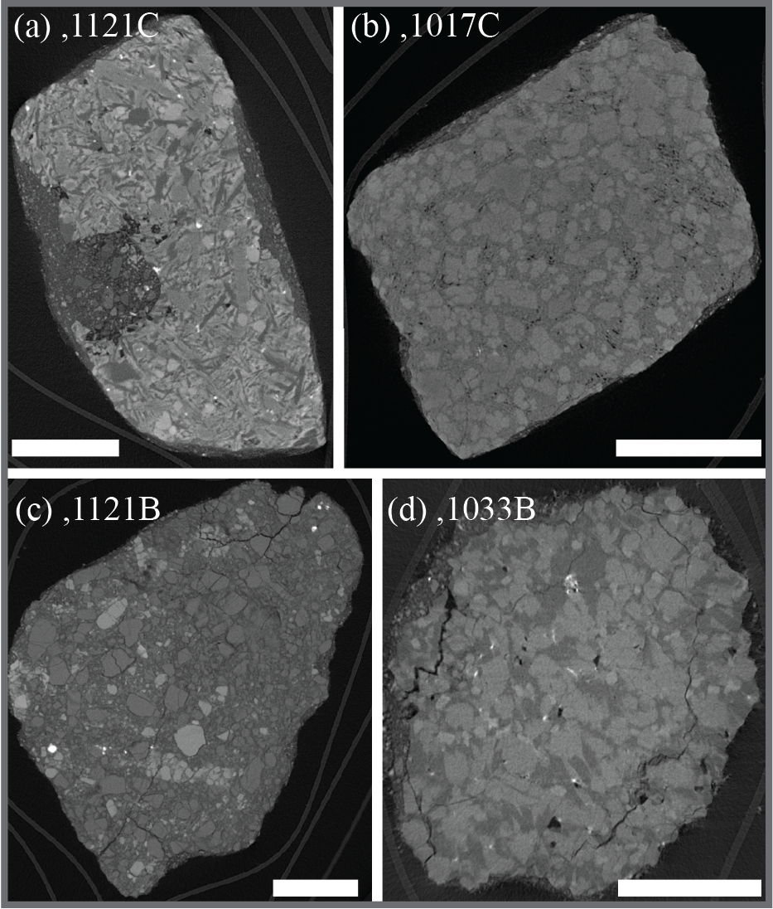Each individually bagged rock fragment was scanned using the 180 kV nano-focus transmission source on the Nikon XTH 320 XCT system at NASA Johnson Space Center [6]. Scanning conditions varied considerably for individual particles, in large part because of the large variation in size (0.008-19.623 g). All scans fell within the following range of scan conditions: 2.8-20.6 μm voxel size; 90-155 kV voltage; 18-39 μA current; 1891-3141 projections; and 902-2000 slices.
Results and Discussion: The 132 rock fragments from sample 73002 fall into the following general categories: agglutinates (n = 6); basalts (13); impact melts (5); impact melt breccias (IMB; 42); regolith breccias (62); and soil breccias (4); see Figure 2 for representative examples of each lithology. Within most of these broad lithologic groups are recognizable subgroups. For example, a significant portion of regolith breccia fragments contain some agglutinate-like glass (n = 9) or are dilithologic (7) because they contain a single large clast (~50% or more by volume). Subgroups can be based on similarities to previously identified lunar lithologies, such as high-Ti basalts (9) and VLT basalts (4; Fig. 3), or based on commonly seen features within the fragments, such as poikilitic ilmenite IMB (10), ilmenite-lath IMB (12), or vesicular IMB (11) “groups”. Particles in the same “group” are not necessarily intended to be genetically related, but rather identify particles that are similar and that follow-up studies can classify in more detail [7].
Figure 3: Representative XCT slices of the four members of the “VLT basalt” subgroup. In each fragment, the darkest major phase is likely plagioclase, the medium grey phase pyroxene, and brighter grey (when present) phase is olivine. Very bright phases (FeTiCr oxides) are largely absent from all particles. The texture in (c) is consistent with a monomict breccia; all others appear to have igneous textures. All scale bars are 1 mm.
Conclusion: Identification of lithologies based on XCT is a powerful tool, but a more absolute classification will sometimes require additional textural information from thin sections (e.g., glassy-matrix regolith vs. impact-melt vs. granulitic breccia) or quantitative mineral compositions (e.g., basalt vs. monomict breccia).
References: [1] Shearer et al. (2020) LPSC 51, #1181. [2] Shearer et al. (2018) LPSC 49, #2083. [3] Zeigler et al. (2021) LPSC 52, #2632. [4] Krysher et al (2020) LPSC 51, #2989. [5] Gross et al. (2021) LPSC 52, #2684. [6] Eckley et al (2020) LPSC 51, #2182. [7] Yen et al (2022) LPSC 53, #1547.

