Water Resources Research
Assimilation of NASA’s Airborne Snow Observatory snow measurements for improved hydrological modeling: A case study enabled by the coupled LIS/WRF-Hydro system
Timothy M. Lahmers^{1,2}, Sujay V. Kumar¹, Daniel Rosen³, Aubrey Dugger⁴, David J. Gochis⁴, Joseph A. Santanello¹, Chandana Gangodagamage^{1,2}, and Rocky Dunlap³
¹Hydrological Sciences Lab, NASA Goddard Space Flight Center (NASA-GSFC), Greenbelt, MD, USA.
²Earth System Science Interdisciplinary Center (ESSIC), University of Maryland, College Park, MD, USA.
³NOAA/Earth System Research Laboratory, Boulder, CO, USA.
⁴National Center for Atmospheric Research, Boulder, Colorado, USA.

Contents of this file

Text to Figure S1
Figure S1
Text to Figure S1
A figure equivalent to Fig. 8 of the full manuscript is included here (Figure S1), and it considers the impacts of hydrologic model routing by plotting WRF-Hydro channel flow compared to LIS-only surface runoff (surface runoff derived from WRF-Hydro is not physically meaningful due to recycled runoff). In this figure, the LIS/WRF-Hydro OL and DA streamflow is plotted with solid red and dark blue lines, respectively (as in Figure 8). LIS OL and DA aggregated surface and sub-surface runoff (over the same basin) are plotted with dashed orange and purple lines, respectively. Observed streamflow is plotted with a solid black line. 24-hour averages are used in this figure as the LIS-only runoff is written daily in our configuration. The LIS-only runoff follows a similar trajectory to LIS/WRF-Hydro, but tends to miss the timing of some peaks captured by LIS/WRF-Hydro and USGS streamflow. LIS-only simulations tend to have runoff peaks that are too fast and flashier compared to the observations and LIS/WRF-Hydro solution. This is especially true earlier in the water year, when runoff is driven by rainfall rather than snowmelt. This is likely due to WRF-Hydro aggregating some runoff and routing it downstream, which is slower and more consistent with actual hydrologic response. In some cases late in the season, LIS-only runoff (surface and sub-surface) also has a longer recession, which may indicate increased reliance on sub-surface flow. Thus, this figure shows the added value of LIS/WRF-Hydro surface runoff.

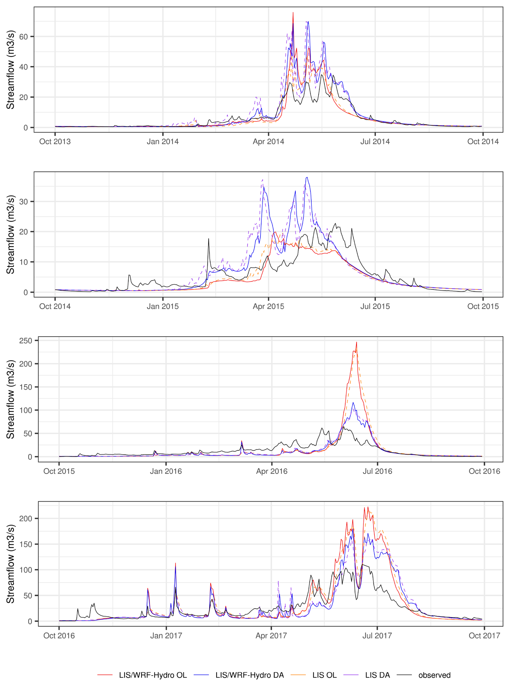Figure S1. Timeseries of modeled LIS and LIS/WRF-Hydro aggregated runoff and streamflow, respectively. This figure includes LIS/WRF-Hydro OL streamflow (red), LIS/WRF-Hydro DA streamflow (blue), LIS OL aggregated runoff (dashed orange), and LIS DA aggregated runoff (dashed purple), and USGS observed streamflow (black). Data for WY2014 (top) to WY2017 (bottom).

