NASA SMALL SPACECRAFT TECHNOLOGY (SST) PROGRAM and RECENT TECHNOLOGY DEMONSTRATIONS

Roger C. Hunter ⁽¹⁾, Elwood F. Agasid ⁽²⁾, Christopher E. Baker ⁽³⁾, Justin V. Treptow ^{(4),}
Chad R. Frost ⁽⁵⁾, David J. Mayer ⁽⁶⁾, Ali Guarneros Luna ⁽⁷⁾, Rodolphe De Rosee ⁽⁸⁾,
Anh N. Nguyen ⁽⁹⁾, Julianna L. Fishman ⁽¹⁰⁾

⁽¹⁾ NASA Ames Research Center, Moffett Field, CA, 94035, 650-604-5004, roger.c.hunter@nasa.gov
⁽²⁾ NASA Ames Research Center, Moffett Field, CA, 94035, 650-604-0558, elwood.i.agasid@nasa.gov
⁽³⁾ NASA Headquarters, 300 E. St. SW, Washington DC, 20546, 202-358-2455, christopher.e.baker@nasa.gov
⁽⁴⁾NASA Headquarters, 300 E. St. SW, Washington DC, 20546, 301-286-0618,
justin.treptow@nasa.gov
⁽⁵⁾ NASA Ames Research Center, Moffett Field, CA, 94035, 650-604-1798, chad@nasa.gov
⁽⁶⁾ NASA Ames Research Center, Moffett Field, CA, 94035, 650-604-6804, david.j.mayer@nasa.gov
⁽⁷⁾ NASA Ames Research Center, Moffett Field, CA, 94035, 650-604-0396, ali.guarnerosluna@nasa.gov
⁽⁸⁾ NASA Ames Research Center, Moffett Field, CA, 94035, 650-604-6203,
rodolphe.derosee@nasa.gov
⁽⁹⁾ NASA Ames Research Center, Moffett Field, CA, 94035, 650-604-6347, anh.n.nguyen@nasa.gov
⁽¹⁰⁾ Technology Horse, LLC, NASA Ames Research Center, Moffett Field, CA, 650-604-0637, julianna.l.fishman@nasa.gov

ABSTRACT

The Small Spacecraft Technology (SST) program within NASA’s Space Technology Mission Directorate, expands the ability to execute unique missions through rapid development and demonstration of capabilities for small spacecraft applicable to exploration, science and the commercial space sector. Through targeted development and frequent in space testing, the program:

- Enables execution of missions at much lower cost than previously possible
- Substantially reduces the time required for development of spacecraft
- Enables new mission architectures through the use of small spacecraft
- Expands the reach of small spacecraft to new destinations and challenging new environments
- Enables the augmentation of existing assets and future missions with supporting small spacecraft.

The program achieves its objectives through:

- Identification and investment in the development of new subsystem technologies to enhance or expand the capabilities of small spacecraft
- Sponsorship of flight demonstrations of new technologies, capabilities and applications for small spacecraft
- Promotion of the use of small spacecraft as platforms for testing and demonstrating technologies and capabilities that might have more general applications in larger-scale spacecraft and systems [1]

Program-funded projects may be executed at academic institutions, in the private sector, at NASA Centers, as public-private partnerships, or cooperative agreements.

INTRODUCTION
Small spacecraft are defined as those with a mass of 180 kilograms or less and capable of being launched into space as an auxiliary or secondary payload. Small spacecraft are not limited to Earth orbiting satellites but also include interplanetary spacecraft and later may also serve as planetary re-entry vehicles and landing craft. CubeSats are a special category of small spacecraft and are of particular interest because launch opportunities tend to be more frequent and affordable compared to other small spacecraft, due to the standard sizes and containerization of CubeSats [2].

NASA’s Small Spacecraft Technology (SST) program portfolio investment ranges from lower technology readiness level (TRL) development projects to technology demonstration missions. A summary of SST’s current and recent projects are briefly outlined in this paper.

SMALLSAT TECHNOLOGY PARTNERSHIPS
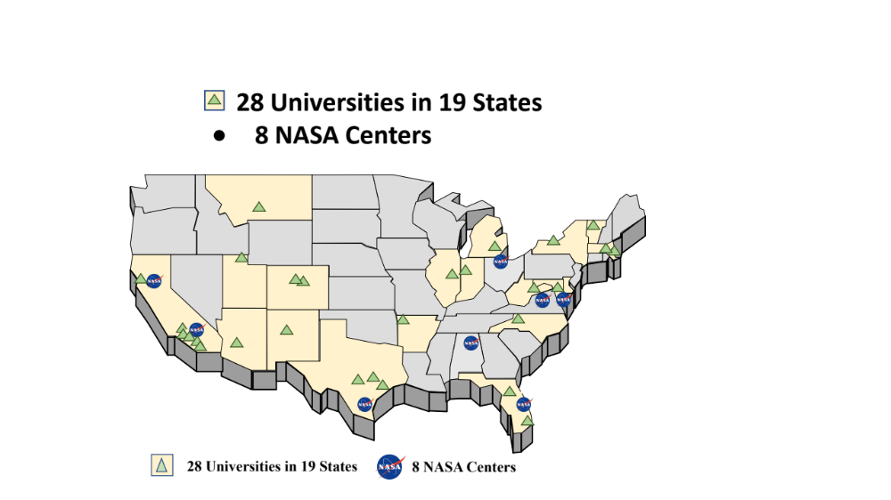
Currently managing its fifth round of selected technology development projects, the SmallSat Technology Partnerships (STP) initiative solicitates and selects university teams to collaborate with NASA on projects to develop and demonstrate new technologies and capabilities to spur innovation in communication, navigation, propulsion, power, thermal management, science capabilities, and advanced manufacturing for small spacecraft. Results from these projects may lead to the development of technologies to improve the quality of small spacecraft data transmissions, integrated power and energy storage systems, power systems, and deorbiting systems. Additional emerging concepts from STP projects include thermal systems and swarm management technologies to enable a new generation of CubeSat science missions. Details on these projects may be found on the program website [3]. The map of the United States in Figure 1 identifies the 19 states hosting the 28 universities with STP awards as well as the location of the 8 NASA centers serving as partners.
Figure 1. NASA’s SmallSat Technology Partnerships initiative has awarded 28
universities in 19 states. The eight NASA centers include NASA’s Jet Propulsion Laboratory,
a federally funded research and development center.

In its most recent STP solicitation, NASA selected nine university teams to collaborate on the development and demonstration of new technologies and capabilities for small spacecraft. Since summer 2020, each university team has worked with NASA engineers and scientists on two-year projects that will be completed in the summer of 2022.

NASA’s STP collaborations are focused on maturing the capability and utility of small spacecraft as powerful and affordable tools for science and exploration missions. The 2020 university teams responded to an STP solicitation requesting proposals in three topic areas: Lunar Communications and Navigation; Smallsat Propulsion for Lunar Missions; and Advanced Electrical Power and Thermal Management.

The nine selected university teams established cooperative agreements with NASA through which each was funded $200,000 per year. In addition, each university was provided technical expertise and support from the NASA partners identified their respective proposal.

The following university teams were selected from a highly competitive pool of proposals [4].
2.1 Topic 1. Lunar Communications and Navigation Network
“Deployable Optical Receiver Aperture for Lunar Communications and Navigation”, Arizona State University, Tempe, in collaboration with NASA’s Jet Propulsion Laboratory in Pasadena, California

This partnership is for a novel deployable wide-aperture optical communications receiver. This technology will enable simpler, quicker optical communications target acquisition by receiving signals from more widely separated locations than other fixed, body-mounted optical systems. This technology will enable small spacecraft to relay data between other assets placed across the lunar surface, other spacecraft in different lunar orbits, and to Earth, simultaneously and more efficiently.

“Flat Panel Phased Array Antennas with Two Simultaneous Steerable Beams Utilizing 5G Ka-Band Silicon RFICs for Tx/Rx Communications Between 6U Small Satellite and Lunar Surface, Gateway and Earth”, San Diego State University, California, in collaboration with NASA’s Glenn Research Center in Cleveland, Ohio

This partnership will develop two dual-band flat-panel phased-array antennas utilizing commercial 5G cellular technology. This approach takes advantage of commercially available communications technology to create a high-performance data communications network in a low-cost CubeSat form factor that’s capable of serving the lunar surface and orbiting systems. Using two separate, electrically steerable antennas would allow simultaneous communications with multiple other systems from a small relay satellite without moving the spacecraft or employing bulky mechanically rotated antennas.

“High-precision Continuous-time PNT Compact Module for the LunaNet Small Spacecraft”, University of California, Los Angeles, in collaboration with NASA’s Jet Propulsion Laboratory in Pasadena, California

This partnership will develop technology for the lunar environment similar to the GPS system at Earth. To develop a system for precise position, navigation and timing services at the Moon or Mars, the effort will incorporate several key building blocks including an integrated continuous time position, navigation and timing module including a chip-scale optomechanical accelerometer and commercial-off-the-shelf compact optical gyroscope paired with a high-performance mercury ion clock.

“A Small Satellite Lunar Communications and Navigation System”, University of Colorado, Boulder, in collaboration with NASA’s Jet Propulsion Laboratory in Pasadena, California

This collaboration will develop and demonstrate a communications, navigation and time signal distribution system using a communications protocol similar to that used by cell phones on Earth. The high data rates and communications protocol will support dozens of users simultaneously while also being capable of broadcasting text and alert messages. This draws from a variety of current and prior development and flight demonstration activities with the goal of integrating these various technologies into a single reliable, yet low-cost satellite that can be copied and deployed as a constellation to form a communications relay network at the Moon.

“On-Orbit Demonstration of Surface Feature-Based Navigation and Timing”, University of Texas, Austin, in collaboration with NASA’s Johnson Space Center in Houston, Texas

This collaboration will extend existing onboard optical navigation techniques by using identification and tracking of lunar craters in place of star tracking to create an intermediate range terrain relative navigation solution. Spacecraft near the Moon can incorporate this technology to track their location relative to the lunar surface as an innovative method of navigation independent of GPS or other Earth-based systems. By using the patterns that craters form on the lunar surface the way that current navigation systems use the patterns that stars form to determine where a spacecraft is in space, this technique can build from well-established star tracking capabilities to quickly produce a new capability from existing highly reliable systems.
2.2 Topic 2. SmallSat Propulsion for Lunar Missions
“Variable Specific Impulse Electrospray Thrusters for SmallSat Propulsion”, University of California, Irvine, and California Polytechnic State University, San Luis Obispo, in collaboration with NASA’s Jet Propulsion Laboratory in Pasadena, California
This effort will build on previous fundamental physics modeling of existing propulsion technology that uses electrostatic charges to propel liquid droplets to generate thrust. It will further develop and test a more versatile system capable of operating in either a high-thrust mode when needed, or more efficient low-thrust mode to conserve fuel and save weight. This technology will add mission flexibility to electrospray propulsion systems while keeping within the compact size suited to small spacecraft.

“Lunar Missions Enabled by Chemical-Electrospray Propulsion”, University of Illinois, Urbana-Champaign, partnered with Froberg Aerospace LLC, Rolla, Missouri, in collaboration with NASA’s Glenn Research Center in Cleveland, Ohio and NASA’s Goddard Space Flight Center in Greenbelt, Maryland

This partnership will build from a previous Small Business Innovation Research effort with Froberg Aerospace to test a dual mode — combustion mode and electrospray mode — propulsion system. The system uses the same propellant, feed system, power unit and thrusters for both modes adding additional mission capabilities while staying within the limited mass and space available on small spacecraft. The chemical combustion mode can provide higher thrust for orbital insertion and fast orbit transfers, while the more efficient electrospray mode used during low-energy maneuvers preserves fuel — reducing size and weight which are critical for small spacecraft.

“3D Printed Hybrid Propulsion Solutions for SmallSat Lunar Landing and Sample Return”, Utah State University, Logan, in collaboration with NASA’s Marshall Space Flight Center, Huntsville, Alabama

This collaborative effort will build from successful suborbital testing of a 3D printed plastic and nitrous-oxide and gaseous oxygen hybrid rocket motor. This technology could enable missions of interest to NASA that require high thrust, such as lunar landing and sample return, to be performed by CubeSat-sized spacecraft.

2.3 Topic 3. Advanced Electrical Power and Thermal Management
“An Additively Manufactured Deployable Radiator with Oscillating Heat Pipes (AMDROHP) to Enable High Power Lunar CubeSats”, California State University, Los Angeles, and California Polytechnic State University, San Luis Obispo, in collaboration with NASA’s Jet Propulsion Laboratory in Pasadena, California

CubeSats are compact and cannot efficiently radiate heat, yet lunar missions will demand more electrical power (which produces heat as a byproduct) for equipment like more powerful radio transmitters while simultaneously needing to deal with the harsh cislunar thermal environment. This technology addresses an increasingly critical need to radiate heat efficiently from small spacecraft. This partnership will develop an additively manufactured deployable radiator that uses integrated flexible oscillating heat pipes to provide more efficient heat transfer than traditional thermal straps.
3 SMALL BUSINESS INNOVATION RESEARCH SEQUENTIALS
NASA’s Small Business Innovation Research (SBIR) program within the Space Technology Mission Directorate encourages small businesses to develop innovative ideas that meet the federal government's specific research and development needs with the potential for commercialization [5].

In addition to annual Phase I and Phase II awards ($125,000 over 6 months and $750,000 over 24 months, respectively) focused on small spacecraft technologies, SST manages the award of $2.5 million - $5.0 million 2020 and 2021 SBIR Sequential post-Phase II awards to mature a range of small spacecraft technologies for sustainable exploration of the Moon under the Artemis program [6], [7]. These awards include:

- Antara Teknik of Granite Bay, California, will support NASA’s expanding deep-space communications needs with a software suite that provides security, efficiency, scalability, and disruption-tolerance for multiple mission scenarios.
- Fibertek of Herndon, Virginia, will advance optical communications technologies for small spacecraft around the Moon and beyond. The system could establish high bandwidth communications in the vicinity of the Moon to relay vast amounts of data from lunar landers to Earth.
- Alameda Applied Sciences Corporation in Oakland, California, will develop a beyond low-Earth orbit small satellite propulsion system that will enable a range of new and more affordable approaches to distributed science missions, lunar communications networks, and more.

NASA ANNOUNCEMENT OF COLLABORATION OPPORTUNITY AND TIPPING POINT TECHNOLOGIES
NASA’s Announcement of Collaboration Opportunity (ACO) and Utilizing Public-Private Partnerships to Advance Tipping Point Technologies solicitations fund research, development and demonstration of innovative technologies that fulfill NASA’s needs for missions to the Moon, Mars, and other deep space destinations. These opportunities are focused on industry-developed space technologies that can advance the commercial space sector as well as benefit future NASA missions. NASA provides technical expertise and test facilities, as well as hardware and software to aid industry partners in maturing technologies. Information on NASA’s Tipping Points and ACOs is available as well as links to current solicitations [8]. The SST program currently manages and four ACOs and three Tipping Points.

The SST program manages two ACO projects for companies that were selected in 2019. These projects were selected under the Advanced Communications, Navigation and Avionics topic [9]. Selected companies include Advance Space, LLC of Westminster, Colorado and Vulcan Wireless, Inc. of Carlsbad, California.
Advance Space, LLC is partnered with NASA’s Goddard Space Flight Center in Greenbelt, Maryland, to advance lunar navigation technologies. The collaboration will help mature a navigation system for use between Earth and the Moon that could supplement NASA’s Deep Space Network as well as support future exploration missions utilizing Cislunar Autonomous Position System (CAPS) [10]. The CAPS technology will be demonstrated on the Cislunar Autonomous Positioning System Technology Operations and Navigation Experiment (CAPSTONE) mission which will launch to the Moon in May 2022. An illustration of CAPS concept of operations is shown in Figure 2, image A.
Vulcan Wireless, Inc. is partnered with NASA Goddard to test a CubeSat radio transponder and its compatibility with NASA’s Space Network. This CubeSat radio is a fully integrated, full-duplex, software-defined radio transponder [11]. Figure 2, image B shows Vulcan Wireless’s NSR-SDR-S/S.

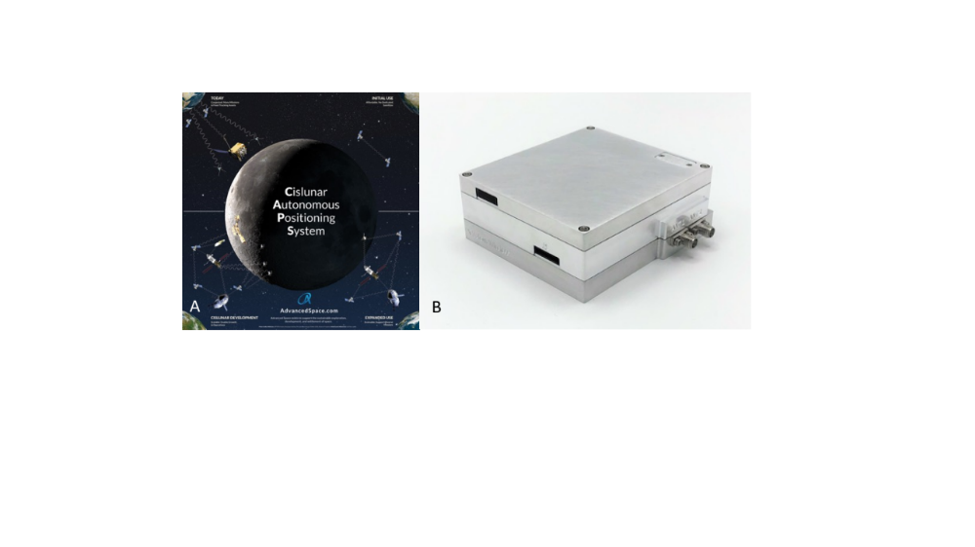
Figure 2. (A.) Concept of operations for the Cislunar Autonomous Position System. Credit: Advanced Space, LLC (B.) The Vulcan Wireless CubeSat radio, NSR-SDR-S/S. Credit: Vulcan Wireless, Inc.

Two companies were selected in 2020 for the ACO propulsion topic [12]. Selected companies include Stellar Exploration, Inc. of San Luis Obispo, California and Phase Four of El Segundo, California.

Stellar Exploration, Inc. is partnered with NASA’s Ames Research Center in California’s Silicon Valley, NASA Johnson, and NASA Goddard to perform qualification testing on a high-performance nanosatellite propulsion system composed of monopropellant and bipropellant systems as shown in Figure 3, image A. Vacuum chamber testing will assess the system’s performance and expected lifetime. The key technology being tested is the propellant pump which is an enabling technology for launch safety approval (no stored gas) and system performance (efficient lightweight tanks) [13].

Phase Four developed a new electric propulsion system for long-duration small spacecraft missions. Phase Four will work with NASA Glenn to test the radio frequency (RF) thruster and estimate the design’s expected lifetime. NASA Glenn will also characterize the thruster’s plasma plume to optimize the system. The new Phase Four RF plasma thruster operates by using RF to heat propellant into ionized plasma that is then ejected away from a spacecraft by a permanent magnet, creating thrust. This simple design avoids high voltage electronics and eliminates components that are challenging to manufacture in large quantities, like the hollow cathode. These innovations allow Phase Four to achieve a 75% reduction in lead time and materials cost compared to leading Hall thrusters [14]. The system is illustrated in Figure 3, image B.

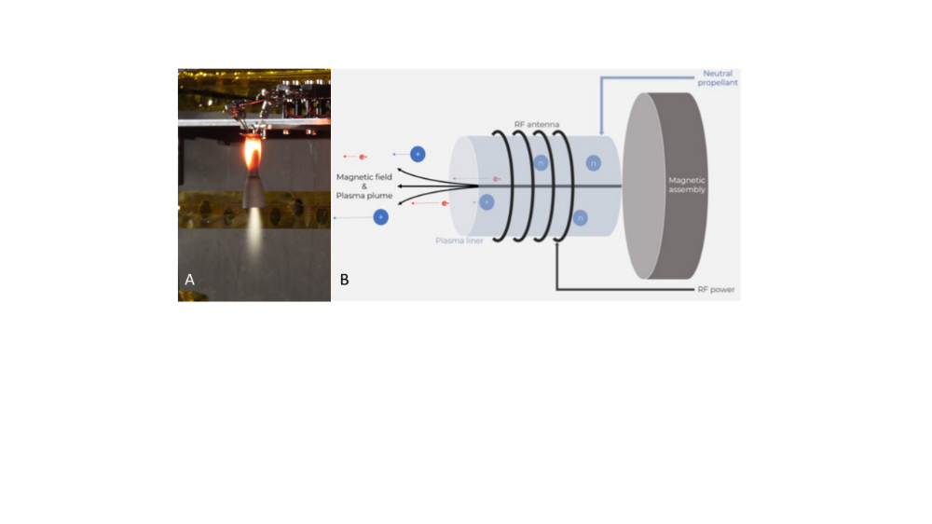
Figure 3. (A.) A prototype biprop thruster in ambient pressure testing. Credit: Stellar Exploration, Inc. (B.) A simple radio frequency plasma propulsion system. Credit: Copyright 2018, Phase Four, Inc.
.
NASA STMD’s Tipping Point solicitations focus on development of promising technologies that need an extra push to mature a capability. These technologies are necessary for sustained exploration of the Moon and Mars. As NASA is planning to put humans in the Moon by 2024, these technologies become more important and relevant in the preparation of the next phases of exploration that feed into the Artemis program [15]. The selected three Tipping Point technologies managed by the SST program are focused on Efficient and Affordable Propulsion Systems.

The first interplanetary CubeSats, NASA’s Mars Cube One (MarCO A, B) used a set of cold gas thrusters for attitude control and course corrections during their cruise to Mars, alongside the Mars Insight lander. Accion Systems, Inc. of Boston, Massachusetts and NASA JPL will partner to mature a propulsion system to demonstrate the same capabilities as those required for the MarCO mission, but with a smaller and lighter system that uses less power. The propulsion system could enable more science opportunities with these small, flexible platforms. The propulsion system to be matured is Accion System’s Tiled Ionic Liquid Electrospray (TILE) propulsion system which was successfully built and integrated into a small spacecraft in 2021. The TILE-3 propulsion system was launched as a technology demonstration mission in December 2021. Figure 4, image A shows Accion System’s TILE-3 propulsion system.

CU Aerospace, LLC of Champaign, Illinois, NearSpace Launch, and the University of Illinois at Urbana-Champaign will build and test a 6U CubeSat equipped with two different propulsion systems. These systems were developed with NASA SBIR funding and offer high performance, low cost and safe pre-launch processing. The company plans to deliver the flight-ready CubeSat to NanoRacks for launch and deployment. The two propulsion systems are the Fiber-fed Pulsed Plasma Thruster (FPPT) [16] and Monofilament Vaporization Propulsion (MVP) [17]. The 6U CubeSat, illustrated in Figure 4, image B, will be jettison from the International Space Station in early 2023. During the mission, these two propulsion systems and other key technologies that are important to the small spacecraft missions in the low-Earth orbit and deep space will be demonstrated.

ExoTerra Resource, LLC of Littleton, Colorado will build, test, and launch a 12U CubeSat with a compact, high impulse solar electric propulsion module. Once flight-ready, the system will be demonstrated in-space as the CubeSat moves from low-Earth orbit to the radiation belt surrounding Earth. This small electric propulsion system could open up the inner solar system for targeted science exploration missions, using affordable spacecraft that range from 44 to 440 pounds. The ExoTerra 12U satellite, called Courier, shown in Figure 4, image C, will demonstrate ExoTerra’s Halo Hall Effect Thruster which operates between 85-175 watts and packages within 1/4U, enabling it to operate within a CubeSat form factor. Courier is powered by ExoTerra’s high specific power Fold Out Solar Arrays (FOSA). The arrays generate 296 watts at BOL and mount to a single axis gimble to increase orbit average power [18].

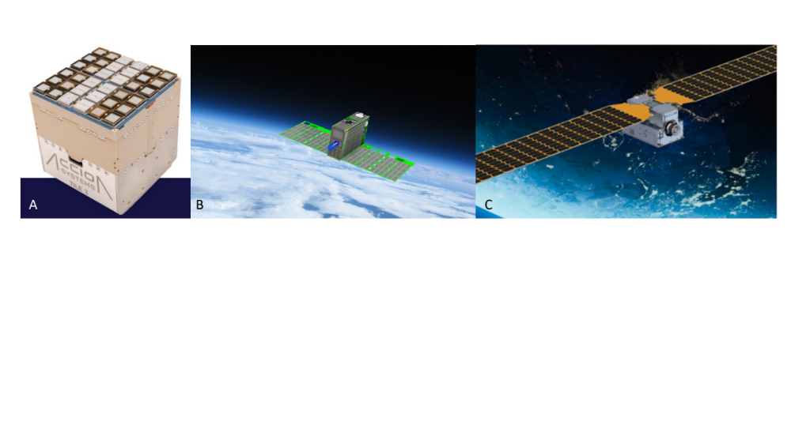
Figure 4. (A.) Accion’s Tiled Ionic Liquid Electrospray 3. Credit: Accion Systems, Inc. (B.) CU Aerospace’s 6U Dual Propulsion Experiment CubeSat. Credit: CU Aerospace, LLC (C.) The Courier CubeSat. Credit: ExoTerra Resource, LLC

PROJECTS and MISSIONS
The SST program funds and manages a number of technology demonstration missions, many slated for launch in the 2022 and 2023 timeframe.

The Advanced Composite Solar Sail System (ACS3) is a technology demonstration of the composite materials used in novel, lightweight booms that deploy from a 12-unit (U) spacecraft. ACS3’s four booms span the diagonals of a square and unspool to reach 7 meters in length, pulling with it a solar sail that when fully deployed is a square-shaped sail measuring approximately nine meters per side. The composite booms are made from a flexible polymer material reinforced with carbon fiber. The material is stiff and resistant to bending and warping due to changes in temperature. The ACS3 technology demonstration will also test an innovative tape-spool boom extraction system designed to minimize jamming of the coiled booms during deployment. Figure 5, image A shows a fully deployed ACS3 solar sail. ACS3 is scheduled to launch in late-2022 [19].

The Cislunar Autonomous Positioning System Technology Operations and Navigation Experiment (CAPSTONE) is a 12U spacecraft weighing approximately 25 kilograms that will serve as the first spacecraft to test a unique elliptical lunar orbit, called a near-rectilinear halo orbit, in cislunar space. As a precursor to Gateway, a Moon-orbiting outpost that is part of NASA’s Artemis program, CAPSTONE will help reduce risk for future spacecraft by validating navigation technologies and verifying the dynamics of this halo-shaped orbit. CAPSTONE will use a hydrazine-fueled propulsion system. The system’s eight thrusters, shown in Figure 5, image B, protrude through four extensions of the CubeSat in order to minimize plume interactions and thermal soakback. CAPSTONE is expected to launch in the first half of 2022 [20].

The CubeSat Laser Infrared Crosslink (CLICK) mission will demonstrate technology to advance the state of the art in communications between small spacecraft as well as the ability to gauge their relative distance and location. CLICK is comprised of two sequential missions. The first mission, CLICK A, will test out elements of an optical communications system with a single 3U spacecraft, as shown in Figure 5, image C. The goal of CLICK B/C, the second mission, is to demonstrate full-duplex optical communications crosslink between two 3U spacecraft at distances between 25-580 kilometers apart at data rates greater than 20 Mbps. CLICK A and CLICK B/C are anticipated to launch in 2022 and 2023, respectively [21].

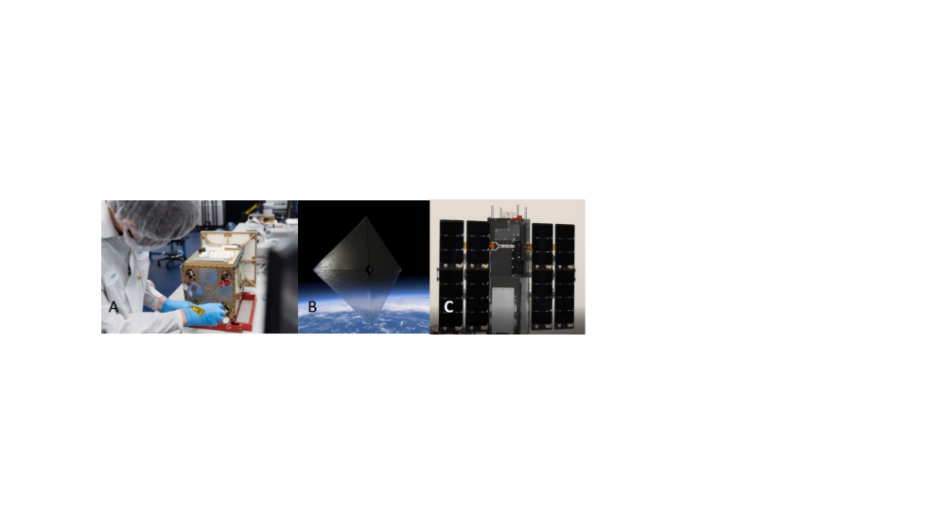
Figure 5. (A.) The CAPSTONE spacecraft uses a hydrazine-fueled propulsion system. Credit: Tyvak Nano-Satellite Systems, Inc., a Terran Orbital Corporation (B.) An illustration of a fully deployed Advanced Composite Solar Sail System solar sail. (C.) CLICK missions use 3U spacecraft. Credit: Blue Canyon Technologies

The CubeSat Proximity Operations Demonstration (CPOD) mission will demonstrate rendezvous, proximity operations and docking using two CubeSats, each 3U in size. This flight demonstration will validate and characterize new miniature low-power proximity operations technologies applicable to future missions. The CPOD spacecraft docking will employ the use of a novel universal docking device, seen on top of each spacecraft in Figure 6, image A, as well as imaging sensors, and a multi-thruster cold gas propulsion system. The two CPOD spacecraft are anticipated to launch into low-Earth orbit in mid-year 2022 [22].

Ahead of Artemis astronauts landing on the moon this decade, a 6U-size spacecraft called Lunar Flashlight will launch as a secondary payload on a NASA Commercial Lunar Payload Services mission in 2022. Lunar flashlight aims to detect naturally occurring surface ice believed to be at the bottom of craters on the Moon that have never seen sunlight. The observations will be made as the spacecraft passes at low altitude over the Moon’s South Pole to shine its lasers into permanently shadowed regions and probe for surface ice [23]. Figure 6, image B, shows he Lunar Flashlight spacecraft during testing.

The Pathfinder Technology Demonstrator (PTD) mission series is comprised of four missions to demonstrate and advance technologies in the following areas: propulsion to advance the capability to maneuver small science platforms and send small spacecraft to deep space; high-bandwidth laser communications to increase the amount of data that can be transmitted from the spacecraft to the ground; and power systems with increased capacity necessary for missions in deep space. The mission series utilizes a new commercial 6U spacecraft bus and avionics platform common to all PTD missions. The PTD mission series is an example of industry-inspired small spacecraft innovation that offers affordable, rapid turn-around opportunities to demonstrate technologies needed to increase the capability and utility of small spacecraft. The first PTD mission, PTD-1, launched in 2021 to demonstrate a water-based electrolysis propulsion system, shown in Figure 6, image C. The launch timeframe for the PTD missions is 2021 through 2023 [24].

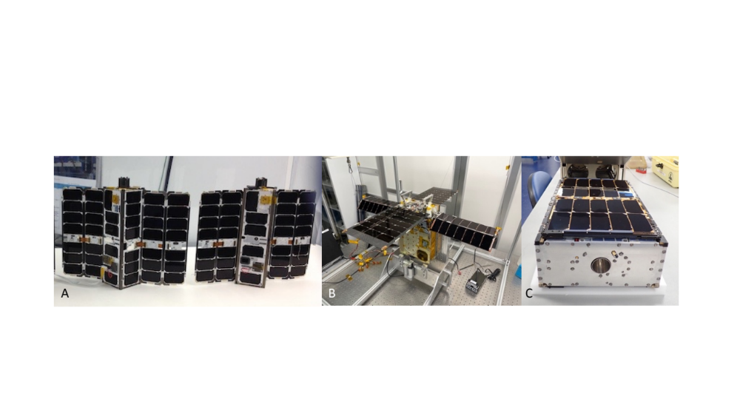
Figure 6. (A.) The CubeSat Proximity Operations Demonstration spacecraft. Credit: Tyvak Nano-Satellite Systems, Inc., a Terran Orbital Corporation (B.) Lunar Flashlight during testing. Credit: NASA/JPL-Caltech (C.) Pathfinder Technology Demonstrator-1 spacecraft. Credit: Tyvak Nano-Satellite Systems, Inc., a Terran Orbital Corporation
The Starling mission will advance the readiness of a technologies for cooperative groups of spacecraft, or distributed missions. Starling will demonstrate technologies to enable multipoint science data collection by several small spacecraft flying in swarms. The six-month mission will use four CubeSats in low-Earth orbit to test four technologies that let spacecraft operate in a synchronized manner without resources from the ground. Starling will advance technologies with the following capabilities: swarm maneuver planning and execution; communications networking; relative navigation; and autonomous coordination between spacecraft. One of the four Starling spacecraft is shown in Figure 7, image A. Starling is expected to launch in mid-2022 [25].
The Payload Accelerator for CubeSat Endeavors (PACE) initiative supports a rapid cadence of flight demonstrations, aiming to speed up advances in the state-of-the-art for new small spacecraft technologies. The PACE initiative supports flight demonstrations, facilitating suborbital and orbital launches for technology payloads. The initiative reduces the cost, risk, complexity, and/or time required to mature technology, lowering the barriers to development. PACE uses a flexible approach to accommodate a wide range of projects to fly as many new technologies as possible, particularly early-stage, higher-risk innovations. PACE’s first mission, V-R3x launched in 2021 as a swarm of three CubeSats to low-Earth orbit to demonstrate low-power, low-cost spacecraft ranging, topology recovery, and coordinated measurement technology [26]. PACE-2, shown in Figure 7, image B, is planned to launch in mid-2022 to demonstrate upgrades to the PACE avionics system as well as a camera and image processing payload.

DiskSat is a new circular satellite design concept being developed by The Aerospace Corporation of El Segundo, California, with funding by NASA’s SST program. An alternate approach to satellite containerization standardized by the CubeSat platform, DiskSat is a plate-shaped satellite 1 meter in diameter and 2.5 centimeters thick. DiskSat will offer high power and a large aperture needed for future missions, as well as the standardized launch interface and low costs characteristic of CubeSats. The DiskSat concept could allow for 20 or more satellites to be integrated and deployed from a single small launch vehicle as illustrated in Figure 7, image C. A demonstration mission to verify the performance of DiskSat is being planned [27], [28].

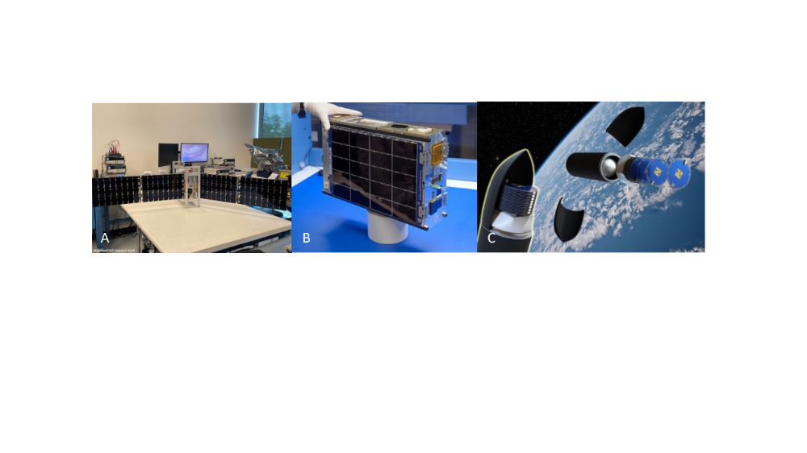
Figure 7. (A.) One of four Starling spacecraft. Credit: NASA (B.) The PACE-2 spacecraft. Credit: NASA (C.) The DiskSat concept. Credit: The Aerospace Corporation

FUTURE WORK
NASA’s technology, science, exploration, and space operations organizations periodically identify a growing number of potential applications for very small spacecraft. Such spacecraft can accomplish missions at a fraction of the cost of larger conventional spacecraft and can be developed quickly and more responsively. In some cases, their small size and ability to be delivered in relatively large numbers may enable mission applications not possible with larger satellites.

Investments in small spacecraft capabilities continue to be made across industry, government, and academia as the value of the platform as a low-cost and effective alternative to larger missions, or in support of larger missions, is being demonstrated. NASA’s SST recognizes the great potential of small spacecraft as contributors toward NASA’s lunar and deep space exploration objectives, as a platform for Earth observation and other science, and promotes partnerships with other organizations afforded by common interests and collaborative spirit.

The anticipated applications of small spacecraft are numerous. NASA’s early and persistent development of technologies for small spacecraft is leading to the demonstration of networked constellations of small spacecraft and their use in lunar and deep space missions. Continued investments to enable highly capable small spacecraft missions equipped with scientific instruments, offer a future that includes deep space infrastructure supported by these spacecraft to capture and transmit more scientific data from low-Earth orbit, and later, from the Moon and Mars.

REFERENCES

[1] | National Aeronautics and Space Administration, "About Small Spacecraft Technology Program," 8 September 2021. [Online]. Available: https://www.nasa.gov/directorates/spacetech/small_spacecraft/smallsat_overview.html. [Accessed 13 March 2022].
[2] | National Aeronautics and Space Administration, "Small Spacecraft Technology Program," 14 September 2021. [Online]. Available: https://www.nasa.gov/smallspacecraft. [Accessed 4 March 2022].
[3] | National Aeronautics and Space Administration, "Projects and Missions," 8 September 2021. [Online]. Available: https://www.nasa.gov/directorates/spacetech/small_spacecraft/projects-missions.html. [Accessed 13 March 2022].
[4] | National Aeronautics and Space Administration, "NASA Selects Universities for Collaborative Development of Small Spacecraft Technologies," 11 March 2020. [Online]. Available: https://www.nasa.gov/feature/ames/nasa-selects-universities-for-collaborative-development. [Accessed 10 March 2022].
[5] | National Aeronautics and Space Administration, "Small Business Innovation Research (SBIR) & Small Business Technology Transfer (STTR) Program," 10 March 2022. [Online]. Available: https://sbir.nasa.gov/. [Accessed 10 March 2022].
[6] | National Aeronautics and Space Administration, "NASA Increases Investment in US Small Businesses to Mature Lunar Capabilities for Artemis," 8 July 2020. [Online]. Available: https://www.nasa.gov/directorates/spacetech/NASA_Increases_Investment_in_US_Small_Businesses_to_Mature_Lunar_Capabilities_for_Artemis. [Accessed 10 March 2022].
[7] | National Aeronautics and Space Administration, "NASA Small Business Partners Advance Lunar Technologies," 10 September 2021. [Online]. Available: https://www.nasa.gov/feature/ames/nasa-small-business-partners-advance-lunar-technologies. [Accessed 10 March 2022].
[8] | National Aeronautics and Space Administration, "Space Tech Industry Partnerships," 22 February 2022. [Online]. Available: https://www.nasa.gov/directorates/spacetech/solicitations/tipping_points. [Accessed 8 March 2022].
[9] | National Aeronautics and Space Administration, "NASA Announces US Industry Partnerships to Advance Moon, Mars Technology," 30 July 2019. [Online]. Available: https://www.nasa.gov/press-release/nasa-announces-us-industry-partnerships-to-advance-moon-mars-technology\. [Accessed 8 March 2022].
[10] | Advanced Space, LLC., "Cislunar Autonomous Positioning System (CAPS)," Advanced Space, LLC., [Online]. Available: https://advancedspace.com/caps/. [Accessed 8 March 2022].
[11] | Vulcan Wireless Inc., "NSR-SDR-S/S," Vulcan Wireless Inc., 23 January 2022. [Online]. Available: https://www.vulcanwireless.com/nsr-sdr-s/s. [Accessed 14 March 2022].
[12] | National Aeronautics and Space Administration, "2020 NASA Announcement of Collaboration Opportunity (ACO) Selections," 9 November 2020. [Online]. Available: https://www.nasa.gov/directorates/spacetech/2020_NASA_Announcement_of_Collaboration_Opportunity_ACO_Selections. [Accessed 8 March 2022].
[13] | Stellar Exploration Inc., "Nanosatellite Propulsion," Stellar Exploration Inc., 2 April 2019. [Online]. Available: https://static1.squarespace.com/static/5c54e307fd67934e24b27846/t/5caa7ce54785d3baf211b7d8/1554677036302/Datasheet+propulsion+2019+03+31.pdf. [Accessed 8 March 2022].
[14] | PhaseFour, "RF PLASMA PROPULSION," PhaseFour, 2021. [Online]. Available: https://phasefour.io/rf-plasma-propulsion/. [Accessed 8 March 2022].
[15] | National Aeronauticss and Space Administration, "NASA Announces New Tipping Point Partnerships for Moon and Mars Technologies," 27 September 2019. [Online]. Available: https://www.nasa.gov/press-release/nasa-announces-new-tipping-point-partnerships-for-moon-and-mars-technologies. [Accessed 8 March 2022].
[16] | CU Aerospace, LLC, "Solid Teflon Propellant," CU Aerospace, LLC, 2022. [Online]. Available: https://cuaerospace.com/products-services/space-propulsion-systems/fiber-fed-pulsed-plasma-thruster-fppt. [Accessed 8 March 2022].
[17] | CU Aerospace, LLC, "Solid Polymer Propellant," CU Aerospace, LLC, 2022. [Online]. Available: https://cuaerospace.com/products-services/space-propulsion-systems/monofilament-vaporization-propulsion-mvp. [Accessed 8 March 2022].
[18] | ExoTerra Resource, LLC, "Solar Electric Propulsion Modules and Bus," ExoTerra Resource, LLC, 2022. [Online]. Available: https://exoterracorp.com/products/solar-electric-propulsion-modules-and-bus/. [Accessed 8 March 2022].
[19] | National Aeronautics and Space Administration, "Advanced Composite Solar Sail System: Using Sunlight to Power Deep Space Exploration," 23 June 2021. [Online]. Available: https://www.nasa.gov/directorates/spacetech/small_spacecraft/ACS3. [Accessed 4 March 2022].
[20] | National Aeronautics and Space Administration, "What is CAPSTONE?," 31 July 2020. [Online]. Available: https://www.nasa.gov/directorates/spacetech/small_spacecraft/capstone/. [Accessed 4 March 2022 2022].
[21] | National Aeronautics and Space Administration, "CubeSat Laser Infrared CrosslinK," 14 May 2019. [Online]. Available: https://www.nasa.gov/directorates/spacetech/small_spacecraft/cubesat_laser_infrared_crosslink/. [Accessed 4 March 2022].
[22] | National Aeronautics and Space Administration, "CubeSat Proximity Operations Demonstration (CPOD)," 2 May 2013. [Online]. Available: https://www.nasa.gov/directorates/spacetech/small_spacecraft/cpod_project.html. [Accessed 4 March 2022].
[23] | National Aeronautics and Space Administration, "NASA CubeSat Will Shine a Laser Light on the Moon's Darkest Craters," 27 April 2020. [Online]. Available: https://www.nasa.gov/feature/jpl/nasa-cubesat-will-shine-a-laser-light-on-the-moons-darkest-craters. [Accessed 4 March 2022].
[24] | National Aeronautics and Space Administration, "Pathfinder Technology Demonstrator," 4 February 2021. [Online]. Available: https://www.nasa.gov/directorates/spacetech/small_spacecraft/Pathfinder_Technology_Demonstrator/. [Accessed 4 March 2022].
[25] | National Aeronautics and Space Administration, "What is Starling?," 31 July 2021. [Online]. Available: https://www.nasa.gov/directorates/spacetech/small_spacecraft/starling/. [Accessed 4 March 2022].
[26] | National Aeronautics and Space Administration, "What is NASA’s Payload Accelerator for CubeSat Endeavors Initiative?," 29 June 2021. [Online]. Available: https://www.nasa.gov/ames/pace. [Accessed 4 March 2022].
[27] | The Aerospace Corporation, "Aerospace is Redefining the Future of Small Satellites," The Aerospace Corporation, 23 August 2021. [Online]. Available: https://aerospace.org/article/aerospace-redefining-future-small-satellites. [Accessed 13 March 2022].
[28] | The Aerospace Corporation, "The DiskSat: A Two-Dimensional Containerized Satellite," 35th Annual Small Satellite Conference Proceedings, 12 August 2021. [Online]. Available: https://digitalcommons.usu.edu/smallsat/2021/all2021/227/. [Accessed 13 March 2022].

