Supplementary Material for
“Evaluation of GPROF V05 Precipitation Retrievals under Different Cloud Regimes”

Jackson Tan,^{a,b} Nayeong Cho,^{a,b} Lazaros Oreopoulos,^{b} Pierre Kirstetter^{c,d,e}
ª Universities Space Research Association, Columbia, Maryland
b NASA Goddard Space Flight Center, Greenbelt, Maryland
^{c} School of Meteorology, University of Oklahoma, Norman
^{d} School of Civil Engineering and Environmental Science, University of Oklahoma, Norman
^{e} NOAA Severe Storms Laboratory, Norman, Oklahoma

Corresponding author: Jackson Tan, jackson.tan@nasa.gov

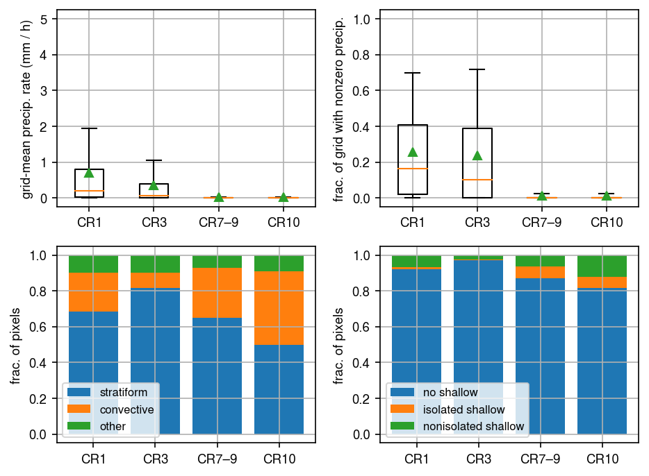
Supplementary Figure 1: Precipitation properties of the four CRs based on global composites over land with DPR active retrievals. See Figure 3 for details.

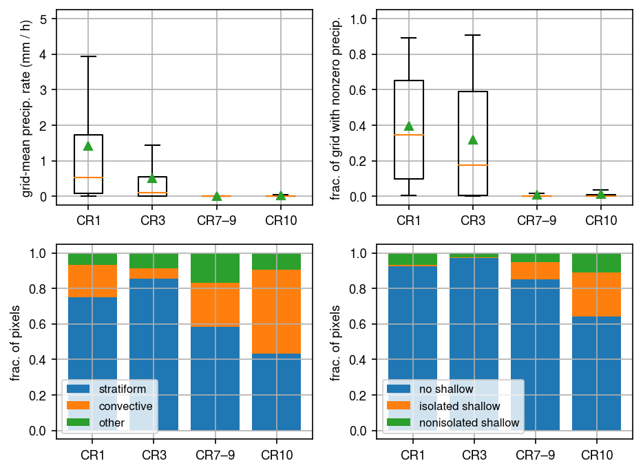
Supplementary Figure 2: Precipitation properties of the four CRs based on global composites over water with DPR active retrievals. See Figure 3 for details.

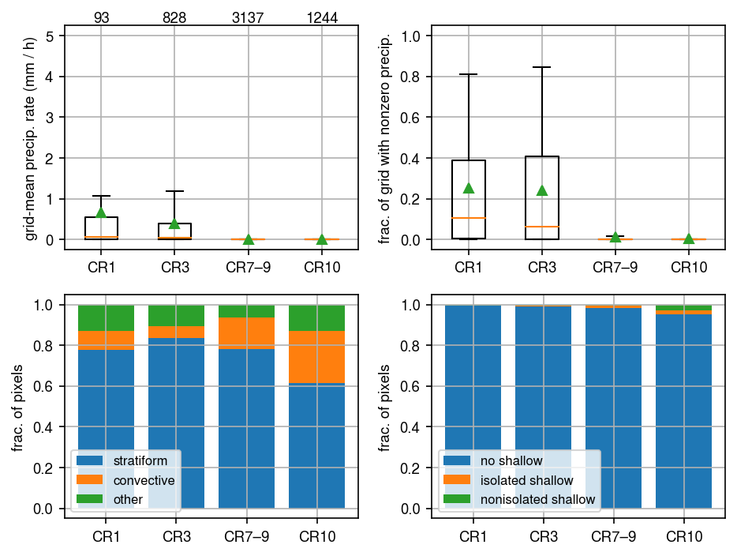
Supplementary Figure 3: Precipitation properties of the four CRs based on composites over land in the northeast quadrant of CONUS (38–55°N, 95–60°W) with DPR active retrievals. See Figure 3 for details. The numbers at the top of the top-left panel shows the sample size.

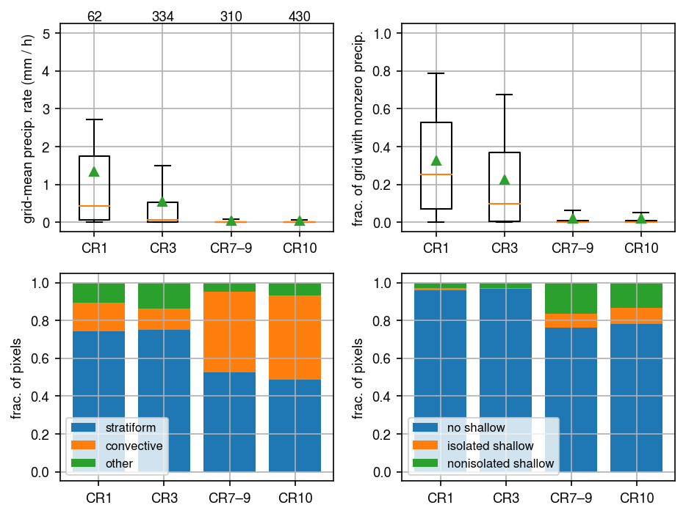
Supplementary Figure 4: Precipitation properties of the four CRs based on composites over land in the southeast quadrant of CONUS (20–38°N, 130–95°W) with DPR active retrievals. See Figure 3 for details. The numbers at the top of the top-left panel shows the sample size.

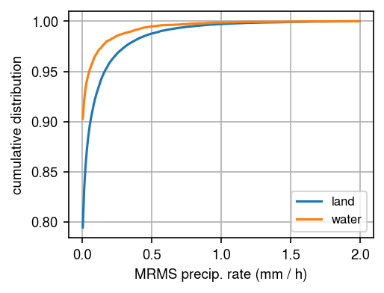
Supplementary Figure 5:The cumulative distribution functions of GV-MRMS precipitation rates at 1° for CR7–9 over land and over water.

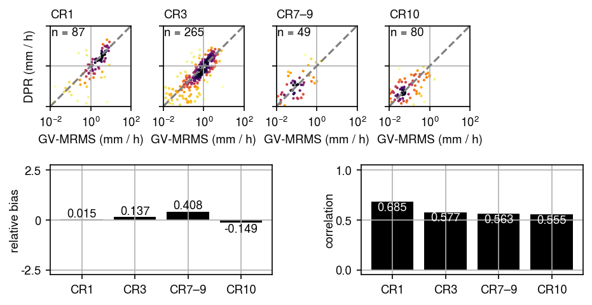
Supplementary Figure 6: Comparison of DPR retrievals for the different CRs over water. See Figure 4 for details on the individual panels.

