Mississippi Embayment Water Resources
Utilizing NASA Earth Observations to Understand Groundwater Recharge in the Mississippi Regional Aquifer System

Technical Report
Final – March 31st, 2022

Lauren Mahoney (Project Lead)
Brenna Hatch
Claire Villanueva-Weeks
Lauren Webster

Advisors:
Madeleine Pascolini-Campbell, NASA Jet Propulsion Laboratory, California Institute of Technology
Kerry Cawse-Nicholson, NASA Jet Propulsion Laboratory, California Institute of Technology
Benjamin Holt, NASA Jet Propulsion Laboratory, California Institute of Technology

1. Abstract
The Memphis Sand Aquifer (MSA) is located in the Mississippi Embayment which extends 250,000 square kilometers across nine states. Groundwater recharge factors that influence the narrow recharge zone of the MSA include precipitation, potential evapotranspiration, and landcover changes. The unsustainable water practices and increasing landcover change from urban development in the MSA's narrow recharge zone threaten the aquifer’s groundwater storage. In partnership with Protect Our Aquifer, the team used data from Terra Moderate Resolution Imaging Spectroradiometer (MODIS), Integrated Multi-Satellite Retrievals for Global Precipitation Measurement (GPM IMERG), National Land Cover Dataset (NLCD), and Gravity Recovery and Climate Experiment (GRACE). These datasets included annually averaged precipitation, evapotranspiration, potential evapotranspiration, biannual landcover change, and monthly total water storage which were used to create groundwater recharge factors maps and timeseries. The evaporative stress index map, water balance map, and landcover change maps were used to identify thriving areas. The team found precipitation did not express a strong linear trend and showed high precipitation years in 2017 and 2018, and a drought year in 2011. The potential evapotranspiration showed a weak negative linear trend. The landcover change showed shifts in forested areas and urban development. The team identified four thriving areas in the western side of Tennessee that successfully contribute to aquifer recharge due to increased forest area, sufficient water use, low changes in total water storage, and lateral positioning to streams. These end products allowed our partners to make informed decisions about areas that are thriving in the Mississippi Embayment recharge zone for conservation efforts of the aquifer.

Key Terms
precipitation, evapotranspiration, potential evapotranspiration, landcover change, evaporative stress index, water balance, total water storage, thriving index

2. Introduction
2.1 Background Information:
Sustainable access to clean, high-quality water is not only a human right, but an increasingly scarce and actively threatened resource globally. The effects of climate change and the proliferation of industry and land development in the United States has caused increased concern over the status of one of the largest sources of clean water in the United States, the Mississippi Embayment. The Memphis Sands Aquifer (MSA) is located in the Mississippi Embayment and extends 250,000 square kilometers across 9 states, with most coverage occurring in Tennessee, Mississippi, and Arkansas. It provides water for domestic, agricultural, and industrial use for West Tennessee and the surrounding states and provides public water systems for upwards of 2.28 million people (TN Roadmap to Securing the Future of Our Water Resources, 2018). The particular geologic history and composition of the MSA allows it to contain some of the highest quality drinking water in the nation, estimated to be between two to three thousand years old.

The Mississippi Embayment currently has one of the highest rates of groundwater pumpage for irrigation use in the U.S., similar to that of the overdrafted Central Valley in California (Scanlon et al., 2021). This potentially indicates that current water practices such as flood irrigation are unsustainable and could have impacts to groundwater recharge both now and in the future. As drought conditions in other parts of the U.S. worsen, agriculture may be pushed eastward toward the Mississippi Embayment. Identifying thriving area in the Mississippi Embayment is critical to maintain a sustainable supply of groundwater for future generations.

2.2 Scientific Basis
While there remains some uncertainty over groundwater recharge dynamics, there is scientific evidence that the most influential factors are precipitation (P), potential evapotranspiration (PET), and landcover changes (Mohan et al., 2017). An increase in urban development in the Memphis region has raised concerns about the conservation of the aquifer, particularly due to landcover changes that affect groundwater recharge. The Ford Plant construction at the Memphis Regional Megasite is expected to be one of the largest battery and vehicle manufacturing campuses in the nation, and this planned development in the recharge zone will most certainly result in an increase in land cover changes. These changes directly affect the ability of the aquifer to be recharged, as urban development makes it difficult for water to infiltrate into the soil, which is essential to the quality and quantity of the water within this aquifer (Smith, 2019).

These factors control groundwater recharge by directly affecting the availability of water at the surface (Mohan et al., 2017). P has a strong influence on surface water availability, especially because it can directly recharge the aquifer in areas of the recharge zone where the Memphis sand is exposed to the surface (Simco, 2018). PET is defined as the amount of evaporation and transpiration (water loss from the pores on the leaves of plants) that would occur if a sufficient water source were available. Actual evapotranspiration (ET) can influence how much P is available to either become surface water runoff or infiltrate the subsurface as recharge. Long-term shifts in recharge rate can result in changes to groundwater storage (Condon, 2020). NASA’s Gravity Recovery and Climate Experiment (GRACE) and GRACE-Follow On (GRACE-FO) satellites provide information on total water storage (TWS) changes over land due to changes in the amount of water stored in the form of snow, ice, surface water, and groundwater (Tapley et al., 2004). Collectively, this is represented by equivalent water thickness, which represents the anomalies in global water storage height relative to a time-derived mean. Groundwater recharge factors in the Mississippi Embayment were assessed annually during the period of 2001-2021. The annual average values of groundwater recharge factors were analyzed across a twenty-year period to demonstrate their long-term behavior and response to historical unsustainable use of the aquifer.
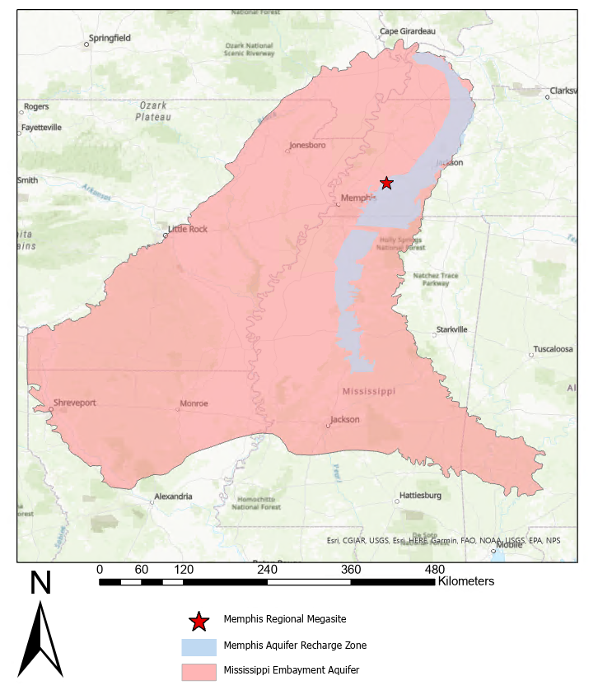
Figure 1. This map displays the project study area of the Mississippi Embayment Aquifer system and the Memphis Aquifer Recharge Zone.
2.3 Project Partners & Objectives
Protect Our Aquifer (POA) is a decision-making group that monitors groundwater supply and use of the MSA and larger aquifer system in the Mississippi Embayment. POA held interest in assessing ME groundwater recharge to determine how the Ford Plant development will affect critical zones where land cover changes and pollutants could directly affect the aquifer. In addition to the unsustainable well use that the Mississippi Embayment is already undergoing, future land development and increased unsustainable pumping for agricultural use may potentially affect groundwater recharge. POA will use maps and time series of factors critical to groundwater recharge to identify thriving areas of groundwater recharge and advocate for these areas to have increased protection from growing infrastructure development. The primary objectives of this study were to quantify changes in the influential groundwater recharge factors and create groundwater recharge factors time series and maps. The team used remotely sensed P, PET, and landcover data to identify critical areas of the Mississippi Embayment recharge zone by creating a risk index map.

3. Methodology
3.1 Data Acquisition
The team acquired Earth observation data via The Land Processes Distributed Active Archive Center Application for Extracting and Exploring Analysis Ready Samples (LP DAAC AppEEARS), the Physical Oceanography Distributed Active Archive Center (PODAAC), and the Goddard Earth Sciences Data and Information Services Center (GES DISC). The team performed ET and PET analyses with data from Terra Moderate Resolution Imaging Spectroradiometer (Terra MODIS), TWS data from GRACE and GRACE-FO, and P data from Integrated Multi-satellite Retrievals for Global Precipitation Measurement (GPM IMERG). The team collected biennial landcover data from the USGS National Landcover Database (NLCD), which was accessed through Google Earth Engine (GEE) using the 2019 NLCD Release. The NLCD landcover classification product primarily relies on Landsat 8 satellite imagery combined with ancillary datasets, such as topography, census, and soil data.

Table 1.
List of sensors and data products utilized for this project.
Platform and Sensor | Data Product | Parameters | Dates | Acquisition Method
Terra MODIS | MOD16A3GF v061 MODIS/Terra Net Evapotranspiration Gap-Filled Yearly L4 Global 500 m SIN Grid | Potential evapotranspiration,  evapotranspiration | 2001-2021 | LP DAAC AppEEARS
GRACE/ GRACE-FO | Mascon Ocean, Ice, and Hydrology Equivalent Water Height Coastal Resolution Improvement (CRI) Filtered Release 06 Version 02 datasets | Total water storage | 2002 – 2021 | PODAAC
GPM IMERG | GPM IMERG Final Precipitation L3 1 month 0.1 degree x 0.1 degree v06 | Precipitation | 2001-2021 | GES DISC

3.2 Data Processing
3.2.1 Total Water Storage
The team processed TWS data in MATLAB R2021a. No data fill values in addition to data that were greater than or equal to 1000 were removed from the analysis. The team regridded and rotated the data. The team applied a scale factor to the data and calculated an annual average using the complete 12 months of every year from 2001 to 2021. Esri ArcGIS Pro 2.8 was used to visualize the interpolated, regridded, scaled TWS data exported in arrays of longitude, latitude, and respective TWS. The team converted the coordinate data to point data, then generated Thiessen polygons from the point data to visualize the spatiotemporal distribution of changes in TWS.

3.2.2 Groundwater Recharge Factors
The team processed data of annual averages of ET and PET datasets in RStudio 4.1.2. The fill values that were greater than 50,000 and lower than 10,000 were masked out of each dataset. Fill values indicate cloud contamination, bad inputs or errors in the Penman-Monteith equation, which was used to calculate ET and PET for these products (Mu et al., 2013). The team selected a scale factor of 0.1 for both Terra MODIS datasets. The conversion of kilograms per square meter per year to millimeters per year was a one-to-one conversion.

The team processed P data in MATLAB. The team removed no data fill values from the analysis and applied a scale factor of 0.1. The team converted precipitation data to millimeters per year from millimeters per hour using the computed number of hours in the respective year the data were extracted from, and averaged monthly data to yearly data. The last year of data was incomplete; to replace these missing months and compute a yearly average, the team computed climatological monthly averages using an average of each respective month during the extent of the time period. The team regridded the data onto the ET latitude-longitude grid, clipped the data using the boundaries of the Mississippi Embayment and exported it in GeoTIFF format to be visualized in RStudio.

3.2.2 Thriving Index
The team processed landcover data using the raster symbolizer tool in Google Earth Engine to call out certain bands of the NLCD landcover classification system. The NLCD legend includes twenty total classification types, of which the team selected eleven, including various developed surfaces, various forested areas, areas of agriculture (crop and pasture), as well as open water, wetlands, and untilled grasslands. The team exported these eight landcover maps in GeoTIFF format, and then visualized them in ArcGIS Pro to create mapping outputs.

In order to find areas where recharge is thriving in the Mississippi Embayment, the team utilized an Evaporative Stress Index (ESI) and a water balance equation. “Thriving” areas have high ESI values and low water balance values. The ESI utilizes the products ET and PET datasets from Terra MODIS (Equation 1; Anderson et al., 2007). They were preprocessed in RStudio, cropping the ET and PET layers to West Tennessee Extent and visualized the spatiotemporal distribution of the ratio of ET to PET in West Tennessee.

$ESI = \frac{ET}{PET}$ (1)

The water balance equation takes into account inflows of water into a basin (for example from P) and outflows (due to ET and discharge out of a basin, or Q). The WB utilizes the products P and ET datasets from Terra MODIS and GPM IMERG (Equation 2; Pascolini-Campbell et al., 2021). The team preprocessed P and ET in RStudio, cropped the P and ET layers to West Tennessee extent, applied a bilinear resampled of the P dataset, and visualized the spatiotemporal distribution of the difference between the P and ET in West Tennessee.

$WB = P -ET - Q-∆TWS$ (2)

3.3 Data Analysis
3.3.1 Total Water Storage
The team plotted monthly and yearly TWS to assess the changes in monthly TWS over the time period. TWS data helped support analyses of groundwater recharge factors and the thriving index. The team created a time series plot in MATLAB of the monthly TWS and a moving mean that was generated from the 12 months of each year to assess the change in average annual TWS over time for the entire Mississippi Embayment.

3.3.2 Groundwater Recharge Factors
The team plotted the average yearly data to determine linear trends in ET, PET, and P over 2001-2021, utilized a linear regression model to fit the data in RStudio. To assess how dispersed the ET, PET, and P were in comparison to their annual averages, the team calculated the standard deviation for each year and plotted the standard deviation alongside the annual averages as error bars. To measure the proportion of variance in the data, the team calculated R² values from the linear regression model within RStudio.

To isolate changes in area to forested landcover types between the years of 2001 to 2019, the team reclassified each of the rasters for these two years to include three classifications: one for non-forested landcover types, two for forested landcover types, and zero for no data. To measure the change in these two years, the team subtracted the 2019 raster from the 2001 raster utilizing the raster calculator function in ArcGIS Pro. Finally, the team created a new raster that represented both newly forested areas and deforested areas and converted it into a shapefile.

3.3.3 Thriving Index
The average yearly ESI and water balance data were plotted to determine linear trends over 2001-2021 in West Tennessee. The team plotted average yearly data utilized a linear regression model to fit the data in RStudio. To identify thriving areas most useful to POA, the team looked at ESI and water balance maps compared with hydrographic stream data zoomed in on the West Tennessee area for the year 2019, as this was the year in which all data products were available. To isolate the open water classification representing rivers and streams, the team reclassified the raster into two classes, with the band representing water being reclassified to a value of one, and every other band being reclassified to zero or no data. The team clipped this new raster to the boundaries of West Tennessee and the Mississippi Embayment and converted it to a shapefile. Elements such as high ESI, low water balance, and certain land cover features such as streams contribute to the identification of this thriving index as they indicate efficient water use and lateral recharge.

4. Results
4.1.1 Total Water Storage Results
The team employed TWS as a means to further understand groundwater recharge factors in the context of the water table and the relative changes in water storage. TWS over time exhibited cyclical increases and decreases in the water table due to seasonality. Responses to climate events are captured in the time series; for example, the water table reduced in 2012 in response to a drought event (Figure 2).

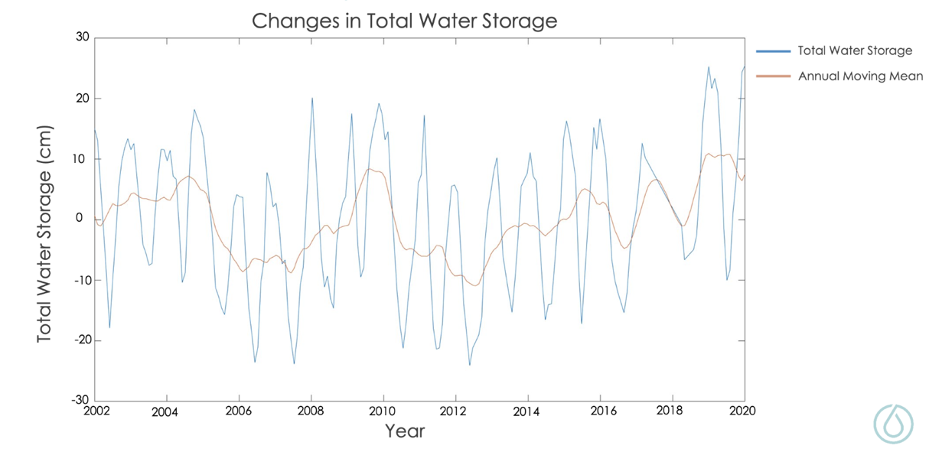
Figure 2: The changes in total water storage in centimeters over the period of 2002 to 2020. Monthly total water storage is plotted in blue and an annual moving mean of the total water storage is plotted in orange.

4.1.2 Groundwater Recharge Factors Results
The ET time series map shows the total ET of the ME from 2001-2021 (Figure A1) and was used to derive an annual mean ET over time. The annual average ET time series plot had a relatively strong linear relationship with an R² value of 0.55 and a p-value of 0.00011 (Figure 3). Annual average ET was assessed for spatial subsets of forested areas, pasture, and crop lands (Figure A2). Forested and pasture locations showed the strongest ET trends. The cropland areas had less of a linear relationship than all other areas, likely due to the seasonal changes of being an agricultural site. The periods of bare soil in the winter were accounted for in the annual average and likely contributed to the weak linear trend (Figure A3; Figure A4; Figure5).

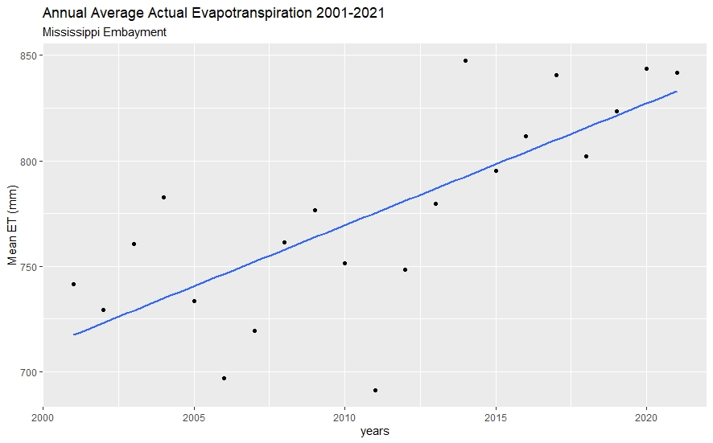
Figure 3. Annual average actual evapotranspiration during the period of 2001 to 2021. Average annual actual evapotranspiration is plotted in black and a best fit line is plotted in blue.

The PET time series map shows the total PET of the Mississippi Embayment from 2001-2021 (Figure A6) and was used to derive an annual mean PET over time. The annual average PET timeseries plot had a weak negative linear trend that was assessed to not be statistically significant with an R² value of 0.13 and a p-value of 0.11 (Figure 4). PET was assessed for three sections: forested areas, pasture, and crop lands (Figure A2). Crop and pasture locations showed a weak negative linear trend over time. The forest section saw an increase in PET until 2011 and a decrease in PET to present (Figure A7; Figure A8; Figure A9). After the severe drought in 2012, PET was reduced in 2013 – 2015. While the PET briefly recovered, it is now at its lowest level of the past 20 years.

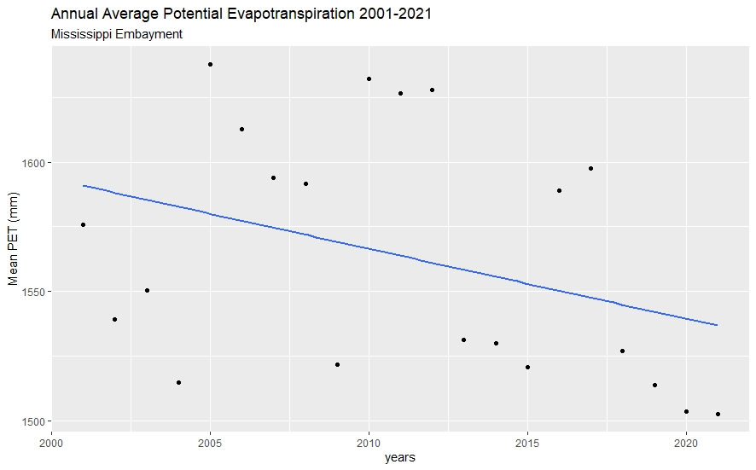
Figure 4. Annual average potential evapotranspiration during the period of 2001 to 2021. Average annual actual evapotranspiration is plotted in black and a best fit line is plotted in blue.

The P time series map shows the total mean P of the Mississippi Embayment from 2001 to 2021 (Figure A10) and was used to derive an annual mean P over time. There was a weak positive trend observed in the annual P time series with an R² value of 0.024 and a p-value of 0.49 (Figure 5). Certain years with relatively lower or higher P were identified by plotting these averages. Notable years were the low P year in 2011 and high P years in 2010, 2017, and 2018.

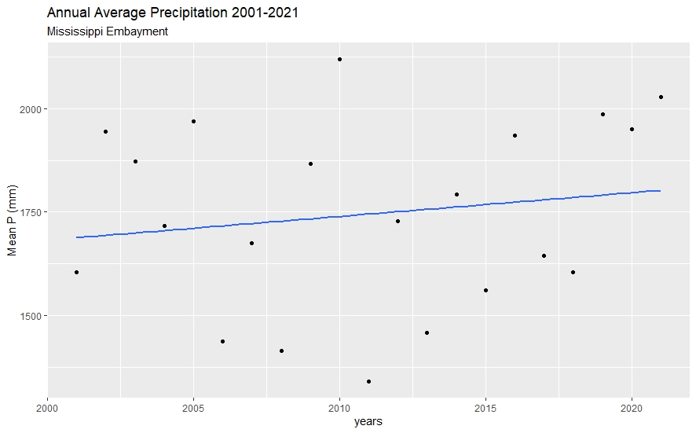
Figure 5: Annual Average Precipitation over the time period of 2001 to 2021. Average annual precipitation values are plotted in black and the line of best fit is plotted in blue.

Comparing spatial mapping products of landcover in 2001-2019 (Figure 6), a noticeable shift from lands dominated by pasture and hay shifted towards mixed forested classification occurred in the northeast corridor of the Mississippi Embayment in West Tennessee surrounding the recharge zone. Moreover, urban areas such as Memphis, TN (northeast of the Mississippi Embayment) and Jackson, MS (southeast of the Mississippi Embayment) experienced an increase in developed surfaces in and around the city borders during the 2001-2019 period.

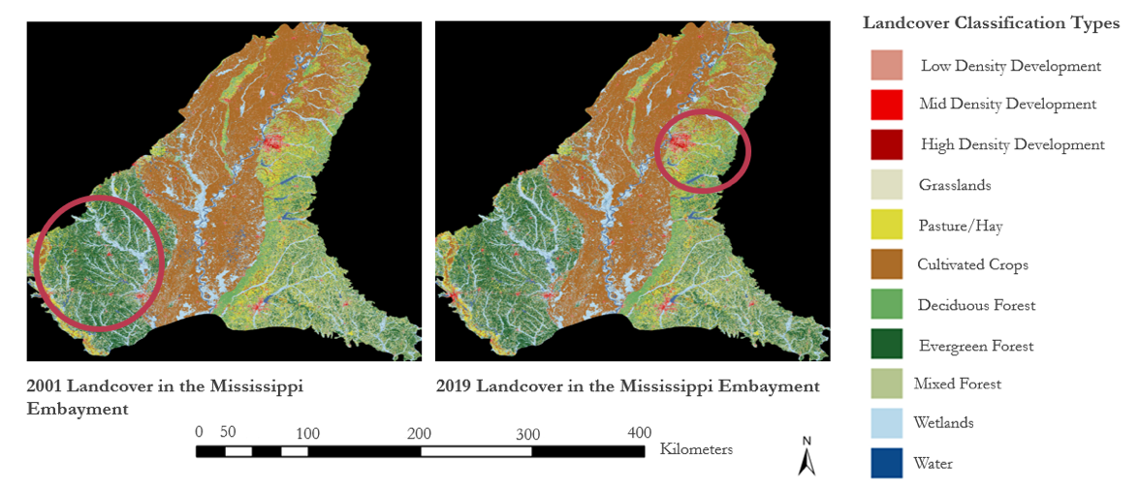
Figure 6. Landcover classification based on modified NLCD classes for the years 2001 (left) and 2019 (right). Circled areas on the map highlight areas that displayed major changes in landcover classification.

Landcover was utilized as backdrop for assessing changes in other groundwater recharge factors to determine if any changes in water usage could be attributed to changes in landcover. Broad shifts in the distribution of forested areas across the Mississippi Embayment is apparent between 2001 and 2019 in Figure 7, where changes in both the positive and negative direction were present in the southeast and southwest corridors of the ME. This indicates that there were a fairly similar number of pixels that changed from non-forested to forested (6,834,427 pixels) as well as forested to non-forested (6,566,150 pixels), with a slightly higher amount being attributed to new growth (non-forested to forested). These patterns of changes in forested areas were assessed in relation to the 2011 drought. Change maps comparing 2001-2011, 2011-2013, and 2013-2019 show an overall similar amount of change in both directions. There was, however, a slight increase in more deforestation than new growth during 2001-2011 and 2013-2019, and more new growth than deforestation during the 2011-2013 time period (Table A1).

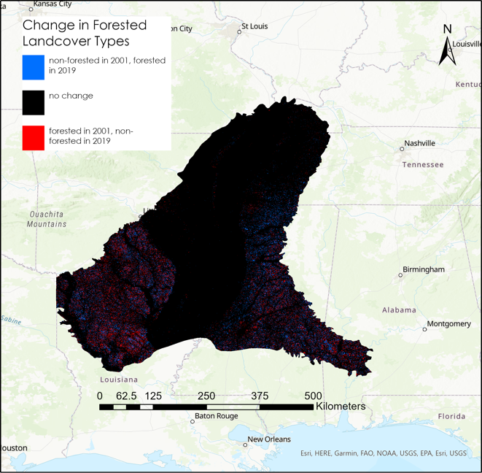
Figure 7. Changes in the landcover classification forested classes between the years 2001-2019. Red pixels indicate land that was characterized as forested in 2001, but non-forested in 2019, and blue pixels describe land that was non-forested in 2001 but forested in 2019.

4.1.3 Thriving Index Results
The upper northeast region of the Mississippi Embayment was identified to include four thriving areas and one vulnerable area to be prioritized for conservation and protection. Analyses of the ESI, water balance, and land cover maps and timeseries plot informed this assessment. Higher ESI and lower water balance indicate that plants have adequate access to water sources and that evapotranspiration is occurring efficiently. Landcover data can elucidate what ways in which the aquifer can be recharged, alluvial plains experience vertical infiltration while areas outside of the alluvial plains may experience lateral infiltration.

In the 2019 ESI map in West Tennessee, areas in light shades of blue have low rates of water use across the land's surface and low vegetative stress. The dark shades of red indicate areas of high rates of water use and high vegetative stress. Areas with higher ESI values in blue show areas that are thriving. Four thriving areas were located within the recharge zone, outlined in yellow, in addition to the identification of a vulnerable location where the Ford Plant is planned to be constructed, outlined in red (Figure 8).

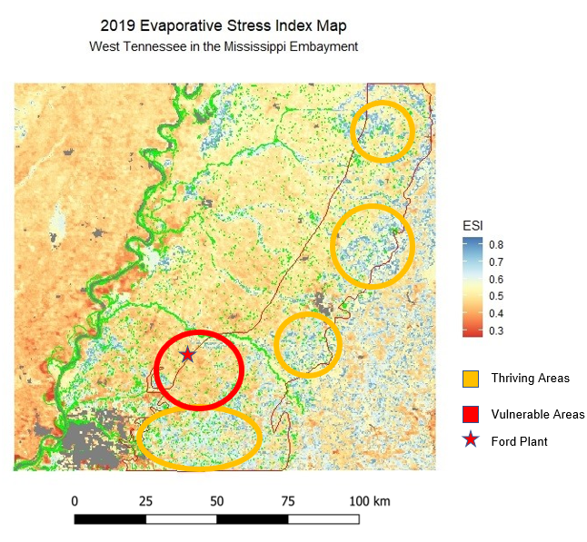
Figure 8. 2019 evaporative stress index map in West Tennessee

The ESI time series map shows the total mean ESI in West Tennessee from 2001 to 2021 (Figure B1) and was used to derive an annual mean ESI over time. The average annual ESI time series plot shows an increasing linear trend with an R² value of 0.39 and a p-value of 0.0025 (Figure 9). In the past two years, ESI has been the highest recorded over the last 20 years, which means the vegetation is not stressed and has sufficient water on average over the region.

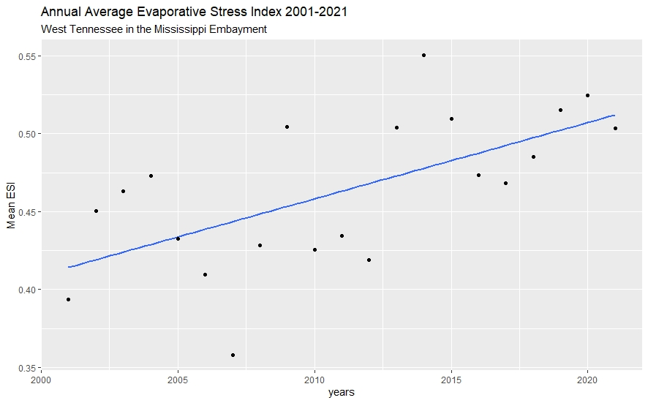
Figure 9. Average annual evaporative stress index over the time period of 2001 to 2021. Average annual evaporative stress index values are plotted in black and the line of best fit is blotted in blue.

In the simplified 2019 water balance map in West Tennessee, areas in dark blue that have high amounts of P and low amounts of ET indicate areas presumed to lack vegetation or areas in which vegetation does not use all available water. Yellow areas show areas where the difference between P and ET is smaller, indicating vegetation is using up available water. A lower water balance indicates that the ET processes are happening efficiently (Figure 10).

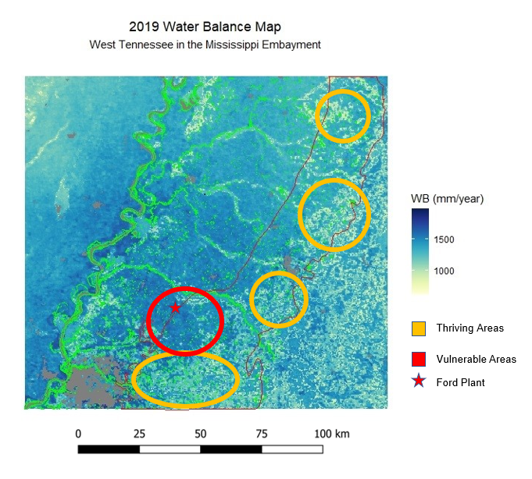
Figure 10. 2019 Water balance map in West Tennessee.

The water balance time series plot shows the total mean water balance in West Tennessee from 2001 to 2021 (Figure B2) and was used to derive an annual mean water balance over time. In the average annual water balance time series plot, there was no trend, with an R² value of 0.00084 and a p-value of 0.9 (Figure 11). In the average annual water balance time series plot, the annual mean P is greater than the annual mean ET inside the Mississippi Embayment in any given year. A notably higher or lower water balance is apparent in some years during the time period. In 2010, the water balance was high as P is relatively large; while in 2011, water balance is low in response to a drought event.

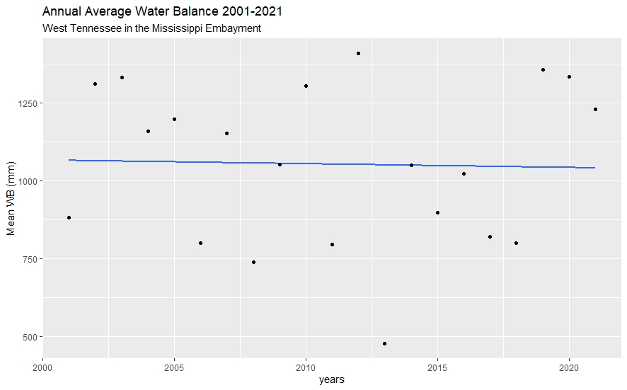
Figure 11. Timeseries of annual average water balance from 2001-2021.

4.2 Errors and Uncertainties
Potential edits and uncertainties source from possible satellite/sensor errors producing bad pixels, gap-filling using climatological monthly averages, and averaging annually. The annual averages may not be adequately representative of the Mississippi Embayment due to seasonality. Because of the seasonal landcover changes characteristic of agriculturally managed land, periods of bare soil are included in the annual averages of data products and may be skewed or otherwise inaccurate.

5. Discussion & Conclusions
Groundwater factors were assessed throughout time and analysis of annually averaged factors in the year 2019 allowed the team to identify thriving regions in the Mississippi Embayment. Four areas in West Tennessee were identified as thriving due to their relative increases in forested land cover, efficient water use, smaller changes to TWS volume, and lateral positioning to streams (Figures 8, 10). The position and specific land cover features of these regions allow for quick and efficient recharge, and ESI and water balance information indicates efficient water use and evapotranspiration systems.
High ESI is an indicator of a thriving region because when the ET approaches the PET, the ESI values increase and indicate that plants in these areas are thriving due to having accessible water through time. water balance information in the context of ET and landcover features is informative to the thriving index, a lower WB indicates that the ET processes are happening efficiently. In addition to the relatively low water balance (Figure 10), the landcover features of this region further identify this region as thriving. In regions with sandy or silty soils, surface runoff and P may directly recharge the aquifer through vertical infiltration. Outside of these plains, surface runoff is available to recharge the aquifer through streams. There is a network of streams situated by the identified thriving regions (Figure 10), and P that is available as surface runoff may flow into these streams and laterally rechange the aquifer. In addition to the four thriving areas, a vulnerable area within West Tennessee near the Ford Megasite was identified due to its high water balance (Figure 10) and low ESI (Figure 8), indicating that the ET processes in this region are not occurring efficiently.
Identification of thriving areas in the Mississippi Embayment allows our partners to advocate for regions that should be protected to prevent potential negative impacts from increased urban development and irrigation practices used by the agricultural industry. in order to prevent negative impacts from increased urban development and the unsustainable irrigation practices used by the agricultural industry. A vulnerable area was identified at the location of the Ford Megasite, indicating that this region should be monitored for unsustainable use. Using the team’s results, principally that of the thriving index and assessments of groundwater recharge factors over time, our partners can pinpoint areas in the Mississippi Embayment to protect and advocate for in the wake of new land development and infrastructure.
Future work should examine groundwater recharge on shorter-term scales and finer resolution data, as well as incorporate Earth observation validation to further assist POA and identify further thriving/at-risk regions in the ME. Examining groundwater recharge factors on shorter-term scales in several year increments can inform the partners as to how recharge factors respond to weather and climate events. Seasonality may be examined and accounted for through the use of shorter-term timescales. Agriculturally managed land comprises a substantial portion of the ME and is characterized by distinct growing and harvesting seasons followed by periods of bare soil. Annual averages fail to account for distinct seasonal trends such as these. Finer-scaled ECOSTRESS may be employed to observe groundwater recharge factors over shorter timescales and smaller areas. Validation of the Earth observations employed in this study through well data, precipitation gauges, and flux towers would provide support to our partners.

6. Acknowledgments
The team would like to thank everyone for the support and guidance in the Mississippi Water Resource project. The team would like to thank our science advisors Madeleine Pascolini-Campbell, Kerry Cawse-Nicholson, and Benjamin Holt at NASA Jet Propulsion Laboratory, California Institute of Technology and Erica Carcelen our NASA DEVELOP JPL Fellow.
A special thanks to our Project Partners who provided us with resources and expertise throughout this project. The team would like to thank Sarah Houston (Executive Director), Ward Archer (President), Jim Kovarik (Board Member) and Deborah Carington (Board Member) from Protect Our Aquifer.
Any opinions, findings, and conclusions or recommendations expressed in this material are those of the author(s) and do not necessarily reflect the views of the National Aeronautics and Space Administration.
This material is based upon work supported by NASA through contract NNL16AA05C.

7. Glossary
Earth Observations (EOs) – Satellites and sensors that collect information about the Earth’s physical, chemical, and biological systems over space and time
Evapotranspiration (ET) – The sum of evaporation from the land surface plus transpiration from plants
Evaporative Stress Index (ESI)– Actual ET / Potential ET; A measure of anomalies in ET that can indicate unusually high or low water usage rates
GPM IMERG – Global Precipitation Measurements Integrated Multi-satellitE Retrievals
GRACE – Gravity Recovery and Climate Experiment
MODIS – Moderate Resolution Imaging Spectroradiometer
NLCD – National Land Cover Database
Total Water Storage (TWS) – Changes in total water storage in a land mass and can quantify ground water storage and runoff
Water Balance (WB) – Precipitation – Actual Evapotranspiration; a measure comparing inflows (precipitation) and outflows (ET) in the water system
Potential Evapotranspiration (PET) – How much evaporation is possible with a sufficient water source

8. References
Anderson, M. C., Norman, J. M., Mecikalski, J. R., Otkin, J. A., & Kustas, W. P. (2007). A climatological study of evapotranspiration and moisture stress across the continental United States based on thermal remote sensing: 1. Model formulation. Journal of Geophysical Research: Atmospheres, 112(D10).
Condon, L. E., Atchley, A. L., & Maxwell, R. M. (2020). Evapotranspiration depletes groundwater under warming over the contiguous United States. Nature communications, 11(1), 1-8.
D. N. Wiese, D.-N. Yuan, C. Boening, F. W. Landerer, M. M. Watkins. 2019. JPL GRACE and GRACE-FO Mascon Ocean, Ice, and Hydrology Equivalent Water Height JPL RL06 Version 02. Ver. 2. PO.DAAC, CA, USA. Dataset accessed 2022-03-31 at https://doi.org/10.5067/TEMSC-3MJ62

Huffman, G.J., E.F. Stocker, D.T. Bolvin, E.J. Nelkin, Jackson Tan (2019), GPM IMERG Final Precipitation L3 Half Hourly 0.1 degree x 0.1 degree V06, Greenbelt, MD, Goddard Earth Sciences Data and Information Services Center (GES DISC), Accessed: 2022-03-31, doi:10.5067/GPM/IMERG/3B-HH/06

MRLC (2019). NLCD 2019 Land Cover (CONUS). https://www.mrlc.gov/data/nlcd-2019-land-cover-conus
Mohan, C., Western, A.W., Wei, Y., Saft, M. (2018). Predicting groundwater recharge for varying land cover and climate conditions – a global meta-study. Hydrology and Earth System Sciences, 22, 2689-2703, doi: 10.5194/hess-22-2689-2018
Mu, Q., Zhao, M., & Running, S. W. (2013). MODIS global terrestrial evapotranspiration (ET) product (NASA MOD16A2/A3). Algorithm Theoretical Basis Document, Collection, 5, 600.
Pascolini-Campbell, M., Fisher, J. B., & Reager, J. T. (2021). GRACE-FO and ECOSTRESS Synergies Constrain Fine-Scale Impacts on the Water Balance. Geophysical Research Letters, 48(15), e2021GL093984.
Running, S., Mu, Q., Zhao, M., Moreno, A. (2021). MODIS/Terra Net Evapotranspiration Gap-Filled Yearly L4 Global 500m SIN Grid V061 [Data set]. NASA EOSDIS Land Processes DAAC. Accessed 2022-03-31 from https://doi.org/10.5067/MODIS/MOD16A3GF.061

Scanlon, B. R., Rateb, A., Pool, D. R., Sanford, W., Save, H., Sun, A., Long, D., & Fuchs, B. (2021). Effects of climate and irrigation on Grace-based estimates of water storage changes in major US aquifers. Environmental Research Letters, 16, 094009. https://doi.org/10.1088/1748-9326/ac16ff
Simco, W. (2018). Recharge of the Memphis aquifer in an incised urban watershed. [Master’s thesis, University of Memphis]. Electronic Theses and Dissertations. 1830.
https://digitalcommons.memphis.edu/etd/1830
Smith, S. (2019). Recharge of the Memphis aquifer in an incised urban watershed: implications of impervious surfaces and stream incision. [Master’s thesis, University of Memphis]. Electronic Theses and Dissertations. 1970.
https://digitalcommons.memphis.edu/etd/1970
Tapley, B. D., Bettadpur, S., Ries, J. C., Thompson, P. F., & Watkins, M. M. (2004). GRACE measurements of mass variability in the Earth system. Science, 305(5683), 503-505.
Tennesse H2O. (2018). Tennessee's Roadmap to Securing the Future of Our Water Resources. https://www.tn.gov/content/dam/tn/environment/water/tn-h2o/documents/plan-&-appendices/wr-tnh2o_plan-app_institutional-and-legal-framework-chapter.pdf

9. Appendices
Appendix A: Groundwater Recharge Factors
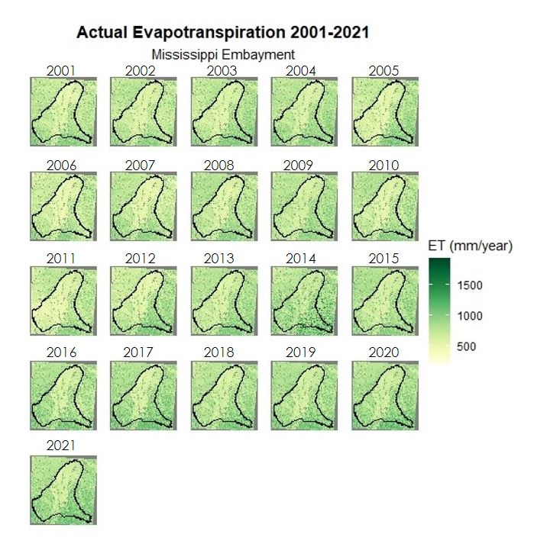

Figure A1. Actual evapotranspiration time series map from 2001 to 2021 of the Mississippi Embayment. Dark green shows an area of high evapotranspiration and yellow shows areas of low evapotranspiration in mm/year. The black line is the boundary of the Mississippi Embayment.

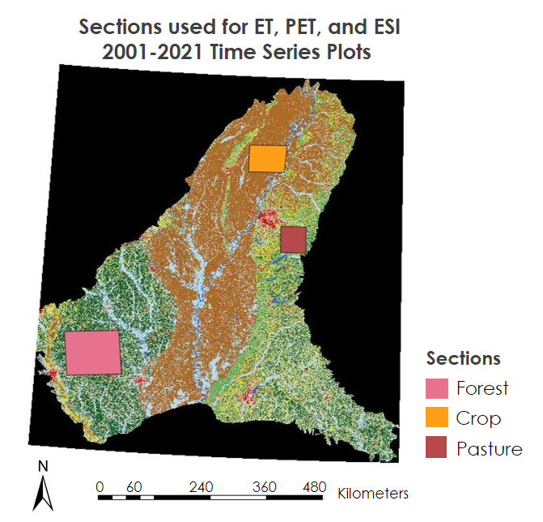
Figure A2. Map of the sections used for the actual evapotranspiration, potential evapotranspiration, and evaporative stress index 2001-2021 time series plot.

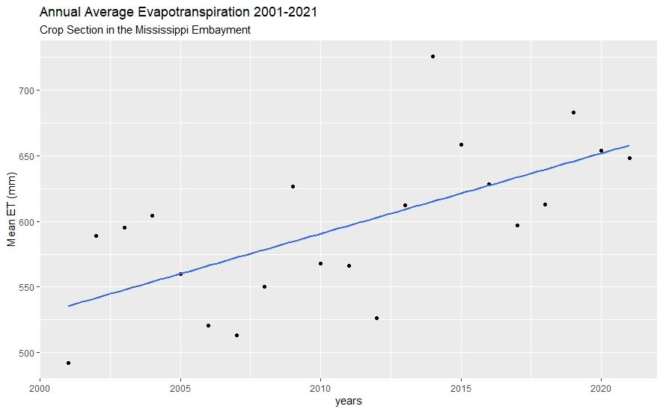
Figure A3. Annual average actual evapotranspiration from 2001 to 2021 of the crop section in the Mississippi Embayment. Average annual actual evapotranspiration is plotted in black and a best fit line is plotted in blue.

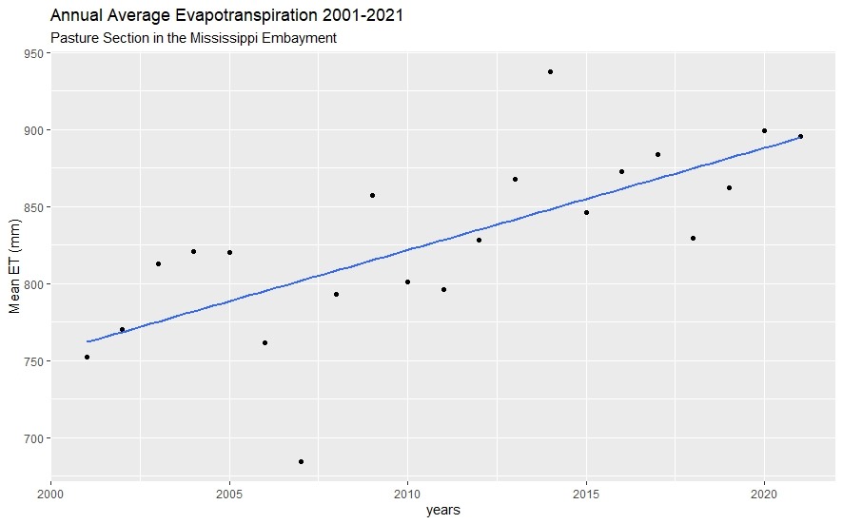
Figure A4. Annual average actual evapotranspiration from 2001 to 2021 of the pasture section in the Mississippi Embayment. Average annual actual evapotranspiration is plotted in black and a best fit line is plotted in blue.

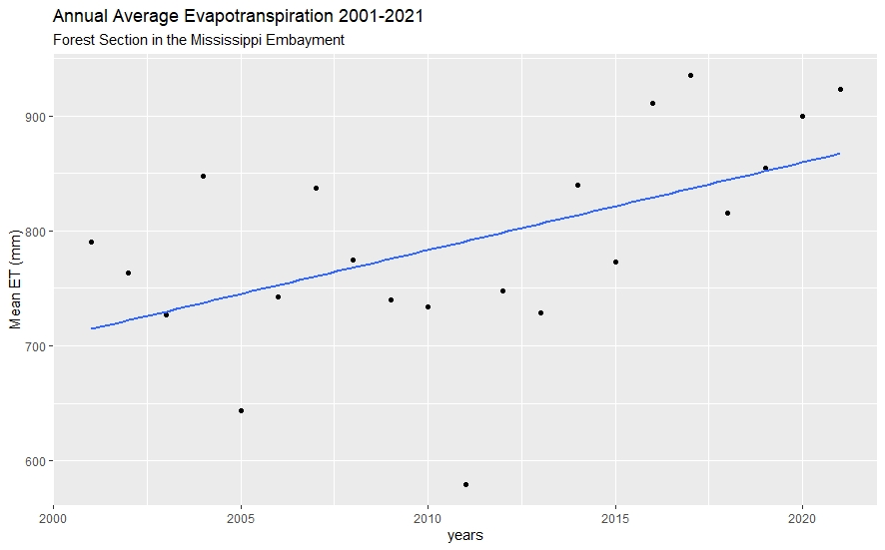
Figure A5. Annual average actual evapotranspiration from 2001 to 2021 of the forest section in the Mississippi Embayment. Average annual actual evapotranspiration is plotted in black and a best fit line is plotted in blue.

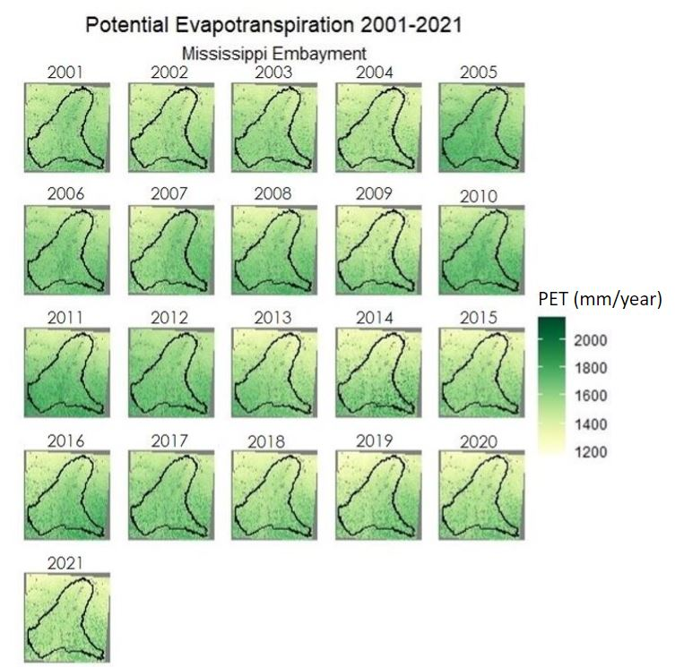
Figure A6. Potential evapotranspiration time series map from 2001 to 2021 of the Mississippi Embayment. Dark green shows an area of high potential evapotranspiration and yellow shows areas of low potential evapotranspiration in mm/year. The black line is the boundary of the Mississippi Embayment.

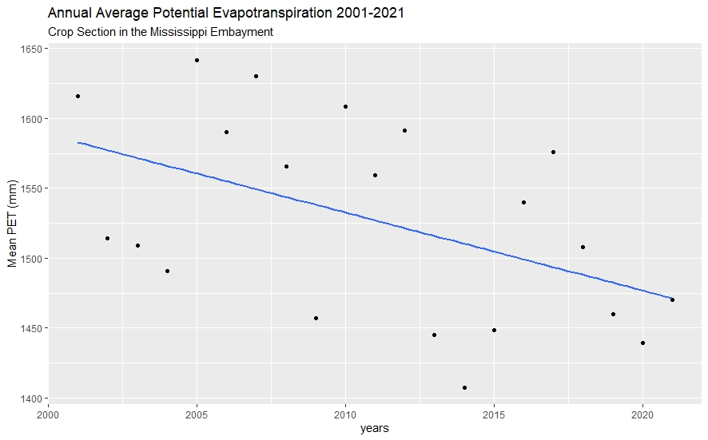
Figure A7. Annual average potential evapotranspiration from 2001 to 2021 of the crop section in the Mississippi Embayment. Average annual potential evapotranspiration is plotted in black and a best fit line is plotted in blue.

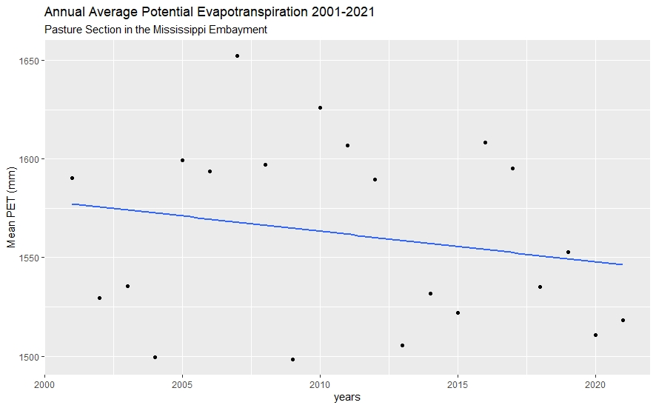
Figure A8. Annual average potential evapotranspiration from 2001 to 2021 of the pasture section in the Mississippi Embayment. Average annual potential evapotranspiration is plotted in black and a best fit line is plotted in blue.

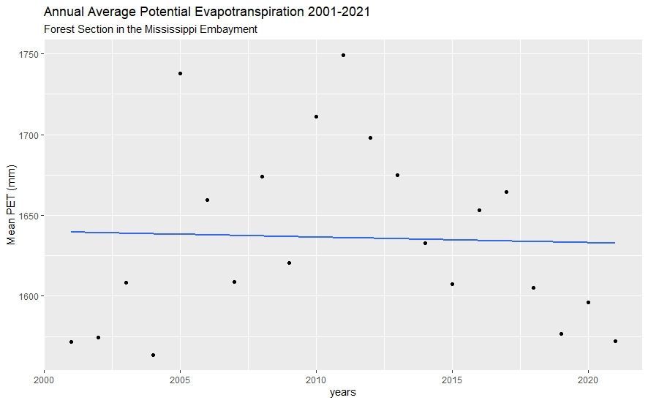
Figure A9. Annual average potential evapotranspiration from 2001 to 2021 of the pasture section in the Mississippi Embayment. Average annual potential evapotranspiration is plotted in black and a best fit line is plotted in blue.

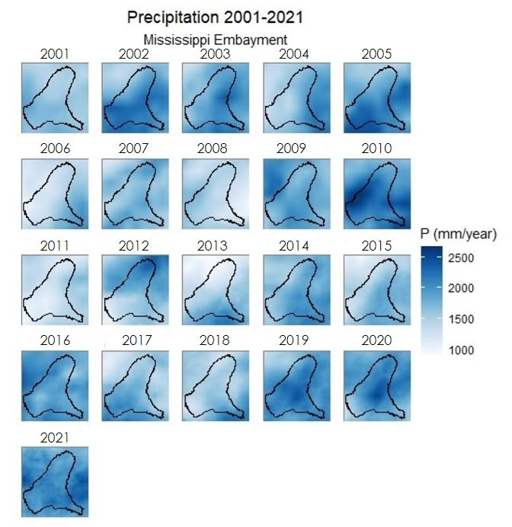
Figure A10. Precipitation time series map from 2001 to 2021 of the Mississippi Embayment. Dark blue shows an area of high precipitation and white shows areas of low precipitation in mm/year. The black line is the boundary of the Mississippi Embayment.

Table A1.
Changes in forested areas in the Mississippi Embayment 2001-2019, with special attention to 2001-2011, 2011-2013, and 2013-2019.
Time Period | # Pixels Deforestation (1) | # Pixels New Growth (-1)
2001- 2019 | 6,566,150 | 6,834,427
2001-2011 | 6,110,722 | 5,969,330
2011-2013 | 1,637,174 | 2,325,012
2013-2019 | 3,900,278 | 3,622,109

Appendix B: Thriving Index

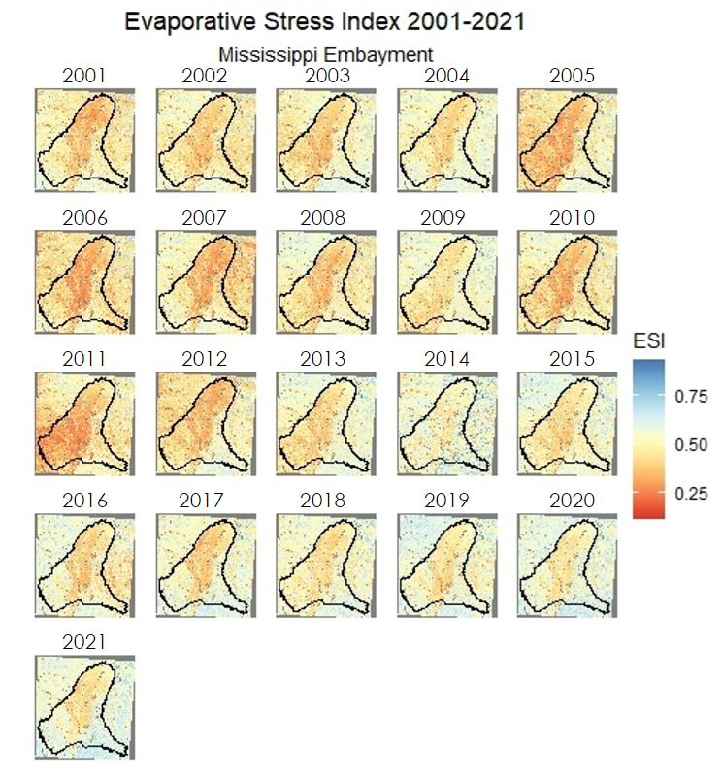

Figure B1. Evaporative stress index time series map during the period of 2001 to 2021 of the Mississippi Embayment. Light blue shows low rates of water use across the land's surface and low vegetative stress. Dark red indicates areas of high rates of water use and high vegetative stress. The black line is the boundary of the Mississippi Embayment.

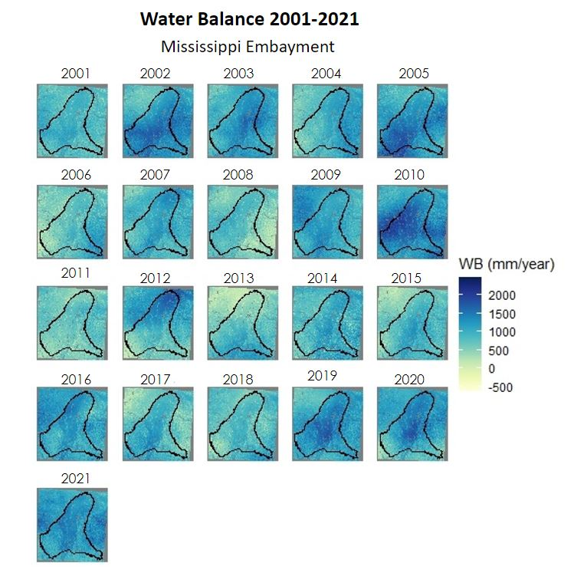
Figure B2. Water balance time series map during the period of 2001 to 2021 of the Mississippi Embayment.
Dark blue shows high amounts of P and low amounts of ET. Yellow areas show the difference between P and ET is smaller. The black line is the boundary of the Mississippi Embayment.

