Integrated Logistics and Supportability Challenges of Sustained Human Lunar Exploration
Andrew C. Owens and William M. Cirillo
NASA Langley Research Center, Hampton, VA 23681, USA
Chel Stromgren, Jason Cho, Chase Lynch,⁴ and Jon M. Vega⁴
Binera, Inc., Rockville, MD 20850, USA
NASA’s Artemis program plans to establish a sustained human presence on the lunar surface. The International Space Station and other space station programs have demonstrated long-duration human spaceflight operations that reuse infrastructure in Low Earth Orbit, sometimes including long uncrewed “dormant” periods. In contrast, all human exploration beyond Low Earth Orbit to date has consisted solely of relatively short sortie missions, rather than a sustained presence. A sustained human outpost on the Moon that can support month-long crewed exploration missions and be reused by multiple crews will be more challenging than past operations, particularly from the perspective of logistics, supportability, and risk. This paper examines the integrated logistics and supportability challenges of sustained human lunar exploration and provides a review of historical spaceflight experience in terms of crewed mission endurance, uncrewed duration, transportation overhead, and access to abort. Planned Artemis Base Camp crewed mission endurance is approximately 2.5 times longer than past lunar surface crewed mission endurance, but similar to average time between resupply for the International Space Station. Sustained human spacecraft have only twice experienced uncrewed durations longer than the planned interval between Artemis Base Camp missions, and Artemis surface assets will face long uncrewed periods more regularly than any past sustained human spacecraft. Transportation of crew and cargo to and from the Moon will be more difficult and time-consuming than transportation to and from Low Earth Orbit, and crew access to abort will be more limited. The implications of Artemis lunar operations for crewed Mars mission planning are also discussed. Historical approaches to risk management—including logistics, supportability, and abort strategies—should be reexamined and re-optimized for this new mission context. Sustained lunar operations will provide a valuable proving ground for testing new approaches to crewed space exploration.

Nomenclature
ABC Artemis Base Camp
ECLSS Environmental Control and Life Support Systems
EVA Extravehicular Activity
GTO Geostationary Transfer Orbit
ISS International Space Station
LEO Low Earth Orbit
LM Lunar Module
OAMS Orbit Altitude and Maneuver System
RCS Reentry Control System
STS Space Transportation System

Introduction
O
NE of the core strategic principles of NASA’s Artemis architecture is to establish a sustainable presence on the lunar surface in order to support lunar exploration and utilization, as well as to serve as a testbed for future human exploration of Mars.¹ The International Space Station (ISS) and other Low Earth Orbit (LEO) platforms have demonstrated long-duration human spaceflight operations that reuse infrastructure, sometimes with uncrewed “dormant” periods. However, the only crewed missions beyond LEO to date—the Apollo program—consisted entirely of relatively short sortie missions with no uncrewed periods longer than 8 hours.
The Artemis Base Camp (ABC)—a sustained, reusable human outpost on the Moon that can support months-long crewed missions separated by long periods of uncrewed dormancy—will be much more challenging than sustained LEO operations or lunar sortie missions. Transportation to and from the Moon exhibits a higher overhead in terms of mass, cost, risk, and transit time. Critical habitat systems will have to cycle between crewed and uncrewed modes and will experience long dormant periods when no crew are present to perform system maintenance. Historical approaches to logistics and supportability need to be reexamined and re-optimized for this new and more challenging mission context.
This paper presents a review, analysis, and discussion of the logistics, risk, and supportability strategies facing sustained lunar surface missions. Section II presents a comparison of planned ABC mission profiles to historical experience in terms of mission endurance, uncrewed periods, transportation overhead, and access to abort. Section III discusses the implications of ABC for crewed Mars missions, and Section IV presents conclusions and future work.

Comparing Artemis Base Camp to Past and Current Experience
This section compares the ABC architecture to past and current experience in terms of four key factors: mission endurance, uncrewed durations, transportation overhead, and access to abort. For all of these factors, the comparison of future plans to historical experience is not intended as a binary indicator of feasibility, but rather as an illustrative example of the scale of the challenges of future missions.

Mission Endurance
Mission endurance is defined as the amount of time that a system must operate without resupply.² For sortie missions in which a crew launches in a spacecraft, performs a mission, and returns home (e.g., Space Shuttle, Apollo), endurance is equivalent to mission duration, or the time between launch and landing. For missions that involve resupply via visiting vehicles (e.g., Mir, ISS), mission endurance is equivalent to the time between resupply missions, which is typically much shorter than duration.
Mission endurance is a critical parameter for supportability assessments, especially spare parts allocations, because it defines the timeline for logistics planning. Each time a spacecraft is resupplied, those supplies must at least provide the resources required to maintain system function until the next resupply event. While the distinction between endurance and duration does not have a large impact on logistics needs for items with relatively low demand uncertainty (e.g., water, oxygen, scheduled maintenance items), it is a primary driver for spare parts allocation. The number of failures that a spacecraft may experience in a given period of time is uncertain, and spares are allocated to cover that uncertainty to a desired level of risk mitigation, based on probabilistic assessments of the number of failures that may occur. Longer planning time horizons—i.e., longer endurance—result in greater uncertainty, and therefore higher spares requirements. Short-endurance systems that are resupplied regularly can operate with a small stockpile of spares on hand to cover failures before the next resupply event. Each resupply event can restock any spares that failed during the previous interval, and the stockpile can remain relatively small. Long-endurance systems, however, must maintain a larger stockpile to cover risks during the longer periods between resupply events.³
The current state-of-the-art human spaceflight operations platform is the ISS, which has hosted a continuous human presence in LEO since November 2, 2000⁴—a crewed operating duration of nearly 22 years. Other space station programs, including Salyut, Skylab, Mir, and Tiangong have also demonstrated years of crewed LEO operations. Though the operating durations of these LEO space stations are long, they have relatively short endurance because they are logistically connected to Earth and receive resupply on a regular basis.
Figure 1 shows historical mission endurances in comparison to sustained ABC mission planned endurances. Data are compiled from a variety of sources and include all missions from historical and current human spaceflight programs: Vostok,⁵ Mercury,⁶ Voskhod,⁵ Gemini,⁷ Soyuz,⁸ Apollo,⁹ Salyut,¹⁰ Skylab,¹¹ Space Transportation System (STS, commonly called the Space Shuttle),¹² Mir,¹⁰ ISS,¹³ Shenzhou,^{9,14} and Tiangong.^{15–21} As of April 18, 2022, the longest period of time that a crewed spacecraft has operated in space without resupply—that is, the LEO human spaceflight endurance record—is 182 days, set by the crew of Shenzhou 13 aboard the Tiangong space station from October 15, 2021 to April 15, 2022.^{20,21} The human spaceflight endurance record for beyond-LEO operations is held by Apollo 17, the most recent crewed mission beyond LEO, which lasted approximately 12.5 days in December 1972.⁹
During the sustained phase of Artemis Base Camp operations, surface elements will support crewed operations for at least 30 days on an annual basis.¹ The 30-day crewed operating period is 12 days longer than the longest Shuttle mission (18 days aboard Columbia on STS-80 in 1996^{12,22}) but similar to the average time between ISS resupply missions. Space station operations over the past several decades have regularly experienced mission endurances longer than the ABC planned endurance, and therefore the crewed portion of the Artemis missions is not an unprecedented period of logistical isolation in general. However, ABC missions will have a crewed endurance nearly 2.5 times longer than the beyond-LEO crewed endurance record set by Apollo 17.
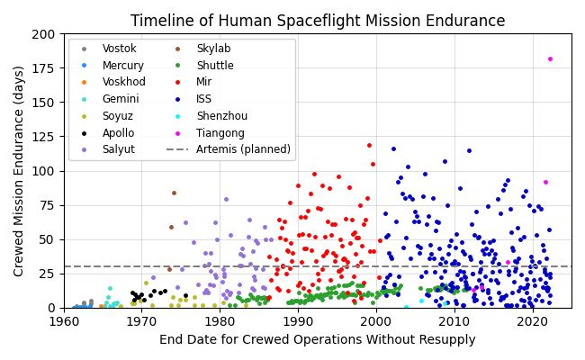
Figure 1: Timeline of historical human spaceflight mission endurance, defined as the time between launch and landing for sortie missions and time between docking events for crewed space stations. X-axis value corresponds to the end date of the associated operating period. Includes all human spaceflights up to April 18, 2022. Adapted and updated from Owens 2019.³

Uncrewed Durations
ABC systems will experience an extended uncrewed period of approximately 335 days between crewed missions.¹ During this dormant period, crew will not be available to perform maintenance. The system will have to maintain itself through some combination of reliability, redundancy, robotic maintenance capability (automated or teleoperated), or other strategy. Under the current typical human spaceflight operations paradigm, logistics can be delivered to a spacecraft while the crew is not present, but crew presence is required to transfer those logistics items into the spacecraft and utilize them for repairs. As a result, while supportability can be handled at least in part via logistics delivery and maintenance activities during a crewed period, uncrewed periods require system reliability and redundancy, which must be designed into the system from the beginning. This paradigm may be upended by advanced strategies, such as a robotic maintenance capability, but it is unclear whether such technology will be available and validated prior to the Artemis missions. For ABC, this means that elements such as the Surface Habitat or Pressurized Rover will likely need to be designed to include required redundancy to support operations through uncrewed periods with an acceptable level of risk mitigation. Some systems, particularly Environmental Control and Life Support Systems (ECLSS), may be able to enter completely dormant modes during uncrewed operations,^{23,24} which will likely reduce risk of failure and associated supportability requirements. Other systems, particularly power and thermal control, must operate throughout the uncrewed period to preserve the habitat for the next crew.
Figure 2 shows the sequence of crewed and uncrewed durations for all historical and current sustained human spacecraft, including space stations from the Salyut,^{8,10} Skylab,^{9,11} Mir,^{8,10} ISS,^{4,12,13,25} and Tiangong^{9,14–21,26–29}
programs, alongside a notional ABC timeline.¹ Figure 3 shows a timeline of historical uncrewed periods (the red bars in Figure 2) in comparison to the planned ABC mission uncrewed dormant period of approximately 335 days.¹ Note that the term “sustained human spacecraft” is used to refer to any spacecraft that is reused on multiple occasions during its operating lifetime. Sustained human spacecraft may experience alternating crewed and uncrewed periods (e.g., Skylab), or they may remain continuously occupied with regular handoffs between different crews (e.g., the past two decades of ISS operations). While all past and current sustained human spacecraft have been space stations, ABC is not a space station in the common sense of the term and therefore a more generic term is required. Brief uncrewed durations while a crew performs Extravehicular Activity (EVA) in the vicinity of the spacecraft are not included. No human spacecraft have experienced extended (multi-day) uncrewed periods beyond LEO. The Apollo Lunar Modules (LMs) were left uncrewed for a few hours at a time during surface EVAs, but the longest of these was just over 7.5 hours on Apollo 17.³⁰
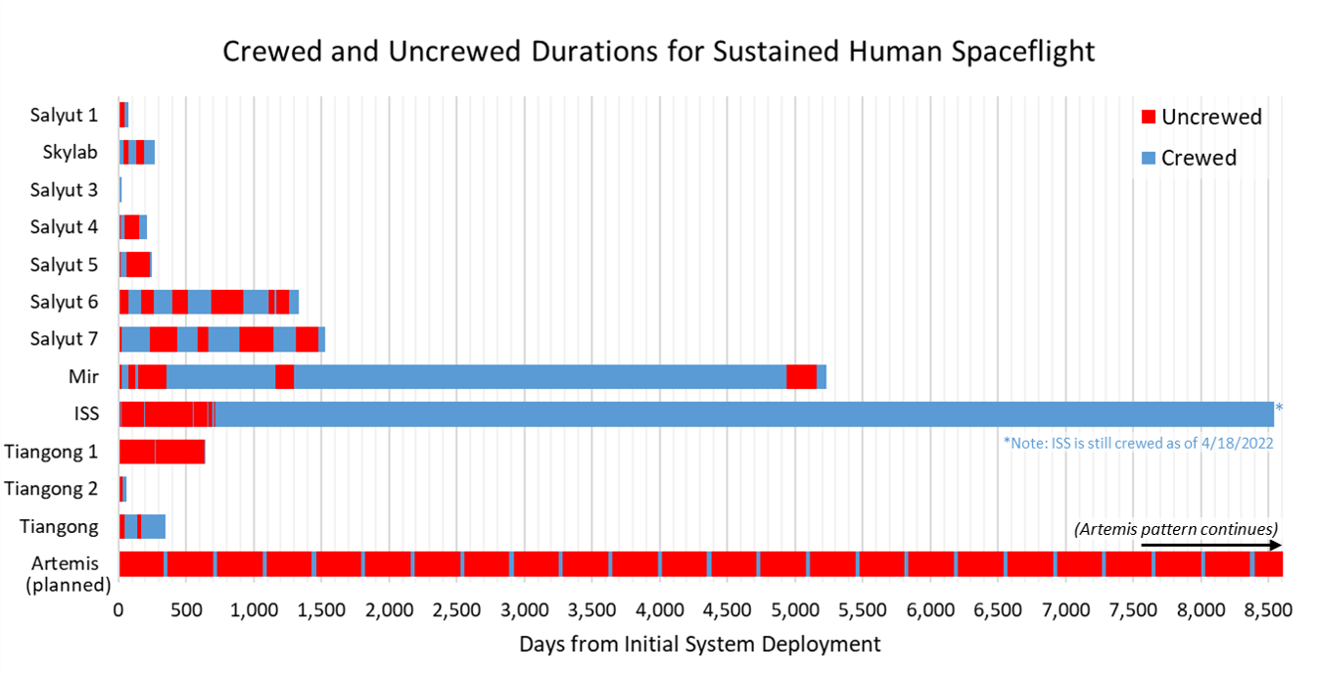
Figure 2: Crewed and uncrewed durations for historical sustained human spacecraft in comparison to the Artemis plan. Spacecraft are listed chronologically from top to bottom in order of deployment. Uncrewed periods during brief EVAs or immediately preceding station reentry are not included. Note that the ISS is still crewed as of April 18, 2022, and therefore the last crewed duration shown here is ongoing.

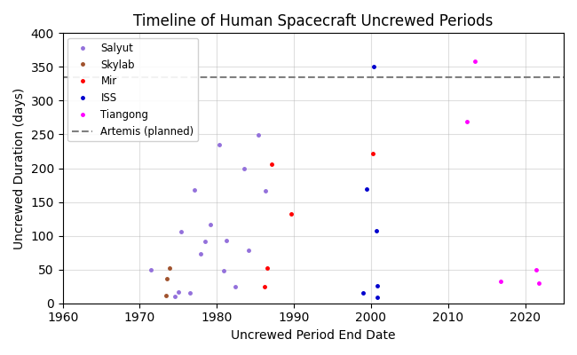
Figure 3: Timeline of historical uncrewed periods for human spacecraft, defined as a period of time that an otherwise crewed spacecraft (such as a space station) is uncrewed, including the period between initial deployment and first crew arrival. Uncrewed periods during EVAs or immediately preceding station reentry are not included. The x-axis value corresponds to the end date of the associated operating period. Includes data from all crewed spacecraft up to April 18, 2022.

Only two sustained human spacecraft have experienced uncrewed periods greater than 335 days. Tiangong 1 holds the record for the longest uncrewed period for a crewed spacecraft, at 359 days between the departure of Shenzhou 9 in 2012 and the arrival of Shenzhou 10 in 2013. The ISS was uncrewed for approximately 350 days between the departure of STS-96 in 1999 and the arrival of STS-101 in 2000. However, this uncrewed period occurred during station assembly, when full ECLSS functionality was not yet implemented.²⁴ Tiangong 1 only hosted two crews (Shenzhou 9 and 10), and it is unclear what level of ECLSS or other functionality were implemented at that time. In contrast, ABC will experience dormancy of similar length on a recurring basis as a fully operational system, for years on end. The next two longest uncrewed durations in history are the time between system deployment and first crew arrival on Tiangong 1 (269 days)^{9,27} and the time between the departure of Soyuz-T 11 and arrival of Soyuz-T 13 on Salyut 7 (249 days).^{8,10} Therefore, while the uncrewed durations that will be experienced by ABC are not unprecedented, they do represent the third-longest uncrewed duration in human spaceflight experience (longer than the next-longest uncrewed duration by over two months), and they will occur regularly as part of nominal system operations.

Transportation Overhead
Transportation to and from the Moon—particularly the lunar surface—is more challenging than transportation to and from LEO. While the ISS orbits at an average altitude of approximately 400 km,⁴ the Moon is over 950 times farther away on average, with the distance ranging from approximately 363,300 km to 405,500 km as it orbits the Earth.⁹ While crew and cargo can travel between the Earth and LEO in hours, travel between the Earth and the Moon takes days. In addition, more energy is required per kilogram of logistics for transportation to cislunar space and landing on the lunar surface. This increased energy requirement translates to increased propellant requirements, and as a result the payload capacity of launch vehicles is much smaller for the Moon than for LEO. For example, the SpaceX Falcon 9 advertises a payload mass capacity of 22,800 kg to LEO, but the payload capability to a Geostationary Transfer Orbit (GTO) is 8,300 kg, or just over 36% of the capacity to LEO.³¹ Once reaching GTO, a spacecraft would still have to expend additional propellant to maneuver to and land on the Moon, and therefore this number is higher than useful payload mass delivered to the lunar surface. The specific differences in propellant mass requirements and payload mass capabilities depend on a variety of vehicle and trajectory design decisions that are beyond the scope of this paper, but in general it is more difficult and time-consuming to transport systems, logistics, and crew to the Moon than it is to transport them to LEO.
While LEO logistics can be delivered via rendezvous and docking in a microgravity environment, lunar surface logistics transfer occurs in a partial gravity environment. Logistics must first be landed on the lunar surface, then transferred from that lander into the habitat or other surface element. In order to avoid damage to existing surface assets, lunar landers typically land some distance away from existing assets, and therefore logistics must be transported across the surface to other elements rather than passed through the hatch of two docked vehicles after landing. As a result, lunar surface logistics incur the overhead associated with a lander and any surface elements required for transportation in addition to the general packaging and launch overhead associated with LEO logistics. The specific transfer and packaging overhead will depend on vehicle design decisions that are beyond the scope of this paper, but logistics transfer in a partial gravity lunar surface environment will be more difficult and complex than logistics transfer in LEO.

Access to Abort
The transportation challenges described above apply to abort as well as resupply. In LEO, the crew are relatively close to home. If something goes wrong—such as system failure or a medical emergency—they can return to Earth relatively quickly by boarding a return spacecraft, deorbiting, and reentering. In contrast, abort from the lunar surface requires an ascent from the lunar surface and transit from cislunar space to Earth before deorbiting and reentering the Earth’s atmosphere. Where a LEO abort system can effectively fall back to Earth, a lunar surface abort system must first achieve orbit. In addition, transit to and from the Moon takes longer than transit to and from LEO. As a result, it will take longer for a crew to return home after an abort, and abort may be a less effective approach for mitigating time-critical hazards.
Table 1: Summary of historical human spaceflight post-launch aborts.
Date | Mission / Vehicle | Location / Mission Phase | Description and References
3/16/1966 | Gemini 8 | LEO | A stuck thruster on the Orbit Altitude and Maneuver System (OAMS) caused the spacecraft to spin rapidly, and crew were forced to use the Reentry Control System (RCS) thrusters to stabilize the spacecraft. The depletion of RCS fuel triggered an abort to Earth.^{8,9,34}
4/14/1970 | Apollo 13 | Cislunar Space | An oxygen tank explosion damaged the spacecraft after translunar injection, forcing an abort via a free-return trajectory around the Moon.^{9,30,35}
4/24/1971 | Soyuz 10 | LEO | Docking system failure prevented Soyuz crew from entering Salyut 1. Limited resources aboard the Soyuz forced an abort to Earth.^{5,8}
8/28/1974 | Soyuz 15 | LEO | Docking system failure prevented Soyuz crew from entering Salyut 3. Limited resources aboard the Soyuz forced an abort to Earth.⁸
4/5/1975 | Soyuz 18a | Ascent | Stage separation failure during ascent triggered automatic separation of the Soyuz from the launch vehicle and return to Earth. Also known as “the April 5 Anomaly.”⁸
10/16/1976 | Soyuz 23 | LEO | Docking system failure prevented Soyuz crew from entering Salyut 5. Limited resources aboard the Soyuz forced an abort to Earth.⁸
10/11/1977 | Soyuz 25 | LEO | Docking system failure prevented Soyuz crew from entering Salyut 6. Limited resources aboard the Soyuz forced an abort to Earth.⁸
4/12/1979 | Soyuz 33 | LEO | Engine failure prevented docking with Salyut 6. Limited resources aboard the Soyuz forced an abort to Earth.⁸
11/12/1981 | STS-2 | LEO | Fuel cell failure after achieving orbit resulted in shortened mission duration from just over 5 days to just over 2 days.^{8,33}
4/22/1983 | Soyuz-T 8 | LEO | Failure to dock with Salyut 7. Excess propellant consumed by multiple docking attempts triggered an abort to Earth.⁸
7/29/1985 | STS-51-F | Ascent | Sensor failure caused premature shutdown of one of the three main engines. An abort to orbit was called, and the Shuttle was able to carry out a replanned mission in a lower orbit.^{12,33}
11/21/1985 | Soyuz-T 14 | LEO | Medical evacuation from Salyut 7.⁸
7/30/1987 | Soyuz-TM 2 | LEO | Medical evacuation from Mir.⁸
10/11/2018 | Soyuz MS-10 | Ascent | Launch vehicle failure triggered separation of the Soyuz and abort to Earth.³²

Table 1 list all successful post-launch abort events in human spaceflight history as of April 18, 2022 and provides the date, mission, location or mission phase, and description for each case. In-flight loss of crew events are not included in this list. Over six decades of human spaceflight, fourteen crewed missions have called an abort of some kind after launch and returned home safely. Three of these aborts occurred during ascent: the launch abort systems on Soyuz 18a and Soyuz MS-10 were triggered to pull the crew away from a launch vehicle failure and return them to the ground,^{8,32} and a premature engine shutdown on STS-51-F triggered an abort to orbit.^{12,33} Ten mission aborts have occurred in LEO, six of which were caused by docking failures during the Salyut program in the 1970s and 1980s.^{5,8} Two LEO aborts were related to medical emergencies,⁸ and two were driven by system failures.^{8,9,33,34} Specific durations between abort and crew return were not readily available for all cases, but in general aborts during ascent can return the crew to the ground within an hour, and aborts from LEO can return crew within a few hours.
Only one crewed mission has experienced an abort beyond LEO. An oxygen tank explosion crippled the Apollo 13 spacecraft just over two days after translunar injection on April 14, 1970. A few hours later and approximately 349,000 km away from Earth, the crew used the LM descent engine to abort the mission and place the spacecraft on a free-return trajectory around the Moon. The crew safely reentered the Earth’s atmosphere just over three days later. Apollo 13 holds the record for the most distant abort and the farthest distance from Earth achieved by any crewed mission: 400,171 km.^{9,30,35} There have been no crewed aborts from the lunar surface or any surface environment other than Earth.
In addition to the post-launch aborts listed above, crewed missions have experienced a variety of pre-launch delays and aborts that are not reviewed in detail here. One dramatic incident in particular is the pad abort of Soyuz-T 10a on September 26, 1983, when the launch escape system was used to pull the Soyuz vehicle to safety after the booster vehicle caught fire just before launch. The booster exploded moments later, destroying the launch pad that had launched the first artificial satellite and the first human into space.⁸
All Earth-based pre-launch abort strategies rely on the fact that the crew is, by default, in or close to a relatively safe and habitable environment. In the event of a hazard from the launch vehicle itself, as was the case for Soyuz-T 10a, a launch escape system can focus on placing distance between the crew and the launch vehicle. If an abort is triggered by a vehicle malfunction that does not cause an immediate hazard, the crew may disembark if needed and attempt the launch at a later time. In contrast, crews on the lunar surface depend on spacecraft systems and logistics for survival. A launch abort during ascent from the lunar surface would simply return the crew to the lunar surface; without additional assets to sustain the crew until a rescue vehicle can arrive, or to enable a second launch attempt, a return to the lunar surface does not provide meaningful risk reduction.
In general, abort from the lunar surface is more difficult and may not provide the same level of risk mitigation as LEO abort capability. When abort capabilities are diminished in this way, other supportability strategies must be utilized to ensure safe operations. Spares and maintenance plans will need to be more conservative, reliability must be better understood and verified, and other contingency options, such as “safe haven” (or abort to some safe location other than Earth) may need to be explored. However, the benefits provided by alternative options should be carefully weighed against the cost and operational impacts of those options in the context of the increased transportation overhead described in Section II.C.

Implications for Mars Missions
Lunar surface operations are more challenging than LEO operations, and crewed missions to Mars will be even more challenging. LEO missions occur in Earth orbit, and lunar missions occur on or around a body that is itself orbiting the Earth. As a result, the distance between Earth and the exploration destination are relatively stable. As noted in Section II.C, the ISS (a representative LEO space station) orbits at an altitude of approximately 400km.⁴ The Moon orbits the Earth at a range of 363,300 km to 405,500 km.⁹ In contrast, Mars and the Earth both orbit the Sun. As a result, the distance between the two varies from approximately 56,000,000 km to 400,000,000 km as the planets move relative to each other.³⁶ Crew and cargo can move between Earth and LEO in a few hours, and between Earth and the Moon in a few days—and can do so fairly regularly. In contrast, transportation to and from Mars requires months.
Moreover, Earth-Mars transit options are heavily constrained by the orbital mechanics of interplanetary travel. Low-energy transit opportunities, which reduce propellant requirements, occur in approximately 26-month intervals, and have total mission endurances ranging from 900 to 1,200 days. Faster, high-energy trajectories are available more frequently and have total mission endurances ranging from 700 to 800 days, but typically require more propellant. In both cases, the specific amount of energy (and therefore propellant) required for the journey varies based on system and trajectory design decisions that are beyond the scope of this paper, but in general propellant mass requirements grow exponentially as mission duration decreases,³⁷ and transportation overhead tends to be much higher for Mars missions than for missions to the Moon. The interplanetary nature of Mars missions also means that abort and resupply options are much more limited relative to LEO or lunar missions, because the relative positions of Earth and Mars are changing constantly and therefore energy requirements are heavily dependent on timing.
Figure 4 shows the historical mission endurances from Figure 1 in comparison to the range of Mars mission endurances. Crewed Mars missions will require a mission endurance of 4 to 6.5 times longer than the longest crewed mission endurance to date. The shorter end of that endurance range will be more difficult from a transportation system perspective than the longer end. For context, the entire Space Shuttle Program logged just over 1,334 days in space, just 11% longer than a low-energy Mars mission.²²
One of the rationales of the ABC approach is “to operationally and scientifically prepare… for the first human mission to Mars.”¹ As a result, the system architecture, concept of operations, and design decisions made for Artemis have implications for future Mars missions. The Artemis missions will be the first human spaceflight operations in a dusty, partial-gravity, surface environment in half a century. A new generation of systems and concepts of operations will need to be validated to inform Mars surface exploration. Similar to terrestrial ship sea trials near a home port, operations on the Moon provide an excellent opportunity to gain experience in a challenging environment without jumping immediately to the unprecedented high-risk environment of a logistically isolated Mars mission with limited access to abort. The experience gained on the Moon will help reduce risk, uncover unknown unknowns, and identify opportunities for improvement of Mars systems.
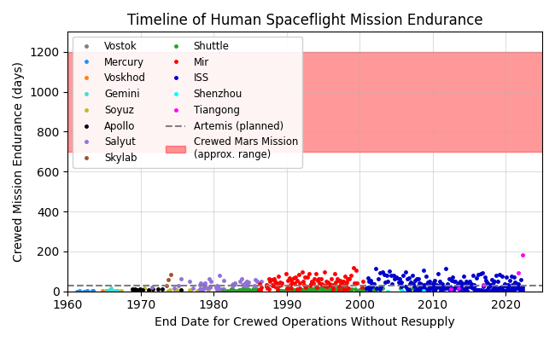
Figure 4: Timeline of historical human spaceflight mission endurance in comparison to the approximate range of crewed Mars mission endurances. Includes all human spaceflights up to April 18, 2022.

However, Artemis activities only provide value to Mars missions to the extent that the systems and techniques used during those missions reflect those that will be used for Mars missions. ABC can only provide valuable test data and operational experience on key systems for future Mars missions if those systems are included in the ABC architecture. Similarly, Artemis activities only mitigate risks for Mars to the extent that the systems are exercised in a Mars-like operating framework. As Figure 4 indicates, the baseline ABC surface crewed endurance is much shorter than the crewed endurance required for Mars missions. Longer Mars analog missions are planned that will use a combination of Gateway, lunar surface assets, and the Mars Transit Habitat to examine human health and performance, crew autonomy, and system performance for Mars missions.¹ If these longer missions simulate logistical isolation as well as long flight durations, they will provide an opportunity to reduce the gap between current crewed mission endurance experience and the mission endurance required for Mars.
The Moon is still close enough to home that—with appropriate precautions, contingency plans, and risk mitigation—ABC missions can be more aggressive in trying new technology, new strategies, and new concepts of operations than a Mars mission (though still less aggressive than LEO). The most effective means to validate new approaches is to operate in the field, and ABC provides a valuable proving ground for that purpose. There are differences between the Moon and Mars, and it is not reasonable to expect that Artemis activities will remove all risks for future Mars exploration. However, they will provide important data to examine potential strategies and guide system and operations development. If a new approach works, ABC operations help validate it and reduce risk and uncertainty for Mars missions. If an approach doesn’t work, consequences can be mitigated through logistics resupply or abort and lessons can be learned. Either way, ABC will enable more informed Mars mission planning.

Conclusions and Future Work
The Artemis missions will be the first human landing on the Moon in over 50 years. A sustained ABC will face greater challenges than current LEO operations and past Apollo missions, and these challenges require a shift in design and operations mindset from the approach that has been used successfully for the ISS for decades. An even greater shift will be required for crewed missions to Mars, and ABC provides a valuable proving ground to test new approaches to human spaceflight in a relatively safe environment. This paper provides an overview of key challenges of sustained lunar operations from a supportability and logistics perspective, focusing on crewed endurance, uncrewed duration, transportation overhead, and access to abort. The additional challenges of crewed Mars missions, as well as the implications of ABC activities for Mars mission planning, are also discussed.
A history of human spaceflight experience in terms of crewed and uncrewed mission endurance, as well as mission abort, are also presented to provide context for future exploration challenges. When considering this context, it is important to keep in mind that current and historical space operations are driven by a variety of changing political, strategic, and economic factors emphasizing some objectives over others, potentially for nontechnical reasons. For example, the fact that the longest period of time that a crew aboard the ISS has gone without resupply is 116 days does not mean that the ISS cannot go without resupply for longer, only that it has not. Comparison to the past can help inform estimates of the difficulty of planned future activities, but the feasibility of a particular mission is not dependent on the existence of relevant past experience. If that were the case, no new records would ever be set, and no new frontiers would ever be explored. Human exploration is fundamentally the process of expanding capabilities, performing missions that go beyond past experience, and making possible that which was not previously possible. None of the challenges described in this paper are insurmountable, but deliberate and careful effort will be required to adapt to the lunar and Mars operating environments and ensure safe and cost-effective human exploration beyond LEO.
The historical datasets and discussion presented in this paper are a starting point for broader exploration of supportability challenges of future missions relative to past experience. Good analysis is data-driven; the history of spaceflight operations is a key source of data that should inform all mission analysis. Future work will expand on the work presented here by performing sensitivity analysis, using integrated system models to explore the impacts of these factors—crewed endurance, uncrewed duration, transportation overhead, and access to abort—in a quantitative manner. This analysis will explore the mass, cost, and risk implications of various architectures under current best estimates of technology performance and reliability. Quantitative models will also be used to explore the relationship between mission-level figures of merit and technology parameters to identify technology development targets and inform investment and testing activities.

Acknowledgments
The authors would like to thank Patrick Chai (Space Mission Analysis Branch, NASA Langley Research Center) for advice and input on transportation overhead considerations.

References
¹HEOMD Strategic Campaign Operations Plan for Exploration. Publication HEOMD-007. National Aeronautics and Space Administration, 2021.
²Do, S. Towards Earth Independence - Tradespace Exploration of Long-Duration Crewed Mars Surface System Architectures. Doctoral Thesis. Massachusetts Institute of Technology, Cambridge, MA, 2016.
³Owens, A. Multiobjective Optimization of Crewed Spacecraft Supportability Strategies. Doctoral Thesis. Massachusetts Institute of Technology, Cambridge, MA, 2019.
⁴Reference Guide to the International Space Station. Publication NP-2010-09-682-HQ. National Aeronautics and Space Administration, Washington, DC, 2010.
⁵Siddiqi, A. A. Challenge to Apollo: The Soviet Union and the Space Race, 1945-1974. NASA History Division, Office of Policy and Plans, NASA Headquarters, Washington, DC, 2000.
⁶Dunbar, B. “Mercury Crewed Flights Summary.” Project Mercury. https://www.nasa.gov/mission_pages/mercury/missions/manned_flights.html. Accessed Apr. 12, 2022. National Aeronautics and Space Administration. November 30, 2006.
⁷Williams, D. R. “The Gemini Program (1962-1966).” https://nssdc.gsfc.nasa.gov/planetary/gemini.html. Accessed Apr. 12, 2022. National Aeronautics and Space Administration. December 30, 2004.
⁸Portree, D. S. F. Mir Hardware Heritage. Publication NASA RP 1357. Information Services Division, Lyndon B. Johnson Space Center, Houston, TX, 1995.
⁹Williams, D. R., and Bell II, E. “NASA Space Science Data Coordinated Archive.” https://nssdc.gsfc.nasa.gov/. Accessed April 18, 2022. National Aeronautics and Space Administration, September 26, 2018.
¹⁰Harland, D. M. The Story of Space Station Mir. Springer; Published in association with Praxis Publishing, Berlin; New York: Chichester, UK, 2005.
¹¹Dunbar, B. “The Skylab Crewed Missions.” https://www.nasa.gov/mission_pages/skylab/missions/skylab_manned.html. Accessed February 8, 2022. National Aeronautics and Space Administration, May 06, 2013.
¹²Kauderer, A. “Space Shuttle Mission Archives.” https://www.nasa.gov/mission_pages/shuttle/shuttlemissions/index.html. Accessed February 8, 2022. National Aeronautics and Space Administration, August 2011.
¹³Garcia, M. “Visiting Vehicle Launches, Arrivals and Departures.” National Aeronautics and Space Administration. https://www.nasa.gov/feature/visiting-vehicle-launches-arrivals-and-departures. Accessed Apr. 12, 2022.
¹⁴Gregersen, E. “Shenzhou.” https://www.britannica.com/technology/Shenzhou. Accessed April 14, 2022. Encyclopedia Britannica, Jun 23, 2021.
¹⁵Gregersen, E. “Tiangong.” https://www.britannica.com/technology/Tiangong. Accessed April 14, 2022. Encyclopedia Britannica, Jun 23, 2021.
¹⁶“China’s Shenzhou-9 Spacecraft Returns to Earth.” https://www.bbc.com/news/world-asia-china-18636819. Accessed April 12, 2022. BBC News, Jun 29, 2012.
¹⁷Reichhardt, T. “The Flight of Shenzhou-10.” https://www.smithsonianmag.com/air-space-magazine/the-flight-of-shenzhou-10-97718526/. Accessed April 14, 2022. Air & Space Magazine, Jun 10, 2013.
¹⁸Clark, S. “Two Chinese Astronauts Back on Earth.” https://spaceflightnow.com/2016/11/18/shenzhou-11-landing/. Accessed April 14, 2022. Spaceflight Now, Nov 18, 2016.
¹⁹Garcia, C., and Wang, S. “Chinese Astronauts Board Space Station Module in Historic Mission.” https://www.reuters.com/world/china/china-launches-crewed-spacecraft-shenzhou-12-historic-mission-2021-06-17/. Accessed April 14, 2022. Reuters, Jun 18, 2021.
²⁰Jones, A. “China’s Shenzhou 13 Crew Takes Its First Spacewalk, the Country’s 1st by a Female Astronaut.” https://www.space.com/china-shenzhou-13-first-female-spacewalk. Accessed April 14, 2022. Space.com, Nov 07, 2021.
²¹Wall, M. “China’s Shenzhou 13 Capsule Lands with Crew of 3 after Record-Setting Mission.” https://www.space.com/china-shenzhou-13-astronauts-landing-returns-to-earth. Accessed April 18, 2022. Space.com, Apr 15, 2022.
²²“Space Shuttle Era Facts.” https://www.nasa.gov/pdf/566250main_SHUTTLE%20ERA%20FACTS_040412.pdf. Accessed April 16, 2022. National Aeronautics and Space Administration, 2012.
²³Carter, D. L., Tabb, D., and Anderson, M. “Water Recovery System Architecture and Operational Concepts to Accommodate Dormancy.” 47th International Conference on Environmental Systems, Charleston, SC, 2017. ICES-2016-043.
²⁴Sargusingh, M. J., and Perry, J. L. “Considering Intermittent Dormancy in an Advanced Life Support Systems Architecture.” AIAA SPACE and Astronautics Forum and Exposition, Orlando, FL, 2017. AIAA 2017-5216.
²⁵“History and Timeline of the ISS.” ISS National Laboratory. https://www.issnationallab.org/about/iss-timeline/. Accessed Apr. 14, 2022.
²⁶Jones, A. “Shenzhou-12 Astronauts Return to Earth after 3-Month Space Station Mission.” https://spacenews.com/shenzhou-12-astronauts-return-to-earth-after-3-month-space-station-mission/. Accessed April 14, 2022. SpaceNews, Sep 17, 2021.
²⁷“Shenzhou 9: China’s 1st Manned Space Docking Mission (Pictures).” https://www.space.com/16096-china-space-docking-shenzhou-9-gallery.html. Accessed April 14, 2022. Space.com, Jun 28, 2012.
²⁸“Photos: China’s Shenzhou 10 Space Mission in Pictures.” https://www.space.com/21506-china-shenzhou-10-mission-photos.html. Accessed April 14, 2022. Space.com, Jun 26, 2013.
²⁹Clark, S. “Assembly of Chinese Space Station Begins with Successful Core Module Launch.” https://spaceflightnow.com/2021/04/29/assembly-of-chinese-space-station-begins-with-successful-core-module-launch/. Accessed April 14, 2022. Spaceflight Now, Apr 29, 2021.
³⁰Orloff, R. W. Apollo by the Numbers: A Statistical Reference. NASA History Division, Office of Policy and Plans, NASA Headquarters, Washington, DC, 2000.
³¹“Falcon 9.” SpaceX. https://www.spacex.com/vehicles/falcon-9/. Accessed Apr. 16, 2022.
³²Harwood, W. “Soyuz Crew Lands Safely after Emergency Launch Abort.” https://spaceflightnow.com/2018/10/11/soyuz-crew-lands-safely-after-emergency-launch-abort/. Accessed April 14, 2022. Spaceflight Now, Oct 11, 2018.
³³Legler, R. D., and Bennett, F. V. Space Shuttle Missions Summary. Publication NASA/TM-2011-216142. NASA Johnson Space Center, Houston, TX, 2011.
³⁴Hacker, B. C., and Grimwood, J. M. On the Shoulders of Titans: A History of Project Gemini. Scientific and Technical Information Office, National Aeronautics and Space Administration, Washington, DC, 1977.
³⁵Report of Apollo 13 Review Board. National Aeronautics and Space Administration, Washington, DC, 1970.
³⁶Belton, M. J. S., Carr, M. H., and Malin, M. C. “Mars.” https://www.britannica.com/place/Mars-planet. Accessed April 18, 2022. Encyclopedia Britannica, Apr 11, 2022.
³⁷Chai, P., Qu, M., and Saputra, B. “Human Mars Mission In-Space Transportation Sensitivity for Nuclear Electric / Chemical Hybrid Propulsion.” AIAA Propulsion and Energy 2021 Forum, Virtual Event, 2021. AIAA 2021-3237.

Aerospace Engineer, Space Mission Analysis Branch, 1 N. Dryden St. MS 462.
Senior Researcher, Space Mission Analysis Branch, 1 N. Dryden St. MS 462.
Vice President / Chief Scientist, 77 S. Washington St.
Aerospace Engineer, 77 S. Washington St.

