Haiti Agriculture

Utilizing NASA Earth Observations to Evaluate the Success of Reforestation Practices in Haiti

**Technical Report**

Final Draft – March 31st, 2022

Kelli Roberts (Project Co-Lead)

Taylor Simkins (Project Co-Lead)

Ilan Bubb

Nohemi Huanca-Nunez

***Advisor:***

Dr. Marguerite Madden, University of Georgia, Center for Geospatial Research (Science Advisor)

# 1. Abstract

Haiti is one of the world’s most deforested and environmentally degraded countries. Over the past 30 years, the Haiti Reforestation Partnership (HRP) has provided resources, education, and expertise to support reforestation work in Haiti. The HRP has planted over 15 million trees through their partnership with Comprehensive Development Program (CODEP). However, they have yet to conduct a comprehensive analysis of forest stand survival. The NASA DEVELOP team partnered with the HRP to aid their future silvicultural decisions using satellite imagery. Through the creation of the Monitoring of Vegetation Presence (MVP) tool in Google Earth Engine, the team produced a time series showing trends in enhanced vegetation index (EVI) from 1984 to 2021, as well as a habitat suitability map using a general model for all tree species. These provided the partner with visuals to communicate their reforestation efforts and guidance on where to apply their future efforts. The team utilized Landsat 5 Thematic Mapper (TM), Landsat 7 Enhanced Thematic Mapper Plus (ETM+), Landsat 8 Operational Land Imager (OLI), Landsat 9 OLI-2 and Sentinel-2 Multispectral Instrument (MSI) vegetation indices as indicators of stand success over time. The team also incorporated WorldClim bioclimatic variables such as precipitation and temperature, Centre National de L’Information Geo-Spatiale (CNIGS) Airborne Lidar elevation, and ancillary datasets areas suitable for future reforestation efforts. Overall, the time series showed that the demonstration forest increased in EVI at a greater rate than the surrounding area and the habitat model suggested there are 49,000 hectares of suitable habitat for planting using slope, aspect and temperature as predictor variables.

**Key Terms**

stand survival, habitat suitability, NDVI, EVI, time series analysis, Google Earth Engine, forestry

# 2. Introduction

***2.1 Background Information***

Haiti was once a country blanketed with tropical forests. However, after centuries of European colonization, the forest was reduced to only 6.7 percent of the land by 1978, with particularly high fragmentation along watersheds (Lewis & Coffey, 1985). These historical events, followed by the lack of environmental regulation on Haiti’s forests, has resulted in Haiti becoming one of the world’s most deforested and environmentally degraded countries (Posner et al., 2010, Tarter et al., 2018, Hedges et al., 2018). Nowadays, Haiti experiences frequent severe weather conditions such as drought, flooding, earthquakes, and cyclones, which can also reduce forested areas, affecting Haitians’ food supply, energy reserves, and sources of income (Rodrigues-Eklund et al., 2021).

Reforestation in strategic areas can influence local and regional climate responses while reducing the land’s vulnerability to weather disasters through improvements in soil moisture, nutrient content, and erodibility (Locatelli et al., 2015). To date, a comprehensive reforestation analysis has yet to be conducted within Haiti. The utilization of satellite imagery offers near real time monitoring without the logistical difficulty of conducting field work in Haiti’s terrain. This allows land changes to be more easily identified, providing context for analysis to influence long term change. For example, through the use of Landsat imagery, Pauleus & Aide (2020) estimated that forest cover in Haiti declined from 26% to 21% over the course of five years, suggesting the development of classification models to identify specific land change patterns. These models provide representations of land cover that serve as a warning to the patterns of destructive land use. Two satellite-sourced measurements that are particularly useful are the Normalized Difference Vegetation Index (NDVI) and the Enhanced Vegetation Index (EVI), which can indicate vegetation presence. Researchers have successfully found statistical distinctions when comparing pre- and post-restoration NDVI and EVI values on Eastern Oregon ranch watersheds over a 33-year time period (Hausner et al., 2018). The analysis of environmental variables such slope, precipitation, or temperature in correlation with vegetation presence or change can allow the DEVELOP team to model suitable areas (e.g.,higher stand success) for future reforestation efforts.

***2.2 Project Partners & Objectives***

The Haiti Reforestation Partnership (HRP) has provided resources, education, and expertise to support reforestation work in Haiti for the past 30-years. The Comprehensive Development Program (CODEP), a community group of Haitian rural neighborhoods actively creating a prosperous community through reforestation techniques, are at the heart of the HRP’s efforts. Together, CODEP and the HRP have planted 15.52 million trees to date with an estimated survival success of 12 million (Haiti Reforestation Partnership, 2022). The HRP partnered with NASA DEVELOP to aid their future silvicultural decisions. By providing historical context to present-day reforestation efforts using satellite imagery, the NASA DEVELOP team pinpointed the conditions behind their success and minimize potential tree loss. The team created a tool in Google Earth Engine (GEE) that analyzed past- and present-day patterns of stand success in the form of vegetation indices, and additionally produced a 37-year time series chart and 17-year animation from vegetation indices to visually display the impacts of the HRP’s reforestation efforts. To guide future restoration efforts, the team produced a Habitat Suitability Model (HSM) that correlates environmental predictors with forest growth. These data will allow the HRP to identify new locations that have similar environmental characteristics to the locations that have had successful restoration.

***2.3 Study Area***

The area selected for study was in Fondwa, a small village to the southwest of Port-au-Prince, along the Jacmel Road in the mountains above Leogane, Haiti. Landlords, referred to as Animators, have hosted revegetation efforts to restore forest cover in a relatively bare location. A lack of data tracking over 30 years has resulted in a degree of uncertainty regarding exact planting locations. The HRP approximates that 75% of all planting efforts have taken place within the provided GPS points walked by previous HRP volunteers. The team divided these zones into seven planting areas of roughly equal size based on land ownership provided by the HRP, as well as a demonstration forest. The demonstration forest represents decades of pinpointed effort from the HRP to show what is possible with reforestation that has been consistently managed from the start. Figure 1 shows the study area selected for this project, including where each planting area is located in Haiti. Climate in the area can range from tropical to semi-arid from December to February, with another period of decreased rain in June and July. The rainy seasons typically extend from March to early June, and from August through November. Additionally, this location is in the midst of hilly terrain that makes travel and environmental monitoring difficult.

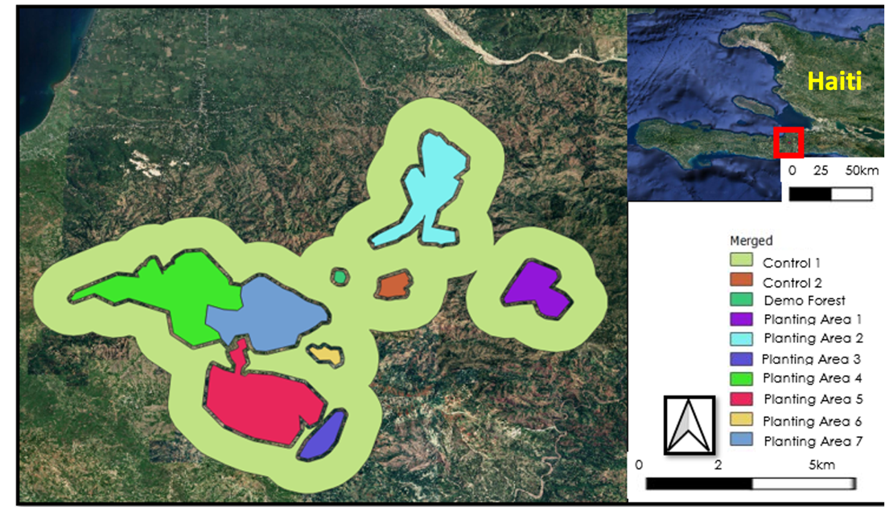

Figure 1. Map of Haiti (top right) zoomed in to show the selected study area (left) with each planting area indicated.

# 3. Methodology

***3.1 Data Acquisition***

In this project, the team utilized Landsat 9 Operational Land Imager 2 (OLI-2), Landsat 8 OLI, , Landsat 7 Enhanced Thematic Mapper Plus (ETM+), Landsat 5 Thematic Mapper (TM), and Sentinel-2 Multispectral Instrument (MSI) imagery to construct an EVI time series of the HRP study area. To determine this study area, the HRP provided shapefile data containing the boundaries of the Animator planting areas. Along with this shapefile, the Digital Chart of the World Server identified Haiti Administrative Boundaries provided geographical context to this area. The team also used WorldClim temperature data and the Centre National de L’Information Geo-Spatiale (CNIGS) digital elevation model (DEM) data to build the HSM (Table 1). The team’s initial analysis included Global Precipitation Measurement Integrated Multi-satellitE Retrievals for GPM (GPM IMERG), and Soil Moisture Active Passive (SMAP) L-Band Radiometer imagery. Lastly, the Hansen Global Forest Change dataset validated and identified locations for high resolution maps of forest stand success, as well as analyzed forest cover loss in Haiti.

Table 1. *List of sensors and data products*

|  |  |  |  |  |
| --- | --- | --- | --- | --- |
| **Platform & Sensor** | **Parameters** | **Use** | **Date Range Used** | **Acquisition Source** |
| **Landsat 9 OLI-2** | True color composites, Normalized Difference Vegetation Index (NDVI), Enhanced Vegetation Index (EVI) | Landsat 9 OLI-2 spectral indices assessed changes in vegetative health over time and characterized environmental conditions. | October 2021 – April 2022 | GEE Collections |
| **Landsat 8 OLI** | True color composites, NDVI, EVI | Landsat 8 OLI spectral indices assessed changes in vegetative health over time and characterized environmental conditions. | April 2013 – April 2022 | GEE Collections |
| **Landsat 7 ETM+** | True color composites, NDVI, EVI | Landsat 7 ETM+ spectral indices assessed changes in vegetative health over time and characterized environmental conditions. | January 1997 – April 2022 | GEE Collections |
| **Landsat 5 TM** | True color composites, NDVI, EVI | Landsat 5 TM spectral indices assessed changes in vegetative health over time and characterized environmental conditions. | January 1992 – April 2022 | GEE Collections |
| **Sentinel-2 MSI** | True color composites, NDVI, EVI | Sentinel-2 MSI spectral indices assessed changes in vegetative health over time and characterized environmental conditions. | June 2016 – April 2022 | GEE Collections |
| **GPM IMERG** | Precipitation | GPM IMERG data provided insight into precipitation patterns that influence stand success. | June 2000 – December 2021 | GEE Collections |
| **SMAP L-Band Radiometer** | Soil moisture | SMAP L-Band Radiometer data provided insight into soil moisture patterns that influence stand success. | April 2015 – December 2021 | GEE Collections |
| **WorldClim Climatology** | Precipitation, temperature | WorldClim Climatology V1 data provided insight into precipitation and temperature patterns that influence stand success. | January 1960 – January 1991 | GEE Collections |
| **CNIGS Airborne Lidar** | Elevation | Elevation data was used as a predictor variable for habitat and to create slope and aspect variables. | January 2014 – December 2016 | OpenTopo-graphy |
| **Digital Chart of the World Server** | Geographical context | Digital Chart of the World Server provided geographical information to the area. | January 2014 – January 2016 | OpenTopo-graphy |
| **Hansen Global Forest Change** | Forest cover loss | Hansen Global Forest Change data provided insight of areas with stand success and forest loss. | January 2000 – January 2020 | GEE Collections |

***3.2 Data Processing***

*3.2.1 Control Groups*

To compare both the NDVI and EVI values of reforested areas to regions with background regeneration, the team designated one control region with similar environmental characteristics that did not have recorded planting efforts. To accomplish this, all planting areas were combined as a single polygon and buffered by 100m and then again by 1.1km. The 100m buffer was subtracted from the 1.1km buffer resulting in a polygon that is 100m separate from the planting areas. These buffers allowed for separation between the study area and one of the controls, while making this control representative of the surrounding forest with a similar environmental niche. In addition, the team chose a second control area based on the lack of vegetation in 1983, located southeast of the Demonstration Forest and within Control 1. With this control area, the team can provide a comparison to how vegetation has changed without human intervention.

*3.2.2 NDVI*

To measure the impact planting efforts had on restoring forests, the team harmonized each image collection from Landsat 5, 7, 8, and 9 satellites. Harmonization was conducted according to the methods outlined by Roy et al. (2016) using a linear transformation of ETM+ and TM imagery to match the OLI and OLI-2 imagery. This combined collection was filtered, removing any image with cloud cover greater than 50% or less than a level 9 image quality, based on the image's properties. For the remaining images, clouds were filtered out using the pixel_qa band, clipped to the study area, and restricted to years 1982 to 2022. This resulted in a total of 419 Landsat images. An NDVI band was calculated using the following equation (Rouse et al., 1974) where *NIR* is near infrared (Landsat 5, 7 band 4, Landsat 8, 9 band 5) and *Red* is visible red light (Landsat 5, 7 band 3 Landsat 8, 9 band 4):

(1)

This NDVI band was added to each image in the collection to facilitate the analysis. The team created a median true color composite image for this time period. Then, the team averaged the NDVI on a yearly basis to provide a 32-point time-series showing the years’ average NDVI value inside the Animator Zones from 1982 to 2022. On average, each year was represented by 13 images. Six years were not represented in the study due to lack of imagery fulfilling the inclusion criteria (1988, 1989, 1992, 1993, 1994, 1995).

*3.2.3 EVI*

The team utilized the Enhanced Vegetation Index for its ability to remove background and atmospheric noise that influence NDVI. To do so, EVI includes an “L” value for canopy adjustments, “C” coefficients for atmospheric resistance, and utilizes the blue light band. The same process was used to create an EVI band using the following equation where *NIR* is near infrared (Landsat 5, 7 band 4, Landsat 8, 9 Band 5), *Red* is visible red light (Landsat 5, 7 band 3 Landsat 8, 9 band 4), and *Blue* is visible blue light (Landsat 5, 7 band 1 Landsat 8, 9 band 2) (Huete et al, 2002):

(2)

The standard coefficients used by MODIS were applied where L=1, C1 = 6, C2 = 7.5, and G = 2.5. The EVI was also averaged on a yearly basis providing a 32-point time series showing the average EVI values inside the Animator zones from 1982 to 2022. Additionally, the team created a median true color EVI composite image for this time period. Six years were not represented in the study due to lack of imagery fulfilling the inclusion criteria (1988, 1989, 1992, 1993, 1994, and 1995).

*3.2.4 Visual Time Series*

A visual time series was created using GEE’s animation toolbox. The team harmonized Landsat 5 and Landsat 7 imagery over the study area, highlighting the Demonstration Forest. This animation is composed of all 32 annual NDVI maps advancing at 2 frames per second to show how vegetation has changed from 1991 to 2008.

***3.3 Data Analysis***

*3.3.1 Time Series Analysis*

To evaluate the success of the HRP’s planting, the team analyzed the average NDVI and EVI within the Demonstration Forest, the seven planting areas, and the two control areas, including a comparison of the areas designated for planting and the control areas where no record of planting has occurred. In initial testing, the team found that EVI better differentiated between bare and vegetated land and chose to only use EVI for the rest of the analysis. The team specified the study area before calculating the average yearly EVI from 1984 through 2022 utilizing Landsat 5, 7, 8, 9 and Sentinel-2 data. This analysis produced an average EVI value over the entire year, for each year, across all study sites and satellites. With this data, the team conducted a paired-t test to determine if there was a statistically significant difference in EVI values between the planting areas and the controls. Finally, this data was charted to create a visual time series showing how EVI changed over time.

The team ran a Granger causality test to compare the trends in EVI between the Landsat and Sentinel time series analyses. This proved a high correlation between the data and no significant difference was found. Any visual discrepancies in the time series were attributed to differing sensors and lack of harmonization. Ultimately, the team chose to utilize Landsat data due to lack of statistical difference. Additionally, Landsat provides data from 1982, allowing for a more comprehensive analysis of the past 30-years of reforestation efforts.

*3.3.2 Google Earth Engine Tool*

To create the tool in Google Earth Engine, the team used the same image collection generated for the EVI time series. The team built a small user interface that allows users to draw a polygon which will exact the average EVI value within the polygon for each overlapping Landsat image. This results in a chart showing the change in EVI overtime. In addition, the chart differentiates between rainy and dry seasons to demonstrate how seasonality impacts EVI, an aspect that the HRP showed interest in.

*3.3.3 Habitat Suitability Modeling*

To begin analysis for the HSM, the team defined stand success using the higher values of EVI. The team calculated the median EVI from the first and last five years of the dataset and then subtracted the first five-year median from the last five-year median to show which pixels increased the most and the least over the study period. From here, the team extracted the top 100 pixels that had increased the most and the bottom 100 pixels that had increased the least. Next, the team defined the target sample area as a 25 km2 buffer from the Demonstration Forest, to cover the highest portion of Jacmal Road. This buffer resulted in 250,000 total hectares, 189,000 of which are on land. To implement the habitat model, the team considered the following predictor variables: bioclimatic predictor variables (temperature seasonality, maximum temperature of warmest month, minimum temperature of coldest month, and annual precipitation) obtained from WorldClim BIO (Hijmans et al. 2005), and elevation, aspect, and slope processed from the CNIGS 2014-2016 DEM. The team attempted to use SMAP L-Band Radiometer data and GPM IMERG data, although the respective spatial resolutions at 10,000m and 11,132m were too coarse for the study area. With the predictors selected, the team modeled habitat using a random tree classification and a binomial regression model (BRM). While the random tree classification showed similar results, the team chose the BRM due the team’s familiarity with R and regression models. The team used an Akaike Information Criterion (AIC) (Burnham et al. 2011) to select the best model by measuring how likely one is to see the observed data in the given model. For the HSM, the lowest AIC value was selected as the best, resulting in slope, aspect, and the maximum temperature of the warmest month as the best variables to explain stand success.

Later, the coefficients ( and for the predictor variables) from the BRM were mapped onto the predictor values in GEE. These were then converted into probability with an inverse logit connector where is probability at location , is the leading coefficient, and is the value of each predictor variable. (Cramer 2010; Equations 3 & 4):

(3)

(4)

*3.3.4 Cover Forest Loss*

Additional investigations of stand survival were conducted using the Hansen et al. (2013) Global Forest Change processed dataset, which represents global forest change in a 30 m resolution between 2000 and 2020. This model shows individual tree loss over specific areas. In this dataset, trees are defined as vegetation taller than 5m in height, and forest cover loss is represented as ‘1’ if the loss happened during the year specified, while ‘0’ indicates no loss. The team explored forest cover loss and calculated the area of the loss by m2/year. The total study area covers 68,908,320m2 of land, which includes all planting areas, the demonstration forest, and the two control areas. The planting sites make up 27,486733 m2 of the total study area. The team extracted the final forest cover loss from 2000 to 2020 and mapped the change as red pixels (Figure 2).

Figure 2.Hansen et al. (2013) estimated cover loss from 2000 and 2020 for the planted sites, and for all of the areas nearby in the region.

# 4. Results & Discussion

***4.1 Analysis of Results***

*4.1.1 Time Series Analysis*

Overall, the team found a large difference in EVI over time when comparing the different areas of interest (Figures 3 & 4). The Demonstration Forest had the largest increase in EVI from 1984 to 2021, with Planting Area 3 as a close second. Planting Area 6 showed the highest EVI readings in 2021, but also started with the highest EVI readings compared to the other areas in 1984. Planting Area 2 had the lowest change in EVI over the study period. Using a paired T-test, the team found that all planting areas had a significantly higher EVI compared to Control 2, the bare ground plot, except for Planting Area 2 (P < .05). Control 1, the 100 m buffer area, showed a similar trend in EVI as planting Areas 1, 3, 4, and 5.

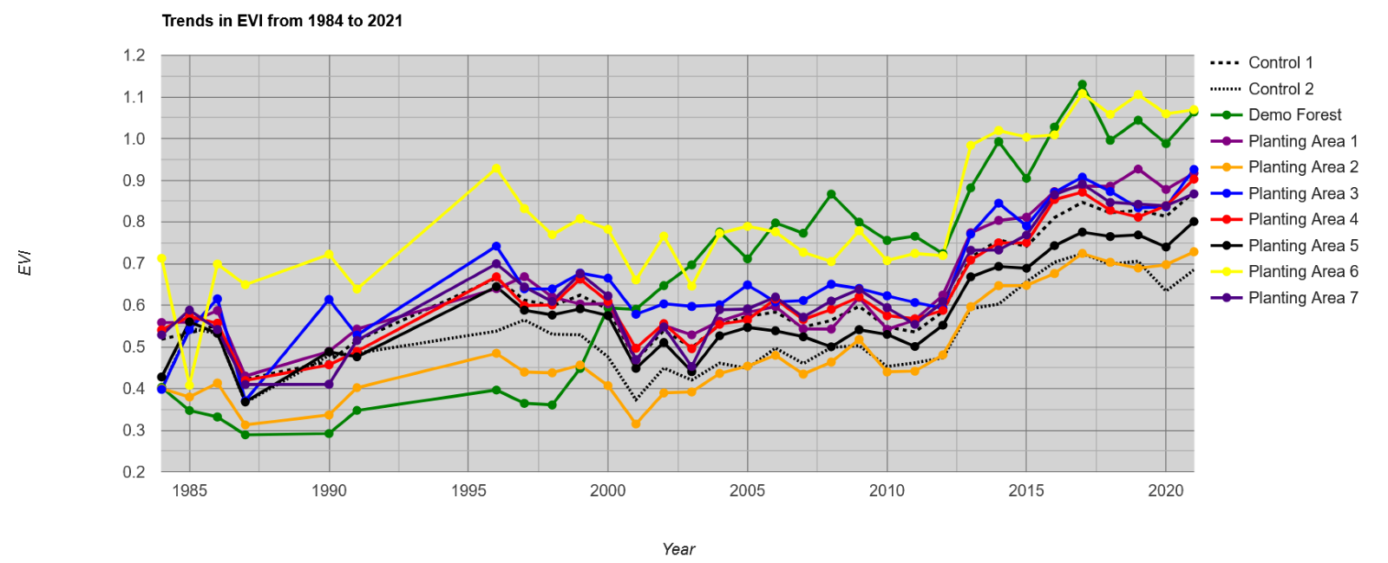Figure 3.Annual EVI trend per planting area from 1984 to 2021.

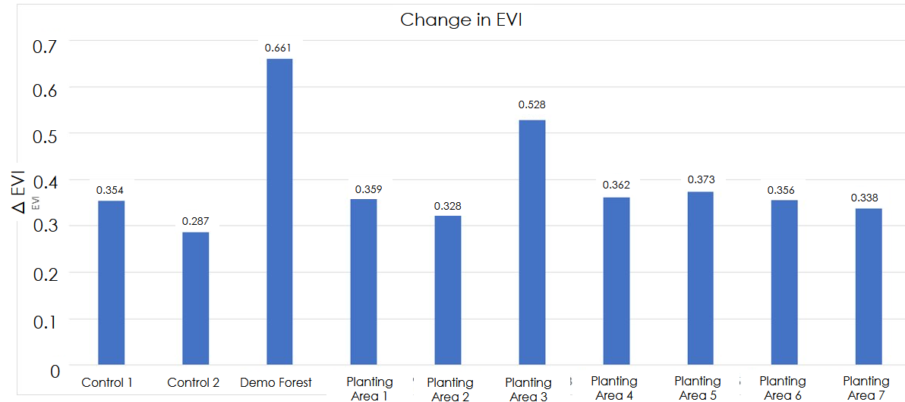

Figure 4. Change in EVI from 1984 to 2021 per planting area.

During the study period, Haiti had experienced multiple historic events which might help explain the time series chart showing a clear decline in EVI from 1984 to 1986 with a subsequent rebound. This coincides with the end of the Duvalier administration which is often seen as a period of increased collective and community spirit. Additionally, a trade embargo occurred from 1991 to 1993, which resulted in poverty, leading to increased tree cutting for economic purposes (Haiti Reforestation Partnership, 2022). While the years 1992 and 1993 are not represented in our data set, if significant tree cutting had occurred, the forest would have recovered by 1996 sufficiently so that loss was not easily detected. Lastly, the earthquake of 2010 may be reflected in the time series. After the earthquake, EVI decreased or stalled for multiple planting areas over two years before growth could be detected again in 2012.

*4.1.2 Habitat Suitability Model*

The final HSM has values between 0 and 1 with higher values being more similar to the high suitability points (Figure 5). The HSM had a precision of 0.84 and an Area Under the Curve (AUC) of 0.76. With the HSM, the team found that aspect, slope, and the maximum temperature of the warmest month were the three significant variables that best predicted the effectiveness of planting. As the slope and maximum temperature of the warmest month increased, the suitability of habitat decreased. Additionally, land facing the west had much higher suitability compared to land facing the east. Using a threshold of over .7 similarity, the HSM suggested there is a total of 49,169 hectares of suitable planting area within the study region.

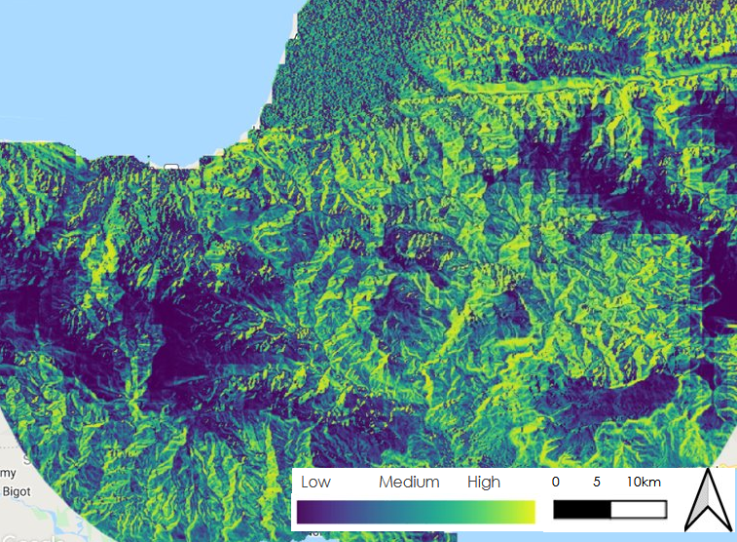

Figure 5. Habitat Suitability Model displayed over the study area.

*4.1.3 GUI Results*

When the end-user runs the Monitoring of Vegetation Presence (MVP) tool in GEE, the MVP tool will prompt the user to create a polygon of a region of interest in the map panel, shown on the bottom left side as seen in Figure 6. The panel contains brief instructions and an explanation of the produced chart in an easy-to-use format. After the area of interest is outlined, the user should select the ‘run’ button at the top of the screen.

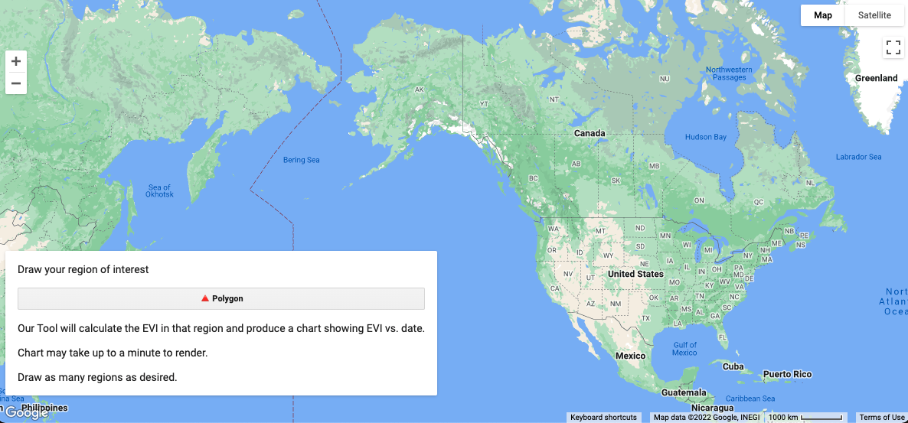

Figure 6. Graphic user interface (GUI) default screen. Basemap credit: Google Earth Engine.

After running the program, the tool creates a chart showing the average EVI values for that specific area over time (Figure 7). The chart plots these data as a scatterplot color coded to differentiate between the rainy season and dry season. This information allows the user to explore the relationship between EVI and seasons in their area of interest.

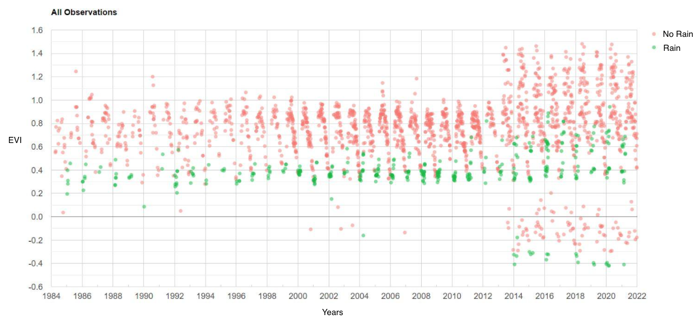

Figure 7. GUI-produced chart displaying EVI change over the chosen area of interest.

*4.1.4 Forest Cover Loss*

Utilizing the Hansen Global Forest Change data, the team found that areas inside the buffer sites covering 68,908,320 m2 had a forest cover loss of 4,400.5 m2/year between 2000 and 2020. Meanwhile, the planted sites covered 27,486,733 m2 and reported a lower scale of forest loss at 685.5 m2/year loss (Figure A5). The team observed higher conglomeration and indication of forest loss northeast of the study area, towards Haiti’s western coast.

***4.2 Future Work***

*4.2.1 Next Term*

In the future, the NASA DEVELOP program will expand upon our work, as well as investigate the HRP’s work in their own analysis, during another project term. During the first term, the team analyzed past- and present-day stand success through vegetation indices and explored environmental variables associated with stand success. The second term will focus on validating which environmental conditions correlate with stand success, as well as investigate the International Space Station (ISS) Global Ecosystem Dynamics Investigation (GEDI) canopy cover analyses. The MVP tool will be further refined to include options such as date filtering, composite images, NDVI, and more. Other efforts may focus on quantifying the reforestation project's positive secondary effects, such as possible water quality improvement in these areas over time. The HRP is also interested in watershed delineation as an additional guide to plantings. While this aspect was beyond the scope of this study, watershed inclusion as a predictor variable in the habitat model could be included in the next term.

*4.2.2 Limitations*

A limitation to this study is that the HRP uses eucalyptus as a primary species for reforestation due to its ability to grow vertically straight, at a faster rate than native species, while lacking natural predators. Eucalyptus tends to show a lower EVI signal on average, partially due to the leaves' waxy surface (Wu et al., 2016). As a result, while the reforestation plots were shown to have a greater and healthier number of trees, the difference between the Control 1 plot (100m buffer) and study area may not be seen in the EVI analysis without accounting for eucalyptus interference.

Second, there is the confounding factor that the Animator Zones may only represent 75% of the planting effort. The HRP suggests that up to 25% of the planting could be in the Control 1 plot, but lack of data makes it impossible to identify these areas and subtract them from the control. As such, it is possible that both controls’ EVI values are being enhanced by a moderate level of planting.

Third, within this study area there are groupings of forest that are not within the defined Animator zones. These groupings are primarily found in the Control plots and may have an impact of increasing EVI. A clear distinction between controls and planting areas will be needed to refine analysis.

Fourth, the initial Landsat 7 data collection we utilized was deprecated. After switching over to a more recent collection, there were noticeable differences in the EVI results around the year 2013. The team also lacked Landsat 7 data for the study area after 2014. Although the satellite was still taking images up to 2014, the reasoning for this lack of imagery is also unknown but might be due to Landsat 7’s scan line malfunction or an issue with image transferring from Landsat 7.

Fifth, the harmonization between Landsat 7 and Landsat 8 is not perfect. The year 2013 was well represented by both Landsat 7 and Landsat 8, offering an insight into the discrepancies between the two sensors. When each individual Landsat image is plotted in 2013, it becomes apparent that Landsat 8 reads higher EVI values than Landsat 7. This might explain why there is a sharp increase in EVI values after 2013 when Landsat 8 became the primary data source.

Sixth, an analysis using Sentinel-2 imagery to evaluate the differences between rain and dry season EVI values was inconclusive. The temporal resolution was too low to produce sufficient results for these short time spans. Although, this does leave room for future analysis to be done seasonally spanning across multiple years, instead of within a single year. In this study, the team used Top of Atmosphere imagery from Sentinel-2, which could have introduced errors not present if Surface Reflectance Sentinel-2 imagery was used instead.

Lastly, there were multiple datasets that the team had originally planned on using that were inadequate due to their coarse spatial resolution. These included GPM IMERG precipitation data, as well as SMAP soil moisture data. As a result, the team used WorldClim data that represented the time period between 1960 and 1991. This means the team’s model mixed predictor variables from different time periods with the maximum temperature of the warmest month from an earlier time period, and the DEM derived variables being from 2014.

# 5. Conclusions

The NASA DEVELOP team provided the HRP with a historical context to their reforestation efforts of 15.52 million trees planted since 1982. The team created a time series analysis that allowed the HRP to examine the change in EVI over the last 37-years in the reforested areas. This visual EVI chart showed the specific change year to year so the user can explore the cover land change at any time compared to control sites. Also, the DEVELOP team created a HSM to guide future planting decisions based on identified environmental variables associated with stand success, such as elevation and precipitation. Using a regression model, the team first identified the most critical variables in stand success (slope, aspect, and temperature of the warmest month) and their optimal values. Then, the team used these variables and identified areas that match these optimal values in nearby lands that can be used in future reforestation efforts, pinpointing 49,000 hectares of suitable land for planting. These results will assist the HRP in allocating their resources, both operationally and economically, for future reforestation efforts by gauging the success of their past work. In addition, pinpointing the most effective reforestation practices within this scope will result in positive social and environmental outcomes such as clean water, fertile land, and habitable landscapes.

# 

# 6. Acknowledgments

The NASA DEVELOP team would like to express their deepest appreciation to Dr. Marguerite Madden and Sarah Payne. As the science advisor and Fellow for the Georgia node, they equally challenged the team’s thinking and provided mentorship throughout the project. The team was extremely grateful for Dr. Kenton Ross’ insights into the research methods of the project. Lastly, the team had the great pleasure of working with the Haiti Reforestation Partnership (HRP). The project would not have been possible without the valuable information and advice from Michael Anello, Hunter Brown, Bill Hathaway, and Jamie Rhoads, as well as all the Animators and workers who have put in countless years of labor into reforesting Haiti.

This material contains modified Copernicus Sentinel data (2016 - 2022), processed by ESA.

Any opinions, findings, and conclusions or recommendations expressed in this material are those of the author(s) and do not necessarily reflect the views of the National Aeronautics and Space Administration.

This material is based upon work supported by NASA through contract NNL16AA05C.

# 

# 7. Glossary

**Akaike Information Criterion** - Model selector based on explaining the most variation in data with the lowest number of variables.

**Area Under the Curve (AUC)** - the measure of the ability of a classifier to distinguish between classes in a receiver operating characteristics probability curve

**Binomial Regression Model** - a regression model in which an independent trail has a probability of success or failure.

**Canopy height** –theheight of the foliage source above ground for any point of the canopy

**Earth observations** – Satellites and sensors that collect information about the Earth’s physical, chemical, and biological systems over space and time

**Enhanced Thematic Mapper Plus (ETM+)** – an instrument on board Landsat 7 that collects 8-bit images with 8 spectral bands

**Enhanced Vegetation Index (EVI)** – an indicator of vegetation variations with a reduction in atmospheric influences that uses red and near-infrared bands

**Global Ecosystem Dynamics Investigation (GEDI)** – a laser-based instrument on the International Space Station that provides a unique 3D view of Earth’s forests

**Google Earth Engine (GEE)** – a cloud-based geospatial analysis platform

**Global Precipitation Measurement Mission (GPM)** –a network of satellites launched in 2014 as a partnership between NASA and JAX (Japanese Space Agency) that collects data on precipitation over the entire globe every 2-3 hours

**Habitat suitability map** – used to predict the distribution of a species from environmental data and occurrence records

**Integrated Multi-satellitE Retrievals IMERG** – an algorithm for GPM that estimates precipitation over the majority of Earth’s surface

**Landsat 5** – a satellite launched in 1984 and decommissioned in 2013 that collected images of Earth on a 16-day repeat cycle

**Landsat 7** – a satellite launched in 1999 that collects images of Earth on a 16-day repeat cycle

**Landsat 8** –a satellite launched in 2013 that collects images of Earth on a 16-day repeat cycle

**Landsat 9 –** a satellite launched in 2021 that collects images of Earth on a 16-day repeat cycle

**Multi-spectral Imaging Mission (MSI)** – an instrument aboard Sentinel-2 that measures Earth’s reflected radiance in 13 spectral bands

**Normalized Difference Vegetation Index (NVDI)** – an index that differentiates between visible and near-infrared reflectance to estimate the density of vegetation in an area

**Operational Land Imager (OLI)** – an instrument aboard Landsat 8 that provides two new spectral bands of deep blue visible designed for water resources and an infrared for detection of cirrus clouds

**Silviculture** – the growing and cultivation of trees

**Sentinel-2** – a satellite group launched in 2015

**Soil Moisture Active Passive (SMAP)** – a satellite launched in 2015 that collects images of Earth with a 10-day repeat cycle

**Stand survival analysis** – statistical method for investigating tree population within an area

**Time series** – a collection of observed data through repeated measurements over time

**Thematic Mapper (TM)** – a sensor aboard Landsat 5 that provides imagery of Earth in 7 spectral bands

# 8. References

Burnham, K.P, Anderson, D.R., Huyvaert, K.P. (2011) AIC model selection and multimodel inference in behavioral ecology: some background, observations, and comparisons. Behavioral Ecology and Sociobiology 65: 23–35. <https://doi.org/10.1007/s00265-010-1029-6>

Copernicus Sentinel-2 (processed by ESA). (2021). *MSI Level-1C TOA Reflectance* *Product*. Collection 1. [Data set]. European Space Agency. <https://doi.org/10.5270/S2_-742ikth>

Cramer, J.S. (2010). The Origins and Development of the Logit Model. *Cambridge University Press,* 149-157. <https://doi.org/10.1017/CBO9780511615412.010>

HaitiData, The World Bank. (2021). Haiti Digital Terrain Model 2014 – 2016. Distributed by OpenTopography. <https://doi.org/10.5069/G9GX48R8>

Haiti Reforestation Partnership. (2022). “Fact sheet Haiti Reforestation Partnership”. <https://haitireforest.org/wp-content/uploads/2020-Fact-Sheet-.pdf>

Hansen, M. C., Potapov, P. V., Moore, R., Hancher, M., Turubanova, S. A., Tyukavina, A., Thau, D., Stehman, S. V., Goetz, S. J., Loveland, T. R., Kommareddy, A., Egorov, A., Chini, L., Justice, C. O., & Townshend, J. R. G. (2013). High-Resolution Global Maps of 21st Century Forest Cover Change. Science 342(6160), 850-853. <https://doi.org/10.1126/science.1244693>

Hausner, M. B., Huntington, J. L., Nash, C., Morton, C., McEvoy, D. J., Pilliod, D. S., Hegewisch, K. C., Daudert, B., Abatzoglou, J. T., & Grant, G. (2018). Assessing the Effectiveness of Riparian Restoration Projects Using Landsat and Precipitation Data from the Cloud-Computing Application Climateengine.org. *Ecological Engineering, 120*, 432–440., <https://doi.org/10.1016/j.ecoleng.2018.06.024>

Hedges, S. B., Cohen, W. B., Timyan, J., & Yang, Z. (2018). Haiti’s biodiversity threatened by nearly complete loss of primary forest. *Proceedings of the National Academy of Sciences of the United States of America*, 115(46), 11850–11855. <https://doi.org/10.1073/pnas.1809753115>

Hijmans, R. J., Cameron, S. E., Parra, J. L., Jones, P. G., & Jarvis, A. (2005). Very high-resolution interpolated climate surfaces for global land areas. *International Journal of Climatology,* 25(15), 1965-1978. <https://doi.org/10.1002/joc.1276>

Lewis, L. A., & Coffey, W. J. (1985). The Continuing Deforestation of Haiti.  *AMBIO, 14*(3), 158-160. <http://www.jstor.org/stable/4313133>

Locatelli, B., Catterall, C. P., Imbach, P., Kumar, C., Lasco, R., Marín-Spiotta, E., Mercer, B., Powers, J. S., Schwartz, N., & Uriarte, M. (2015). Tropical reforestation and climate change: beyond carbon. *Restoration Ecology*, 23(4), 337–343. <https://doi.org/10.1111/rec.12209>

Pauleus, O., & Aide, T. M. (2020). Haiti has more forest than previously reported: land change 2000-2015. *PeerJ*, 8. <https://doi.org/10.7717/peerj.99919>

Posner, S., Michel, G. A., & Toussaint, J. R. (2010). *Haiti biodiversity and tropical forest assessment*. The Haiti Repository. <https://thehaitirepository.com/wp-content/uploads/2020/01/Haiti_FAA_118-119-Dec_2010-1.pdf>

Rodrigues-Eklund, G., Hansen, M. C., Tyukavina, A., Stehman, S. V., Hubacek, K., & Baiocchi, G. (2021). Sample-Based Estimation of Tree Cover Change in Haiti Using Aerial Photography: Substantial Increase in Tree Cover Between 2002 and 2010. *Forests*, *12*(9). <https://doi.org/10.3390/f12091243>

Rouse, J. W., Haas, R. H., Schell, J. A., & Deering, D. W. (1974). Monitoring vegetation systems in the Great Plains with ERTS. *NASA,* 1(A). Retrieved March 23, 2022 from <https://ntrs.nasa.gov/citations/19740022614>

Tarter, A., Freeman, K. K., Ward, C., Sander, K., Theus, K., Coello, B., Fawaz, Y., Miles, M., & Ahmed, T. T. G. (2018). Charcoal in Haiti: A National Assessment of Charcoal Production and Consumption Trends World Bank. *World Bank Group,* <http://hdl.handle.net/10986/31257>

USGS. (2020). *Landsat 4-5 TM Collection 2 Level-2 Science Products.* [Data set]. USGS EROS Archive. <https://doi.org/10.5066/P9IAXOVV>

USGS. (2020). *Landsat 7 ETM Plus Collection 2 Level-2 Science Products.* [Data set]. USGS EROS Archive. <https://doi.org/10.5066/P9C7I13B>

USGS. (2020). *Landsat 8-9 OLI/TIRS Collection 2 Level-2 Science Products.* [Data set]. USGS EROS Archive. <https://doi.org/10.5066/P9OGBGM6>

# 9. Appendices

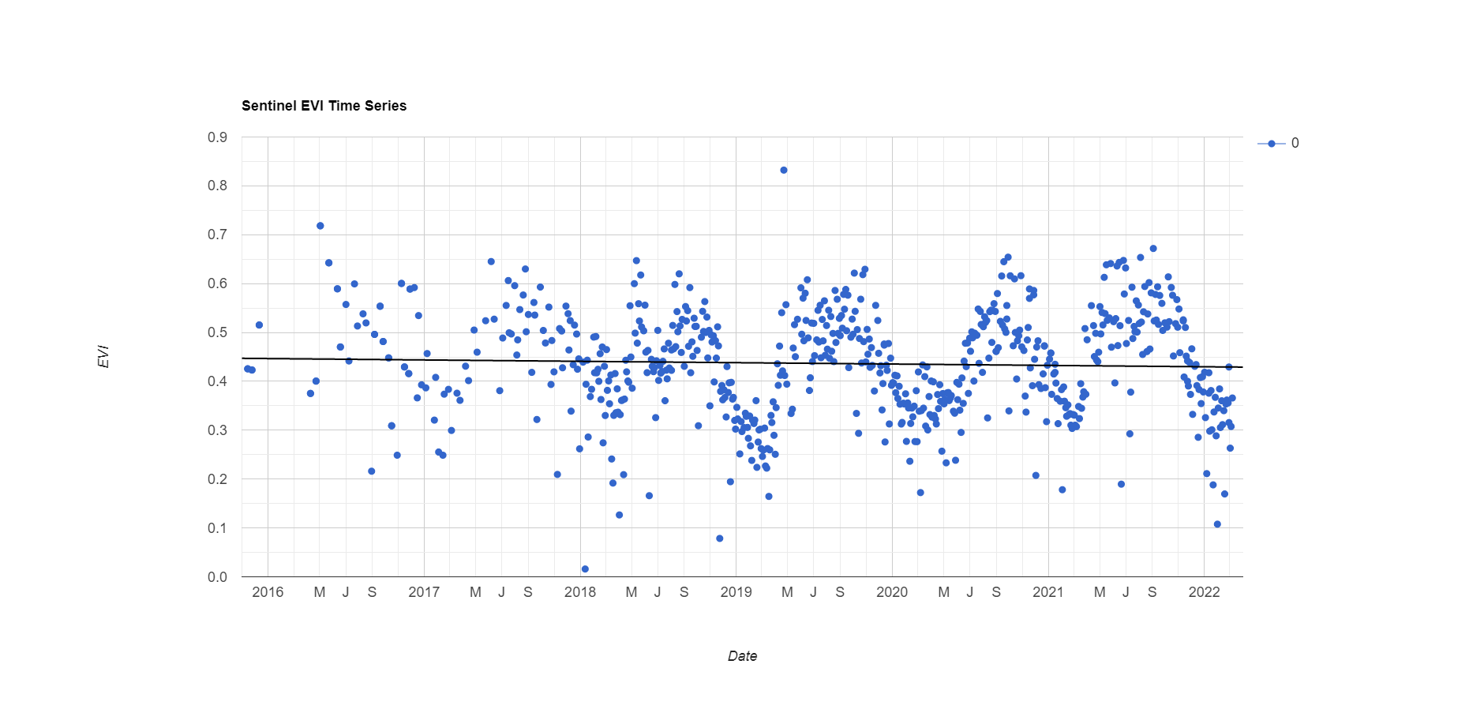

*Figure A1.* Chart showing the average EVI in the general study area for Sentinel-2 data from 2016-2022.

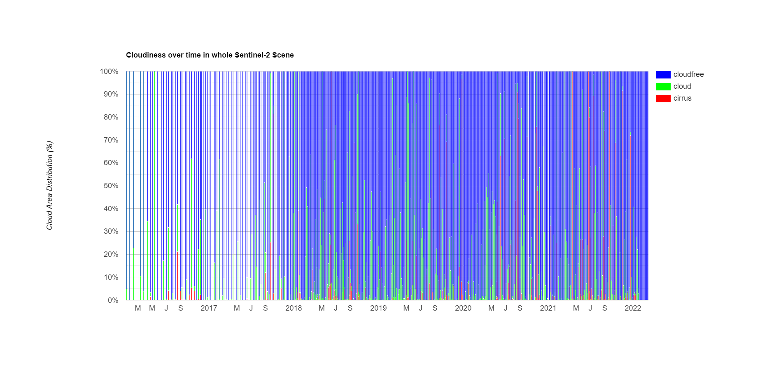

*Figure A2.* Graph showing the cloud percentage cover for use in masking of each Sentinel-2 image from 2016-2022.

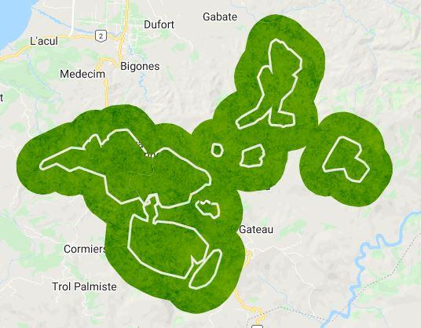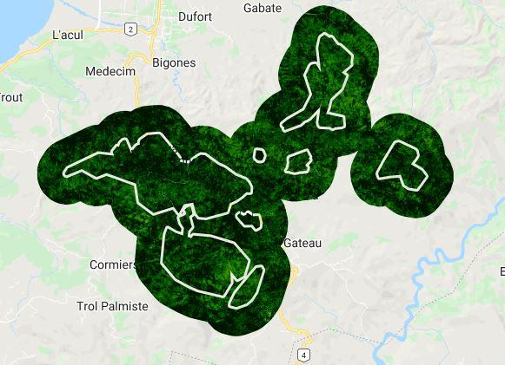

*Figure A3.* Visual of the most recent median composite images for NDVI and EVI over the study area, created with data from Landsat 9.

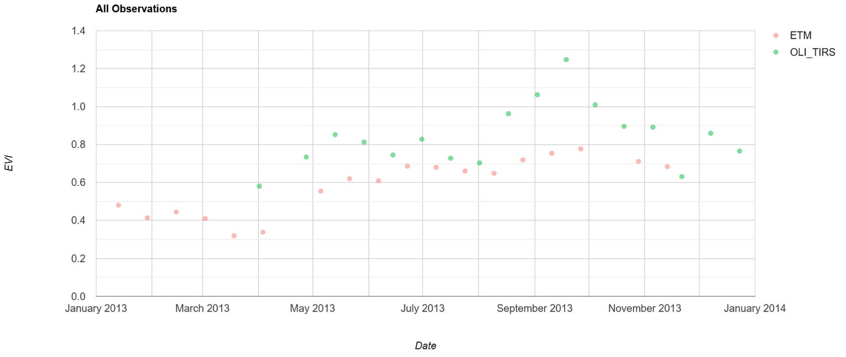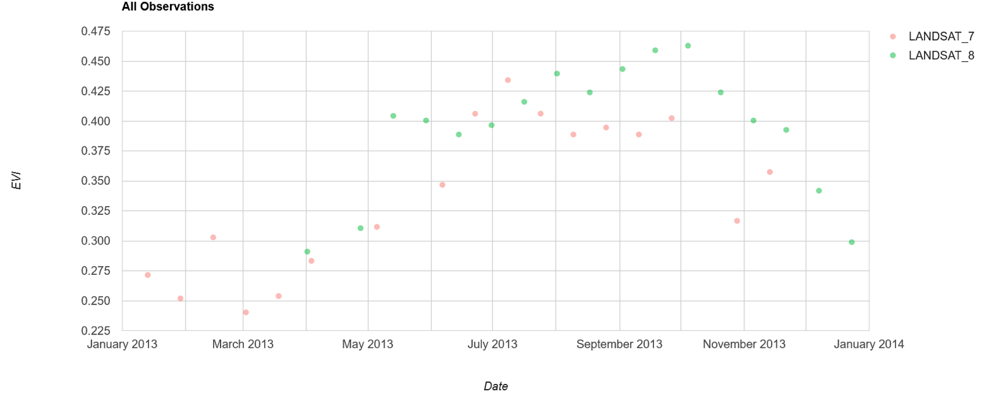

*Figure A4.* Top Landsat 7 vs Landsat 8 Collection 2 Tier 1 EVI readings. Bottom Landsat 7 vs Landsat 8 Collection 1 Tier 1 deprecated EVI readings.

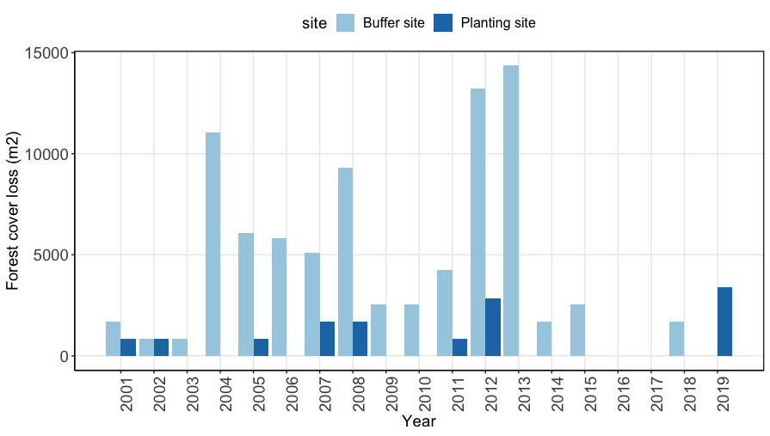

*Figure A5.* YearlyHansen et al. estimated cover loss from 2000-2020 for the planting sites, and our buffer site between 2000-2020.